Volume 11. Battery and Powertrain

Chapter 05. Charging System

05.01. CC-CV Charging Profile
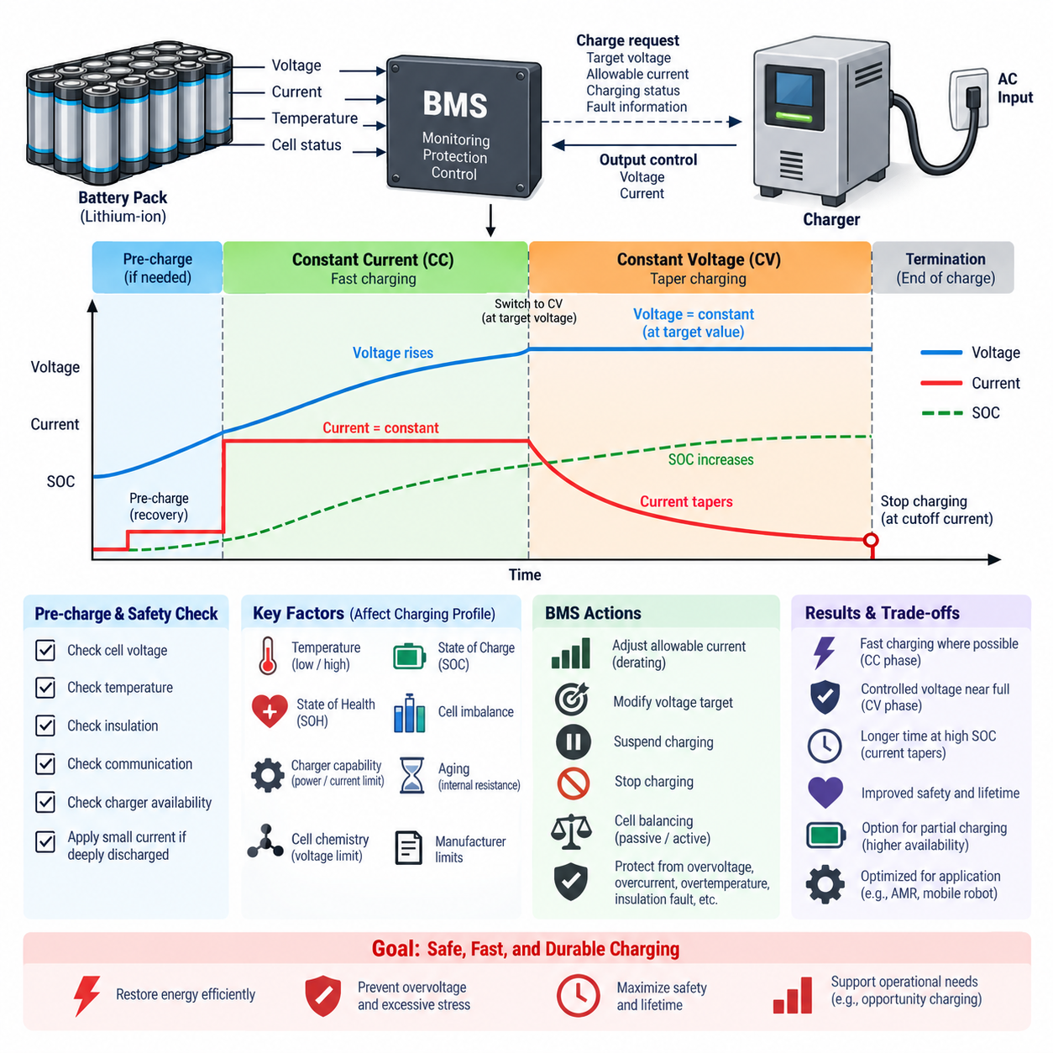
Constant Current–Constant Voltage (CC–CV) charging is the dominant charging method for lithium-ion batteries because it provides a practical balance among charging speed, usable capacity, thermal behavior, and cell protection. The charging process is divided into two principal operating regions: a constant-current phase that restores most of the energy efficiently and a constant-voltage phase that completes charging while preventing the cell voltage from exceeding its allowable upper limit.
Before normal CC charging begins, the battery management system (BMS) evaluates whether the battery is in a valid condition for charging. Cell voltages, pack voltage, temperature, insulation status, communication health, and charger availability are typically checked. If a cell is deeply discharged below its normal operating range, the charger may first apply a small pre-charge or recovery current instead of immediately supplying the full charging current, reducing stress on a potentially degraded cell.
During the constant-current (CC) phase, the charger regulates current at a predefined value while the cell voltage gradually rises as the state of charge (SOC) increases. The selected current is commonly expressed as a C-rate relative to the rated cell capacity. A higher charging current can shorten charging time, but it also increases resistive heating, electrochemical polarization, and the possibility of lithium plating under unfavorable temperature or SOC conditions.
The CC current limit is therefore not necessarily a fixed value under every operating condition. A practical BMS may calculate the permitted charge current dynamically according to cell temperature, SOC, state of health (SOH), maximum cell voltage, pack imbalance, and manufacturer-defined limits. This process is often implemented through charge-current derating, allowing high current in favorable operating regions while progressively reducing the allowable current near thermal, voltage, or aging-related boundaries.
As charging proceeds, individual cell voltages increase toward the specified upper charging voltage. The transition from CC to CV operation occurs when the limiting cell or controlled battery voltage reaches the defined voltage target. For many lithium-ion chemistries, this upper voltage must be controlled accurately because even relatively small sustained overvoltage can accelerate electrolyte degradation, increase parasitic reactions, and reduce safety margins. The exact voltage threshold depends on the cell chemistry and manufacturer specification.
During the constant-voltage (CV) phase, the charger holds the charging voltage near the specified target rather than maintaining the previous current. Because the electrochemical driving potential decreases as the cell approaches full charge, the charging current naturally tapers downward. The CV phase therefore fills the remaining capacity more gradually while preventing voltage from continuing to rise beyond the permitted limit, making voltage regulation accuracy particularly important near high SOC.
The current-taper behavior provides useful information about the battery’s approach to full charge. Charging is normally terminated when the current falls below a defined termination threshold, sometimes called the cutoff or end-of-charge current, while voltage and temperature remain within acceptable limits. Continuing CV charging indefinitely after the current has reached a sufficiently low level provides little additional usable energy and can unnecessarily increase the time spent at high SOC.
CC–CV charging should therefore be understood as a coordinated control process rather than simply two charger settings. The charger controls the electrical output, while the BMS continuously determines whether charging remains permissible. The BMS may request a lower current, reduce the voltage target, suspend charging, or open the charge path if cell voltage, temperature, current, insulation, or other monitored parameters violate allowable boundaries.
Cell imbalance becomes especially important near the CC-to-CV transition. In a series-connected battery pack, cells do not reach the upper voltage limit at exactly the same time because of differences in capacity, impedance, temperature, aging, and SOC. The highest-voltage cell may therefore reach its limit while other cells still have available charging capacity. Since pack charging must protect every individual cell, this limiting cell can determine when current reduction becomes necessary.
Cell balancing can help reduce this limitation by decreasing SOC differences among series-connected cells. Passive balancing typically dissipates a small amount of energy from higher-voltage cells through balancing resistors, whereas active balancing transfers energy between cells or modules. Balancing is often most relevant in the upper SOC region, where small SOC differences can produce significant voltage divergence and prematurely force the charger into current reduction or charge termination.
Temperature strongly influences the permissible CC–CV profile. At low temperature, lithium-ion diffusion and charge-transfer processes become slower, increasing polarization and lithium-plating risk if excessive charging current is applied. At high temperature, charging may accelerate undesirable chemical reactions and battery aging. A robust BMS therefore defines temperature-dependent charging regions and may derate current, modify voltage limits, or prohibit charging entirely outside the approved thermal operating window.
Battery aging also changes the appropriate charging behavior. As cells accumulate cycles and calendar exposure, internal resistance can increase and available capacity can decline. The same nominal charging current may consequently generate more heat and produce a faster voltage rise in an aged battery than in a new one. SOH-aware charging strategies can compensate by reducing allowable current or adjusting charging limits to preserve safety margins and extend remaining service life.
For large battery packs, charger power capability introduces another practical constraint. At lower pack voltage, the charger may be capable of supplying the requested CC value, but as battery voltage increases, its maximum power or current rating can become limiting. Consequently, the observed charging profile may contain power-limited or thermally derated regions in addition to ideal CC and CV behavior. Real charging curves should therefore be interpreted as controlled approximations of the theoretical CC–CV profile.
Charging control also requires reliable communication between the BMS and charger. In intelligent charging systems, the BMS can communicate requested voltage, allowable charging current, operating status, and fault information through interfaces such as CAN or other supported communication protocols. The charger then regulates its output within these commands, while independent hardware protections provide additional defense against communication failures, controller faults, or abnormal electrical conditions.
The charging profile has a direct relationship with charging time. Most energy is normally transferred during the relatively high-current CC region, whereas the final portion of charge can require disproportionate time because current progressively decreases during CV operation. This explains why reaching a moderately high SOC can be considerably faster than reaching a fully saturated state. Applications requiring high availability may therefore intentionally stop charging below maximum SOC to improve turnaround time and reduce high-SOC exposure.
For AMRs, mobile robots, and other continuously operated battery systems, CC–CV parameters should be integrated with mission scheduling rather than optimized only for maximum capacity. Opportunity charging, partial charging, automated docking, and fleet-level charger allocation may favor shorter charging sessions within a moderate SOC window. The BMS can still enforce the underlying CC–CV safety principles while supervisory software determines when charging should begin and what target SOC is operationally appropriate.
The resulting CC–CV charging profile is therefore a system-level interaction among cell chemistry, charger capability, BMS estimation, thermal conditions, balancing behavior, aging state, and operational requirements. Correct implementation restores energy rapidly where the battery can safely accept it, progressively limits electrical stress as full charge approaches, and terminates charging at a controlled endpoint. This coordinated behavior forms the foundation for safe, repeatable, and durable lithium-ion battery charging.

05.02. Auto Docking Charging
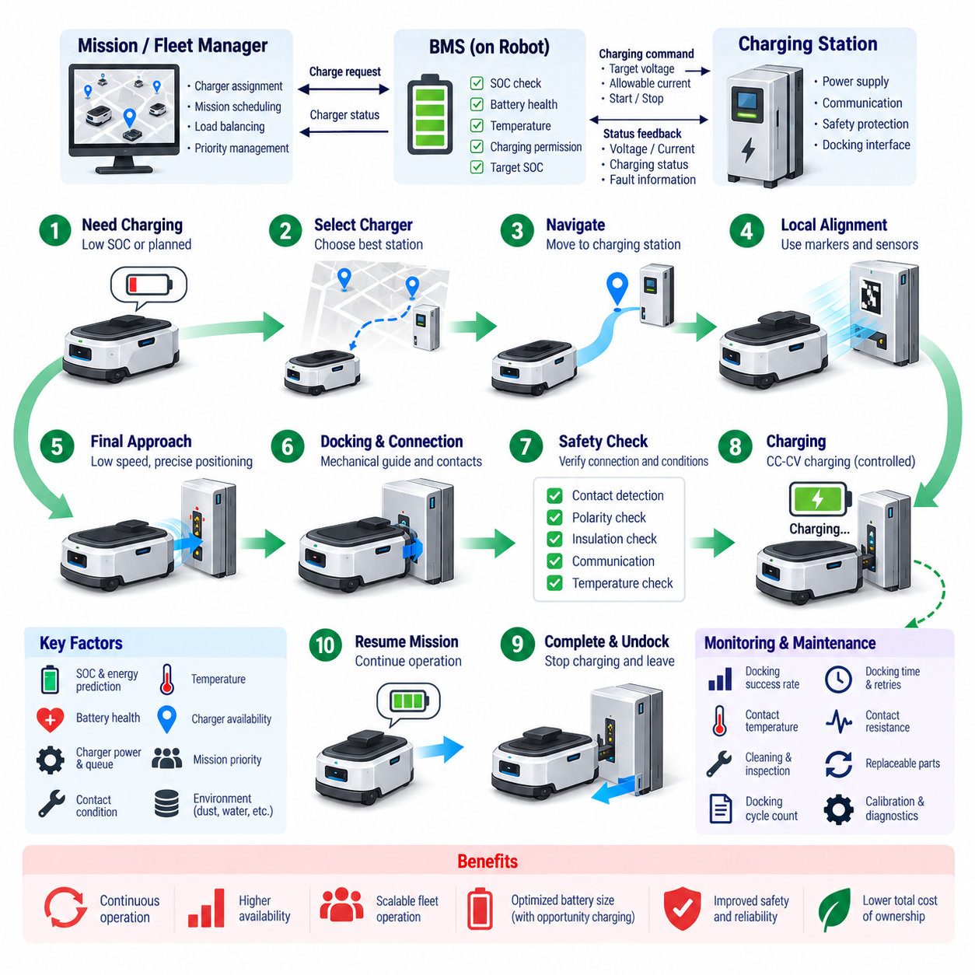
Automatic docking charging enables an autonomous mobile robot (AMR) to restore battery energy without manual cable connection or operator intervention. The robot detects the need for charging, travels to a designated charging station, aligns with the docking interface, establishes an electrical connection, verifies charging conditions, and begins controlled charging. This capability supports continuous operation and is essential for scalable autonomous robot fleets.
The charging decision normally begins with the battery management system (BMS) and fleet or mission controller. State of charge (SOC), predicted energy consumption, remaining mission distance, charger availability, and operational priorities can all influence when docking is requested. Rather than waiting for a fixed low-SOC threshold, advanced systems can estimate whether sufficient energy remains to complete the current mission and safely reach an available charger.
Once charging is required, the robot must select an appropriate docking station and generate a route toward it. In a multi-robot fleet, charger assignment can consider distance, charger power, queue length, battery condition, mission priority, and expected charging duration. Fleet-level coordination prevents several robots from simultaneously targeting the same charger and allows charging resources to be treated as shared infrastructure within the overall mission scheduling system.
Navigation toward the charging station generally uses the same localization and path-planning functions employed during normal AMR operation. LiDAR, cameras, wheel odometry, inertial sensors, maps, and localization algorithms can guide the robot through the facility. As the AMR approaches the charger, however, ordinary navigation accuracy may no longer be sufficient because the electrical contacts typically require much tighter positional and angular alignment than normal waypoint navigation.
Docking therefore commonly uses a transition from global navigation to local precision alignment. The charging station may contain visual markers, reflective targets, geometric features, infrared emitters, magnetic references, or other localization aids that help the robot determine its relative pose. Cameras, LiDAR, proximity sensors, or dedicated docking sensors can then provide closed-loop corrections until lateral, longitudinal, and angular alignment errors fall within acceptable tolerances.
The final approach is normally performed at low speed to reduce collision energy and improve positioning accuracy. The motion controller progressively corrects steering and velocity while monitoring obstacles and docking references. Mechanical guides such as tapered rails, funnels, spring-loaded contacts, or compliant structures can compensate for small residual positioning errors. Combining software alignment with mechanical tolerance generally produces more reliable docking than depending on extremely precise navigation alone.
Contact-based charging requires a reliable electrical interface after physical docking. Spring-loaded pins, conductive plates, brushes, or similar contacts may carry the charging current, while separate signal contacts or communication links can confirm connection status. Contact geometry should tolerate repeated docking cycles, surface contamination, vibration, minor misalignment, and mechanical wear without creating excessive resistance or unstable electrical connections.
Electrical power should not normally be applied at full charging voltage and current merely because mechanical contact has occurred. The charger and BMS first verify conditions such as contact detection, polarity, pack voltage, insulation status, communication validity, battery temperature, and charging permission. A controlled handshake or pre-charge sequence can establish that the charging path is safe before the main charging circuit is enabled, reducing arcing and abnormal current transients.
After validation, the charging station and BMS coordinate the charging process according to the battery chemistry and permitted operating limits. For lithium-ion batteries, this typically involves a Constant Current–Constant Voltage (CC–CV) profile. The BMS continuously monitors cell voltages, pack current, temperature, SOC, and fault conditions while communicating allowable voltage and current limits to the charger. Charging power can be reduced dynamically when thermal or electrical limits are approached.
Docking contacts introduce additional electrical considerations that are less significant in manually connected charging systems. Contact resistance can generate localized heat according to current and resistance, particularly when conductive surfaces become oxidized, contaminated, worn, or incompletely engaged. Temperature sensing near the charging interface, contact-voltage monitoring, current plausibility checks, and periodic inspection can therefore help detect degradation before it develops into charging instability or thermal damage.
Charging stations also require protection against abnormal mechanical and environmental conditions. Foreign objects, water, dust, conductive debris, damaged contacts, or unintended human interaction can create hazards depending on voltage and installation environment. Protective covers, recessed electrodes, interlocks, isolation monitoring, current limiting, environmental sealing, and de-energized contacts before successful docking can be combined according to the required safety architecture.
A failed docking attempt should be treated as a recoverable operational event rather than immediately becoming a mission failure. If alignment or electrical validation is unsuccessful, the AMR can disengage, move to a defined retry position, reassess its pose, and attempt docking again. Retry count, remaining SOC, fault classification, and alternative charger availability should determine whether the robot continues retrying, selects another station, or requests operator assistance.
Undocking also requires controlled sequencing. When the target SOC or scheduled charging objective has been reached, charging current should first be reduced or terminated before the robot mechanically separates from the station. The charger confirms that the electrical path is safely de-energized, the BMS verifies readiness, and the robot releases any mechanical retention mechanism before reversing from the dock. This prevents disconnecting high charging current through exposed contacts.
Automatic docking is particularly valuable when opportunity charging is used. Instead of waiting for a deeply discharged battery, an AMR can recharge during idle periods, production breaks, loading delays, or naturally available mission gaps. Frequent partial charging can maintain the battery within a planned SOC operating window, reducing long charging interruptions and potentially allowing a smaller battery to support a given duty cycle when sufficient charging opportunities exist.
Fleet operation changes charging from an individual robot function into an energy-management problem. The fleet manager can predict future charger demand from robot SOC, mission schedules, energy consumption, and charger occupancy. Robots with urgent tasks may receive priority, while lower-priority units charge during idle periods. Effective scheduling minimizes charger congestion and prevents simultaneous low-energy conditions that could reduce the productive capacity of the entire fleet.
The number and power rating of charging stations should therefore be designed together with robot utilization and battery capacity. Installing too few chargers can create queues and reduce robot availability, whereas excessive charger capacity increases infrastructure cost without proportional operational benefit. Simulation or duty-cycle analysis can estimate charger utilization, expected queue time, energy demand, charging duration, and the minimum charging infrastructure required for the target fleet throughput.
Docking reliability is an important system-level performance indicator because even a highly efficient charger provides little benefit if physical connection frequently fails. Useful metrics include successful docking rate, first-attempt success rate, average docking time, number of retries, contact resistance, charging-start success rate, undocking success, and charger availability. Logging these values enables maintenance teams to identify mechanical wear, localization drift, contamination, or charging-interface degradation.
Maintenance requirements should be considered from the initial docking-station design. Repeated contact cycles can gradually wear conductive surfaces and mechanical guides, while accumulated dust can alter electrical resistance or sensor performance. Replaceable contact modules, accessible cleaning points, diagnostic measurements, alignment calibration procedures, and recorded docking-cycle counts simplify preventive maintenance and reduce unexpected charging failures during fleet operation.
Automatic docking charging ultimately combines navigation, precision localization, motion control, mechanical alignment, electrical connection, BMS supervision, charger control, safety protection, and fleet scheduling into one coordinated process. A well-designed system does more than automatically connect a battery to a power source; it manages robot energy as part of autonomous operation, enabling AMRs to maintain high availability with minimal human intervention and predictable charging behavior.

05.03. Opportunity Charging Strategy
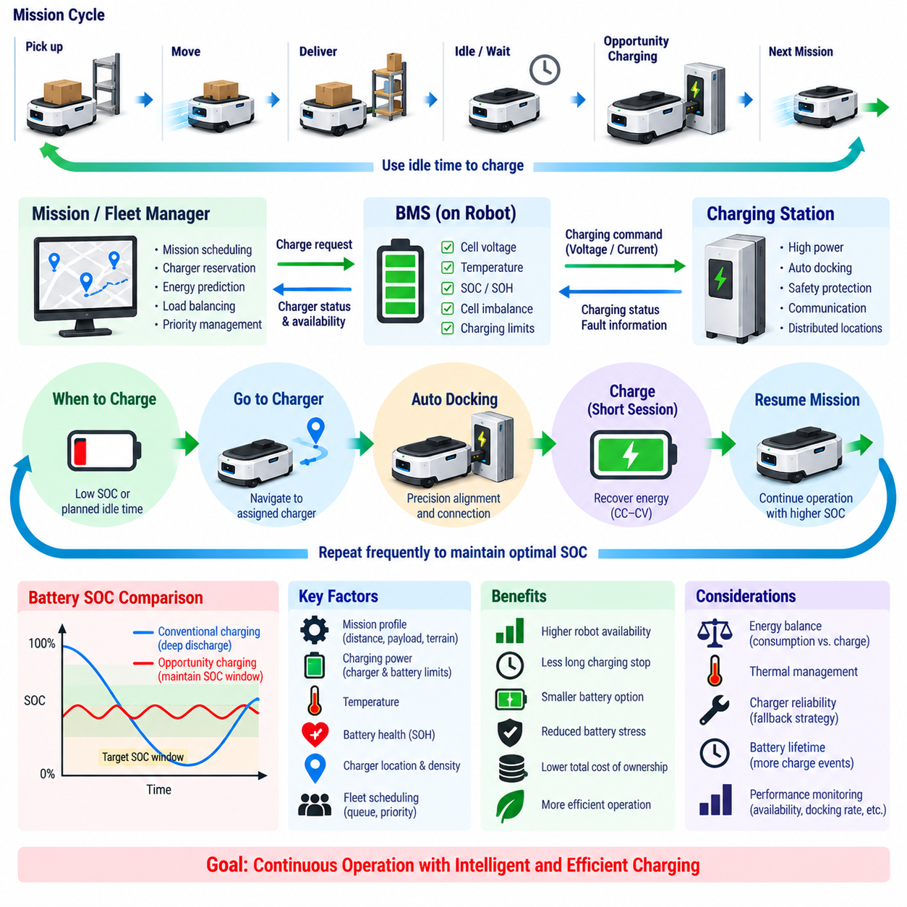
Opportunity charging is an energy-management strategy in which an autonomous mobile robot (AMR) charges its battery during naturally occurring idle periods instead of waiting for the battery to reach a low state of charge (SOC). Short charging sessions can occur between missions, during loading or unloading, at production pauses, or while the robot waits for new tasks. The objective is to convert otherwise unused time into productive energy recovery.
Unlike conventional charging strategies that operate primarily between a low-SOC threshold and a high-SOC target, opportunity charging can maintain the battery within a narrower operating window. For example, the robot may repeatedly receive small amounts of energy whenever operational conditions permit. This reduces deep discharge events and can decrease the duration of dedicated charging stops, improving robot availability when the charging schedule is properly coordinated with mission demand.
The effectiveness of opportunity charging depends on the relationship between energy consumption and recoverable charging energy. During each operating cycle, the robot consumes energy while moving, carrying payloads, computing, sensing, and operating auxiliary devices. During available idle periods, the charger must recover enough energy to maintain a sustainable long-term energy balance. If average energy consumption continuously exceeds recoverable charging energy, SOC will gradually decline regardless of scheduling intelligence.
A useful strategy therefore begins with duty-cycle analysis. Mission duration, travel distance, payload, terrain, acceleration frequency, auxiliary loads, average propulsion power, idle time, and available charging duration should be evaluated together. Rather than sizing the battery only from maximum mission endurance, designers can calculate how much energy is consumed between charging opportunities and how much can realistically be restored during each available charging window.
Charging power is a critical design parameter because opportunity-charging windows may be relatively short. A higher-power charger can restore more energy during a brief stop, but the battery must be capable of accepting the corresponding charging current without exceeding voltage, temperature, or aging limits. The practical charging rate is therefore constrained by charger capability, battery chemistry, cell temperature, SOC, state of health (SOH), and battery management system (BMS) limits.
The BMS remains responsible for determining the electrically permissible charging envelope during every opportunity-charging event. It monitors cell voltage, temperature, current, SOC, SOH, and cell imbalance and communicates allowable charging limits to the charger. Even when the fleet controller identifies a valuable ten-minute charging window, the actual energy recovered may be lower than expected if the BMS derates current because of low temperature, high SOC, elevated temperature, or battery aging.
Opportunity charging is generally most efficient when the battery is maintained away from extreme SOC regions. Very high SOC can reduce charge acceptance because the charging process approaches the Constant Voltage (CV) region and current begins to taper. Extremely low SOC reduces operational reserve and increases the risk that unexpected delays will prevent the robot from reaching a charger. A moderate SOC operating band can therefore provide both useful charging power and sufficient mission reserve.
The target SOC window should be selected according to operational requirements rather than applying a universal value to every AMR. A high-utilization logistics robot may require a wider energy reserve than a robot operating near multiple chargers. Mission criticality, charger density, battery capacity, charging power, route uncertainty, payload variation, and expected queue time all influence the appropriate lower and upper SOC boundaries. These limits can also change dynamically during operation.
Predictive energy management can improve opportunity-charging decisions beyond simple threshold-based control. The fleet manager can estimate energy required for upcoming missions and compare it with current SOC, expected charger access, and future idle periods. A robot with sufficient reserve for several short missions may continue working, while another robot with an energy-intensive task scheduled later can be sent to charge even though its present SOC is relatively high.
Automatic docking charging is a key enabling technology because frequent short charging sessions would become impractical if human intervention were required. The AMR can autonomously navigate to a charger, perform precision docking, verify the electrical connection, initiate charging, and return to operation when the available charging window ends. Fast and reliable docking is particularly important because excessive docking time directly reduces the useful portion of a short charging opportunity.
Charging infrastructure can also be distributed around operational areas rather than concentrated in a single charging room. Chargers may be positioned near loading stations, waiting zones, production cells, elevators, transfer points, or other locations where robots naturally stop. This reduces nonproductive travel to charging stations and allows energy recovery to become part of the normal material-flow process. Charger placement should therefore be optimized together with route and facility design.
In multi-robot systems, opportunity charging becomes a fleet scheduling problem because chargers are shared resources. The fleet manager must determine which robot should charge, where it should charge, and for how long. Decisions can consider SOC, predicted energy demand, mission priority, charger distance, charging rate, queue length, and future workload. Poor scheduling can create charger congestion even when the total installed charging power appears sufficient.
Charger reservation can reduce uncertainty by assigning future charging windows before robots become energy constrained. A robot approaching a scheduled idle period can reserve a nearby charger, while another unit is directed elsewhere or delayed until capacity becomes available. Dynamic reservation can be updated as missions change, allowing the fleet to balance production throughput and energy demand rather than treating charging as an unexpected interruption to normal operations.
Opportunity charging can influence battery sizing. If reliable charging opportunities occur throughout the operating cycle, the battery does not necessarily need to store enough energy for an entire shift. A smaller battery can reduce robot mass, cost, charging energy, and structural requirements. However, excessive downsizing creates dependency on charging infrastructure and reduces resilience against charger failures, schedule disruptions, unusually demanding missions, or unexpected facility conditions.
Battery lifetime must also be considered because opportunity charging increases the number of charging events even though each event may involve only a small SOC change. Lithium-ion aging depends on more than simple cycle count; temperature, charging rate, average SOC, depth of discharge, and time spent near maximum voltage are also important. Maintaining a moderate SOC window and avoiding unnecessary high-SOC saturation can make frequent partial charging compatible with long battery service life.
Thermal management becomes important when frequent high-power charging is combined with intensive robot operation. Propulsion and computing loads can heat the battery during a mission, after which charging immediately introduces additional thermal load. The BMS may need to reduce charging current until temperature returns to a favorable range. Thermal design should therefore consider repeated drive–charge–drive cycles rather than evaluating driving and charging as isolated operating modes.
The strategy should include fallback behavior for abnormal conditions. If a planned charger is occupied, unavailable, or faulty, the robot must determine whether it has enough energy to continue its mission, wait, or travel to another station. Reserve SOC should account for such uncertainty. Fleet control can also temporarily reduce mission assignments, prioritize low-energy robots, or redirect charging resources when infrastructure availability falls below the expected level.
Performance should be evaluated using system-level indicators rather than charging efficiency alone. Important measures include robot availability, productive mission time, energy recovered per charging opportunity, average SOC, minimum SOC, charger utilization, queue time, docking success rate, charging duration, battery temperature, and mission interruptions caused by insufficient energy. These metrics reveal whether the strategy actually improves fleet productivity rather than merely increasing charging frequency.
Opportunity charging ultimately integrates battery characteristics, BMS control, automatic docking, charger placement, mission prediction, fleet scheduling, and operational energy demand. Its purpose is not simply to charge more frequently, but to place charging intelligently inside the natural rhythm of robot operation. When energy consumption and recovery are properly balanced, AMRs can maintain continuous availability with fewer long charging stops, controlled battery stress, and more efficient use of battery and charging infrastructure.

05.04. Wireless Charging (WPT)
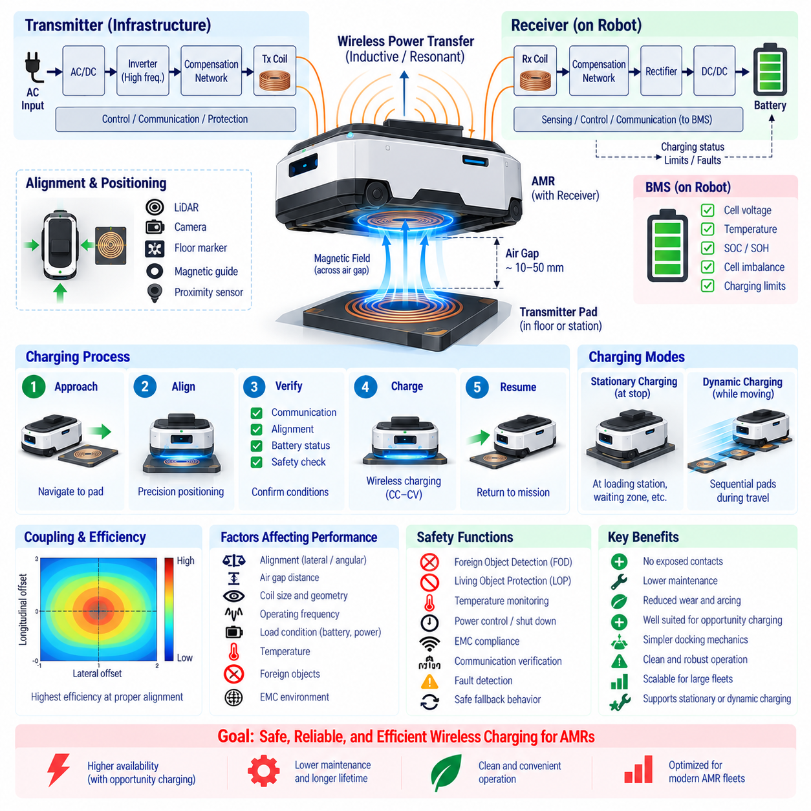
Wireless Power Transfer (WPT) enables an autonomous mobile robot (AMR) to receive charging energy without exposed conductive contacts or manually connected cables. A transmitter installed in the floor, charging pad, or docking station transfers electromagnetic energy across an air gap to a receiver mounted on the robot. The received energy is converted and regulated before being supplied to the battery through the battery management system (BMS).
For AMR charging, WPT is commonly implemented using inductive or resonant inductive coupling. An alternating current applied to the transmitter coil generates a time-varying magnetic field, which induces voltage in the receiver coil. Resonant compensation networks improve energy transfer across the physical gap by tuning the transmitter and receiver circuits to compatible operating frequencies, allowing useful power to be delivered without direct electrical contact.
The complete WPT system includes more than two coils. The infrastructure side typically contains an AC/DC conversion stage, high-frequency inverter, compensation network, transmitter coil, communication interface, and protection circuits. The robot side contains the receiver coil, compensation network, rectifier, DC/DC conversion stage, sensing circuits, and BMS interface. These elements jointly convert grid power into controlled DC charging power for the battery.
Coupling between the transmitter and receiver strongly influences charging performance. Maximum transfer efficiency is generally obtained when the coils have appropriate separation and good positional alignment. Lateral displacement, angular error, excessive vertical air gap, or differences in coil geometry reduce magnetic coupling and can lower delivered power. WPT docking therefore still requires positioning control, although it eliminates the need to physically mate electrical contacts.
Mechanical tolerance can be one of the important advantages of wireless charging. A contact-based dock may require conductive surfaces to meet within a limited physical region, while a properly designed WPT system can transfer energy over a defined alignment envelope. This can simplify docking mechanics and reduce sensitivity to contact wear. However, large misalignment still reduces efficiency and may cause additional heating, so positioning requirements cannot be eliminated completely.
An AMR can use LiDAR, cameras, floor markers, magnetic references, proximity sensors, or localization information to position its receiver above the charging transmitter. During the final approach, the robot may switch from normal navigation to precision alignment. The charging system can additionally estimate coupling quality or transferred power and provide feedback that helps the robot determine whether its final position is suitable for efficient charging.
Charging does not begin simply because the robot enters the transmitter area. The WPT controller and BMS first establish communication and verify that a valid receiver is present. Battery voltage, SOC, temperature, charging permission, requested power, alignment quality, and system fault status can be checked before significant power transfer begins. This controlled activation prevents unnecessary transmitter operation and supports safer automated charging.
Foreign Object Detection (FOD) is an important safety function in practical WPT systems. Metallic objects unintentionally placed within the active magnetic field can experience induced currents and potentially heat. The system may detect abnormal power loss, changes in electrical characteristics, temperature rise, or other indicators of an unintended object. If a hazardous condition is identified, transmitted power should be reduced or disabled before excessive heating occurs.
Living Object Protection (LOP) may also be considered depending on system power, geometry, frequency, and installation environment. The charging system should be designed so that people, animals, or unintended objects are not exposed to unacceptable electromagnetic or thermal conditions. Physical installation, shielding, detection functions, operating zones, power control, and compliance with applicable electromagnetic-field requirements contribute to the overall protection strategy.
Electromagnetic compatibility (EMC) is particularly important because WPT intentionally generates a high-frequency electromagnetic field while the AMR contains sensitive electronics and communication systems. Poorly controlled emissions can interfere with sensors, communication links, BMS measurements, navigation electronics, or nearby equipment. Coil design, shielding, filtering, grounding, cable routing, switching control, and system-level EMC validation are therefore essential design activities.
Efficiency should be evaluated across the entire power-conversion chain rather than only between the transmitter and receiver coils. Losses occur in AC/DC conversion, inverter switching, resonant components, magnetic structures, rectification, DC/DC conversion, wiring, and the battery charging process. Misalignment can further increase losses. Total grid-to-battery efficiency is therefore a more meaningful system metric than quoting the peak efficiency of the magnetic coupling stage alone.
Thermal management is closely related to efficiency. Power lost in semiconductor switches, coils, magnetic materials, compensation components, rectifiers, and converters becomes heat. The receiver is particularly important because it is installed on the mobile robot, where available cooling space may be limited. Temperature monitoring and power derating can prevent components or the battery from exceeding allowable limits during prolonged or high-power wireless charging.
The BMS continues to determine how much charging power the battery can safely accept. WPT changes the physical energy-transfer interface but does not replace lithium-ion charging requirements. The BMS monitors cell voltage, current, temperature, SOC, state of health (SOH), and imbalance and provides allowable charging limits. The wireless power electronics then regulate their output so that the battery follows the required charging profile, such as Constant Current–Constant Voltage (CC–CV).
Wireless charging is well suited to opportunity charging because it removes mechanical electrical-contact engagement from frequent charging events. Charging pads can be installed at locations where AMRs naturally stop, such as loading stations, transfer points, elevators, waiting zones, or work cells. The robot can recover energy during short pauses without connector wear, allowing charging to become more deeply integrated into the normal mission cycle.
Dynamic or quasi-dynamic WPT extends this concept by transferring energy while the robot is moving slowly or passing through an energized charging zone. Multiple transmitter segments can be activated sequentially as the robot moves above them. Although this can reduce stationary charging time, it substantially increases infrastructure complexity, control requirements, installation cost, electromagnetic design challenges, and coordination between robot position and transmitter activation.
Infrastructure design must therefore consider whether stationary wireless charging provides sufficient operational benefit before adopting dynamic WPT. Stationary pads are generally simpler to install, control, maintain, and protect. Dynamic charging may become attractive for high-utilization applications where robots have limited stationary time and predictable travel routes. The correct architecture depends on duty cycle, fleet size, required charging power, facility layout, and economic constraints.
WPT can reduce maintenance associated with exposed electrical contacts because there are no conductive charging surfaces that must repeatedly mate and separate. Contact oxidation, mechanical abrasion, spring-pin fatigue, contamination-related resistance, and electrical arcing can therefore be reduced or eliminated. However, wireless systems introduce different maintenance requirements involving coil integrity, thermal interfaces, power electronics, alignment calibration, shielding, and communication functions.
System monitoring should include transferred power, input and output voltage, current, efficiency, coil temperature, power-electronics temperature, alignment quality, communication status, charging duration, fault events, and FOD activations. Trends in these parameters can reveal degradation, misalignment, cooling problems, or abnormal losses. Fleet-level data can also identify charging pads that consistently perform worse than equivalent stations and require inspection.
Wireless charging architecture should include safe fallback behavior. If communication is lost, excessive temperature is detected, alignment becomes unacceptable, a foreign object is detected, or the BMS withdraws charging permission, power transfer should be reduced or stopped in a controlled manner. The robot can then reposition, retry charging, select another station, or return to service if sufficient SOC remains. Fault handling should be coordinated with fleet energy management.
For large AMR fleets, WPT stations become shared energy resources similar to contact-based chargers. Fleet management can assign charging pads based on SOC, predicted mission energy, distance, station power, occupancy, and charging priority. When wireless charging is combined with automatic positioning and opportunity charging, the charging process can become almost invisible to normal logistics operation, occurring automatically during otherwise unproductive waiting periods.
Wireless Power Transfer ultimately replaces the physical charging contact with a controlled electromagnetic energy link while preserving the need for accurate energy management, battery protection, thermal control, communication, and safety supervision. Properly engineered WPT can provide automated, low-maintenance, and highly repeatable charging for AMRs, particularly where frequent docking, contamination, connector wear, or opportunity charging make conventional conductive interfaces less attractive.

05.05. Charging Safety and Standards
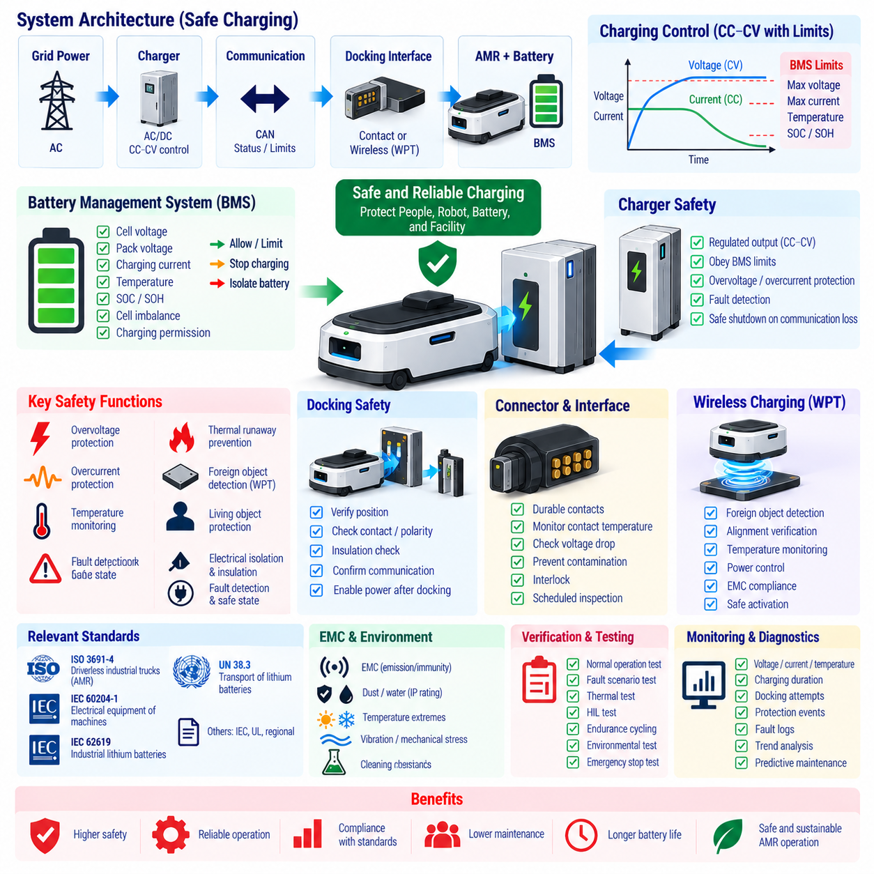
Charging safety for autonomous mobile robots (AMRs) must be treated as a system-level engineering function rather than a feature of the battery or charger alone. Safe charging depends on coordinated behavior among the lithium-ion cells, battery management system (BMS), charger, electrical distribution, docking interface, thermal design, communication network, mechanical structure, and supervisory robot controller.
The BMS provides the primary battery-level supervision during charging. It continuously monitors individual cell voltage, pack voltage, charging current, temperature, state of charge (SOC), and relevant diagnostic conditions. Charging is permitted only when these parameters remain within defined limits. If an abnormal condition develops, the BMS can request current reduction, prohibit charging, or electrically isolate the battery depending on the severity of the event.
Overvoltage protection is particularly important because lithium-ion cells must remain below their specified upper voltage limit. The BMS evaluates individual cells rather than relying only on total pack voltage, since one weak or imbalanced cell may reach its maximum voltage before the rest of the pack. Charging current must be reduced or terminated before the limiting cell enters an unsafe region, even when the overall pack voltage still appears acceptable.
Overcurrent protection addresses excessive charging current caused by charger faults, incorrect commands, short circuits, control failures, or abnormal electrical connections. Software current limits can regulate normal operation, while independent hardware protection provides additional fault containment. Fuses, contactors, current sensors, protection circuits, and charger-side limits may be combined so that a single control failure does not result in uncontrolled battery current.
Temperature supervision is required throughout the charging process because lithium-ion charge acceptance varies strongly with temperature. Charging at excessively low temperature can increase lithium-plating risk, while charging at excessive temperature accelerates degradation and can reduce safety margins. Multiple temperature sensors may be distributed across cells, modules, contactors, charging connectors, and power electronics to detect both battery and interface-related thermal abnormalities.
Thermal runaway prevention requires more than detecting high average battery temperature. Localized cell defects, internal shorts, mechanical damage, manufacturing defects, or severe electrical abuse can initiate rapid self-heating. Battery design should combine cell-level protection, thermal propagation resistance, temperature monitoring, fault isolation, enclosure design, ventilation or pressure management, and emergency response measures appropriate to the battery chemistry and stored energy.
The charger must regulate its output within the voltage and current envelope permitted by the BMS. For lithium-ion systems, charging typically follows a Constant Current–Constant Voltage (CC–CV) profile, but the nominal profile is modified whenever temperature, SOC, cell imbalance, state of health (SOH), or charger conditions require derating. Charging control should therefore be based on real-time permissible limits rather than assuming a permanently fixed charging curve.
Communication between the BMS and charger is an important part of the safety architecture in intelligent charging systems. Interfaces such as CAN can exchange requested voltage, allowable current, charging status, battery conditions, and fault information. Communication loss, corrupted data, implausible commands, timeout conditions, or inconsistent states should place the charging system into a predefined safe state rather than allowing uncontrolled continuation of power transfer.
Automatic docking introduces additional hazards because electrical connection is established without direct human confirmation. The system should verify docking position, contact engagement, polarity, insulation condition, battery status, and communication before enabling significant charging power. High-current contacts should preferably remain de-energized until successful docking is confirmed, reducing electrical arcing, accidental contact, and damage caused by incomplete mechanical engagement.
Charging connectors and conductive docking contacts must withstand repeated mechanical cycles, contamination, oxidation, vibration, and alignment errors. Increased contact resistance can create localized heating even when battery current remains within its normal range. Contact temperature sensing, voltage-drop monitoring, current plausibility checks, protective covers, interlocks, and scheduled inspection can provide additional protection against interface degradation and progressive thermal damage.
Wireless Power Transfer (WPT) removes exposed charging contacts but introduces different safety considerations. Foreign Object Detection (FOD), temperature monitoring, alignment verification, power control, electromagnetic compatibility (EMC), and appropriate protection against unintended exposure become important. The transmitter should not deliver substantial power unless a valid receiver and acceptable operating conditions have been confirmed through controlled detection and communication.
Electrical isolation and insulation are important wherever charging equipment interfaces with higher-voltage power sources. Insulation monitoring, dielectric design, protective earth, isolation barriers, creepage and clearance distances, enclosure protection, and appropriate fault-disconnection mechanisms help prevent electric shock and unintended current paths. Requirements depend on system voltage, charger topology, installation environment, and applicable regional regulations.
Functional safety principles can improve charging-system robustness by considering how faults are detected, controlled, and transitioned to safe states. Safety-related functions should define their triggering conditions, diagnostic coverage, response time, fallback behavior, and independence where required. Examples include terminating charging after overvoltage detection, disabling power after communication loss, and preventing robot motion while an energized charging connection remains engaged.
Charging safety must also account for interactions with robot motion. An AMR should not normally drive away while substantial charging current is flowing through conductive contacts. Interlocks can prevent propulsion until charging has stopped and the electrical interface has been safely de-energized. Conversely, charging should not begin until the robot is mechanically stable at the intended charging position. These state transitions should be explicitly managed by the control architecture.
Applicable standards depend on robot type, battery configuration, charger design, installation region, and intended market. ISO 3691-4 addresses safety requirements for driverless industrial trucks and their systems, including mobile robot applications. IEC 60204-1 provides widely used requirements for electrical equipment of machines, while relevant battery and industrial standards may additionally govern cell safety, battery assemblies, charging equipment, EMC, and environmental protection.
For lithium-ion industrial battery systems, standards such as IEC 62619 provide requirements and tests related to the safety of secondary lithium cells and batteries used in industrial applications. Depending on product architecture and certification strategy, other IEC, ISO, UL, UN, or regional requirements may also apply. Standards should therefore be selected through a formal applicability analysis rather than assuming that one battery standard covers the complete AMR charging system.
Transport compliance is separate from normal operational charging safety. Lithium batteries transported commercially are commonly subject to the UN Manual of Tests and Criteria, including UN 38.3 testing requirements. Passing transportation tests does not demonstrate that an AMR charging system is safe for everyday operation, just as compliance with an operational robot standard does not automatically establish compliance with battery transportation regulations.
EMC compliance must be evaluated because chargers, DC/DC converters, switching power electronics, WPT systems, communication networks, and robot electronics can generate or receive electromagnetic disturbances. Conducted and radiated emissions, immunity, electrostatic discharge, electrical transients, grounding, and cable routing should be validated at the integrated-system level. Charging must not compromise navigation, safety sensing, BMS measurements, or communication reliability.
Environmental protection is also part of charging safety. Charging equipment may encounter dust, moisture, cleaning fluids, condensation, conductive debris, temperature extremes, or outdoor exposure depending on the application. Enclosure design, ingress protection, corrosion resistance, drainage, connector protection, and environmental qualification should reflect the actual installation environment rather than relying only on laboratory charging conditions.
Verification should include both normal operation and credible fault scenarios. Testing can cover overvoltage, overcurrent, sensor failure, communication loss, excessive temperature, charger malfunction, contact resistance, incorrect docking, insulation faults, foreign objects, power interruption, emergency stop, and recovery behavior. Hardware-in-the-loop testing, environmental testing, endurance cycling, and controlled fault injection can complement conventional functional tests.
Charging-related events should be logged for diagnostics and lifecycle management. Useful information includes maximum cell voltage, minimum and maximum temperature, charging current, charging duration, contact temperature, charger identity, docking attempts, protection activations, communication faults, and termination reasons. Trend analysis can identify deterioration before a failure becomes critical and can support preventive maintenance across a large AMR fleet.
A structured safety process should connect hazard analysis, requirements, architecture, implementation, verification, validation, and field monitoring. Safety mechanisms are most effective when their assumptions and responsibilities are clearly allocated among the battery, BMS, charger, docking station, robot controller, and fleet system. Traceability from identified charging hazards to implemented controls and verification evidence supports both engineering quality and certification activities.
Charging safety and standards ultimately provide the framework for delivering energy without creating unacceptable electrical, thermal, mechanical, electromagnetic, or operational risk. Compliance should not be treated as a final certification exercise after design completion. By incorporating protection mechanisms, applicable standards, fault handling, verification, and lifecycle monitoring from the beginning, an AMR charging system can achieve reliable operation while protecting people, equipment, batteries, and the surrounding facility.

