Volume 11. Battery and Powertrain

Chapter 07. Inverter Design

07.01. 3-Phase Inverter Topology
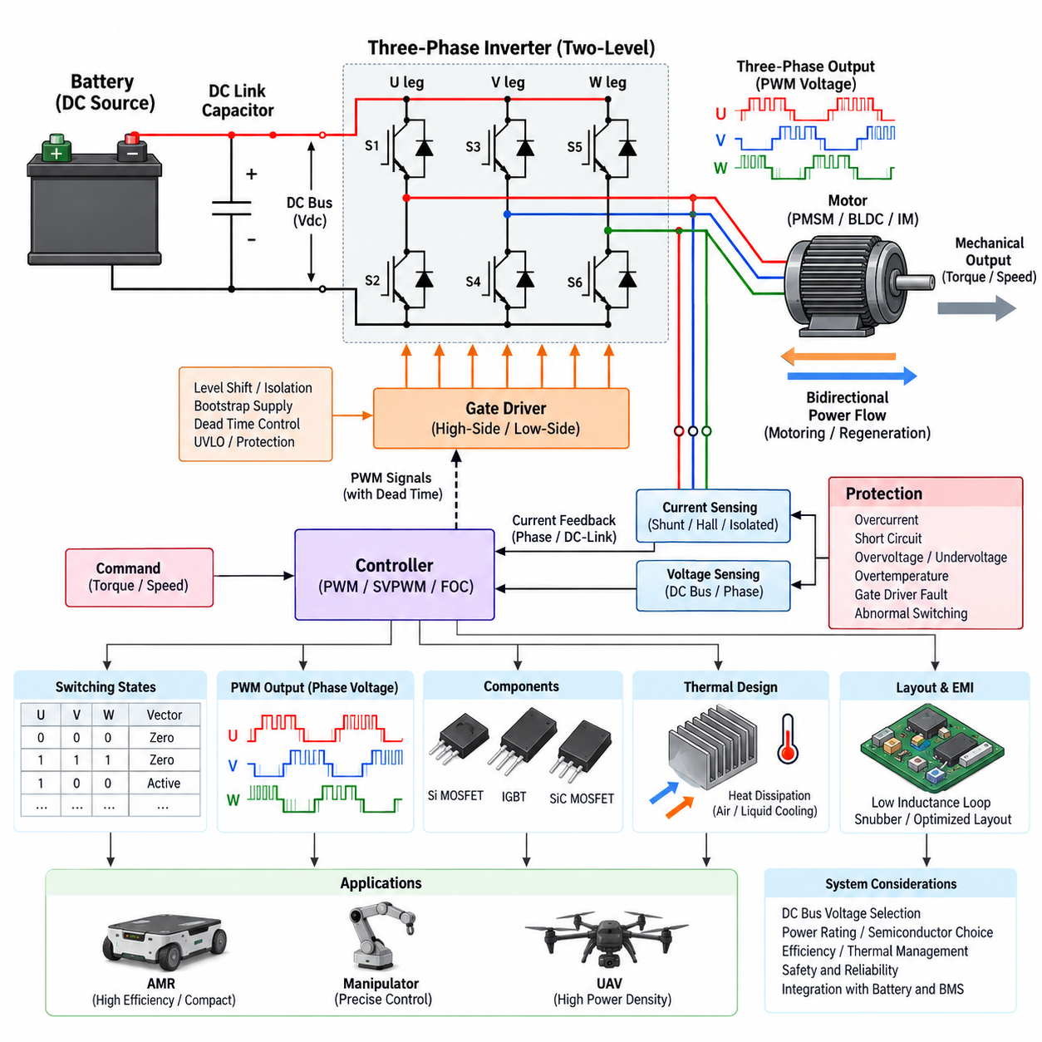
A three-phase inverter is the core power-electronic interface that converts a DC energy source into controlled three-phase AC power for an electric motor. In robotic powertrains, the DC source is typically a battery or regulated DC bus, while the load is commonly a permanent-magnet synchronous motor (PMSM), brushless DC motor (BLDC), or induction motor. The inverter determines the instantaneous phase voltages and currents required to generate motor torque, speed, and direction.
The conventional topology is a two-level, three-phase voltage-source inverter composed of three switching legs. Each leg contains an upper and lower semiconductor switch connected between the positive and negative DC rails, with the midpoint forming one motor phase output. The three midpoints are connected to phases U, V, and W. Six controlled switching devices therefore form the basic bridge, allowing each phase terminal to be dynamically connected toward either side of the DC link.
Each inverter leg must be controlled so that its upper and lower switches are never intentionally turned on simultaneously. Such simultaneous conduction creates a low-impedance path directly across the DC bus, producing shoot-through current that can destroy semiconductor devices within microseconds. Gate-driver logic therefore introduces dead time between complementary switching transitions. Dead time improves switching safety but also distorts the commanded phase voltage, so precision motor drives often compensate for its electrical effects.
Power semiconductor selection strongly influences inverter efficiency, switching frequency, thermal performance, voltage capability, and cost. Silicon MOSFETs are widely used in low- and medium-voltage robotic systems because of their low conduction resistance and fast switching characteristics. IGBTs remain useful at higher voltages and powers, while silicon-carbide MOSFETs provide lower switching losses and higher temperature capability for demanding systems. Device voltage and current margins must accommodate transients as well as nominal operation.
Each switching device normally includes an intrinsic or parallel freewheeling path that permits motor current to continue flowing when the commanded semiconductor turns off. This function is essential because motor windings are inductive and their current cannot change instantaneously. Depending on switching state, current direction, and motor operating condition, energy circulates through transistors and diodes or returns toward the DC link. These bidirectional current paths also form the electrical foundation for regenerative operation.
A DC-link capacitor is placed close to the inverter bridge to stabilize the local DC bus and supply high-frequency switching current. The battery and upstream wiring cannot efficiently provide every rapid current pulse demanded by PWM operation because cable inductance and source impedance cause voltage variation. The capacitor reduces DC-bus ripple and switching-loop impedance while absorbing transient energy. Its capacitance, ripple-current rating, equivalent series resistance, temperature rating, and physical placement are therefore critical design parameters.
Three-phase output voltage is synthesized by rapidly switching the six semiconductor devices rather than generating sinusoidal voltages directly. Pulse-width modulation controls the average voltage applied to each motor phase during every switching interval. The resulting phase voltage contains switching-frequency components, but motor winding inductance filters much of this high-frequency content so that phase currents can approximate the desired waveforms. More advanced modulation and current-control methods are developed from this fundamental switching structure.
The bridge has eight possible switching combinations when each of the three legs is represented by one binary switching state. Six combinations produce active voltage vectors that apply nonzero line-to-line voltage to the motor, while two combinations produce zero vectors. By controlling the sequence and duration of these states, the inverter can synthesize a rotating voltage vector. This switching-state interpretation provides the fundamental hardware basis for space-vector pulse-width modulation and field-oriented motor control.
Motor operation is inherently bidirectional in energy terms. During motoring, electrical energy flows from the DC source through the inverter into the motor and becomes mechanical output. During deceleration, descending loads, or externally driven motion, the motor can behave as a generator. The inverter then provides controlled paths for electrical energy to return to the DC link. Battery acceptance limits, DC-bus overvoltage protection, and regenerative braking strategy must therefore be coordinated with inverter operation.
Current sensing is a fundamental part of practical inverter topology because closed-loop torque control depends on accurate phase-current information. Current can be measured using shunt resistors, Hall-effect sensors, magnetic sensors, or isolated current transducers. Designs may employ three phase sensors, two phase sensors with mathematical reconstruction, or DC-link sensing. Sensor topology affects cost, bandwidth, measurement accuracy, common-mode immunity, fault detection capability, and the control algorithm's ability to reconstruct currents during particular switching states.
The gate-driver stage provides the electrical interface between the controller and power switches. High-side devices require level-shifted or isolated drive circuitry because their source or emitter potential moves with the switching node. Bootstrap supplies are common in compact low-voltage designs, while isolated bias supplies are preferred where operating range or safety requirements demand greater independence. Gate resistance, drive voltage, propagation delay, isolation, Miller immunity, and undervoltage lockout directly influence reliable switching behavior.
Parasitic inductance in the commutation loop can generate substantial voltage overshoot whenever high current switches rapidly. Consequently, inverter topology cannot be treated only as a schematic arrangement; physical implementation is part of the electrical design. The DC-link capacitor, semiconductor bridge, busbars, and return paths should form compact low-inductance loops. Snubbers, optimized gate resistance, laminated bus structures, and controlled switching slew rates may be required to limit ringing, electromagnetic interference, and semiconductor voltage stress.
Protection functions are integrated around the three-phase bridge because power-stage faults can develop much faster than supervisory software can react. Typical protection mechanisms monitor overcurrent, short circuit, DC-bus overvoltage and undervoltage, semiconductor temperature, gate-driver supply status, and abnormal switching behavior. Hardware-level shutdown is commonly used for severe faults, while the motor controller manages slower diagnostic responses. Safe inverter design therefore combines semiconductor capability, sensing, gate-driver protection, and coordinated control.
Thermal design is closely coupled to topology because conduction and switching losses are concentrated in the six power devices. Conduction loss depends primarily on phase current and device characteristics, while switching loss depends on bus voltage, current, switching frequency, gate behavior, and transition time. Loss distribution varies with modulation and operating point. Heat spreading, thermal-interface materials, heat sinks, airflow, liquid cooling, and temperature sensing must keep junction temperatures within reliable limits under continuous and transient loads.
In battery-powered robots, inverter voltage class should be selected together with motor winding design, battery voltage, cable current, protection devices, and required mechanical power. A lower-voltage architecture simplifies insulation and personnel protection but requires higher current for a given power level. Higher DC-bus voltage reduces current and conductor losses but increases semiconductor voltage requirements, insulation demands, switching stress, and safety complexity. The inverter is therefore a system-level powertrain design choice rather than an isolated component.
For AMRs and other mobile robots, compactness, efficiency, low-speed torque quality, acoustic behavior, EMC, and fault tolerance are often as important as peak power. Repeated acceleration, braking, turning, and low-speed operation create operating profiles different from steady industrial drives. UAV propulsion introduces still stronger requirements for power density, mass, thermal performance, and fault consequences. The same fundamental six-switch three-phase bridge can support these platforms, but semiconductor technology, cooling, packaging, sensing, and protection must be optimized for the mission.
The three-phase inverter topology ultimately establishes the hardware foundation upon which modulation and motor-control algorithms operate. The DC link provides energy, the six-switch bridge creates controllable voltage vectors, gate drivers execute switching commands, current and voltage sensors provide feedback, and protection circuits constrain unsafe operation. Space-vector PWM, field-oriented control, thermal management, and platform-specific inverter design can therefore be understood as progressively higher layers built upon this basic three-phase power-conversion architecture.

07.02. SVPWM Algorithm
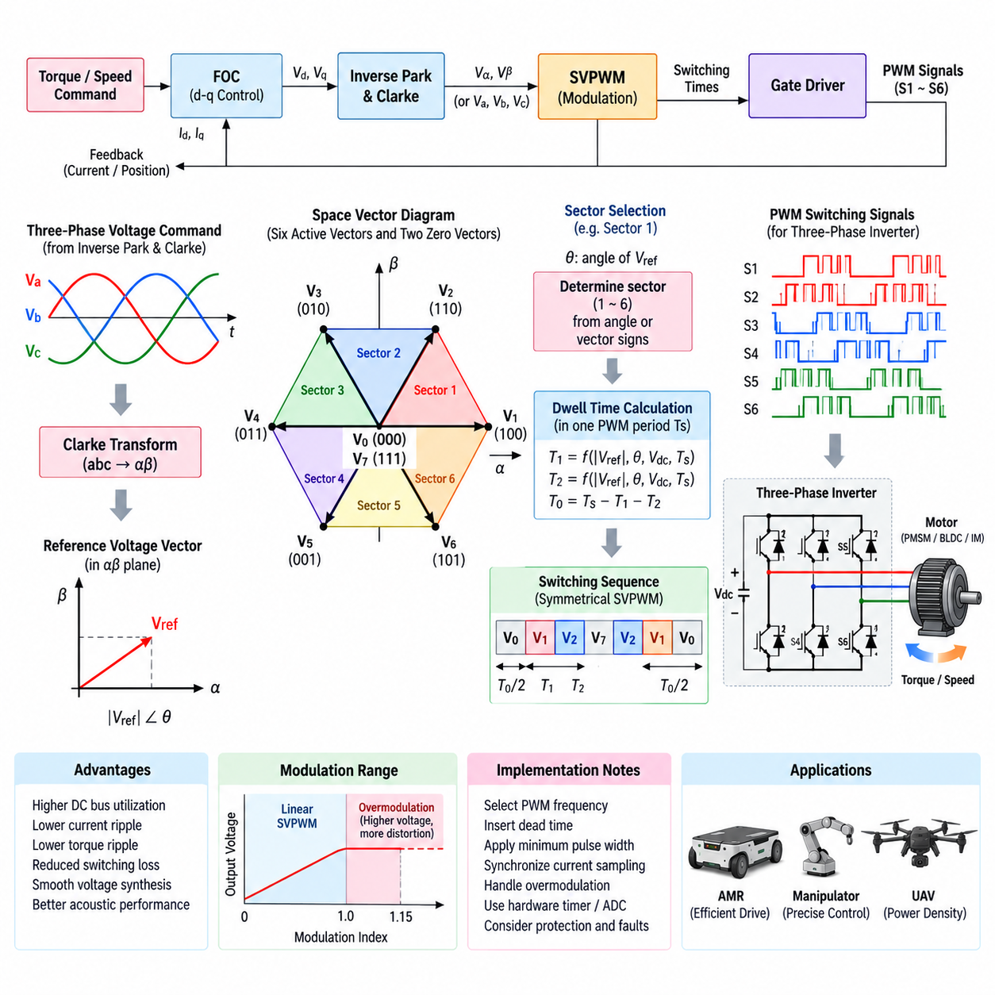
Space Vector Pulse Width Modulation (SVPWM) is a digital modulation technique used to control the switching states of a three-phase voltage-source inverter. Instead of treating the three motor phases as independent sinusoidal signals, SVPWM represents the inverter output as a single rotating voltage vector in a two-dimensional plane. This representation provides a systematic method for converting a commanded motor voltage into precise switching times for the six semiconductor devices.
In a conventional two-level three-phase inverter, each of the three switching legs can connect its phase output toward either the positive or negative DC rail. The resulting binary switching combinations create eight possible inverter states. Six states generate nonzero line-to-line voltages and are called active voltage vectors, while two states produce zero voltage vectors. SVPWM organizes these vectors geometrically so that the desired reference voltage can be synthesized from neighboring switching states.
The six active voltage vectors are separated by 60 electrical degrees and form a hexagonal structure in the stationary reference plane. This hexagon is divided into six sectors, with each sector bounded by two adjacent active vectors. The commanded reference vector rotates through these sectors according to the desired motor electrical frequency. At every PWM period, the algorithm determines which sector contains the reference vector and calculates how long the adjacent vectors must remain active.
SVPWM commonly begins with the desired three-phase voltage command generated by a higher-level motor-control algorithm. The phase quantities can be transformed into stationary orthogonal α and β components using a Clarke transformation. These two components define the magnitude and angular position of the reference voltage vector. Sector identification can then be performed from the vector angle, component signs, or equivalent computational logic optimized for real-time implementation.
Once the active sector is known, the reference vector is approximated during one switching period by applying the two adjacent active vectors for calculated durations. These durations are commonly represented as T1 and T2. The remaining portion of the switching period is assigned to the zero vectors and represented by T0. Ideally, T1 + T2 + T0 equals the complete PWM period, ensuring that the time-averaged inverter voltage corresponds to the requested reference vector.
The calculation of T1 and T2 depends on the reference-vector magnitude, its angular position within the current sector, the DC-link voltage, and the PWM period. As the vector approaches one boundary of a sector, the dwell time associated with the neighboring vector changes smoothly. When the reference passes into the next sector, the algorithm changes the active-vector pair while maintaining continuous voltage synthesis. This behavior enables smooth generation of rotating three-phase excitation.
Zero-vector time is important because it allows the requested average voltage to be synthesized while providing flexibility in the switching sequence. The two zero states correspond to all upper or all lower switching states being simultaneously selected according to the inverter's switching convention. In symmetrical SVPWM, the available zero-vector duration is usually distributed around the active-vector intervals. This produces a centered switching waveform and helps achieve consistent switching behavior over successive PWM cycles.
A typical symmetrical switching sequence progresses from a zero vector to the first active vector, then to the second active vector, and finally to the opposite zero vector before reversing the sequence. This ordering minimizes unnecessary switching transitions because only selected inverter legs change state between adjacent vectors. Reduced transition count lowers switching losses and simplifies waveform symmetry while maintaining the required average voltage vector during each modulation period.
One major advantage of SVPWM is improved utilization of the available DC-link voltage compared with conventional sinusoidal PWM. By coordinating all three inverter legs as a unified vector system, SVPWM can produce a larger fundamental output voltage before reaching the linear modulation boundary. This is especially useful in battery-powered robots because improved DC-bus utilization can extend the usable motor speed range without increasing battery voltage or changing the inverter hardware.
SVPWM is closely associated with field-oriented control (FOC), although the two perform different functions. FOC determines the voltage commands needed to regulate motor flux and torque, typically in a rotating d-q reference frame. These commands are transformed into stationary voltage components and passed to the modulation stage. SVPWM then converts the requested voltage vector into practical gate-switching commands. FOC therefore determines what voltage is required, while SVPWM determines how the inverter produces it.
The PWM switching frequency must be selected by balancing several competing requirements. A higher switching frequency generally improves current waveform quality, reduces low-frequency torque ripple, and can move audible components outside sensitive frequency ranges. However, every switching transition dissipates energy in the semiconductor devices. Increasing switching frequency therefore raises inverter switching losses and thermal load, requiring coordination among motor inductance, semiconductor technology, acoustic requirements, control bandwidth, and cooling capability.
Dead time must be inserted between complementary high-side and low-side switching commands to prevent shoot-through in each inverter leg. Although necessary for hardware protection, dead time changes the effective phase voltage and creates nonlinear distortion whose polarity depends partly on phase-current direction. At low motor speed, the resulting error can become significant relative to the commanded voltage. High-performance drives may therefore incorporate dead-time compensation using measured or estimated phase-current polarity.
SVPWM implementation must also consider minimum pulse width. Semiconductor switches and gate drivers require finite time to turn on and off reliably, and current-sensing circuits may need stable intervals for valid measurements. Extremely short calculated dwell times can therefore be physically impractical. Real motor controllers apply minimum pulse constraints, sampling-window management, or modified switching sequences so that theoretical voltage commands remain compatible with actual semiconductor, driver, sensing, and timing limitations.
Current measurement is often synchronized with the PWM sequence because switching transitions introduce electrical noise and some inverter states provide better sensing conditions than others. The controller may trigger analog-to-digital conversion at carefully selected points within the PWM cycle where phase currents are sufficiently stable. In systems using one or two current sensors rather than three independent phase sensors, the modulation sequence may also influence whether missing phase currents can be reconstructed accurately.
The transition from linear modulation toward overmodulation occurs when the requested voltage vector becomes too large to be synthesized using the available active and zero-vector times within one PWM period. As modulation depth increases, zero-vector duration decreases toward zero. Beyond the linear region, the controller must limit the reference or deliberately enter an overmodulation strategy. Such operation can increase available fundamental voltage but introduces greater waveform distortion and requires careful control of current and torque behavior.
Digital implementation requires precise timing because SVPWM normally executes at every PWM update period. The motor-control processor calculates voltage commands, identifies the sector, determines vector dwell times, applies timing constraints, and updates hardware timer compare registers before the next switching cycle. Modern microcontrollers, digital signal processors, and motor-control SoCs commonly provide complementary PWM generators, programmable dead time, synchronized ADC triggers, fault inputs, and timer hardware specifically designed to support this real-time process.
For AMRs, mobile manipulators, and other battery-powered robots, SVPWM contributes to efficient use of limited DC-bus voltage while supporting smooth torque production over a wide operating range. Low-speed maneuvering benefits from accurate current regulation and reduced torque ripple, while higher-speed operation benefits from improved voltage utilization. In UAV propulsion, efficient modulation can similarly contribute to power density and motor performance, although switching losses, electromagnetic interference, thermal limits, and fault response remain critical constraints.
SVPWM should therefore be understood as the modulation bridge between continuous motor-control commands and the discrete switching states available in a three-phase inverter. The reference voltage vector is located within one of six sectors, decomposed into adjacent active vectors and zero vectors, and translated into carefully timed semiconductor switching commands. Together with current sensing, dead-time management, protection, and FOC, this process enables efficient and precise control of three-phase motors used throughout robotic powertrains.

07.03. FOC (Field Oriented Control)
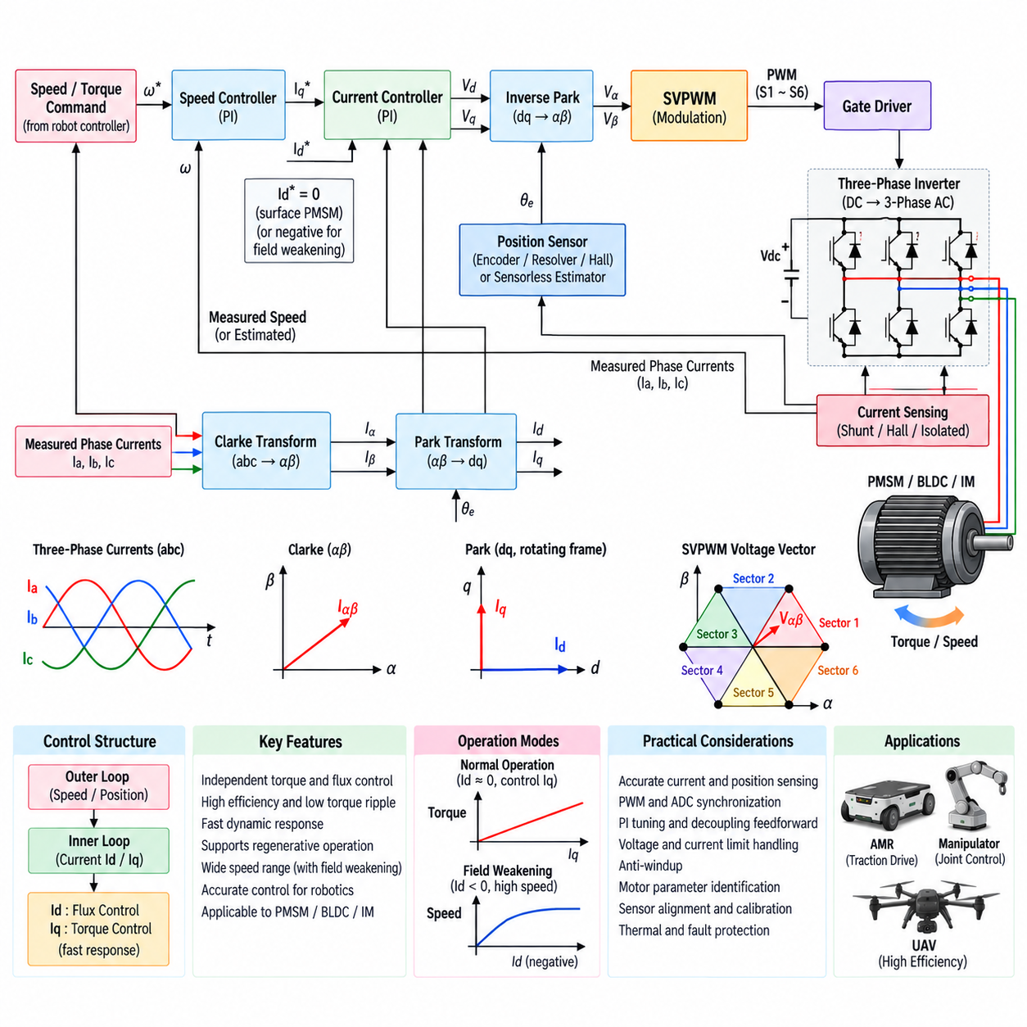
Field-Oriented Control (FOC), also called vector control, is a high-performance motor-control method that regulates torque and magnetic flux as approximately independent quantities. It is widely applied to permanent-magnet synchronous motors (PMSM), brushless motors, and AC drives used in robotic powertrains. Instead of directly controlling three rapidly varying phase currents, FOC transforms them into a rotating coordinate system aligned with the motor magnetic field.
The fundamental objective of FOC is to make an AC motor behave from the controller's perspective like a separately controlled DC motor. Three-phase stator currents create a rotating magnetic field whose relationship to the rotor determines electromagnetic torque. FOC mathematically decomposes this current vector into a direct-axis component, Id, associated primarily with magnetic flux, and a quadrature-axis component, Iq, associated primarily with torque production.
FOC begins with accurate knowledge of the motor phase currents and rotor electrical position. Phase currents are normally measured using shunt resistors, Hall-effect sensors, or isolated current sensors integrated with the inverter. Rotor position may be obtained from an encoder, resolver, Hall sensors, or a sensorless estimator. Precise synchronization between current sampling, rotor position acquisition, PWM generation, and control computation is essential for stable high-bandwidth operation.
The measured three-phase currents Ia, Ib, and Ic are first converted from the three-phase stationary system into two orthogonal stationary components using the Clarke transformation. These components are conventionally designated Iα and Iβ. Because the three balanced phase currents contain redundant information, this transformation provides a compact two-dimensional representation of the stator current vector without losing the information required for electromagnetic control.
The Park transformation then rotates the stationary α-β current vector into the d-q coordinate system using the measured or estimated rotor electrical angle. In this rotating frame, sinusoidally varying phase currents become approximately constant quantities during steady operating conditions. This is one of the key advantages of FOC because conventional proportional-integral controllers can regulate Id and Iq efficiently without directly tracking rapidly varying sinusoidal waveforms.
For a surface-mounted PMSM, the d-axis is typically aligned with the rotor permanent-magnet flux. Under normal operation, the controller may command Id close to zero while regulating Iq according to the requested torque. This produces torque efficiently without intentionally increasing the magnetic flux. Motor types with significant saliency, such as interior permanent-magnet machines, may use nonzero Id to exploit reluctance torque and improve efficiency through more advanced operating strategies.
The torque command normally originates from a higher-level speed, velocity, traction, or motion controller. A speed controller compares commanded speed with measured motor speed and generates an Iq reference representing the torque-producing current required to reduce the error. The current-control loop operates much faster than the outer speed loop, allowing motor torque to respond rapidly while the mechanical system changes on a slower timescale.
Independent current controllers compare the measured Id and Iq values with their corresponding references. The resulting errors are processed, commonly by proportional-integral controllers, to calculate commanded d-axis and q-axis voltages Vd and Vq. Controller gains must account for motor resistance, inductance, control-loop frequency, inverter delay, and desired bandwidth. Poor tuning can cause sluggish torque response, current oscillation, excessive overshoot, or instability.
Motor cross-coupling must also be considered because the d-axis and q-axis electrical dynamics are not perfectly independent in the physical machine. Rotor speed produces back electromotive force and coupling terms that influence the required axis voltages. Practical FOC implementations often add feedforward decoupling terms based on electrical speed, motor inductances, current, and permanent-magnet flux. This improves dynamic response and allows the PI regulators to operate on a more nearly decoupled system.
After Vd and Vq have been calculated, the inverse Park transformation rotates the commanded voltage vector back into the stationary α-β reference frame. The resulting Vα and Vβ values represent the stator voltage vector that the inverter must generate. These continuous voltage commands cannot be applied directly by the semiconductor bridge, so they are transferred to a modulation algorithm such as Space Vector Pulse Width Modulation (SVPWM).
SVPWM converts the requested α-β voltage vector into switching times for the six semiconductor devices of the three-phase inverter. The modulation stage identifies the relevant space-vector sector, calculates active-vector and zero-vector dwell times, and generates complementary PWM signals with appropriate dead time. FOC and SVPWM therefore form complementary layers: FOC determines the electromagnetic voltage requirement, while SVPWM translates that requirement into realizable inverter switching actions.
The complete FOC signal path forms a closed control loop. Motor currents are measured, transformed into the d-q frame, compared with reference currents, converted into voltage commands, transformed back to the stationary frame, modulated into inverter switching signals, and applied to the motor. The resulting electromagnetic behavior changes the measured currents and rotor motion, closing the loop. This process repeats at high frequency, commonly thousands or tens of thousands of times per second.
Current-loop performance depends strongly on PWM and ADC synchronization. Measurements taken close to switching transitions may contain substantial noise caused by semiconductor commutation, parasitic capacitance, ground movement, and electromagnetic interference. Motor controllers therefore trigger current sampling at carefully selected positions within the PWM period. The sampling strategy must also accommodate minimum pulse widths and current-reconstruction limitations associated with the selected inverter sensing topology.
FOC must operate within physical voltage and current limits. When the requested Vd and Vq vector exceeds the voltage available from the DC bus, the controller must limit or rescale the voltage command before modulation. Similarly, current references must respect semiconductor, motor, battery, connector, and thermal limits. Saturation management and PI anti-windup are important because uncontrolled integrator accumulation during voltage limitation can degrade transient response after the system leaves saturation.
At higher motor speeds, the back electromotive force can approach the maximum voltage that the inverter can generate from the available DC bus. Field-weakening control extends the operating speed range by commanding negative d-axis current to reduce the effective air-gap flux and therefore the required stator voltage. This allows operation beyond the normal base-speed region, although available torque decreases and additional current produces greater electrical and thermal loading.
FOC also supports regenerative operation naturally because commanded Iq can change sign. During positive torque operation, electrical power normally flows from the battery through the inverter to the motor. During regenerative braking, the electromagnetic torque opposes mechanical motion and energy can flow from the motor through the inverter toward the DC link. Battery charging limits, DC-bus voltage, BMS restrictions, and mechanical braking requirements must therefore be coordinated with the torque controller.
Accurate motor parameters improve FOC performance. Stator resistance, d-axis and q-axis inductance, permanent-magnet flux linkage, pole-pair count, rotor inertia, and sensor alignment affect control calculations and tuning. These parameters can vary with temperature, magnetic saturation, manufacturing tolerance, and operating condition. Advanced drives may use parameter identification, adaptive estimation, lookup tables, or online compensation to preserve torque accuracy and dynamic performance across the operating envelope.
Rotor-angle accuracy is particularly important because an angular error rotates the assumed d-q frame away from the actual rotor flux. The commanded flux-producing and torque-producing components then become incorrectly coupled, reducing torque efficiency and potentially increasing current. Encoder offset calibration, electrical-zero alignment, sensor latency compensation, and reliable sensorless estimation are therefore important parts of practical FOC commissioning and motor-drive calibration.
In AMRs and mobile manipulators, FOC provides smooth low-speed motion, accurate torque regulation, efficient acceleration, controlled regenerative braking, and reduced torque ripple. These characteristics are valuable for traction wheels, steering actuators, joints, and precision manipulators. UAV propulsion similarly benefits from rapid torque response and high efficiency, although high rotational speed, power density, thermal constraints, sensorless operation, and fault response place additional demands on the control implementation.
FOC can ultimately be understood as the control layer that connects robot-level torque and speed commands to the electromagnetic behavior of a three-phase motor. Clarke and Park transformations establish a convenient rotating coordinate system, d-q current regulators independently manage flux and torque, inverse transformations recover the required stator voltage vector, and SVPWM converts that vector into inverter switching commands. Together, these functions form the core of modern high-performance robotic motor drives.

07.04. Inverter Thermal Management
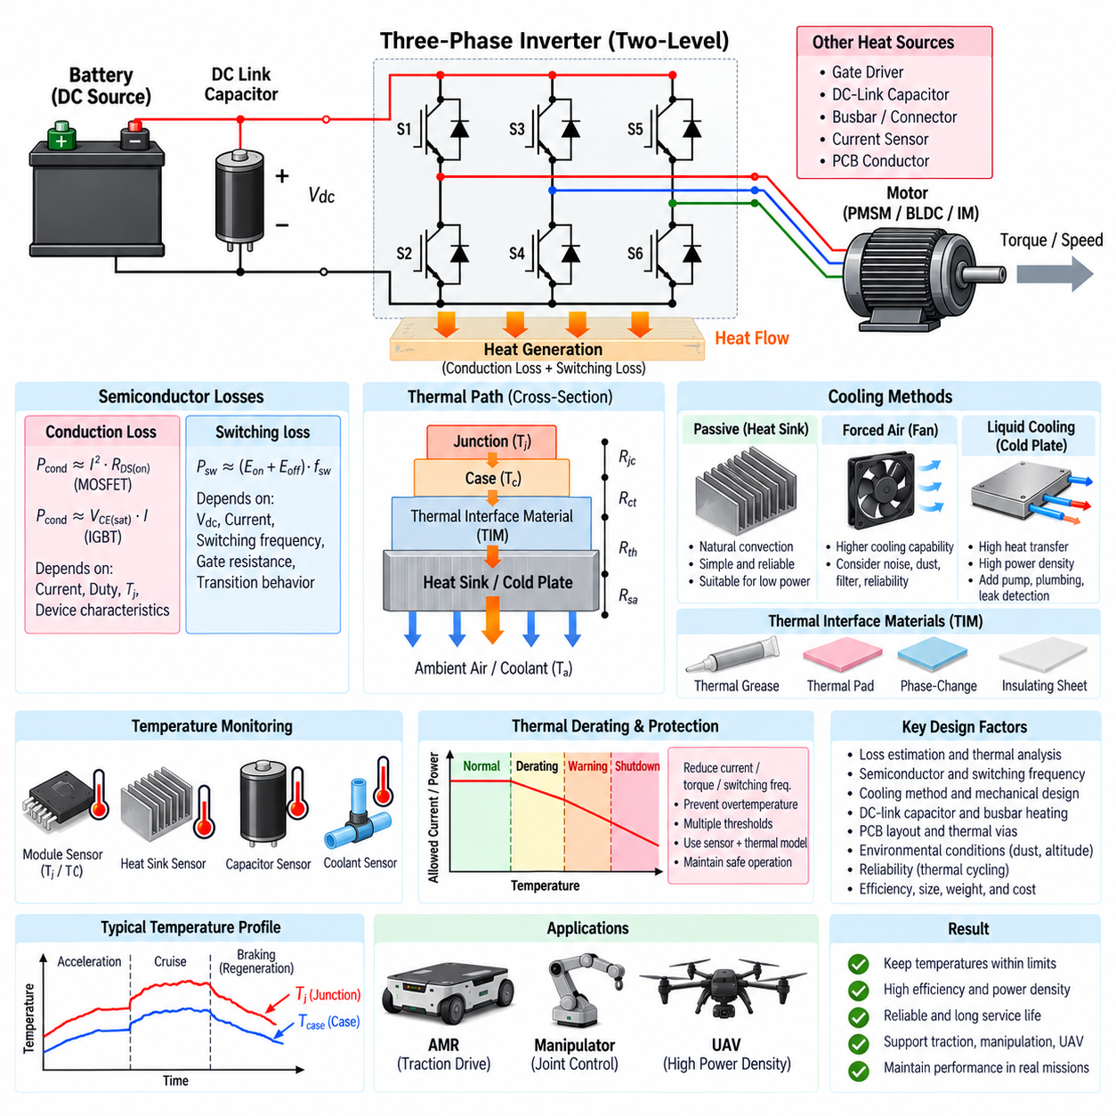
Thermal management is a fundamental part of inverter design because every power-conversion process generates losses that ultimately become heat. In a three-phase inverter, the dominant heat sources are normally the six power semiconductor switches, although gate drivers, DC-link capacitors, busbars, current sensors, and PCB conductors also dissipate energy. Effective thermal design keeps component temperatures within safe operating limits while preserving efficiency, reliability, power density, and service life.
Semiconductor losses are generally divided into conduction losses and switching losses. Conduction loss occurs while a MOSFET, IGBT, or SiC device carries motor phase current and depends on current magnitude, duty cycle, junction temperature, and device characteristics. Switching loss occurs during turn-on and turn-off transitions when voltage and current temporarily coexist across the semiconductor. The total inverter heat load therefore varies strongly with torque, motor speed, DC-bus voltage, PWM frequency, and modulation strategy.
For MOSFET-based inverters, conduction loss is strongly influenced by drain-to-source on-resistance, commonly represented as RDS(on). Because this resistance normally increases with junction temperature, rising temperature can increase conduction loss and create additional heating. IGBT conduction behavior is more commonly characterized by collector-emitter saturation voltage. SiC MOSFETs can reduce switching losses significantly, particularly at higher bus voltages and switching frequencies, but their fast transitions introduce demanding packaging, gate-drive, and EMI considerations.
Switching losses depend on semiconductor switching energy, phase current, DC-link voltage, switching frequency, gate resistance, and actual voltage and current transition behavior. Increasing PWM frequency can improve current waveform quality, reduce torque ripple, and support higher control bandwidth, but it also increases the number of switching events per second. Thermal design must therefore be coordinated with modulation and control requirements rather than treating switching frequency as an independent software parameter.
The semiconductor junction temperature is the most important internal thermal quantity because excessive junction temperature accelerates degradation and may cause immediate device failure. Junction temperature cannot usually be measured directly during normal operation, so it is estimated from case or module temperature, dissipated power, and the thermal impedance between the semiconductor junction and its surroundings. Transient thermal impedance is particularly important when evaluating short acceleration, braking, stall, or overload events.
Heat generated at the semiconductor junction must pass through a sequence of thermal interfaces before reaching the surrounding environment. A simplified thermal path can be represented as junction-to-case, case-to-thermal-interface material, thermal-interface material to heat sink or cold plate, and finally heat sink to ambient air or coolant. Each section introduces thermal resistance, and the resulting temperature rise can be approximated from dissipated power multiplied by the effective thermal resistance along the heat-flow path.
Thermal-interface materials are used to reduce the contact resistance between semiconductor packages or power modules and cooling structures. Even apparently flat surfaces contain microscopic gaps that trap air and increase thermal resistance. Thermal grease, pads, phase-change materials, and electrically insulating thermal sheets can fill these gaps. Material selection must balance thermal conductivity, electrical isolation, thickness, mechanical compliance, assembly pressure, aging behavior, manufacturability, and serviceability.
Passive cooling may be sufficient for low-power inverter applications where losses are modest and adequate surface area is available. Heat sinks increase the effective area for transferring heat from semiconductor devices to the surrounding air through conduction and natural convection. Their effectiveness depends on fin geometry, orientation, enclosure temperature, airflow obstruction, mounting configuration, and thermal contact quality. Passive systems are mechanically simple and reliable but can become large when high continuous power must be dissipated.
Forced-air cooling improves heat transfer by moving air across the heat sink or inverter enclosure using fans or system airflow. It can provide significantly higher cooling capability than natural convection without the complexity of liquid cooling. However, fan reliability, dust accumulation, acoustic noise, filter maintenance, airflow blockage, and environmental sealing must be considered. Mobile robots operating in warehouses, outdoor environments, or industrial facilities may encounter contamination that progressively reduces cooling performance.
Liquid cooling is appropriate when inverter power density or continuous thermal load exceeds practical air-cooling capability. A cold plate can be placed directly beneath power modules or semiconductor mounting surfaces, creating a short thermal path from the heat source to the coolant. Coolant channels, flow rate, inlet temperature, pressure drop, pump capacity, sealing, corrosion compatibility, and leak detection become important system parameters. Liquid cooling provides high heat-transfer capability but adds mass, cost, plumbing, and failure modes.
The DC-link capacitor also requires thermal consideration because ripple current flowing through its equivalent series resistance generates internal heat. Capacitor lifetime can decrease rapidly as operating temperature rises, making capacitor temperature a major inverter reliability concern. Placement close to the semiconductor bridge reduces electrical loop inductance, but proximity to hot power devices can increase thermal exposure. Electrical optimization and thermal isolation must therefore be balanced when designing the DC-link assembly.
Busbars, connectors, PCB copper, terminals, and cable interfaces generate resistive losses proportional to current squared. These losses can become significant in low-voltage, high-current robotic powertrains where several hundred amperes may occur during acceleration or transient loading. Localized resistance at joints or connectors can create thermal hot spots even when average inverter temperature appears acceptable. Proper conductor sizing, contact resistance control, fastening torque, plating, and thermal inspection are therefore important.
Thermal sensors provide the feedback required for protection and temperature-dependent control. Sensors may be integrated into semiconductor modules or placed near MOSFETs, heat sinks, capacitors, inductors, connectors, and cooling-fluid paths. Because measured temperature may lag the actual semiconductor junction temperature, controllers often combine sensor measurements with thermal models. The resulting estimate can support faster protection and more accurate use of the available transient power capability.
Thermal derating reduces inverter output when temperature approaches a defined operating limit. Instead of waiting for an overtemperature shutdown, the controller can progressively reduce allowable phase current, torque, switching frequency, or power. This approach maintains operation at reduced performance while preventing thermal damage. Multiple thresholds may distinguish normal operation, warning, derating, and emergency shutdown, allowing the robot supervisory controller to respond appropriately to decreasing powertrain capability.
Worst-case thermal analysis must consider operating profiles rather than only rated motor power. An AMR may repeatedly accelerate a heavy payload, climb ramps, execute low-speed turns, stop, and regenerate energy during braking. Low motor speed can be especially demanding because high torque may require high phase current while vehicle airflow remains limited. Thermal validation should therefore reproduce realistic duty cycles, environmental temperatures, payload conditions, and repeated transient events.
Regenerative braking also influences inverter thermal behavior. During regeneration, current still flows through semiconductor switches and freewheeling paths, producing conduction and switching losses even though net energy flows from the motor toward the battery. If the battery cannot accept all regenerative energy, DC-bus voltage may rise and braking strategy may need modification. Thermal management, regenerative control, battery limits, and inverter protection must consequently operate as a coordinated powertrain system.
PCB layout and mechanical packaging strongly affect both thermal and electrical performance. Wide copper areas, thermal vias, copper planes, direct-bonded substrates, busbars, and heat spreaders can reduce local thermal resistance and distribute heat more uniformly. At the same time, high-current switching loops must remain short to control parasitic inductance and EMI. A successful inverter layout therefore jointly optimizes heat flow, electrical resistance, switching-loop geometry, insulation, and mechanical robustness.
Thermal cycling is an important reliability mechanism because inverter components repeatedly expand and contract as power changes. Differences in thermal expansion between semiconductor dies, solder layers, substrates, bond wires, copper structures, and enclosure materials create mechanical stress. Repeated junction-temperature swings can degrade solder joints, interconnections, and package interfaces. Reliability assessment must therefore consider not only maximum temperature but also temperature swing magnitude, cycling frequency, and accumulated operating life.
For AMRs and mobile manipulators, thermal management must balance continuous torque capability, enclosure size, environmental sealing, acoustic limits, energy consumption, and maintenance requirements. Compact fanless cooling can improve reliability in dusty environments, while higher-power traction or manipulator systems may require forced air or liquid cooling. Thermal design also affects battery runtime because energy consumed by fans, pumps, and inverter losses ultimately reduces the energy available for robotic operation.
UAV inverter thermal management imposes different constraints because mass and aerodynamic performance are critical. Large heat sinks or liquid-cooling hardware may be unacceptable, so designers rely heavily on high-efficiency semiconductors, optimized switching frequency, lightweight thermal spreading, and available propeller or flight airflow. The thermal system must also tolerate changing altitude, ambient temperature, flight speed, and mission power while maintaining sufficient fault margin for propulsion safety.
Inverter thermal management is therefore a system-level engineering discipline connecting semiconductor selection, PWM operation, mechanical packaging, cooling technology, sensing, protection, and robot mission profiles. Losses must first be understood and converted into realistic temperature predictions, then removed through controlled thermal paths. Temperature monitoring and derating close the operational loop, enabling the inverter to deliver required torque and power without exceeding the thermal limits that determine performance, reliability, and lifetime.

07.05. Inverter for AMR/UAV
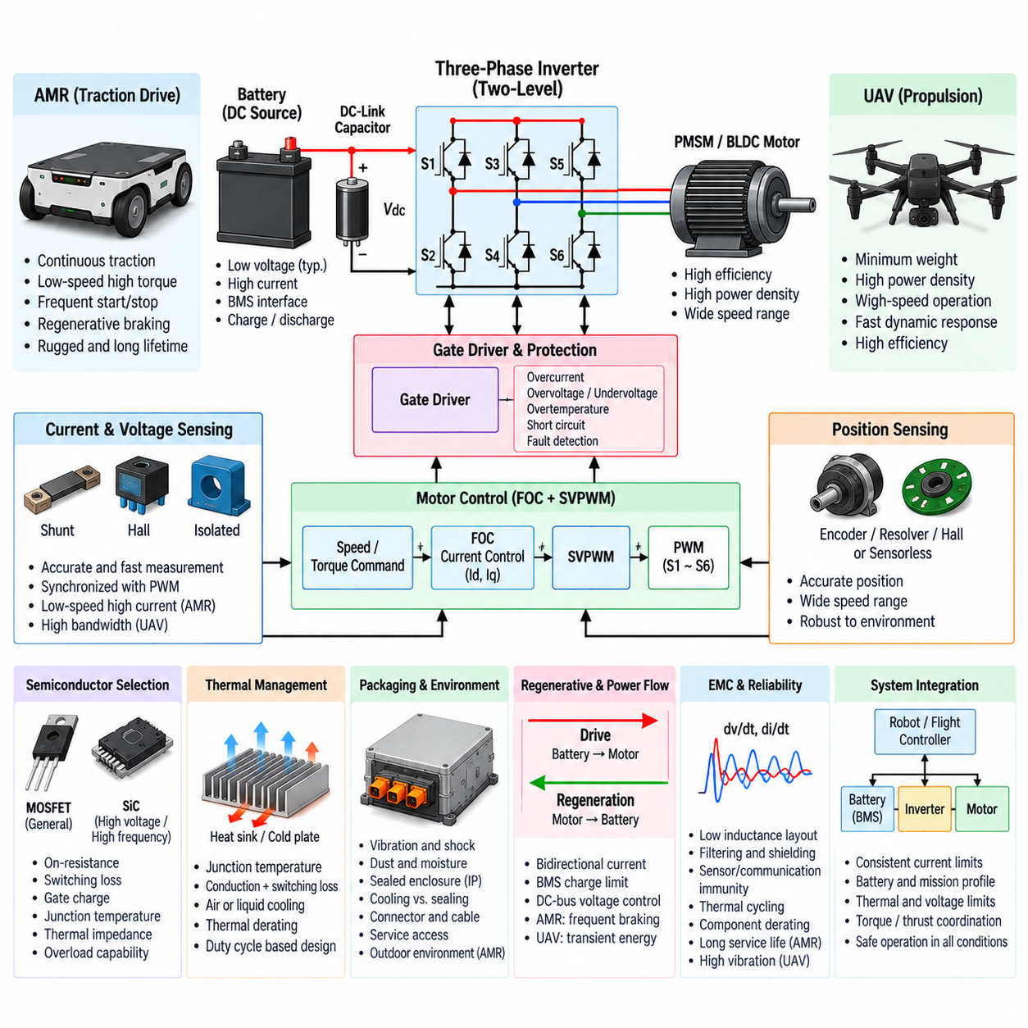
Inverters for autonomous mobile robots (AMRs) and unmanned aerial vehicles (UAVs) share the same fundamental purpose of converting battery DC power into controlled three-phase AC power for electric motors, but their design priorities differ substantially. AMRs emphasize continuous traction, low-speed torque, regenerative operation, ruggedness, and long service life, whereas UAV propulsion places stronger emphasis on minimum mass, exceptional power density, rapid dynamic response, and high efficiency.
The conventional two-level three-phase voltage-source inverter remains a practical foundation for both platforms. Six semiconductor switches arranged as three half-bridge legs generate controlled phase voltages for PMSM or BLDC motors. The topology is combined with a DC-link capacitor, gate drivers, current and voltage sensing, protection circuitry, and a real-time motor controller. SVPWM and field-oriented control can then regulate motor torque efficiently across the required operating envelope.
Battery voltage strongly influences inverter and powertrain architecture. AMRs commonly favor relatively low-voltage battery systems because they simplify insulation, service procedures, connectors, and personnel safety, but substantial traction power at low voltage requires high current. UAV systems may adopt higher bus voltages to reduce conductor current and cable mass for a given propulsion power. The voltage class must therefore be selected together with battery configuration, motor winding design, semiconductor rating, insulation, and protection requirements.
AMR traction produces a demanding combination of high starting torque, repeated acceleration, low-speed operation, turning, ramp climbing, braking, and occasional stall-like loading. These conditions can produce large phase currents even when average vehicle speed is low. The inverter must therefore provide adequate continuous and peak current capability while maintaining accurate low-speed torque control. Thermal design should reflect the actual mission duty cycle rather than relying only on nominal motor power.
UAV propulsion presents a different operating profile in which motors can remain at relatively high rotational speed for extended periods while responding rapidly to thrust commands. The inverter must provide fast and stable current control without adding excessive mass to the aircraft. Semiconductor switching losses, conduction losses, cooling structure, PCB copper, capacitors, and connectors all contribute to propulsion-system mass and efficiency. Small improvements in inverter efficiency can therefore influence both flight endurance and thermal margin.
MOSFET technology is widely applicable to battery-powered robotic inverters, while SiC devices become increasingly attractive as voltage, switching frequency, and power density rise. Semiconductor selection should consider more than nominal voltage and current ratings. On-resistance, switching energy, reverse-conduction behavior, gate charge, junction-temperature capability, short-term overload requirements, package thermal impedance, and switching transient characteristics collectively determine whether a device is appropriate for a particular AMR or UAV mission.
AMR inverter packaging must tolerate vibration, mechanical shock, dust, moisture, cable movement, and potentially large temperature variations. Outdoor robots may additionally experience rain, contamination, solar heating, and restricted airflow inside sealed electrical enclosures. Environmental protection can conflict with cooling because sealing the enclosure reduces natural air exchange. The mechanical and thermal architecture must therefore coordinate ingress protection, heat transfer, connector placement, service access, and electromagnetic compatibility.
UAV inverter packaging is dominated by weight, volume, airflow, and structural integration. Propeller-generated or flight-induced airflow can provide valuable cooling and reduce the need for heavy heat sinks, but cooling capability varies with flight condition. Hover, climb, forward flight, altitude, ambient temperature, and rotor configuration can create different thermal environments. The inverter must remain within safe junction-temperature limits during the most demanding propulsion condition rather than assuming constant cooling airflow.
Current sensing is essential for high-performance torque control and protection in both platforms. AMR drives may prioritize robust measurement accuracy at low speed and high torque, while UAV drives require rapid measurement compatible with high electrical frequencies and fast control loops. Shunt resistors, Hall-effect sensors, and isolated current sensors can be selected according to voltage, current, bandwidth, isolation, efficiency, packaging, and cost. Sampling should be synchronized with PWM to minimize switching-related measurement errors.
Field-oriented control provides a useful control framework because it separates motor current into flux-producing and torque-producing components. In AMRs, this supports smooth starting, precise wheel torque, low-speed maneuvering, traction control, and efficient regenerative braking. In UAVs, rapid torque response allows propulsion controllers to change thrust quickly in response to flight-control commands. Accurate rotor-position information or reliable sensorless estimation is necessary to maintain efficient vector control over the intended speed range.
SVPWM complements FOC by translating requested motor voltage vectors into switching commands for the three-phase bridge. Improved utilization of the available DC-link voltage is beneficial when battery voltage decreases with state of charge or high motor speed approaches the inverter voltage limit. Switching frequency must nevertheless be selected carefully because higher frequency can improve current quality and control performance while increasing semiconductor switching loss, thermal load, and electromagnetic interference.
Regenerative braking is particularly valuable for AMRs because frequent deceleration can return part of the vehicle's kinetic or potential energy to the battery. The inverter must support bidirectional current flow while coordinating regenerative torque with battery charge acceptance, BMS limits, and DC-bus voltage protection. If the battery cannot accept the requested regenerative power, the controller must reduce electrical braking or coordinate with another braking mechanism to prevent excessive DC-link voltage.
Conventional multirotor UAV propulsion does not normally use regenerative braking as a primary energy-recovery mechanism, but bidirectional electrical behavior can still appear during rapid motor deceleration or externally driven propeller conditions. The inverter must safely manage transient energy and DC-bus voltage even when useful energy recovery is not a design objective. Propulsion control should prioritize stable thrust response and electrical protection rather than assuming that all generated energy can be returned to the battery.
Protection architecture must react faster than high-level robot or flight software when severe electrical faults occur. Hardware protection commonly addresses overcurrent, short circuit, DC-bus overvoltage and undervoltage, gate-driver faults, and excessive semiconductor temperature. AMRs may transition to controlled stopping or reduced-power operation after recoverable faults, while UAV propulsion requires careful consideration of whether immediate shutdown, degraded thrust, or fault-tolerant operation creates the safer system-level response.
Thermal derating provides an important intermediate response between normal operation and emergency shutdown. An AMR can often reduce acceleration, maximum speed, payload performance, or available torque while continuing its mission or moving to a safe location. UAV derating is more constrained because propulsion power may be directly required to maintain flight. Thermal limits must therefore be coordinated with vehicle-level control so that reduced inverter capability does not unexpectedly compromise mobility or flight stability.
Electromagnetic compatibility is another major design concern because inverter switching produces high dv/dt and di/dt transients. AMRs frequently contain cameras, LiDAR, radar, GNSS, IMUs, Ethernet networks, CAN interfaces, and high-performance computers near traction electronics. UAVs similarly integrate navigation sensors, flight controllers, GNSS, radios, and communication links within a compact structure. Low-inductance switching loops, controlled gate transitions, filtering, grounding, shielding, and careful cable routing are therefore essential.
Reliability requirements also reflect the platform mission. AMR inverters may accumulate thousands of operating hours with frequent thermal cycling caused by repeated acceleration and stopping. UAV propulsion inverters can experience severe vibration, rapid thermal changes, high power density, and potentially critical consequences from propulsion failure. Component derating, thermal-cycle durability, connector integrity, solder reliability, fault diagnostics, and environmental validation must therefore be included in the design rather than evaluated only after prototype integration.
System integration requires coordination among the battery, BMS, inverter, motor, mechanical drivetrain or propeller, cooling system, and supervisory controller. Current limits must be consistent across the complete energy path, while voltage limits must accommodate normal battery variation and regenerative or switching transients. Torque and power commands should also reflect battery state, thermal conditions, motor capability, and mission requirements. The inverter consequently acts as both a power converter and a tightly integrated actuator interface.
An effective AMR or UAV inverter is therefore not defined simply by maximum electrical power. It must deliver the required torque or thrust throughout realistic operating conditions while remaining within semiconductor, battery, thermal, mechanical, and electromagnetic limits. The same three-phase bridge, SVPWM, and FOC principles can serve both applications, but AMRs favor rugged continuous traction and regenerative capability, whereas UAVs demand extreme power density and mass efficiency. Platform-specific optimization transforms the common inverter architecture into a reliable robotic propulsion system.

