Volume 11. Battery and Powertrain

Chapter 03. NMC Battery

03.01. NMC Energy Density Advantage
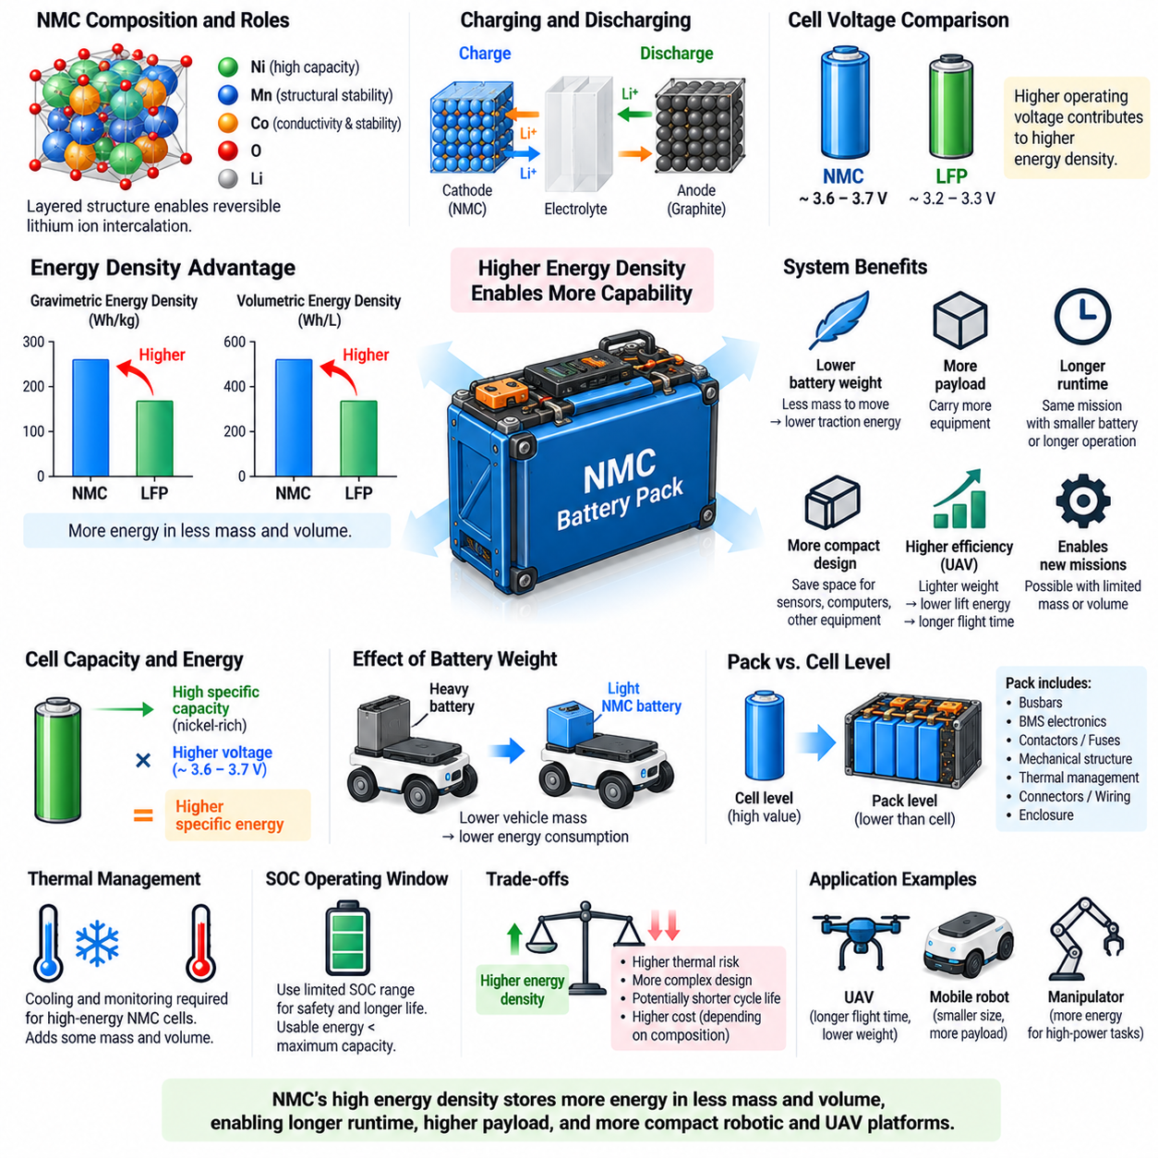
Nickel manganese cobalt, commonly abbreviated as NMC, is a lithium-ion battery cathode chemistry designed to combine high energy storage capability with useful power performance and practical cycle life. Within the battery structure provided for this volume, NMC is treated separately from LFP because its material properties create a different balance between energy density, power capability, thermal behavior, and application suitability.
The principal advantage of NMC chemistry is its high energy density. Energy density describes how much electrical energy can be stored relative to battery mass or volume. Gravimetric energy density is expressed in watt-hours per kilogram, while volumetric energy density is expressed in watt-hours per liter. Higher values allow a battery system to store more usable energy without proportionally increasing vehicle mass or packaging volume.
NMC cathodes use nickel, manganese, and cobalt in different proportions to obtain complementary electrochemical properties. Nickel contributes strongly to capacity and therefore supports high energy density, manganese helps provide structural stability, and cobalt contributes to conductivity and electrochemical stability. Changing the relative proportions of these elements allows manufacturers to optimize cells for energy, power, durability, cost, and safety requirements.
The layered crystal structure of NMC cathode material enables reversible insertion and extraction of lithium ions during battery operation. During charging, lithium ions leave the cathode and migrate through the electrolyte toward the graphite-based anode while electrons flow through the external circuit. During discharge, lithium ions return toward the NMC cathode, releasing electrical energy that can be supplied to the vehicle or robotic system.
NMC cells generally operate at a higher nominal voltage than LFP cells. Depending on the specific formulation and cell design, nominal voltage is commonly around 3.6 to 3.7 V per cell, compared with approximately 3.2 to 3.3 V for LFP. Because battery energy is related to both voltage and charge capacity, this higher operating voltage contributes directly to the energy-density advantage of NMC battery systems.
Higher specific capacity of the cathode provides another major contribution. Modern nickel-rich NMC formulations can store substantial charge per unit mass of active material. When combined with relatively high operating voltage, this produces greater specific energy at the cell level. Consequently, fewer kilograms of battery may be required to store a specified amount of energy compared with a lower-energy-density chemistry.
The practical advantage becomes especially important when battery mass affects the energy required to move the platform itself. A heavier battery increases vehicle mass, which can increase traction energy, structural requirements, and propulsion demand. Reducing battery mass while maintaining stored energy can therefore create a secondary system benefit by lowering the energy required for acceleration, climbing, or sustained mobile operation.
Volumetric energy density is equally important when installation space is limited. Robots, mobile manipulators, autonomous vehicles, and unmanned aerial vehicles must allocate internal volume among batteries, motors, electronics, sensors, computers, structural components, cooling equipment, and payloads. A higher-energy-density battery can reduce the volume dedicated to energy storage and make more packaging space available for mission equipment.
This relationship is particularly significant for aircraft and UAV applications, where every kilogram directly influences lift requirements and flight efficiency. A battery with higher specific energy can provide longer endurance for a given battery mass or reduce battery mass for a specified mission duration. For this reason, the battery architecture of this volume connects NMC characteristics with later consideration of NMC for UAV applications.
Energy density should nevertheless be evaluated at both cell and pack levels. Published cell-level values do not include all components required for a functional battery system. Busbars, electrical insulation, BMS electronics, contactors, fuses, mechanical structures, thermal-management components, connectors, wiring, and enclosure materials add mass and volume without directly storing energy. Pack-level energy density is therefore lower than the value stated for individual cells.
Thermal-management requirements can further influence the realized system advantage. High-energy NMC cells may require carefully designed cooling, temperature monitoring, cell spacing, propagation mitigation, and mechanical protection. These components reduce some of the theoretical mass and volume advantage obtained at the cell level. A meaningful comparison between battery chemistries should therefore evaluate complete packs designed to equivalent safety and reliability requirements.
The energy-density advantage also cannot be considered independently from state-of-charge operating limits. A cell may have a large theoretical energy capacity, but practical systems often restrict the upper and lower SOC boundaries to improve safety and lifecycle performance. The relevant engineering quantity is consequently usable energy within the permitted operating window rather than the maximum electrochemical capacity indicated by the cell specification.
Nickel content is an important design variable in modern NMC chemistry. Increasing nickel content generally supports greater capacity and reduced dependence on cobalt, helping improve specific energy and potentially material economics. However, nickel-rich compositions can also present greater challenges in structural stability, interface degradation, thermal behavior, manufacturing control, and long-term durability, requiring more sophisticated cell and battery-system engineering.
Energy density also interacts with cycle life. Maximizing stored energy by operating near voltage and SOC extremes can increase stress on electrode materials and electrolyte interfaces. A battery designed for maximum energy utilization may therefore age differently from one operated within a narrower SOC window. System designers must decide how much of the theoretical NMC energy advantage should actually be used while meeting required service-life targets.
For mobile robots, NMC can be attractive when packaging space or vehicle mass is strongly constrained. Compact inspection robots, mobile manipulators, high-speed platforms, or robots carrying energy-intensive computing and sensing systems may benefit from increased energy storage within a limited battery compartment. The benefit becomes stronger as mission duration increases and battery replacement or intermediate charging becomes operationally difficult.
For conventional AMRs with sufficient battery volume and frequent charging opportunities, maximum energy density may be less important than cycle durability, thermal margin, cost, or operational simplicity. In such systems, LFP can remain highly attractive. NMC becomes increasingly compelling when additional stored energy directly enables a mission that would otherwise require excessive battery mass, excessive volume, reduced payload, or unacceptable operating duration.
Battery chemistry selection should therefore be performed as a system optimization rather than through energy density alone. Designers should compare usable pack energy, mass, volume, peak and continuous power, charging capability, thermal-management requirements, safety architecture, cycle life, environmental conditions, cost, and mission requirements. The best chemistry is the one that provides the required vehicle capability with acceptable engineering margins.
The NMC energy-density advantage ultimately represents an important design resource rather than an isolated performance number. Higher operating voltage and high cathode capacity allow substantial energy to be stored within limited mass and volume, enabling longer runtime, lower battery weight, increased payload, or more compact platforms. Its greatest value appears when these advantages are converted into measurable improvements in complete robotic or UAV system performance.

03.02. NMC High Power Characteristic
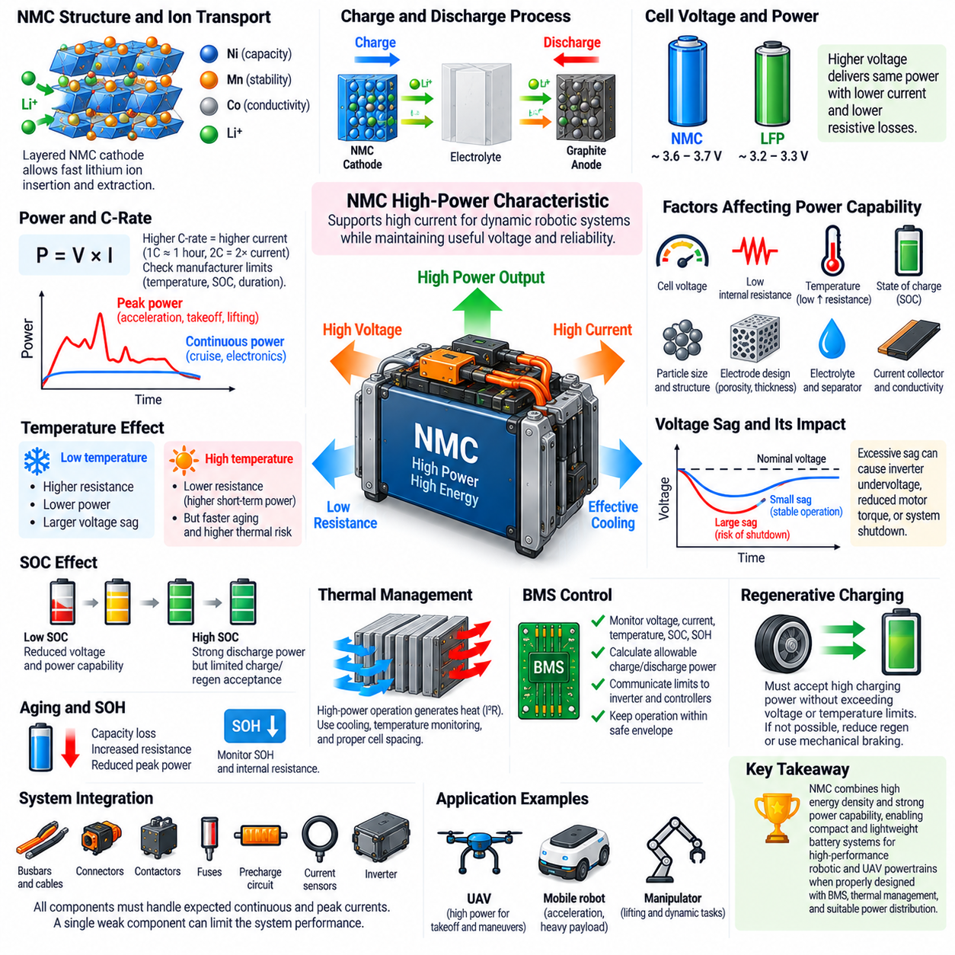
Nickel manganese cobalt batteries are valued not only for high energy density but also for their ability to deliver substantial electrical power from relatively compact and lightweight cells. In robotic powertrains, this characteristic is important because propulsion motors and actuators often demand currents far above their average level for short periods. NMC can therefore support systems requiring both stored energy and strong dynamic power capability.
Battery power represents the rate at which electrical energy is delivered and is fundamentally related to voltage and current through P = V × I. A high-power battery must maintain sufficient terminal voltage while supplying large current without excessive voltage sag, heating, or degradation. Consequently, practical power capability depends on cell voltage, internal resistance, electrochemical kinetics, thermal conditions, SOC, cell construction, and allowable discharge rate.
NMC cells typically operate at a relatively high nominal voltage, commonly around 3.6 to 3.7 V depending on the specific formulation and design. This voltage contributes to power capability because a given electrical power can be delivered with less current when system voltage is higher. Lower current for equivalent power can reduce resistive losses in cells, busbars, cables, connectors, contactors, and other parts of the battery power-distribution path.
Internal resistance is one of the most important factors controlling high-power performance. When current flows through a cell, internal resistance produces a voltage drop approximately proportional to I × R and heat generation approximately proportional to I²R. Cells optimized for power therefore seek low resistance and efficient ionic and electronic transport so that high current can be delivered while retaining useful terminal voltage and limiting internal heat generation.
The layered structure of NMC cathode materials permits reversible lithium-ion insertion and extraction, while practical electrode engineering determines how rapidly these reactions can occur. Particle dimensions, conductive additives, electrode thickness, porosity, electrolyte penetration, separator characteristics, and current-collector design influence ion and electron transport. High-power cell designs optimize these parameters to reduce transport limitations during rapid charge and discharge.
C-rate provides a convenient way to express battery current relative to cell capacity. A 1C discharge theoretically removes the rated capacity in approximately one hour, while higher C-rates correspond to larger currents and shorter discharge periods. However, a manufacturer's continuous and pulse current limits must be interpreted according to specified temperature, SOC, voltage, cooling, and duration conditions rather than treating C-rate as an unrestricted performance value.
Continuous power and peak power represent different requirements. Continuous power describes the output that can be sustained while maintaining acceptable voltage and temperature, whereas peak power is available for shorter events. Robotic systems commonly require peak power during acceleration, takeoff, rapid maneuvering, climbing, lifting, or simultaneous actuator operation, while cruise motion and onboard electronics establish the lower but longer-duration continuous load.
Voltage sag becomes especially important during these high-current events. When a motor suddenly requests large current, the battery terminal voltage decreases because of internal resistance and electrochemical polarization. Excessive sag can cause inverter undervoltage protection, reduced motor torque, unstable DC-bus behavior, or shutdown of sensitive equipment. Battery selection must therefore verify minimum loaded voltage rather than considering only nominal or open-circuit voltage.
Temperature strongly affects NMC power capability. At low temperature, ionic conductivity and lithium diffusion decrease while internal resistance and polarization increase, reducing available discharge power and increasing voltage sag. At higher temperature, short-term power capability may improve because resistance decreases, but accelerated aging and greater thermal risk can result. Power limits should consequently be temperature dependent rather than represented by one fixed current rating.
State of charge also influences available power. Near the lower SOC boundary, reduced cell voltage and increased polarization can limit discharge capability even when some energy remains. Near the upper boundary, discharge power may be strong, but charging or regenerative-energy acceptance can become constrained by maximum cell voltage. A BMS should therefore calculate allowable charge and discharge power using SOC, voltage, temperature, and cell condition together.
High-power operation produces significant thermal stress because current-dependent losses increase rapidly as current rises. Repeated acceleration, high-speed operation, heavy payload movement, or aggressive flight maneuvers can generate localized heating even when average mission power appears acceptable. Thermal design must therefore consider transient power profiles, cell temperature gradients, cooling paths, and the accumulation of heat over repeated high-load events.
The BMS plays a central role in converting theoretical NMC cell capability into safe usable power. It monitors cell voltages, pack current, temperatures, SOC, and potentially state of health, then determines allowable discharge and charge limits. These limits can be communicated to motor controllers, inverters, vehicle controllers, or flight-control systems so that requested power remains within the battery's instantaneous operating envelope.
State of health becomes increasingly important as the battery ages. Capacity loss reduces available energy, while increasing internal resistance directly reduces peak power capability and increases heat generation. A battery may therefore retain enough capacity for a mission but no longer provide the required acceleration or takeoff power. Power-oriented battery diagnostics should track resistance growth as well as conventional capacity retention.
Regenerative braking or regenerative descent introduces the opposite high-power condition by forcing current back into the battery. The pack must be capable of accepting this transient charging power without exceeding cell-voltage or temperature limits. If charge acceptance is insufficient because of high SOC, low temperature, or cell degradation, the powertrain must reduce regeneration or dissipate excess energy through another braking mechanism.
High-power capability influences the entire electrical architecture rather than the battery alone. Busbars, cables, connectors, fuses, contactors, precharge circuits, current sensors, and inverter interfaces must all tolerate the expected continuous and transient currents. A cell capable of very high current provides little system benefit if another component introduces excessive resistance, heating, voltage drop, or a lower current limitation.
NMC's combination of high specific energy and strong power capability is particularly attractive for UAVs. Takeoff, vertical climb, rapid maneuvering, wind compensation, and payload stabilization can create large power demands, while aircraft mass must remain low. A battery that combines energy and power within limited mass can therefore support both flight endurance and the transient propulsion requirements necessary for controlled aerial operation.
Mobile robots and manipulators can also benefit where dynamic loads are substantial. Rapid acceleration, steep gradients, heavy payload transport, lifting mechanisms, robotic arms, and high-performance computing can create simultaneous power demand. However, applications dominated by moderate power and frequent cycling may prioritize other characteristics such as thermal margin, cycle life, cost, and operational simplicity rather than maximum specific power.
High-power performance should therefore never be evaluated from a single maximum-current number. Meaningful selection requires examination of pulse duration, repetition rate, minimum loaded voltage, SOC range, temperature, cooling, resistance growth, aging, and pack-level electrical losses. Vehicle-level testing with realistic power profiles is necessary to verify that theoretical cell capability remains available after integration into the complete battery and powertrain system.
NMC high-power capability ultimately results from the interaction of relatively high cell voltage, low internal resistance, effective lithium-ion transport, optimized electrode construction, and appropriate thermal management. When coordinated with BMS power limits and correctly rated power-distribution hardware, these characteristics enable compact battery systems to support rapid and demanding energy flows required by high-performance robotic and UAV powertrains.

03.03. NMC Thermal Runaway Risk
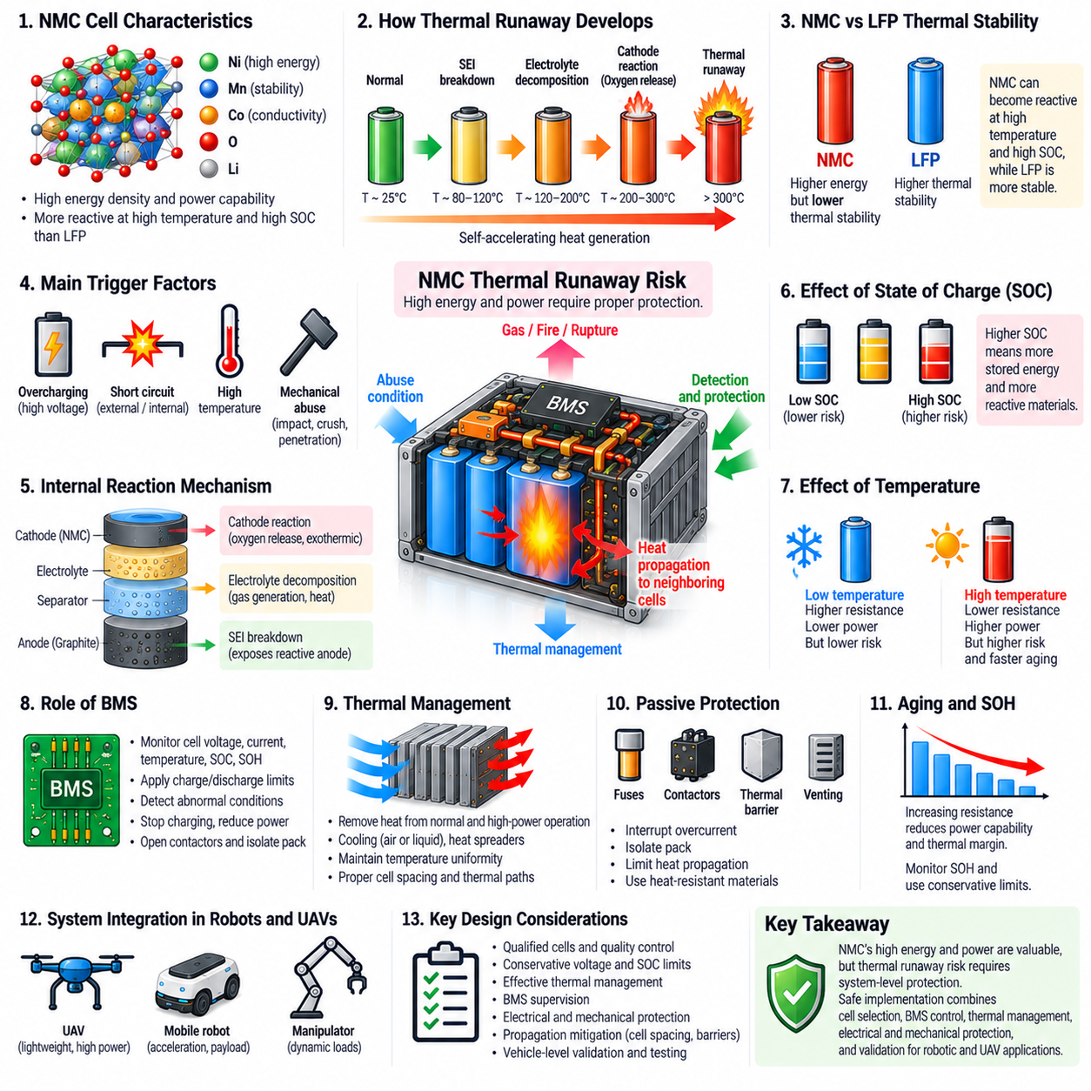
Nickel manganese cobalt batteries provide high energy density and strong power capability, but these advantages are accompanied by greater thermal runaway concerns than more thermally stable chemistries such as LFP. NMC cathodes contain transition-metal oxides that can become increasingly reactive as temperature and state of charge rise, making thermal safety a central consideration in cell selection, pack design, BMS control, and robotic powertrain integration.
Thermal runaway is a self-accelerating process in which heat generated inside a cell exceeds the rate at which heat can be removed. Rising temperature activates additional exothermic reactions, which generate still more heat and further increase temperature. If this positive feedback is not interrupted, the cell can experience rapid temperature escalation, gas generation, venting, fire, or rupture, potentially transferring heat to neighboring cells.
The process does not normally begin with one single cathode reaction. A battery subjected to electrical, thermal, or mechanical abuse can pass through several stages of degradation. Excessive temperature may destabilize protective electrode interfaces, accelerate electrolyte decomposition, increase gas generation, and promote reactions between charged electrode materials and electrolyte. These interacting mechanisms can eventually produce heat faster than the cell and pack can dissipate it.
The solid electrolyte interphase, or SEI, on the graphite anode is an important early protective layer. During normal operation it limits continuous electrolyte decomposition while allowing lithium-ion transport. When cell temperature becomes excessive, the SEI can degrade and expose reactive lithiated anode material to the electrolyte. Subsequent reactions generate additional heat and can contribute to progression toward more severe thermal instability.
NMC cathode behavior becomes increasingly important as temperature continues to rise. Compared with the strongly bonded phosphate structure of LFP, layered NMC materials can exhibit lower thermal stability under severe conditions. Oxygen associated with the cathode lattice can participate in highly energetic reactions with electrolyte and other cell materials, increasing heat generation and making control more difficult once a severe internal failure has developed.
State of charge strongly influences this risk. A highly charged NMC cell contains greater stored electrochemical energy and electrode materials in more reactive states than a partially charged cell. Operation near the upper voltage limit can therefore reduce thermal safety margin, particularly when combined with high temperature or cell degradation. Battery systems may use conservative upper SOC limits when lifecycle durability and safety are more important than extracting maximum usable energy.
Nickel content also affects the balance between energy density and thermal stability. Increasing nickel content can improve cathode capacity and specific energy, which is attractive for mass-sensitive applications such as UAVs. However, nickel-rich NMC compositions generally demand increasingly careful management of interfaces, charging voltage, temperature, manufacturing quality, and degradation because maximizing energy density can reduce some of the intrinsic thermal margin available to the cell.
Overcharging is an important electrical trigger because it can drive cell voltage beyond its intended operating region. Excessive voltage promotes undesirable electrode and electrolyte reactions and can increase heat generation. A properly designed BMS must therefore monitor every series-connected cell rather than relying only on total pack voltage, since an imbalanced cell can reach its upper voltage limit even when average pack voltage still appears acceptable.
External short circuits and excessive discharge currents create another thermal pathway through very high current and I²R heating. Internal short circuits can be more difficult to detect because they may originate from separator damage, manufacturing defects, contamination, mechanical deformation, or dendritic structures. Localized internal heating can develop before pack-level current measurements clearly indicate the severity of the fault, making cell quality and mechanical protection essential.
Mechanical damage is especially relevant in mobile robotic systems. Collision, crushing, penetration, vibration, shock, or deformation can damage electrodes or separators and create internal electrical contact. A battery enclosure must therefore do more than hold cells in position. It should provide structural protection, secure mounting, controlled clearances, insulation, and resistance to the mechanical loads expected during vehicle operation, transportation, maintenance, and foreseeable accidents.
Temperature monitoring provides an important indication of abnormal conditions but has physical limitations. Sensors measure selected locations rather than the temperature everywhere inside every cell. A rapidly developing internal hot spot may therefore become severe before an external sensor detects its full magnitude. Sensor placement should be based on thermal analysis and testing, with particular attention to densely packed regions, high-current paths, cooling limitations, and likely hot spots.
Thermal management is consequently a fundamental part of NMC pack safety. Heat generated by normal discharge, rapid charging, repeated peak-power events, and regenerative energy must be transferred away from cells effectively. Depending on power level and packaging density, this may require heat spreaders, forced-air cooling, liquid cooling, or other controlled thermal paths. Maintaining cell-to-cell temperature uniformity also reduces unequal aging and resistance growth.
The BMS provides the primary active control layer for preventing operation from progressing toward dangerous conditions. It monitors cell voltage, current, temperature, SOC, and diagnostic information and applies charge and discharge limits accordingly. When abnormal conditions are detected, the system can reduce power, stop charging, disable regeneration, request vehicle derating, open contactors, or isolate the pack before electrical or thermal stress reaches a critical level.
Passive protection remains necessary because electronic control cannot guarantee prevention of every fault. Fuses can interrupt severe overcurrent, contactors can isolate the pack, and appropriate insulation reduces unintended conductive paths. Mechanical barriers, controlled cell spacing, heat-resistant materials, and venting provisions can limit the consequences of a failed cell. These measures form independent protection layers rather than relying on one BMS function or one sensor.
Thermal propagation is one of the most important pack-level concerns. If a failed cell releases sufficient heat into adjacent cells, neighboring cells may also enter thermal runaway, creating a cascading event. Propagation resistance depends on cell energy, spacing, orientation, thermal barriers, enclosure geometry, cooling paths, and vent-gas management. Pack validation must therefore evaluate whether a single-cell failure can remain localized rather than assuming cell-level qualification guarantees pack safety.
Aging can gradually reduce thermal margin even when no obvious fault is present. Repeated cycling, high-temperature exposure, high SOC storage, and aggressive charging can increase internal resistance and modify electrode interfaces. Higher resistance generates more heat at a given current, while degraded materials may respond differently to electrical stress. State-of-health monitoring and conservative power limits can therefore become increasingly important as the battery approaches end of life.
For UAV applications, NMC thermal safety requires particularly careful system optimization because high energy density is one of the main reasons for selecting the chemistry. Adding excessive structural protection and cooling mass can reduce the weight advantage, while insufficient protection increases risk. Cell selection, pack layout, thermal paths, BMS limits, flight power requirements, enclosure design, and emergency behavior must therefore be engineered together rather than independently.
Robotic ground platforms generally have greater freedom to allocate mass to protection and cooling, but they can still experience demanding conditions such as rapid charging, high-current acceleration, enclosed battery compartments, impacts, and operation near people or infrastructure. The consequences of a battery event can therefore be operationally significant even when vehicle lift is not a concern, requiring deliberate pack-level containment and fault-management strategies.
NMC thermal runaway risk should ultimately be treated as a system engineering problem rather than as a reason to reject the chemistry categorically. High energy and power capability can provide substantial benefits when mass and volume are constrained, but these benefits require corresponding protection. Safe NMC implementation combines qualified cells, conservative operating limits, thermal management, BMS supervision, electrical protection, mechanical containment, propagation mitigation, and vehicle-level validation.

03.04. NMC for UAV Application
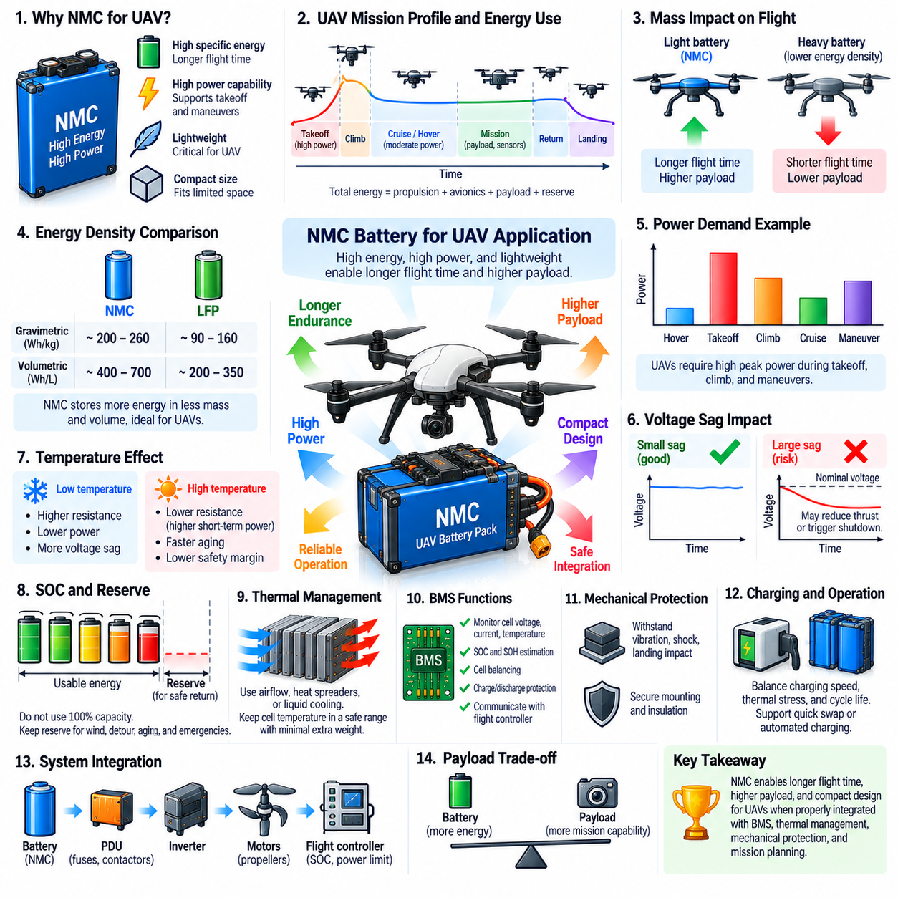
Nickel manganese cobalt batteries are particularly attractive for unmanned aerial vehicle applications because UAV performance is strongly constrained by mass, volume, and available electrical energy. The battery must provide enough energy for useful flight endurance while delivering high power for takeoff, climbing, maneuvering, stabilization, and payload operation. NMC combines high specific energy with substantial power capability, making it suitable for mass-sensitive aerial powertrains.
In a UAV, battery mass directly affects the propulsion energy required to remain airborne. Unlike a ground robot, an aircraft must continuously generate aerodynamic lift or rotor thrust sufficient to counteract its weight. Adding battery capacity therefore creates a tradeoff because additional stored energy also increases vehicle mass. High-specific-energy NMC cells help reduce this penalty by storing more energy per kilogram of battery.
The same advantage applies to volumetric energy density. UAV fuselages and airframes have limited internal space that must accommodate propulsion electronics, flight computers, sensors, communication equipment, landing systems, thermal components, payloads, and structural members. Compact NMC battery packs can provide substantial energy within a restricted installation envelope, allowing more space to remain available for mission-critical equipment.
Flight endurance depends on the complete aircraft energy balance rather than battery capacity alone. Hovering, forward flight, climbing, descending, maneuvering, wind compensation, avionics, sensors, communication, computing, and payload systems all consume energy. Battery sizing should therefore use representative mission profiles that include takeoff, cruise or hover, mission activity, return flight, landing, and an appropriate reserve rather than assuming constant average power.
Power capability is especially important during takeoff and climb. Multirotor UAVs may require substantial current when all propulsion motors simultaneously generate high thrust, while fixed-wing or hybrid VTOL aircraft can experience large transient loads during vertical takeoff or transition between flight modes. NMC cells with suitable discharge capability can support these peak-power events while maintaining useful terminal voltage and limiting excessive voltage sag.
Voltage sag must be considered because propulsion systems can respond strongly to battery voltage. High current causes a voltage drop through cell internal resistance and the resistance of busbars, cables, connectors, and protection devices. If loaded voltage falls excessively, motor speed or available thrust can decrease and inverter or flight-system undervoltage protection may activate. Pack design must therefore verify minimum voltage under worst-case flight loads.
UAV battery architecture should distinguish energy reserve from immediately usable energy. A vehicle should not plan a mission assuming that the entire nominal battery capacity can be consumed before landing. Reserve energy is required to accommodate wind, route changes, navigation errors, holding time, unexpected payload demand, battery aging, and emergency maneuvers. Energy-management software should continuously update whether sufficient energy remains for safe return or landing.
State-of-charge estimation is consequently a flight-safety function rather than merely a battery display feature. The BMS and flight controller should use measured current, cell voltage, temperature, estimated capacity, and operating history to estimate remaining energy. Mission planning can then compare predicted energy demand with available battery energy and initiate return-to-home, route shortening, payload prioritization, or controlled landing before the reserve margin becomes insufficient.
Temperature has a strong influence on aerial battery performance. Low temperature increases cell resistance and reduces available power, which can create greater voltage sag during takeoff or high-thrust operation. High temperature may improve short-term power capability but accelerates aging and reduces thermal safety margin. UAV power limits and mission planning should therefore consider battery temperature together with SOC rather than assuming constant capability across environmental conditions.
Cooling presents a unique integration problem because adding thermal-management hardware increases aircraft mass. Airflow generated during flight can assist heat rejection, but cooling effectiveness varies with airspeed, hover conditions, enclosure design, ambient temperature, and battery location. Pack design should use available airflow efficiently while avoiding assumptions that external flight airflow automatically provides uniform cooling to every cell.
NMC thermal safety requires particular attention in UAVs because high energy density concentrates substantial stored energy within a small and lightweight package. Mechanical protection, electrical isolation, cell monitoring, thermal sensing, current protection, and conservative operating limits must be integrated without eliminating the mass advantage that justified NMC selection. The design objective is therefore optimized protection rather than simply maximizing battery energy.
Mechanical loads differ significantly from those of stationary battery systems. UAV packs can experience vibration, landing shock, turbulence, repeated acceleration, structural flexing, and in some applications severe impact loads. Cells, busbars, connectors, BMS boards, and wiring must remain mechanically secure throughout these conditions. Battery mounting should also prevent relative motion that could damage insulation or electrical connections during prolonged operation.
The BMS must supervise individual cell voltages because series-connected cells can gradually become imbalanced. A single weak or highly charged cell can reach its voltage limit before the overall pack appears abnormal. Cell-level monitoring, temperature supervision, current measurement, balancing, and protection logic help prevent overcharge and excessive discharge while providing the flight controller with realistic information about available battery capability.
Battery state of health becomes increasingly important for aircraft because degradation affects both energy and power. Capacity loss shortens flight endurance, while increasing internal resistance causes greater voltage sag and heating during high-thrust events. A pack that can still store substantial energy may nevertheless become unsuitable for flight if it can no longer provide required takeoff or emergency power with sufficient voltage margin.
Mission planning should therefore consider battery aging explicitly. Flight-time predictions based on a new battery can become unsafe after repeated cycles unless the energy model adapts to measured capacity and resistance. Historical flight data can be used to refine consumption models for specific aircraft, payloads, routes, temperatures, and weather conditions, allowing increasingly accurate prediction of remaining endurance and return-energy requirements.
Payload and battery mass are directly coupled in UAV design. Increasing payload reduces the mass available for batteries under a fixed maximum takeoff mass, while increasing battery mass can reduce payload capability. High-energy NMC cells can improve this tradeoff by providing more stored energy within a limited battery mass allocation. This is particularly valuable for inspection sensors, communication equipment, delivery payloads, or other mission hardware.
Cargo UAVs amplify these considerations because propulsion energy changes substantially with payload mass and flight profile. Heavy payloads increase takeoff and climb power, while long-distance transport increases total energy demand. Battery architecture must therefore be coordinated with propulsion sizing, maximum takeoff mass, payload targets, route distance, reserve policy, and potentially hybrid powertrain concepts rather than treating the battery as an independently sized component.
Charging strategy also affects fleet availability. UAV fleets may require batteries to be charged between missions, exchanged rapidly, or managed through automated ground infrastructure. Higher charging rates can reduce turnaround time but increase thermal and degradation stress. Operational planning should balance charging speed, battery temperature, cycle life, available chargers, spare packs, and required sortie frequency to achieve the desired fleet utilization.
Electrical architecture must be designed around the battery's high-power capability. Conductors, connectors, fuses, contactors or switching devices, current sensors, power-distribution units, motor inverters, and DC-DC converters must support expected peak and continuous currents with acceptable losses. Minimizing unnecessary resistance reduces heat and voltage sag while also improving the fraction of stored battery energy that reaches propulsion and mission systems.
NMC is therefore valuable for UAVs not simply because it stores more energy than many alternative chemistries, but because its combination of energy density and power capability can directly improve aircraft-level design freedom. When integrated with accurate energy estimation, thermal management, BMS protection, structural design, propulsion requirements, and mission reserves, NMC can support longer endurance, higher payload capability, compact packaging, and demanding aerial power profiles.

03.05. NMC Cell Selection
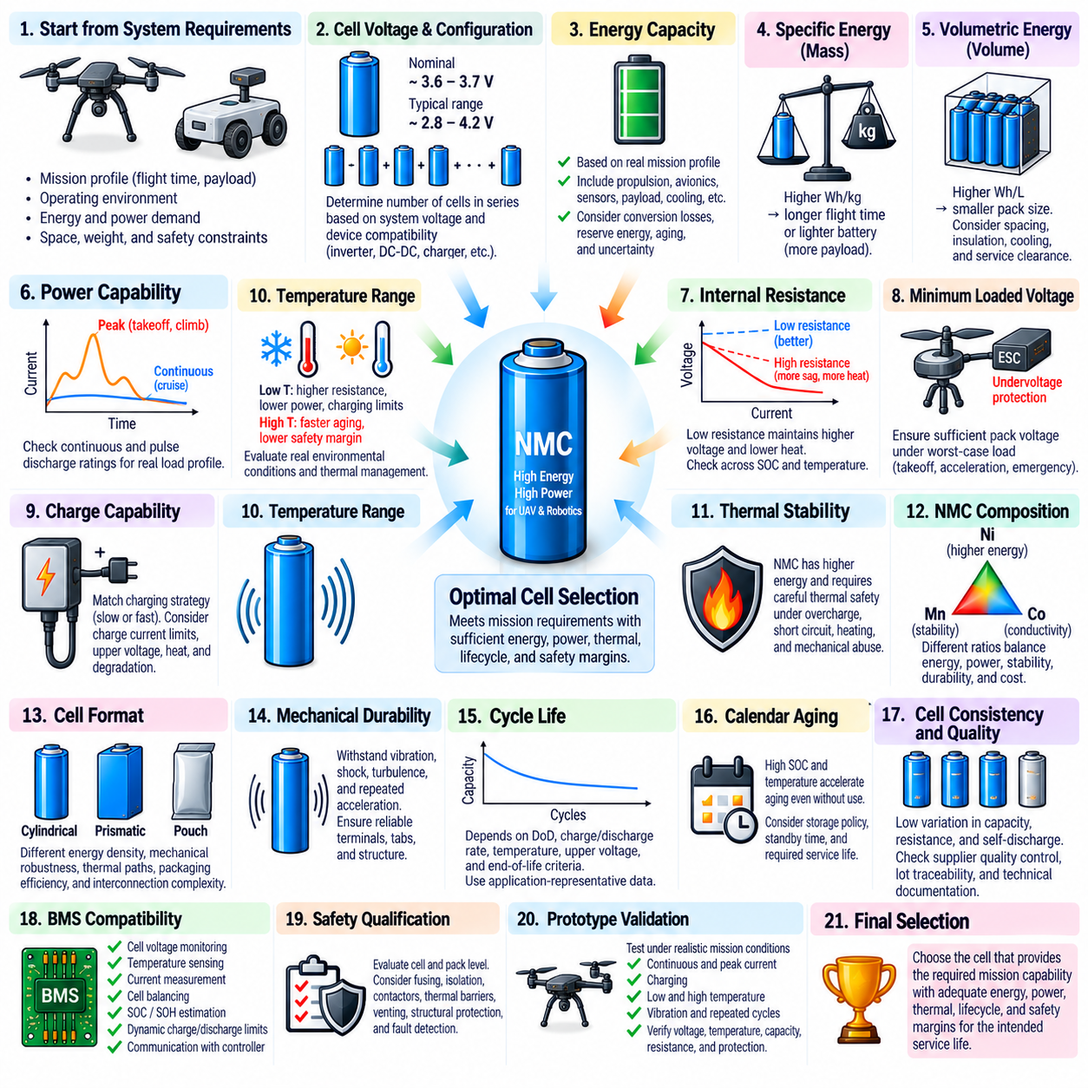
Selecting an NMC cell for a robotic or UAV battery system requires balancing energy density, power capability, thermal behavior, lifecycle performance, safety, and integration constraints. The cell with the highest advertised capacity is not automatically the best choice. Selection should begin from vehicle-level requirements and determine which cell can provide the required usable energy and power throughout the intended operating environment and service life.
The first requirement is the battery system voltage. NMC cells commonly have a nominal voltage around 3.6 to 3.7 V, although the exact operating range depends on cell chemistry and manufacturer specifications. The required number of series-connected cells must be determined from maximum charge voltage, minimum allowable discharge voltage, and compatibility with motor inverters, DC-DC converters, chargers, power-distribution equipment, and protection devices.
Energy capacity should be determined from the actual mission profile rather than nominal vehicle runtime alone. Propulsion, avionics, computers, sensors, communication equipment, cooling systems, actuators, and payload devices all contribute to energy consumption. Conversion losses, reserve energy, environmental conditions, battery aging, and operational uncertainty should also be included when translating vehicle energy requirements into the required cell capacity and pack configuration.
Specific energy becomes especially important for UAVs and other mass-constrained platforms. A cell capable of storing more watt-hours per kilogram can increase endurance without proportionally increasing battery mass. Alternatively, the same mission energy can be provided with a lighter battery, leaving additional mass available for payload, structural components, sensors, or other equipment. Cell-level specific energy should therefore be evaluated together with the resulting pack-level mass.
Volumetric energy density should be considered separately because available installation volume may be more restrictive than mass. Battery compartments must coexist with propulsion hardware, electronics, thermal-management equipment, wiring, structural elements, and payload systems. A cell with favorable volumetric energy density can reduce required battery volume, but spacing, insulation, mechanical support, cooling paths, and service clearances must be included before evaluating the actual packaging advantage.
Power capability is another fundamental selection criterion. UAV takeoff, vertical climb, rapid maneuvering, and robotic acceleration can require currents substantially higher than average mission demand. Continuous and pulse discharge ratings should therefore be compared with realistic load profiles. The selected cell must provide sufficient peak current while maintaining acceptable voltage, temperature, and degradation margins rather than merely satisfying an energy-capacity requirement.
Internal resistance strongly influences whether the theoretical current capability can be used effectively. High current produces an approximately I × R voltage drop and I²R heat generation within the cell. Low-resistance cells can therefore maintain higher loaded voltage and generate less heat during demanding power events. Resistance should be evaluated across SOC and temperature because values measured under favorable laboratory conditions may not represent cold-weather or aged-cell performance.
Minimum loaded voltage is particularly important for propulsion applications. Even when open-circuit voltage appears sufficient, voltage sag during a high-current event can reduce motor performance or trigger inverter undervoltage protection. Cell selection should therefore consider the complete series configuration and estimate pack voltage during worst-case acceleration, takeoff, climbing, or emergency power demand, including resistance from cells and the external power-distribution network.
Charge capability must correspond to the intended operational strategy. Some systems can tolerate slow charging between operating periods, while high-utilization robotic or UAV fleets may require rapid turnaround or automated charging. Higher charge current reduces charging time but increases heat generation and electrochemical stress. Cell specifications should therefore be examined for continuous charging capability, temperature-dependent limits, upper-voltage requirements, and expected degradation under repeated charging.
Temperature range is a critical selection parameter. Low temperature increases internal resistance, voltage sag, and charging limitations, while high temperature accelerates aging and can reduce thermal safety margin. A cell intended for outdoor operation should be evaluated at realistic environmental extremes rather than room temperature alone. Heating or cooling requirements should also be included because thermal-management hardware adds mass, volume, power consumption, and system complexity.
Thermal stability deserves greater emphasis for NMC than for more thermally tolerant chemistries such as LFP. High energy density concentrates significant electrochemical energy within limited mass and volume, so cell selection should consider thermal behavior under overcharge, short circuit, external heating, and mechanical abuse. The objective is not only to prevent normal operating temperatures from becoming excessive but also to reduce the consequences of abnormal conditions.
NMC composition itself influences the selection tradeoff. Different nickel, manganese, and cobalt ratios provide different balances of capacity, power, thermal stability, durability, and cost. Nickel-rich formulations can provide high specific energy, which is attractive for UAVs, but may require more careful thermal and voltage management. The chemistry designation alone is therefore insufficient; the characteristics of the specific cell formulation and construction must be evaluated.
Cell format also affects system design. Cylindrical, prismatic, and pouch cells provide different combinations of energy density, mechanical robustness, thermal paths, packaging efficiency, interconnection complexity, and manufacturing requirements. A high-performance pouch cell may offer excellent mass efficiency but require carefully controlled mechanical support, while cylindrical cells may provide convenient structural consistency at the cost of additional interconnections in large packs.
Mechanical durability should match the vehicle environment. UAV batteries can experience vibration, turbulence, landing shock, and repeated acceleration, while mobile robots can experience impact, rough terrain, and chassis vibration. Terminals, tabs, separators, enclosures, and electrical connections must remain reliable throughout these loads. Cell selection should therefore consider mechanical qualification together with the design of pack supports, compression structures, insulation, and vibration isolation.
Cycle life should be interpreted using the conditions under which it was measured. Published cycle numbers can vary significantly with depth of discharge, charge rate, discharge rate, temperature, upper voltage, and end-of-life criteria. A cell offering exceptional energy density may not provide the best lifetime economics if its capacity or resistance deteriorates rapidly under the intended mission profile. Application-representative cycling data is therefore more valuable than a single headline cycle-life value.
Calendar aging is equally relevant for systems that spend substantial time stored or waiting between missions. High SOC and elevated temperature can accelerate degradation even without active cycling. UAV batteries that remain fully charged awaiting deployment may therefore age differently from batteries cycled continuously. Storage policy, expected standby duration, operating temperature, and desired service life should be considered when comparing candidate NMC cells.
Cell consistency and manufacturing quality become critical when many cells are assembled into a pack. Variations in capacity, resistance, self-discharge, or initial SOC can cause individual cells to reach voltage or temperature limits before the rest of the pack. Supplier evaluation should therefore include manufacturing consistency, lot traceability, quality control, incoming inspection capability, and availability of reliable technical documentation rather than focusing only on unit price.
The selected cell must also be compatible with the BMS strategy. Individual cell-voltage monitoring, temperature sensing, current measurement, balancing, SOC estimation, SOH estimation, and dynamic charge and discharge limits should reflect the actual cell characteristics. For high-power applications, the BMS should be able to communicate available battery power to the propulsion or vehicle controller so that transient demands remain within safe operating limits.
Safety qualification must be evaluated at both cell and pack levels. Cell-level test results provide essential information but cannot fully represent thermal propagation, mechanical containment, electrical fault behavior, or cooling performance after integration. Pack architecture should therefore combine qualified cells with appropriate fusing, isolation, contactors, thermal barriers, venting provisions, structural protection, and fault-detection mechanisms according to the application's risk requirements.
Prototype validation should reproduce realistic mission conditions before the cell is approved for production. Testing should include representative continuous and peak currents, charging, low and high temperatures, vibration, expected SOC ranges, and repeated mission cycles. Voltage sag, cell temperature distribution, capacity retention, resistance growth, SOC accuracy, and protection behavior should be compared with design assumptions to identify limitations that are not visible in datasheets.
The final NMC cell choice should therefore emerge from system-level optimization rather than a single specification. Energy density, specific power, resistance, temperature capability, charging performance, cycle and calendar life, mechanical format, safety, supplier quality, BMS compatibility, and pack integration must be evaluated together. The optimal cell is the one that provides the required mission capability with sufficient energy, power, thermal, lifecycle, and safety margins throughout the vehicle's intended service life.

