Volume 11. Battery and Powertrain

Chapter 06. DC-DC Converter

06.01. Buck/Boost/Buck-Boost Topology
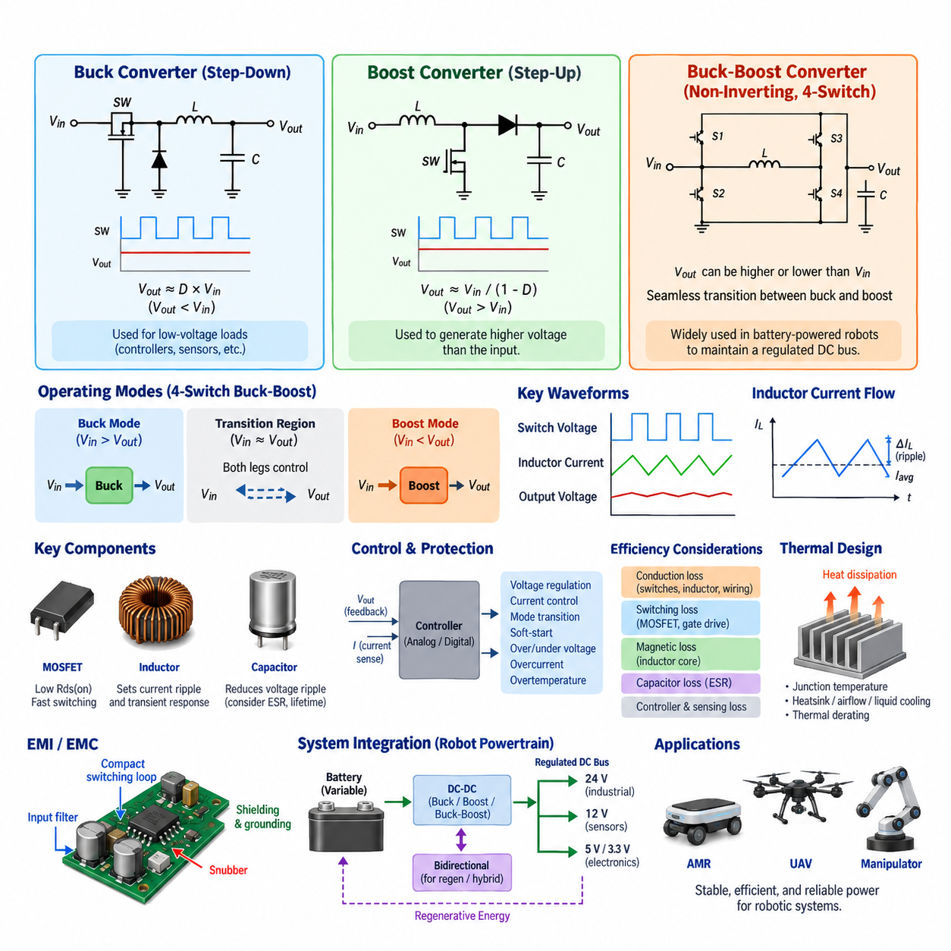
A buck converter is a non-isolated DC-DC topology designed to produce an output voltage lower than its input voltage. It regulates energy transfer by rapidly switching a semiconductor device and controlling the average voltage delivered through an inductor. In robotics power systems, buck conversion is commonly used when a battery bus must supply lower-voltage electronic loads such as controllers, sensors, communication modules, and embedded computers.
The basic buck topology consists of a controlled switching device, a freewheeling path, an inductor, an output capacitor, and the connected load. When the main switch is turned on, energy flows from the input source into the inductor and load. When the switch is turned off, the inductor maintains current through the freewheeling path. Repeated switching and filtering transform the pulsed switching waveform into a relatively stable DC output.
For an ideal buck converter operating in continuous conduction mode, the average output voltage is approximately proportional to the input voltage and duty ratio, expressed as Vout ≈ D × Vin. The duty ratio D represents the fraction of each switching period during which the main switch conducts. A feedback controller continuously adjusts this duty ratio to compensate for variations in battery voltage, load current, component tolerances, and operating conditions.
Modern synchronous buck converters replace the passive freewheeling diode with a controlled MOSFET. This substantially reduces conduction losses, particularly in low-voltage and high-current applications where diode forward-voltage loss would otherwise represent a significant percentage of transferred power. Precise dead-time control is required to prevent simultaneous conduction of the high-side and low-side switches, which could create destructive shoot-through current.
A boost converter performs the complementary function by generating an output voltage higher than its input voltage. During the switch-on interval, current increases through the inductor and electromagnetic energy is stored. When the switch turns off, the inductor releases this stored energy toward the output, adding its induced voltage to the input source. This process allows the converter to maintain a regulated output above the available source voltage.
For an ideal boost converter in continuous conduction mode, the relationship can be approximated as Vout ≈ Vin/(1-D). As the duty ratio increases, the theoretical voltage conversion ratio rises. Practical operation is limited by semiconductor ratings, inductor current, switching losses, control stability, thermal constraints, and parasitic resistance. Consequently, extreme duty ratios are generally avoided because current stress and efficiency degradation become increasingly severe.
Buck-boost conversion becomes important when the required output voltage can be either lower or higher than the instantaneous input voltage. Battery-powered robots are a typical example because battery terminal voltage changes with state of charge, load, temperature, chemistry, and transient current demand. A regulated DC bus may therefore require step-down operation at high battery voltage and step-up operation as the battery approaches its lower operating range.
The classical inverting buck-boost converter can provide both step-down and step-up conversion, but its output polarity is reversed relative to the input. Many robotic and automotive systems instead use non-inverting buck-boost architectures because they preserve common polarity and integrate more naturally into conventional DC power distribution. Four-switch synchronous buck-boost converters are particularly useful where efficiency, bidirectional capability, and wide voltage regulation are important.
A four-switch buck-boost stage can be understood as a buck switching leg and a boost switching leg connected through a common inductor. When the input voltage is sufficiently above the target output, the converter primarily behaves as a buck stage. When the input falls below the target, it transitions toward boost operation. Near the input-output crossover region, both switching legs may participate in controlling energy transfer and maintaining continuous regulation.
The transition between buck and boost regions is an important control challenge. Poor transition management can create output-voltage disturbances, increased ripple, circulating current, or sudden efficiency degradation. Advanced controllers therefore coordinate switch timing, duty ratios, current limits, and operating modes around the crossover point. Smooth transitions are particularly valuable for autonomous robots whose computing and sensing systems require uninterrupted, tightly regulated electrical power.
Inductor selection strongly influences all three converter classes. Inductance determines current ripple, transient response, peak current, magnetic size, and conduction loss. A smaller inductance can improve transient response and reduce physical size but generally increases ripple current. A larger inductance reduces ripple but may increase volume, resistance, and dynamic response time. Saturation current must remain safely above the maximum expected inductor current under abnormal transients.
Output capacitors complement the inductor by absorbing switching-frequency current and reducing output-voltage ripple. Their capacitance, equivalent series resistance, temperature characteristics, lifetime, and ripple-current capability must be considered together. Input capacitors are equally important because they provide a local high-frequency current path near the switching devices and prevent switching pulses from propagating excessively into the battery, wiring harness, or upstream power distribution system.
Switching frequency creates a fundamental engineering tradeoff. Increasing frequency allows smaller inductors and capacitors and can improve power density, but switching losses, gate-drive losses, magnetic core losses, and electromagnetic interference generally increase. Lower switching frequencies reduce some switching losses but require larger passive components. The optimum frequency therefore depends on power level, semiconductor technology, cooling capability, packaging constraints, efficiency targets, and EMC requirements.
MOSFETs are widely used in low- and medium-voltage robotic DC-DC converters because of their fast switching capability and relatively low conduction resistance. Silicon carbide and gallium nitride devices can provide advantages at higher voltage, frequency, temperature, or power-density requirements. Device selection must consider voltage margin, current rating, on-state resistance, switching energy, gate charge, thermal resistance, reverse conduction behavior, and short-circuit robustness.
Converter efficiency cannot be evaluated from semiconductor conduction loss alone. Total loss includes switching transitions, gate driving, inductor copper resistance, magnetic core loss, capacitor ESR, PCB and busbar resistance, sensing circuits, and controller consumption. Because robotic loads can vary dramatically between standby, computation, acceleration, manipulation, and peak actuator operation, efficiency should be evaluated across the complete expected operating envelope rather than only at rated power.
Control architecture typically combines voltage regulation with current monitoring and protection. Voltage-mode, current-mode, peak-current-mode, and average-current-mode strategies offer different dynamic characteristics. Digital control can additionally support programmable limits, telemetry, fault logging, operating-mode transitions, and communication with supervisory controllers. Regardless of implementation, loop bandwidth and compensation must provide adequate stability margin across expected input voltage and load conditions.
Transient response is especially important in robotics because electrical loads can change rapidly. Motor acceleration, steering actuators, manipulators, pumps, computing accelerators, and communication equipment may create abrupt power demands. The DC-DC converter must respond without allowing excessive bus droop or overshoot. Energy stored in inductors and capacitors provides immediate buffering while the control loop modifies switching behavior to establish the new steady-state operating point.
Protection functions normally include input undervoltage, output overvoltage, overcurrent, short-circuit protection, and overtemperature shutdown or derating. Soft-start limits inrush current during startup, while controlled shutdown can prevent undesirable bus transients. Reverse-current protection may also be necessary where multiple supplies or regenerative loads share a DC bus. Protection thresholds should coordinate with battery, BMS, fuse, PDU, wiring, and downstream load limits.
Thermal design directly determines sustainable converter power. Semiconductor junction temperature, inductor winding and core temperature, capacitor lifetime, PCB copper temperature, and connector heating must remain within acceptable limits. Heat spreading through copper planes, thermal vias, heat sinks, chassis interfaces, airflow, or liquid cooling may be required depending on power density. Thermal derating should account for worst-case ambient temperature and restricted cooling conditions.
Electromagnetic compatibility is another critical consequence of high-frequency switching. Rapid voltage and current transitions generate conducted and radiated emissions through parasitic capacitance, loop inductance, wiring, and common-mode paths. Compact switching loops, controlled gate slew rate, appropriate grounding, input and output filtering, shielding, snubbers, and careful PCB layout help prevent converter noise from degrading cameras, LiDAR, GNSS, IMUs, communication networks, or sensitive analog circuits.
In an AMR power architecture, a 48 V battery may feed multiple DC-DC stages that create regulated rails for 24 V industrial devices, 12 V sensors, and lower-voltage electronics. Buck conversion is appropriate when the battery remains above the required rail. A buck-boost converter becomes attractive when a tightly regulated intermediate bus must remain constant despite a battery voltage range that crosses the required output voltage during charge and discharge operation.
For UAV and mobile robotic platforms, converter mass and power density become particularly important. Every additional gram or cubic centimeter competes with battery capacity, payload, cooling equipment, and structural components. High-efficiency synchronous topologies can reduce both electrical loss and cooling mass. However, aggressive power-density optimization must not compromise transient capability, EMI performance, insulation, thermal margin, component lifetime, or fault containment.
Bidirectional buck-boost converters extend the topology by allowing controlled power flow in both directions. This is useful when energy must move between battery and DC bus during propulsion, regenerative braking, energy buffering, or hybrid power operation. Instead of treating the converter only as a voltage adapter, bidirectional control allows it to become an active energy-management interface capable of regulating current, voltage, and power flow between electrical domains.
The selected topology must ultimately be evaluated at system level rather than as an isolated converter circuit. Battery voltage range, BMS limits, peak and continuous load, regenerative energy, harness voltage drop, protection coordination, thermal environment, EMC constraints, efficiency, reliability, packaging, and service requirements all influence the design. Within the Battery and Powertrain structure, buck, boost, and buck-boost topology therefore forms the foundation for subsequent isolated conversion, efficiency, thermal, and EMI engineering.

06.02. Isolated DC-DC (LLC, DAB)
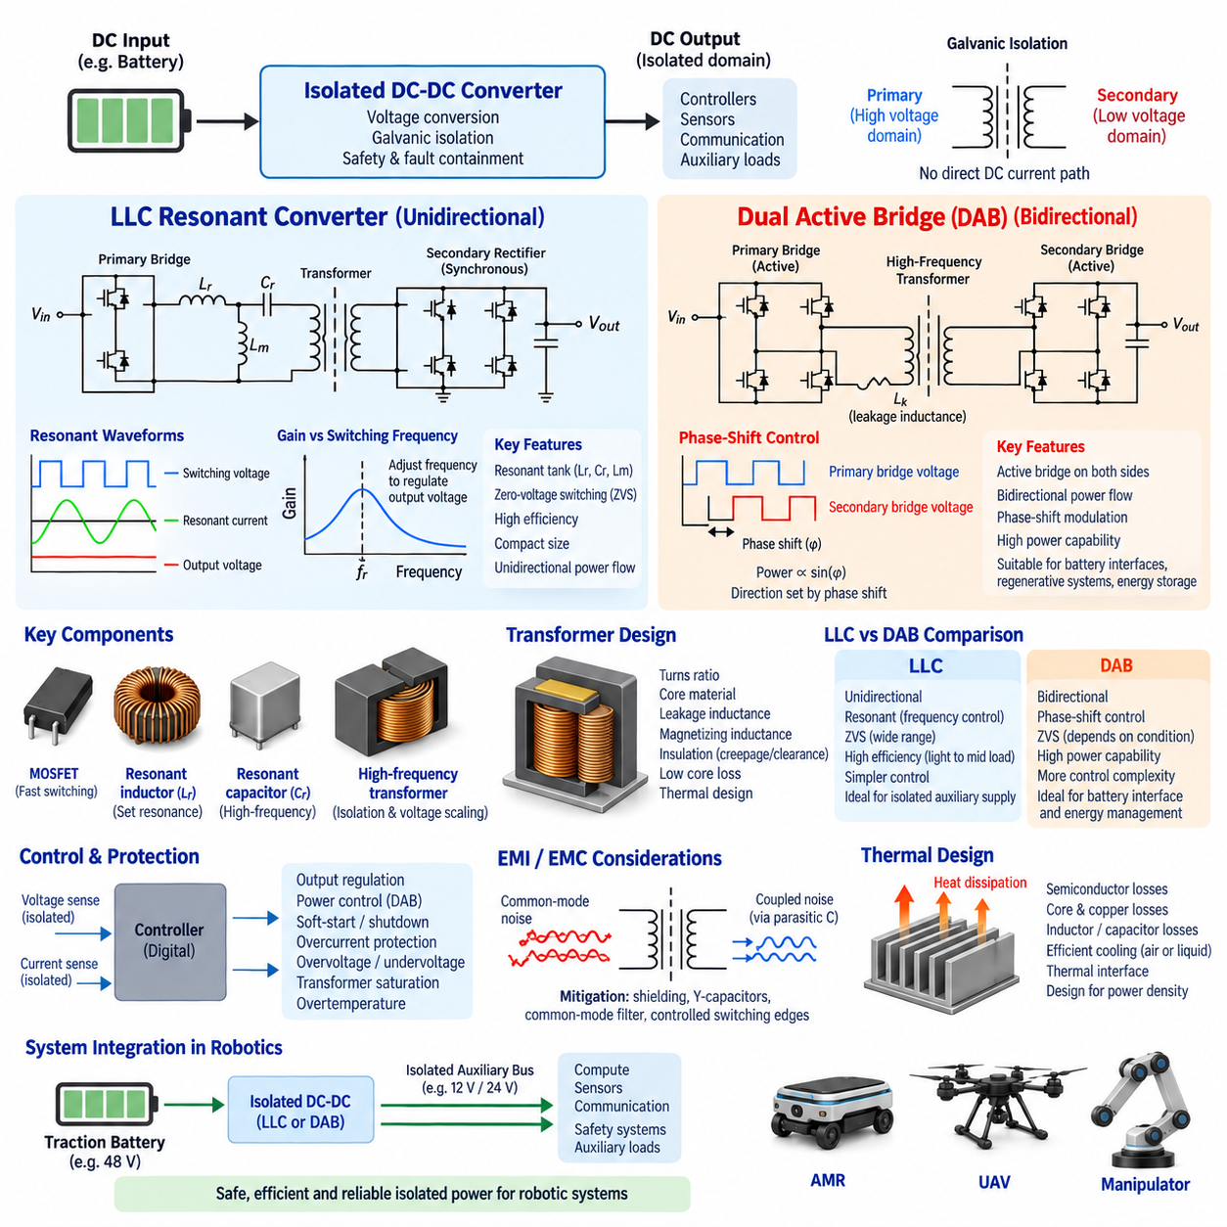
An isolated DC-DC converter transfers electrical power between two DC domains while providing galvanic isolation between the input and output. Unlike non-isolated buck or boost stages, isolated converters use a high-frequency transformer as part of the energy-transfer path. This separation prevents direct DC current flow between domains while enabling voltage conversion, grounding separation, fault containment, and improved system-level safety.
Galvanic isolation becomes important when different electrical subsystems operate with incompatible ground references or when hazardous energy must be separated from low-voltage electronics. In robotic platforms, an isolated converter can separate a traction battery from control electronics, sensors, communication equipment, or auxiliary power networks. Isolation also helps control common-mode current paths and prevents some faults from propagating directly across power domains.
The transformer provides both isolation and voltage scaling. Its turns ratio establishes a fundamental relationship between primary-side and secondary-side voltage, while switching modulation determines the actual transferred power. Because the transformer operates at a much higher frequency than conventional line-frequency transformers, its magnetic components can be considerably smaller. Higher frequency therefore enables compact power conversion, although magnetic, switching, thermal, and EMI losses become increasingly important.
Isolation requirements influence transformer construction, PCB layout, connector selection, and mechanical packaging. Creepage distance, clearance distance, insulation materials, dielectric strength, pollution level, operating voltage, transient overvoltage, and environmental conditions must be considered together. Functional isolation may be sufficient for some internal power domains, whereas safety-related architectures can require reinforced or equivalent insulation strategies according to applicable system requirements.
The LLC resonant converter is a widely used isolated topology for efficient unidirectional power conversion. Its resonant network typically contains a resonant inductor Lr, resonant capacitor Cr, and the transformer magnetizing inductance Lm, which gives the topology its LLC designation. A switching bridge excites this resonant network, the transformer transfers energy across the isolation barrier, and the secondary stage rectifies and filters the resulting high-frequency waveform.
Unlike hard-switched converters, the LLC topology intentionally uses resonance to shape current and voltage waveforms. Switching frequency is normally adjusted relative to the resonant frequency to regulate output voltage and transferred power. The resonant tank changes its impedance with frequency, allowing the controller to modify conversion gain without relying exclusively on conventional pulse-width modulation. This behavior enables efficient operation across a useful range of input and load conditions.
One of the major advantages of LLC conversion is the possibility of zero-voltage switching (Zero-Voltage Switching, ZVS) for primary-side MOSFETs. Resonant current can charge and discharge device capacitances before the switching transition, allowing the MOSFET to turn on when its drain-to-source voltage is near zero. This substantially reduces switching loss and can permit higher switching frequencies while limiting semiconductor heating and electromagnetic emissions.
Secondary-side devices may also achieve favorable soft-switching conditions, including reduced-current switching depending on operating point and implementation. Synchronous rectification can replace conventional diodes with controlled MOSFETs to reduce secondary conduction losses, especially where output voltage is relatively low and current is high. Correct timing remains essential because inappropriate synchronous switching can increase circulating current, reverse current, and device stress.
LLC converter behavior depends strongly on resonant component ratios, transformer turns ratio, quality factor, load condition, and switching-frequency range. The designer must ensure that the required voltage gain is available across the complete input-voltage and output-load envelope. Excessively wide frequency operation can increase circulating energy or reduce efficiency, so transformer and resonant-tank parameters should be optimized together rather than designed as independent components.
The Dual Active Bridge (DAB) is another important isolated DC-DC topology, particularly when bidirectional power transfer is required. A conventional DAB consists of an active full bridge on each side of a high-frequency transformer. Both bridges generate controlled AC square-wave voltages, and power is transferred through transformer leakage inductance or an intentionally added series inductance according to the phase relationship between the two bridge waveforms.
In basic single-phase-shift control, the phase difference between the primary and secondary bridge switching waveforms determines the magnitude and direction of transferred power. When the relative phase changes sign, the direction of energy flow can also reverse without changing the fundamental hardware structure. This makes the DAB particularly attractive for battery interfaces, regenerative systems, energy storage, bidirectional charging, and DC microgrid architectures.
The transformer turns ratio in a DAB is generally selected so that the reflected voltages on both sides are reasonably matched around the primary operating region. Large voltage mismatch can increase circulating current and reactive power, causing unnecessary RMS current and conduction loss even when useful transferred power is relatively small. Selecting an appropriate turns ratio is therefore essential for achieving high efficiency over the intended battery and bus voltage ranges.
More advanced DAB modulation techniques extend basic phase-shift control. Dual-phase-shift, triple-phase-shift, and related modulation strategies introduce additional switching degrees of freedom that can reduce circulating current, extend soft-switching regions, or improve efficiency under light-load and wide-voltage-ratio conditions. The resulting control is more complex, but digital controllers can calculate switching patterns based on voltage ratio, requested power, current limits, and thermal conditions.
Soft switching is also a major design objective for DAB converters. Under appropriate voltage, load, inductance, and phase-shift conditions, bridge switches can achieve zero-voltage switching and substantially reduce transition losses. However, ZVS may not naturally occur across the entire operating envelope. Light load or strongly mismatched bridge voltages can reduce the available commutation current, requiring careful modulation design to balance switching loss against circulating-current loss.
LLC and DAB converters therefore address different system priorities despite sharing transformer-based high-frequency isolation. LLC is particularly attractive for highly efficient, compact, predominantly unidirectional conversion where a regulated output is required. DAB is especially attractive where bidirectional energy transfer, controllable power flow, and flexible interaction between two DC buses are fundamental requirements. The application determines which advantages are more important.
Semiconductor technology strongly affects both architectures. Silicon MOSFETs remain practical across many low- and medium-voltage applications, while silicon carbide (SiC) devices provide advantages at higher bus voltages and power levels. Gallium nitride (GaN) devices can enable very fast switching and high power density in suitable voltage ranges. Device choice must consider switching energy, conduction resistance, output capacitance, gate characteristics, thermal behavior, and short-circuit requirements.
Transformer design is often one of the most challenging aspects of isolated conversion. Core material, core geometry, turns ratio, winding arrangement, flux density, copper loss, skin effect, proximity effect, leakage inductance, magnetizing inductance, insulation, and thermal paths interact with converter performance. In LLC designs, magnetizing and leakage-related parameters influence resonance, while in DAB designs leakage inductance can intentionally become part of the power-transfer mechanism.
High-frequency magnetic design must also account for saturation and core loss. Excessive volt-seconds can drive the transformer core toward saturation, producing rapidly increasing magnetizing current and potentially damaging switching devices. At the same time, increasing switching frequency can raise hysteresis and eddy-current losses. Magnetic design therefore requires coordinated selection of core material, switching frequency, flux-density swing, winding structure, cooling, and operating margin.
Isolation does not automatically eliminate electromagnetic interference. Fast switching transitions generate common-mode displacement currents through transformer interwinding capacitance and other parasitic paths across the isolation barrier. These currents can couple noise into secondary electronics even though no conductive DC path exists. Winding arrangement, electrostatic shielding, Y-capacitor strategy, common-mode filtering, controlled switching edges, grounding, and PCB geometry therefore remain important EMC design considerations.
Control and protection must coordinate both sides of the isolation barrier. Depending on architecture, voltage and current feedback can cross the barrier through digital isolators, isolated amplifiers, transformers, or optically isolated interfaces. Protection normally addresses overcurrent, overvoltage, undervoltage, transformer saturation, overtemperature, short circuit, and abnormal switching conditions. Bidirectional DAB systems additionally require controlled management of power direction and reverse-energy events.
Startup and shutdown deserve particular attention because energy stored in resonant elements, transformers, capacitors, and connected DC buses can create significant transient currents. Pre-charge, soft-start, controlled frequency or phase ramping, discharge paths, and fault-state sequencing can prevent excessive stress. In multi-domain robotic architectures, the DC-DC converter should coordinate startup with the battery management system, power distribution unit, downstream controllers, and supervisory power manager.
Thermal performance ultimately limits continuous converter output. Semiconductor conduction and switching losses, transformer copper and core losses, resonant-inductor losses, capacitor ESR, busbar resistance, and PCB conduction losses all become heat. High conversion efficiency reduces cooling requirements, but compact converters can still exhibit high local heat flux. Thermal interfaces, heat spreaders, chassis conduction, airflow, or liquid cooling must therefore be designed according to the required power density.
For an AMR, an isolated LLC converter can provide a stable auxiliary DC rail from the main traction battery while maintaining electrical separation between propulsion and sensitive electronics. Such separation can be valuable for computing, perception, communication, or safety-related subsystems. Where power normally flows from the battery toward auxiliary loads, the LLC architecture offers an effective combination of high efficiency, isolation, and compact high-frequency conversion.
A DAB becomes more attractive when a robotic power architecture requires energy to flow in either direction between two DC domains. Examples include battery-to-DC-bus interfaces, regenerative energy routing, hybrid energy storage, supercapacitor integration, or systems containing multiple battery domains. The converter can then regulate not only voltage but also commanded power flow, allowing the supervisory energy-management system to actively distribute energy according to operating conditions.
In UAV and high-power mobile platforms, isolated conversion must balance safety, mass, efficiency, thermal performance, and power density. High-frequency transformers and soft-switching architectures can reduce magnetic and cooling mass, but insulation distance and dielectric requirements cannot simply be reduced for packaging convenience. Mechanical vibration, altitude, humidity, contamination, temperature variation, and cooling availability should also be incorporated into the converter design envelope.
The choice between LLC and DAB should therefore begin with the required power-flow architecture. A predominantly one-way isolated supply with high efficiency and tightly controlled output often favors LLC. A system requiring bidirectional transfer and active power exchange between battery and DC buses often favors DAB. Voltage range, power level, isolation requirement, switching technology, transformer design, cooling, EMI, control complexity, reliability, and cost must then be evaluated together.
Within the Battery and Powertrain architecture, isolated LLC and DAB converters extend basic DC-DC conversion into electrically separated and potentially bidirectional power domains. Their successful implementation depends not only on selecting a circuit topology but on coordinating semiconductor switching, resonant or leakage inductance, transformer design, control, protection, thermal management, and EMC. These principles provide the foundation for subsequent converter efficiency, thermal design, and EMI engineering.

06.03. Efficiency Optimization
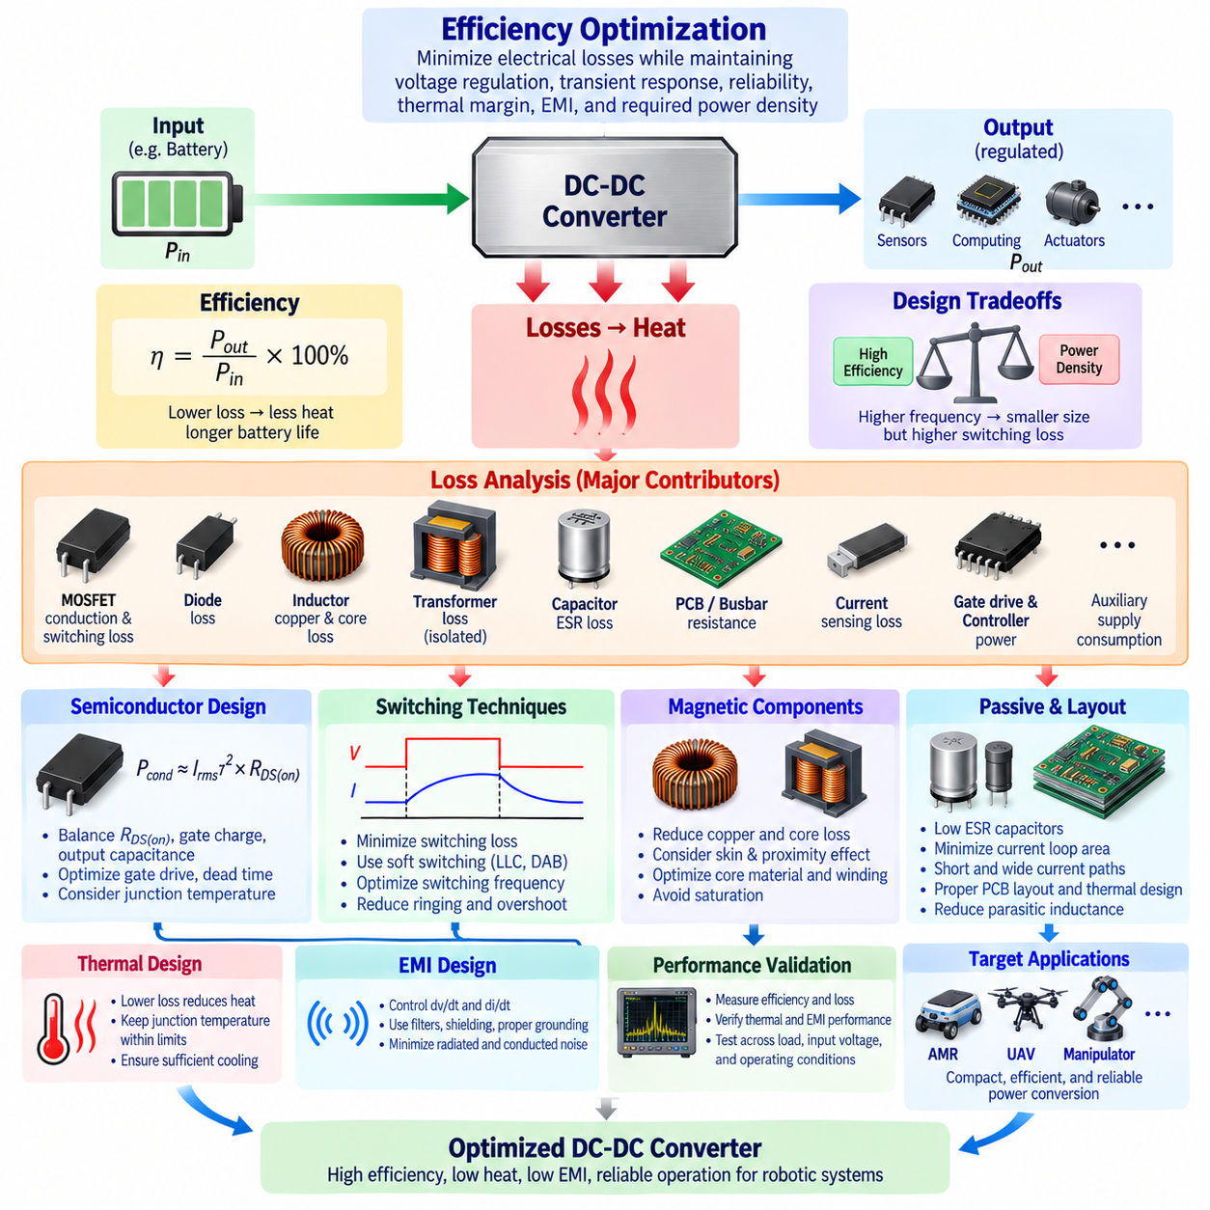
Efficiency optimization in a DC-DC converter is the systematic reduction of electrical losses while maintaining voltage regulation, transient response, reliability, thermal margin, electromagnetic compatibility, and required power density. Within the DC-DC converter design flow, efficiency optimization connects topology selection with the subsequent thermal and EMI design activities, making it a system-level engineering task rather than a single component improvement.
Converter efficiency is defined as the ratio of useful output power to electrical input power, expressed as η = Pout/Pin × 100%. The difference between input and output power becomes converter loss. Even a small efficiency improvement can significantly reduce heat generation at high power. For example, reducing total loss from five percent to three percent can substantially decrease cooling requirements, component temperatures, and wasted battery energy.
Loss analysis should begin by constructing a complete power-loss budget. Important contributors include semiconductor conduction loss, semiconductor switching loss, gate-drive consumption, inductor copper and core losses, transformer losses in isolated converters, capacitor ESR loss, PCB and busbar resistance, current sensing loss, auxiliary supply consumption, and controller power. Optimization requires identifying which mechanisms dominate under each operating condition.
MOSFET conduction loss is primarily related to drain-to-source on-state resistance and RMS current. It can be approximated using the relationship Pcond ≈ Irms² × RDS(on), with appropriate consideration of duty cycle and switching configuration. Because RDS(on) normally increases with junction temperature, conduction loss and device heating interact. Low-resistance devices, appropriate paralleling, effective cooling, and minimized current paths can therefore improve overall efficiency.
Selecting a MOSFET solely for minimum RDS(on), however, does not necessarily produce the most efficient converter. Devices with very low conduction resistance may have greater gate charge and output capacitance, increasing switching and gate-drive losses. The optimum semiconductor therefore depends on switching frequency, voltage, current, topology, thermal environment, and operating duty. Device selection must balance conduction characteristics against dynamic switching behavior.
Switching loss occurs primarily during transitions when substantial voltage and current exist simultaneously across a semiconductor. Approximate switching energy depends on switching voltage, current, rise and fall times, switching frequency, and device capacitances. Increasing switching frequency usually raises switching loss, even though it enables smaller magnetic and capacitive components. Frequency selection is therefore one of the central tradeoffs between efficiency and power density.
Soft-switching techniques can significantly reduce transition losses. LLC resonant converters can achieve zero-voltage switching for primary switches over suitable operating regions, while Dual Active Bridge converters can also achieve favorable ZVS conditions through appropriate phase-shift operation. By controlling current and voltage relationships during commutation, soft switching reduces switching energy, semiconductor heating, and potentially high-frequency electromagnetic emissions.
Gate-drive optimization is another important consideration. Every switching transition requires energy to charge and discharge semiconductor gate capacitance. Excessive gate resistance produces slow transitions and higher switching loss, whereas extremely fast transitions can increase ringing, overshoot, EMI, and device stress. Gate-drive voltage, resistance, dead time, driver strength, and PCB loop inductance should therefore be optimized together instead of maximizing switching speed independently.
Dead-time optimization is particularly important in synchronous converters. Excessive dead time forces current through body diodes or other reverse-conduction paths, increasing conduction loss and reverse-recovery effects. Insufficient dead time can cause simultaneous conduction of complementary switches and potentially destructive shoot-through current. Adaptive dead-time control can improve efficiency by maintaining the shortest safe interval as voltage, current, temperature, and operating mode change.
Magnetic components can represent a substantial portion of converter loss. Inductor and transformer copper loss is approximately related to RMS current squared multiplied by effective winding resistance. At high frequency, skin effect and proximity effect increase AC resistance beyond the DC winding resistance. Winding geometry, conductor thickness, litz wire, foil structures, interleaving, and magnetic integration can therefore influence both efficiency and physical size.
Magnetic core loss depends on core material, switching frequency, flux-density swing, waveform shape, and temperature. Increasing frequency can reduce magnetic component dimensions but may sharply increase hysteresis and eddy-current losses. Core selection should therefore consider the actual excitation waveform rather than only nominal frequency. Maintaining appropriate flux-density margin also prevents saturation, excessive magnetizing current, and severe efficiency degradation.
Inductor ripple current creates another optimization tradeoff. Larger inductance generally reduces ripple and RMS current but may require a larger magnetic component with increased winding resistance. Smaller inductance can reduce component size and improve transient response but increases ripple, peak current, semiconductor stress, and capacitor RMS current. The optimum value minimizes total system loss while satisfying transient, saturation, packaging, and EMI constraints.
Capacitor losses are mainly associated with equivalent series resistance and ripple current. High RMS ripple can produce significant internal heating even when average current is low. Capacitor technology, capacitance, ESR, voltage rating, temperature capability, and placement should be selected according to the converter waveform. Parallel capacitor banks can reduce effective ESR and distribute ripple current, but additional components increase cost, area, and parasitic complexity.
PCB layout has a direct influence on electrical efficiency. Long or narrow high-current traces introduce resistive loss, while excessive switching-loop inductance creates voltage overshoot and ringing that can require slower switching or stronger snubbing. Wide copper areas, appropriate copper thickness, short current loops, optimized vias, low-inductance connections, and properly designed busbars reduce parasitic resistance and inductance while supporting thermal spreading.
Snubbers and clamp circuits illustrate the relationship between efficiency and reliability. A dissipative snubber consumes energy and therefore reduces measured conversion efficiency, but it can suppress ringing and limit semiconductor voltage stress. Eliminating the snubber without reducing the underlying parasitic energy may compromise reliability. Optimization should first reduce parasitic inductance through layout and packaging, then use only the damping required for robust operation.
Converter efficiency varies strongly with load. At high load, conduction and magnetic losses often dominate, while at light load fixed switching, gate-drive, controller, and auxiliary losses become proportionally more important. A converter optimized only at rated output may therefore perform poorly during standby or low-power operation. This is especially relevant to robots, whose power demand changes continuously according to mission state and actuator activity.
Light-load efficiency can be improved through operating-mode management. Pulse-frequency modulation, pulse skipping, burst operation, phase shedding, or reduced switching frequency can lower unnecessary switching activity when output demand is small. These methods must be implemented carefully because they can increase output ripple, acoustic noise, low-frequency spectral content, or transient delay. The optimum strategy depends on the sensitivity of connected electronic loads.
For multiphase converters, phase shedding can improve efficiency over a broad load range. Multiple phases provide low ripple and high current capability at heavy load, but operating every phase at light load creates unnecessary switching and gate-drive losses. Disabling selected phases allows the remaining stages to operate closer to their efficient region. Additional phases can then be activated smoothly as power demand increases.
Efficiency optimization should account for battery voltage variation rather than using a single nominal input voltage. In an AMR, battery voltage changes with state of charge, current, temperature, and cell characteristics. These changes modify converter duty ratio, RMS current, switching conditions, and loss distribution. Efficiency maps should therefore cover input voltage, output power, and temperature across the complete expected operating envelope.
Temperature is both a consequence and a cause of conversion loss. Higher semiconductor temperature increases MOSFET on-state resistance, while winding resistance also rises as copper temperature increases. This creates a feedback relationship in which loss generates heat and heat produces additional loss. Thermal design and electrical efficiency optimization must consequently be performed together using realistic component temperatures rather than room-temperature datasheet values alone.
Wide-bandgap semiconductors such as silicon carbide and gallium nitride can improve efficiency in appropriate applications. SiC devices are particularly useful for higher-voltage and higher-power converters, while GaN devices can enable very fast switching and high-frequency operation at suitable voltage levels. Their advantages are greatest when gate drive, layout, magnetics, thermal design, and EMI engineering are optimized for their switching characteristics.
Control algorithms can also optimize efficiency dynamically. A digital controller can select switching frequency, operating mode, phase count, dead time, or modulation strategy according to input voltage, output demand, temperature, and measured current. In a DAB converter, phase-shift strategy can be adjusted to reduce circulating current. In an LLC converter, frequency operation can be managed to remain near efficient resonant regions whenever system conditions permit.
Bidirectional converters require efficiency optimization in both directions of energy flow. Forward and reverse operation may produce different semiconductor conduction paths, switching conditions, RMS currents, and thermal distributions. A design optimized only for battery discharge may perform inefficiently during regenerative energy recovery. Bidirectional efficiency maps should therefore evaluate both power direction and magnitude across the relevant bus-voltage combinations.
System-level optimization extends beyond the converter itself. Increasing distribution voltage can reduce current and I²R losses in wiring, connectors, fuses, and busbars, but may require additional conversion stages or higher-voltage components. Conversely, minimizing the number of conversion stages can reduce cumulative conversion loss. The best architecture balances distribution efficiency, isolation requirements, load voltage needs, wiring mass, safety, and serviceability.
For AMRs and other battery-powered robots, converter efficiency directly affects operating time and thermal loading. Energy lost in conversion is unavailable for propulsion, perception, computing, communication, or manipulation. Lower converter loss can increase mission endurance while reducing fan power and cooling hardware. These benefits become particularly important in compact sealed robots where airflow is limited and internal temperature accumulation can constrain continuous operation.
UAV platforms impose even stronger relationships between efficiency and mass. Inefficient conversion generates heat that may require additional heat sinks, airflow paths, or structural thermal interfaces, increasing vehicle mass. Higher efficiency can therefore produce secondary benefits beyond recovered electrical energy. However, optimization must preserve sufficient voltage margin, insulation, transient capability, reliability, and environmental robustness rather than pursuing peak efficiency as an isolated objective.
Efficiency verification should use measurements over representative operating conditions rather than relying only on theoretical calculations. Accurate input and output voltage and current measurements allow direct determination of power loss, while thermal measurements help identify concentrated loss sources. Testing across load, input voltage, temperature, and operating modes produces an efficiency map that can reveal regions where topology, modulation, component selection, or cooling should be improved.
The final objective is not necessarily the highest possible peak efficiency but the lowest practical energy loss across the real mission profile. A robotic DC-DC converter should maintain high efficiency during the operating states where the system spends most of its time while preserving transient performance, thermal margin, EMC compliance, protection, and reliability. Efficiency optimization therefore becomes an integrated process linking electrical design, control, magnetics, packaging, and system operation.

06.04. Thermal Design
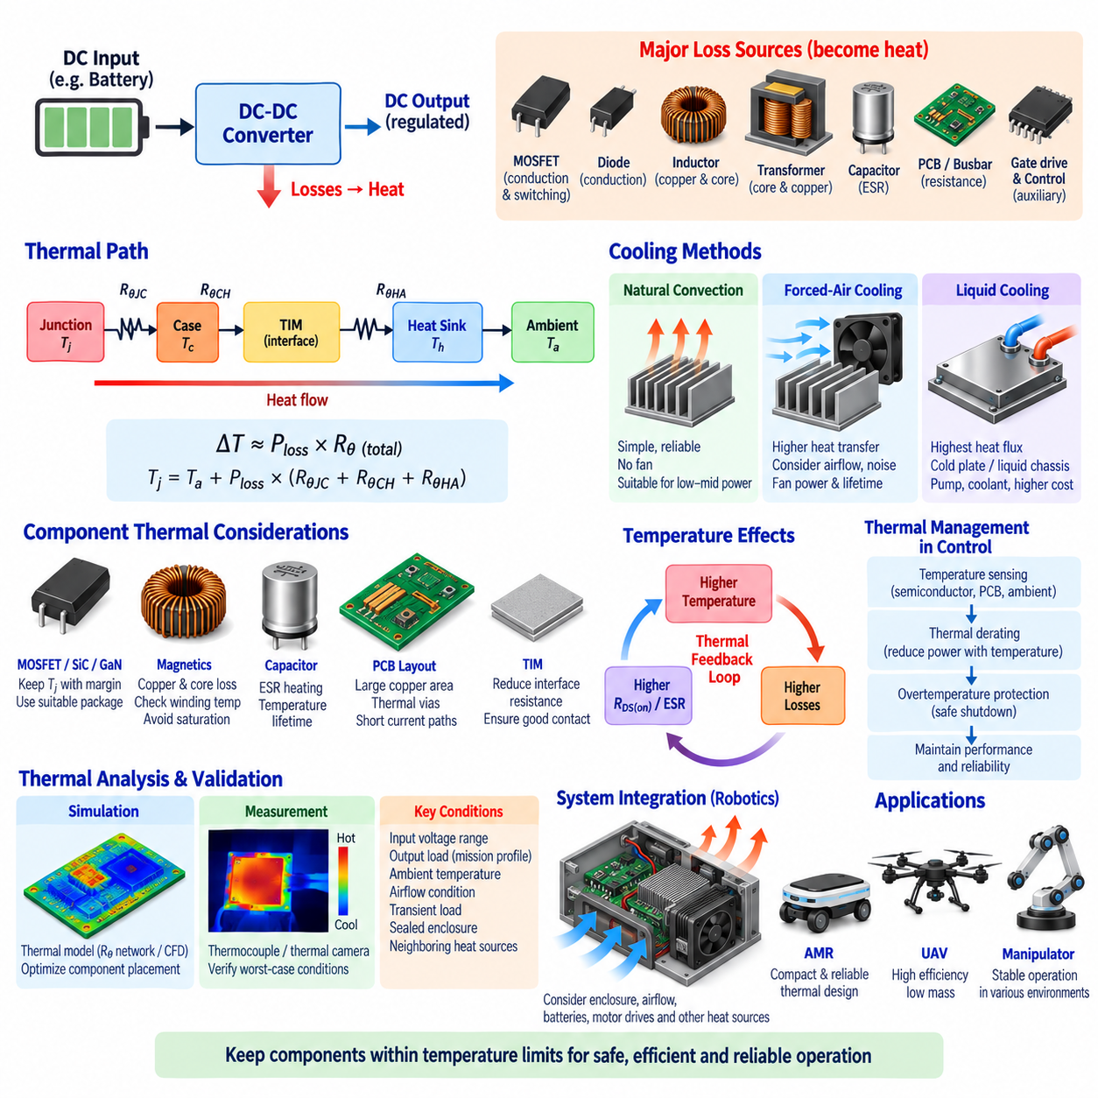
Thermal design of a DC-DC converter ensures that heat generated by semiconductor, magnetic, capacitive, conductive, and control losses is transferred safely to the surrounding environment. Because excessive temperature accelerates component degradation and can cause protection trips or catastrophic failure, thermal engineering must be integrated with electrical design from the earliest stage rather than treated as a final packaging activity.
Every electrical loss inside the converter ultimately appears as heat. Major heat sources include MOSFET conduction and switching losses, diode losses, gate-drive consumption, inductor copper and core losses, transformer losses, capacitor ESR losses, PCB trace resistance, busbar resistance, and auxiliary circuitry. Accurate thermal design therefore begins with a realistic loss budget covering input voltage, output power, switching frequency, and operating mode.
Semiconductor junction temperature is one of the most important thermal limits. MOSFETs, SiC devices, GaN devices, diodes, and integrated power modules have specified maximum junction temperatures, but continuous operation should normally maintain sufficient margin below these limits. Repeated exposure to high junction temperature can accelerate package degradation, interconnection fatigue, parameter drift, and other temperature-dependent reliability mechanisms.
A simplified thermal path can be represented as junction-to-case, case-to-heat-sink, and heat-sink-to-ambient thermal resistances. The temperature rise can be estimated from dissipated power multiplied by the effective thermal resistance, expressed conceptually as ΔT ≈ Ploss × Rθ. Although this model is useful for preliminary sizing, practical converters often require multidimensional thermal analysis because several components interact through the PCB, enclosure, and cooling structure.
Junction-to-case thermal resistance describes heat movement from the semiconductor junction through its package toward an external thermal interface. Package selection strongly influences this path. Power packages with exposed thermal pads, large metal surfaces, or direct-bonded substrates can transfer heat more effectively than packages intended for low-power electronics. Electrical parasitics, mechanical assembly, insulation, and manufacturing capability must also be considered during package selection.
The printed circuit board can function as an important heat spreader rather than merely an electrical interconnection structure. Large copper areas distribute heat away from power devices, while thermal vias can transfer heat between PCB layers or toward a chassis interface. Copper thickness, layer count, via diameter, via density, solder coverage, and internal copper planes influence thermal performance and should be coordinated with high-current electrical routing requirements.
Thermal vias are especially useful beneath MOSFETs, power ICs, rectifiers, and other devices with exposed thermal pads. Multiple vias reduce effective thermal resistance by providing parallel conduction paths through the PCB. However, via geometry must remain compatible with soldering and manufacturing processes. Poorly designed via arrays can cause solder wicking, void formation, assembly defects, or reduced thermal contact beneath the package.
Heat sinks increase the surface area available for transferring heat from components to ambient air. Their performance depends on material conductivity, fin geometry, orientation, airflow, mounting pressure, and interface resistance. A large heat sink does not guarantee effective cooling if heat cannot efficiently reach it from the semiconductor. The complete path from junction through package, thermal interface material, heat sink, and ambient environment must therefore be evaluated.
Thermal interface materials reduce microscopic air gaps between mating surfaces such as a power module and chassis or a semiconductor and heat sink. Thermal pads, grease, phase-change materials, and electrically insulating interface sheets offer different combinations of conductivity, compliance, thickness, dielectric strength, and assembly convenience. Interface thickness and mounting pressure can significantly affect the resulting thermal resistance.
Natural convection can be sufficient for low- and moderate-power converters when adequate surface area and airflow paths are available. It offers advantages in reliability, acoustic noise, contamination resistance, and maintenance because no fan is required. However, natural convection depends strongly on enclosure orientation and ambient conditions, and its cooling capability can become inadequate for compact high-power converters or sealed robotic platforms.
Forced-air cooling increases convective heat transfer by moving air across heat sinks, PCB surfaces, and magnetic components. Fan selection must consider airflow, static pressure, acoustic noise, power consumption, dust exposure, lifetime, and failure behavior. In robotic systems, cooling airflow may be obstructed by internal packaging or filters, so thermal validation should use realistic assembled configurations rather than unrestricted laboratory airflow.
Liquid cooling can support substantially higher heat flux where air cooling becomes impractical. Cold plates or liquid-cooled chassis structures can remove heat directly from power semiconductor modules and other concentrated heat sources. This approach is relevant to high-power mobile platforms, but pumps, hoses, seals, coolant, connectors, monitoring, and leak management increase system complexity, mass, cost, and maintenance requirements.
Magnetic components require dedicated thermal consideration because their heat generation is distributed through both windings and cores. Copper loss heats the winding, while hysteresis and eddy-current mechanisms heat the magnetic core. Winding temperature can exceed the externally measured core or case temperature, particularly in compact transformers and inductors. Insulation class and maximum winding temperature therefore establish important design limits.
Transformer thermal design is particularly significant in isolated LLC and DAB converters. High-frequency operation can increase AC winding resistance through skin and proximity effects, while core loss depends on frequency and flux-density swing. Winding arrangement, conductor structure, core geometry, air circulation, potting material, and contact with thermally conductive surfaces determine how effectively this internally generated heat reaches the surrounding environment.
Capacitors are also temperature-sensitive components. Ripple current flowing through equivalent series resistance generates internal heat, while elevated ambient temperature accelerates aging, particularly in electrolytic technologies. Capacitor placement near hot MOSFETs, inductors, or heat sinks can therefore reduce expected lifetime even when capacitor electrical stress remains within rating. Thermal layout should protect lifetime-sensitive components from concentrated heat sources.
Temperature influences electrical efficiency as well as reliability. MOSFET RDS(on) generally increases with junction temperature, and copper winding resistance rises with conductor temperature. Consequently, higher temperature increases conduction loss, which creates additional heat and can further increase temperature. This electrothermal feedback means loss calculations should be iterated using expected operating temperatures rather than relying exclusively on room-temperature component parameters.
Thermal coupling between components can produce hot spots that are not predicted by individual component calculations. A MOSFET, inductor, transformer, and rectifier positioned closely together can heat the same PCB region and enclosure volume. Component spacing, airflow direction, copper distribution, and mechanical contact should therefore be designed using the combined heat map of the converter rather than independent maximum-temperature estimates.
Ambient temperature establishes the starting point for the entire thermal budget. A converter operating safely at room temperature may exceed component limits inside a sealed AMR exposed to summer conditions or near motors and batteries. Maximum internal ambient temperature should therefore be based on the actual installation environment, including solar loading, enclosure heating, restricted airflow, neighboring equipment, and mission duration where applicable.
Thermal derating reduces allowable converter power as temperature approaches defined limits. Instead of operating normally until an abrupt overtemperature shutdown occurs, the controller can progressively reduce current or output power according to measured temperature. This approach maintains thermal margin and may allow the robotic system to continue operating at reduced capability rather than immediately losing an essential power rail.
Temperature sensing should focus on locations that represent critical thermal conditions. Sensors may monitor semiconductor packages, heat sinks, PCB hot spots, inductors, transformers, connectors, or coolant. Because the actual semiconductor junction cannot usually be measured directly during normal operation, junction temperature may be estimated from case temperature, thermal models, electrical parameters, or integrated semiconductor sensing functions.
Overtemperature protection provides a final defense against abnormal thermal conditions. Protection thresholds should account for sensor location, thermal delay, measurement tolerance, maximum component ratings, and the time required to reduce power safely. A fast semiconductor temperature rise may occur before a remotely located PCB sensor responds, so protection architecture should distinguish between rapid local heating and slower enclosure-level temperature changes.
Transient thermal behavior is important because converter loads are rarely constant in robotic applications. Motors, manipulators, computing accelerators, sensors, and communication systems create time-varying demand. Thermal capacitance allows components to tolerate short power peaks that would be unacceptable continuously. Mission-based thermal analysis can therefore distinguish permissible transient overload from continuous thermal capability without unnecessarily oversizing the converter.
Thermal time constants vary substantially among semiconductor junctions, packages, PCB structures, magnetic components, heat sinks, and enclosures. Semiconductor junction temperature can respond quickly to changing power, while a large chassis may warm over many minutes. Dynamic thermal models help determine whether repeated acceleration, charging, manipulation, or regenerative events accumulate heat faster than the system can reject it.
Mechanical design and thermal design are closely connected. A metal robot chassis can serve as a large heat spreader when the converter is mounted through an appropriate thermal interface. This approach can eliminate or reduce dedicated heat sinks, but chassis temperature, user-accessible surface limits, vibration, mounting tolerances, corrosion, electrical isolation, and serviceability must be considered before using structural components as thermal paths.
Environmental protection can conflict with cooling requirements. Sealed enclosures improve resistance to dust and water but restrict convective airflow. Potting can improve environmental robustness and heat transfer in some regions while creating mechanical stress or trapping heat in others. The required ingress protection, vibration resistance, humidity tolerance, contamination resistance, and cooling architecture should therefore be developed as one integrated packaging strategy.
AMR converters frequently operate in enclosed compartments containing batteries, motor drives, computers, and communication equipment. Heat from these neighboring systems raises the converter inlet or local ambient temperature. The DC-DC converter thermal design should therefore be based on compartment-level energy balance and airflow rather than assuming external room temperature. Shared cooling resources must account for simultaneous peak operation of major heat-producing subsystems.
UAV applications impose stricter mass and cooling constraints. Large heat sinks directly reduce available payload, while airflow varies with vehicle speed, rotor flow, altitude, and operating condition. Efficient power conversion is therefore particularly valuable because every watt of avoided loss reduces both battery consumption and cooling demand. Thermal architecture must nevertheless maintain adequate component temperature during low-airflow conditions such as ground operation or hover.
Thermal simulation can support component placement, heat-sink sizing, airflow design, and enclosure optimization before hardware is finalized. Analytical thermal-resistance networks provide fast preliminary estimates, while detailed computational models can examine conduction, convection, and local hot spots. Simulation results should be correlated with prototype measurements because interface quality, airflow leakage, material properties, and manufacturing variation can differ from idealized assumptions.
Thermal validation should reproduce worst-case electrical and environmental conditions. Measurements can include thermocouples, embedded temperature sensors, thermal cameras, semiconductor telemetry, and coolant measurements where appropriate. Testing across input voltage, output load, ambient temperature, airflow, and operating modes verifies whether junction, magnetic, capacitor, connector, PCB, and enclosure temperatures remain within their specified limits.
The objective of DC-DC converter thermal design is not simply to prevent immediate overheating. A successful design maintains acceptable temperatures throughout the expected mission profile while supporting efficiency, lifetime, reliability, power density, EMC performance, and environmental robustness. Thermal engineering therefore forms a continuous link between converter loss optimization and physical integration, providing the foundation for reliable power conversion in AMRs, UAVs, manipulators, and other robotic systems.

06.05. DC-DC EMI Design
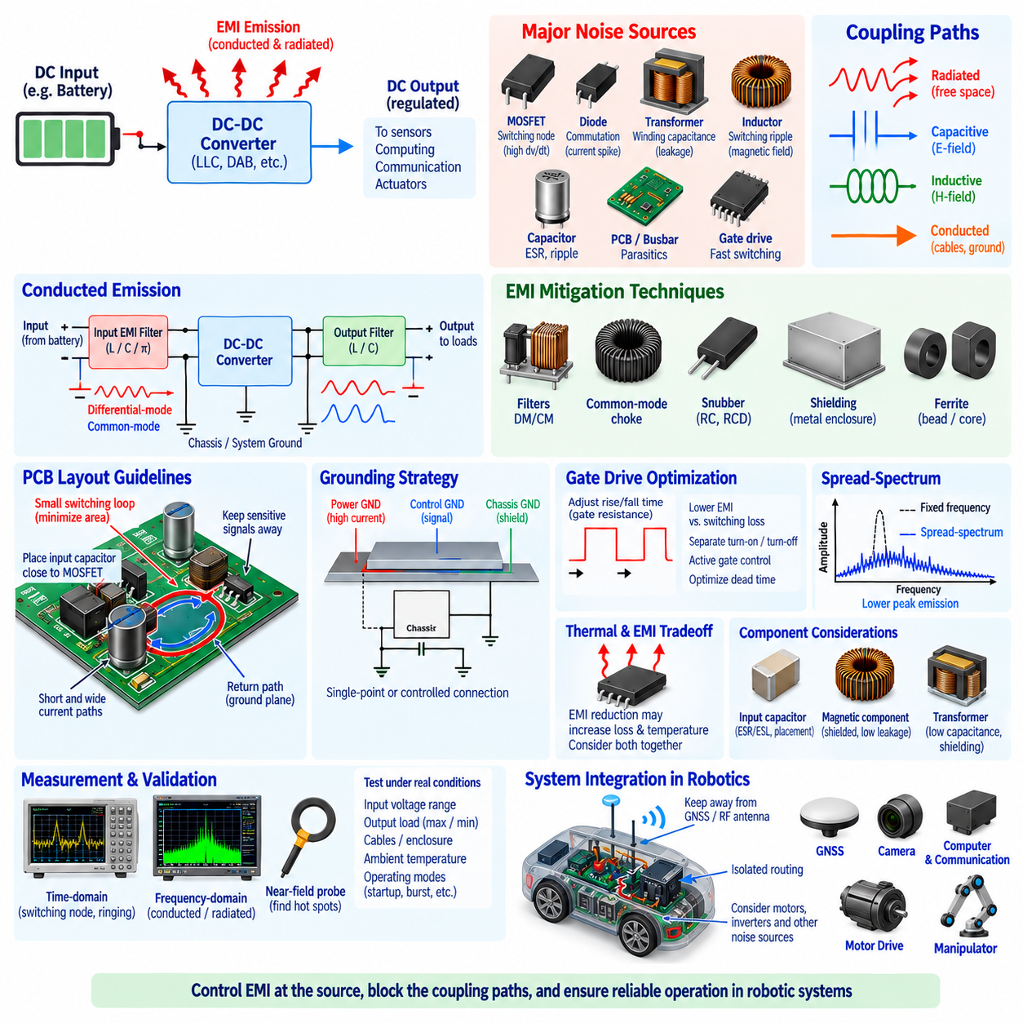
Electromagnetic interference in a DC-DC converter originates primarily from rapid changes in voltage and current created by semiconductor switching. High dv/dt switching nodes generate electric-field coupling, while high di/dt current loops generate magnetic-field coupling. Without careful design, these disturbances can propagate through power cables, PCB structures, chassis, and free space into sensitive electronic systems.
EMI design should begin by identifying the converter’s dominant noise sources and coupling paths rather than adding filters after hardware problems appear. MOSFET switching nodes, diode commutation, transformer windings, inductors, gate-drive loops, and parasitic resonances can all generate interference. The resulting noise reaches other circuits through conducted, capacitive, inductive, or radiated coupling mechanisms.
Conducted emissions travel through electrical connections such as battery cables, DC buses, grounding networks, and output wiring. Switching current drawn from the input capacitor can produce substantial differential-mode noise, while parasitic capacitance between switching structures and chassis or ground can generate common-mode current. These mechanisms require different mitigation techniques and should therefore be distinguished during measurement and analysis.
Differential-mode noise appears primarily between the positive and negative conductors of a power interface. It is strongly related to pulsed converter input current and switching ripple. Input capacitors placed close to the switching stage provide a local high-frequency current path, reducing the current transmitted into the upstream harness. Additional differential-mode inductors and capacitors can form LC or π filters when further attenuation is required.
Common-mode noise flows in the same direction through multiple conductors and returns through parasitic paths involving chassis, shielding, structural metal, or stray capacitance. High dv/dt switching nodes are major excitation sources. Common-mode chokes, controlled chassis coupling, shielding, optimized transformer construction, and carefully selected Y-capacitors can reduce these currents while maintaining required isolation and safety characteristics.
PCB layout is one of the most effective EMI-control techniques because electromagnetic behavior is strongly determined by current-loop geometry. High-frequency switching loops should be made as short and compact as possible. The input bypass capacitor, switching devices, rectification path, and associated return path should be positioned to minimize loop area, thereby reducing parasitic inductance, voltage overshoot, ringing, and magnetic radiation.
The switching-node copper area should generally be limited to what is electrically and thermally necessary. A large switching node can behave as a capacitive radiator and increase coupling into neighboring circuits or chassis structures. Sensitive analog traces, communication interfaces, feedback networks, and sensor signals should be routed away from high dv/dt regions. Layer arrangement should provide controlled return paths without unintentionally increasing parasitic coupling.
Grounding strategy requires careful separation of high-current switching returns from sensitive signal references. Power ground, control ground, chassis ground, and protective or functional grounding may serve different purposes depending on the architecture. Uncontrolled ground impedance can convert switching current into unwanted voltage disturbances. Intentional connection points and low-impedance return paths help prevent converter noise from contaminating measurement and communication circuits.
Input capacitors are critical for containing switching current locally. High-frequency ceramic capacitors should normally be positioned close to the switching devices, while larger bulk capacitors support lower-frequency energy demand and load transients. Capacitor effective series resistance, effective series inductance, voltage bias characteristics, ripple capability, and physical placement determine their actual filtering effectiveness at the frequencies of interest.
An input EMI filter can prevent converter-generated noise from propagating toward the battery or upstream power distribution unit. However, the filter cannot be designed independently of the converter input impedance. An improperly damped LC filter may interact with the converter control loop and create oscillation or instability. Passive damping, capacitor ESR, dedicated damping networks, or active damping techniques may therefore be necessary.
Output filtering reduces switching ripple and high-frequency noise delivered to downstream electronics. This is especially important when the converter supplies cameras, GNSS receivers, IMUs, communication modules, analog sensors, or precision measurement electronics. Filter design must provide sufficient attenuation without creating excessive voltage drop, transient response degradation, resonant peaking, or unwanted interaction with downstream input filters.
Gate-drive design directly influences the EMI spectrum. Faster MOSFET transitions reduce switching loss but increase dv/dt and di/dt, potentially producing stronger ringing and higher-frequency emissions. Increasing gate resistance can slow transitions and reduce EMI, but excessive resistance increases switching loss and device heating. Gate resistance, drive voltage, dead time, layout, and semiconductor characteristics must therefore be optimized as a combined system.
Separate turn-on and turn-off gate resistances can provide additional control over switching behavior. Designers may intentionally slow the transition most responsible for EMI while maintaining faster operation during another transition. Active gate drivers can dynamically control gate current or voltage slew rate according to operating conditions, allowing switching performance to be balanced against efficiency, overshoot, device stress, and electromagnetic emissions.
Parasitic inductance combined with semiconductor capacitance creates resonant ringing during switching transitions. This ringing can generate narrow-band emission peaks at frequencies much higher than the nominal switching frequency. Minimizing loop inductance is the preferred first solution. RC snubbers, RCD networks, active clamps, or other damping techniques can then suppress remaining oscillation, although dissipative suppression introduces additional power loss.
Magnetic components can both generate and suppress electromagnetic interference. Inductors carry high-frequency ripple current and can radiate magnetic fields if flux leakage is significant. Shielded inductors and appropriate core structures reduce external field coupling. Component orientation and distance from sensitive circuitry are also important because even a well-designed magnetic component can couple interference into nearby signal loops.
Transformer design is especially important in isolated LLC and DAB converters. Parasitic capacitance between primary and secondary windings provides a path for common-mode displacement current across the isolation barrier. Winding arrangement can reduce this capacitance, while electrostatic shields may redirect common-mode current toward a controlled reference. These measures must be balanced against leakage inductance, insulation, efficiency, and thermal requirements.
Shielding is most effective when it forms a controlled electromagnetic boundary with appropriate grounding. Metal enclosures, conductive covers, cable shields, and PCB-level shields can reduce electric-field and radiated coupling. Poorly terminated shields may provide little benefit or create unintended current paths. High-frequency shield connections should generally minimize impedance because long grounding leads can behave inductively and reduce shielding effectiveness.
Cable design becomes part of converter EMI engineering because DC power wiring can act as both a conducted-noise path and an antenna. Keeping positive and return conductors close together reduces loop area and magnetic radiation. Twisted pairs can further reduce coupling in suitable applications. Shielded cables may be required for particularly noisy or sensitive interfaces, but shield termination strategy must be coordinated with chassis and grounding architecture.
Connector pin assignment also influences EMI performance. High-current supply and return pins should be arranged to minimize current-loop area, and sensitive signals should not be placed unnecessarily close to noisy switching-related conductors. Multiple ground or return pins may reduce connection impedance. Connector shielding and chassis bonding become increasingly important where cables leave a metallic enclosure and can radiate internal converter noise.
Spread-spectrum modulation can distribute switching energy across a wider frequency range rather than concentrating it at discrete spectral peaks. This can reduce measured peak emissions in some systems, particularly where regulatory limits are evaluated with finite receiver bandwidth. However, spread spectrum does not eliminate total electromagnetic energy and should complement, rather than replace, good layout, filtering, grounding, and switching design.
Efficiency and EMI frequently create competing requirements. Very fast switching can reduce transition energy and enable smaller passive components, but it also increases high-frequency spectral content. Strong filtering or snubbing can reduce emissions while adding conduction or dissipation losses. The optimum design therefore minimizes noise at its physical source first and applies filtering or damping only where necessary to satisfy system-level requirements.
Thermal design and EMI design are similarly connected. Increasing gate resistance to reduce emissions can raise semiconductor switching loss and junction temperature. Adding a common-mode choke introduces winding loss and heat, while compact shielding may restrict airflow. EMI countermeasures should therefore be evaluated for their thermal impact, and thermal modifications should be checked for unintended changes in grounding, parasitic capacitance, and radiation paths.
EMI filters must be selected for realistic current and environmental conditions. Inductor saturation, common-mode choke heating, capacitor ripple current, DC bias, temperature, and component tolerances can change filter performance. A filter that provides adequate attenuation during low-power laboratory testing may behave differently at maximum converter current or elevated temperature. Worst-case operating conditions should therefore be included in validation.
Robotic systems create particularly demanding electromagnetic environments because DC-DC converters operate near motor drives, inverters, processors, Ethernet interfaces, CAN networks, cameras, LiDAR, radar, GNSS, and IMUs. These subsystems can both generate and receive interference. Converter EMI design must therefore consider the complete electrical architecture rather than treating regulatory emissions from the converter as the only acceptance criterion.
GNSS and other radio-frequency receivers can be especially sensitive because their desired signals may be extremely weak. Harmonics or broadband noise from switching converters can degrade receiver sensitivity even when basic converter operation appears normal. Physical separation, shielding, switching-frequency planning, cable routing, filtering, and clean power rails can help prevent converter noise from reducing localization or wireless communication performance.
Communication networks can also be affected through conducted and common-mode coupling. CAN, Ethernet, USB, and other high-speed interfaces rely on controlled signal integrity and common-mode behavior. Converter switching currents entering connector grounds or chassis structures can increase communication errors. Power and communication routing should therefore be coordinated, with appropriate filtering and reference-plane design at subsystem boundaries.
EMI verification should combine time-domain and frequency-domain measurements. Oscilloscope measurements can reveal switching-node ringing, voltage overshoot, ground bounce, and current-loop behavior, while spectrum measurements identify fundamental switching components, harmonics, and resonant peaks. Near-field probes are useful for locating PCB hot spots before expensive system-level testing and can guide layout or component modifications.
Conducted-emission testing evaluates disturbances appearing on power interfaces, while radiated-emission testing evaluates electromagnetic energy leaving the converter and associated wiring. Immunity testing is equally important because the converter must continue operating correctly when exposed to disturbances generated elsewhere in the robot. Robust power conversion therefore requires both low emissions and adequate immunity against external electromagnetic disturbances.
Pre-compliance testing during development can identify problems before final certification or system validation. Testing successive PCB revisions with representative cables, enclosure structures, loads, grounding, and operating modes provides more useful information than evaluating an isolated open-board converter alone. Worst-case switching states, maximum load, light-load burst modes, startup, shutdown, and regenerative conditions should be included where applicable.
Successful DC-DC EMI design is achieved through coordinated source reduction, coupling-path control, filtering, grounding, shielding, layout, and validation. EMI should not be treated as a final filter added after electrical design is complete. For AMRs, UAVs, manipulators, and other robotic platforms, integrating electromagnetic compatibility with efficiency, thermal design, isolation, protection, and packaging enables stable power conversion without degrading the sensors, communication networks, or computing systems that depend on it.

