Volume 11. Battery and Powertrain

Chapter 01. Battery Fundamentals

01.01. Electrochemical Principles
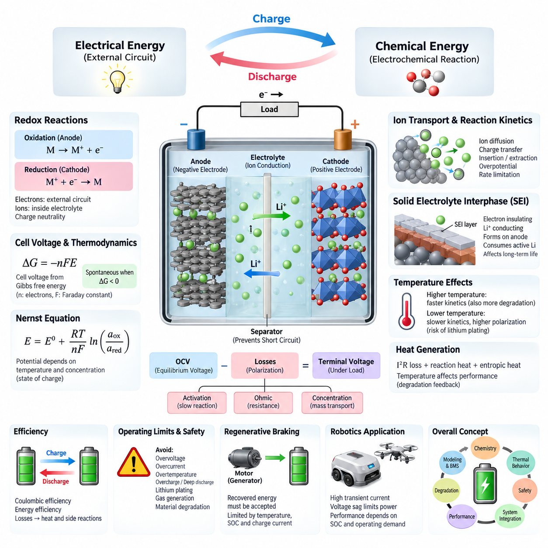
Electrochemical energy storage is based on the controlled conversion between chemical energy and electrical energy through oxidation and reduction reactions. A battery cell contains two electrodes separated by an ionically conductive electrolyte. During operation, electrons travel through the external circuit while ions move internally through the electrolyte, allowing electrical work to be delivered without direct electronic conduction between the electrodes.
An electrochemical cell operates through two coupled half-reactions. Oxidation releases electrons at one electrode, while reduction consumes electrons at the other. These reactions must occur simultaneously because charge cannot accumulate indefinitely within either electrode. The external electron flow and internal ionic flow therefore form complementary paths that maintain charge neutrality and sustain continuous electrochemical conversion.
During discharge, the negative electrode functions as the anode, where oxidation supplies electrons to the external circuit. The electrons pass through the connected electrical load and reach the positive electrode, or cathode, where reduction occurs. Inside the cell, ions migrate through the electrolyte to balance the electronic charge transfer. Charging applies an external voltage that drives these processes in the reverse direction.
The tendency of an electrode to participate in oxidation or reduction is represented by its electrode potential. A practical cell voltage results from the difference between the electrochemical potentials of its positive and negative electrodes. Selecting electrode materials with an appropriate potential difference enables useful operating voltage, while their chemical stability determines whether the reactions can be repeated reversibly over many charge-discharge cycles.
Under equilibrium conditions, cell voltage is related to the change in Gibbs free energy of the electrochemical reaction. The fundamental relationship ΔG = −nFE connects chemical driving force with electrical potential, where n is the number of electrons transferred and F is the Faraday constant. A negative Gibbs free-energy change for the discharge reaction corresponds to the ability of the cell to deliver electrical energy spontaneously.
Electrode potential is not constant under all operating conditions. The Nernst equation describes how equilibrium potential varies with temperature and the activities or effective concentrations of participating chemical species. Consequently, battery voltage depends not only on electrode chemistry but also on composition and state of charge. This relationship provides an important thermodynamic foundation for interpreting open-circuit voltage and electrochemical state.
The electrolyte provides the ionic conduction path required to complete the internal electrochemical circuit while ideally blocking electronic conduction. Depending on battery chemistry, charge may be transported by lithium ions or other ionic species. The separator physically prevents direct contact between positive and negative electrodes while remaining permeable to ions, thereby reducing the possibility of an internal short circuit while permitting normal cell operation.
At each electrode-electrolyte interface, electrochemical reactions involve charge transfer between electronic states in the electrode and ionic species in the electrolyte. Reaction kinetics determine how rapidly this transfer can occur. When current increases, the actual electrode potential departs from its equilibrium value. This deviation, commonly described as overpotential, represents additional electrochemical driving force required to sustain the desired reaction rate.
Battery voltage under load therefore differs from equilibrium open-circuit voltage. Activation polarization arises from finite charge-transfer kinetics, ohmic polarization results from resistance in electrodes, electrolyte, current collectors, tabs, and connections, and concentration polarization develops when reactants cannot be transported rapidly enough. These effects collectively produce voltage loss during discharge and additional required voltage during charging.
Ion transport inside electrodes and electrolyte is another fundamental limitation on battery performance. Ions must migrate or diffuse through electrolyte pathways and, in many rechargeable cells, enter or leave active electrode materials. At high current, transport may become unable to maintain uniform concentration distributions. Resulting concentration gradients increase polarization, reduce accessible capacity, generate additional heat, and can accelerate degradation under demanding operating conditions.
Rechargeable lithium-ion cells commonly store charge through reversible insertion and extraction of lithium ions within host electrode structures. During discharge, lithium ions move through the electrolyte from the negative side toward the positive side while electrons follow the external circuit. During charging, an external power source reverses these flows. Maintaining structural and chemical reversibility is essential for achieving acceptable efficiency and cycle life.
The solid-electrolyte interphase, commonly called the SEI, illustrates the importance of interface chemistry. It forms primarily through electrolyte reduction at the negative electrode and can become electronically insulating while remaining conductive to lithium ions. A stable SEI suppresses continuous electrolyte decomposition, but its formation consumes active lithium. Continued growth or repeated damage can increase impedance and contribute to long-term capacity loss.
Electrochemical reactions are strongly influenced by temperature. Increasing temperature generally accelerates reaction kinetics and ionic transport, potentially reducing internal resistance, but it also accelerates undesirable side reactions and material degradation. Low temperature slows charge transfer and diffusion, increasing polarization and reducing available power. Charging under unsuitable low-temperature conditions may also create damaging deposition mechanisms instead of normal reversible ion insertion.
Electrical current and heat generation are closely coupled within a working cell. Resistive losses approximately increase with the square of current through I²R heating, while electrochemical polarization and reversible entropic effects can contribute additional thermal behavior. Because temperature subsequently changes resistance, kinetics, transport, and degradation rates, battery operation forms an electrochemical-thermal feedback system rather than an isolated electrical energy source.
The observable terminal voltage of a battery can consequently be interpreted as an equilibrium electrochemical voltage modified by dynamic losses. A simplified engineering representation expresses terminal behavior through open-circuit voltage, internal resistance, and polarization components. Although real cells require more sophisticated models, this viewpoint connects fundamental electrochemistry with equivalent-circuit models used by battery management systems for state estimation, prediction, protection, and power limitation.
Energy efficiency depends on how closely charging and discharging occur to their reversible electrochemical potentials. Internal resistance, activation losses, transport limitations, and parasitic reactions convert part of the supplied or stored energy into heat or irreversible chemical change. Coulombic efficiency describes charge recovery, while energy efficiency additionally accounts for voltage differences between charging and discharging. Small persistent inefficiencies can become significant over many cycles.
Electrochemical stability defines practical operating boundaries. Excessive voltage, current, temperature, overcharge, or deep discharge can push electrode and electrolyte potentials outside stable regions, promoting electrolyte decomposition, gas generation, metal dissolution, lithium plating, structural damage, or other unwanted reactions. Battery protection therefore depends on controlling not only terminal voltage but also the internal electrochemical conditions that terminal measurements indirectly represent.
For robotics, electrochemical behavior directly affects available propulsion and computing performance. Motors can impose large transient currents during acceleration, climbing, steering, manipulation, or recovery from obstacles, while processors and sensors create persistent auxiliary loads. Voltage sag caused by internal resistance and polarization can therefore constrain peak power even when considerable stored energy remains, making battery capability dependent on both state of charge and instantaneous operating demand.
Regenerative operation introduces the opposite power flow. When motors act as generators, recovered electrical energy must be accepted by the battery through electrochemical charging reactions. Charge acceptance depends on temperature, state of charge, cell chemistry, internal resistance, and allowable charging current. A nearly full or cold battery may accept considerably less regenerative power, requiring the powertrain controller and battery management system to restrict recovery.
These electrochemical principles form the foundation for understanding battery capacity, energy, power, C-rate, degradation, safety, charging, and battery management. They also explain why battery design cannot be reduced to nominal voltage and ampere-hour ratings. Effective robotic powertrain engineering requires coordinated consideration of thermodynamics, reaction kinetics, ion transport, electrical resistance, thermal behavior, operating limits, and the time-varying power demands of the complete system.

01.02. Capacity/Energy/Power
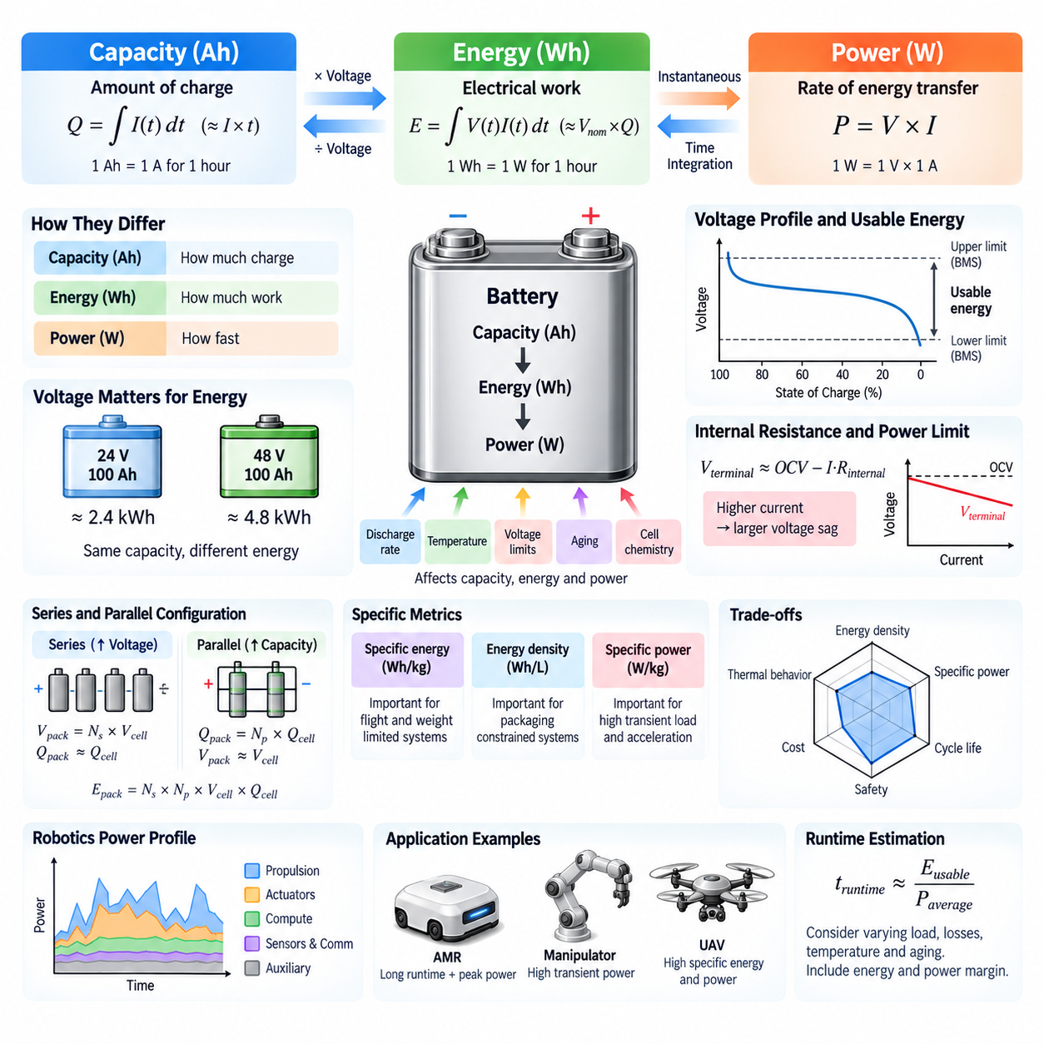
Battery capacity describes the quantity of electrical charge that a battery can deliver under specified operating conditions. It is commonly expressed in ampere-hours (Ah), where one ampere-hour represents a current of one ampere flowing for one hour. Capacity is fundamentally associated with the amount of electrochemically active material available for reversible reaction, but the usable value depends strongly on discharge rate, temperature, voltage limits, aging, and cell chemistry.
The basic relationship between current and capacity can be expressed as Q = ∫I(t)dt. For approximately constant current, this becomes Q = I × t, making capacity a convenient indicator of how long a battery can support a given electrical load. A 100 Ah battery could theoretically provide 10 A for 10 hours, but practical runtime differs because voltage changes, internal losses, protection limits, temperature, and rate-dependent electrochemical effects reduce accessible capacity.
Rated capacity is measured according to defined test conditions rather than representing an unconditional property of the cell. Manufacturers specify discharge current, temperature, initial state of charge, and cutoff voltage when reporting capacity. Changing any of these conditions can alter the measured result. Consequently, engineering comparisons between battery cells or packs should use equivalent test conditions instead of comparing nominal ampere-hour values without considering their measurement basis.
Battery energy represents the electrical work that can be delivered and is measured in watt-hours (Wh) or kilowatt-hours (kWh). Energy depends on both transferred charge and cell voltage, so it provides information that capacity alone cannot provide. The general relationship is E = ∫V(t)I(t)dt. When voltage can be approximated by a representative value, stored energy is often estimated using E ≈ Vnom × Q, where Vnom is nominal voltage.
This distinction becomes important when comparing batteries operating at different voltages. A 100 Ah battery at 24 V stores approximately half the nominal energy of a 100 Ah battery at 48 V, despite having identical ampere-hour capacity. For robotic systems, energy therefore provides a more meaningful first-order measure of potential operating duration, while ampere-hour capacity remains useful for analyzing cell charge, current loading, battery management, and configuration.
Nominal energy is not identical to usable energy. Battery voltage varies with state of charge, current, temperature, and electrochemical polarization, while the battery management system normally prevents operation beyond defined upper and lower voltage limits. Additional reserve margins may be introduced to improve cycle life or safety. Usable energy therefore represents the portion of nominal stored energy that can actually be accessed within the permitted operating window.
Power describes the instantaneous rate at which electrical energy is transferred and is expressed in watts or kilowatts. Electrical power is calculated as P = V × I. A battery may contain substantial energy yet be unable to supply a required peak power if its allowable current is insufficient. Conversely, a high-power battery can support intense short-duration loads while having relatively modest total energy and therefore limited operating duration.
The distinction between energy and power is especially important in robotic powertrain design. Energy determines how long an AMR, mobile manipulator, quadruped, or UAV can continue operating, whereas power determines whether the system can perform demanding actions at a particular moment. Acceleration, climbing, lifting, steering, rapid joint motion, and high-compute operation can produce transient power requirements significantly above the average mission load.
Battery power capability is constrained by cell voltage, internal resistance, reaction kinetics, ion transport, thermal limits, and manufacturer-defined current limits. When high current is drawn, internal resistance and polarization cause terminal voltage to fall. A simplified representation is Vterminal ≈ OCV − I·Rinternal. The corresponding voltage sag can prevent the powertrain from obtaining its requested power even though considerable electrochemical energy remains stored in the battery.
Maximum battery output power therefore cannot be inferred from capacity alone. A large-capacity cell optimized for energy density may have lower permissible current than a smaller high-power cell designed with lower internal resistance and faster electrochemical transport. Cell selection requires consideration of both energy capability and power capability, particularly when motors, actuators, pumps, heaters, computing systems, or other loads create large transient demands.
Specific energy expresses stored energy relative to battery mass, typically in Wh/kg, while energy density may describe energy relative to volume in Wh/L. These metrics are important where mass or packaging volume is constrained. UAVs are particularly sensitive to specific energy because additional battery mass directly influences flight performance, while AMRs may tolerate greater battery mass but face constraints involving payload, chassis space, floor loading, and runtime.
Specific power, typically expressed in W/kg, describes the ability to deliver power relative to battery mass. High specific power is important for systems requiring rapid acceleration, high actuator output, or repeated transient loads. Battery chemistry and cell construction often involve tradeoffs between specific energy, specific power, cycle life, thermal behavior, safety, and cost, so the highest value of a single metric rarely identifies the most suitable battery.
Series and parallel cell configurations influence voltage, capacity, energy, and current capability differently. Connecting cells in series increases pack voltage while maintaining approximately the same ampere-hour capacity as one series string. Connecting identical strings in parallel increases ampere-hour capacity and available current while maintaining voltage. Total pack energy increases when additional cells are added in either configuration because the total amount of stored electrochemical energy increases.
For a pack containing Ns cells in series and Np parallel strings, nominal pack voltage is approximately Ns times cell voltage, while pack capacity is approximately Np times cell capacity. Pack energy can therefore be approximated as Vcell × Qcell × Ns × Np. Real pack performance is lower than ideal calculations because interconnections, contactors, fuses, conductors, balancing circuits, and thermal conditions introduce additional losses and constraints.
Battery sizing begins with the system power profile rather than only the average electrical load. Engineers estimate propulsion, actuator, compute, sensor, communication, cooling, control, and auxiliary consumption across the expected mission. Integrating this time-dependent power demand provides required mission energy, while examining the highest short-duration demands establishes peak power and current requirements. Both conditions must be satisfied by the selected battery architecture.
For an autonomous mobile robot, steady travel may require moderate propulsion power while acceleration, turning, climbing, or overcoming rolling resistance can temporarily increase motor demand. Simultaneously, edge computers, GPUs, LiDARs, cameras, communication devices, and controllers continue consuming power. The battery must therefore support the combined load without excessive voltage sag, overcurrent protection activation, or thermal stress that could interrupt autonomous operation.
UAV power sizing places even stronger emphasis on the relationship between energy and power. Hovering requires continuous propulsion power, while takeoff, climbing, maneuvering, wind compensation, and payload changes can create higher demands. Increasing battery capacity extends available energy but also adds mass, which increases propulsion power consumption. Battery sizing therefore becomes a coupled optimization problem rather than a simple process of maximizing stored energy.
Usable runtime can be estimated from usable battery energy divided by average system power, but this calculation should be treated as a first-order approximation. Real missions contain varying loads, idle periods, acceleration events, thermal-management consumption, conversion losses, and changing battery voltage. Aging further reduces usable capacity and increases internal resistance, meaning that both mission energy margin and peak-power margin should be evaluated throughout the intended service life.
Energy and power margins are essential because a battery designed exactly for nominal requirements may become inadequate under cold temperatures, aging, manufacturing variation, payload changes, or unexpected mission conditions. Engineering designs therefore reserve additional capacity and power capability while respecting battery mass, volume, cost, and charging constraints. The appropriate margin depends on system reliability requirements and the consequences of power interruption.
Capacity, energy, and power consequently describe different but interconnected dimensions of battery performance. Capacity quantifies transferable electrical charge, energy represents the total electrical work available across the operating voltage range, and power describes the instantaneous rate at which that energy can be delivered or absorbed. Understanding all three is fundamental to battery selection, BMS design, charging strategy, regenerative operation, and powertrain integration for robotic systems.

01.03. C-Rate and Performance
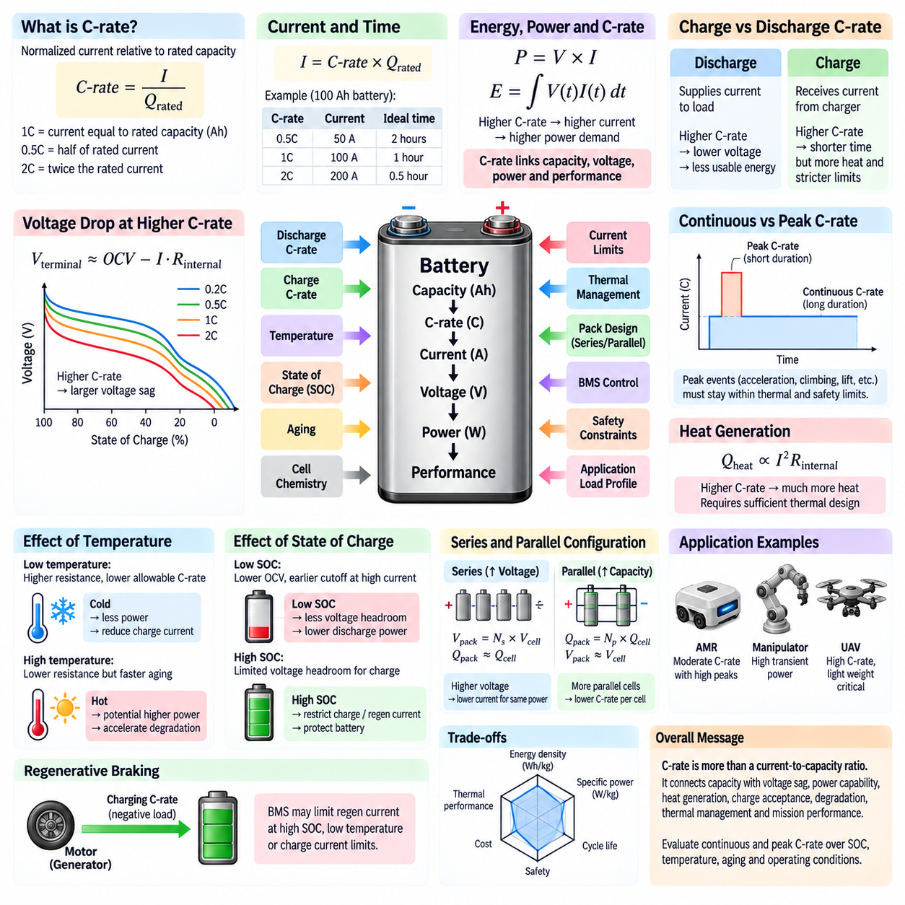
C-rate is a normalized measure of battery current relative to the rated capacity of a cell or battery pack. It provides a convenient way to compare charging and discharging intensity across batteries of different sizes. A rate of 1C corresponds to a current numerically equal to the rated capacity in ampere-hours, while 0.5C represents half that current and 2C represents twice the rated-capacity value.
For a battery with rated capacity Qrated in ampere-hours, the current associated with a specified C-rate can be approximated by I = C-rate × Qrated. A 100 Ah battery discharged at 1C therefore carries approximately 100 A, while 0.5C corresponds to 50 A and 2C corresponds to 200 A. Under ideal conditions, a 1C discharge would require about one hour and a 0.5C discharge about two hours.
C-rate provides a normalized description of current loading, but it does not mean that a battery can safely operate at any selected rate. Every cell has manufacturer-defined continuous and peak charge and discharge current limits determined by chemistry, electrode construction, internal resistance, thermal capability, and safety considerations. Battery pack design must therefore translate the desired C-rate into actual current and verify it against cell, interconnection, BMS, and thermal limits.
Discharge C-rate strongly influences usable battery performance. As discharge current increases, internal ohmic losses and electrochemical polarization become larger, causing greater terminal-voltage reduction. The battery may consequently reach its lower cutoff voltage before all theoretically available charge has been extracted. High-rate discharge can therefore reduce usable energy and operating time even when the nominal ampere-hour capacity remains unchanged.
The relationship between current and voltage can be approximated using Vterminal ≈ OCV − I·Rinternal, although real batteries include additional dynamic polarization effects. At higher C-rates, the I·R voltage drop becomes larger and terminal voltage decreases more rapidly under load. This voltage sag is particularly important in robotic systems because motor drives, DC-DC converters, computers, and other electrical equipment require minimum operating voltages.
Power demand and C-rate are closely connected through P = V × I. When a robot requests greater propulsion or actuator power, battery current normally increases and therefore raises the effective discharge C-rate. Acceleration, climbing, lifting, rapid manipulation, and recovery from obstacles can produce short high-C-rate events. The battery must tolerate these transients without excessive voltage sag, overheating, protection activation, or accelerated degradation.
Continuous C-rate and peak C-rate describe different operating capabilities. Continuous rating indicates the current that a battery can sustain for an extended period while remaining within specified electrical and thermal limits. Peak rating permits a higher current for a limited duration, often to support acceleration or other transient loads. The permitted duration and recovery conditions are essential because repeated peak events can accumulate heat and exceed safe operating limits.
Charging also has a C-rate. A 100 Ah battery charged at 0.5C receives approximately 50 A, while charging at 1C corresponds to approximately 100 A before other charging constraints are considered. Increasing charge rate can shorten charging time, but electrochemical reactions and ion transport must accept the incoming current. Excessive charging current increases polarization, heat generation, side reactions, and the possibility of damaging deposition mechanisms.
Charge C-rate is particularly sensitive to state of charge and temperature. A battery may accept relatively high current over part of its charging range but require progressively reduced current as it approaches its upper voltage limit. At low temperature, ion diffusion and charge-transfer processes become slower, reducing safe charge acceptance. The BMS and charger therefore need to adjust charging current according to voltage, temperature, SOC, and cell-specific limits.
Heat generation becomes increasingly important as C-rate rises. The resistive component of battery heating is approximately proportional to I²R, meaning that doubling current can produce roughly four times the resistive heating when resistance is treated as constant. Real internal resistance also changes with temperature, SOC, and aging. High-rate operation therefore requires sufficient thermal paths to prevent cell temperature from exceeding allowable limits.
Temperature and C-rate interact dynamically. Low temperature generally increases internal resistance and polarization, producing greater voltage sag for the same current. High temperature may temporarily improve transport and reduce resistance but accelerates undesirable chemical reactions and aging. Consequently, allowable C-rate is often temperature-dependent, and battery control systems may apply current derating when cells become too cold or too hot.
State of charge also affects power capability. Near the lower SOC region, reduced open-circuit voltage combined with voltage sag can cause the terminal voltage to reach the discharge cutoff earlier during high-current operation. Near the upper SOC region, charging and regenerative current may need to be restricted because the cells have limited voltage headroom. Available discharge and charge C-rates therefore vary throughout the battery operating window.
Battery aging changes C-rate performance even if the nominal system architecture remains unchanged. Capacity loss reduces available charge and energy, while increasing internal resistance produces greater voltage sag and heat at a given current. An aged battery may therefore satisfy low-power operation but fail during acceleration or other peak-power events. Battery sizing should consider end-of-life power capability as well as beginning-of-life capacity.
Cell chemistry strongly influences practical C-rate capability. Cells optimized for high energy density may emphasize stored energy per unit mass or volume, whereas high-power cells may use electrode structures and materials that support faster ion and electron transport. These design choices create tradeoffs among energy density, power capability, cycle life, thermal performance, safety, mass, volume, and cost rather than allowing all characteristics to be maximized simultaneously.
Parallel cell configuration can reduce the C-rate experienced by individual cells when load current is shared appropriately. If identical parallel strings divide current uniformly, increasing the number of parallel paths reduces current per cell while increasing total pack capacity. In practice, current sharing depends on cell matching, temperature, resistance, interconnections, and aging, so pack design must prevent individual cells or strings from carrying disproportionate current.
Series configuration increases pack voltage without directly increasing the ampere-hour capacity of a series string. For a given system power, increasing operating voltage can reduce required current because I = P/V. Lower current can decrease conductor losses, voltage drop, and current stress elsewhere in the powertrain. However, higher voltage introduces different insulation, switching, protection, connector, and safety requirements that must be considered at system level.
For an AMR, average operation may occur at a moderate C-rate while acceleration, turning, climbing ramps, crossing obstacles, or carrying heavy payloads creates temporary high-rate discharge. Compute platforms, sensors, communication equipment, cooling systems, and auxiliary loads add a relatively persistent electrical demand. Battery performance must therefore be evaluated against the complete mission current profile rather than a single average C-rate.
UAV applications impose particularly demanding C-rate requirements because propulsion power can change rapidly with takeoff, climb, maneuvering, wind, and payload. High discharge current produces voltage sag and heat, while increasing battery size to reduce C-rate also adds mass and can increase propulsion demand. Battery selection for UAVs must therefore balance specific energy, specific power, allowable C-rate, thermal capability, and mission duration.
Regenerative braking creates a temporary charging C-rate rather than a discharge C-rate. During deceleration, motor drives return electrical energy to the DC bus, and the battery must absorb the resulting current. If SOC is high, temperature is low, or allowable charge current is limited, the BMS may restrict regenerative power. Powertrain control must then coordinate regenerative braking with other braking mechanisms or energy-management strategies.
C-rate is therefore more than a simple current-to-capacity ratio. It links battery capacity with voltage sag, power capability, heat generation, charge acceptance, degradation, thermal management, and mission performance. Effective robotic battery engineering evaluates continuous and peak C-rate over SOC, temperature, aging, and operating conditions so that the battery can provide both required energy and instantaneous power throughout its intended service life.

01.04. Cycle Life and Degradation
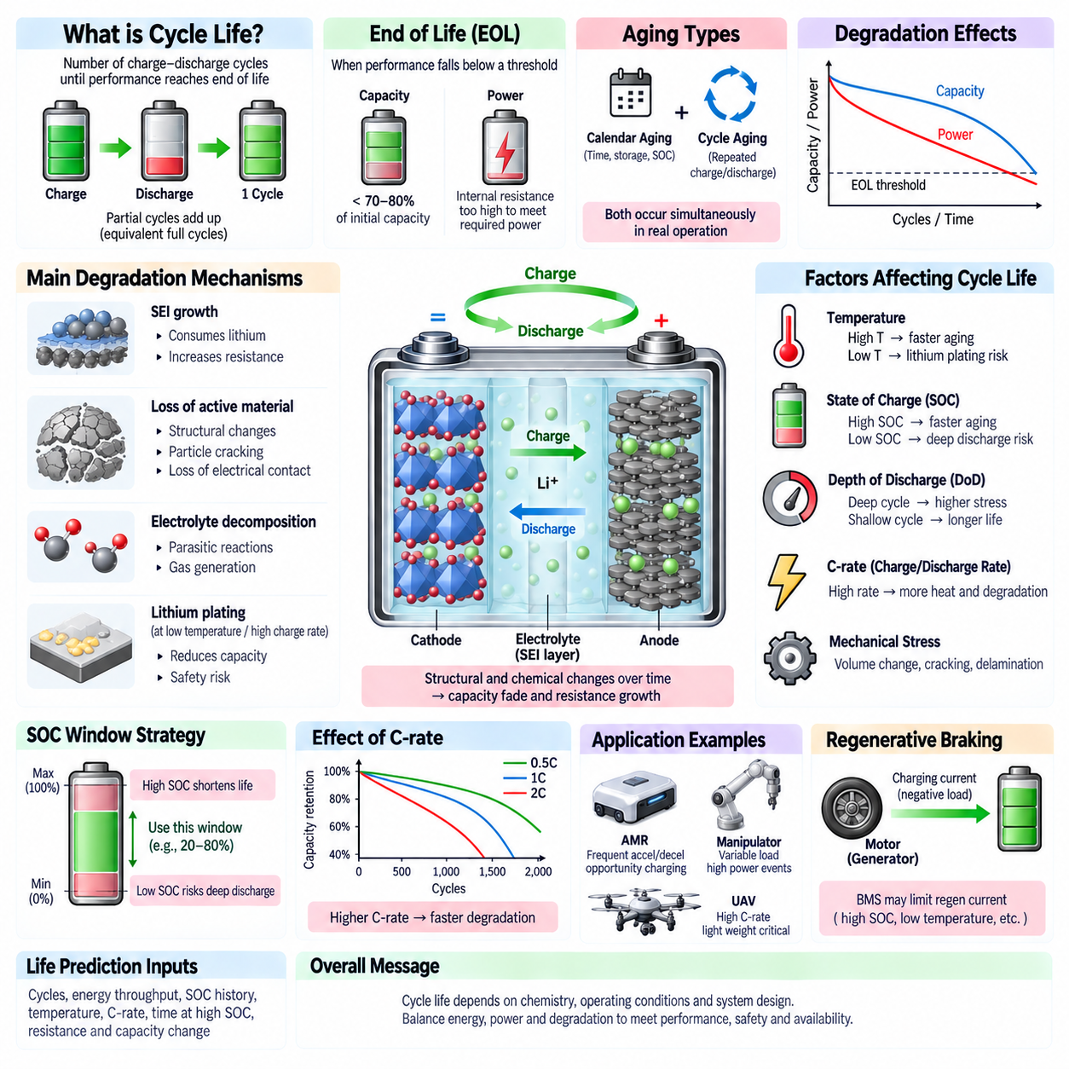
Battery cycle life describes how many charge-discharge cycles a battery can complete before its performance declines to a defined end-of-life threshold. A cycle does not necessarily mean one uninterrupted discharge from 100% to 0% and recharge to 100%. Partial charge and discharge events accumulate as equivalent full cycles, allowing cycle life to represent the cumulative electrochemical usage experienced during practical operation.
End of life is commonly defined by remaining capacity relative to the battery’s beginning-of-life value. A battery may, for example, be considered to have reached its application-specific end of life when available capacity falls below a specified percentage of initial capacity or when internal resistance becomes too high to satisfy required power. Capacity retention and power capability must therefore be evaluated together.
Battery degradation is the gradual and generally irreversible change of electrochemical, electrical, mechanical, and thermal properties during storage and operation. Degradation reduces available capacity, increases internal resistance, changes voltage behavior, and can reduce charge acceptance and peak-power capability. These changes accumulate through multiple mechanisms rather than through a single aging process, making battery life dependent on both chemistry and operating history.
Two broad forms of battery aging are calendar aging and cycle aging. Calendar aging occurs while the battery is stored or remains at a particular state of charge, even when little cycling occurs. Cycle aging results from repeated charging and discharging. Real robotic systems experience both simultaneously because batteries spend time operating, charging, waiting, docked, transported, and stored under different temperature and SOC conditions.
Capacity fade occurs when the amount of charge that can be reversibly stored and recovered decreases. One important cause is loss of cyclable lithium through parasitic reactions and continued formation or growth of interfacial layers such as the solid-electrolyte interphase. Active electrode material can also become electrically or ionically inaccessible, reducing the amount of material that participates effectively in normal charge-discharge reactions.
Resistance growth is another major form of degradation. Changes at electrode interfaces, electrolyte decomposition, loss of conductive pathways, contact deterioration, and structural changes can increase cell impedance. Higher resistance produces greater voltage sag during discharge and greater voltage rise during charging. It also increases I²R heating, which can further accelerate aging and reduce the battery’s usable power capability.
The solid-electrolyte interphase, or SEI, is necessary for stable operation in many lithium-ion cells but also contributes to aging. Initial SEI formation consumes lithium, while continued growth over time can consume additional cyclable lithium and increase impedance. Mechanical expansion and contraction of electrode materials may damage the layer, causing repeated repair reactions that consume electrolyte and lithium throughout the battery’s life.
High state of charge can accelerate degradation because electrode potentials remain in regions where undesirable side reactions may proceed more rapidly. Keeping a battery continuously near its maximum voltage can therefore shorten life even when little energy is being cycled. For many applications, restricting the upper SOC limit provides a practical method of improving longevity at the cost of reducing immediately available energy.
Very low state of charge can also create undesirable conditions, particularly if cells remain deeply discharged for extended periods. Excessive discharge may push electrode potentials beyond their intended operating range and can promote irreversible chemical changes. Battery management systems therefore enforce lower voltage and SOC boundaries to prevent damaging deep discharge and preserve a controlled electrochemical operating window.
Depth of discharge, commonly abbreviated DoD, describes how much of the available capacity is removed during a discharge event. Repeated deep cycling generally imposes greater electrochemical and mechanical stress than shallower cycling under otherwise similar conditions. Partial cycling within a controlled SOC window can therefore extend cycle life, although the exact relationship between DoD and degradation depends strongly on cell chemistry and design.
Temperature is one of the strongest factors affecting battery life. Elevated temperature accelerates reaction kinetics, including unwanted side reactions that consume active lithium and electrolyte. It can increase SEI growth, gas generation, and structural degradation. Even if high temperature temporarily improves power performance by lowering resistance, prolonged exposure can significantly accelerate calendar and cycle aging.
Low temperature creates a different degradation environment. Ion transport and charge-transfer processes become slower, increasing polarization and limiting charge acceptance. Charging too rapidly under cold conditions can cause lithium to deposit on the negative electrode rather than being properly inserted into its host structure. Repeated lithium plating can reduce capacity, increase resistance, and create additional safety concerns.
C-rate influences degradation through current density, polarization, and heat generation. High discharge rates produce larger voltage losses and thermal stress, while high charging rates can create severe concentration gradients and increase the risk of undesirable reactions. Short high-current events may be acceptable within specified limits, but repeated or sustained high-C-rate operation can shorten life unless the battery and thermal system are designed accordingly.
Mechanical effects also contribute to electrochemical aging. Electrode materials can expand and contract as ions are inserted and removed during cycling. Repeated dimensional changes may generate stress, particle cracking, delamination, or loss of electrical contact. These mechanisms can expose fresh surfaces to electrolyte, promote additional interfacial reactions, and progressively isolate active material from the electrochemical network.
Battery degradation is frequently represented through state of health, or SOH. Capacity-based SOH compares present usable capacity with initial capacity, while resistance- or power-based indicators describe the ability to support electrical loads. A battery may retain substantial energy capacity while no longer supplying required peak power because resistance has increased. Robotics applications therefore benefit from multidimensional SOH assessment.
The operating mission strongly determines degradation in robotic systems. An AMR performing frequent acceleration, climbing, payload transport, and opportunity charging experiences a different aging profile from a robot operating continuously at low power. Charging strategy, docking frequency, idle SOC, ambient temperature, regenerative braking, compute load, and thermal-management behavior collectively determine the stress accumulated by the battery.
Opportunity charging can improve robot availability by replenishing energy during short idle periods, but frequent charging changes the battery’s cycling pattern and average SOC. If managed appropriately, shallow cycling may reduce depth-of-discharge stress. However, repeatedly holding the battery near high SOC or applying excessive charging current can offset this benefit. Charging strategy should therefore optimize both operational availability and long-term battery health.
Regenerative braking also contributes to the battery’s lifetime operating profile. Recovered energy creates repeated charging pulses whose magnitude depends on vehicle mass, speed, deceleration, SOC, and battery temperature. When charge acceptance is limited, regenerative current should be reduced to prevent excessive voltage and electrochemical stress. Coordinated control between the BMS and powertrain helps preserve both energy recovery and battery life.
Battery life prediction requires tracking more than the number of cycles. Useful information includes cumulative energy throughput, equivalent full cycles, SOC history, depth of discharge, temperature exposure, charge and discharge C-rates, time spent at high SOC, and changes in resistance and capacity. These variables allow aging models and BMS algorithms to estimate degradation trends and adapt operating limits as the battery ages.
Designing for cycle life therefore requires a system-level approach. Cell chemistry, pack configuration, thermal management, charging control, SOC operating window, power limits, regenerative strategy, and mission scheduling all influence degradation. For AMRs, manipulators, UAVs, and other robotic platforms, maximizing battery life means balancing usable energy and performance against electrochemical stress so that required capacity, power, safety, and availability remain acceptable throughout the intended service life.

01.05. Battery Safety Overview
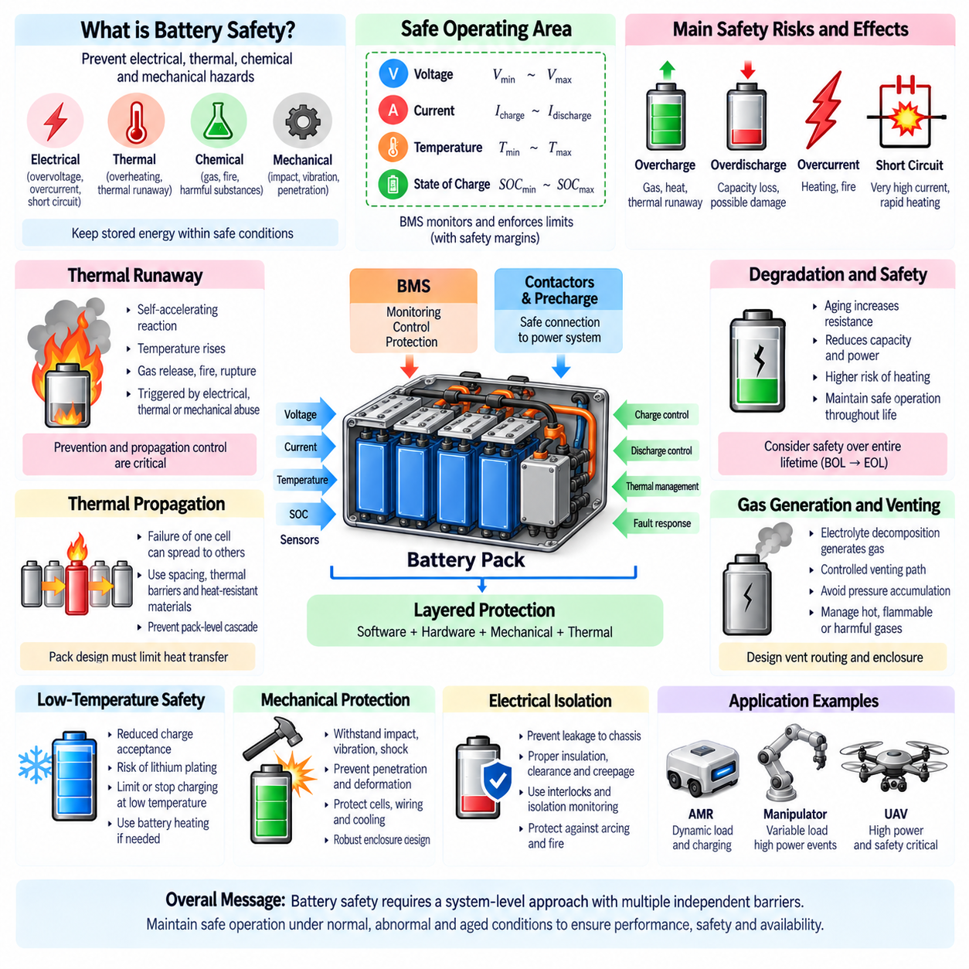
Battery safety is the discipline of maintaining electrochemical energy storage within conditions that prevent unacceptable electrical, thermal, chemical, and mechanical hazards. A battery contains substantial stored energy in a compact volume, so abnormal operation can release energy rapidly. Safe design therefore requires coordinated control of cell chemistry, electrical protection, thermal management, mechanical packaging, charging, monitoring, and system-level fault response.
A battery normally operates within a defined safe operating area bounded by voltage, current, temperature, and state-of-charge limits. Exceeding these boundaries can accelerate degradation or initiate hazardous reactions. The battery management system monitors operating conditions and restricts charging or discharging when limits are approached. Safety margins are typically included because sensor uncertainty, cell variation, aging, environmental conditions, and transient loads can alter actual cell behavior.
Overcharge occurs when charging continues beyond the permitted upper voltage or state-of-charge region. Excessive electrode potentials can promote electrolyte decomposition, gas generation, unwanted chemical reactions, and rapid heat production. Severe overcharge can destabilize electrode materials and initiate thermal failure. Charging systems therefore combine voltage regulation, current control, BMS supervision, cell monitoring, and independent protection mechanisms to prevent uncontrolled energy input.
Overdischarge occurs when a cell is driven below its allowable lower voltage. Deep discharge can produce irreversible electrochemical changes and may damage electrode materials or current collectors. A severely overdischarged cell can become unsafe when subsequently recharged. The BMS therefore disconnects or limits loads before critical undervoltage conditions occur, while system design should minimize parasitic consumption during long storage or shutdown periods.
Overcurrent can result from excessive load demand, motor faults, wiring faults, inverter failures, internal defects, or short circuits. Because battery packs can deliver very large currents, an uncontrolled fault may rapidly heat cells, conductors, busbars, connectors, or switching devices. Current sensors, fuses, circuit breakers, contactors, semiconductor protection, and BMS logic provide complementary layers for detecting and interrupting abnormal current paths.
An external short circuit creates a low-resistance path across battery terminals and can produce extremely high current limited primarily by cell and interconnection impedance. Rapid I²R heating may damage conductors and cells before software control can respond. For this reason, battery safety cannot depend exclusively on software. Properly coordinated hardware protection, including appropriately rated fuses and contactors, provides essential fault isolation when severe electrical failures occur.
Internal short circuits are particularly serious because they occur within a cell and may bypass pack-level electrical protection. They can originate from manufacturing defects, separator damage, metallic contamination, dendritic growth, deformation, or mechanical penetration. Localized internal current produces concentrated heating that may trigger further separator failure and exothermic reactions. Cell quality, mechanical protection, monitoring, and thermal containment are therefore critical.
Thermal runaway is a self-accelerating condition in which internal heat generation exceeds the ability of the cell and surrounding system to remove heat. Rising temperature accelerates exothermic reactions, which generate additional heat and further increase temperature. Depending on cell chemistry and construction, thermal runaway can involve gas release, venting, smoke, fire, or rupture, making prevention and propagation control central objectives of battery safety engineering.
Thermal runaway can be initiated by electrical abuse, thermal abuse, mechanical damage, internal defects, or combinations of these conditions. Overcharge, short circuit, excessive current, external heating, crushing, penetration, and severe cell degradation can all contribute to failure. Effective safety architecture therefore uses multiple independent barriers so that a single sensor failure, control error, or damaged component does not immediately escalate into a hazardous pack-level event.
Thermal propagation occurs when failure of one cell transfers enough heat to neighboring cells to initiate additional failures. Pack safety must therefore consider not only whether an individual cell can fail, but also whether that failure can spread. Cell spacing, thermal barriers, heat-resistant materials, vent routing, cooling architecture, module segmentation, and structural design can reduce heat transfer and help prevent a single-cell event from becoming a cascading pack failure.
Gas generation and venting are important considerations during abnormal battery conditions. Electrolyte decomposition and other reactions can produce gases that increase internal cell pressure. Cells may incorporate controlled venting mechanisms, while modules and enclosures require pathways that avoid dangerous pressure accumulation. Vent products can be hot, flammable, or chemically hazardous, so their direction and interaction with electronics, occupants, equipment, and ignition sources must be considered.
Temperature monitoring provides an essential indication of battery condition, but sensor placement is critical because local hotspots may develop before the average pack temperature changes significantly. Multiple sensors may be distributed across modules, cells, cooling interfaces, and high-current connections. Thermal control can reduce current, modify charging, activate cooling, or shut down the battery when abnormal temperature rise or excessive temperature gradients are detected.
Low-temperature safety is primarily associated with restricted electrochemical kinetics and charge acceptance. Charging a lithium-ion battery too rapidly when cold can promote lithium plating on the negative electrode, potentially causing permanent capacity loss and increasing future safety risk. The BMS should therefore reduce or prohibit charging below defined temperature thresholds and may coordinate battery heating before high-rate charging or regenerative energy recovery is permitted.
Mechanical protection is essential for batteries installed in mobile robots, vehicles, manipulators, and UAVs. Impact, vibration, shock, compression, penetration, or enclosure deformation can damage cells, insulation, busbars, cooling structures, and electrical connections. Battery enclosures should provide structural support while preventing conductive debris, moisture, sharp components, or external loads from compromising cell isolation and creating internal or external short circuits.
Electrical isolation and insulation prevent hazardous current from reaching the chassis, electronics, or accessible conductive structures. Higher-voltage battery systems require appropriate creepage and clearance distances, insulation materials, connector designs, interlocks, and isolation monitoring. Even lower-voltage robotic systems require careful grounding and protection because high battery current can produce severe heating, arcing, connector damage, or fire without necessarily presenting a high-voltage shock hazard.
The BMS is a central supervisory element of battery safety. It measures cell and pack voltage, current, and temperature while estimating states such as SOC and SOH. Protection logic identifies overvoltage, undervoltage, overcurrent, short-circuit, and abnormal-temperature conditions and can command contactors or power limits. However, safe architecture combines BMS software with independent hardware mechanisms rather than relying on a single control layer.
Contactors and precharge circuits support controlled connection of a battery to high-capacitance power electronics. Closing a main contactor directly into an uncharged DC-link capacitor can create damaging inrush current, contact welding, or electrical arcing. A precharge path limits initial current until the DC bus approaches battery voltage, after which the main contactor can close. Fault detection should prevent connection when expected precharge behavior is not observed.
Charging safety requires coordination between the battery, BMS, charger, electrical interface, and thermal system. Charging current and voltage must remain within cell-specific limits over temperature and SOC. Communication faults, incorrect charger settings, damaged connectors, poor contact resistance, or cooling failures must be considered. Automated docking robots additionally require reliable alignment, connection verification, and safe interruption before movement away from the charging station.
Robotic applications introduce dynamic safety conditions because battery loading changes with propulsion, payload, terrain, manipulation, computation, and regenerative operation. An AMR may encounter sudden motor current during obstacle recovery or ramp climbing, while a UAV can experience rapidly changing propulsion demand. Battery protection must distinguish acceptable short-duration transients from genuine faults without allowing repeated high-power events to exceed electrical or thermal limits.
Battery safety is ultimately achieved through layered risk reduction rather than a single protective device. Appropriate cell chemistry and qualification provide the foundation, while BMS supervision, fuses, contactors, insulation, thermal management, mechanical containment, charging control, diagnostics, and system-level fault handling create additional barriers. Robust robotic battery design maintains these protections throughout aging, environmental exposure, maintenance, abnormal operation, and the complete intended service life.

