Volume 11. Battery and Powertrain

Chapter 04. BMS Design

04.01. Cell Balancing (Passive/Active)
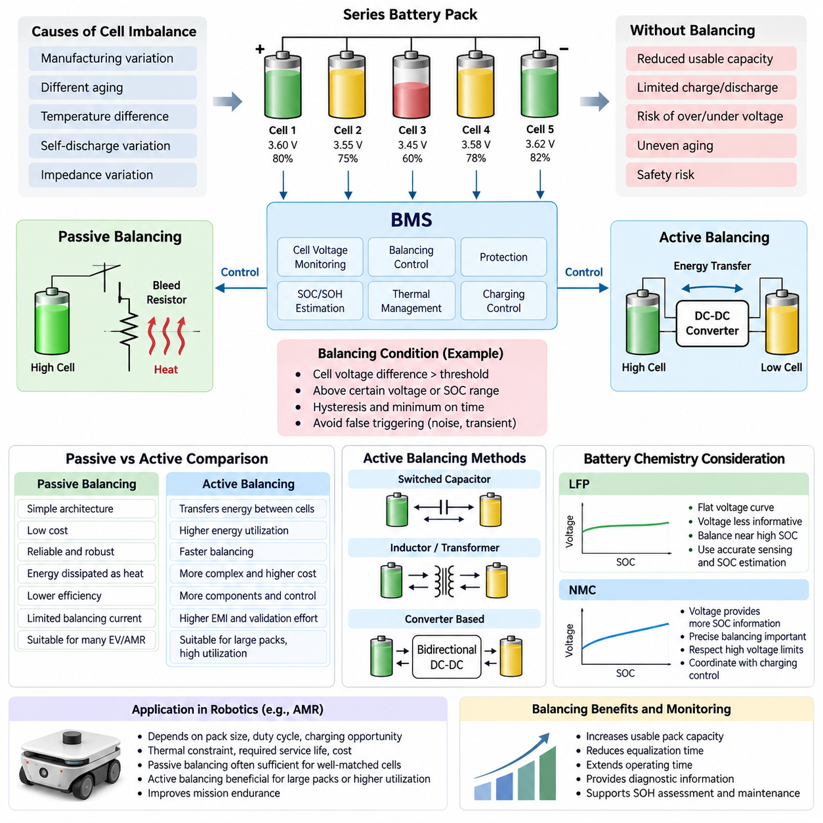
Cell balancing is a core function of a battery management system because cells connected in series rarely maintain exactly the same state of charge, capacity, internal resistance, and aging behavior. Small manufacturing variations and unequal thermal conditions gradually create voltage differences. Without balancing, the weakest or highest-voltage cell can determine the usable capacity and operating limits of the entire battery pack.
In a series-connected battery pack, the same charging and discharging current flows through every cell, but individual cell voltages do not necessarily change at identical rates. Differences in self-discharge, temperature, impedance, and usable capacity accumulate over repeated cycles. The BMS therefore monitors each cell voltage and applies balancing when the deviation exceeds predefined thresholds under suitable operating conditions.
Passive balancing reduces imbalance by removing energy from cells whose voltage or estimated state of charge is higher than that of neighboring cells. The most common implementation connects a resistor across each cell through a transistor or switching device controlled by the BMS. When balancing is activated, a small current bypasses the selected cell and converts excess electrical energy into heat until its voltage approaches the desired pack balance level.
The main advantage of passive balancing is architectural simplicity. Bleed resistors, switching devices, sensing circuits, and control logic can be implemented with relatively low component cost and modest circuit complexity. This makes passive balancing attractive for many industrial batteries, electric mobility systems, and AMRs where reliability, maintainability, predictable behavior, and economical BMS implementation are more important than recovering small amounts of balancing energy.
Passive balancing efficiency is inherently limited because the removed energy is dissipated rather than transferred to another cell. The balancing current is also constrained by resistor power rating, semiconductor temperature, PCB thermal design, and enclosure cooling capability. Increasing the current can shorten balancing time, but it increases heat generation according to electrical power dissipation and may create undesirable temperature gradients inside the BMS or battery module.
Balancing control must distinguish meaningful cell mismatch from normal voltage variation caused by current, temperature, and electrochemical dynamics. A BMS may enable passive balancing only above a specified cell voltage or state-of-charge region and when the difference between the highest and lowest cells exceeds a threshold. Hysteresis and minimum activation time are commonly used to prevent rapid switching caused by measurement noise or transient voltage recovery.
Active balancing transfers energy instead of intentionally dissipating it. Energy can be moved from a high-energy cell to a lower-energy cell, from individual cells to the complete pack, from the pack to selected cells, or between groups of cells. Depending on the architecture, active balancing circuits use capacitors, inductors, transformers, or bidirectional DC-DC converters to redistribute charge while preserving a larger portion of the stored electrical energy.
Switched-capacitor balancing periodically connects capacitors between cells so that charge moves according to voltage differences. Inductor-based and transformer-based circuits provide more controllable energy transfer and can support higher balancing power. Converter-based architectures offer even greater flexibility because energy flow can be actively regulated, although they require additional switching devices, magnetic components, sensing, gate control, and sophisticated protection mechanisms.
Active balancing can improve usable pack capacity when cell mismatch is significant because energy from stronger cells can support weaker cells instead of being discarded as heat. Higher balancing currents can also reduce equalization time, which becomes increasingly valuable in large-capacity battery packs. These benefits can extend effective operating time and reduce the degree to which a single mismatched cell restricts the charge or discharge capability of the complete system.
The additional capability of active balancing introduces engineering tradeoffs. Component count, PCB area, control complexity, electromagnetic interference, diagnostic requirements, conversion losses, and cost generally increase compared with passive systems. Fault analysis must also consider unintended energy transfer, failed switching devices, isolation problems, and thermal stress. Consequently, active balancing is justified when its improvements in energy utilization and balancing speed outweigh the added hardware and validation burden.
Battery chemistry strongly affects balancing strategy because the relationship between cell voltage and state of charge is chemistry dependent. LFP cells exhibit a particularly flat voltage curve over a broad SOC range, making voltage-only comparison less informative during much of normal operation. Balancing is therefore often concentrated near the upper charging region, while accurate sensing, temperature compensation, coulomb counting, and appropriate SOC estimation help prevent unnecessary balancing decisions.
For NMC batteries, cell voltage generally provides stronger SOC information across much of the operating range, but precise balancing remains important because high-voltage operation must respect strict cell limits. The BMS must coordinate balancing with charging control so that no individual cell exceeds its permitted voltage while the pack approaches full charge. Balancing logic must therefore operate as part of the broader protection, SOC estimation, thermal management, and charging strategy.
For robotic systems such as AMRs, the appropriate balancing architecture depends on pack capacity, duty cycle, charging opportunities, thermal constraints, required service life, and acceptable cost. Passive balancing is often sufficient when cells are well matched and periodic full charging is available. Active balancing becomes more attractive for large packs, demanding utilization targets, persistent imbalance, or applications where maximizing usable energy directly improves mission endurance.
A practical BMS should evaluate balancing performance over the battery lifetime rather than treating equal cell voltage as the only objective. Cell-voltage spread, balancing current, balancing duration, temperature rise, SOC deviation, capacity mismatch, and historical balancing activity provide useful diagnostic information. Persistent imbalance can indicate cell degradation or thermal asymmetry, allowing balancing data to contribute to state-of-health assessment and maintenance decisions.
Ultimately, cell balancing does not restore lost cell capacity or repair a degraded battery. Its purpose is to manage unavoidable differences so that series-connected cells operate within safe limits and the available pack energy can be used effectively. Passive balancing emphasizes simplicity and robustness, while active balancing emphasizes energy redistribution and higher balancing capability. Selecting between them requires a system-level evaluation of safety, efficiency, cost, thermal design, reliability, and mission requirements.

04.02. SOC Estimation Algorithm
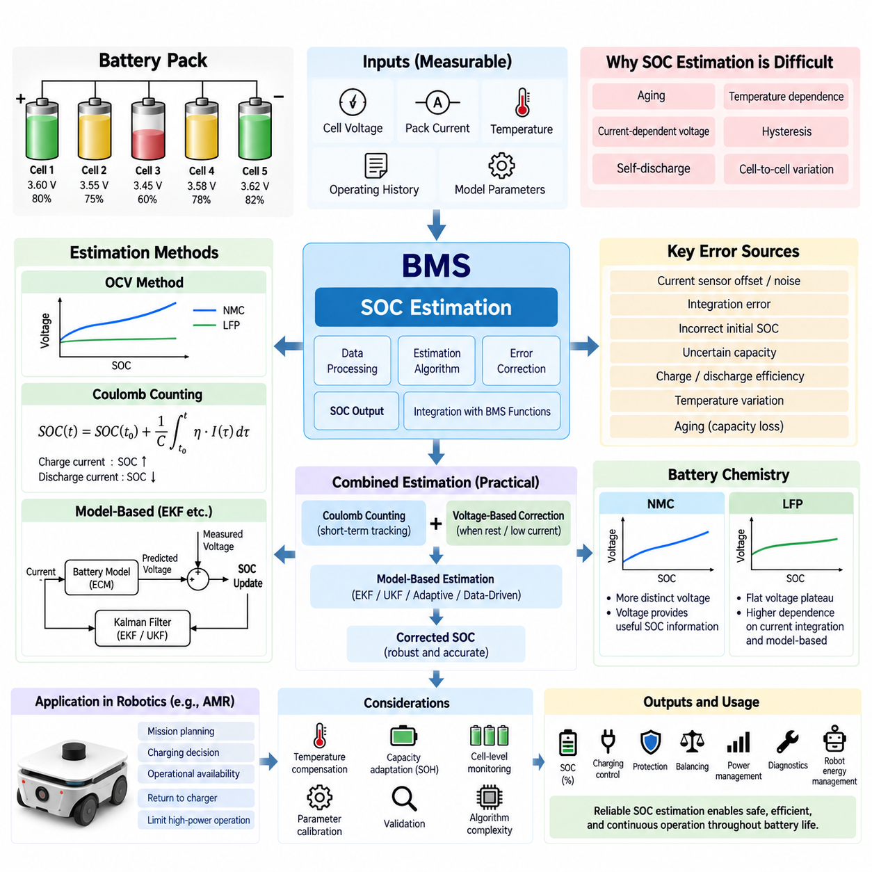
State of Charge (SOC) represents the amount of usable electrical charge remaining in a battery relative to its available capacity and is one of the most important quantities estimated by a Battery Management System (BMS). Unlike voltage or current, SOC cannot normally be measured directly by a sensor. The BMS must therefore estimate it from measurable variables such as cell voltage, pack current, temperature, operating history, and battery model parameters.
SOC is commonly expressed as a percentage, where 100% represents a fully charged condition and 0% represents the defined lower usable charge limit. Although this definition appears simple, practical estimation is complicated by battery aging, temperature dependence, current-dependent voltage behavior, hysteresis, self-discharge, and differences among individual cells. Consequently, SOC should be regarded as an estimated internal battery state rather than a directly observable physical quantity.
One of the simplest estimation approaches is the Open Circuit Voltage (OCV) method. After a battery has remained at rest long enough for transient electrochemical effects to decay, its terminal voltage can be compared with a predefined OCV-SOC relationship. This technique can provide an absolute SOC reference, but it is difficult to apply continuously because robotic and mobility batteries frequently operate under load and may not remain at rest for sufficient time.
The usefulness of OCV-based estimation depends strongly on battery chemistry. NMC cells generally exhibit a more distinguishable voltage change across their SOC range, allowing voltage to provide meaningful state information. LFP cells have a much flatter voltage plateau through a large portion of their operating range, so small voltage measurement errors can correspond to substantial SOC uncertainty. Accurate LFP SOC estimation therefore requires greater dependence on current integration and model-based correction.
Coulomb counting estimates SOC by integrating battery current over time. Charging current increases the estimated stored charge while discharge current decreases it, with the calculation referenced to the estimated usable battery capacity. This method responds well during dynamic operation and is widely used in BMS implementations because current is continuously measurable while a robot, vehicle, or other electrical system is operating.
The principal weakness of coulomb counting is accumulated error. Current sensor offset, measurement noise, integration error, inaccurate initial SOC, uncertain capacity, and charging or discharging efficiency can gradually cause the calculated SOC to drift away from the actual battery state. Even a small persistent current measurement bias can become significant over long operating periods. Coulomb counting therefore requires periodic correction or synchronization using additional battery information.
A practical SOC estimator commonly combines coulomb counting with voltage-based correction. Current integration provides short-term tracking during operation, while OCV information can correct accumulated drift when the battery enters suitable low-current or rest conditions. The BMS may recognize these conditions automatically and gradually adjust the estimated SOC rather than applying an abrupt correction that could produce unrealistic changes in the reported battery state.
Model-based SOC estimation improves accuracy by representing the battery through an electrical or electrochemical model. Equivalent Circuit Models (ECMs) commonly describe the battery using an OCV source together with resistive and capacitive elements that reproduce internal resistance and transient polarization behavior. Measured current is applied to the model, and the predicted terminal voltage is compared with actual voltage to determine whether the internal SOC estimate requires correction.
The Extended Kalman Filter (EKF) is widely associated with model-based battery state estimation. It predicts the battery state using a mathematical model and then corrects that prediction using the difference between predicted and measured voltage. By repeatedly performing prediction and correction, the EKF can combine current, voltage, model parameters, and measurement uncertainty while reducing sensitivity to noise and accumulated coulomb-counting error.
Other estimation approaches can include the Unscented Kalman Filter (UKF), adaptive observers, particle filters, and data-driven algorithms. These methods may better represent nonlinear battery behavior or uncertain operating conditions, but they can require additional computation, parameter identification, training data, or calibration effort. Algorithm complexity should therefore be selected according to required SOC accuracy, available processing resources, battery characteristics, and system safety requirements.
Temperature must be incorporated into SOC estimation because battery voltage, internal resistance, charge acceptance, and available capacity vary with temperature. A battery operating at low temperature can temporarily deliver less usable energy even when substantial chemical charge remains. The BMS should therefore distinguish electrochemical SOC from immediately available energy and use temperature-dependent parameters or compensation maps when predicting practical operating capability.
Battery aging creates another major source of SOC estimation error. Coulomb counting based on the nominal capacity of a new battery becomes inaccurate as usable capacity decreases with cycle aging and calendar aging. SOC estimation should therefore interact with State of Health (SOH) estimation so that the capacity used by the SOC algorithm reflects the actual condition of the battery. Capacity adaptation allows the SOC scale to remain meaningful throughout battery life.
Cell-level behavior is also important because a series battery pack does not operate as a perfectly uniform energy reservoir. Individual cells can have different capacities, resistances, temperatures, and SOC values. Pack-level SOC may describe the average battery condition, but the lowest-SOC cell can determine the practical discharge limit while the highest-SOC cell can determine the charging limit. The BMS must therefore coordinate SOC estimation with cell-voltage monitoring and balancing functions.
For an AMR, SOC estimation directly influences mission planning, charging decisions, and operational availability. The robot may use SOC to determine whether sufficient energy remains to complete a mission, return to a charging station, perform opportunity charging, or temporarily restrict high-power operation. An inaccurate optimistic SOC estimate can cause mission interruption, whereas an excessively conservative estimate reduces usable operating time and fleet productivity.
Dynamic robotic loads make SOC estimation particularly challenging because acceleration, steering, payload movement, computing equipment, sensors, and auxiliary systems can produce rapidly changing battery currents. Regenerative braking can additionally reverse power flow and return energy to the battery. The estimator must correctly integrate bidirectional current while accounting for voltage transients and avoiding false SOC corrections caused by short-duration load or regenerative events.
A robust BMS therefore treats SOC estimation as a continuously corrected state-estimation process rather than a single calculation. Current integration, voltage information, temperature compensation, battery models, capacity adaptation, cell monitoring, and operating-history data can be combined according to system requirements. The resulting SOC estimate becomes a fundamental input to charging control, protection, balancing, power management, diagnostics, and robot-level energy management.
Ultimately, no SOC estimation algorithm can remain accurate without appropriate sensing, battery characterization, parameter calibration, and validation. Current sensor accuracy, cell-voltage measurement resolution, temperature sensing, OCV-SOC characterization, capacity identification, and model parameters directly affect estimation quality. Effective SOC estimation therefore requires coordinated design of battery hardware, BMS electronics, estimation software, calibration procedures, and system-level validation throughout the battery operating life.

04.03. SOH Estimation Algorithm
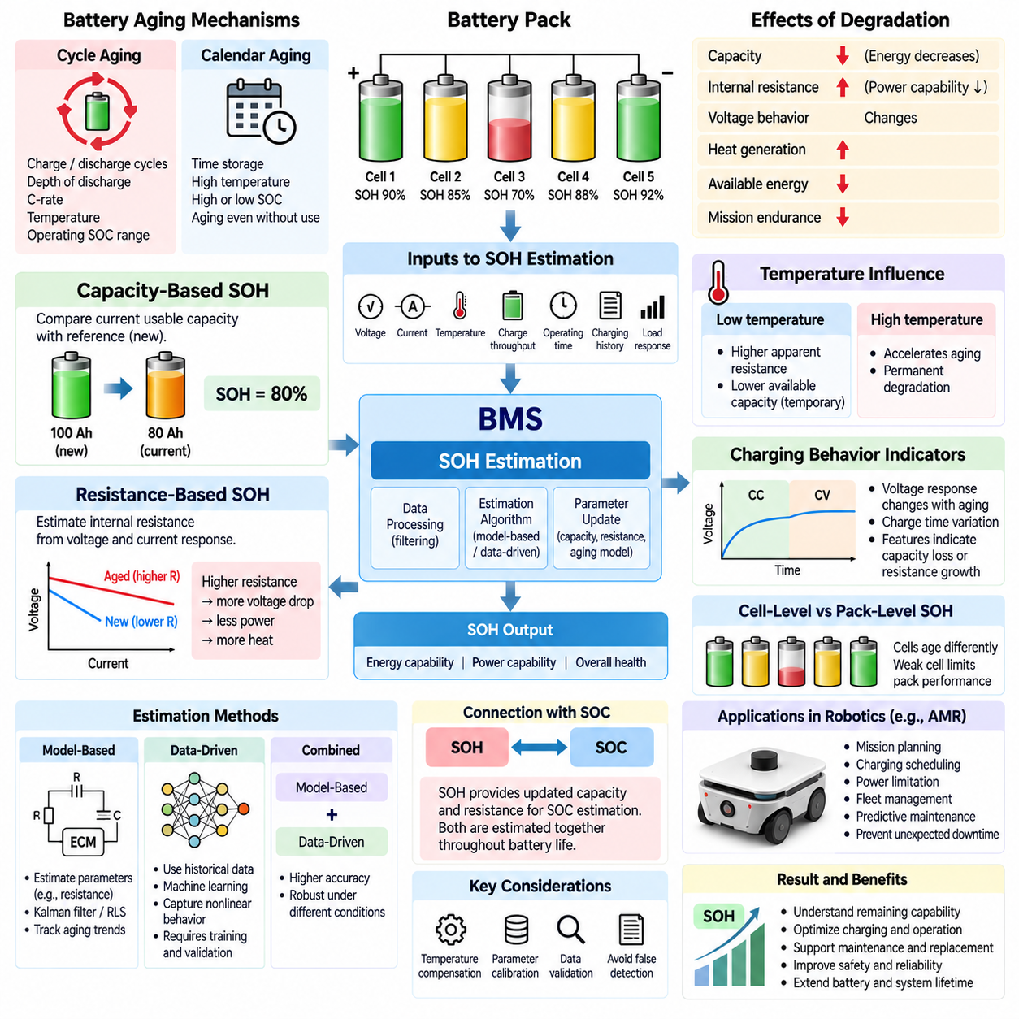
State of Health (SOH) describes the condition of a battery relative to an appropriate reference state, typically the performance available when the battery was new. Unlike State of Charge (SOC), which changes continuously during normal charging and discharging, SOH evolves slowly as the battery ages. A Battery Management System (BMS) estimates SOH to determine how much useful capability has been lost and how reliably the battery can continue operating.
SOH cannot normally be measured directly by a single sensor because battery degradation appears through several interacting characteristics. Capacity decreases, internal resistance increases, power capability changes, and electrochemical behavior gradually deviates from the initial condition. The BMS must therefore infer SOH from measurable quantities such as voltage, current, temperature, charge throughput, operating time, charging history, and responses to controlled or naturally occurring load conditions.
Capacity-based SOH is one of the most intuitive definitions. It compares the battery's currently available capacity with a reference capacity, commonly the usable capacity measured or estimated when the battery was new. If a battery originally provided 100 Ah but can now deliver only 80 Ah under equivalent conditions, its capacity-based SOH is approximately 80%. This representation directly indicates the reduction in available energy storage capability.
Accurate capacity estimation requires observing sufficient charge or discharge operation between recognizable SOC reference points. The BMS can integrate measured current through coulomb counting and determine how much charge was transferred across a known SOC interval. Partial cycles complicate this process because robots and vehicles frequently use opportunity charging and may rarely complete full charge-discharge cycles. Capacity estimation must therefore accumulate useful information over multiple operating events.
Resistance-based SOH provides another important indication of degradation. As cells age, their internal resistance generally increases because of electrochemical and structural changes. The BMS can estimate resistance by observing the relationship between changes in terminal voltage and current during suitable load transitions. Increasing resistance causes greater voltage drop during discharge, greater voltage rise during charging, additional heat generation, and reduced ability to deliver high power.
Capacity loss and resistance increase describe different aspects of battery health and should not automatically be treated as equivalent. A battery may retain substantial energy capacity while its power capability has deteriorated because resistance has increased. Conversely, capacity may decline while resistance remains acceptable for moderate loads. A robust SOH estimator can therefore maintain separate indicators for energy capability, power capability, and overall battery usability.
Battery aging is commonly divided into cycle aging and calendar aging. Cycle aging results from repeated charging and discharging and depends on factors such as charge throughput, depth of discharge, C-rate, temperature, and operating SOC range. Calendar aging occurs even when the battery is not actively cycled and is influenced strongly by storage time, temperature, and SOC. Practical SOH estimation should account for both mechanisms because robotic batteries experience combinations of active operation and idle storage.
Temperature has a major influence on both degradation and SOH measurement. Low temperature can temporarily increase apparent resistance and reduce available capacity without representing permanent degradation, while sustained high temperature can accelerate irreversible aging. An estimator must therefore distinguish reversible temperature-dependent performance changes from long-term health deterioration. Temperature compensation and measurements obtained under comparable operating conditions improve the consistency of SOH evaluation.
Historical operating data provides valuable information for estimating gradual battery degradation. The BMS can record accumulated ampere-hour throughput, energy throughput, equivalent full cycles, time spent at high or low SOC, maximum and minimum temperatures, high-current events, charging behavior, and balancing activity. These variables form a battery usage history that can support empirical aging models and help explain why batteries with the same chronological age exhibit different health conditions.
Model-based SOH estimation uses mathematical representations of battery behavior to identify parameters that change with aging. An Equivalent Circuit Model (ECM), for example, can estimate internal resistance and polarization-related parameters from measured current and voltage. Parameter trends observed over long periods can then be associated with degradation. Recursive estimation methods can continuously update these parameters while the battery operates instead of requiring dedicated laboratory measurements.
Kalman-filter-based techniques, adaptive observers, Recursive Least Squares (RLS), and related estimation methods can be used to track aging-sensitive parameters. These algorithms compare predicted battery behavior with measured responses and progressively update internal estimates. Their effectiveness depends on model accuracy, sufficient excitation in the operating data, measurement quality, and appropriate parameter initialization. Poorly observable operating conditions can make some health parameters difficult to identify reliably.
Data-driven SOH estimation provides another approach by learning relationships between measurable battery behavior and degradation. Machine-learning models can use features derived from voltage curves, current profiles, temperature, charging time, resistance, and historical usage. Such methods can capture complex nonlinear relationships, but their accuracy depends strongly on representative training data and validation across cell production variation, operating environments, aging paths, and battery chemistries.
Charging behavior can provide useful health indicators because aging changes the voltage response and the time required for different portions of the charging process. Features extracted from constant-current and constant-voltage charging stages may correlate with capacity loss or resistance growth. This approach can be attractive when robots return regularly to controlled charging stations because charging events provide repeatable operating conditions from which health information can be extracted.
Cell-level SOH monitoring is important in series-connected battery packs because cells do not necessarily age uniformly. Differences in temperature, manufacturing characteristics, current distribution, and balancing history can cause one cell to degrade faster than others. A pack-level average can conceal this weak cell even though it may determine the practical charge, discharge, and power limits. The BMS should therefore monitor cell-level indicators and identify abnormal divergence.
SOH estimation and SOC estimation are closely connected. SOC calculations require an estimate of usable battery capacity, but that capacity decreases as SOH deteriorates. If the BMS continues using the original nominal capacity, SOC calculated through coulomb counting can become increasingly inaccurate. Updated SOH information should therefore adapt the capacity and resistance parameters used by the SOC estimator, creating coordinated state estimation throughout battery life.
For an Autonomous Mobile Robot (AMR), SOH affects more than maintenance scheduling. Reduced capacity shortens mission endurance, while increased resistance can limit acceleration, climbing capability, payload handling, and peak power delivery. Fleet management can use SOH information to assign demanding missions to healthier batteries, schedule charging appropriately, predict replacement requirements, and prevent unexpected loss of availability during operational tasks.
A practical BMS should evaluate SOH as a long-term trend rather than reacting strongly to individual measurements. Temporary temperature changes, unusual loads, incomplete charging, sensor noise, and voltage relaxation can distort short-term indicators. Filtering, confidence evaluation, parameter plausibility checks, and historical comparison help prevent false degradation detection. Significant SOH changes should normally be supported by repeated evidence collected across suitable operating conditions.
Ultimately, SOH estimation combines sensing, battery characterization, aging models, parameter identification, historical data, and continuous validation. Capacity retention and resistance growth remain fundamental health indicators, but reliable estimation requires interpreting them within temperature, SOC, usage, and cell-level context. A well-designed BMS converts these observations into actionable health information for SOC correction, power limitation, diagnostics, predictive maintenance, mission planning, and safe battery replacement.

04.04. BMS Protection Circuit
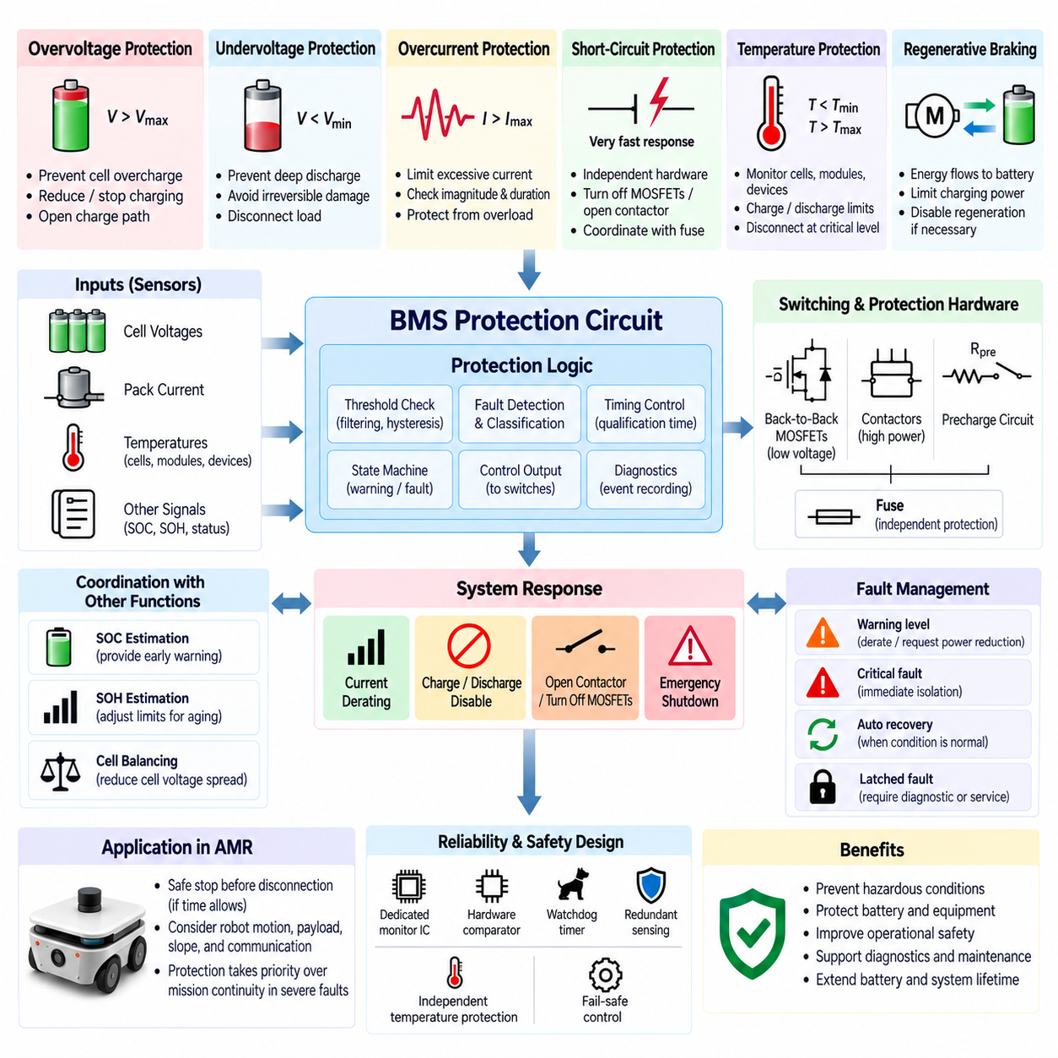
A BMS protection circuit is the hardware and control layer that prevents a battery from operating outside its safe electrical and thermal limits. While estimation functions such as SOC and SOH describe battery condition, protection functions must detect hazardous conditions and take deterministic action. The protection architecture therefore combines cell monitoring, current sensing, temperature sensing, fault logic, switching devices, and independent safety mechanisms.
Overvoltage protection prevents individual cells from exceeding their permitted upper voltage during charging or regenerative energy recovery. Because cells in a series pack can have different SOC and capacity, the highest-voltage cell may reach its limit before the overall pack appears fully charged. The BMS continuously compares each measured cell voltage with calibrated thresholds and can reduce charging current, disable charging, or open the charging path when necessary.
Undervoltage protection prevents excessive cell discharge that could cause irreversible degradation or unstable battery behavior. During high load, the weakest cell may reach the minimum allowable voltage before other cells, particularly when capacity imbalance or increased internal resistance exists. Protection logic typically includes voltage thresholds, filtering, and time delays so that temporary voltage sag can be distinguished from a sustained undervoltage condition requiring shutdown.
Overcurrent protection limits excessive current during charging and discharging. Abnormal current can result from an overloaded motor, stalled actuator, inverter fault, wiring fault, short circuit, or defective external equipment. The BMS measures current using a shunt resistor, Hall-effect sensor, or another current-sensing device and evaluates both current magnitude and duration because allowable current generally decreases as the duration of the overload increases.
Short-circuit protection must respond much faster than normal overload protection because fault current can rise rapidly and generate severe thermal and electrical stress. Hardware comparators or dedicated protection integrated circuits may therefore operate independently of the main BMS processor. Depending on pack voltage and architecture, the protection response can turn off power MOSFETs, command contactors to open, or rely on coordinated fuses as a final interruption mechanism.
Temperature protection prevents operation outside the allowable thermal range of the cells and power electronics. Temperature sensors are typically distributed across representative cells, modules, busbars, switching devices, and other thermally critical locations. The BMS can restrict charging or discharging as temperatures approach warning limits and disconnect the battery when critical thresholds are exceeded, reducing the risk of accelerated degradation or thermal failure.
Charging and discharging temperature limits are not necessarily identical. Lithium-ion cells may tolerate discharge at temperatures where charging should already be prohibited or significantly reduced. The protection strategy must therefore evaluate temperature together with operating direction and current demand. Temperature-dependent current limits can provide gradual derating before a hard shutdown threshold is reached, improving both battery availability and protection effectiveness.
The main battery current path can be controlled using back-to-back MOSFETs in lower-voltage systems or contactors in higher-power battery packs. Separate charge and discharge control allows the BMS to prohibit one direction of current while permitting the other. For example, discharge may remain available after a charging overvoltage fault, while charging may remain possible after a low-SOC discharge cutoff when conditions permit safe recovery.
Contactor-based battery systems require additional supervision because a contactor itself can fail. The BMS can monitor pack-side and load-side voltages to determine whether commanded contactor states match actual electrical behavior. A welded contactor may prevent isolation, while a contactor that fails to close can interrupt normal operation. Auxiliary contacts, voltage feedback, and diagnostic logic can therefore be combined to detect switching-path faults.
Precharge protection is important when a battery connects to equipment containing large DC-link capacitors, such as motor inverters and high-power converters. Direct connection can produce a large inrush current that damages contactors, connectors, or capacitors. A precharge resistor and controlled switching sequence gradually raise the load-side voltage before the main contactor closes, while the BMS verifies that voltage rises within an expected time window.
A fuse provides an independent protection layer for fault conditions that electronic control may be unable to interrupt safely. Unlike a software-controlled BMS function, the fuse operates from the thermal effect of excessive current and does not depend on processor execution or communication. Fuse selection must be coordinated with normal peak current, wiring capacity, contactor capability, semiconductor limits, and the expected short-circuit current of the battery pack.
Protection thresholds should not be implemented as single instantaneous values without considering measurement noise and normal transients. Practical BMS logic uses filtering, hysteresis, qualification time, warning thresholds, fault thresholds, and recovery thresholds. This structure prevents nuisance shutdown while ensuring that genuinely dangerous conditions are detected. Different faults can require different persistence times, ranging from milliseconds for severe overcurrent to much longer periods for thermal warnings.
Fault severity should also influence the required system response. A warning-level condition may trigger current derating or request the robot controller to reduce power, whereas a critical electrical fault may require immediate battery isolation. Some faults can automatically recover after voltage or temperature returns to an acceptable range, while serious faults may remain latched until a diagnostic procedure, service action, or controlled system restart confirms that operation is safe.
Protection must remain effective even when the main BMS software or communication interface fails. Safety-oriented designs therefore use layered mechanisms such as dedicated battery-monitor ICs, hardware comparators, watchdog timers, redundant measurements, independent temperature protection, fuses, and fail-safe contactor control. The objective is to avoid a single failure that could leave the battery connected while critical voltage, current, or temperature limits are violated.
Protection logic should coordinate closely with SOC estimation, SOH estimation, and cell balancing. SOC can provide advance warning that discharge or charge limits are approaching, while SOH can indicate that an aged battery requires reduced power limits because of capacity loss or increased resistance. Cell balancing reduces voltage divergence, but protection must always prioritize the most critical individual cell rather than relying only on average pack voltage or estimated pack SOC.
For an Autonomous Mobile Robot (AMR), abrupt battery disconnection can itself create an operational hazard. A robot may be moving, carrying a payload, operating on a slope, or communicating with a fleet controller when a battery fault develops. Where sufficient time remains, the BMS can request controlled power reduction or a safe stop before isolation. Severe short circuits or critical faults, however, require electrical protection to take priority over mission continuity.
Regenerative braking introduces another protection consideration because energy flows from the motor drive back toward the battery. If the battery is near full charge, cold, overheated, or unable to accept the requested regenerative current, cell voltage can rise rapidly. The BMS must communicate allowable charging power to the powertrain controller or disable regeneration when necessary, coordinating battery protection with inverter and braking control.
Diagnostic recording is essential for understanding protection events and improving serviceability. The BMS should preserve information such as fault type, affected cell or sensor, voltage, current, temperature, SOC, operating mode, timestamp, and protection action around significant events. Historical fault data can distinguish occasional operating transients from repeated abnormalities and can support troubleshooting, predictive maintenance, warranty analysis, and battery replacement decisions.
Ultimately, a BMS protection circuit is not a single cutoff device but a coordinated safety architecture surrounding the battery. Cell-voltage supervision, current protection, temperature monitoring, MOSFETs or contactors, precharge circuits, fuses, diagnostics, and fail-safe control work together to maintain safe operation. Effective design requires protection thresholds and hardware ratings to be validated against battery chemistry, pack configuration, powertrain behavior, wiring limits, thermal conditions, and the robot's complete operating envelope.

04.05. BMS CAN/SMBus Communication
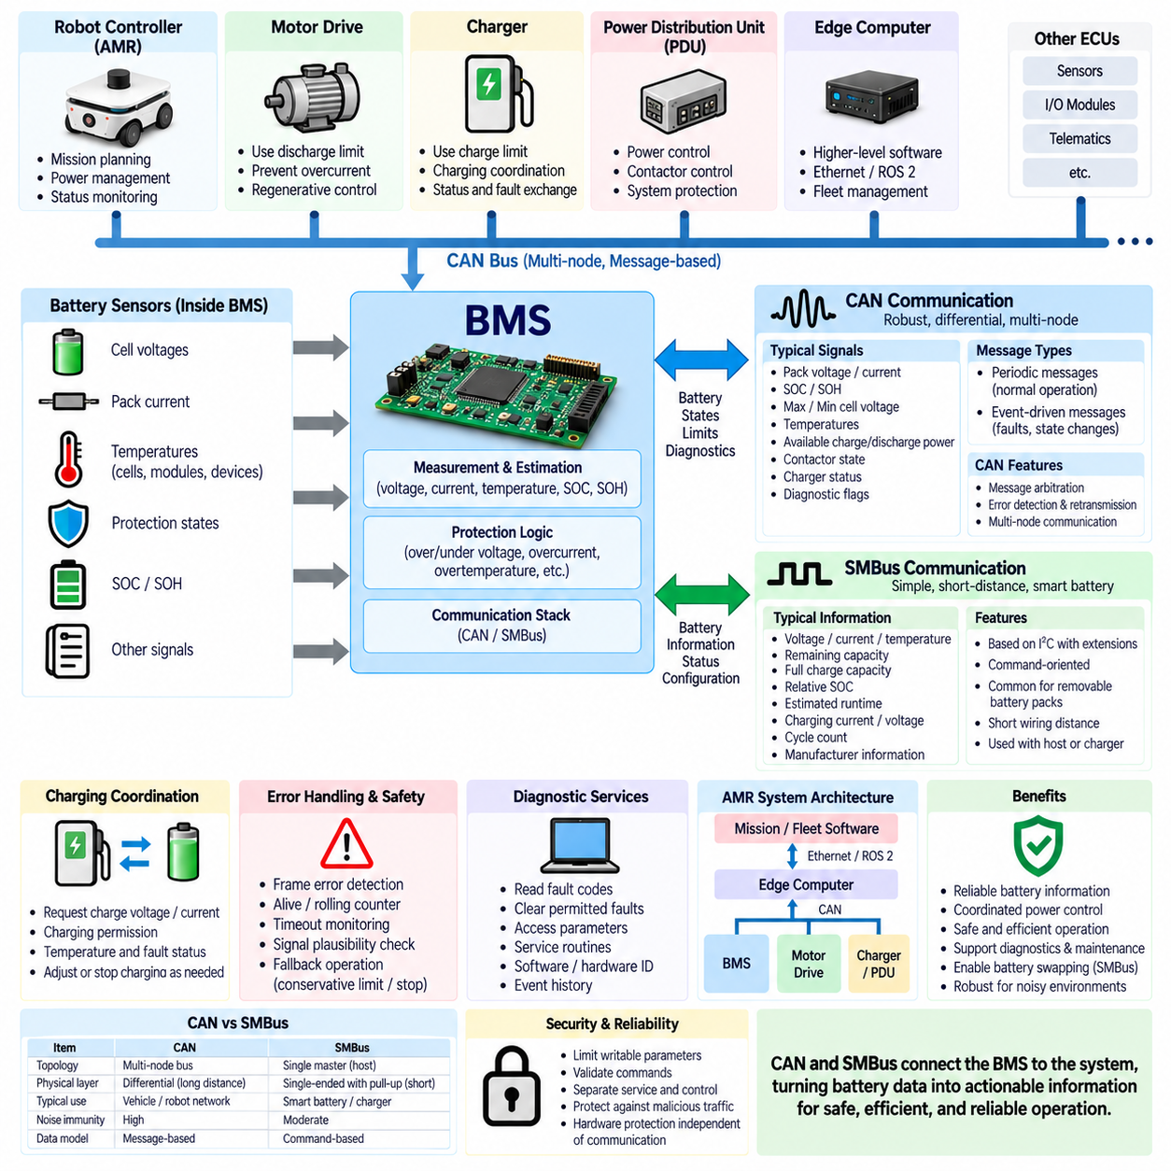
CAN communication is widely used in Battery Management Systems (BMS) that must exchange battery information with vehicle controllers, motor drives, chargers, power distribution units, and robot computers. The Controller Area Network (CAN) provides robust differential signaling, message arbitration, error detection, and multi-node communication. These characteristics make it well suited to electrically noisy mobile platforms such as Autonomous Mobile Robots (AMRs).
The BMS acts as an information gateway between the electrochemical battery and the rest of the electrical system. Internally, it measures cell voltages, pack current, temperatures, protection states, State of Charge (SOC), and State of Health (SOH). Through CAN, these internal states are converted into standardized messages that other controllers can use for power management, charging coordination, diagnostics, mission planning, and fault handling.
CAN communication is message-oriented rather than based on a dedicated connection between two devices. Each transmitted frame contains an identifier that represents message priority and usually indicates the meaning of the transmitted data. Multiple electronic control units can share the same CAN bus, and arbitration allows the highest-priority message to continue transmission without destructive collisions when several nodes attempt to communicate simultaneously.
A BMS CAN database typically defines signals such as pack voltage, pack current, SOC, SOH, maximum and minimum cell voltage, battery temperature, available charge power, available discharge power, contactor state, charger status, and diagnostic flags. Each signal requires a defined bit position, length, scaling factor, offset, physical unit, valid range, update period, and interpretation so that every connected controller processes the information consistently.
Periodic messages are commonly used for continuously changing battery states. Fast signals such as current, protection status, or allowable power may require relatively short transmission periods, while slowly changing information such as SOH or accumulated energy can be transmitted less frequently. Communication design must balance update latency against bus utilization so that important battery information remains timely without unnecessarily loading the network.
Event-driven CAN messages can complement periodic transmission when immediate notification of a significant state change is required. A critical overvoltage, undervoltage, overcurrent, overtemperature, insulation-related fault, or contactor transition may need to be communicated without waiting for a slower periodic message. However, safety-critical protection should not depend solely on successful CAN communication because the communication network itself can fail.
The BMS can transmit dynamic charge and discharge limits to other controllers. A motor controller or robot power manager can use the allowable discharge power to prevent excessive battery loading, while a charger or regenerative braking controller can use allowable charge current or power to avoid violating cell voltage and temperature limits. This creates coordinated power control in which the BMS communicates the battery's present operating envelope to the system.
CAN also supports charging coordination. During charging, the BMS can communicate requested voltage, requested current, SOC, battery temperature, charging permission, and fault status to a compatible charger. The charger can then regulate its output according to battery requirements while the BMS continuously supervises individual cells. If a protection limit is approached, the BMS can request reduced charging current or terminate charging according to the system architecture.
Communication integrity requires mechanisms for detecting missing, delayed, corrupted, or inconsistent information. CAN hardware already provides frame-level error detection, acknowledgment, retransmission, and fault confinement, but application-level protection may add alive counters, rolling counters, checksums, timeout monitoring, sequence validation, and signal plausibility checks. These mechanisms allow receiving controllers to distinguish valid battery information from stale or abnormal communication.
Timeout handling is particularly important because a controller must know what to do when expected BMS messages disappear. A robot controller should not continue assuming that previously reported power limits remain valid indefinitely. Depending on system risk, loss of communication may cause conservative power limitation, charging inhibition, controlled stopping, or transition to a defined safe state. The fallback behavior should be specified explicitly during system design.
Diagnostic communication over CAN allows service equipment or higher-level controllers to retrieve battery status, fault information, identification data, operating history, and selected measurements. Depending on the system, diagnostic protocols can support reading fault codes, clearing permitted faults, accessing parameter values, performing service routines, and obtaining software or hardware identification. Diagnostic access should remain separated from functions that could compromise battery protection.
SMBus, or System Management Bus, is another communication interface frequently associated with intelligent battery systems. It is derived from the I²C electrical concept but defines additional conventions for system management communication. SMBus is commonly used where a smart battery communicates with a host device or charger over a relatively short physical connection, making it particularly suitable for removable battery packs and compact embedded systems.
A Smart Battery System using SMBus can expose standardized battery information such as voltage, current, temperature, remaining capacity, full-charge capacity, relative SOC, estimated runtime, charging current, charging voltage, cycle count, and manufacturer information. This standardized command-oriented approach allows a host to query battery parameters without requiring a proprietary CAN message database for every basic battery measurement.
CAN and SMBus therefore serve overlapping but different system roles. CAN is particularly effective for distributed control networks containing multiple controllers over longer wiring distances and in environments with significant electrical noise. SMBus is better suited to local communication between a smart battery, host, and charger. A battery product may support one interface or both depending on whether it is designed as an integrated vehicle battery or a replaceable intelligent battery module.
The physical-layer requirements of the two interfaces are significantly different. CAN normally uses a differential pair with appropriate termination resistors, which provides strong noise immunity and supports robust communication across a distributed network. SMBus typically uses clock and data lines with pull-up resistors and is intended for shorter connections. Harness design, grounding, connector selection, electromagnetic compatibility, and bus topology must therefore match the selected interface.
In an AMR architecture, CAN can connect the BMS with the main robot controller, motor drives, charging controller, or power-management ECU. The edge computer does not necessarily need direct access to every raw battery measurement. Instead, a lower-level controller can receive deterministic battery information through CAN and provide selected energy states to higher-level software through Ethernet, ROS 2, or another system communication layer.
This separation supports a layered robot architecture. The BMS maintains fast local monitoring and protection, CAN distributes operational battery states and power limits among embedded controllers, and higher-level computing uses summarized battery information for mission and fleet decisions. Mission software can then estimate remaining operating time, schedule charging, select charging stations, or reassign tasks without becoming responsible for cell-level electrical protection.
SMBus can be useful when an AMR uses removable or modular smart batteries. A battery module can provide identification, capacity, SOC, temperature, cycle count, and charging requirements to the host immediately after connection. This supports battery swapping and module-level maintenance because the robot can identify the installed battery and determine its condition rather than assuming that every physically compatible pack has identical characteristics.
Communication design must also consider cybersecurity and unintended commands, particularly when battery data becomes accessible through gateways connected to Ethernet, wireless networks, or remote diagnostic systems. The BMS should limit writable parameters, validate commands, separate service functions from normal control, and ensure that communication faults or malicious higher-level traffic cannot override fundamental hardware protection mechanisms or unsafe operating limits.
Reliable BMS communication ultimately requires coordinated design of signals, timing, physical interfaces, diagnostics, fault responses, and system architecture. CAN provides robust distributed communication for battery integration with robot and powertrain controllers, while SMBus provides a compact smart-battery interface for local host and charger interaction. Both interfaces transform the BMS from an isolated protection device into an integrated source of battery state, capability, diagnostic, and energy-management information.

