Volume 11. Battery and Powertrain

Chapter 02. LFP Battery

02.01. LFP Electrochemistry
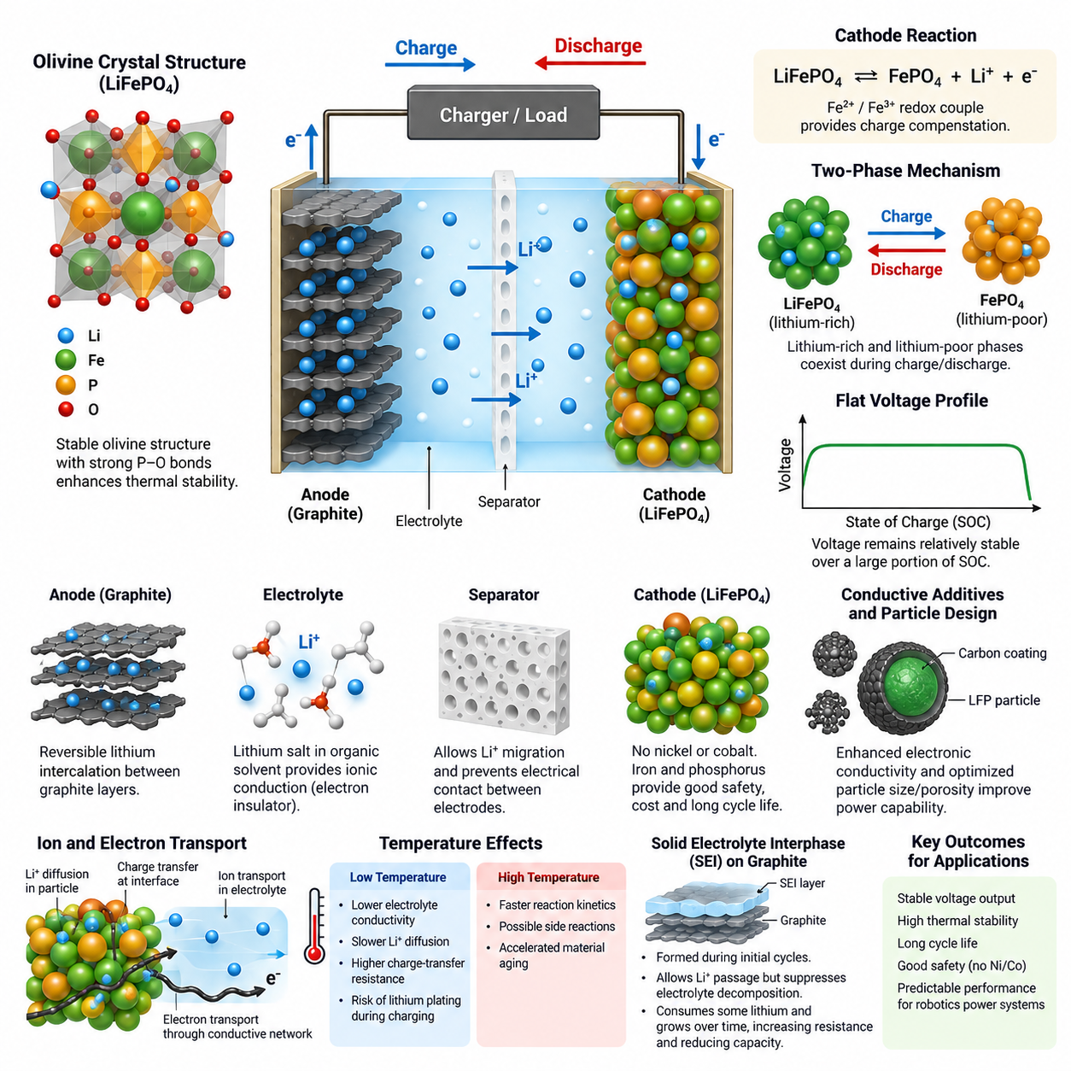
Lithium iron phosphate, commonly abbreviated as LFP, is a lithium-ion battery chemistry that uses lithium iron phosphate, LiFePO4, as the positive electrode active material. Its electrochemical behavior originates from the reversible insertion and extraction of lithium ions within a stable olivine-type crystal structure. This chemistry distinguishes LFP from layered oxide cathodes such as NMC.
During charging, lithium ions are extracted from the LiFePO4 cathode while electrons leave the cathode through the external electrical circuit. The cathode progressively transforms toward iron phosphate, FePO4. Lithium ions migrate through the electrolyte and separator toward the negative electrode, where they are inserted into graphite or another compatible anode material while maintaining overall charge neutrality.
The principal cathode reaction can be represented as LiFePO4 ⇌ FePO4 + Li+ + e−. Iron participates through the Fe2+/Fe3+ redox couple, providing the electronic charge compensation required as lithium is removed or inserted. During discharge, the reaction proceeds in the reverse direction: lithium ions return to the cathode and Fe3+ is reduced toward Fe2+, releasing electrical energy to the external load.
In a conventional graphite-based LFP cell, the negative electrode stores lithium primarily through reversible intercalation between graphite layers. During charging, lithium ions arriving from the electrolyte combine electrochemically with electrons supplied through the external circuit and form lithium-intercalated graphite. During discharge, lithium leaves the graphite and travels back through the electrolyte toward the LFP cathode.
The electrolyte provides ionic conduction between the electrodes while remaining electronically insulating. Typical lithium-ion electrolytes contain a lithium salt dissolved in organic solvents, allowing Li+ transport through the porous electrodes and separator. The separator physically prevents electronic contact between cathode and anode while permitting ionic migration, thereby sustaining electrochemical operation without an internal electrical short circuit.
A fundamental characteristic of LFP electrochemistry is the two-phase transformation between LiFePO4 and FePO4 over much of the usable state-of-charge range. Rather than continuously changing composition as a single homogeneous phase, lithium-rich and lithium-poor regions can coexist within cathode particles. Their relative fractions evolve as the battery charges or discharges, producing the characteristic electrochemical behavior of LFP cells.
This two-phase mechanism contributes directly to the relatively flat voltage profile associated with LFP batteries. Because the electrochemical potential changes only moderately while LiFePO4 and FePO4 phases coexist, cell voltage remains comparatively stable through a large portion of discharge. This property is valuable for delivering predictable operating voltage, although it makes voltage-based state-of-charge estimation more difficult.
The olivine crystal structure is one of the most important reasons for the stability of LFP chemistry. Phosphate groups contain strong phosphorus-oxygen bonds that stabilize oxygen within the cathode lattice. Compared with many layered transition-metal oxides, LFP therefore has a lower tendency to release oxygen under severe thermal or electrical abuse, contributing to its favorable thermal stability and resistance to runaway reactions.
LFP also avoids the use of nickel and cobalt in its cathode active material. Iron and phosphorus form the principal transition-metal and polyanion components, respectively, while lithium participates as the mobile charge carrier. This material composition influences cost, resource availability, thermal behavior, energy density, and lifecycle characteristics, making LFP particularly attractive where durability and safety are prioritized over maximum gravimetric energy density.
Electrochemical performance is nevertheless limited by transport processes inside the cell. Lithium ions must move through the electrolyte, cross electrode-electrolyte interfaces, and diffuse within active-material particles, while electrons must travel through conductive networks and current collectors. LFP itself has relatively low intrinsic electronic conductivity, so practical electrodes commonly employ conductive carbon and optimized particle structures.
Particle size, carbon coating, electrode porosity, electrolyte penetration, and conductive-additive distribution strongly influence practical LFP performance. Smaller particles can shorten lithium diffusion paths, while conductive coatings improve electronic transport around active particles. Electrode engineering therefore converts the favorable thermodynamic properties of LiFePO4 into useful power capability without changing the fundamental Fe2+/Fe3+ redox mechanism.
Temperature has a strong effect on these electrochemical processes. At low temperature, electrolyte conductivity decreases, lithium diffusion becomes slower, and interfacial charge-transfer resistance increases. Charging becomes particularly sensitive because excessive current can increase anode polarization and create conditions favorable to lithium plating. At elevated temperature, reaction kinetics improve but undesirable side reactions and material aging can accelerate.
The solid electrolyte interphase, or SEI, formed primarily on the graphite anode is another essential part of LFP cell operation. During initial cycling, electrolyte components react at the anode surface and create a passivating layer. A stable SEI allows lithium ions to pass while suppressing continuous electrolyte decomposition, but its formation consumes some lithium and its gradual evolution contributes to resistance growth and capacity loss.
LFP electrochemistry therefore reflects an interaction between thermodynamics, reaction kinetics, ionic transport, electronic conduction, interfacial chemistry, and thermal conditions. The LiFePO4/FePO4 phase transition provides a stable cathode reaction, while the anode, electrolyte, separator, and electrode microstructure determine how efficiently that reaction can be exploited under practical current and temperature conditions.
For robotic power systems, these electrochemical characteristics provide the foundation for understanding later engineering decisions involving state-of-charge estimation, thermal protection, charging control, cell selection, and powertrain integration. The battery architecture places LFP chemistry before these application topics because cell-level reaction mechanisms ultimately determine voltage behavior, current capability, safety margins, degradation, and usable energy.

02.02. LFP Flat SOC Curve
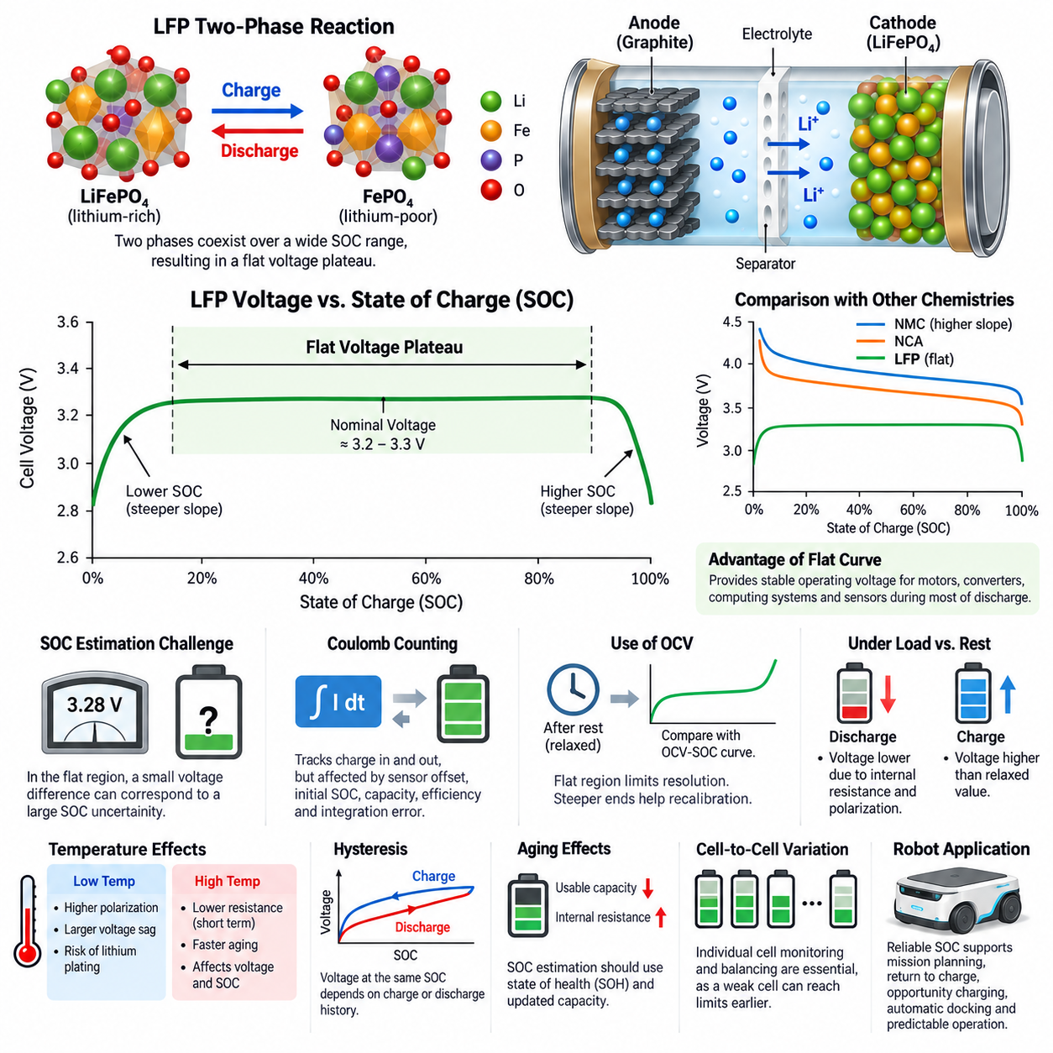
Lithium iron phosphate batteries exhibit a distinctive voltage behavior in which the cell voltage remains nearly constant across a large portion of the usable state-of-charge range. This characteristic, commonly called the flat SOC curve or flat voltage plateau, originates from the electrochemical properties of the LiFePO4 cathode and is one of the defining features that distinguishes LFP from many other lithium-ion chemistries.
State of charge, or SOC, represents the amount of usable charge remaining in a battery relative to its available capacity. An SOC of 100% corresponds approximately to a fully charged condition, while 0% represents the defined lower discharge limit. Although terminal voltage often provides useful information about SOC, the relationship between voltage and SOC depends strongly on battery chemistry, temperature, current, aging, and relaxation conditions.
In an LFP cell, the cathode undergoes a reversible transformation between lithium-rich LiFePO4 and lithium-poor FePO4. Over much of the operating range, these two phases coexist rather than forming a continuously changing homogeneous composition. The electrochemical potential therefore changes relatively little while the proportion of the two phases changes, producing a broad and characteristically flat voltage plateau during charge and discharge.
A typical LFP cell has a nominal voltage near 3.2 to 3.3 V, while its actual terminal voltage varies according to SOC and operating conditions. Near the middle portion of the SOC range, substantial changes in stored charge may correspond to only small changes in open-circuit voltage. Near the upper and lower SOC boundaries, however, the voltage curve becomes considerably steeper and provides stronger information about proximity to full charge or deep discharge.
The flat voltage plateau provides an important operational advantage because equipment supplied by an LFP battery experiences relatively stable battery voltage during much of a discharge cycle. Motor drives, DC-DC converters, computing systems, sensors, and auxiliary electronics therefore operate from a source whose voltage changes comparatively slowly as energy is consumed. This can simplify power-system design and improve consistency of robot operation over a mission.
The same characteristic creates a significant challenge for SOC estimation. In battery chemistries having a steeper open-circuit-voltage curve, a measured voltage difference can correspond to a relatively clear difference in SOC. For LFP, a small voltage measurement error within the plateau can represent a much larger SOC uncertainty because many different charge states may produce very similar equilibrium voltages.
Consequently, simple voltage-based SOC estimation is generally insufficient for accurate LFP battery management. A battery management system can instead integrate measured current over time using coulomb counting to track charge entering and leaving the battery. The estimate must account for sensor offset, initial SOC uncertainty, usable capacity, charging efficiency, and accumulated integration error, because even a small persistent current-measurement bias can gradually produce substantial SOC drift.
Open-circuit voltage can still provide valuable information when the battery has rested long enough for transient polarization effects to decay. The measured voltage may then be compared with an experimentally characterized OCV-SOC relationship. For LFP, however, the flat central region limits the resolution of this correction method, while the steeper regions near high and low SOC generally provide stronger opportunities for recalibrating the estimated battery state.
Terminal voltage under load should not be interpreted as equilibrium SOC voltage. Internal resistance, electrochemical polarization, charge-transfer processes, diffusion limitations, wiring resistance, and connection losses create voltage differences that depend on current. During high-current discharge the measured voltage decreases, while charging raises terminal voltage above its relaxed value. These dynamic effects can easily exceed the small SOC-dependent voltage variation present within the LFP plateau.
Temperature further complicates interpretation of the SOC-voltage relationship. Changes in temperature influence reaction kinetics, ionic conductivity, diffusion, internal resistance, and equilibrium potential. Low-temperature operation can produce stronger polarization and larger voltage sag under load, while high temperature can reduce some short-term resistive effects but accelerate degradation. An SOC estimator should therefore interpret voltage together with current and temperature rather than as an isolated measurement.
The LFP voltage curve also exhibits hysteresis, meaning that the voltage observed at a particular SOC can depend on whether the cell approached that state through charging or discharging. Relaxation history and previous current conditions can additionally influence measured voltage. Consequently, a single fixed mapping from terminal voltage to SOC cannot fully represent practical LFP behavior, especially during dynamic operation in a mobile robotic platform.
Battery aging introduces another source of uncertainty. As cells accumulate cycles and calendar time, usable capacity can decrease and internal resistance can increase. Coulomb counting based on the original rated capacity may then overestimate the energy actually available. Reliable SOC estimation therefore benefits from state-of-health information so that the estimator can update effective capacity and distinguish charge-state variation from long-term battery degradation.
More advanced battery management systems combine multiple sources of information rather than relying on one measurement. Current integration provides short-term SOC tracking, voltage supplies electrochemical state information, temperature supports operating-condition compensation, and battery models describe dynamic voltage response. Model-based observers or filtering algorithms can combine these signals to continuously correct estimation errors and maintain a more robust SOC estimate.
Cell-to-cell variation becomes particularly important when many LFP cells are connected in series to create a robotic battery pack. Even when pack voltage appears normal, individual cells may have slightly different capacities, resistances, temperatures, or SOC values. A weak or imbalanced cell can therefore reach its upper or lower voltage limit before the average pack state suggests a problem, making individual cell-voltage monitoring and balancing important BMS functions.
For an autonomous mobile robot, the flat SOC curve affects more than the battery display. Mission planning, return-to-charge decisions, opportunity charging, automatic docking, power derating, and remaining-runtime prediction all depend on trustworthy estimates of available energy. An optimistic SOC estimate can leave a robot unable to complete its mission, while an excessively conservative estimate reduces productive operating time and causes unnecessary charging interruptions.
The flat LFP SOC curve should therefore be understood as both an electrochemical advantage and a battery-management challenge. Its stable voltage supports predictable electrical operation, but the weak voltage-to-SOC sensitivity across the central operating range requires sophisticated estimation. Accurate LFP management ultimately depends on combining cell voltage, current, temperature, capacity, aging information, and operating history into a coherent estimate of the battery's usable state.

02.03. LFP Thermal Safety
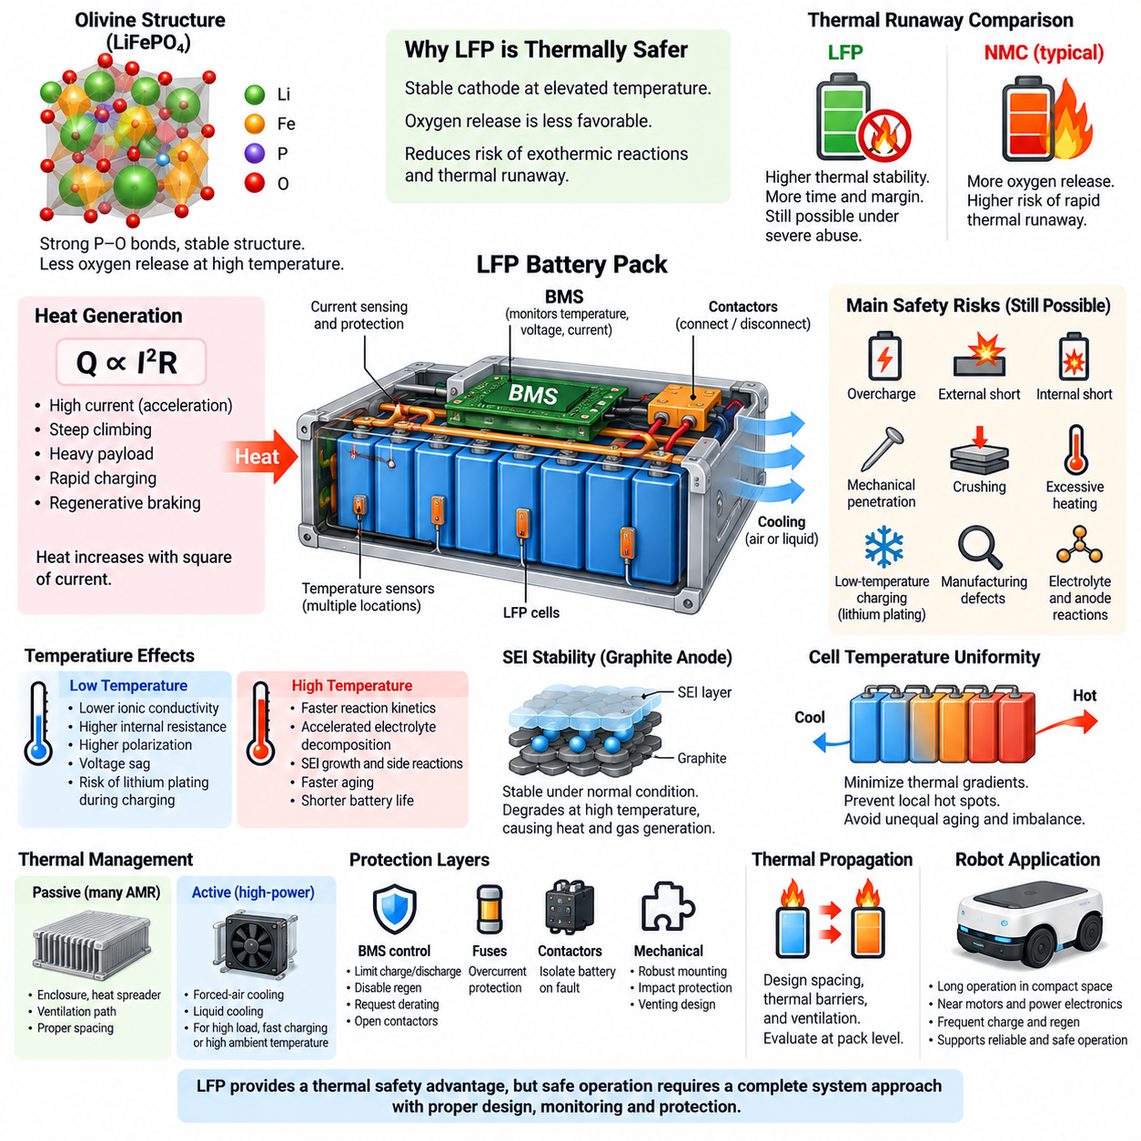
Lithium iron phosphate batteries are widely recognized for their favorable thermal safety compared with many high-energy lithium-ion chemistries. This behavior originates primarily from the stable olivine crystal structure of LiFePO4 and the strong phosphorus-oxygen bonds within the phosphate framework. These structural characteristics reduce the tendency of the cathode to release reactive oxygen when exposed to elevated temperature or abusive electrical conditions.
Thermal safety in a battery refers to its ability to remain within acceptable temperature limits and resist hazardous reactions during normal operation, charging, discharging, faults, and external abuse. Heat is continuously generated by internal resistance, electrochemical polarization, and other irreversible processes. Under normal conditions this heat is transferred to the cell casing, battery structure, cooling medium, and surrounding environment without causing dangerous temperature escalation.
The heat generated during battery operation is strongly related to current. Resistive heating can be approximated by the I²R relationship, meaning that heat generation increases approximately with the square of current for a given internal resistance. High acceleration demand, steep climbing, heavy payload operation, rapid charging, or regenerative braking can therefore create substantial short-duration thermal loads even when the average battery power remains moderate.
LFP chemistry provides an important safety advantage because the LiFePO4 cathode remains comparatively stable at elevated temperature. The phosphate framework binds oxygen strongly, making oxygen release less favorable than in many layered oxide cathodes. Since released oxygen can intensify reactions between electrode materials and electrolyte, suppressing this mechanism reduces one of the major pathways that can accelerate self-heating and thermal runaway.
Thermal runaway is a condition in which internal heat generation becomes greater than the rate at which heat can be removed, causing temperature to rise and accelerate additional exothermic reactions. This creates a positive feedback process that can eventually result in venting, fire, or cell rupture. LFP has a comparatively high resistance to this process, but it is not immune to thermal runaway under sufficiently severe abuse.
Battery safety therefore cannot rely on cathode chemistry alone. Overcharge, external short circuits, internal short circuits, mechanical penetration, crushing, excessive heating, manufacturing defects, and inappropriate charging at low temperature can still damage an LFP cell. Electrolyte and anode materials remain chemically active, and sufficiently high temperatures can destabilize protective interfaces and initiate exothermic reactions even when the cathode itself is relatively stable.
The solid electrolyte interphase, or SEI, on the graphite anode plays an important role in thermal behavior. Under normal conditions the SEI stabilizes the electrode-electrolyte interface, but excessive temperature can degrade this protective layer. Once the interface becomes unstable, additional reactions between the lithiated anode and electrolyte may occur, generating heat and gases and contributing to further temperature increase.
Temperature also influences electrical resistance and available power. At low temperatures, ionic conductivity and lithium diffusion decrease while internal resistance and polarization increase. The resulting voltage drop and resistive heating can limit usable power. Charging at low temperature is particularly important because unfavorable anode conditions can promote lithium plating, which may reduce capacity and potentially increase the risk of internal short circuits as degradation progresses.
High temperature creates a different set of problems. Although reaction kinetics improve and short-term internal resistance may decrease, elevated temperature accelerates electrolyte decomposition, SEI growth, side reactions, and material aging. Continuous operation at unnecessarily high temperature therefore shortens battery life even when immediate safety limits are not exceeded. Thermal management must consequently address both acute safety and long-term durability.
Cell temperature uniformity is almost as important as maximum temperature. Cells located near motors, inverters, DC-DC converters, chargers, or poorly ventilated regions may operate hotter than neighboring cells. Persistent temperature differences create unequal aging rates and internal resistance, which gradually increase electrical imbalance. Battery-pack design should therefore minimize thermal gradients as well as prevent individual cells from exceeding allowable temperature limits.
The battery management system provides the primary electronic layer for thermal supervision. Temperature sensors distributed throughout the pack allow the BMS to detect abnormal heating and modify system operation. Depending on severity, the BMS can reduce charging current, limit discharge power, disable regenerative charging, request powertrain derating, stop charging, or open contactors to electrically isolate the battery from the robot.
Sensor placement is critical because a limited number of temperature measurements cannot perfectly represent every cell. Sensors should be positioned where thermal analysis and testing indicate likely hot spots, including regions with restricted airflow, high current paths, dense cell packaging, or nearby heat-generating electronics. Pack validation should confirm that measured temperatures adequately represent the most thermally stressed cells under realistic operating conditions.
Passive thermal management may be sufficient for many moderate-power LFP robotic applications. Pack enclosures, conductive cell holders, heat spreaders, ventilation paths, and appropriate spacing can distribute and reject heat without pumps or refrigeration systems. Higher-power platforms may require forced-air or liquid cooling, particularly when continuous traction loads, rapid charging, high ambient temperature, or dense packaging create heat loads beyond passive cooling capability.
Mechanical and electrical protection must complement thermal management. Fuses, contactors, current sensing, insulation, properly sized conductors, secure cell mounting, and protection against impact or penetration reduce the probability that an electrical or mechanical fault will become a thermal event. Pack enclosure design should also consider venting behavior so that gases released from a failed cell do not create excessive internal pressure or directly propagate heat to neighboring cells.
Thermal propagation describes the possibility that failure of one cell heats adjacent cells sufficiently to initiate additional failures. LFP's thermal stability generally provides more time and margin for controlling this process, but pack-level propagation still depends strongly on cell spacing, enclosure geometry, thermal barriers, heat-transfer paths, cell capacity, and ventilation. Safety evaluation must therefore consider the complete battery pack rather than treating individual cell chemistry as sufficient protection.
For autonomous mobile robots, LFP thermal safety is particularly attractive because batteries may operate for long periods inside compact platforms near motors, power electronics, computers, and payload equipment. Robots can experience repeated acceleration, regenerative braking, automatic charging, and opportunity charging throughout the day. A thermally robust battery architecture supports predictable operation while reducing the probability that abnormal electrical conditions escalate into hazardous events.
The practical safety advantage of LFP should therefore be understood as additional engineering margin rather than permission to reduce protection requirements. Reliable robotic battery systems combine stable LFP electrochemistry with appropriate cell selection, thermal design, BMS monitoring, electrical protection, mechanical containment, fault detection, and validated operating limits. This layered approach converts the inherent thermal stability of LFP into dependable pack-level safety throughout the robot's service life.

02.04. LFP for AMR Application
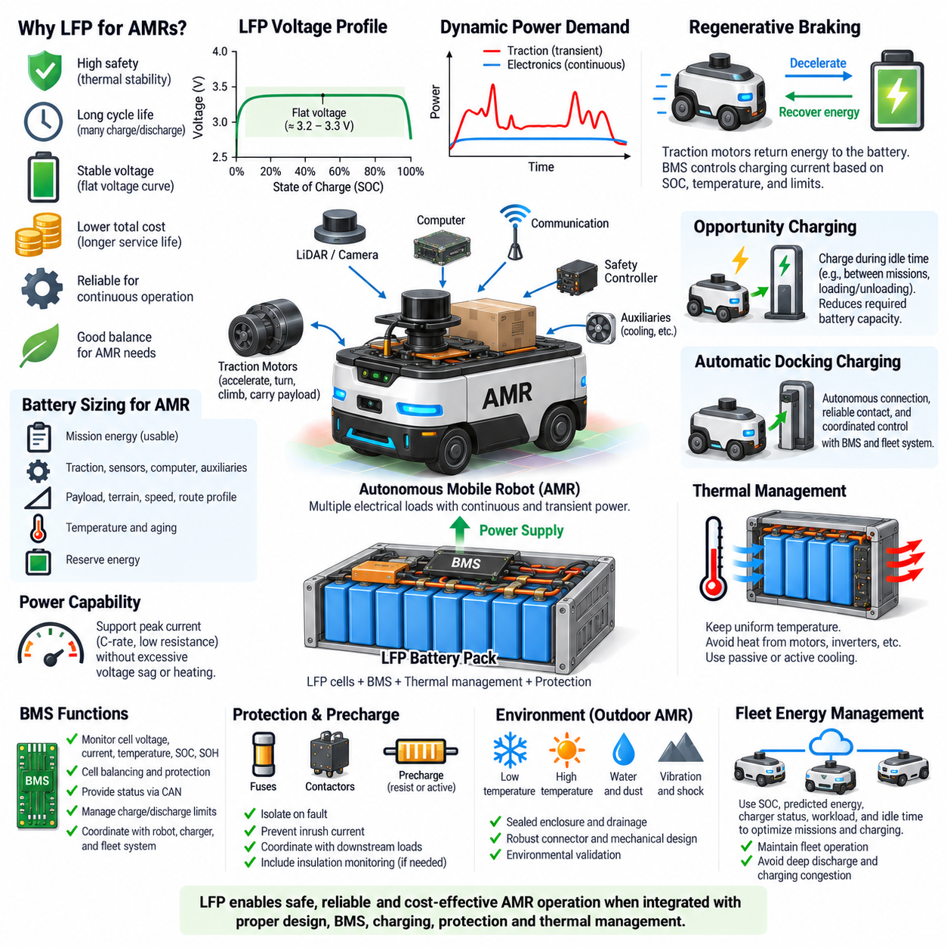
Lithium iron phosphate batteries are particularly well suited to autonomous mobile robot applications because their electrical, thermal, and lifecycle characteristics align closely with the operating requirements of mobile robotic platforms. AMRs commonly require repeated acceleration, long operating hours, frequent charging, predictable voltage, and high safety margins. LFP provides a balanced solution where reliability and service life are often more important than maximum energy density.
An AMR battery must supply both continuous and transient power. Continuous loads include onboard computers, LiDAR, cameras, communication devices, safety controllers, cooling systems, and auxiliary electronics, while traction motors can create much larger short-duration currents during acceleration, turning, climbing, or payload transport. LFP cells can support these dynamic loads when cell capacity, allowable C-rate, pack resistance, and thermal limits are properly matched to the vehicle.
The relatively stable operating voltage of LFP is beneficial for AMR electrical architecture. Because the voltage remains comparatively flat across much of the usable state-of-charge range, motor drives, DC-DC converters, sensors, computers, and control electronics experience less supply-voltage variation during normal operation. This helps maintain consistent subsystem behavior as the battery transitions from a high to a moderate or relatively low SOC.
The flat voltage characteristic also creates an important AMR engineering challenge because terminal voltage alone provides limited information about remaining battery capacity. Reliable mission planning therefore requires a BMS capable of robust SOC estimation using current integration, cell voltage, temperature, capacity information, and operating history. Accurate SOC information supports decisions such as whether a robot can accept another mission or should return to a charging station.
Long cycle life is another major advantage because AMRs can accumulate large numbers of partial charge and discharge cycles. A fleet operating continuously in a factory, warehouse, hospital, logistics center, or outdoor site may charge several times per day. Battery replacement cost includes not only the cells themselves but also maintenance labor, vehicle downtime, fleet availability, and operational disruption, making lifecycle performance an important economic design parameter.
Opportunity charging can exploit this lifecycle characteristic by charging the robot during naturally occurring idle periods. An AMR may connect to a charger while waiting at a station, loading or unloading cargo, or between missions rather than relying exclusively on one long charging session. This strategy can reduce the battery capacity required for continuous operation, but charging power, thermal behavior, charger availability, and fleet scheduling must be considered together.
Automatic docking charging is particularly important for autonomous operation because manual battery connection conflicts with the objective of unattended fleet operation. The robot must accurately approach the charging station, establish a reliable electrical connection, verify charging conditions, and coordinate with the BMS and fleet-management system. LFP packs can support repeated automated charging, provided that charger voltage, current limits, contact design, and charging control are properly engineered.
Battery sizing should be based on usable mission energy rather than nominal capacity alone. Designers must account for traction energy, computing and sensor loads, auxiliary equipment, conversion losses, temperature effects, aging, reserve energy, and expected route conditions. Payload mass, floor resistance, gradients, acceleration frequency, and travel speed can substantially change traction demand, so realistic mission profiles are necessary when defining the required LFP pack capacity.
Power capability must also be evaluated separately from energy capacity. A battery may contain enough watt-hours to complete a mission but still be unable to provide the instantaneous current required for acceleration, steering actuators, lifts, manipulators, or simultaneous auxiliary loads. Cell C-rate capability, internal resistance, busbar design, connectors, fuses, contactors, and wiring must therefore support peak current without unacceptable voltage sag or thermal stress.
Regenerative braking introduces bidirectional power flow into the AMR battery system. During deceleration, traction motors can operate as generators and return electrical energy to the DC bus and battery. The BMS must verify that the LFP pack can accept this charging current. When SOC is high, temperature is outside the permitted range, or cell voltage approaches its upper limit, regenerative current may need to be reduced or redirected through an alternative braking strategy.
Thermal behavior is important even though LFP offers comparatively strong thermal stability. Repeated acceleration, high payloads, charging, regenerative braking, and compact battery packaging can create localized heating. Battery placement should avoid unnecessary exposure to heat from motors, inverters, DC-DC converters, and computing hardware. Temperature sensing and appropriate passive or active cooling help maintain uniform cell conditions and prevent accelerated aging.
The BMS acts as the supervisory interface between the LFP pack and the AMR powertrain. It monitors individual cell voltages, pack current, temperatures, SOC, and potentially state of health. It also supervises balancing and protection functions. Through CAN or another vehicle communication interface, the BMS can provide battery status and allowable charge or discharge power to the robot controller, charger, motor system, and fleet-management functions.
Protection coordination is essential because an AMR contains multiple electrical loads with different current and fault characteristics. The battery pack may include cell-level protection, a main fuse, contactors, precharge circuitry, current sensing, insulation monitoring where appropriate, and service disconnect functions. Downstream power distribution must coordinate these protections so that a local subsystem fault does not unnecessarily disable the entire robot while severe battery faults result in rapid isolation.
Precharge becomes important when the LFP pack supplies motor inverters or other equipment containing large DC-link capacitors. Directly connecting a charged battery to an uncharged capacitor can create a high inrush current that stresses contactors, connectors, fuses, and capacitors. A controlled precharge path raises the DC-bus voltage before the main contactor closes, allowing the AMR power system to transition safely from the disconnected state to normal operation.
Pack architecture must also consider serviceability and fleet maintenance. Modular battery assemblies can simplify replacement, diagnostics, and capacity scaling across related AMR platforms. Connectors should support the required current while resisting vibration, contamination, and repeated maintenance operations. Mechanical mounting must protect cells from shock and impact while allowing controlled removal without exposing technicians to unnecessary electrical or mechanical hazards.
For outdoor AMRs, environmental conditions expand the battery design envelope. Low ambient temperature can reduce available power and charging capability, while high ambient temperature can accelerate aging. Water, dust, vibration, shock, solar heating, and uneven terrain can also influence pack design. Enclosure sealing, drainage, mechanical isolation, thermal design, connector selection, and environmental validation therefore become integral parts of the LFP battery architecture.
Fleet-level energy management can use battery information to improve overall AMR utilization. Rather than waiting until every robot reaches a fixed low-SOC threshold, fleet software can consider current SOC, predicted mission energy, charger occupancy, route distance, workload priority, and expected idle time. Robots can then be assigned missions and charging opportunities in a way that maintains operational coverage while avoiding unnecessary deep discharge or charging congestion.
The value of LFP for AMRs therefore extends beyond the chemistry of an individual cell. Its stable voltage, favorable thermal behavior, cycle durability, and practical power capability support long-duration robotic operation, but successful implementation depends on coordinated pack sizing, BMS design, charging, protection, thermal management, regenerative braking, power distribution, and fleet energy management. LFP becomes most effective when the battery is engineered as an integrated part of the complete AMR powertrain.

02.05. LFP Cell Selection
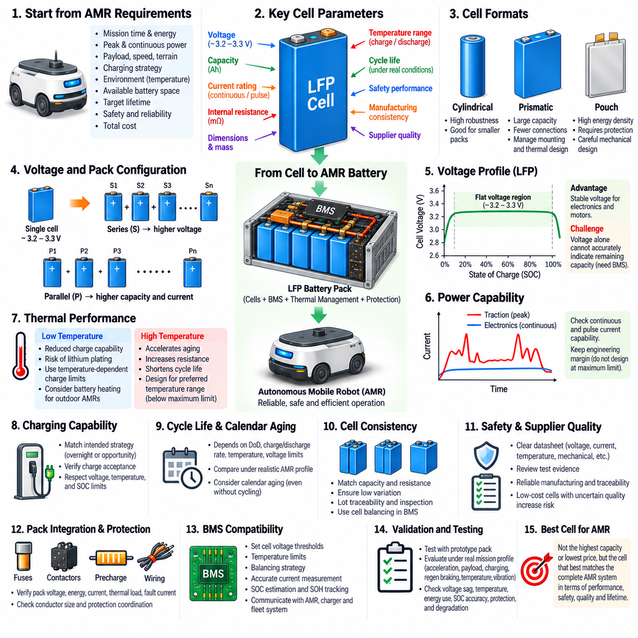
Selecting an LFP cell for an autonomous mobile robot requires more than choosing a cell with sufficient nominal capacity. The cell becomes the fundamental electrical, thermal, mechanical, and lifecycle building block of the complete battery pack. Its voltage, capacity, current capability, resistance, dimensions, mass, temperature limits, cycle life, and safety characteristics ultimately constrain the performance and reliability of the AMR powertrain.
The selection process should begin with system-level requirements rather than a preferred cell specification. Required pack voltage, usable energy, continuous power, peak power, charging strategy, operating time, payload, vehicle mass, environmental conditions, available battery volume, and expected service life should first be defined. These requirements can then be translated into cell-level voltage, capacity, current, thermal, and packaging targets.
Nominal cell voltage determines the number of cells required in series. LFP cells commonly operate around a nominal voltage of approximately 3.2 to 3.3 V, but pack design must consider the complete operating voltage range rather than nominal voltage alone. The series count must ensure that the battery remains compatible with motor inverters, DC-DC converters, chargers, contactors, and other high-power components from maximum charge voltage to minimum permitted discharge voltage.
Cell capacity, expressed in ampere-hours, determines how much charge each parallel group can store. Required capacity should be derived from realistic mission energy rather than theoretical runtime alone. Traction demand, onboard computing, sensors, communication equipment, auxiliary loads, conversion losses, reserve energy, temperature effects, and aging margins should be included so that the selected cell continues to support the intended AMR mission after significant service.
Energy capacity and power capability must be evaluated separately. A high-capacity cell may provide sufficient operating time while being unsuitable for the peak currents required by acceleration, climbing, steering, lifting mechanisms, or manipulators. Continuous and pulse discharge ratings should therefore be compared with the expected current profile, while appropriate engineering margin should be retained rather than designing the pack directly at the manufacturer's maximum limits.
Internal resistance is a critical parameter because it influences voltage sag, power loss, and heat generation. Under high current, a cell with excessive resistance produces greater I²R loss and experiences a larger terminal-voltage drop. Resistance also tends to increase with aging and at low temperature. Cell selection should therefore evaluate not only initial resistance but also how the resulting pack is expected to perform under realistic temperature and end-of-life conditions.
Charging capability must match the intended operating strategy. AMRs using overnight charging may tolerate relatively modest charging rates, whereas fleets relying on automatic docking and opportunity charging can require higher charge acceptance. The selected cell should support the required charging current without excessive heating or accelerated degradation, while the charging strategy must respect cell voltage, temperature, SOC, and manufacturer-defined operating limits.
Low-temperature charging performance deserves particular attention for outdoor or unconditioned environments. LFP cells may provide useful discharge capability at reduced temperature while becoming much more restricted during charging. Excessive charging current under cold conditions can increase the risk of lithium plating at the graphite anode. The cell specification and BMS strategy must therefore provide appropriate temperature-dependent charge-current limits and, where necessary, battery heating.
High-temperature performance should be assessed separately from immediate safety. LFP chemistry offers favorable thermal stability, but sustained operation at elevated temperature still accelerates electrolyte degradation, SEI growth, resistance increase, and capacity loss. A cell that technically permits a high maximum temperature may not deliver acceptable lifecycle performance when repeatedly operated near that limit. Thermal design should therefore target a preferred operating range below absolute safety boundaries.
Cycle-life specifications should be interpreted carefully because published values depend on test conditions. Depth of discharge, charging rate, discharge rate, temperature, voltage limits, rest periods, and the capacity-retention criterion can substantially change measured cycle life. For an AMR, the most useful comparison is not simply the largest advertised cycle number but performance under conditions resembling the intended daily charging and mission profile.
Calendar aging must also be considered because battery degradation occurs even when the robot is not cycling. Time spent at high temperature or extreme SOC can reduce available capacity and increase resistance. This becomes important for spare robots, seasonal outdoor platforms, or fleets that remain fully charged for long periods. Cell selection and operating policy should therefore consider both cycling degradation and storage behavior over the expected service life.
Cell format strongly influences mechanical and thermal integration. LFP cells are available in cylindrical, prismatic, and pouch configurations, each creating different tradeoffs in packaging density, structural support, cooling, electrical interconnection, manufacturing complexity, and serviceability. The preferred format should fit the AMR chassis while allowing secure mounting, predictable heat transfer, appropriate compression where required, and practical inspection or replacement.
Prismatic LFP cells are attractive for many medium- and large-capacity AMRs because relatively large cell capacities can reduce the number of parallel electrical connections and simplify pack construction. However, their mechanical mounting, terminal loading, dimensional tolerance, swelling behavior, and thermal gradients must be managed carefully. Cell holders and compression structures should follow the requirements applicable to the specific cell rather than relying on generic mechanical assumptions.
Cell consistency is essential when cells are connected in series. Differences in capacity, internal resistance, self-discharge, or initial SOC can cause individual cells to reach voltage limits at different times. A pack is ultimately constrained by its weakest cell, not merely by average pack capacity. Procurement specifications should therefore consider manufacturing consistency, lot traceability, incoming inspection, capacity matching, resistance measurement, and appropriate cell balancing.
Safety qualification and supplier quality are as important as electrical performance. Datasheets should clearly define voltage, current, temperature, mechanical, storage, and charging limits, while relevant test evidence should be reviewed for the intended application. A low-cost cell with uncertain manufacturing control or inconsistent documentation can create greater lifecycle and safety risk than a more expensive cell supported by stable production, traceability, and technical data.
Pack configuration follows from the selected cell and system requirements. Series connections establish voltage, while parallel connections increase capacity and current capability. The resulting configuration must be checked against maximum and minimum pack voltage, usable energy, continuous and peak current, charging current, thermal load, fault current, conductor sizing, fuse coordination, contactor rating, and BMS measurement capability before the architecture is finalized.
The BMS must be compatible with the chosen cell chemistry and configuration. Cell-voltage thresholds, temperature limits, balancing strategy, SOC estimation, allowable charge power, and allowable discharge power should reflect the actual characteristics of the selected LFP cell. Because LFP has a relatively flat SOC-voltage curve, current measurement accuracy, capacity estimation, cell consistency, and state-of-health tracking become especially important for reliable AMR energy management.
Cell selection should ultimately be validated at pack and vehicle level rather than concluded from datasheets alone. Representative cells and prototype packs should be tested under realistic acceleration, payload, charging, regenerative braking, temperature, vibration, and mission-cycle conditions. Voltage sag, temperature distribution, energy consumption, SOC accuracy, protection behavior, and degradation trends can then be compared with design assumptions before production release.
The best LFP cell for an AMR is therefore not necessarily the cell with the highest capacity, highest current rating, lowest price, or longest advertised cycle life. It is the cell whose electrical, thermal, mechanical, safety, quality, and lifecycle characteristics best match the complete robotic system. Effective selection connects cell specifications directly to pack architecture, BMS control, charging infrastructure, powertrain demand, environmental conditions, maintenance strategy, and fleet operation.

