Volume 15 Perception and Sensor Architecture

Chapter 09. GNSS

09.01. RTK GNSS Architecture
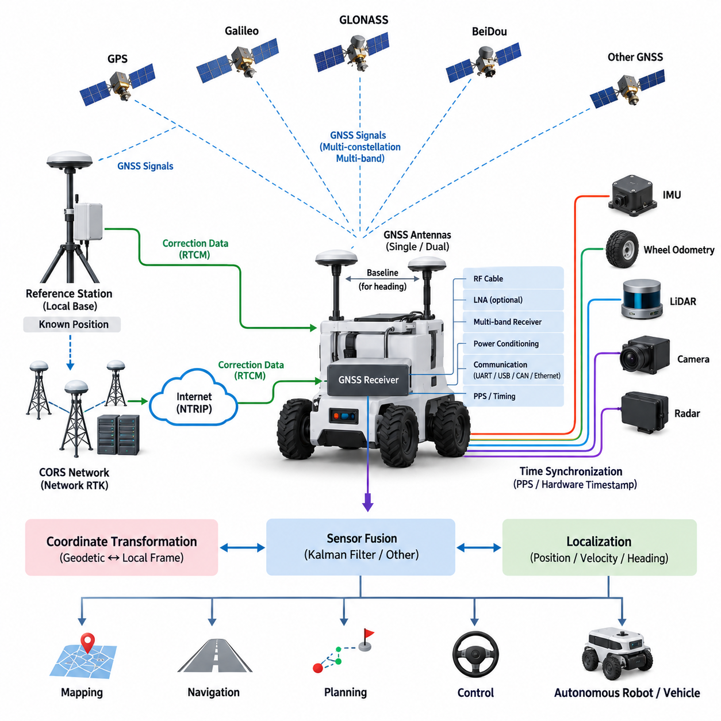
Real-Time Kinematic GNSS is a high-precision positioning architecture that improves conventional satellite navigation by estimating and removing common measurement errors. Instead of relying only on pseudorange observations, RTK uses carrier-phase measurements from multiple GNSS constellations and frequency bands. A reference station with a precisely known position observes the same satellites as the mobile receiver and provides correction information that enables centimeter-level relative positioning under favorable conditions.
An RTK GNSS architecture normally consists of GNSS satellites, a reference source, a correction communication path, and a rover receiver installed on the robot or vehicle. The reference source may be a dedicated local base station or a continuously operating reference station network. The rover combines received satellite measurements with correction data and calculates a high-accuracy navigation solution that can be supplied to localization, navigation, mapping, control, and sensor-fusion functions.
The satellite segment should be considered a multi-constellation system rather than a single GPS source. Modern receivers commonly process signals from GPS, Galileo, GLONASS, BeiDou, and regional systems where supported. Observing more satellites improves geometric diversity and availability, particularly when buildings, vegetation, terrain, or vehicle structures partially obstruct the sky. Multi-band reception further improves ionospheric error estimation and accelerates ambiguity resolution.
Carrier-phase measurement is the fundamental mechanism behind RTK accuracy. The wavelength of the GNSS carrier is much shorter than the code sequence used for ordinary positioning, allowing very precise measurement of relative phase. However, the receiver initially does not know the integer number of complete carrier cycles between the satellite and antenna. RTK processing therefore performs integer ambiguity estimation, and successful resolution of these ambiguities is required to achieve the highest positioning accuracy.
RTK operating status is commonly interpreted through solution states such as standalone, differential, float, and fixed. A float solution means that carrier ambiguities have not yet been reliably resolved to integers, so positioning accuracy remains below the final RTK capability. An RTK fixed solution indicates successful integer ambiguity resolution and normally represents the desired state for precision autonomous navigation. Robot software should therefore monitor both coordinates and solution quality rather than treating every GNSS output as equally trustworthy.
A local base station generates corrections by comparing measured satellite observations with measurements expected from its accurately surveyed location. These corrections can be transmitted directly to a rover through radio, cellular communication, Ethernet-connected infrastructure, or other suitable communication channels. The base-to-rover distance should remain within the operational limits of the correction strategy because atmospheric and satellite-related errors become less correlated as separation increases.
Network RTK extends this principle by using multiple geographically distributed reference stations. A network service estimates spatially varying GNSS errors and supplies corrections appropriate for the rover region. Correction delivery is frequently performed through Internet-based communication, allowing autonomous robots to obtain precision positioning without deploying a dedicated base station at every operating site. This architecture is especially useful for distributed outdoor AMRs, inspection vehicles, agricultural machines, and smart-city robotic fleets.
RTCM messages provide a standardized mechanism for transporting GNSS observation and correction information between reference infrastructure and rover receivers. In an Internet-connected implementation, an NTRIP client running in the GNSS receiver, edge computer, or communication gateway can obtain RTCM streams from an NTRIP caster. The communication architecture must maintain sufficient availability and predictable latency because prolonged interruption of correction data can cause degradation from fixed RTK operation toward float or standalone positioning.
The rover architecture includes more than the GNSS receiver itself. A practical robotic implementation contains one or more GNSS antennas, RF cabling, low-noise amplification where required, the multi-band receiver, correction interface, power conditioning, communication interfaces, and an edge computer. The receiver may provide position, velocity, heading-related information, timing signals, raw observations, and diagnostic data through interfaces such as UART, USB, CAN, or Ethernet depending on the selected hardware.
Antenna design has a direct influence on the achievable RTK performance. The antenna requires a sufficiently clear view of the sky while minimizing multipath caused by metallic surfaces, robot structures, nearby buildings, and other reflective objects. Ground-plane characteristics, cable loss, connector quality, antenna gain, and electromagnetic interference must therefore be treated as system-level engineering parameters. Antenna placement is consequently part of both mechanical packaging and electrical architecture.
Single-antenna RTK provides accurate position and velocity but cannot always provide reliable absolute heading while the platform is stationary. A dual-antenna GNSS configuration can estimate heading from the precisely measured baseline vector between two antennas. This is particularly valuable for outdoor AMRs, autonomous vehicles, inspection platforms, and slow-moving robots because the navigation system can obtain orientation information before sufficient vehicle motion exists to derive course from GNSS velocity.
RTK GNSS should normally operate as one component of a broader localization architecture rather than as an isolated navigation source. GNSS provides globally referenced position, while the IMU supplies high-rate angular velocity and acceleration measurements. Wheel odometry, steering information, LiDAR localization, visual odometry, radar, or other sensors can provide complementary motion constraints. Their fusion allows the localization system to continue producing stable state estimates during temporary GNSS degradation or correction outages.
The different update characteristics of these sensors make temporal alignment important. GNSS position may be generated at a relatively modest rate compared with an IMU operating at hundreds of measurements per second. Hardware timing outputs such as PPS can establish a precise time reference, while timestamped data interfaces associate observations with the correct measurement epoch. Poor synchronization can convert vehicle motion into apparent spatial error even when each individual sensor is accurate.
The coordinate architecture must also distinguish global geographic coordinates from robot-local frames. GNSS receivers naturally operate with Earth-referenced representations such as latitude, longitude, altitude, or Earth-centered coordinates, while autonomous navigation software often requires a local Cartesian map frame. A transformation layer converts the global GNSS solution into the navigation coordinate system and maintains relationships among GNSS antenna, IMU, vehicle body, LiDAR, camera, and robot base frames.
Mechanical calibration is therefore inseparable from positioning architecture. The GNSS antenna phase center is usually displaced from the vehicle reference point used by navigation and control. This lever arm must be measured and represented correctly, particularly when high-precision positioning is expected. In dual-antenna configurations, the baseline length and orientation must also be accurately characterized. Incorrect frame definitions can create systematic localization errors even when the GNSS receiver itself reports a valid RTK fixed solution.
Outdoor autonomous robots must additionally handle transitions between strong and degraded satellite environments. Open-sky operation may provide stable fixed RTK positioning, while trees, bridges, buildings, tunnels, loading areas, and urban canyons can reduce satellite visibility or introduce multipath. The localization system should evaluate satellite count, geometry, correction age, ambiguity status, receiver-reported uncertainty, and consistency with inertial or odometric motion before deciding how strongly GNSS measurements should influence the fused state.
System integrity is more important than nominal centimeter accuracy alone. Navigation software should detect abrupt coordinate jumps, stale corrections, unrealistic velocities, inconsistent heading, loss of fix, and disagreement between GNSS and independent sensors. A fault-management layer can reduce GNSS weighting, reject suspicious observations, switch localization modes, constrain robot speed, or request a controlled stop according to application requirements. Precision positioning becomes useful for autonomy only when uncertainty and failure behavior are explicitly managed.
The overall electrical architecture must protect GNSS performance from the robot itself. Switching converters, motor drives, high-current cables, GPUs, Ethernet electronics, wireless transmitters, and poorly shielded digital systems can introduce electromagnetic noise into sensitive GNSS reception paths. Careful grounding, filtering, cable routing, shielding, connector selection, power isolation, and physical separation between antennas and interference sources are therefore essential parts of RTK GNSS integration in electrically complex robotic platforms.
For outdoor AMRs and autonomous inspection vehicles, the resulting architecture forms a continuous chain from satellites and correction infrastructure to the rover receiver, synchronized sensor fusion, coordinate transformation, localization, planning, and motion control. RTK GNSS supplies the globally referenced geometric anchor, while inertial and perception sensors provide continuity and local environmental awareness. This layered approach allows centimeter-class positioning to become a dependable component of a complete autonomous navigation system rather than merely a high-accuracy coordinate output.

09.02. Multi Band Receiver
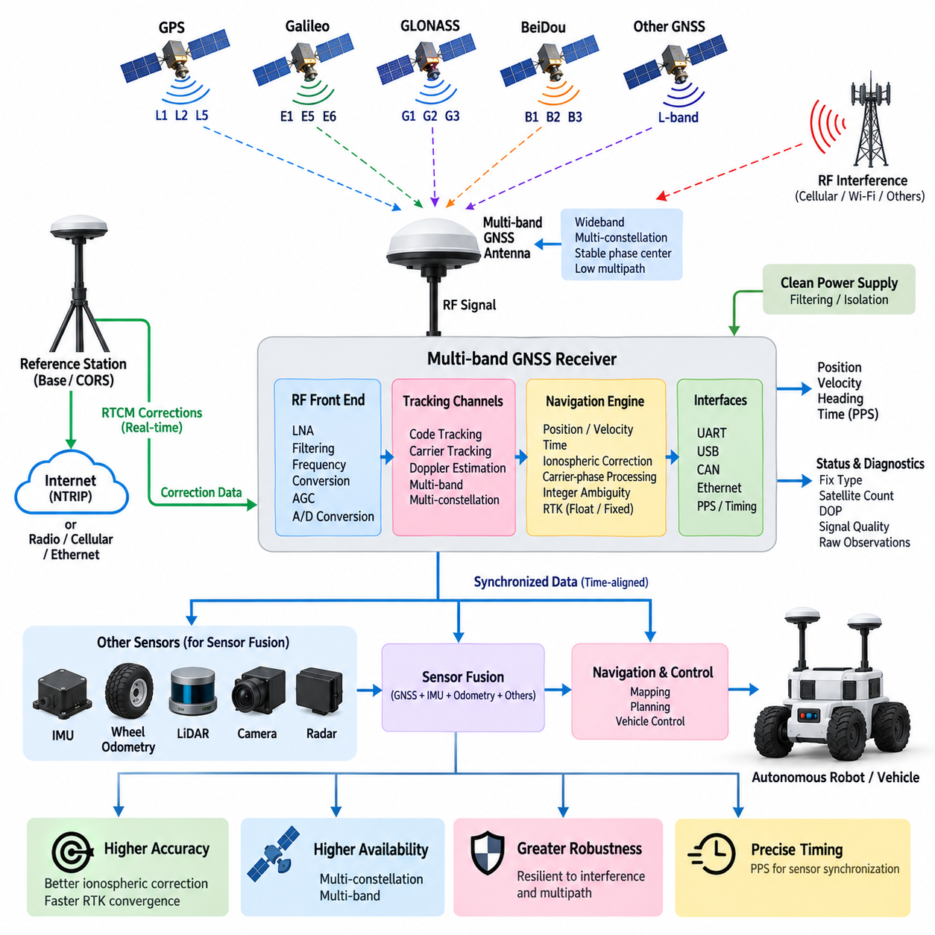
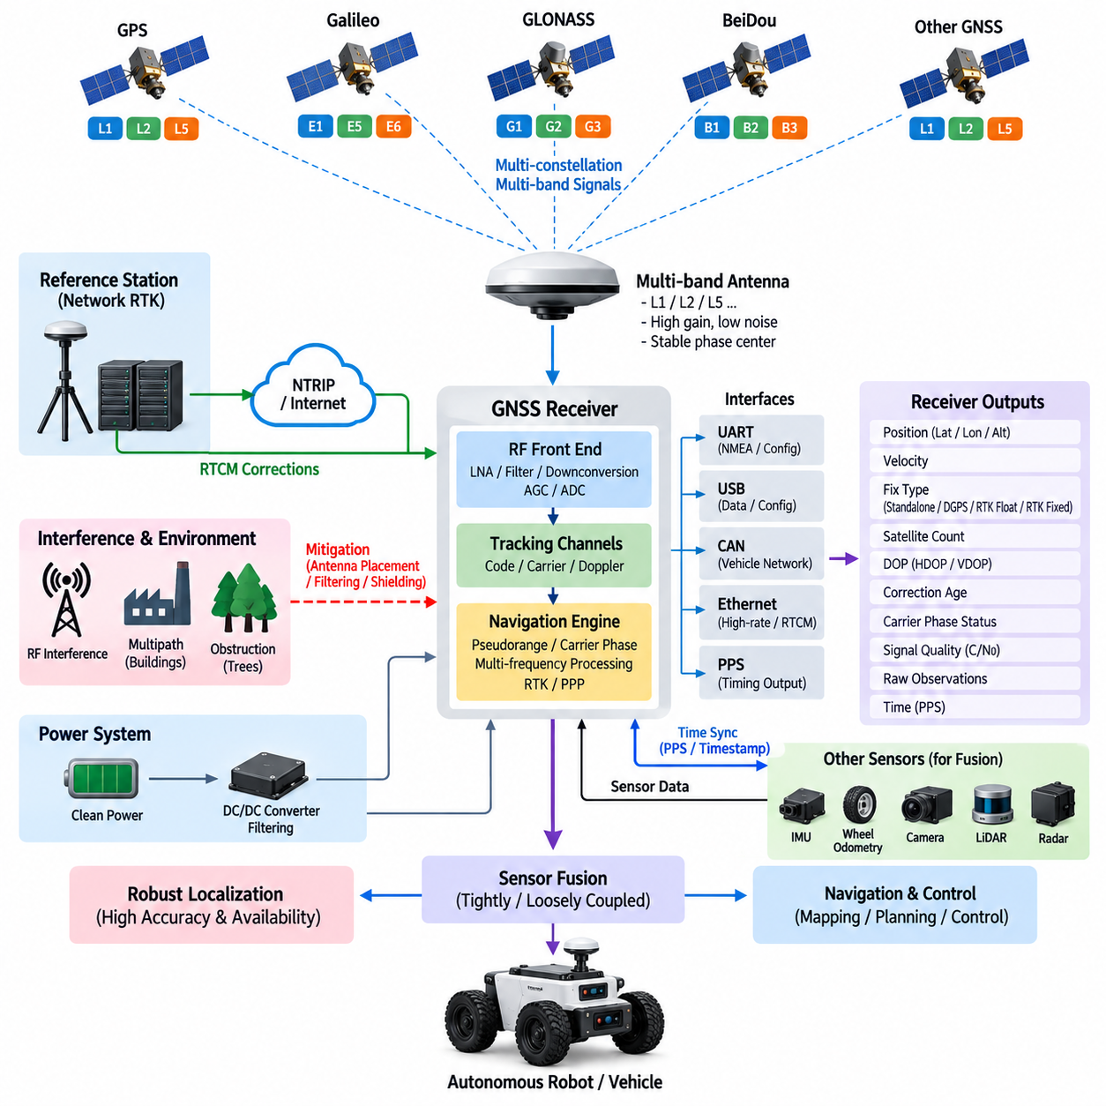
A multi-band GNSS receiver is designed to observe navigation signals transmitted on multiple carrier frequencies rather than relying on a single frequency such as GPS L1. Modern receivers can simultaneously process combinations such as L1, L2, and L5 or their corresponding frequencies from Galileo, GLONASS, BeiDou, and other constellations. This frequency diversity improves positioning accuracy, availability, convergence speed, and robustness for autonomous robotic platforms.
The receiver architecture begins at the GNSS antenna, which must support the required frequency bands with appropriate gain, polarization, impedance characteristics, and radiation patterns. Signals arriving from satellites are extremely weak, so antenna performance directly affects the quality of every downstream measurement. Multi-band antennas are therefore engineered to receive several GNSS frequency ranges while maintaining stable phase-center behavior and sufficient rejection of signals outside the intended navigation spectrum.
After the antenna, the radio-frequency front end processes the received satellite signals before digital navigation algorithms can use them. Typical functions include low-noise amplification, filtering, frequency conversion, automatic gain control, and analog-to-digital conversion. Because several GNSS bands may be processed simultaneously, the front end must maintain adequate bandwidth and isolation while preventing strong nearby radio transmitters or electronic noise generated by the robot from saturating sensitive receiver stages.
The principal advantage of multi-band reception is the ability to characterize frequency-dependent propagation errors. Ionospheric delay is dispersive, meaning that its magnitude changes according to signal frequency. By comparing measurements obtained from two or more frequencies, the receiver can estimate or eliminate a significant portion of this error. This capability is especially important for high-precision positioning because atmospheric errors that may be acceptable in ordinary navigation become significant when centimeter-level accuracy is required.
Multiple frequencies also improve carrier-phase ambiguity resolution used by real-time kinematic positioning. RTK algorithms must determine the integer number of carrier cycles between satellites and the rover antenna before a fixed high-accuracy solution can be established. Measurements from additional frequencies provide more independent constraints and useful wavelength combinations. As a result, a multi-band receiver can generally achieve faster and more reliable ambiguity resolution than a comparable single-band architecture under suitable satellite visibility.
Frequency diversity should be combined with constellation diversity. A modern receiver may simultaneously track GPS, Galileo, GLONASS, and BeiDou signals across several supported bands, substantially increasing the number of usable observations. This becomes particularly valuable for outdoor AMRs operating near buildings, industrial structures, trees, containers, or other obstacles. Even when some satellites are blocked, the receiver may retain sufficient geometry through other constellations and frequencies to maintain a usable navigation solution.
Signal availability alone does not guarantee measurement quality. Reflections from buildings, vehicle surfaces, ground structures, and nearby objects can create multipath, where delayed copies of satellite signals arrive together with the direct signal. Multi-band receivers can provide additional measurements that help navigation algorithms detect inconsistent observations, but antenna placement remains essential. The antenna should therefore be positioned with a clear sky view and appropriate separation from reflective structures and electromagnetic interference sources.
A practical multi-band receiver contains multiple tracking channels that independently acquire and follow satellite signals. Digital correlators identify the ranging codes and continuously estimate code phase, carrier phase, Doppler shift, and signal strength. These measurements are converted into pseudorange, carrier-phase, and range-rate observations. The navigation engine then combines observations from multiple satellites, frequencies, and constellations to estimate position, velocity, time, and associated quality indicators.
For RTK applications, the receiver must process both local satellite observations and correction information received from a base station or network service. RTCM correction streams may arrive through serial communication, Ethernet, cellular networking, or an NTRIP client implemented in the receiver or edge computer. The navigation processor associates these corrections with the appropriate satellite, signal, and measurement epoch before performing differential carrier-phase processing and integer ambiguity resolution.
Receiver output should expose more information than latitude, longitude, and altitude. Autonomous systems benefit from velocity, fix type, satellite count, dilution-of-precision indicators, estimated covariance, correction age, carrier-phase status, signal quality, and raw observation data. These diagnostics allow localization software to determine whether a reported position originates from standalone GNSS, differential positioning, RTK float, or RTK fixed operation and to adjust its confidence accordingly.
The electrical interface between the receiver and robotic compute platform depends on required data rate, determinism, integration complexity, and hardware configuration. UART is widely used for conventional navigation messages and configuration, while USB may simplify development platforms. CAN can integrate GNSS information into vehicle-oriented networks, and Ethernet provides greater bandwidth for raw measurements, diagnostics, network corrections, and high-rate data exchange. Interface selection should reflect the complete localization architecture rather than receiver capability alone.
Accurate timing is another important function of a multi-band GNSS receiver. GNSS satellites provide highly precise time references, allowing receivers to generate pulse-per-second signals and timestamped navigation measurements. PPS can synchronize an edge computer or establish a common time reference for IMUs, LiDARs, cameras, radars, and other perception devices. Accurate synchronization ensures that sensor measurements describing a moving robot correspond to the same physical state when they are combined by localization algorithms.
Multi-band receivers are commonly integrated with an inertial measurement unit because the two technologies provide complementary information. GNSS offers globally referenced position and velocity but can degrade when satellite signals are obstructed. An IMU provides continuous high-rate angular velocity and acceleration but accumulates error when integrated over time. Sensor-fusion algorithms combine these characteristics so that GNSS limits long-term drift while inertial measurements preserve short-term motion continuity during temporary satellite degradation.
Some receiver architectures extend this integration with wheel speed, steering angle, or vehicle odometry. Such information supports dead reckoning when GNSS availability becomes temporarily insufficient under bridges, near tall buildings, inside partially covered facilities, or during short communication interruptions. A tightly integrated navigation system may process GNSS and inertial observations within a common estimation framework, whereas a loosely coupled architecture may fuse complete GNSS position and velocity outputs at a higher software layer.
The receiver power architecture requires careful attention because GNSS signals are extremely sensitive to internally generated electrical noise. Switching regulators, motor inverters, DC/DC converters, GPUs, high-speed Ethernet interfaces, wireless modems, and digital clocks can produce conducted or radiated interference. Clean power rails, filtering, grounding, shielding, RF cable routing, and physical separation should therefore be designed together with the receiver and antenna installation rather than treated as corrective measures after integration.
RF cabling introduces another practical design constraint. Cable attenuation increases with frequency and length, reducing the signal level available at the receiver input. Active antennas or external low-noise amplifiers can compensate for cable losses, but excessive gain can also increase susceptibility to strong interfering signals. Cable type, connector insertion loss, amplifier gain, noise figure, antenna gain, and receiver input limits should therefore be evaluated as a complete RF link budget.
Multi-band reception also increases the importance of interference monitoring. Intentional or accidental radio-frequency interference may affect one band, several bands, or the entire GNSS spectrum. Receiver diagnostics can monitor carrier-to-noise density, automatic gain-control behavior, satellite tracking consistency, and abnormal signal conditions. Autonomous navigation software should use these indicators together with position innovation and sensor-fusion consistency to avoid accepting apparently precise but unreliable GNSS measurements.
For robotic system integration, receiver configuration should be controlled as part of the platform baseline. Enabled constellations, frequency bands, measurement rates, dynamic models, correction formats, elevation masks, output messages, communication speeds, timing configuration, and RTK parameters should be version-controlled. Reproducible configuration prevents different robots in the same fleet from exhibiting inconsistent positioning behavior even when nominally identical GNSS hardware is installed.
The resulting multi-band receiver architecture forms a bridge between weak multi-frequency satellite signals and the high-confidence state estimate required by autonomous navigation. Antenna and RF design preserve signal quality, multi-constellation tracking increases observation availability, multiple frequencies improve atmospheric compensation and ambiguity resolution, RTK corrections establish centimeter-class positioning, and synchronized interfaces deliver measurements to sensor fusion. Together, these elements make the multi-band GNSS receiver a central component of robust outdoor AMR and autonomous vehicle localization.

09.03. Antenna Placement Design
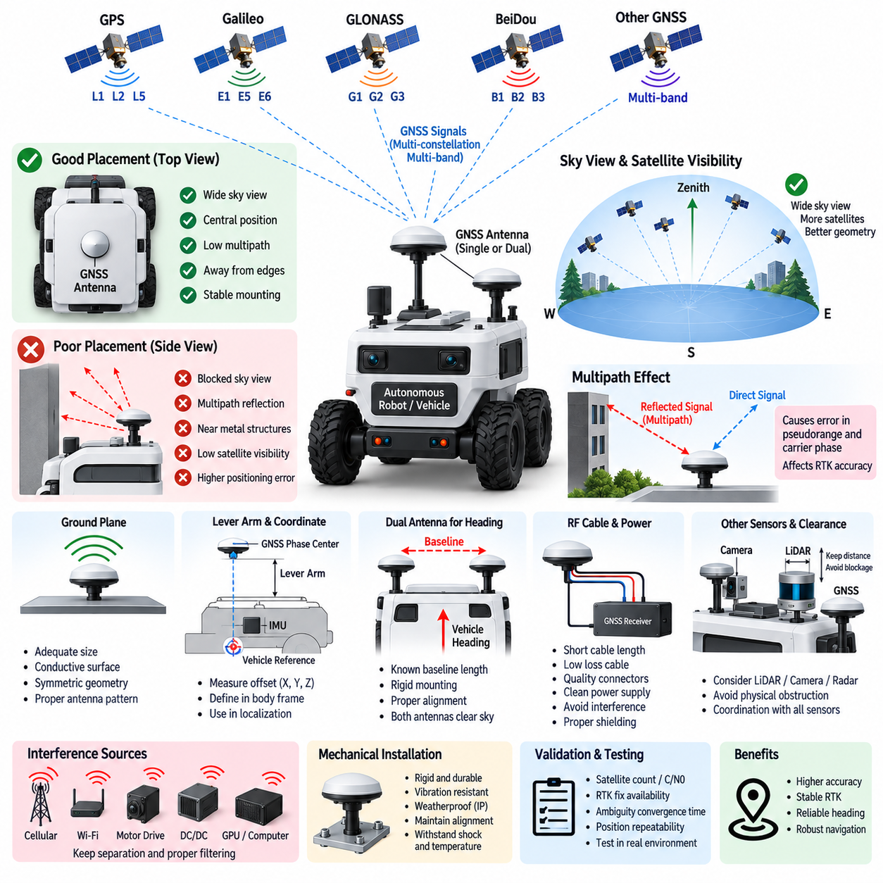
GNSS antenna placement is a system-level design problem that directly affects positioning accuracy, RTK availability, heading estimation, and navigation robustness. Even a high-performance multi-band receiver cannot recover information that has already been degraded at the antenna. The antenna location must therefore provide strong satellite visibility while minimizing multipath, electromagnetic interference, structural blockage, and installation-induced phase errors.
The primary placement objective is to provide the antenna with the widest practical view of the sky. GNSS satellites are distributed across the visible hemisphere, so structures above or beside the antenna can reduce the number and geometric diversity of usable satellites. For outdoor AMRs and autonomous vehicles, the antenna is generally placed on an elevated upper surface where the chassis, payload, sensors, protective covers, and other equipment obstruct as little of the sky as possible.
Satellite visibility should be considered over the complete operating environment rather than only during installation. A robot may operate beside buildings, containers, trees, walls, industrial machinery, or parked vehicles that repeatedly obscure portions of the sky. The antenna position should therefore maximize visibility across different vehicle orientations and operating scenarios. Improved visibility increases satellite availability and generally produces more favorable measurement geometry for high-precision localization.
Multipath is one of the most important antenna-placement concerns. GNSS signals can reflect from metal panels, glass surfaces, buildings, pavement, machinery, and nearby structures before reaching the antenna. These delayed signals interfere with the direct satellite signal and introduce measurement errors into pseudorange and carrier-phase observations. RTK systems are particularly sensitive because reliable carrier-phase measurements are required for fast integer ambiguity resolution and stable fixed positioning.
Antenna placement should consequently avoid locations immediately beside vertical metal surfaces, large reflective panels, rails, masts, or other structures likely to generate strong reflections. Installing the antenna near the geometric center of a sufficiently large horizontal roof can often provide a more symmetric RF environment than mounting it near an edge. However, the exact location must also consider other sensors, payload equipment, maintenance access, mechanical strength, and the vehicle reference coordinate system.
The ground plane beneath a GNSS antenna strongly influences its electromagnetic behavior. Many antennas are designed to operate above a conductive surface that helps shape the radiation pattern and suppress signals arriving from below the horizon. An inadequate or asymmetric ground plane can alter antenna gain and phase characteristics. The selected antenna datasheet and integration requirements should therefore be reviewed before determining the size, material, and geometry of the mounting surface.
Multi-band GNSS makes placement consistency even more important because the antenna must simultaneously receive signals across several frequency ranges. The antenna should maintain stable phase-center characteristics for the supported bands, such as L1, L2, and L5 or corresponding signals from other constellations. Mechanical mounting, nearby conductive structures, radomes, and cable routing should not significantly distort these characteristics, especially when centimeter-class RTK positioning is required.
The antenna phase center is the effective point from which GNSS measurements are referenced, and it does not necessarily coincide exactly with the visible mechanical center of the antenna housing. High-precision navigation therefore requires the phase-center location to be related accurately to the robot coordinate system. Mechanical drawings, calibration data, and installation measurements should define the antenna reference point so that localization software can apply the correct geometric transformation.
The displacement between the GNSS antenna phase center and the vehicle reference point is commonly represented as a lever arm. This offset becomes important whenever the robot rotates, pitches, or rolls because the antenna follows a different trajectory from the vehicle control point. The lever-arm vector should therefore be measured in the defined body coordinate frame and included in the localization configuration rather than assuming that the GNSS position directly represents the center of the robot.
For a single-antenna system, placement is often chosen near the longitudinal centerline to simplify the relationship between the GNSS measurement and vehicle body frame. Centerline placement can reduce asymmetric lever-arm effects during turning and simplify calibration. Nevertheless, the optimal position remains a compromise among sky visibility, multipath performance, mechanical packaging, RF interference, sensor installation, and the reference point required by the navigation and control architecture.
Dual-antenna GNSS introduces additional placement requirements because the vector between antennas is used to estimate absolute heading. The antennas should be mounted on a mechanically rigid structure with a precisely known baseline length and orientation. A longer baseline generally improves heading observability, but the achievable separation is constrained by vehicle dimensions and packaging. Both antennas should also experience similarly favorable satellite visibility to support reliable common observations.
The baseline should be aligned with a clearly defined vehicle axis, such as the longitudinal or lateral body axis, unless another orientation is intentionally selected and calibrated. Installation tolerances become direct heading errors if the actual baseline differs from its configured orientation. The mounting structure must therefore resist vibration, deformation, impact, and thermal movement that could alter the relative antenna geometry during operation.
Placement must also account for other roof-mounted perception sensors. LiDARs, cameras, radar units, communication antennas, warning lamps, cooling structures, and payload equipment can obstruct GNSS signals or create reflective surfaces. Sensor packaging should be treated as a coordinated architecture rather than allowing each device to occupy the most convenient local position. GNSS antennas require sufficient clearance from objects that can block low-elevation satellites or disturb their radiation pattern.
Radio-frequency interference is another major design consideration. Cellular modems, Wi-Fi radios, telemetry transmitters, high-speed digital electronics, GPU computers, switching power supplies, motor drives, and DC/DC converters can produce conducted or radiated emissions. Although these systems operate outside nominal GNSS bands, harmonics and broadband noise can raise the receiver noise floor. Antennas and RF cables should therefore be separated from strong interference sources wherever practical.
The RF cable path between antenna and receiver must be considered together with antenna location. Excessive cable length introduces attenuation, while tight bends, damaged shielding, poor connectors, and routing beside noisy power cables can degrade signal integrity. The preferred architecture usually keeps the RF path reasonably short while preserving the best antenna position. Cable loss, antenna gain, optional low-noise amplification, connector loss, and receiver input requirements should be evaluated as an RF link budget.
Active GNSS antennas require clean electrical power for their integrated low-noise amplifier. Receiver-provided antenna bias or an external supply must satisfy the required voltage and current while preventing conducted noise from entering the RF path. Protection against short circuits, electrostatic discharge, surge events, and incorrect connections may also be necessary depending on the platform. Antenna power diagnostics can help detect disconnected cables, damaged antennas, or abnormal current conditions.
Mechanical installation must withstand the vibration and environmental conditions of the target robot. Outdoor AMRs may experience continuous vibration, shocks, rain, dust, temperature variation, and occasional impact. The antenna mounting should preserve orientation and position throughout these conditions while maintaining environmental sealing. Flexible or weak mounting structures can introduce movement relative to the IMU and vehicle frame, reducing the consistency of high-precision sensor fusion.
Antenna placement and IMU placement must be geometrically related when GNSS and inertial measurements are fused. The transformation between the GNSS phase center and IMU reference frame should be measured accurately, particularly for tightly coupled navigation. Errors in this relationship can appear as position or velocity inconsistencies during rotation. Calibration data should therefore include the relevant translation and orientation relationships among GNSS, IMU, body, and navigation frames.
Installation validation should include more than checking whether the receiver reports a position. Testing should examine satellite count, signal strength, carrier-to-noise density, RTK fix availability, ambiguity convergence time, correction age, position repeatability, and behavior during vehicle rotation and motion. Comparing candidate antenna positions can reveal multipath or interference problems that may not be obvious from mechanical inspection alone.
Field validation should also represent difficult operating conditions. Tests near buildings, vegetation, industrial structures, and partially obstructed areas help determine whether antenna placement remains acceptable outside open-sky conditions. Dual-antenna systems should additionally verify heading stability while stationary, moving slowly, turning, and operating on slopes. Repeated measurements can distinguish persistent installation-related errors from temporary environmental degradation.
A robust GNSS antenna placement design ultimately connects RF engineering, mechanical packaging, coordinate calibration, EMC control, and localization architecture. Clear sky visibility preserves satellite observations, appropriate ground-plane design supports antenna performance, controlled RF routing limits signal loss, and accurate lever-arm calibration relates measurements to the robot body. Together, these measures allow multi-band RTK GNSS to provide stable global position and heading information for outdoor autonomous navigation.

09.04. Dead Reckoning Integration
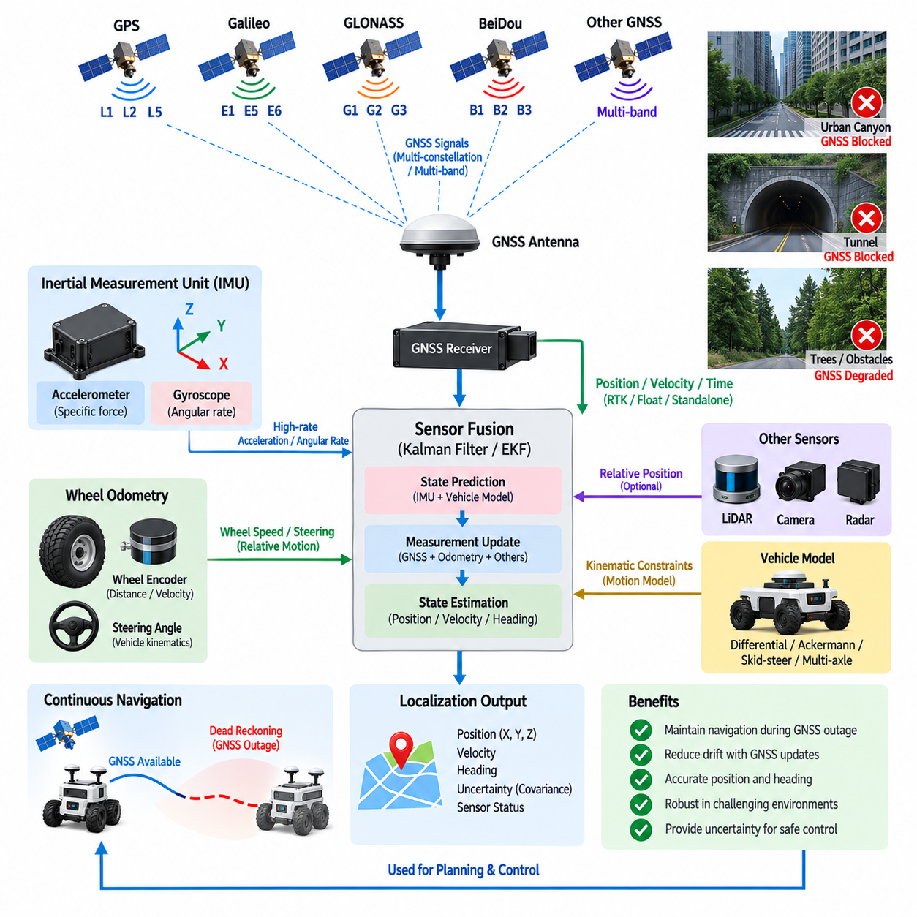
Dead reckoning is a localization method that estimates the current position and orientation of a robot by continuously integrating its measured motion from a previously known state. In outdoor autonomous systems, it complements GNSS by maintaining short-term navigation continuity when satellite positioning becomes degraded or temporarily unavailable. The architecture typically combines an IMU, wheel odometry, vehicle motion information, and a state estimator with globally referenced GNSS measurements.
GNSS and dead reckoning provide fundamentally complementary information. GNSS supplies an absolute position referenced to the Earth but depends on satellite visibility, signal quality, and correction availability. Dead reckoning operates independently of external satellite signals and can provide high-rate relative motion estimates, but its errors accumulate with time. Integrating both allows GNSS to periodically constrain drift while dead reckoning bridges temporary gaps in global positioning.
The inertial measurement unit is a central component of dead reckoning. Accelerometers measure specific force along three axes, while gyroscopes measure angular velocity around those axes. By integrating angular velocity, the navigation system estimates orientation changes, and by transforming and integrating acceleration it estimates velocity and position changes. Because even small sensor biases accumulate during integration, inertial-only navigation gradually drifts away from the true trajectory.
Wheel odometry provides an additional motion constraint for ground robots and autonomous vehicles. Wheel encoders can estimate traveled distance and longitudinal velocity from wheel rotation, while steering-angle information can help estimate vehicle curvature and yaw motion. These measurements generally exhibit less short-term longitudinal drift than low-cost accelerometer integration, making wheel odometry particularly useful for maintaining position during brief GNSS outages.
Wheel measurements are not perfect representations of vehicle motion. Tire slip, wheel spin, uneven surfaces, changes in effective tire radius, mechanical compliance, and skid-steering behavior can cause odometry errors. Outdoor AMRs operating on gravel, wet pavement, slopes, grass, or rough terrain may experience substantial differences between wheel rotation and actual displacement. Dead-reckoning integration must therefore estimate measurement uncertainty rather than treating encoder motion as an exact constraint.
Vehicle kinematic information can further improve the dead-reckoning solution. Steering angle, commanded velocity, measured wheel speeds, yaw rate, and drive configuration can be combined with a suitable vehicle model to constrain physically plausible motion. Differential-drive, Ackermann-steered, skid-steered, and multi-axle robots require different motion models. Selecting a model that reflects the actual platform prevents systematic errors from being introduced into the localization estimator.
The integration architecture commonly uses a Kalman-filter family estimator or another probabilistic state-estimation framework. The estimator maintains a state containing quantities such as position, velocity, orientation, IMU biases, and possibly wheel-related calibration parameters. High-rate inertial measurements propagate this state forward in time, while GNSS, wheel odometry, and other observations periodically correct accumulated prediction errors according to their estimated uncertainty.
An extended Kalman filter is frequently used because robot motion, coordinate transformations, and inertial dynamics are nonlinear. The prediction stage propagates the state using IMU measurements and a dynamic model, while the measurement-update stage compares predicted observations with GNSS or odometry measurements. The resulting innovation indicates how strongly the predicted state disagrees with new sensor information and provides an important signal for both correction and fault monitoring.
A loosely coupled GNSS/INS architecture uses complete GNSS position or velocity solutions as measurement updates to the inertial estimator. This approach is relatively straightforward to implement and allows the GNSS receiver to perform most satellite-processing functions internally. However, when the receiver cannot produce a valid navigation solution, the fusion layer receives little GNSS information and must rely primarily on inertial and odometric dead reckoning until positioning becomes available again.
Tightly coupled integration operates at a lower measurement level by combining GNSS pseudorange, carrier-phase, Doppler, or related satellite observations directly with inertial navigation information. This architecture can continue using individual satellite measurements even when too few satellites are visible for an independent GNSS position solution. It can therefore improve robustness in partially obstructed environments, although implementation complexity, calibration requirements, computation, and receiver access are greater.
RTK GNSS adds a high-accuracy global constraint to the integrated system. When an RTK fixed solution is available, centimeter-class position information can strongly correct accumulated dead-reckoning drift. If RTK degrades to float or standalone operation, the estimator should increase the corresponding measurement uncertainty rather than abruptly treating the degraded solution as equally accurate. Smooth confidence management helps prevent localization jumps during transitions between GNSS states.
GNSS outages should be treated as expected operating conditions rather than exceptional failures. Bridges, tunnels, urban canyons, trees, loading facilities, industrial structures, and nearby large vehicles can temporarily block or reflect satellite signals. During such intervals, the estimator continues propagating position and orientation using IMU and vehicle-motion information. Localization uncertainty should gradually increase as the duration of the outage grows because dead-reckoning error is fundamentally cumulative.
When reliable GNSS measurements return, the navigation system must carefully reconcile them with the propagated dead-reckoning state. Immediately replacing the estimated position with the new GNSS coordinate can create a discontinuity that destabilizes planning or control. A probabilistic estimator instead applies corrections according to measurement covariance and innovation consistency, allowing the state to converge toward the recovered global position while preserving dynamically reasonable behavior.
Heading estimation is especially important during GNSS interruption. Gyroscope integration provides continuous short-term yaw information but accumulates bias-related drift. Wheel and steering measurements can constrain heading changes for ground vehicles, while a dual-antenna GNSS system can provide absolute heading whenever adequate satellite observations are available. Combining these sources reduces dependence on any single heading mechanism and improves stationary or low-speed localization.
Accurate sensor calibration is essential because dead reckoning repeatedly integrates small measurement errors. IMU bias, scale factor, axis misalignment, wheel radius, steering ratio, encoder scale, and sensor mounting orientation can all generate systematic trajectory errors. Calibration parameters should therefore be established during platform integration and, where appropriate, estimated or monitored during operation. Temperature-dependent IMU behavior may also require compensation for demanding applications.
Lever-arm compensation is required when the GNSS antenna, IMU, and vehicle reference point are located at different physical positions. During rotational motion, each sensor follows a different trajectory even though all are mounted on the same rigid body. The localization system must transform measurements using accurately defined sensor extrinsics. Incorrect lever-arm values can appear as velocity or position errors during turns and may be mistaken for poor GNSS or inertial sensor performance.
Time synchronization is equally critical. An IMU may operate at hundreds of hertz, wheel encoders at another rate, and GNSS at a lower update frequency. If measurements are fused using incorrect timestamps, vehicle motion between acquisition times becomes an artificial spatial or angular error. GNSS pulse-per-second timing, hardware timestamps, synchronized clocks, or carefully characterized software timestamps should therefore establish a common temporal reference across the localization system.
Dead-reckoning integrity requires continuous observation of sensor consistency. The estimator can compare GNSS velocity with wheel speed, GNSS heading with inertial yaw, predicted position with RTK updates, and measured yaw rate with the vehicle model. Large or persistent innovations may indicate wheel slip, IMU faults, GNSS multipath, incorrect calibration, or communication delays. Fault detection should reduce the influence of suspicious measurements rather than allowing one sensor to corrupt the complete state.
Localization software should expose uncertainty together with the estimated state. Position covariance, velocity covariance, heading uncertainty, GNSS fix quality, correction age, sensor health, and dead-reckoning duration provide downstream navigation functions with information about confidence. Planning and control can then adapt behavior by reducing speed, increasing obstacle margins, restricting maneuvers, or initiating a controlled stop when localization uncertainty exceeds the operational safety threshold.
For outdoor AMRs, dead-reckoning integration ultimately creates a continuous localization chain between globally accurate but environmentally dependent GNSS and locally continuous motion sensing. RTK GNSS anchors the state to global coordinates, the IMU propagates high-rate motion, wheel and steering measurements constrain vehicle dynamics, and sensor fusion manages uncertainty and failures. This architecture allows navigation to remain stable through short GNSS disturbances while preventing accumulated relative-motion error from becoming an uncontrolled long-term drift.

09.05. GNSS Jamming/Spoofing
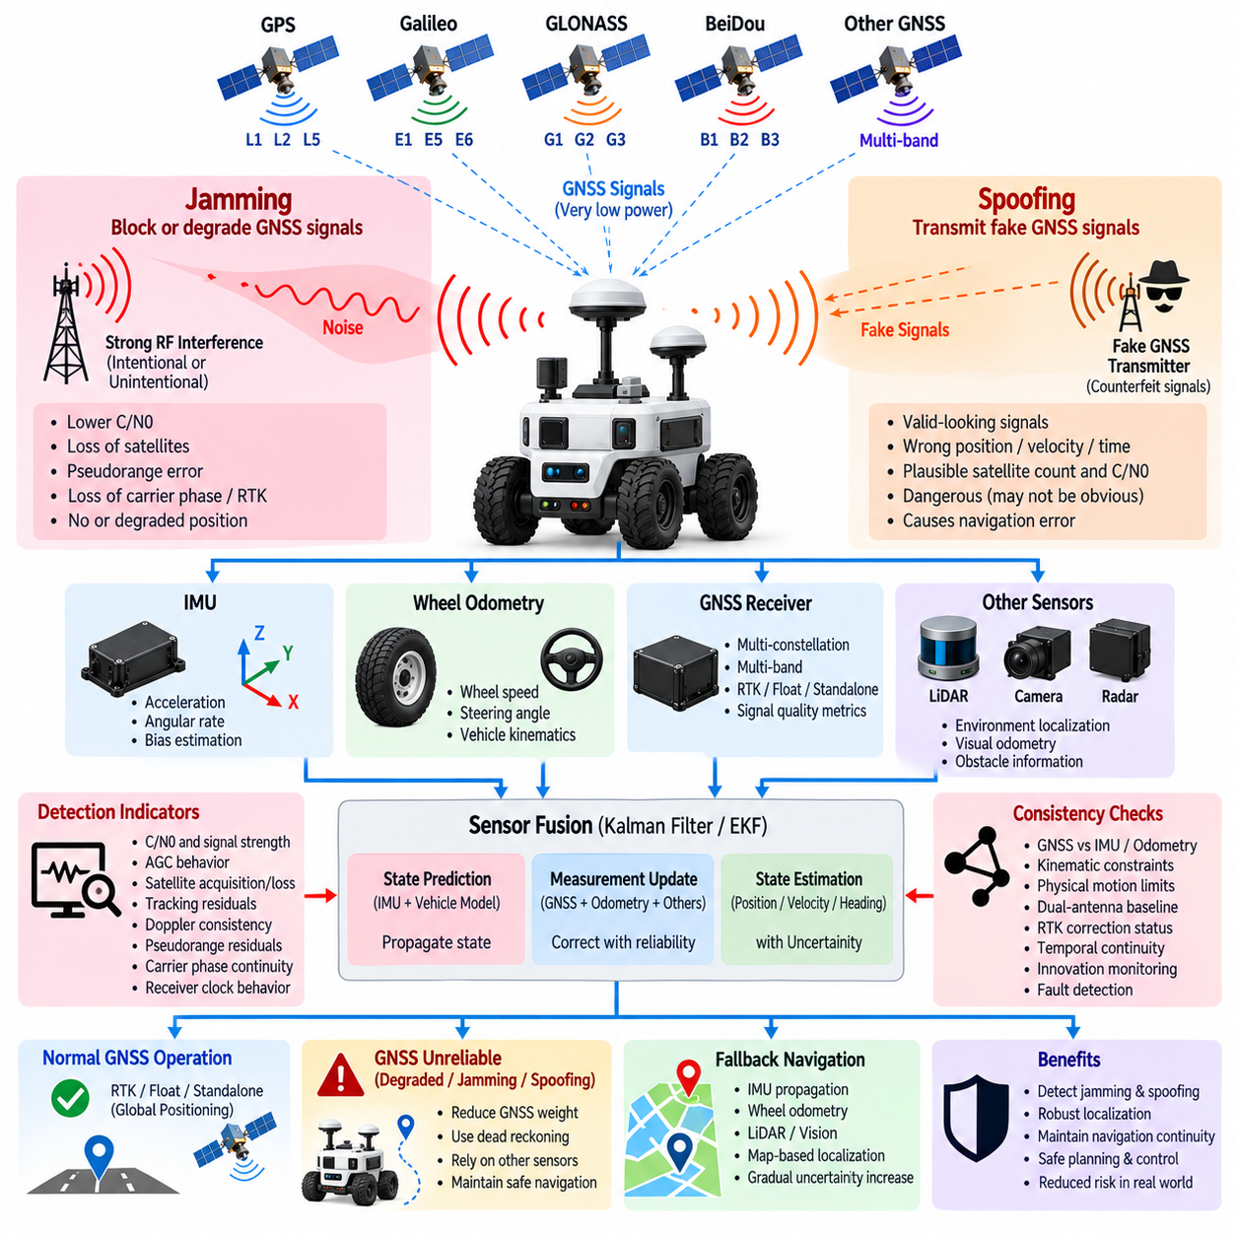
GNSS jamming and spoofing represent two fundamentally different threats to satellite-based positioning. Jamming attempts to prevent a receiver from obtaining usable satellite signals by increasing radio-frequency interference, while spoofing attempts to make the receiver accept false navigation signals as legitimate. For autonomous robots, both conditions can compromise position, velocity, heading, timing, and therefore the integrity of localization, planning, and motion control.
GNSS signals arrive at the Earth with extremely low received power after traveling more than twenty thousand kilometers from navigation satellites. This makes the receiver inherently vulnerable to interference generated near the vehicle. A comparatively weak terrestrial transmitter can raise the local noise floor enough to prevent satellite acquisition or tracking. The resulting degradation may affect one frequency band, several bands, or multiple GNSS constellations simultaneously.
Jamming may be intentional or unintentional. Intentional interference is generated specifically to deny satellite navigation, whereas unintentional interference can originate from defective electronics, poorly designed transmitters, harmonics, switching power supplies, motor drives, communication equipment, or other electromagnetic sources. From the receiver perspective, both can produce similar symptoms, so detection should focus on measurable signal behavior rather than assuming the origin of the interference.
Typical jamming effects include decreasing carrier-to-noise density, loss of tracked satellites, increasing pseudorange uncertainty, failure of carrier-phase tracking, and transitions from RTK fixed to float or standalone positioning. Severe interference can cause complete loss of the GNSS solution. A navigation system should therefore monitor the progression of signal degradation rather than waiting until the receiver stops reporting coordinates before recognizing that positioning integrity has deteriorated.
Spoofing is different because the receiver may continue producing an apparently valid navigation solution. Counterfeit or manipulated GNSS-like signals can cause the calculated position, velocity, or time to deviate from reality while maintaining plausible satellite observations. This characteristic makes spoofing potentially more dangerous for autonomous systems than obvious signal loss, because incorrect coordinates may be accepted by localization and control functions unless independent consistency checks detect the anomaly.
A spoofing event may initially resemble normal GNSS operation. Satellite count can remain high, signal strength may appear acceptable, and the receiver may continue generating position updates. The important indication is often inconsistency between GNSS-derived motion and independently measured vehicle behavior. A robot that is stationary while GNSS reports gradual movement, or a vehicle whose GNSS trajectory disagrees with inertial and wheel measurements, should be treated as experiencing a potentially unreliable navigation condition.
Multi-constellation and multi-band receivers improve normal positioning availability but do not automatically guarantee immunity to jamming or spoofing. Frequency diversity can help identify interference concentrated in a particular band, while constellation diversity provides additional observations for consistency analysis. However, sophisticated interference may affect multiple frequencies or systems. Diversity should therefore be treated as one layer of resilience rather than as a complete security mechanism.
Receiver-level monitoring provides the first layer of detection. Useful indicators include carrier-to-noise density, automatic gain-control behavior, satellite acquisition and loss patterns, tracking residuals, Doppler consistency, pseudorange residuals, carrier-phase continuity, and sudden changes in receiver clock behavior. Abnormal patterns across many satellites at approximately the same time can indicate a common interference source rather than ordinary satellite geometry or environmental obstruction.
Signal-strength behavior is particularly informative because authentic satellite signals normally arrive within a predictable low-power range. A sudden simultaneous increase in the apparent strength of many satellite signals can be suspicious, especially when accompanied by correlated changes in navigation measurements. Conversely, jamming often reduces effective signal quality by raising the noise floor. Detection logic should evaluate trends and cross-satellite relationships rather than relying on a single fixed signal-strength threshold.
Navigation-domain consistency checking adds another protection layer. GNSS position and velocity can be compared with IMU acceleration, gyroscope yaw rate, wheel odometry, steering angle, vehicle kinematics, LiDAR localization, visual odometry, or radar-derived motion. If GNSS indicates motion that cannot be explained by independent sensors or by the physical capabilities of the vehicle, the localization system can reduce GNSS confidence or reject the measurement before it significantly alters the fused state.
An inertial measurement unit is especially valuable because it does not depend on external radio signals. During GNSS interference, the IMU can continue propagating orientation, velocity, and relative motion for a limited period. Wheel odometry and vehicle models can further constrain this propagation for ground robots. These sensors cannot provide indefinitely accurate global positioning, but they create a trusted short-term reference against which suspicious GNSS behavior can be evaluated.
RTK correction status should also be monitored during interference events. Loss of RTCM corrections caused by communication failure is different from loss of carrier-phase tracking caused by RF interference, although both may result in degradation from RTK fixed operation. Monitoring correction age, ambiguity status, satellite observations, network connectivity, and receiver signal metrics helps distinguish correction-link problems from problems affecting the GNSS radio-frequency environment.
Spoofing detection can also exploit temporal continuity. A physically realistic robot cannot instantaneously change position, velocity, acceleration, or heading beyond its dynamic limits. Sudden coordinate jumps, impossible acceleration, unexplained heading rotation, or gradually increasing disagreement with inertial navigation can therefore trigger integrity checks. Slow deviations require particular attention because they may remain within simple instantaneous thresholds while accumulating into a significant navigation error.
Dual-antenna GNSS provides another useful consistency mechanism for platforms requiring reliable heading. The baseline between two antennas is mechanically fixed, so measured baseline length and relative orientation should remain consistent with the vehicle geometry. If GNSS-derived antenna relationships become incompatible with the known rigid-body configuration, the system can identify suspicious measurements. Dual antennas nevertheless remain dependent on the same external satellite environment and cannot serve as the only defense.
A robust architecture should separate GNSS availability from GNSS trust. A receiver may technically provide a valid fix while the localization system determines that the measurement is not sufficiently trustworthy for autonomous control. The state estimator should therefore maintain measurement quality and integrity information alongside position. GNSS weighting can be reduced dynamically when interference indicators, innovation tests, or cross-sensor consistency checks suggest abnormal behavior.
When GNSS is declared unreliable, the localization architecture should transition toward dead reckoning and perception-based localization rather than immediately losing navigation capability. IMU, wheel odometry, steering information, LiDAR localization, visual odometry, and mapped environmental features can maintain a relative or locally referenced state. The permissible duration of such operation depends on sensor quality, environmental observability, accumulated uncertainty, and the safety requirements of the autonomous platform.
Uncertainty must increase appropriately while the system operates without a trusted global GNSS reference. Dead-reckoning errors accumulate, environmental localization may become ambiguous, and heading drift can eventually affect position estimates. Planning and control should receive this uncertainty information so that the robot can reduce speed, increase safety margins, restrict complex maneuvers, return to a known localization region, or perform a controlled stop before localization confidence becomes unacceptable.
Electromagnetic compatibility design reduces vulnerability to unintentional interference. GNSS antennas and RF cables should be separated from cellular transmitters, Wi-Fi antennas, high-speed computers, motor inverters, DC/DC converters, and high-current wiring. Appropriate grounding, shielding, filtering, low-noise power design, connector quality, and antenna placement help preserve the receiver noise margin. Platform-generated interference should be characterized during EMC and full-system operating tests.
Validation should deliberately examine degraded GNSS conditions rather than testing only in open-sky environments. Engineers can evaluate receiver behavior near buildings, vegetation, reflective structures, and known electromagnetic noise sources while monitoring signal quality, RTK status, localization innovations, and fallback behavior. Testing should verify that abnormal GNSS data is detected early enough that the fused localization state is not corrupted before the system changes operating mode.
System logs are important for both validation and field diagnostics. Raw or summarized GNSS observations, signal-quality indicators, fix state, RTK status, correction age, receiver alarms, IMU data, odometry, localization innovations, covariance, and fault-state transitions should be recorded with synchronized timestamps. These records allow engineers to distinguish ordinary multipath, communication outages, receiver faults, electromagnetic interference, and potentially deceptive signal behavior after an event.
For outdoor AMRs and autonomous vehicles, protection against GNSS jamming and spoofing should therefore be implemented as a layered navigation-integrity architecture. Receiver diagnostics detect abnormal RF and tracking conditions, multi-band and multi-constellation observations provide diversity, independent sensors verify physical motion, sensor fusion controls measurement trust, and dead reckoning provides temporary continuity. The objective is not merely to keep GNSS operating, but to ensure that an autonomous system never treats an untrustworthy global position as reliable navigation truth.

