Volume 15 Perception and Sensor Architecture

Chapter 02. Stereo Camera

02.01. Stereo Baseline Design
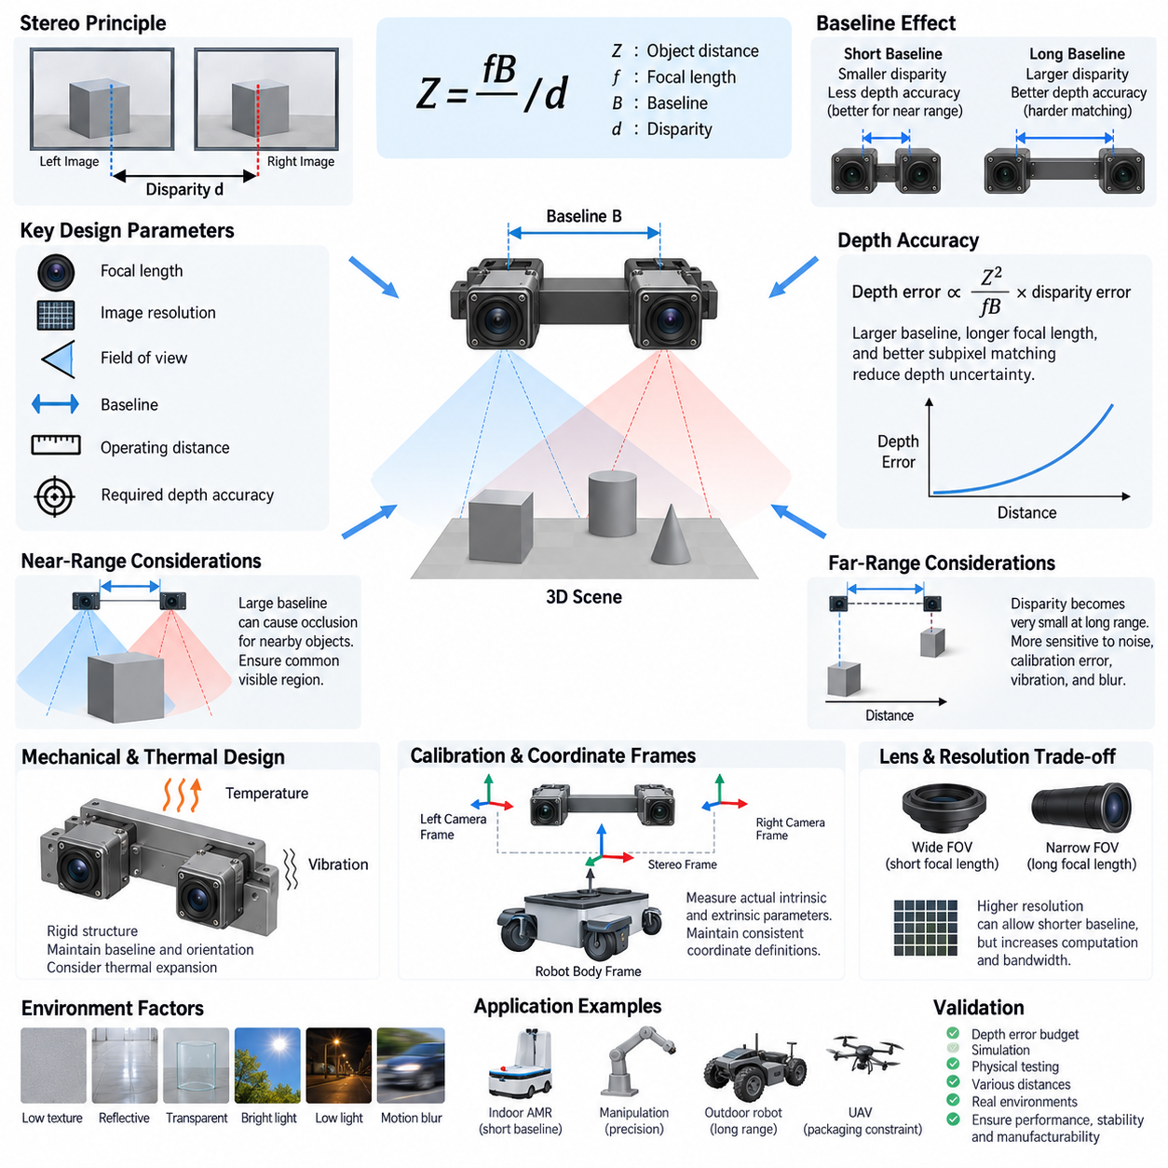
Stereo baseline design defines the physical separation between the left and right optical centers of a stereo camera and is one of the most influential hardware parameters governing depth perception. The baseline must be selected together with focal length, image resolution, expected operating distance, field of view, and required depth accuracy. It is therefore a system-level mechanical and optical design variable rather than simply a camera mounting dimension.
Stereo vision estimates depth by observing the displacement of corresponding scene points between two images. For a rectified stereo pair, depth can be approximated by Z = fB/d, where Z is object distance, f is focal length expressed consistently with disparity coordinates, B is the stereo baseline, and d is disparity. Increasing the baseline increases disparity for an object at a given distance, improving the geometric sensitivity available for depth estimation.
The same relationship also explains why baseline selection cannot be optimized independently. A very short baseline produces small disparities at medium and long ranges, making depth estimates increasingly sensitive to pixel-level matching errors. A longer baseline improves distant depth discrimination, but it also increases viewpoint differences between the cameras and can make correspondence more difficult, particularly around object boundaries, narrow structures, and highly three-dimensional scenes.
Depth uncertainty grows rapidly with distance because disparity decreases as objects move farther from the stereo pair. A useful first-order relationship is that depth error is proportional to Z²/(fB) multiplied by disparity error. Consequently, doubling the baseline can approximately halve the depth uncertainty caused by a given disparity error under otherwise identical conditions. Higher focal length and more accurate subpixel correspondence provide similar geometric benefits.
Short-range robotic perception creates the opposite constraint. When the baseline becomes too large, nearby objects may appear substantially different in the two cameras, and portions of the scene can be visible to only one camera. This stereo occlusion reduces the common observable region required for reliable matching. Mobile manipulators, indoor AMRs, and robots operating near walls or people therefore often require a more compact baseline than systems optimized primarily for distant perception.
The minimum operating distance should consequently be evaluated as part of baseline design. Engineers must verify that important objects remain inside both camera fields of view and generate disparities that can be processed by the intended stereo algorithm. Maximum supported disparity, image width, rectification geometry, lens distortion, and matching-window behavior can impose practical limits even when the theoretical triangulation equations predict valid depth.
The maximum useful sensing distance introduces another boundary. At long range, disparity may approach only a few pixels or fractions of a pixel, making depth increasingly vulnerable to calibration error, image noise, vibration, synchronization error, blur, and imperfect feature matching. Baseline should therefore be chosen from the required depth-error envelope across the operating range rather than from a single nominal sensing distance.
Mechanical implementation is inseparable from optical geometry. The camera modules require a rigid structure that maintains relative translation and rotation during vibration, acceleration, temperature variation, and long-term operation. Small angular changes can produce significant correspondence and depth errors. A mechanically convenient bracket that flexes under robot motion may therefore degrade stereo performance even when its nominal baseline dimension is manufactured accurately.
Thermal expansion deserves particular attention when the stereo assembly spans a relatively long distance. Different coefficients of thermal expansion among the chassis, bracket, camera housing, PCB, and fasteners can alter the effective baseline and relative orientation as temperature changes. Material selection, structural symmetry, fastening strategy, and thermal paths should therefore be considered together with calibration requirements when stable metric depth is required across a wide environmental range.
Baseline tolerance should be specified according to perception performance rather than only general mechanical manufacturing practice. The design must control optical-center position, camera orientation, mounting repeatability, and structural deformation. Nominal CAD dimensions alone are insufficient because the effective baseline is determined by calibrated camera geometry. Production calibration should measure the actual intrinsic and extrinsic parameters of the assembled stereo unit.
A stereo assembly also requires careful coordinate definition. The left and right camera frames, stereo reference frame, robot body frame, and other sensor frames should have explicitly defined transformations. Baseline direction is normally aligned predominantly with the horizontal image axis to simplify rectification, but residual translation and rotation are captured through extrinsic calibration. Consistent coordinate conventions prevent sign, axis, and transformation errors in downstream perception software.
Horizontal baselines are common because they provide left-right disparity that maps naturally to conventional stereo processing. However, the physical robot may constrain camera placement, especially on narrow AMRs, humanoid heads, manipulators, UAVs, or sensor masts. Designers should avoid forcing an idealized geometry when packaging produces poor rigidity or severe obstruction. Optical performance, structural stability, visibility, serviceability, and cable routing must be optimized as one assembly.
Camera resolution changes the practical interpretation of baseline because disparity is measured in image coordinates. Higher spatial resolution can provide finer disparity information and may allow a shorter physical baseline to satisfy a given depth requirement, assuming sufficient image quality and correspondence accuracy. Conversely, increasing resolution without adequate optics, exposure control, synchronization, or calibration does not automatically improve metric depth and may substantially increase computation and interface bandwidth.
Lens selection interacts strongly with baseline. A wide field-of-view lens supports broad environmental awareness and nearby obstacle perception, but its shorter effective focal length generally reduces disparity sensitivity for distant objects. A narrower field of view can improve long-range geometric resolution while sacrificing coverage. Stereo architecture must therefore balance baseline and focal length against the robot's required horizontal coverage, working distance, and depth precision.
Baseline design should also account for the characteristics of the target environment. Texture-poor walls, repetitive patterns, reflective surfaces, transparent objects, strong sunlight, low illumination, and motion blur can dominate stereo performance regardless of ideal geometry. Increasing baseline may improve triangulation sensitivity but cannot eliminate correspondence ambiguity. Hardware design should therefore preserve image quality and provide sufficient geometric margin without assuming perfect stereo matching.
For autonomous mobile robots, baseline selection should ultimately be derived from mission requirements. Indoor navigation emphasizes nearby obstacles, doors, people, docking areas, and confined passages, while outdoor robots may require meaningful depth over substantially longer distances. Manipulation demands precise short-range geometry, whereas patrol or inspection platforms may prioritize distant structures. A single baseline is therefore rarely optimal for every robotic application represented within a broader perception architecture.
The final design should be validated using a depth-error budget covering baseline tolerance, focal-length uncertainty, disparity error, calibration residuals, synchronization effects, structural deformation, vibration, and thermal drift. Simulation can identify an initial baseline, but physical testing across representative distances and environmental conditions is essential. A robust stereo baseline is the one that preserves useful depth accuracy throughout the robot's actual operating envelope while remaining mechanically stable and manufacturable.

02.02. Hardware Synchronization
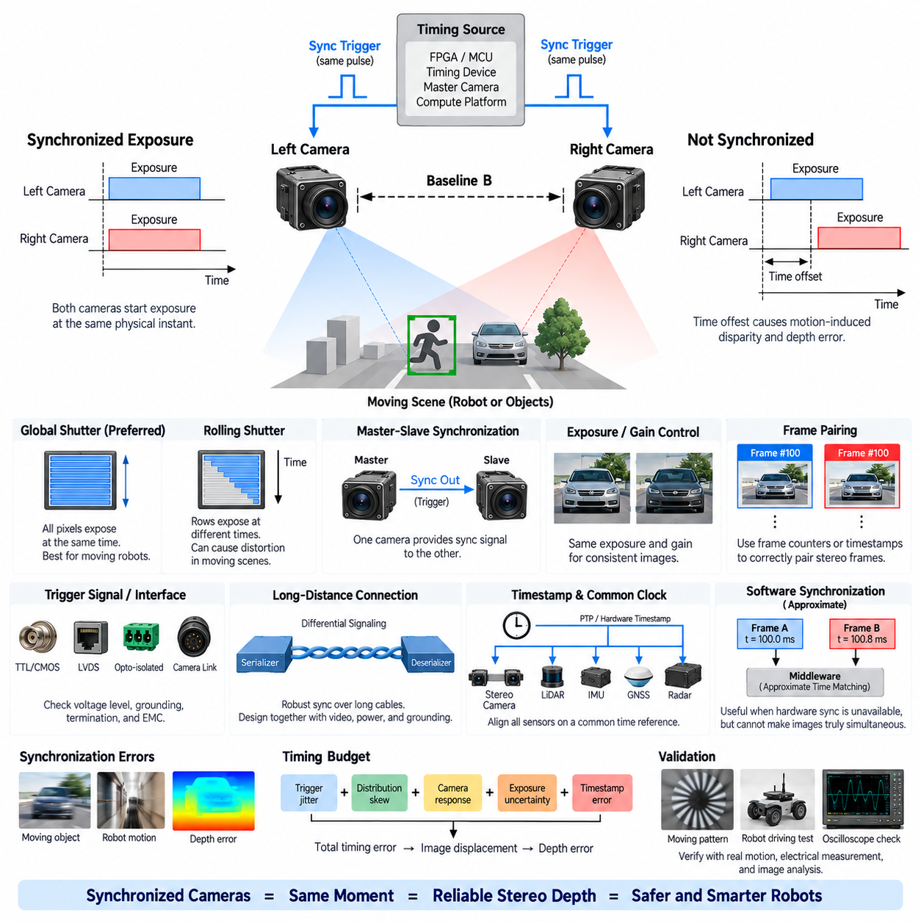
Hardware synchronization ensures that the left and right cameras of a stereo vision system capture corresponding images at the same physical instant. This requirement is fundamental whenever the observed scene or the robot itself is moving. Without synchronization, each camera records a slightly different temporal state, converting motion into apparent geometric disparity and introducing depth errors that cannot be corrected reliably by ordinary stereo calibration alone.
In a perfectly static scene, a small timing offset between stereo cameras may have little visible effect. Robotic environments, however, contain moving people, rotating wheels, manipulators, vehicles, and continuously changing viewpoints caused by robot motion. Even a millisecond-scale offset can produce measurable image displacement when relative velocity is high. Hardware synchronization therefore becomes increasingly important as robot speed, object speed, focal length, image resolution, and required depth precision increase.
Stereo synchronization should distinguish frame-rate agreement from true exposure synchronization. Two cameras may both operate at 30 frames per second while their exposure periods remain offset by several milliseconds. Matching nominal frame rates only ensures similar repetition frequency; it does not guarantee simultaneous observation. A robust stereo architecture aligns the actual exposure start, exposure interval, or another precisely defined image acquisition event between both camera modules.
A common implementation uses a shared hardware trigger signal distributed to the left and right cameras. A master timing source generates periodic electrical pulses, and both camera sensors begin exposure in response to the same trigger edge. This architecture removes much of the nondeterministic delay associated with independent software commands. Trigger frequency normally corresponds to the required frame rate, while pulse characteristics must satisfy the electrical timing specifications of each camera or image sensor.
Trigger distribution must be treated as an electrical engineering problem rather than merely a logical connection. Different cable lengths, propagation delays, voltage thresholds, buffering circuits, connector characteristics, and signal integrity can create skew between camera trigger inputs. Although electrical propagation is typically much faster than image acquisition timing, high-precision systems should still define a maximum trigger skew and verify it at the camera interfaces under representative wiring and environmental conditions.
The trigger source may be generated by an FPGA, microcontroller, dedicated timing device, camera master module, or synchronization-capable compute platform. Selection depends on required timing accuracy, channel count, configurability, diagnostics, and system architecture. FPGA-based timing can provide highly deterministic multi-channel control, while simpler robotic systems may use MCU timers or a master camera output when their synchronization accuracy satisfies the perception requirements.
Master-slave synchronization is another practical architecture. One camera operates as the timing master and provides a synchronization output that controls the exposure timing of the second camera. This reduces the need for an independent timing generator, but the design must consider master-camera failure, output timing characteristics, startup behavior, and compatibility between camera modules. For higher-reliability systems, an independent common timing source can provide more symmetric control.
Exposure synchronization must also account for sensor readout architecture. Global-shutter sensors expose the complete image array at approximately the same instant, making them particularly suitable for moving robotic platforms and stereo geometry. Rolling-shutter sensors expose different image rows at different times, so simultaneous frame triggers do not guarantee that every corresponding pixel pair represents exactly the same instant. Motion can consequently produce spatial distortion and stereo matching errors.
When rolling-shutter cameras are unavoidable, row timing, readout direction, exposure duration, and frame timing must be understood explicitly. Using identical sensor configurations can reduce systematic differences, but it does not eliminate motion-induced distortion. Global-shutter stereo cameras are generally preferred for high-dynamic robotic applications because temporal correspondence is more directly related to the trigger event and therefore easier to control, characterize, and validate.
Exposure time creates an additional synchronization consideration. Even if both cameras begin exposure simultaneously, different exposure durations can produce inconsistent motion blur, brightness, and effective temporal integration. Automatic exposure algorithms operating independently on each camera may select different exposure values. Stereo systems should therefore coordinate exposure settings whenever possible, particularly when accurate correspondence is more important than independently optimized image brightness.
Gain and image-processing behavior should also remain sufficiently consistent between the stereo channels. Hardware synchronization does not itself guarantee photometric consistency, but synchronized acquisition can be undermined when automatic gain control, high-dynamic-range processing, or image signal processor behavior produces substantially different images. Stereo hardware and software should therefore coordinate timing and relevant imaging parameters as part of a unified acquisition architecture.
Synchronization signals require appropriate electrical interfaces. Depending on camera hardware, trigger inputs may use CMOS or TTL-level signaling, LVDS, opto-isolated industrial interfaces, or synchronization channels embedded in specialized camera links. Voltage compatibility, input thresholds, edge rate, grounding, isolation, termination, and electromagnetic compatibility must be reviewed. Directly connecting incompatible trigger interfaces can cause unreliable synchronization or potentially damage the camera electronics.
Long-distance camera connections introduce additional complexity. Robotic platforms may place cameras several meters from the central compute unit, particularly on large AMRs, inspection vehicles, manipulators, or UAV structures. In such cases, differential signaling and serializer-deserializer architectures can improve robustness against electromagnetic interference. The synchronization path should be engineered together with video transport, power distribution, grounding, shielding, and cable harness design rather than added afterward.
Hardware synchronization and timestamp synchronization solve related but different problems. A hardware trigger aligns physical image acquisition, while timestamps describe when acquired data belongs on a common system timeline. Precise stereo systems often require both. Frames should receive timestamps associated with a clearly defined acquisition event, preferably using hardware-derived timing rather than the later moment when the frame reaches a driver, operating system, middleware, or application process.
A common clock can further improve temporal consistency across the perception system. The stereo pair may eventually need alignment with LiDAR, IMU, GNSS, radar, or other cameras. Technologies such as hardware timestamps and Precision Time Protocol can establish a shared time reference, while trigger signals provide deterministic acquisition events. The appropriate architecture depends on whether sensors support external triggering, clock synchronization, timestamping, or combinations of these mechanisms.
Software synchronization should not be considered an equivalent replacement when precise stereo depth is required. Middleware can pair frames whose timestamps are close, but it cannot make independently captured images simultaneous. Approximate-time matching is useful when hardware synchronization is unavailable or requirements are relaxed, yet residual temporal offsets remain embedded in the image content. Software should therefore verify and manage synchronization rather than compensate for fundamentally uncontrolled acquisition timing.
Frame identification is also important because synchronized cameras can still experience dropped, delayed, or duplicated frames. Each stereo pair should be associated through frame counters, trigger sequence numbers, timestamps, or equivalent metadata. If one camera loses a frame, the system must avoid incorrectly pairing it with the next frame from the opposite camera. Such mismatches can produce severe but superficially plausible depth artifacts that are difficult to diagnose downstream.
Startup and recovery behavior should be defined explicitly. Cameras may require different initialization times, and one sensor may temporarily lose synchronization because of communication faults, power disturbances, thermal events, or driver recovery. The system should detect synchronization loss, invalidate affected stereo pairs, and restore a known synchronized state before depth processing resumes. Diagnostics should expose timing status rather than assuming synchronization remains valid indefinitely after startup.
Synchronization performance should ultimately be expressed as an engineering timing budget. The budget can include trigger-generator jitter, distribution skew, camera input response variation, sensor exposure uncertainty, timestamp error, and frame-pair association tolerance. These contributions should be related to allowable image displacement and resulting depth error for the robot's expected motion. This converts an abstract requirement such as “synchronized cameras” into a measurable electrical and perception specification.
Validation should be performed under realistic motion rather than only with stationary calibration targets. Rotating patterns, moving edges, vibration tables, robot driving tests, or precisely timed optical events can reveal temporal misalignment between channels. Electrical measurements with an oscilloscope or logic analyzer can verify trigger timing, while image-level analysis confirms the actual exposure relationship. Both measurements are necessary because correct trigger pulses do not automatically prove synchronized optical acquisition.
A robust stereo hardware synchronization architecture therefore integrates the timing source, trigger distribution, sensor shutter behavior, exposure control, electrical interface, timestamp generation, frame association, diagnostics, and recovery mechanisms. The objective is not merely to make two cameras operate at the same frame rate, but to guarantee that every valid stereo pair represents the same physical scene state within a defined temporal tolerance suitable for reliable robotic depth perception.

02.03. Depth Calculation Pipeline
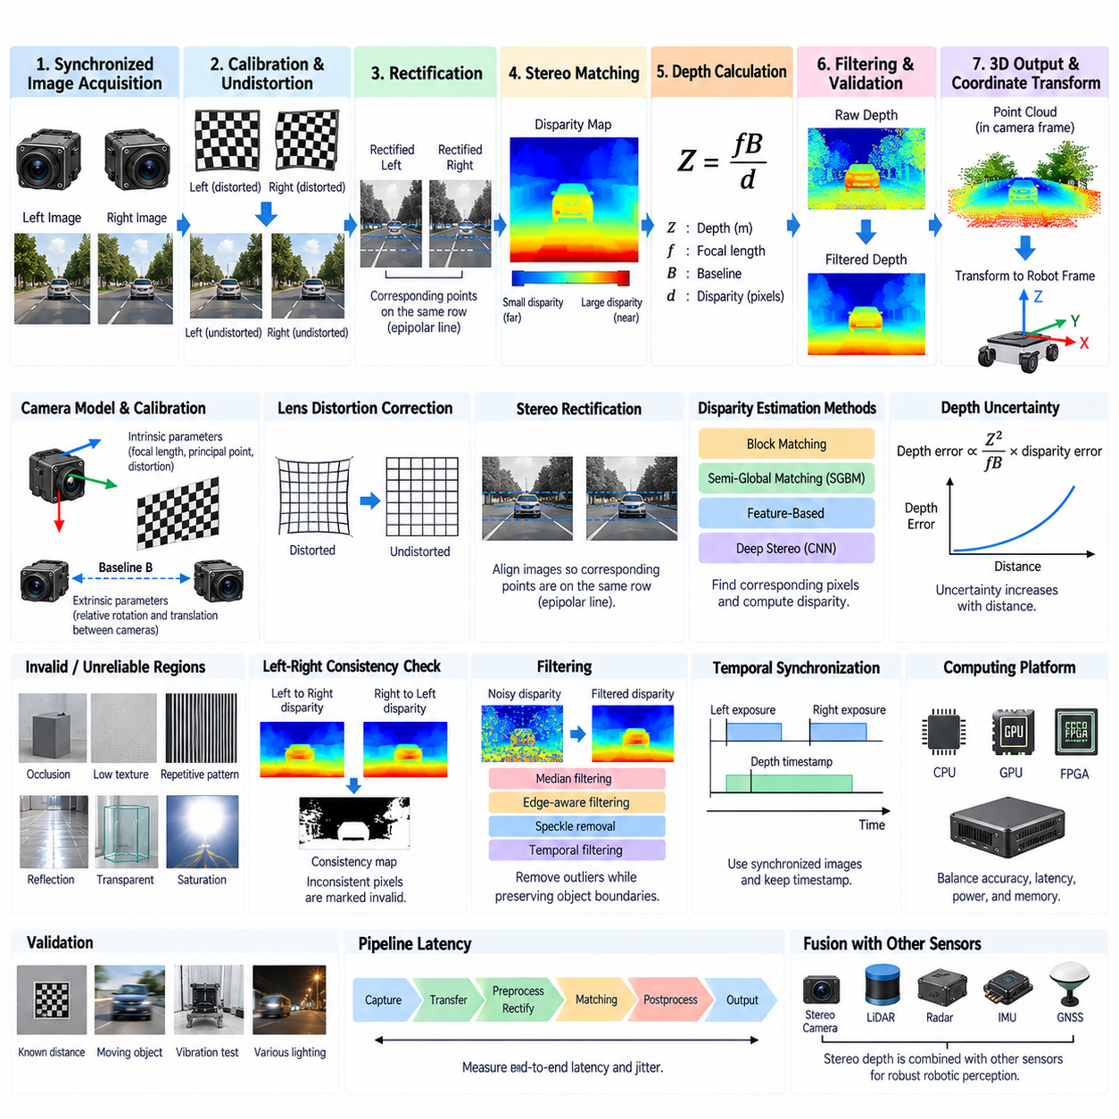
A stereo depth calculation pipeline converts two synchronized camera images into a metric representation of scene geometry. The process begins with left and right image acquisition and continues through calibration correction, rectification, correspondence search, disparity estimation, depth conversion, filtering, and coordinate transformation. Each stage contributes uncertainty, so reliable robotic depth perception depends on treating the pipeline as an integrated sensing system rather than as a single stereo-matching algorithm.
The pipeline assumes that the stereo camera has known intrinsic and extrinsic parameters. Intrinsic parameters describe focal length, principal point, and lens distortion for each camera, while extrinsic parameters describe the relative rotation and translation between the two optical frames. These values are normally obtained through stereo calibration and provide the geometric foundation required to convert pixel correspondences into physically meaningful three-dimensional measurements.
Raw images generally require geometric correction before stereo matching. Lens distortion causes observed pixels to deviate from the ideal pinhole-camera model, especially near image boundaries and with wide-angle optics. Undistortion uses calibrated lens parameters to compensate for radial and tangential distortion. Accurate correction is important because even small residual geometric errors can shift corresponding features and become significant depth errors at long sensing distances.
Stereo rectification transforms the left and right images so corresponding scene points lie approximately on the same horizontal image row. This reduces correspondence search from a two-dimensional problem to a primarily one-dimensional search along epipolar lines. Rectification therefore improves computational efficiency and matching robustness. Its quality depends directly on accurate calibration and on the mechanical stability of the physical baseline between the two cameras.
After rectification, the system searches for corresponding pixels or image regions between the left and right views. The horizontal displacement between matched observations is called disparity. Nearby objects normally produce larger disparity, while distant objects produce smaller disparity. A disparity map assigns this displacement to many image locations and becomes the intermediate geometric representation from which stereo depth is subsequently calculated.
Correspondence can be estimated using local block matching, semi-global approaches, feature-based techniques, or learned stereo networks. Traditional algorithms compare intensity or descriptor similarity over candidate disparities, while modern neural methods can learn stronger representations for difficult textures and complex environments. Algorithm selection affects accuracy, latency, memory consumption, GPU utilization, deterministic behavior, and the ability to operate under changing illumination or weak texture.
The disparity search range must reflect the intended operating distance and stereo geometry. A large maximum disparity supports closer objects but increases computation and memory requirements. Restricting the range improves efficiency but can prevent valid reconstruction outside the configured depth interval. Baseline, focal length, image resolution, minimum sensing distance, and available processing resources should therefore be considered together when defining the disparity configuration.
Once disparity is available, metric depth follows from the stereo triangulation relationship Z = fB/d. Here, Z represents depth, f is focal length in the appropriate image-coordinate units, B is the calibrated stereo baseline, and d is disparity. The equation shows that depth is inversely proportional to disparity. Large disparities correspond to nearby geometry, while very small disparities correspond to distant objects and produce increasingly sensitive depth estimates.
Subpixel disparity estimation is important because correspondence rarely occurs at exact integer-pixel positions. Estimating disparity to fractional-pixel precision can significantly improve depth resolution, particularly at medium and long ranges where disparity becomes small. However, subpixel precision should not be confused with guaranteed physical accuracy. Calibration residuals, image noise, blur, synchronization error, optical quality, and matching ambiguity can still dominate the final depth uncertainty.
Invalid or unreliable disparities must be detected before the depth map is used for robotic decisions. Occluded regions, repetitive textures, uniform surfaces, reflections, transparent materials, saturated pixels, and image boundaries frequently produce ambiguous matches. Confidence scores, matching costs, left-right consistency checks, uniqueness criteria, and validity masks can identify questionable estimates. Rejecting uncertain depth is often safer than presenting dense but geometrically incorrect measurements.
A left-right consistency check compares disparity estimated from the left image toward the right image with the corresponding reverse estimate. If the two results disagree beyond a defined tolerance, the pixel can be marked invalid or low confidence. This technique is especially useful near occlusion boundaries and mismatched structures. It adds computation but provides an important integrity mechanism before stereo depth enters navigation, mapping, manipulation, or obstacle-detection functions.
Filtering is commonly applied to suppress isolated disparity errors while preserving meaningful geometric boundaries. Median filtering, edge-aware filtering, speckle removal, temporal filtering, and confidence-guided refinement may be used depending on the implementation. Excessive smoothing should be avoided because it can erase thin obstacles, object edges, steps, cables, or other safety-relevant structures. Filtering parameters should therefore be validated against the robot's actual perception requirements.
Depth values may be represented as a dense depth image, organized point cloud, unorganized point cloud, occupancy representation, or another geometric structure. Reprojection converts image pixels and their disparities into three-dimensional coordinates using calibrated stereo geometry. The resulting points are initially expressed in a camera-related coordinate frame and must be transformed into the robot body, navigation, manipulator, or world frame before they can support higher-level functions.
Coordinate transformation requires accurate extrinsic calibration between the stereo camera and the robot. A depth point that is geometrically correct in the camera frame can still become incorrect for navigation if the camera-to-robot transformation is inaccurate. Mounting angle, sensor height, mechanical deformation, vibration, and service replacement can affect this relationship. Perception architecture should therefore preserve calibration metadata and apply transformations through clearly defined coordinate frames.
Temporal information must accompany the calculated depth. The left and right images should originate from the same synchronized acquisition event, and the resulting disparity and depth products should retain an appropriate timestamp. When the robot moves, even a geometrically accurate point cloud becomes stale as time passes. Timestamp integrity is therefore essential when stereo depth is fused with IMU, LiDAR, wheel odometry, GNSS, or motion estimates in downstream systems.
Pipeline latency is another critical engineering parameter. Image transfer, preprocessing, rectification, stereo matching, post-processing, reprojection, and middleware transport all consume time. A depth map with excellent static accuracy may still be unsuitable for fast robotic control if it arrives too late. Designers should measure end-to-end latency and jitter from physical image exposure to availability of validated depth data at the consuming perception or control process.
Computational architecture strongly influences achievable stereo performance. Rectification and conventional matching may execute on CPUs, GPUs, FPGAs, dedicated vision accelerators, or heterogeneous combinations of these devices. Deep stereo networks generally benefit from GPU acceleration but can consume substantial memory bandwidth and power. Embedded robotic platforms must balance depth quality, image resolution, frame rate, thermal limits, energy consumption, and competing AI workloads on the same compute hardware.
Error propagation should be understood throughout the pipeline. Depth uncertainty increases approximately with the square of distance and decreases with larger focal length and baseline for a given disparity uncertainty. Consequently, stereo depth normally provides strong geometric information within a designed operating range rather than uniform accuracy at every distance. The pipeline should expose confidence or uncertainty information whenever downstream algorithms need to distinguish reliable geometry from marginal measurements.
Environmental conditions can affect several pipeline stages simultaneously. Low texture weakens correspondence, poor illumination increases noise, strong sunlight can reduce contrast, reflective or transparent surfaces violate ordinary appearance assumptions, and motion blur reduces feature localization accuracy. A robust pipeline combines appropriate camera hardware, exposure control, synchronization, stereo geometry, matching algorithms, and validity assessment instead of relying on post-processing to recover fundamentally inadequate image information.
Robotic systems should monitor pipeline health during operation. Useful diagnostic information includes camera frame counters, synchronization status, rectification validity, disparity coverage, invalid-pixel ratio, confidence distribution, processing latency, dropped frames, temperature, and compute load. Sudden changes in these indicators can reveal camera obstruction, calibration movement, communication problems, timing faults, environmental degradation, or computational overload before they cause larger autonomous-system failures.
Validation should cover the complete path from photons to metric geometry. Known-distance targets can measure depth accuracy, moving objects can evaluate synchronization sensitivity, textured and texture-poor surfaces can test matching robustness, and temperature or vibration testing can reveal calibration drift. Performance should be characterized across distance, illumination, robot velocity, object motion, and processing load rather than summarized by a single nominal depth-accuracy value.
The resulting depth product should be considered an input to broader sensor fusion rather than an infallible description of the environment. Stereo cameras provide rich geometry and visual context, while LiDAR, radar, IMU, GNSS, and odometry offer complementary sensing characteristics. A well-designed depth calculation pipeline therefore delivers not only depth values but also timestamps, coordinate information, validity masks, confidence estimates, and diagnostic status needed by the wider robotic perception architecture.

02.04. Stereo Camera Power
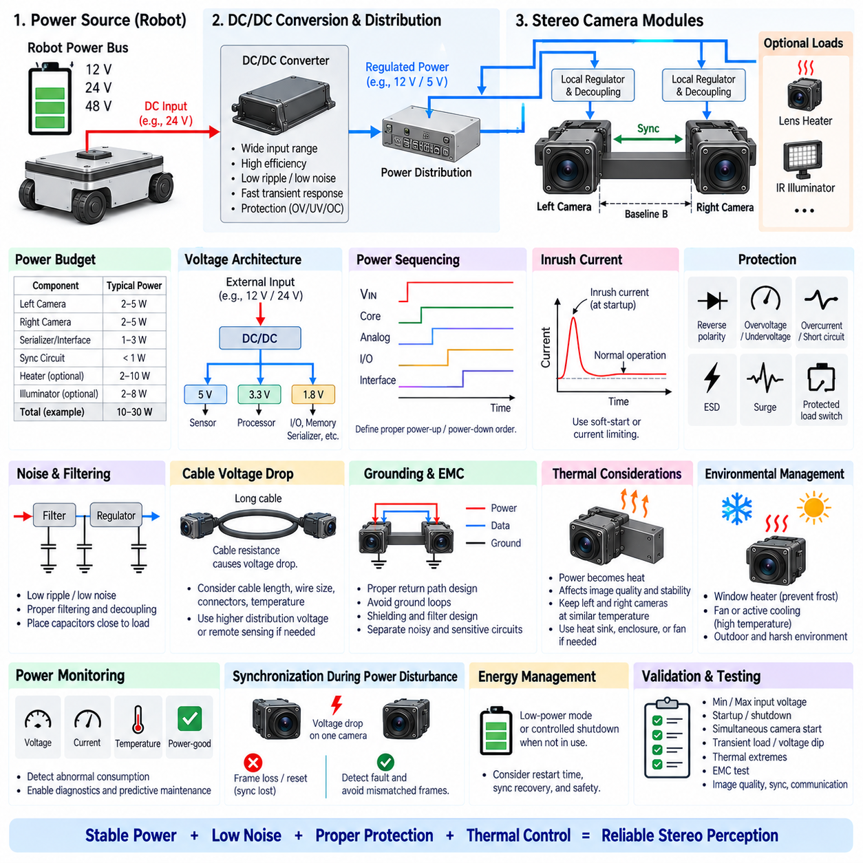
Stereo camera power architecture must provide stable, low-noise, and appropriately protected electrical power to both imaging channels while preserving matched behavior between the left and right cameras. Power design influences image quality, synchronization stability, thermal behavior, communication reliability, and long-term calibration. A stereo camera should therefore be treated as a coordinated sensing subsystem rather than as two independent loads connected to a convenient supply rail.
The first design step is to establish a complete power budget for the stereo assembly. This includes both camera modules, image sensors, image signal processors, serializers, synchronization circuits, local regulators, heaters if required, status electronics, and auxiliary illumination when present. Nominal consumption alone is insufficient because startup, exposure transitions, processing activity, and communication interfaces can create transient loads substantially different from steady-state operation.
Camera power requirements depend strongly on the selected architecture. Compact embedded stereo modules may operate from 5 V or another regulated low-voltage rail, while industrial or automotive camera assemblies may accept 12 V or higher input voltage and perform local conversion. The system designer should distinguish external input voltage from the internal rails required by image sensors, processors, memory, serializers, oscillators, and interface circuitry.
A robot commonly distributes 12 V, 24 V, or 48 V power, while sensitive camera electronics operate at much lower voltages. DC/DC conversion is therefore frequently required between the robot power bus and the stereo camera. Converter selection should consider input range, efficiency, transient response, output ripple, switching frequency, electromagnetic interference, thermal dissipation, protection behavior, and the ability to maintain regulation during battery voltage variation.
Powering both cameras from a common upstream source can improve symmetry, but each channel should still receive controlled local distribution and decoupling. Separate branch protection, filtering, and monitoring can prevent a fault in one camera from collapsing the entire stereo subsystem. At the same time, excessive electrical asymmetry should be avoided because different voltage drops, regulator characteristics, or grounding conditions can create unequal behavior between otherwise identical imaging channels.
Voltage regulation quality directly affects camera operation. Excessive ripple, switching noise, or supply droop can influence analog sensor circuitry, clock stability, serializer performance, and image quality. Sensitive rails should use suitable filtering and local decoupling capacitors placed close to the consuming devices. In some architectures, a switching regulator provides efficient primary conversion while low-dropout regulators generate particularly noise-sensitive secondary rails.
Power-supply sequencing can be important when a stereo camera contains multiple voltage domains. Image sensors and processing devices may require core, analog, I/O, and interface rails to rise or fall in a defined order. Improper sequencing can cause unreliable startup, excessive current, communication failure, or undefined internal states. The camera manufacturer's electrical requirements should therefore be incorporated into power-enable logic and system startup procedures.
Inrush current must be considered separately from normal operating current. Input capacitors, local converters, serializers, processors, and illumination circuits can draw a substantial current pulse when power is first applied. If both stereo cameras start simultaneously, their combined inrush may cause bus voltage sag or trigger upstream protection. Soft-start circuits, controlled enable timing, current limiting, or appropriately sized converters can reduce this risk.
Power-on synchronization should not be confused with image synchronization. Both cameras may receive power simultaneously but still complete boot, configuration, and sensor initialization at different times. The system must establish that both devices are operational and configured before synchronized acquisition begins. Camera-ready signals, driver state, frame counters, or diagnostic communication can be used to prevent depth processing from starting with an incompletely initialized stereo pair.
Protection architecture should reflect the electrical environment of the robot. Reverse polarity, overvoltage, undervoltage, short circuit, overcurrent, electrostatic discharge, surge events, and load transients should be considered according to the deployment environment. A laboratory stereo camera may require relatively simple protection, whereas an outdoor AMR, inspection robot, or vehicle-mounted system may experience considerably harsher power disturbances and wiring conditions.
Branch protection should be coordinated with cable current capacity and upstream distribution. A fuse, resettable protection device, electronic fuse, or protected load switch may be used depending on service requirements and fault strategy. Protection should isolate abnormal loads without introducing excessive normal-state voltage drop. The selected trip behavior must also tolerate legitimate startup current so that camera initialization does not repeatedly activate the protection mechanism.
Cable voltage drop becomes important when stereo cameras are located far from the central power distribution unit. Long cables and small conductor sizes increase resistance, producing lower voltage at the camera during high-current conditions. The design should evaluate worst-case supply voltage, cable resistance, connector resistance, temperature, transient current, and return-path resistance. Remote sensing or local conversion from a higher distribution voltage can improve regulation for long-distance installations.
Grounding is especially important because camera power and high-speed data interfaces coexist within the same sensing subsystem. Poor return-path design can allow motor currents, DC/DC switching currents, or other robot loads to modulate camera ground reference. Ground loops can also develop when cameras are connected mechanically and electrically through multiple paths. Power return, chassis connection, shield termination, and data-interface grounding should therefore be designed as one EMC strategy.
Electromagnetic compatibility is closely linked to the power architecture. Switching converters can inject conducted and radiated noise into image sensors, synchronization lines, GMSL-class links, Ethernet interfaces, or neighboring perception sensors. Input filters, output filters, controlled switching-node layout, shielding, grounding, and physical separation from sensitive circuits can reduce interference. Filter design should also avoid resonances that compromise converter stability.
Stereo systems require particular attention to synchronization circuitry during power disturbances. A temporary voltage drop affecting only one camera may cause frame loss, sensor reset, timestamp discontinuity, or synchronization loss while the other camera continues operating. The perception system should recognize this condition rather than pairing unrelated frames. Power-good signals and camera health information can therefore contribute directly to stereo data integrity.
Thermal design is inseparable from power design because almost all consumed electrical energy eventually becomes heat. Image sensors, processors, serializers, and regulators can create concentrated thermal sources within compact camera housings. Temperature influences image noise, dark current, oscillator behavior, component reliability, and potentially mechanical calibration. Power budgeting should consequently be translated into realistic thermal dissipation requirements under the worst expected ambient conditions.
Thermal symmetry between the two cameras can also be important. If one camera is heated by a nearby compute unit, sunlight, motor, or poorly positioned regulator while the other remains cooler, their sensor characteristics and mechanical structures may diverge. Stereo mounting and enclosure design should attempt to maintain reasonably similar thermal conditions, especially where high metric depth accuracy and long-term calibration stability are required.
Outdoor stereo cameras may require additional power for environmental management. Lens or window heaters can prevent condensation, frost, or ice, while fans or active cooling may be necessary in high-temperature enclosures. These auxiliary loads can exceed the consumption of the imaging electronics themselves during certain operating conditions. The power budget should therefore distinguish continuous camera consumption from temperature-dependent peak environmental loads.
Power-over-data approaches can simplify robotic harness architecture when supported by the camera interface. Automotive serializer-deserializer systems may combine video communication, control, synchronization, and remote power through a compact cable architecture, while Ethernet-based cameras may use Power over Ethernet where appropriate. Such approaches reduce cable count but require careful analysis of power capacity, voltage drop, fault isolation, grounding, connector rating, and EMC behavior.
Power monitoring improves diagnosability and preventive maintenance. Measuring branch voltage, current, power-good status, and possibly camera temperature allows the system to detect abnormal consumption before complete failure. Increasing current may indicate cable damage, moisture ingress, regulator degradation, or internal electronics problems, while unexpectedly low consumption can indicate disconnected or partially powered hardware. These signals can be integrated into robot health monitoring.
Energy management becomes relevant for battery-powered robots operating for long periods. Stereo cameras may consume only a fraction of total robot power, but multiple cameras, heaters, illumination, and processing hardware can collectively become significant. Low-power modes or controlled shutdown may be useful when the perception function is temporarily unnecessary, provided that restart time, synchronization recovery, calibration stability, and safety requirements are properly considered.
The power architecture must also support serviceability. Connectors should prevent accidental polarity reversal and tolerate expected mating cycles, while diagnostic access should allow technicians to verify input voltage and branch current without dismantling the complete sensor assembly. Replacement of one camera should not require uncontrolled changes to the power or grounding configuration. Consistent harnessing and clearly defined electrical interfaces improve production and field maintenance.
Validation should reproduce both nominal and abnormal operating conditions. Tests should include minimum and maximum input voltage, startup and shutdown, simultaneous camera activation, transient loads, voltage dips, cable voltage drop, thermal extremes, and representative electromagnetic disturbances. Image quality, frame continuity, synchronization, communication integrity, and recovery behavior should be observed together because electrical problems may first appear as perception anomalies rather than obvious power failures.
A robust stereo camera power system therefore integrates power budgeting, voltage conversion, filtering, sequencing, inrush management, circuit protection, grounding, EMC, thermal design, diagnostics, and fault recovery. The objective is not merely to keep both cameras powered, but to preserve synchronized and geometrically consistent image acquisition throughout the robot's operating envelope while supporting reliability, safety, maintainability, and predictable perception performance.

02.05. Stereo Calibration (Electrical)
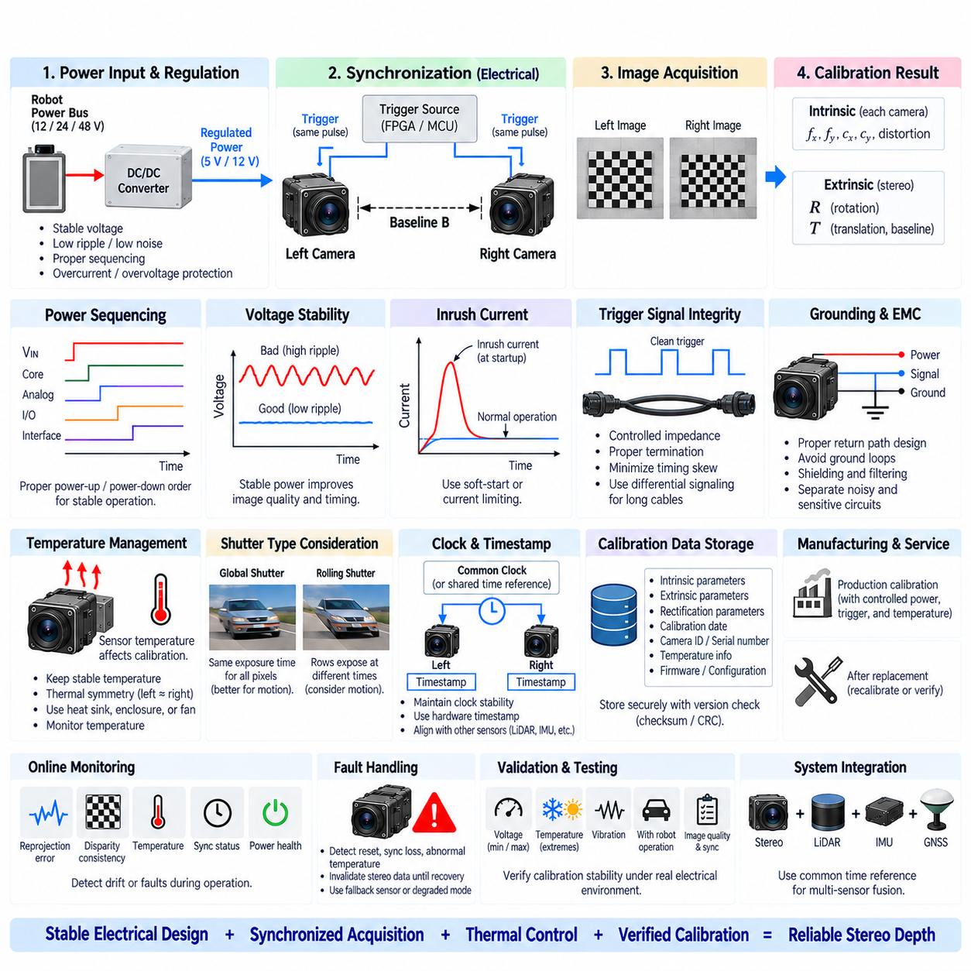
Stereo calibration electrical design addresses the hardware conditions required to preserve the geometric relationship established during stereo camera calibration. Calibration mathematically estimates intrinsic and extrinsic camera parameters, but those parameters remain valid only while the electrical, timing, thermal, and mechanical conditions of the stereo assembly remain sufficiently stable. Electrical architecture is therefore an important part of maintaining calibration integrity throughout operation.
Intrinsic calibration characterizes parameters such as focal length, principal point, and lens distortion for each camera, while stereo extrinsic calibration determines the relative rotation and translation between the left and right optical frames. Although these quantities are geometric, their practical stability can be influenced by sensor temperature, supply variation, clock behavior, image processing, synchronization, and operating state. Calibration should consequently be considered a system property rather than a purely software-generated parameter set.
The two camera channels should operate under electrically consistent conditions during calibration and normal operation. Large differences in supply voltage, regulator behavior, grounding, sensor configuration, or thermal state can produce unequal imaging characteristics. Electrical symmetry does not guarantee geometric accuracy, but it reduces avoidable differences between the channels and makes calibration results more repeatable when the system transitions from laboratory calibration to real robotic operation.
Stable power regulation is important because image sensors, oscillators, serializers, processors, and analog circuitry depend on controlled supply rails. Excessive ripple, voltage droop, or transient disturbances can cause image noise, timing instability, frame loss, or temporary camera reset. A calibration process performed under clean laboratory power may not represent field behavior if the deployed robot exposes the stereo cameras to substantially different electrical conditions.
Power sequencing should also be deterministic where multiple internal voltage domains are involved. Different startup states can influence sensor initialization, clock configuration, exposure control, or interface behavior. Both cameras should reach a known operating state before calibration images or operational stereo frames are accepted. Power-good information and camera-ready status can help ensure that calibration or depth processing does not begin while one channel remains partially initialized.
Hardware synchronization is a fundamental electrical requirement for stereo calibration involving moving cameras or targets. The left and right images should correspond to the same physical scene state. A common trigger source, master-slave synchronization, or another deterministic hardware timing mechanism can align exposure events. Without this alignment, temporal displacement may be interpreted as geometric displacement, contaminating estimated stereo relationships or producing misleading validation results.
Synchronization accuracy should be verified at the electrical and optical levels. Measuring trigger edges with an oscilloscope or logic analyzer confirms signal timing at the interfaces, but it does not alone prove that the image sensors expose simultaneously. Sensor response delay, shutter architecture, internal processing, and firmware behavior can introduce additional offsets. Calibration validation should therefore combine electrical timing measurements with image-based tests using controlled motion or timed optical events.
Global-shutter sensors simplify calibration under motion because corresponding pixels are exposed over nearly the same time interval. Rolling-shutter sensors require additional attention because individual rows are captured at different times. Even when both sensors receive a common trigger, camera or target motion can distort the calibration pattern differently in each image. Calibration procedures should therefore minimize motion or explicitly account for shutter timing when rolling-shutter hardware is used.
Clock stability becomes increasingly important when stereo cameras must remain synchronized over extended periods. Independent oscillators can accumulate relative phase error unless synchronization is periodically enforced. A shared reference clock, hardware trigger, or synchronized timing architecture can reduce drift. Where stereo data must also align with LiDAR, IMU, radar, or GNSS, a common system time reference and hardware timestamps improve consistency across the complete perception architecture.
Timestamp integrity should be maintained together with exposure synchronization. A timestamp generated when an image reaches the operating system or middleware may contain variable communication and processing delays and may not accurately represent physical exposure time. Hardware-derived timestamps associated with trigger or sensor acquisition events provide a stronger basis for calibration verification, multi-sensor alignment, frame pairing, and diagnosis of timing-related geometric errors.
Electrical trigger distribution requires controlled signal integrity. Cable length, impedance, termination, logic thresholds, propagation delay, grounding, buffering, and electromagnetic interference can introduce timing skew or unreliable edges. In compact stereo modules these effects may be small, but distributed cameras on large AMRs, vehicles, UAVs, or manipulators can require longer harnesses. Differential signaling or suitable buffering can improve robustness for remote synchronization paths.
Grounding architecture can indirectly affect calibration stability by influencing both imaging and synchronization circuits. Ground offsets or loops may inject motor noise, converter switching noise, or transient currents into camera electronics. This can produce corrupted frames, unstable trigger thresholds, communication errors, or intermittent resets. Camera power returns, chassis grounding, cable shields, synchronization returns, and high-speed data interfaces should therefore be designed as a coordinated EMC structure.
Electromagnetic compatibility is particularly important when calibration must remain valid on an operating robot rather than only on a stationary bench. Motors, inverters, DC/DC converters, wireless transmitters, compute systems, and high-speed communication links generate electromagnetic disturbances. A stereo system that calibrates correctly with other loads disabled may behave differently during driving or manipulation. Calibration validation should therefore include representative robot electrical activity.
Temperature is one of the most important links between electrical design and geometric calibration. Sensor electronics and local regulators generate heat, while power consumption varies with processing, frame rate, exposure, communication activity, and environmental control. Temperature changes can alter lens characteristics, sensor package geometry, mounting structures, and baseline dimensions. Electrical and thermal design should therefore maintain predictable temperature conditions or support compensation for measurable thermal drift.
Thermal symmetry between the left and right cameras improves calibration repeatability. If one camera operates significantly hotter because of nearby electronics, sunlight, cable heating, or asymmetric cooling, the two optical systems may experience different dimensional or focal changes. Temperature sensors near each camera can provide valuable diagnostic information, allowing calibration data to be associated with operating temperature and enabling detection of abnormal thermal imbalance.
Calibration data must be stored in a controlled and traceable form. Intrinsic matrices, distortion coefficients, stereo rotation, translation, rectification parameters, calibration date, hardware identification, and relevant configuration information should remain associated with the physical camera pair. If one camera, lens, bracket, or stereo assembly is replaced, the previous calibration may no longer be valid. Electrical identification mechanisms can help prevent incorrect calibration files from being applied.
Nonvolatile memory within a camera module, stereo controller, EEPROM, or system storage can retain calibration parameters and hardware identifiers. The architecture should define which device owns the authoritative calibration data and how software verifies compatibility during startup. Serial numbers, module identifiers, firmware versions, sensor configuration, and calibration revision can be checked before stereo processing begins, reducing the risk of configuration mismatch after manufacturing or service.
Calibration data integrity should also be protected against accidental corruption. Checksums, cyclic redundancy checks, version control, redundant storage, or signed configuration packages may be appropriate depending on system criticality. A corrupted baseline or rectification parameter can produce plausible-looking but incorrect depth data. The system should detect invalid calibration information and prevent normal depth processing rather than silently operating with unverified geometric parameters.
Manufacturing introduces additional electrical requirements because multiple stereo assemblies must be calibrated consistently. Production fixtures should provide repeatable power, triggering, communication, and temperature conditions while recording hardware identity and calibration results. Automated calibration stations can control image acquisition, target presentation, parameter calculation, acceptance criteria, and database storage. Consistent electrical interfaces reduce variation between engineering prototypes and production units.
Service replacement requires an explicit recalibration strategy. Disconnecting and reconnecting an electrically identical camera does not guarantee that its optical position is unchanged. Replacement of a camera module, lens, bracket, or structural component can modify intrinsic or extrinsic geometry. The robot should therefore track service events and determine whether factory calibration, field recalibration, or verification is required before stereo depth is considered trustworthy.
Online calibration monitoring can detect changes that occur after deployment. Reprojection error, epipolar alignment, disparity consistency, synchronization status, temperature, frame counters, and electrical health indicators can reveal gradual drift or sudden faults. Online monitoring does not necessarily replace controlled geometric recalibration, but it can identify when the stored calibration is becoming inconsistent with observed camera behavior and trigger maintenance or degraded-operation strategies.
Fault handling should prevent electrical disturbances from silently invalidating stereo geometry. If one camera resets, loses synchronization, changes operating mode, or reports abnormal temperature, the system should invalidate affected stereo pairs until a known state is restored. Depending on the application, the robot may continue with another sensor modality, reduce speed, enter a degraded perception mode, or request service rather than trusting uncertain stereo depth.
Calibration verification should include power and timing corner cases in addition to conventional geometric targets. Testing at minimum and maximum operating voltage, different temperatures, startup conditions, vibration, high compute load, active motors, and representative EMC environments can reveal dependencies that ordinary calibration procedures miss. The objective is to demonstrate that calibrated geometry remains sufficiently stable throughout the electrical and environmental operating envelope.
A robust stereo calibration electrical architecture therefore combines stable power, deterministic startup, synchronized exposure, reliable clocks and timestamps, controlled grounding, EMC protection, thermal monitoring, calibration-data storage, hardware identification, diagnostics, and fault recovery. Calibration becomes trustworthy when the system can preserve and verify the conditions under which geometric parameters remain valid, allowing stereo depth to remain consistent from production calibration through long-term robotic operation.

