Volume 15 Perception and Sensor Architecture

Chapter 04. 2D LiDAR

04.01. SICK TIM/S300/S3000
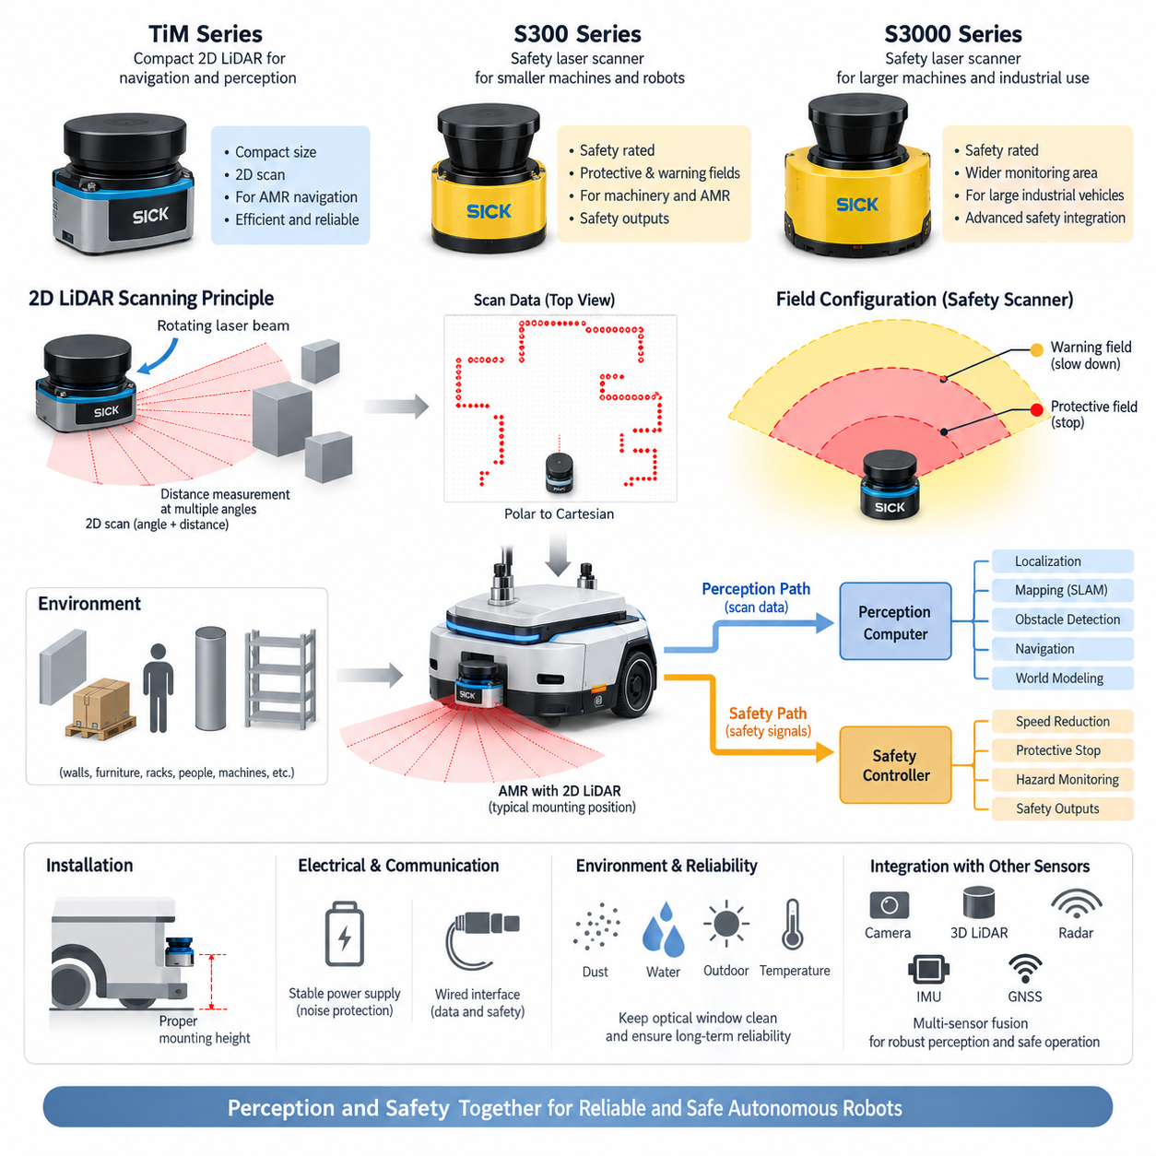
The SICK TiM, S300, and S3000 families represent three important generations and application classes of two-dimensional laser scanning technology used in industrial automation and mobile robotics. Within a perception and sensor architecture, they illustrate the transition from compact navigation-oriented LiDAR toward safety-rated protective laser scanners. Although all three observe the environment by scanning a laser beam across a horizontal plane, their intended functions, interfaces, diagnostic concepts, and safety responsibilities differ significantly.
A 2D LiDAR determines obstacle geometry by repeatedly measuring distance along many angular directions within a scanning plane. A rotating or optically deflected laser beam illuminates surrounding objects, and the returned optical energy is detected and converted into range measurements. Successive measurements form a polar representation consisting of angle and distance. Robot software transforms these measurements into Cartesian coordinates and uses the resulting scan for localization, mapping, obstacle detection, navigation, or protective-zone supervision.
The SICK TiM series is particularly relevant to compact autonomous mobile robots because it combines relatively small mechanical dimensions with practical scanning capability. A TiM sensor can provide a planar representation of walls, furniture, racks, machinery, people, and other obstacles around a robot. Rather than generating dense three-dimensional geometry, it delivers an efficient two-dimensional scan that can be processed with comparatively modest computing resources, making it suitable for navigation layers that must operate continuously with predictable latency.
In an AMR, a TiM-class scanner is commonly mounted near the lower perimeter of the chassis so that its scan plane intersects obstacles that threaten vehicle motion. The mounting height must be selected according to wheel geometry, bumper height, expected obstacle dimensions, floor irregularities, and payload structure. A scanner mounted too high may fail to observe low obstacles, while an excessively low installation can increase unwanted detections from floor transitions, ramps, reflections, dust, or mechanical structures belonging to the robot itself.
The S300 belongs to a different design category because it is fundamentally associated with safety laser scanning rather than ordinary perception alone. A safety scanner monitors configurable regions around machinery or mobile platforms and can generate safety-related outputs when an object enters a defined protective field. This allows the sensor to participate directly in functions such as controlled deceleration, protective stopping, personnel protection, and hazardous-area monitoring instead of merely delivering environmental data to navigation software.
Protective fields and warning fields are central concepts in safety scanner integration. A warning field may cause the robot controller to reduce velocity or prepare for a stop before an object reaches the critical region. The protective field represents the region in which continued hazardous motion is no longer permitted under the configured safety concept. Field geometry therefore depends on vehicle speed, braking performance, controller response time, scanner response characteristics, positioning uncertainty, and required safety margins rather than on obstacle distance alone.
The S3000 extends this safety-scanning philosophy toward larger machines and applications requiring broader monitoring capability and more elaborate safety integration. It has historically been used in industrial vehicles, automated guided systems, manufacturing equipment, and protected production areas. From an architectural perspective, the important distinction is that an S3000-class device is not simply a higher-performance navigation LiDAR. Its primary engineering value comes from dependable protective monitoring and integration into a safety control chain.
This distinction creates two parallel information paths in a robot. The perception path may transfer scan data toward an industrial PC, edge computer, localization module, SLAM system, or obstacle-processing software. The safety path instead connects protective detection to safety-rated logic and ultimately to motion-inhibiting hardware. A robot architecture should avoid assuming that an AI perception computer can automatically replace this independent safety path, because navigation intelligence and functional safety supervision have fundamentally different assurance requirements.
Electrical integration begins with a stable power supply selected according to the exact scanner variant and manufacturer requirements. LiDAR power should be protected against excessive voltage drop, reverse connection, transient disturbances, conducted noise, and disturbances generated by motors or switching converters. Cable routing should separate sensitive sensor wiring from high-current motor phases whenever practical. Connector retention, shielding strategy, grounding, enclosure protection, and service access also become important because scanner reliability directly influences robot availability and, for safety devices, protective functionality.
Communication architecture depends on the product generation and configuration. Scan data intended for perception may be transferred through interfaces supported by the selected device, while safety-related states can use dedicated safety outputs or appropriate safety communication structures. Engineers should therefore distinguish ordinary measurement data, configuration communication, diagnostic information, and safety signals. Combining these conceptually into a single generic “LiDAR interface” can obscure failure modes and make system-level verification significantly more difficult.
Mechanical installation affects measurement quality as strongly as electrical integration. The scanner requires a rigid reference to the chassis because vibration, bracket deformation, collision damage, or mounting-angle error changes the relationship between the scan plane and the robot coordinate frame. The optical window must remain unobstructed across the required field of view. Covers, bumpers, payload structures, cables, decorative panels, and neighboring sensors must therefore be evaluated during CAD packaging before the final mounting position is released.
Contamination is another practical concern. Dust, water droplets, condensation, oil films, scratches, and accumulated debris on the optical surface can degrade returned signals or create abnormal measurements. Outdoor and semi-outdoor robots require particular attention because environmental exposure can be much more severe than in controlled factories. Sensor diagnostics should therefore be combined with inspection and maintenance procedures so that deteriorating optical conditions are detected before they become persistent navigation or safety problems.
For navigation, 2D LiDAR remains valuable because planar geometry is highly compatible with occupancy grids, scan matching, localization, and obstacle maps. Walls, columns, racks, and other stable structures provide geometric features that can support reliable localization even when visual appearance changes. A robot may therefore combine a TiM-class scanner with wheel odometry, IMU data, cameras, or depth sensors. Each sensor compensates for limitations of the others, while the 2D scanner provides a geometrically stable horizontal reference.
Safety scanners require a different validation philosophy. Protective-field dimensions must account for the complete stopping process rather than merely the scanner detection distance. The system must consider sensing and evaluation time, communication or output delay, safety-controller processing, actuator response, brake engagement, mechanical stopping distance, vehicle speed, load condition, tire-floor friction, and uncertainty. Consequently, increasing robot speed normally requires larger protective fields or a coordinated field-switching strategy that preserves the required stopping margin.
Mobile robots can employ multiple field sets according to operating state. Forward motion may activate a long frontal protective region, while reverse travel requires appropriate rear monitoring. Turning can require asymmetric coverage because the swept volume changes with steering geometry. Low-speed docking may permit a different field arrangement from normal transit. The active field must therefore correspond to actual vehicle motion, and transitions between field configurations must be designed so that no temporary unprotected condition appears.
The comparison between TiM, S300, and S3000 consequently should not be reduced to range, angular resolution, or scan frequency. TiM is best understood as a compact 2D sensing platform suited to perception and navigation tasks, whereas S300 and S3000 represent safety-scanning architectures intended to supervise hazardous motion under defined protective conditions. Exact capabilities vary by model and generation, so electrical limits, interfaces, field configurations, environmental ratings, and safety parameters must always be confirmed against the datasheet for the specific part number.
In a modern Physical AI robot, these scanners can coexist with cameras, stereo systems, depth cameras, 3D LiDAR, radar, IMUs, and GNSS. The 2D scanner remains useful because it provides a computationally efficient and deterministic geometric slice of the environment. More advanced sensors may improve semantic understanding and three-dimensional awareness, but they do not automatically eliminate the value of a dedicated planar scanner, particularly near the vehicle perimeter where dependable obstacle geometry is required.
The resulting architecture should treat perception LiDAR and safety LiDAR as related but distinct subsystems. Perception data supports localization, planning, world modeling, and autonomous decision-making, while safety sensing supervises whether hazardous motion is permitted. Maintaining this separation allows increasingly sophisticated AI functions to be introduced without weakening the independent protective mechanisms. This principle makes the TiM, S300, and S3000 families useful reference points for understanding both the evolution of 2D LiDAR and its continuing role in AMR sensor architecture.

04.02. Hokuyo Series
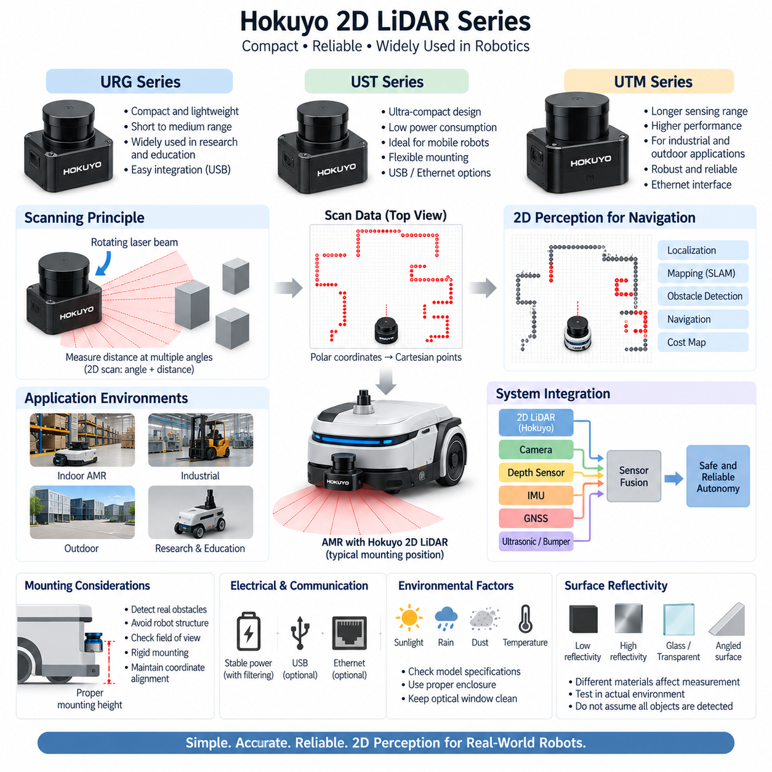
Hokuyo Electric is widely recognized for compact two-dimensional laser range sensors used in robotics, autonomous mobile robots, automated guided vehicles, research platforms, and industrial automation. Within a 2D LiDAR architecture, Hokuyo sensors are particularly important because they combine relatively small size, low power requirements, straightforward digital interfaces, and mature scanning technology. These characteristics make them practical sensors for localization, mapping, obstacle detection, and navigation.
A Hokuyo 2D LiDAR measures surrounding geometry by emitting laser light across a horizontal scanning plane and detecting reflections from objects at multiple angular positions. Each measurement associates a scan angle with a calculated distance, producing a sequence of polar coordinates. Robot software converts these measurements into Cartesian points and assembles them into a two-dimensional representation of walls, columns, furniture, racks, machinery, people, and other objects intersecting the scanning plane.
The Hokuyo portfolio includes multiple sensor families developed for different ranges, environmental conditions, interfaces, and robotic applications. Compact models are commonly associated with indoor mobile robots and laboratory systems, while longer-range and more environmentally robust models can support industrial or outdoor applications. Consequently, the term Hokuyo series should be treated as a product family rather than as a single electrical or optical specification, and the exact characteristics must be verified for the selected model.
URG-series sensors became especially familiar within mobile robotics because they provided an accessible method of obtaining planar range measurements from relatively compact hardware. They have been widely adopted in research robots, educational platforms, service robots, and experimental autonomous systems. Their significance extends beyond individual specifications: extensive robotics software support helped establish 2D laser scans as a standard perception representation for localization, SLAM, navigation, and obstacle-processing pipelines.
UST-series devices represent another important class of compact Hokuyo scanners. Their packaging and scanning characteristics make them suitable for mobile platforms where installation space and sensor mass are constrained. In an AMR, a UST-class sensor can be positioned near the lower perimeter of the chassis to observe obstacles around the vehicle. Depending on the required coverage, one scanner may supervise the primary travel direction or multiple scanners may be arranged to reduce blind regions around the platform.
UTM-series scanners are commonly associated with applications requiring greater sensing capability than very compact short-range devices. A longer usable range can improve detection of environmental structures and provide localization algorithms with geometric information before the robot approaches nearby objects. This becomes useful in larger indoor spaces, corridors, warehouses, industrial facilities, and certain outdoor environments where the navigation system benefits from observing structural features over a wider area.
The fundamental data product of a Hokuyo scanner is a sequence of range measurements ordered according to scan angle. This representation is computationally efficient compared with dense three-dimensional point clouds and can be processed rapidly by an embedded computer or industrial PC. Scan matching algorithms can compare successive measurements to estimate relative motion, while SLAM algorithms combine repeated scans with odometry or other sensor information to construct maps and estimate the robot pose within them.
For localization, stable geometric structures are particularly valuable. Walls, pillars, racks, machine boundaries, and building features often remain spatially consistent even when lighting conditions or visual textures change. A 2D LiDAR can therefore complement camera-based perception by providing direct geometric measurements that are less dependent on visible texture. However, the scanner observes only objects intersecting its scan plane, so objects above or below that plane can remain undetected unless additional sensors provide vertical coverage.
Mounting height is consequently one of the most important mechanical design decisions. The scan plane should intersect obstacles that can realistically interfere with robot motion while avoiding excessive interference from the robot chassis itself. Very low mounting can increase sensitivity to floor irregularities or structural components, whereas high mounting may allow low objects to pass beneath the laser plane. Mechanical CAD analysis should evaluate the complete field of view, bumper geometry, wheel envelope, payload structure, and possible occlusion.
Rigid mounting is also essential because the scanner coordinate frame must maintain a known relationship with the robot base frame. Bracket deformation, vibration, collision displacement, or incorrect installation angle can introduce systematic errors into localization and obstacle coordinates. After installation, the transformation between the LiDAR and robot coordinate systems should be defined accurately. For multi-sensor robots, this extrinsic relationship must also remain consistent with camera, IMU, depth sensor, and other perception coordinate frames.
Electrical architecture must be designed around the requirements of the exact Hokuyo model. The sensor supply should remain within its specified operating range during startup, normal driving, acceleration, braking, charging transitions, and other electrical disturbances. Motor drivers and DC/DC converters can introduce conducted or radiated noise, so sensor power distribution should consider filtering, grounding, cable routing, connector quality, and voltage-drop margins. A stable supply contributes directly to reliable scan acquisition.
Communication interfaces differ among Hokuyo product generations and models, with USB and Ethernet-based connectivity being familiar options across the broader family. USB can simplify integration in compact research systems, whereas Ethernet is attractive for distributed robot architectures because it supports longer cable routing and conventional network infrastructure. The electrical engineer must nevertheless verify connector pinout, protocol behavior, network configuration, cable requirements, and startup characteristics for the specific device rather than assuming compatibility across the entire series.
In a ROS or ROS 2 architecture, Hokuyo scan measurements are typically represented as a planar laser-scan data stream containing angular limits, angular increments, ranges, and timing information. Navigation software can transform this data through the robot coordinate-frame hierarchy and use it for localization, cost-map generation, obstacle avoidance, and SLAM. The simplicity of this representation is one reason 2D scanners remain effective even as robots increasingly incorporate cameras and three-dimensional perception sensors.
Timing must still be considered carefully because a complete scan is acquired over a finite interval rather than at a mathematically instantaneous moment. If the robot translates or rotates rapidly while scanning, individual measurements correspond to slightly different platform poses. For low-speed indoor AMRs this effect may be manageable, but higher-speed or precision applications can require better timestamp handling, motion compensation, and synchronization with odometry or IMU information to maintain accurate geometric alignment.
Environmental performance depends strongly on the selected Hokuyo model. Indoor sensors may operate reliably in controlled lighting and relatively clean conditions but should not automatically be assumed suitable for rain, direct sunlight, dust, condensation, or severe temperature variation. Outdoor-capable installations require verification of optical performance, enclosure protection, operating temperature, vibration tolerance, and environmental limitations. Mechanical covers can provide protection, but they must not obstruct the laser scanning aperture or introduce unwanted reflections.
Reflectivity and surface geometry influence laser ranging behavior. Dark materials may return weaker optical energy, highly reflective surfaces can produce unusual responses, and glass or transparent structures may create difficult measurement conditions. Angled surfaces can redirect reflected light away from the receiver. Robot designers should therefore avoid assuming that every physical obstacle will produce an equally reliable return and should validate representative materials from the actual operating environment during system testing.
A single Hokuyo 2D LiDAR can provide excellent planar awareness but cannot fully represent three-dimensional hazards. Table surfaces, forklift forks, hanging objects, protruding shelves, ramps, holes, and obstacles outside the scanning plane may require depth cameras, additional LiDARs, ultrasonic sensors, bumpers, or 3D perception. Sensor fusion therefore expands coverage rather than merely duplicating measurements, allowing the navigation architecture to combine efficient planar geometry with richer spatial and semantic information.
Hokuyo scanners are especially useful as part of a layered AMR perception architecture. The 2D LiDAR can provide stable geometry for localization and immediate obstacle mapping, while cameras contribute appearance and semantic information, depth cameras provide local three-dimensional structure, and IMUs improve motion estimation. In outdoor platforms, GNSS and additional long-range sensors can extend this architecture further. Each sensing modality addresses a different uncertainty rather than competing to become the single universal sensor.
Unlike dedicated safety laser scanners, a navigation-oriented Hokuyo device should not automatically be treated as the independent protective element of a safety-related stopping function. Perception and functional safety have different design and validation requirements. A robot may use Hokuyo scan data for navigation and ordinary obstacle avoidance while a separate safety-rated sensing and control chain supervises hazardous motion. Maintaining this architectural distinction prevents high-level autonomy functions from being confused with certified protective mechanisms.
The Hokuyo series therefore provides a useful reference architecture for compact and efficient 2D perception in robotics. Its principal engineering value lies in converting surrounding planar geometry into a simple, rapidly processed range representation that integrates naturally with localization, SLAM, navigation, and obstacle detection. Correct model selection, mounting, power design, communication, timing, environmental validation, and multi-sensor integration determine whether this apparently simple sensor becomes a dependable component of a modern AMR perception system.

04.03. RPLIDAR Series
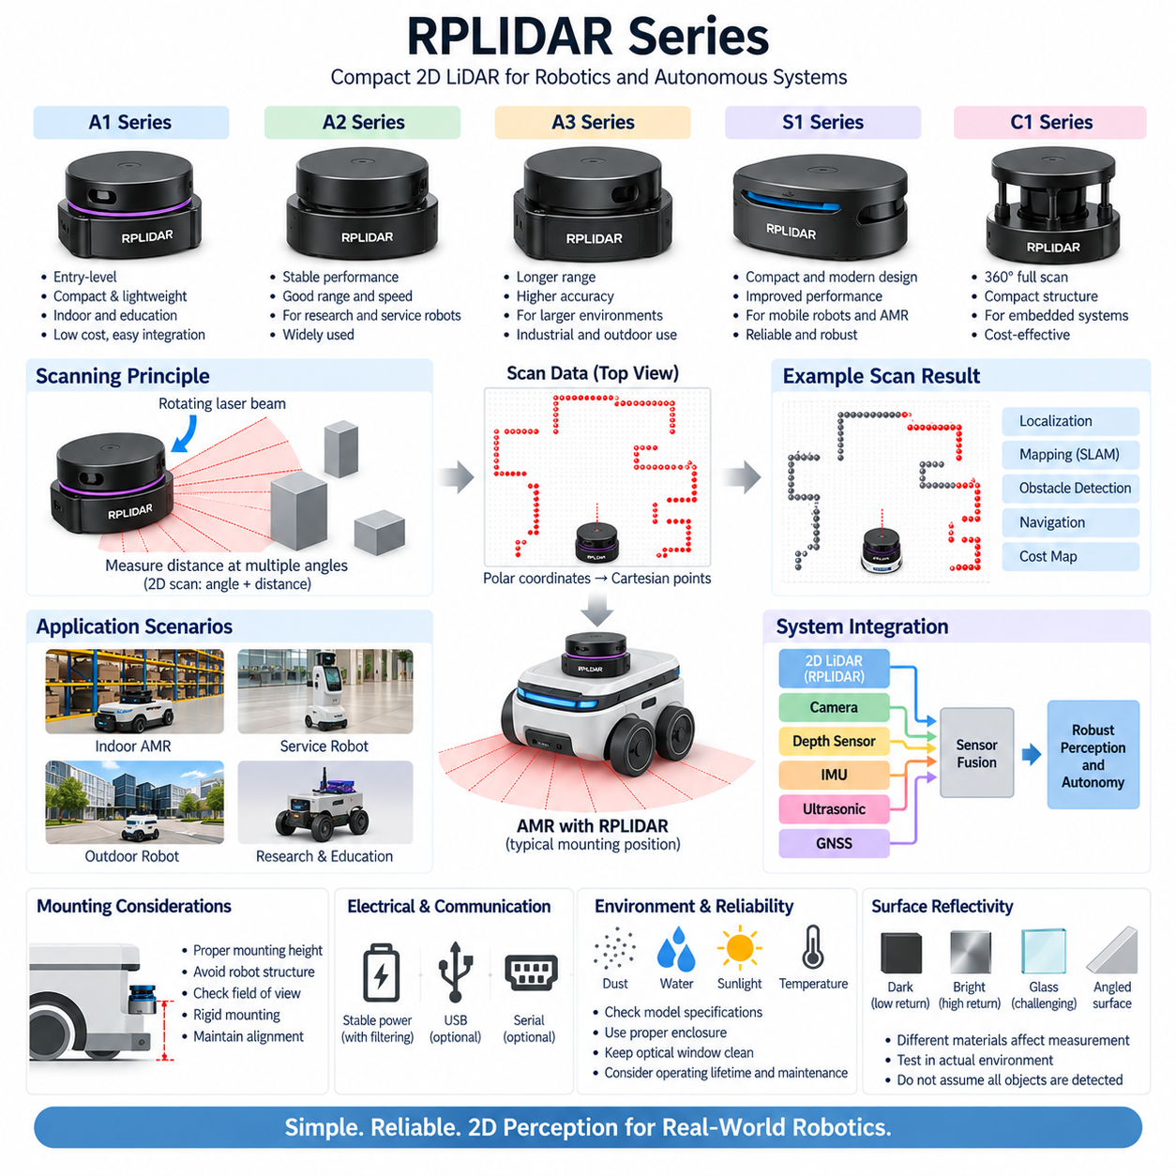
RPLIDAR is a family of compact two-dimensional laser scanners developed for robotics, autonomous mobile robots, service robots, mapping platforms, education, research, and embedded perception systems. Within a 2D LiDAR architecture, the series is notable for combining relatively accessible hardware with continuous planar scanning, compact packaging, and software integration suitable for localization, SLAM, obstacle detection, and autonomous navigation.
The fundamental operating principle of RPLIDAR is similar to other rotating 2D laser scanners. A laser ranging module measures distances while the sensing mechanism rotates through the surrounding environment. Each measurement contains an angular position and corresponding range, producing a polar representation of nearby geometry. Software converts these samples into Cartesian points that describe walls, furniture, racks, people, equipment, and other objects intersecting the scanning plane.
Unlike a camera, which primarily measures image intensity and appearance, a 2D LiDAR directly produces geometric range information. This makes RPLIDAR useful when a robot requires a lightweight representation of free space and obstacle boundaries without processing dense image data. The resulting scan can be incorporated into occupancy grids, local cost maps, scan-matching algorithms, localization systems, and SLAM pipelines while maintaining relatively modest computational requirements.
The RPLIDAR portfolio includes several generations and performance classes rather than a single standardized sensor specification. Different models provide different combinations of measurement range, scan rate, angular sampling, optical performance, mechanical construction, communication interface, and environmental capability. Therefore, engineering selection should begin with application requirements instead of assuming that specifications from one RPLIDAR model apply automatically to another model within the family.
Entry-level RPLIDAR models are particularly useful for educational robots, research prototypes, indoor service robots, and low-cost autonomous platforms. They allow developers to construct practical mapping and navigation systems without immediately adopting higher-cost industrial LiDAR hardware. This accessibility has also made the series valuable for algorithm development, where engineers can study scan processing, localization, occupancy mapping, path planning, and obstacle avoidance using real range data.
Higher-performance members of the RPLIDAR family extend this concept toward larger environments and more demanding mobile robot applications. Increased usable range, improved sampling characteristics, faster scanning, or enhanced mechanical designs can provide more environmental information for localization and navigation. Such capabilities are valuable in warehouses, corridors, commercial buildings, logistics facilities, and other environments where stable geometric structures may be observed over greater distances.
For SLAM, the scanner repeatedly observes surrounding geometric features while the robot moves. Consecutive scans can be compared to estimate changes in position and orientation, while wheel odometry and IMU measurements can provide additional motion information. The SLAM system combines these observations to construct a map and estimate the robot pose within it. Walls, corners, columns, racks, and other persistent structures generally provide useful geometric constraints for this process.
A major advantage of planar LiDAR is the compact structure of its data. Instead of producing a large three-dimensional point cloud, the scanner outputs a sequence of angular range samples representing one horizontal slice of the environment. This allows navigation algorithms to update maps and obstacle layers efficiently. For many indoor AMRs moving primarily on flat floors, this planar representation can provide sufficient geometric information for a significant portion of the navigation pipeline.
However, the same planar structure creates an important limitation. RPLIDAR detects only objects that intersect the laser scanning plane. A low object may remain below the scan, while a table surface, shelf, projecting structure, or suspended obstacle may exist above it. Negative obstacles such as stairs or holes also require additional consideration. A robot intended for complex environments should therefore combine planar LiDAR with complementary sensing when three-dimensional hazard coverage is required.
Sensor mounting height should be selected according to the physical geometry of the robot and its operating environment. The laser plane should intersect representative obstacles while avoiding wheels, bumpers, body panels, cables, and other parts of the robot itself. Mounting too high can create vulnerability to low obstacles, while mounting too close to the floor can increase unwanted measurements from floor irregularities. CAD packaging should verify unobstructed scanning around the required angular region.
Mechanical rigidity is equally important because localization algorithms assume that the LiDAR maintains a stable transformation relative to the robot base. Vibration, bracket flexibility, accidental impact, or mounting displacement can change this transformation and introduce systematic errors into maps and obstacle positions. The LiDAR coordinate frame should therefore be defined precisely, and its extrinsic relationship with the robot, camera, depth sensor, and IMU frames should remain mechanically stable.
The rotating mechanism also deserves engineering attention because many 2D scanners depend on continuous mechanical motion during operation. Scan quality can be influenced by rotational stability, mechanical wear, contamination, vibration, and operating conditions. Long-duration AMR deployment therefore requires consideration of operating lifetime and maintenance rather than evaluating only initial ranging performance. Diagnostics should detect abnormal scan behavior before degradation produces persistent localization or obstacle-detection problems.
Electrical integration begins with a regulated supply that satisfies the requirements of the selected RPLIDAR model. The sensor should remain stable during robot startup, motor acceleration, braking, battery-voltage variation, and DC/DC converter switching. Noise from traction motors and motor drivers can propagate through power and grounding paths, so filtering, cable routing, grounding, connector retention, and voltage-drop analysis should be considered as part of the complete sensor electrical architecture.
Data connectivity depends on the particular RPLIDAR model and integration hardware. Common robotic implementations transfer scan information through serial or USB-related interfaces, while other product variants and system configurations can provide different communication arrangements. Interface selection affects cable length, bandwidth, connector robustness, processor compatibility, and serviceability. The exact electrical and communication requirements should therefore be verified from documentation for the selected device rather than generalized across the series.
Within ROS or ROS 2, RPLIDAR measurements can be represented using the standard planar laser-scan structure used throughout robotic navigation software. The scan includes angular information, range measurements, and timing-related parameters that downstream modules can transform into the robot coordinate system. This allows the sensor to interact naturally with mapping, localization, navigation, obstacle-layer, visualization, and diagnostic components without requiring a proprietary perception representation throughout the software stack.
Timing becomes increasingly important as robot velocity increases. A rotating scanner does not measure every direction simultaneously; instead, individual points are acquired sequentially during each revolution. If the robot moves substantially during this interval, the resulting scan can contain motion distortion. Accurate timestamps, odometry, and IMU information can be used by higher-level processing to compensate for platform motion when the application requires greater geometric accuracy.
Surface properties can also affect measurement reliability. Dark or weakly reflective materials may produce reduced return energy, while highly reflective, transparent, or angled surfaces can generate difficult or inconsistent measurements. Glass walls are particularly important in service and commercial environments because their optical behavior differs from opaque walls. System validation should therefore include representative materials and lighting conditions from the intended deployment environment rather than relying only on ideal laboratory targets.
Environmental suitability must be evaluated independently for each model. A scanner that performs effectively on an indoor research robot should not automatically be assumed suitable for rain, dust, condensation, strong sunlight, vibration, or wide temperature variation. Outdoor and industrial AMRs require careful review of enclosure protection, optical limitations, mechanical robustness, operating temperature, and contamination exposure. Protective covers must preserve the required field of view and avoid optical interference.
RPLIDAR can form one layer of a broader multi-sensor perception architecture. The 2D scanner provides efficient planar geometry, cameras contribute visual and semantic information, depth cameras provide local three-dimensional structure, and IMUs support motion estimation. Additional ultrasonic sensors or bumpers can improve close-range coverage, while outdoor robots may incorporate 3D LiDAR, radar, and GNSS. Sensor fusion allows these complementary measurements to address different environmental uncertainties.
Navigation sensing must also be distinguished from safety-rated protective sensing. A RPLIDAR used for SLAM or ordinary obstacle avoidance should not automatically be considered equivalent to a certified safety laser scanner. Safety-related stopping requires appropriate sensors, safety logic, response-time analysis, protective-field design, and system-level validation. Separating autonomous perception from the independent safety chain allows navigation software to evolve without unintentionally weakening the mechanisms responsible for hazardous-motion protection.
The RPLIDAR series therefore represents an important class of accessible 2D perception hardware for modern robotics. Its practical value comes from transforming surrounding geometry into compact planar range data that can be processed efficiently for mapping, localization, navigation, and obstacle detection. Reliable deployment ultimately depends on selecting the appropriate model and correctly engineering its mounting, power, communication, timing, environmental protection, calibration, software integration, and relationship with complementary sensors.

04.04. Power and Communication Interface
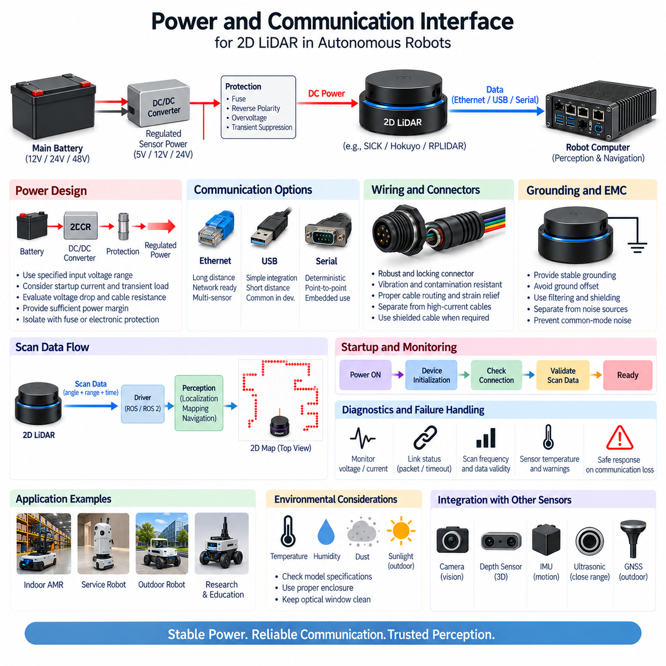
The power and communication interface of a 2D LiDAR forms the electrical boundary between the sensing device and the robot’s power, computing, and control architecture. Although the optical subsystem performs distance measurement, reliable perception depends equally on stable electrical power and deterministic data transfer. Power integrity, grounding, connectors, communication protocols, cable routing, startup behavior, and diagnostics must therefore be designed as one integrated sensor interface.
A mobile robot commonly distributes power from a main battery through one or more DC/DC converters before supplying its sensors. The 2D LiDAR may therefore operate from a regulated sensor rail rather than directly from the traction battery. The required voltage depends on the selected scanner, so the design must use the manufacturer-specified input range and consider tolerance, startup current, cable loss, connector resistance, protection devices, and converter regulation under changing robot operating conditions.
Power budgeting should consider more than the nominal LiDAR consumption. Startup behavior, internal motor operation in rotating scanners, temperature-dependent load variation, interface electronics, and transient current can affect the required supply capacity. The power distribution unit should provide sufficient continuous and transient margin while avoiding excessive oversizing. Multiple sensors sharing one rail must be evaluated together because simultaneous startup can produce a larger voltage disturbance than steady-state calculations predict.
Voltage drop becomes important when a scanner is mounted far from the central power distribution unit. Harness resistance, connector contacts, fuse resistance, and intermediate terminals can reduce the voltage available at the sensor. The engineering calculation should therefore evaluate voltage at the LiDAR connector under worst-case current and temperature conditions. Adequate conductor cross-section and minimized unnecessary connection points help maintain a stable supply and improve long-term system reliability.
Protection circuitry should isolate the LiDAR branch from faults elsewhere in the robot. A fuse, resettable protection device, or electronically controlled power channel can limit damage caused by short circuits or wiring failures. Reverse-polarity protection, overvoltage protection, and transient suppression may also be appropriate depending on the platform. Protection thresholds must be coordinated so that normal startup behavior does not create nuisance trips while genuine electrical faults are interrupted safely.
Motor drives, switching converters, relays, contactors, and high-current wiring can introduce electromagnetic interference into the sensor supply. Conducted disturbances may propagate through shared power or ground paths, while radiated interference can couple into nearby cables. The LiDAR supply architecture should therefore consider filtering, grounding topology, cable separation, shielding, and connector termination. Sensitive communication wiring should not be routed unnecessarily alongside traction-motor phases or other strong noise sources.
Grounding requires particular attention because power return and communication reference paths can interact. Poor grounding can create common-mode disturbances, ground offsets, intermittent communication, or corrupted measurements. The preferred topology depends on the scanner interface and overall robot electrical architecture, but the objective is consistent: provide controlled return paths and avoid unintended current flow through communication shields or signal references. Shield termination should follow the requirements of the selected interface and sensor manufacturer.
The communication interface transfers measured ranges, angular information, timestamps, status information, configuration data, and diagnostics from the scanner to the robot computer. Different 2D LiDAR families may use Ethernet, USB, serial communication, or manufacturer-specific interfaces. Interface selection must therefore consider not only raw bandwidth but also cable length, latency, electrical robustness, connector retention, software support, network topology, maintenance requirements, and the environmental conditions of the robot.
Ethernet is attractive for modern AMRs because it supports distributed sensor architectures and allows multiple network devices to connect through switches. A LiDAR can communicate with an edge computer through a dedicated port or through a shared sensor network. The network design should define addressing, link speed, packet flow, switch capacity, and failure behavior. Where several cameras and LiDARs share the network, aggregate traffic must be evaluated rather than considering each sensor independently.
USB provides convenient integration for compact robots, development platforms, and sensors located close to the host computer. It can simplify initial setup because power or communication functions may be closely integrated depending on the device. However, USB cable length, connector retention, vibration resistance, topology, host-controller behavior, and electromagnetic susceptibility require attention in production robots. A connection that works reliably on a laboratory bench may require additional mechanical and electrical engineering for continuous field operation.
Serial interfaces remain useful where bandwidth requirements are moderate and simple point-to-point communication is preferred. Their deterministic structure can be convenient for embedded systems, but baud rate, cable length, voltage levels, grounding, and error handling must match the selected hardware. Engineers should distinguish the physical electrical interface from the protocol transported over it because identical connector shapes or serial terminology do not guarantee electrical or software compatibility between different LiDAR products.
Connectors are part of the sensor architecture rather than passive accessories. A production AMR connector must tolerate vibration, repeated maintenance, cable forces, contamination, and possible accidental loading. Locking mechanisms, keying, pin current rating, contact resistance, shielding continuity, environmental sealing, and service access should be considered. The harness should provide strain relief near the scanner so that vehicle vibration and cable movement are not continuously transferred to the sensor connector.
Power and data cables should be routed with mechanical protection and electromagnetic compatibility in mind. Sharp bends, repeated flexing, abrasion points, hot surfaces, moving mechanisms, and high-current conductors should be avoided. Where separation from noise sources is impossible, appropriate shielding and routing geometry become more important. Service loops may improve maintenance access, but excessive cable length can increase voltage drop, electromagnetic coupling, packaging complexity, and opportunities for connector mistakes.
Startup sequencing can influence system reliability. The robot computer, Ethernet switch, DC/DC converter, and LiDAR may require different initialization times after power is applied. Navigation software should not assume that valid scan data exists immediately when the main controller boots. A robust system monitors device availability, communication status, and scan validity before enabling dependent functions. Controlled sensor power cycling can also provide a useful recovery mechanism when supported by the system architecture.
Communication loss must be treated as a defined system state rather than an unexpected software exception. The perception system should monitor message arrival, timestamps, scan frequency, data validity, and device status. If the LiDAR stops transmitting or produces stale data, downstream navigation modules should detect the condition within a specified timeout. The robot response can then be selected according to the function affected, operational risk, redundancy, and whether an independent safety sensing system remains available.
Data latency is another important interface characteristic. A scan is generated by the sensor, internally processed, transmitted across the communication link, received by the operating system, and finally consumed by perception software. Each stage contributes delay and jitter. For low-speed indoor robots the total delay may be relatively tolerant, but faster AMRs require a defined latency budget because stale obstacle coordinates can directly reduce the accuracy of localization and motion planning.
Timestamp quality becomes especially important when LiDAR data is fused with wheel odometry, IMU, cameras, or other sensors. Measurements representing different physical times should not be treated as simultaneous without considering their temporal relationship. The system may use host timestamps, device timestamps, trigger mechanisms, or network-based synchronization depending on sensor capability. Accurate timing reduces spatial misalignment when the robot moves and improves the consistency of multi-sensor estimation.
A shared Ethernet sensor network requires additional architectural discipline. Cameras can generate substantially more traffic than a 2D LiDAR, while multiple sensors may transmit simultaneously. Switch port capacity, uplink bandwidth, buffering, packet loss, quality-of-service requirements, and compute-interface capacity should therefore be considered at system level. Network segmentation or dedicated sensor links may be appropriate when perception traffic must be isolated from general robot communication or fleet connectivity.
Diagnostics should span both the electrical and communication domains. Useful observations include supply voltage, current abnormalities, link state, packet reception, scan frequency, internal sensor warnings, temperature status, and communication error counters when available. These signals can be integrated into robot health monitoring so that degradation is identified before complete sensor failure. Fleet systems can further use diagnostic history to distinguish isolated sensor faults from recurring harness, power, or network problems.
The interface design should also support maintainability. A technician should be able to identify the LiDAR power branch, connector, network address, communication port, fuse or electronic protection channel, and diagnostic status without extensive disassembly. Clear harness labeling and consistent connector conventions reduce service errors. Where replacement sensors require configuration, the maintenance procedure should define parameter restoration, network setup, coordinate-frame verification, and functional testing before the robot returns to operation.
Perception and safety interfaces must remain conceptually separated when the robot uses both navigation LiDAR and safety-rated scanners. Ordinary scan data may travel to the perception computer for localization and obstacle processing, while safety signals follow an independently engineered safety path. Sharing power infrastructure, network equipment, or control logic without analyzing common-cause failures can undermine this separation. Safety architecture must therefore determine which resources may be shared and which must remain independent.
A robust 2D LiDAR interface is ultimately a system-level design rather than a simple combination of two wires for power and one cable for data. Stable voltage, coordinated protection, controlled grounding, EMC-aware harness routing, reliable connectors, appropriate communication technology, timing management, diagnostics, and failure handling collectively determine whether scan information remains trustworthy during real robot operation. This electrical foundation allows the 2D LiDAR layer defined within the broader perception architecture to support dependable localization, mapping, navigation, and obstacle detection.

04.05. Safety LiDAR Integration
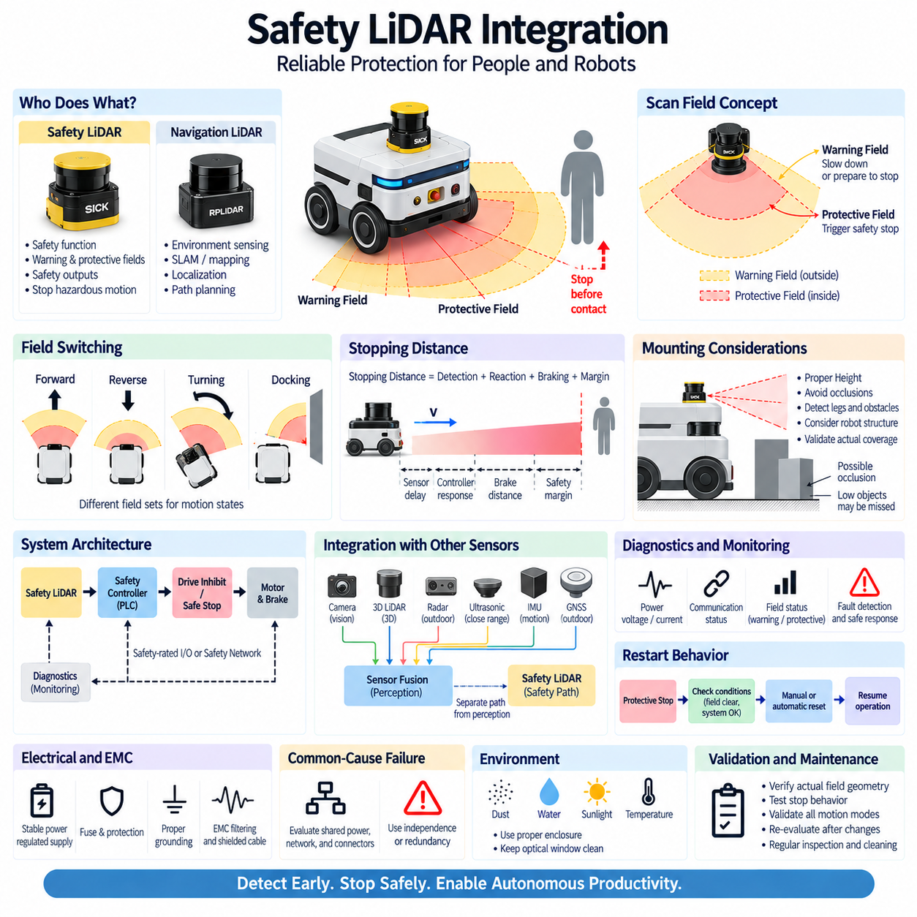
Safety LiDAR integration is the process of incorporating a safety-rated laser scanner into the protective control architecture of an autonomous mobile robot, automated guided vehicle, or industrial machine. Unlike a navigation LiDAR that primarily supplies environmental measurements to perception software, a safety LiDAR participates in preventing hazardous motion. Its detection fields, safety outputs, response time, controller interface, braking behavior, and diagnostic mechanisms must therefore be engineered as parts of one safety function.
A safety laser scanner continuously observes a defined two-dimensional plane around the robot and evaluates whether objects enter configured monitoring regions. These regions are normally divided into warning fields and protective fields according to the required operating strategy. The scanner does not merely report that an obstacle exists; it evaluates intrusion into predefined safety zones and provides outputs that allow the safety control system to reduce or inhibit hazardous vehicle movement.
A warning field is generally positioned outside the protective field and can be used to initiate a non-emergency response before a person or obstacle reaches the critical region. An AMR may reduce velocity, modify its trajectory, or prepare for stopping when this field is occupied. The protective field represents the region where continued hazardous motion is not permitted. Intrusion therefore causes the safety architecture to command the appropriate protective response, typically including a controlled or safety-related stop.
Protective-field dimensions cannot be selected only from the physical distance between the scanner and the front of the robot. The complete stopping process must be considered. Scanner detection and evaluation time, communication or output delay, safety-controller processing, drive response, brake actuation, mechanical stopping distance, robot velocity, payload, tire-floor friction, and engineering margins all contribute to the distance required to prevent contact with a hazardous region.
The stopping-distance concept creates a direct relationship between vehicle speed and safety-field geometry. A robot traveling slowly can normally operate with a shorter protective distance than the same platform traveling at higher speed. As velocity increases, the system requires more distance to detect an intrusion, process the event, remove or reduce drive torque, activate braking, and reach a safe state. Field design must therefore remain coordinated with the validated motion envelope of the vehicle.
Dynamic field switching allows a mobile robot to adapt protective coverage to its current motion state. Different field sets may be selected for forward travel, reverse travel, turning, docking, narrow passages, or different velocity ranges. The selected field should correspond to the actual direction and predicted swept volume of the robot. Switching logic must be designed so that transitions do not temporarily create an unprotected region while the platform continues to move.
Turning requires particular attention because the swept volume of an AMR is not identical to its static footprint. Corners of the chassis, payload structures, or attachments may move laterally as the robot rotates. A rectangular forward field that is sufficient during straight travel may therefore be inadequate during a tight turn. Protective-field geometry should account for steering configuration, turning radius, body overhang, localization uncertainty where relevant, and the physical envelope occupied during the maneuver.
Scanner placement strongly influences achievable safety coverage. A low mounting position can detect legs and many floor-level obstacles, but chassis structures, wheels, bumpers, or payload supports can create occluded regions. A higher position may improve some visibility while allowing low objects to pass below the scanning plane. The installation must therefore be evaluated against the hazards defined for the actual application rather than selecting mounting height solely for convenient mechanical packaging.
Multiple safety scanners may be required when a single device cannot provide adequate coverage around the entire vehicle. Front and rear scanners can support bidirectional travel, while additional devices or appropriately positioned fields may be necessary for side regions and complex vehicle geometries. Overlapping coverage can reduce blind zones, but sensor placement must be validated geometrically. Merely increasing the number of scanners does not guarantee complete protection if their scan planes remain obstructed.
The safety LiDAR should connect to an appropriate safety control layer rather than relying solely on the main autonomy computer. Depending on the architecture, this layer can include safety-rated inputs, dedicated safety outputs, a safety PLC, safety controller, or supported safety communication network. The resulting path extends from obstacle detection through safety logic to drive inhibition or braking. Each component contributes to the integrity and response characteristics of the complete protective function.
The perception path and safety path should remain conceptually distinct even when the same robot contains both navigation and safety scanners. Navigation LiDAR data may be processed by ROS 2, SLAM, cost-map, localization, and path-planning software. Safety detection instead follows an independently engineered path toward safety logic and motion control. An AI or perception computer can improve autonomous behavior, but ordinary perception software should not silently become the sole mechanism responsible for personnel protection.
Electrical power for the safety scanner must be designed with the same rigor as the safety signal path. Supply voltage should remain within the specified range during startup, acceleration, braking, charging transitions, and electrical disturbances. Protection devices, conductor sizing, connector resistance, grounding, EMC filtering, and harness routing can influence availability. A scanner that loses power because of an inadequately designed sensor branch cannot provide the protective function expected from it.
Common-cause failures require special consideration when safety and ordinary perception equipment share infrastructure. A single DC/DC converter, fuse, network switch, connector, grounding fault, or harness damage could potentially disable multiple sensors simultaneously. Architecture reviews should therefore identify shared dependencies and determine whether independence, redundancy, monitoring, or another mitigation is required. Physical separation alone does not provide functional independence if critical electrical resources remain common.
Communication and output monitoring must detect faults rather than assuming that absence of a signal means a safe environment. Broken wires, disconnected connectors, loss of scanner power, communication failures, internal device faults, and invalid field selection should produce defined diagnostic behavior. Safety logic must distinguish valid clear-field information from unavailable or corrupted information. The safe response is determined by the designed safety function and should be established before software implementation.
Restart behavior is another critical integration issue. After a protective stop, the robot should not resume hazardous motion simply because the protective field becomes clear. The required restart logic depends on the application and risk assessment, but the system must define conditions for returning from the safe state. Scanner status, safety-controller state, drive readiness, field validity, and surrounding conditions may all need verification before motion is enabled again.
Braking performance must be measured under representative worst-case conditions rather than assumed from nominal motor specifications. Payload mass, battery condition, tire wear, floor material, slope, temperature, brake characteristics, and vehicle velocity can change stopping distance. Field dimensions based on optimistic laboratory measurements may therefore be inadequate in real operation. Validation should establish a conservative stopping envelope that represents the combinations of conditions expected during deployment.
Safety LiDAR integration also interacts with the robot's motion controller. Normal navigation should attempt to avoid obstacles before the protective field is violated, allowing smooth deceleration and path replanning. The safety system acts as an independent protective layer when ordinary autonomy does not maintain sufficient separation. This layered architecture improves both productivity and protection: navigation handles expected environmental interaction, while safety logic limits hazardous behavior when normal operation becomes insufficient.
Diagnostics should continuously supervise scanner availability, active field set, protective-field state, warning-field state, communication status, internal faults, and relevant safety-controller conditions. These signals can also be reported to the robot health-management system for maintenance and fleet supervision. However, diagnostic visualization should not be confused with execution of the safety function itself. A dashboard may explain why the robot stopped, while the protective action remains within the validated safety control chain.
Commissioning requires verification of actual field geometry after the scanner is mechanically installed. CAD definitions and configuration files alone are insufficient because mounting tolerances, bracket alignment, chassis structures, and configuration errors can alter effective coverage. Test objects should be introduced at representative positions around the robot to verify detection boundaries, field switching, stop behavior, restart conditions, diagnostic reactions, and interaction with the vehicle's different operating modes.
Changes to robot hardware or software can require renewed safety evaluation. Increasing maximum speed, changing payload geometry, replacing tires, modifying braking parameters, relocating the scanner, updating field configurations, or changing safety-controller logic may alter the assumptions used to establish protective distances. Safety configuration should therefore be managed under controlled engineering change procedures rather than treated as a parameter set that can be modified independently during ordinary navigation tuning.
Environmental conditions must also be considered because dust, contamination, condensation, water, reflective surfaces, vibration, temperature, and optical obstruction can affect scanner operation. The selected device, mounting method, protective structure, and maintenance plan should match the intended operating environment. Covers must not obstruct the required scanning plane, and maintenance procedures should keep the optical window in a condition consistent with the assumptions used during system validation.
Integration with cameras, 3D LiDAR, radar, depth sensors, ultrasonic sensors, and AI perception can significantly improve environmental understanding, but these sensors do not automatically inherit the safety integrity of the safety scanner. They may support semantic recognition, prediction, navigation, and operational awareness while the safety LiDAR maintains a dedicated protective function. This separation allows sophisticated Physical AI perception to evolve while preserving an independently engineered boundary against hazardous motion.
Safety LiDAR integration is therefore fundamentally a system architecture problem rather than a sensor installation task. The scanner, protective fields, vehicle dynamics, braking system, electrical supply, safety controller, drive interface, diagnostics, mounting geometry, software states, and validation procedures must operate as a coordinated protective chain. When these elements are engineered together, the 2D safety LiDAR becomes an effective bridge between environmental detection and dependable motion protection in modern AMRs and autonomous robotic platforms.

