Volume 15 Perception and Sensor Architecture

Chapter 08. IMU

08.01. MEMS IMU Selection
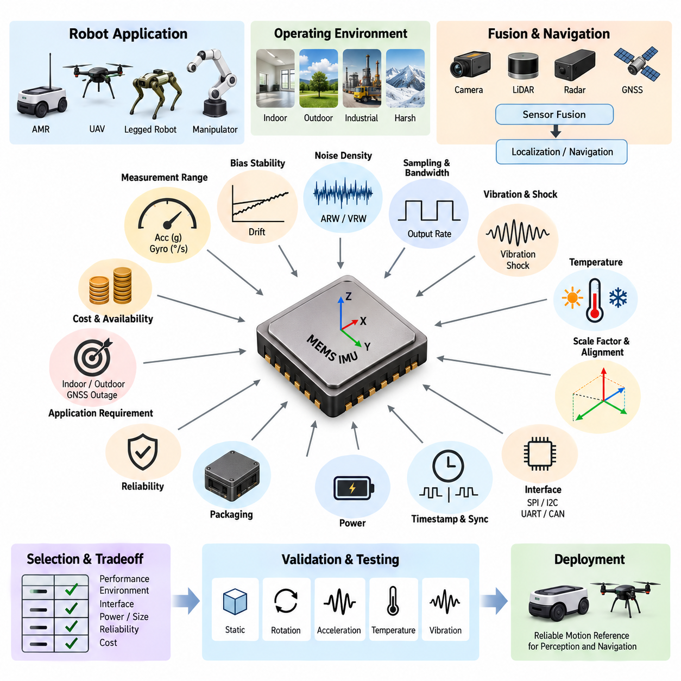
Selecting a MEMS inertial measurement unit for a robotic perception architecture begins with defining the motion that must be observed rather than choosing the device with the highest headline accuracy. A MEMS IMU typically combines three-axis accelerometers and three-axis gyroscopes, while some devices also integrate a magnetometer. The required sensor class depends on vehicle dynamics, navigation objectives, operating environment, fusion architecture, and acceptable position or attitude drift.
Accelerometer range should cover both normal vehicle motion and short-duration shocks without frequent saturation. Indoor AMRs operating at low speed may function well with moderate acceleration ranges, whereas outdoor robots, quadrupeds, manipulators, and UAVs can experience much larger transient loads. Selecting excessive range reduces effective resolution, however, so the preferred device provides sufficient mechanical margin while preserving sensitivity within the normal operating envelope.
Gyroscope range is selected according to the maximum expected angular velocity of the platform. A slowly turning logistics AMR requires substantially less angular-rate capability than an agile UAV or dynamically moving legged robot. Saturation during rapid rotation can corrupt attitude estimation and dead reckoning, but unnecessarily wide range can reduce useful measurement resolution. Mechanical dynamics and emergency maneuvers therefore need to be considered together with nominal operation.
Bias stability is one of the most important parameters when an IMU supports localization or navigation. A small constant gyroscope bias accumulates into increasing orientation error, while accelerometer bias can produce rapidly growing velocity and position errors during inertial integration. Datasheets may specify initial bias, bias repeatability, in-run bias stability, and temperature-dependent bias separately. These values should not be treated as interchangeable when comparing candidate devices.
Noise density describes the short-term random noise contained in accelerometer and gyroscope measurements and directly affects the quality of estimated motion. Lower noise generally improves attitude, velocity, and localization estimation, particularly when the IMU is sampled at high frequency. Angular random walk and velocity random walk provide additional measures useful for navigation analysis. Selection should therefore consider both instantaneous noise specifications and integrated error behavior.
Sampling frequency and internal bandwidth must match the dynamics of the robot and the downstream estimation algorithm. The IMU normally operates faster than cameras, LiDARs, or high-level perception pipelines because inertial data provides high-rate information between slower sensor updates. High output rates are useful only when interface bandwidth, timestamp quality, processor load, filtering, and estimator update frequency are designed consistently across the complete sensor architecture.
MEMS IMUs are strongly affected by vibration because mechanical energy can enter the accelerometer and gyroscope sensing structures and appear as measurement noise or bias. Motors, gearboxes, wheels, propellers, pumps, and structural resonance are common vibration sources in robotic platforms. Device selection should examine vibration sensitivity, internal filtering, shock rating, and mechanical package characteristics, while the final system must also address mounting and vibration isolation separately.
Temperature performance is particularly important for outdoor AMRs, UAVs, and industrial robots exposed to wide environmental variations. MEMS sensor bias, scale factor, and noise characteristics change with temperature, and inexpensive devices can exhibit significant drift during warm-up or rapid thermal transitions. A suitable IMU should provide an operating temperature range compatible with the platform and preferably include factory calibration or compensation across the intended thermal envelope.
Scale-factor error determines how accurately measured acceleration or angular rate follows the actual physical input. Cross-axis sensitivity describes unwanted coupling between orthogonal sensing axes, while axis misalignment represents geometric deviation between the internal sensor axes and the assumed coordinate frame. These errors become important when high-quality localization is required and must be considered together with mechanical alignment, calibration procedures, and sensor-fusion compensation.
Interface selection affects both electrical integration and timing performance. MEMS IMUs commonly provide SPI, I2C, UART, CAN, or other interfaces depending on device class. SPI is often attractive for tightly integrated embedded systems because of its deterministic, relatively high-speed communication, while UART or CAN can simplify integration of packaged industrial IMUs. Interface choice should account for cable length, electromagnetic environment, update rate, latency, and synchronization requirements.
Timestamp accuracy can be as important as raw measurement accuracy in a multi-sensor robot. An excellent IMU produces poor fusion results if acceleration and angular-rate samples cannot be aligned accurately with camera frames, LiDAR scans, radar measurements, or GNSS observations. Selection should therefore examine hardware data-ready signals, external synchronization inputs, timestamp support, clock behavior, and deterministic communication latency rather than considering only sensor precision.
For GNSS-assisted outdoor navigation, the IMU must maintain useful motion estimates during short periods of satellite degradation or loss. Higher-quality bias stability and thermal compensation extend the period over which dead reckoning remains reliable. For indoor AMRs, the IMU more commonly supports LiDAR or visual localization by providing short-term orientation and motion constraints. The required IMU grade should therefore be derived from expected sensor outages and fusion responsibilities.
Mechanical packaging influences practical sensor performance. A small board-level IMU may offer excellent specifications but can perform poorly if installed near a motor, cooling fan, flexible panel, or structural resonance point. Packaged industrial units can provide better environmental protection, controlled mounting surfaces, connectors, and calibrated coordinate frames at higher cost and mass. Selection should consider installation location and mechanical architecture from the beginning rather than after electrical design.
Power consumption is usually modest compared with cameras, LiDARs, and GPU computers, but it remains relevant in battery-operated robots and UAVs. The power architecture should provide a clean and stable supply because switching noise and ground disturbances can degrade sensitive inertial measurements. Supply-voltage tolerance, startup behavior, sleep modes, brownout recovery, current consumption, grounding, and local decoupling requirements should therefore be evaluated during component selection.
Reliability requirements depend strongly on the target platform. Industrial AMRs may require long operating life and resistance to continuous vibration, while outdoor vehicles need environmental robustness and UAVs place additional emphasis on mass, shock tolerance, and redundancy. Safety-oriented systems may employ two or three independent IMUs so that disagreement can be detected. In such architectures, independence of power, communication, mounting, and failure modes can matter as much as sensor accuracy.
A practical comparison should therefore evaluate measurement range, resolution, noise density, bias stability, random walk, scale-factor error, cross-axis sensitivity, bandwidth, output rate, temperature behavior, vibration sensitivity, shock tolerance, synchronization capability, communication interface, power consumption, package design, reliability, availability, and cost as one system-level tradeoff. No single datasheet number adequately represents the suitability of an IMU for robotic perception.
The final selection should be validated using representative motion profiles rather than accepted solely from manufacturer specifications. Candidate IMUs can be logged simultaneously during stationary operation, controlled rotation, acceleration, thermal transitions, vibration exposure, and actual robot driving. Allan deviation and long-duration stationary measurements can reveal stochastic characteristics, while comparison against trusted reference sensors helps quantify bias, scale-factor, and dynamic tracking errors.
MEMS IMU selection ultimately determines the quality of the high-rate motion reference available to the perception and localization stack. The correct device is not necessarily the most expensive or most accurate sensor, but the one whose dynamic range, stability, bandwidth, environmental behavior, timing, interface, and reliability match the robot's operational requirements. Proper selection also establishes the foundation for subsequent vibration isolation, interface design, navigation-grade integration, power design, calibration, and multi-sensor fusion.

08.02. Vibration Isolation Mount
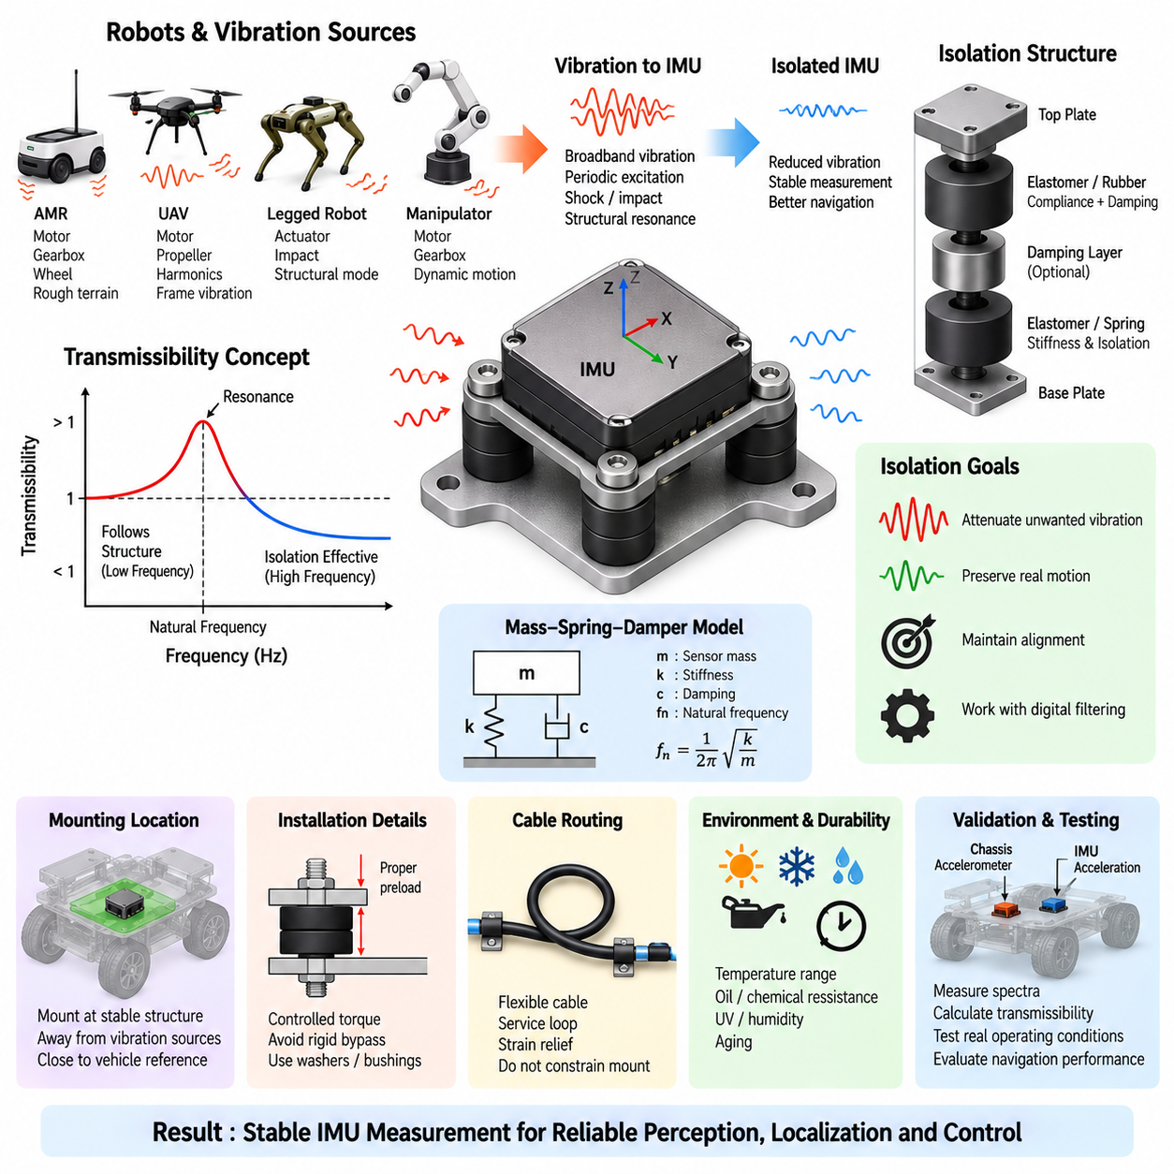
A vibration isolation mount for an inertial measurement unit is designed to reduce the transmission of mechanical vibration from the robot structure into the sensitive accelerometer and gyroscope elements. Motors, gearboxes, wheels, tracks, propellers, cooling fans, pumps, and structural resonance can generate broadband or periodic excitation. Without appropriate isolation, these disturbances can appear as false acceleration, angular-rate noise, bias variation, or unstable navigation estimates.
The fundamental principle of vibration isolation is to place a compliant mechanical element between the IMU and the vibrating structure. This element, commonly implemented using elastomer, rubber, silicone, polymer, spring, or combined damping structures, forms a mass-spring-damper system with the IMU assembly. Properly designed, the mount attenuates vibration above its isolation region while maintaining sufficient stiffness to preserve the physical orientation and position of the sensor.
The natural frequency of the mounted IMU is a critical design parameter. It depends primarily on the effective mass of the sensor assembly and the stiffness of the isolation material. When excitation approaches the mount natural frequency, resonance can amplify rather than suppress vibration. The isolation system should therefore be designed so that dominant vibration frequencies from motors, wheels, gearboxes, or propellers remain sufficiently separated from the mounting resonance.
Transmissibility describes how much vibration passes from the robot structure through the mount to the IMU. At low excitation frequencies, the sensor tends to follow the motion of the supporting structure, which is necessary for measuring actual vehicle dynamics. Near resonance, transmissibility can exceed unity and amplify vibration. At frequencies sufficiently above resonance, the isolation mount becomes effective and progressively reduces the vibration transmitted to the sensor.
Damping controls the magnitude of resonance and the transient behavior of the mounted sensor. Insufficient damping can produce a large resonance peak, while excessive damping can reduce high-frequency isolation performance. Elastomeric mounts naturally provide both elasticity and damping, making them practical for robotic systems. Material hardness, geometry, thickness, compression, temperature characteristics, aging, and mounting preload determine the effective stiffness and damping of the completed installation.
Isolation must not remove the actual rigid-body motion that the IMU is intended to measure. An excessively soft mount may allow the sensor to move independently from the robot chassis during acceleration, braking, steering, or attitude changes. This relative motion introduces phase delay and measurement errors into localization and control algorithms. The design objective is therefore selective attenuation of unwanted structural vibration while accurately preserving the platform's meaningful low-frequency motion.
Before selecting an isolator, vibration sources should be characterized under representative operating conditions. Frequency spectra measured during idle operation, acceleration, maximum speed, turning, braking, obstacle crossing, manipulator movement, or UAV propulsion can reveal dominant excitation frequencies and structural resonances. This information is more useful than selecting isolation material from hardness alone because the mount must be matched to the actual vibration environment of the platform.
Wheel-driven AMRs frequently experience vibration from motor rotation, gearbox meshing, tire deformation, wheel imbalance, floor irregularities, and impacts at joints or obstacles. Outdoor AMRs add stronger shock excitation from rough terrain, gravel, curbs, and suspension motion. The IMU should therefore be located on a structurally stable region of the chassis and separated from major vibration sources while remaining close to the vehicle reference point whenever practical.
UAV vibration isolation presents different challenges because propulsion systems generate strong periodic excitation related to motor and propeller rotational speeds. Harmonics can extend across a broad frequency range and interact with structural modes of the airframe. The IMU mount must provide attenuation without introducing excessive flexibility that could degrade attitude control. Propeller balancing, motor condition, frame stiffness, digital filtering, and mechanical isolation should therefore be treated as complementary measures.
Mounting location is as important as the isolator itself. Installing an IMU near a motor bracket, gearbox housing, flexible panel, cooling fan, or structural node with high vibration amplitude can overwhelm the isolation system. A rigid central structure usually provides a more stable reference. For navigation applications, the sensor location relative to the robot coordinate frame must also be accurately known because translational offset produces measurable acceleration during rotational motion.
The orientation of the IMU must remain mechanically repeatable after isolation is introduced. Soft mounts can permit small rotations or shifts during assembly, maintenance, shock events, or long-term operation. These changes alter the transformation between the sensor coordinate frame and the robot body frame. Mechanical locating features, controlled fastener torque, symmetric mounting geometry, and repeatable installation procedures help maintain alignment while still allowing the compliant elements to perform their isolation function.
Elastomer selection requires consideration of environmental conditions in addition to vibration performance. Temperature changes can modify stiffness and damping, while oils, chemicals, ultraviolet exposure, humidity, and aging can alter material properties over time. A mount that performs correctly at room temperature may become substantially harder in cold environments or softer at elevated temperatures. Outdoor robots therefore require isolation materials qualified across the intended environmental operating range.
Mechanical preload significantly affects elastomeric isolators. Excessive compression can increase stiffness, shift the natural frequency, and reduce the expected isolation performance. Insufficient preload can permit movement, impact, or loss of mechanical constraint. Fasteners should not create an unintended rigid bypass around the isolation material because such a path can transmit vibration directly into the sensor. Washers, bushings, sleeves, and mounting geometry must therefore be designed as part of the isolation system.
Electrical connections can also form mechanical vibration paths. A rigid cable harness attached tightly between the chassis and an isolated IMU may partially bypass the mount and transmit vibration or force into the sensor enclosure. Flexible cable sections, suitable service loops, controlled connector orientation, and strain relief should be used so that communication and power wiring do not constrain the isolated assembly. Cable motion must simultaneously remain controlled for long-term reliability.
Mechanical isolation should be coordinated with digital signal processing rather than considered a replacement for filtering. The IMU may provide configurable low-pass filters, anti-aliasing filters, or digital filtering functions, while the localization system may apply additional estimation filters. Mechanical isolation reduces vibration before it reaches the sensing element, whereas digital filtering processes measurements after sampling. Combining both approaches helps prevent high-frequency vibration from causing aliasing or nonlinear sensor errors.
Shock protection must also be considered because robots experience events that cannot be represented by continuous vibration alone. Wheel impacts, drops, collisions, emergency stops, landing events, and transportation can generate high acceleration for short durations. Isolation mounts can reduce peak shock transmitted to the IMU, but sufficient mechanical travel and clearance must be provided. Hard stops may be necessary to prevent excessive displacement while avoiding repeated impact during normal operation.
Validation should measure both chassis vibration and isolated IMU vibration simultaneously. Accelerometers can be installed on the supporting structure and sensor mount to calculate frequency-dependent transmissibility. Tests should include representative operating speeds, payloads, surfaces, temperatures, and dynamic maneuvers. The resulting spectra reveal whether the isolation system suppresses unwanted frequencies, introduces resonance, or causes excessive sensor motion in the frequency region containing actual vehicle dynamics.
Final validation should also evaluate navigation and perception performance rather than mechanical vibration alone. Gyroscope noise, accelerometer noise, bias behavior, attitude stability, localization drift, and sensor-fusion consistency can be compared before and after isolation. A mechanically impressive reduction in vibration is not useful if the mount introduces excessive phase delay or relative movement. System-level performance therefore remains the final criterion for accepting an isolation design.
A properly engineered vibration isolation mount becomes part of the IMU measurement architecture rather than a simple mechanical accessory. Sensor selection, mounting location, natural frequency, damping, material properties, preload, alignment, cable routing, filtering, environmental durability, and validation must be designed together. The objective is a mechanically stable inertial reference that follows genuine robot motion while rejecting vibration and shock that would otherwise degrade perception, localization, navigation, and control.

08.03. SPI/I2C/UART Interface
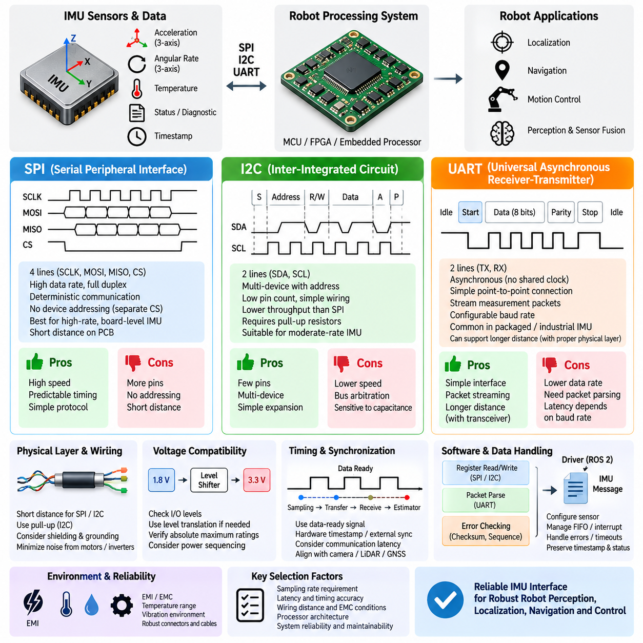
An IMU interface determines how acceleration, angular-rate, temperature, status, and timing information are transferred from the sensor to the robot's processing system. MEMS IMUs commonly provide SPI, I2C, or UART interfaces, with each protocol offering different characteristics in bandwidth, wiring complexity, determinism, distance, and software integration. Interface selection should therefore begin from the required sampling rate, latency, physical placement, and reliability of the complete sensing architecture.
SPI, or Serial Peripheral Interface, is widely used for board-level IMUs connected directly to an MCU, FPGA, or embedded processor. It normally uses a clock line, controller-to-device data line, device-to-controller data line, and chip-select signal. Because clocking is controlled directly by the host and communication is typically full duplex, SPI provides predictable transfers and relatively high data rates, making it attractive for high-frequency inertial acquisition.
SPI has no protocol-level device addressing comparable to I2C, so individual peripheral devices normally require separate chip-select signals. This increases signal count when several sensors share the same bus, but it also gives the controller explicit control over which device communicates at a given moment. For an IMU requiring deterministic sampling, this architecture can simplify transaction scheduling and reduce contention between inertial measurements and other peripheral traffic.
The practical SPI clock rate is constrained by the IMU specification, processor capability, PCB routing, signal integrity, and electrical loading. High clock frequency does not automatically improve navigation performance because the actual benefit depends on sensor output data rate and estimator requirements. Excessively fast edges or long traces can introduce ringing, crosstalk, electromagnetic interference, and timing margin problems. SPI is therefore most appropriate for relatively short connections within an electronic assembly.
I2C, or Inter-Integrated Circuit, uses only two primary signal lines: serial data and serial clock. Multiple devices can share these lines through protocol-level addresses, allowing accelerometers, gyroscopes, magnetometers, temperature sensors, and other peripherals to operate on a common bus. This low pin count makes I2C convenient for compact embedded designs where wiring simplicity and peripheral expansion are more important than maximum communication throughput.
I2C lines generally use pull-up resistors because devices actively pull the signals low rather than driving both logic states. Pull-up resistance, bus capacitance, supply voltage, device count, trace length, and selected clock rate determine signal rise time and communication reliability. A design that functions on a short development board can become unreliable after additional devices or longer wiring are introduced. Electrical bus loading must therefore be evaluated as part of the sensor architecture.
Compared with SPI, I2C typically provides lower effective throughput and introduces shared-bus arbitration and addressing overhead. This may be entirely acceptable for moderate-rate inertial sensing, configuration registers, auxiliary sensors, or compact indoor robotic systems. However, a high-rate IMU used for navigation or control should be evaluated carefully to ensure that reading accelerometer, gyroscope, temperature, status, and timestamp data does not consume excessive bus time or introduce variable latency.
UART, or Universal Asynchronous Receiver-Transmitter, differs from SPI and I2C because it does not normally require a shared clock between transmitter and receiver. Both sides agree on communication parameters such as baud rate, data length, parity, and stop bits. Packaged IMUs and industrial inertial sensors frequently use serial communication because it provides a simple point-to-point interface and allows the sensor to transmit complete measurement packets rather than exposing only internal registers.
A UART-based IMU may continuously stream acceleration, angular rate, orientation, temperature, timestamp, and diagnostic information at a configured output frequency. This reduces the need for the host to repeatedly initiate register transactions. The receiving processor must nevertheless parse packets, detect framing or checksum errors, manage receive buffers, and associate the incoming measurements with the robot timing system. Packet structure and error-detection capability therefore become important selection criteria.
Baud rate determines the maximum raw UART data capacity. The required rate should be calculated from packet size, output frequency, framing overhead, and adequate operating margin. A sensor transmitting large packets at high frequency can approach the practical limit of a low baud-rate connection. Buffering inside the sensor or host may then introduce latency that is not obvious from the nominal sampling rate, so communication throughput and end-to-end timing should be evaluated together.
Physical distance strongly influences interface choice. Board-level SPI and I2C are generally intended for short electrical connections and become increasingly sensitive to capacitance, noise, ground differences, and electromagnetic interference as wiring length increases. UART logic-level signals also have practical distance limitations, but UART data can be transported through more robust physical layers when required. Packaged industrial sensors may therefore combine serial packet communication with differential electrical interfaces for longer robot harnesses.
For robotic IMUs, communication latency must be distinguished from sensor sampling latency. A measurement is first captured by the MEMS sensing element, processed by internal filtering, placed into registers or a FIFO, transferred through the interface, received by the processor, and finally delivered to the estimator. The complete delay through this chain determines the temporal relationship between inertial measurements and observations from cameras, LiDARs, radar, or GNSS.
A data-ready signal can improve timing behavior by notifying the processor when a new inertial sample becomes available. With SPI or I2C, the host can respond to this signal and immediately retrieve the measurement rather than continuously polling registers. FIFO functions can reduce processor interrupt load by storing multiple samples, but they also require careful timestamp management because reading several stored samples at once does not mean that those measurements were physically acquired at the same time.
Time synchronization becomes particularly important when an IMU participates in multi-sensor fusion. Software timestamps generated after a transaction may include unpredictable operating-system, driver, and communication delays. Hardware timestamps, external synchronization inputs, data-ready edges, or synchronized clocks can provide a more accurate representation of the actual measurement instant. Interface selection should therefore include timing features rather than treating communication bandwidth as the only performance criterion.
Signal integrity must be considered together with robot electromagnetic compatibility. Motor inverters, DC/DC converters, switching power supplies, servos, relays, high-current battery wiring, and communication networks can generate electrical disturbances near IMU connections. Short routing, appropriate grounding, controlled return paths, decoupling, separation from noisy conductors, and suitable shielding or differential signaling help prevent communication errors from becoming intermittent navigation faults.
Voltage compatibility is another fundamental integration requirement. A processor and IMU may operate at different I/O voltage levels even when both support the same logical protocol. Designers must verify absolute maximum ratings, input thresholds, output levels, pull-up voltage, power sequencing, and whether level translation is required. Incorrect assumptions about interface voltage can cause unreliable communication or permanent device damage despite otherwise correct software configuration.
Software architecture also influences the preferred interface. SPI and I2C IMUs commonly require register-level drivers that configure measurement range, bandwidth, filters, FIFO operation, interrupts, and calibration parameters. UART devices frequently provide packet-oriented protocols with commands and predefined output messages. In ROS 2 or other robotic middleware, the low-level driver should convert these transactions into consistently timestamped inertial messages while preserving sensor status and diagnostic information.
Error handling must be designed explicitly because an IMU can continue operating while its communication path becomes degraded. The system should detect invalid packets, missing samples, repeated data, FIFO overflow, bus timeout, unexpected register values, and sensor reset events. Sequence counters, checksums, status registers, timeout supervision, and plausibility checking can prevent corrupted inertial data from silently propagating into localization, navigation, or control algorithms.
The preferred interface therefore depends on system architecture rather than a universal ranking of SPI, I2C, and UART. SPI is often suitable for high-rate, deterministic board-level acquisition; I2C is attractive when low pin count and shared peripheral connectivity are priorities; and UART is convenient for packet-oriented point-to-point communication with packaged sensors. Sampling requirements, timing accuracy, wiring distance, EMC conditions, processor architecture, and maintainability should determine the final choice.
A robust IMU integration treats the electrical interface as part of the measurement chain rather than merely a method for moving bytes. Sensor bandwidth, output data rate, interface capacity, interrupt behavior, FIFO design, timestamp generation, signal integrity, voltage compatibility, driver architecture, and fault detection must operate coherently. When these elements are properly matched, SPI, I2C, or UART can provide reliable inertial information for perception, localization, navigation, and real-time robot control.

08.04. Navigation Grade IMU
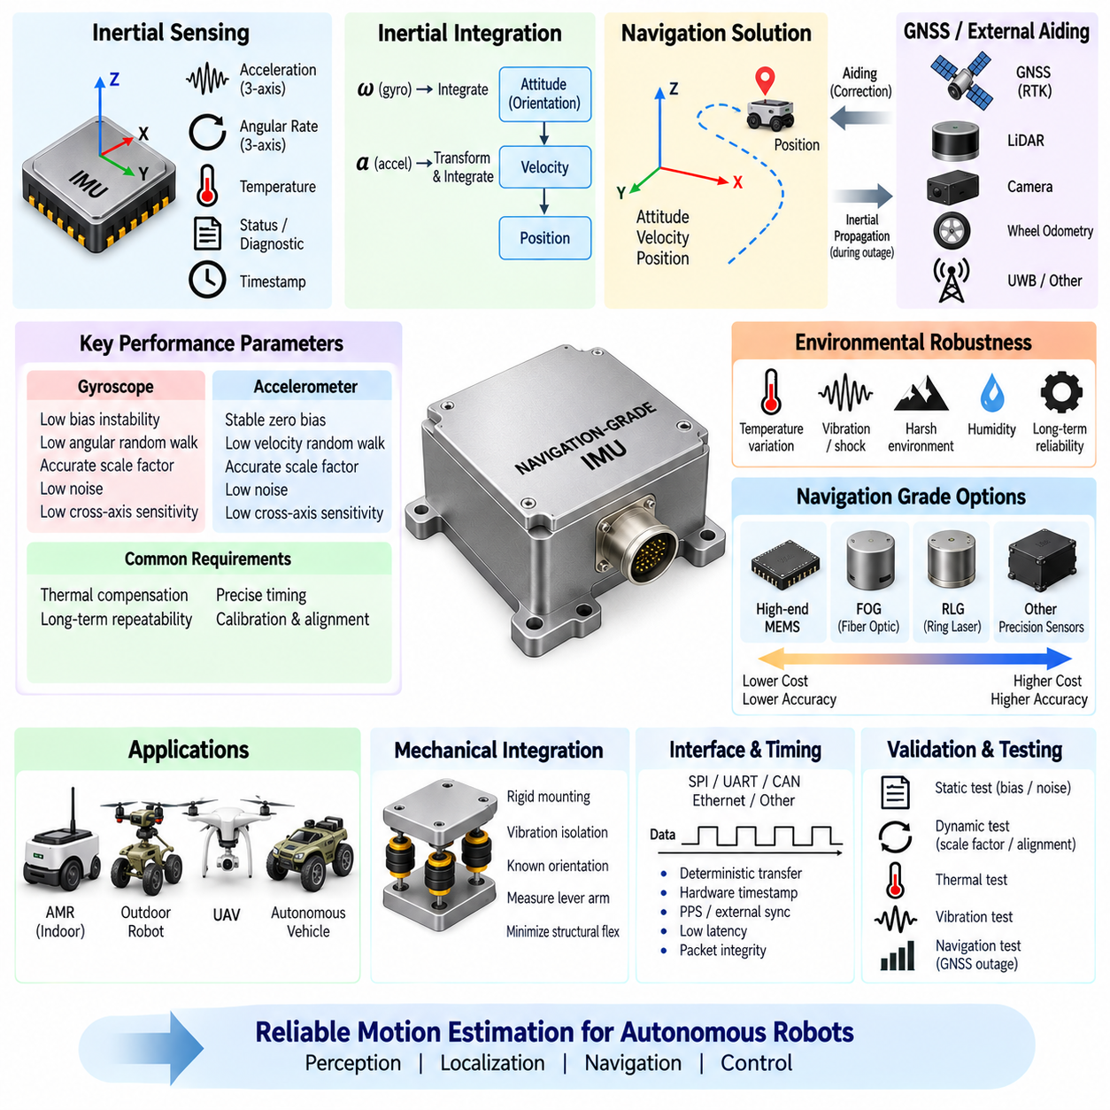
A navigation-grade inertial measurement unit is designed to maintain accurate estimates of orientation, velocity, and position when external references are unavailable, degraded, or temporarily interrupted. Unlike consumer or basic industrial MEMS IMUs, navigation-grade devices emphasize extremely low bias instability, low random noise, precise scale-factor control, thermal compensation, and long-term repeatability. Their purpose is not simply to detect motion but to support reliable inertial navigation through continuous integration of acceleration and angular rate.
The fundamental difference between ordinary and navigation-grade IMUs becomes apparent during inertial integration. Gyroscope measurements are integrated to determine orientation, while acceleration measurements are transformed into the navigation frame and integrated to estimate velocity and position. Even very small sensor errors accumulate over time. Consequently, bias stability, angular random walk, velocity random walk, scale-factor accuracy, axis alignment, and timing quality become critical parameters for sustained navigation performance.
Gyroscope bias is particularly important because an angular-rate offset continuously changes the estimated attitude. Incorrect attitude then causes gravity to be projected incorrectly onto the horizontal acceleration axes, creating additional velocity and position errors. Navigation-grade gyroscopes therefore require substantially better bias characteristics than sensors used primarily for motion detection or short-term stabilization. Low in-run bias instability allows the navigation solution to remain useful for longer periods between external corrections.
Accelerometer bias produces a different but equally important error mechanism. A constant acceleration offset is integrated into velocity error and then integrated again into position error. Small biases that appear insignificant in instantaneous measurements can therefore become dominant during GNSS outages or extended dead reckoning. Navigation-grade accelerometers require stable zero offsets, low noise, accurate scale factors, and predictable thermal characteristics so that these accumulating errors can be modeled and compensated.
Random noise also determines how rapidly navigation uncertainty grows. Gyroscope angular random walk describes short-term orientation uncertainty caused by rate noise, while accelerometer velocity random walk represents corresponding uncertainty in integrated velocity. These stochastic characteristics are commonly evaluated through long-duration stationary measurements and Allan deviation analysis. Navigation performance should therefore be assessed using statistical error behavior rather than relying only on resolution or nominal output-rate specifications.
Scale-factor accuracy becomes important when the platform experiences significant acceleration or rotation. If a gyroscope or accelerometer reports a slightly incorrect magnitude, the resulting error increases with the applied motion. Cross-axis sensitivity and sensor-axis misalignment can additionally transfer motion from one axis into another. High-quality IMUs apply factory calibration matrices and compensation models so that bias, scale factor, non-orthogonality, and alignment errors remain controlled throughout the intended operating range.
Temperature is one of the strongest environmental influences on inertial sensors. MEMS structures, analog electronics, reference voltages, and packaging characteristics vary as temperature changes, producing shifts in bias and scale factor. Navigation-grade units commonly employ extensive factory characterization across temperature and store compensation coefficients internally. Some designs also use controlled thermal behavior or internal temperature monitoring to maintain repeatable performance during startup, outdoor operation, and rapidly changing environmental conditions.
Navigation-grade performance is not defined by MEMS technology alone. Higher-performance inertial systems may use fiber-optic gyroscopes, ring-laser gyroscopes, resonant devices, or other precision sensing technologies when mission requirements exceed practical MEMS limits. Modern high-end MEMS devices nevertheless provide increasingly capable solutions for autonomous vehicles, industrial robots, UAVs, and mobile platforms where size, weight, power consumption, cost, and navigation accuracy must be balanced.
An IMU becomes an inertial navigation system when its measurements are processed through navigation algorithms that propagate attitude, velocity, and position. The estimator must account for gravity, Earth-related reference frames when required, sensor biases, coordinate transformations, and accumulated uncertainty. Navigation-grade hardware therefore provides the measurement foundation, but actual navigation performance depends equally on initialization, calibration, estimation algorithms, timing, external aiding, and mechanical integration.
GNSS and IMU integration is particularly important for outdoor autonomous robots and vehicles. GNSS provides long-term absolute position and velocity references, while the IMU provides high-rate motion information between GNSS updates. During temporary GNSS blockage caused by buildings, vegetation, tunnels, interference, or antenna obstruction, inertial propagation maintains the navigation solution. When GNSS returns, the estimator uses the external observation to correct accumulated inertial errors and update estimated sensor biases.
RTK GNSS can provide centimeter-class absolute positioning under favorable conditions, but high position accuracy does not eliminate the need for a capable IMU. RTK availability can degrade in urban canyons, beneath structures, near reflective surfaces, or during communication loss with correction services. A navigation-grade IMU improves continuity through these intervals and supports smooth estimates of attitude, velocity, and motion. The required grade depends strongly on the maximum expected duration of external-reference outages.
Indoor robots use navigation-grade inertial sensing differently because GNSS is generally unavailable. LiDAR SLAM, visual odometry, wheel odometry, UWB, or other localization systems provide external constraints, while the IMU supplies high-frequency rotational and translational motion information. During rapid turns, feature-poor environments, temporary visual degradation, or LiDAR matching uncertainty, a stable IMU improves estimator continuity. The sensor grade should therefore be matched to the expected frequency and duration of localization corrections.
UAV navigation places demanding requirements on inertial sensing because the vehicle continuously changes orientation and acceleration while relying on accurate attitude estimation for stabilization. An IMU must capture rapid angular motion without saturation while maintaining sufficiently low noise and bias for navigation. Higher-grade systems may employ redundant IMUs so that sensor disagreement, drift, or failure can be detected before the navigation error propagates into flight-control functions.
Timing accuracy is essential because navigation-grade measurements lose value if their acquisition time is uncertain. IMU samples must be aligned accurately with GNSS observations, camera frames, LiDAR scans, radar measurements, or other aiding sensors. Hardware timestamps, pulse-per-second signals, external synchronization inputs, precise clocks, or PTP-based architectures can reduce temporal error. Timestamp uncertainty can otherwise appear as spatial error whenever the platform is moving or rotating rapidly.
Mechanical installation also determines whether navigation-grade specifications can be achieved at system level. The IMU should be mounted on a rigid and stable structure with accurately known orientation relative to the robot body frame. Lever-arm offsets between the IMU, GNSS antenna, LiDAR, cameras, and vehicle reference point must be measured when precision navigation is required. Vibration, structural flex, thermal gradients, and mounting misalignment can degrade performance even when the sensor itself has excellent specifications.
Vibration isolation requires particular care with high-performance IMUs. Mechanical isolation can suppress motor, gearbox, wheel, or propulsion vibration, but an excessively compliant mount can introduce relative motion between the IMU and vehicle body. The isolation system must preserve the rigid-body motion required by the navigation estimator while attenuating unwanted high-frequency excitation. Mechanical design, sensor bandwidth, digital filtering, and estimator tuning should therefore be developed as a coordinated system.
Interface architecture must support deterministic and loss-free delivery of high-rate inertial data. Depending on the IMU class, communication may use SPI, UART, CAN, Ethernet, or dedicated industrial interfaces. Navigation units may transmit calibrated acceleration, angular rate, temperature, status, timestamps, and sometimes internally computed attitude or navigation outputs. Communication bandwidth, packet integrity, latency, synchronization capability, and fault detection should be evaluated together with the raw sensor specifications.
Reliability and diagnostics become increasingly important when navigation information contributes directly to autonomous motion or safety-related functions. A navigation-grade IMU should expose health indicators for sensor saturation, temperature limits, internal faults, communication errors, initialization state, or degraded performance where available. Redundant sensing architectures can compare independent inertial measurements and isolate faulty channels. However, redundancy must also consider common power, clock, mounting, thermal, and vibration failure mechanisms.
Selecting the appropriate navigation grade requires translating mission requirements into allowable drift during external-reference outages. A robot that receives reliable localization corrections several times per second may not require the same inertial performance as a vehicle expected to navigate for tens of seconds or minutes without GNSS, LiDAR, or vision updates. Required outage duration, velocity, maneuver intensity, position error, heading error, environmental conditions, size, weight, power, and cost should therefore define the sensor class.
Validation must include static, dynamic, thermal, vibration, and navigation-level testing. Long stationary recordings can characterize bias and random noise, controlled rotations can evaluate scale factor and alignment, and thermal testing can reveal compensation quality. Vehicle tests should intentionally introduce GNSS or localization outages and compare inertial propagation against a trusted reference trajectory. This directly measures whether the selected IMU provides the required navigation continuity under realistic operating conditions.
A navigation-grade IMU should ultimately be viewed as the high-rate inertial backbone of a multi-sensor navigation architecture. Its value comes from stable bias behavior, low noise, accurate scale factors, thermal repeatability, precise timing, robust interfaces, careful mechanical integration, and effective fusion with absolute or relative positioning sensors. Correctly matched to the mission, it enables autonomous robots, outdoor AMRs, UAVs, and other Physical AI platforms to maintain reliable motion estimation when external perception or positioning becomes temporarily uncertain.

08.05. IMU Power and Thermal
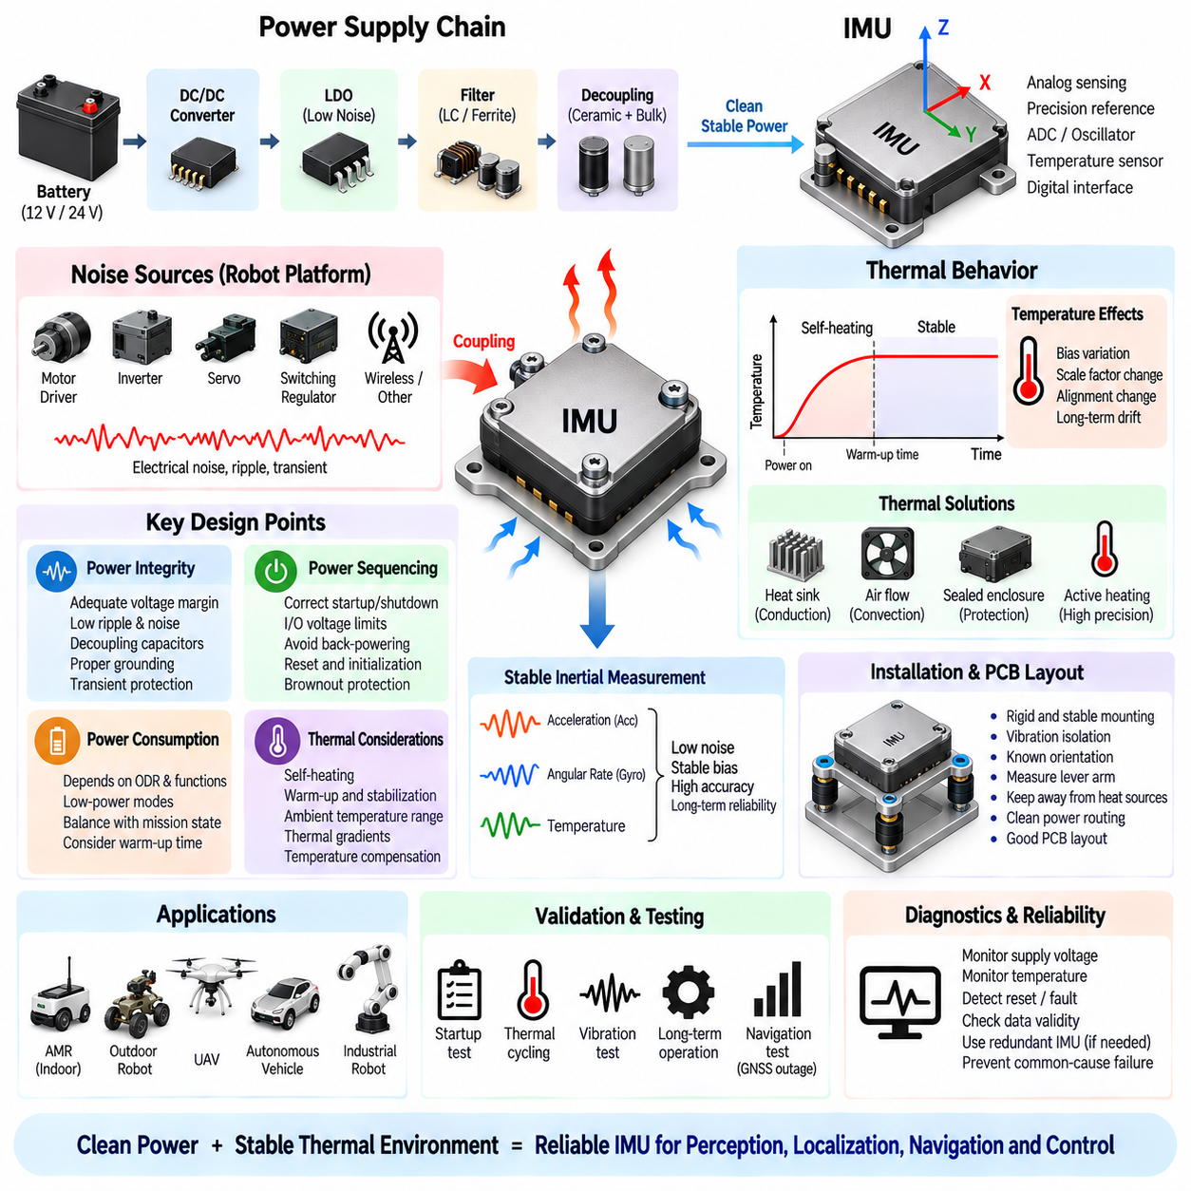
The power and thermal design of an inertial measurement unit directly influences measurement stability, startup behavior, reliability, and long-term navigation accuracy. Although MEMS IMUs consume far less power than cameras, LiDARs, radars, or GPU computers, their analog sensing elements and precision references are sensitive to supply disturbances and temperature variation. Power integrity and thermal stability must therefore be treated as part of the inertial measurement architecture rather than as secondary electrical concerns.
An IMU power path normally begins with the robot battery or regulated low-voltage distribution network and passes through one or more DC/DC converters, low-dropout regulators, filters, and local decoupling components before reaching the sensor. Board-level MEMS devices may require separate analog and digital supply domains, while packaged industrial IMUs often accept a wider input voltage range and perform internal regulation. The external architecture should nevertheless provide adequate voltage margin, transient protection, and noise suppression.
Supply noise can couple into analog front-end circuits, reference voltages, oscillators, and analog-to-digital conversion stages inside the IMU. Switching regulators, motor drivers, inverters, servos, relays, and high-current loads are common disturbance sources in robotic platforms. A supply that appears acceptable when measured with a multimeter may contain high-frequency ripple or transient events capable of degrading inertial measurements, so oscilloscope-based evaluation under realistic operating conditions is important.
Local decoupling provides a low-impedance energy source close to the IMU during rapid internal current changes. Small ceramic capacitors are typically positioned near supply pins to suppress high-frequency disturbances, while larger capacitance can support lower-frequency load variations. Component values, dielectric characteristics, placement, grounding, and PCB return paths all influence effectiveness. Decoupling should follow the sensor manufacturer's recommendations while also considering the electrical noise environment of the complete robot.
A low-dropout regulator can be useful when very clean power is required near a sensitive board-level IMU. A switching converter may efficiently reduce the robot supply voltage to an intermediate rail, followed by an LDO that provides additional ripple attenuation and local regulation. This approach trades some conversion efficiency and thermal dissipation for improved supply quality. The decision should consider IMU current, voltage drop, available thermal margin, required power-supply rejection, and overall system efficiency.
Grounding is equally important because an IMU measures very small physical signals while operating near electrically noisy actuators and computing systems. Poor return-path design can allow motor or converter currents to create voltage differences across the sensor ground reference. Analog and digital grounding recommendations, local ground planes, short return paths, controlled connection to chassis or system ground, and separation from high-current conductors help prevent power-system disturbances from appearing as measurement errors.
Power sequencing must be considered when an IMU contains multiple supply rails or communicates with a processor operating from a different domain. Applying interface signals while the sensor supply is absent can cause unintended current paths through protection structures. Designers should verify startup and shutdown sequencing, input/output voltage limits, reset timing, regulator ramp rates, and processor behavior during boot. A repeatable startup sequence is especially important when autonomous systems must recover reliably after power interruptions.
Brownout behavior is another important system characteristic. Battery voltage can temporarily decrease during motor startup, acceleration, steering actuation, payload movement, or other high-current events. If the IMU supply falls below its operating threshold, the device may reset, produce invalid data, or temporarily lose calibration state. Adequate regulation margin, energy storage, brownout detection, reset supervision, and software recovery mechanisms should ensure that such events cannot silently corrupt navigation or localization.
Power consumption depends on sensor architecture, sampling rate, enabled axes, internal filtering, communication activity, and optional processing functions. Some MEMS devices provide low-power modes that reduce sampling frequency or disable selected functions when the robot is inactive. These modes can benefit battery-operated systems, but transitions between operating states may require settling time or recalibration. Energy-saving strategies should therefore be coordinated with mission state, estimator initialization, and required readiness time.
Self-heating occurs whenever electrical power is dissipated inside the IMU package and surrounding electronics. Even modest power can raise the sensing element above ambient temperature, particularly in compact enclosures with limited airflow. Because MEMS bias and scale factor are temperature dependent, the internal thermal state can influence measurement accuracy. A stable elevated temperature may be easier to compensate than a continuously changing temperature, making thermal transient behavior an important design consideration.
Warm-up time describes the interval after power-on during which sensor temperature, bias, oscillator behavior, and internal electronics approach a stable operating condition. Consumer-grade sensors may become usable quickly but continue to drift slightly, while higher-performance inertial units may specify longer stabilization periods. Navigation software should not assume that maximum accuracy is available immediately after startup. Initialization logic can monitor temperature, elapsed time, bias convergence, or device status before enabling precision navigation.
Ambient temperature variation affects both the MEMS sensing structure and surrounding electronics. Outdoor AMRs, UAVs, and industrial robots can experience cold starts, direct sunlight, enclosed hot compartments, seasonal changes, and heat from nearby computers or power electronics. Thermal gradients across the mounting structure can also alter mechanical alignment. IMU placement should therefore avoid unnecessary proximity to major heat sources while remaining mechanically suitable for accurate inertial measurement.
Temperature compensation is commonly implemented by characterizing sensor bias and scale factor across a defined thermal range. Compensation coefficients may be stored inside the IMU and applied automatically, or raw temperature measurements may be supplied to the host for external correction. High-performance systems can use multi-dimensional calibration models because heating and cooling behavior may not be identical. Factory compensation improves performance, but system-level thermal validation remains necessary after the sensor is installed in the robot.
Thermal design must also consider the enclosure. A sealed housing improves protection against dust, moisture, and contamination but can reduce heat transfer to ambient air. Metal enclosures can spread heat effectively and provide electromagnetic shielding, while plastic housings may offer different thermal and electrical characteristics. Conduction through the mounting surface, convection inside the enclosure, radiation, and heat generated by nearby components collectively determine the actual IMU operating temperature.
PCB layout can influence both electrical and thermal performance. Placing an IMU next to a high-power processor, switching regulator, memory device, or communication transceiver may expose it to localized heating and electrical noise. Conversely, locating the sensor at the edge of a flexible board can increase mechanical vibration or bending. The preferred location balances mechanical rigidity, thermal uniformity, short clean power routing, interface integrity, and separation from strong electrical and thermal disturbance sources.
Heating is not always undesirable. Precision inertial systems may deliberately regulate sensor temperature so that the sensing elements operate within a narrow thermal region despite changing ambient conditions. Such thermal stabilization can reduce temperature-dependent bias variation, but it increases power consumption and requires heater control, temperature sensing, insulation, and thermal modeling. Whether active thermal control is justified depends on required navigation accuracy, environmental range, available energy, and sensor technology.
Power and thermal conditions also influence calibration repeatability. A calibration performed after full thermal stabilization may not accurately represent behavior immediately after a cold start. Similarly, sensor characteristics measured from a laboratory supply may differ from those observed when the robot's motors and converters are operating. Calibration and validation should therefore reproduce representative supply voltage, electrical load, ambient temperature, warm-up state, airflow, enclosure configuration, and vibration conditions.
Fault monitoring should include power and temperature information whenever the IMU exposes these diagnostics. Supply undervoltage, overvoltage, excessive temperature, internal reset, communication interruption, or abnormal startup behavior can indicate that inertial measurements should not be trusted. The navigation system should distinguish between valid measurements and degraded sensor states rather than continuing to integrate questionable data. Diagnostic status should propagate through the sensor driver to higher-level localization and safety functions.
Redundant IMU architectures require additional attention to power independence. Two sensors connected to the same regulator, connector, ground path, or thermal hotspot may fail or drift simultaneously even though the sensing elements are physically separate. Safety-oriented designs can reduce common-cause failures by separating power channels, protection devices, routing, and sometimes physical locations. Thermal correlation should also be considered because neighboring sensors can experience nearly identical temperature-induced errors.
Validation should measure supply quality and thermal behavior together with inertial output. Tests can record rail voltage, ripple, current consumption, sensor temperature, accelerometer bias, gyroscope bias, and navigation estimates during startup, motor operation, charging, high computational load, cold conditions, and elevated ambient temperature. Correlating electrical and thermal disturbances with measurement errors helps identify problems that may otherwise appear to be random IMU instability.
Thermal cycling and long-duration operation are particularly valuable for revealing drift that short bench tests cannot detect. The robot can be tested from cold startup through normal operating temperature and then through repeated heating and cooling cycles. Bias repeatability, scale-factor behavior, communication stability, reset events, and navigation accuracy should be observed throughout the process. Environmental testing can then confirm that the selected power and thermal architecture maintains acceptable performance over the intended operating envelope.
A robust IMU power and thermal architecture ultimately provides clean electrical energy and a predictable thermal environment for the inertial sensing elements. Regulation, filtering, decoupling, grounding, sequencing, brownout protection, warm-up behavior, self-heating, temperature compensation, enclosure design, diagnostics, and validation must be engineered together. When these factors are controlled, the IMU can provide stable acceleration and angular-rate measurements that support reliable perception, localization, navigation, and control.

