Volume 15 Perception and Sensor Architecture

Chapter 01. Mono Camera

01.01. Image Sensor Selection
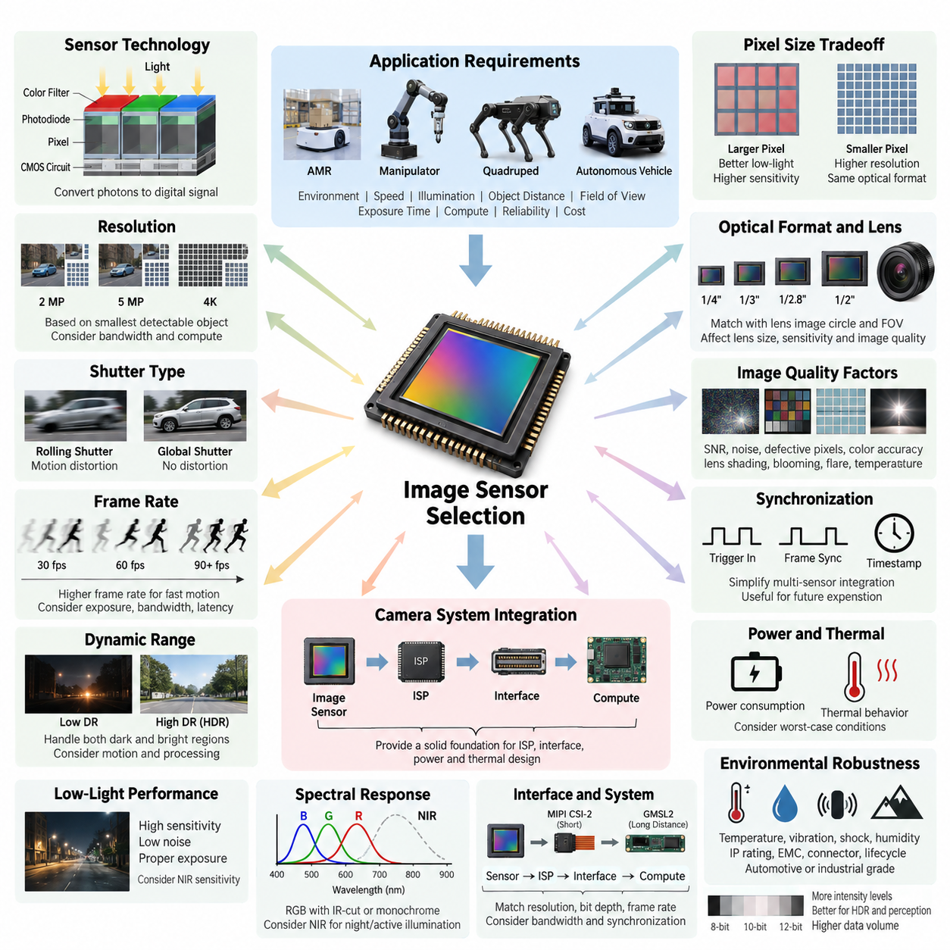
Image sensor selection is the first architectural decision in a monocular camera system because it determines the fundamental limits of spatial resolution, temporal response, dynamic range, sensitivity, noise, and downstream perception quality. In robotics, the sensor should not be selected only by megapixel count. The operating environment, robot velocity, illumination range, object distance, required field of view, exposure time, interface bandwidth, processing capability, and reliability requirements must be evaluated together.
A CMOS image sensor converts incident photons into electrical charge at each pixel and then transforms that charge into digital image information. Pixel size strongly influences this process. Larger pixels generally collect more photons during a given exposure and therefore provide better signal-to-noise performance in low-light conditions, while smaller pixels allow higher spatial resolution within the same optical format. Robotics applications must balance these characteristics rather than assuming that smaller pixels or higher resolution always produce better perception.
Resolution should be derived from the smallest object or feature that the perception system must reliably detect at the required distance. A 4K sensor may provide excellent spatial detail, but it also increases interface bandwidth, memory traffic, ISP workload, GPU processing, storage requirements, and system power. For an AMR performing navigation and obstacle detection, a carefully selected 2 MP or 5 MP sensor can sometimes provide more useful system performance than a higher-resolution sensor whose frames cannot be processed at the required rate.
Sensor optical format must be matched to the lens image circle and the desired field of view. Common formats such as 1/4-inch, 1/3-inch, 1/2.8-inch, 1/2-inch, and larger formats influence lens size, focal-length selection, packaging, sensitivity, and achievable image quality. A mismatch between sensor and lens can cause vignetting, reduced corner resolution, excessive distortion, or unnecessary optical cost. Sensor selection must therefore be performed together with lens and mechanical packaging design rather than as an isolated electronics decision.
Rolling shutter and global shutter represent an especially important tradeoff for mobile robots. A rolling-shutter sensor exposes image rows at slightly different times, which can produce geometric distortion when the robot, camera, or observed object moves rapidly. Global-shutter sensors expose the entire image simultaneously and are therefore advantageous for visual odometry, SLAM, high-speed navigation, manipulation, and machine vision. Rolling shutter remains attractive where cost, resolution, sensitivity, or availability has higher priority and motion artifacts can be tolerated or compensated.
Frame rate defines how frequently the perception system receives visual observations. Thirty frames per second is adequate for many indoor navigation and monitoring applications, while faster robots, manipulators, visual servo systems, and high-dynamic-motion applications may require 60, 90, or more frames per second. Higher frame rate also shortens the available exposure interval and increases data throughput. The selected frame rate must consequently be evaluated together with illumination, shutter speed, motion blur, interface capacity, ISP latency, and AI inference frequency.
Dynamic range determines how effectively the camera preserves information when dark and bright regions appear simultaneously. This is critical for outdoor AMRs moving between sunlight and shadow, indoor robots facing windows or entrances, and platforms operating under headlights or artificial lighting. High-dynamic-range techniques can combine multiple exposures or use specialized pixel structures, but they may introduce motion artifacts, additional latency, or processing complexity. The required HDR capability should therefore be derived from actual operational lighting scenarios.
Low-light performance depends on quantum efficiency, pixel area, read noise, dark current, analog gain characteristics, lens aperture, exposure time, and ISP processing. Increasing gain can brighten an image but also amplifies noise, while increasing exposure improves photon collection but increases motion blur. A sensor intended for autonomous robots should therefore be evaluated with moving targets and moving platforms under realistic illumination rather than judged from static laboratory images. Near-infrared sensitivity may also be important for nighttime or active-illumination systems.
Spectral response determines which wavelengths contribute to the captured image. Standard RGB cameras normally use an infrared-cut filter to maintain natural color reproduction, while robotic perception may intentionally exploit near-infrared information. Day/night systems can use removable IR filters or dedicated monochrome sensors when color is unnecessary. Monochrome sensors can provide higher effective sensitivity because they avoid color filter array losses, making them attractive for localization, feature tracking, inspection, and low-light machine-vision applications.
The sensor interface must support the required resolution, bit depth, frame rate, and number of cameras without exceeding the compute platform's input capacity. MIPI CSI-2 is well suited to compact camera modules and short internal connections, while later architectural stages may extend camera links through serializer/deserializer technologies such as GMSL2. Sensor selection must therefore anticipate the complete camera data path, including ISP processing, interface lanes, memory bandwidth, hardware synchronization, cabling, and edge-compute connectivity.
Bit depth affects the number of intensity levels available before image processing. Eight-bit output may be sufficient for display-oriented applications, whereas 10-bit, 12-bit, or higher raw data can preserve substantially more information for HDR imaging, low-light processing, calibration, and machine perception. However, additional bit depth increases data volume and processing requirements. The useful criterion is not maximum numerical precision but whether the complete sensor-to-perception pipeline preserves enough information for reliable algorithmic decisions.
Image quality must be considered as a collection of interacting parameters rather than a single specification. Signal-to-noise ratio, fixed-pattern noise, dark-current behavior, defective pixels, color accuracy, lens shading, temporal noise, blooming, flare sensitivity, and temperature dependence can all influence AI perception. A sensor that produces visually attractive images is not automatically the best sensor for neural-network inference. Feature stability, object-detection consistency, localization accuracy, and robustness across environmental conditions are often more meaningful engineering metrics.
Synchronization capability becomes important when a monocular camera later participates in a multi-sensor architecture. Hardware trigger inputs, frame-sync outputs, timestamp support, and deterministic exposure timing can simplify integration with stereo cameras, LiDAR, radar, IMU, and GNSS. Even when the initial design uses only one camera, selecting a sensor and camera module with synchronization capability can reduce redesign effort when the platform evolves toward sensor fusion or multi-camera perception. The volume structure explicitly treats multi-camera and sensor-compute synchronization as subsequent architectural topics.
Power consumption and thermal behavior also affect sensor performance. The image sensor, clock circuitry, ISP, serializer, memory, and supporting regulators generate heat inside a compact camera enclosure. Rising junction temperature can increase dark current and noise and may reduce long-term reliability. Outdoor robots additionally experience wide ambient-temperature variation and solar heating. Sensor evaluation should therefore include worst-case thermal conditions, continuous streaming, maximum frame rate, and enclosure constraints rather than relying only on room-temperature electrical specifications.
Environmental robustness is particularly important when a camera becomes part of an outdoor AMR, inspection robot, quadruped, humanoid, or autonomous vehicle. Temperature range, vibration, shock, humidity, ingress protection, electromagnetic compatibility, connector retention, and component lifecycle should influence the selection. Automotive-grade sensors may offer stronger qualification and long-term availability, while industrial sensors may provide specialized triggering or machine-vision features. The appropriate grade depends on the platform's operational and safety requirements.
The image sensor must ultimately be selected as part of the complete perception architecture. Resolution, pixel size, shutter type, frame rate, dynamic range, spectral sensitivity, optical format, interface bandwidth, synchronization, power, thermal behavior, reliability, availability, and cost should be evaluated against measurable mission requirements. This system-level approach establishes a stable foundation for the subsequent ISP, MIPI CSI-2, GMSL2, power, and thermal design stages defined within the monocular-camera architecture.

01.02. ISP Design
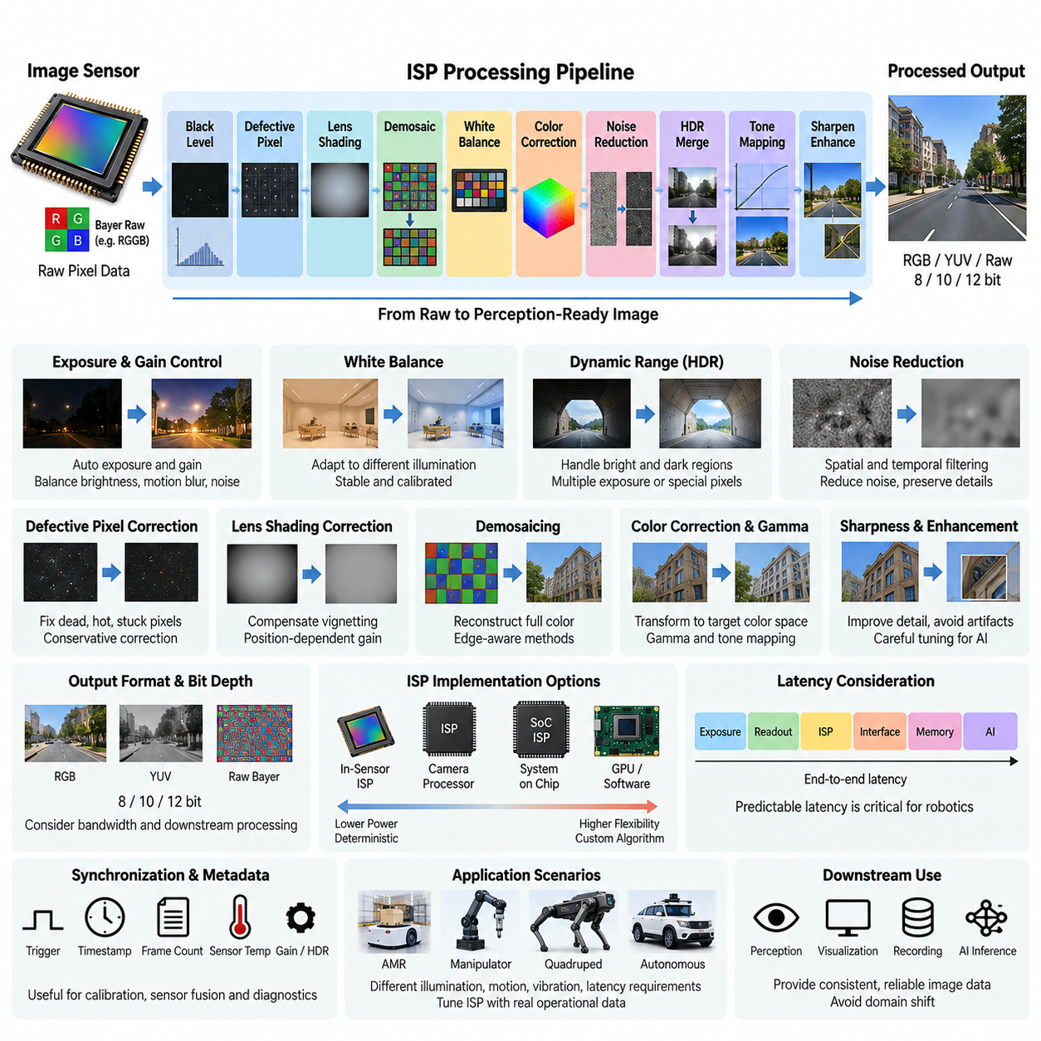
An Image Signal Processor (ISP) transforms raw pixel measurements from an image sensor into structured image data suitable for perception, visualization, recording, or AI inference. Within a monocular camera architecture, the ISP forms the processing bridge between the selected CMOS sensor and downstream computing. Its design determines how effectively sensor information is preserved, corrected, enhanced, and delivered while controlling latency, bandwidth, power consumption, and image consistency.
The ISP pipeline begins with raw sensor data, commonly represented through a Bayer color filter array such as RGGB, BGGR, GRBG, or GBRG. Each photosite measures only a limited spectral component, so the raw frame is not yet a conventional RGB image. Before higher-level perception can use it, the ISP must compensate for sensor imperfections and reconstruct useful color and intensity information while avoiding unnecessary destruction of features that may be valuable to machine-vision algorithms.
Black-level correction removes the electrical offset that remains when a pixel receives little or no light. Without this correction, dark regions may contain artificial brightness, color imbalance, or temperature-dependent bias. The correction value can vary with sensor operating mode, analog gain, exposure, and temperature. Accurate black-level processing establishes a stable reference for subsequent operations such as gain adjustment, demosaicing, color correction, noise reduction, and high-dynamic-range processing.
Defective-pixel correction identifies pixels whose responses differ abnormally from neighboring pixels because of manufacturing variation, aging, radiation, temperature, or electrical defects. Dead, stuck, hot, or excessively noisy pixels can generate false features that interfere with computer vision. An ISP can replace these measurements using neighboring spatial information while preserving real edges. For robotic perception, correction should remain conservative because aggressive filtering may remove small but legitimate visual features required for localization or inspection.
Lens-shading correction compensates for brightness and color variation across the image caused by optical characteristics, sensor geometry, and chief-ray angle. Image corners commonly receive less illumination than the center, producing vignetting and nonuniform color response. Calibration tables or mathematical models can apply position-dependent gains to restore uniformity. The correction must be coordinated with the selected sensor and lens because changing the lens, aperture, sensor format, or mechanical alignment can alter the required compensation.
Demosaicing reconstructs full-color information from the color filter array by estimating missing color components at each pixel. Simple interpolation requires little computation but may create zipper artifacts, false colors, or reduced edge quality. More advanced edge-aware methods preserve boundaries and fine structures more effectively at greater computational cost. In robotics, demosaicing should be evaluated not only by visual appearance but also by its influence on feature detection, optical flow, segmentation, recognition, and neural-network inference.
White-balance processing adjusts the relative red, green, and blue gains so that objects maintain useful color representation under different illumination sources. Automatic white balance may respond continuously to daylight, fluorescent lighting, LEDs, shadows, or mixed illumination. Rapid or unstable adjustments, however, can cause frame-to-frame color variation that is undesirable for perception. Robotic camera systems may therefore favor controlled, slowly varying, calibrated, or application-specific white-balance strategies over display-oriented behavior.
Color correction transforms the sensor's native spectral response into a desired color space using a color correction matrix and associated calibration parameters. The sensor, lens, IR-cut filter, illumination, and ISP configuration all influence the resulting color. Gamma correction and tone mapping subsequently transform intensity values into representations appropriate for display or processing. For AI perception, these transformations should remain deterministic because differences between training images and deployed-camera processing can create domain shifts that reduce model accuracy.
Noise reduction becomes increasingly important under low illumination or high analog gain. Spatial filtering suppresses noise within an individual frame, while temporal filtering combines information across consecutive frames to achieve stronger noise reduction. Excessive filtering can erase texture, thin edges, small objects, or transient events, whereas insufficient filtering increases false features and degrades compression or inference. Mobile robots require particular caution with temporal filtering because camera and scene motion can create ghosting or delayed visual responses.
High-dynamic-range processing is required when a scene contains both very bright and very dark regions. Depending on the sensor, HDR may combine short and long exposures, use staggered exposure sequences, or process specialized high-dynamic-range pixel outputs. The ISP must merge these measurements while controlling saturation, noise, motion artifacts, and temporal inconsistency. Outdoor AMRs and autonomous platforms particularly benefit from HDR when moving between sunlight, shadow, tunnels, entrances, reflective surfaces, and artificial lighting.
Exposure control determines how long the sensor integrates incoming light, while gain control determines how strongly the resulting signal is amplified. Automatic exposure algorithms must balance brightness against motion blur, noise, saturation, and frame-rate constraints. A stationary surveillance camera can tolerate relatively long exposure, but a moving robot may require short exposure to preserve geometric features. Consequently, robotics-oriented auto-exposure should consider platform velocity and perception requirements rather than optimizing average image brightness alone.
Sharpness and edge enhancement can improve apparent image detail, but aggressive enhancement may create artificial contours or ringing that machine-perception algorithms interpret as real structure. Local contrast enhancement and tone mapping present similar tradeoffs. ISP tuning for robotics should therefore prioritize repeatable physical information over visually impressive output. An image that appears slightly less vivid to a human observer may provide more stable features and better neural-network performance across changing environmental conditions.
The ISP output format should be selected according to downstream processing requirements. RGB and BGR formats are convenient for many vision algorithms, while YUV formats can reduce bandwidth or support video pipelines. Raw Bayer output preserves more sensor information and allows processing on the edge computer or GPU but requires substantially greater downstream responsibility. Bit depth, chroma subsampling, compression, resolution, and frame rate collectively determine memory bandwidth and communication requirements.
ISP implementation can reside inside the image sensor, within a dedicated camera processor, in a system-on-chip, or as part of an edge-computing platform. Hardware ISP blocks provide deterministic high-throughput processing with relatively low power, whereas GPU or software processing offers greater flexibility for experimental algorithms and specialized perception. The appropriate partition depends on camera count, latency requirements, compute resources, thermal limits, interface bandwidth, development flexibility, and the need for deterministic real-time behavior.
Latency must be treated as an architectural parameter rather than merely a processing benchmark. Sensor exposure, frame readout, buffering, ISP stages, interface transfer, memory movement, and AI inference collectively determine perception latency. Excessive buffering or multi-frame processing can produce high-quality images while delaying the robot's understanding of the environment. For autonomous navigation and visual control, predictable end-to-end latency can be more important than maximizing individual image-quality metrics.
The ISP must also support synchronization and metadata propagation when cameras participate in larger sensor architectures. Exposure timestamps, frame counters, gain values, sensor temperature, HDR state, and trigger information can be valuable for calibration, diagnostics, sensor fusion, and dataset generation. Maintaining a reliable relationship between processed frames and their acquisition time becomes increasingly important when camera information is fused with LiDAR, radar, IMU, GNSS, or additional cameras.
ISP tuning should ultimately be performed using representative operational data rather than generic consumer-camera preferences. Indoor AMRs, outdoor robots, manipulators, quadrupeds, and autonomous vehicles experience different illumination, motion, vibration, object scale, and latency requirements. The final ISP configuration should therefore be validated against downstream perception metrics as well as conventional image-quality measurements. This creates the processing foundation for the subsequent MIPI CSI-2 interface, GMSL2 long-distance link, and camera power and thermal architecture defined in the monocular-camera structure.

01.03. MIPI CSI-2 Interface
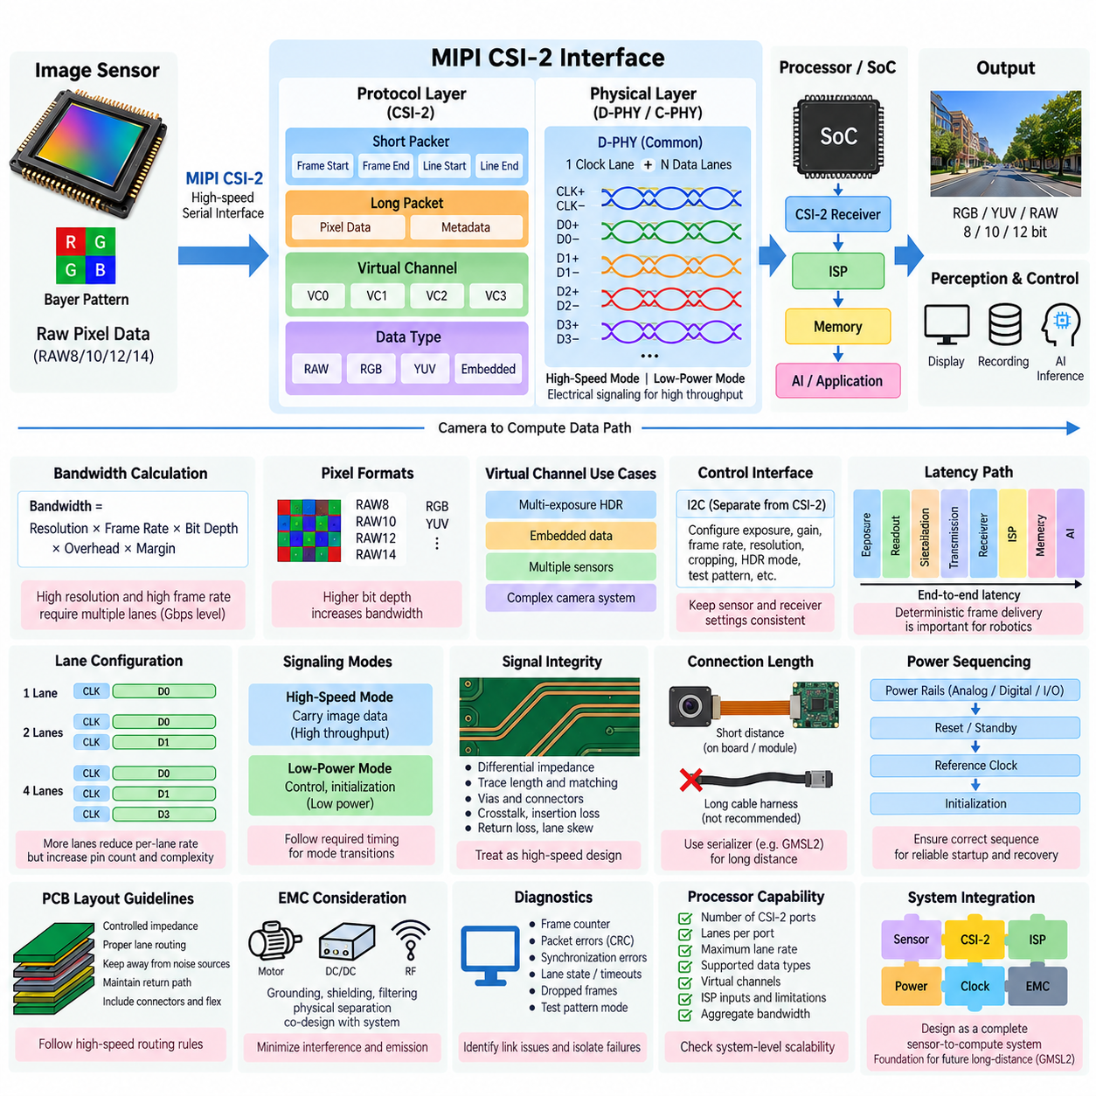
MIPI CSI-2 (Mobile Industry Processor Interface Camera Serial Interface 2) is a high-speed serial interface widely used to connect image sensors and camera modules to processors, SoCs, and embedded computing platforms. Within a monocular camera architecture, it provides the primary transport path between the image sensor or camera-side processing circuitry and downstream computing. Its design directly affects achievable resolution, frame rate, latency, wiring complexity, power consumption, and signal integrity.
CSI-2 separates the camera protocol from the physical signaling layer. The protocol defines how image pixels, synchronization information, metadata, and control-related information are organized into packets, while a physical layer such as MIPI D-PHY or C-PHY transports those packets electrically. This separation allows camera architectures to evolve toward higher data rates while maintaining a standardized logical interface between sensors, processors, and supporting devices.
A typical D-PHY camera connection contains one differential clock lane and one or more differential data lanes. Depending on sensor capability and required bandwidth, one, two, four, or additional lanes may be used. Increasing the lane count distributes the image stream across more physical channels and reduces the required data rate per lane, but it also increases pin count, PCB routing complexity, connector requirements, and physical design constraints.
Required CSI-2 bandwidth should be calculated from image resolution, frame rate, pixel format, bit depth, protocol overhead, and operating margin. A camera producing millions of pixels at 30 or 60 frames per second can generate several gigabits per second of raw traffic before processing or compression. Selecting a CSI-2 configuration without an explicit bandwidth budget can result in dropped frames, reduced operating modes, or an inability to use the sensor's intended resolution and frame rate simultaneously.
CSI-2 transports information using short and long packets. Short packets commonly convey synchronization events such as frame start, frame end, line start, or line end, while long packets carry pixel payloads and other larger data structures. Packet headers identify the data type and virtual channel, allowing the receiver to interpret the incoming stream correctly. Error-detection mechanisms help identify corrupted headers or payloads before invalid information propagates into the ISP or perception pipeline.
Virtual channels allow multiple logical image streams to share a CSI-2 link. This capability can support multi-exposure HDR, embedded data, multiple sensor streams, or more complex camera architectures when the connected devices support the required configuration. The receiver must correctly associate each virtual channel and data type with the intended processing path. Incorrect configuration can cause frames to be mixed, ignored, or interpreted with the wrong pixel format.
Pixel data may be transported in formats such as RAW8, RAW10, RAW12, RAW14, RGB, or YUV depending on the sensor and camera architecture. Raw Bayer formats preserve sensor-level information and are commonly delivered to an ISP for subsequent processing. Higher bit depth improves available intensity precision but directly increases interface bandwidth. Pixel format selection should therefore be coordinated with ISP capability, memory bandwidth, AI requirements, and the desired image-quality pipeline.
The D-PHY physical layer supports high-speed and low-power signaling modes. High-speed operation carries image data at high throughput, while low-power states support control, initialization, and reduced energy consumption when continuous high-speed transmission is unnecessary. Transitions between these modes must follow the required timing behavior. Reliable initialization is particularly important in robotics, where cameras may experience repeated power cycles, software restarts, or recovery operations during long-duration deployment.
Signal integrity becomes increasingly difficult as CSI-2 lane rates rise. Differential impedance, trace length, pair matching, via structures, connectors, reference planes, crosstalk, insertion loss, and return loss all influence link quality. PCB routing should maintain controlled impedance and minimize discontinuities. Excessive skew between the positive and negative traces of a differential pair, or between related lanes, can reduce timing margin and cause intermittent errors that may only appear at high temperature or maximum data rate.
CSI-2 is primarily intended for relatively short connections inside electronic assemblies. The interface can work effectively between a nearby sensor module and processing board, but direct extension through long robot cable harnesses is generally undesirable. Cable length, connectors, electromagnetic interference, mechanical movement, and environmental exposure can degrade high-speed signaling. This limitation is one reason camera architectures often combine local MIPI CSI-2 connections with serializer/deserializer technologies for longer-distance transport.
Clock architecture must be considered together with CSI-2 communication. The image sensor normally requires a reference clock, while internal timing determines exposure, line readout, frame timing, and serialized output. Clock quality, jitter, startup sequence, and frequency accuracy can affect stable operation. Multi-camera systems additionally require careful synchronization if images must represent the same physical instant, particularly for stereo vision, sensor fusion, visual odometry, and autonomous navigation.
PCB layout for MIPI CSI-2 should be treated as high-speed interface engineering rather than ordinary digital routing. Lane pairs should follow consistent routing rules, maintain suitable separation from switching power nodes, motors, clocks, and other strong noise sources, and preserve continuous return-current paths. Connector transitions and flex cables must also be included in the channel analysis. A design that operates on an evaluation board may fail after integration into a robot if the final interconnect environment is substantially different.
Electromagnetic compatibility is especially important in robotic platforms containing motor drives, DC/DC converters, high-current battery wiring, Ethernet, LiDAR, and wireless communication systems. Fast switching edges can couple noise into sensitive camera links, while the CSI-2 interface itself can contribute high-frequency emissions. Grounding, layer-stack design, shielding, filtering, physical separation, and careful power distribution must therefore be coordinated with the broader electrical architecture rather than optimized only at the camera PCB level.
Power sequencing can directly influence successful CSI-2 initialization. Image sensors often require multiple voltage rails for analog, digital-core, and I/O domains, together with reset, standby, reference-clock, and configuration sequences. If the processor enables the CSI-2 receiver before the sensor reaches a valid operating state, initialization may fail or produce unstable frames. Robust robotics designs should define deterministic startup, shutdown, reset, fault recovery, and camera reconnection behavior.
Camera configuration is normally performed through a separate control interface such as I2C, while CSI-2 carries the high-bandwidth image stream. The control path programs exposure, gain, frame rate, resolution, cropping, HDR mode, test patterns, and other sensor registers. Software must maintain consistency between sensor configuration and CSI-2 receiver settings. A mismatch in lane count, pixel format, frame dimensions, timing, or data type can prevent correct image acquisition even when the electrical link is functioning normally.
Latency through a CSI-2 camera path includes exposure time, sensor readout, serialization, packet transport, receiver handling, buffering, ISP processing, and memory transfer. The serial link itself may contribute only a portion of total camera latency, but its configuration can influence buffering and throughput. For visual control and autonomous navigation, deterministic frame delivery is often more valuable than maximizing theoretical link utilization because variable delay directly affects the relationship between perception and physical motion.
Diagnostics should distinguish physical-link problems from sensor, configuration, ISP, and application-level failures. Useful indicators include frame counters, packet errors, CRC failures, synchronization errors, lane-state information, receiver timeouts, and dropped-frame statistics. Test-pattern modes generated by the sensor can help isolate optical and ISP issues from transmission problems. Robust diagnostics become particularly valuable when a robot contains several cameras and intermittent failures must be identified during field operation.
The processor or SoC must provide sufficient CSI-2 receiver capability for the intended camera architecture. Engineers should verify the number of supported camera ports, lanes per port, maximum lane rate, supported data types, virtual channels, ISP inputs, and simultaneous-stream limitations. A processor may advertise multiple CSI-2 interfaces while still imposing aggregate bandwidth or ISP restrictions. Camera scalability must therefore be evaluated at system level rather than by counting physical connectors alone.
MIPI CSI-2 should ultimately be designed as part of the complete sensor-to-compute data path. Sensor resolution, bit depth, frame rate, lane configuration, physical-layer capability, PCB routing, clocking, synchronization, power sequencing, ISP compatibility, processor bandwidth, diagnostics, and EMC behavior must operate as one coordinated system. In the monocular-camera architecture, this short-distance interface provides the foundation from which longer camera connections can subsequently be extended through technologies such as GMSL2.

01.04. GMSL2 Long Distance
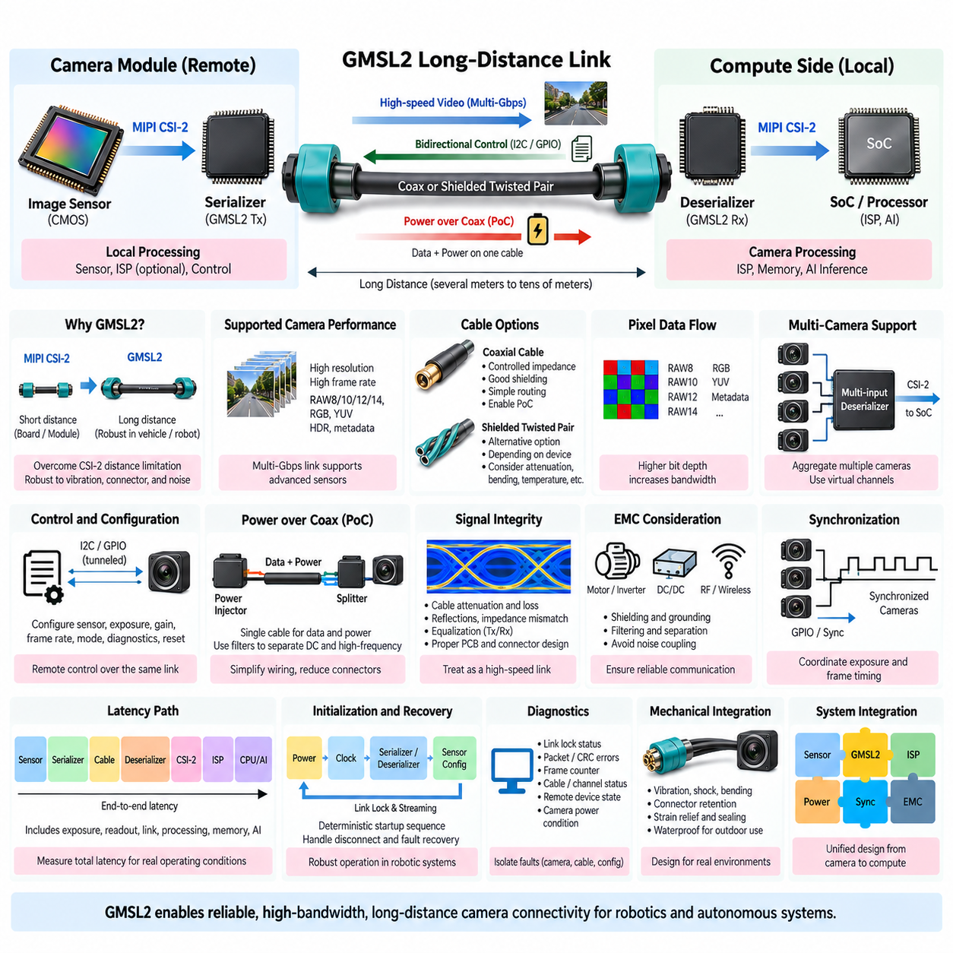
GMSL2 (Gigabit Multimedia Serial Link 2) is a high-speed serializer/deserializer communication technology designed to transport camera and sensor data over substantially longer distances than direct MIPI CSI-2 connections. In robotic systems, it allows a camera to be mounted remotely from the central processor while maintaining high-bandwidth image transmission, making it particularly useful for AMRs, autonomous vehicles, mobile manipulators, quadrupeds, and other distributed perception platforms.
A typical GMSL2 camera architecture places a serializer close to the image sensor or camera module and a deserializer near the processor or edge computer. The camera-side serializer converts parallel or MIPI CSI-2 image information into a high-speed serial stream suitable for cable transmission. At the receiving side, the deserializer reconstructs the data and commonly outputs MIPI CSI-2 toward the SoC or ISP, creating a transparent bridge between remote cameras and local computing resources.
This architecture addresses one of the major physical limitations of MIPI CSI-2. CSI-2 is highly effective for short board-level or module-level connections but becomes difficult to maintain across long harnesses exposed to vibration, connectors, electromagnetic noise, and mechanical routing constraints. GMSL2 extends the camera data path through automotive-style coaxial or shielded twisted-pair cabling, allowing the sensitive native camera interface to remain localized near the sensor and processor endpoints.
GMSL2 supports multi-gigabit-per-second transmission rates suitable for high-resolution and high-frame-rate cameras. The required link capacity depends on resolution, frame rate, pixel bit depth, HDR mode, embedded metadata, and protocol overhead. Engineers should calculate the complete camera bandwidth before selecting serializer and deserializer devices because theoretical link speed does not automatically guarantee that every sensor operating mode can be transported simultaneously with adequate engineering margin.
Coaxial cable is frequently attractive for camera installations because it provides controlled impedance, effective shielding, relatively simple routing, and the possibility of combining data and power functions. Shielded twisted pair can provide another implementation option depending on the selected transceiver family and system requirements. Cable selection should consider attenuation, insertion loss, return loss, bending radius, connector type, temperature range, vibration resistance, shielding effectiveness, weight, and expected service life.
One important advantage of a serializer/deserializer architecture is the ability to carry bidirectional control information in addition to the high-bandwidth forward video stream. The processor can remotely configure image sensors, serializers, and camera-related devices through tunneled control interfaces such as I2C or GPIO. This allows exposure, gain, frame rate, operating mode, diagnostics, and reset functions to be managed from the central compute platform without requiring separate long-distance control wiring for every camera.
Power over coaxial cable, commonly implemented as Power over Coax (PoC), can further simplify distributed camera wiring by carrying electrical power and high-speed communication over the same physical cable. Appropriate filtering networks separate DC power from high-frequency communication signals at both ends. This approach can reduce connector count and harness mass, but power budget, voltage drop, startup current, filter characteristics, grounding, fault protection, and EMC behavior must be carefully engineered.
PoC design becomes more demanding as cable length and camera power increase. The remote camera must receive sufficient voltage under worst-case battery voltage, cable resistance, connector resistance, temperature, and transient load conditions. Camera startup can create temporary current peaks that interact with PoC filters and upstream power converters. Engineers should therefore evaluate steady-state voltage drop, transient response, short-circuit protection, reverse polarity, overvoltage behavior, and recovery after temporary communication or power faults.
Signal integrity remains a fundamental design requirement even though GMSL2 is intended for robust long-distance communication. Cable attenuation increases with frequency and length, while connectors, PCB transitions, stubs, impedance discontinuities, and poor termination can create reflections. Serializer and deserializer equalization functions can compensate for part of the channel loss, but they cannot replace sound physical design. The complete channel from transmitter PCB through cable and connectors to receiver PCB should be treated as one high-speed transmission system.
Electromagnetic compatibility is particularly important because robotic platforms combine sensitive camera links with motors, inverters, DC/DC converters, batteries, Ethernet networks, wireless radios, LiDAR, and other switching electronics. Cable shielding and connector shield termination should provide a controlled high-frequency return path. Grounding strategy, common-mode behavior, filtering, cable routing, enclosure bonding, and physical separation should be coordinated to prevent motor switching noise or other disturbances from corrupting camera communication.
GMSL2 architectures can support multiple remote cameras through multi-input deserializers. Several serialized camera links may terminate at one deserializer, which then aggregates or maps their streams onto one or more MIPI CSI-2 outputs connected to the processor. This reduces compute-side connector complexity and enables centralized camera processing. However, aggregate CSI-2 bandwidth, virtual-channel mapping, receiver lane capacity, ISP resources, and simultaneous camera operating modes must all be verified.
Synchronization is a major requirement when multiple cameras participate in stereo vision, surround perception, visual odometry, or sensor fusion. Serializer/deserializer devices can distribute synchronization signals or provide GPIO mechanisms that help coordinate sensor exposure and frame timing. The design should distinguish communication synchronization from actual image exposure synchronization. A frame arriving correctly at the processor does not necessarily mean that multiple sensors captured their images at the same physical instant.
Latency should be evaluated across the entire remote-camera pipeline rather than attributed only to the GMSL2 link. Total delay includes sensor exposure, readout, serializer processing, cable transmission, deserializer processing, CSI-2 output, ISP processing, buffering, memory transfer, and AI inference. Serializer/deserializer transport is generally designed for low latency, but buffering or format conversion elsewhere can dominate the result. Autonomous control therefore requires end-to-end timing measurement using realistic operating configurations.
Link initialization must follow a deterministic startup sequence. Power rails, serializer, deserializer, reference clocks, camera reset, control-channel configuration, sensor registers, CSI-2 output, and processor receiver settings must reach compatible states before stable image streaming begins. Distributed robots should also support recovery when a camera is disconnected, a cable is damaged, communication lock is temporarily lost, or the camera is power-cycled independently of the main compute platform.
Diagnostics are especially valuable in long-distance camera systems because faults can originate from the sensor, serializer, cable, connector, deserializer, CSI-2 interface, ISP, or software configuration. Useful diagnostic information includes link-lock status, packet and transmission errors, CRC-related indicators, cable or channel status, frame counters, remote-device communication state, and camera power condition. Fault isolation should enable maintenance personnel to distinguish a damaged harness from a failed camera or configuration problem.
Mechanical integration directly affects electrical reliability. Camera cables routed through mobile robots experience bending, vibration, shock, abrasion, temperature cycling, and repeated maintenance handling. Connector retention, strain relief, minimum bending radius, shield continuity, sealing, and harness attachment should therefore be included in the electrical architecture. Outdoor systems may additionally require waterproof connectors and environmental sealing appropriate to rain, dust, condensation, cleaning operations, and temperature variation.
The serializer and deserializer should be selected together with the image sensor, ISP, and compute platform rather than as independent communication components. Compatibility must be verified for CSI-2 lane count, pixel data type, maximum throughput, virtual channels, synchronization, control tunneling, GPIO functions, PoC architecture, diagnostics, and processor receiver capability. A link that is electrically functional may still be unusable if its video mapping or aggregate bandwidth does not match the target SoC architecture.
A robust GMSL2 design therefore extends the camera architecture from a local electronic interface into a distributed sensor network. Image sensor, MIPI CSI-2, serializer, long-distance cable, power delivery, deserializer, ISP, processor, synchronization, diagnostics, EMC, and mechanical harness design must operate as one coordinated chain. Within the monocular-camera structure, this long-distance architecture naturally follows MIPI CSI-2 and provides the connectivity foundation for remote camera placement before camera power and thermal engineering are addressed in the subsequent design stage.

01.05. Camera Power and Thermal
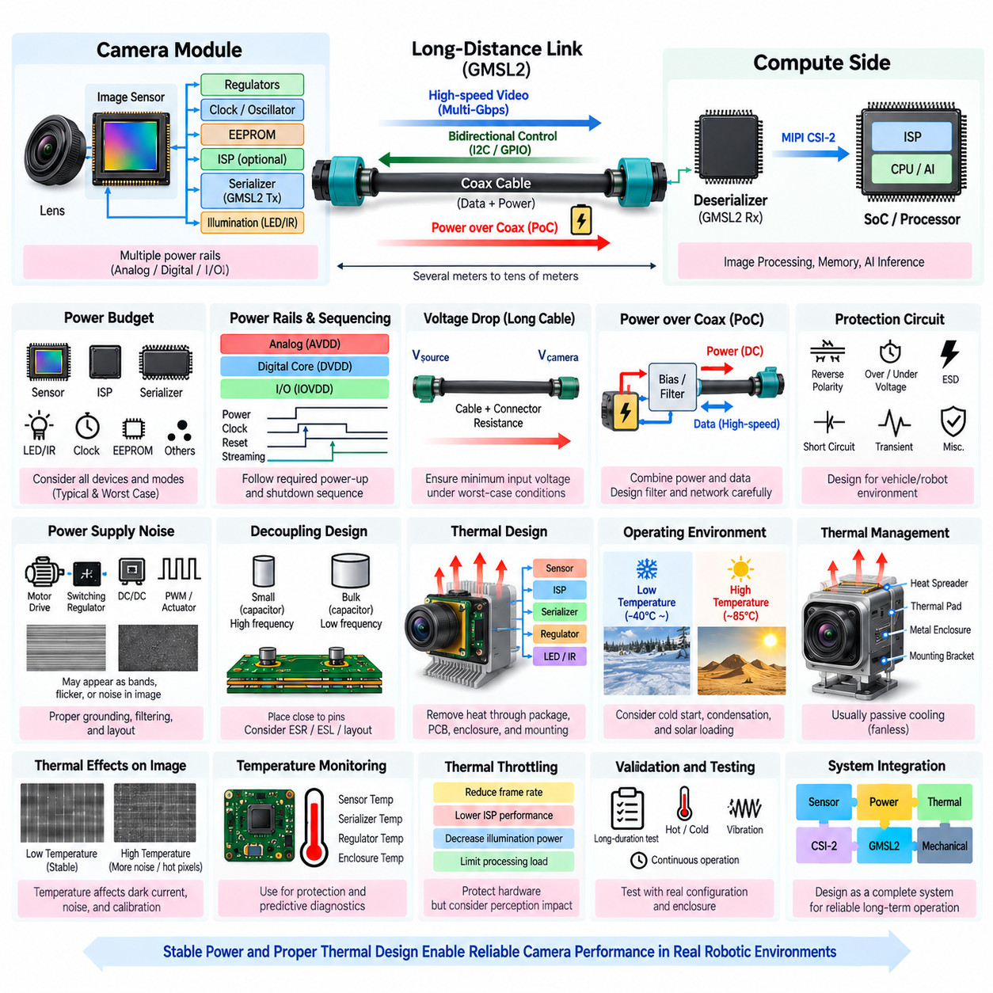
Camera power and thermal design determines whether an imaging system can maintain stable perception performance throughout continuous robotic operation. A camera is not only an image sensor; it may contain regulators, oscillators, memory, ISP circuitry, serializers, illumination drivers, and communication interfaces. Their combined electrical and thermal behavior must be considered from the beginning because unstable power or excessive temperature can directly degrade image quality, communication reliability, and component lifetime.
The camera power budget should be constructed from every active device and every operating mode rather than from the nominal sensor consumption alone. Image sensor, ISP, serializer, clock generator, EEPROM, regulators, LEDs or infrared illumination, and auxiliary circuitry can contribute to total demand. Startup, HDR operation, maximum frame rate, high-speed communication, and low-temperature initialization may produce different loads, so both typical and worst-case consumption must be evaluated.
Image sensors commonly require several regulated voltage domains, including analog supply, digital-core supply, and I/O supply. Each rail has different voltage accuracy, current capability, ripple, noise, and sequencing requirements. The analog rail is particularly sensitive because supply disturbances can appear directly as image noise or pattern artifacts. Low-noise regulators, suitable filtering, local decoupling capacitors, and carefully separated current paths are therefore fundamental parts of camera electrical design.
Power sequencing must follow the requirements of the sensor and supporting devices. Core, analog, I/O, reference clock, reset, standby, serializer, and control interfaces may need to become active in a defined order before image streaming begins. Incorrect sequencing can cause excessive current, incomplete register initialization, CSI-2 communication failure, or unpredictable sensor behavior. The shutdown and restart sequences should receive equal attention because robots frequently require controlled recovery after communication or software faults.
Voltage drop becomes important when cameras are remotely installed through long wiring harnesses. Cable resistance, connector resistance, fuse elements, protection devices, and temperature can reduce the voltage available at the camera. The design should verify minimum camera input voltage under maximum current and minimum system supply conditions. Supplying a higher distribution voltage followed by local point-of-load conversion can reduce harness current and voltage loss compared with distributing low-voltage, high-current power directly over long distances.
For GMSL2 remote cameras, Power over Coax (PoC) can combine high-speed communication and DC power on the same cable. Biasing and filtering networks separate the power path from the serial data path while maintaining the required high-frequency impedance. PoC simplifies the harness and reduces connector count, but the filter, cable, serializer, deserializer, and regulator must be designed as one network because inappropriate component values can degrade either power stability or communication signal integrity.
Camera power inputs should include appropriate protection against electrical faults and vehicle or robot power disturbances. Reverse polarity, overvoltage, undervoltage, short circuit, electrostatic discharge, transient pulses, and abnormal ground conditions should be considered according to the intended platform. Protection components must be selected carefully because additional series resistance, capacitance, or leakage can interfere with startup, PoC operation, or high-speed communication when placed incorrectly.
Power-supply noise can become visible in the image even when the camera remains functionally operational. Switching regulators, motor drives, PWM-controlled actuators, DC/DC converters, and digital processors can introduce conducted or radiated disturbances. These disturbances may appear as horizontal bands, temporal flicker, fixed patterns, or increased sensor noise. Power architecture, PCB layout, grounding, filtering, shielding, and regulator switching frequency should therefore be evaluated together with actual image output.
Local decoupling provides the short-duration current required when internal sensor and digital circuits switch rapidly. Small ceramic capacitors should be located close to relevant power pins, while larger bulk capacitance supports slower load changes. Effective decoupling depends not only on capacitance value but also on equivalent series resistance, equivalent series inductance, mounting geometry, PCB vias, and return paths. Poor placement can make theoretically adequate capacitance ineffective at high frequencies.
Thermal design begins with an accurate understanding of where electrical power is converted into heat. The image sensor, ISP, serializer, regulators, and illumination circuitry can create localized hot spots even when total camera power appears modest. Heat must travel through the package, PCB, thermal interface materials, enclosure, mounting structure, and surrounding air before reaching the environment. Each section contributes thermal resistance and influences the final semiconductor junction temperature.
Image sensor temperature can influence dark current, noise, pixel response, calibration stability, and long-exposure performance. As temperature increases, dark-current-related artifacts generally become more significant, especially in low-light operation. Temperature changes may also alter optical alignment indirectly through mechanical expansion. Consequently, thermal design is not only a reliability issue; it can become part of perception accuracy and calibration stability when robots operate across wide environmental temperature ranges.
Junction temperature should be estimated from component power dissipation, package thermal characteristics, board conditions, and ambient temperature rather than inferred from enclosure surface temperature alone. A camera housing that feels moderately warm can still contain a significantly hotter semiconductor junction. Thermal simulation or resistance-network analysis can identify critical paths, while thermocouples, onboard temperature sensors, and infrared measurements can verify the physical prototype under realistic operating conditions.
Passive cooling is generally preferred for robotic camera modules because it avoids fans, moving parts, acoustic noise, dust ingestion, and additional failure modes. Heat spreaders, thermal pads, conductive enclosures, metal mounting brackets, copper PCB areas, and thermal vias can transfer heat away from high-power components. The mechanical mounting structure itself may become part of the heat path, particularly when a sealed outdoor camera cannot rely on significant internal airflow.
Sealed camera enclosures create an important conflict between environmental protection and heat dissipation. Increasing ingress protection can reduce natural airflow, while sunlight can raise enclosure temperature substantially above ambient conditions. Outdoor cameras must therefore be evaluated under solar loading, high ambient temperature, continuous streaming, maximum processing load, and limited convection. A design that operates reliably on an open laboratory bench may overheat after installation inside a compact waterproof housing.
Low-temperature operation introduces a different set of challenges. Semiconductor startup behavior, oscillator stability, regulator characteristics, capacitor performance, cable flexibility, lens condensation, and heater requirements may become relevant. If a camera uses a heater or window defogging element, its consumption must be included in the worst-case power budget. Thermal architecture should therefore address both heat removal at high temperature and controlled warm-up or condensation prevention at low temperature.
Thermal throttling may protect components but can conflict with perception requirements. Reducing sensor frame rate, ISP performance, illumination power, or processing load lowers temperature, yet it can simultaneously reduce detection performance or increase control latency. If throttling is necessary, the robot should understand the resulting degraded operating mode. Thermal protection should therefore be coordinated with diagnostics, system health monitoring, and higher-level safety or mission management.
Temperature sensing provides valuable information for both protection and predictive diagnostics. Sensor-die temperature, serializer temperature, regulator temperature, or enclosure temperature can be monitored depending on available hardware. Software can establish warning, derating, and shutdown thresholds and record temperature history for maintenance analysis. Correlating thermal information with image noise, communication errors, and power consumption can also help identify gradual degradation before complete camera failure occurs.
Camera power and thermal validation should reproduce the actual mission rather than rely only on nominal bench measurements. Testing should include maximum resolution and frame rate, HDR, continuous operation, worst-case communication load, minimum and maximum supply voltage, high and low ambient temperature, vibration, and representative enclosure installation. Long-duration testing is especially valuable because thermal equilibrium may require substantial time and intermittent faults may appear only after repeated heating and cooling cycles.
Camera power and thermal engineering ultimately connects the entire monocular-camera architecture. Image sensor selection defines electrical and thermal characteristics; ISP processing changes computational load; MIPI CSI-2 determines local high-speed connectivity; and GMSL2 can extend both communication and power toward remote camera locations. Treating power delivery, thermal paths, signal integrity, mechanical packaging, diagnostics, and perception performance as one coordinated design produces a camera subsystem capable of reliable long-duration operation in practical robotic environments.

