Volume 15 Perception and Sensor Architecture

Chapter 11. Time Synchronization

11.01. PTP Hardware Timestamp
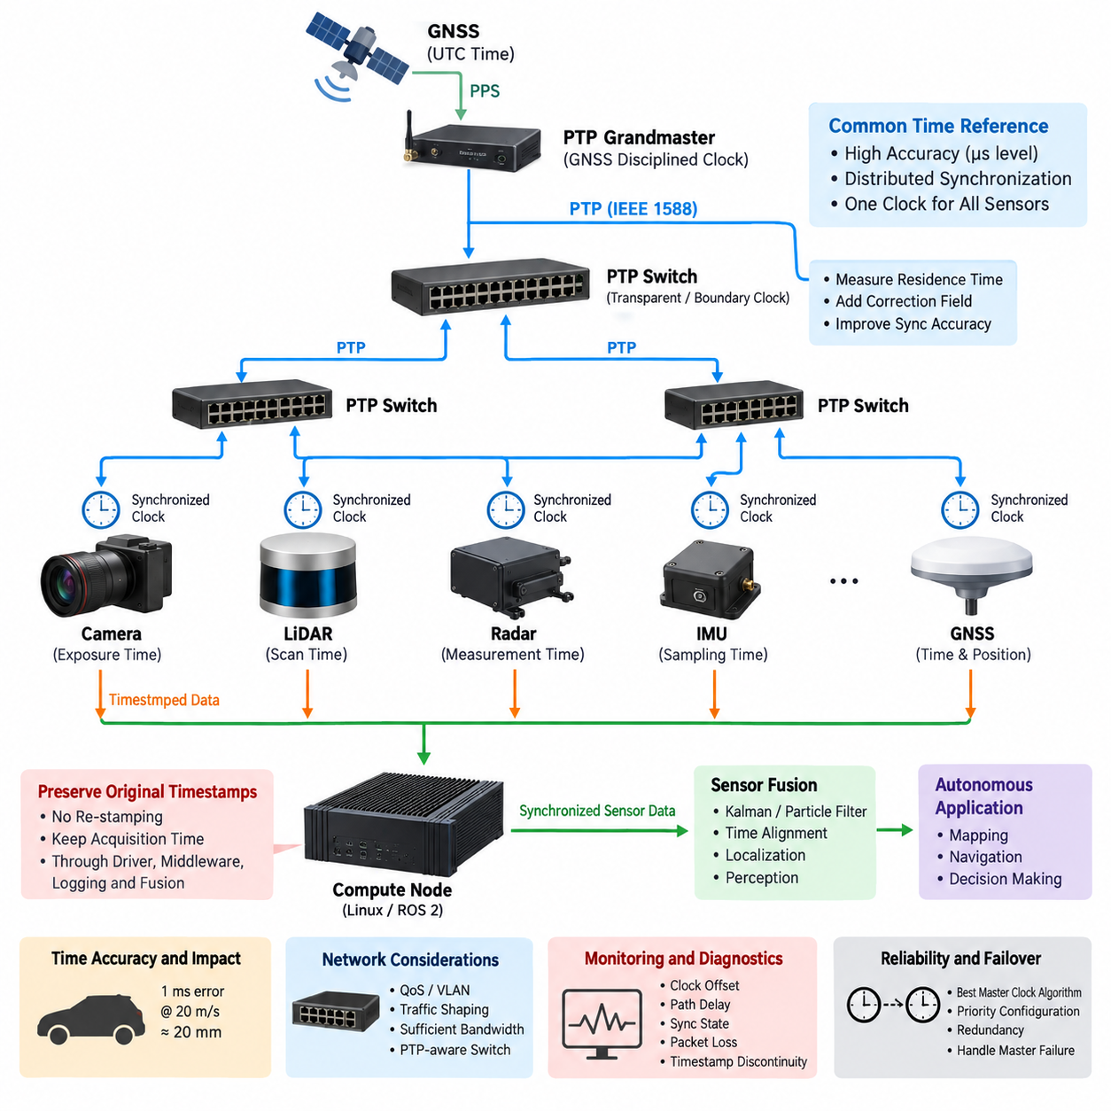
Precision Time Protocol (PTP) provides a common time reference across distributed sensors, switches, and computing nodes in a robotic perception system. In applications such as autonomous mobile robots, outdoor vehicles, and UAVs, accurate time is essential because camera images, LiDAR point clouds, radar detections, IMU measurements, and GNSS observations must represent the physical environment at consistent moments.
PTP is standardized by IEEE 1588 and synchronizes clocks through timestamped Ethernet messages exchanged between a Grandmaster Clock and participating devices. The protocol estimates clock offset and network propagation delay, then disciplines local clocks toward the common reference. Unlike simple application-level timestamping, PTP is designed specifically for distributed systems where deterministic and measurable synchronization accuracy is required.
A typical PTP domain contains a Grandmaster Clock, one or more Ethernet switches, and multiple Ordinary or Boundary Clocks. The Grandmaster establishes the reference timescale, while Sync and Follow_Up messages distribute timing information. Delay_Req and Delay_Resp exchanges estimate path delay. The resulting offset calculation allows each synchronized node to continuously correct its local clock without requiring a dedicated timing wire.
Hardware timestamping is critical when synchronization requirements reach microsecond or sub-microsecond levels. Instead of recording packet time after it has passed through the operating system and network stack, a PTP-capable Ethernet controller timestamps the frame close to the physical or MAC interface. This removes much of the nondeterministic delay caused by interrupts, driver scheduling, queues, kernel processing, and application execution.
Software timestamps may vary because CPU load, operating-system scheduling, network buffering, and driver behavior introduce unpredictable latency. A packet physically arriving at the Ethernet interface at one instant may not reach the synchronization software until considerably later. Hardware timestamps capture the event at a much more deterministic boundary, allowing the synchronization algorithm to distinguish actual network propagation delay from host-side processing latency.
A PTP-capable sensor architecture therefore depends on more than installing a PTP software daemon. The Ethernet PHY, MAC, network interface controller, switch, device driver, operating system, and sensor firmware must form a compatible timing chain. If only one portion supports hardware timestamps while another introduces uncontrolled buffering or software timestamping, end-to-end synchronization performance can be substantially worse than the nominal capability of PTP.
Transparent Clocks improve synchronization through Ethernet switches by measuring how long PTP packets remain inside each switch. This residence time is added to a correction field carried by the PTP message, allowing downstream clocks to compensate for switching latency. Boundary Clocks instead terminate one PTP timing domain and regenerate synchronization toward downstream ports, which can improve scalability and isolate timing disturbances in larger robotic networks.
The Best Master Clock Algorithm determines which eligible clock becomes the Grandmaster according to advertised clock properties and priorities. In a robot, the selected reference may originate from a dedicated timing module, GNSS-disciplined clock, industrial computer, or another high-quality source. System architects should explicitly control clock priority and failover behavior rather than assuming that the preferred clock will always become Grandmaster automatically.
GNSS can provide an absolute UTC-related reference while PTP distributes that reference through the robot's Ethernet network. A GNSS receiver may combine precise time information with a pulse-per-second signal, allowing a timing controller to discipline the PTP Grandmaster. Cameras, LiDARs, radar units, compute nodes, and data loggers can then share a timebase that is traceable to the external navigation timing source.
The distinction between clock synchronization and sensor measurement timing is important. A sensor may possess an accurately synchronized PTP clock while still producing measurements with internal acquisition latency. Camera exposure, LiDAR scanning, radar chirp processing, IMU sampling, buffering, compression, and packetization occur at different stages. The timestamp must therefore correspond to a clearly defined measurement event rather than merely the moment when data reaches the host computer.
For cameras, the desired timestamp may represent exposure start, exposure midpoint, or frame completion. For LiDAR, timing may be associated with an individual point, packet, firing sequence, or scan. Radar measurements can involve acquisition and processing intervals, while an IMU produces samples at much higher rates. Sensor fusion software must understand these timestamp semantics before measurements from different modalities can be aligned correctly.
PTP synchronization accuracy should therefore be translated into spatial error. If a platform travels at 20 m/s, a 1 ms timing error corresponds to approximately 20 mm of platform translation before rotational effects are considered. Fast UAV motion, steering transients, vibration, and nearby objects can amplify the consequences. Required timing accuracy should consequently be derived from motion dynamics, perception resolution, and fusion-error requirements.
Network architecture also influences PTP performance. High-bandwidth camera streams and dense LiDAR traffic can create queues in shared Ethernet switches, while burst traffic may increase packet-delay variation. Quality of Service, VLAN separation, traffic shaping, sufficient link capacity, and PTP-aware switches can protect synchronization traffic. Timing architecture should therefore be designed together with bandwidth and network-topology planning rather than treated as an independent software feature.
PTP profiles and operating modes must be selected consistently across the system. Devices may support different IEEE 1588 versions, delay mechanisms, message intervals, one-step or two-step operation, multicast behavior, and hardware timestamp capabilities. A device advertised simply as “PTP supported” is not necessarily interoperable with every sensor or switch, so engineering validation must confirm the exact profile and configuration used by all participating components.
One-step PTP inserts precise timing information directly into the synchronization message as it is transmitted, whereas two-step PTP sends a subsequent Follow_Up message containing the accurate transmission timestamp. Hardware architecture and device capability determine which mechanism is available. Both approaches can provide precise synchronization, but mixed networks require careful interoperability testing, especially when sensors and switches originate from different vendors.
Linux-based edge computers commonly expose hardware clock resources through the network interface and synchronize them with system time using appropriate PTP clock infrastructure. The important architectural concept is that the NIC hardware clock, operating-system clock, application timestamps, and sensor clocks must maintain a defined relationship. A synchronized Ethernet interface alone does not guarantee that ROS 2 nodes or perception applications are using the correct clock domain.
ROS 2 and sensor middleware should preserve original acquisition timestamps rather than replacing them with host reception time. Once sensor data enters the software pipeline, timestamps must survive drivers, middleware queues, recording systems, fusion modules, and AI processing. Re-stamping messages at intermediate stages destroys information about when the physical observation actually occurred and can produce apparently synchronized data that is temporally incorrect.
Monitoring is therefore part of the timing architecture. The system should observe Grandmaster identity, clock offset, path delay, synchronization state, clock transitions, packet loss, and timestamp discontinuities. Diagnostics should distinguish normal locked operation from degraded synchronization and complete loss of timing. Recorded datasets should also contain enough timing metadata to reconstruct synchronization quality during later debugging, calibration, or AI dataset analysis.
Grandmaster failure requires a defined strategy. Another clock may automatically become master, but the transition can introduce temporary offset changes or uncertainty. Safety-critical perception should know when timing quality has degraded and decide whether to continue normally, enter a reduced-performance mode, or reject temporally sensitive fusion. Clock redundancy is therefore not only a network feature but part of fault-tolerant perception architecture.
Validation should measure synchronization at the hardware boundaries rather than relying only on software status reports. PPS outputs, trigger signals, timestamped test packets, oscilloscopes, logic analyzers, and controlled sensor events can reveal actual clock offset and jitter. Tests should cover startup, steady operation, high network load, Grandmaster switching, cable reconnection, compute overload, temperature variation, and loss and restoration of the external time source.
A robust PTP hardware timestamp architecture ultimately creates a common temporal coordinate system for perception. Spatial calibration defines where sensors are located relative to one another, while time synchronization defines when their measurements occurred. Both are required for reliable multi-sensor fusion. Within the perception architecture, PTP therefore becomes fundamental infrastructure connecting sensor hardware, Ethernet networking, compute platforms, middleware, calibration, localization, and autonomous decision making.

11.02. Sensor Compute Sync Design
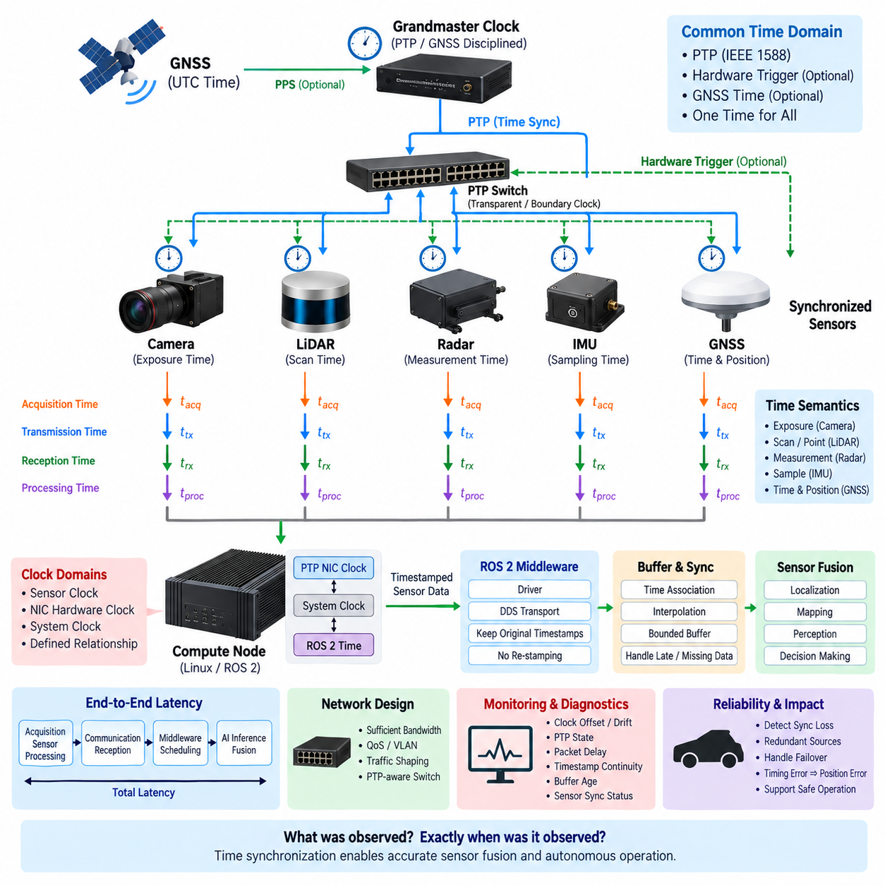
Sensor–compute synchronization establishes a deterministic temporal relationship between physical measurements and the computing platform that processes them. In a robotic perception architecture, cameras, LiDARs, radar, IMUs, and GNSS receivers operate with different sampling rates and internal pipelines. Their measurements must therefore be referenced to a common clock before reliable localization, perception, mapping, and sensor fusion can occur.
The synchronization design begins by defining a system-wide time domain shared by sensors and compute nodes. Precision Time Protocol (PTP), hardware trigger signals, GNSS-derived time, or combinations of these mechanisms can establish this reference. The objective is not simply to make device clocks display similar values, but to ensure that every sensor measurement can be associated with an accurately known physical acquisition time.
A sensor and its host computer usually contain several independent clocks. The sensor may have an internal oscillator, the Ethernet interface may contain a PTP Hardware Clock, and the compute node maintains both a system clock and possibly a Network Interface Card hardware clock. Synchronization architecture must explicitly define how these clock domains are disciplined and how timestamps are translated without introducing ambiguity or uncontrolled offset.
Hardware timestamping provides an important bridge between sensor time and compute time. When Ethernet packets are timestamped close to the MAC or PHY boundary, variable delays introduced by drivers, operating-system scheduling, interrupt handling, and application processing can largely be excluded. The compute node can then determine when sensor information crossed a known hardware boundary instead of relying on the less deterministic moment when software received the message.
However, packet arrival time is not necessarily measurement time. A camera may capture an image and transmit it several milliseconds later, while a LiDAR may construct a scan over a finite interval before packet transmission. Radar processing can add internal latency, and an IMU may buffer several samples before sending them. Sensor–compute synchronization must therefore preserve the relationship between acquisition timestamp, transmission timestamp, reception timestamp, and processing timestamp.
For cameras, synchronization should identify whether the timestamp represents exposure start, exposure midpoint, exposure end, or frame delivery. Rolling-shutter cameras require additional consideration because different image rows are exposed at different times. If the compute pipeline treats the entire frame as a single instantaneous measurement, rapid robot motion can produce temporal errors that appear as geometric distortion or inaccurate alignment with LiDAR and IMU measurements.
LiDAR synchronization is similarly dependent on measurement semantics. A rotating LiDAR acquires points sequentially while the sensor and robot may both be moving. A single scan timestamp is therefore insufficient for high-accuracy motion compensation when individual packets or points have their own timing information. The compute system should retain the sensor-provided timing structure so that point clouds can be deskewed using synchronized IMU, odometry, or vehicle-motion estimates.
IMUs typically operate at substantially higher frequencies than cameras or LiDARs and are frequently used as the temporal backbone of state estimation. Precise sample timestamps allow measurements to be integrated between camera frames, LiDAR scans, or GNSS updates. Even small timestamp offsets can cause incorrect angular or linear motion compensation, particularly during rapid rotation, acceleration, vibration, or aggressive UAV maneuvering.
GNSS provides both navigation measurements and an external timing reference. A GNSS receiver may supply absolute time together with a pulse-per-second signal, while PTP distributes synchronized time through the Ethernet network. When the GNSS timebase, sensor clocks, and compute clocks are consistently related, recorded perception data can maintain a traceable timeline across localization, mapping, sensor fusion, and offline dataset reconstruction.
The compute architecture should distinguish the hardware clock from the operating-system system clock. A PTP-capable Network Interface Card may maintain a precise PTP Hardware Clock while Linux applications normally reference the system clock. Clock synchronization services must maintain a controlled relationship between them. Otherwise, sensor packets may carry precise PTP timestamps while ROS 2 nodes compare them against a system clock that has a different offset or drift.
ROS 2 middleware should preserve acquisition timestamps from the sensor driver through the complete perception pipeline. Replacing them with the current host time when publishing a message removes the original physical timing information. Queuing, serialization, DDS transport, callback scheduling, GPU inference, and downstream processing may introduce latency, but these delays should remain separate from the timestamp representing when the physical observation occurred.
Synchronization design must also account for sensor rates that are not integer multiples of one another. A 30 Hz camera, 10 or 20 Hz LiDAR, 100 or 200 Hz IMU, radar, and lower-rate GNSS receiver will rarely produce measurements simultaneously. Fusion software therefore requires timestamp-based association, interpolation, integration, or bounded buffering rather than assuming that measurements arriving close together belong to the same physical instant.
Buffer management becomes a fundamental part of synchronization. The compute node may temporarily retain measurements until temporally compatible data from other sensors becomes available. Buffer windows must be large enough to tolerate expected network and processing variation but small enough to avoid excessive perception latency. Late data, missing data, and out-of-order packets should be detected rather than silently fused with unrelated measurements.
End-to-end latency should be decomposed into acquisition, sensor processing, communication, host reception, middleware transport, compute scheduling, AI inference, and fusion latency. Only some of these delays affect timestamp accuracy directly, but all influence when a perception result becomes available to the controller. A system can therefore have excellent clock synchronization while still suffering unacceptable control latency if the downstream processing pipeline is too slow.
Deterministic network design improves the relationship between sensor timestamps and compute reception. Sufficient Ethernet bandwidth, Quality of Service, VLAN separation, traffic shaping, and PTP-aware switches reduce congestion and packet-delay variation. High-bandwidth camera and LiDAR streams should not be allowed to interfere unpredictably with timing messages or safety-critical communication, particularly when multiple sensors share the same network infrastructure.
Synchronization requirements should be derived from spatial and dynamic performance. A timing error becomes a position or orientation error whenever the robot moves between the actual measurement instant and the assumed measurement instant. Faster vehicles, UAVs, rotating platforms, nearby obstacles, and high-resolution perception require tighter timing tolerances. The acceptable clock offset must therefore be linked to vehicle velocity, angular rate, sensor resolution, and fusion accuracy.
Calibration and synchronization must be treated together. Extrinsic calibration determines the spatial transformation between sensors, while time calibration determines their temporal relationship. A fixed timestamp offset can sometimes resemble an incorrect extrinsic calibration during motion, making diagnosis difficult. Validation should therefore separate spatial misalignment from temporal misalignment and estimate persistent sensor-specific latency where necessary.
The system should continuously monitor synchronization quality rather than assuming that successful startup guarantees correct timing. Useful indicators include clock offset, drift, PTP state, Grandmaster identity, packet delay, trigger status, sensor timestamp continuity, buffer age, and measurement arrival latency. These metrics can be exposed through diagnostics and recorded with operational datasets for later failure analysis.
Fault handling is essential because sensors can lose synchronization independently. A disconnected Ethernet link, restarted sensor, failed Grandmaster, GNSS outage, oscillator drift, or PTP configuration mismatch can cause one device to leave the common time domain. The perception system should detect such conditions and mark affected measurements as temporally degraded instead of continuing fusion under the assumption that all timestamps remain valid.
Redundant synchronization can improve availability in safety-relevant robotic systems. PTP may provide network-wide clock synchronization while hardware triggers provide deterministic capture events for selected cameras, and GNSS PPS may discipline the master reference. These mechanisms serve different purposes and can complement one another. The architecture should define which source is authoritative and how transitions occur when the preferred source becomes unavailable.
Verification requires measurement of the complete sensor-to-compute timing chain. Controlled optical, electrical, mechanical, or PPS events can be observed simultaneously by sensors and external measurement equipment. Oscilloscopes, logic analyzers, timestamped Ethernet traffic, and software logs can then quantify offset, jitter, drift, and latency. Testing should include startup, high network load, CPU/GPU overload, sensor reconnection, clock failover, and long-duration operation.
A well-designed sensor–compute synchronization architecture ultimately allows every perception measurement to answer two questions reliably: what was observed, and exactly when was it observed. This temporal consistency enables accurate motion compensation, multi-sensor fusion, localization, mapping, dataset recording, and autonomous decision making. Time synchronization therefore forms a fundamental interface connecting sensor hardware, Ethernet communication, compute platforms, ROS 2 middleware, perception algorithms, and Physical AI execution.

11.03. Trigger Signal Architecture
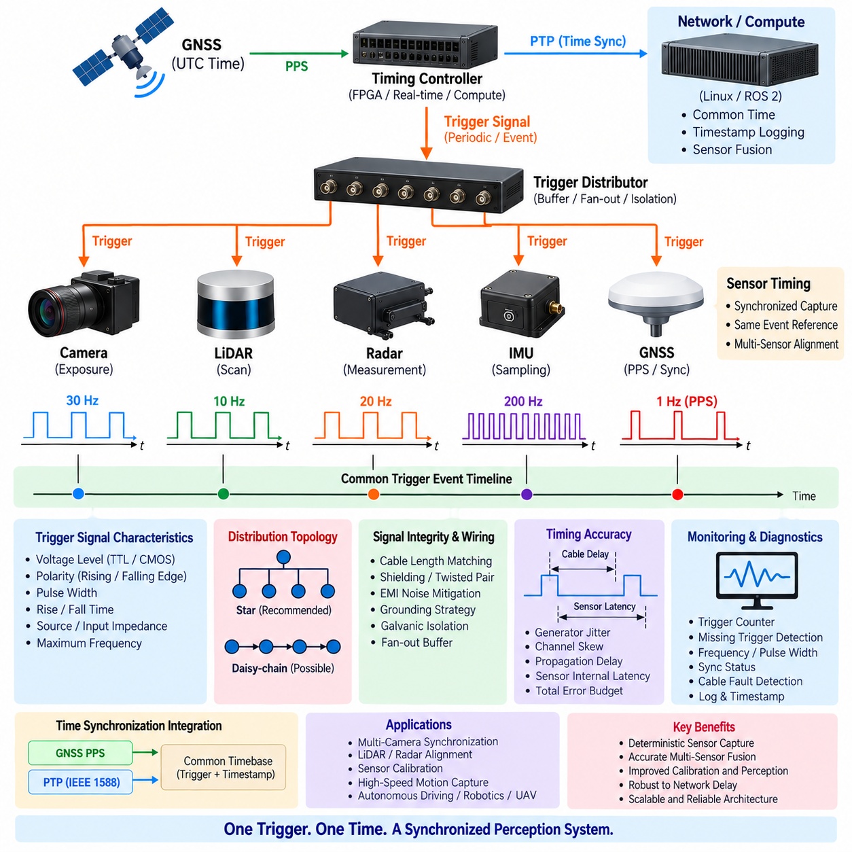
A trigger signal architecture provides a deterministic hardware mechanism for coordinating measurement events across multiple sensors. Instead of relying only on network-distributed clock synchronization, a physical electrical signal instructs cameras, LiDARs, measurement devices, or other acquisition hardware exactly when an event should occur. This is especially valuable when simultaneous capture is required for accurate multi-sensor perception and calibration.
The fundamental concept is to generate a timing event from one authoritative trigger source and distribute it to every participating device through controlled electrical paths. The trigger may originate from a dedicated timing controller, GNSS-disciplined clock, FPGA, real-time controller, compute platform, or synchronized sensor. Each receiving device detects the defined signal edge and starts exposure, sampling, scanning, or another measurement operation.
Trigger synchronization and clock synchronization solve related but different problems. Precision Time Protocol provides participating devices with a common representation of time, whereas a hardware trigger creates a specific physical event shared among sensors. PTP can tell devices what time it is, while the trigger tells them when to perform an acquisition. High-performance robotic systems can combine both mechanisms to obtain common time and deterministic capture.
The electrical characteristics of the trigger interface must be defined before system integration. Voltage level, logic threshold, polarity, pulse width, source impedance, input impedance, rise time, fall time, and maximum repetition frequency affect reliable detection. Depending on the sensor, interfaces may use TTL, CMOS, LVTTL, differential signaling, optically isolated inputs, or vendor-specific industrial trigger circuits.
Trigger polarity determines whether a rising edge, falling edge, or signal level initiates measurement. Edge-triggered operation is generally useful for precise timing because the acquisition event can be associated with a clearly defined transition. Pulse width may still matter because some sensors require a minimum high or low duration, while others interpret pulse duration as exposure time or operating mode rather than merely as an event marker.
A single trigger output should not be connected to an unlimited number of sensor inputs without electrical analysis. Every input contributes capacitance and loading, while long cables introduce additional capacitance, resistance, reflections, and electromagnetic susceptibility. As the fan-out increases, signal edges may become slower or distorted. Dedicated trigger distribution buffers or fan-out modules can preserve electrical integrity across multiple sensor branches.
Star distribution is often preferable when precise relative timing is required. A central trigger distributor sends independent outputs toward each sensor, reducing interaction between branches and making cable delays easier to characterize. Daisy-chain distribution can simplify wiring, but each intermediate device may introduce propagation delay or jitter. The selected topology should therefore reflect synchronization accuracy, wiring complexity, serviceability, and redundancy requirements.
Cable propagation delay becomes relevant when synchronization requirements approach microsecond or nanosecond scales. Electrical signals travel through cables at a finite velocity, so sensors connected through substantially different cable lengths do not receive the same trigger edge at exactly the same time. For many robotic systems the difference is small, but high-accuracy calibration or fast-motion applications may require matched cable lengths or measured delay compensation.
Signal integrity is particularly important in mobile robots, autonomous vehicles, and UAVs because trigger wiring can run near motors, inverters, DC/DC converters, high-current power cables, radios, and switching electronics. Shielding, twisted-pair routing where appropriate, controlled grounding, physical separation, differential signaling, and filtering can reduce electromagnetic interference. Excessive filtering must be avoided because it can degrade trigger-edge timing.
Galvanic isolation can protect sensors and compute hardware when devices operate from different power domains or ground potentials. Optocouplers, digital isolators, or isolated trigger interfaces can prevent ground-loop currents and improve fault containment. Isolation components, however, introduce propagation delay and channel-to-channel skew, so their timing specifications must be included in the synchronization error budget.
Multi-camera systems are a major application of hardware trigger architecture. A common trigger can command several cameras to begin exposure nearly simultaneously, allowing corresponding frames to represent the same scene state. This is important for stereo vision, surround perception, visual odometry, 3D reconstruction, and fast-moving environments where software-started acquisition could produce significant inter-camera temporal displacement.
Camera trigger design must consider exposure behavior in addition to the trigger edge. Global-shutter cameras can expose the full image simultaneously, while rolling-shutter sensors expose rows sequentially even if frame acquisition begins from a common trigger. Consequently, identical trigger timing does not automatically imply identical pixel acquisition timing. Exposure duration, readout mode, frame rate, and shutter architecture must be included in temporal calibration.
LiDAR and radar interfaces may use synchronization inputs differently from cameras. Some sensors accept PPS, frame-sync, scan-sync, or external clock signals rather than a conventional exposure trigger. Others primarily rely on PTP and provide hardware synchronization outputs for external devices. The system architecture must therefore distinguish between event triggers, frequency references, PPS signals, clock signals, and timestamp synchronization instead of treating them as interchangeable.
GNSS PPS is particularly useful as a stable timing reference because it produces a pulse aligned with a known absolute second. A timing controller can combine PPS with GNSS time messages to associate physical trigger events with an absolute timebase. PTP may then distribute the same time reference over Ethernet, creating an architecture where hardware triggers provide deterministic events while network synchronization provides timestamp context.
The trigger generator should itself operate from a well-defined clock domain. An FPGA or timing controller can generate periodic pulses with deterministic phase and frequency, while a general-purpose operating system may introduce scheduling jitter if trigger transitions are produced directly by software. For tight synchronization requirements, hardware timers, FPGA logic, real-time I/O, or dedicated timing hardware are preferable to ordinary software-controlled GPIO.
Frequency and phase relationships must be defined when sensors operate at different rates. For example, cameras may operate at 30 Hz while another sensor operates at 10 Hz and an IMU at 200 Hz. A master timing controller can derive several synchronized trigger frequencies from one reference clock, maintaining known phase relationships. This allows fusion software to associate measurements systematically rather than depending only on asynchronous arrival times.
Trigger signals should also be timestamped whenever possible. Recording the time at which each trigger was generated creates a direct relationship between the hardware event and the common PTP or system time domain. Sensor frames can then carry trigger sequence numbers or corresponding timestamps, allowing the compute pipeline to verify that the received measurement belongs to the expected trigger event.
Sequence identification becomes important when packets are delayed, dropped, duplicated, or delivered out of order. A trigger counter associated with each acquisition cycle allows the sensor driver and fusion software to detect missing frames and maintain temporal correspondence. Without this mechanism, measurements arriving close together may appear valid even when one sensor has skipped an acquisition or delivered data from a previous trigger cycle.
Trigger-to-exposure latency should be characterized rather than assumed to be zero. A sensor may detect the trigger immediately but require internal electronics to start exposure, sampling, or scanning. This latency can contain both a fixed component and variable jitter. Fixed latency can often be calibrated, while random jitter determines the practical synchronization limit. Vendor specifications should therefore be complemented by system-level measurement.
The complete timing error budget includes trigger-generator jitter, output-channel skew, cable propagation differences, isolation delay, receiver detection uncertainty, sensor internal latency, exposure timing, and timestamp uncertainty. Evaluating only the trigger generator can therefore give an unrealistically optimistic result. End-to-end synchronization should be measured from the authoritative timing source to the actual physical acquisition event.
Fault detection should identify missing triggers, abnormal frequency, unexpected pulse width, loss of synchronization, disconnected cables, and sensors that fail to respond. A monitoring circuit or timing controller can count transmitted and returned synchronization events where supported. Software diagnostics can compare expected trigger sequence numbers with received sensor frames, providing a practical method for detecting partial synchronization failures during operation.
Redundancy may be appropriate for safety-relevant perception systems. The architecture can retain PTP synchronization if a dedicated trigger path fails, or use multiple timing references when required by system availability goals. However, automatic switching must preserve a known temporal relationship. An uncontrolled transition between trigger sources can introduce a phase discontinuity that is more damaging than temporarily operating in a clearly identified degraded mode.
Verification should include oscilloscope or logic-analyzer measurements at the trigger source and sensor inputs. Channel-to-channel skew, pulse shape, jitter, propagation delay, and voltage margins can be measured directly. Optical tests using LEDs or other controlled visual events can additionally verify actual camera exposure timing, while synchronized motion targets can reveal residual temporal offsets between cameras, LiDARs, and other perception sensors.
A robust trigger signal architecture ultimately provides a deterministic physical timing layer beneath the perception system. PTP establishes common time, hardware triggers establish coordinated acquisition events, timestamps preserve those events through the computing pipeline, and temporal calibration accounts for remaining fixed delays. Together these mechanisms allow distributed sensors to observe a dynamic environment as a temporally coherent system rather than as independent asynchronous devices.

11.04. Multi Camera Sync
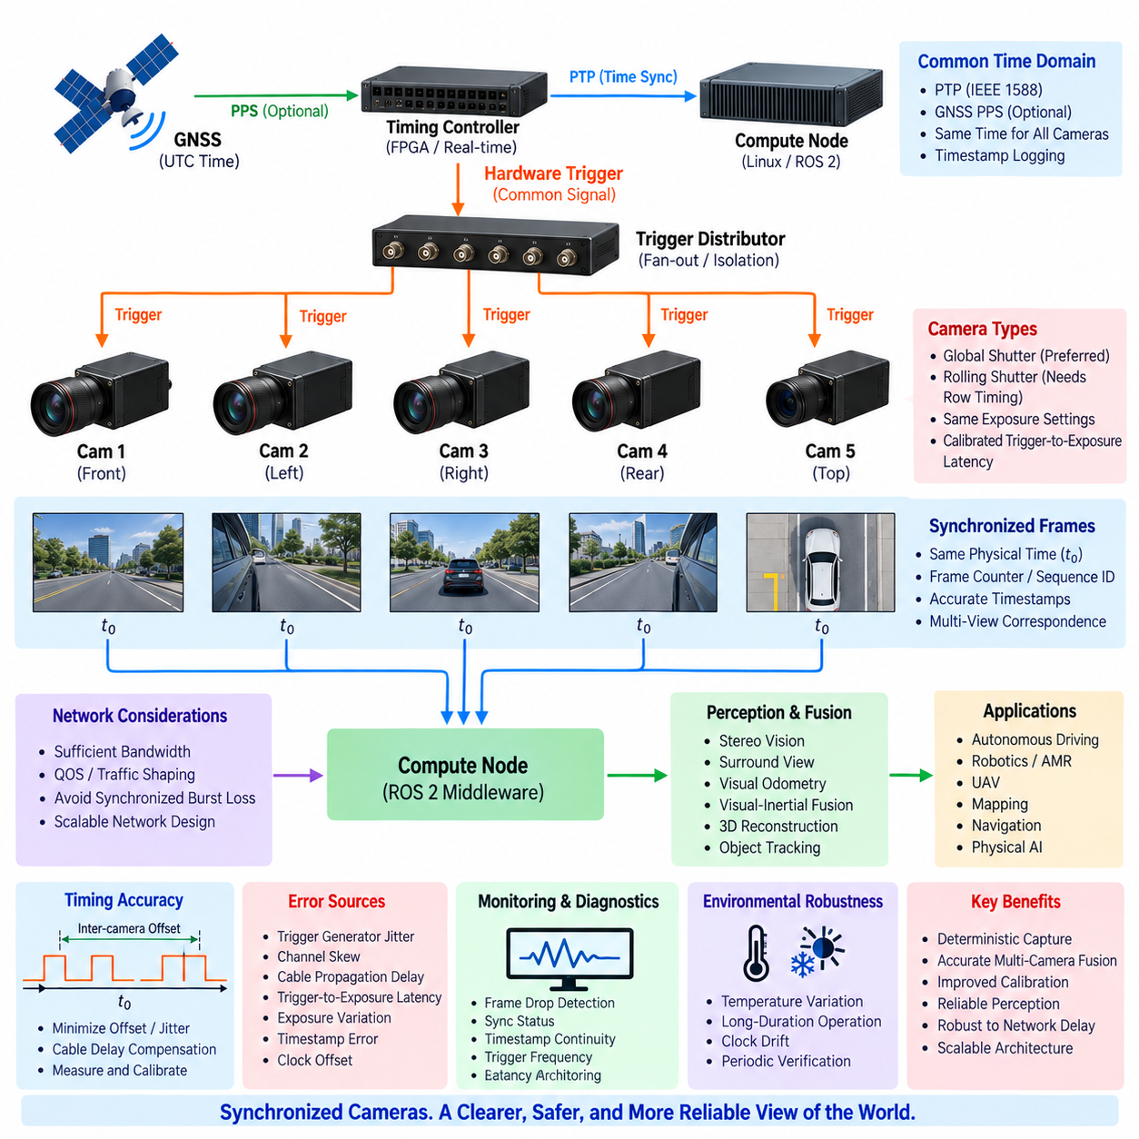
Multi-camera synchronization ensures that images from multiple cameras represent the environment at the same or precisely known physical time. In robotic perception systems, cameras may cover overlapping stereo views, surround fields of view, or independent observation directions. Without temporal alignment, moving objects and platform motion can cause corresponding images to describe different scene states, reducing the accuracy of perception, localization, and reconstruction.
Synchronization requirements depend strongly on the application. A slowly moving indoor AMR may tolerate larger inter-camera offsets than a high-speed outdoor vehicle or UAV. Stereo depth, visual odometry, surround-view perception, object tracking, and sensor fusion can each impose different timing constraints. The required accuracy should therefore be derived from vehicle velocity, angular motion, scene distance, camera resolution, and allowable spatial error.
Hardware triggering provides one of the most deterministic approaches to multi-camera synchronization. A master timing controller generates a common electrical trigger and distributes it to every camera. Each camera begins exposure in response to the same trigger event. Compared with independent software commands, this approach minimizes operating-system scheduling, network communication, driver, and application-level timing variations between cameras.
The trigger distribution network should preferably use a controlled star topology when high synchronization accuracy is required. A central timing or fan-out module provides separate trigger outputs to individual cameras, reducing interaction between branches. Channel-to-channel skew, cable propagation delay, electrical loading, and signal integrity must still be considered because identical trigger generation does not guarantee identical arrival time at every camera input.
Camera synchronization involves more than delivering the same trigger edge. Each camera has an internal trigger-to-exposure latency determined by sensor electronics, image sensor configuration, and readout architecture. Two cameras receiving an identical trigger may begin actual exposure at slightly different times. This fixed offset should be measured and calibrated, while variable trigger-to-exposure jitter determines the achievable synchronization precision.
Global-shutter cameras are particularly suitable for synchronized robotic perception because all pixels can integrate light over essentially the same exposure interval. When several global-shutter cameras receive coordinated triggers, their frames can closely represent a common physical scene state. This simplifies stereo correspondence, multi-view geometry, motion analysis, and fusion with other precisely timestamped perception sensors.
Rolling-shutter cameras require a more detailed temporal model. Although several cameras may receive the same frame trigger simultaneously, individual image rows are exposed sequentially. Rapid translation or rotation can therefore produce different geometric distortions within each image. Multi-camera synchronization must consider row timing, readout direction, exposure duration, and frame timing rather than treating every triggered frame as an instantaneous measurement.
Exposure settings can also affect synchronization quality. Different exposure durations may cause cameras to integrate different intervals of a dynamic scene even when exposure starts are synchronized. Automatic exposure algorithms can independently change integration times unless coordinated. For applications requiring precise multi-view correspondence, exposure duration, frame rate, gain strategy, and synchronization mode should therefore be managed consistently across cameras.
A master–slave camera architecture allows one camera or timing device to establish the acquisition cadence while other cameras follow synchronized signals. This can simplify smaller systems, but the master camera becomes an important dependency. A dedicated timing controller or FPGA can provide a more scalable architecture for larger camera arrays because timing generation is separated from individual perception sensors and can support multiple synchronized output channels.
Precision Time Protocol can complement hardware triggering by providing a common clock across Ethernet-connected cameras and compute nodes. Hardware triggers define when exposure occurs, while PTP provides the time value associated with that event. When both mechanisms reference the same timing domain, each synchronized frame can be assigned an accurate timestamp that remains meaningful throughout recording, processing, sensor fusion, and distributed computation.
Some network cameras support scheduled acquisition using synchronized PTP clocks rather than dedicated trigger wiring. In this architecture, each camera maintains a synchronized local clock and performs exposure at specified times. This reduces dedicated cabling and can improve scalability, but achievable precision depends on camera hardware, clock implementation, network architecture, and exposure scheduling. System-level validation remains necessary.
Frame identification is essential when multiple synchronized image streams enter the compute platform. Each acquisition cycle should ideally have a frame counter, trigger sequence number, or equivalent identifier. Matching only by message arrival time can fail when network congestion, buffering, retransmission, or processing causes one camera stream to arrive later than another even though the underlying exposures were correctly synchronized.
The compute node should preserve original camera acquisition timestamps instead of replacing them with host reception timestamps. Network transmission, driver processing, ROS 2 middleware, image conversion, compression, GPU transfer, and AI inference introduce additional latency after exposure. These delays determine when results become available but should not change the timestamp representing when photons were physically integrated by the image sensor.
Multi-camera systems generate substantial network bandwidth, particularly when high-resolution images, high frame rates, or many cameras are used simultaneously. Triggering all cameras at once can create synchronized traffic bursts that stress Ethernet switches and compute interfaces. Adequate link capacity, Quality of Service, traffic engineering, switch buffering, and distributed camera connections may be necessary to prevent packet loss and excessive reception jitter.
Synchronization and stereo calibration are tightly related. Stereo algorithms assume that corresponding left and right images represent approximately the same scene geometry. If the robot or observed objects move between exposures, temporal offset creates apparent disparity unrelated to depth. This can degrade correspondence matching and produce incorrect depth estimates even when intrinsic and extrinsic camera calibration is geometrically accurate.
Surround-view systems introduce another challenge because neighboring cameras may observe overlapping regions from different orientations. Temporal misalignment can create duplicated, shifted, or discontinuous moving objects when images are stitched or transformed into a common representation. Accurate synchronization therefore improves panoramic perception, bird's-eye-view generation, multi-camera object association, and neural-network feature fusion.
Visual odometry and visual-inertial estimation also benefit from precise camera timing. Camera frames must be related correctly to high-rate IMU measurements so that rotation and translation occurring between observations can be estimated. In multi-camera visual-inertial systems, synchronization errors can appear as inconsistent motion between cameras, increasing state-estimation error and potentially being confused with extrinsic calibration errors.
A synchronization error budget should include trigger-generator jitter, distribution-channel skew, cable-delay differences, camera input detection uncertainty, trigger-to-exposure latency, exposure variation, timestamp error, and clock offset. These contributions determine the actual inter-camera temporal error. Evaluating only the nominal trigger accuracy or PTP specification can significantly underestimate the complete system-level synchronization uncertainty.
Temperature and long-duration operation should also be considered because oscillators, electronics, cable characteristics, and camera processing behavior can change over time. A synchronization architecture that performs correctly during laboratory startup may drift during extended outdoor operation. Continuous clock discipline, timestamp monitoring, and periodic verification help maintain temporal consistency under changing environmental and operational conditions.
The system should detect missing frames and synchronization anomalies during operation. Frame counters and trigger sequence numbers can reveal dropped or duplicated frames, while timestamp comparisons can identify abnormal inter-camera offsets. Diagnostics should monitor trigger frequency, synchronization state, clock offset, frame period, timestamp continuity, and stream latency so that degraded cameras are not silently included in perception processing.
Fault handling should define what happens when one camera loses synchronization while the remaining cameras continue operating. Depending on the application, the affected camera may be excluded from stereo or multi-view fusion, marked as temporally degraded, restarted, or allowed to provide non-synchronized imagery for lower-criticality functions. The fusion system should never assume temporal validity merely because image data continues to arrive.
Verification requires measuring actual optical exposure timing rather than relying only on software timestamps. A precisely controlled flashing LED, moving target, or other optical timing source can be observed simultaneously by multiple cameras. Oscilloscope measurements of trigger outputs and exposure-active signals can then be correlated with captured images to quantify inter-camera offset, jitter, fixed latency, and frame-to-frame stability.
Testing should include startup, steady operation, high network load, CPU and GPU overload, camera reconnection, trigger interruption, PTP Grandmaster transition, different exposure settings, temperature changes, and extended operation. These conditions reveal synchronization failures that may not appear during simple bench testing and allow engineers to establish realistic temporal performance limits for the complete perception architecture.
A robust multi-camera synchronization architecture ultimately combines common time, deterministic acquisition, accurate timestamps, frame identification, controlled networking, temporal calibration, monitoring, and fault handling. When these elements operate together, distributed cameras behave as a coordinated perception array rather than independent image sources, enabling reliable stereo vision, surround perception, visual localization, multi-view fusion, and Physical AI operation.

11.05. LiDAR Camera Time Alignment
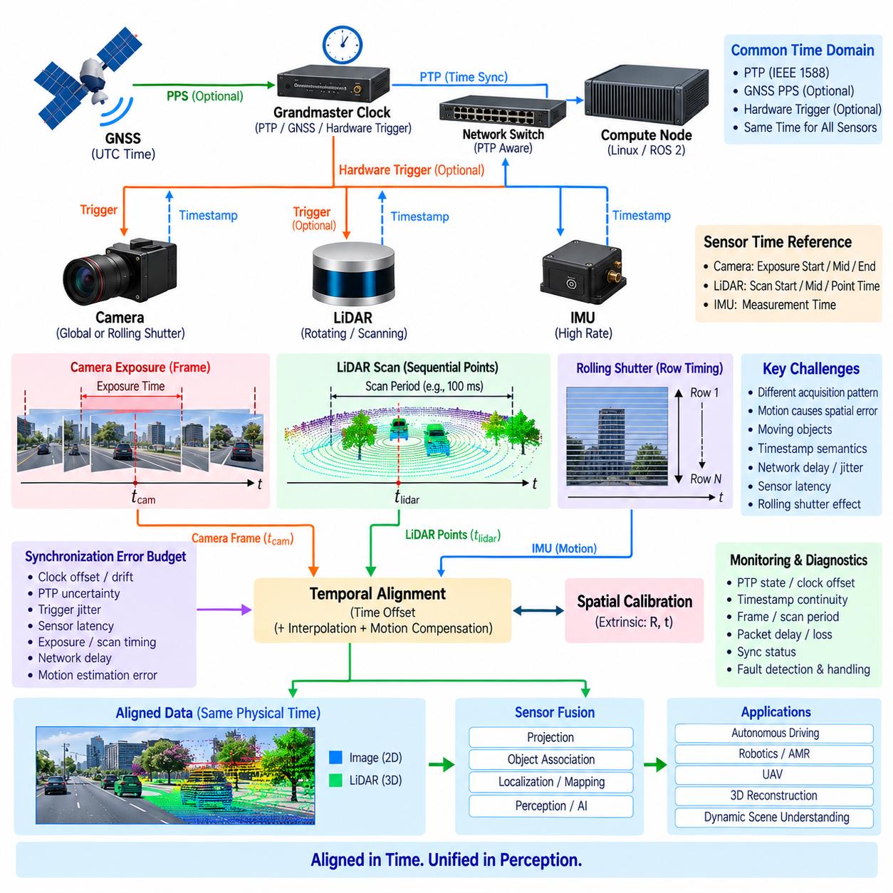
LiDAR–camera time alignment ensures that three-dimensional range measurements and two-dimensional image observations correspond to the same or accurately known physical time. LiDAR and cameras acquire data through fundamentally different mechanisms, so timestamps alone do not guarantee temporal correspondence. Precise alignment is essential for projection, object association, localization, mapping, calibration, and multi-modal perception.
A camera typically captures an image during a defined exposure interval, whereas a LiDAR acquires points sequentially during a scan. A rotating LiDAR may require tens of milliseconds to complete one revolution, meaning that different points in a point cloud represent different physical times. Consequently, aligning one camera timestamp with one LiDAR scan timestamp can introduce significant temporal error when either the robot or surrounding objects are moving.
The first design requirement is a common time domain shared by the LiDAR, camera, and compute platform. Precision Time Protocol, GNSS-derived timing, hardware triggers, PPS, or combinations of these mechanisms can establish this relationship. The synchronization architecture should define which clock is authoritative and how sensor-local timestamps are transformed into the common system time without introducing unknown offset or drift.
Hardware timestamping improves alignment by recording network events close to the Ethernet MAC or PHY rather than after nondeterministic software processing. This reduces uncertainty caused by operating-system scheduling, drivers, queues, and middleware. However, hardware packet timestamps still describe communication events unless the sensor explicitly relates them to acquisition time, so sensor-specific timestamp semantics must remain clearly defined.
Camera timing depends on shutter architecture and exposure configuration. A global-shutter camera can associate an entire image with a narrow common exposure interval, while a rolling-shutter camera exposes individual rows sequentially. For rolling shutter, each image row can correspond to a different physical time. Accurate LiDAR projection may therefore require row-dependent timing rather than treating the complete camera frame as an instantaneous observation.
LiDAR timing is inherently distributed across the point cloud. Individual laser firings, channels, packets, azimuth positions, or points may contain relative timing information referenced to a scan timestamp. High-accuracy systems should preserve this fine-grained timing rather than assigning every point the same scan time. Point-level or packet-level timestamps allow motion compensation and more accurate alignment with camera exposure.
A useful temporal reference must be explicitly selected for both sensors. The camera reference may be exposure start, midpoint, or end, while the LiDAR reference may be scan start, scan midpoint, packet time, or individual point time. Temporal alignment algorithms must understand these definitions before comparing timestamps. Otherwise, two numerically identical timestamps may still represent different stages of physical acquisition.
Robot motion converts temporal error directly into spatial alignment error. If the platform moves between LiDAR measurement and camera exposure, projected LiDAR points can appear shifted from their corresponding image features. Translation produces positional displacement, while rotation can create larger image-plane errors, particularly for distant image regions or during rapid steering, turning, vibration, and UAV attitude changes.
Moving objects create an additional source of misalignment even when the sensor platform itself is stationary. A pedestrian, vehicle, manipulator, or other dynamic object may occupy different positions during LiDAR sampling and camera exposure. Temporal alignment is therefore important not only for ego-motion compensation but also for object detection, 3D bounding-box association, tracking, semantic fusion, and dynamic-scene understanding.
Motion compensation, often called LiDAR deskewing, transforms points acquired at different times into a common reference time. IMU, wheel odometry, visual odometry, or state-estimation outputs can provide the motion trajectory required for this transformation. After deskewing, the point cloud better approximates the geometry that would have been observed at one instant and can be aligned more accurately with the selected camera exposure time.
IMU synchronization is therefore closely related to LiDAR–camera alignment. High-rate inertial measurements describe rotational and translational motion between LiDAR points and camera frames. If IMU timestamps themselves contain offset or drift, deskewing can introduce rather than remove errors. LiDAR, camera, IMU, and compute clocks should consequently belong to a controlled timing architecture rather than being synchronized independently.
Spatial calibration and temporal calibration must be considered together. Extrinsic calibration defines the rigid transformation between the LiDAR and camera coordinate frames, while temporal calibration determines the time offset between their measurements. During motion, a temporal offset can appear similar to an incorrect rotation or translation. Optimizing spatial calibration without accounting for timing can therefore produce parameters that compensate incorrectly for temporal error.
Hardware triggering can provide deterministic relationships where supported. A timing controller may trigger camera exposure while simultaneously generating synchronization events for other sensors or recording the trigger in the common clock domain. Many LiDARs do not accept conventional frame triggers, so PTP or PPS may establish their timebase while the camera uses hardware triggering. The architecture must then connect both mechanisms through one common temporal reference.
PTP is especially useful for Ethernet-based LiDAR and camera systems because it can synchronize device clocks without dedicated timing wiring for every connection. PTP-aware switches and hardware timestamping reduce network-related uncertainty. Nevertheless, PTP synchronization accuracy should not be confused with complete measurement alignment because internal camera exposure latency and LiDAR scan timing remain sensor-dependent and must be characterized separately.
The compute pipeline should preserve original sensor acquisition timestamps through drivers, ROS 2 middleware, recording, preprocessing, and fusion. Replacing acquisition time with host reception time destroys the information required for accurate temporal association. Network delay and processing latency determine when data becomes available, but they should remain separate from the timestamp describing when the environment was physically measured.
Temporal association software usually selects camera frames and LiDAR data according to timestamp differences within a defined tolerance. Simple nearest-neighbor matching may be sufficient for slow systems, while high-dynamic applications require interpolation, point-level correction, or trajectory-based transformation. The association window should be derived from the allowed spatial error rather than chosen only for software convenience.
The synchronization error budget should include clock offset, clock drift, PTP uncertainty, trigger jitter, camera trigger-to-exposure latency, exposure duration, rolling-shutter readout, LiDAR packet timing, point timing, network timestamp uncertainty, and motion-estimation error. These contributions interact, so the complete end-to-end temporal uncertainty can be considerably larger than the specification of any individual synchronization component.
Network architecture also affects operational alignment. High-resolution camera streams and dense LiDAR traffic can create congestion, packet-delay variation, and out-of-order delivery. Sufficient Ethernet bandwidth, Quality of Service, VLAN design, traffic shaping, and PTP-aware switching reduce these effects. Even when acquisition timestamps remain correct, excessive network delay can make temporally aligned data arrive too late for real-time autonomous control.
Alignment quality should be monitored continuously. Diagnostics can observe PTP state, clock offset, timestamp continuity, LiDAR scan period, camera frame period, packet latency, frame drops, and the measured time difference between associated sensor data. Sudden changes can indicate clock loss, sensor restart, network faults, configuration errors, or a transition to a different Grandmaster Clock.
Fault handling should prevent unsynchronized measurements from silently entering high-confidence fusion. If the LiDAR or camera leaves the common time domain, the system can mark the data as temporally degraded, increase association uncertainty, disable selected fusion functions, or enter a reduced-performance mode. Continued packet reception does not prove that the measurements remain temporally valid.
Verification should combine electrical, software, and physical observations. PTP diagnostics and packet captures can verify clock behavior, while trigger signals can be measured with oscilloscopes or logic analyzers. A moving target or controlled optical event observed simultaneously by the camera and LiDAR can expose residual temporal offset after projection, providing an end-to-end test of the complete acquisition and alignment chain.
Dynamic validation is particularly important because temporal errors may be almost invisible when the robot and environment are stationary. Tests should include straight motion, acceleration, braking, rapid rotation, vibration, moving objects, network load, sensor reconnection, PTP failover, and long-duration operation. Projection errors that systematically increase with velocity or angular rate are strong indicators of remaining temporal misalignment.
A robust LiDAR–camera time-alignment architecture ultimately combines a common clock, precise acquisition timestamps, fine-grained LiDAR timing, camera exposure semantics, motion compensation, temporal calibration, spatial calibration, controlled networking, monitoring, and fault handling. Together these mechanisms allow 3D geometry and image information to describe the same dynamic world state, enabling reliable sensor fusion and Physical AI perception.

