Volume 15 Perception and Sensor Architecture

Chapter 07. Radar

07.01. 77GHz FMCW Radar Basics
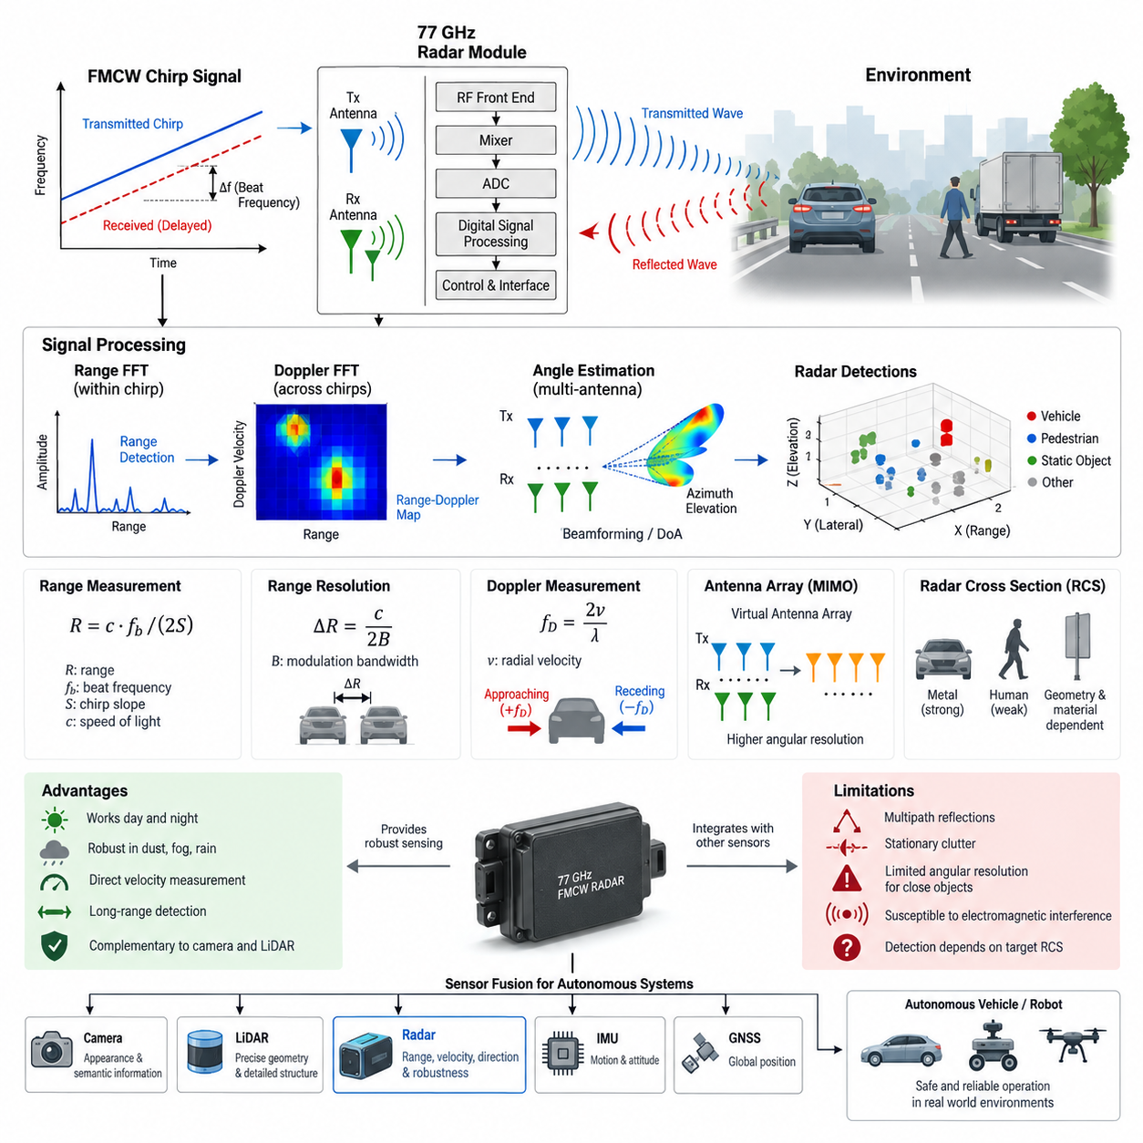
A 77 GHz FMCW radar measures the surrounding environment by transmitting a continuous electromagnetic wave whose frequency changes in a controlled manner over time. Unlike pulse radar, which estimates distance primarily from the travel time of short transmitted pulses, Frequency-Modulated Continuous-Wave radar continuously compares the transmitted waveform with the received reflection. The frequency difference between them, called the beat frequency, contains information about the distance and motion of reflecting objects.
The 77 GHz band is widely used for automotive and robotic perception because its short wavelength enables compact antenna structures, relatively narrow beams, and high angular resolution when combined with antenna arrays. A frequency of 77 GHz corresponds to a wavelength of approximately 3.9 mm in free space. This millimeter-wave characteristic allows multiple transmitting and receiving antenna elements to be integrated into a relatively small radar module suitable for vehicles, outdoor AMRs, mobile robots, and autonomous platforms.
In a typical FMCW radar, the transmitted frequency increases linearly during a time interval called a chirp. If the transmitted signal encounters an object, part of its electromagnetic energy is reflected toward the radar. Because the reflected signal has traveled to the object and back, it arrives after a propagation delay. During this delay the transmitter frequency has continued changing, creating a measurable frequency difference between the current transmitted signal and the delayed received signal.
The radar receiver mixes the transmitted signal with the received reflection to produce the beat signal. For a stationary target, the beat frequency is approximately proportional to the round-trip propagation delay and therefore to target range. If the chirp slope is defined by the transmitted bandwidth divided by the chirp duration, the range can be obtained from the beat frequency, the speed of light, and the chirp slope. This conversion forms the fundamental ranging mechanism of FMCW radar.
Range resolution is primarily determined by modulation bandwidth rather than carrier frequency alone. For an ideal FMCW system, range resolution can be approximated as ΔR = c/(2B), where c is the speed of light and B is the frequency sweep bandwidth. Increasing bandwidth therefore allows two closely spaced objects to be separated more effectively in range. This relationship is important when selecting radar hardware for robots operating near vehicles, walls, pedestrians, vegetation, infrastructure, or other obstacles.
Moving objects introduce an additional frequency shift caused by the Doppler effect. When a target approaches the radar, its reflected waveform experiences a Doppler shift different from that of a receding target. Practical FMCW systems transmit sequences of chirps and analyze changes across those chirps to distinguish range-related beat frequencies from motion-related Doppler frequencies. Consequently, radar can estimate both target distance and radial velocity from a sequence of received measurements.
Digital radar processing commonly organizes samples into two dimensions. Samples collected within each chirp are processed using a Fast Fourier Transform to estimate range, while corresponding samples across multiple chirps are processed using another FFT to estimate Doppler velocity. The resulting range-Doppler representation separates detected energy according to both distance and radial motion. Detection algorithms can then identify peaks representing potential objects while suppressing thermal noise, interference, and unwanted background reflections.
Angular information is obtained using multiple receiving antennas positioned at known spatial intervals. A reflected wave reaches individual antenna elements with slightly different phases because of their different physical positions. By measuring these phase relationships, the radar processor can estimate the direction from which the reflection originated. Digital beamforming, angle FFT processing, and more advanced direction-of-arrival algorithms can transform these phase differences into azimuth and, with suitable antenna geometry, elevation estimates.
Modern radar devices often use Multiple-Input Multiple-Output antenna architectures to increase the effective aperture without requiring an equally large number of physical receiver channels. Multiple transmitting antennas illuminate the environment according to a defined transmission scheme, while multiple receiving antennas capture the reflections. Their combinations form a virtual antenna array. This virtual aperture improves angular discrimination and enables increasingly dense radar detections for perception systems used in autonomous machines.
The basic radar measurement can therefore be understood through four connected domains: transmitted chirps establish the modulation structure, propagation delay provides range information, Doppler variation provides radial velocity, and antenna-array phase differences provide direction. Signal processing combines these measurements into radar detections containing parameters such as range, velocity, azimuth, elevation when supported, signal strength, and confidence. These detections may subsequently be converted into object lists or radar point clouds.
Radar Cross Section describes how strongly an object reflects electromagnetic energy toward the radar and depends on considerably more than physical object size. Material properties, geometry, orientation, surface structure, polarization, and viewing angle can strongly affect returned power. A large metallic structure may produce an intense reflection, while some objects may return substantially weaker signals. Consequently, radar detection performance must be evaluated using representative targets and operating environments rather than range specifications alone.
Millimeter-wave radar has important environmental advantages for outdoor autonomous systems. Because it does not depend on visible illumination, it can operate during daytime and nighttime without requiring external light. Radar can also remain useful in conditions that degrade optical sensors, including dust, mist, spray, moderate precipitation, glare, and low-contrast scenes. Its direct sensitivity to radial velocity is especially valuable for detecting approaching vehicles, moving machinery, pedestrians, and other dynamic obstacles.
Radar nevertheless has limitations that must be considered in perception architecture. Multipath reflections can create detections that do not correspond directly to physical object locations, while highly reflective surfaces can generate complex returns. Objects with similar range and velocity may be difficult to separate when angular resolution is insufficient. Stationary clutter can dominate some environments, and electromagnetic interference from other radar systems may degrade measurements unless waveform design and interference mitigation are properly implemented.
Detection processing therefore extends beyond FFT calculations. Practical radar systems estimate background noise, identify statistically significant signal peaks, group related detections, and reject measurements unlikely to represent meaningful objects. Constant False Alarm Rate processing is commonly used to adapt detection thresholds according to surrounding signal conditions. Subsequent clustering and tracking stages can combine individual radar detections over time to produce more stable estimates of object position, velocity, and trajectory.
For robotic perception, radar is usually treated as a complementary sensor rather than a complete replacement for cameras or LiDAR. Cameras provide rich appearance and semantic information, while LiDAR can provide precise geometric measurements and detailed spatial structure. Radar contributes robust range measurement, direct radial-velocity information, long-distance detection capability, and resilience under difficult environmental conditions. Sensor fusion can exploit these different physical sensing principles to reduce dependence on any single modality.
The electrical architecture of a 77 GHz radar includes more than the radio-frequency front end. A practical module contains transmitting and receiving antenna structures, RF generation and mixing circuitry, analog signal conditioning, analog-to-digital conversion, digital signal processing, embedded control, power regulation, timing functions, and external communication interfaces. Depending on system requirements, processed detections may be delivered through CAN, CAN FD, Automotive Ethernet, or other interfaces to an edge computer or perception controller.
Installation geometry directly influences usable radar information. The mounting height, pitch, yaw, field of view, antenna orientation, nearby metallic structures, robot body panels, and sensor covers can alter propagation and introduce unwanted reflections. A radar mounted on an outdoor AMR must therefore be treated as part of the complete electromagnetic and mechanical system. Calibration establishes the relationship between the radar coordinate frame and the robot coordinate frame so that measurements can be fused correctly with other sensors.
In autonomous robots, the greatest value of 77 GHz FMCW radar emerges when physical measurement principles, antenna design, digital signal processing, mechanical integration, communication, calibration, and sensor fusion are considered together. The radar is not merely a distance sensor; it is a multidimensional perception device capable of observing range, radial motion, direction, and reflected signal characteristics. These capabilities make it an important sensing modality for robust outdoor AMR and autonomous-system perception architectures.

07.02. CAN/Ethernet Radar Interface
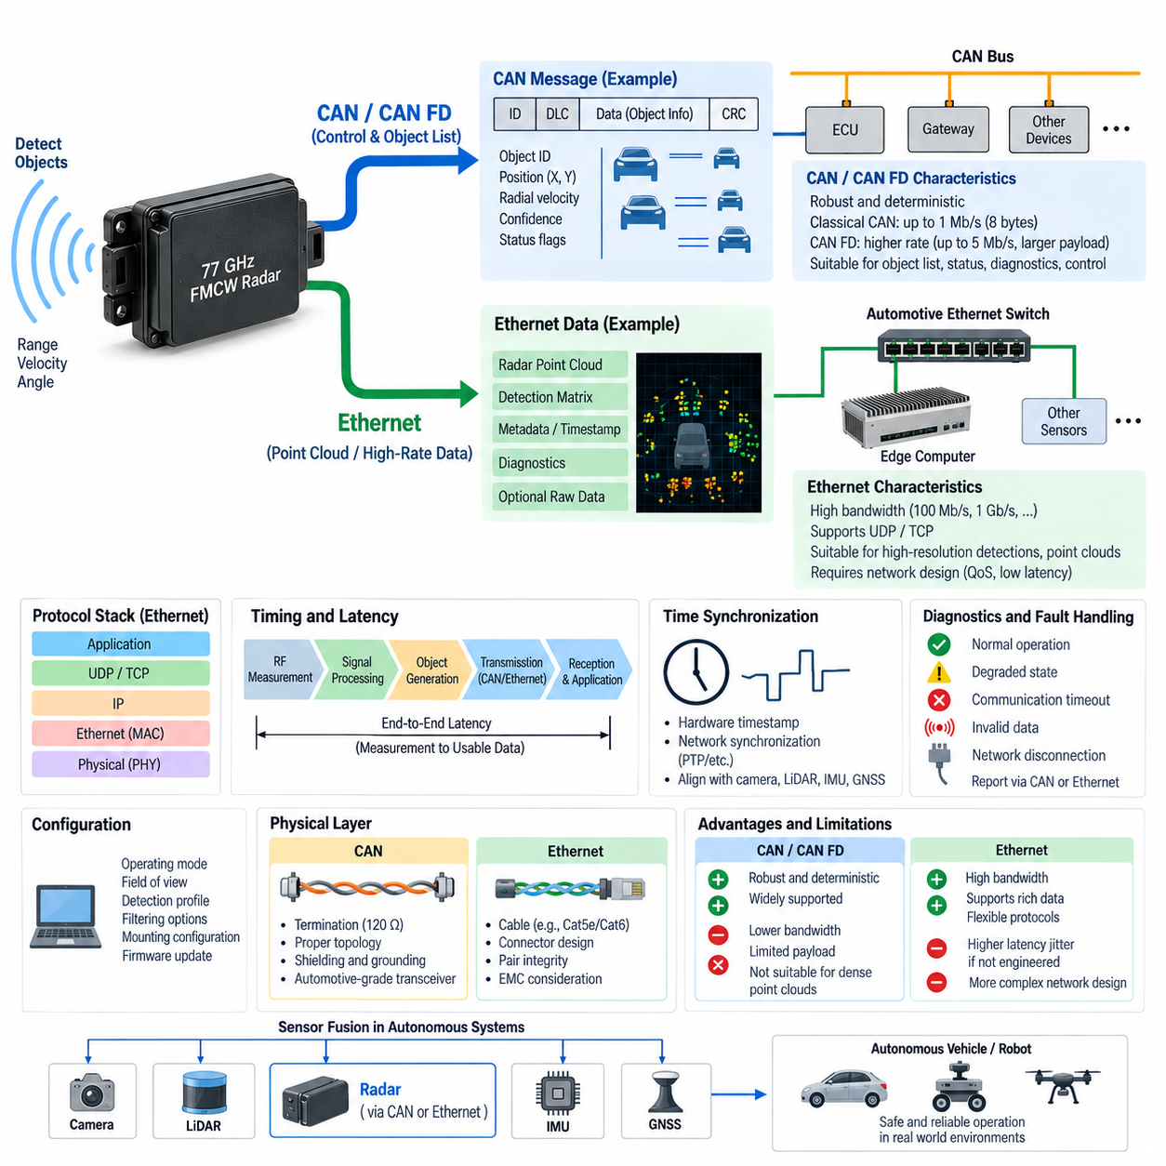
A radar interface defines how detection information, diagnostic status, configuration data, timing information, and raw or processed measurements move between the radar sensor and the vehicle or robot computing architecture. In 77 GHz radar systems, CAN and Ethernet represent two fundamentally different communication approaches. CAN emphasizes deterministic control-oriented communication and robustness, while Ethernet provides substantially greater bandwidth for data-intensive perception workloads.
CAN is widely used when a radar outputs compact information such as tracked-object lists, detected-object attributes, sensor health, operating state, and diagnostic messages. Instead of transmitting every internal radar measurement, the sensor performs substantial signal processing locally and sends only selected results. A message may contain object identifier, longitudinal and lateral position, radial velocity, confidence, status flags, and related parameters encoded into predefined CAN frames.
Classical CAN provides excellent robustness and predictable arbitration behavior, but its limited payload and communication rate constrain the amount of radar information that can be transported. This is generally acceptable for conventional object-list radar because dozens of tracked objects can be represented using multiple compact messages. However, increasingly dense radar detections, high-resolution point clouds, and advanced imaging-radar outputs can exceed the practical capacity of Classical CAN.
CAN FD extends the CAN architecture by allowing larger data fields and higher data rates during the payload portion of a frame. This makes it useful for radar systems requiring more information than Classical CAN can efficiently transport while retaining much of the familiar CAN ecosystem. Nevertheless, CAN FD remains primarily suitable for control, diagnostics, status information, and moderately sized detection outputs rather than continuous high-volume radar measurement streams.
A radar connected through CAN normally shares a bus with an electronic control unit, gateway, edge controller, or other embedded devices. CAN identifiers determine message priority, while the receiver reconstructs radar information according to a defined communication database or interface specification. Signal scaling, offset, signed representation, byte order, update rate, timeout behavior, invalid values, and fault states must be defined precisely because incorrect interpretation can produce erroneous perception information.
Ethernet becomes increasingly important as radar resolution and output density increase. A radar that generates hundreds or thousands of detections per measurement cycle requires considerably more bandwidth than a conventional object-list sensor. Ethernet allows the sensor to transfer richer radar point clouds, detection matrices, metadata, diagnostic information, and in some architectures intermediate processing results to an edge computer where perception algorithms perform clustering, tracking, classification, and sensor fusion.
Automotive Ethernet provides a particularly useful physical network technology for mobile platforms because it combines high communication capacity with wiring approaches designed for embedded environments. Depending on radar and system architecture, links may operate at 100 Mb/s, 1 Gb/s, or higher rates. The required link capacity should be determined from actual radar output size, measurement frequency, protocol overhead, diagnostic traffic, synchronization requirements, and engineering margin rather than nominal sensor update rate alone.
Ethernet radar communication normally uses a protocol stack above the physical link. UDP is frequently appropriate for high-rate perception data because it introduces relatively low transport overhead and does not require retransmission of every lost packet. TCP can be useful where reliable ordered delivery is more important than minimum latency, particularly for configuration, file transfer, software maintenance, or selected diagnostic functions. The protocol choice should therefore reflect the semantics of each radar data stream.
For real-time perception, losing an occasional old measurement may be preferable to retransmitting it after it has already become temporally irrelevant. This characteristic makes UDP attractive for cyclic radar detections and point-cloud streams. However, UDP itself does not guarantee delivery, ordering, or duplicate suppression, so the application layer should provide sequence counters, timestamps, packet identifiers, payload-length validation, and other integrity mechanisms needed to detect missing or malformed radar data.
Packetization becomes an important design consideration when radar output exceeds the practical payload of one Ethernet packet. A radar frame may need to be divided into multiple packets and reconstructed by the receiving computer. Each packet should be associated with the correct radar measurement cycle, and incomplete frames must be handled deliberately. Poor packet management can create mixed measurements, stale detections, variable latency, or corrupted point clouds even when the physical Ethernet connection itself is operating correctly.
Latency is not simply the transmission time across CAN or Ethernet. End-to-end radar latency includes electromagnetic measurement, chirp acquisition, ADC sampling, internal FFT processing, detection processing, object generation, interface buffering, network transmission, receiving-stack processing, and application scheduling. For autonomous robots, the relevant engineering quantity is therefore the time between the physical observation of the environment and availability of usable radar information to the perception or control algorithm.
CAN can provide highly predictable behavior when bus loading and message priorities are engineered correctly, but increasing bus utilization raises arbitration delay and reduces timing margin. Radar messages should therefore be included in the complete CAN communication budget rather than added independently. Critical status or object messages may receive higher-priority identifiers, while configuration and diagnostic traffic can use lower-priority communication paths to prevent interference with time-sensitive perception information.
Ethernet offers much higher bandwidth, but high bandwidth alone does not guarantee deterministic latency. Switch queues, operating-system scheduling, socket buffering, competing network traffic, packet bursts, and software processing can introduce jitter. A perception network should therefore be engineered as an end-to-end system. Traffic separation, quality-of-service mechanisms, suitable switch architecture, controlled network utilization, hardware timestamping, and real-time software techniques may be required when timing accuracy is important.
Time synchronization is particularly important when radar information is fused with camera, LiDAR, IMU, or GNSS measurements. Each radar measurement must represent a known observation time rather than merely the time at which a packet arrived at the edge computer. Ethernet architectures can support precise network-based synchronization and hardware timestamping, while CAN-based architectures may use synchronized clocks, periodic time references, or gateway-assisted timing strategies depending on system requirements.
The timestamp should ideally correspond as closely as possible to the actual radar measurement epoch. If software assigns a timestamp only after reception, variable processing and network delays become embedded in the apparent measurement time. This can produce spatial errors during vehicle or robot motion. The problem becomes increasingly significant at higher platform speeds, during rapid rotation, or when combining radar velocity information with geometrically precise LiDAR and camera measurements.
Radar interface design must also address diagnostics and fault handling. The receiving controller should detect communication timeout, counter mismatch, invalid payload, radar initialization failure, degraded sensor state, synchronization loss, and network disconnection. CAN systems commonly communicate such states through status frames and diagnostic services, while Ethernet systems can combine cyclic health messages with network supervision and application-level diagnostics. A missing radar stream must never be silently interpreted as an empty environment.
Configuration communication should be separated conceptually from perception output. Parameters such as radar operating mode, field of view, detection profile, filtering options, mounting configuration, or software state may require controlled write access. The interface should prevent unintended configuration changes during operation and provide a defined startup sequence. Version compatibility between radar firmware, communication definitions, and perception software is equally important for maintaining consistent interpretation of sensor data.
Physical-layer engineering remains essential for both interface types. CAN requires correct termination, topology, grounding, shielding, transceiver selection, and wiring practices. Ethernet requires appropriate cable category, connector design, pair integrity, shielding strategy where applicable, and electromagnetic compatibility consideration. Radar modules are often mounted near motors, DC/DC converters, high-current wiring, wireless equipment, and other noise sources, making EMC-aware routing and grounding important to reliable communication.
A practical autonomous platform may use both interfaces simultaneously. Ethernet can carry high-rate radar detections or point clouds to the perception computer, while CAN or CAN FD carries sensor status, diagnostics, wake-up information, operational commands, or safety-related state. This hybrid architecture avoids forcing every radar function onto one communication technology and allows each network to be used according to its strengths in bandwidth, determinism, compatibility, diagnostics, and system integration.
The appropriate interface therefore depends on where radar intelligence is processed. A smart radar that internally performs detection, clustering, and tracking can send a compact object list over CAN or CAN FD. A high-resolution radar intended to expose dense detections to centralized AI perception generally benefits from Ethernet. The architectural decision is consequently not simply CAN versus Ethernet; it is a partitioning decision that determines which radar processing functions execute inside the sensor and which execute on the edge computer.
For outdoor AMRs and advanced autonomous systems, a scalable design commonly places high-volume perception traffic on Ethernet while retaining CAN or CAN FD for low-bandwidth control and diagnostic functions when required. The edge computer can then receive radar together with camera and LiDAR streams, align them using timestamps, and perform sensor fusion. A carefully engineered radar interface thus connects RF sensing to the larger perception architecture through controlled bandwidth, timing, integrity, diagnostics, and fault-management mechanisms.

07.03. Radar Point Cloud
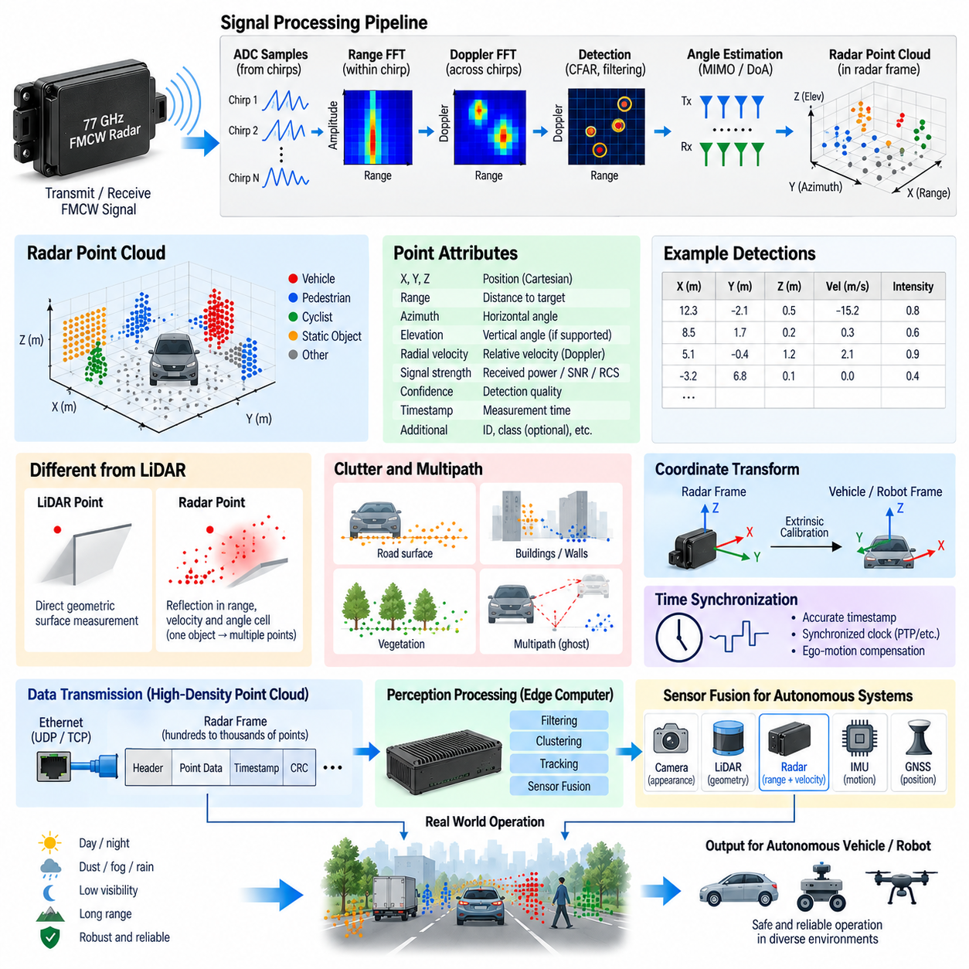
Radar point clouds represent radar measurements as spatially distributed detections rather than only as predefined tracked objects. Each point corresponds to a reflection that has passed through the radar signal-processing and detection pipeline and may contain range, azimuth, elevation, radial velocity, reflected signal strength, and confidence information. This representation exposes more of the physical sensing result to downstream perception software and allows an edge computer to interpret the environment beyond the radar sensor’s internal object model.
The generation of a radar point cloud begins with FMCW signal acquisition. Samples collected within individual chirps contain range-related information, while measurements across repeated chirps contain Doppler information. Multiple receiving antenna channels provide phase relationships used for angular estimation. Range FFT, Doppler FFT, detection processing, and direction-of-arrival estimation progressively transform raw ADC samples into detections located within the radar coordinate frame.
A radar point should not be interpreted in exactly the same way as a LiDAR point. A LiDAR point usually represents a relatively direct geometric observation of a reflecting surface, whereas a radar detection represents electromagnetic energy associated with a resolved range, velocity, and angular cell. One physical object may therefore generate several radar points, a single strong point, unstable reflections, or different detection patterns as its orientation, material, distance, and surrounding environment change.
The fundamental attributes of a radar point typically include range and direction. Range specifies the radial distance between the radar and the detected reflection, while azimuth describes its horizontal direction relative to the radar coordinate frame. Radars with suitable antenna arrays may additionally estimate elevation. These measurements can be converted from polar or spherical coordinates into Cartesian coordinates such as x, y, and z for integration with robotic perception and mapping software.
Radial velocity is one of the most distinctive properties of radar point clouds. FMCW radar obtains Doppler information directly from the received electromagnetic signal, allowing individual detections to carry relative velocity along the radar line of sight. Positive and negative velocity conventions depend on the implementation, but the measurement can distinguish approaching and receding reflections. This capability makes radar especially useful for identifying dynamic objects and estimating motion before full object tracking has been established.
Signal strength provides additional information about each radar return. Depending on the radar implementation, this may be represented by received power, amplitude, signal-to-noise ratio, Radar Cross Section, or another normalized intensity measure. Strong signal strength does not necessarily indicate a large object because radar reflection depends on material, geometry, orientation, multipath conditions, and frequency-dependent electromagnetic behavior. Intensity should therefore be interpreted together with spatial and temporal information.
Detection algorithms determine which signal peaks become point-cloud elements. After range-Doppler processing, the radar observes a measurement space containing desired reflections, thermal noise, interference, and clutter. Constant False Alarm Rate processing can establish adaptive detection thresholds according to surrounding noise conditions. Measurements exceeding the required threshold become candidate detections, while additional filtering may reject low-confidence or physically implausible results before point-cloud generation.
Point-cloud density depends strongly on radar architecture and processing configuration. Conventional automotive radar may produce relatively sparse detections, while high-resolution or imaging radar can generate substantially denser spatial measurements. More points can improve object shape interpretation and clustering, but density alone does not determine perception quality. Angular resolution, range resolution, velocity resolution, detection stability, false-alarm behavior, update rate, and measurement uncertainty are equally important.
Angular resolution is particularly important because radar point clouds can be much less geometrically precise than LiDAR point clouds in the lateral direction. Two objects at similar range and radial velocity may appear difficult to separate when their angular spacing is smaller than the radar’s effective resolution. Larger antenna apertures, MIMO virtual arrays, digital beamforming, and advanced direction-of-arrival estimation can improve separation and produce more useful point distributions for autonomous perception.
Radar point clouds also contain clutter. Reflections from road surfaces, walls, fences, vegetation, metallic structures, machinery, and other stationary objects can create numerous detections. Some clutter is valuable because it describes the environment, while other detections may interfere with dynamic-object perception. Filtering strategies can use radial velocity, signal strength, spatial location, persistence, and environmental models to distinguish useful measurements from unwanted returns without indiscriminately removing stationary obstacles.
Multipath creates a more difficult class of radar point-cloud artifact. Electromagnetic waves can reflect between the target, ground, walls, vehicles, or other structures before returning to the radar. The resulting propagation path may correspond to a range or direction that does not represent the target’s direct physical position. Such ghost detections can persist across multiple frames, making simple threshold filtering insufficient. Temporal consistency and multi-sensor reasoning are therefore valuable for identifying suspicious measurements.
Before radar points can be fused with other sensors, their coordinate system must be defined precisely. The radar naturally measures detections relative to its own sensor frame, while the autonomous platform usually operates with robot, vehicle, odometry, map, or world coordinate frames. Extrinsic calibration determines the rotation and translation between the radar and platform reference frame. Incorrect mounting parameters can systematically shift every radar point and degrade clustering, tracking, and sensor fusion.
Time alignment is equally important for moving platforms. Each point cloud should be associated with the actual radar measurement time rather than only the network reception time. If the robot translates or rotates between radar acquisition and fusion processing, uncompensated timing error causes the point cloud to appear spatially displaced relative to camera or LiDAR measurements. Accurate timestamps, synchronized clocks, and ego-motion compensation become increasingly important as platform speed and sensor latency increase.
Radar point clouds are commonly transported to an edge computer through Ethernet when detection density is high. A point record may contain coordinates, velocity, intensity, quality indicators, and metadata, while a complete radar frame may contain hundreds or thousands of such records. Packet sequence information, frame identifiers, timestamps, and integrity checks are required so that the receiving software can reconstruct each measurement cycle correctly and reject incomplete or corrupted data.
Once received by the perception computer, radar points can undergo filtering, clustering, association, and tracking. Spatial clustering groups neighboring detections that may originate from the same physical object, while velocity information provides another dimension for separating targets. Tracking algorithms then associate clusters or individual detections across successive frames. The result can evolve from a low-level radar point cloud into stable object hypotheses containing position, velocity, trajectory, size estimates, and confidence.
Ego-motion must be considered when interpreting radar velocity. The measured Doppler velocity is relative to the moving radar rather than automatically representing absolute object velocity in the world. A stationary wall can therefore exhibit apparent radial motion when the robot itself moves. Vehicle or robot velocity obtained from wheel odometry, IMU, GNSS, visual odometry, or fused localization can be used to compensate radar measurements and distinguish platform motion from independently moving objects.
Sensor fusion increases the semantic value of radar point clouds. Radar provides robust distance and direct radial-velocity measurements, LiDAR contributes precise geometric structure, and cameras provide appearance and semantic information. When their coordinate frames and timestamps are aligned, radar points can support camera detections during poor visibility, add velocity evidence to LiDAR clusters, or preserve dynamic-object awareness when optical sensing is degraded by darkness, glare, dust, fog, or precipitation.
Radar point clouds should therefore be regarded as probabilistic perception measurements rather than exact three-dimensional reconstructions. Every detection has uncertainty associated with range, angle, velocity, signal strength, and detection processing. A robust autonomous system preserves or models this uncertainty instead of treating all points as equally accurate. Confidence values, covariance estimates, sensor characteristics, temporal consistency, and cross-sensor agreement can all contribute to more reliable downstream interpretation.
For outdoor AMRs, autonomous vehicles, UAVs, and other Physical AI platforms, radar point clouds provide a useful bridge between traditional object-list radar and centralized AI perception. They expose richer measurement information while retaining radar’s ability to observe range and motion under challenging environmental conditions. When combined with accurate calibration, synchronization, Ethernet transport, filtering, clustering, tracking, ego-motion compensation, and multi-sensor fusion, radar point clouds become an important component of robust perception architecture.

07.04. Radar Power and Mounting
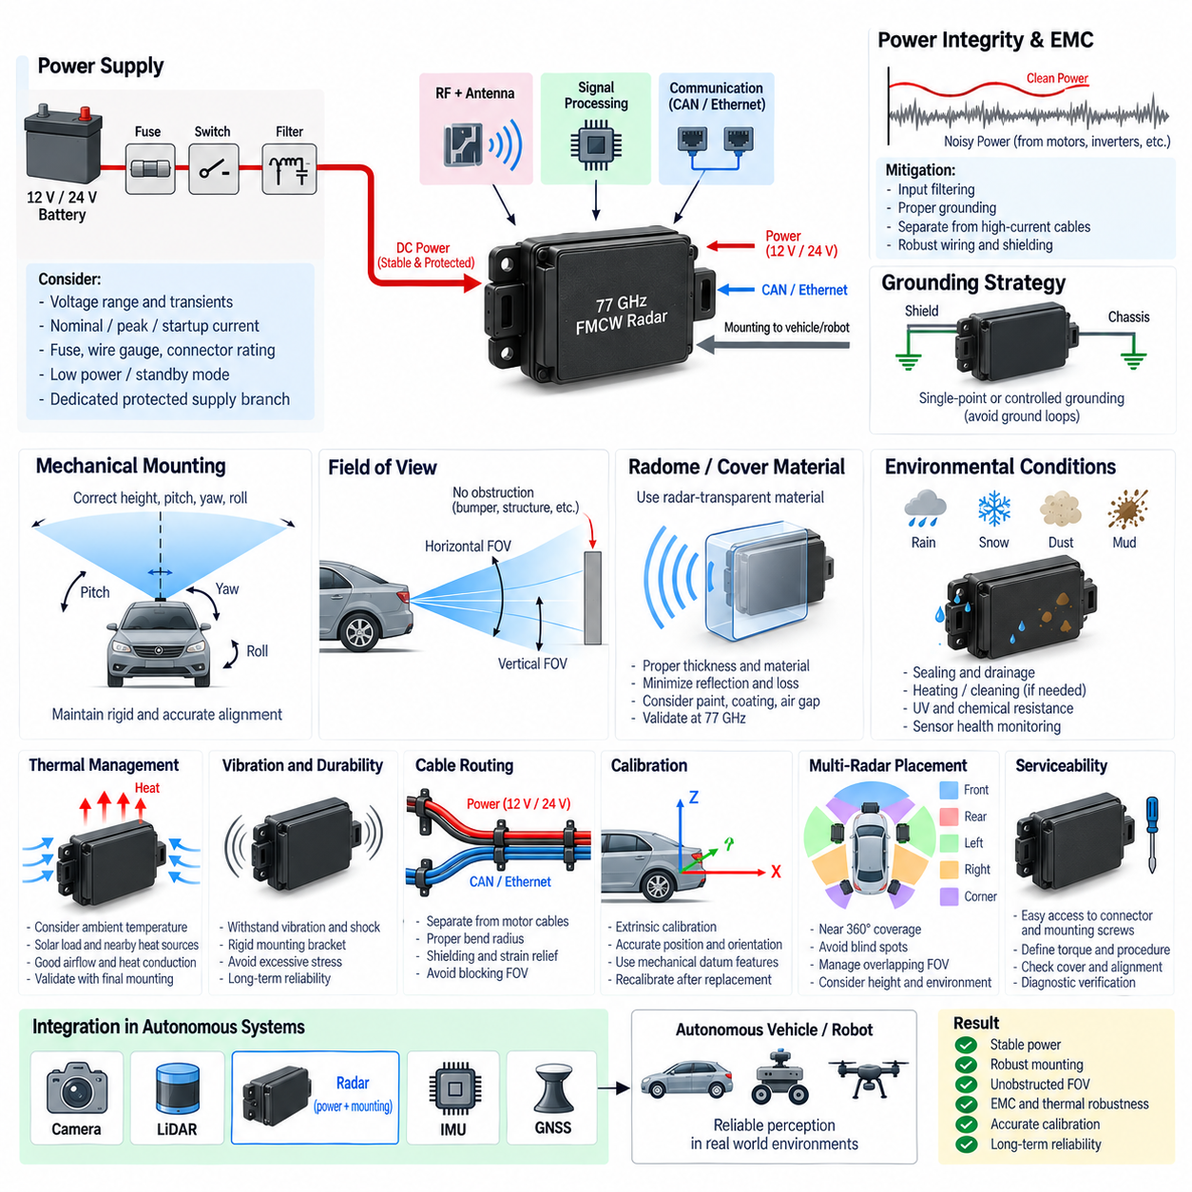
Radar power and mounting design directly affect sensing reliability, measurement stability, thermal behavior, electromagnetic compatibility, and long-term durability. A 77 GHz radar may appear to be a compact sensor, but it combines RF circuitry, antennas, signal processing, power conversion, and communication electronics inside one enclosure. The electrical supply and mechanical installation must therefore be engineered as part of the complete perception architecture rather than treated as simple auxiliary connections.
Radar modules commonly operate from vehicle or robot low-voltage power domains such as 12 V or 24 V, although the exact allowable range depends on the sensor design. The nominal system voltage alone is insufficient for power-interface definition because battery charging, DC/DC converter behavior, transient events, startup conditions, and wiring voltage drop can change the voltage presented to the radar. The interface must remain within the sensor’s specified operating and survival limits under all expected conditions.
Power budgeting should consider both steady-state consumption and transient demand. Radar electronics may change operating states during initialization, RF transmission, signal processing, communication, diagnostics, or thermal management. The system designer should therefore determine nominal power, peak current, startup current, and low-power or standby consumption where applicable. These values influence DC/DC converter sizing, fuse selection, connector rating, wire gauge, and the total energy budget of an autonomous platform.
A dedicated protected supply branch is generally preferable for perception sensors. The radar power path can include a fuse or electronic protection device, switching element, filtering network, connector, and local regulation inside the sensor. Protection should isolate wiring or sensor faults without unnecessarily disabling unrelated perception equipment. In multi-radar architectures, individual or logically grouped protection can improve fault containment and simplify diagnosis when one sensor develops an electrical failure.
Voltage drop must be evaluated from the power source to the radar connector, particularly when sensors are mounted far from the main power distribution unit. Cable resistance, connector contact resistance, current, temperature, and harness length all contribute to supply loss. A radar that operates correctly during laboratory testing may reset intermittently on a robot if the voltage at its connector falls below the minimum requirement during battery sag, motor acceleration, or simultaneous high-current loads.
Power-supply noise is another important consideration because radar contains sensitive RF and analog circuitry. Motors, inverters, motor drivers, DC/DC converters, relays, and switching power supplies can inject conducted disturbances into the electrical system. Input filtering, appropriate grounding, suitable cable routing, and separation from high-current switching paths help prevent these disturbances from affecting radar operation. Filtering must be designed without creating unacceptable voltage drop or unstable interaction with the radar input circuitry.
Grounding strategy should be consistent with the overall robot electrical architecture. The radar power return, chassis connection where provided, cable shielding, communication reference, and enclosure mounting can create unintended current paths if designed independently. Ground loops and high-frequency common-mode currents may degrade communication or electromagnetic compatibility. The installation should therefore define where shields terminate, how the enclosure relates electrically to chassis, and how sensor return current reaches the power source.
Startup and shutdown behavior should also be controlled. Some platforms switch radar power directly, while others provide permanent supply and use wake-up or communication commands to control operating state. The selected strategy should account for initialization time, communication readiness, diagnostic checks, edge-computer startup, and safe shutdown. If perception software begins before the radar is ready, the system should distinguish normal initialization from communication failure instead of reporting an immediate sensor fault.
Mechanical mounting establishes the radar’s physical relationship to the environment and therefore directly influences measurement geometry. The mounting bracket must maintain the intended position, height, pitch, yaw, and roll during operation. Even a small angular error can create significant lateral or vertical position error at long range. Mounting tolerance must consequently be derived from perception accuracy requirements rather than only from mechanical packaging convenience.
The radar field of view must remain free from unintended obstruction. Robot body panels, bumpers, structural members, lamps, cables, fasteners, accessories, and payload equipment can partially block or distort the transmitted and received electromagnetic waves. A mechanically convenient location is not automatically a good RF location. The complete installation should be evaluated for the radar’s horizontal and vertical field of view as well as nearby structures that may generate strong reflections.
When a radar is installed behind a protective cover or radome, the material becomes part of the RF design. Cover thickness, dielectric properties, curvature, surface coatings, paint, air gaps, and mounting angle can influence transmission loss and reflection at millimeter-wave frequencies. Materials that appear transparent to visible light or ordinary radio systems are not necessarily transparent at 77 GHz. The radome should therefore be selected and validated specifically for the radar frequency band.
Water, ice, snow, mud, dust, and condensation on the radar cover can alter electromagnetic propagation or reduce usable sensing performance. Outdoor AMRs require installation positions that limit contamination while preserving the intended field of view. Mechanical design may incorporate drainage, surface geometry, environmental sealing, heating, or cleaning strategies when necessary. Sensor-health monitoring should also recognize that a powered and communicating radar can still have degraded perception because its sensing surface is obstructed.
Structural stiffness is important because vibration can change radar orientation and eventually damage connectors, brackets, or internal assemblies. Radar mounts should tolerate vibration generated by motors, wheels, suspension, rough terrain, and impacts expected during operation. Excessively flexible brackets can cause dynamic pointing errors even when the static calibration is correct. At the same time, mounting structures should avoid unnecessary mass and should not transfer severe mechanical stress into the sensor enclosure.
Thermal conditions must be considered together with mounting. Radar electronics dissipate heat while solar radiation, enclosed body panels, nearby processors, motors, and power electronics can increase ambient temperature. A mounting location with poor airflow may cause the sensor enclosure temperature to exceed expectations even when electrical power consumption is modest. Thermal design should evaluate worst-case ambient temperature, solar loading, internal dissipation, conductive heat paths, and available convection.
The radar enclosure and bracket can participate in heat transfer, depending on sensor construction. Direct attachment to a metallic structure may provide a useful conductive path, while thermally insulating mounts can retain heat inside the module. However, thermal improvements must not compromise RF performance, electrical isolation requirements, vibration behavior, or corrosion resistance. Temperature validation should therefore be performed using the final mounting configuration rather than evaluating the radar as an isolated bench component.
Environmental protection includes more than temperature. Outdoor radar installations may experience rain, humidity, salt, dust, pressure washing, vibration, shock, ultraviolet exposure, and chemical contamination. Connector orientation and cable routing should prevent water accumulation and reduce mechanical loading on seals. Service loops and strain relief should protect the connector from harness forces while avoiding excessive cable movement that could lead to fatigue during long-term robot operation.
Cable routing must coordinate power integrity, communication integrity, EMC, and mechanical durability. Radar power and CAN or Ethernet cables should be routed away from high-current motor phases and noisy switching nodes where practical. Minimum bend radius, abrasion protection, connector strain relief, shielding continuity, and service accessibility should be considered simultaneously. Harness routing should also prevent cables from entering the radar field of view or creating unwanted reflective structures near the antenna.
Extrinsic calibration links mechanical installation to perception software. The radar’s position and orientation relative to the robot reference frame must be represented accurately so that radar detections can be transformed into a common coordinate system. Mechanical datum features can improve repeatability during assembly and replacement. If a radar is removed for service and reinstalled with significant positional variation, recalibration may be required before its measurements can be reliably fused with camera or LiDAR data.
Multiple-radar systems require additional mounting analysis because each sensor must provide useful coverage without excessive blind regions or problematic overlap. Front, rear, side, and corner radars may be arranged to achieve near-surround perception, but their fields of view, mounting heights, structural obstructions, and coordinate transformations must be considered together. Overlapping coverage can improve redundancy and tracking, while poor placement can create unnecessary duplicate detections or persistent reflection artifacts.
Serviceability should be included from the beginning of the design. Technicians should be able to inspect the connector, wiring, mounting hardware, cover condition, and sensor alignment without dismantling major sections of the robot. Replacement procedures should define fastening torque, mounting datum, connector locking, calibration requirements, and diagnostic verification. Good service design reduces the risk that a correctly functioning replacement radar is installed with an incorrect orientation or compromised electrical connection.
For outdoor AMRs and other autonomous platforms, radar power and mounting therefore form a single engineering problem connecting electrical architecture, mechanical packaging, RF propagation, EMC, thermal management, environmental protection, calibration, and maintenance. Reliable radar perception requires stable power, controlled grounding, protected communication, rigid and accurate alignment, an unobstructed RF field of view, and validated environmental performance throughout the platform’s operating life.

07.05. Radar in Outdoor AMR/UAV
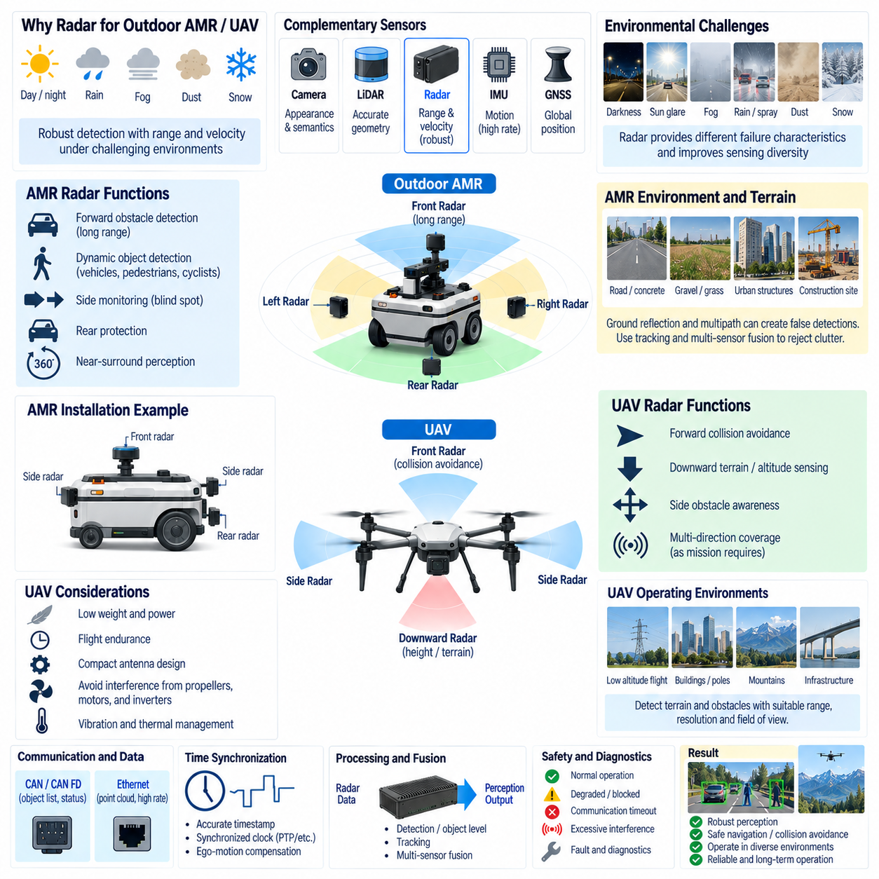
Outdoor AMRs and UAVs operate in environments where perception sensors must remain useful despite changing illumination, weather, terrain, vibration, dust, and long sensing distances. Radar provides a complementary sensing principle based on electromagnetic reflection rather than visible light. In these platforms, 77 GHz FMCW radar is particularly valuable because it can measure range and radial velocity directly while maintaining useful detection capability under conditions that can degrade cameras or LiDAR.
For an outdoor AMR, radar can support forward obstacle detection, dynamic-object detection, side monitoring, rear protection, and near-surround perception. Vehicles, pedestrians, bicycles, construction equipment, walls, guardrails, and other objects can generate radar returns that contribute to navigation and collision avoidance. Unlike a purely geometric sensor, radar also provides Doppler velocity, allowing the perception system to distinguish important motion patterns before a complete object trajectory has been established.
Radar placement on an outdoor AMR depends on vehicle geometry and required coverage. A forward-facing radar can provide long-range detection along the primary driving direction, while side and corner radars can reduce blind regions around the platform. Rear radar supports reversing and monitoring of approaching objects. Multiple sensors can create overlapping fields of view, improving continuity as objects move from one sensing region to another and providing redundancy when one viewing direction becomes partially obstructed.
Outdoor AMRs frequently encounter environmental conditions that challenge optical perception. Darkness, direct sunlight, glare, shadows, fog, dust, water spray, and moderate precipitation can reduce camera contrast or degrade LiDAR returns. Radar is not immune to environmental effects, but its millimeter-wave sensing mechanism provides a different failure characteristic. Combining radar with camera and LiDAR therefore increases sensing diversity and reduces the probability that one environmental condition simultaneously degrades all perception channels.
Terrain also affects radar interpretation. Roads, concrete, grass, gravel, curbs, slopes, metallic infrastructure, fences, parked vehicles, and buildings can create strong or complex reflections. Ground reflections and multipath may generate detections that do not correspond directly to physical obstacle locations. Outdoor AMR perception software should therefore evaluate radar measurements over time and use geometric constraints, Doppler information, tracking, and cross-sensor agreement to distinguish useful objects from clutter and ghost detections.
Radar velocity information becomes especially useful when an AMR shares space with moving vehicles or pedestrians. A camera can classify an approaching vehicle and LiDAR can estimate its geometry, while radar can directly measure its radial motion. Sensor fusion can combine these properties into a more stable dynamic-object estimate. This capability supports collision-risk assessment, time-to-collision estimation, path planning, and speed control in logistics yards, industrial sites, ports, campuses, roads, and other mixed-traffic environments.
Radar can also support ego-motion estimation indirectly. Stationary environmental structures observed from a moving robot exhibit Doppler patterns related to the robot’s own motion. With suitable processing, these measurements can contribute to radar odometry or provide additional motion constraints when GNSS, visual odometry, or LiDAR localization becomes unreliable. Radar should generally be treated as another complementary localization source rather than as a replacement for the platform’s primary navigation architecture.
UAV radar integration introduces a different geometric problem because sensing occurs in three-dimensional flight space. Depending on the mission, radar may be directed forward for collision avoidance, downward for terrain or altitude-related sensing, sideways for obstacle awareness, or arranged in multiple directions. UAV applications benefit from compact millimeter-wave antennas, but sensor placement must consider the airframe, landing gear, payload, propulsion system, and required field of view.
For low-altitude UAV operation, radar can assist in detecting terrain, structures, poles, vehicles, and other obstacles where sufficient radar reflection and resolution are available. Downward-looking radar can contribute to height or ground-relative measurements, while forward radar can supplement camera or LiDAR obstacle detection. The suitability of a specific radar depends strongly on its minimum and maximum range, angular coverage, resolution, update rate, antenna pattern, processing architecture, and target characteristics.
UAV motion creates additional interpretation challenges. Translation, pitch, roll, and yaw continuously change the radar coordinate frame relative to the environment. A detection measured during aircraft rotation can rapidly shift in the body frame even when the target itself is stationary. Accurate IMU information, timestamps, extrinsic calibration, and coordinate transformation are therefore essential. Ego-motion compensation can transform radar measurements into a stabilized navigation or world frame before tracking and sensor fusion.
Propellers, motors, inverters, and rotating structures can also influence UAV radar integration. Electrically, high-current propulsion systems can create conducted and radiated electromagnetic disturbances. Mechanically, vibration can change sensor orientation or stress mounting structures. Radar power routing, grounding, shielding, communication wiring, bracket stiffness, and separation from noisy propulsion components must therefore be engineered together with the airframe rather than added after the flight system has been completed.
Weight and power consumption are particularly important for UAVs because every sensor affects payload capacity and flight endurance. Radar selection must consider sensor mass, mounting structure, cable mass, power conversion losses, processor requirements, and thermal management. A high-resolution radar may provide richer perception data but can also require greater electrical and computing resources. The appropriate design balances perception performance against aircraft energy, mass, thermal, and payload constraints.
Outdoor AMRs usually have more available electrical power and payload capacity than small UAVs, allowing multiple radars, larger edge computers, and more extensive sensor redundancy. UAVs often require stricter optimization of sensor count and processing location. Some radar processing can occur inside the sensor to reduce communication bandwidth and edge-compute demand, while high-resolution systems may transmit point clouds through Ethernet for centralized processing. Functional partitioning should reflect platform constraints.
Communication architecture depends on the radar output type. Compact tracked-object information and sensor status can be transported through CAN or CAN FD, which is useful for embedded control and diagnostic integration. Dense radar point clouds and high-rate detections are better suited to Ethernet. Outdoor AMRs can use switched Ethernet perception networks, while UAV implementations may require lightweight high-speed links and careful bandwidth allocation among radar, cameras, navigation sensors, and flight-control systems.
Time synchronization becomes critical when radar is combined with other sensors. A moving AMR can travel a measurable distance during processing and network delay, while a UAV can translate and rotate significantly over short intervals. Radar timestamps should therefore correspond closely to the actual measurement epoch. Hardware timestamping or synchronized clocks allow radar detections to be aligned with camera frames, LiDAR scans, IMU measurements, and GNSS data before multi-sensor fusion.
Sensor fusion should exploit the physical strengths of each modality rather than simply combine all available measurements. Cameras provide semantic appearance, LiDAR provides accurate spatial geometry, radar provides robust range and radial velocity, IMU provides high-rate motion information, and GNSS provides global positioning outdoors. A fusion architecture can use radar to confirm moving targets, preserve detections during poor visibility, improve velocity estimation, and provide complementary evidence when another sensor becomes uncertain.
Radar data can be processed at several abstraction levels. Low-level or detection-level fusion uses radar points before object formation, allowing centralized algorithms to combine detailed measurements. Object-level fusion uses tracks already generated inside the radar, reducing bandwidth and computational demand. Intermediate approaches can transmit clustered detections with velocity and confidence. The appropriate level depends on radar capability, network bandwidth, edge-compute performance, software architecture, and required perception flexibility.
Safety-related use requires explicit handling of radar degradation and failure. Communication timeout, invalid data, excessive interference, blocked sensor surfaces, power faults, synchronization loss, and internal diagnostic states should be propagated to the autonomous system. A radar that stops producing detections must not automatically be interpreted as evidence that the environment is clear. The perception architecture should distinguish valid empty measurements from unavailable or degraded sensing and adjust robot behavior accordingly.
Environmental contamination is particularly relevant for outdoor platforms. Mud, snow, ice, water, dust, or foreign material on a radar cover can alter RF transmission even when the electronics remain fully operational. AMR body design can use suitable placement, drainage, protective geometry, heating, or cleaning where necessary. UAV installations must similarly consider rain, icing, condensation, and airflow. Environmental qualification should evaluate the complete installed sensor configuration rather than only the standalone radar module.
Multi-radar AMRs can use overlapping coverage to improve tracking and reduce blind zones. A target detected by a front radar can transition into a corner or side radar as the robot passes it. The perception system must transform all detections into a common coordinate frame and avoid treating the same physical target as multiple independent objects. Accurate extrinsic calibration, synchronized measurements, data association, and track management are therefore essential in surround-radar architectures.
For UAVs, multiple radar directions can provide broader spatial awareness but introduce greater mass, power, communication, and calibration complexity. Sensor count should be derived from the actual flight mission and hazard geometry. A cargo UAV operating near infrastructure may require substantially different coverage from a small inspection UAV. Radar architecture should therefore be mission-driven, with sensing range, field of view, redundancy, installation geometry, and failure behavior defined from operational scenarios.
Radar ultimately provides outdoor AMRs and UAVs with a perception channel whose physical characteristics differ substantially from optical sensing. Its direct velocity measurement, long-range potential, day-and-night operation, and resilience under challenging visibility make it valuable for robust Physical AI systems. When integrated with correct power design, mounting, calibration, synchronization, communication, ego-motion compensation, diagnostics, and multi-sensor fusion, radar becomes an important component of dependable autonomous operation.

