Volume 16 Compute and AI Architecture

Chapter 05. GPU Server

05.01. A100/H100 Cluster Design
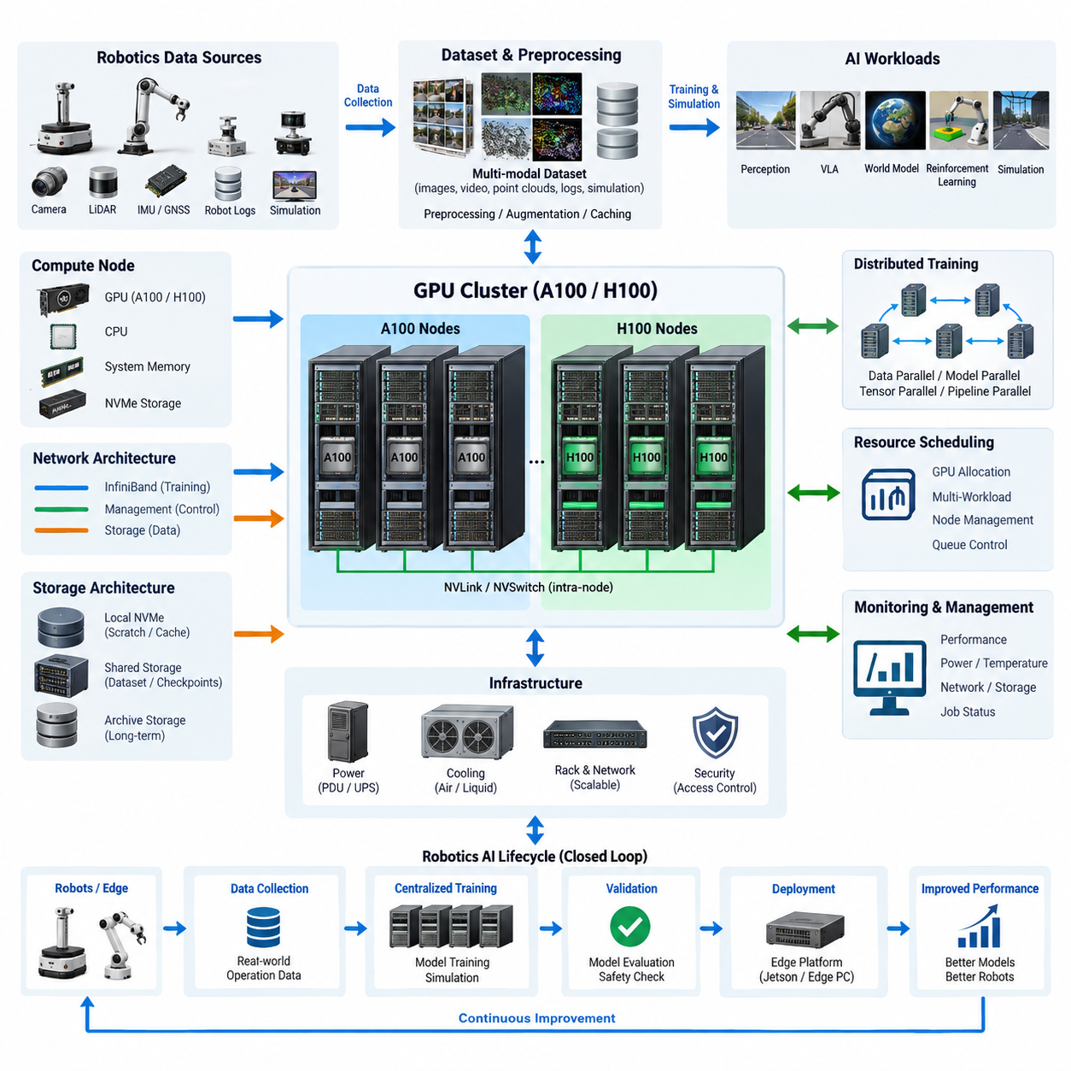
GPU clusters based on NVIDIA A100 and H100 accelerators provide the centralized computing foundation required for large-scale AI training, simulation, synthetic data generation, and model optimization in robotics. Within a robotics compute architecture, the cluster complements embedded Jetson platforms and edge PCs by executing workloads whose memory capacity, computational intensity, or training duration exceeds the practical limits of robot-mounted hardware.
A cluster should be designed as a complete computing system rather than as a collection of independent GPU servers. Compute nodes, accelerator topology, CPU resources, system memory, local storage, high-speed networking, shared storage, power distribution, cooling, scheduling, and monitoring must be engineered together. A bottleneck in any one subsystem can prevent expensive GPUs from reaching their expected utilization and significantly increase model development time.
A100 and H100 GPUs represent different generations of data-center acceleration and may coexist during infrastructure evolution. A100 nodes remain effective for many deep-learning, simulation, and data-processing workloads, while H100 nodes provide substantially higher performance for modern transformer-oriented training and large-scale mixed-precision computation. Cluster architecture should therefore classify workloads before assigning them to particular GPU generations.
GPU count alone is not a sufficient measure of cluster capability. Memory capacity per GPU, memory bandwidth, tensor computation capability, inter-GPU communication, host-to-device transfer performance, and workload scalability collectively determine useful performance. Large vision models, vision-language-action models, world models, multimodal foundation models, and high-resolution perception networks can place very different demands on these resources.
Inside a multi-GPU server, high-bandwidth GPU interconnection is essential because distributed training repeatedly exchanges parameters, gradients, activations, and synchronization information. NVLink and NVSwitch-based configurations reduce communication overhead compared with architectures that depend primarily on conventional PCIe paths. The objective is to make several physical GPUs behave as efficiently as possible as one tightly coupled computational domain.
The cluster network extends this communication domain across multiple servers. When a training job spans several nodes, network latency and bandwidth become part of the training critical path. High-speed InfiniBand or comparable low-latency fabrics are therefore normally separated from ordinary management Ethernet. This allows distributed GPU traffic to operate without competing with administration, monitoring, software deployment, and general storage-management communication.
A practical design separates networks according to their functions. A management network handles operating-system access, orchestration, monitoring, and administrative traffic, while a high-performance fabric carries distributed training communication. Storage traffic may use an additional dedicated path where dataset throughput is substantial. Such separation improves predictability and simplifies diagnosis when performance degradation occurs during large training jobs.
CPU and system-memory sizing must support the accelerators rather than merely satisfy minimum server requirements. CPUs execute data loading, preprocessing, augmentation, decompression, orchestration, and portions of simulation workloads. Insufficient CPU cores or memory bandwidth can leave GPUs waiting for input. Large host memory is also valuable for dataset caching, simulation processes, preprocessing pipelines, and workloads involving extensive metadata.
Storage architecture should be hierarchical. High-performance local NVMe storage provides temporary datasets, caches, checkpoints, and scratch space close to each compute node. Shared high-capacity storage maintains authoritative datasets, experiment outputs, model artifacts, and reusable training resources. Archival storage can preserve historical datasets and validated model versions without consuming the highest-performance storage tier.
Robotics workloads make storage design particularly demanding because training data is highly multimodal. Camera images and video, LiDAR point clouds, radar measurements, GNSS and IMU streams, robot telemetry, ROS bags, simulation outputs, annotations, and synthetic datasets may be consumed simultaneously. The data pipeline must deliver these streams quickly enough that accelerator utilization is not constrained by file access, decoding, or preprocessing.
Distributed training software converts the physical cluster into a usable AI platform. Training frameworks divide models, batches, or tensors across GPUs and coordinate collective communication between workers. Data parallelism is effective when models fit within individual GPU memory, while model, tensor, or pipeline parallelism becomes necessary as model size increases. The selected strategy must correspond to both network topology and accelerator memory capacity.
Resource scheduling is equally important because robotics organizations rarely run only one workload. Perception training, reinforcement learning, VLA development, world-model experiments, simulation, synthetic data generation, validation, and inference benchmarking may compete for the same infrastructure. A scheduler should allocate GPUs, CPUs, memory, storage, and node groups while preventing one experiment from unintentionally monopolizing shared resources.
Cluster topology should reflect expected scaling behavior. A small installation may begin with one multi-GPU node and later expand into several interconnected nodes. Designing network switches, rack space, power distribution, cooling capacity, storage bandwidth, and addressing schemes for expansion avoids disruptive redesign. Modular growth is especially useful when A100 resources are initially available but newer H100-class nodes are introduced later.
Reliability becomes increasingly important as training duration grows. A multi-day training job can be interrupted by GPU faults, network failures, storage problems, operating-system crashes, or facility-level power events. Regular checkpointing, redundant storage paths, hardware monitoring, job restart mechanisms, and reproducible software environments reduce the cost of such failures. Fault handling should therefore be considered part of the training architecture.
Power density is a fundamental design constraint for GPU clusters. Multiple high-end accelerators, CPUs, memory modules, NVMe devices, network adapters, and fans can create substantial rack-level electrical demand. Power supplies, PDUs, circuit capacity, UPS strategy, and facility distribution must be sized for sustained operation rather than average utilization. Expansion planning should reserve electrical capacity before additional GPU nodes are installed.
Cooling design must follow actual heat generation and airflow characteristics. Dense GPU servers produce concentrated thermal loads, and inadequate airflow can cause component throttling even when nominal room temperature appears acceptable. Rack placement, hot-aisle and cold-aisle organization, fan capability, inlet temperature, exhaust management, and potentially liquid-cooling support should be evaluated together with expected sustained GPU utilization.
Monitoring should combine infrastructure and AI workload information. GPU temperature, power consumption, memory usage, utilization, communication activity, CPU load, storage throughput, network congestion, and job status provide complementary views of system health. A GPU showing low utilization does not necessarily indicate insufficient workload; the root cause may instead be slow storage, preprocessing limitations, synchronization delay, or network contention.
Software environments should be reproducible across cluster nodes. GPU drivers, CUDA libraries, communication libraries, machine-learning frameworks, simulation packages, ROS-related tools, and project dependencies must remain compatible. Containerized environments are particularly useful because different robotics projects may require conflicting software versions. Reproducibility also allows a validated training environment to be restored when hardware nodes are replaced or upgraded.
Security boundaries are necessary because centralized AI infrastructure may contain valuable robot datasets and proprietary models. User authentication, role-based access, network segmentation, encrypted administrative access, controlled dataset permissions, audit logging, and protected model repositories should be incorporated from the beginning. On-premise deployment can strengthen data control, but physical ownership alone does not automatically provide adequate security.
The cluster should connect naturally to the wider robotics AI lifecycle described by the compute architecture. Robots and edge systems collect operational data, centralized infrastructure prepares datasets and performs training, validation systems evaluate resulting models, and approved artifacts are deployed back to edge platforms. This creates a closed development loop between field experience, centralized learning, model verification, and distributed robot execution.
For Physical AI, the GPU cluster increasingly serves purposes beyond conventional supervised learning. It can train multimodal perception models, world models, VLA systems, reinforcement-learning policies, and foundation models while also supporting large-scale simulation. Synthetic environments can generate rare events, safety scenarios, environmental variations, and interaction sequences that would be difficult or expensive to collect entirely from physical robots.
Simulation and training may share the same infrastructure but have different resource characteristics. Training often emphasizes tensor throughput and high-speed GPU communication, whereas simulation can demand substantial CPU resources, graphics processing, memory, and storage I/O. Separating workload queues or reserving node classes for specific purposes can prevent simulation jobs from degrading tightly synchronized distributed-training workloads.
A100-to-H100 migration should consequently be treated as architectural evolution rather than simple GPU replacement. Existing A100 nodes can continue supporting preprocessing, established training pipelines, simulation, evaluation, or medium-scale experiments while H100 resources are concentrated on computationally intensive foundation-model and multimodal training. This tiered allocation increases infrastructure lifetime and reduces unnecessary consumption of premium accelerators.
Capacity planning should ultimately begin with measurable workloads: dataset size, model parameter count, precision, batch size, training frequency, expected completion time, simulation concurrency, checkpoint volume, and number of simultaneous development teams. These requirements can then be translated into GPU count, memory requirements, network bandwidth, storage throughput, rack power, and cooling capacity instead of selecting hardware primarily from theoretical peak performance.
A well-designed A100/H100 cluster therefore forms the centralized intelligence-production layer of a robotics computing ecosystem. Its purpose is not simply to maximize GPU quantity, but to maintain balanced data movement, scalable communication, reliable operation, controlled power and thermal behavior, and reproducible AI workflows. When these elements are engineered as one system, the cluster becomes a sustainable foundation for progressively larger Physical AI models and robot fleets.

05.02. InfiniBand Network
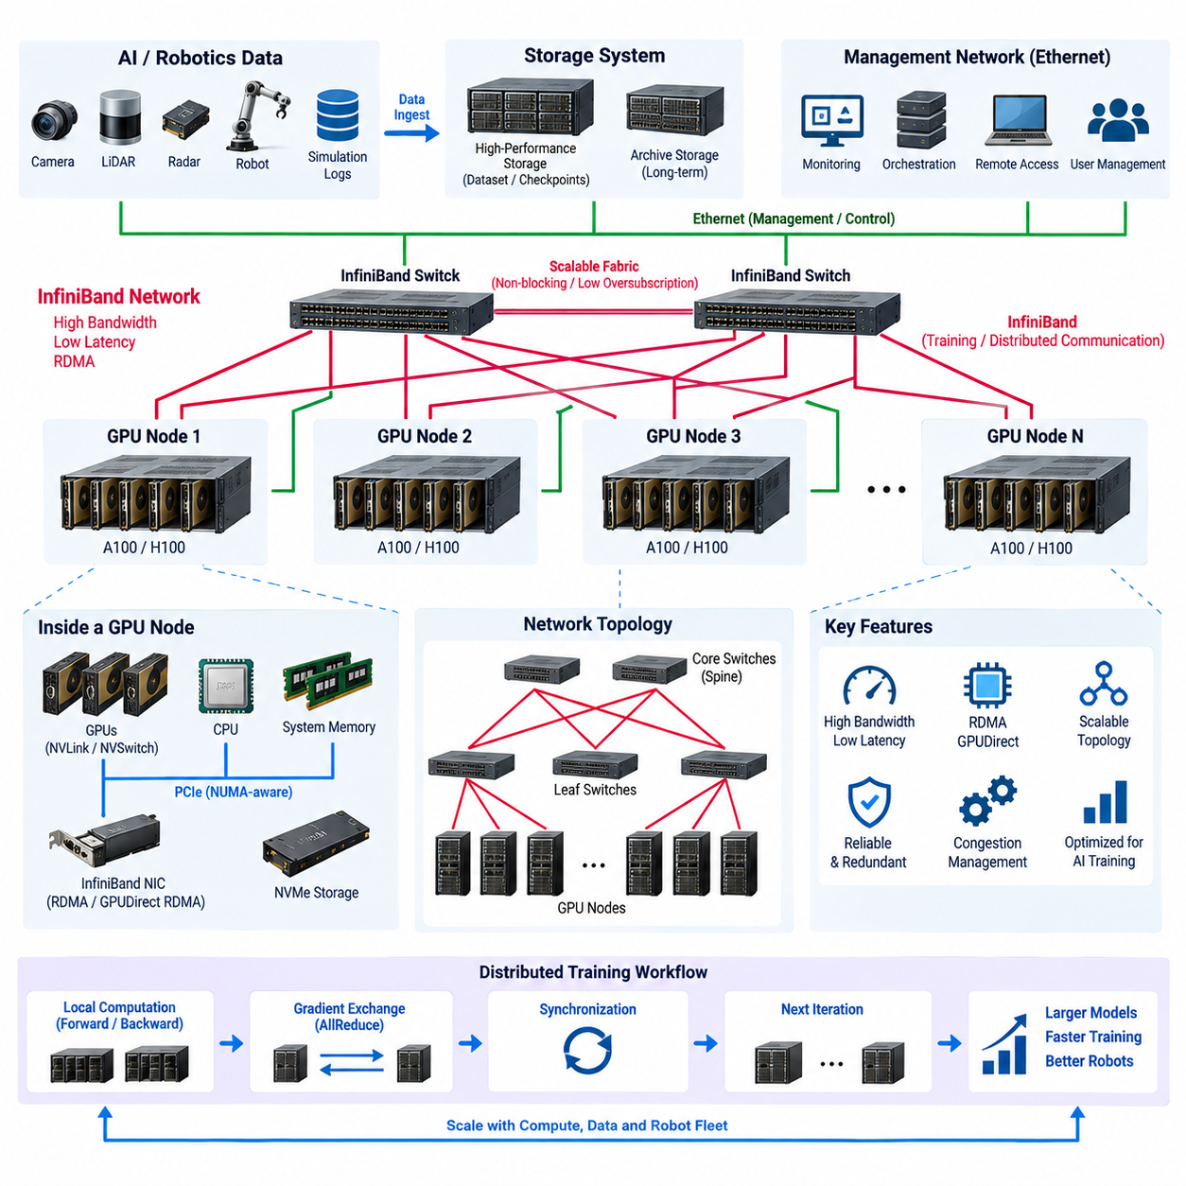
InfiniBand is a high-performance interconnect architecture designed for environments where extremely low latency, high bandwidth, and predictable communication are required between compute nodes. In an A100 or H100 GPU cluster, it forms the primary network fabric for distributed AI training, allowing multiple GPU servers to exchange gradients, parameters, activations, tensors, and synchronization data without depending on conventional Ethernet paths.
The importance of InfiniBand increases as training expands beyond a single multi-GPU server. GPUs within one server can communicate through PCIe, NVLink, or NVSwitch, but these technologies do not directly provide the inter-node fabric required across multiple servers. InfiniBand extends high-speed communication from the node level to the cluster level, enabling distributed applications to treat physically separated GPU systems as a coordinated computational resource.
An effective cluster therefore contains multiple communication domains. NVLink and NVSwitch provide high-bandwidth communication between GPUs inside a node, while InfiniBand connects GPU nodes across the cluster. Conventional Ethernet can remain responsible for management, monitoring, software installation, remote access, and general services. Separating these functions prevents administrative traffic from interfering with latency-sensitive distributed training communication.
InfiniBand performance is characterized by both bandwidth and latency. High link bandwidth allows large tensors and gradient buffers to move rapidly between nodes, while low latency reduces the cost of frequent synchronization operations. Both properties are important because distributed training does not simply transfer large files. It repeatedly performs communication operations during training iterations, making communication delay directly visible in total training time.
Distributed data-parallel training illustrates this requirement clearly. Each GPU or group of GPUs processes a portion of a training batch and calculates local gradients. These gradients must then be exchanged and combined before the next optimization step proceeds. Collective operations such as AllReduce therefore become part of the critical training path. If network communication is slow, GPUs may remain idle while waiting for synchronization even when their computational capability is extremely high.
Remote Direct Memory Access, commonly called RDMA, is a fundamental mechanism behind high-performance InfiniBand communication. RDMA allows data to move between memory regions of different systems with limited CPU involvement and fewer software-layer transitions than conventional network processing. This reduces CPU overhead and communication latency while allowing processors to concentrate on data preparation, simulation, orchestration, and other supporting workloads.
GPU clusters can extend this principle through direct GPU-oriented communication mechanisms such as GPUDirect RDMA. Instead of repeatedly staging communication data through host CPU memory, suitable configurations can transfer data more directly between GPU memory and the network interface. Reducing unnecessary memory copies is particularly valuable when large tensors are exchanged continuously across many nodes during distributed deep-learning training.
The network interface adapter is therefore a critical component rather than a secondary peripheral. Each GPU server requires sufficient network interface bandwidth to match its accelerator configuration and expected communication load. A server containing several high-performance GPUs can generate substantial inter-node traffic, so an undersized network adapter or insufficient PCIe connectivity can become a bottleneck even when the external InfiniBand fabric itself provides high bandwidth.
PCIe topology must consequently be considered together with the network topology. GPUs, network adapters, NVMe devices, and CPUs share internal I/O resources, and inefficient placement can force communication through additional CPU sockets or constrained PCIe paths. NUMA-aware system design and appropriate adapter placement can reduce these penalties. Physical server topology therefore influences the effective performance of the external network fabric.
InfiniBand switches connect individual compute nodes into a scalable cluster fabric. Small GPU clusters may operate with a single high-speed switch, while larger systems require multi-switch topologies. The objective is to provide sufficient aggregate bandwidth between communicating nodes while minimizing oversubscription and unnecessary switch hops. Network architecture should be selected according to expected cluster size, traffic pattern, distributed-training strategy, and future expansion requirements.
A non-blocking or low-oversubscription topology is desirable for tightly synchronized AI workloads because many nodes may communicate simultaneously. Severe oversubscription can produce congestion when several training workers exchange data at the same time. The theoretical speed of an individual InfiniBand link therefore does not guarantee cluster-level performance. Switch capacity, uplink structure, routing, and concurrent traffic must all be considered when estimating effective bandwidth.
Topology becomes increasingly important for large-scale model training. Data parallelism, tensor parallelism, pipeline parallelism, and model parallelism generate different communication patterns. Some workloads perform frequent collective communication among almost every participating GPU, while others exchange data mainly between neighboring stages. Mapping software communication patterns to the physical GPU and network topology can significantly improve training efficiency.
Communication libraries provide the software layer that allows AI frameworks to exploit this hardware. NVIDIA Collective Communications Library, commonly known as NCCL, supports optimized collective operations across GPUs and can use high-speed interconnects such as NVLink and InfiniBand. Distributed training frameworks build upon these communication mechanisms, allowing developers to scale applications without manually implementing low-level network transfers for every training operation.
Network configuration should support predictable communication rather than merely maximum peak throughput. Message size, queue configuration, routing behavior, adapter settings, communication libraries, and process placement can influence performance. Benchmarking should therefore include realistic distributed AI workloads in addition to basic network bandwidth tests. A fabric that performs well in a synthetic transfer benchmark may still expose inefficiencies during synchronized multi-node training.
Congestion management is another important design consideration. Multiple training jobs, simulation tasks, storage transfers, and model-processing workloads may operate simultaneously in a shared cluster. Without appropriate workload placement and network management, one communication-intensive job can affect others. Resource scheduling should therefore consider network demand together with GPU count, CPU resources, memory capacity, and storage requirements when allocating nodes.
Storage traffic should be evaluated carefully before sharing the same high-performance fabric. Large robotics datasets containing images, video, LiDAR point clouds, simulation outputs, and ROS data can create substantial I/O demand. In some architectures, InfiniBand can participate in high-performance storage access, but training synchronization and storage communication must be engineered so that large dataset transfers do not unpredictably interfere with collective GPU communication.
For robotics and Physical AI, this requirement becomes especially important because model development frequently combines enormous multimodal datasets with computationally intensive training. Vision-language-action models, world models, multimodal foundation models, perception networks, and reinforcement-learning systems can simultaneously stress GPUs, storage, CPUs, and networking. InfiniBand serves as the communication backbone that prevents inter-node data exchange from becoming the dominant limitation as these workloads scale.
Network reliability must also be considered because communication failures can interrupt distributed jobs involving many expensive accelerators. Adapter health, switch status, link errors, port utilization, retransmission-related indicators, and fabric-level events should be continuously monitored. When a training job slows unexpectedly, network telemetry can help distinguish communication problems from GPU, CPU, storage, preprocessing, or application-level bottlenecks.
Redundancy requirements depend on the role and scale of the cluster. Research systems may accept temporary interruption and restart jobs from checkpoints, whereas production AI infrastructure may require stronger fault isolation and alternative communication paths. The network architecture should therefore align with expected service availability, training duration, infrastructure cost, and the operational consequences of losing a switch, adapter, cable, or compute node.
Physical implementation also affects reliability and maintainability. High-speed adapters, optical or copper interconnects, switches, rack layout, cable length, airflow, labeling, and port allocation should be planned together. Dense GPU racks already impose significant thermal and packaging constraints, so network components must not obstruct server cooling or create difficult cable-management conditions. Expansion ports should be reserved when future GPU nodes are anticipated.
InfiniBand should not automatically replace every Ethernet connection in the system. Ethernet remains appropriate for cluster administration, SSH access, monitoring dashboards, software repositories, orchestration, external services, and many general-purpose data flows. A practical architecture assigns each network technology according to its role: Ethernet for broad connectivity and management, and InfiniBand for communication paths where distributed computation requires consistently high performance.
Security remains relevant even when InfiniBand operates primarily inside an isolated on-premise AI environment. Management access to switches and adapters should be controlled, cluster nodes should be authenticated through the surrounding infrastructure, and high-performance compute networks should be segmented from unnecessary external connectivity. The high-speed fabric should be treated as part of the protected AI infrastructure rather than as an implicitly trusted unmanaged network.
Performance validation should measure the complete communication path from GPU memory through the server I/O architecture, network adapter, switch fabric, remote adapter, and destination GPU. GPU-to-GPU communication bandwidth, collective-operation performance, latency, scaling efficiency, and GPU utilization during distributed workloads provide more meaningful indicators than link speed alone. Testing at increasing node counts can reveal when network scaling begins to limit computational scaling.
Capacity planning should consider not only the current number of GPU nodes but also the expected expansion of the A100/H100 cluster. Switch port count, adapter bandwidth, available PCIe lanes, cable infrastructure, rack placement, power requirements, and future topology should be planned before additional servers arrive. A fabric designed only for the initial installation can require expensive restructuring when the cluster expands from a few nodes to a significantly larger training system.
Within the overall GPU server architecture, InfiniBand ultimately acts as the inter-node nervous system of distributed AI computing. A100 and H100 accelerators provide computation, NVLink and NVSwitch provide tightly coupled intra-node GPU communication, and InfiniBand extends that high-performance communication across servers. Combined with appropriate storage, scheduling, monitoring, power, and cooling infrastructure, it enables individual GPU servers to operate as a coordinated AI training cluster.
For future Physical AI systems, the value of this architecture grows as models, datasets, simulation environments, and robot fleets become larger. Efficient InfiniBand networking allows compute capacity to scale without allowing communication overhead to consume the benefit of additional GPUs. The engineering objective is therefore not simply to install the fastest network available, but to construct a balanced fabric in which GPU computation, memory movement, distributed communication, and data delivery scale together as one integrated system.

05.03. Training Infrastructure
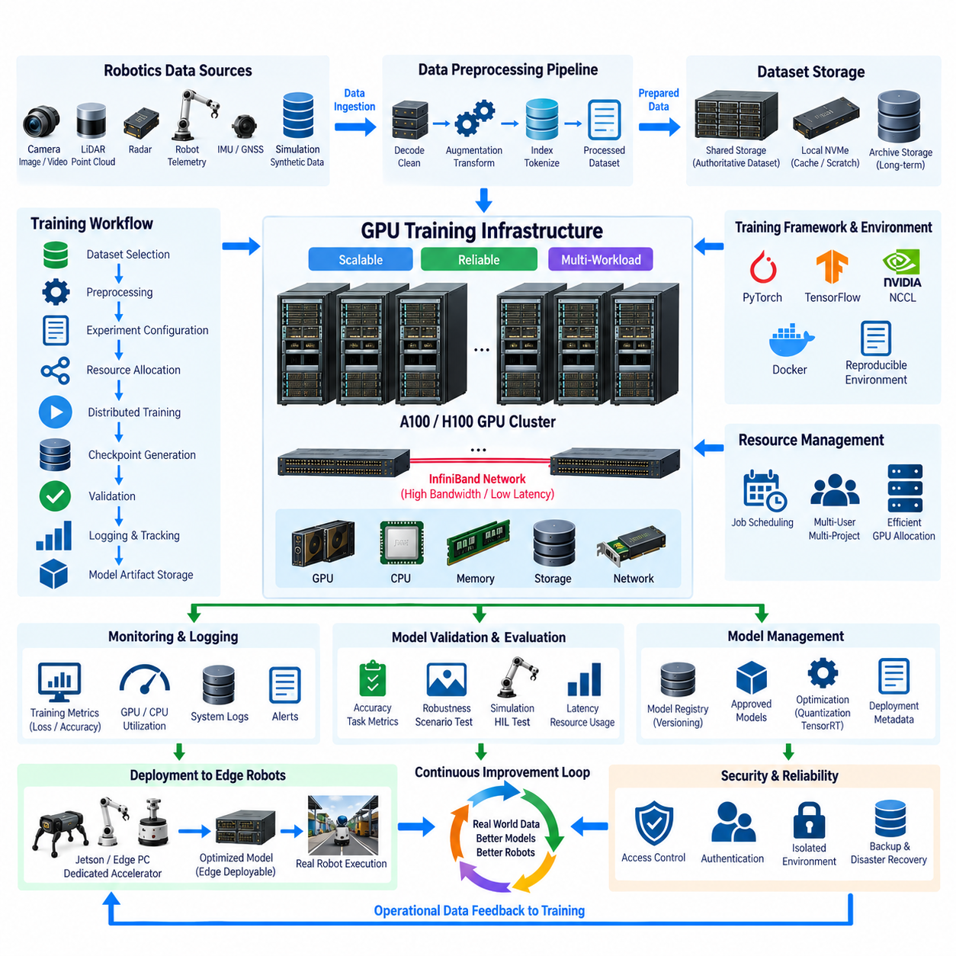
A training infrastructure is the integrated environment that transforms GPU hardware, datasets, software frameworks, and engineering workflows into a repeatable AI development system. Within the GPU server architecture, it sits above the A100/H100 cluster and InfiniBand network, coordinating compute resources so that perception models, world models, VLA systems, reinforcement-learning policies, and other Physical AI models can be trained efficiently.
The infrastructure must be designed around complete training workflows rather than peak GPU performance alone. A typical workflow includes dataset selection, preprocessing, experiment configuration, resource allocation, distributed execution, checkpoint generation, validation, logging, and model artifact storage. Each stage depends on different combinations of GPU, CPU, memory, network, and storage resources, so the platform must coordinate these components as one system.
Training begins with reliable dataset access. Robotics datasets may contain camera images, video streams, LiDAR point clouds, radar measurements, IMU and GNSS records, robot telemetry, ROS bags, annotations, simulation outputs, and synthetic data. The infrastructure must preserve relationships between these modalities while supplying data at sufficient throughput to prevent high-performance GPUs from waiting for storage or preprocessing operations.
A hierarchical storage architecture supports this requirement. Shared storage maintains authoritative datasets, experiment results, checkpoints, and model artifacts, while local NVMe storage provides high-speed caching and temporary working space near individual compute nodes. Frequently accessed training samples can be staged locally before execution, reducing repeated network transfers and improving data-loading consistency during long-running GPU workloads.
Data preprocessing should be treated as a dedicated computational stage rather than an incidental function inside the training loop. Decoding, resizing, normalization, augmentation, point-cloud transformation, sequence generation, tokenization, and dataset indexing can consume substantial CPU and storage bandwidth. Preprocessing pipelines should therefore be parallelized and profiled so that input preparation scales together with GPU training capacity.
Experiment environments must remain reproducible across developers and compute nodes. GPU drivers, CUDA versions, communication libraries, Python packages, machine-learning frameworks, simulation tools, and project-specific dependencies can otherwise produce inconsistent results. Container technologies provide isolated software environments that can be versioned and redeployed, allowing the same training configuration to execute consistently on different A100 or H100 nodes.
Container images should represent controlled execution environments rather than temporary developer configurations. A validated image can include the training framework, CUDA runtime, NCCL libraries, data-processing utilities, project code, and required dependencies. Associating container versions with experiments improves traceability and makes it possible to reconstruct the software environment used to generate a particular model months after the original training run.
A resource scheduler converts the physical GPU cluster into a shared training platform. It allocates GPUs, CPUs, host memory, storage resources, and compute nodes according to job requirements and organizational priorities. Scheduling becomes essential when multiple teams simultaneously perform perception training, simulation, reinforcement learning, foundation-model development, validation, and benchmarking on the same infrastructure.
GPU allocation should reflect workload characteristics. Small experiments may require only one GPU, conventional deep-learning workloads may use several GPUs within one server, and large multimodal models may span multiple H100 nodes. Reserving an entire high-end server for a workload that uses only a fraction of its resources reduces utilization, while excessive sharing can create memory contention, I/O interference, and unpredictable training performance.
Distributed training allows workloads to scale beyond one GPU or one server. Data parallelism divides training samples among workers, while tensor, model, and pipeline parallelism divide increasingly large neural networks across accelerators. The training infrastructure must coordinate process launching, worker discovery, communication initialization, synchronization, error handling, and job termination across participating nodes.
High-speed communication is especially important when distributed jobs span several servers. NVLink and NVSwitch provide tightly coupled communication within suitable multi-GPU nodes, while InfiniBand extends the communication domain across nodes. NCCL and related communication mechanisms perform collective operations such as AllReduce, allowing gradients and other training information to be synchronized efficiently across the distributed accelerator topology.
Training jobs require configuration management so that experiments can be compared systematically. Hyperparameters, dataset versions, random seeds, model architecture, optimizer settings, precision mode, batch size, augmentation rules, checkpoint frequency, and hardware allocation should be recorded with each run. Without this information, a high-performing model may be difficult to reproduce, validate, debug, or certify for later deployment.
Experiment tracking provides a structured history of model development. Training and validation loss, accuracy metrics, task-specific scores, GPU utilization, learning rates, execution time, checkpoints, configuration files, and software versions can be associated with a unique experiment identifier. Engineers can then compare alternative models based on recorded evidence rather than relying on filenames or manually maintained notes.
Checkpoint management is essential for expensive and long-running workloads. Training state should be saved periodically so that a job can recover from hardware failures, network interruptions, software errors, or planned maintenance. Checkpoints may include model parameters, optimizer state, learning-rate scheduler state, training progress, and other information required to resume execution without restarting the entire training process.
Checkpoint frequency must balance reliability against storage and I/O overhead. Saving extremely large models too frequently can generate substantial storage traffic and temporarily reduce training throughput. Saving too infrequently increases the amount of computation lost after a failure. The appropriate interval therefore depends on model size, job duration, infrastructure reliability, checkpoint bandwidth, and the cost of repeating training iterations.
Mixed-precision training is an important capability of modern GPU infrastructure. Lower-precision numerical formats can reduce memory consumption and increase tensor processing throughput while appropriate training techniques preserve model quality. A100 and H100 accelerators provide specialized capabilities for AI arithmetic, but precision selection should be validated for each workload rather than assuming that the lowest available precision is always appropriate.
Monitoring must observe both training behavior and infrastructure behavior. Model loss may appear abnormal because of a software or dataset problem, but it can also coincide with GPU memory pressure, thermal throttling, storage delays, network congestion, or failed workers. Combining application metrics with GPU, CPU, memory, network, storage, temperature, and power telemetry provides a more complete explanation of training performance.
Logs should be centralized whenever possible. Distributed jobs can produce output from many workers across several compute nodes, making node-local logs difficult to analyze after a failure. Central collection of application logs, scheduler events, system messages, and infrastructure alerts enables engineers to reconstruct the sequence of events that preceded an error and reduces the time required to diagnose unsuccessful training runs.
Validation should be separated conceptually from training even when both use the same GPU cluster. Training optimizes model parameters, whereas validation determines whether the resulting model satisfies defined performance requirements. Robotics validation may evaluate perception accuracy, trajectory prediction, policy behavior, robustness, latency, resource consumption, or performance across environmental and operational scenarios.
Physical AI requires additional attention because offline model metrics alone may not represent real robot behavior. A model that performs well on a validation dataset may still fail under sensor noise, motion, occlusion, lighting changes, unfamiliar environments, or interaction with dynamic objects. The training infrastructure should therefore connect naturally to simulation, scenario testing, hardware-in-the-loop evaluation, and eventually controlled physical robot testing.
Simulation can operate as both a data source and an evaluation environment. Large GPU infrastructure can generate synthetic scenes, execute reinforcement-learning environments, create rare safety events, and evaluate policies across many scenarios in parallel. Simulation results can then return to the dataset pipeline, creating an iterative relationship between training, synthetic data generation, validation, and model improvement.
Model artifacts require formal lifecycle management after training. Candidate checkpoints, validated models, optimized inference engines, configuration files, calibration information, and deployment metadata should be stored with identifiable versions. A model repository should distinguish experimental artifacts from approved releases so that robots receive only models that have completed the required validation and deployment process.
The infrastructure should support transformation from training models to edge-deployable models. Central training may use large A100 or H100 resources, while target robots execute models on Jetson platforms, edge PCs, or dedicated accelerators. Export, quantization, graph optimization, TensorRT conversion, benchmarking, and hardware-specific validation therefore connect centralized training infrastructure with real-time robot execution.
Security and access control are necessary because training systems contain valuable datasets, source code, model weights, and operational robot information. Authentication, role-based permissions, isolated project environments, protected model repositories, controlled external connectivity, and audit logging should be incorporated into the platform. On-premise infrastructure is particularly valuable when sensitive robotics data must remain under organizational control.
Backup and disaster-recovery policies should distinguish replaceable intermediate data from irreplaceable assets. Temporary caches and reproducible preprocessing outputs may not require extensive protection, whereas original field datasets, annotations, validated model releases, experiment metadata, and critical source configurations should be protected. This classification prevents backup systems from being overwhelmed by unnecessary copies of large temporary training files.
Capacity planning must account for simultaneous workloads rather than evaluating one training job in isolation. The required infrastructure depends on the number of developers, concurrent experiments, dataset size, model scale, simulation demand, checkpoint generation, validation workload, and expected training completion time. GPU capacity should therefore be planned together with CPU, storage throughput, network bandwidth, and operational support resources.
A mature training infrastructure ultimately creates a closed development loop for robotics AI. Robots collect real-world data, datasets are curated and prepared, centralized GPU systems train new models, validation and simulation evaluate them, approved artifacts are optimized for edge hardware, and deployed robots generate new operational experience. The cycle continuously converts field data into improved intelligence while preserving traceability between data, experiments, models, and deployment.
Within the broader Compute and AI Architecture, the training infrastructure therefore acts as the operational layer connecting the A100/H100 cluster, InfiniBand network, storage architecture, AI software, and robot deployment environment. Its engineering objective is not simply faster training, but repeatable, scalable, observable, recoverable, and secure model development that can support increasingly complex Physical AI systems and growing robot fleets.

05.04. GPU Server Power/Cooling
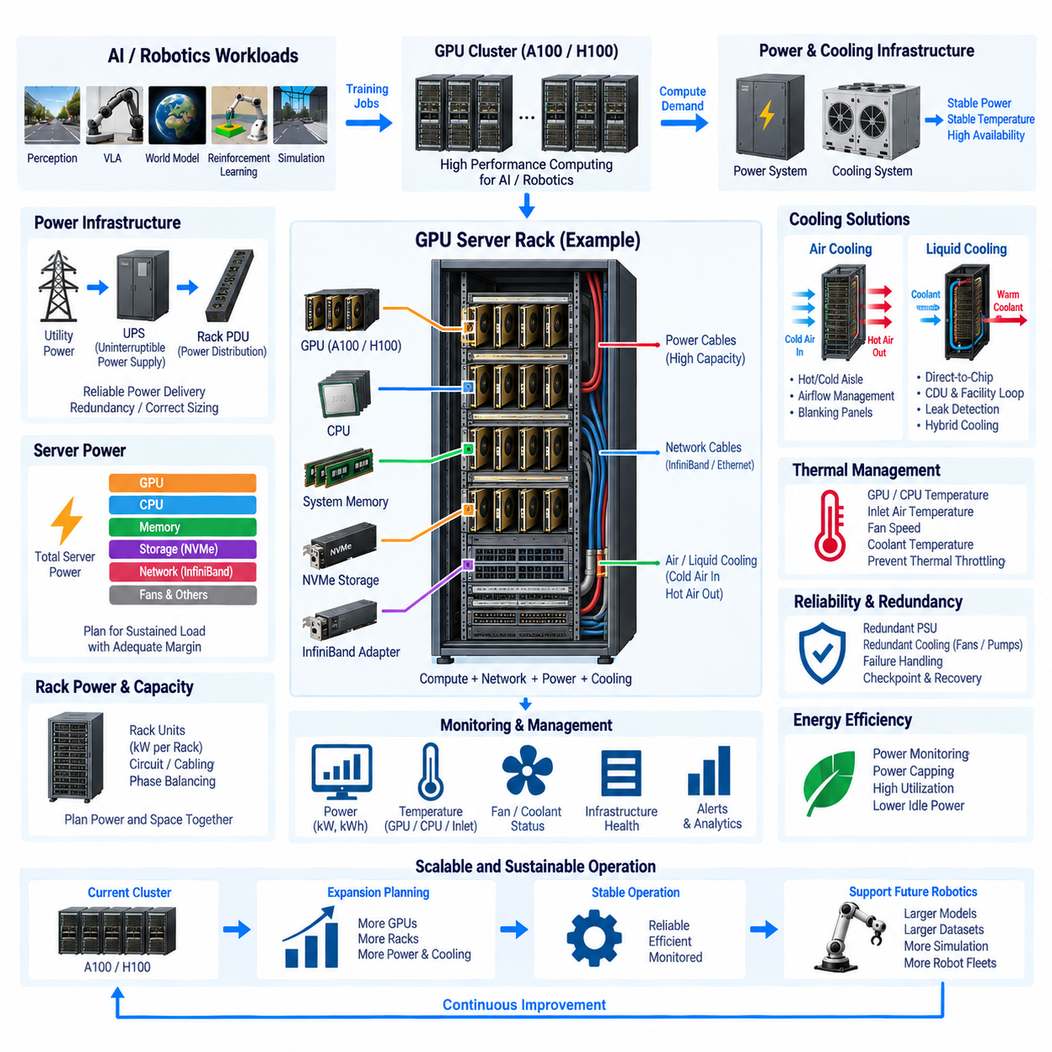
GPU servers built around A100 and H100 accelerators concentrate exceptional computational capability into a relatively small physical volume, creating equally concentrated electrical and thermal demands. Power and cooling must therefore be treated as primary architectural elements rather than facility-level afterthoughts. Stable AI training depends on delivering sufficient electrical power while continuously removing heat without triggering throttling, instability, or hardware degradation.
Server power consumption includes much more than the GPUs themselves. CPUs, system memory, NVMe storage, InfiniBand adapters, motherboard components, fans, power-conversion circuits, and auxiliary devices contribute to total demand. During distributed training, several subsystems can operate near maximum utilization simultaneously, so power capacity should be calculated from realistic sustained workloads and worst-case operating conditions rather than idle or average measurements.
GPU thermal design power provides an important starting point, but it should not be interpreted as complete server power demand. A multi-GPU node can contain several high-power accelerators together with dual CPUs, large memory capacity, high-speed networking, and storage. The combined system can create several kilowatts of sustained load, making server configuration, rack density, power-supply sizing, and cooling capacity closely interdependent engineering decisions.
Power supply units must provide sufficient capacity, conversion efficiency, and operating margin for sustained computational workloads. Redundant PSU configurations are commonly used so that failure of one supply does not immediately stop a critical training node. However, redundancy is meaningful only when the remaining power path can support the required load, so PSU sizing must consider both normal operation and degraded conditions after a component failure.
Power distribution should be engineered from the server outward through rack PDUs, branch circuits, UPS systems, and facility electrical infrastructure. A rack containing several dense GPU servers may require substantially more power than a conventional IT rack. Circuit ratings, connector capacity, phase balancing, cable sizing, breaker coordination, and PDU limits must therefore be evaluated before determining how many GPU nodes can safely occupy a rack.
Rack-level power density is often a more useful design parameter than individual server consumption. Installing additional GPU servers may be physically possible while exceeding the electrical or thermal capacity of the rack. Capacity planning should therefore reserve both rack units and kilowatts. Future A100/H100 cluster expansion must account for available switch ports, power circuits, cooling capacity, floor loading, and service access simultaneously.
Uninterruptible power supply design should reflect the operational role of the cluster. A UPS may provide sufficient ride-through time for short disturbances, allow controlled shutdown during longer failures, or bridge the interval until backup generation becomes available. Attempting to support a large GPU cluster for extended periods entirely from batteries can become expensive, so required runtime should be determined from workload criticality and recovery strategy.
Distributed training changes the consequences of power interruption because failure of one node can affect an entire multi-node job. Checkpointing reduces the amount of training progress lost, while UPS protection and redundant power paths reduce unnecessary interruptions. Electrical reliability should therefore be coordinated with software recovery mechanisms rather than attempting to eliminate every possible failure exclusively through increasingly expensive facility redundancy.
Power monitoring should be performed at several levels. GPU telemetry can report accelerator power, while server management interfaces provide node-level information and intelligent PDUs can measure rack or outlet consumption. Combining these measurements allows engineers to understand how model architecture, GPU utilization, communication, storage activity, and cooling behavior influence actual electrical demand during different AI workloads.
Power capping can be useful when infrastructure limits are stricter than theoretical server capability. GPU or server power limits may reduce peak electrical demand and improve rack-level predictability, although excessive limits can reduce training performance. The appropriate operating point should therefore be determined by measuring performance per watt, job completion time, thermal behavior, and available facility capacity rather than maximizing accelerator power independently.
Almost all electrical energy consumed by a GPU server ultimately becomes heat that must be removed from the computing environment. Cooling architecture must therefore be sized according to sustained thermal load. A cluster consuming tens of kilowatts requires a corresponding heat-removal capability, and the problem becomes increasingly difficult as that load is concentrated into fewer racks containing high-density accelerator systems.
Air cooling remains practical for many GPU installations when server density and facility airflow are appropriate. Cold air enters the server, passes across GPUs, CPUs, memory, networking components, and power electronics, and exits as heated exhaust. Cooling performance depends not only on room temperature but also on airflow volume, pressure, inlet conditions, internal server design, rack arrangement, and separation of hot and cold air streams.
Hot-aisle and cold-aisle organization helps prevent heated exhaust from returning directly to server inlets. Servers should normally be oriented consistently so that airflow follows the intended front-to-back path. Poor rack arrangement, open rack spaces, cable obstruction, or uncontrolled recirculation can create localized hot spots even when the overall data-center temperature appears acceptable, causing individual GPU nodes to throttle unexpectedly.
Blanking panels and airflow management are simple but important elements of air-cooled infrastructure. Empty rack spaces can allow hot exhaust to circulate toward the front of the rack, while poorly routed power and network cables can restrict rear airflow. Effective cooling therefore depends on mechanical organization as well as cooling equipment, particularly in racks containing dense GPU servers and high-port-count InfiniBand networking.
Temperature monitoring should focus on server inlet conditions and component temperatures rather than relying only on ambient room sensors. GPU temperature, CPU temperature, memory temperature, network adapter temperature, fan speed, and inlet air measurements can reveal localized problems. Trends are especially valuable because a gradual increase in temperature at constant workload may indicate filter blockage, airflow degradation, fan wear, or increasing recirculation.
Thermal throttling directly affects AI productivity. When GPUs exceed defined thermal or power limits, clock frequencies may be reduced to protect the hardware. A training job may continue running without obvious failure while taking significantly longer to complete. Monitoring systems should therefore correlate GPU frequency, temperature, power, utilization, and training throughput so that cooling problems are recognized as performance problems rather than only hardware alarms.
Liquid cooling becomes increasingly attractive as accelerator power density rises beyond what conventional air cooling can manage efficiently. Direct-to-chip liquid cooling can remove heat from GPUs and CPUs through cold plates, while facility water loops and coolant distribution units transfer that heat away from the rack. Air cooling may still be required for memory, storage, networking, power supplies, and other components not connected to the liquid loop.
Liquid-cooled systems introduce additional engineering requirements. Coolant temperature, flow rate, pressure, material compatibility, leak detection, pumps, manifolds, quick-disconnect fittings, heat exchangers, and maintenance procedures become part of the compute infrastructure. The advantage is much higher heat-removal capability near the source, but the system must be designed so that a cooling fault does not create a widespread cluster outage.
Hybrid cooling can provide a practical transition strategy. Existing A100 nodes or lower-density servers may remain air cooled, while newer high-density H100-class systems use direct liquid cooling where required. This allows infrastructure to evolve gradually rather than forcing an immediate facility-wide conversion. Rack planning should nevertheless anticipate differences in plumbing, service clearance, weight, airflow, and heat rejection between cooling technologies.
Cooling redundancy should reflect workload criticality in the same way as electrical redundancy. Failure of a fan, pump, coolant distribution unit, or facility cooling component can rapidly affect high-density GPU hardware. Temperature alarms, redundant pumps where appropriate, controlled workload reduction, emergency shutdown logic, and job checkpointing can work together to protect equipment while minimizing the amount of computational work lost.
Power and cooling systems should be monitored as one operational domain because they are physically coupled. Increased GPU utilization raises electrical consumption and heat generation, which increases fan or liquid-cooling demand. Monitoring power, temperature, fan speed, coolant conditions, GPU clocks, and job performance together enables operators to identify whether a workload is compute-limited, power-limited, thermally limited, or constrained by facility infrastructure.
Energy efficiency becomes significant when clusters operate continuously. Accelerator utilization should remain high enough to justify the power consumed by servers and cooling equipment. Idle nodes can be placed into appropriate lower-power states, workloads can be consolidated when practical, and inefficient data pipelines should be corrected because GPUs consuming power while waiting for data represent both computational and energy waste.
Facility efficiency should also be distinguished from server efficiency. Even highly efficient GPU hardware can be supported by an inefficient cooling and power-delivery system. Conversion losses in UPS equipment, PDUs, power supplies, fans, pumps, chillers, and other infrastructure contribute to total energy consumption. Cluster design should therefore consider energy from the facility input through the final computation rather than evaluating GPU efficiency alone.
Physical AI workloads can produce highly variable power profiles. Large model training may maintain sustained accelerator utilization for days, simulation may alternate between GPU and CPU intensity, and preprocessing may emphasize storage and processors. Power and cooling infrastructure should tolerate these workload transitions without creating voltage instability, thermal excursions, or excessive cycling of facility equipment.
Expansion planning is especially important because compute hardware can often be purchased faster than electrical and cooling infrastructure can be upgraded. Adding another group of H100 servers may require new circuits, PDUs, UPS capacity, switch infrastructure, cooling equipment, or liquid distribution. Power and thermal capacity should therefore be reserved as part of the GPU cluster roadmap rather than addressed only after new servers arrive.
A balanced design connects compute density to facility capability. The highest possible number of GPUs per rack is not necessarily the best configuration if it produces difficult cooling, reduced redundancy, complicated maintenance, or expensive electrical upgrades. Distributing nodes across additional racks may sometimes provide better reliability and serviceability even when it uses more floor space and longer network connections.
Within the broader GPU server architecture, power and cooling form the physical foundation beneath the A100/H100 cluster, InfiniBand fabric, training infrastructure, and data pipeline. Their purpose is to keep every computational component within stable electrical and thermal operating limits while supporting predictable performance. Without this foundation, theoretical GPU capability cannot be converted reliably into sustained AI training throughput.
For future robotics and Physical AI infrastructure, power and cooling must scale together with model complexity, dataset size, simulation demand, and robot fleet growth. Successful engineering therefore requires coordinated planning of accelerators, racks, electrical distribution, UPS protection, airflow, liquid cooling, monitoring, redundancy, and facility capacity so that expanding computational intelligence remains physically sustainable, reliable, and economically manageable.

05.05. Data Pipeline Architecture
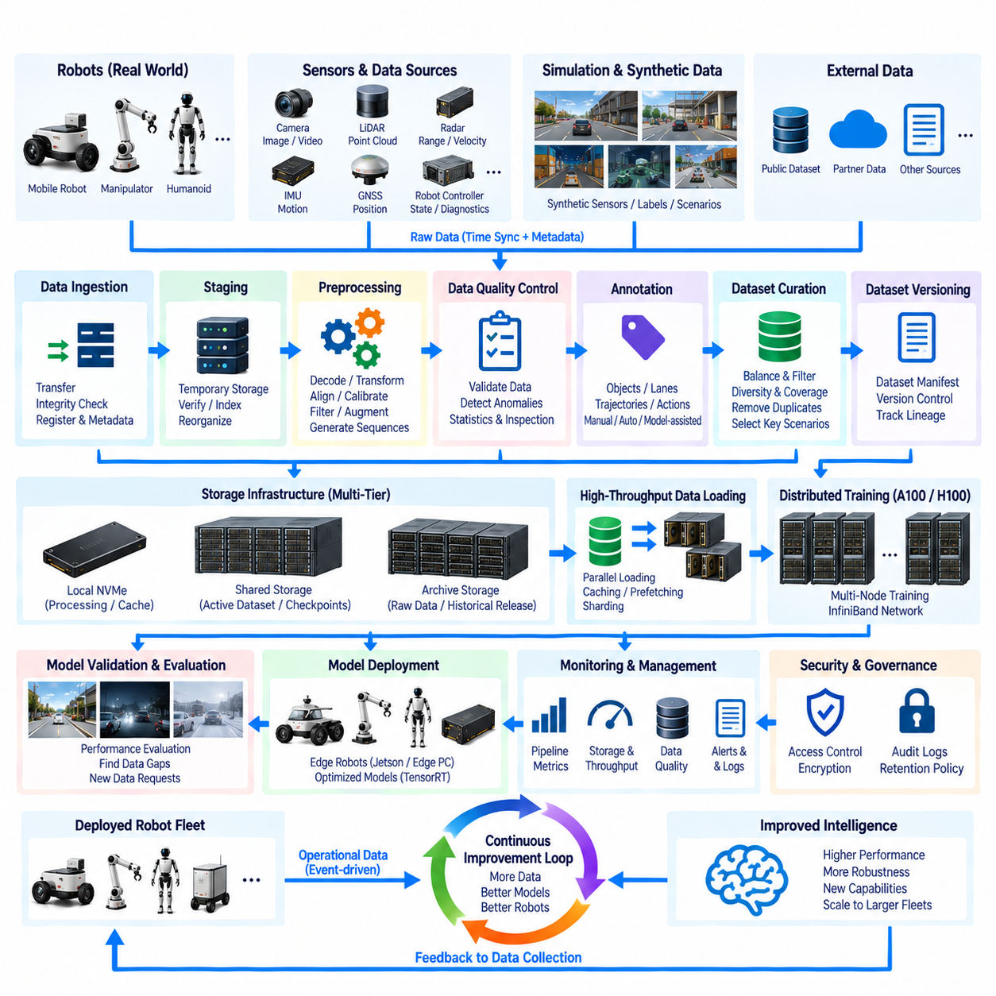
A data pipeline architecture provides the continuous path through which robotics data moves from physical machines and simulation environments into centralized AI infrastructure. Within a GPU server system, the pipeline connects robot data collection, ingestion, preprocessing, storage, dataset management, distributed training, validation, and model deployment. Its purpose is to deliver trustworthy multimodal data to A100/H100 computing resources at sufficient speed and with complete traceability.
Robotics data originates from heterogeneous sources operating at different frequencies, resolutions, and data rates. Cameras generate image or video streams, LiDAR produces point clouds, radar measures range and velocity, IMUs provide high-frequency motion information, GNSS supplies global position, and robot controllers generate state, diagnostic, and actuator information. Simulation systems add synthetic sensor streams, labels, trajectories, and controlled scenario data to the same ecosystem.
Data collection must preserve temporal and contextual relationships between these sources. A camera frame, LiDAR scan, IMU measurement, robot pose, control command, and system event may describe the same physical moment and should remain associated throughout processing. Accurate timestamps, synchronized clocks, sequence identifiers, calibration information, and mission metadata are therefore fundamental components of the data architecture rather than optional annotations added after collection.
Time synchronization becomes especially important for Physical AI because learning systems often reconstruct interactions between perception, decision, and action. PTP, GNSS-derived timing, hardware timestamps, or other synchronization mechanisms can establish a common temporal reference across sensors and computers. The pipeline should preserve original timestamps even when data is subsequently copied, converted, compressed, segmented, or reorganized for training.
The ingestion layer transfers collected data from robots, test systems, simulation platforms, and external repositories into centralized infrastructure. Transfer may occur continuously through networks or periodically after a mission. The ingestion process should verify file integrity, identify incomplete transfers, register source information, and create metadata describing where, when, and under what operating conditions the data was generated.
Raw data should normally be preserved as an authoritative source whenever storage capacity and governance policies permit. Processing pipelines can then create derived representations without destroying the original evidence. This separation is important because preprocessing methods, calibration algorithms, annotation rules, and model requirements evolve over time. Retaining raw data allows future teams to regenerate improved datasets without repeating expensive physical data collection.
A staging layer provides temporary space between ingestion and long-term storage. Incoming files can be checked for corruption, decompressed, indexed, reorganized, and scanned for required metadata before being admitted into the primary dataset repository. High-speed NVMe storage is useful for this stage because preprocessing may involve repeated reads and writes that would otherwise place unnecessary load on shared long-term storage systems.
Preprocessing transforms raw sensor information into representations suitable for machine learning. Camera processing may include decoding, resizing, rectification, normalization, and frame selection, while LiDAR processing may include coordinate transformation, filtering, point-cloud accumulation, or voxelization. Sequence generation, sensor alignment, calibration application, trajectory extraction, and token preparation may also be required depending on the target model architecture.
Preprocessing should remain reproducible and version controlled. A dataset is not defined only by its raw files; it is also defined by the software, calibration parameters, filtering rules, transformation sequence, and configuration used to generate the training representation. Recording pipeline versions allows engineers to determine why two datasets derived from identical raw data may produce different model behavior.
Data quality control should operate throughout the pipeline rather than only before training. Missing frames, timestamp discontinuities, corrupted files, invalid calibration, sensor dropouts, unrealistic values, duplicated sequences, and incomplete missions can reduce training quality. Automated validation can identify many of these problems early, while statistical summaries and visual inspection can reveal anomalies that simple file-integrity checks cannot detect.
Annotation adds semantic information required by supervised or evaluation-oriented workloads. Depending on the application, labels may describe objects, segmentation regions, lanes, free space, trajectories, actions, events, interactions, robot states, or safety conditions. Annotation provenance should record whether labels were produced manually, automatically, synthetically, or through model-assisted processes so that confidence and quality can be evaluated later.
Dataset curation converts large collections of available data into purposeful training resources. More data is not automatically better if it contains excessive duplication, poor-quality sequences, or severe scenario imbalance. Curation should consider environmental diversity, sensor conditions, geographic coverage, operational modes, rare events, failure cases, object distributions, and task relevance so that the resulting dataset reflects the intended deployment domain.
Dataset versioning provides a stable reference for experiments. Once a training run begins, the exact dataset composition should be identifiable even if new robot data continues arriving. Dataset manifests can record sample identifiers, source locations, labels, calibration versions, preprocessing versions, and filtering decisions. This allows a model checkpoint to be traced back to the exact information that influenced its training.
Storage should be organized into performance tiers according to data lifecycle and access frequency. Local NVMe can support temporary processing and training caches, high-performance shared storage can serve active datasets and checkpoints, and high-capacity archive storage can preserve raw collections and historical releases. Moving data intelligently between tiers reduces infrastructure cost while maintaining sufficient throughput for active AI development.
The pipeline must provide enough throughput to keep expensive GPUs continuously supplied with training data. High-performance accelerators can process data faster than conventional storage systems can prepare it, particularly when workloads include video decoding, point-cloud transformation, or complex augmentation. Parallel data loaders, caching, prefetching, sharding, sequential access patterns, and local staging can reduce GPU idle time caused by input bottlenecks.
Distributed training introduces additional requirements because many workers may read different portions of the same dataset simultaneously. Dataset sharding can distribute access across storage resources and reduce contention, while deterministic sample assignment prevents unintended duplication between workers. Storage bandwidth, metadata performance, network capacity, and CPU preprocessing must scale with GPU count if adding accelerators is expected to reduce training time.
The relationship between the data pipeline and InfiniBand should be engineered carefully. InfiniBand primarily supports high-performance distributed computation, but some architectures may also use high-speed fabrics for storage access. Large dataset transfers should not interfere unpredictably with latency-sensitive GPU collective communication. Separate traffic paths, quality controls, or appropriately provisioned fabrics can preserve predictable training performance.
Simulation and synthetic-data systems should connect to the same dataset governance framework as real-world robot data. Synthetic scenes can provide automatically generated labels, controlled environmental variations, rare events, and safety-critical scenarios that are difficult to capture physically. Metadata should clearly identify synthetic origin, simulator configuration, scenario parameters, and generation versions so that synthetic and real data can be analyzed separately or combined deliberately.
The pipeline also supports closed-loop learning from deployed robot fleets. Operational robots can identify difficult scenarios, failures, low-confidence predictions, unusual sensor patterns, or human interventions and return selected data to centralized infrastructure. Rather than transferring every recorded byte indefinitely, event-driven selection and prioritization can concentrate storage and engineering effort on information with the highest potential learning value.
Fleet-scale collection requires policies for bandwidth and edge filtering. Robots may generate far more data than practical wireless or cloud links can continuously transfer. Edge systems can compress data, summarize routine operation, preserve high-value event windows, and schedule bulk uploads when appropriate connectivity becomes available. The pipeline must retain enough metadata to understand what was selected, discarded, compressed, or transformed at the robot.
Experiment tracking should connect datasets directly with training infrastructure. Each experiment can reference dataset version, preprocessing configuration, model code, container image, hyperparameters, hardware allocation, checkpoints, and evaluation results. This creates lineage from original sensor data through processing and training to the resulting model, enabling reproducibility and systematic comparison between model generations.
Model validation can generate new data requirements. If evaluation reveals poor performance in rain, darkness, crowded environments, unusual objects, sensor degradation, or specific robot maneuvers, those gaps can be converted into collection or simulation requests. The data pipeline therefore becomes an active component of model improvement rather than a one-directional mechanism that simply delivers existing files to training servers.
Security and governance must follow data throughout its lifecycle. Robotics datasets may contain proprietary environments, operational information, location data, images of people, or other sensitive content. Access permissions, encryption where appropriate, audit logs, retention policies, project isolation, and controlled export procedures should apply from ingestion through archive and prevent unrestricted copying of valuable datasets.
Backup policy should distinguish authoritative information from reproducible intermediate products. Original field data, critical annotations, calibration records, dataset manifests, and validated releases may require strong protection, while temporary caches and regenerated preprocessing outputs can often be recreated. Classifying data by recoverability prevents backup capacity from being consumed unnecessarily by transient AI processing artifacts.
Monitoring should expose both data quality and pipeline performance. Useful indicators include ingestion rate, transfer failures, storage utilization, preprocessing throughput, queue depth, cache efficiency, corrupted samples, dataset growth, data-loader performance, and GPU waiting time. These metrics reveal whether training performance is limited by computation or by the infrastructure responsible for preparing and delivering data.
Scalability must be designed from the beginning because robot fleets can transform data volume faster than compute hardware alone suggests. Increasing the number of robots increases sensor streams, mission logs, annotation demand, storage requirements, and network traffic. The architecture should therefore scale collection, metadata services, preprocessing workers, storage capacity, and dataset management together with A100/H100 training resources.
Within the broader Compute and AI Architecture, the data pipeline forms the information backbone connecting robots, simulation, storage, the A100/H100 cluster, InfiniBand networking, training infrastructure, validation systems, and edge deployment. Its engineering objective is not merely to move large quantities of data, but to preserve synchronization, quality, provenance, reproducibility, security, and performance throughout the complete AI lifecycle.
A mature Physical AI data pipeline ultimately creates a continuous intelligence feedback loop. Robots and simulations generate experience, the pipeline converts that experience into governed datasets, GPU infrastructure transforms datasets into models, validation identifies strengths and weaknesses, and approved models return to edge systems. New field experience then enters the pipeline again, allowing data, models, infrastructure, and robot behavior to improve together over successive development cycles.

