Volume 16 Compute and AI Architecture

Chapter 01. MCU Architecture

01.01. STM32/Cortex-M Selection
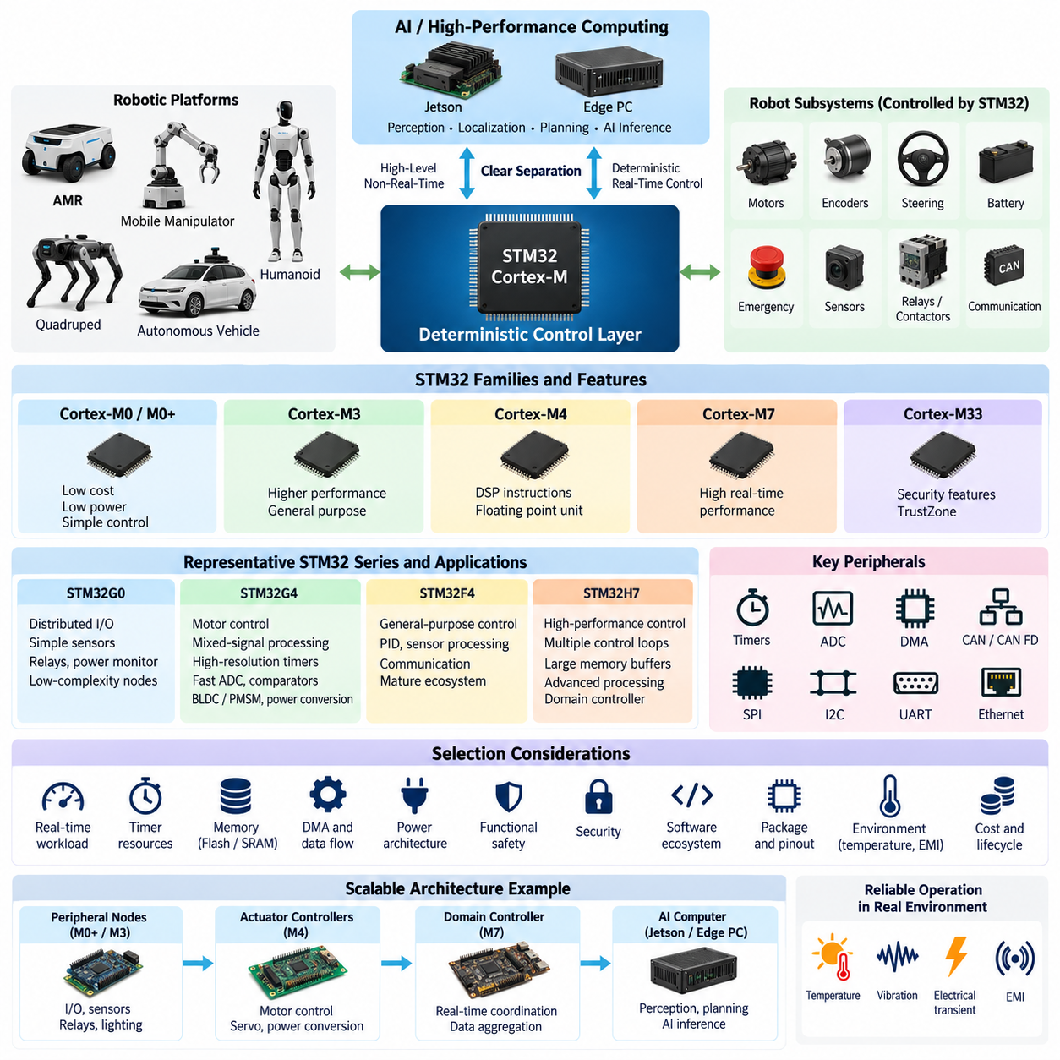
The STM32 Cortex-M family provides a broad range of microcontrollers suitable for deterministic control, sensor interfacing, communication, diagnostics, and safety supervision in robotic electrical architectures. Selecting the correct device is therefore not simply a matter of choosing the highest clock frequency. The MCU must be matched to control-loop timing, peripheral requirements, memory demand, power consumption, functional safety goals, environmental constraints, software complexity, and the expected evolution of the robot platform.
A useful starting point is to treat the MCU as the deterministic control layer beneath higher-performance computing platforms. In an AMR, mobile manipulator, quadruped, humanoid, or autonomous vehicle, an STM32 may manage motor commands, wheel encoders, steering actuators, battery signals, emergency inputs, thermal sensors, relays, contactors, and communication buses while a Jetson or edge PC performs perception, localization, planning, and AI inference. This separation prevents variable AI workloads from disturbing time-critical hardware control.
The Cortex-M architecture spans devices optimized for very different purposes. Cortex-M0/M0+ devices emphasize low cost, low power, and relatively simple control tasks. Cortex-M3 and M4 devices provide stronger processing capability, with Cortex-M4 adding DSP-oriented instructions and commonly a floating-point unit. Cortex-M7 devices target substantially higher real-time computing performance, while Cortex-M33 and newer security-oriented implementations introduce capabilities such as TrustZone that are valuable when secure execution becomes part of the embedded architecture.
For robotics, STM32G0 and similar entry-level families are appropriate for distributed I/O modules, simple sensor interfaces, relay controllers, power monitors, lighting modules, and low-complexity actuator nodes. These applications normally require deterministic GPIO, ADC, timers, UART, SPI, I2C, or CAN connectivity rather than intensive numerical computation. Using a smaller MCU at distributed nodes can reduce PCB cost, power consumption, software complexity, and harness traffic while keeping local hardware functions independent from the central computer.
STM32G4 is particularly attractive where motor control and mixed-signal processing are central requirements. Its combination of Cortex-M4 processing, high-resolution timers, fast ADC resources, comparators, operational amplifiers, and mathematical acceleration makes it suitable for BLDC/PMSM control, servo systems, power conversion, battery-related control, and compact actuator electronics. In such applications, peripheral timing and analog integration can be more important than raw CPU frequency because current sampling and PWM generation must remain tightly synchronized.
STM32F4 and related Cortex-M4 devices remain useful for general-purpose robotic controllers requiring a mature software ecosystem and balanced computational capability. They can execute PID control, kinematic preprocessing, sensor filtering, communication management, diagnostic logic, and moderate DSP workloads while supporting common embedded interfaces. Their long history also means that extensive middleware, board examples, libraries, debugging knowledge, and existing firmware designs can often be reused, reducing development risk when maximum MCU performance is unnecessary.
STM32H7-class devices are better suited to high-performance real-time controllers where multiple fast control loops, extensive communications, large memory buffers, signal processing, or sophisticated local estimation must execute simultaneously. Cortex-M7 implementations provide substantially greater computational capability, and some H7 variants combine heterogeneous cores. Such devices can serve as domain controllers between simple distributed MCUs and Linux-based AI computers, handling deterministic control and aggregation without assigning every real-time function to the central processor.
Selection should begin with the worst-case real-time workload rather than average CPU utilization. Engineers should identify the fastest control period, interrupt frequency, communication traffic, sensor sampling rates, filtering workload, diagnostic execution, and maximum simultaneous event load. A controller that appears lightly loaded during normal operation can become unstable when CAN traffic, encoder interrupts, ADC conversion callbacks, diagnostics, and fault processing occur together. Adequate timing margin is therefore an architectural requirement rather than unused computing capacity.
Timer architecture deserves special attention in robotics. Motor control, encoder measurement, PWM generation, input capture, synchronized ADC triggering, pulse counting, and precise actuator sequencing often depend directly on timer resources. The number and capability of advanced-control timers, general-purpose timers, encoder interfaces, DMA channels, and trigger connections should be evaluated before selecting the MCU. A processor with higher benchmark performance can still be unsuitable when its timer topology cannot support the required deterministic I/O relationships.
Communication interfaces are equally important because the MCU normally connects several electrical domains. CAN and CAN FD may connect motor controllers, battery systems, steering modules, and distributed ECUs, while SPI and I2C connect local sensors and peripheral ICs. UART may support GNSS, service interfaces, or auxiliary modules, and Ethernet can provide higher-level connectivity on capable devices. Peripheral quantity must include redundancy and future expansion rather than merely matching the first prototype configuration.
Memory sizing must consider executable code, RTOS objects, communication stacks, calibration parameters, bootloader space, diagnostic data, buffers, logging, and future software growth. SRAM requirements can increase rapidly when CAN FD, Ethernet, sensor streams, filtering, and multiple software tasks operate concurrently. Flash capacity should also reserve sufficient space for secure boot, firmware update strategies, rollback images, or additional diagnostic functionality. Selecting memory with reasonable engineering margin reduces expensive MCU migration later in the product lifecycle.
DMA capability is critical when high-rate peripherals operate concurrently. ADC acquisition, SPI transfers, UART reception, timer events, and communication interfaces should move data with minimal CPU intervention wherever practical. Effective DMA usage reduces interrupt overhead and improves timing predictability, but channel allocation, bus contention, cache behavior, and memory placement must be considered on high-performance devices. MCU selection should therefore evaluate the complete data movement architecture rather than treating DMA as a secondary peripheral feature.
Power architecture also influences device choice. Distributed robot controllers may remain continuously energized even when high-performance computers are shut down, making standby current and low-power modes significant. Conversely, high-performance STM32 devices may require more careful regulator sizing, decoupling, clock design, and thermal analysis. The designer should evaluate operating voltage, peak current, startup behavior, brownout conditions, reset sequencing, and interaction with the robot's 12 V, 24 V, or 48 V power distribution system.
Safety-related controllers require additional consideration. Independent watchdogs, window watchdogs, brownout detection, clock monitoring, ECC or parity protection where available, memory protection, fault exceptions, redundant sensing, and deterministic safe-state outputs can contribute to a robust architecture. The MCU itself does not automatically make the system functionally safe; safety depends on the complete hardware and software design, diagnostic coverage, failure analysis, independence, verification process, and the safety integrity required by the target robotic application.
Security is increasingly connected to MCU selection because robotic controllers may receive firmware updates or commands through interconnected networks. Hardware cryptographic accelerators, secure key storage, protected memory regions, secure boot mechanisms, debug-port protection, and TrustZone-capable Cortex-M33 architectures can strengthen the root of trust. This becomes particularly important when an MCU controls physical actuators while communicating with Linux computers, fleet infrastructure, maintenance tools, or remote update systems that have broader attack surfaces.
Software ecosystem maturity should be evaluated together with hardware capability. STM32CubeMX, HAL and LL drivers, RTOS support, CMSIS components, debugging tools, motor-control libraries, communication middleware, and established development practices can shorten implementation time. However, generated configuration should not replace architectural understanding. Clock trees, interrupt priorities, DMA allocation, memory mapping, watchdog behavior, startup sequencing, and peripheral error recovery should be explicitly engineered and documented for production robotic systems.
Package selection is another practical constraint. High-pin-count packages provide additional communication channels, ADC inputs, timers, external memory interfaces, and expansion capability but increase PCB routing complexity and board area. Smaller packages reduce cost and footprint but may expose only a subset of peripheral functions. Pin multiplexing must therefore be validated early, especially when CAN, Ethernet, multiple SPI buses, encoder channels, PWM outputs, safety inputs, debugging interfaces, and external memory must coexist on one controller.
Environmental requirements should be included before the final part number is frozen. Industrial and mobile robots can experience vibration, temperature variation, electrical transients, electromagnetic interference, supply disturbances, and repeated power cycling. Appropriate temperature grades, qualification levels, PCB protection, EMC design, grounding, filtering, connector design, and power conditioning must complement the MCU. A technically powerful processor cannot compensate for an electrical design that allows resets, corrupted communication, or unstable sensor acquisition in the actual operating environment.
A scalable robotic architecture often benefits from using several STM32 classes rather than standardizing on one oversized MCU. Low-cost Cortex-M0+/M3 devices can operate peripheral nodes, Cortex-M4 devices can handle actuator and motor-control functions, and Cortex-M7-class controllers can perform domain-level real-time coordination. Above them, Jetson platforms or edge PCs execute perception and Physical AI workloads. This hierarchy distributes computation according to determinism, bandwidth, safety, and processing characteristics rather than concentrating every function in one processor.
The final STM32 selection should therefore emerge from a requirements matrix covering control frequency, computational margin, timer resources, ADC performance, CAN/CAN FD channels, SPI/I2C/UART demand, Ethernet requirements, Flash and SRAM capacity, DMA topology, safety mechanisms, security functions, temperature range, package constraints, power consumption, software support, cost, and lifecycle availability. The best Cortex-M device is the smallest platform that satisfies these requirements with sufficient margin while preserving a clear migration path for future robotic functions.

01.02. Real Time Control Design
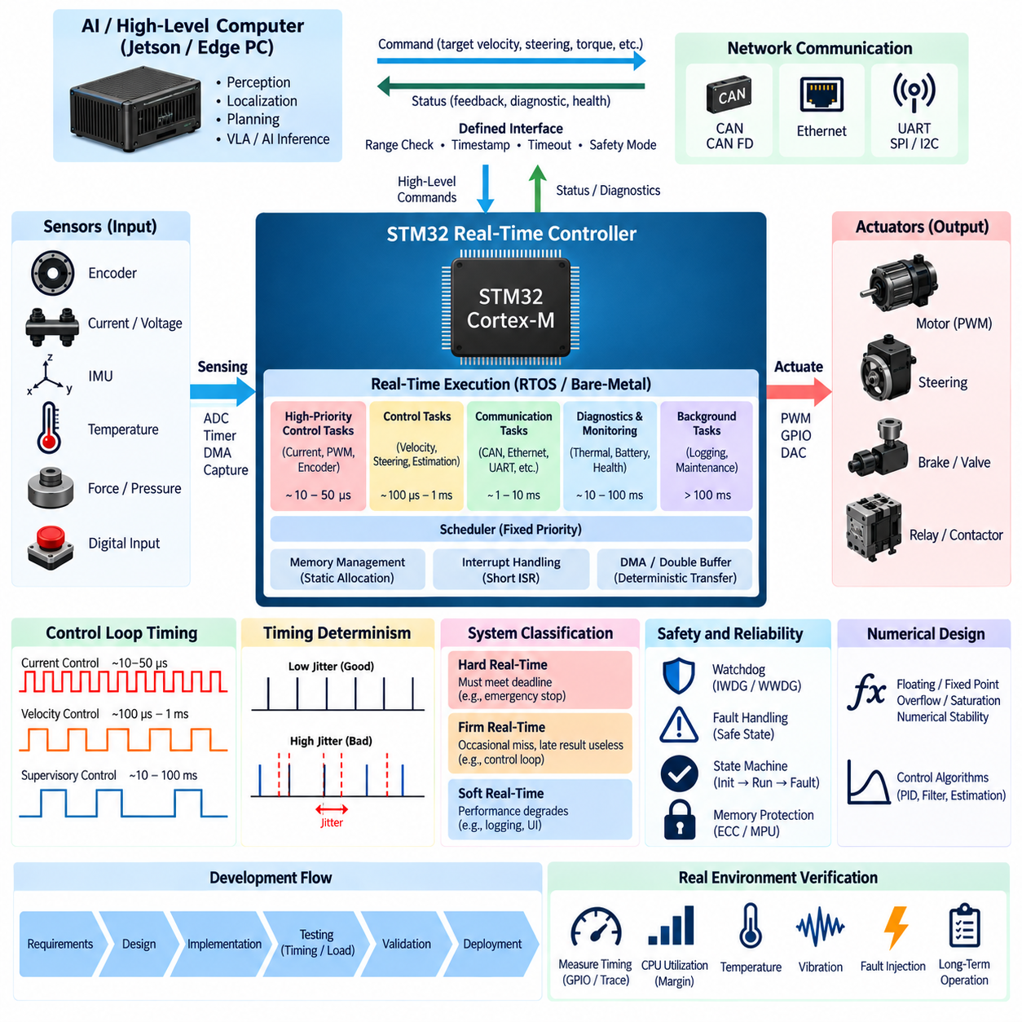
Real-time control design defines how a robotic controller senses physical events, computes control actions, and updates actuators within explicitly bounded time intervals. Unlike general computing, correctness depends not only on producing the correct numerical result but also on producing it before a defined deadline. In an STM32-based robotic architecture, deterministic execution is therefore a fundamental design requirement for motor control, steering, braking, power management, safety supervision, and distributed actuator coordination.
A real-time system should first be classified according to the consequences of missing its timing deadline. Hard real-time functions require the result to be available before the deadline because a late response may create an unsafe or uncontrollable state. Firm real-time functions tolerate occasional misses but consider late results useless, while soft real-time functions primarily experience degraded performance. Emergency shutdown, motor commutation, and safety monitoring generally require much stricter timing behavior than telemetry, logging, or user-interface updates.
The fundamental structure of a real-time controller is a repeated sense-compute-actuate cycle. Sensors provide encoder positions, currents, voltages, temperatures, forces, inertial measurements, or digital states. The MCU acquires these inputs at defined sampling instants, executes estimation and control algorithms, and updates PWM signals, motor commands, valves, relays, or other actuators. Maintaining a stable and predictable cycle period is essential because most control algorithms are designed around a known sampling interval rather than an arbitrarily varying execution schedule.
Control-loop frequency must be selected according to the dynamics of the controlled system. Fast electrical processes such as motor current regulation may require substantially higher update rates than velocity, steering, thermal, or supervisory control. A robot can therefore contain several nested control loops operating at different frequencies. The MCU architecture must guarantee that the fastest loop receives the highest timing priority while slower functions execute without introducing excessive interference, blocking, or computational overload.
Sampling jitter is one of the most important sources of real-time control degradation. Jitter occurs when the actual execution or sampling instant deviates from its intended periodic schedule. Excessive jitter changes the effective sampling interval and can reduce controller accuracy, phase margin, or stability. Timer-triggered ADC conversion, hardware capture, DMA transfers, and precisely scheduled control tasks are preferable to software polling when deterministic acquisition is required, because hardware timing minimizes variability introduced by unrelated software activity.
Execution time must be characterized using worst-case execution time rather than average measurements. A control algorithm that normally completes in 100 microseconds but occasionally requires 250 microseconds must be designed around the longer condition if its deadline is critical. Cache behavior, interrupt preemption, communication processing, memory contention, conditional branches, floating-point operations, and diagnostic functions can all change execution time. Adequate timing margin should remain after the worst credible combination of tasks has been considered.
Interrupt architecture strongly influences deterministic behavior. High-priority interrupts should be reserved for genuinely time-critical events such as control timers, encoder capture, critical communication reception, or safety-related inputs. Long computations should generally not execute directly inside interrupt service routines. Instead, the interrupt should capture the event, store essential data, and activate an appropriate task or state transition. Keeping interrupt service routines short reduces blocking and makes response latency easier to analyze and verify.
Interrupt priority must reflect system criticality rather than software development convenience. A high-frequency but low-importance peripheral can otherwise delay a lower-frequency safety-critical event. Nested interrupts, priority grouping, critical sections, and interrupt masking should therefore be designed systematically. Particular attention is required when firmware disables interrupts while accessing shared data, because an apparently short critical section can increase worst-case latency and interfere with motor-control, communication, or emergency-response deadlines.
A real-time operating system can organize increasingly complex robotic firmware into independent tasks for control, communication, diagnostics, monitoring, and background processing. Each task can be assigned a period, deadline, and priority according to its function. Fixed-priority scheduling is common in MCU systems because it is relatively straightforward to implement and analyze. However, an RTOS does not automatically guarantee real-time behavior; task execution time, blocking, synchronization, interrupt interaction, and total processor utilization must still be engineered explicitly.
Priority inversion can occur when a high-priority control task waits for a resource held by a lower-priority task while an intermediate-priority task continues executing. This condition can unexpectedly increase response latency and violate deadlines. Mutex mechanisms with priority inheritance or priority ceiling techniques can reduce this risk. Better architectural partitioning can eliminate many shared-resource dependencies entirely, particularly when control loops communicate through carefully defined buffers rather than sharing large mutable software structures.
Communication processing must also be integrated into the timing model. CAN, CAN FD, SPI, I2C, UART, and Ethernet traffic can generate asynchronous interrupts and significant processing load. Critical control messages should be assigned appropriate network priorities and handled without allowing communication bursts to monopolize the processor. Receive queues, transmit queues, DMA, hardware filtering, and bounded message-processing budgets help separate communication timing from control-loop timing while preventing buffer overflow or stale command execution.
DMA is especially valuable for deterministic real-time designs because it allows peripheral data to move without requiring the CPU to process every byte or sample. ADC sequences, SPI sensor transfers, UART streams, and other repetitive transactions can be transferred directly between peripherals and memory. The CPU can then execute control algorithms while DMA operates concurrently. Nevertheless, DMA itself must be designed carefully because simultaneous transfers can create bus contention, memory-access delays, or synchronization problems on high-performance STM32 devices.
Double buffering is a useful technique for separating data acquisition from computation. One memory buffer can receive sensor data through DMA while the control algorithm processes the previously completed buffer. When acquisition finishes, the buffers exchange roles. This approach reduces the need to stop sampling during computation and establishes a clear boundary between producer and consumer operations. Sequence counters or timestamps can additionally detect lost, duplicated, or delayed samples when system integrity is important.
Time synchronization becomes increasingly important when a controller combines measurements from several sensors or distributed ECUs. Encoder, IMU, force, steering, and motor-current measurements should represent sufficiently consistent physical time if they are used together in estimation or control. Local hardware timers provide precise timing within an MCU, while distributed systems may require synchronized clocks or timestamp exchange across communication networks. Without consistent timestamps, sensor fusion can interpret temporal misalignment as actual physical motion or disturbance.
State machines provide an effective supervisory structure around high-frequency control loops. A robotic controller may transition through initialization, self-test, standby, enabled, active control, degraded operation, fault, and safe shutdown states. Each transition should have explicit conditions and defined outputs. Separating supervisory state logic from numerical control algorithms improves traceability and prevents uncontrolled actuator activation during startup, communication loss, sensor failure, or abnormal power conditions.
Watchdog mechanisms should supervise the real-time execution architecture rather than merely reset the MCU when software freezes. An independent watchdog can verify that essential software execution continues, while a window watchdog can detect tasks executing too slowly or unexpectedly quickly. More advanced designs update watchdog supervision only after several critical tasks have completed successfully. This prevents a noncritical background task from continually refreshing the watchdog while the actual control function has failed.
Fault handling must be bounded in time just like normal control execution. Sensor timeout, invalid encoder values, overcurrent, overtemperature, communication loss, memory errors, and actuator disagreement should trigger predetermined responses. Depending on severity, the controller may substitute a valid fallback value, reduce actuator authority, enter degraded operation, disable a channel, or transition immediately to a safe state. Fault management should avoid uncontrolled retry loops or lengthy diagnostic routines inside critical execution paths.
Numerical design also affects real-time performance. Floating-point processing is convenient for control algorithms, filters, coordinate transformations, and estimation, particularly on Cortex-M4 and Cortex-M7 devices equipped with floating-point hardware. Fixed-point arithmetic may still be appropriate for highly constrained controllers or algorithms requiring tightly bounded execution. Regardless of representation, numerical overflow, saturation, division by small values, invalid floating-point results, and accumulated integration error must be explicitly handled.
Memory allocation should remain predictable during real-time operation. Dynamic allocation can introduce variable execution time, fragmentation, allocation failure, and difficult-to-reproduce behavior. Critical firmware therefore commonly allocates control structures, communication buffers, task stacks, and sensor data statically during initialization. Stack usage should be measured under worst-case nesting conditions, and sufficient margin should be reserved for interrupts, library calls, diagnostic paths, and exceptional operating conditions.
Control and communication data shared between tasks or interrupts require explicit concurrency protection. Atomic operations, short critical sections, lock-free buffers, queues, or carefully designed ownership models can prevent partially updated data from being consumed. Protection mechanisms should be selected according to timing impact because excessive locking can damage determinism. For high-rate sensor and actuator paths, transferring immutable snapshots or indexed buffers is often preferable to allowing several software components to modify the same structure.
A practical STM32 real-time architecture can divide execution into several timing domains. The fastest domain handles motor current, PWM synchronization, encoder capture, or other hardware-near functions. A medium-rate domain performs velocity, steering, actuator coordination, and state estimation. Slower domains handle diagnostics, thermal management, battery supervision, communication management, and health reporting. Background execution can perform logging or maintenance functions only when sufficient processor time remains.
Real-time control should be separated from high-level AI and perception workloads. Jetson platforms or edge PCs can execute camera processing, LiDAR perception, localization, path planning, VLA models, or other computationally intensive algorithms whose latency may vary. The STM32 should receive bounded commands such as target velocity, steering angle, torque, or actuator position and convert them into deterministic hardware actions. If the high-level computer becomes delayed or unavailable, the MCU must detect command timeout and execute a predefined safe response.
The interface between AI computing and deterministic control should therefore be treated as a contract. Commands require valid ranges, sequence information, timestamps where necessary, timeout limits, operating-mode conditions, and explicit fault behavior. The MCU should not blindly execute arbitrary values received from a high-level processor. Range checking, rate limiting, plausibility verification, state validation, and command freshness checks form a protective boundary between nondeterministic intelligent computing and the physical actuator system.
Verification requires measurement of actual timing behavior on the target hardware. GPIO timing pins, hardware timers, trace facilities, cycle counters, RTOS runtime statistics, and communication timestamps can reveal execution duration, jitter, interrupt latency, scheduling delays, and deadline misses. Testing should include maximum communication load, simultaneous sensor activity, fault injection, startup and shutdown, thermal conditions, and prolonged operation rather than evaluating only a lightly loaded laboratory scenario.
Processor utilization should retain sufficient reserve for abnormal conditions and future software expansion. Designing a controller to operate continuously near full CPU utilization leaves little margin for communication bursts, diagnostics, fault processing, firmware growth, or execution-time variation. The exact acceptable margin depends on architecture and criticality, but the engineering objective is clear: deterministic deadlines must remain satisfied under worst credible operating conditions rather than only during nominal demonstrations.
A robust real-time control design ultimately combines deterministic hardware timing, bounded software execution, carefully assigned priorities, predictable memory behavior, structured communication, explicit fault management, watchdog supervision, and measured timing verification. In the compute hierarchy of a Physical AI robot, the STM32 real-time controller forms the dependable bridge between intelligent high-level decisions and physical motion, ensuring that commands are translated into actuator behavior with predictable timing even when the surrounding computing environment is complex or variable.

01.03. CAN/SPI/I2C Peripheral
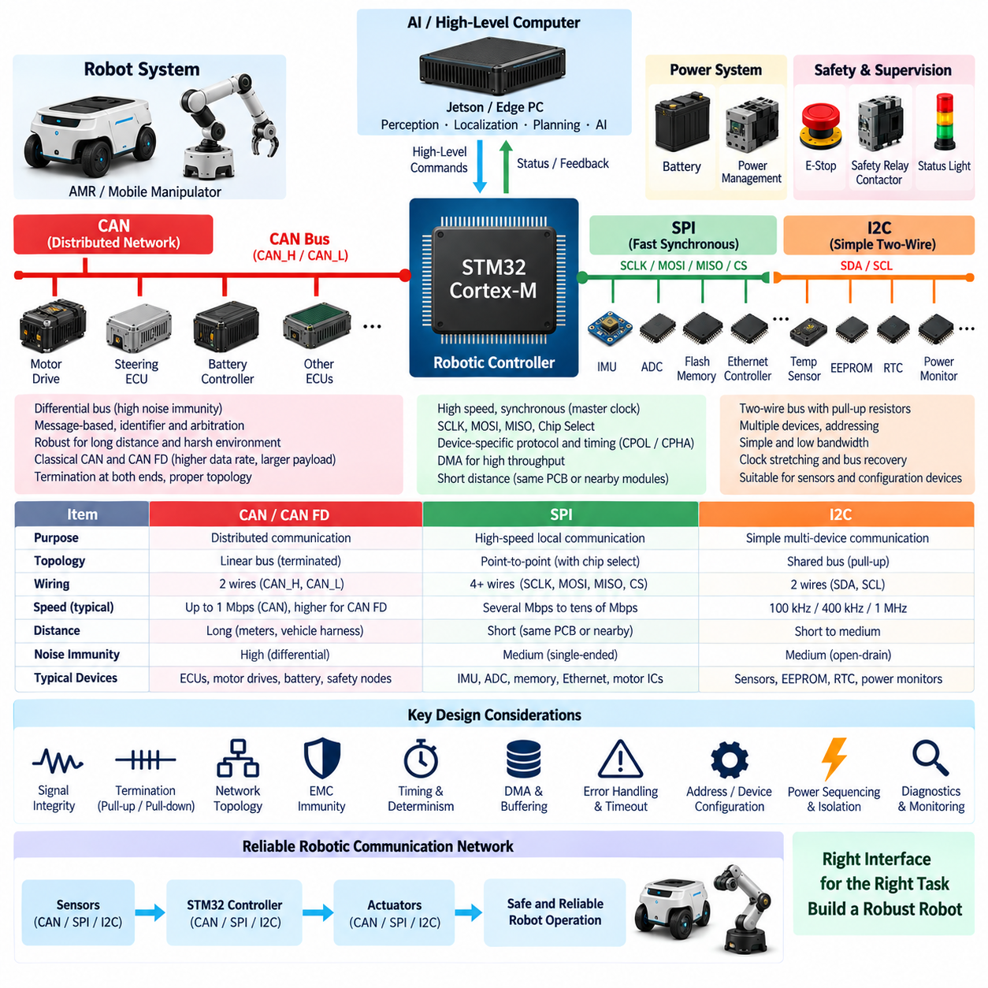
CAN, SPI, and I2C form the core communication interfaces of many STM32-based robotic controllers. Although all three move information between electronic components, they address fundamentally different communication requirements. CAN is designed for robust distributed networking across multiple controllers, while SPI provides fast synchronous communication between devices on the same PCB or nearby modules. I2C emphasizes simple two-wire connectivity for lower-bandwidth peripherals such as sensors, configuration devices, monitoring ICs, and identification memories.
In a robotic electrical architecture, these interfaces should be assigned according to physical distance, bandwidth, timing requirements, electromagnetic environment, device count, fault tolerance, and serviceability. CAN commonly connects distributed ECUs, motor drives, battery controllers, steering modules, and safety-related nodes. SPI is typically used for high-rate local sensors, ADCs, memory devices, and communication controllers. I2C is well suited to temperature sensors, power monitors, EEPROMs, RTCs, and other relatively low-speed devices located within a controlled electrical environment.
CAN uses a differential physical layer that provides strong noise immunity for distributed systems operating around motors, switching power electronics, long harnesses, and other sources of electromagnetic interference. CAN transceivers communicate through CAN_H and CAN_L lines, and the network normally uses termination resistors at both ends of the main bus. Differential signaling allows the receiver to detect the voltage difference between the two conductors, reducing sensitivity to common-mode electrical disturbances compared with many single-ended communication interfaces.
The CAN protocol is message-oriented rather than based on fixed point-to-point addressing. Nodes transmit frames containing identifiers, and other nodes determine whether a message is relevant through hardware or software filtering. The identifier also participates in bus arbitration, allowing higher-priority messages to gain access without corrupting lower-priority transmissions. This characteristic is especially useful in robots because emergency states, actuator commands, and critical feedback can be assigned higher communication priority than diagnostics, configuration data, or noncritical telemetry.
CAN FD extends classical CAN by allowing a larger payload and a higher data rate during the data phase. This improves efficiency when controllers exchange richer diagnostic information, multiple sensor values, calibration parameters, or higher-rate control data. STM32 devices equipped with FDCAN peripherals can therefore serve as important communication nodes in modern robotic networks. Nevertheless, nominal bit rate, data-phase bit rate, bus length, transceiver characteristics, termination, cable quality, and network topology must be engineered as one complete communication system.
Reliable CAN design requires careful attention to bus topology. A linear trunk with short stubs is generally preferable to uncontrolled star wiring because reflections can degrade signal integrity as communication speed increases. Termination should match the characteristic impedance of the network, and connector pin assignments, twisted-pair routing, shielding strategy, grounding, and common-mode behavior should be considered together. Oscilloscope measurements of CAN_H and CAN_L under actual operating conditions are often essential when diagnosing intermittent communication errors in a robot.
The STM32 CAN or FDCAN peripheral reduces CPU workload through hardware frame handling, filtering, buffering, error detection, and interrupt generation. Filters should be configured so that irrelevant traffic is rejected before unnecessary software processing occurs. Receive FIFOs and transmit queues must be sized according to worst-case traffic rather than normal traffic. Software should also detect queue overflow, repeated transmission failure, bus-off conditions, stale messages, unexpected identifiers, and sequence errors instead of assuming that network communication is continuously valid.
SPI operates differently from CAN because it is normally a short-distance synchronous interface controlled by a clock generated by the master. Typical signals include SCLK, MOSI, MISO, and one or more chip-select lines. Because clock and data are transferred separately, SPI can achieve high throughput with relatively simple protocol overhead. This makes it useful for inertial sensors, high-speed ADCs, external Flash memory, Ethernet controllers, motor-control devices, and other peripherals requiring faster local communication than I2C commonly provides.
SPI does not define a single universal transaction format above the electrical signaling level. Each peripheral can specify its own command structure, register addressing, frame length, clock polarity, clock phase, bit order, timing delays, and chip-select behavior. Firmware must therefore configure the STM32 SPI peripheral according to the exact requirements of each connected device. Incorrect CPOL or CPHA settings can produce communication that appears active on an oscilloscope but generates completely invalid data at the receiving device.
Chip-select architecture becomes important when several SPI peripherals share the same clock and data lines. Each device normally requires an independent chip-select signal so that only the intended peripheral participates in a transaction. The firmware must respect setup, hold, and inactive timing around chip select. Devices with incompatible SPI modes or substantially different electrical requirements may be better separated onto different SPI controllers, particularly when deterministic sensor acquisition or high communication reliability is required.
DMA can significantly improve SPI performance by transferring blocks of data between the peripheral and memory without requiring the CPU to process every transmitted or received byte. This is valuable for high-rate IMUs, ADC sampling, display data, or external memory transfers. Timer-triggered acquisition combined with SPI and DMA can create highly deterministic sampling pipelines. Double buffering can further allow one data block to be processed while the next block is transferred, reducing CPU interruption and improving real-time execution consistency.
SPI signal integrity becomes increasingly important as clock frequency and PCB trace length increase. Clock edges can produce ringing, overshoot, crosstalk, and timing uncertainty even when the nominal SPI frequency appears modest. Trace routing, reference planes, connector transitions, series damping resistors, device drive strength, capacitive loading, and cable length can influence reliability. SPI should therefore not automatically be treated as a convenient long-distance robot harness interface merely because laboratory prototypes function with loosely connected wires.
I2C provides a simpler shared bus using serial data, SDA, and serial clock, SCL. Both signals typically use open-drain outputs with external pull-up resistors, allowing multiple devices to share the same two conductors. Devices are identified through addresses, enabling several sensors or support ICs to connect with minimal MCU pin usage. This makes I2C especially attractive when PCB space and GPIO resources are limited and the required communication bandwidth is moderate.
Pull-up resistor selection is a fundamental part of I2C electrical design. The resistor value interacts with supply voltage, bus capacitance, communication speed, and the current that devices must sink when driving the line low. Pull-ups that are too weak produce slow rising edges and timing violations, while excessively strong pull-ups increase sink current and power consumption. The complete bus capacitance, including PCB traces, connectors, cables, and device inputs, should therefore be considered rather than selecting a resistor value only from a common reference schematic.
I2C address management must be checked early when multiple devices are connected. Two devices with the same fixed address cannot normally coexist on one bus unless an address-selection option, multiplexer, or separate I2C controller is used. This issue frequently appears when several identical sensors are required around a robot. Engineers should therefore create an address map during architecture design and verify configurable address pins, startup states, voltage domains, and required bus segmentation before PCB routing is finalized.
Bus recovery is particularly important for I2C because an interrupted transaction or malfunctioning peripheral can leave SDA or SCL in an unexpected state. Robust firmware should detect communication timeout and provide a defined recovery strategy rather than waiting indefinitely. Depending on the device and hardware architecture, recovery may involve generating additional clock pulses, reinitializing the I2C peripheral, resetting the affected sensor, switching its power domain, or declaring the device unavailable and entering an appropriate degraded operating mode.
Clock stretching is another I2C behavior that must be considered. A peripheral may hold SCL low while it completes internal processing, delaying the master transaction. Firmware and timeout logic must account for this behavior when supported by the device. In real-time robotic systems, however, peripherals with unpredictable clock-stretching delays should not be placed directly in highly time-critical control paths unless their worst-case timing characteristics are understood and compatible with the required control deadline.
Peripheral selection should therefore consider determinism as well as bandwidth. CAN arbitration introduces bounded network access behavior that can be analyzed when message priorities and bus utilization are controlled. SPI can provide highly predictable local transfers because the master explicitly determines transaction timing. I2C is efficient for low-bandwidth configuration and monitoring but can become less predictable when many devices, retries, clock stretching, or bus recovery events occur. The fastest interface is not automatically the best interface for every robotic function.
STM32 firmware should isolate communication drivers from application-level control logic. A low-level driver can manage registers, DMA, interrupts, errors, and electrical-interface behavior, while a service layer interprets sensor values or network messages. Control algorithms should consume validated data through clearly defined interfaces rather than directly manipulating peripheral registers. This separation improves portability, testability, fault containment, and migration when a sensor, MCU family, communication speed, or peripheral assignment changes during product development.
Timeout handling is essential across all three interfaces. A controller should never wait indefinitely for a CAN frame, SPI response, or I2C transaction when the missing information affects physical operation. Each data source should have a freshness requirement based on its function. A missing temperature reading may permit temporary degraded operation, while missing steering feedback or motor-state information may require rapid transition to a safe state. Communication timeout policy should therefore be linked directly to system-level fault management.
Data integrity should also be considered beyond the error mechanisms built into each interface. CAN includes strong frame-level error detection, whereas many SPI and I2C peripheral protocols may require additional application-level checks. Sequence counters, status fields, plausibility checks, redundant values, CRC fields, timestamps, or register consistency checks can detect stale or corrupted information. The appropriate mechanism depends on the consequence of incorrect data and the diagnostic coverage required by the robotic function.
Power sequencing can influence peripheral communication. A sensor or transceiver that is unpowered while the STM32 remains active may clamp communication lines through internal protection structures or produce undefined bus states. Conversely, an MCU that starts before a peripheral has completed initialization may interpret temporary communication failure as a permanent fault. Power-good signals, reset control, startup delays, voltage-domain compatibility, and controlled initialization sequences should therefore be integrated with CAN, SPI, and I2C software design.
Electrical isolation may be required when CAN connects controllers operating across different power or grounding domains. Isolated CAN transceivers can reduce ground-current problems and improve protection in systems with high-power drives, long cables, or distributed power supplies. SPI and I2C can also be isolated when necessary, but isolation adds propagation delay, component cost, power requirements, and sometimes protocol-specific limitations. Isolation should therefore be based on electrical architecture and hazard analysis rather than added without system-level justification.
Diagnostic visibility greatly improves development and field service. Firmware should expose communication error counters, timeout counts, bus states, queue utilization, retry information, peripheral reset events, and relevant timing statistics. CAN networks can additionally support service and diagnostic protocols, while SPI and I2C devices can report status registers through higher-level diagnostics. Capturing these indicators makes intermittent wiring, EMI, sensor, firmware, and timing problems significantly easier to distinguish during robot validation.
Verification should combine software tests with measurements on actual hardware. CAN should be tested under maximum expected bus utilization, error injection, node disconnection, and power cycling. SPI should be checked across supported clock rates, transfer lengths, DMA operation, and electrical loading. I2C should be tested with maximum device population, bus capacitance, timeout conditions, and forced stuck-bus scenarios. Temperature, vibration, supply disturbances, and motor-generated EMI should be included when they represent realistic robot operating conditions.
A scalable STM32 robotic controller often uses all three interfaces simultaneously rather than choosing only one. CAN or CAN FD forms the distributed communication backbone between controllers, SPI connects high-rate local peripherals requiring deterministic throughput, and I2C connects lower-bandwidth monitoring and configuration devices with minimal wiring. When their electrical characteristics, timing behavior, firmware architecture, diagnostics, and failure responses are designed together, these peripherals form a reliable communication foundation between the MCU and the wider robotic electrical system.

01.04. MCU Watchdog and Safety
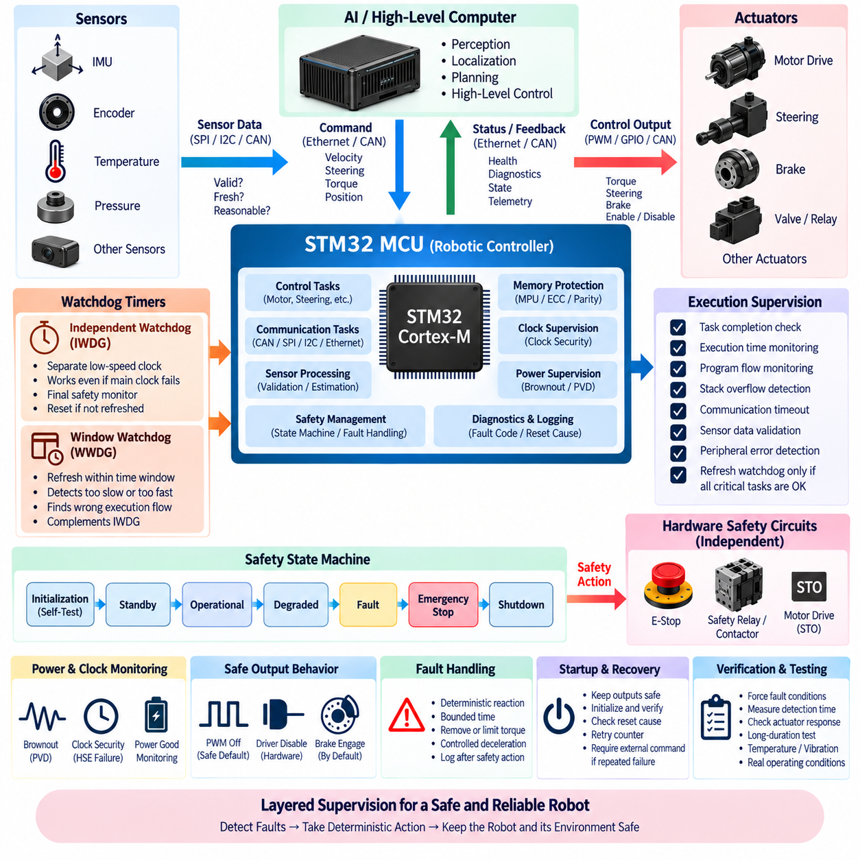
An MCU watchdog is a supervisory mechanism designed to detect failures that prevent embedded software from executing its intended control sequence. In a robotic controller, the watchdog is not merely a reset timer but part of the overall safety architecture. It must detect stalled tasks, corrupted execution flow, timing violations, deadlocks, peripheral failures, and other abnormal conditions before they propagate into uncontrolled motor, steering, braking, power, or actuator behavior.
STM32 microcontrollers commonly provide an Independent Watchdog and a Window Watchdog with different supervision characteristics. The Independent Watchdog operates from a dedicated low-speed clock source and can continue functioning even when the main system clock becomes abnormal. The Window Watchdog supervises whether software refreshes the watchdog within an allowed time window, enabling detection of execution that is not only too slow but also unexpectedly fast or incorrectly sequenced.
The Independent Watchdog is particularly valuable as a final software-execution monitor because its operation is relatively independent of the main CPU clock configuration. Firmware must periodically refresh it before expiration, otherwise the MCU is reset. However, simply refreshing the watchdog from a periodic interrupt or low-priority background loop provides weak diagnostic coverage because the watchdog may continue to be serviced even when an important control algorithm, communication task, or safety function has already failed.
A stronger architecture uses watchdog servicing as evidence that critical software functions have completed correctly. Motor control, communication supervision, sensor validation, safety-state processing, and actuator monitoring can each report successful execution to a central watchdog manager. The watchdog is refreshed only when all required execution checkpoints have been observed within the expected cycle. If one critical function stalls or misses its deadline, the refresh condition is withheld and the watchdog eventually forces recovery.
The Window Watchdog adds temporal supervision by defining an acceptable refresh interval. A refresh that occurs too late indicates delayed execution, while one that occurs too early may indicate corrupted program flow, an unexpectedly accelerated loop, or incorrect watchdog logic. This makes window-based supervision useful when the execution sequence itself must remain within known timing boundaries. The window must nevertheless be configured with sufficient margin for worst-case interrupt latency, task scheduling, and legitimate execution-time variation.
Watchdog timeout selection should be derived from the controlled system rather than chosen arbitrarily. A timeout that is too short can generate nuisance resets during temporary but acceptable execution delays, while a timeout that is too long allows unsafe conditions to persist unnecessarily. The designer should consider control-loop periods, actuator dynamics, communication timeout requirements, fault reaction time, shutdown sequence duration, and the maximum acceptable interval before an independent safety mechanism must intervene.
Resetting the MCU is not automatically equivalent to placing the robot in a safe state. During reset, MCU pins may become high impedance, PWM outputs may stop, communication may disappear, and actuator-control circuits may enter hardware-dependent conditions. The electrical architecture must therefore define what every safety-relevant output does before, during, and after reset. External pull resistors, gate-driver disable inputs, relay logic, contactor circuits, brake defaults, and independent safety hardware may be required to guarantee predictable behavior.
For motor-control systems, a watchdog failure should normally remove or limit torque through a mechanism that does not depend solely on continued firmware execution. A motor driver may provide a hardware enable input that defaults to disabled when the MCU stops driving it. Similar principles apply to steering, braking, hydraulic valves, relays, and other physical outputs. Safety-related actuators should be designed so that loss of MCU control leads toward a defined state rather than leaving the last command indefinitely active.
A watchdog should also supervise communication freshness where external commands influence physical motion. An STM32 controller receiving target velocity, steering, torque, or actuator position from a Jetson or edge PC must detect when commands stop arriving within the specified interval. This communication watchdog is logically separate from the MCU hardware watchdog. The processor may still be functioning perfectly while the high-level computer, Ethernet connection, CAN network, or upstream application has failed.
Command timeout behavior should be explicitly linked to operating state. A missing command during standby may require no action, whereas the same timeout during active autonomous motion may require controlled deceleration, torque inhibition, braking, or transition to a safe state. The controller should therefore evaluate message freshness together with state-machine context rather than implementing a universal timeout response. Sequence counters and timestamps can additionally identify repeated or delayed messages that appear electrically valid.
Sensor supervision follows the same principle. A sensor may continue communicating while producing implausible, frozen, saturated, or internally faulty data. Safety monitoring should therefore evaluate not only whether data arrives but whether it remains physically reasonable. Range checks, rate-of-change limits, timeout monitoring, redundant comparison, status-bit inspection, and consistency checks between related sensors can reveal failures that a communication watchdog alone cannot detect.
A robust MCU safety architecture combines hardware watchdogs with software supervision. Software monitors can detect task overruns, invalid states, stack problems, communication timeouts, sensor inconsistencies, numerical faults, and peripheral errors before the hardware watchdog expires. The hardware watchdog then provides an independent final layer when software supervision itself becomes unable to execute. These mechanisms should complement each other rather than duplicate the same failure detection path.
Clock supervision is another important protection mechanism because real-time control depends directly on correct timing. STM32 devices may provide clock security mechanisms capable of detecting failure of an external oscillator and switching or reacting accordingly. Firmware should define whether continued degraded operation is acceptable after a clock fault. A controller performing timing-critical PWM, communication, or control calculations may need to disable outputs rather than continue operating with uncertain timing characteristics.
Brownout and power-supply supervision are equally important. A falling supply voltage can cause unpredictable processor or peripheral behavior before complete power loss occurs. Brownout reset and power-voltage detection mechanisms can force the MCU into reset or generate an early warning when voltage leaves the valid operating region. The power architecture should coordinate these mechanisms with regulators, power-good signals, contactors, motor drivers, and energy storage so that the controller does not continue issuing commands under unstable supply conditions.
Memory faults can compromise control logic even when the processor continues executing. Depending on the selected STM32 family, parity, ECC, memory protection, MPU functions, or error-status mechanisms may provide additional diagnostic coverage. Critical variables can also be protected through range checks, duplicated representations, CRC verification, or periodic integrity testing. The required level of protection should correspond to the consequence of corrupted data rather than applying identical mechanisms to every variable in the firmware.
Stack overflow is a particularly dangerous embedded failure because it can overwrite unrelated memory and produce unpredictable behavior rather than an immediate clean crash. RTOS-based designs should allocate sufficient stack for worst-case execution and monitor stack usage during validation. Stack guards, MPU regions, RTOS overflow detection, and runtime high-water-mark measurements can provide additional protection. Interrupt nesting and exceptional diagnostic paths must be included when determining worst-case stack consumption.
Program-flow monitoring can detect cases where software executes but follows an incorrect sequence. Critical functions can update signatures, counters, or checkpoints as they pass through expected execution stages. A supervisor verifies that these events occur in the correct order and within expected timing boundaries. This provides stronger evidence of correct execution than a single watchdog refresh point because random execution or partial task completion is less likely to satisfy the complete supervision sequence.
The safety state machine should define how detected faults change robot behavior. Typical states may include initialization, self-test, standby, operational, degraded, fault, emergency stop, and shutdown. Faults should be classified according to severity and recoverability so that every anomaly does not unnecessarily produce the same response. A temporary noncritical sensor failure may permit degraded operation, while loss of actuator feedback, corrupted control timing, or emergency-stop activation may require immediate motion inhibition.
Fault reactions should be deterministic and bounded in time. When a critical condition is detected, the controller should not enter lengthy logging, retry, or diagnostic routines before executing the required safety action. The physical output should first move toward the defined safe condition, after which diagnostic information can be captured if sufficient time and resources remain. This ordering prevents diagnostic software from delaying the function that actually protects the robot and its surrounding environment.
External safety circuits should remain independent where the risk assessment requires independence from the main MCU. Emergency-stop chains, safety relays, safety PLCs, motor-driver safe-torque-off inputs, or dedicated safety controllers can remove actuator energy without relying on the STM32 application software. The MCU can monitor these circuits and report their state, but monitoring should not create a dependency that prevents the independent hardware safety path from functioning when the MCU itself has failed.
Startup behavior requires the same attention as runtime faults. Immediately after power-on or reset, outputs should remain in safe defaults until clocks, memory, peripherals, communication, sensors, and internal software states have been initialized and validated. The controller should not enable motor drivers merely because firmware has reached the main loop. An explicit enable sequence should confirm required preconditions before actuator authority is granted, and failed startup checks should prevent transition into the operational state.
Recovery after watchdog reset should be controlled rather than automatically returning to active operation. Reset-cause registers should be examined during startup so that firmware can distinguish watchdog reset, power reset, software reset, brownout, or other causes where supported. Repeated watchdog resets can indicate a persistent fault and should not create an endless reboot cycle that repeatedly energizes hardware. A retry counter or latched fault policy can require maintenance or an external command before operation resumes.
Diagnostic information should be preserved whenever practical. Reset cause, fault code, operating state, task status, communication condition, recent sensor information, and timing statistics can help engineers determine why the watchdog activated. Nonvolatile memory or retained memory may be used selectively, but diagnostic storage must not delay critical safety reactions or wear Flash excessively. Event records should be compact, bounded, and designed specifically for post-fault analysis.
Functional safety requires systematic reasoning beyond the presence of watchdog hardware. Safety goals, hazards, failure modes, diagnostic coverage, independence, fault reaction time, and verification evidence must be considered at system level. Depending on the robotic application, relevant engineering processes may draw on standards such as IEC 61508, ISO 13849, ISO 3691-4, or ISO 26262 concepts. The MCU watchdog contributes to the safety mechanism, but it cannot by itself establish the required safety integrity.
Verification should deliberately force watchdog and safety mechanisms to operate. Tests can suspend critical tasks, block interrupts, corrupt execution checkpoints, disconnect communication, freeze sensor updates, introduce abnormal timing, disturb power, or force software into invalid states. The objective is not merely to confirm that a reset occurs but to measure detection latency, physical actuator response, reset behavior, diagnostic preservation, and successful transition to the intended safe state under realistic operating conditions.
Long-duration testing is also necessary because timing faults, memory corruption, resource leakage, and rare communication interactions may not appear during short laboratory tests. Robot controllers should be exercised under high CPU load, maximum network traffic, repeated power cycles, temperature variation, vibration, actuator switching, and prolonged operation. Watchdog statistics and fault counters can reveal marginal conditions before they become field failures, providing valuable evidence for production readiness.
A dependable STM32 safety design therefore treats the watchdog as one component of a layered supervision architecture. Independent and window watchdogs, task execution monitoring, communication and sensor freshness checks, clock and voltage supervision, memory protection, deterministic state machines, external safety circuits, controlled startup, and post-fault diagnostics work together. The objective is not simply to keep the MCU running, but to ensure that any loss of trustworthy control is detected quickly and drives the physical robot toward a predictable and verifiable safe condition.

01.05. MCU Power Supply Design
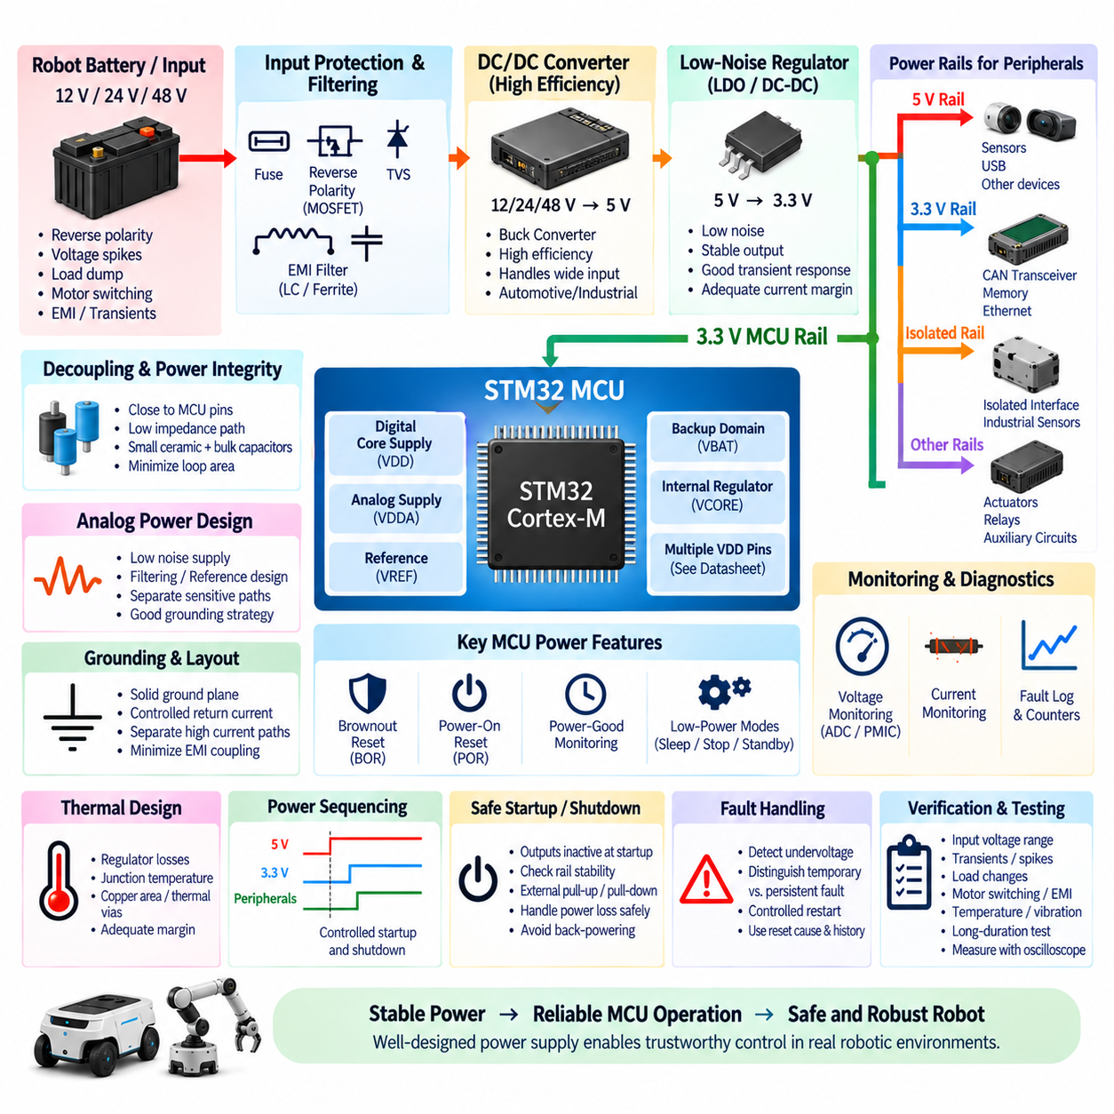
The MCU power supply is a foundational element of robotic controller reliability because every computation, communication interface, sensor input, and actuator command ultimately depends on stable electrical power. An STM32 may operate from only a few volts, but the surrounding robot can contain 12 V, 24 V, or 48 V power domains exposed to motor switching, battery transients, contactor events, electromagnetic interference, and repeated startup or shutdown cycles. Power design must therefore be treated as part of the controller architecture rather than as a simple voltage conversion function.
The first design step is to define the complete power tree from the robot battery or low-voltage distribution network to the MCU and its peripherals. A typical architecture may convert the main supply through a protected DC/DC converter to an intermediate rail such as 5 V, followed by a low-noise regulator generating 3.3 V for the STM32. Additional rails may supply sensors, CAN transceivers, Ethernet devices, memory, analog circuits, or isolated interfaces. Each rail should have a defined source, load, startup sequence, protection strategy, and fault behavior.
A switching regulator is generally preferred when a large voltage difference must be converted efficiently. Converting 24 V or 12 V directly to 3.3 V with a linear regulator would dissipate substantial power as heat, especially when the controller also supplies peripheral devices. A buck converter can efficiently generate an intermediate 5 V or 3.3 V rail, while an LDO may be placed downstream where low noise is more important than conversion efficiency. The architecture should balance efficiency, thermal performance, noise, cost, and PCB area.
Regulator selection should be based on worst-case current rather than the MCU's nominal consumption alone. The power budget must include STM32 peak current, external memories, transceivers, sensors, indicator circuits, oscillators, pull-up networks, communication devices, and startup surges. Peripheral activity can create significant transient demand when several interfaces operate simultaneously. Engineering margin should be retained so that regulator current limiting or excessive voltage droop does not occur during maximum CPU load, communication bursts, or sensor activation.
Transient response is particularly important because MCU current consumption can change rapidly as processor frequency, peripheral activity, DMA transfers, communication, and computational workload vary. A regulator that maintains the correct average voltage may still produce short voltage dips or overshoot during load transitions. Output capacitance, regulator control-loop characteristics, PCB impedance, and local decoupling determine how effectively these disturbances are controlled. Power integrity should therefore be evaluated in both steady-state and dynamic operating conditions.
Decoupling capacitors provide local energy storage and a low-impedance path for high-frequency current demanded by the MCU. Small ceramic capacitors should be located close to the corresponding STM32 supply pins with short connections to power and ground. Larger local bulk capacitance supports lower-frequency load changes. The objective is not merely to place a specified number of capacitors on the schematic but to minimize the current-loop area and impedance between each supply pin, its decoupling capacitor, and the ground return.
STM32 devices can contain several supply domains such as digital core supplies, analog supplies, reference supplies, backup domains, and internal regulator connections depending on the selected family. Each pin must be connected according to the device-specific reference manual and datasheet rather than assuming that all VDD-related pins are electrically identical. Analog supply and reference quality are especially important when the MCU ADC is used for current, voltage, temperature, pressure, or other measurements that influence control or diagnostics.
Analog power should be protected from excessive digital and switching noise. ADC accuracy can be degraded by regulator ripple, motor switching, fast GPIO activity, Ethernet traffic, PWM edges, or poor grounding. Appropriate filtering, reference design, power-plane partitioning, and careful return-current management can reduce coupling. Complete separation of analog and digital grounds is not automatically desirable; the grounding strategy should instead control current paths so that high-current or high-frequency return currents do not disturb sensitive measurement references.
Input protection is necessary because robotic power networks can experience reverse polarity, overvoltage, voltage spikes, load dump-like events, inductive switching, and connector disturbances. Protection may include a fuse or resettable protection element, reverse-polarity protection, transient-voltage suppression, filtering, and appropriately rated DC/DC components. The exact protection architecture depends on the robot's supply system and expected environment. Protection components must be coordinated so that they survive the energy they are expected to absorb or interrupt.
A transient voltage suppressor can clamp short overvoltage events before they reach sensitive regulators and MCU circuits, but selecting a TVS requires more than choosing a voltage above the nominal supply. Stand-off voltage, breakdown voltage, clamping voltage, pulse capability, source impedance, and downstream component ratings must be evaluated together. If the clamp voltage remains higher than the regulator's absolute maximum rating under the expected transient current, the protection network may fail to provide meaningful protection.
Reverse-polarity protection is valuable when batteries, service connectors, or removable modules can be connected incorrectly. A simple diode provides straightforward protection but introduces voltage drop and power loss. MOSFET-based reverse protection can achieve substantially lower loss and is often preferable for higher-current controllers. The design must also consider reverse current through regulators, communication lines, sensor interfaces, and protection structures because unintended current paths can partially power the MCU even when its primary supply is disconnected.
Power sequencing is important when the STM32 communicates with peripherals operating from different rails. If the MCU is powered while a sensor or communication device is unpowered, signal lines may inject current through internal protection diodes. The reverse condition can produce similar problems. Enable pins, reset signals, isolation switches, series resistance, and firmware-controlled power domains can help maintain defined states. The initialization sequence should ensure that communication begins only after each required rail and peripheral has become stable.
Power-good monitoring provides the MCU or an external supervisor with information about whether a supply rail has reached a valid operating range. This can prevent firmware from enabling actuators or communication before supporting electronics are ready. In more safety-critical designs, an independent voltage supervisor can hold the MCU in reset until power is stable and force reset when voltage falls outside defined limits. This provides protection that does not depend on software being operational during an unstable supply event.
Brownout reset is an important internal defense against low supply voltage. When VDD falls below the valid operating region, processor instructions, memory accesses, peripheral operation, or Flash behavior may become unreliable. A correctly configured brownout mechanism forces the MCU into reset before uncontrolled execution occurs. The selected threshold should be compatible with the operating voltage, regulator tolerance, transient behavior, and required system margin rather than being disabled simply to prevent resets observed during an inadequately designed power transient.
Power-on reset and startup timing should establish deterministic behavior from the moment energy is applied. Safety-related outputs should remain inactive while supply rails rise, clocks stabilize, memory initializes, and firmware performs self-tests. External pull-up or pull-down resistors may be required to guarantee safe logic levels before GPIO configuration is complete. Motor enables, contactor commands, brake release signals, and other critical outputs should never depend on undefined MCU pin states during power-up.
Shutdown behavior requires equivalent attention. When the main supply disappears, different rails may decay at different rates because of capacitance and load conditions. The MCU can remain partially powered while peripherals shut down, or communication lines can back-power internal circuitry. If sufficient energy remains, early power-fail detection can allow the controller to store essential diagnostic information or command a controlled shutdown. Safety actions, however, must not depend solely on software having enough time to execute after power begins collapsing.
Grounding is inseparable from power-supply design. The MCU ground is the reference for digital logic, analog measurement, communication transceivers, and many protection devices. Motor currents, relay coils, DC/DC converters, and high-current loads should not share uncontrolled return paths with sensitive MCU or ADC circuits. PCB ground planes, connector grounding, chassis connections, shield termination, and system-level current paths should be considered together to prevent voltage differences that appear to the controller as noise or false sensor signals.
DC/DC converter switching can become a significant electromagnetic interference source. Switching-node geometry, inductor placement, input and output capacitor loops, diode or synchronous MOSFET paths, and ground-plane design strongly influence radiated and conducted emissions. The high di/dt loop should be physically compact and separated from sensitive clocks, ADC references, communication traces, and sensor inputs. A converter with good specifications can still create serious EMC problems when its PCB layout is poorly implemented.
Input filtering can prevent high-frequency disturbances from entering the controller and reduce switching noise returned to the robot power network. LC, ferrite, or common-mode filtering may be useful depending on the disturbance mechanism. Filters must be designed with source and load impedance in mind because poorly damped networks can resonate and create larger voltage excursions than the original disturbance. Filter components must also tolerate DC current without saturation or unacceptable voltage drop.
Thermal design is directly related to power reliability. Regulator losses, protection components, transceivers, and the MCU itself generate heat that raises local PCB temperature. Maximum junction temperature must be evaluated under high ambient temperature, enclosed housings, reduced airflow, maximum processing load, and worst-case input voltage. Copper area, thermal vias, component placement, heatsinking, and enclosure conduction can be used to control temperature. Thermal margin also improves component lifetime and parameter stability.
Low-power modes can reduce energy consumption when a robotic subsystem is idle, but the power architecture must support the intended wake-up behavior. STM32 sleep, stop, standby, or backup modes can preserve different levels of state while reducing consumption. Wake sources may include timers, CAN activity, GPIO events, safety inputs, or external supervisors. Designers must determine which regulators, sensors, communication devices, and memory domains remain powered so that the system can return to operation predictably.
Battery-powered robots also require consideration of quiescent current. Even small continuous currents can significantly discharge a battery during long storage or standby periods when multiplied across many distributed controllers. DC/DC converter standby current, LDO quiescent current, pull resistors, transceivers, LEDs, supervisors, and sensors should therefore be included in the off-state power budget. A controller that consumes little power during active operation can still create unacceptable battery drain if its shutdown architecture is poorly designed.
Power-domain partitioning can improve fault containment and energy management. Sensors, communication interfaces, actuators, and auxiliary electronics may be supplied from separately controllable rails while the MCU supervisory domain remains active. The controller can then power-cycle a failed sensor, disable nonessential loads during low-battery conditions, or isolate a malfunctioning peripheral. Power switching devices should include defined default states so that firmware failure does not unintentionally energize hazardous loads.
Monitoring supply voltage and current gives the MCU valuable diagnostic information. ADC channels or dedicated power-monitor ICs can measure input voltage, regulated rails, current consumption, and sometimes energy usage. Trends can reveal overloaded regulators, deteriorating connectors, abnormal peripheral consumption, or battery problems before complete failure occurs. Measurements used for safety decisions should include appropriate accuracy, filtering, plausibility checking, and independent protection where the risk requires it.
Fault handling should distinguish between temporary disturbances and persistent electrical failures. A short voltage dip may justify a controlled restart, while repeated brownouts can indicate an overloaded supply, damaged battery, poor connector, or failing regulator. Repeated automatic rebooting without diagnosis can create unstable actuator behavior. Reset-cause information, voltage history, fault counters, and power-good status can therefore be incorporated into startup logic to determine whether normal operation should resume.
Verification must reproduce realistic electrical conditions rather than testing only from a clean laboratory bench supply. The controller should be evaluated across its specified input-voltage range, maximum load, startup and shutdown, rapid load changes, communication activity, actuator switching, brownout, transient events, reverse connection where applicable, and repeated power cycling. Oscilloscope measurements at MCU supply pins are essential for observing voltage ripple, droop, overshoot, startup behavior, and disturbances hidden by slower instruments.
Environmental verification should combine power testing with temperature, vibration, and electromagnetic conditions because these stresses interact. Connector resistance can change with vibration, regulator thermal margin decreases at high temperature, and motor-generated EMI can couple into supply rails. Long-duration operation under representative load is especially valuable for detecting marginal regulator sizing, thermal accumulation, intermittent resets, and component degradation that may not appear during short functional tests.
A robust STM32 power supply therefore combines efficient voltage conversion, adequate current margin, local decoupling, transient and reverse-polarity protection, controlled sequencing, brownout supervision, safe startup and shutdown, disciplined grounding, EMC-conscious layout, thermal management, and diagnostic monitoring. Its purpose is not merely to deliver 3.3 V to the MCU, but to maintain trustworthy computation and predictable control despite the electrically harsh and dynamically changing conditions of a real robotic system.

