Volume 16 Compute and AI Architecture

Chapter 06. On-Premise AI System

06.01. Robot AI Server Architecture
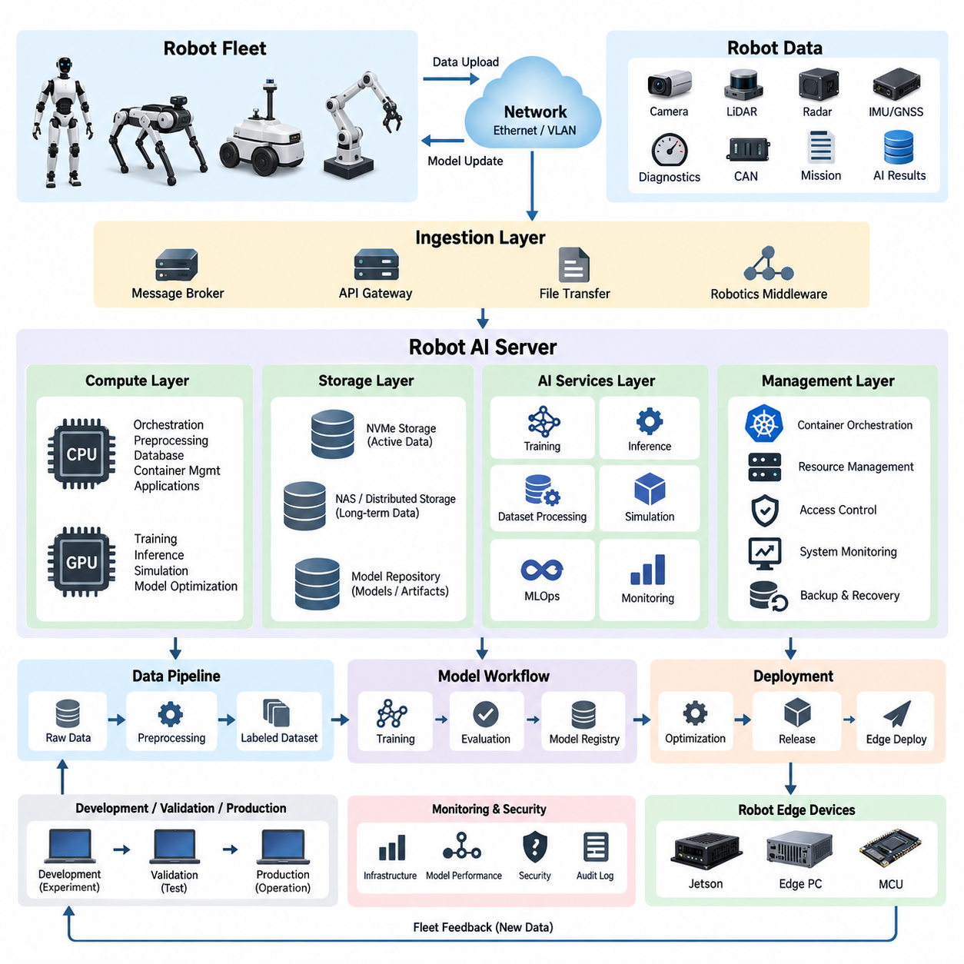
A Robot AI Server Architecture provides the centralized computing foundation that connects robot-generated data, AI model development, validation, deployment, and operational monitoring within an on-premise environment. Unlike an individual robot computer, which must satisfy strict power and real-time constraints, the server layer can concentrate high-performance GPU, CPU, storage, and networking resources. It therefore acts as the computational backbone between robot fleets and the AI engineering infrastructure.
The architecture should separate robot-side real-time execution from server-side computational workloads. Motion control, emergency response, localization, obstacle avoidance, and other latency-critical functions remain on embedded controllers, Jetson platforms, or edge PCs. The server instead performs large-scale perception processing, dataset preparation, model training, simulation, analytics, model optimization, and fleet-level learning. This separation prevents network delays or server failures from directly compromising basic robot safety.
A practical server architecture is organized around compute, storage, networking, AI services, and management layers. CPU resources handle orchestration, preprocessing, database services, container management, and general application workloads, while GPUs accelerate deep neural network training and high-throughput inference. Local NVMe storage provides high-speed workspace for active datasets and checkpoints, while larger NAS or distributed storage systems retain long-term sensor data, trained models, logs, and simulation assets.
GPU resources should be selected according to workload rather than simply maximizing accelerator count. Large training jobs may require multi-GPU nodes interconnected through high-bandwidth GPU communication, while inference, preprocessing, or evaluation services can operate on smaller GPU partitions or independent servers. The architecture should allow compute resources to be assigned dynamically so that perception networks, VLM/VLA models, world models, synthetic-data pipelines, and simulation workloads can coexist without unnecessarily blocking one another.
Robot connectivity forms another major architectural boundary. Robots may continuously or periodically upload camera frames, LiDAR point clouds, radar observations, IMU and GNSS measurements, diagnostics, CAN data, mission histories, and AI inference results. These streams should enter the server through controlled ingestion services rather than directly accessing training storage. Message brokers, API gateways, file-transfer services, and robotics middleware can isolate operational networks from internal AI infrastructure.
High-bandwidth Ethernet is normally required between ingestion servers, GPU nodes, and storage systems because robotics datasets contain large image sequences, point clouds, and multimodal recordings. Network design should therefore consider not only peak throughput but also simultaneous robot uploads, dataset replication, training reads, checkpoint writes, and administrative traffic. Dedicated network segments or VLANs can separate robot communication, storage traffic, GPU-cluster traffic, management access, and external service interfaces.
The storage architecture should reflect the complete AI data lifecycle. Raw robot observations are first preserved as immutable or controlled source data, after which preprocessing pipelines generate synchronized, calibrated, filtered, labeled, or transformed datasets. Training systems consume versioned datasets and produce checkpoints, metrics, and artifacts. Validated models then move into a controlled model repository. This organization establishes traceability between field observations, dataset versions, experiments, and deployed robot software.
Time synchronization and metadata management are particularly important for Physical AI systems because meaningful training examples frequently depend on relationships between multiple sensors and robot actions. Camera images, LiDAR scans, localization states, actuator commands, mission states, and operator interventions must be associated with consistent timestamps and robot identities. The server should therefore preserve synchronization information, calibration versions, software versions, hardware configuration, mission context, and environmental metadata alongside the sensor payload.
Containerized AI services provide an effective mechanism for isolating software dependencies across development teams and workloads. Training environments, inference servers, dataset processors, simulation services, databases, dashboards, and robotics gateways can operate as separate containers or service groups. Container orchestration can allocate CPU, GPU, memory, and storage resources while restarting failed services and supporting controlled upgrades. This reduces conflicts among CUDA, framework, driver, and application dependencies.
The Robot AI Server should also provide a clear path from experimentation to deployment. Engineers develop and train models using controlled datasets, execute automated evaluation, compare candidate models against established baselines, and register models that satisfy defined acceptance criteria. Deployment services can then package optimized models with configuration and runtime dependencies before distributing them to Jetson platforms, edge PCs, or other robot compute modules through managed release channels.
Model deployment must recognize that server hardware and robot hardware have fundamentally different performance envelopes. A model trained using large GPU resources may require pruning, quantization, graph optimization, TensorRT compilation, reduced input resolution, or architectural modification before edge deployment. Consequently, the server should maintain both training representations and hardware-specific deployment artifacts. Validation must confirm that optimization preserves acceptable perception accuracy, latency, memory consumption, and operational robustness.
Fleet operation transforms the server from a simple training machine into a continuous learning infrastructure. Deployed robots generate new observations, difficult cases, failures, unusual environments, and operator interventions. Selected information can return to the on-premise server, where it is classified and incorporated into new datasets. Updated models can then be trained, evaluated, and redeployed. This creates a closed engineering loop connecting physical operation, data collection, learning, validation, and improved robot behavior.
The architecture should distinguish development, validation, and production environments even when they share physical hardware. Experimental code and unverified models should not directly modify operational robot services. Development resources support rapid experimentation, validation resources reproduce controlled test conditions, and production services handle approved models, fleet interfaces, and operational databases. Access control and release gates between these environments reduce the probability that unfinished AI components reach deployed robots.
Reliability requires redundancy at architectural boundaries rather than assuming that every component must be duplicated. Critical databases, model repositories, configuration records, and operational services require backup and recovery mechanisms, while large reproducible training jobs may tolerate temporary interruption. Storage protection, redundant network paths, UPS-backed infrastructure, server health monitoring, thermal monitoring, and automated service recovery should therefore be prioritized according to the operational consequence of each failure.
Security becomes especially important because an on-premise AI system contains robot telemetry, proprietary datasets, source code, trained models, credentials, and potentially sensitive sensor recordings. Authentication, role-based authorization, network segmentation, encrypted communication, audit logging, secure model repositories, controlled external connectivity, and backup protection should be incorporated from the initial architecture. Robot credentials should also be managed independently so that compromise of one robot does not automatically expose the complete server environment.
Monitoring should cover both conventional IT resources and AI-specific behavior. CPU utilization, GPU utilization, GPU memory, temperature, storage capacity, network throughput, service availability, and job status provide infrastructure visibility. AI monitoring additionally tracks dataset versions, training loss, validation metrics, inference latency, model versions, deployment status, and field-performance indicators. Combining these views allows engineers to distinguish infrastructure failures from model degradation or data-quality problems.
Scalability should be achieved through modular expansion rather than complete architectural replacement. An initial installation may contain one GPU server, local NVMe storage, NAS capacity, and a management server. As robot numbers and datasets increase, additional GPU nodes, storage arrays, high-speed network switches, backup systems, and dedicated ingestion servers can be introduced. The same logical architecture can therefore evolve from laboratory development to organization-wide Physical AI infrastructure.
Within the broader Compute and AI Architecture, the Robot AI Server forms the first foundation of the On-Premise AI System and connects naturally to the subsequent data collection pipeline, model training workflow, MLOps framework, and security architecture defined in the chapter structure. It also bridges the GPU server infrastructure of the preceding chapter with fleet-level AI and distributed execution covered later, establishing a continuous path from centralized computation to deployed robotic intelligence.

06.02. Data Collection Pipeline
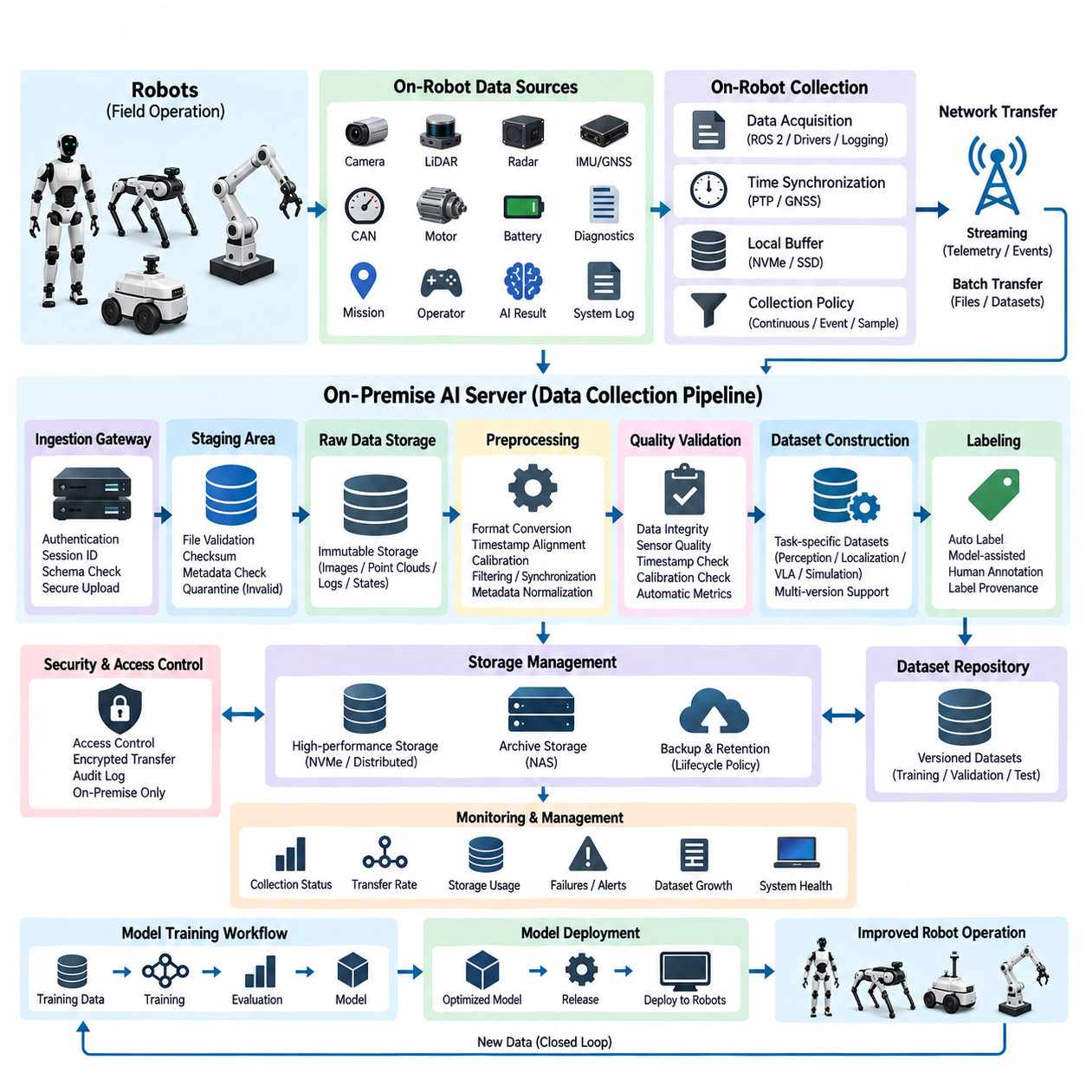
A Data Collection Pipeline forms the operational bridge between physical robots and the on-premise AI infrastructure. Its purpose is not simply to copy sensor files from robots to a server, but to capture, transport, organize, validate, and preserve multimodal operational data in a form suitable for AI development. Within the On-Premise AI System, this pipeline converts continuous robot experience into controlled engineering assets that can support training, validation, diagnostics, simulation, and fleet learning.
Robots generate heterogeneous information at very different rates and with different operational importance. Cameras produce high-volume image or video streams, LiDAR generates point clouds, radar provides object and motion observations, while IMU and GNSS systems produce high-frequency localization information. Additional sources include CAN messages, motor states, battery information, diagnostics, mission events, operator commands, AI inference results, and system logs. The pipeline must accept these sources without forcing them into a single acquisition mechanism.
Data acquisition should begin as close as practical to the original robot interfaces while avoiding interference with real-time control. Sensor drivers, ROS 2 nodes, CAN interfaces, logging processes, and application services can publish information to dedicated collection processes. Safety-critical control paths should remain independent from bulk data recording. Collection software therefore observes or duplicates relevant information rather than becoming an unnecessary dependency in braking, steering, localization, motion control, or emergency functions.
Accurate timestamps are essential because Physical AI training depends on relationships among perception, robot state, and action. Camera frames, LiDAR scans, radar observations, IMU measurements, localization estimates, actuator commands, and mission events must be aligned to a common time reference whenever possible. PTP, GNSS-derived timing, hardware timestamps, or synchronized system clocks can establish this reference, while metadata should record clock source, synchronization status, sensor frequency, and known timing uncertainty.
The pipeline should attach contextual metadata to collected sensor payloads rather than treating every file as an isolated object. Useful context includes robot identity, hardware configuration, sensor serial information, calibration version, software build, AI model version, mission identifier, operating mode, map version, location context, and environmental conditions when available. This metadata enables engineers to reconstruct the circumstances under which data was produced and prevents apparently similar recordings from being incorrectly combined.
Continuous recording of every available signal is often impractical because modern robots can generate enormous amounts of data. Collection policies should therefore distinguish continuous signals, event-triggered recordings, sampled data, diagnostic snapshots, and selectively retained high-value cases. A robot may preserve short rolling buffers and permanently save them when collisions, localization failures, emergency stops, perception uncertainty, operator interventions, unusual obstacles, or other predefined events occur.
Edge-side buffering protects data integrity when network connectivity is unstable or unavailable. Robots operating outdoors, inside large facilities, underground, or across wireless coverage boundaries cannot assume continuous access to the AI server. Local NVMe or SSD storage can temporarily hold collection sessions together with upload state and checksums. Once communication is restored, transfer services can resume incomplete uploads rather than restarting entire datasets or discarding valuable field observations.
Data transport should be selected according to payload characteristics. Lightweight telemetry and events can move through messaging systems or robotics middleware, while large camera recordings, point-cloud archives, and dataset packages are better transferred using reliable file or object transfer mechanisms. The collection architecture can therefore combine streaming and batch transfer instead of requiring one protocol for every source. Bandwidth limits and mission-critical network traffic should always take priority over background dataset uploads.
An ingestion gateway provides a controlled boundary between robot networks and internal AI storage. Incoming sessions can be authenticated, assigned unique identifiers, checked against expected schemas, and routed toward appropriate staging locations. The gateway also prevents individual robots from obtaining unrestricted access to central datasets or training infrastructure. This boundary becomes increasingly important as the system expands from a few development robots to large fleets distributed across multiple operational sites.
The first server-side destination should normally be a staging area rather than the final training dataset. Staging preserves uploaded data while automated processes verify file completeness, checksums, timestamps, message schemas, metadata availability, and basic sensor validity. Corrupted or incomplete sessions can be quarantined for investigation. Separating ingestion from curated storage prevents malformed recordings from silently contaminating downstream datasets and provides a recoverable boundary for data-processing operations.
Raw data should be preserved whenever storage policy permits because preprocessing algorithms and AI requirements evolve over time. A camera image that appears unnecessary for one perception task may later become useful for VLM training, anomaly analysis, or world-model development. Similarly, raw LiDAR and robot-state information can be reprocessed using improved calibration or localization algorithms. The architecture should therefore distinguish immutable raw data from derived datasets that can be regenerated.
Preprocessing transforms collected observations into forms suitable for downstream AI workloads. Typical operations include decompression, format conversion, timestamp alignment, coordinate transformation, calibration application, image resizing, point-cloud filtering, sensor synchronization, sequence extraction, and metadata normalization. Computationally expensive processing can be performed on server CPUs or GPUs rather than consuming robot resources. Each derived artifact should retain references to its original recording and processing configuration.
Quality validation should evaluate more than whether files can be opened. Camera streams can contain dropped frames, blur, saturation, or exposure problems; LiDAR recordings can contain missing packets or abnormal point distributions; IMU and GNSS streams can exhibit discontinuities; and calibration relationships can become invalid after hardware maintenance. Automated quality metrics allow the pipeline to identify suspicious sessions before they enter training workflows and help engineering teams discover sensor or robot problems.
Dataset construction converts validated recordings into controlled collections associated with specific AI objectives. Perception training may require synchronized camera and LiDAR sequences, localization research may emphasize GNSS, IMU, wheel odometry, and map information, while VLA or Physical AI learning may require observations paired with commands, actions, task states, and outcomes. The pipeline should therefore support multiple derived datasets from the same raw recording rather than imposing one universal dataset representation.
Labeling can combine automated generation, existing robot outputs, simulation-derived information, and human annotation. Current perception models may generate preliminary labels that are reviewed or corrected, while robot state and map information can automatically provide certain geometric or operational labels. Human annotation remains important for ambiguous objects, unusual events, task semantics, and failure interpretation. Label provenance should be recorded so that engineers know whether each annotation was generated automatically, manually, or through a hybrid process.
Dataset versioning provides reproducibility between data collection and model training. Once a dataset is released for an experiment, its membership, labels, preprocessing parameters, calibration references, and relevant metadata should remain identifiable as a specific version. New field data or corrected annotations should create an updated version instead of silently modifying previous training inputs. This allows a trained model to be traced back to the exact data configuration used to produce it.
Storage lifecycle management becomes increasingly important as fleet size grows. High-value raw recordings may be retained for long periods, while temporary caches, intermediate preprocessing products, duplicated downloads, and obsolete derived artifacts can follow shorter retention policies. Frequently accessed training data can reside on high-performance NVMe or distributed storage, while archived recordings can move to capacity-oriented NAS or backup systems. This tiered strategy balances AI development speed against long-term storage cost.
Security and privacy controls must remain active throughout the pipeline. Robot recordings may contain people, facilities, maps, operational routines, proprietary environments, or other sensitive information. Data should therefore be authenticated during ingestion, protected during transfer, restricted according to roles, and recorded in audit logs where appropriate. Sensitive datasets can remain entirely within the on-premise environment, reducing dependence on external cloud services while preserving organizational control over collected robot information.
Operational monitoring should make the collection pipeline observable as a system. Engineers need visibility into recording status, robot storage capacity, upload queues, network throughput, failed transfers, ingestion rates, corrupted sessions, processing backlogs, dataset growth, and storage utilization. Alerts can identify robots that unexpectedly stop reporting data or sensors whose recording characteristics change. These indicators transform collection from an informal logging activity into a managed production capability.
The pipeline ultimately supports a closed learning loop between deployed robots and the AI engineering environment. Field robots encounter new objects, environments, failures, edge cases, and human interactions; selected observations return through the collection pipeline and become validated datasets. Those datasets feed the subsequent Model Training Workflow, where improved models can be developed and evaluated before controlled redeployment to robots. Data collection therefore becomes the first stage of continuous fleet intelligence.
Within the chapter structure, Data Collection Pipeline follows Robot AI Server Architecture and establishes the data foundation required by Model Training Workflow, Model Management and MLOps, and On-Premise Security Design. Together, these components transform the on-premise server from static computing hardware into an integrated AI lifecycle platform. The pipeline is therefore not merely a storage mechanism, but the controlled interface through which physical robot experience becomes reusable, traceable, and continuously improving AI knowledge.

06.03. Model Training Workflow
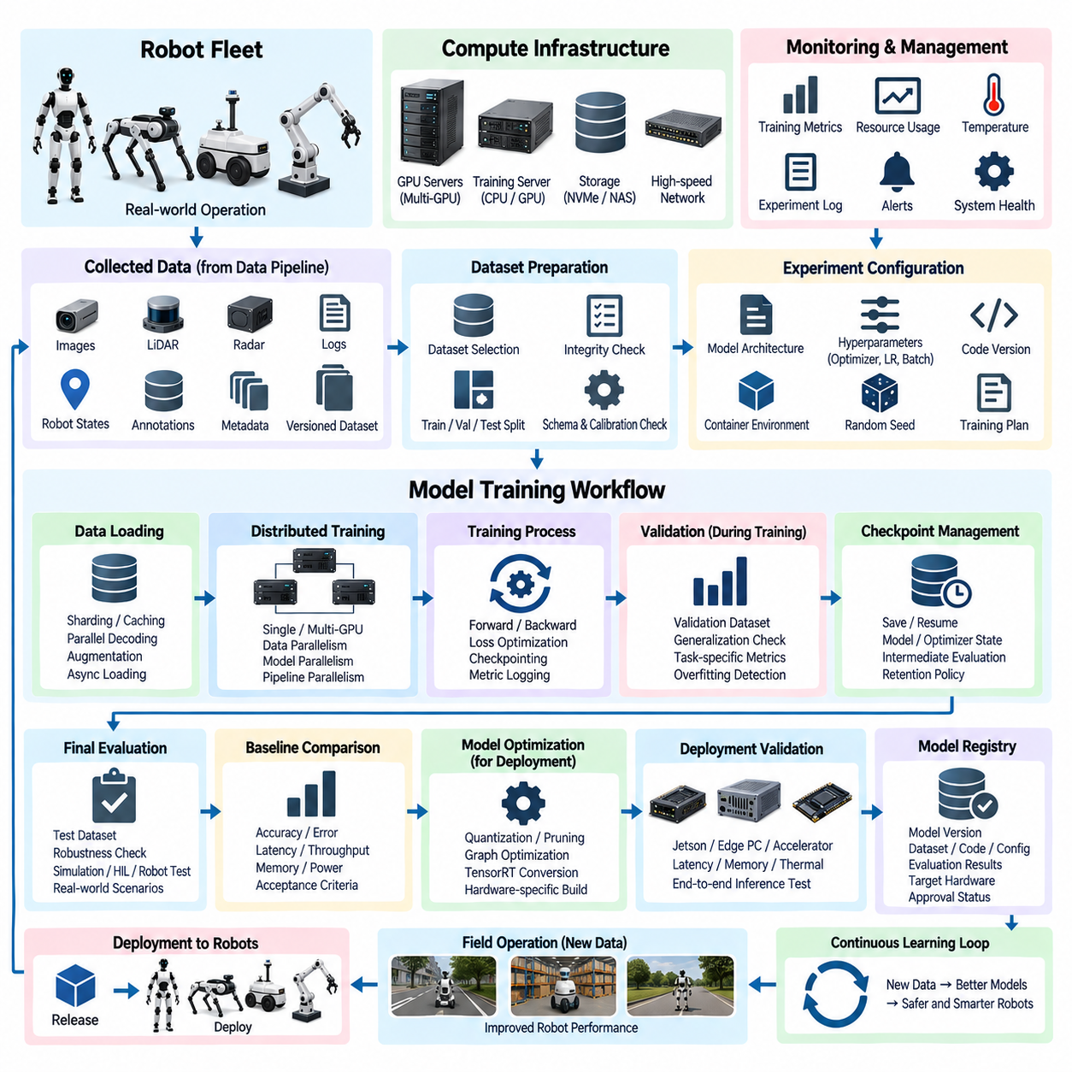
A Model Training Workflow transforms curated robot datasets into validated AI models that can be deployed to physical systems. Within an On-Premise AI System, training is not an isolated GPU operation but a controlled sequence connecting dataset selection, experiment configuration, distributed computation, evaluation, optimization, registration, and deployment readiness. The workflow must preserve traceability so that every trained model can be related to the exact data, software, parameters, and computing environment used to create it.
Training begins with a clearly defined AI objective and an associated dataset configuration. A perception model may require synchronized camera, LiDAR, or radar observations, while localization models can depend on GNSS, IMU, odometry, and map information. VLM, VLA, world-model, or Physical AI workloads may additionally require language, temporal sequences, robot states, actions, and outcomes. The training workflow therefore consumes task-specific, versioned datasets produced by the preceding Data Collection Pipeline.
Before computation begins, dataset integrity and compatibility should be verified. Training software should confirm dataset version, annotation schema, calibration references, preprocessing configuration, class distribution, sequence structure, and expected input dimensions. Training, validation, and test partitions should be explicitly identified to prevent accidental data leakage. These checks establish a reproducible input boundary and reduce the risk that apparently improved model performance is caused by inconsistent or contaminated evaluation data.
Experiment configuration defines how the model will be trained and should itself be treated as a version-controlled engineering artifact. It can include architecture selection, initialization method, optimizer, learning rate, batch size, augmentation policy, loss functions, training duration, random seeds, checkpoint frequency, and hardware requirements. Configuration files should be stored together with source-code revisions and dataset identifiers so that successful or failed experiments can later be reconstructed without relying on undocumented manual settings.
The training environment must also be reproducible. CUDA versions, GPU drivers, deep-learning frameworks, Python packages, custom operators, compiler versions, and supporting libraries can materially affect execution and sometimes numerical results. Containerized environments provide a practical mechanism for packaging these dependencies. A training container can be associated with a specific model project and reused across workstation, single-server, and multi-GPU infrastructure while maintaining a controlled software baseline.
Compute resources should be allocated according to model size and experimental purpose. Small experiments and debugging jobs can run on a single GPU, while large perception networks, foundation models, multimodal models, or world models may require multi-GPU servers or GPU clusters. CPU resources perform decoding, augmentation, preprocessing, and data loading, while high-speed NVMe or distributed storage supplies training samples. Balanced resource design prevents expensive GPUs from remaining idle while waiting for storage or preprocessing operations.
Large-scale training can use data parallelism, model parallelism, pipeline parallelism, or combinations of these techniques depending on model characteristics. Data parallelism distributes batches across GPUs and synchronizes gradients, while model-oriented approaches partition networks that cannot fit efficiently into one accelerator. High-bandwidth GPU interconnects and cluster networking become increasingly important as scale grows. Distributed execution should nevertheless remain transparent enough that experiment metadata identifies all participating resources and software versions.
The input pipeline must deliver data fast enough to sustain GPU utilization without compromising reproducibility. Dataset sharding, caching, prefetching, parallel decoding, augmentation, and asynchronous loading can improve throughput. Frequently accessed training data may be staged on NVMe storage while larger source datasets remain on NAS or distributed storage. Performance monitoring should identify whether training is compute-bound, storage-bound, CPU-bound, or network-bound so that infrastructure improvements target the actual bottleneck.
During training, the system should continuously capture metrics and operational state. Loss values, learning rates, accuracy measures, gradient statistics, GPU utilization, memory consumption, iteration speed, temperature, and checkpoint status provide visibility into both model behavior and infrastructure health. Metrics should be associated with an experiment identifier rather than stored as disconnected logs. This allows engineers to compare training runs systematically and identify divergence, overfitting, instability, or inefficient resource utilization.
Checkpoint management protects long-running experiments and enables controlled analysis. Model weights, optimizer state, scheduler state, training progress, and relevant configuration information can be saved periodically so that interrupted jobs resume without restarting from the beginning. Checkpoints also allow engineers to evaluate intermediate model states instead of assuming the final training epoch is optimal. Retention policies should preserve significant checkpoints while removing redundant intermediate files that consume excessive high-performance storage.
Validation should occur throughout training rather than only after completion. A dedicated validation dataset can measure generalization while remaining isolated from parameter updates. For robotics applications, useful metrics may include detection or segmentation accuracy, depth error, localization error, trajectory prediction quality, action success, collision-related indicators, or task completion performance. The appropriate metric depends on the model role, and no single numerical score should automatically represent overall robot capability.
Completed models should undergo a more controlled evaluation using datasets and scenarios not used for optimization. Evaluation can include nominal cases, difficult environments, rare events, sensor degradation, lighting changes, dynamic obstacles, and previously observed field failures. Physical AI systems may additionally require simulation, replay, software-in-the-loop, hardware-in-the-loop, or controlled robot testing. The objective is to determine whether improved offline metrics translate into behavior that is useful and sufficiently robust for physical deployment.
Baseline comparison provides an engineering gate between experimentation and model promotion. A candidate model should be compared with the currently approved model using the same datasets, metrics, runtime conditions, and acceptance thresholds. Improvements in accuracy must be considered together with inference latency, GPU memory, power demand, model size, and failure behavior. A model that achieves higher laboratory accuracy but exceeds the robot compute budget may not represent an operational improvement.
Models intended for edge deployment frequently require optimization after training. Quantization, pruning, operator fusion, graph optimization, TensorRT conversion, reduced precision, or architecture-specific compilation can transform a server-trained model into an efficient deployment artifact. Optimization must be followed by another evaluation cycle because numerical behavior may change. The workflow should therefore distinguish the original training checkpoint from each hardware-specific optimized model produced from it.
Deployment validation should use the actual or representative target hardware whenever practical. Jetson platforms, edge PCs, dedicated accelerators, and server GPUs have different memory limits, execution characteristics, supported operators, and thermal constraints. Measurements should include end-to-end inference latency, throughput, initialization time, peak memory consumption, sustained thermal behavior, and interaction with other robot workloads. This step closes the gap between AI benchmark performance and real robot computing performance.
A model that satisfies technical and operational criteria can be registered in a controlled Model Registry. Registration should associate the model with its dataset version, source-code revision, training configuration, container environment, checkpoints, evaluation results, optimization method, target hardware, and approval status. The registry becomes the authoritative connection between experimentation and deployment, allowing engineering teams to identify exactly which model is operating on each robot and why it was approved.
Failed experiments should remain part of the engineering knowledge base rather than disappearing after training. Recording unsuccessful configurations, unstable training behavior, performance regressions, incompatible optimizations, and resource limitations prevents repeated mistakes and improves future experiment planning. The value of an on-premise training platform therefore comes not only from producing successful models but also from accumulating structured evidence about which approaches work under the organization’s datasets, hardware, and robot requirements.
Automation can progressively convert the workflow into a repeatable training pipeline. Dataset validation, environment creation, training execution, checkpointing, metric collection, evaluation, optimization, and registration can be connected through scheduled or event-driven jobs. However, automated execution should not imply automatic deployment. Promotion to operational robots should remain governed by explicit acceptance criteria, validation evidence, approval states, and rollback capability, particularly for models influencing robot motion or safety-related behavior.
Security controls must protect training data, model weights, source code, credentials, and computing resources throughout the workflow. Role-based access, isolated containers, authenticated storage, controlled repositories, audit records, and restricted external connectivity help preserve intellectual property and data sovereignty. On-premise execution is particularly valuable when robot recordings or trained models cannot be transferred to public cloud environments, while internal segmentation limits unnecessary access even within the organization.
The workflow ultimately forms a repeatable loop rather than a one-time development sequence. New field data enters through the Data Collection Pipeline, datasets are updated and versioned, experiments generate candidate models, evaluation identifies improvements, optimized artifacts are deployed, and operational results return as new training evidence. This continuous cycle allows robot intelligence to evolve while preserving reproducibility, validation discipline, and control over the relationship between physical experience and AI behavior.
Within the chapter structure, Model Training Workflow follows Robot AI Server Architecture and Data Collection Pipeline and provides the computational process that converts collected robot experience into deployable intelligence. Its outputs naturally enter Model Management and MLOps, where model versions, approvals, releases, monitoring, and lifecycle control can be formalized. Together, these components establish the core learning loop of the On-Premise AI System within the broader Compute and AI Architecture.

06.04. Model Management (MLOps)
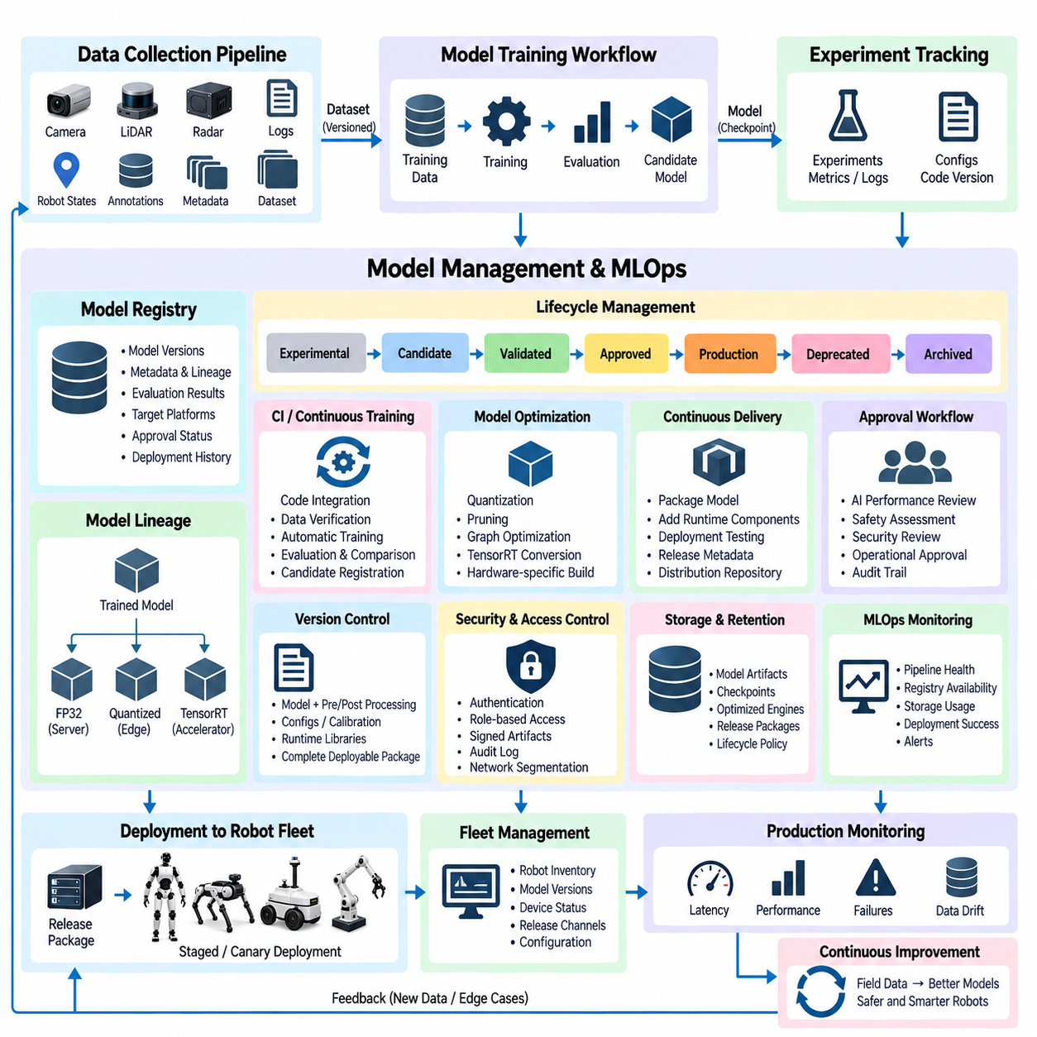
Model Management and MLOps provide the governance layer that controls how trained AI models move from experimentation into validated, deployable, monitored, and maintainable robot intelligence. In an On-Premise AI System, this capability connects the Model Training Workflow with operational robot fleets. It ensures that models are not treated as isolated files but as controlled engineering assets with identifiable versions, dependencies, evaluation evidence, target hardware, approval states, and complete lifecycle histories.
A model lifecycle begins when a training experiment produces a candidate checkpoint together with its associated metadata. The model should remain linked to the dataset version, source-code revision, experiment configuration, training environment, framework version, hyperparameters, metrics, and hardware used during training. Preserving these relationships allows engineers to reproduce results and investigate why two apparently similar models behave differently when evaluated or deployed on physical robots.
The Model Registry serves as the authoritative repository for model identity and lifecycle status. Rather than storing only binary weights, the registry should maintain model versions, descriptions, lineage, evaluation results, optimization artifacts, target platforms, approval information, and deployment history. Models can progress through states such as experimental, candidate, validated, approved, production, deprecated, or archived. Explicit states prevent unfinished experimental models from being confused with operationally approved releases.
Model lineage is particularly important because one trained model may generate several deployment variants. A full-precision checkpoint produced on a GPU server can later be quantized, pruned, converted to TensorRT, or compiled for different accelerators. Each derived artifact should retain a parent relationship to the original model and record the transformation applied. This creates a traceable hierarchy connecting training checkpoints to Jetson, edge-PC, server-inference, or other hardware-specific deployment packages.
Versioning should cover more than model weights. A meaningful model release may depend on preprocessing code, calibration assumptions, input resolution, class definitions, normalization parameters, runtime libraries, TensorRT engines, configuration files, and post-processing logic. Changing any of these components can alter robot behavior even when the neural-network weights remain unchanged. MLOps should therefore manage the deployable AI package as a versioned system rather than identifying releases solely by a model filename.
Promotion gates define when a candidate model can advance toward production. Automated checks may verify accuracy, robustness, inference latency, memory consumption, model size, hardware compatibility, and regression against an approved baseline. Robotics applications can additionally require simulation, replay, software-in-the-loop, hardware-in-the-loop, or controlled physical testing. Models that influence perception, planning, or robot actions should not enter production merely because a training metric exceeds a numerical threshold.
Continuous Integration principles can be extended to AI development by automatically validating changes to training code, inference software, configuration, and model interfaces. When engineers modify source code or submit a new model candidate, automated pipelines can execute unit tests, interface checks, dataset compatibility tests, inference tests, and selected regression scenarios. This reduces integration problems caused by changes that appear harmless in development but break preprocessing, runtime execution, or robot interfaces.
Continuous Training can automate repeated model generation when approved datasets are updated. A new dataset version may trigger preprocessing verification, training, evaluation, baseline comparison, and candidate registration. However, continuous training should remain distinct from automatic production release. The resulting model is a new candidate that must satisfy established technical and operational gates before deployment. This distinction preserves engineering control while still reducing repetitive manual work.
Continuous Delivery prepares validated models for controlled release to target robot platforms. The delivery pipeline can retrieve an approved model, apply hardware-specific optimization, package required runtime components, execute deployment tests, generate release metadata, and place the artifact into an authorized distribution repository. Deployment can then occur according to fleet policies rather than through engineers manually copying model files onto individual robots.
Robot fleets require deployment strategies that limit operational risk. A new model can first be installed on development robots, followed by validation units or a small production subset before wider fleet release. Canary deployment exposes the model to a limited population, while staged rollout progressively increases deployment coverage. If monitoring identifies unexpected behavior, deployment can be stopped before the model reaches every robot. This is especially valuable when field conditions differ significantly from laboratory datasets.
Rollback capability should be designed into the deployment architecture rather than improvised after a failure. Robots can retain the previously approved model or maintain access to a known-good deployment package. If the new release fails initialization, exceeds latency limits, produces abnormal outputs, or causes operational regression, the system can return to the earlier version. Model configuration, runtime dependencies, and preprocessing components must roll back consistently with the weights to ensure deterministic recovery.
The fleet inventory should identify which AI software and model versions are running on every robot. Useful records include robot identity, hardware platform, firmware or operating-system version, deployed model package, deployment time, configuration, and current release channel. Without this mapping, engineers cannot reliably correlate field failures with specific model releases. Fleet-level model inventory therefore connects MLOps configuration management with robotics asset management and operational diagnostics.
Production monitoring extends beyond server health and must observe model behavior after deployment. Runtime information can include inference latency, throughput, memory usage, GPU utilization, dropped inputs, confidence distributions, failure events, intervention rates, and task-level performance. Depending on bandwidth and privacy constraints, robots may transmit summarized metrics while retaining large sensor recordings locally until selected events require upload through the Data Collection Pipeline.
Model performance can degrade even when the deployed software remains unchanged because the physical operating environment evolves. New facilities, seasonal conditions, lighting, object types, human behavior, sensor aging, or changes in robot hardware can produce data distributions that differ from training conditions. MLOps should therefore support detection of data drift and performance drift by comparing field observations and operational indicators with expected baselines established during model validation.
When monitoring detects difficult or abnormal cases, selected observations can be routed back into the data lifecycle. Low-confidence predictions, operator interventions, localization failures, collisions, unusual obstacles, or task failures can become candidates for additional analysis and labeling. After validation, these examples can be incorporated into new dataset versions and used by the Model Training Workflow. MLOps thus closes the loop between deployment monitoring, data collection, retraining, and improved model releases.
Experiment tracking and production model management should remain connected but logically distinct. Research teams may conduct hundreds of experiments, many of which never need production status. Experiment tracking preserves configurations, metrics, checkpoints, and comparisons, while the Model Registry contains models that have entered formal lifecycle control. Separating these concerns prevents the production repository from becoming overloaded with temporary experiments while preserving research traceability.
Approval workflows introduce organizational accountability into model promotion. Different roles can be responsible for AI performance, software integration, robot validation, safety assessment, cybersecurity, or operational release. Approval records should identify what evidence was reviewed and which model version was authorized. For higher-risk robot functions, multiple approvals may be required before deployment. The resulting audit trail makes model release an engineering decision rather than an informal transfer between developers.
Security must protect the MLOps control plane because compromise of the model lifecycle can affect an entire robot fleet. Model repositories, deployment credentials, signing keys, orchestration services, CI/CD pipelines, and administrative interfaces require strong authentication and role-based access control. Model artifacts can be hashed or cryptographically signed so robots verify authenticity and integrity before installation. Network segmentation further limits the ability of compromised development systems to directly reach production robots.
On-premise MLOps is particularly valuable when datasets, models, or robot telemetry must remain under organizational control. Training infrastructure, registries, artifact repositories, monitoring databases, and deployment services can operate inside controlled networks without requiring sensitive information to leave the facility. External software repositories or update services, when necessary, can be accessed through governed interfaces while internal robot data and proprietary model artifacts remain isolated.
Storage policies should manage the increasing number of experiments, checkpoints, optimized engines, releases, logs, and archived models generated over time. Production releases and their supporting evidence require long-term retention, while redundant intermediate checkpoints may be removed according to lifecycle policies. Archived models should remain recoverable when required for incident analysis, historical comparison, regulatory evidence, or reproduction of behavior observed on an earlier robot configuration.
MLOps monitoring should also measure the health of the lifecycle infrastructure itself. Pipeline failures, training queue delays, registry availability, artifact-storage capacity, deployment success rates, rollback events, fleet-version fragmentation, and monitoring-data latency provide indicators of operational maturity. Dashboards and alerts can expose problems before they disrupt model releases or leave portions of the robot fleet operating with unintended or obsolete AI configurations.
The complete MLOps architecture creates a controlled feedback cycle: field data produces versioned datasets, datasets generate reproducible experiments, validated candidates enter the Model Registry, approved models become hardware-specific deployment packages, controlled rollout places them onto robots, and production monitoring generates new evidence. Every transition retains identity and provenance, allowing the organization to improve robot intelligence without losing control over what was trained, tested, released, or operated.
Within the chapter structure, Model Management and MLOps follows Robot AI Server Architecture, Data Collection Pipeline, and Model Training Workflow, converting their outputs into a governed operational AI lifecycle. It also establishes the management framework required before On-Premise Security Design can protect the complete infrastructure. Together, these elements transform centralized AI computing into a repeatable system for developing, releasing, observing, recovering, and continuously improving Physical AI across robot fleets.

06.05. On-Prem Security Design
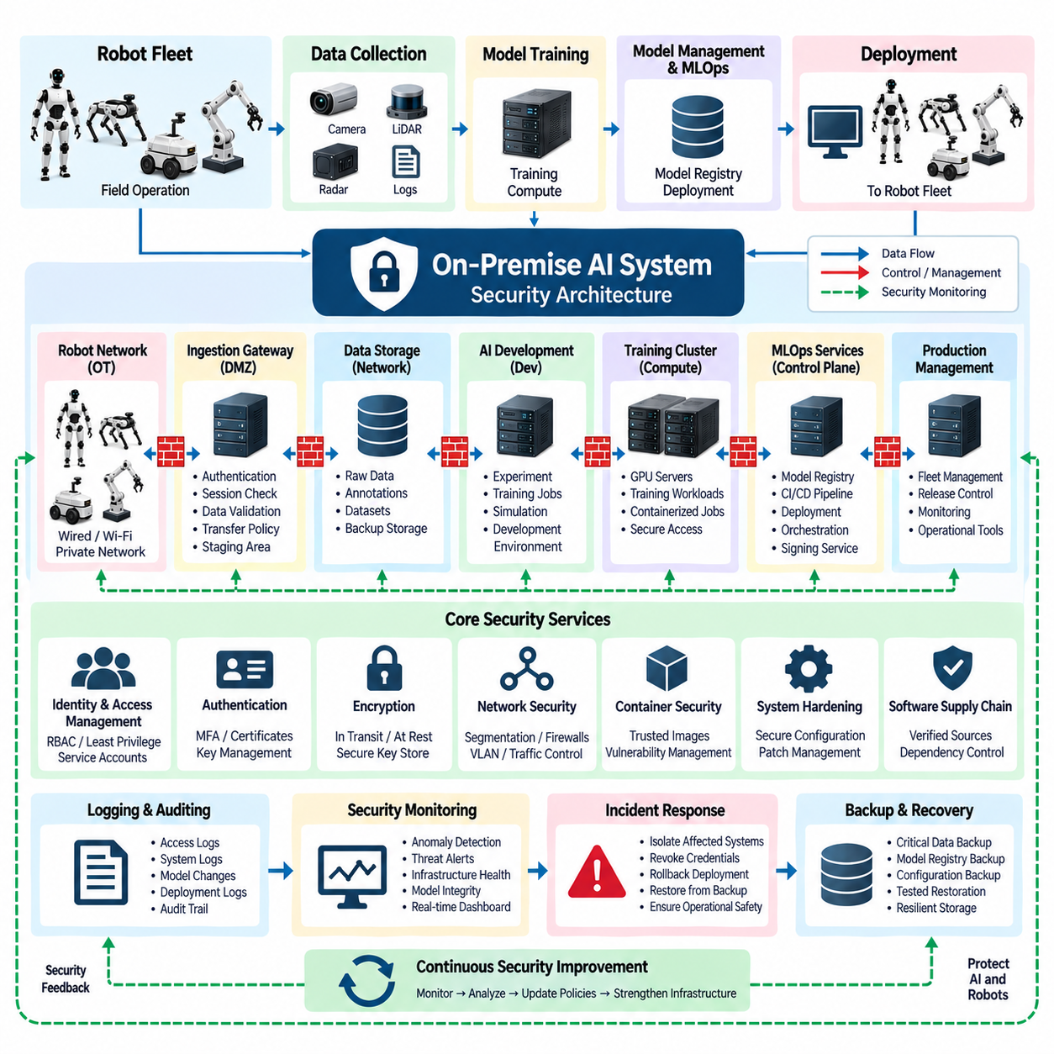
On-Premise Security Design establishes the protection boundary around robot data, AI models, compute infrastructure, development services, and fleet deployment systems that remain under organizational control. Within the On-Premise AI System, security must cover the entire lifecycle rather than only the server perimeter. Robot connectivity, data ingestion, storage, GPU servers, MLOps services, model repositories, administrative interfaces, and deployment channels all become part of one interconnected security architecture.
The fundamental design principle is to separate trust domains according to function and operational risk. Robot networks, data-ingestion systems, AI development environments, training clusters, storage networks, MLOps services, production management, and administrative interfaces should not operate as one unrestricted network. Segmentation limits lateral movement when one component is compromised and allows communication between domains to be controlled according to explicitly permitted services and protocols.
Robot networks require particular attention because physical machines operate outside the protected server environment and may connect through Ethernet, Wi-Fi, private wireless networks, or remote facilities. A robot should authenticate before accessing ingestion or management services and should receive only the permissions required for its role. Compromise of one robot credential must not automatically provide access to other robots, central storage, GPU servers, model repositories, or administrative systems.
An ingestion gateway can provide the first controlled interface between robot-generated traffic and internal AI infrastructure. Instead of allowing robots to write directly into central storage, the gateway authenticates devices, validates sessions, applies transfer policies, checks metadata, and routes accepted data into staging areas. This architecture creates a security boundary where malformed, unauthorized, or unexpected traffic can be rejected before it reaches valuable datasets and training systems.
Identity and Access Management should apply the principle of least privilege to users, robots, services, and automated pipelines. Engineers may require different permissions for datasets, training jobs, production models, deployment systems, or security administration. Service accounts should be separated from personal accounts, and automated processes should receive narrowly scoped credentials. Role-Based Access Control can formalize these permissions while reducing dependence on shared administrator credentials.
Authentication strength should reflect the consequence of unauthorized access. Administrative interfaces, model deployment services, security consoles, and sensitive repositories should use stronger authentication than low-risk monitoring endpoints. Multi-factor authentication can protect privileged human access, while robots and software services can use certificates, cryptographic keys, or other machine identities. Credentials should have defined issuance, renewal, revocation, and recovery processes rather than remaining permanently embedded in software images.
Encryption protects information while it moves between robots, servers, storage systems, and management services. Robot telemetry, model packages, administrative commands, and sensitive datasets should use authenticated encrypted communication where practical. Encryption at rest can additionally protect storage devices, backup media, model repositories, and portable systems. Key management must remain separate from ordinary data storage so that possession of a disk or backup alone does not automatically provide access to protected information.
Data security must preserve both confidentiality and integrity throughout the collection pipeline. Raw camera recordings, LiDAR data, maps, facility information, human interactions, operational histories, and annotations can contain sensitive or proprietary information. Dataset permissions should therefore follow project and role requirements, while checksums, hashes, immutable storage policies, or controlled versioning can help detect unauthorized modification and preserve the provenance of training information.
AI models require protection comparable to source code and proprietary datasets because trained weights may represent substantial intellectual property and operational knowledge. Model registries and artifact repositories should restrict read, write, promotion, and deletion permissions. Approved deployment artifacts can be hashed or digitally signed, allowing receiving systems to verify that a model originated from an authorized release process and has not been modified after approval.
The MLOps control plane represents a particularly sensitive security domain because it can influence many robots simultaneously. CI/CD pipelines, model registries, artifact repositories, orchestration systems, deployment services, signing infrastructure, and release-management interfaces require strong isolation and auditing. A compromised development workstation should not be able to bypass validation gates and directly publish an unapproved model to the production fleet.
Development, validation, and production environments should remain logically separated even when physical server resources are shared. Development environments require flexibility for experimentation, while production systems require stable configurations and tighter permissions. Model promotion should occur through controlled interfaces rather than direct file copying. This separation reduces the possibility that experimental software, temporary credentials, debugging services, or unvalidated dependencies become part of operational robot systems.
Container security extends protection to individual AI workloads. Training, preprocessing, inference, simulation, and MLOps services may execute inside containers, but containerization alone does not create a complete security boundary. Images should originate from controlled repositories, unnecessary privileges should be removed, host access should be limited, and dependencies should be tracked. Vulnerability management should include base operating systems, CUDA environments, AI frameworks, libraries, and container images.
Server hardening reduces the attack surface of GPU servers, management nodes, storage systems, and edge gateways. Unnecessary services and ports should be disabled, privileged accounts restricted, operating systems maintained, and remote administration limited to controlled management paths. Configuration baselines can define approved system settings so that unexpected changes are detectable. High-performance AI infrastructure should receive the same systematic hardening discipline as conventional production servers.
Network security should combine segmentation with explicit traffic control. Firewalls or equivalent policy enforcement can define which robot networks may communicate with ingestion services, which training nodes may access storage, and which management systems may control deployment infrastructure. Storage, cluster, management, and robot traffic can use separate VLANs or physical networks where appropriate. External Internet connectivity should be limited to systems and destinations that genuinely require it.
Remote access requires additional controls because on-premise systems may still need support from engineers working outside the facility. Remote users should enter through a managed access point rather than exposing GPU servers, NAS systems, robot interfaces, or administrative consoles directly to the Internet. Authentication, authorization, encrypted tunnels, session logging, and restricted network reachability can ensure that remote maintenance does not create an uncontrolled path into the internal AI environment.
Software supply-chain security is important because AI infrastructure depends on operating-system packages, GPU drivers, CUDA libraries, Python packages, containers, robotics middleware, and open-source frameworks. Software should be obtained from controlled or verified sources and tracked sufficiently to identify affected systems when vulnerabilities are discovered. Dependency versions and container contents should remain reproducible so that security updates can be tested before controlled deployment.
Backup architecture must protect against both hardware failure and malicious modification. Critical databases, model registries, configuration repositories, source code, security records, and selected datasets require recoverable backups. At least some backup copies should be protected from routine modification by production accounts so that compromise of an active system cannot automatically destroy every recovery point. Restoration procedures should also be tested rather than assuming that the existence of backup files guarantees recovery.
Logging and auditing provide evidence about activities across the security architecture. Authentication events, privileged actions, dataset access, model registration, approval changes, deployment operations, configuration modifications, security alerts, and administrative sessions should generate appropriate records. Centralized log collection allows events from robots, servers, storage, and MLOps systems to be correlated, helping engineers distinguish ordinary operational failures from suspicious or unauthorized behavior.
Security monitoring should combine infrastructure indicators with robotics and AI lifecycle events. Repeated authentication failures, unexpected network connections, unusual data transfers, unauthorized model changes, abnormal deployment attempts, or sudden configuration changes may indicate compromise. Monitoring systems should generate actionable alerts rather than overwhelming operators with every low-level event. Severity should reflect the potential effect on data confidentiality, model integrity, fleet availability, and physical operation.
Incident response must account for the fact that cybersecurity events can affect physical robots. A response procedure may need to isolate a robot, revoke its credentials, block a network segment, suspend model deployment, preserve logs, restore trusted configurations, or roll back affected software. Security recovery should avoid creating additional operational hazards, particularly when robots are moving or performing critical missions. Cybersecurity and robot operational safety therefore require coordinated response planning.
On-premise architecture improves data sovereignty by allowing sensitive robot information, proprietary datasets, model weights, and operational records to remain within infrastructure controlled by the organization. However, physical ownership of servers does not automatically create security. Internal misuse, compromised credentials, vulnerable software, unauthorized devices, and configuration errors remain possible. On-premise deployment must therefore combine local control with disciplined identity, network, system, data, and lifecycle security.
Security architecture should also scale with the robot fleet. A laboratory environment with several robots may tolerate manually managed credentials and simple network segmentation, but large fleets require automated identity provisioning, certificate renewal, centralized policy management, fleet inventory, security monitoring, and controlled revocation. Security mechanisms should therefore be designed so that adding hundreds of robots does not require proportional growth in manual administrative work.
The resulting design follows defense-in-depth: device identity protects robot access, segmentation restricts communication, gateways control ingestion, access management protects services, encryption protects information, signed artifacts protect model integrity, monitoring detects anomalies, and backups support recovery. No single mechanism is assumed to prevent every failure. Multiple independent controls reduce the probability that one compromised component can expose the complete AI infrastructure or robot fleet.
Within the chapter structure, On-Premise Security Design completes the On-Premise AI System after Robot AI Server Architecture, Data Collection Pipeline, Model Training Workflow, and Model Management and MLOps. It protects the computing, data, training, model lifecycle, and deployment mechanisms established by the preceding sections. Together, these components create a controlled foundation from which later Fleet AI and Physical AI architectures can operate while maintaining organizational ownership of data, models, infrastructure, and deployment authority.

