Volume 16 Compute and AI Architecture

Chapter 02. ECU Design

02.01. Automotive Robot ECU Architecture
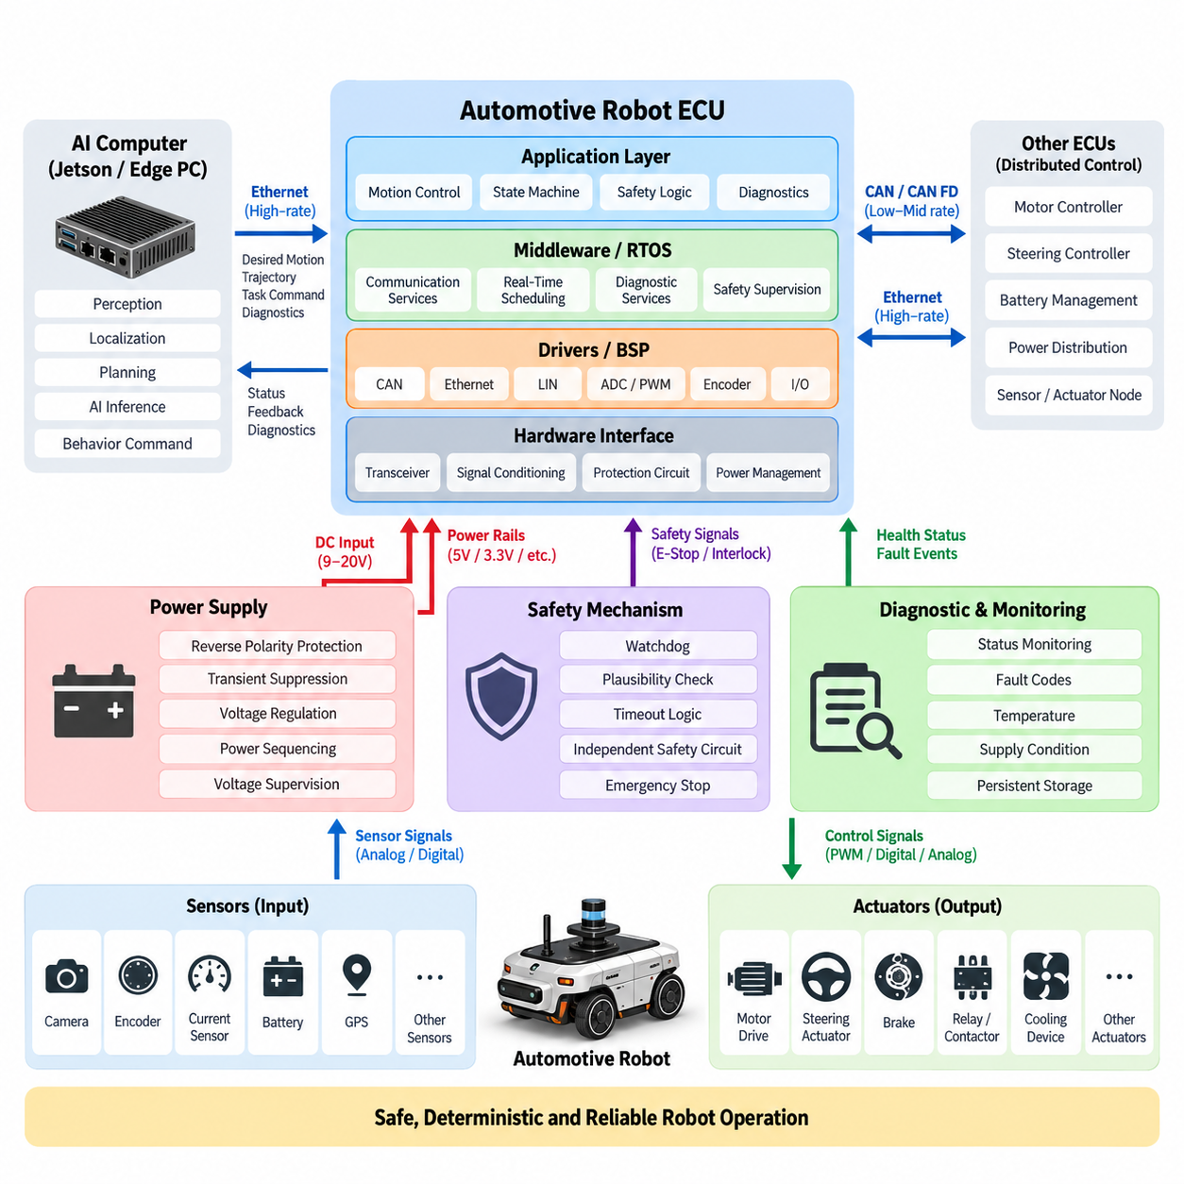
An automotive robot ECU is the deterministic control core that connects high-level computing with the physical mechanisms of a mobile robot. While an AI computer performs perception, localization, planning, and learned inference, the ECU manages functions that require predictable timing, direct hardware access, and controlled failure behavior. Typical responsibilities include steering, propulsion, braking, power-state supervision, actuator coordination, sensor acquisition, diagnostics, and communication with other embedded controllers.
The architecture is usually divided into functional layers rather than implemented as one monolithic controller. Hardware interfaces occupy the lowest layer and connect the processor to CAN or CAN FD transceivers, Ethernet PHYs, LIN devices, digital and analog I/O, PWM outputs, encoder interfaces, current sensors, and safety circuits. Above them, device drivers and the board support package abstract processor-specific resources so application functions can operate without continuously manipulating registers or peripheral hardware directly.
At the center of the ECU is an automotive- or industrial-grade microcontroller selected for deterministic execution, rich communication peripherals, fault monitoring, and long-term availability. Cortex-M and higher-performance automotive MCU families can execute control loops while supervising timers, ADC channels, capture units, watchdogs, and communication interfaces. More demanding robot ECUs may combine a real-time MCU with an application processor or companion accelerator, separating hard real-time control from computationally intensive functions.
This separation is especially important in Physical AI robots. A Jetson platform or edge PC may determine desired velocity, steering angle, trajectory, manipulation command, or behavioral objective, but these commands should not directly drive power electronics. The ECU acts as an execution boundary. It validates command ranges, checks system state, applies rate and acceleration constraints, verifies interlocks, and converts accepted commands into deterministic actuator requests while continuously observing feedback from the physical system.
A representative signal path therefore begins with the autonomy computer and passes through an Ethernet, CAN FD, or other controlled interface into the ECU. The ECU interprets the requested action and combines it with encoder feedback, steering position, motor status, battery information, emergency-stop state, and other local signals. Real-time control logic then generates outputs for motor drives, steering actuators, brakes, relays, contactors, cooling devices, or auxiliary equipment while reporting actual execution status upstream.
Communication architecture strongly influences ECU scalability. CAN remains valuable for robust distributed control, CAN FD increases payload and bandwidth, and Automotive Ethernet provides a path for high-rate diagnostics, software services, gateways, and integration with advanced compute platforms. A robot may consequently use Ethernet between the AI computer and central ECU while using CAN or CAN FD between the ECU, motor controllers, steering controller, BMS, power-distribution modules, and distributed sensor or actuator nodes.
Time behavior must be explicitly engineered because robot control is a cyber-physical process. Tasks such as motor supervision, steering control, wheel-speed acquisition, brake monitoring, and safety-state evaluation operate at different periods and priorities. A real-time scheduler or RTOS assigns execution windows so critical control functions are protected from lower-priority diagnostics and communication workloads. Worst-case execution time, interrupt latency, bus delay, and task jitter must therefore be considered as architectural parameters.
Power architecture is equally important because the ECU must remain predictable during battery transients and abnormal operating states. The input stage normally includes reverse-polarity protection, transient suppression, filtering, regulated voltage rails, sequencing, and voltage supervision. Separate supply domains may be used for the MCU, communication interfaces, analog measurement circuitry, external sensors, and actuator interfaces. Brownout detection and controlled reset behavior prevent partially powered electronics from generating undefined commands during startup or shutdown.
The ECU should also manage the robot as a state machine rather than merely execute continuous control algorithms. States may include power-off, initialization, standby, ready, autonomous operation, manual operation, degraded operation, emergency stop, fault handling, and shutdown. Transition conditions are evaluated using communication health, actuator readiness, safety inputs, battery condition, sensor validity, and command authorization. This creates a controlled operational envelope around both conventional autonomy and AI-generated behavior.
Diagnostics form another architectural layer. Each important subsystem should expose operating status, fault codes, communication health, supply conditions, temperature, reset cause, and plausibility information. The ECU can aggregate these observations into diagnostic events and communicate them to service software or the robot management system. Persistent fault storage is useful for distinguishing transient anomalies from recurring hardware problems and supports field maintenance, root-cause analysis, reliability improvement, and fleet-level monitoring.
Safety mechanisms must remain sufficiently independent from complex AI software. Watchdogs can detect stalled execution, communication supervision can detect missing messages, plausibility checks can reject impossible sensor values, and timeout logic can invalidate obsolete commands. Critical designs may additionally use lock-step processors, external watchdogs, redundant sensing, independent safety controllers, or separate emergency-stop circuits. The objective is to ensure that failure of high-level computing does not automatically become uncontrolled physical motion.
A robust ECU also distinguishes between normal control communication and safety-related authority. For example, an autonomy computer may request forward motion, but the ECU can deny that request if an emergency stop is active, the steering system is not initialized, a drive controller reports a critical fault, or communication freshness exceeds its allowed timeout. This command arbitration establishes a hierarchy in which physical safety conditions and verified machine state have priority over behavioral commands generated elsewhere.
Software architecture benefits from a similarly disciplined separation. The BSP and driver layer manages hardware dependencies, middleware handles communication and diagnostic services, real-time services provide scheduling and state supervision, and application components implement vehicle or robot functions. AUTOSAR concepts can be adopted where automotive compatibility and standardized software abstraction are valuable, while lighter RTOS-based architectures may be more appropriate for compact AMRs and specialized robotic platforms.
Thermal and EMC engineering must be treated as part of ECU architecture rather than as enclosure-level afterthoughts. Processor load, power conversion, communication transceivers, and output drivers create localized heat, while motors, inverters, relays, switching converters, and long harnesses create electromagnetic disturbances. PCB partitioning, grounding, filtering, shielding, connector selection, thermal conduction, component derating, and enclosure design collectively determine whether control electronics remain reliable in real robotic operating environments.
The ECU becomes more valuable as the robot architecture expands from one machine into a product family. Stable interfaces allow the same control concept to support indoor AMRs, outdoor autonomous robots, inspection platforms, mobile manipulators, and other Physical AI systems while higher-level compute hardware evolves independently. The uploaded architecture places ECU design between MCU architecture and Jetson, edge-PC, GPU-server, on-premise AI, fleet AI, and Physical AI computing topics, reflecting this bridging role.
Ultimately, automotive robot ECU architecture should be understood as the trusted real-time execution layer of the robotic system. AI computing determines increasingly sophisticated interpretations and intentions, but the ECU converts those intentions into bounded, observable, diagnosable, and physically executable actions. By combining deterministic control, hardware abstraction, communication, power supervision, diagnostics, state management, and safety mechanisms, the ECU provides the stable engineering foundation on which scalable autonomous and Physical AI robots can operate.

02.02. BSP and Driver Layer
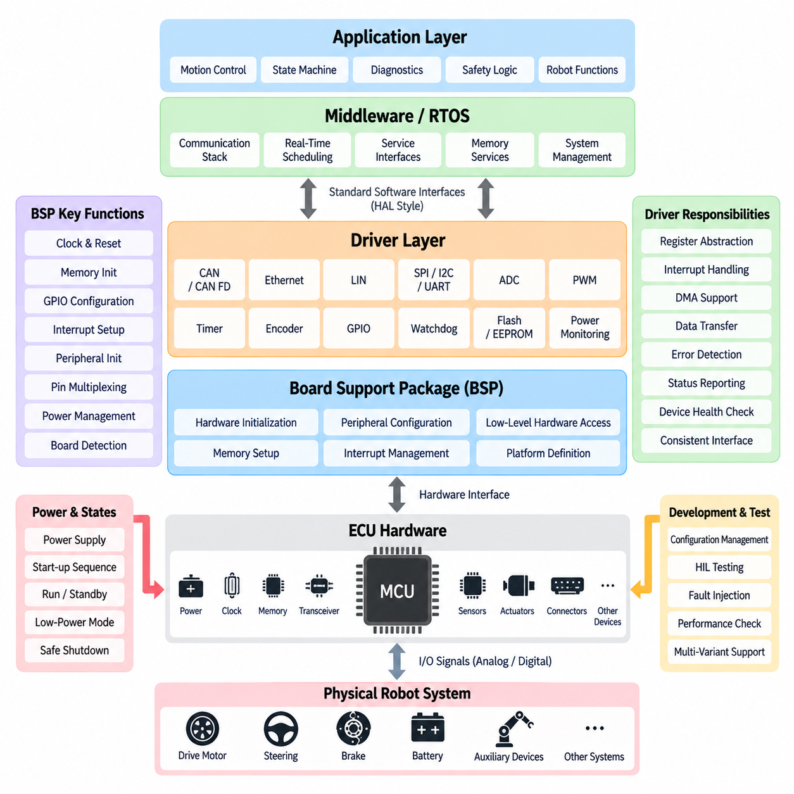
A Board Support Package, or BSP, forms the software boundary between an ECU’s physical hardware and the higher-level embedded software that controls the robot. It contains the processor-specific initialization, peripheral configuration, low-level hardware access, and platform definitions required to make a particular ECU board operational. By isolating these hardware dependencies, the BSP allows control applications, middleware, diagnostics, and safety functions to operate through stable software interfaces rather than directly manipulating microcontroller registers.
During ECU startup, the BSP is among the first software components executed after reset. It establishes the processor clock, configures memory, initializes interrupt controllers, prepares timers, enables watchdog resources, configures GPIO pins, and activates required communication peripherals. It may also initialize external memories, power-management devices, Ethernet PHYs, CAN transceivers, and board-specific monitoring circuits. This controlled initialization sequence creates a known hardware state before application software begins normal robot operation.
The driver layer sits directly above or partially within the BSP and provides functional access to individual hardware peripherals. Drivers translate software requests into register operations, interrupt handling, DMA transfers, and electrical interface behavior. Typical ECU drivers include CAN and CAN FD, Ethernet, LIN, SPI, I2C, UART, ADC, PWM, timer, encoder, GPIO, watchdog, flash memory, and power-monitoring drivers. Each driver hides implementation details while exposing a predictable interface to upper software layers.
This abstraction is essential when robot hardware evolves across product generations. A motion-control application should not need to know which timer register generates a PWM signal or which CAN controller instance transmits a motor command. Instead, it requests a defined service from the driver interface. If the ECU later changes to another MCU family or PCB revision, engineers can modify the BSP and hardware drivers while preserving much of the middleware and application software above them.
BSP design normally begins with a detailed mapping between the ECU schematic and MCU resources. Every connector signal must ultimately correspond to a physical pin, peripheral channel, communication controller, ADC input, timer channel, interrupt source, or external device. Pin multiplexing must therefore be carefully managed because one MCU pin may support several alternate functions. Incorrect configuration can produce failures that appear to be software problems even though the underlying cause is a mismatched hardware-resource definition.
Interrupt management is another fundamental responsibility. Robot ECUs receive asynchronous events from communication controllers, encoders, timers, fault inputs, and external devices. The BSP configures interrupt sources and priorities, while drivers implement interrupt service routines that capture events with minimum latency. Time-critical interrupts must be protected from excessive processing by lower-priority services, and lengthy operations should normally be deferred to scheduled tasks rather than executed entirely inside interrupt context.
Direct Memory Access, or DMA, can significantly reduce MCU workload when peripherals exchange continuous or high-frequency data. ADC sampling, UART communication, SPI transfers, and some Ethernet operations can move data between peripherals and memory without requiring the CPU to process every byte or sample individually. Drivers coordinate DMA descriptors, buffers, completion events, and error handling. Proper DMA design improves deterministic behavior but requires careful management of memory ownership, synchronization, and cache coherency.
Communication drivers are particularly important in an automotive robot ECU because distributed controllers must exchange commands and status reliably. A CAN driver configures bit timing, message buffers, acceptance filters, interrupts, and error states, while higher software interprets the actual application messages. CAN FD adds larger payloads and higher data-phase rates. Ethernet drivers manage MAC and PHY operation, frame transfer, link status, and buffers, providing the foundation for higher-level protocols, diagnostics, gateways, and communication with AI computers.
Sensor and actuator interfaces require equally disciplined driver design. ADC drivers acquire voltages from current sensors, temperature sensors, analog position devices, and power-monitoring circuits. PWM and timer drivers generate precisely timed outputs for actuators or auxiliary devices. Encoder drivers capture wheel, steering, or motor position information, while GPIO drivers handle discrete signals such as enable lines, contactor feedback, interlocks, and fault inputs. Hardware access is thereby converted into consistent software-visible signals and commands.
Device drivers should not merely transfer data; they must also represent hardware health. Communication drivers can report bus-off conditions, frame errors, link failures, and timeout events. ADC services can detect saturation or implausible ranges, while memory drivers can report programming or integrity failures. Peripheral initialization failures should also be exposed to diagnostic software. This approach allows the ECU to distinguish a valid measurement from data produced by a failed, disconnected, or incorrectly initialized hardware interface.
Watchdog support demonstrates the close relationship between the BSP, drivers, and ECU safety architecture. The BSP configures internal or external watchdog hardware during initialization, but normal software must service it only when required execution conditions are satisfied. A simple periodic watchdog refresh may conceal stalled application functions. A stronger architecture allows supervisory software to verify critical task execution and system health before authorizing the low-level watchdog driver to refresh the hardware timer.
Power-state handling also depends heavily on BSP services. An ECU may pass through reset, initialization, standby, operational, degraded, shutdown, and low-power states. Drivers must behave correctly during these transitions, particularly when peripherals or external devices lose power independently. Communication interfaces may need to be disabled before supply removal, output pins may require safe default states, and wake-up sources must be configured before entering sleep. BSP behavior therefore contributes directly to predictable ECU startup and shutdown.
Memory services form another important part of the low-level software architecture. Internal flash, external EEPROM, QSPI flash, or other nonvolatile memory may store calibration parameters, diagnostic records, boot information, configuration data, and software images. Drivers must manage erase and write constraints, alignment, access timing, and error conditions. Critical data may require CRC protection, redundant storage, version information, or transactional updates so interrupted writes do not leave the ECU configuration in an unusable state.
The BSP also establishes the time base used by higher-level software. Hardware timers provide periodic scheduler ticks, high-resolution timestamps, input capture, output compare, and timeout measurement. Reliable timing is essential for real-time control, communication supervision, sensor acquisition, actuator control, and diagnostics. When an ECU participates in a larger synchronized robot architecture, low-level timer services may also support timestamp alignment with CAN, Ethernet, PTP, or other system-level synchronization mechanisms.
Configuration management becomes increasingly important as a BSP supports multiple ECU variants. Different robot models may share one software architecture while using different pin assignments, sensor populations, communication channels, or actuator interfaces. Hardware-specific configuration should therefore be separated from reusable driver logic wherever practical. Board identifiers, compile-time configuration, generated configuration files, or runtime hardware detection can allow one software platform to support several ECU variants without duplicating the entire codebase.
Testing of BSP and driver software must begin before full robot integration. Engineers can verify GPIO states, ADC accuracy, PWM timing, communication throughput, interrupt latency, watchdog behavior, memory access, and fault handling using bench equipment and hardware-in-the-loop environments. Boundary conditions such as communication overload, invalid frames, supply disturbances, sensor disconnection, and repeated resets should also be exercised. These tests establish confidence in the hardware abstraction before complex autonomy software depends on it.
In a layered ECU software architecture, the BSP and drivers should remain focused on hardware control rather than robot behavior. Motion decisions, state machines, diagnostic policies, safety strategies, and autonomy logic belong in higher layers. Maintaining this boundary prevents hardware-specific code from spreading throughout the application and makes software easier to test, port, maintain, and certify. The uploaded structure places this topic directly between automotive robot ECU architecture and AUTOSAR structure, reflecting this foundational role.
For Physical AI systems, this separation becomes even more important because high-level compute platforms may change much faster than embedded control hardware. Jetson modules, edge PCs, AI accelerators, perception models, and VLA systems can evolve while the robot still requires stable real-time access to motors, steering, brakes, power devices, and safety signals. A well-engineered BSP and driver layer therefore provides the durable hardware foundation that allows advanced AI computing to interact with physical machinery through controlled, deterministic, and maintainable interfaces.

02.03. AUTOSAR Structure
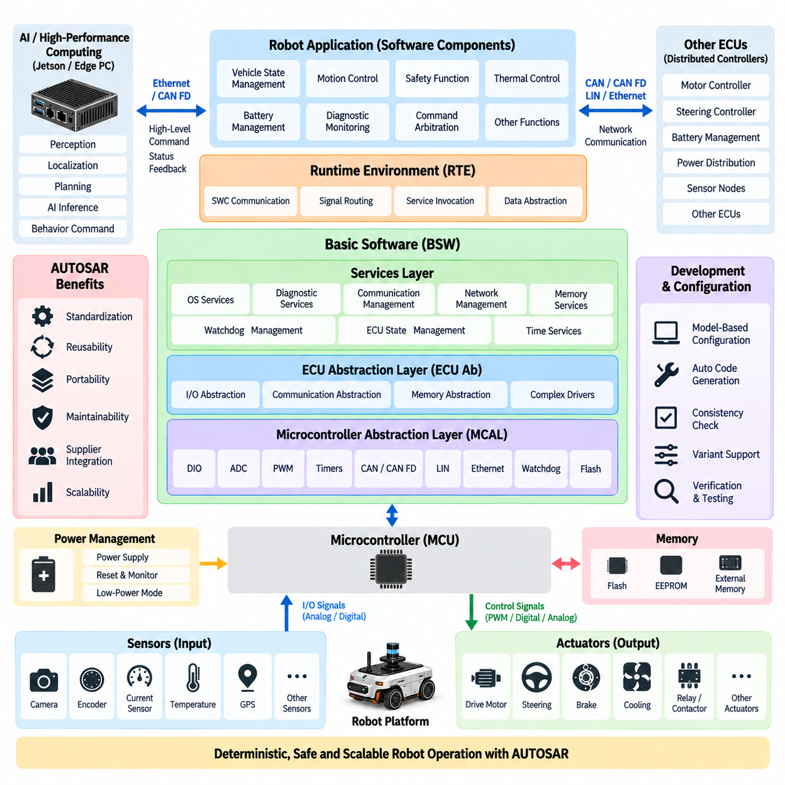
AUTOSAR, or AUTomotive Open System ARchitecture, provides a standardized software architecture for automotive electronic control units by separating application functions from hardware-dependent implementation. In a robot ECU, this concept can reduce coupling between motion-control logic, communication services, diagnostics, safety functions, and the underlying microcontroller. The resulting architecture improves software reuse, portability, integration discipline, and maintainability across different ECU hardware generations.
The fundamental AUTOSAR concept is layered software separation. Application functionality is placed at the upper level, standardized runtime communication occupies an intermediate abstraction layer, and infrastructure software manages operating-system services, communication, diagnostics, memory, and hardware access below it. This prevents application developers from directly controlling peripheral registers and allows robot functions to interact with hardware through defined interfaces rather than board-specific software dependencies.
Classic AUTOSAR is particularly relevant to deterministic embedded controllers that execute real-time functions on microcontrollers. Such ECUs may supervise propulsion, steering, braking, power distribution, actuator states, communication, and safety-related functions. These workloads differ significantly from perception or AI inference running on Jetson or edge computers. AUTOSAR therefore fits naturally into the deterministic ECU domain while higher-performance computing platforms can use other software frameworks suited to complex operating systems and AI workloads.
At the top of the Classic AUTOSAR architecture are Software Components, commonly called SWCs. An SWC represents a functional unit such as vehicle-state management, actuator supervision, thermal control, battery coordination, diagnostic monitoring, or command arbitration. Instead of accessing hardware directly, SWCs exchange data or invoke services through standardized ports and interfaces. This structure makes functional software less dependent on the specific MCU, communication controller, or ECU board on which it executes.
The Runtime Environment, or RTE, forms the communication boundary between application Software Components and the underlying AUTOSAR infrastructure. It provides standardized mechanisms through which SWCs exchange signals, invoke operations, and access services without requiring detailed knowledge of communication routing or hardware implementation. From the application perspective, communication can therefore remain logically consistent even when data originates from another SWC, another ECU, or an underlying communication network.
Below the RTE is the Basic Software, commonly abbreviated as BSW. Basic Software provides the reusable infrastructure required by the ECU and is organized into functional groups rather than application-specific robot behavior. It supports communication, diagnostics, memory, operating-system execution, ECU-state management, watchdog supervision, I/O access, and hardware abstraction. This layer is essential because it converts low-level MCU and peripheral resources into standardized services that higher software can use consistently.
The Services Layer occupies the upper region of Basic Software and provides system-level capabilities largely independent of individual hardware devices. Typical responsibilities include operating-system services, diagnostic event handling, communication management, network management, ECU-state control, memory services, watchdog management, and time-related functions. In a robot ECU, these services support coordinated startup, normal operation, degraded states, fault handling, shutdown, diagnostic recording, and communication supervision across multiple embedded functions.
The ECU Abstraction Layer isolates upper software from the physical arrangement of devices on the ECU board. It provides interfaces for accessing onboard and external peripherals without requiring higher layers to understand whether a device is connected directly to the MCU or through another interface component. This abstraction is valuable when ECU revisions change sensor interfaces, external memory, transceivers, I/O expanders, or power-monitoring devices while the higher software architecture remains largely unchanged.
The Microcontroller Abstraction Layer, or MCAL, is positioned close to the MCU hardware and provides standardized drivers for microcontroller peripherals. Depending on the platform, these can include digital I/O, ADC, PWM, timers, communication controllers, watchdogs, flash memory, and other processor resources. MCAL performs a role closely related to the BSP and driver layer, but within an AUTOSAR-defined structure that standardizes configuration and interfaces for automotive embedded software integration.
Complex Drivers provide an intentional escape path when standard AUTOSAR modules cannot efficiently support specialized hardware or strict timing requirements. Robot ECUs may contain unusual motor interfaces, high-speed encoder acquisition, custom FPGA connections, specialized safety devices, or proprietary sensor interfaces. A Complex Driver can provide direct or optimized access to such resources while remaining integrated with the broader ECU architecture. Its use should remain controlled because excessive custom access can weaken the benefits of standardized abstraction.
Communication inside AUTOSAR is divided across multiple cooperating modules. Application signals can pass through the RTE into communication services and eventually reach CAN, CAN FD, LIN, or Ethernet interfaces through lower-level modules and drivers. The reverse path delivers received network information upward to the appropriate software components. This layered routing separates application meaning from physical transport and allows communication architecture to evolve without forcing extensive modifications to robot-control functions.
Diagnostic architecture is similarly integrated into the software stack. Fault information generated by drivers, Basic Software modules, or application functions can be processed by diagnostic services and associated with standardized diagnostic events. Communication failures, sensor faults, actuator abnormalities, memory errors, voltage problems, and internal software conditions can therefore be represented within a common diagnostic framework. Persistent information can then support service tools, maintenance analysis, fleet monitoring, and systematic root-cause investigation.
Operating-system integration provides the deterministic execution foundation required by Classic AUTOSAR. Application runnables and Basic Software functions are mapped to tasks, events, interrupts, and scheduling mechanisms with defined timing behavior. Control functions can therefore be assigned appropriate periods and priorities while communication, diagnostics, and background processing are scheduled separately. This organization is important for robot ECUs where steering, propulsion, safety monitoring, and actuator supervision must meet bounded execution and response times.
AUTOSAR configuration is heavily model- and configuration-driven because many relationships between software components, signals, tasks, networks, drivers, and ECU resources must remain consistent. Configuration tools can generate significant portions of the RTE, Basic Software configuration, and low-level integration code. This reduces repetitive manual implementation but does not eliminate engineering responsibility. Timing, resource allocation, communication mapping, memory usage, safety behavior, and hardware assumptions still require careful system-level design and verification.
For robotic systems, full AUTOSAR adoption is not always necessary. Compact AMRs with a small number of controllers may achieve better development efficiency using a lightweight RTOS, carefully designed BSP, hardware abstraction, middleware, and application layers. AUTOSAR becomes more attractive as ECU complexity, supplier interaction, functional-safety requirements, product variants, diagnostic requirements, and automotive compatibility increase. The engineering decision should therefore be based on system scale and lifecycle requirements rather than standardization for its own sake.
A hybrid architecture is particularly practical for Physical AI robots. The deterministic ECU domain can use AUTOSAR concepts or Classic AUTOSAR for actuator control, safety supervision, diagnostics, and automotive communication, while Jetson or edge-computing platforms execute Linux, ROS 2, perception, localization, planning, and AI inference. Ethernet or CAN FD can form the controlled boundary between these domains, allowing advanced AI functions to request actions without directly bypassing the embedded real-time control architecture.
This separation also establishes a useful authority boundary. High-level AI software may generate desired velocity, trajectory, steering, manipulation, or behavioral commands, but ECU software can independently validate those requests against machine state, communication freshness, safety conditions, actuator readiness, and configured limits. AUTOSAR-style layering does not itself guarantee robot safety, but it provides disciplined interfaces and software separation that make supervision, diagnostics, verification, and controlled execution easier to engineer systematically.
The relationship between AUTOSAR and the surrounding compute architecture should therefore be understood as complementary rather than universal. The uploaded structure places AUTOSAR after the BSP and Driver Layer and before Functional Safety MCU Lock-Step, while later chapters address Jetson platforms, edge PCs, GPU servers, on-premise AI, fleet AI, and Physical AI architecture. This sequence reflects AUTOSAR’s primary role as structured embedded ECU software rather than as a replacement for high-performance AI computing.
Ultimately, AUTOSAR provides a disciplined architectural framework for transforming MCU hardware resources into reusable ECU software services and well-defined application interfaces. Its Software Components, RTE, Basic Software, ECU abstraction, MCAL, communication services, diagnostics, and operating-system mechanisms establish clear boundaries from hardware to application behavior. For advanced robots, these principles help create a stable deterministic control foundation beneath rapidly evolving autonomy and Physical AI computing layers.

02.04. Functional Safety (MCU Lock-Step)
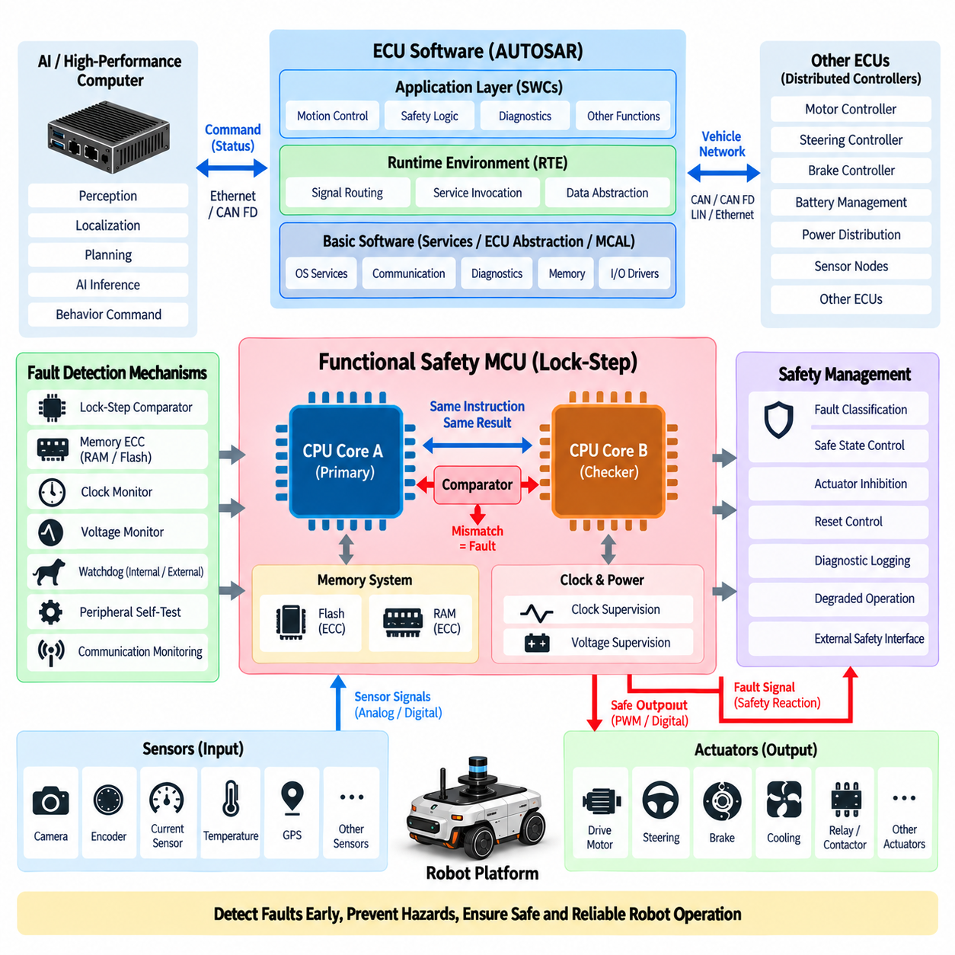
Functional safety in a robot ECU is concerned with preventing unacceptable physical risk when electronic or software faults occur. Because an ECU may directly influence propulsion, steering, braking, power distribution, or actuator behavior, an internal computation error can become a hazardous physical action. Safety-oriented MCU architectures therefore incorporate hardware mechanisms that detect faults quickly, contain their effects, and move the controlled system toward a predefined safe or degraded operating state.
A lock-step MCU addresses this problem by executing the same instruction stream simultaneously on two closely coupled processor cores. One core performs the primary computation while another performs an equivalent computation under controlled synchronization. Their internal results are continuously compared by dedicated hardware. Under correct operation, corresponding results should agree. A mismatch indicates that at least one computational path has experienced an abnormal condition requiring immediate safety supervision.
Lock-step operation is different from ordinary multicore parallel processing. In a conventional multicore processor, different cores execute different tasks to increase computational throughput. In lock-step operation, redundant cores intentionally execute equivalent operations so that one execution path can check the other. Computational redundancy is therefore used primarily for fault detection rather than performance improvement. This distinction is important when selecting an MCU for safety-critical steering, braking, propulsion, or motion-control functions.
The comparator is a critical element of the lock-step architecture. It observes selected outputs or internal states from the redundant execution paths and determines whether they remain consistent. Comparison may cover instruction execution results, addresses, control signals, or other implementation-dependent processor states. When divergence is detected, the MCU generates a fault indication that can be routed to an exception handler, safety management logic, external watchdog, reset controller, or independent safety device.
Lock-step processing is particularly effective against transient hardware faults that can corrupt computation without producing an obvious software failure. Electrical disturbances, radiation-induced bit changes, clock anomalies, marginal voltage conditions, and internal logic faults can potentially alter processor state or calculation results. If only one redundant execution path is affected, the comparator can detect the divergence before the corrupted value propagates into an actuator command or safety-related control decision.
However, lock-step architecture alone cannot guarantee functional safety. Redundant cores may still be vulnerable to common-cause failures that affect both channels simultaneously. A defective clock source, incorrect power supply, systematic software error, shared memory corruption, or flawed requirement can cause both cores to produce the same incorrect result. Functional safety architecture must therefore combine lock-step processing with additional independent mechanisms covering memory, clock, power, communication, software execution, and external system behavior.
Memory integrity is commonly protected using error detection and correction mechanisms. Error-Correcting Code, or ECC, can detect and correct certain faults in RAM and flash storage, while parity or CRC mechanisms can protect other memory structures and transferred data. Memory tests performed during startup or periodically during operation can identify latent faults. Together with lock-step execution, these mechanisms extend fault coverage beyond the processor core into the data and program storage used by safety-related software.
Clock supervision is equally important because redundant CPU cores may depend on common timing resources. Safety-oriented MCUs can use clock monitors to detect missing, excessively slow, excessively fast, or unstable clocks. Independent oscillators or backup clock sources may provide additional protection depending on the architecture. If the primary clock becomes invalid, safety logic must detect the condition within the required fault-tolerant time interval and prevent uncontrolled continuation of safety-critical control functions.
Voltage monitoring protects the MCU against supply conditions that could produce unpredictable digital behavior. Brownout detectors, overvoltage monitors, power-on reset circuits, and external power-management ICs can supervise critical rails. A safety architecture should define how the ECU responds when supply voltage leaves its valid range. Depending on the robot function, the response may include controlled reset, output inhibition, actuator disablement, degraded operation, or transition toward a system-level safe state.
Watchdogs provide another independent line of defense. An internal watchdog can detect software that stops executing normally, while an external watchdog can supervise the MCU from outside the processor itself. More advanced watchdog schemes use challenge-response mechanisms or execution monitoring rather than accepting a simple periodic trigger. The objective is to ensure that the watchdog is refreshed only when critical tasks, timing behavior, and software control flow remain consistent with expected ECU operation.
Safety-related communication also requires protection because correct computation is insufficient if corrupted commands are transmitted to distributed actuators. CAN, CAN FD, or Ethernet communication can be supplemented by end-to-end protection mechanisms such as sequence counters, data identifiers, CRC values, freshness checks, and timeout supervision. These measures help detect repeated, lost, delayed, incorrectly addressed, or corrupted messages before they are accepted as valid steering, braking, propulsion, or actuator commands.
The ECU safety manager coordinates these hardware and software fault-detection mechanisms. It collects information from the lock-step comparator, ECC logic, watchdogs, clock monitors, voltage supervisors, communication diagnostics, peripheral tests, and application-level plausibility checks. Rather than treating every fault identically, it classifies their severity and determines the appropriate response. Some faults permit continued degraded operation, while others require immediate torque removal, motion inhibition, controlled stopping, or emergency shutdown.
A safe state must be defined at the system level rather than assumed to mean simply resetting the MCU. Resetting a steering or braking ECU at the wrong moment may itself create hazardous behavior. For an AMR or autonomous robot, a safe response may involve commanding zero propulsion torque, applying a brake, maintaining steering control long enough to stop, disabling selected actuators, or transferring authority to an independent safety controller. The required reaction depends on the robot’s mechanics, operating environment, speed, and hazard analysis.
Lock-step MCU architecture should therefore be connected to independent actuator-control boundaries. A processor fault indication can disable PWM outputs, block motor-enable signals, open safety relays, command a safety power stage, or notify another controller. Hardware-based reaction paths are valuable when software execution itself may no longer be trustworthy. The architecture should minimize the number of components between fault detection and the mechanism that places hazardous outputs into their defined safe condition.
Startup diagnostics help identify faults before the robot begins motion. Processor self-tests, RAM tests, flash integrity checks, peripheral tests, watchdog verification, clock monitoring, and I/O plausibility checks can be executed during initialization. Some tests may also run periodically during normal operation to detect latent faults that appear after startup. The challenge is to achieve sufficient diagnostic coverage without violating real-time deadlines or interrupting critical control functions during robot operation.
Software architecture must complement the MCU hardware mechanisms. Safety-related tasks should have defined execution periods, deadlines, data ranges, state transitions, and fault responses. Memory protection, privilege separation, controlled interfaces, and defensive programming can prevent unrelated software from corrupting critical functions. In an AUTOSAR-oriented ECU, standardized operating-system, watchdog, diagnostic, communication, and end-to-end protection services can be combined with MCU-specific safety mechanisms provided through the lower software layers.
The relationship with high-level AI computing must remain carefully controlled. Jetson platforms or edge PCs may perform perception, planning, VLA inference, or trajectory generation, but their requested actions should pass through a deterministic ECU safety boundary. The safety MCU can validate command freshness, permitted ranges, robot state, actuator readiness, and interlocks before execution. If the AI computer crashes, communicates invalid data, or stops responding, the ECU can independently initiate the predefined degraded or safe response.
Verification requires deliberate fault injection rather than only normal functional testing. Engineers can simulate corrupted memory, watchdog expiration, communication timeout, sensor inconsistency, invalid voltage conditions, processor faults, and other abnormal states to confirm that detection and reaction mechanisms operate within required timing limits. Hardware-in-the-loop testing can further verify how ECU faults propagate through motors, steering, braking, power systems, and supervisory controllers without exposing a full robot to uncontrolled hazards.
Safety analysis must also consider diagnostic coverage, latent faults, independence, and common-cause failure. Adding two processor cores does not automatically create a sufficiently safe architecture if both depend on the same vulnerable resource or if fault detection cannot activate the required system response. Lock-step processing should therefore be treated as one mechanism within a broader safety concept that combines redundancy, monitoring, fault containment, diagnostics, communication protection, and controlled physical reaction.
Within the uploaded compute and AI architecture, Functional Safety MCU Lock-Step follows Automotive Robot ECU Architecture, BSP and Driver Layer, and AUTOSAR Structure, and precedes ECU Thermal and EMC Design. This placement reflects a progression from ECU organization and software abstraction toward fault-tolerant execution and then physical reliability considerations. It positions lock-step safety as an integral property of ECU design rather than an isolated processor feature.
Ultimately, a functional-safety MCU architecture creates a trusted execution boundary between sophisticated robot intelligence and potentially hazardous physical motion. Lock-step cores provide rapid computational fault detection, while ECC, watchdogs, clock and voltage supervision, communication protection, diagnostics, and independent reaction paths broaden system fault coverage. When integrated with well-defined safe states and verified fault responses, these mechanisms allow advanced autonomous and Physical AI robots to execute commands through a more deterministic, fault-aware, and controllable embedded platform.

02.05. ECU Thermal and EMC Design
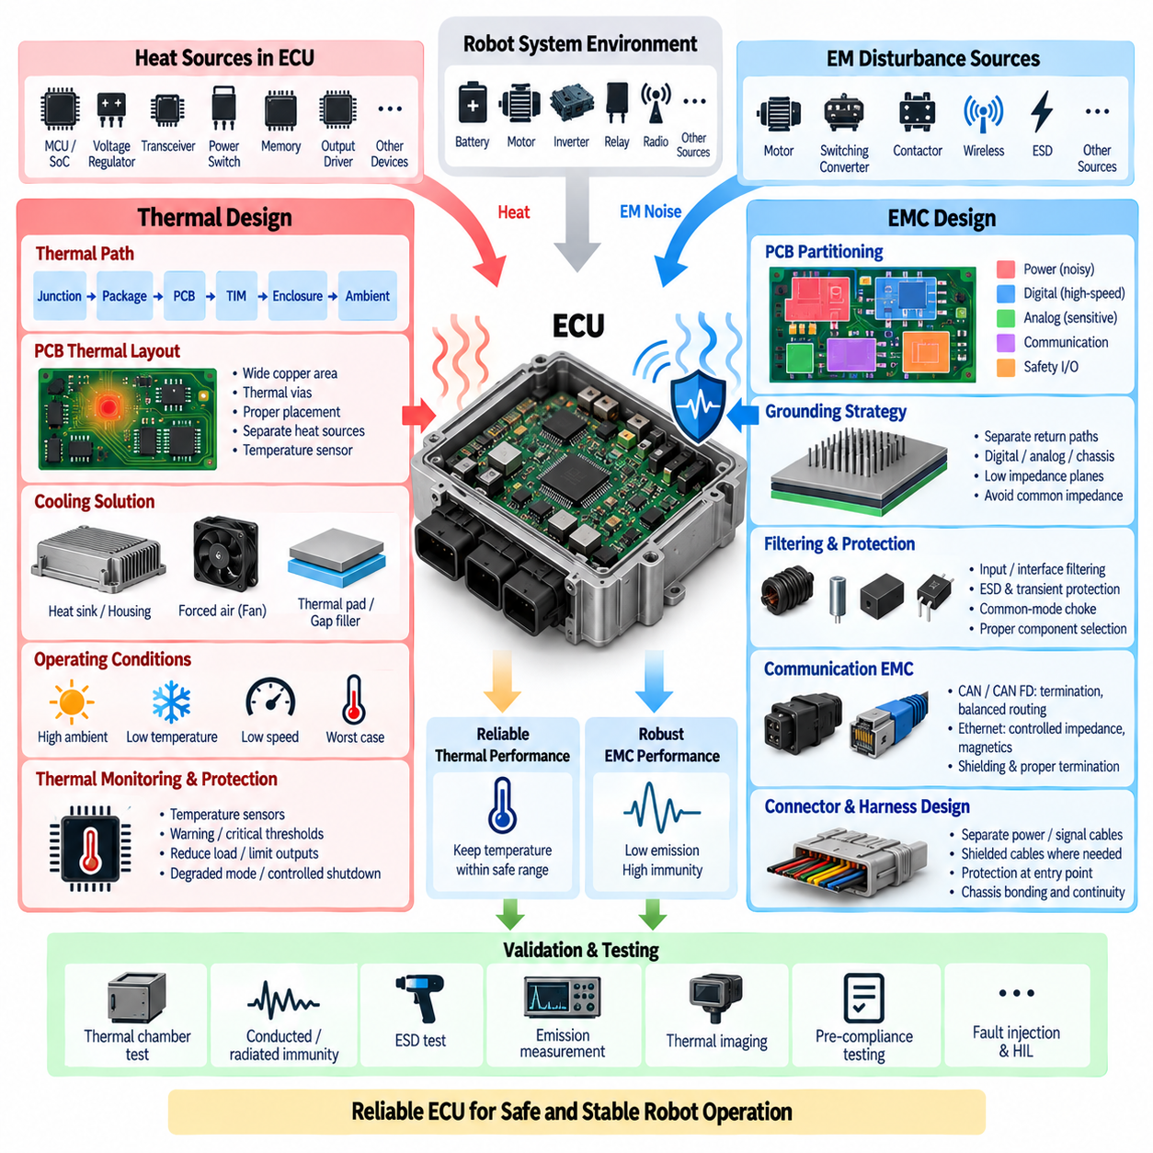
Thermal and electromagnetic compatibility design are fundamental parts of ECU engineering because electronic reliability depends on both temperature and electromagnetic environment. A robot ECU may operate near motors, inverters, DC/DC converters, relays, batteries, high-current harnesses, and radio equipment while continuously executing real-time control. The design must therefore remove internally generated heat while preventing external or self-generated electromagnetic disturbances from corrupting computation, communication, sensing, or actuator commands.
Heat inside an ECU originates from multiple components rather than only from the main microcontroller. Voltage regulators, communication transceivers, power switches, protection devices, memory, output drivers, and processing devices all dissipate electrical power as heat. Their combined losses determine the internal thermal load. Because power density can vary greatly across the PCB, thermal analysis must identify localized hot spots instead of relying only on average enclosure temperature or total ECU power consumption.
The basic thermal path extends from a semiconductor junction through its package, PCB, thermal interface materials, enclosure, and finally into the surrounding environment. Every element introduces thermal resistance, so junction temperature can be significantly higher than ambient temperature. Component power dissipation and the effective junction-to-ambient thermal resistance therefore provide an initial estimate of operating temperature, but detailed designs must also consider airflow, mounting orientation, enclosure material, neighboring heat sources, and transient operating conditions.
PCB layout strongly influences heat distribution. High-loss regulators, processors, transceivers, and power drivers should be positioned so that heat can spread into adequate copper areas without excessively heating temperature-sensitive components. Thermal vias can transfer heat between PCB layers, while internal and external copper planes increase spreading area. Components with conflicting thermal characteristics should be separated where practical, and temperature sensors should be placed where they provide meaningful information about critical thermal zones rather than simply measuring convenient locations.
The enclosure becomes part of the thermal system when natural convection alone cannot remove sufficient heat. Aluminum or other thermally conductive housings can transfer heat from the PCB to the exterior through thermal pads, gap fillers, heat spreaders, or direct mechanical interfaces. Fins can increase external surface area, while forced airflow may be used for higher-power ECUs. Robot applications must balance cooling performance against dust, water ingress, fan reliability, acoustic noise, packaging space, weight, and maintenance requirements.
Thermal design must consider worst-case operating conditions rather than room-temperature laboratory behavior. Outdoor robots may experience solar heating, high ambient temperature, enclosed installation spaces, low vehicle speed, blocked airflow, and simultaneous high actuator loads. Conversely, low-temperature operation affects component characteristics and startup behavior. Engineering margins should account for component tolerances, aging, contamination, thermal-interface degradation, and production variation so that the ECU remains reliable throughout its intended operating environment and service life.
Temperature monitoring allows software to participate in thermal protection. MCU sensors, external temperature devices, power-management ICs, and intelligent transceivers can provide measurements to diagnostic and supervisory functions. The ECU may reduce computational load, limit selected outputs, increase cooling, enter a degraded operating mode, or initiate controlled shutdown when temperature thresholds are exceeded. Thermal protection should use defined warning and critical limits with suitable hysteresis so that the system does not repeatedly oscillate between operating states.
Electromagnetic compatibility, or EMC, addresses both emissions generated by the ECU and immunity to disturbances originating elsewhere. Conducted emissions can propagate through power and signal wiring, while radiated emissions can couple through free space. Conversely, disturbances from motors, inverters, contactors, switching converters, wireless transmitters, electrostatic discharge, or nearby harnesses can enter the ECU. A successful design must therefore control noise at its source, interrupt coupling paths, and protect susceptible circuits simultaneously.
PCB partitioning is one of the most effective EMC design techniques. Noisy switching-power circuits, high-speed digital logic, analog measurement sections, communication interfaces, and safety-related I/O should be organized according to their electrical behavior. High-current switching loops should be physically compact, and sensitive analog traces should be kept away from fast clock lines and switching nodes. Signal return paths must remain continuous because uncontrolled return-current detours increase loop area, electromagnetic radiation, susceptibility, and signal-integrity problems.
Grounding strategy must be designed as a current-return architecture rather than treated simply as connecting every circuit to ground. Digital, analog, chassis, shield, and power return currents have different characteristics and should be controlled so that high-frequency or high-current noise does not flow through sensitive reference paths. Ground planes generally provide low-impedance return paths, while carefully designed chassis connections can divert high-frequency disturbances away from functional electronics. Poor grounding can create common-impedance coupling and difficult intermittent failures.
Filtering is most effective when applied close to the point where disturbances enter or leave the ECU. Power inputs may use transient suppression, common-mode filtering, differential filtering, capacitors, ferrites, and appropriate protection devices. Communication and sensor lines may require common-mode chokes, termination networks, ESD protection, or feedthrough filtering depending on interface requirements. Filter components must be selected using real frequency behavior because parasitic inductance and capacitance can make idealized low-frequency calculations misleading at high frequencies.
The ECU power input deserves particular attention because robot batteries and power electronics create severe electrical transients. Motor switching, regenerative events, contactor operation, load changes, and long harness inductance can generate disturbances that propagate through the low-voltage supply network. Input protection should coordinate transient suppressors, reverse-polarity protection, filtering, DC/DC conversion, and local decoupling. Sensitive MCU and analog supply rails should remain stable even when the robot power network experiences short-duration disturbances.
Decoupling capacitors provide local high-frequency current to integrated circuits and reduce noise propagation through power-distribution networks. Small capacitors should be located close to relevant supply pins with short connections to power and ground planes, while larger bulk capacitance supports lower-frequency load changes. Effective decoupling is not simply a matter of adding more capacitance; capacitor value, package inductance, placement, plane geometry, regulator dynamics, and resonances collectively determine power-distribution impedance across frequency.
Communication interfaces require special EMC attention because their cables can become efficient coupling paths. CAN and CAN FD networks depend on controlled differential signaling, correct termination, balanced routing, suitable transceivers, and appropriate common-mode behavior. Ethernet interfaces require controlled impedance, differential-pair symmetry, magnetics or interface components as applicable, and careful connector integration. Shield termination and chassis coupling should be designed according to frequency behavior rather than relying on long, high-inductance grounding leads.
Connector and harness design directly affect ECU EMC performance. External cables can collect radiated energy and conduct disturbances into the PCB, so protection should be positioned near connector entry points. Power, motor, communication, analog sensor, and high-speed signals should be separated according to noise sensitivity and emission potential. Shielded cables may be necessary for selected interfaces, but shielding effectiveness depends strongly on termination quality, connector construction, chassis bonding, and continuity through the complete installation.
Thermal and EMC design interact physically on the same PCB and enclosure. Large copper structures can improve heat spreading while also affecting return-current paths and electromagnetic coupling. Metal housings can act as effective heat spreaders and electromagnetic shields, but only when bonding, seams, connector penetrations, and grounding are properly engineered. Thermal pads and mounting structures must therefore be evaluated not only mechanically and thermally but also for their influence on chassis coupling, isolation, and noise-current paths.
Component placement should also consider temperature-dependent electrical behavior. Oscillators, precision references, analog front ends, sensors, and communication components can change characteristics with temperature, while high-power switching devices may generate both heat and electromagnetic noise. Locating sensitive circuits beside hot switching regulators can therefore create combined thermal and EMC problems. Early architecture should establish functional PCB zones so that thermal sources, noise sources, sensitive measurements, and external interfaces are intentionally managed together.
Validation must reproduce realistic electrical and thermal stress rather than testing these domains independently under ideal conditions. Thermal chamber testing, high-load operation, repeated power cycling, conducted immunity, radiated immunity, electrostatic discharge, transient testing, and emission measurements can reveal interactions that simulation or bench operation misses. Tests should also evaluate communication errors, sensor deviations, processor resets, diagnostic events, actuator behavior, and safe-state transitions while disturbances are applied.
Pre-compliance testing early in development can significantly reduce redesign risk. Near-field probes, current probes, spectrum analyzers, thermal cameras, thermocouples, and programmable power equipment can identify hot spots and dominant noise sources before formal qualification. Engineers can compare PCB revisions, grounding alternatives, filter configurations, shielding concepts, and enclosure designs while modifications remain practical. Thermal simulation and electromagnetic analysis can further guide design decisions, but physical measurement remains essential for final verification.
Functional safety considerations make thermal and EMC robustness even more important. Excessive temperature or electromagnetic disturbance may not cause immediate permanent damage but can produce transient processor faults, corrupted sensor readings, communication errors, or unintended resets. Safety mechanisms such as lock-step execution, ECC, watchdogs, voltage monitoring, communication protection, and plausibility checks provide additional fault coverage, but they should complement rather than replace robust physical ECU design.
Within the uploaded compute and AI architecture, ECU Thermal and EMC Design completes the ECU Design chapter after Automotive Robot ECU Architecture, BSP and Driver Layer, AUTOSAR Structure, and Functional Safety MCU Lock-Step. This sequence connects system architecture, software abstraction, standardized embedded structure, fault-tolerant computation, and finally physical electronic robustness before the material advances to Jetson and higher-performance computing platforms.
Ultimately, a reliable robot ECU must remain computationally correct while operating inside a thermally and electromagnetically harsh machine. Thermal paths, PCB layout, enclosure design, grounding, filtering, shielding, decoupling, connector engineering, power protection, monitoring, and validation must therefore be developed as one coordinated architecture. When these disciplines are integrated from the beginning, the ECU can provide the stable deterministic control foundation required by autonomous robots and increasingly powerful Physical AI systems.

