Volume 16 Compute and AI Architecture

Chapter 08. Physical AI Architecture

08.01. VLA Model Architecture
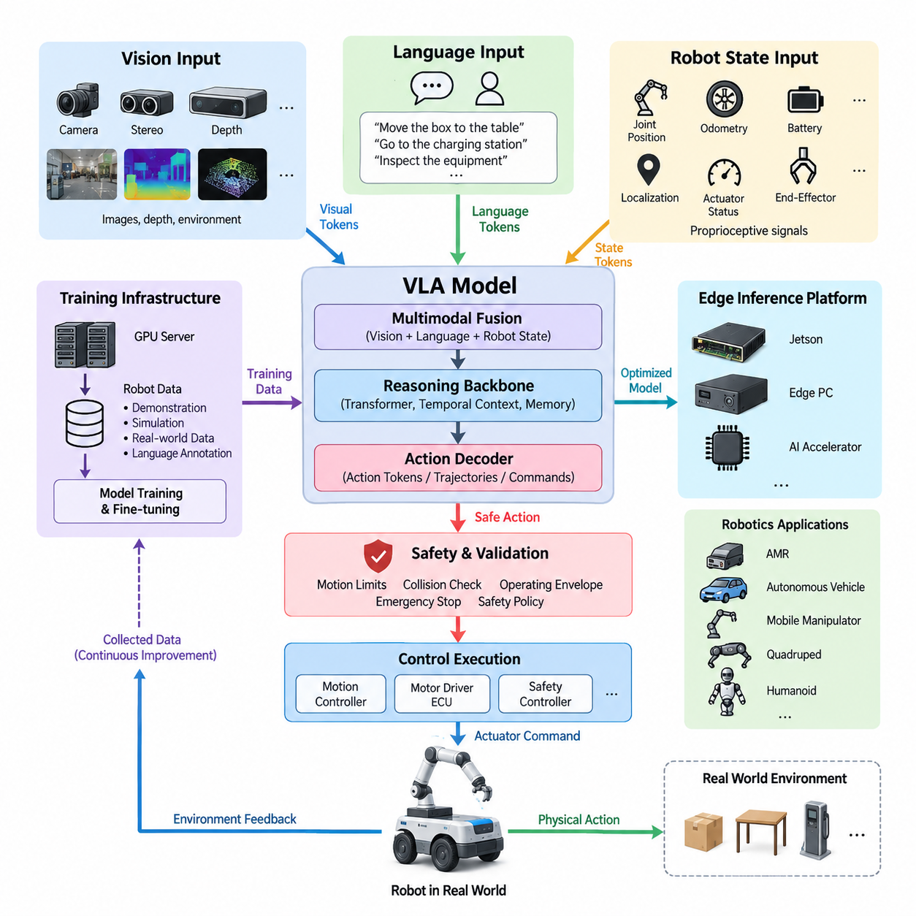
A Vision-Language-Action model, or VLA, is an integrated Physical AI architecture that converts multimodal observations and language-level intent into executable robot actions. Unlike conventional robotic systems that separate perception, semantic reasoning, planning, and control into independently engineered modules, a VLA model learns relationships across these domains within a shared computational framework. The architecture therefore connects what the robot perceives, what the task means, and what physical behavior should occur next.
The vision pathway provides the model with information about the physical environment. Inputs may originate from monocular, stereo, depth, or other perception cameras and can be combined with representations derived from additional robot sensors. A visual encoder transforms raw observations into compact feature tokens representing objects, spatial relationships, free space, human activity, robot state, and task-relevant environmental conditions. These tokens become the perceptual context used by subsequent reasoning and action-generation stages.
The language pathway represents commands, goals, constraints, task descriptions, and contextual knowledge in a tokenized semantic space. Instructions such as moving an object, navigating toward a destination, inspecting equipment, or interacting with a person are converted into embeddings that can be jointly processed with visual features. Language therefore acts not merely as a human interface but as a flexible task specification mechanism that allows the same robot intelligence architecture to support many behaviors without constructing a dedicated control program for every individual task.
Multimodal fusion is the central mechanism connecting vision and language. Visual tokens and language tokens are projected into compatible representation spaces and processed through attention-based networks so that linguistic concepts can be grounded in observed physical entities. A command referring to a particular object, location, direction, or condition must become associated with the corresponding visual evidence. This grounding process allows the model to interpret instructions according to the current scene rather than treating language and perception as independent information streams.
The reasoning backbone maintains the contextual representation needed to determine an appropriate behavior. Transformer-based architectures are commonly suited to this role because attention mechanisms can model relationships among instructions, visual observations, robot state, and previous actions over time. For Physical AI, temporal context is particularly important because an action changes the environment and consequently changes the observations available to the model. The architecture must therefore operate as a repeated perception-reasoning-action loop rather than as a single static prediction process.
The action component converts the multimodal latent representation into a form that can influence physical motion. Depending on the robot architecture, outputs may represent discrete action tokens, continuous trajectories, poses, velocities, manipulation commands, navigation objectives, or intermediate motion intentions. The VLA model does not necessarily replace every deterministic controller. Instead, it can generate higher-level or intermediate actions that are subsequently executed by real-time motion controllers, motor-control ECUs, safety controllers, and other deterministic subsystems.
Action tokenization provides an important interface between learned intelligence and robotic execution. Continuous robot behaviors can be quantized or encoded into structured action representations that a transformer can predict similarly to other token sequences. Alternatively, continuous-action heads can directly estimate motion parameters. The appropriate representation depends on control frequency, robot dynamics, manipulation precision, compute resources, and safety requirements. This action interface also establishes the architectural boundary addressed by downstream action-token transport and real-time inference mechanisms.
A practical VLA architecture should incorporate robot-state information in addition to vision and language. Joint positions, wheel velocities, odometry, actuator status, localization, battery state, end-effector state, and other proprioceptive signals provide information that cannot always be inferred reliably from camera observations. Encoding these signals together with multimodal context allows the model to reason not only about the external world but also about the robot's current physical configuration and operational capability before producing an action.
Memory and temporal history further extend the architecture beyond instantaneous perception. A robot operating in a dynamic environment must distinguish newly observed events from persistent scene structure and understand how previous actions produced current conditions. Short-term observation histories, latent-state memories, previous action tokens, or recurrent context windows can provide this continuity. Such temporal representations are particularly important for navigation, manipulation sequences, human interaction, recovery behavior, and tasks in which relevant objects temporarily disappear from the camera view.
The inference architecture must be designed around the compute hierarchy of the robot. Vision encoding and multimodal reasoning may execute on a Jetson-class platform, an edge PC, a dedicated accelerator, or a combination of processors, while larger training workloads remain on GPU servers or on-premise AI infrastructure. This reflects the broader compute hierarchy of MCU, ECU, Jetson platform, edge PC, GPU server, on-premise AI system, fleet AI, and Physical AI architecture defined within the volume structure.
Training and deployment are therefore separate but tightly connected architectural concerns. Large-scale GPU infrastructure can train or fine-tune the VLA model using robot demonstrations, teleoperation trajectories, simulation data, synthetic scenes, language annotations, and operational datasets. The resulting model can then be compressed, quantized, distilled, partitioned, or otherwise optimized for edge execution. Data collected from deployed robots can subsequently return through controlled data pipelines and fleet-learning infrastructure to improve later model versions.
Physical execution requires a stronger safety boundary than ordinary language or vision inference. A statistically generated action should not automatically receive unrestricted authority over motors and actuators. The VLA output should pass through validation layers that can enforce motion limits, collision constraints, operating envelopes, emergency states, actuator limits, and system-level safety policies. Safety PLCs, dedicated MCUs, drive controllers, and independent emergency-stop paths can remain outside the learned model so that critical protection does not depend solely on neural-network behavior.
Latency is equally fundamental because the usefulness of an intelligent prediction depends on when it becomes available. Camera acquisition, preprocessing, token generation, multimodal inference, action decoding, communication, and actuator response collectively form the end-to-end VLA latency path. Different portions of this pipeline may operate at different frequencies. Semantic reasoning can run more slowly than low-level servo control, while deterministic controllers maintain fast stabilization loops between VLA updates. This hierarchical timing model enables advanced reasoning without forcing a large neural model to execute every electrical control cycle.
The resulting system is best understood as an intelligence layer embedded within a broader robotics compute architecture rather than as a standalone neural network. Vision provides environmental evidence, language specifies intent, robot state describes physical capability, multimodal reasoning connects these representations, and the action decoder produces executable intent. Real-time controllers then transform that intent into controlled physical behavior while safety systems independently supervise execution. This separation combines learned generalization with the deterministic properties required by practical robotic hardware.
Within Physical AI, the long-term significance of VLA architecture is its ability to create a common intelligence interface across different robot forms. An indoor AMR, outdoor autonomous vehicle, mobile manipulator, quadruped, humanoid, or other embodied platform may possess different actuators and dynamics while sharing portions of visual understanding, language reasoning, task knowledge, and action abstraction. The surrounding electrical, communication, sensor, compute, and safety architectures therefore become the physical foundation upon which increasingly general VLA-based robot intelligence can be deployed.

08.02. Real Time Inference Design
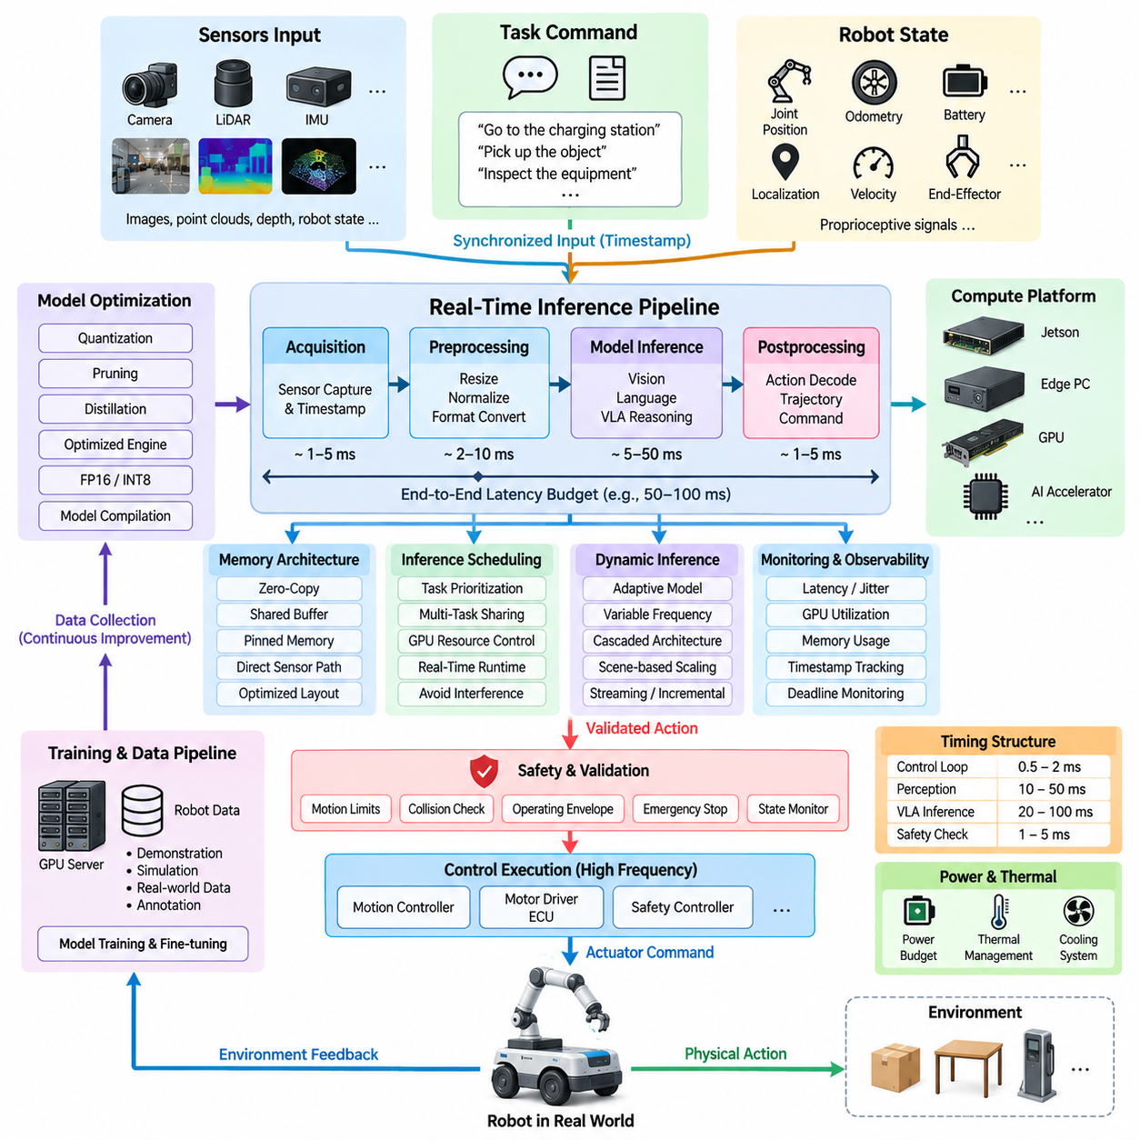
Real-time inference design for Physical AI defines how perception, reasoning, and action-generation models execute within strict timing constraints while interacting with a continuously changing physical environment. Unlike offline AI inference, robot inference must deliver useful results before the surrounding world or robot state changes significantly. The architecture must therefore treat latency, determinism, compute scheduling, data movement, and control-loop synchronization as fundamental design parameters rather than secondary performance optimizations.
A practical architecture separates inference workloads according to their required update rates. Low-level motor control, stabilization, emergency response, and actuator supervision may operate at hundreds or thousands of cycles per second, while perception networks commonly operate at camera or sensor frame rates. VLA reasoning and semantic task interpretation can operate at lower frequencies when appropriate. This hierarchical timing structure prevents computationally expensive AI models from becoming directly responsible for every high-frequency control cycle.
The end-to-end inference path begins when sensors acquire information from the environment and robot. Camera images, LiDAR measurements, depth data, localization information, proprioceptive signals, and task commands must be captured, timestamped, preprocessed, and delivered to the appropriate AI models. Each stage introduces latency, so real-time performance cannot be evaluated using neural-network execution time alone. Sensor acquisition, memory transfer, preprocessing, inference, postprocessing, communication, and actuator response must be considered as one complete timing chain.
Latency budgeting assigns an allowable execution time to each stage of this chain. If a robotic function requires an action decision within a defined deadline, the total available time must be distributed among sensing, preprocessing, model execution, action decoding, safety validation, network transport, and controller response. This approach makes timing requirements measurable at the system level and prevents individual components from consuming excessive portions of the available response window. Worst-case behavior is especially important for safety-related functions.
Inference scheduling becomes more complex when several AI workloads share the same GPU or edge processor. Object detection, segmentation, depth estimation, localization support, VLA inference, speech processing, and monitoring functions may compete for GPU cores, memory bandwidth, and accelerator resources. The runtime architecture must establish priorities and execution policies so that critical workloads receive predictable compute access. Noncritical analytics or logging tasks should not delay perception or action-generation workloads that participate directly in robot behavior.
Asynchronous pipelines can improve utilization by allowing sensing, preprocessing, inference, and control execution to proceed concurrently rather than sequentially. While one camera frame is being processed by an AI model, the next frame can be acquired and prepared, and a previously generated command can be evaluated by the control system. Such pipelining increases throughput, but designers must carefully manage frame age and temporal consistency. High throughput is not useful if actions are generated from observations that have become too old for the current physical situation.
Memory architecture strongly affects real-time inference performance. Repeated copying of high-resolution images or large tensor data between CPU memory, GPU memory, and accelerator buffers can consume significant time and bandwidth. Zero-copy mechanisms, shared buffers, pinned memory, direct sensor-to-accelerator paths, and optimized tensor layouts can reduce unnecessary transfers. For edge robotics, memory bandwidth may become as important as raw computational throughput because multiple perception models can simultaneously process large sensor streams.
Model optimization provides another major mechanism for meeting real-time requirements. Neural networks can be quantized, pruned, distilled, compiled, or converted into hardware-optimized execution engines. Reduced-precision computation such as FP16 or INT8 can significantly decrease memory consumption and inference time when supported by the target accelerator. Optimization, however, must be validated against task accuracy and operational robustness because a faster model provides little benefit if compression materially degrades perception, reasoning, or action quality.
Dynamic inference strategies can adapt computational effort to the current operating condition. A robot moving through an uncomplicated environment may use a lightweight model, reduced input resolution, or lower inference frequency, while complex scenes can activate more capable processing. Cascaded architectures can first execute inexpensive models and invoke larger models only when uncertainty or task complexity increases. Such strategies improve average compute efficiency while preserving access to stronger reasoning when the operational situation requires it.
VLA-based Physical AI introduces additional timing challenges because multimodal reasoning can be substantially more computationally demanding than conventional perception networks. Vision tokens, language tokens, robot-state representations, temporal history, and action context may all participate in a single inference cycle. The system must control context length, token count, model size, and decoding strategy so that action generation remains responsive. Streaming or incremental processing can reduce repeated computation by reusing previously calculated representations when the scene changes gradually.
Action generation also requires careful temporal design. Autoregressive generation of long action-token sequences can create unacceptable delay if every future action must be produced sequentially before execution begins. The architecture can instead generate short action horizons, action chunks, trajectories, or intermediate motion goals that are passed to deterministic controllers. The robot can execute the current segment while the AI system prepares subsequent actions, creating a rolling inference-and-control process that balances model intelligence with physical responsiveness.
The boundary between AI inference and deterministic control is therefore essential. VLA or other learned models can determine semantic intentions, target objects, navigation goals, manipulation strategies, or short-horizon actions, while real-time controllers handle trajectory tracking, motor commands, steering, braking, joint control, and stabilization. This division allows relatively variable AI inference latency to coexist with tightly bounded control loops. It also prevents temporary AI delays from immediately destabilizing the physical platform.
Safety supervision must operate independently of the normal AI inference path. Generated actions should be checked against velocity limits, acceleration limits, collision constraints, restricted regions, actuator capabilities, robot state, and emergency conditions before execution. A dedicated MCU, safety controller, safety PLC, or drive-level protection mechanism can maintain essential protection even when the GPU, VLA model, operating system, or communication layer becomes delayed or unavailable. AI inference should never become the sole mechanism responsible for maintaining a safe physical state.
Deadline monitoring detects situations in which an inference result arrives too late to remain valid. Every observation and resulting action can carry timestamps so that the execution layer can determine the age of the information used for decision making. If the permitted latency is exceeded, the system may reject the action, retain the previous safe command, reduce velocity, transition to a degraded operating mode, or initiate a controlled stop. This converts timing from an assumed property into an explicitly supervised system variable.
The compute platform must consequently be selected according to sustained real-time behavior rather than peak AI performance alone. Jetson-class processors, edge PCs, GPUs, and dedicated AI accelerators should be evaluated using model latency, memory bandwidth, thermal behavior, power limits, concurrent workload performance, and long-duration stability. Thermal throttling is particularly important because an accelerator that meets timing requirements during a short benchmark may violate deadlines after prolonged operation inside a robot enclosure.
Real-time inference also interacts directly with power and thermal architecture. Increasing GPU frequency or activating additional accelerators can reduce inference latency but increases electrical power consumption and heat generation. Conversely, aggressive power limiting can increase execution time and deadline risk. Physical AI compute design must therefore coordinate inference performance with available battery energy, DC power capacity, cooling capability, enclosure temperature, and mission duration. Real-time performance is ultimately a system-level hardware and software property.
Observability is required to validate the complete architecture. Runtime telemetry should measure sensor timestamps, queue depth, preprocessing time, model execution time, GPU utilization, memory consumption, action-decoding latency, communication delay, control response, temperature, and deadline violations. Average latency alone is insufficient because occasional long delays can be more dangerous than consistently moderate latency. Percentile distributions, maximum observed latency, jitter, and worst-case operating scenarios should therefore be examined during validation.
The resulting real-time inference architecture connects the VLA model to the remaining Physical AI compute stack. Multimodal models provide intelligent interpretation and action generation, optimized edge hardware provides bounded computational resources, action-token transport carries generated intentions toward execution systems, and deterministic controllers maintain fast physical control. Hardware accelerators and power-budget design then determine how much inference capability can be sustained continuously within the robot, forming the foundation for the subsequent Physical AI architecture elements.

08.03. Action Token Transport
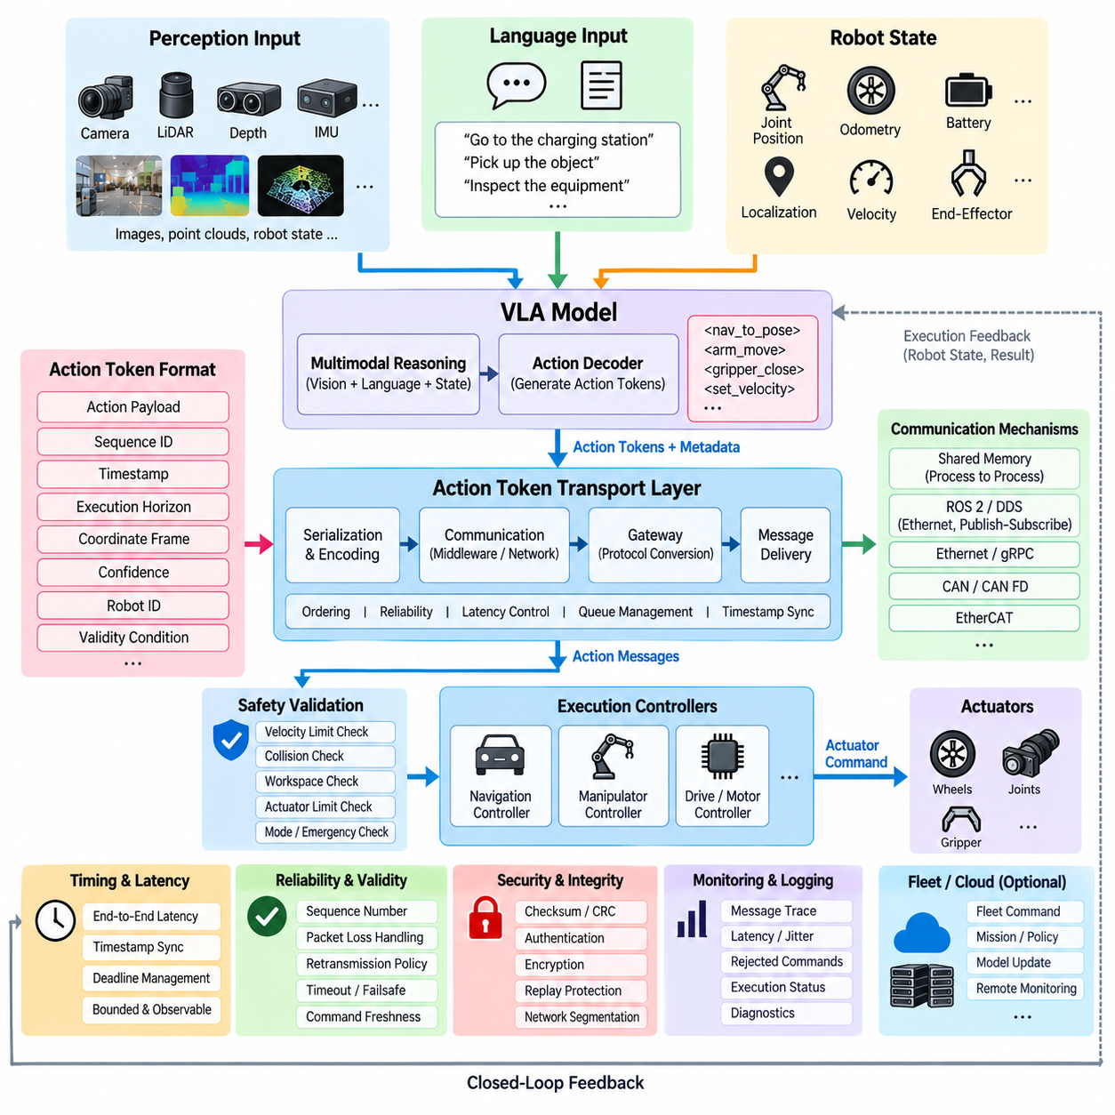
Action token transport defines the communication architecture that carries AI-generated behavioral intentions from a Vision-Language-Action model or other Physical AI reasoning component toward deterministic robot execution systems. The transport layer occupies the boundary between probabilistic AI inference and real-time physical control. Its purpose is not merely to transmit numerical commands, but to preserve the meaning, timing, ordering, validity, and safety context of generated actions as they move through the robot compute architecture.
An action token is a machine-interpretable representation of intended robot behavior. Depending on the model and platform, a token may describe a discrete command, target pose, velocity, trajectory segment, manipulation primitive, navigation objective, gripper operation, or higher-level task transition. Multiple tokens can form an action sequence representing behavior over a short temporal horizon. This abstraction allows learned AI models to communicate with heterogeneous robotic platforms without directly generating every low-level electrical or actuator command.
The transport architecture begins at the action decoder of the VLA model. Multimodal reasoning produces a latent representation of the required behavior, and the decoder converts that representation into structured action tokens or continuous action parameters. Before transmission, these outputs should be packaged into a defined message format containing the action payload together with metadata such as sequence identifiers, timestamps, execution horizons, coordinate frames, confidence information, robot identifiers, and validity conditions.
Temporal information is essential because an action has meaning only within the physical state for which it was generated. Every action message should therefore be associated with the observation time, generation time, and, when required, intended execution time. The receiving controller can compare these timestamps with its local clock and reject stale commands. Accurate time synchronization across the AI computer, edge controller, ECU, and actuator network becomes a fundamental requirement when action tokens cross multiple computational and communication domains.
Sequence management preserves the intended order of actions. Network delays, asynchronous processing, retransmissions, or parallel inference pipelines can cause messages to arrive at different times or in an unexpected order. Sequence numbers and action identifiers allow the execution layer to detect missing, duplicated, or reordered tokens. The controller can then determine whether to execute, buffer, discard, or request replacement of a command rather than blindly applying every message that arrives at its interface.
Action transport must also distinguish between commands that require reliable delivery and those whose value rapidly expires. A high-level navigation goal may tolerate retransmission because receiving the instruction correctly is more important than minimum latency. A rapidly updated velocity command may instead become obsolete before a retransmitted packet arrives. Transport policies should therefore reflect action semantics, allowing reliability, latency, queue depth, history, and delivery behavior to be configured according to the physical consequence of each message class.
The communication mechanism can vary across the robot compute hierarchy. Action tokens may move between processes through shared memory or inter-process communication, between computers through Ethernet-based middleware, and toward embedded controllers through CAN, CAN FD, EtherCAT, or other deterministic interfaces. ROS 2 and DDS can provide structured publish-subscribe communication at higher computational layers, while gateways translate selected commands into compact messages appropriate for ECU, motor-controller, or actuator networks.
A gateway is especially important when the AI domain and control domain use different data models. The VLA system may express an action as a semantic instruction or short trajectory, while a real-time controller requires target velocity, steering angle, joint position, torque limit, or actuator mode. The gateway performs controlled translation between these representations. This translation should be explicitly defined so that changes in the AI model do not unintentionally alter the electrical or control interface expected by downstream hardware.
Coordinate-frame information must accompany spatial actions whenever ambiguity is possible. A target pose may be expressed in a global map frame, robot base frame, camera frame, manipulator base frame, or end-effector frame. Transmitting coordinates without frame identity can result in physically incorrect behavior even when every numerical value is received correctly. Action messages should therefore identify the reference frame and, where necessary, the transform version or timestamp associated with the spatial representation.
Transport latency forms part of the end-to-end Physical AI response time. Action encoding, serialization, queueing, middleware processing, network transmission, gateway conversion, safety validation, and controller reception all contribute to the delay between AI inference and physical execution. The architecture should measure these components rather than treating communication as instantaneous. Bounded and observable latency is particularly important when short-horizon actions are generated continuously by a real-time VLA inference pipeline.
Queue design strongly influences action freshness. Large communication queues can prevent packet loss but may cause old actions to remain in the system after newer decisions have already been generated. For continuously updated robot commands, retaining only the most recent valid action can be safer and more responsive than processing every historical message. For ordered manipulation sequences, however, preserving multiple commands may be necessary. Queue policy must therefore be matched to the temporal semantics of the action rather than selected only for communication efficiency.
Safety validation should remain between action reception and unrestricted actuator execution. Transport integrity confirms that the intended data arrived correctly, but it does not prove that the action itself is physically safe. The execution architecture should evaluate received commands against velocity, acceleration, workspace, collision, actuator, operating-mode, and emergency-state constraints. Commands violating these boundaries can be rejected, clipped, transformed, or replaced by predefined safe behavior before reaching motor or drive controllers.
A command-validity mechanism defines what happens when communication is interrupted. Each action can include a validity duration, deadline, or heartbeat dependency. If new commands stop arriving, the controller should not indefinitely execute the last AI-generated intention unless that behavior has explicitly been designed as safe. Depending on the robot function, communication timeout can trigger command hold, zero velocity, controlled deceleration, trajectory cancellation, degraded operation, or transition to an independent safety state.
Integrity protection is also required because corrupted action data can directly affect physical motion. Message structures can incorporate checksums, cyclic redundancy checks, length validation, range checking, and schema or version identifiers. Communication systems may provide additional integrity and authentication mechanisms. At system level, the receiver should validate both message structure and physical plausibility before accepting a command, creating multiple barriers between malformed data and actuator execution.
Security becomes increasingly important when action tokens cross Ethernet, wireless, fleet, or remote-compute boundaries. Unauthorized modification, injection, replay, or impersonation of action messages could create unsafe robot behavior. Authentication, authorization, encryption where appropriate, secure session management, replay protection, network segmentation, and controlled gateway interfaces should therefore protect command channels. Safety and cybersecurity remain distinct engineering disciplines, but both converge at the action-transport boundary because compromised communication can produce physical consequences.
The transport system should support observability for development and validation. Engineers need to trace an action from model output through serialization, communication, gateway processing, safety validation, controller acceptance, and actuator response. Logging sequence numbers, timestamps, message age, transport latency, rejected commands, timeout events, and execution status allows failures to be reconstructed. Such traceability is particularly valuable when diagnosing intermittent behaviors that involve interactions between AI inference, networking, and physical control.
Feedback completes the transport loop. Controllers should report whether an action was accepted, rejected, completed, interrupted, or modified by safety logic. Robot state, actuator status, localization, and execution results then return to the perception and reasoning layers as updated context. The VLA model can use this information during subsequent inference cycles, preventing the architecture from assuming that every generated action was executed exactly as predicted and enabling closed-loop Physical AI behavior.
For fleet-connected robots, action transport should maintain a clear distinction between central intelligence and local execution authority. Fleet AI or an on-premise server may distribute missions, policies, semantic goals, or model updates, but time-critical actuator control should normally remain local to the robot. Loss of external connectivity should therefore not destroy essential control or safety capability. Local controllers can maintain bounded autonomous behavior while higher-level communication is restored.
Ultimately, action token transport provides the engineered bridge between VLA intelligence and physical machinery. The VLA architecture determines what should happen, real-time inference determines when the decision becomes available, action transport preserves and delivers that decision, and downstream controllers determine how it is physically executed. Together with hardware acceleration and power-budget design, this interface enables Physical AI models to operate as part of a dependable robot compute system rather than as isolated neural-network demonstrations.

08.04. Hardware Accelerator Design
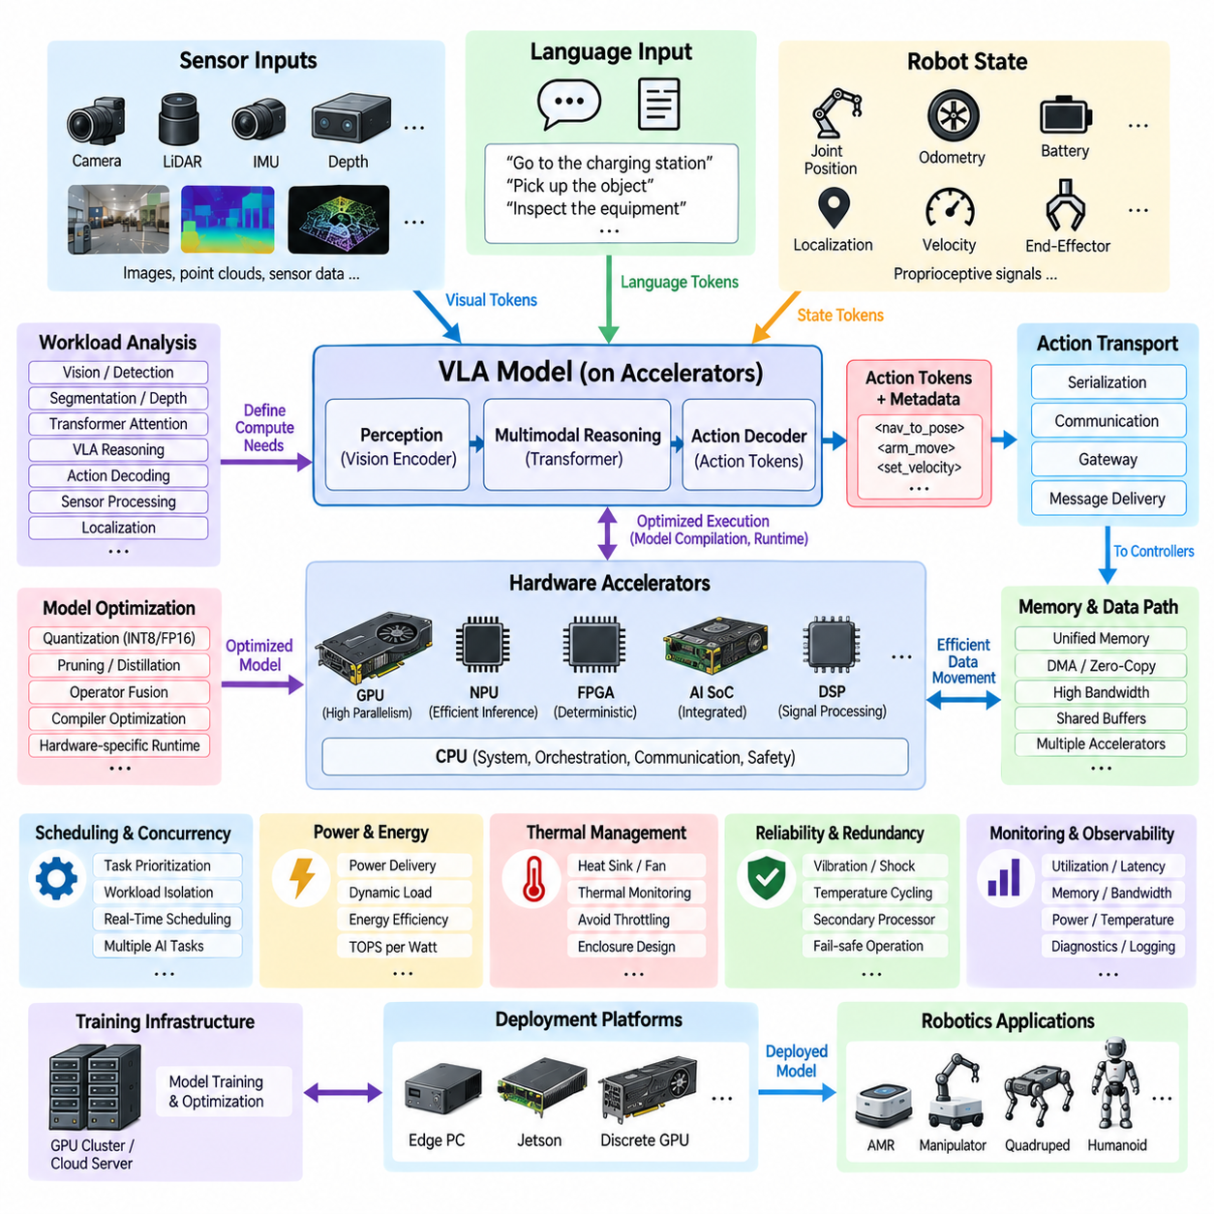
Hardware accelerator design for Physical AI determines how computationally intensive perception, multimodal reasoning, and action-generation workloads are mapped onto specialized processing resources inside a robot. General-purpose CPUs remain important for operating systems, orchestration, communication, and supervisory logic, but modern AI workloads require much higher parallel throughput. GPUs, NPUs, tensor accelerators, DSPs, FPGAs, and dedicated AI SoCs therefore become fundamental components of the Physical AI compute architecture.
The accelerator architecture should begin with workload characterization rather than device selection. Vision encoders, object detection, segmentation, depth estimation, transformer attention, VLA reasoning, action decoding, localization support, and sensor processing have different computational structures. Some operations are dominated by matrix multiplication, while others depend heavily on memory access, preprocessing, sequential execution, or specialized signal-processing functions. Understanding this workload composition allows hardware resources to be assigned according to actual computational behavior.
GPUs are particularly effective for highly parallel neural-network operations and remain a primary accelerator for advanced robotic AI. Thousands of parallel execution units can process convolution, matrix multiplication, attention, and tensor operations efficiently, while specialized tensor-processing units accelerate reduced-precision arithmetic. In a Physical AI platform, the GPU can execute perception networks and multimodal models while the CPU handles system coordination, middleware, diagnostics, and application-level management.
Integrated AI SoCs provide another important design option for mobile robots. Platforms combining CPU cores, GPU resources, AI accelerators, memory controllers, video engines, and high-speed interfaces can reduce board area, power consumption, and communication overhead. Jetson-class systems exemplify this architecture by integrating general computation and accelerated AI processing within a compact edge platform. Such integration is particularly valuable for AMRs, mobile manipulators, quadrupeds, and humanoids where size, weight, power, and thermal capacity are limited.
Dedicated NPUs or tensor accelerators can provide higher performance per watt for supported neural-network operations. These devices are optimized for matrix and tensor computation and commonly emphasize low-precision formats such as INT8, FP8, FP16, or other hardware-specific representations. Their efficiency can make them attractive for continuously operating perception or inference workloads. However, model compatibility, operator support, compiler maturity, memory capacity, and runtime flexibility must be evaluated before assigning critical Physical AI functions to them.
FPGAs provide a different acceleration model based on configurable hardware pipelines. They can implement deterministic preprocessing, sensor interfaces, image pipelines, timestamp processing, protocol conversion, or specialized neural-network operators with tightly controlled latency. Their parallel dataflow architecture can be useful when predictable timing is more important than general programmability. FPGA development, however, requires greater hardware-design effort and should be justified by latency, interface, determinism, or customization requirements that cannot be satisfied efficiently by conventional processors.
Hardware partitioning determines which workload executes on which processor. Camera preprocessing may use dedicated video engines or GPU kernels, neural perception may execute on a GPU or NPU, VLA reasoning may require a larger GPU, and deterministic control should remain on an MCU or real-time controller. This heterogeneous compute architecture allows each processing technology to operate where it is strongest instead of forcing all robotic functions onto a single high-performance processor.
Data movement between accelerators is often as important as computation itself. Transferring large images, point clouds, feature maps, and model tensors repeatedly between CPU, GPU, NPU, and system memory can consume bandwidth and introduce substantial latency. Shared-memory architectures, unified memory, direct memory access, zero-copy buffers, and accelerator-aware middleware can reduce unnecessary transfers. Hardware accelerator design must therefore analyze the complete data path rather than comparing only peak TOPS or FLOPS specifications.
Memory capacity also constrains the models that can execute on an edge platform. Large VLA and multimodal models require storage for parameters, activations, attention caches, visual tokens, temporal context, and intermediate tensors. Several simultaneously executing perception models can further increase demand. Designers must evaluate usable memory after operating-system and application overhead, not merely installed capacity. Memory bandwidth and access contention should also be considered when multiple accelerators or workloads operate concurrently.
Precision selection directly influences accelerator efficiency. FP32 may provide broad numerical range but consumes more memory and computational resources than lower-precision formats. FP16, BF16, FP8, and INT8 can improve throughput and reduce memory traffic when the model and accelerator support them. Quantization-aware training or post-training quantization can further reduce resource requirements. The selected precision should nevertheless be validated against perception accuracy, reasoning quality, action stability, and rare operational conditions.
Accelerator utilization depends strongly on model compilation and runtime software. AI frameworks normally transform trained models into optimized computational graphs and hardware-specific kernels. Operator fusion, constant folding, memory planning, kernel selection, graph optimization, and hardware-specific compilation can substantially improve execution performance. The software toolchain must therefore be treated as part of the accelerator architecture because nominal hardware capability cannot be realized if the compiler or runtime cannot efficiently map the target model onto the device.
Concurrency becomes critical when multiple Physical AI functions share accelerator resources. A robot may simultaneously execute camera perception, LiDAR processing, VLA inference, localization assistance, speech recognition, anomaly detection, and recording functions. Scheduling policies should prevent background tasks from monopolizing compute or memory bandwidth. Priority streams, workload isolation, execution quotas, separate accelerators, or time-partitioned processing can be used when predictable response time is required for critical inference functions.
Accelerator redundancy may be considered for robots requiring higher availability. A secondary processor can provide degraded perception or simplified autonomy if the primary AI accelerator fails, overheats, or becomes unavailable. This does not necessarily require duplicating the complete high-performance AI stack. A smaller independent processor may execute essential obstacle detection, localization support, safe navigation, or controlled-stop functions, allowing the system to transition into a reduced-capability state rather than immediately losing all autonomous behavior.
Thermal design is inseparable from accelerator selection. GPUs and high-performance AI processors can generate significant heat during sustained inference, particularly when several models execute concurrently. Heat sinks, fans, heat pipes, cold plates, enclosure airflow, thermal interface materials, and temperature monitoring must maintain the processor below throttling limits. A system that achieves excellent benchmark performance for several minutes but reduces clock frequency during long missions does not provide dependable real-time AI performance.
Power delivery must also support accelerator transients and sustained load. AI processors can rapidly change power consumption as workloads begin, stop, or change complexity. DC/DC converters, power distribution units, wiring, connectors, and local regulators should be designed for these dynamic conditions. Voltage stability is important because transient drops can reset or destabilize compute modules. Hardware accelerator design therefore connects directly with the Physical AI power-budget architecture that follows this section.
Energy efficiency should be evaluated using useful robotic performance rather than accelerator specifications alone. TOPS per watt can provide a rough comparison, but actual efficiency depends on model utilization, precision, memory traffic, compiler optimization, idle behavior, and thermal conditions. A theoretically powerful accelerator operating at low utilization may consume more mission energy than a smaller processor optimized for the required workload. Measurements using representative robot models and sensor streams provide more meaningful engineering evidence.
Reliability considerations include vibration, shock, temperature cycling, dust, humidity, connector integrity, and long-duration operation. Accelerator modules installed in mobile robots experience harsher conditions than conventional data-center hardware. Mechanical mounting, PCB support, cooling attachment, SSD retention, connector locking, and cable strain relief should therefore be considered alongside computational design. Environmental qualification is especially important for outdoor AMRs, inspection vehicles, and other robots operating beyond controlled indoor environments.
Observability enables engineers to determine whether accelerator resources are meeting system requirements. Runtime monitoring can collect processor utilization, tensor-core activity, memory usage, bandwidth, inference latency, queue depth, power consumption, clock frequency, and temperature. Correlating these measurements with robot behavior reveals whether missed deadlines originate from model execution, memory contention, thermal throttling, communication, or scheduling. Such telemetry supports both laboratory optimization and field diagnostics.
A scalable Physical AI architecture can use different accelerator tiers for different robot classes while maintaining a common software and model interface. Lightweight robots may use an integrated edge SoC, higher-performance robots may combine an edge processor with a discrete GPU, and research or premium platforms may employ multiple accelerators. Training and large-scale optimization can remain on GPU servers or on-premise infrastructure, while deployment models are adapted to the compute envelope of each robot platform.
Ultimately, hardware accelerator design transforms AI model requirements into a realizable robotic compute platform. The VLA architecture defines the intelligence workload, real-time inference establishes timing constraints, and action-token transport connects model output to execution. Hardware accelerators then provide the computational throughput needed to sustain these functions within practical limits of memory, latency, thermal capacity, reliability, and electrical power. The remaining design problem is therefore to determine how this compute capability fits within the complete Physical AI power budget.

08.05. Physical AI Power Budget
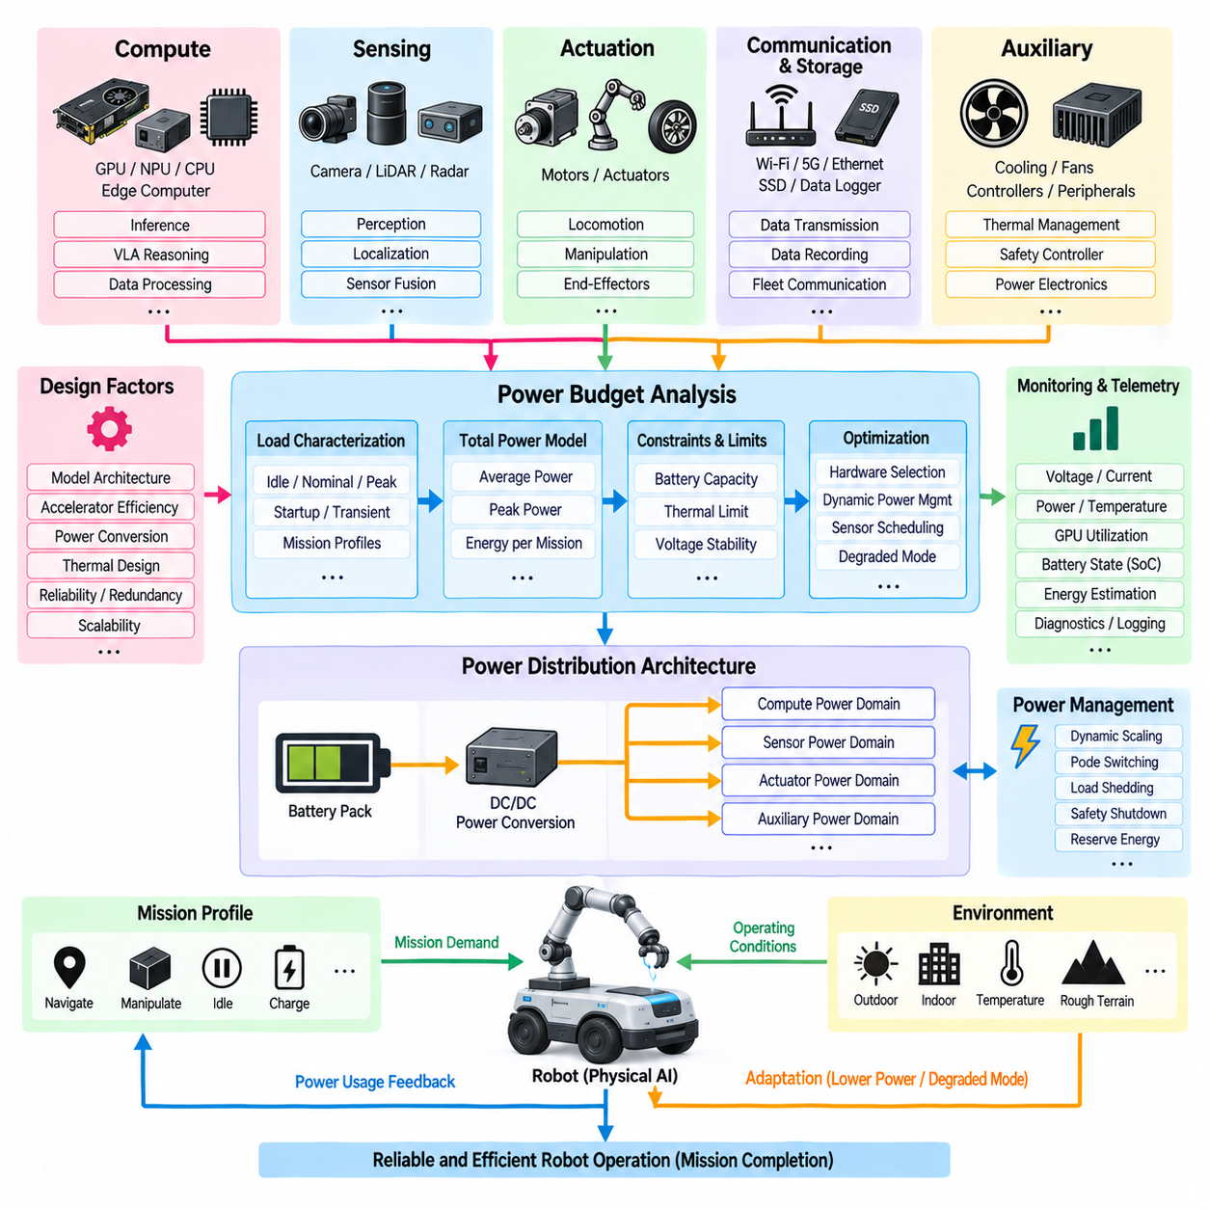
Physical AI power budgeting defines how electrical energy is allocated across the computing, sensing, communication, control, and supporting infrastructure required to operate intelligent robots. Unlike conventional embedded systems, Physical AI platforms may continuously execute perception networks, VLA reasoning, localization, sensor fusion, and action generation while controlling physical machinery. Power design must therefore consider not only average consumption but also peak demand, transient behavior, thermal limits, mission duration, and degraded operating modes.
The power budget should begin with a complete inventory of electrical loads. Major consumers typically include AI processors, CPUs, GPUs, NPUs, edge computers, cameras, LiDARs, radar, communication modules, storage devices, cooling systems, controllers, and peripheral electronics. Motors and actuators may dominate total robot energy, but computing and sensing often represent a large continuous auxiliary load. Separating propulsion, actuation, compute, sensing, and auxiliary domains makes energy consumption easier to analyze and control.
Each load should be characterized using multiple operating states rather than a single rated value. An AI accelerator may exhibit different consumption during idle operation, perception inference, VLA reasoning, model loading, or simultaneous multi-model execution. Cameras and LiDARs may operate continuously, intermittently, or at reduced rates depending on mission state. The resulting power model should therefore represent idle, nominal, peak, startup, emergency, and degraded conditions to capture realistic robot operation.
Peak power is especially important because simultaneous workload activation can create short periods of demand significantly above the mission average. GPU inference, sensor startup, communication transmission, cooling fans, steering systems, manipulators, and propulsion loads may overlap. DC/DC converters, batteries, power distribution units, connectors, wiring, and protection devices must tolerate these combinations without excessive voltage drop or unwanted shutdown. Peak-load analysis should therefore include realistic concurrency rather than independently measured maximum values that can never occur together.
Transient power behavior requires additional attention for high-performance AI accelerators. GPUs and other processors can rapidly transition from low-power states to intensive computation, producing fast changes in current demand. If the power distribution network has excessive impedance, these transients can cause local voltage instability, processor reset, or communication failure. Appropriate converter response, local capacitance, power-plane design, cable sizing, and connector selection help maintain stable supply voltage during dynamic AI workloads.
The compute power budget is closely linked to model architecture. Larger VLA models, higher image resolutions, longer context windows, increased inference frequency, and simultaneous perception networks generally require more accelerator activity and memory traffic. A model that fits computationally on a GPU may still be unsuitable for a mobile robot if sustained operation exceeds the available electrical or thermal envelope. AI architecture should therefore be optimized against watts, latency, and task performance simultaneously rather than computational capability alone.
Hardware accelerator selection provides one of the strongest mechanisms for controlling AI power consumption. GPUs offer high flexibility and parallel throughput, while NPUs and dedicated tensor accelerators can provide higher efficiency for supported workloads. Integrated AI SoCs can reduce data-transfer and peripheral overhead, and FPGAs or DSPs may efficiently handle specialized preprocessing functions. The optimal architecture may therefore distribute workloads across heterogeneous processors rather than operating every AI function on the largest available GPU.
Dynamic power management can adapt compute consumption to mission requirements. When the robot is stationary or operating in a simple environment, perception frequency, camera resolution, GPU clocks, model size, or active accelerator count can be reduced. Complex navigation, manipulation, or emergency situations can temporarily activate higher-performance modes. This adaptive strategy allows the platform to reserve maximum computing capability for situations in which it produces meaningful operational benefit instead of continuously consuming peak power.
Sensor power should be considered together with computational demand because sensing and inference are functionally coupled. Increasing camera frame rate or enabling additional LiDAR, radar, or depth sensors not only consumes sensor power but also increases downstream data processing. Conversely, disabling unnecessary sensors can reduce both direct electrical consumption and AI workload. Mission-aware sensor scheduling can therefore produce system-level energy savings that are larger than the sensor's individual rated power would suggest.
Communication and storage also contribute to the continuous power budget. Ethernet switches, wireless radios, cellular modems, GNSS receivers, SSDs, data recorders, and fleet communication modules may remain active throughout a mission. High-rate logging of images and point clouds increases storage activity and can also increase CPU and network utilization. Data architecture should consequently distinguish information required for immediate autonomy from information collected for diagnostics, fleet learning, or later model training.
Cooling power is part of the AI power budget rather than an independent overhead. Fans, pumps, and other active thermal-management components consume energy specifically because compute hardware generates heat. Increasing accelerator power may therefore increase both direct electrical consumption and secondary cooling demand. The effective energy cost of an AI workload should include this supporting infrastructure, particularly in sealed or outdoor enclosures where thermal rejection can require substantial design margin.
Power conversion efficiency influences how much battery energy actually reaches the computing hardware. A robot may convert a 48 V battery bus into 24 V, 12 V, 5 V, or processor-specific rails through several conversion stages. Losses in DC/DC converters, wiring, connectors, protection devices, and local regulators reduce overall efficiency and appear as additional heat. The budget should therefore distinguish useful load power from battery-side input power and account for conversion efficiency under realistic operating loads.
Power-domain architecture can isolate critical functions from high-demand AI loads. Safety controllers, emergency-stop circuits, communication gateways, and essential low-level control electronics can be supplied through protected power domains that remain operational even if the main AI computer is reset or intentionally shut down. Separate switching and protection also allow nonessential accelerators or sensors to be disconnected during faults or low-energy conditions while preserving the robot's ability to reach a controlled safe state.
Mission energy is obtained by integrating power consumption over time rather than considering watts alone. A robot may spend portions of its mission navigating, waiting, manipulating, communicating, charging, or executing intensive AI reasoning. Each phase has a different power profile. Combining these profiles with expected mission duration produces a more realistic energy estimate and enables engineers to determine whether the battery can support both mobility and Physical AI computation throughout the required operating period.
Battery sizing should include usable capacity rather than nominal capacity alone. State-of-charge limits, discharge-rate effects, temperature, battery aging, conversion losses, reserve energy, and safety margins reduce the energy available for normal missions. A power budget that consumes the entire nominal battery capacity leaves no margin for route deviation, communication failure, obstacle recovery, or return-to-charge behavior. Energy reserves should therefore be explicitly associated with safe mission completion.
Power budgeting also supports degraded operating modes. If battery state becomes low, temperature rises, or an accelerator exceeds its permitted power envelope, the robot can reduce AI workload before reaching a critical condition. Lower inference rates, smaller models, reduced sensor configurations, limited speed, disabled nonessential logging, or simplified autonomy can extend remaining operating time. Such degradation should be intentionally designed and validated rather than emerging unpredictably from processor throttling or battery protection.
Thermal and power budgets must be solved together because nearly all electrical energy consumed by computing equipment eventually becomes heat. A processor configured for a higher power limit may reduce inference latency but require larger cooling hardware and consume mission energy more rapidly. Conversely, restricting processor power can reduce thermal load while increasing inference time. The optimal operating point depends on the interaction among AI performance, real-time deadlines, cooling capability, ambient temperature, and required mission endurance.
Instrumentation is necessary to validate the theoretical budget against real operation. Voltage, current, power, temperature, GPU utilization, processor clocks, sensor activity, and battery state can be logged during representative missions. Measurements should capture startup, steady navigation, complex perception, VLA inference, manipulation, communication, and fault conditions. Comparing measured energy profiles with design assumptions reveals hidden loads, unexpected concurrency, conversion losses, or thermal behavior that static component specifications may not expose.
Power telemetry can also become part of runtime intelligence. The robot can estimate remaining mission energy from current consumption, battery state, planned route, task complexity, and expected compute workload. Fleet systems can use this information to schedule charging, redistribute missions, or select robots with sufficient remaining energy. Physical AI power management can therefore evolve from static electrical sizing into an active resource-management function integrated with autonomy and fleet operation.
Scalability requires the power architecture to support different compute configurations without redesigning the entire robot. A lightweight model may use an integrated Jetson-class platform, while a higher-performance configuration may add discrete GPUs or dedicated accelerators. Modular power domains, appropriately sized converters, configurable cooling, and standardized compute interfaces allow these tiers to share a common architectural foundation while maintaining different power and performance envelopes.
Ultimately, the Physical AI power budget closes the relationship among intelligence, computation, and physical energy. VLA model architecture defines what intelligence must be executed, real-time inference defines how quickly it must execute, action-token transport connects intelligence to control, and hardware accelerators provide the required computational throughput. Power-budget engineering determines whether all of these capabilities can operate continuously and safely within the robot's battery, distribution, cooling, reliability, and mission constraints.

