Volume 16 Compute and AI Architecture

Chapter 03. Jetson Platform

03.01. Jetson Orin NX/AGX Selection
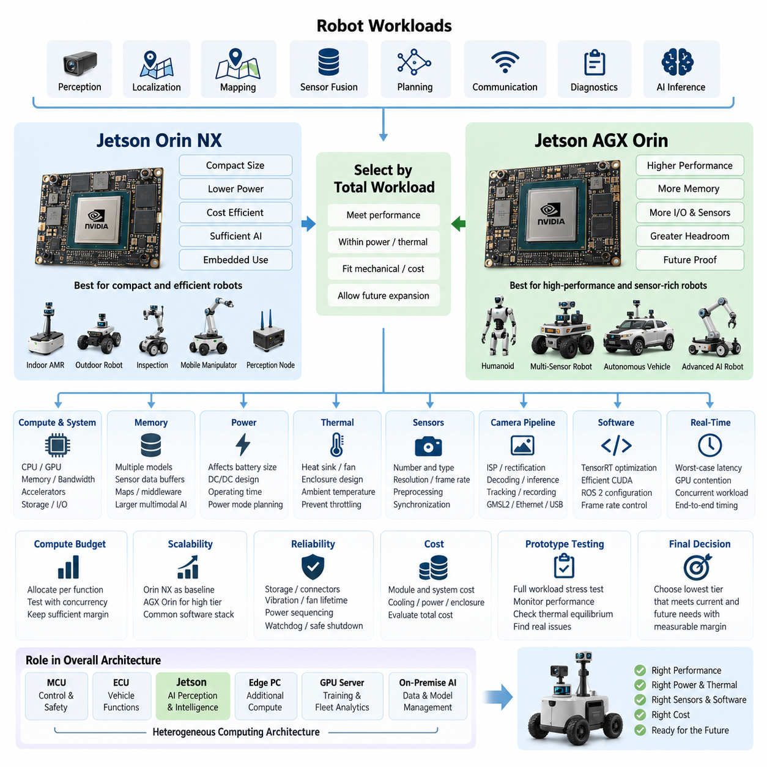
The selection between Jetson Orin NX and Jetson AGX Orin should begin with the robot’s complete computing workload rather than a simple comparison of processor specifications. A robotics computer must execute perception, localization, mapping, sensor fusion, planning, communication, diagnostics, and increasingly AI inference at the same time. The appropriate platform is therefore the device that satisfies peak computational demand while remaining within the robot’s electrical, thermal, mechanical, and cost constraints.
Jetson Orin NX is particularly suitable when high AI performance must be concentrated into a compact embedded computing module. It provides a practical foundation for indoor AMRs, compact outdoor robots, inspection platforms, mobile manipulators, and distributed perception nodes. Its relatively moderate power requirement simplifies battery integration and cooling, while the module architecture allows designers to build application-specific carrier boards containing Ethernet, CAN, USB, camera, storage, and other robot interfaces.
Jetson AGX Orin should be considered when the robot requires substantially greater computing headroom or must execute several demanding AI pipelines concurrently. Typical workloads include multi-camera perception, high-resolution object detection, semantic segmentation, 3D perception, large sensor-fusion networks, local planning, and advanced neural inference. The additional compute margin is valuable when future software releases are expected to introduce larger models or additional perception functions without replacing the computing platform.
Raw AI performance alone is not an adequate selection criterion. CPU resources, GPU utilization, memory capacity, memory bandwidth, accelerator availability, storage traffic, and communication interfaces must be evaluated as one computing system. Robotics applications frequently move large amounts of camera, LiDAR, radar, and intermediate neural-network data between processing stages. A platform with sufficient nominal inference performance may therefore become constrained by memory pressure, data movement, CPU scheduling, or I/O throughput before the GPU reaches its theoretical limit.
Memory capacity becomes increasingly important as Physical AI workloads evolve from independent perception models toward integrated multimodal architectures. Multiple neural networks, CUDA buffers, camera frames, point clouds, occupancy representations, maps, middleware processes, and system services may coexist in memory. Vision-language and vision-language-action workloads can increase this demand further. Orin NX can be appropriate for carefully optimized embedded pipelines, whereas AGX Orin provides greater architectural margin for larger models and concurrent workloads.
Power consumption must be treated as a system-level design parameter because compute selection directly influences battery capacity, DC/DC conversion, wiring, protection devices, and operating duration. Orin NX generally favors robots where energy efficiency and compact packaging are dominant requirements. AGX Orin permits higher sustained computational loading but requires the electrical architecture to support correspondingly greater peak and continuous demand. Power-mode configuration should therefore be incorporated into mission-level energy calculations rather than selected only after software development.
Thermal design is inseparable from platform selection. AI processors may operate for long periods near high utilization while the robot is moving slowly or stationary, conditions in which natural airflow can be limited. Heat-sink size, fan capacity, enclosure temperature, ambient operating range, dust protection, and neighboring heat sources must therefore be considered before finalizing the module. A theoretically faster AGX Orin can provide little practical benefit if thermal throttling prevents sustained operation at the required performance level.
The number and type of sensors strongly influence the decision. A robot using a small number of depth cameras and a 2D LiDAR may operate efficiently on Orin NX, while a platform combining several high-resolution cameras, multiple 3D LiDARs, radar, GNSS, IMU, and advanced fusion algorithms can justify AGX Orin. Sensor count should not be considered alone; resolution, frame rate, preprocessing, encoding, synchronization, neural inference frequency, and retained historical frames determine the actual computing and memory workload.
Camera architecture deserves particular attention because image processing can consume a large portion of embedded computing resources. Multi-camera robots may require image signal processing, rectification, synchronization, decoding, neural preprocessing, detection, segmentation, depth estimation, tracking, and recording simultaneously. Designers should estimate bandwidth from the sensor interface through memory and inference stages. This analysis also determines whether native interfaces are sufficient or whether GMSL2, Ethernet, USB, or dedicated expansion hardware is required elsewhere in the Jetson platform architecture.
Software architecture can reduce the required hardware class. TensorRT optimization, reduced-precision inference, efficient CUDA pipelines, zero-copy transport, appropriate ROS 2 communication settings, controlled frame rates, and selective execution of expensive models can allow Orin NX to support workloads that would otherwise appear to require a larger platform. Conversely, poorly optimized pipelines can exhaust AGX Orin resources. Hardware selection should therefore be performed using representative software rather than theoretical TOPS calculations alone.
Real-time behavior must also be distinguished from average throughput. A robot may achieve an acceptable mean inference rate while occasionally experiencing latency spikes caused by GPU contention, memory allocation, storage access, middleware scheduling, or simultaneous neural execution. Autonomous systems are sensitive to these tail latencies because delayed perception can propagate into localization and planning. Platform benchmarking should consequently measure worst-case and percentile latency under concurrent mission workloads, not merely isolated model frames per second.
A useful engineering approach is to construct a compute budget for every major function. Perception, localization, SLAM, sensor fusion, planning, VLA inference, recording, networking, visualization, and diagnostics should each receive estimated CPU, GPU, memory, bandwidth, and power allocations. The combined workload should then be tested with realistic concurrency. Sufficient reserve should remain after nominal operation because production robots require logging, health monitoring, remote access, software updates, and abnormal-condition processing that prototype benchmarks often omit.
Scalability should influence the decision when a common architecture will support several robot products. Orin NX can serve as the efficient baseline compute tier, while AGX Orin can become the high-performance tier for sensor-rich or AI-intensive variants. Maintaining compatible software interfaces, container environments, middleware conventions, and deployment pipelines across these tiers reduces engineering fragmentation. Applications can then migrate between platforms with limited architectural change while individual products receive computing capacity appropriate to their mission.
Reliability considerations extend beyond processor capability. Storage endurance, connector retention, vibration resistance, fan lifetime, power sequencing, undervoltage behavior, watchdog recovery, and controlled shutdown must be engineered around the Jetson module. Mobile robots experience battery transients, motor-generated electrical noise, shock, vibration, and environmental temperature variation that laboratory AI computers may never encounter. The selected platform must therefore be evaluated as part of the robot ECU rather than as an isolated development board.
For cost-sensitive production robots, Orin NX is often attractive because it can reduce not only module cost but also secondary costs associated with cooling, power conversion, enclosure volume, and battery capacity. AGX Orin becomes economically reasonable when its additional computing capability eliminates another computer, supports significantly more sensors, enables higher-value AI functions, or preserves the architecture across future software generations. Total system cost is consequently more meaningful than comparing the purchase prices of the modules alone.
Prototype development should include representative stress scenarios before committing to either platform. Tests should run simultaneous sensor acquisition, perception, localization, planning, recording, networking, and AI inference while monitoring GPU utilization, CPU utilization, memory consumption, memory bandwidth, temperatures, clock behavior, power draw, and end-to-end latency. Testing should continue long enough to reveal thermal equilibrium and resource accumulation. Short demonstrations can hide throttling, memory leaks, queue growth, and intermittent latency problems.
The final selection can therefore be expressed as a workload-and-margin decision. Jetson Orin NX is the preferred starting point when compactness, energy efficiency, cost, and optimized embedded inference dominate the requirements. Jetson AGX Orin is preferred when multi-sensor processing, concurrent high-performance AI, large models, or substantial future expansion dominate. Neither platform should be selected solely because it is smaller or faster; the correct choice is the platform that satisfies the complete robot compute budget with measurable operational margin.
Within the broader compute and AI architecture, the Jetson platform should also remain distinct from MCU, ECU, edge-PC, GPU-server, and on-premise AI roles. Deterministic low-level control and safety functions can remain on dedicated controllers, while Jetson performs computationally intensive perception and intelligence. Edge PCs and servers can provide additional acceleration, training, fleet analytics, and centralized services. This separation creates a heterogeneous computing architecture in which each processor class executes workloads matched to its timing, power, safety, and performance characteristics.
Ultimately, Orin NX versus AGX Orin selection is an architectural decision connecting AI ambition to physical robot constraints. The compute module determines not only inference capability but also power architecture, thermal engineering, sensor scalability, software optimization requirements, enclosure design, and product cost. A disciplined selection process therefore begins with mission workloads, models concurrent execution, validates sustained performance, preserves engineering margin, and chooses the lowest platform tier that can reliably satisfy both current functions and credible future expansion.

03.02. Power Supply (9-20V) Design
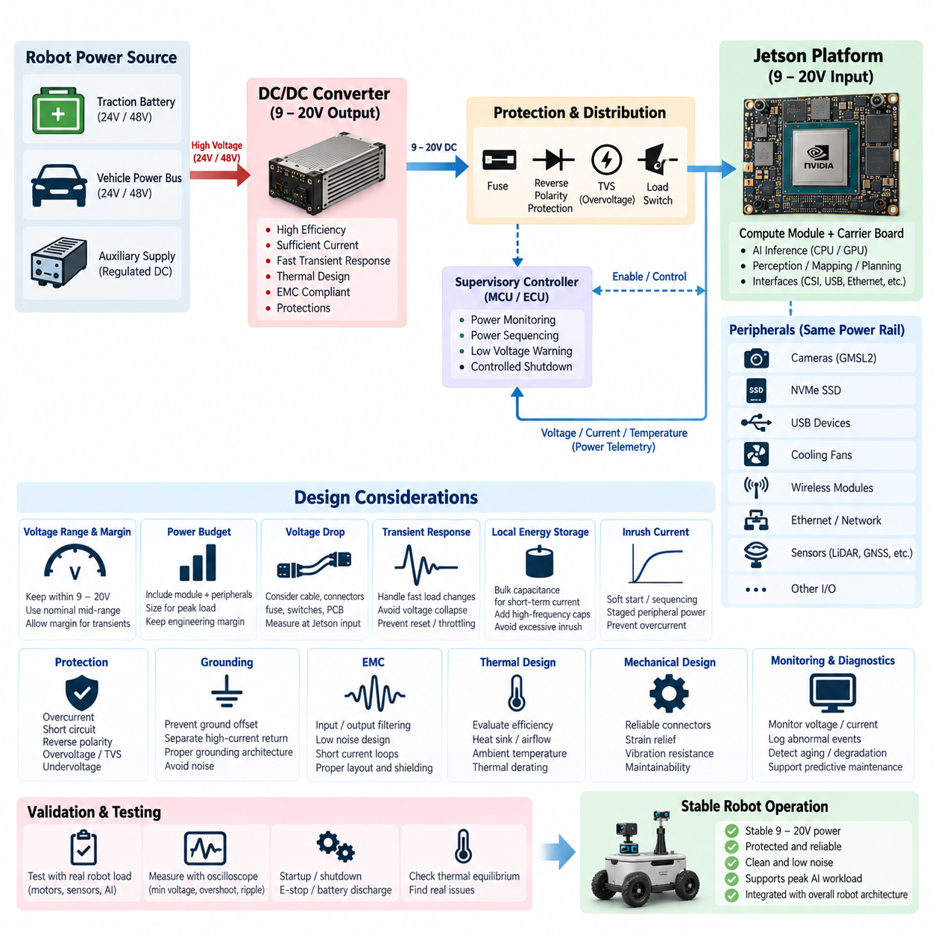
A 9–20 V power supply for a Jetson-based robotic computing platform must be designed as a complete power-delivery system rather than as a simple voltage connection. The input source may originate from a battery, DC/DC converter, vehicle power bus, or regulated auxiliary rail, and its behavior can change significantly during startup, charging, motor acceleration, regenerative events, or emergency shutdown. The design must therefore guarantee stable input voltage at the Jetson under both steady-state and transient operating conditions.
The first design objective is to maintain the Jetson input within its permitted operating range under every expected robot condition. A nominal supply voltage does not guarantee that the voltage measured at the computing module remains identical. Cable resistance, connectors, fuses, switches, protection devices, PCB traces, and converter impedance introduce voltage drop. These losses become particularly important when CPU and GPU workloads change rapidly and the platform draws short-duration peak current.
Input-voltage selection should include sufficient margin from both the lower and upper operating boundaries. Operating continuously near the minimum input voltage increases sensitivity to cable drop, battery discharge, connector aging, and transient current demand. Operating close to the upper boundary similarly reduces tolerance to converter overshoot or supply disturbances. A well-designed system therefore establishes a controlled nominal voltage near the center of the usable range and reserves margin for dynamic conditions.
In mobile robots, the Jetson supply is commonly derived from a higher-voltage traction battery through a dedicated DC/DC converter. A 24 V or 48 V robot power architecture should not feed the computing module directly unless the voltage is explicitly compatible with the selected hardware configuration. The converter must regulate the battery-domain voltage into the required Jetson input range while providing isolation from major disturbances generated by motors, actuators, relays, pumps, and other high-current loads.
DC/DC converter selection must be based on more than its nominal output voltage. Continuous output current, peak current capability, conversion efficiency, switching frequency, thermal derating, transient response, protection functions, and electromagnetic compatibility must all be evaluated. The converter should sustain the maximum realistic Jetson workload together with connected peripherals while maintaining adequate engineering margin rather than being sized exactly to the average measured consumption.
Peak power demand deserves particular attention because modern AI processors exhibit highly dynamic loading. GPU inference, camera processing, CUDA kernels, neural-network initialization, storage activity, and CPU bursts can cause current to change much faster than a battery-level power estimate suggests. If the DC/DC converter or distribution path responds too slowly, the local input voltage can collapse temporarily even though average power remains acceptable, potentially causing throttling, instability, or an unexpected system reset.
The power budget should include the complete Jetson subsystem rather than only the compute module. Carrier-board losses, NVMe SSDs, USB devices, GMSL2 camera interfaces, Ethernet adapters, cooling fans, wireless modules, and external I/O hardware may all draw energy from the same regulated rail. Their simultaneous startup or operation can increase both continuous and transient demand. The supply should therefore be sized from measured or conservatively estimated worst-case system consumption.
Voltage-drop analysis should be performed from the converter output to the actual Jetson power connector. Wire length, conductor cross-section, connector contact resistance, fuse resistance, switching elements, and PCB distribution paths should be included. Because voltage drop is proportional to current, a design that appears acceptable during idle operation may become unstable during intensive inference. Measuring voltage directly at the Jetson input during maximum computational loading provides a more meaningful validation than measuring only at the converter.
Local energy storage helps stabilize fast load transitions that the upstream converter cannot immediately follow. Appropriate bulk capacitance near the computing platform can supply short-duration current while the regulator responds, while smaller capacitors suppress higher-frequency disturbances. Capacitance should not be added without analysis, however, because excessive input capacitance can create large inrush current, stress connectors and switches, or interact with the DC/DC converter control loop.
Inrush-current management is especially important during system startup. Charging input capacitors, powering the carrier board, initializing storage, starting fans, and activating peripherals can produce a short but substantial current pulse. If several robot computers and sensors are enabled simultaneously, the combined inrush may exceed the converter or protection-device capability. Controlled power sequencing, soft-start behavior, staged peripheral activation, or dedicated load switches can reduce this startup stress.
Protection architecture should address overcurrent, short circuit, reverse polarity, overvoltage, undervoltage, and abnormal transient conditions. A fuse or electronic protection device should protect the wiring and downstream electronics without nuisance interruption during normal peak loads. Reverse-polarity protection is valuable for service and prototype environments, while overvoltage suppression can prevent upstream converter failures or electrical transients from propagating directly into the expensive computing subsystem.
Undervoltage behavior requires deliberate engineering because a slowly collapsing supply can produce unpredictable software and storage behavior. When battery voltage approaches its operational limit, the robot should detect the condition before the Jetson becomes unstable. A supervisory controller or MCU can initiate workload reduction, data synchronization, controlled application termination, and orderly shutdown. This approach is preferable to allowing the computer to reset repeatedly as the input crosses its minimum operating threshold.
Power sequencing should coordinate the Jetson with the robot’s MCU, ECU, sensors, network devices, and actuator controllers. The low-level controller may need to remain operational before and after the AI computer so that startup authorization, shutdown supervision, diagnostics, and safe-state management remain available. The Jetson should therefore not necessarily be connected to the same uncontrolled ignition line as every peripheral. A supervised enable architecture provides more predictable system behavior.
Grounding is equally important in the power-supply design. High-current motor return paths should be prevented from introducing excessive voltage differences into sensitive computing and sensor grounds. The distribution architecture should define where power returns are joined and how the Jetson, sensors, communication interfaces, chassis, and shielding reference one another. Poor grounding can appear as random USB failures, Ethernet instability, camera corruption, sensor noise, or intermittent computer resets rather than as an obvious power problem.
Electromagnetic compatibility must be considered when selecting and integrating the DC/DC converter. Switching converters generate conducted and radiated noise, while motors and inverters can inject additional disturbances onto the shared battery network. Input filtering, output filtering, appropriate grounding, short current loops, shield termination, PCB layout, and physical separation from sensitive communication paths help prevent power electronics from degrading cameras, LiDAR, GNSS, Ethernet, or other perception systems.
Thermal performance of the power converter must be evaluated under the same environmental conditions as the Jetson. Converter efficiency directly determines heat generation, and efficiency may vary with input voltage and load. A converter that operates comfortably on an open laboratory bench may overheat inside a sealed robot enclosure exposed to high ambient temperature. Thermal derating, airflow, heat-sink mounting, enclosure conduction, and nearby heat sources should therefore be incorporated into the power architecture.
The mechanical implementation of the power path also affects reliability. Connectors must tolerate vibration and repeated service operations, while cables require appropriate strain relief and routing away from sharp edges or high-temperature components. Power connectors should not loosen under vehicle vibration, and service technicians should be able to disconnect the computing subsystem without disturbing unrelated safety wiring. Electrical performance and maintainability should be treated as complementary requirements.
Monitoring voltage, current, temperature, and power status provides valuable diagnostic information for production robots. The MCU or supervisory controller can record abnormal voltage dips, converter overtemperature events, excessive current consumption, or repeated startup failures. These records help distinguish software crashes from electrical problems and support predictive maintenance. Power telemetry can also reveal gradual degradation caused by aging connectors, cooling deterioration, or newly introduced computational workloads.
Validation should reproduce realistic worst-case operating conditions rather than testing the Jetson independently on a laboratory supply. Motors should accelerate, actuators should switch, sensors should stream data, storage should record, and AI workloads should execute concurrently while input voltage and current are monitored. Startup, shutdown, battery discharge, emergency-stop transitions, communication activity, and thermal equilibrium should all be tested to expose disturbances that may not appear during isolated bench operation.
Oscilloscope measurements are particularly useful because a conventional multimeter can hide short-duration voltage dips and switching transients. Measurements should be taken at the converter input, converter output, and Jetson power connector under representative dynamic loads. Engineers should examine minimum voltage, overshoot, ripple, startup waveform, shutdown behavior, and transient recovery. This allows the actual electrical margin to be quantified rather than inferred from nominal component specifications.
Ultimately, the 9–20 V supply architecture should provide clean, stable, protected, and observable power throughout the robot mission. The preferred solution combines adequate converter capacity, low-resistance distribution, transient energy support, controlled sequencing, grounding, filtering, protection, thermal management, and diagnostics. Designing these elements together allows the Jetson platform to sustain intensive AI workloads without electrical instability while remaining integrated with the broader MCU, ECU, sensor, communication, and robot power architecture.

03.03. Thermal Dissipation Design
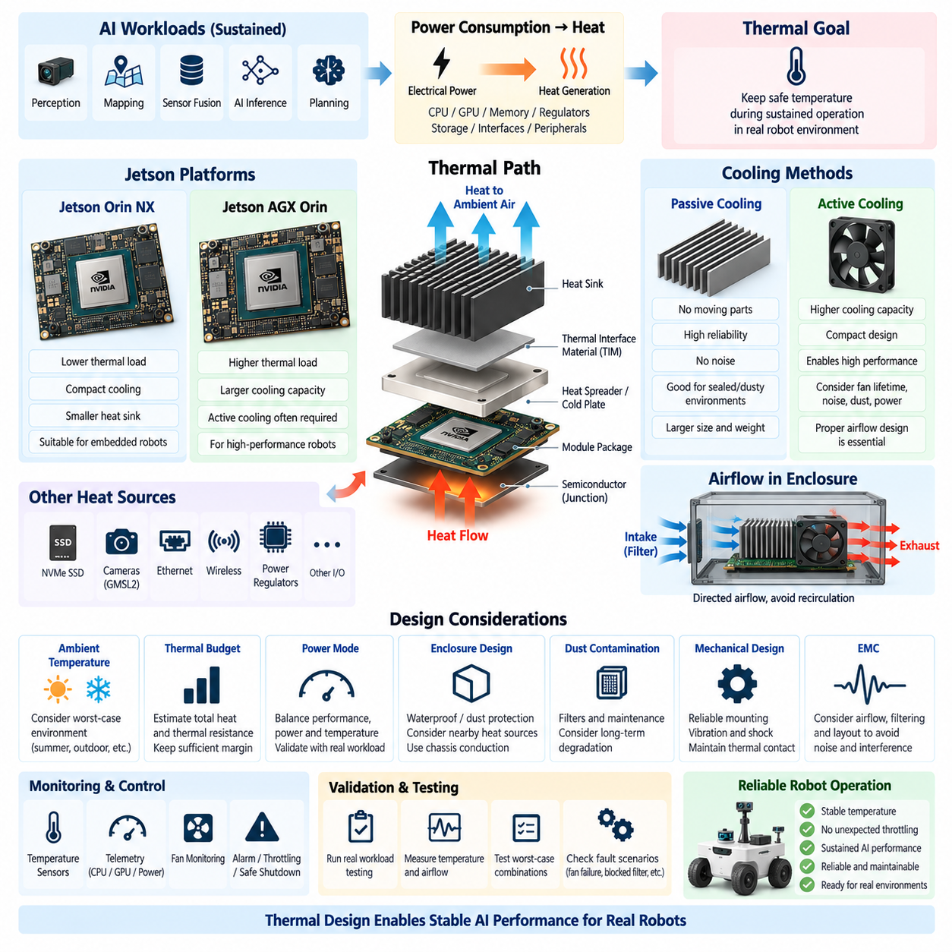
Thermal dissipation design for a Jetson-based robotic computing platform must begin with the recognition that electrical power consumed by the processor ultimately becomes heat that must be transferred to the surrounding environment. CPU, GPU, memory, power regulators, storage, and interface circuits may operate simultaneously under intensive AI workloads. The cooling architecture must therefore maintain acceptable component temperatures during sustained operation, not merely during short laboratory demonstrations.
The thermal requirement should be derived from realistic mission workloads rather than idle or average processor utilization. Perception, mapping, sensor fusion, neural-network inference, camera processing, and planning can create long periods of high CPU and GPU activity. When several functions execute concurrently, heat generation may remain near its upper operating level for extended periods. Thermal design must therefore consider sustained worst-case workloads together with realistic ambient temperature and enclosure conditions.
Jetson Orin NX and Jetson AGX Orin require different cooling approaches because their achievable performance, configurable power modes, module dimensions, and thermal loads differ. A compact Orin NX system can often use a relatively small heat sink and controlled airflow, while a higher-performance AGX Orin configuration may require substantially greater heat-transfer capacity. Cooling hardware should consequently be selected together with compute performance and power-mode configuration rather than after the computing platform has already been fixed.
The fundamental thermal path begins at the semiconductor junction and continues through the package, thermal interface material, heat spreader or cold plate, heat sink, enclosure, and surrounding air. Every interface contributes thermal resistance. Even a large heat sink cannot compensate effectively for poor contact between the module and cooling surface. Thermal engineering should therefore optimize the entire heat-flow path instead of focusing only on the visible fan or heat-sink assembly.
Thermal interface material, commonly referred to as TIM, is used to reduce microscopic air gaps between mating surfaces and improve heat conduction. Its thickness, thermal conductivity, compression, surface coverage, and long-term stability influence cooling performance. Excessively thick material can increase thermal resistance, while insufficient contact pressure can create local hot spots. Mechanical tolerances must therefore be coordinated with TIM selection so that consistent thermal contact is maintained throughout manufacturing and field operation.
Passive cooling removes heat without relying on powered airflow and can improve reliability by eliminating fan wear, noise, and moving parts. It is attractive for sealed robots, dusty environments, and systems requiring low maintenance. However, passive cooling depends strongly on heat-sink area, orientation, enclosure conduction, and natural convection. As AI workload and ambient temperature increase, the required heat sink can become too large or heavy, making active cooling more practical.
Active cooling uses fans or blowers to increase airflow across the heat sink and substantially reduce thermal resistance. This approach enables compact packaging and higher sustained processor performance, but introduces additional engineering concerns such as fan lifetime, dust accumulation, vibration, acoustic noise, power consumption, and failure detection. Fan selection should therefore consider airflow under actual system resistance rather than only the unrestricted airflow value listed in a component specification.
Airflow must be treated as a controlled path through the computing enclosure. Simply installing a powerful fan does not guarantee effective cooling if air recirculates around the heat sink or bypasses the hottest components. Intake and exhaust locations, duct geometry, cable obstruction, neighboring PCBs, filters, and enclosure vents determine the real flow pattern. Cooling air should be intentionally directed across the major heat-generating surfaces before leaving the enclosure.
Enclosure design has a major influence on thermal performance because mobile robots often package computing electronics inside compact protected spaces. Waterproofing and dust protection reduce uncontrolled airflow, while nearby batteries, DC/DC converters, motor drivers, and other electronics can increase internal temperature. The Jetson cooling system must therefore be evaluated as part of the complete enclosure rather than as an isolated module tested in open laboratory air.
Conduction through the enclosure can become an important cooling mechanism in sealed systems. A heat spreader, cold plate, thermal bridge, or chassis-mounted heat sink can transfer energy from the Jetson toward a larger metal structure. Aluminum chassis components can sometimes serve as part of the thermal path if electrical isolation, structural loading, corrosion, sealing, and serviceability are properly addressed. This approach can reduce dependence on internal recirculating airflow.
Ambient temperature defines the available thermal margin between the processor and the environment. A cooling system that maintains acceptable temperatures at room temperature may fail when the robot operates outdoors in summer, inside a warehouse without climate control, or near heat-producing machinery. Solar loading can further increase enclosure temperature. Validation should therefore include the highest credible environmental temperature rather than relying on typical indoor laboratory conditions.
Temperature sensors and platform telemetry should be used to observe the thermal state of the computing system continuously. Jetson software can report relevant temperatures, clock behavior, utilization, and power information, while additional sensors may monitor enclosure air, heat-sink surfaces, DC/DC converters, or nearby components. Combining these measurements provides a more complete thermal picture and helps determine whether rising processor temperature originates from workload, airflow degradation, or elevated ambient conditions.
Thermal throttling protects the processor by reducing operating frequency or performance when temperature approaches defined limits. Although this mechanism prevents immediate hardware damage, it should not be treated as the primary cooling strategy. In an autonomous robot, throttling can increase inference latency, reduce perception throughput, or disturb planning timing during precisely the conditions when high performance is required. A robust design should maintain the required workload without sustained thermal throttling.
The relationship between power mode and cooling capacity should be explicitly engineered. Reducing the configured processor power can decrease heat generation and enable smaller cooling hardware, while higher power modes can increase AI throughput at the cost of greater thermal demand. Product variants can therefore use software-configurable power limits to balance performance, energy consumption, and temperature. The selected mode should be validated using actual mission software rather than theoretical processor capability alone.
Storage and peripheral devices must also be included in the thermal model. NVMe SSDs can generate significant heat during continuous logging or dataset recording, while camera interface boards, Ethernet devices, wireless modules, and power regulators add localized thermal loads. If these components share the same enclosure and airflow path, their heat contributes to Jetson inlet temperature. Cooling design should therefore consider the complete compute subsystem rather than only the processor module.
Dust contamination gradually changes cooling performance in field robots. Filters, heat-sink fins, fan blades, and ventilation openings can accumulate particles and increase airflow resistance over time. A cooling system that barely satisfies temperature limits when new may fail after months of operation. Design margin, accessible filters, maintenance intervals, fan monitoring, and contamination testing should therefore be incorporated when robots are expected to operate in warehouses, factories, construction sites, or outdoor environments.
Mechanical vibration and shock also affect thermal hardware. Heavy heat sinks require secure mounting, while fans and thermal interfaces must maintain contact under repeated vibration. Large unsupported cooling structures can apply undesirable mechanical loads to the module or carrier board. Mounting points, fasteners, spring pressure, retention mechanisms, and mass distribution should be designed so that the thermal solution remains mechanically stable throughout the robot’s operating life.
A thermal budget provides a useful engineering framework for connecting power dissipation with allowable temperature rise. Heat generated by the Jetson and neighboring devices must pass through a sequence of thermal resistances before reaching ambient air. Estimating these resistances allows designers to determine whether a proposed heat sink, airflow rate, or chassis conduction path can provide sufficient margin. Measurements can then refine the model during prototype development.
Computational fluid dynamics and thermal simulation can support enclosure development when airflow paths are complex. Simulation can identify recirculation zones, insufficient vent areas, hot components, and ineffective fan placement before hardware revisions become expensive. However, simulation results depend strongly on boundary conditions, material properties, heat-source assumptions, and airflow models. Physical measurements remain necessary because cables, assembly tolerances, filters, and real fan behavior can differ from idealized models.
Prototype validation should operate the Jetson with representative AI workloads while all major robot electronics are active. CPU and GPU utilization, processor temperature, memory temperature where available, SSD temperature, fan speed, input power, clock frequency, and ambient temperature should be recorded over time. Testing should continue until temperatures reach thermal equilibrium, because short tests may appear successful even though internal temperature continues rising slowly.
Worst-case thermal testing should combine demanding conditions rather than evaluating them independently. High ambient temperature, maximum AI workload, simultaneous sensor streaming, continuous storage activity, restricted airflow, and neighboring power-electronics operation may occur together. Testing combinations of these factors exposes thermal coupling that individual component tests can miss. Appropriate engineering margin should remain after the worst credible condition has reached steady state.
Fault scenarios should also be evaluated. Fan slowdown or failure, blocked ventilation, partially clogged filters, abnormal processor loading, elevated enclosure temperature, and sensor failure can degrade cooling unexpectedly. The system should detect important thermal abnormalities and respond predictably through alarms, workload reduction, controlled performance limiting, or safe shutdown. Supervisory MCU or ECU logic can complement Jetson thermal management by coordinating robot-level responses to persistent overheating.
Thermal diagnostics are valuable for fleet operation because temperature trends can reveal degradation before a failure occurs. Increasing temperature under an unchanged workload may indicate dust accumulation, fan deterioration, degraded thermal contact, or higher enclosure temperature. Recording temperature, fan speed, processor utilization, and power telemetry allows maintenance systems to distinguish temporary workload effects from progressive cooling problems and supports condition-based maintenance across deployed robots.
Ultimately, Jetson thermal dissipation design must connect compute performance, electrical power, mechanical packaging, environmental protection, and software operation into one engineering architecture. The objective is not simply to keep the processor below an absolute temperature limit, but to preserve predictable AI performance throughout sustained robot missions. A successful design provides a low-resistance heat path, controlled airflow or conduction, adequate environmental margin, reliable monitoring, and validated operation without unacceptable throttling.
Within the broader compute and AI architecture, thermal design also influences platform selection, power-supply sizing, enclosure design, sensor integration, reliability, and product scalability. Orin NX may be preferred where compact and energy-efficient thermal solutions dominate, while AGX Orin can support higher computational capability when sufficient cooling capacity is available. The final thermal architecture should therefore be established together with the Jetson performance target, power budget, and complete robot operating environment.

03.04. GMSL2 Camera Integration
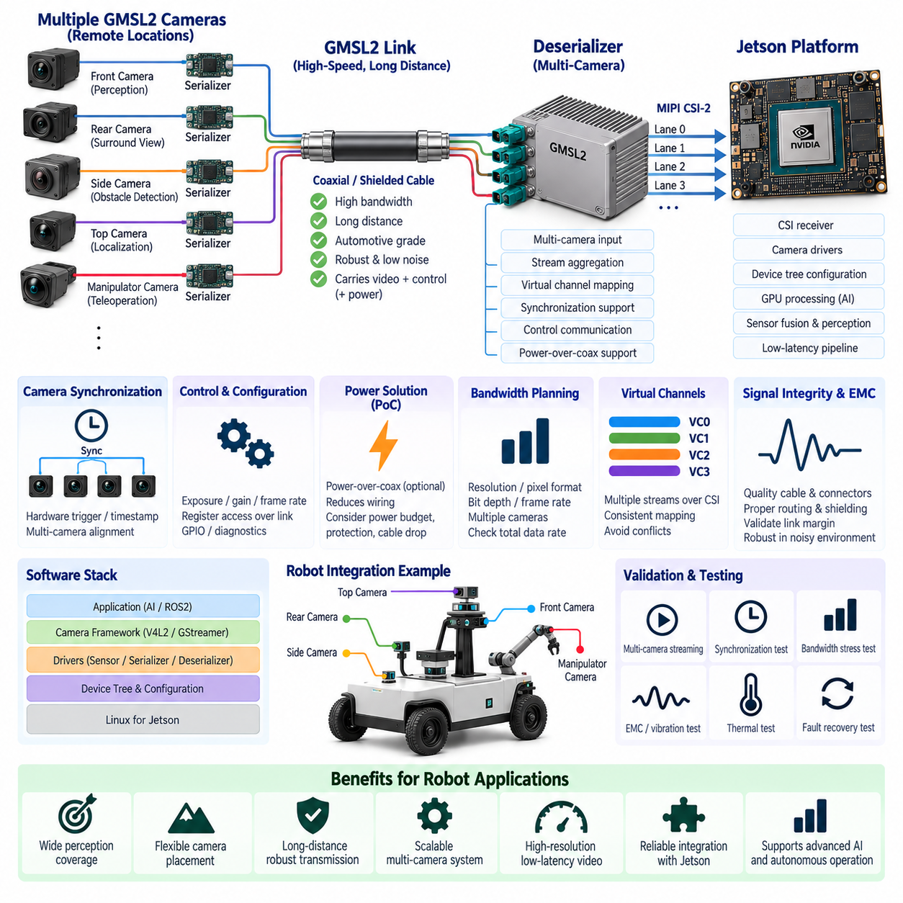
GMSL2 camera integration provides a high-bandwidth and robust video transport architecture for Jetson-based robotic computing systems. GMSL2, or Gigabit Multimedia Serial Link 2, allows high-resolution camera data to be transmitted over automotive-grade coaxial or shielded twisted-pair cabling across distances that are difficult for conventional embedded camera interfaces. This makes it particularly suitable for AMRs, autonomous vehicles, inspection robots, and sensor-rich Physical AI platforms.
A typical GMSL2 camera architecture consists of an image sensor, serializer, transmission cable, deserializer, and Jetson camera interface. The serializer converts the camera’s native video and control signals into a high-speed serial stream, while the deserializer reconstructs those signals near the computing platform. The recovered image data is then transferred toward the Jetson through interfaces such as MIPI CSI-2, creating a bridge between remotely mounted cameras and the embedded AI processor.
The principal advantage of this architecture is that cameras can be physically separated from the Jetson while maintaining high data rates and deterministic connectivity. Cameras may be installed at the front, rear, sides, roof, manipulator, or other remote locations of the robot without positioning the main computer nearby. This separation improves sensor placement flexibility and allows the compute enclosure to remain protected while cameras are positioned according to perception coverage rather than cable-length limitations.
GMSL2 is particularly valuable for multi-camera perception because several camera streams can be aggregated through one or more deserializers before entering the Jetson. A robot may use cameras for forward perception, surround view, obstacle detection, semantic understanding, teleoperation, or visual localization simultaneously. The integration architecture must therefore consider the total pixel rate, resolution, frame rate, number of cameras, CSI lane allocation, and processing workload rather than evaluating each camera independently.
Camera bandwidth should be calculated from the actual sensor configuration. Resolution, pixel format, bit depth, frame rate, metadata, synchronization information, and protocol overhead all contribute to the required transport capacity. A camera configured for high-resolution raw output can consume significantly more bandwidth than a compressed or lower-bit-depth stream. The complete design must ensure that the serializer, GMSL2 link, deserializer, CSI interface, Jetson capture subsystem, and memory path can all sustain the combined data rate.
The serializer is normally located close to the image sensor and forms the remote camera-side interface. It receives sensor video data and may also transport control, synchronization, GPIO, and other auxiliary signals over the same physical link. This reduces the amount of separate wiring required between the camera and compute unit. Serializer configuration must match the sensor output format, lane structure, clocking, link mode, and control architecture used by the selected camera module.
The deserializer is located near the Jetson and performs the reverse conversion while often supporting multiple incoming camera links. It may aggregate several video streams and map them onto one or more CSI-2 outputs. Deserializer selection therefore affects the maximum camera count, supported resolutions, virtual channels, synchronization capability, and CSI connectivity. The carrier-board architecture must provide sufficient physical interfaces and lane routing to connect these outputs correctly to the Jetson platform.
MIPI CSI-2 integration requires careful lane and bandwidth planning. The number of available CSI lanes is finite, and multiple cameras may need to share physical interfaces through virtual channels or deserializer aggregation. Lane speed, lane count, stream mapping, and Jetson camera-port configuration must be coordinated. A design can fail even when individual GMSL2 links have sufficient bandwidth if the downstream CSI interface becomes the bottleneck for the combined camera traffic.
Virtual channel handling enables multiple image streams to share a CSI connection while remaining logically distinguishable. Each stream must be mapped consistently through the serializer, deserializer, CSI receiver, device tree, driver, and application software. Incorrect virtual-channel configuration can result in missing frames, stream collisions, or cameras appearing on unintended interfaces. The logical camera topology should therefore be defined together with the physical wiring architecture.
Camera synchronization is essential when images from several viewpoints are combined for stereo processing, surround perception, depth estimation, sensor fusion, or machine-learning inference. Free-running cameras can capture the same scene at different moments, producing spatial inconsistencies when the robot or surrounding objects are moving. GMSL2 systems can support synchronization signals that coordinate exposure timing across multiple cameras, but the complete timing architecture must include sensors, serializers, deserializers, and Jetson timestamp handling.
Hardware synchronization should be distinguished from software timestamp alignment. Hardware triggering can align camera exposure events closely, while timestamps describe when captured data enters or progresses through the computing system. For advanced sensor fusion, camera timing may also need to be related to LiDAR, IMU, GNSS, or other sensors. The camera architecture should therefore connect with the robot’s broader time-synchronization strategy rather than treating synchronization as an isolated camera feature.
Control communication is another important function of the GMSL2 link. Camera sensors frequently require register configuration for exposure, gain, frame rate, operating mode, and diagnostic functions. Serializer and deserializer devices can provide tunneled control paths that allow the Jetson or an associated controller to communicate with remote camera electronics. Address mapping and initialization order must be carefully managed when several identical camera modules are connected to the same system.
Power-over-coax or related remote-power architectures can reduce harness complexity by carrying camera power and high-speed data through the same cable assembly. This is attractive for mobile robots because fewer wires and connectors simplify routing, reduce weight, and improve serviceability. However, the power architecture must account for camera current, cable voltage drop, filtering, protection, startup behavior, and fault isolation so that a remote camera failure does not destabilize the Jetson or other perception sensors.
Cable and connector selection is critical because the GMSL2 physical layer operates at high data rates in an electrically noisy robotic environment. Cable impedance, insertion loss, shielding, connector quality, routing length, bend radius, and termination affect signal integrity. Harnesses may also run near motors, inverters, DC/DC converters, or high-current battery wiring. Automotive-grade coaxial or shielded solutions are therefore commonly preferred when vibration, EMC, and long-term reliability are important.
Signal integrity should be validated across the complete communication path rather than assumed from individual component ratings. Serializer output, cable attenuation, connectors, deserializer equalization, PCB traces, and CSI routing all contribute to link margin. Poor signal quality may appear as intermittent frame loss, corrupted images, link retraining, or failures that occur only at elevated temperature or under electromagnetic disturbance. Production validation should include representative cable lengths and connector combinations.
Carrier-board PCB design becomes especially important between the deserializer and Jetson. High-speed CSI signals require controlled impedance, appropriate differential-pair routing, length management, reference-plane continuity, and careful connector placement. Power and switching circuits should be separated from sensitive high-speed signal paths where practical. The carrier board must also provide clean supplies and suitable reset, interrupt, synchronization, and control connections for the GMSL2 devices.
Software integration extends from low-level hardware configuration to the perception application. Jetson camera support generally requires correct device-tree descriptions, sensor drivers, serializer and deserializer configuration, CSI receiver settings, and capture frameworks. The software must recognize the physical camera topology and initialize components in the correct sequence. Hardware that produces a valid electrical link can still fail to deliver usable images if the software representation does not match the actual architecture.
Driver development should account for camera mode selection, exposure control, gain, synchronization, link status, error recovery, and stream restart behavior. In a production robot, cameras cannot be assumed to remain permanently healthy after startup. Connectors may experience disturbance, sensors may reset, or links may temporarily lose synchronization. The software architecture should detect abnormal conditions and attempt controlled recovery without requiring the entire Jetson computing platform to reboot.
The captured camera stream must then be integrated efficiently with the Jetson AI pipeline. Unnecessary copying between camera buffers, CPU memory, GPU memory, and inference frameworks can increase latency and memory bandwidth consumption. Hardware-accelerated and zero-copy or low-copy pipelines are therefore desirable when supported. Efficient transport from CSI capture through preprocessing and GPU inference becomes increasingly important as camera count, resolution, and frame rate increase.
Latency must be analyzed from image exposure to usable AI output rather than only from cable transmission time. Exposure duration, serializer transport, deserialization, CSI reception, buffering, image processing, GPU scheduling, neural inference, and middleware communication all contribute to end-to-end latency. Autonomous robots require predictable timing because delayed perception directly affects localization, obstacle avoidance, and planning. Both average latency and worst-case variation should therefore be measured.
Thermal and power considerations remain relevant even though cameras are distributed around the robot. Serializers inside compact camera housings generate heat, while deserializers handling several high-bandwidth streams can become significant thermal sources on the carrier board. Remote camera power and deserializer consumption must be included in the system power budget. Thermal design should ensure reliable link operation under sustained multi-camera streaming and the highest expected ambient temperature.
Diagnostics are essential for maintaining a multi-camera robotic system. The platform should monitor camera availability, frame counters, link lock, synchronization status, communication errors, temperature where available, and repeated recovery events. These diagnostics can be reported to the robot MCU, ECU, or fleet-management system. A camera that intermittently loses frames may otherwise appear as an AI perception problem when the actual cause is a cable, connector, power, synchronization, or physical-link issue.
Validation should combine bandwidth, synchronization, EMC, thermal, vibration, and software testing. All cameras should stream simultaneously at their target resolution and frame rate while representative AI workloads execute on the Jetson. Testing should include long-duration operation, startup and shutdown, cable movement, temperature variation, electrical disturbances, and recovery from disconnected or failed cameras. This exposes integration problems that cannot be identified through single-camera bench testing.
Ultimately, GMSL2 integration should be treated as a complete perception data architecture connecting remote image sensors to Jetson AI processing. Successful implementation requires coordinated selection of sensors, serializers, cables, connectors, deserializers, CSI resources, carrier-board routing, synchronization, power, drivers, and GPU data pipelines. When these elements are engineered together, GMSL2 provides a scalable foundation for reliable high-resolution multi-camera perception in advanced AMRs, autonomous robots, and Physical AI systems.

03.05. Jetson IO Expansion
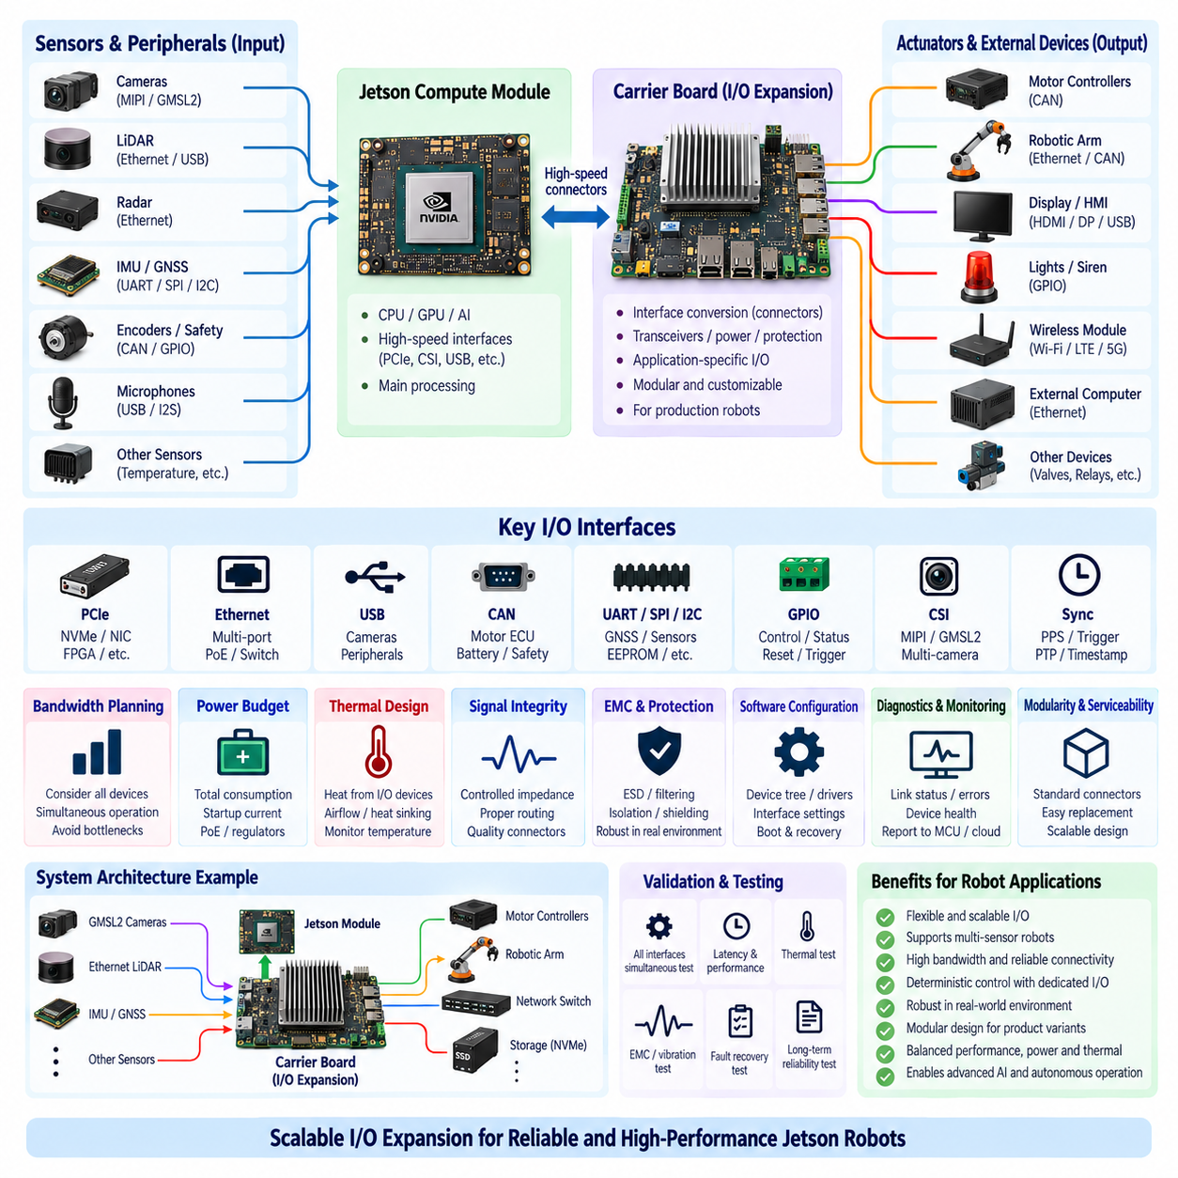
Jetson I/O expansion is the engineering process of extending an embedded AI computer beyond the interfaces available directly from the compute module or reference carrier board. A production robot may need multiple cameras, LiDARs, Ethernet networks, CAN buses, USB devices, NVMe storage, serial interfaces, GPIO, synchronization signals, and wireless communication simultaneously. The expansion architecture must therefore be designed around the complete robot interface requirement rather than the number of connectors visible on a development kit.
The Jetson compute module and carrier board should be treated as two distinct architectural layers. The module provides processing resources and high-speed interfaces, while the carrier board converts those resources into application-specific connectors, transceivers, power domains, protection circuits, and peripheral interfaces. This separation enables one Jetson platform to support different AMRs, manipulators, inspection robots, and autonomous vehicles through carrier boards optimized for each product.
I/O planning should begin with an interface inventory describing every external device connected to the computing platform. Each device should be classified by interface type, required bandwidth, data direction, update rate, latency sensitivity, power demand, synchronization requirement, and safety relevance. Cameras and LiDARs may dominate high-speed bandwidth, while CAN, UART, GPIO, and synchronization signals consume relatively little bandwidth but can be essential for deterministic robot operation and system supervision.
PCI Express provides one of the most important expansion paths for high-performance Jetson systems. PCIe can connect NVMe storage, Ethernet controllers, frame grabbers, communication adapters, FPGA accelerators, and other high-bandwidth peripherals. Expansion planning must consider available PCIe controllers, lane count, lane width, generation, topology, and bandwidth sharing. Installing several high-speed devices does not guarantee full simultaneous performance if they ultimately compete for the same upstream PCIe resources.
PCIe switches can increase the number of devices connected to a limited set of root-complex lanes. They are useful when a robot requires several NVMe drives, network interfaces, or specialized accelerators, but they do not create additional upstream bandwidth. Traffic from downstream devices still shares the available Jetson connection. Switch latency, power consumption, thermal load, initialization behavior, and software compatibility must therefore be evaluated together with the apparent increase in physical connectivity.
Ethernet expansion is central to modern robotics because LiDARs, industrial cameras, radar interfaces, gateways, and distributed computers frequently use Ethernet. A carrier board may integrate multiple Ethernet controllers or connect an external managed switch to provide additional ports. Designers should distinguish physical port count from total network capacity and consider link speed, packet rate, multicast traffic, Quality of Service, synchronization traffic, and simultaneous sensor streams when determining the required architecture.
Power over Ethernet can simplify integration of compatible sensors by combining communication and power on one cable. However, PoE expansion introduces additional power conversion, heat generation, isolation, protection, and power-budget requirements. The Jetson power architecture should not be expected to supply an arbitrary number of PoE devices without system-level analysis. Sensor startup current, cable losses, switch capacity, and fault isolation must be included when Ethernet becomes both a data and power distribution network.
USB remains useful for depth cameras, development sensors, wireless adapters, diagnostic equipment, and general peripherals. Nevertheless, several physical USB connectors may share the same host controller or upstream bandwidth. High-resolution cameras connected through a common hub can therefore compete for throughput even when each individual device operates correctly. USB topology, controller allocation, hub architecture, cable length, power delivery, and recovery from device disconnection should be validated under simultaneous operation.
CAN and CAN FD interfaces provide robust communication between Jetson and distributed robot controllers such as motor ECUs, battery systems, steering controllers, safety supervisors, and sensor modules. The carrier board may require dedicated CAN transceivers even when controller functionality exists within the computing platform. Proper termination, common-mode behavior, isolation requirements, ESD protection, connector design, and bus topology are essential because the logical interface alone does not provide a production-ready physical network.
UART, SPI, and I2C remain valuable for local peripherals and board-level devices. UART can support GNSS receivers, diagnostic interfaces, or auxiliary controllers, while SPI and I2C are commonly used for sensors, monitoring devices, EEPROMs, and configuration components. These interfaces should not automatically be extended over long robot harnesses because their electrical characteristics are primarily suited to short connections. Remote devices may require differential transceivers or more robust industrial communication methods.
GPIO expansion supports enable signals, interrupts, reset lines, status inputs, power control, and simple digital interfaces. When the number of native GPIO pins is insufficient, I/O expanders, microcontrollers, or FPGA-based interfaces can provide additional channels. However, software-controlled GPIO from a Linux AI computer should not automatically be used for functions requiring strict real-time or safety behavior. Critical control should remain assigned to appropriate MCU, ECU, or safety-controller domains.
Camera expansion requires more than adding physical connectors. Multiple MIPI CSI-2 or GMSL2 cameras consume CSI lanes, virtual channels, memory bandwidth, synchronization resources, and GPU processing capacity. A deserializer can aggregate several remote GMSL2 cameras, but the resulting streams must still enter the Jetson through available capture resources. Camera expansion should therefore be planned jointly with resolution, frame rate, pixel format, synchronization, AI inference load, and end-to-end bandwidth.
Storage expansion is important when robots record high-resolution sensor data, maps, diagnostic logs, or AI datasets. NVMe SSDs connected through PCIe provide high throughput, but multiple drives increase lane consumption, peak power, and thermal load. Continuous recording can also expose SSD endurance limitations. Storage architecture should distinguish operating-system storage, application storage, logging, temporary AI data, and removable or service storage so that a failure or full data partition does not destabilize the robot.
Expansion through external microcontrollers or FPGAs can provide deterministic preprocessing and interface aggregation before data reaches the Jetson. An MCU can manage power sequencing, watchdogs, low-speed sensors, and real-time I/O, while an FPGA can aggregate specialized high-speed streams or implement precise timing functions. This heterogeneous approach prevents the Jetson from becoming responsible for every electrical interface and allows Linux-based AI processing to remain separated from deterministic hardware-management functions.
Time synchronization signals should be considered part of the I/O architecture rather than an optional diagnostic feature. Multi-camera perception, LiDAR-camera fusion, GNSS/IMU integration, and distributed computing can require PPS, trigger signals, PTP, or hardware timestamps. Expansion boards must preserve timing integrity when signals pass through connectors, level translators, switches, or interface devices. Additional connectivity is of limited value if sensor data cannot be aligned accurately in time.
Bandwidth budgeting should model simultaneous operation rather than adding interfaces independently. Camera capture, Ethernet LiDAR traffic, NVMe recording, USB devices, and AI processing can all generate memory and interconnect traffic concurrently. Bottlenecks may occur in PCIe, USB host controllers, Ethernet uplinks, CSI receivers, system memory, or software queues. The expansion architecture should therefore map every major data path from sensor input to memory, GPU processing, storage, or network output.
Power budgeting becomes increasingly important as I/O capability grows. Ethernet PHYs, PCIe switches, NVMe SSDs, GMSL2 deserializers, USB peripherals, transceivers, and cooling devices all add consumption beyond the Jetson module itself. Some peripherals also produce substantial startup current. Carrier-board regulators and upstream DC/DC converters must be sized for continuous and transient loads while maintaining voltage margin and avoiding one peripheral fault from collapsing the complete compute subsystem.
Thermal design must include all expansion components because high-speed I/O devices can become significant heat sources. PCIe switches, multi-port Ethernet controllers, NVMe SSDs, camera deserializers, and voltage regulators may operate continuously near the Jetson. Their heat raises local board and enclosure temperature and can reduce processor thermal margin. Component placement, airflow, heat spreading, and temperature monitoring should therefore be developed together with the electrical expansion topology.
Signal integrity becomes more difficult as interface count and speed increase. PCIe, USB, CSI, and high-speed Ethernet require controlled-impedance routing, suitable reference planes, differential-pair management, connector selection, and careful PCB stack-up design. Long traces, excessive vias, poor return paths, or noisy power circuits can reduce link margin. Expansion connectors and cables must also preserve the electrical characteristics required by each interface under vibration and temperature variation.
EMC and protection requirements apply to every interface that leaves the computing enclosure. External connectors can introduce electrostatic discharge, electrical fast transients, conducted noise, ground differences, and electromagnetic interference into the carrier board. Appropriate ESD protection, common-mode filtering, shielding, grounding, isolation, and connector placement should be applied according to interface requirements. Protection components must be selected without degrading high-speed signal quality.
Linux software configuration must accurately represent the expanded hardware topology. Device-tree settings, kernel drivers, PCIe enumeration, network interfaces, CAN configuration, USB device rules, camera drivers, GPIO mapping, and startup services must correspond to the physical carrier board. Expansion hardware that functions during manual laboratory configuration can still fail during automated boot if initialization dependencies, device naming, or driver loading order are not controlled.
Diagnostics should expose the health of the expanded I/O system to higher-level robot software. Useful information includes link state, packet errors, CAN bus status, USB disconnect events, storage health, camera availability, peripheral temperature, and power faults. A supervisory MCU or system-management service can combine these signals into a compute-health model. This makes it easier to distinguish AI software failures from physical interface, cable, power, or peripheral problems.
Modularity and serviceability should influence connector and expansion-board design. Frequently replaced sensors should not require removal of the main Jetson module, and optional product features should preferably connect through standardized expansion interfaces. Clearly defined power, data, mechanical, and software contracts allow camera, communication, or storage modules to evolve independently. Such modularity also supports reuse of a common Jetson architecture across several robot families.
Validation must operate all important interfaces concurrently under representative robot conditions. Multiple cameras should stream while LiDAR traffic arrives over Ethernet, NVMe devices record data, CAN networks communicate, and AI inference runs on the GPU. Power, temperature, bandwidth, latency, packet loss, storage throughput, and interface errors should be monitored. Vibration, cable disturbance, startup sequencing, peripheral removal, and fault recovery should also be included in production-oriented testing.
Ultimately, Jetson I/O expansion is not the process of maximizing connector count but of constructing a balanced data, control, power, and timing architecture around the AI computer. PCIe, Ethernet, USB, CAN, CSI, serial interfaces, GPIO, storage, synchronization, and external controllers must share finite compute and electrical resources. A successful design provides sufficient bandwidth and scalability while preserving signal integrity, deterministic control separation, thermal margin, diagnostics, and reliable robot operation.

