Volume 16 Compute and AI Architecture

Chapter 07. Fleet AI

07.01. Central AI/Distributed Execution
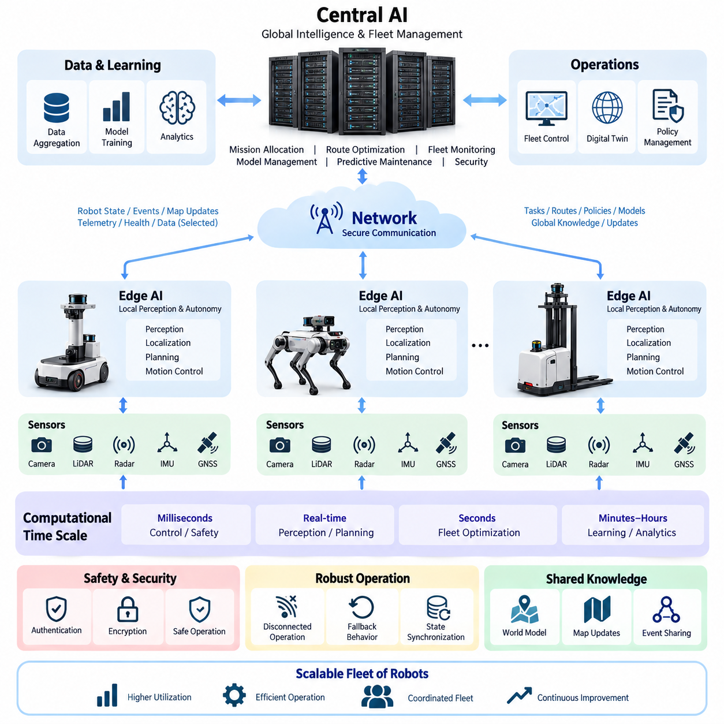
Fleet AI becomes necessary when autonomous robots are no longer treated as isolated machines but as members of a coordinated operational system. A single robot may execute perception, localization, planning, and motion control locally, while a fleet-level intelligence layer observes the collective state of many robots. Central AI therefore focuses on coordination, optimization, policy management, and shared intelligence rather than replacing onboard autonomy.
Central AI with distributed execution separates fleet-wide reasoning from time-critical physical control. Computationally expensive analysis can be performed by an on-premise GPU server or central computing cluster, while each robot retains sufficient edge computing capability to operate independently. This separation prevents network latency or temporary communication loss from directly interrupting essential navigation, obstacle avoidance, braking, actuator control, or other safety-critical functions.
The central layer maintains a global representation of fleet conditions. It can combine robot position, mission state, battery level, payload condition, traffic information, charging availability, diagnostic status, and environmental observations into a common operational view. Because the central system observes conditions that are invisible to an individual robot, it can make decisions based on the overall efficiency and stability of the fleet rather than optimizing only one robot at a time.
Distributed execution places immediate perception and control close to the physical system. Cameras, LiDAR, radar, IMU, GNSS, and other sensors generate data that must often be interpreted within milliseconds. Transmitting every raw sensor stream to a remote server would create unnecessary bandwidth demand and unpredictable latency. Edge AI therefore processes high-rate sensor information locally and communicates selected states, events, features, or compressed observations to the central intelligence layer.
The architecture naturally produces several computational time scales. Motor control and emergency responses operate at the shortest intervals, local perception and trajectory generation operate at real-time robotic frequencies, and fleet optimization may operate over longer intervals. Model distribution, analytics, learning, and operational planning can occur even more slowly. Separating these time scales allows each computational task to be assigned to hardware and communication resources appropriate to its timing requirements.
A fundamental design principle is that central intelligence should provide objectives and constraints rather than continuous low-level actuator commands. The central system may assign a destination, mission priority, operating zone, traffic constraint, charging request, or behavioral policy. The robot then converts these higher-level instructions into locally executable trajectories and control actions. This preserves responsive physical behavior while still allowing coordinated fleet-wide operation.
Mission allocation is one of the strongest reasons for centralized intelligence. When multiple robots are available, the fleet controller can determine which platform should perform a task by considering distance, battery state, payload capability, sensor configuration, maintenance condition, workload, and mission priority. The resulting assignment can improve utilization because decisions are based on the state of the complete fleet instead of the limited knowledge available to individual robots.
Traffic coordination extends this concept from task assignment to shared-space management. Robots operating in corridors, intersections, elevators, loading areas, charging stations, gates, or narrow outdoor passages may compete for limited resources. Central AI can predict conflicts and coordinate priorities before physical congestion develops. Local robots nevertheless retain responsibility for immediate collision avoidance because unexpected people, vehicles, or obstacles cannot safely depend on remote decision latency.
Central AI can also provide global route optimization while local planners handle detailed motion. The fleet layer may select preferred corridors, reserve shared resources, distribute traffic, or redirect robots around congestion. The onboard planner then interprets the assigned route using current sensor observations and local maps. This hierarchical relationship combines the strategic advantage of global information with the responsiveness of local perception and planning.
Communication between central AI and distributed robots should therefore carry semantic information whenever practical rather than unrestricted raw data. Typical exchanges include robot pose, health state, task progress, detected events, map changes, resource requests, trajectory intentions, and policy updates. High-bandwidth sensor data may still be transferred for selected diagnostics, recording, retraining, or difficult cases, but continuous raw-data transmission should not be assumed as the normal operational mode.
A well-designed fleet architecture must explicitly tolerate communication degradation. Wireless networks can experience delay, packet loss, handover, interference, congestion, or complete temporary disconnection. The robot should therefore maintain a defined autonomous operating envelope when the central connection disappears. Depending on mission risk, it may continue the current task, move to a safe location, reduce speed, wait for reconnection, or execute a predefined fallback behavior rather than immediately becoming uncontrollable.
State synchronization becomes important when intelligence is divided across central and edge systems. The central server needs sufficiently recent information to reason about fleet conditions, while each robot must understand whether received commands are current and valid. Timestamps, sequence identifiers, version information, acknowledgments, and expiration rules can prevent stale instructions from being executed. Consistent time synchronization further improves event reconstruction, diagnostics, and multi-robot coordination.
The central layer can maintain a fleet-level world representation constructed from observations contributed by many robots. One robot may detect an obstruction, environmental change, restricted area, degraded road condition, or temporary traffic pattern that is relevant to other robots. After validation, the information can be incorporated into shared operational knowledge. Fleet intelligence consequently transforms individual observations into reusable knowledge that benefits robots that have never directly observed the original event.
This shared knowledge does not imply that every robot must maintain an identical internal world model. Different platforms may have different sensors, compute resources, mobility capabilities, or mission roles. Central AI can preserve a common semantic representation while distributing only the information required by each platform. A lightweight indoor AMR and a high-performance outdoor inspection robot can therefore participate in the same fleet architecture without requiring identical onboard hardware.
Hardware partitioning follows the same principle. MCU and ECU layers handle deterministic interfaces and low-level control, Jetson-class or industrial edge computers execute perception and autonomous functions, and centralized GPU servers provide heavier AI computation, analytics, optimization, and model lifecycle services. This layered arrangement fits the broader compute architecture in which MCU, ECU, Jetson, Edge PC, GPU Server, On-Premise AI, Fleet AI, and Physical AI form progressively broader computational scopes.
Central computing resources can execute algorithms that would be inefficient to replicate continuously on every robot. Large-scale scheduling, fleet simulation, global optimization, historical analytics, map consolidation, large AI models, and cross-robot inference can use server-class GPUs and larger memory pools. The results can then be transformed into compact policies, embeddings, routes, parameters, or models suitable for deployment to edge platforms with limited power and thermal budgets.
Distributed execution also improves scalability because the central server does not need to process every control cycle of every machine. As fleet size increases, robots continue performing most high-frequency computation locally, while the central system handles information whose value comes from aggregation. Scalable fleet architecture therefore depends not only on increasing server capacity but also on controlling message frequency, data granularity, computational placement, and the boundaries of central responsibility.
AI model deployment becomes another important central function. A validated perception, prediction, or behavior model can be registered centrally, associated with hardware compatibility and operating constraints, and distributed to selected robots. Deployment may proceed gradually through test groups before fleet-wide activation. Each robot should verify model integrity, version compatibility, available compute resources, and required dependencies before activating the new model in operational execution.
The architecture should also support rollback because a newer model is not automatically safer or more effective in every operating condition. Central management can observe performance after deployment and compare operational indicators across model versions. If unexpected behavior appears, affected robots can return to a previously validated configuration. Model versioning therefore becomes part of fleet configuration management rather than merely an AI development convenience.
Central AI can further support predictive fleet operation by analyzing historical and current telemetry across multiple machines. Repeated increases in motor current, thermal behavior, vibration, localization failures, sensor degradation, communication errors, or battery abnormalities may reveal patterns that are difficult to recognize from a single robot. Fleet-wide analysis can convert these distributed signals into maintenance priorities and operational restrictions before failures propagate into mission interruption.
Security boundaries must remain consistent with the distributed architecture. Central commands should be authenticated, robot identities should be controlled, communication should be protected, and software or model artifacts should be integrity-checked before execution. A compromised central service could otherwise influence many robots simultaneously, while a compromised robot could inject misleading fleet information. Trust therefore needs to be established in both directions rather than assuming that internal network participants are inherently trustworthy.
Safety authority must remain clearly separated from optimization authority. Fleet AI may recommend faster routes, higher utilization, closer scheduling, or different mission priorities, but these objectives cannot override local safety constraints. A robot should reject or modify a centrally generated instruction when local perception, safety logic, operating limits, or hardware protection mechanisms indicate that execution is unsafe. Distributed safety enforcement creates a final protective boundary around physical action.
The same separation becomes increasingly important as Physical AI models become more capable. A central VLA or other large multimodal model may interpret fleet context, reason about missions, or generate high-level action intentions, while onboard systems translate those intentions into validated executable behavior. Large-model reasoning can therefore contribute strategic intelligence without being directly connected to unrestricted actuator authority, reducing the consequences of uncertain or inappropriate model outputs.
Observability is essential because decisions are distributed across multiple computational layers. Operators and engineers need to reconstruct which component generated a mission, which policy version was active, what the robot perceived, why local execution deviated from a central request, and whether communication conditions affected the outcome. Structured telemetry, synchronized logs, event traces, model identifiers, and decision records provide the evidence required for diagnosis and continuous improvement.
Central AI and distributed execution ultimately form a hierarchical intelligence architecture rather than a simple client-server system. Central computing contributes global knowledge, fleet optimization, learning, coordination, and lifecycle management, while edge systems preserve real-time perception, autonomy, and physical control. The boundary between them should be determined by latency, bandwidth, safety, computational cost, resilience, and the geographic scope of information required for each decision.
This architecture also provides the foundation for the remaining Fleet AI functions in the volume. Once central intelligence and distributed execution are clearly separated, fleet learning can use experience gathered across robots, federated approaches can reduce unnecessary movement of sensitive data, aggregation pipelines can organize operational information, and fleet security can protect shared models and control channels. These capabilities extend the same principle: learn globally where beneficial, but execute physical intelligence locally where necessary.

07.02. Fleet Learning Architecture
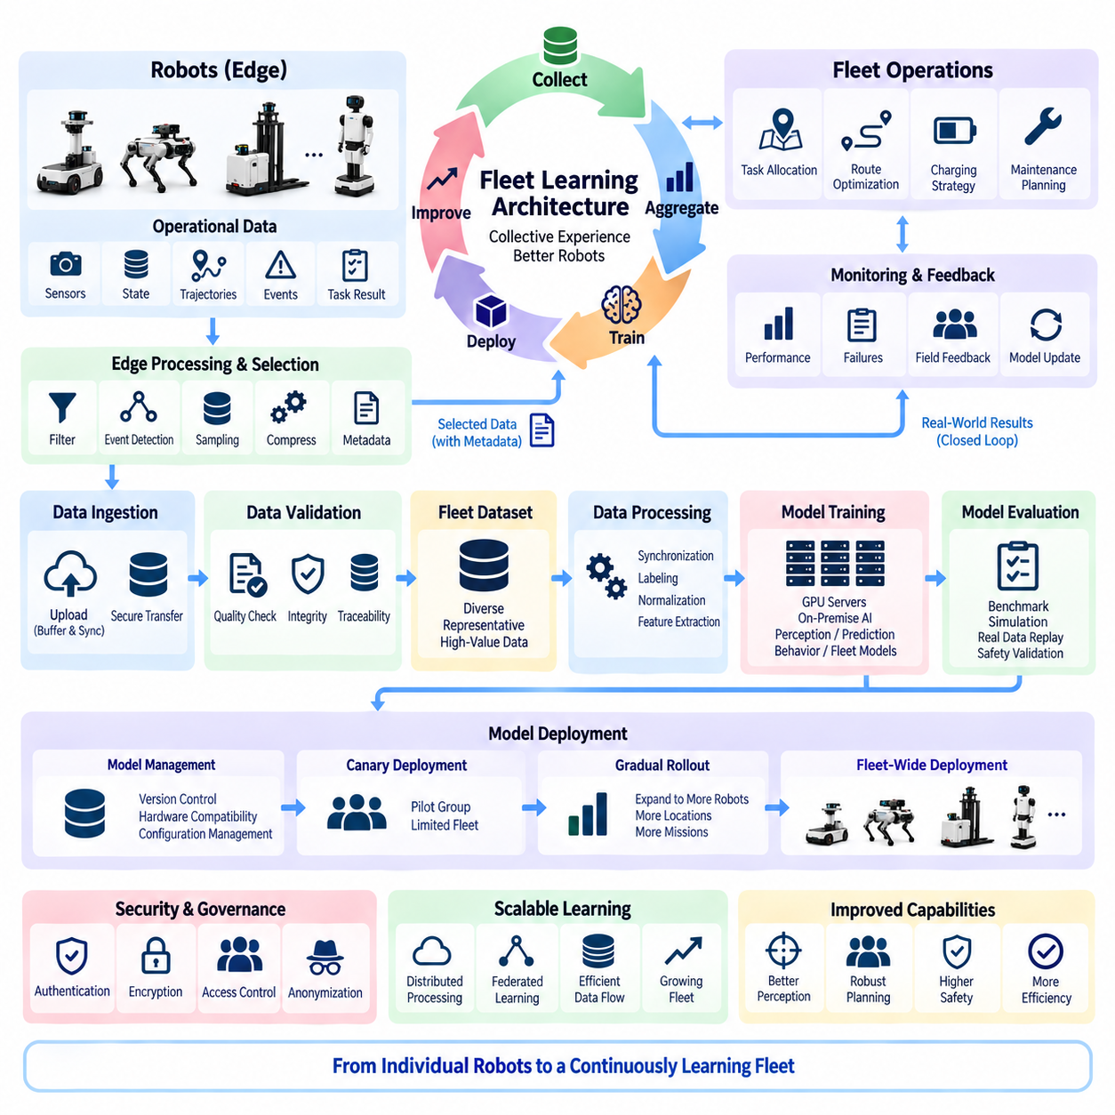
Fleet learning extends autonomous robot intelligence from individual experience to collective improvement across an entire fleet. Instead of allowing each robot to learn only from its own missions, operational experiences from many robots are collected, organized, analyzed, and converted into reusable knowledge. This creates a continuous learning architecture in which every deployed robot can contribute to improving perception, prediction, planning, diagnostics, and operational policies for future fleet operation.
The architecture begins at the robot edge, where each platform continuously produces operational observations while performing its assigned mission. These observations may include sensor measurements, localization results, trajectories, detected objects, environmental conditions, control responses, system health, task outcomes, and exceptional events. Because raw robotic data can be extremely large, the edge system should determine which information has sufficient learning value before transferring it to fleet infrastructure.
Local data selection is therefore an important component of fleet learning. Routine operation may generate millions of similar frames that provide little additional information, while unusual obstacles, localization failures, near-collision situations, difficult lighting, unexpected human behavior, sensor degradation, or unsuccessful planning decisions may have significantly greater training value. Event-driven collection and intelligent sampling can reduce storage and communication requirements while preserving informative examples.
Each selected observation should be accompanied by contextual metadata that explains how and why the data was generated. Robot identity, hardware configuration, software version, AI model version, sensor calibration, timestamp, location context, mission type, environmental condition, and execution result can all influence interpretation. Without this context, two apparently similar sensor sequences may represent fundamentally different operational situations and could produce misleading conclusions during training or evaluation.
Fleet learning requires a structured data ingestion pipeline between distributed robots and centralized learning infrastructure. Robot data can first be buffered locally and transferred when network conditions, bandwidth, and operational policies permit. High-priority events may be uploaded immediately, while large sensor recordings can be transferred later through high-bandwidth connections. This asynchronous approach prevents learning traffic from competing unnecessarily with real-time command, telemetry, and safety communication.
After ingestion, fleet data must pass through validation and quality-control processes before becoming part of a training dataset. Corrupted files, incomplete sensor sequences, invalid timestamps, calibration inconsistencies, duplicated samples, or incompatible software versions should be detected. Data provenance should also be retained so that engineers can trace a training sample back to the robot, mission, configuration, and processing pipeline that produced it.
Centralized aggregation allows observations from many robots to be organized into a shared fleet dataset. The objective is not simply to accumulate the largest possible volume of information but to create representative coverage of the operational domain. Data should capture different environments, robot configurations, weather conditions, lighting, traffic patterns, object classes, mission types, failure modes, and rare events so that models do not become optimized only for frequently observed conditions.
The learning pipeline can transform collected data into training-ready representations through filtering, synchronization, labeling, annotation, normalization, and feature extraction. Multi-sensor observations may require temporal alignment among cameras, LiDAR, radar, IMU, GNSS, and robot state information. Accurate synchronization is particularly important when learning relationships between perception and physical action because incorrect timing can associate an observation with the wrong robot response.
Label generation can combine manual annotation, automated labeling, existing model predictions, simulation, and rule-based processing. Human review remains useful for ambiguous or safety-relevant examples, while automated pipelines can process large volumes of routine data. Active learning can further prioritize samples where current models show high uncertainty, disagreement, or poor performance, allowing annotation resources to focus on information likely to produce the greatest model improvement.
Fleet learning is especially valuable for discovering long-tail scenarios that individual robots encounter only rarely. A single robot may operate for months without experiencing a particular obstacle configuration or environmental failure, while hundreds of deployed robots collectively encounter many such cases. Aggregating these experiences increases the probability that rare but important situations become visible to the learning system and can be incorporated into future model development.
Training infrastructure can use the aggregated dataset to improve perception, prediction, behavior, or fleet-level models. GPU servers and on-premise AI infrastructure are suitable for computationally intensive retraining because they provide substantially greater compute and storage capacity than individual robot platforms. Training can begin from an existing validated model rather than rebuilding intelligence from the beginning whenever new fleet experience becomes available.
Continuous learning should not mean that every newly collected sample immediately changes deployed models. A controlled learning cycle separates data collection, dataset preparation, model training, evaluation, approval, deployment, and monitoring. This separation prevents unstable or poorly understood model changes from automatically reaching physical machines. Fleet learning therefore combines rapid accumulation of operational knowledge with disciplined model lifecycle management.
Evaluation should compare candidate models against validated baselines using both common scenarios and difficult fleet-derived cases. Performance can be measured across perception accuracy, prediction quality, planning success, robustness, computational latency, resource consumption, and mission-level outcomes. Safety-relevant scenarios deserve separate evaluation because an improvement in average model accuracy does not necessarily imply improvement in the rare conditions that determine operational risk.
Simulation and recorded-data replay can provide an intermediate validation layer before deployment to real robots. Newly trained models can be exposed to previously observed fleet scenarios, synthetic variations, difficult environmental conditions, and known failure cases without immediately affecting physical operation. Hardware-in-the-loop or robot-in-the-loop testing can then confirm that model behavior remains compatible with actual compute, sensors, communication, and control interfaces.
Once a model passes validation, deployment should proceed incrementally rather than updating the complete fleet simultaneously. A small group of representative robots can operate as a canary fleet or pilot group, allowing engineers to compare new and previous model behavior under real conditions. If operational indicators remain acceptable, deployment can gradually expand to additional robots, locations, or mission categories until the validated model becomes the fleet baseline.
Model distribution must account for differences among robot platforms. A fleet may contain multiple generations of compute hardware, sensors, mobility systems, and mission-specific configurations. Central model management should therefore associate each model with compatible hardware, required sensor inputs, memory requirements, inference latency, software dependencies, and operating constraints. Fleet learning becomes practical only when learned intelligence can be reliably mapped back onto heterogeneous physical platforms.
Feedback after deployment closes the learning loop. Robots operating with the new model generate fresh telemetry, events, confidence values, failures, and mission outcomes that can be compared with previous versions. If the new model improves performance, the evidence supports broader deployment. If unexpected regressions appear, deployment can be stopped or rolled back while the problematic cases are returned to the dataset for additional analysis and retraining.
This closed-loop process creates a cycle of deployment, observation, learning, validation, and redeployment. The fleet gradually becomes a distributed sensing and experience-generation system, while centralized infrastructure acts as the knowledge integration and model improvement layer. The value of a deployed robot therefore extends beyond completing its immediate mission because its operational experience can contribute to improving other robots across the fleet.
Fleet learning can also improve functions beyond perception models. Historical mission data can support better task allocation, route selection, charging strategies, congestion prediction, maintenance scheduling, and resource utilization. Repeated operational patterns may reveal which robot configuration performs best in particular environments or which mission policies create unnecessary energy consumption, waiting time, or component wear. Learning can consequently optimize both robot intelligence and fleet operations.
Shared learning must nevertheless preserve the distinction between global knowledge and local execution. A centrally improved model may encode experience gathered from many robots, but real-time inference and physical control can still occur at the edge. This allows fleet-wide experience to influence individual behavior without making every action dependent on continuous connectivity to the learning server. Learned intelligence can therefore be centralized during development and distributed during execution.
Data governance becomes increasingly important as fleet learning scales. Collected information may contain operationally sensitive environments, people, customer facilities, geographic information, or proprietary processes. Access control, encryption, retention policies, anonymization, audit records, and dataset permissions should therefore accompany the technical learning pipeline. The architecture should define not only how data is collected but also who can use it, for what purpose, and for how long.
Security must protect both directions of the learning cycle. Uploaded robot data should be authenticated so that manipulated observations cannot silently contaminate training datasets, while downloaded models should be verified before activation to prevent unauthorized software from reaching physical systems. Dataset integrity, model signatures, version control, secure transport, and controlled deployment authority collectively protect the fleet learning chain from data collection through execution.
Fleet learning also requires strong observability and reproducibility. Engineers should be able to determine which dataset produced a particular model, which training configuration was used, which evaluation results justified deployment, and which robots currently execute that version. Dataset versions, model registries, experiment records, deployment histories, and fleet telemetry create traceability across the complete AI lifecycle and make systematic investigation possible when unexpected behavior occurs.
As fleet size grows, the learning architecture can evolve from periodic centralized retraining toward more distributed approaches. Some preprocessing, feature extraction, event detection, or adaptation may occur directly on robots, reducing unnecessary data movement. In environments where raw data cannot leave the robot or operating site, federated learning can allow local training contributions to be aggregated without requiring every original dataset to be centrally transferred.
Fleet learning architecture therefore connects edge robots, communication networks, data aggregation, on-premise AI infrastructure, GPU training systems, model management, validation, and distributed deployment into one continuous intelligence lifecycle. It occupies the logical bridge between Central AI Distributed Execution and the following Federated Learning, Fleet Data Aggregation, and Fleet AI Security topics defined within the Fleet AI chapter of the Compute and AI Architecture structure.
The long-term objective is a fleet whose intelligence improves as operational experience accumulates. Individual robots remain responsible for responsive and safe physical execution, while collective experience is transformed into increasingly capable models and operational policies. Through controlled feedback loops, representative datasets, rigorous validation, secure deployment, and continuous monitoring, fleet learning converts many autonomous machines into a coordinated learning ecosystem rather than a collection of independently evolving robots.

07.03. Federated Learning Overview
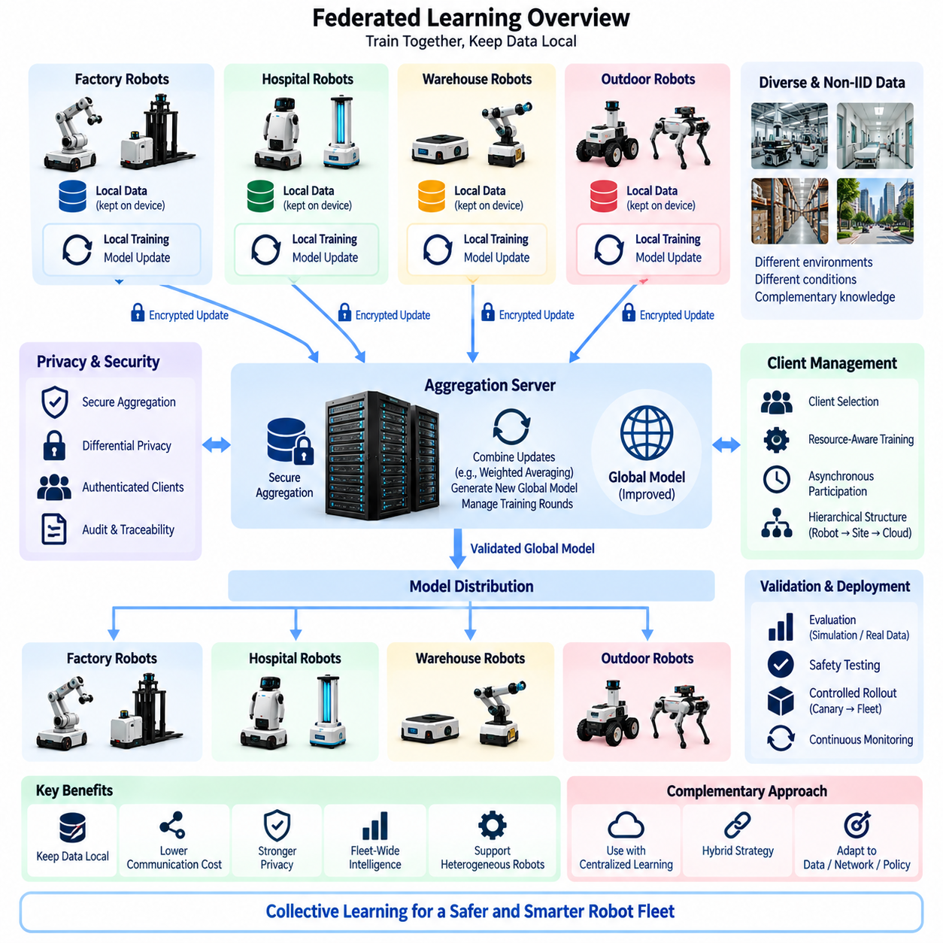
Federated learning enables a robot fleet to improve shared AI models without requiring every robot to transfer its complete local dataset to a central training system. Instead of moving raw operational data, participating robots or edge sites perform selected training operations locally and transmit model updates to an aggregation server. The server combines these contributions into an improved global model and redistributes the resulting model to participating fleet members.
This approach extends the fleet learning architecture by changing where learning computation occurs and what information moves across the network. In conventional centralized learning, robot observations are collected into a shared dataset before training. In federated learning, significant portions of the training data can remain on the robot, local edge server, or operating site. The architecture therefore moves computation toward the data rather than requiring all data to move toward centralized computation.
A typical federated learning cycle begins with a validated global model maintained by the central AI infrastructure. The model and its training configuration are distributed to selected participating clients. Each client trains or fine-tunes the model using locally available operational data for a defined period or number of optimization steps. The resulting parameters, gradients, or other model updates are then prepared for transmission without requiring the original sensor recordings to leave the local environment.
The central aggregation service receives updates from multiple participants and combines them to generate a new global model. A basic strategy can use weighted averaging so that contributions reflect the amount of local training data or another defined weighting policy. More advanced aggregation methods may account for differences in data quality, client reliability, hardware capability, operating environment, or model convergence behavior. Aggregation therefore becomes a controlled knowledge-integration process rather than simple file collection.
After aggregation, the candidate global model must still pass validation before operational deployment. Federated learning changes the training architecture but does not remove the need for model evaluation, safety testing, version management, and controlled rollout. The aggregated model can be tested against reference datasets, recorded fleet scenarios, simulation environments, known failure cases, and safety-critical benchmarks before being approved for deployment to physical robots.
The architecture is particularly valuable when fleet data is geographically distributed. Robots may operate in factories, hospitals, campuses, warehouses, smart cities, ports, or customer facilities where transferring complete sensor datasets to one central location is undesirable or restricted. Local training allows knowledge from these environments to contribute to global intelligence while reducing the amount of operational information that must cross organizational, geographic, or network boundaries.
Federated learning can also reduce communication requirements when raw robotic datasets are much larger than the corresponding model updates. Cameras, LiDAR, radar, audio, and other sensors can generate large continuous data streams, whereas selected parameter updates may be substantially smaller. The actual communication advantage depends on model size, update frequency, compression, and training configuration, so federated learning should be designed together with network bandwidth and edge compute constraints.
Local data distributions are rarely identical across a robot fleet. An indoor logistics robot may observe corridors, elevators, shelves, and people, while an outdoor inspection robot may encounter roads, vegetation, weather, vehicles, and infrastructure. Even robots of the same type may experience different lighting, floor materials, traffic density, or user behavior. Federated learning must therefore handle non-independent and non-identically distributed data, commonly described as non-IID data.
Non-IID data creates both value and difficulty. The diversity of local experience can improve the global model by exposing it to conditions unavailable at a single site, but strongly different local distributions can cause training updates to move in conflicting directions. Aggregation policies, client selection, learning rates, local training duration, and model personalization may therefore need to be adjusted so that fleet diversity improves generalization rather than destabilizing convergence.
Client selection determines which robots or edge sites participate in each training round. It may be inefficient to activate every robot simultaneously, particularly when robots have different mission schedules, battery levels, network conditions, compute resources, or available datasets. The central coordinator can select an appropriate subset according to learning objectives and operational constraints, allowing training to occur without unnecessarily interfering with the primary mission of the physical system.
Resource-aware participation is especially important for robots because training competes with perception, planning, control, logging, and other onboard workloads. Local learning should not reduce the compute capacity required for safe real-time operation. Training may therefore be scheduled while a robot is charging, idle, connected to high-bandwidth infrastructure, or operating below defined compute and thermal limits. Fleet learning must remain subordinate to mission execution and safety requirements.
Federated learning can operate at several physical levels. Training may occur directly on individual robots, on local edge computers serving groups of robots, or on site-level servers that aggregate data from a local fleet before participating in a broader federation. Hierarchical federated learning can combine these levels, allowing robot-level knowledge to be aggregated locally before selected updates are transmitted to regional or central infrastructure.
This hierarchical structure is useful for large fleets distributed across many facilities. A factory or customer site can maintain its own local learning domain while contributing selected model knowledge to a global fleet model. Such organization can reduce wide-area communication, support site-specific policies, and create clearer data governance boundaries. It also aligns naturally with an architecture containing robot edge computing, on-premise AI systems, and central fleet AI infrastructure.
Privacy is an important motivation for federated learning, but keeping raw data local does not automatically guarantee complete privacy. Model updates can potentially reveal information about local training data under certain attack conditions. Privacy-preserving mechanisms such as secure aggregation, update clipping, differential privacy, controlled participation, and encryption can therefore be incorporated depending on the sensitivity and risk profile of the robotic application.
Secure aggregation allows the central service to obtain a combined result without necessarily inspecting each participant's individual update in ordinary form. This can reduce exposure of site-specific learning information and strengthen trust boundaries between participants. Cryptographic protection, authenticated clients, secure communication channels, and controlled key management should accompany the aggregation mechanism so that only authorized fleet members can contribute to the learning process.
The architecture must also defend against malicious or defective participants. A compromised robot could intentionally submit manipulated updates, while a malfunctioning client could unintentionally contribute corrupted parameters. Model poisoning, backdoor behavior, abnormal gradients, and unreliable training results can damage the shared model because aggregation distributes knowledge across the fleet. Update validation, anomaly detection, reputation mechanisms, and robust aggregation can reduce these risks.
Client identity and software integrity therefore become fundamental parts of federated learning security. Before accepting an update, the coordinator should know which authorized robot or site produced it and which software, model, and training configuration were used. Signed artifacts, authenticated communication, trusted execution environments where appropriate, model version control, and audit records can provide traceability from each contribution to the resulting global model.
Federated learning must also tolerate unreliable connectivity. Mobile robots can disconnect, change wireless access points, enter coverage gaps, or become unavailable because of mission priorities. A practical coordinator should not assume that every selected client will return an update within the same period. Training protocols can accommodate partial participation, delayed updates, communication retries, or asynchronous aggregation depending on the consistency requirements of the learning process.
Model compression can further improve federated communication efficiency. Quantization, sparsification, selective parameter exchange, low-rank updates, or other compression techniques can reduce the amount of information transmitted during each learning round. These methods introduce tradeoffs among bandwidth, computation, convergence speed, and model quality, so compression policies should be evaluated using representative robot hardware and realistic network conditions rather than communication volume alone.
Personalization becomes useful when one global model cannot optimally represent every robot or operating environment. A common fleet model can provide broadly learned capabilities, while selected layers, adapters, parameters, or policies are locally adapted to a particular robot type or site. This creates a balance between global knowledge sharing and local specialization, allowing the fleet to benefit from collective experience without forcing heterogeneous robots into an identical behavioral model.
The relationship between federated learning and centralized fleet learning should therefore be complementary rather than exclusive. Some datasets may be appropriate for centralized collection and GPU-server training, while sensitive, high-volume, or site-restricted data may remain local and contribute through federated updates. A hybrid architecture can choose the learning path according to data sensitivity, bandwidth, computational resources, model type, operational policy, and regulatory requirements.
Central GPU servers remain important even when federated learning is adopted. They can maintain the global model, coordinate training rounds, aggregate updates, execute large-scale evaluation, manage model registries, perform simulation, and train components using centrally available datasets. Federated learning redistributes part of the training workload but does not eliminate the need for centralized AI infrastructure or disciplined machine learning operations.
Observability and reproducibility remain necessary throughout the federation. The system should record which clients participated, which global model initiated a round, which training configuration was applied, how updates were aggregated, and which evaluation results justified the next model version. These records allow engineers to investigate performance changes and reproduce the learning process when an unexpected regression appears after aggregation or deployment.
Federated learning ultimately creates a distributed knowledge-sharing mechanism for Fleet AI. Robots preserve local responsibility for real-time physical execution while contributing experience to collective model improvement. Central infrastructure coordinates learning and integrates knowledge without requiring unrestricted transfer of every raw observation. The resulting architecture supports scalable learning across heterogeneous robots, sites, networks, and operational environments while maintaining stronger control over data movement.
Within the Compute and AI Architecture structure, Federated Learning follows Central AI Distributed Execution and Fleet Learning Architecture and precedes Fleet Data Aggregation and Fleet AI Security. Together, these topics describe a progression from coordinated fleet execution toward collective learning, distributed training, systematic data management, and secure fleet-wide intelligence.
The long-term objective is not simply to train one global model but to create an adaptable learning ecosystem in which knowledge can move safely between robots without requiring all underlying experience to move with it. By combining local training, secure aggregation, heterogeneous client management, validation, personalization, controlled deployment, and continuous feedback, federated learning allows a robot fleet to transform geographically distributed experience into shared intelligence while preserving local autonomy and operational boundaries.

07.04. Fleet Data Aggregation
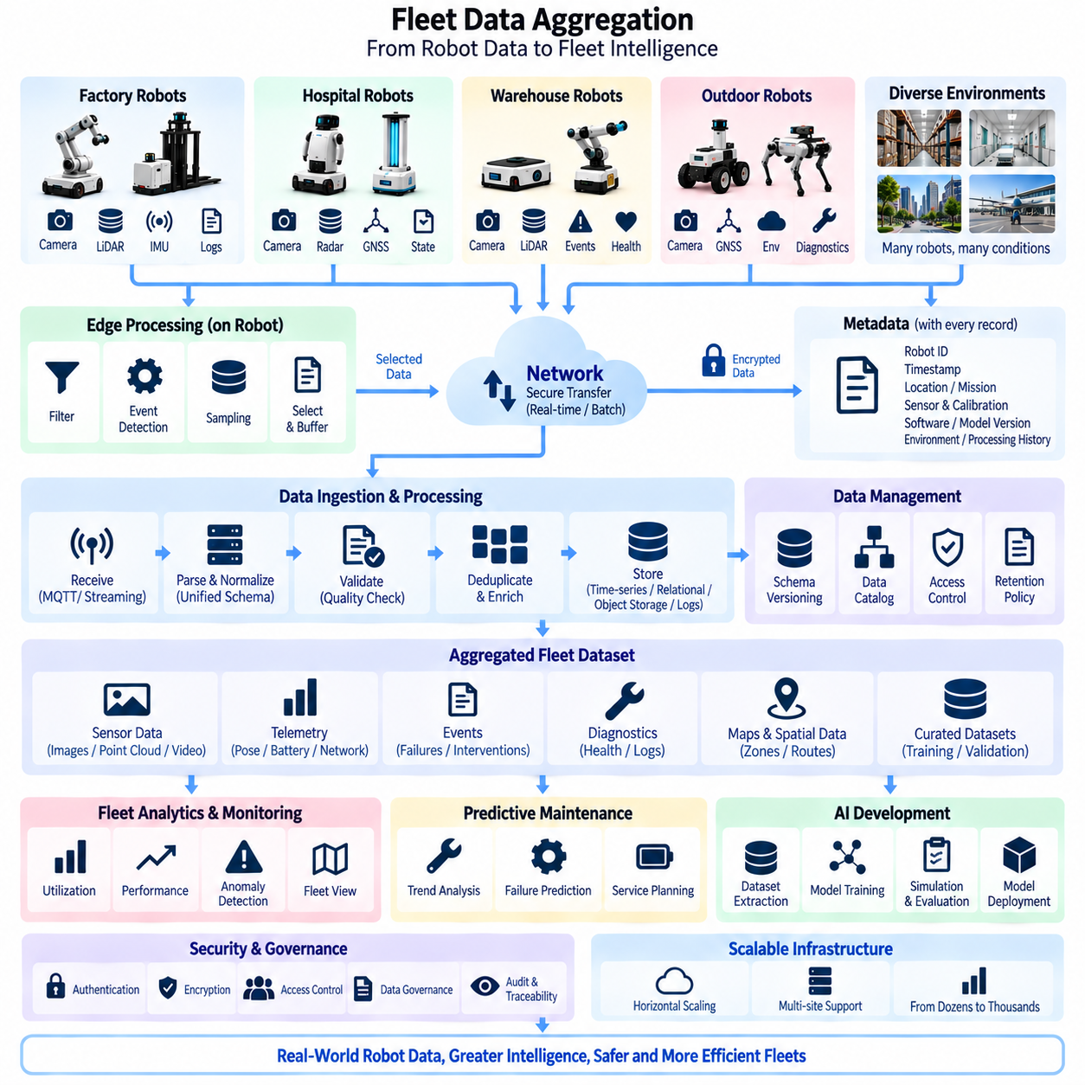
Fleet data aggregation provides the information foundation that allows many autonomous robots to operate as a coordinated and continuously improving fleet. Each robot generates sensor observations, localization states, trajectories, mission events, diagnostics, system health information, and AI inference results. Aggregation converts these distributed streams into structured fleet-level information that can support monitoring, analytics, learning, optimization, maintenance, and future model development.
The first architectural challenge is deciding what information should leave each robot. Cameras, LiDAR, radar, audio, IMU, GNSS, and internal system logs can generate data at rates that make unrestricted transmission impractical. Edge processing should therefore classify information according to operational value, urgency, bandwidth requirements, retention needs, and learning importance before transferring selected data toward central or on-premise infrastructure.
Robot-generated information can be divided conceptually into high-frequency telemetry, operational events, AI results, diagnostic records, and large sensor datasets. Telemetry may describe pose, velocity, battery condition, temperature, network quality, or mission progress, while events identify failures, obstacles, safety interventions, or task transitions. Large sensor recordings can be retained selectively for difficult scenarios, incident reconstruction, model training, and validation rather than continuously uploaded.
Edge filtering reduces unnecessary duplication before aggregation begins. A robot operating repeatedly along the same route may produce thousands of nearly identical observations, while a rare localization failure or unexpected obstacle can contain significantly greater information value. Event detection, novelty scoring, confidence thresholds, temporal sampling, and configurable recording policies can prioritize high-value data while preserving sufficient routine information for statistical analysis and baseline comparison.
Local buffering is necessary because mobile robots cannot assume continuous high-bandwidth connectivity. Selected data can be temporarily stored on onboard SSD or other edge storage and transmitted according to network availability and operational priority. Critical events may be uploaded immediately, ordinary telemetry can use periodic transmission, and large datasets may wait until the robot reaches a charging station or reliable high-speed network connection.
Every aggregated record requires metadata that preserves its operational meaning. Robot identifier, platform type, hardware configuration, sensor configuration, software release, AI model version, calibration version, timestamp, mission identifier, environmental context, and processing history can all affect interpretation. Metadata transforms isolated files into traceable engineering evidence and allows later analysis to distinguish changes caused by environment, hardware, software, or model behavior.
Time synchronization is especially important when aggregating information from multiple sensors and multiple robots. Camera frames, LiDAR scans, IMU measurements, GNSS positions, control commands, AI outputs, and system events must be associated with consistent timestamps. PTP, GNSS-derived time, or other synchronization mechanisms can establish a common temporal reference so that distributed observations can be reconstructed and compared accurately during analysis.
The ingestion layer receives information from robots and converts heterogeneous streams into manageable data flows. Message brokers, telemetry services, file transfer mechanisms, databases, object storage, and streaming pipelines can be combined according to data type. Small state messages may require low-latency streaming, whereas multi-gigabyte sensor recordings are better handled through asynchronous file transfer and scalable storage services.
Aggregation should preserve separation between real-time operational data and large historical datasets. Fleet control requires current robot state with predictable latency, while AI development may require months of accumulated sensor information. Mixing these workloads without resource isolation can allow large uploads or analytical jobs to interfere with operational communication. Separate logical pipelines can therefore share infrastructure while maintaining different priorities and service requirements.
A fleet data platform commonly requires several storage forms because no single database is optimal for every robotic workload. Time-series storage can efficiently retain telemetry, relational databases can manage robot and mission metadata, object storage can hold images, point clouds, video, and training datasets, while log systems can preserve diagnostic events. A catalog or metadata layer can connect these resources into a searchable fleet information environment.
Data normalization makes information from heterogeneous robots comparable. Different platforms may report velocity in different units, use different coordinate frames, encode diagnostic states differently, or produce sensor data with different resolutions. Common schemas, units, coordinate conventions, naming rules, quality flags, and interface definitions reduce ambiguity and allow fleet applications to consume information without implementing unique interpretation logic for every robot model.
Schema evolution must be controlled because fleet systems change over time. New sensors, software functions, diagnostic fields, or AI outputs introduce additional data structures while older robots may continue using previous formats. Versioned schemas and backward-compatible interfaces allow the aggregation platform to accept information from multiple generations without forcing the entire fleet to upgrade simultaneously.
Data quality assessment should occur as information enters the aggregation system. Missing timestamps, impossible positions, corrupted files, duplicated events, invalid sensor ranges, inconsistent identifiers, or incomplete metadata can reduce analytical reliability. Automated validation can flag or quarantine suspicious records rather than allowing low-quality information to silently enter datasets used for operational decisions or AI training.
Deduplication is particularly important when communication retries or overlapping recording mechanisms produce repeated information. Hashes, event identifiers, timestamps, sequence numbers, and robot-specific keys can help determine whether records represent new observations or retransmissions. Reliable deduplication reduces unnecessary storage and prevents duplicated events from distorting fleet statistics, failure rates, or training dataset distributions.
Fleet aggregation should retain data provenance from the point of generation through every processing stage. Engineers should be able to determine which robot generated an observation, which sensor and calibration produced it, which software transformed it, and which dataset later incorporated it. Provenance supports debugging, reproducibility, safety investigation, dataset governance, and removal of affected information when a sensor or processing defect is discovered.
Spatial aggregation adds another dimension to fleet intelligence. Observations from different robots can be associated with common maps, zones, routes, buildings, or geographic coordinates. Multiple robots may report congestion, obstacles, surface conditions, wireless coverage, or environmental changes from different positions and times. Combining these observations can create a fleet-level representation that is more complete than the local map maintained by any single robot.
Event aggregation transforms individual incidents into operational patterns. A single motor temperature warning may not indicate a systematic problem, but similar warnings across several robots with the same hardware configuration may reveal a fleet-wide reliability issue. Likewise, repeated localization failures in one physical area may indicate environmental difficulty rather than independent robot faults. Aggregated evidence therefore supports both robot diagnostics and infrastructure diagnosis.
Fleet analytics can derive higher-level indicators from the aggregated data. Mission completion rate, travel distance, energy consumption, charging frequency, idle time, localization stability, intervention frequency, network availability, component temperatures, and AI confidence trends can be evaluated across robots, sites, and time periods. These indicators provide a quantitative basis for improving fleet utilization, reliability, and operational policy.
Aggregated information also supports predictive maintenance. Long-term trends in motor current, battery resistance, vibration, thermal behavior, wheel performance, sensor health, or communication errors can be compared across similar robots. Models can identify deviations from normal fleet behavior and estimate when maintenance should occur. This shifts service strategy from reacting to failures toward condition-based and predictive maintenance.
For AI development, the aggregation layer becomes the gateway between real-world operation and the training infrastructure. High-value sensor examples, failure cases, uncertain predictions, unusual environmental conditions, and operator interventions can be extracted from fleet storage and assembled into curated datasets. These datasets can then enter labeling, preprocessing, training, simulation, evaluation, and model management pipelines within the broader on-premise AI architecture.
Data aggregation also complements federated learning. Federated learning can keep sensitive raw datasets local while exchanging model updates, but centralized aggregation remains useful for telemetry, metadata, approved datasets, benchmark samples, and operational statistics. A practical fleet architecture can therefore combine centralized data aggregation and federated model learning rather than treating them as mutually exclusive approaches.
Bandwidth management should be integrated into aggregation policy. Data priority, compression, upload scheduling, network type, robot mission state, and available bandwidth can determine when and how information is transferred. Critical safety or diagnostic events may receive immediate priority, while large training datasets can use deferred transfer. Adaptive policies prevent data collection from degrading command, control, or mission-critical communication.
Retention policies determine how long different information remains available. High-frequency raw sensor data may require large storage capacity and can be retained selectively, while compact mission summaries or maintenance records may remain useful for years. Storage tiers can move older information from high-performance systems to lower-cost archives while preserving metadata that allows engineers to locate and restore historical datasets when necessary.
Security must protect fleet data throughout collection, transmission, storage, processing, and access. Robot identities should be authenticated, communication encrypted, storage permissions controlled, and sensitive datasets protected according to operational policy. Integrity mechanisms should detect unauthorized modification because corrupted telemetry or manipulated training information could influence fleet decisions, maintenance conclusions, or future AI models.
Data governance defines the organizational rules surrounding the technical aggregation pipeline. Ownership, access rights, retention, anonymization, customer restrictions, geographic constraints, and permitted AI uses should be associated with datasets and metadata. This becomes increasingly important when robots operate in hospitals, factories, public spaces, customer facilities, or other environments where operational information may contain sensitive or proprietary content.
Observability of the aggregation infrastructure itself is equally important. Operators should monitor ingestion rate, transmission delay, storage utilization, dropped messages, validation failures, database health, queue depth, and processing latency. A fleet data platform that silently loses information can create misleading analytics and incomplete training datasets, so data pipeline health should be treated as an operational system metric.
Scalability requires the architecture to accommodate growth from a few robots to hundreds or thousands without redesigning the complete data system. Partitioning by robot, site, time, mission, or data type can distribute storage and processing workloads. Horizontal scaling, asynchronous processing, configurable sampling, and hierarchical site-level aggregation can prevent centralized infrastructure from becoming a bottleneck as the fleet expands.
Within the Compute and AI Architecture structure, Fleet Data Aggregation follows Central AI Distributed Execution, Fleet Learning Architecture, and Federated Learning, and it precedes Fleet AI Security. This position reflects its role as the data backbone connecting distributed robot operation with fleet intelligence, learning infrastructure, model improvement, diagnostics, and secure fleet-wide management.
The long-term objective is to transform massive amounts of distributed robot data into reliable fleet knowledge rather than merely accumulating files. Through edge selection, synchronized ingestion, standardized schemas, quality validation, scalable storage, provenance, analytics, governance, and secure access, fleet data aggregation creates a persistent information layer from which individual robot experiences can become operational intelligence for the entire fleet.

07.05. Fleet AI Security
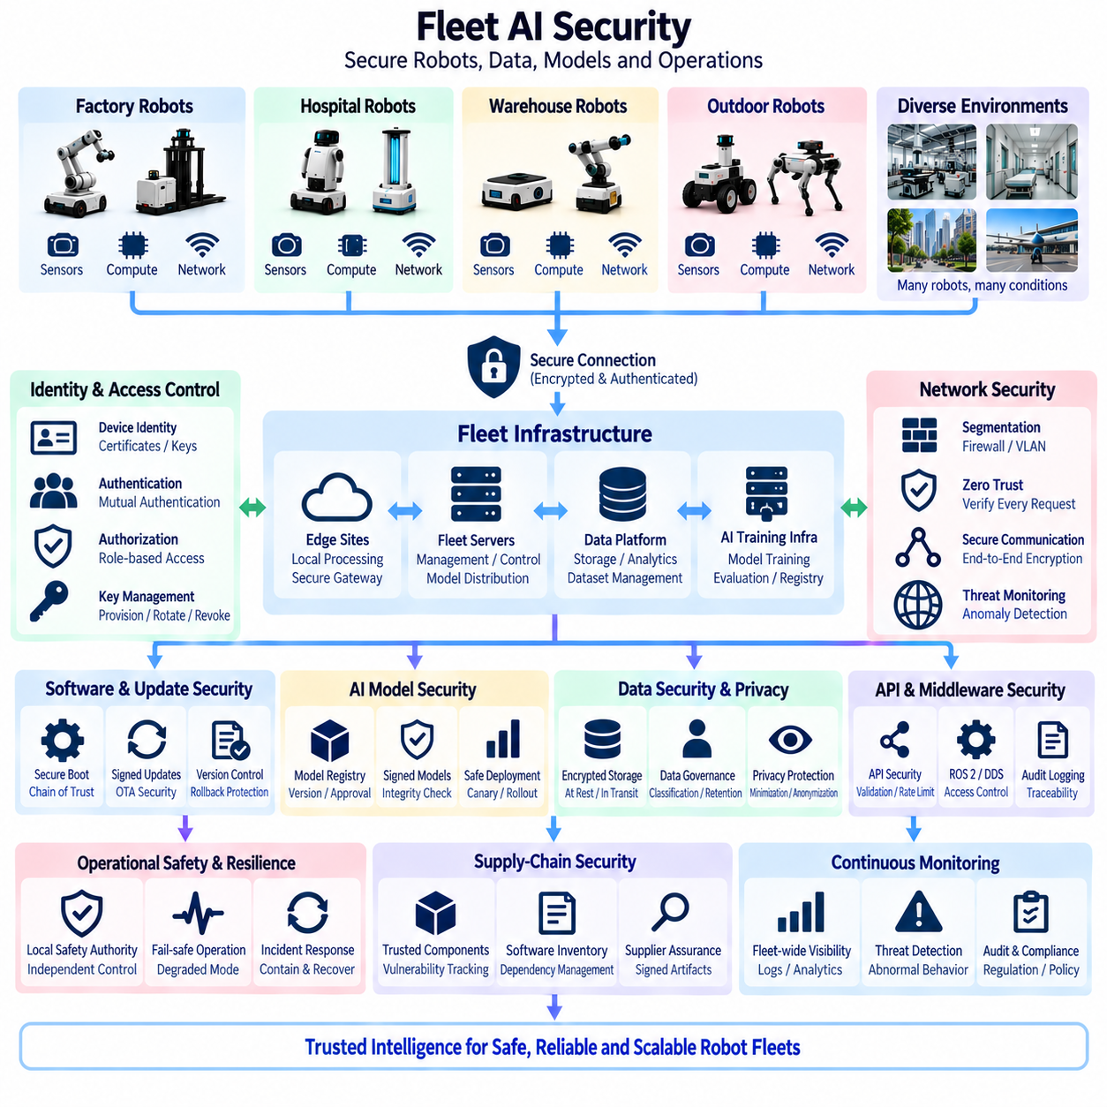
Fleet AI security protects the complete intelligence chain that connects autonomous robots, edge computers, communication networks, fleet servers, data platforms, training infrastructure, and operational applications. Unlike security for a single robot, fleet security must consider how compromise of one component can propagate across many machines. Identity, communication, software, models, data, control authority, and operational policies therefore require coordinated protection across the entire fleet architecture.
The attack surface expands significantly when robots operate as connected fleet members. Each robot may expose wireless interfaces, Ethernet, CAN gateways, maintenance ports, APIs, ROS 2 middleware, remote diagnostics, OTA services, and cloud or on-premise connections. Central servers add databases, dashboards, model registries, training systems, message brokers, and fleet-management interfaces. Security architecture must treat every connection between these components as a controlled trust boundary rather than assuming that an internal network is inherently safe.
Strong device identity provides the foundation for trusted fleet communication. Every robot, edge computer, server, and authorized service should possess a verifiable identity that cannot easily be copied or impersonated. Certificates, cryptographic keys, hardware-backed credentials, or secure identity modules can establish machine identity. The fleet controller should authenticate a robot before accepting telemetry, data, learning contributions, diagnostic requests, or operational messages from that device.
Mutual authentication is preferable because trust must operate in both directions. Robots need to verify that commands, policies, software packages, and AI models originate from authorized infrastructure, while central services must verify that incoming information originates from legitimate robots. This prevents an attacker from simply imitating a fleet server or inserting a fraudulent robot into the network and influencing fleet-wide decisions through false information.
Communication confidentiality and integrity are required because fleet messages may contain robot locations, mission information, sensor events, system status, model updates, or control instructions. Encryption protects information from unauthorized observation, while integrity mechanisms detect modification during transmission. Secure transport should cover robot-to-server, server-to-robot, site-to-site, administrative, model-distribution, and data-transfer channels rather than protecting only external Internet connections.
Network segmentation limits the consequences of compromise. Safety-related communication, robot control, fleet management, AI training, data storage, maintenance access, and general corporate networks should not automatically share unrestricted connectivity. Firewalls, VLANs, access-control policies, gateways, and application-level authorization can create controlled communication paths. A compromised analytics workstation should not automatically gain direct access to low-level robot control interfaces.
Zero-trust principles are useful for fleet AI because physical location inside a factory or private network does not prove that a device or user is trustworthy. Each request should be evaluated according to identity, authorization, device state, service role, and context. Access can be limited to the minimum resources required for a specific function, reducing the possibility that one stolen credential or compromised endpoint provides unrestricted movement through the fleet infrastructure.
Authorization must be separated from authentication. A valid identity proves who or what is communicating, but it does not determine which actions should be permitted. Role-based or attribute-based access control can distinguish fleet operators, maintenance engineers, AI developers, administrators, robots, training services, and external support personnel. High-impact functions such as emergency policy changes, model deployment, remote control, or fleet-wide configuration updates should receive particularly strict authorization.
Robot software integrity begins before normal operation. Secure boot can establish a chain of trust from hardware initialization through firmware, operating system, middleware, and application software. Signed software packages allow the robot to reject unauthorized binaries or modified updates. Hardware security modules, trusted platform modules, or secure elements can protect cryptographic material and support device attestation where the platform and risk requirements justify their use.
Over-the-air update security is especially important because OTA mechanisms intentionally provide a path for changing deployed robots. Update packages should be authenticated, integrity-checked, version-controlled, and compatible with the target hardware before installation. Rollback protection can prevent unauthorized installation of vulnerable historical versions, while controlled rollback procedures should still allow operators to return safely to a previously validated release when a legitimate new deployment fails.
AI models must be treated as controlled software assets rather than ordinary data files. A modified perception, prediction, planning, or VLA model can change physical robot behavior even when conventional application software remains intact. Model registries should therefore maintain version, origin, approval state, compatibility, evaluation evidence, and cryptographic integrity information. Robots should activate only models that satisfy defined trust and deployment policies.
Model distribution requires protection from both unauthorized replacement and accidental incompatibility. Before activation, the edge platform should verify the model signature, expected hash, hardware target, runtime dependency, required sensors, memory demand, and approved configuration. Canary deployment and gradual rollout reduce the blast radius of an unexpected defect. A problematic model can then be stopped before it reaches every robot in the fleet.
Fleet learning introduces additional security risks because operational experience becomes an input to future intelligence. Attackers may attempt data poisoning by injecting misleading observations into centralized training datasets or manipulating local contributions in federated learning. Even unintentional sensor faults can contaminate learning data. Provenance, quality validation, anomaly detection, client authentication, dataset versioning, and controlled approval help prevent unreliable information from silently influencing future models.
Federated learning requires special protection because model updates arrive from distributed participants. A compromised client may submit malicious gradients or parameters designed to degrade the global model or introduce a hidden behavior. Robust aggregation, update clipping, anomaly analysis, participant reputation, secure aggregation, and controlled client selection can reduce this exposure. Raw data remaining local improves data control but does not eliminate security or privacy risks.
Fleet data aggregation must preserve confidentiality, integrity, and traceability throughout the data lifecycle. Sensor recordings, maps, telemetry, diagnostics, mission history, customer-site information, and training datasets can contain sensitive operational information. Access controls, encryption at rest and in transit, retention rules, dataset classification, audit logs, and provenance records should follow information from robot generation through storage, processing, training, archiving, and deletion.
Privacy protection becomes important when robot sensors observe people or environments not intended for unrestricted reuse. Camera, audio, location, and behavioral information may require stricter handling than ordinary machine telemetry. Edge filtering, minimization, anonymization, masking, retention limits, and purpose-based access can reduce unnecessary exposure. The security architecture should therefore protect not only system availability but also information associated with people and customer environments.
API security is critical because fleet management increasingly depends on software interfaces. REST, gRPC, WebSocket, MQTT, DDS, ROS 2, and proprietary interfaces may connect robots, dashboards, services, and external systems. Authentication, authorization, input validation, rate limiting, secure configuration, interface versioning, and logging should be consistently applied. An apparently minor API can become a fleet-wide attack path when it has access to shared operational services.
ROS 2 and DDS deployments require deliberate security configuration rather than relying solely on network isolation. Robot topics, services, and actions may contain perception information, navigation states, commands, or system configuration. Permissions should restrict which participants can publish, subscribe, invoke services, or access specific resources. Namespace design and communication policy should reflect functional boundaries so that unnecessary components cannot influence safety-relevant execution.
Safety and cybersecurity must interact without becoming identical disciplines. Cybersecurity protects systems against unauthorized or malicious actions, while functional safety addresses hazards that may occur even without an attacker. A cyberattack can nevertheless create a safety hazard by changing commands, disabling sensors, corrupting localization, or altering models. Security architecture should therefore ensure that compromised high-level services cannot directly bypass independent local safety mechanisms.
Local safety authority provides an important containment boundary. Even when a central fleet service is compromised or sends an inappropriate instruction, onboard safety logic should enforce speed limits, collision avoidance, emergency stopping, actuator constraints, and operating envelopes. Central AI may optimize missions and routes, but it should not possess unrestricted authority to override validated local safety controls. This limits the physical consequences of failures in higher-level intelligence.
Resilience requires the fleet to continue operating safely when security mechanisms detect abnormal conditions. A robot may isolate a suspicious communication channel, reject an invalid model, disable remote commands, or enter a degraded operating mode while retaining essential local autonomy. Depending on mission risk, it may complete a safe maneuver, stop in a controlled location, return to base, or wait for authorized recovery rather than failing unpredictably.
Security monitoring should combine information from robots, networks, servers, and applications. Repeated authentication failures, unusual traffic patterns, unexpected configuration changes, abnormal model updates, unauthorized API calls, software integrity failures, or unexplained robot behavior can indicate compromise. Central security analytics can correlate weak signals across many machines and detect fleet-level patterns that would be difficult to recognize from one robot alone.
Logging and auditability are essential for incident investigation. Security-relevant actions should record identity, timestamp, source, target, command, configuration, model version, and result where appropriate. Time synchronization allows events from robots, gateways, servers, and administrative systems to be reconstructed in the correct sequence. Protected logs also provide evidence for determining whether abnormal behavior originated from software defects, operational mistakes, hardware faults, or malicious activity.
Incident response must account for the physical nature of the fleet. Conventional IT systems can sometimes be disconnected immediately, but abruptly isolating a moving robot may create additional hazards. Response procedures should define how to revoke credentials, quarantine devices, stop model distribution, isolate network segments, preserve evidence, recover trusted software, and return robots to service while maintaining safe physical behavior throughout the process.
Credential and key lifecycle management becomes increasingly important as fleet size grows. Keys must be securely provisioned, rotated, renewed, revoked, and replaced without requiring uncontrolled manual intervention on every robot. When a robot is serviced, transferred, compromised, or retired, its credentials should no longer provide fleet access. Scalable identity lifecycle management prevents old or duplicated credentials from becoming persistent security weaknesses.
Supply-chain security extends protection beyond software developed internally. Robot systems contain operating systems, drivers, libraries, containers, AI frameworks, firmware, third-party applications, and hardware components from multiple suppliers. Vulnerability tracking, software inventories, signed artifacts, dependency management, controlled repositories, and update procedures help identify which deployed robots are affected when a component vulnerability is discovered.
Security architecture should be designed for heterogeneous fleets rather than assuming identical hardware and software. Indoor AMRs, outdoor robots, inspection vehicles, manipulators, quadrupeds, and future Physical AI platforms may use different compute modules, sensors, operating systems, and communication technologies. Common identity, authorization, logging, model governance, and security policy frameworks can provide fleet-wide consistency while allowing platform-specific enforcement mechanisms.
Within the Compute and AI Architecture structure, Fleet AI Security completes the Fleet AI chapter following Central AI Distributed Execution, Fleet Learning Architecture, Federated Learning, and Fleet Data Aggregation. Its role is to protect the execution, learning, communication, and data mechanisms introduced by those preceding architectural layers so that increasing fleet intelligence does not simultaneously create uncontrolled fleet-wide risk.
The long-term objective is a fleet in which intelligence can be shared broadly while authority and trust remain tightly controlled. Authentication establishes identity, authorization limits capability, encryption protects communication, secure boot and signed deployment protect software and models, data governance protects information, monitoring detects abnormal behavior, and local safety boundaries contain failures. Together, these mechanisms create a resilient security foundation for scalable Fleet AI and future Physical AI systems.

