Volume 16 Compute and AI Architecture

Chapter 09. Future AI Computing

09.01. Neuromorphic Computing
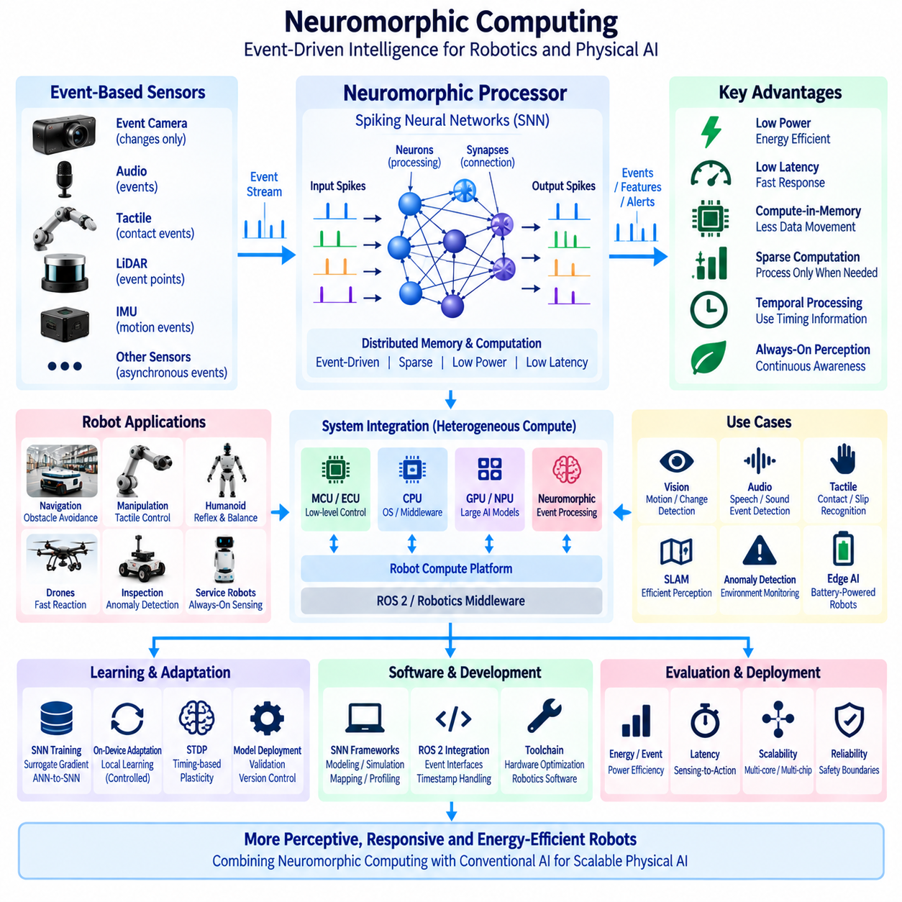
Neuromorphic computing is a computing paradigm inspired by the structure and operating principles of biological nervous systems. Instead of relying primarily on sequential instruction execution and continuous numerical processing, neuromorphic systems organize computation around distributed neuron-like processing elements and synapse-like connections. This approach is particularly relevant to robotics and Physical AI, where perception, decision, and reaction must often occur continuously under strict power, latency, and thermal constraints.
Conventional processors separate computation and memory, requiring data to move repeatedly between processing units and memory devices. This movement becomes increasingly expensive as AI workloads grow because energy and latency are consumed not only by arithmetic operations but also by memory access and data transfer. Neuromorphic architectures attempt to reduce this limitation by placing state and computation closer together, allowing information to be processed through highly distributed local interactions.
A central concept in neuromorphic computing is the spiking neural network, or SNN. Unlike conventional artificial neural networks that typically communicate using continuously valued activations, SNNs exchange discrete events called spikes. A neuron integrates incoming events over time and produces an output spike when its internal state reaches a defined condition. Information can therefore be represented not only by signal magnitude but also by spike timing, frequency, temporal relationships, and sparse activity patterns.
Event-driven computation changes when hardware performs work. Conventional AI accelerators frequently execute dense matrix operations at predetermined computational cycles even when much of the input information changes only slightly. Neuromorphic processors can remain largely inactive until relevant events arrive. Computation is activated by changes in the environment, allowing processing activity to follow the information content of the input rather than continuously processing every possible value at the same rate.
This property is naturally compatible with event-based sensors. Event cameras, for example, do not necessarily transmit complete image frames at fixed intervals but can report local brightness changes asynchronously. When combined with neuromorphic processing, sensor events can propagate directly into event-driven perception pipelines. The resulting architecture can reduce redundant processing in scenes where most visual regions remain unchanged while preserving rapid response to motion and other significant environmental changes.
Temporal information is fundamental to neuromorphic computation. Biological perception and control depend strongly on relationships among events occurring over time, and SNNs incorporate internal temporal dynamics directly into neuron states. This makes neuromorphic approaches potentially useful for motion perception, temporal pattern recognition, audio processing, tactile sensing, sensor fusion, anomaly detection, and other robotic functions in which the timing of observations carries important information.
Sparse computation provides another potential efficiency advantage. At any particular moment, only a subset of neurons or synapses may be active, allowing hardware resources to focus on the portions of the network responding to current events. If the workload and hardware architecture successfully exploit this sparsity, power consumption can be substantially lower than continuously executing dense neural operations. This characteristic is attractive for battery-powered robots that must operate for long periods without increasing battery size.
Low latency is equally important for Physical AI. A robot encountering a rapidly changing obstacle should not always need to wait for a complete sensor frame, large batch, or remote server response before beginning computation. Event-driven architectures can process information as events arrive and potentially create short sensing-to-response paths. Such capability is relevant to high-speed obstacle detection, collision avoidance, manipulation, reflexive control, and other functions where milliseconds can influence physical safety.
Neuromorphic processors can therefore be considered complementary to CPUs, GPUs, NPUs, and conventional AI accelerators rather than universal replacements for them. GPUs remain highly effective for large dense neural networks, foundation models, training, simulation, and parallel numerical computation. CPUs are essential for general-purpose control and system management. Neuromorphic hardware can instead target selected workloads where temporal processing, sparse activity, event-driven sensing, and energy efficiency provide architectural advantages.
A heterogeneous robot compute platform can combine these technologies according to workload characteristics. An MCU or ECU can maintain deterministic low-level control, a CPU can execute operating-system and middleware functions, a GPU or NPU can perform high-capacity perception and multimodal inference, while a neuromorphic processor handles selected event-driven sensing or rapid temporal inference. Such partitioning allows each workload to execute on hardware that better matches its computational structure.
Sensor preprocessing is a practical candidate for neuromorphic acceleration. Rather than sending every raw observation directly to a high-power GPU, a neuromorphic front end can detect changes, temporal patterns, anomalies, or salient events and forward only relevant information to subsequent processing stages. This creates an event-driven attention mechanism at the hardware level and can reduce downstream bandwidth, memory traffic, and computational demand across the overall robot architecture.
Neuromorphic computing can also support always-on perception. Mobile robots may need to monitor sound, movement, vibration, proximity, touch, or other environmental signals continuously even when high-performance processors are operating in reduced-power states. A low-power neuromorphic subsystem can remain active as a persistent sensing layer and wake higher-performance compute resources only when significant conditions are detected, improving system-level energy management.
Robotic audio processing provides another suitable example because acoustic signals are inherently temporal. Neuromorphic systems can potentially process event sequences representing speech characteristics, direction changes, abnormal mechanical sounds, alarms, impacts, or environmental acoustic patterns. In a Physical AI system, such processing could provide an efficient always-on awareness channel that complements vision, LiDAR, radar, and other sensing modalities without continuously occupying the main GPU.
Tactile sensing and manipulation also contain strong temporal characteristics. Robotic hands and manipulators may receive high-frequency signals describing contact, pressure variation, slip, vibration, and material interaction. Event-driven processing can focus computation on changes in contact state rather than repeatedly processing unchanged sensor values. This can support rapid reflex-like responses and provide an additional computational pathway between tactile sensing and low-level manipulation control.
Learning methods for neuromorphic systems differ from conventional deep learning in important ways. Standard backpropagation assumes differentiable operations, while discrete spikes introduce difficulties for direct gradient computation. SNN development can therefore use surrogate-gradient methods, conversion from trained artificial neural networks, local learning rules, or other training approaches. The choice of learning method affects accuracy, hardware efficiency, temporal behavior, and compatibility with existing AI development pipelines.
Spike-timing-dependent plasticity, commonly known as STDP, illustrates the biologically inspired learning principles associated with neuromorphic systems. Connection changes can depend on the relative timing of pre-synaptic and post-synaptic activity, allowing temporal relationships to influence learning. Although practical robotic AI does not need to reproduce biology exactly, such mechanisms demonstrate how adaptation can potentially occur through local interactions rather than relying exclusively on large centralized training procedures.
On-device adaptation is therefore an important long-term possibility. Robots operate in environments that change over time, and selected neuromorphic learning mechanisms may allow limited adaptation near the sensors without continuously transferring data to central GPU servers. Local adaptation could support personalized sensing, environmental calibration, anomaly recognition, or changing temporal patterns. However, uncontrolled online learning would introduce validation, stability, safety, and cybersecurity challenges that require strict architectural boundaries.
Neuromorphic computing also changes the software development model. Conventional AI frameworks are primarily optimized around tensors, layers, dense numerical operations, and GPU execution. Neuromorphic applications require representations of spikes, neuron states, temporal dynamics, connectivity, and asynchronous events. Toolchains must therefore support model creation, simulation, mapping, profiling, deployment, and hardware-specific optimization while still integrating with the broader robotics software environment.
Integration with ROS 2 and robotic middleware requires careful interface design. Neuromorphic processing may operate asynchronously while many existing robot software components expect periodic messages or frame-based data. Gateways may therefore convert event streams into conventional representations or expose event-native interfaces to compatible applications. Timestamp preservation is critical because converting asynchronous events without maintaining temporal relationships can eliminate one of the principal advantages of neuromorphic processing.
Benchmarking must evaluate more than conventional inference accuracy. Relevant measures include energy per inference or event, sensing-to-action latency, event throughput, memory traffic, idle power, temporal accuracy, robustness, and performance under realistic sparse workloads. A neuromorphic system that appears efficient on a highly sparse benchmark may offer less advantage when the application generates dense continuous activity, so evaluation should reflect actual robot sensors and operational environments.
Scalability depends on how neuron and synapse resources are mapped onto physical hardware. Large SNNs may require communication among multiple processing cores or chips, making interconnect architecture important. If spike traffic becomes dense, communication overhead can reduce the efficiency expected from sparse computation. Network topology, routing, memory locality, neuron placement, and workload partitioning therefore become important design variables when scaling neuromorphic processing to more complex robotic intelligence.
Reliability and deterministic behavior also require consideration. Physical robots operate under safety constraints, and asynchronous event-driven processing can make timing behavior different from conventional periodic pipelines. Engineers must understand worst-case latency, event congestion, dropped events, processor saturation, and failure modes before neuromorphic outputs are allowed to influence safety-relevant control. Neuromorphic acceleration should therefore be integrated within clearly defined safety and supervisory boundaries.
Neuromorphic processors are especially attractive at the edge because power and thermal limitations often determine how much intelligence can be installed on a mobile platform. Reducing continuous GPU utilization can extend operating time, reduce cooling requirements, and permit smaller computing modules. For outdoor AMRs, drones, humanoids, quadrupeds, and compact inspection robots, these improvements can directly influence payload, battery capacity, enclosure design, reliability, and overall system architecture.
At the fleet level, neuromorphic edge processing can reduce the amount of information that must be transmitted to central infrastructure. Local event detection can convert continuous sensor streams into compact events, features, or alerts before communication. Central AI and GPU servers can then focus on fleet optimization, large-model inference, learning, historical analysis, and model management while distributed neuromorphic devices perform selected low-power perception and temporal processing close to physical sensors.
Neuromorphic computing should consequently be viewed as part of a broader heterogeneous Physical AI architecture rather than an isolated processor technology. Its strongest role emerges where sparse temporal information, asynchronous sensing, low latency, and energy efficiency intersect. Conventional compute remains essential for general robotics and large-scale AI, while neuromorphic hardware provides another specialized execution domain that can be selected when workload characteristics justify its architectural complexity.
The long-term significance of neuromorphic computing lies in enabling Physical AI systems to process continuous interaction with the real world more efficiently. By combining event-driven sensors, spiking neural networks, distributed memory and computation, sparse activation, temporal reasoning, and low-power edge execution, neuromorphic architectures offer a path toward robotic systems that remain perceptually active for longer periods while reacting rapidly to meaningful environmental change.
Future robot architectures may therefore combine conventional deep learning, foundation models, world models, neuromorphic perception, and deterministic control within a unified compute hierarchy. Large GPU systems can provide high-capacity reasoning and learning, while neuromorphic subsystems provide efficient always-on interaction with dynamic physical environments. The architectural objective is not to imitate the biological brain literally, but to use its computational principles where they provide measurable advantages for scalable, responsive, and energy-efficient Physical AI.

09.02. Analog AI Chip
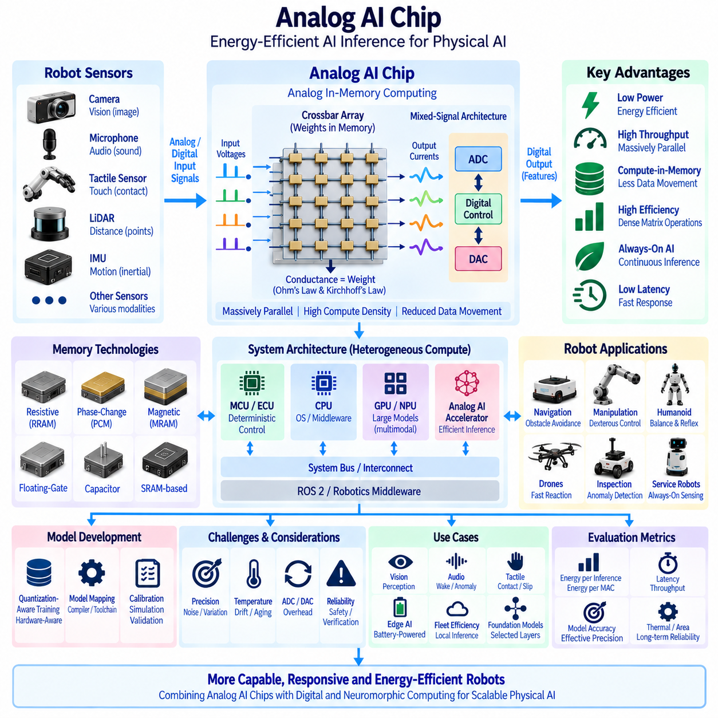
Analog AI chips perform selected artificial intelligence computations by representing and manipulating information through physical electrical quantities rather than relying exclusively on conventional digital arithmetic. Voltages, currents, conductance states, charge, or other analog properties can participate directly in computation. For Physical AI systems, this approach is attractive because it can reduce the energy and data movement associated with large numbers of multiply-and-accumulate operations used in neural-network inference.
Conventional digital AI accelerators normally represent weights and activations as binary numerical values and repeatedly move them between memory and arithmetic units. Even when the arithmetic itself is efficient, memory access can consume substantial energy and introduce latency. Analog AI architectures attempt to reduce this overhead by storing model parameters close to, or directly within, the computational structure so that memory access and computation can occur together.
The most important architectural idea is analog in-memory computing. Instead of reading individual neural-network weights from memory and transferring them into separate multiply-accumulate units, an array of programmable memory elements can represent many weights simultaneously. Input signals are applied across the array, and the physical response of the circuit performs many multiplication and accumulation operations in parallel. This changes the fundamental relationship among memory, computation, bandwidth, and energy.
Crossbar arrays are commonly associated with this computing model. Conductive elements are arranged at intersections of rows and columns, with each element representing a programmable weight or part of a weight. Input voltages applied to rows generate currents through these conductances, while currents accumulated along columns represent weighted sums. Ohm's law and Kirchhoff's current law therefore become part of the physical mechanism implementing neural-network matrix operations.
This massively parallel operation is particularly relevant because matrix-vector multiplication dominates many neural-network workloads. A digital processor may execute large numbers of individual arithmetic instructions or use arrays of digital MAC units, whereas an analog array can evaluate many weighted interactions through the electrical behavior of the circuit itself. The potential advantage is extremely high computational density with substantially reduced movement of model parameters.
Analog AI does not mean that the complete AI system must operate in the analog domain. Practical architectures are typically mixed-signal systems combining analog compute arrays with digital control, memory management, activation functions, scheduling, communication, and system interfaces. Digital-to-analog converters translate digital inputs into electrical signals, while analog-to-digital converters convert accumulated analog results back into digital representations for subsequent processing.
These data converters are essential but also introduce architectural overhead. ADC and DAC circuits consume power, occupy silicon area, and add latency, particularly when high precision or high sampling rates are required. The efficiency of an analog AI chip therefore depends not only on the analog compute array but also on peripheral circuitry. A design with highly efficient matrix computation can lose much of its advantage if conversion and data movement dominate total system energy.
Precision is another fundamental consideration. Digital computation can provide highly repeatable numerical representations within a specified bit width, while analog computation is influenced by circuit noise, device variation, temperature, supply voltage, aging, and manufacturing differences. Analog AI architectures therefore generally accept controlled numerical uncertainty in exchange for improved efficiency. Neural networks can often tolerate some computational error, making AI inference a promising workload for this tradeoff.
Quantization-aware training and hardware-aware training can help models operate successfully under these limitations. During model development, the training process can simulate reduced precision, conductance variation, noise, nonlinear behavior, saturation, or other hardware effects. The resulting model learns to remain robust under the characteristics of the target analog accelerator rather than assuming mathematically ideal computation that cannot be reproduced by physical devices.
Memory technology strongly influences analog AI architecture. Candidate implementations can use resistive memory, phase-change memory, magnetic memory, floating-gate devices, capacitor-based structures, SRAM-assisted analog computation, or other technologies. Each option presents different tradeoffs in programming precision, retention, endurance, write energy, density, variability, manufacturing maturity, and compatibility with conventional semiconductor processes.
Resistive devices are especially interesting because their conductance can directly represent neural-network weights. When many such devices are arranged into arrays, electrical currents can naturally implement weighted summation. However, practical deployment requires handling device-to-device variation, limited conductance states, programming errors, drift, endurance limitations, and nonlinear behavior. System-level efficiency therefore depends on both device physics and algorithmic compensation.
Analog AI chips can provide significant benefits for edge inference where power and thermal budgets are constrained. Mobile robots cannot continuously increase GPU performance without affecting battery size, cooling, enclosure volume, and operating time. Selected neural-network layers executed on efficient analog accelerators could reduce the energy required for repetitive inference and allow more intelligence to remain active locally without relying on continuous communication with central servers.
Perception workloads are natural candidates because robotic systems repeatedly execute convolution, attention, projection, feature transformation, and matrix multiplication operations. Camera, audio, radar, tactile, and other sensor-processing networks can potentially benefit when their computational structure maps efficiently onto analog arrays. The strongest advantage appears when large weight matrices can remain resident in compute arrays and be reused many times without repeated external memory transfers.
Always-on AI is another potential application. Robots may need to continuously detect wake events, anomalies, people, motion, acoustic patterns, equipment conditions, or environmental changes even when the main GPU is not fully active. A low-power analog inference subsystem could process selected neural models continuously and activate higher-performance processors only when more complex reasoning is required, reducing average system power consumption.
Analog AI can therefore participate in a heterogeneous Physical AI compute architecture. An MCU or ECU can execute deterministic control, CPUs can manage operating systems and middleware, GPUs and NPUs can execute large multimodal models, and analog accelerators can handle suitable high-volume neural operations. The objective is not to force every algorithm onto one processor type but to allocate computation according to latency, precision, energy, programmability, and workload structure.
This workload partitioning requires careful analysis because not every neural-network operation maps efficiently to analog hardware. Large matrix operations may benefit significantly, while control flow, indexing, sparse irregular operations, symbolic processing, and general-purpose software are usually better suited to digital processors. A practical system must therefore minimize the overhead of moving intermediate results between analog and digital execution domains.
Transformer and foundation-model workloads create both opportunities and challenges. Their large matrix operations can potentially exploit analog parallelism, but model size, precision requirements, dynamic activations, attention structures, and frequent movement of intermediate data complicate implementation. Analog acceleration may initially target selected linear layers or repeated matrix operations rather than attempting to execute an entire large language or multimodal model purely in analog hardware.
Weight-stationary execution is particularly attractive for inference. Once trained model weights are programmed into analog arrays, they can remain physically resident while many input vectors are processed. This reduces repeated weight fetching from external memory, which is one of the major energy costs in conventional AI systems. The benefit becomes greater when the same model executes continuously over long periods, as commonly occurs in deployed robotic perception systems.
Training directly on analog hardware is more difficult than inference because training requires frequent and precise weight updates, gradient computation, and stable numerical behavior. Some architectures investigate on-chip or in-memory learning, but many practical systems can use conventional GPU infrastructure for training and then map validated models onto analog accelerators for deployment. This separates high-flexibility model development from energy-efficient edge execution.
Model mapping is therefore an important part of the software toolchain. Large neural-network matrices may need to be divided across multiple physical arrays according to array dimensions, precision, device characteristics, and available memory capacity. Calibration parameters, scaling factors, quantization rules, converter settings, and error compensation may also need to be generated during compilation. Deployment becomes a combined algorithm, compiler, and hardware optimization problem.
Calibration is essential because the physical behavior of analog circuits can differ across devices and operating conditions. The system can characterize array responses during manufacturing, startup, maintenance, or periodic operation and use correction parameters to compensate for predictable errors. Temperature sensors, reference circuits, digital correction, redundancy, or adaptive calibration can improve stability when robots operate across changing thermal and electrical environments.
Reliability must be evaluated over the complete robot operating life. Mobile platforms experience temperature variation, vibration, power fluctuations, repeated startup cycles, and long operational periods. Analog weight representations may drift or change as devices age, depending on the underlying technology. Monitoring, self-test, recalibration, fault detection, and fallback execution on conventional processors can therefore become important elements of a robust Physical AI architecture.
Safety-relevant functions require particular caution because analog computational uncertainty must not silently propagate into uncontrolled physical actions. Perception or prediction results produced by an analog accelerator can be checked by confidence thresholds, plausibility tests, redundant sensing, supervisory logic, or independent safety channels. Deterministic safety functions such as emergency stopping should remain within architectures whose worst-case behavior can be appropriately verified.
Benchmarking analog AI requires system-level measurements rather than focusing only on theoretical operations per second. Important metrics include energy per inference, energy per MAC, end-to-end latency, throughput, effective precision, model accuracy, converter overhead, memory traffic, thermal behavior, calibration stability, silicon area, and performance over temperature. Comparisons should use equivalent workloads and accuracy targets to avoid overstating efficiency through unrealistic assumptions.
The relationship between analog AI and neuromorphic computing is complementary but distinct. Neuromorphic systems emphasize event-driven temporal processing, spikes, sparse activation, and neuron-inspired dynamics, whereas analog AI primarily exploits physical electrical computation to accelerate numerical neural operations. Future chips may combine elements of both approaches, but their architectural motivations and optimal workloads should remain clearly distinguished when designing robotic computing systems.
At the fleet level, efficient analog inference can reduce the power required by continuously operating edge intelligence. Robots can process more perception locally, transmit higher-level features instead of raw sensor streams, and reserve central GPU servers for large-scale reasoning, fleet learning, simulation, model training, and historical analytics. This supports the broader principle of performing time-sensitive physical intelligence near the robot while using centralized resources for computationally intensive shared intelligence.
Analog AI also affects hardware-software co-design. Neural architectures, quantization methods, memory technology, circuit characteristics, compiler mapping, calibration, thermal design, and robot workload cannot be optimized independently. A model that performs well on a GPU may not be the most efficient model for an analog accelerator. Physical AI development can therefore benefit from designing models and hardware together around realistic sensing, latency, power, and reliability requirements.
The long-term importance of analog AI chips lies in overcoming the energy cost of moving enormous amounts of neural-network data through conventional computing architectures. By allowing memory devices and electrical circuits to participate directly in matrix computation, analog AI offers a path toward much higher inference efficiency. Its practical success depends on controlling precision, variation, conversion overhead, programmability, reliability, and manufacturing complexity.
Future Physical AI platforms may combine CPUs, GPUs, NPUs, neuromorphic processors, and analog AI accelerators within a unified heterogeneous computing hierarchy. Large digital processors will continue to provide flexible reasoning and model execution, while specialized analog hardware can accelerate suitable repetitive neural operations at much lower energy. The architectural goal is to place each computation where its physical implementation provides the best balance of intelligence, latency, power, robustness, and scalability.

09.03. Wafer Scale Chip
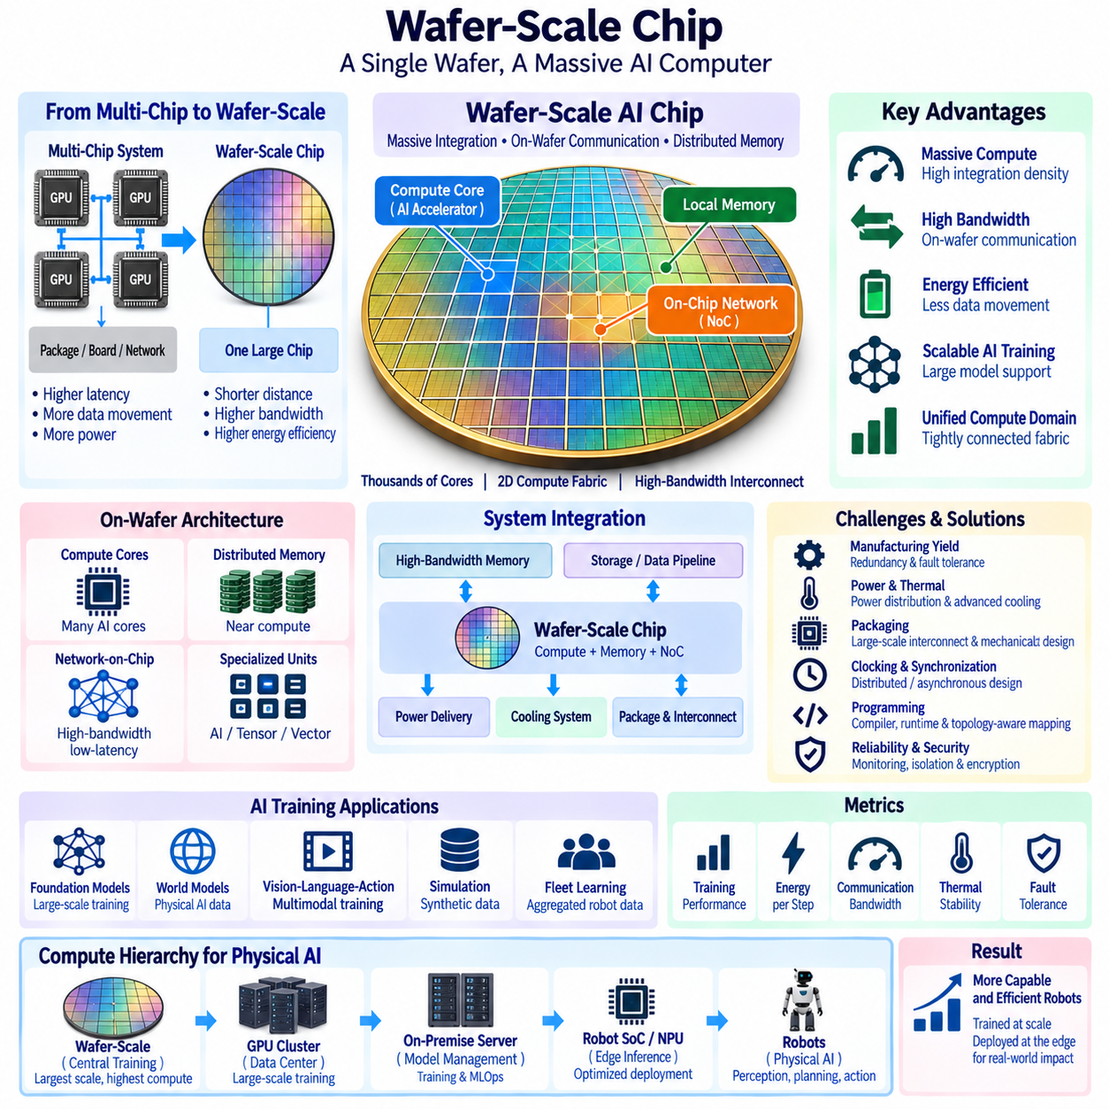
Wafer-scale chips extend semiconductor computing beyond the conventional assumption that a processor must be divided into relatively small dies. Instead of cutting a silicon wafer into many independent chips and reconnecting them through packages, boards, and external networks, wafer-scale integration attempts to use a very large portion of the wafer as one coordinated computing system. This approach targets AI workloads whose performance is increasingly limited by communication, memory bandwidth, and data movement rather than arithmetic alone.
Traditional multi-chip AI systems scale computation by connecting many GPUs, accelerators, or processor dies through PCIe, high-speed fabrics, and network switches. Such systems can provide enormous aggregate performance, but communication between devices is slower and more energy-intensive than communication inside a chip. Wafer-scale architecture attempts to move a much larger fraction of that communication onto silicon, reducing the physical distance between processing elements and increasing available interconnect bandwidth.
The fundamental advantage comes from integration density. A wafer provides enough physical area to contain very large numbers of processing cores, local memories, communication routers, and specialized AI execution units. Instead of treating each accelerator as an isolated device with its own external communication boundary, the architecture can organize these resources into a massive two-dimensional computing fabric. Large AI workloads can then be distributed across the wafer while remaining within a tightly integrated execution environment.
On-wafer communication is central to this architecture. Thousands of computing elements must exchange activations, gradients, parameters, intermediate tensors, and synchronization information efficiently. A dense network-on-chip can provide short, high-bandwidth communication paths among neighboring regions and hierarchical routes across the larger wafer. This reduces dependence on external networking for communication that would otherwise occur between separate accelerator packages.
Local memory distribution is equally important. AI workloads frequently become limited by the movement of parameters and intermediate results between compute units and external memory. Wafer-scale systems can place memory resources near processing cores so that frequently accessed data remains physically close to computation. Distributed memory architectures can therefore reduce latency and energy while providing very high aggregate bandwidth across the complete computing surface.
The architecture is particularly attractive for large neural-network training. Foundation models, multimodal models, world models, vision-language-action models, and other large AI systems require extensive tensor operations and communication among parallel workers. When model parameters or intermediate states are distributed across many conventional accelerators, synchronization can become a major bottleneck. Wafer-scale integration can reduce some of these boundaries by presenting a much larger tightly connected compute domain.
Model parallelism can map naturally onto a wafer-scale fabric. Different portions of a neural network can execute on different processor regions, while high-bandwidth on-wafer links transfer intermediate activations between them. Tensor parallelism can divide large matrix operations across multiple compute regions, and pipeline parallelism can assign successive model stages to different areas. The large physical fabric therefore becomes a programmable spatial representation of the AI workload.
Data parallelism can also be combined with these methods. Multiple regions may process different training samples while sharing or synchronizing model information through the communication fabric. Efficient collective operations become important because large training systems frequently require reductions, broadcasts, and parameter synchronization. The ability to perform these operations without repeatedly traversing conventional server and network boundaries can improve overall system utilization.
Wafer-scale integration does not eliminate the need for external memory. Large AI models and training datasets can exceed the storage capacity available directly on the wafer. High-bandwidth memory, external memory systems, storage servers, and data pipelines may therefore remain part of the complete architecture. The design objective is to keep latency-sensitive and repeatedly accessed information as close to compute as practical while using external tiers for larger-capacity storage.
One of the greatest engineering challenges is manufacturing yield. Conventional semiconductor production divides a wafer into smaller dies partly because defects can affect individual chips without invalidating the entire wafer. A wafer-scale processor cannot assume that every region of an extremely large silicon area will be defect-free. The architecture must therefore tolerate manufacturing defects and continue functioning even when selected cores, memory blocks, or communication links cannot be used.
Redundancy is a practical response to this challenge. Additional processing elements and communication paths can be incorporated so that defective resources are disabled and workloads are routed around them. During manufacturing test, the system can identify usable and unusable regions and construct a logical topology from functioning components. Fault tolerance consequently becomes a fundamental architectural requirement rather than an optional reliability feature.
Routing must remain robust after defective regions are removed. If a communication link or processing tile is unavailable, the network fabric should provide alternative paths that preserve connectivity among healthy resources. Routing algorithms, spare links, configurable switches, and topology-aware compilation can cooperate to map AI workloads onto the actual working structure of each manufactured wafer. Hardware defects can therefore be abstracted from higher-level model execution where possible.
Power delivery represents another major challenge because an extremely large processor can consume substantial power across a broad silicon surface. Stable voltage must reach many active regions while minimizing resistive losses and voltage variation. Power distribution networks, package design, voltage regulation, workload scheduling, and physical placement must therefore be engineered together. Peak activity cannot be considered independently from the electrical limits of the entire wafer-scale system.
Thermal management is closely connected to power delivery. Thousands of active processing elements can generate high heat density, and uneven workloads may create localized hot spots. Cooling solutions must remove heat across a much larger area than conventional processors while maintaining acceptable temperature gradients. Thermal sensors, workload placement, dynamic power management, cooling plates, liquid cooling, and system-level airflow can become integral components of the compute architecture.
Packaging is fundamentally different from packaging a normal semiconductor die. The wafer-scale device requires electrical connectivity, mechanical support, power delivery, cooling interfaces, and external communication across an unusually large structure. Mechanical stress and thermal expansion must also be controlled because the silicon surface and surrounding materials experience different physical behavior as temperature changes. Package engineering therefore becomes inseparable from processor architecture.
Clocking and synchronization also become more difficult as physical dimensions increase. Signals require finite time to travel across a large wafer, making it unrealistic to treat the complete system exactly like a small synchronous processor. Architectures can use distributed clocks, locally synchronous regions, asynchronous communication, or carefully designed synchronization domains. Software and hardware must tolerate the timing characteristics of a physically large computing fabric.
Programming such a system requires abstraction above individual cores. Developers should not need to manually place every tensor operation onto thousands of processing elements. Compilers and runtime systems can partition models, allocate memory, map communication, schedule operations, and avoid defective or unavailable resources. Effective software tools are therefore as important as silicon because poor workload mapping can leave large portions of the wafer underutilized.
Topology-aware compilation can exploit physical locality. Operations that exchange large amounts of information can be placed near one another, while independent workloads can occupy more distant regions. Frequently reused tensors can remain close to the compute elements that consume them. This converts physical chip layout into an optimization variable and allows compiler decisions to influence communication energy, execution latency, and thermal distribution.
Scalability beyond one wafer remains possible by connecting multiple wafer-scale systems. At that point, however, a hierarchy of communication reappears: communication within a wafer is fastest, communication between wafer systems is more expensive, and communication with storage or remote infrastructure is slower again. Distributed AI software should therefore place the most communication-intensive portions of a workload within the lowest-latency domain whenever possible.
This hierarchical communication model resembles locality-aware design in conventional GPU clusters but operates at a different physical scale. The system may contain local processor communication, wafer-level fabric, inter-wafer links, rack-level networking, and data-center networking. Scheduling software can use these layers strategically, keeping tightly coupled tensor operations on the wafer while distributing less communication-intensive workloads across larger infrastructure.
For Physical AI, wafer-scale computing is more relevant to centralized training and large-scale intelligence infrastructure than direct installation inside most mobile robots. Power, cooling, size, and packaging requirements make wafer-scale systems unsuitable for typical battery-powered AMRs or compact robotic platforms. Their value instead lies in training and evaluating the large models that are later compressed, quantized, distilled, or otherwise optimized for deployment on robot edge computers.
Large-scale world-model training is a particularly relevant future application. Physical AI systems can generate enormous datasets containing video, LiDAR, actions, trajectories, language, proprioception, and multimodal sensor histories. Learning predictive representations from these datasets requires both substantial computation and communication. Wafer-scale architectures can provide a tightly coupled environment for training models that represent complex spatial, temporal, and action-conditioned physical dynamics.
Vision-language-action models can similarly benefit from large centralized compute resources. Training these models may combine visual encoders, language representations, action tokens, temporal context, and robot demonstration datasets. Wafer-scale computing can accelerate the large matrix operations and communication-heavy parallel training required during development, while the resulting models can later be transformed into smaller deployment variants for real-time execution on robotic edge hardware.
Simulation and synthetic-data generation can also consume large computational resources. Physical AI development may require millions of simulated interactions, environment variations, sensor configurations, or policy evaluations. Wafer-scale systems can contribute to the AI portion of such pipelines, particularly where large neural models must process extensive simulated datasets. Conventional CPU and GPU infrastructure can remain complementary for physics engines, rendering, orchestration, and specialized workloads.
Fleet learning creates another possible role. Large numbers of robots can continuously produce operational data, failure cases, difficult scenarios, and model feedback. Central infrastructure can aggregate approved information and perform large-scale retraining or model evaluation. Wafer-scale computing can function as a high-capacity intelligence engine within this architecture, while robots continue to execute latency-critical perception, planning, and safety functions locally.
This division illustrates the difference between centralized intelligence capacity and edge execution efficiency. Wafer-scale systems maximize tightly integrated computation at infrastructure scale, whereas robot-dedicated SoCs, NPUs, analog AI accelerators, and neuromorphic processors target constrained edge environments. Future Physical AI architectures can use both approaches, training increasingly capable models centrally while deploying optimized versions onto heterogeneous robotic compute platforms.
Reliability remains important even after manufacturing because large computing systems must tolerate runtime failures. Processing regions, memory elements, communication links, power components, or cooling subsystems can degrade during operation. Health monitoring, error detection, redundant resources, workload migration, and graceful degradation can allow useful computation to continue instead of treating every local fault as a complete system failure.
Security must also be integrated into the platform. Wafer-scale systems may process proprietary models, robot datasets, simulation results, and sensitive fleet information. Secure boot, authenticated software, workload isolation, encrypted communication, access control, model protection, and audit logging remain necessary even though the underlying processor architecture is unconventional. Extremely high compute density increases the value of protecting the infrastructure from unauthorized use or model extraction.
Benchmarking should therefore evaluate more than peak arithmetic throughput. Effective training performance, model utilization, communication bandwidth, memory capacity and bandwidth, energy per training step, thermal behavior, fault tolerance, scaling efficiency, compiler quality, and end-to-end time-to-solution are more meaningful system metrics. A processor with enormous theoretical compute capacity provides limited benefit if communication, memory, power, or software prevents that capacity from being used.
Within the Compute and AI Architecture structure, Wafer Scale Chip appears in Future AI Computing after Neuromorphic Computing and Analog AI Chip, and before Robot Dedicated SoC and In-Memory Computing. This position highlights a complementary future direction: scaling AI through extreme silicon integration while the surrounding topics explore event-driven processing, analog computation, robot-specific integration, and reduced memory movement.
The long-term significance of wafer-scale computing is the possibility of treating an entire silicon wafer as a programmable AI machine rather than merely a manufacturing substrate for smaller chips. By integrating massive computation, distributed memory, and high-bandwidth communication across one physical fabric, the architecture can reduce boundaries that constrain conventional accelerator clusters and create a powerful platform for increasingly large and communication-intensive AI models.
Future Physical AI ecosystems may therefore combine wafer-scale training infrastructure with GPU clusters, on-premise AI servers, robot-dedicated SoCs, neuromorphic processors, analog accelerators, and in-memory computing. The wafer-scale system would not replace every computing layer; it would provide an extreme centralized compute tier for model creation and large-scale intelligence. The broader objective is a hierarchy in which each workload executes where compute density, communication locality, energy, latency, reliability, and physical constraints are best balanced.

09.04. Robot Dedicated SoC
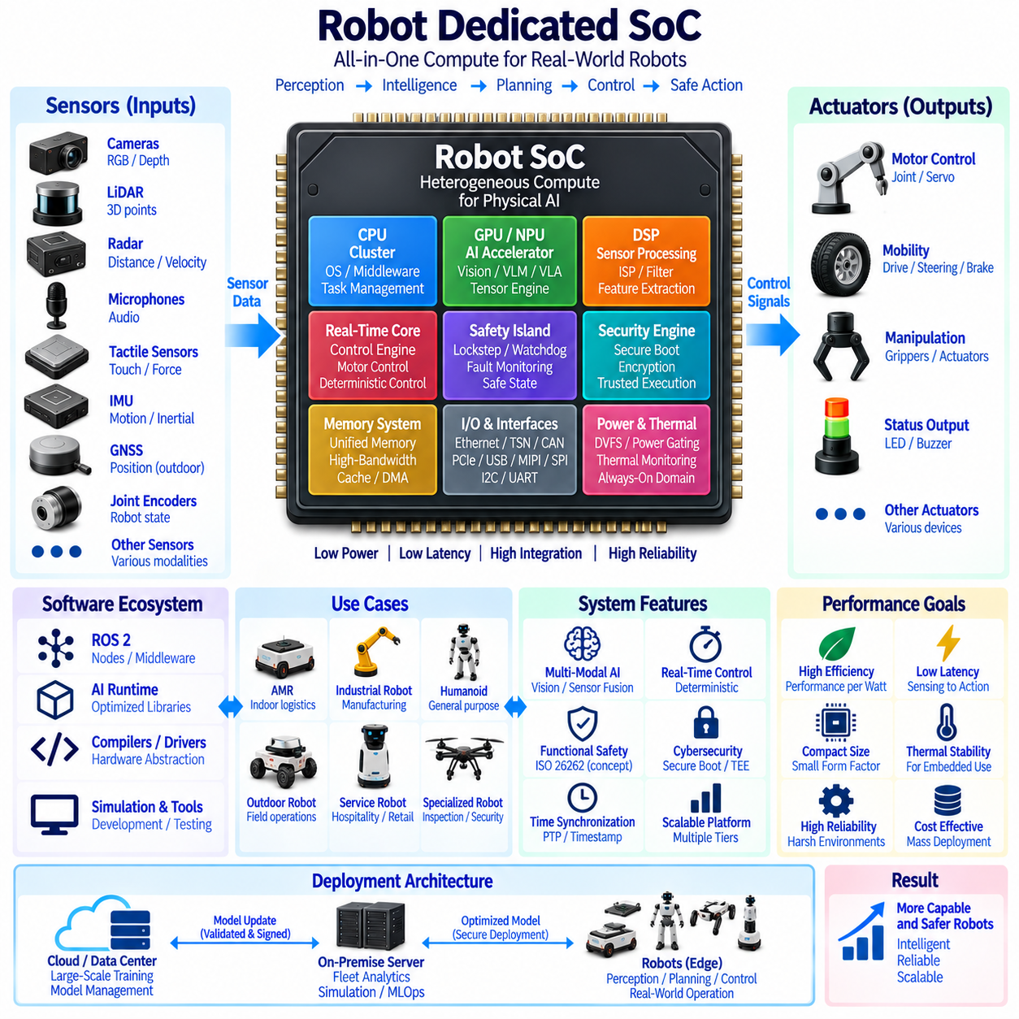
A Robot Dedicated SoC is a system-on-chip designed specifically for the computational, communication, sensing, control, safety, and artificial intelligence requirements of robotic systems. Unlike general-purpose processors adapted from PCs, servers, or mobile devices, a robot-specific SoC integrates heterogeneous computing resources around the real-time interaction loop between perception, intelligence, planning, and physical action. Its objective is to reduce size, power, latency, cost, and system complexity while increasing integration and reliability.
Modern robots require several fundamentally different forms of computation. High-level AI workloads demand massive parallel processing, deterministic control requires predictable execution timing, sensor pipelines require continuous high-bandwidth processing, and safety functions must remain available even when complex software fails. A dedicated SoC can integrate CPU cores, GPU or NPU accelerators, DSPs, microcontrollers, memory controllers, security engines, and specialized interfaces into a coordinated architecture optimized for these simultaneous requirements.
The CPU subsystem provides general-purpose computation for the operating system, middleware, task management, communication protocols, navigation software, and system orchestration. Multicore CPU clusters can separate high-level application workloads from infrastructure services and critical management functions. Virtualization or hardware isolation can further divide execution domains, allowing Linux-based AI software, real-time applications, and supervisory functions to coexist without unrestricted interference between them.
AI acceleration is a central element because perception and increasingly decision-making depend on neural networks. Integrated GPUs, NPUs, tensor accelerators, or specialized matrix engines can execute object detection, segmentation, depth estimation, localization, multimodal fusion, transformer models, and other neural workloads. Compared with using separate accelerator cards, on-chip integration can reduce communication distance and eliminate some external interfaces, improving energy efficiency and sensing-to-inference latency.
Future robot SoCs must increasingly support multimodal Physical AI. A robot may simultaneously process RGB cameras, depth cameras, LiDAR, radar, microphones, tactile sensors, IMUs, GNSS, joint encoders, and internal diagnostic signals. Dedicated preprocessing engines can perform image signal processing, filtering, compression, feature extraction, timestamp handling, or sensor synchronization before data reaches larger AI accelerators, preventing unnecessary raw data from consuming high-value compute resources.
Real-time control requires a different execution domain from high-capacity AI inference. Motor control, actuator coordination, stabilization, steering, braking, joint control, and emergency behavior may require deterministic cycles that cannot depend on GPU scheduling or variable neural-network latency. Robot-dedicated SoCs can therefore incorporate real-time CPU cores, lockstep processors, microcontroller islands, or dedicated control engines that continue operating independently from the primary application processors.
This separation enables a hierarchical control architecture. High-level AI can interpret the environment, generate goals, select behaviors, or calculate trajectories, while real-time processors execute validated commands within defined physical constraints. If the high-level AI becomes overloaded, crashes, or produces an invalid command, lower-level controllers can maintain actuator limits and safe states. Dedicated hardware boundaries consequently help separate probabilistic intelligence from deterministic machine control.
Functional safety can be designed directly into the SoC architecture. Safety islands may contain independent processors, memory, watchdogs, clock sources, diagnostic logic, and communication interfaces. Lockstep execution, error-correcting memory, memory protection, fault monitoring, and hardware watchdogs can detect selected failures before they propagate into physical actions. Such mechanisms are particularly important for autonomous mobile robots, industrial robots, humanoids, outdoor platforms, and other machines operating near people.
Cybersecurity is equally important because a highly integrated robot processor controls both digital information and physical behavior. Secure boot can verify firmware and software before execution, while hardware roots of trust can protect cryptographic keys and device identities. Secure storage, memory isolation, authenticated updates, trusted execution environments, hardware encryption, and anti-rollback mechanisms can protect software, AI models, configuration data, and communication credentials throughout the robot lifecycle.
A robot-dedicated SoC also requires extensive communication interfaces. Ethernet, time-sensitive networking, CAN, CAN FD, UART, SPI, I2C, PCIe, USB, MIPI CSI, and other interfaces may connect sensors, actuators, storage, external accelerators, and vehicle controllers. Integrating these interfaces reduces the number of external bridge devices and enables tighter control over bandwidth, synchronization, diagnostics, security, and real-time communication across the complete robot electronics architecture.
Time synchronization is especially important in sensor-rich Physical AI systems. Camera frames, LiDAR points, radar measurements, IMU samples, actuator states, and localization information must often be aligned within a common temporal reference. Hardware timestamping, precision time protocol support, synchronized sensor triggers, and deterministic communication paths can reduce timing uncertainty. Accurate temporal alignment improves sensor fusion, mapping, localization, perception, and training-data quality.
Memory architecture strongly influences SoC performance because modern AI models require high bandwidth while embedded robots have strict power limitations. Shared memory can reduce unnecessary copies between CPU, GPU, NPU, and sensor-processing engines. High-bandwidth memory controllers, intelligent caching, local accelerator memory, compression, and direct-memory-access engines can keep data close to the processors that need it and reduce energy consumed by repeated movement of large sensor tensors and model parameters.
Unified memory can simplify heterogeneous execution when multiple processors need access to the same perception or planning data. A camera pipeline can write a frame into shared memory, an AI accelerator can process it, a CPU can interpret the resulting objects, and a planning engine can consume the representation without repeated full-buffer copying. Zero-copy or low-copy data paths are therefore important architectural objectives for reducing end-to-end latency in robotic perception loops.
Power management is another defining requirement because many robots operate from batteries. Different compute domains do not need maximum performance continuously, so dynamic voltage and frequency scaling, clock gating, power gating, sleep states, and workload-aware scheduling can reduce average consumption. An always-on low-power domain can monitor essential sensors while larger AI engines remain inactive until required, allowing the SoC to balance computational capability with mission endurance.
Thermal design is closely connected to power management. Unlike data-center accelerators, robot processors may operate inside compact sealed enclosures with limited airflow and near batteries, sensors, or actuators. The SoC must sustain required performance without creating excessive heat that reduces reliability or forces large cooling systems. Thermal sensors, dynamic workload migration, power limits, frequency control, and efficient packaging can maintain operation within the robot's thermal envelope.
Packaging and physical integration can further differentiate a robot-specific SoC. The processor may be combined with memory, power-management components, communication devices, or security elements through advanced packaging or system-in-package techniques. Reduced board area enables smaller computing modules and shorter electrical paths. This can improve electromagnetic compatibility, mechanical robustness, and resistance to vibration while simplifying installation in compact robotic platforms.
Hardware-software co-design is essential because a robot SoC cannot be evaluated independently from its software ecosystem. Operating systems, ROS 2, middleware, AI runtimes, compilers, device drivers, safety software, simulation environments, and deployment tools must efficiently use the heterogeneous hardware. Standard APIs and abstraction layers allow applications to exploit accelerators without embedding excessive hardware-specific logic throughout the robotics software stack.
ROS 2 integration is particularly important for practical deployment. Hardware acceleration can be exposed through optimized libraries, ROS 2 nodes, zero-copy communication, shared-memory transport, or accelerator-aware middleware. Sensor and AI pipelines should avoid unnecessary serialization and memory duplication. Deterministic communication mechanisms can coexist with ordinary ROS 2 traffic so that perception, planning, diagnostics, and control workloads receive communication behavior appropriate to their timing requirements.
Robot-dedicated SoCs can also include acceleration for localization and mapping. Visual odometry, feature extraction, stereo depth, point-cloud processing, scan matching, occupancy generation, and sensor fusion repeatedly consume substantial computing resources in autonomous robots. Specialized engines or optimized AI accelerators can reduce the CPU and GPU load associated with these operations, leaving more resources available for semantic understanding, planning, and higher-level intelligence.
As Physical AI evolves, transformer, VLM, VLA, and compact world-model inference will become increasingly relevant at the edge. Future SoCs may therefore include tensor engines optimized for attention, low-precision matrix operations, sparsity, quantization, and large shared memory bandwidth. The objective is not necessarily to execute the largest foundation model locally, but to support compressed, distilled, or task-specialized models that provide useful multimodal reasoning within robot power and latency limits.
Model deployment requires hardware support for multiple numerical formats. INT8, INT4, FP16, BF16, and potentially lower-precision or mixed-precision representations can provide different balances among accuracy, throughput, memory capacity, and energy. Efficient quantized execution allows larger models to fit within embedded memory budgets. Hardware-aware model optimization can therefore become a standard step between centralized training and deployment onto robot-dedicated SoCs.
The SoC can operate as the primary edge intelligence layer within a larger centralized and distributed architecture. Robots execute latency-critical perception, localization, planning, control, and safety locally, while on-premise servers or cloud infrastructure perform large-scale training, fleet analytics, simulation, model management, and historical analysis. Updated models can then be validated, optimized, signed, and deployed back to compatible robot SoCs through controlled lifecycle management.
Fleet deployment increases the importance of hardware consistency. When hundreds or thousands of robots share a common SoC platform, software versions, AI runtimes, model optimization, diagnostics, cybersecurity policies, and performance characteristics become easier to standardize. A common hardware abstraction also simplifies fleet learning because data generated by different robots can be interpreted within known sensor, timestamp, compute, and software configurations.
At the same time, robot families may require multiple SoC performance tiers. Small indoor AMRs may prioritize low power and cost, outdoor autonomous robots may require additional perception and communication capacity, while humanoids or advanced manipulation platforms may demand much greater AI and control performance. A scalable SoC architecture can reuse common software and safety concepts while varying CPU cores, accelerator capacity, memory bandwidth, interfaces, and power envelopes.
Reliability must account for harsh robotic operating conditions. Temperature cycles, vibration, shock, electromagnetic interference, unstable power conditions, and long operating periods can affect embedded electronics. Error correction, fault detection, watchdogs, voltage monitoring, thermal monitoring, diagnostic interfaces, and degraded operating modes can improve resilience. The processor should support predictable recovery rather than allowing a single compute fault to produce uncontrolled physical behavior.
A robot-specific SoC can also reduce total system complexity. Separate CPUs, GPUs, microcontrollers, interface bridges, security chips, and sensor processors require additional boards, connectors, power converters, cooling structures, and software integration. Consolidating suitable functions into one device can reduce component count and communication overhead. However, excessive integration can create a single point of failure, so independent safety and redundancy requirements must remain part of the system design.
Benchmarking should therefore evaluate complete robotic workloads rather than only peak AI throughput. Relevant measures include sensing-to-action latency, AI performance per watt, memory bandwidth, deterministic control latency, sensor throughput, idle power, thermal stability, model compatibility, safety capability, communication performance, and end-to-end application efficiency. A processor with high theoretical TOPS may perform poorly in a robot if memory, software, I/O, or thermal limitations prevent effective utilization.
Robot Dedicated SoC represents a convergence point for many future computing technologies. Conventional digital AI acceleration can coexist with in-memory computing, event-driven processing, neuromorphic subsystems, specialized safety processors, and advanced sensor interfaces. Not every technology needs to be integrated immediately, but the SoC provides a platform where selected accelerators can progressively move closer to sensing and control as their maturity and practical value increase.
Within future Physical AI computing, the strategic significance of a robot-dedicated SoC is the transition from adapting general-purpose computing hardware to designing silicon around the robot itself. Perception, AI inference, real-time control, safety, communication, security, memory, and power management become parts of one coordinated architecture. This enables optimization around the complete physical interaction loop rather than optimizing isolated computational benchmarks.
The long-term objective is a compact computing platform capable of supporting increasingly intelligent robots without proportional increases in power consumption, thermal load, electronics volume, or integration complexity. By combining heterogeneous compute, shared memory, deterministic control, AI acceleration, sensor processing, safety, and security, a robot-dedicated SoC can become the central electronic foundation of scalable Physical AI platforms operating from individual robots to large autonomous fleets.

09.05. In-Memory Computing
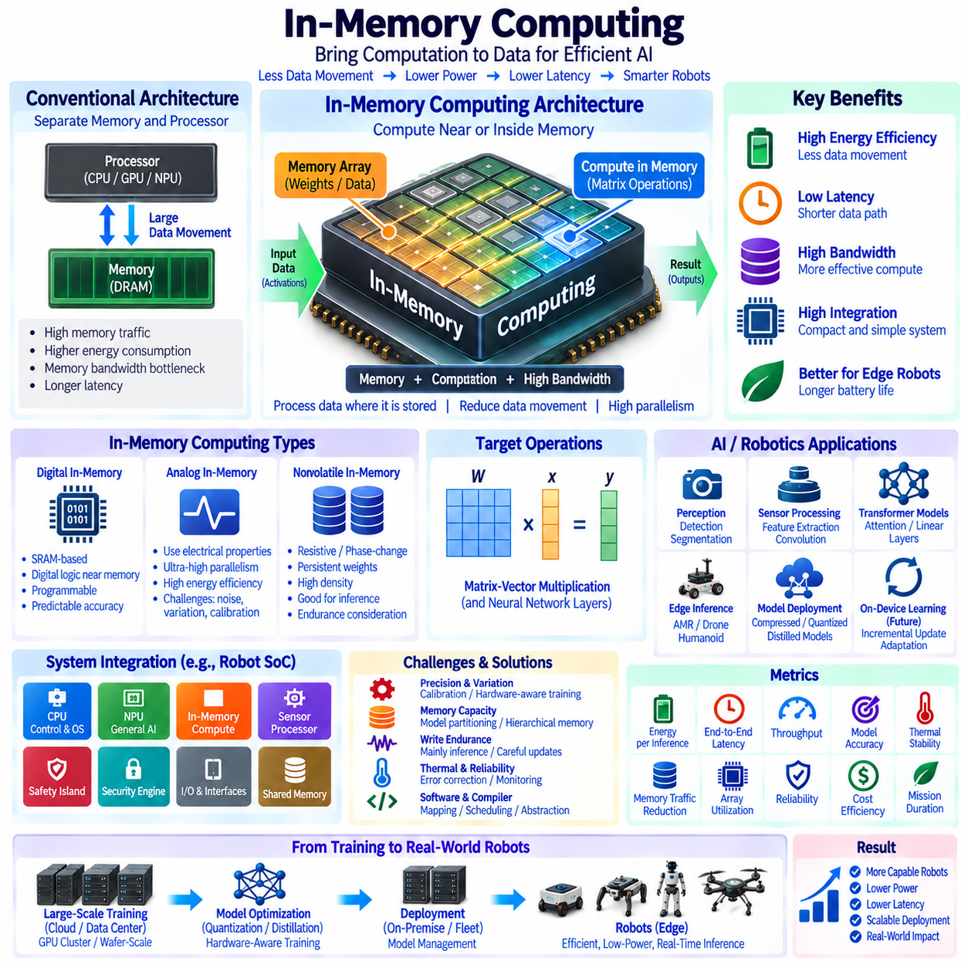
In-memory computing moves selected computation into or immediately adjacent to memory so that data does not need to travel repeatedly between separate memory and processing units. This approach addresses one of the fundamental limitations of modern AI systems: the energy, latency, and bandwidth cost of moving large quantities of model parameters and intermediate data. For Physical AI, reducing this movement can improve edge inference efficiency under strict power and thermal constraints.
Conventional computing generally follows a processor-memory separation in which CPUs, GPUs, or accelerators retrieve data from memory, perform operations, and write results back. As neural networks grow, arithmetic units can become increasingly capable while memory traffic remains a major bottleneck. In-memory computing changes this relationship by allowing memory structures to participate directly in computation or perform operations near stored data.
The central objective is to minimize the so-called memory wall. AI workloads repeatedly access weights, activations, feature maps, attention matrices, and other tensors, and the energy required to move these values can exceed the energy required for the arithmetic itself. By processing information where it is stored, in-memory computing can reduce memory transactions, shorten data paths, and increase effective computational bandwidth.
Processing-in-memory and compute-in-memory represent closely related architectural concepts. Processing-in-memory can place programmable logic or processing elements near memory arrays, while compute-in-memory allows memory cells or arrays themselves to participate more directly in mathematical operations. The exact boundary varies by implementation, but both approaches seek to reduce communication between physically separated storage and computation domains.
Matrix-vector multiplication is an important target because it dominates many neural-network workloads. Instead of transferring a complete weight matrix into conventional multiply-and-accumulate units, an in-memory architecture can keep weights resident in memory arrays and apply input vectors directly to those structures. Large numbers of weighted operations can then be executed close to the stored parameters, substantially reducing repeated weight movement.
Digital in-memory computing performs such operations using digital circuit techniques. SRAM or other digital memory structures can be modified with local logic that supports multiplication, accumulation, bitwise operations, comparison, or other functions. Digital implementations preserve many advantages of conventional binary computation, including predictable numerical behavior, while reducing the distance between data storage and arithmetic operations.
Analog in-memory computing uses electrical properties of memory arrays to perform mathematical operations. Conductance, current, voltage, or charge can represent values and contribute directly to multiplication and accumulation. This can provide extremely high parallelism and energy efficiency, particularly for matrix operations, but introduces challenges involving precision, noise, device variation, conversion circuitry, calibration, and long-term stability.
In-memory computing and analog AI therefore overlap but are not identical concepts. Analog AI emphasizes computation through physical analog quantities, while in-memory computing emphasizes reducing data movement by performing computation within or near memory. An in-memory architecture can be digital, analog, or mixed-signal, and an analog accelerator does not necessarily need to use memory cells as the primary computational structure.
Memory technology determines many characteristics of the architecture. SRAM offers high speed and compatibility with established semiconductor processes but has relatively low storage density. Emerging nonvolatile technologies such as resistive RAM, phase-change memory, magnetic memory, and other programmable devices can potentially combine parameter storage and computation with higher density, although endurance, variability, programming accuracy, and manufacturing maturity remain important considerations.
Nonvolatile in-memory computing can be especially attractive for neural-network inference because trained weights may remain stored even when power is removed. A robot can potentially retain selected model parameters directly within the compute arrays and avoid repeatedly loading them from external storage during startup. This can reduce initialization overhead and support compact always-ready inference subsystems, depending on the underlying memory technology.
Weight-stationary execution naturally complements in-memory computing. Neural-network weights remain close to their computational location while streams of activations are applied repeatedly. This is valuable for robotic perception models that continuously process camera, radar, audio, tactile, or other sensor inputs using the same trained parameters. The more frequently a model is reused, the greater the potential benefit of avoiding repeated weight transfers.
Sensor processing is therefore a promising application for Physical AI. Feature extraction, convolution, projection, classification, segmentation, and selected transformer operations contain large amounts of repetitive matrix computation. In-memory acceleration can execute suitable portions of these pipelines with lower energy, leaving CPUs, GPUs, and NPUs available for irregular processing, high-level reasoning, planning, and general-purpose robotics software.
Transformer models create additional opportunities because their linear layers contain large matrix multiplications and significant parameter movement. Selected projection, feed-forward, or attention-related operations may be mapped onto in-memory accelerators. However, dynamic activations, nonlinear operations, normalization, control logic, and intermediate data movement still require conventional processing, making heterogeneous execution more practical than attempting to move the entire transformer into memory.
Physical AI foundation models can benefit from this heterogeneous approach. Large models may be trained centrally using GPU clusters or wafer-scale infrastructure and then compressed, quantized, distilled, or partitioned for robotic deployment. Frequently executed layers can be mapped to in-memory accelerators, while flexible or dynamically changing functions remain on CPUs, GPUs, or NPUs. The complete system can therefore optimize energy without sacrificing general programmability.
Memory capacity remains a practical limitation. A large model may contain more parameters than available in-memory compute arrays can hold, requiring partitioning across multiple arrays or memory tiers. Model mapping software must determine which parameters remain resident, which operations execute locally, and when data must move between conventional and in-memory resources. Poor partitioning can eliminate much of the expected efficiency advantage.
Dataflow architecture is therefore critical. Intermediate tensors should move through the system with as few unnecessary copies as possible. Direct-memory access, shared memory, local buffers, accelerator interconnects, and carefully designed scheduling can connect in-memory compute with other processors. The objective is not merely to accelerate one matrix operation but to reduce total end-to-end data movement across the complete inference pipeline.
Precision represents another important design variable. AI inference increasingly uses INT8, INT4, FP16, BF16, mixed precision, and other compact numerical formats. In-memory computing architectures can exploit reduced precision to increase storage density, parallelism, and energy efficiency. However, the model must maintain acceptable accuracy, and hardware-aware quantization can be necessary to account for the numerical characteristics of the target memory architecture.
Hardware-aware training can further improve deployment. Training procedures can model limited precision, memory-cell variation, analog noise, saturation, device drift, or other implementation effects so that neural networks become more tolerant of the actual hardware. This is especially important for analog or emerging-memory implementations where physical computation differs from ideal mathematical operations assumed by conventional software frameworks.
Calibration can compensate for predictable hardware variation. Memory arrays may be characterized during manufacturing, startup, or operation, and correction factors can be applied through digital logic or software. Temperature monitoring, reference cells, redundancy, adaptive scaling, and periodic recalibration can improve consistency. For robots operating across changing environmental conditions, calibration must remain practical throughout the expected operational lifetime.
Write endurance becomes important when memory devices are frequently updated. Inference workloads can keep model weights relatively stable, making them easier to support than continuous on-device training. Online learning, however, may require repeated parameter modifications that accelerate wear in some nonvolatile memory technologies. The architecture must therefore consider whether memory is used primarily for inference, occasional model updates, or continuous adaptation.
Training in memory is a longer-term possibility. If weight updates and gradient-related operations can be executed close to stored parameters, some of the enormous data movement associated with AI training could be reduced. However, training demands greater numerical stability, frequent writes, optimizer state, and complex communication. Centralized digital accelerators may therefore remain dominant while in-memory techniques progressively accelerate selected training operations.
Power efficiency is one of the strongest motivations for robotics. Battery-powered systems must divide limited energy among locomotion, sensing, communication, computation, cooling, and payload functions. Reducing AI memory traffic can lower computational power consumption and extend mission duration. It can also reduce cooling requirements, enabling smaller edge modules and creating more design freedom for compact AMRs, drones, humanoids, and inspection robots.
Lower latency provides another benefit. When weights and computation are physically close, repeated transfers through external memory buses can be reduced. This can shorten inference pipelines for perception and prediction tasks. In safety-sensitive robotic systems, however, average latency alone is insufficient; worst-case latency, memory contention, scheduling behavior, and failure conditions must also be understood before outputs influence physical control.
In-memory computing should therefore be integrated within a hierarchical robot architecture. Deterministic control and safety functions can remain on verified real-time processors, while in-memory accelerators support suitable neural workloads. CPUs manage system software and orchestration, GPUs or NPUs execute flexible high-capacity models, and specialized memory-centric engines accelerate repetitive operations. Each computing domain serves the workload characteristics for which it is best suited.
Integration into a Robot Dedicated SoC is a natural future direction. In-memory compute arrays could coexist with CPU clusters, NPUs, sensor processors, safety islands, security engines, and shared memory within a single device or advanced package. Such integration would shorten communication paths further and allow the SoC scheduler to place neural-network layers dynamically across conventional and memory-centric execution resources according to power, latency, and accuracy requirements.
Software support remains essential for practical adoption. Compilers must identify compatible operations, partition neural networks, allocate memory arrays, schedule data transfers, apply quantization, and generate hardware-specific execution plans. AI frameworks and robotics middleware should expose these capabilities through usable abstractions so developers do not need to manually control individual memory cells or accelerator arrays.
ROS 2 integration can occur above this hardware abstraction. A perception node may invoke an optimized inference runtime without needing to know whether individual neural layers execute on an NPU, GPU, or in-memory accelerator. Zero-copy communication and shared-memory transport can further reduce unnecessary data movement at the software level, extending the same memory-centric principle from semiconductor architecture into the complete robotics data pipeline.
Reliability requires mechanisms for detecting defective or degraded memory cells and compute regions. Error correction, redundancy, self-test, fault mapping, spare resources, and fallback execution can maintain service when selected elements become unreliable. Because the memory also participates in computation, faults can affect both stored parameters and arithmetic results, making health monitoring particularly important for long-lived autonomous systems.
Cybersecurity must protect model parameters stored directly in computational memory. Secure boot, authenticated model loading, encrypted external communication, access control, memory isolation, hardware roots of trust, and secure update mechanisms can prevent unauthorized model replacement or extraction. If persistent memory stores neural weights across power cycles, secure erasure and lifecycle management also become important when hardware is repaired, transferred, or decommissioned.
Benchmarking should evaluate complete system behavior rather than theoretical operations alone. Relevant metrics include energy per inference, memory traffic reduction, end-to-end latency, throughput, model accuracy, effective precision, array utilization, write endurance, thermal behavior, calibration stability, silicon area, and software overhead. Comparisons should include the cost of data conversion, movement between accelerators, and any processing that remains outside the memory arrays.
At the fleet level, efficient in-memory inference can allow robots to perform more intelligence locally while transmitting less raw information to centralized infrastructure. Edge systems can generate semantic features, detections, trajectories, or selected events, while central servers perform large-scale training, simulation, fleet learning, and model governance. Validated models can then return to the robots as optimized deployments mapped to their local compute architecture.
In-memory computing consequently complements neuromorphic computing, analog AI, wafer-scale computing, and robot-dedicated SoCs within future AI computing. Neuromorphic systems reduce unnecessary activity through event-driven processing, analog AI exploits physical electrical computation, wafer-scale systems maximize centralized integration, and robot SoCs integrate heterogeneous edge functions. In-memory computing specifically attacks the cost of moving data between memory and computation.
The long-term significance of in-memory computing lies in changing memory from a passive storage resource into an active part of the computational architecture. As AI models continue to grow, simply increasing arithmetic throughput cannot solve the energy and bandwidth limitations created by data movement. Bringing computation to stored parameters provides a path toward higher efficiency without requiring every value to repeatedly cross conventional processor-memory boundaries.
Future Physical AI platforms may therefore combine centralized GPU or wafer-scale training with heterogeneous edge systems containing CPUs, NPUs, neuromorphic engines, analog accelerators, and in-memory compute. The architectural objective is to keep data and computation as close as practical while preserving flexibility, safety, reliability, and programmability. In-memory computing becomes a key technology for building compact, low-latency, energy-efficient intelligence that can operate continuously inside real-world autonomous machines.

