Volume 17 Outdoor Autonomous Vehicle

Chapter 05. Inspection Vehicle

05.01. NDT Sensor Integration
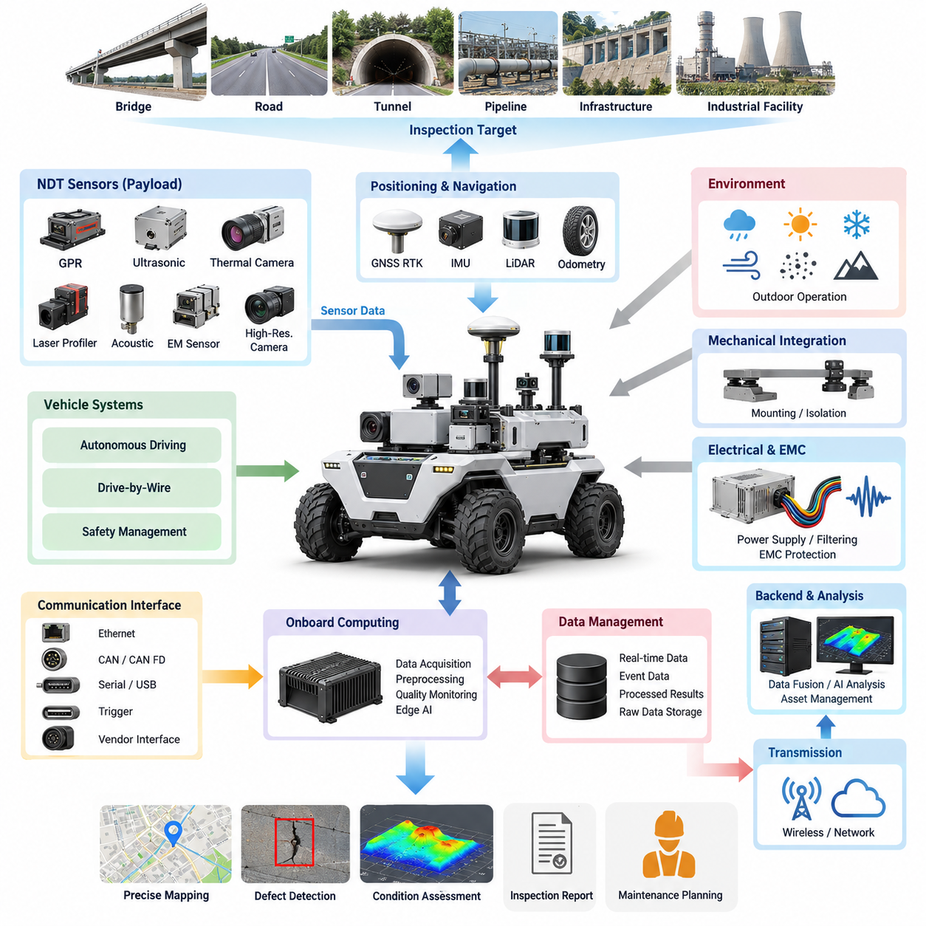
Non-Destructive Testing (NDT) sensor integration transforms an outdoor autonomous inspection vehicle from a mobile observation platform into a measurement system capable of evaluating infrastructure condition without damaging the inspected asset. Within the inspection-vehicle architecture, NDT sensors operate as specialized payloads that must be coordinated with vehicle motion, positioning, computing, power, communication, and safety functions.
Unlike conventional perception sensors used primarily for localization and obstacle detection, NDT sensors measure physical characteristics associated with structural integrity, material condition, geometry, thermal behavior, or subsurface anomalies. Typical inspection payloads may include ground-penetrating radar, ultrasonic devices, thermal cameras, laser profilers, acoustic sensors, electromagnetic instruments, and high-resolution imaging systems selected according to the target infrastructure and required inspection depth.
Sensor integration begins with defining the relationship between the measurement principle and vehicle motion. Some instruments can acquire reliable measurements while the vehicle travels continuously, whereas others require controlled speed, constant sensor-to-surface distance, stable orientation, or temporary stopping. The autonomous driving system must therefore treat inspection requirements as mission constraints rather than operating the NDT payload independently from vehicle trajectory planning.
Mechanical integration strongly influences measurement quality. Sensors mounted on an outdoor vehicle experience vibration, shock, chassis deformation, suspension movement, and changing surface geometry. Mounting structures must maintain the required field of view, standoff distance, alignment, and rigidity while protecting sensitive equipment. Isolation mechanisms can reduce harmful vibration, but excessive compliance may introduce sensor motion that degrades spatial accuracy or complicates calibration.
Electrical integration requires more than supplying the nominal voltage of each instrument. NDT payloads may contain transmitters, high-speed acquisition electronics, heaters, illumination devices, motors, or processing units that create highly variable power demands. Dedicated power branches, appropriate circuit protection, grounding, filtering, and controlled startup sequences help prevent payload disturbances from propagating into navigation, drive-by-wire, safety, or computing systems.
Electromagnetic compatibility is particularly important when active NDT instruments operate near GNSS receivers, communication radios, cameras, LiDAR, vehicle controllers, and high-current motor drives. Ground-penetrating radar and other active measurement devices may generate broadband electromagnetic energy, while inverters and DC/DC converters can contaminate sensitive inspection signals. Physical separation, cable shielding, grounding strategy, filtering, and synchronized operating modes should therefore be considered at system level.
Accurate inspection requires every measurement to be associated with a reliable spatial and temporal reference. GNSS RTK can provide outdoor absolute positioning, while IMU, wheel odometry, LiDAR localization, and vehicle-state information can support continuity when satellite reception deteriorates. The NDT acquisition timestamp should be aligned with the localization timeline so that detected anomalies can later be mapped to precise infrastructure coordinates rather than merely associated with an approximate vehicle position.
Time synchronization becomes increasingly critical when multiple inspection sensors are fused. A thermal anomaly, radar reflection, surface crack image, and laser-derived geometric defect may describe the same physical location but arrive through different interfaces and processing pipelines. Hardware timestamps, synchronized clocks, deterministic acquisition triggers, or network-based synchronization allow these heterogeneous measurements to be reconstructed within a common mission timeline.
Calibration must include both intrinsic sensor characteristics and the geometric relationship between each NDT device and the vehicle coordinate system. Mounting position, orientation, sensor origin, measurement axis, and effective sensing footprint should be represented through defined transforms. Calibration errors that appear insignificant at the sensor bracket can produce substantial mapping errors when measurements are projected onto roads, tunnels, bridges, utility corridors, or other large infrastructure assets.
The onboard computing architecture should separate real-time acquisition from computationally expensive interpretation. A local edge computer can collect raw sensor streams, perform timestamping, quality monitoring, compression, preliminary filtering, and anomaly screening while the vehicle is moving. More demanding reconstruction, multimodal fusion, historical comparison, or AI-based defect classification can then be executed by higher-performance onboard computing or transferred to backend infrastructure.
Communication interfaces vary significantly among NDT instruments. Industrial Ethernet, Gigabit Ethernet, CAN, CAN FD, serial communication, USB, trigger lines, and vendor-specific interfaces may coexist within one inspection vehicle. Rather than connecting every instrument directly to application software, an integration layer should normalize sensor status, timestamps, measurement metadata, diagnostics, and data transport while preserving access to raw measurements required for engineering analysis.
Inspection data can be substantially larger than ordinary vehicle telemetry. High-resolution images, thermal sequences, radar profiles, point clouds, and waveform data may accumulate continuously throughout a long mission. The architecture should therefore distinguish between real-time operational data, event-triggered diagnostic information, processed inspection results, and archival raw data. Local buffering prevents temporary communication loss from causing irreversible gaps in inspection records.
Data quality monitoring should occur during acquisition rather than only after a mission has finished. The system can evaluate missing frames, excessive vibration, invalid sensor range, temperature limits, synchronization errors, GNSS degradation, communication faults, or unexpected changes in signal statistics. When measurement quality falls below defined thresholds, the vehicle may reduce speed, repeat a segment, modify its trajectory, or mark the affected region for later reinspection.
Sensor fusion provides greater value when NDT measurements are interpreted together rather than as independent channels. Surface imagery can identify visible deterioration, thermal sensing can reveal abnormal heat patterns, geometric profiling can quantify deformation, and subsurface sensing can expose hidden discontinuities. Combining these observations with vehicle position and infrastructure maps enables the inspection system to build a spatially coherent representation of asset condition.
Autonomous inspection also requires mission-aware trajectory generation. The best navigation path is not always the best sensing path. Inspection planning may specify lane spacing, scanning overlap, sensor orientation, maximum velocity, minimum turning radius, repeated passes, or directional constraints required by the measurement technology. Consequently, the mission planner should translate inspection coverage requirements into executable vehicle trajectories while respecting autonomous-driving and safety constraints.
Functional separation between mobility and inspection is important for fault containment. Failure of an NDT sensor should normally degrade inspection capability without directly compromising steering, braking, obstacle detection, or emergency stopping. Conversely, a localization or vehicle-control fault must prevent inspection data from being incorrectly presented as trustworthy spatial measurements. Explicit health states and fault propagation rules allow the system to distinguish measurement failure from vehicle-safety failure.
Environmental robustness determines whether laboratory-quality sensing can become practical field inspection. Outdoor NDT payloads may encounter rain, dust, mud, temperature variation, direct sunlight, condensation, vibration, electromagnetic interference, and uneven terrain. Enclosures, connectors, optical windows, thermal management, drainage, cleaning mechanisms, and mounting protection should be designed according to both the sensor specification and the vehicle's intended operating environment.
A well-integrated inspection vehicle maintains traceability from the original sensor observation to the final defect record. Each inspection result should retain relevant information such as sensor identity, calibration state, acquisition time, vehicle pose, processing version, confidence or quality indicators, and associated raw-data references. This traceability supports engineering review, repeated inspection, trend analysis, maintenance decisions, and validation of AI-generated defect classifications.
The final objective of NDT sensor integration is therefore not simply to install multiple inspection instruments on an autonomous vehicle. It is to create a coordinated measurement architecture in which sensing, mobility, positioning, timing, power, computing, communication, calibration, diagnostics, and data management operate as one system. This architecture forms the technical foundation for subsequent infrastructure inspection, transmission, payload-power, and inspection-AMR functions defined within the inspection-vehicle chapter.

05.02. Infrastructure Inspection
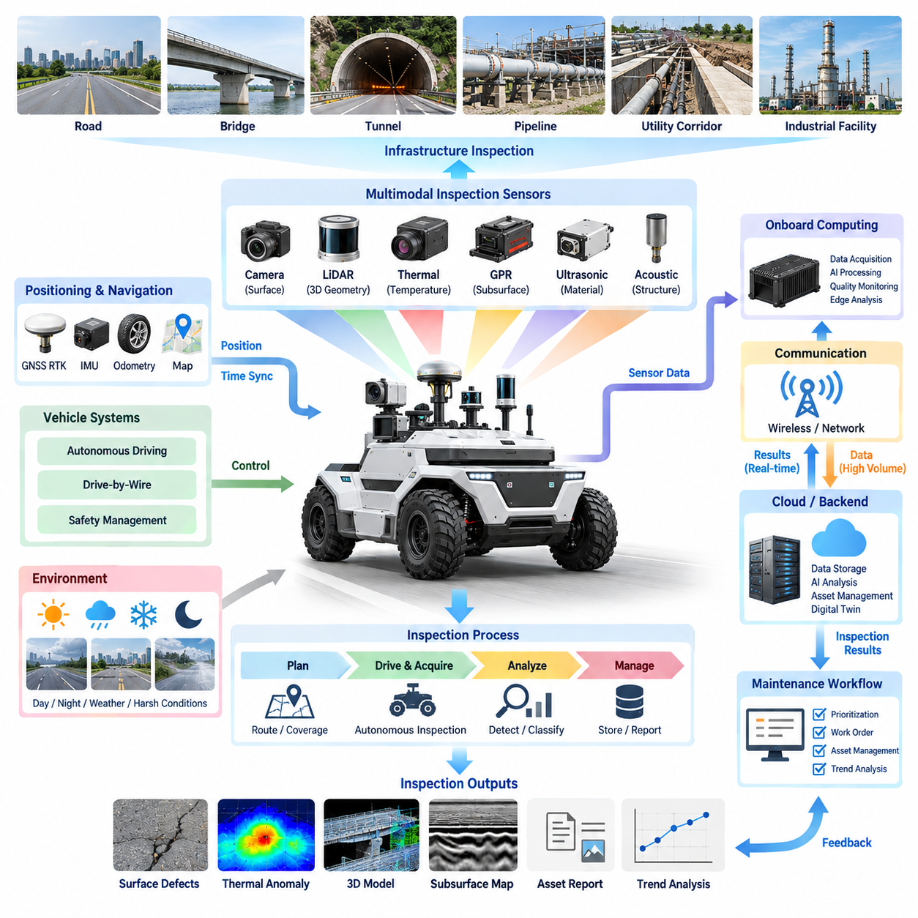
Infrastructure inspection using an outdoor autonomous vehicle combines mobility, sensing, localization, and automated analysis to evaluate the condition of roads, bridges, tunnels, pipelines, utility corridors, industrial facilities, and other civil assets. Within the inspection vehicle architecture, the vehicle becomes a repeatable data-acquisition platform capable of collecting geographically referenced evidence while following predefined inspection routes and operational constraints.
The inspection process begins by translating infrastructure maintenance objectives into measurable inspection requirements. Different assets require different observations: road surfaces may require crack, rutting, settlement, and subsurface assessment, while bridges may require structural surface imaging, thermal evaluation, geometric deformation measurement, and localized material examination. The vehicle mission must therefore define what must be measured, where measurements are required, and what spatial resolution is necessary.
Autonomous mobility provides an important advantage over manually operated inspection platforms because measurement trajectories can be reproduced systematically. GNSS RTK, IMU, LiDAR localization, wheel odometry, and infrastructure maps can be combined to maintain the vehicle pose during inspection. Accurate positioning allows observations from different sensors and different inspection dates to be associated with the same physical location, enabling condition changes to be analyzed over time.
Inspection route planning differs from ordinary point-to-point autonomous navigation. The vehicle must cover the required infrastructure surface while maintaining sensor-specific speed, orientation, spacing, and overlap constraints. A road inspection mission may require parallel passes along predefined lanes, while a facility inspection may require repeated trajectories near walls, pipes, equipment, or structural boundaries. Coverage completeness becomes an explicit mission-performance requirement.
Surface inspection commonly relies on high-resolution cameras, LiDAR, laser profilers, and related optical sensors. These devices can identify cracks, potholes, surface deterioration, deformation, missing components, corrosion-related visual features, and geometric irregularities. Vehicle motion must remain sufficiently stable to preserve image sharpness and geometric consistency, while illumination and exposure control should compensate for rapidly changing outdoor lighting conditions.
Thermal inspection adds information that cannot always be obtained from visible imagery. Temperature patterns can reveal abnormal heating, moisture-related effects, insulation problems, material discontinuities, or operational anomalies in infrastructure and industrial equipment. Because thermal measurements are influenced by sunlight, ambient temperature, wind, surface properties, and inspection time, environmental context should be recorded together with thermal observations to support reliable interpretation.
Subsurface inspection extends the inspection capability beyond visible infrastructure conditions. Ground-penetrating radar and other non-destructive testing sensors can provide information about underground structures, pavement layers, voids, discontinuities, buried objects, or material boundaries. These measurements must be precisely synchronized with vehicle position so that detected subsurface anomalies can be represented as spatially referenced inspection results rather than isolated sensor signals.
Three-dimensional inspection supports the quantitative evaluation of infrastructure geometry. LiDAR and laser profiling can generate point clouds or surface profiles that describe road shape, structural deformation, clearance, displacement, and dimensional changes. When repeated surveys are registered within a consistent coordinate framework, differences between inspection epochs can reveal gradual deterioration or geometric movement that may not be obvious from individual images.
Infrastructure inspection frequently requires multimodal sensing because no single sensor can characterize every defect mechanism. Visible cameras, thermal sensors, LiDAR, GPR, acoustic devices, and other NDT instruments observe different physical properties. Their measurements can be combined through a common spatial and temporal reference so that surface appearance, temperature, geometry, and subsurface characteristics contribute to a unified representation of infrastructure condition.
Onboard processing allows the vehicle to evaluate inspection quality while the mission is still in progress. Edge computing can monitor sensor availability, localization accuracy, image quality, signal strength, vehicle vibration, coverage, and synchronization status. Preliminary AI models may identify candidate anomalies or suspicious regions, enabling the vehicle to slow down, perform an additional pass, or collect higher-resolution measurements before leaving the inspection area.
Inspection reliability depends on distinguishing an actual infrastructure anomaly from a measurement artifact. Poor lighting, water, dust, vegetation, reflective surfaces, vibration, GNSS degradation, temporary objects, or sensor contamination may produce misleading observations. Quality indicators and contextual information should therefore accompany detected anomalies, allowing downstream analysis to determine whether a result represents physical deterioration, uncertain evidence, or an invalid measurement.
The inspection vehicle should maintain a digital relationship between sensor observations and the infrastructure asset being examined. Measurements can be associated with road segments, bridge components, tunnel sections, utility locations, or predefined inspection zones. This asset-centered organization makes the resulting information more useful than an unstructured collection of sensor files because maintenance personnel can retrieve inspection history according to physical infrastructure components.
Repeated autonomous inspection enables condition monitoring rather than one-time defect detection. By following comparable trajectories and maintaining consistent calibration and localization, the system can compare measurements collected across days, months, or years. Changes in crack dimensions, surface deformation, thermal patterns, subsurface signatures, or geometric profiles can then be evaluated as trends, providing evidence for deterioration rates and maintenance priorities.
Data management must preserve both processed inspection results and sufficient source information for later verification. Raw sensor data may be retained selectively according to storage capacity and inspection policy, while processed outputs can include anomaly coordinates, defect classifications, severity indicators, images, profiles, point clouds, and confidence values. Each result should remain traceable to its acquisition time, sensor configuration, calibration state, and vehicle pose.
Communication architecture determines how inspection information moves from the vehicle to remote engineering and asset-management systems. High-priority events and compact inspection summaries may be transmitted during operation, while large raw datasets can remain in onboard storage until higher-bandwidth connectivity becomes available. This separation reduces dependence on continuous wireless communication while preserving the ability to report critical findings during field operations.
Safety remains independent from inspection productivity. The vehicle must continue to respect obstacle avoidance, operational boundaries, drive-by-wire limitations, emergency stopping, and minimal-risk behavior even when inspection coverage would otherwise benefit from a different trajectory. If a required inspection path cannot be executed safely, the mission manager should record the incomplete region rather than allowing the inspection objective to override vehicle safety constraints.
Environmental conditions must also be incorporated into inspection planning. Rain, snow, dust, surface water, extreme temperature, strong sunlight, darkness, and electromagnetic interference may reduce the effectiveness of particular sensing technologies. The system can use environmental limits to determine whether an inspection should proceed normally, operate with reduced confidence, switch sensing modes, or postpone selected measurements until acceptable conditions are available.
Infrastructure inspection results become most valuable when converted into engineering information rather than remaining as raw sensor detections. Spatially referenced anomalies can be classified, prioritized, compared with previous inspections, and connected to maintenance workflows. Maps and digital asset records can present defect location, extent, confidence, severity, and supporting sensor evidence, allowing engineers to determine where detailed examination or physical intervention is required.
An autonomous inspection vehicle therefore acts as the connection between physical infrastructure and its evolving digital condition record. Its effectiveness depends not only on autonomous driving or individual sensor performance, but on coordinated mission planning, repeatable localization, multimodal sensing, quality monitoring, data traceability, and systematic interpretation. This foundation naturally connects infrastructure inspection with the subsequent data transmission, inspection-payload power, and inspection-AMR case architecture defined in the same chapter.

05.03. Data Transmission Architecture
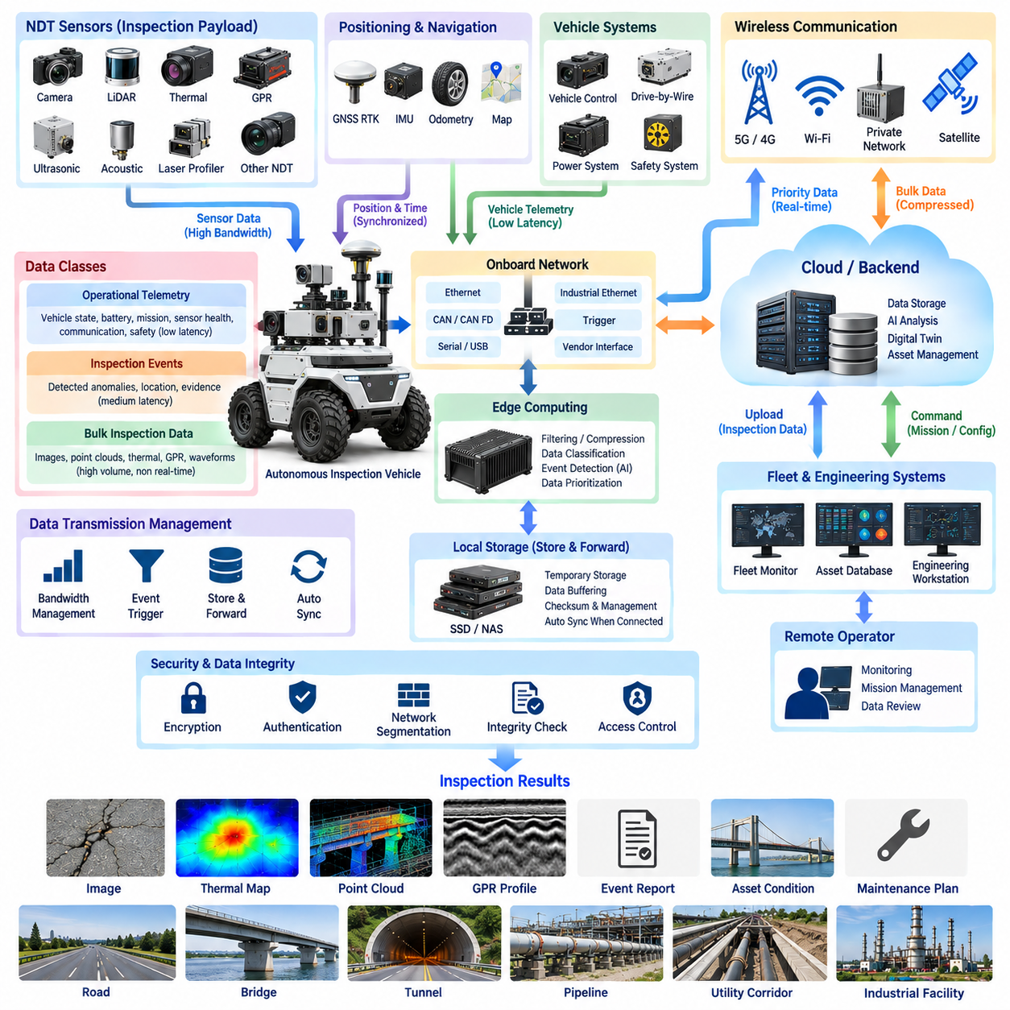
Data transmission architecture defines how inspection information moves from an outdoor autonomous vehicle to onboard storage, fleet systems, engineering workstations, edge infrastructure, and cloud or on-premise platforms. In an inspection vehicle, communication is not a single wireless link but a layered data path connecting NDT sensors, localization devices, vehicle controllers, computing nodes, storage, and remote services while preserving data integrity and operational continuity.
The architecture begins by classifying information according to operational importance, latency, bandwidth, and retention requirements. Vehicle-control and safety messages require predictable low latency, while inspection events may tolerate moderate delay. High-resolution images, LiDAR point clouds, thermal sequences, GPR profiles, and other raw NDT measurements can require substantial bandwidth but usually do not need continuous real-time transmission to the remote system.
This distinction leads naturally to multiple data classes. Real-time operational telemetry includes vehicle pose, speed, battery condition, mission status, sensor health, communication quality, and safety states. Inspection-event data contains detected anomalies and supporting evidence, while bulk inspection data includes raw imagery, point clouds, radar profiles, waveforms, and other high-volume records intended primarily for detailed engineering analysis or archival storage.
The onboard network provides the first stage of the transmission architecture. NDT instruments and perception sensors may use Gigabit Ethernet, industrial Ethernet, CAN, CAN FD, serial links, USB, or vendor-specific interfaces. Edge gateways and computing nodes should normalize these heterogeneous connections into controlled data streams while preserving timestamps, sensor identity, calibration metadata, and diagnostic information needed to reconstruct the original measurement context.
Ethernet is particularly suitable for high-bandwidth inspection payloads because cameras, LiDAR, thermal systems, and advanced NDT instruments can generate large continuous streams. CAN or CAN FD remains useful for compact deterministic information such as vehicle states, actuator feedback, power-system status, and device diagnostics. Separating high-volume sensor traffic from control-oriented communication reduces network congestion and limits interference between inspection and mobility functions.
Time synchronization must remain intact as data passes through different interfaces and computing layers. Sensor timestamps should correspond to a common system clock so that inspection measurements can be matched with GNSS RTK position, IMU orientation, LiDAR localization, and vehicle state. Transmission delays must not be mistaken for acquisition time, because accurate infrastructure mapping depends on where and when the measurement was physically collected rather than when it reached the backend.
An edge data layer can perform filtering, aggregation, compression, encoding, and prioritization before information leaves the vehicle. Raw sensor streams do not always need to be transmitted unchanged. The edge computer can generate thumbnails, reduced-resolution previews, anomaly descriptors, compressed point clouds, selected GPR segments, or summarized health information while retaining original high-fidelity measurements in local storage for later engineering analysis.
Store-and-forward operation is fundamental for outdoor inspection vehicles because wireless coverage cannot be assumed throughout the mission. Tunnels, underground areas, industrial facilities, remote roads, ports, and dense urban structures can interrupt external connectivity. The vehicle should continue collecting and storing inspection data locally during communication loss and automatically resume synchronization when an appropriate network connection becomes available.
Local storage therefore acts as part of the communication architecture rather than merely as an archive. A structured buffer can maintain unsent data, transmission state, priority, timestamps, checksums, and destination information. When connectivity returns, the system can determine which records have already been delivered and which remain pending, preventing unnecessary retransmission while reducing the risk of missing inspection information.
External connectivity may combine cellular networks, private 5G, Wi-Fi, industrial wireless systems, or site-specific communication infrastructure depending on the deployment environment. The communication manager should evaluate link availability, signal quality, latency, bandwidth, and cost before selecting the appropriate path. Different interfaces may operate simultaneously, allowing critical telemetry to use one connection while bulk inspection transfer uses another higher-bandwidth channel.
Bandwidth management becomes essential when inspection sensors generate data faster than the wireless network can transmit it. Instead of treating every byte equally, the architecture should prioritize safety and operational telemetry, followed by alarms, anomaly evidence, mission summaries, and finally large raw datasets. This hierarchy allows remote operators to maintain situational awareness even when available communication capacity is significantly below the onboard data-generation rate.
Event-triggered transmission can further reduce unnecessary network load. When onboard analytics detects a crack, thermal anomaly, subsurface feature, localization problem, sensor failure, or safety-related event, the vehicle can immediately transmit a compact event package. Such a package may contain location, timestamp, event type, confidence, sensor status, and selected supporting data while the complete raw dataset remains stored onboard.
Remote monitoring systems require bidirectional communication rather than simple vehicle-to-server uploading. Fleet or control-center systems may send mission assignments, route modifications, inspection parameters, software configuration, or requests for additional data. The vehicle must distinguish these supervisory commands from low-level drive-by-wire control so that unreliable wide-area communication cannot directly compromise deterministic local vehicle-control and safety functions.
Communication failures should therefore produce controlled degradation rather than mission instability. Loss of cloud connectivity does not necessarily require the vehicle to stop if autonomous navigation, safety, localization, and data storage remain healthy. The system may continue the approved mission, enter a predefined restricted mode, return to a communication area, or transition to a minimal-risk condition depending on operational policy and the type of information that has become unavailable.
Data integrity must be protected across the complete transmission path. Sequence identifiers, checksums, message authentication, acknowledgement mechanisms, and retry policies can detect corrupted, duplicated, missing, or incomplete transfers. Large inspection datasets may be divided into manageable blocks so that interrupted transfers can resume from verified checkpoints instead of restarting an entire multi-gigabyte dataset after every network interruption.
Cybersecurity is inseparable from external data transmission because the inspection vehicle connects physical actuators and valuable infrastructure data to remote networks. Authentication, encryption, certificate or key management, access control, network segmentation, secure interfaces, and logging should protect both vehicle-bound commands and outbound inspection information. Remote engineering access should be separated from safety-critical control domains through explicitly managed gateways.
Backend architecture receives transmitted information and converts it into persistent operational and engineering records. Real-time telemetry may feed fleet monitoring dashboards, while inspection events can populate asset-condition databases and alert systems. Large datasets may be transferred to object storage, NAS, on-premise servers, or cloud platforms where AI analysis, multimodal fusion, reconstruction, digital-twin processing, and historical comparison can be performed.
A useful backend should maintain traceability between transmitted data and the physical inspection mission. Sensor records should remain associated with vehicle identity, mission identifier, acquisition timestamp, geographic position, calibration state, processing version, and infrastructure asset. This metadata allows engineers to reproduce analyses, compare repeated inspections, validate AI conclusions, and determine whether a reported defect originated from valid and complete source data.
The overall data transmission architecture therefore operates as an adaptive pipeline rather than a permanent high-bandwidth connection. Data is generated by sensors, synchronized and processed onboard, classified by importance, stored locally, selectively transmitted according to network conditions, verified at the destination, and integrated into fleet and engineering systems. This approach supports reliable infrastructure inspection even when communication availability is intermittent or bandwidth is constrained.
Within the broader robotics electrical architecture, this transmission design connects inspection sensing with onboard computing, robotics communication, fleet communication, cloud communication, and time synchronization while maintaining separation from safety-critical vehicle control. It also provides the communication foundation for the inspection payload power and complete inspection-AMR case architecture that follow within the Inspection Vehicle chapter.

05.04. Power for Inspection Payload
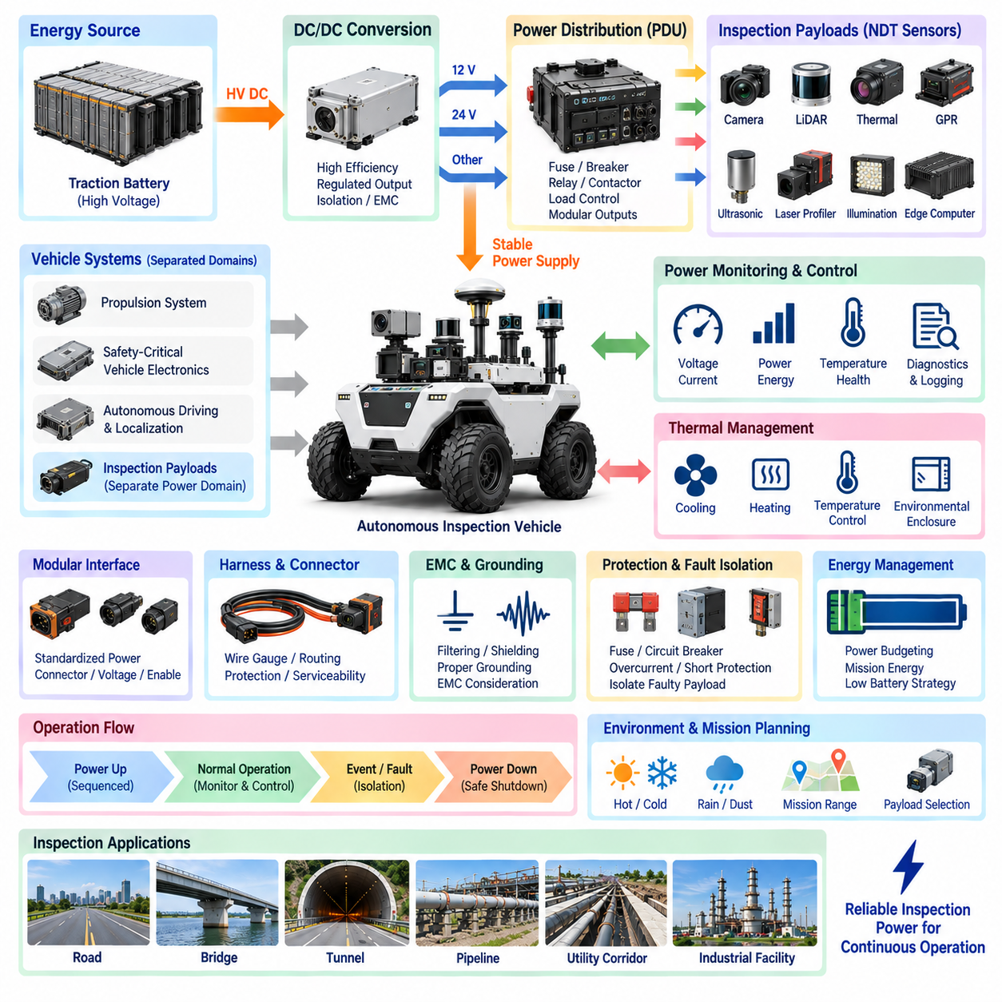
Inspection payload power architecture defines how an outdoor autonomous vehicle supplies stable, protected, and controllable electrical energy to specialized inspection equipment without compromising propulsion, autonomous driving, or safety functions. Within the inspection vehicle architecture, NDT sensors and their supporting electronics form a dedicated payload domain whose electrical behavior must be coordinated with the vehicle-level power distribution system.
Inspection payloads can have significantly different electrical characteristics. Cameras, LiDAR, thermal sensors, GPR, ultrasonic equipment, laser profilers, illumination units, communication devices, edge computers, and environmental-control hardware may require different voltage levels and current capacities. The power architecture should therefore begin with a complete load inventory defining nominal voltage, average consumption, peak current, startup behavior, operating duty cycle, and allowable interruption time.
A useful design separates propulsion, safety-critical vehicle electronics, autonomous-driving systems, and inspection payloads into controlled electrical domains. The inspection equipment should normally receive power through dedicated distribution branches rather than sharing unprotected circuits with steering, braking, safety controllers, or essential localization devices. This separation limits the possibility that a payload short circuit, overload, or transient disturbance will disable critical vehicle functions.
The vehicle battery generally acts as the primary energy source, but inspection equipment may require voltage levels different from the traction bus. DC/DC converters can create regulated low-voltage rails such as 12 V, 24 V, or other payload-specific supplies from the main battery system. Converter selection must consider continuous output power, transient capability, conversion efficiency, thermal behavior, electrical isolation requirements, input-voltage variation, and electromagnetic compatibility.
Power budgeting must consider mission energy rather than only instantaneous electrical load. The energy required by propulsion changes with vehicle speed, terrain, slope, payload mass, and environmental conditions, while inspection sensors and computing systems may operate continuously for many hours. Mission planning should reserve sufficient battery capacity for sensing, processing, communication, thermal management, safe return, and contingency operation instead of allocating the entire available energy to mobility.
Peak loads can become important even when average inspection power is relatively modest. Active radar or GPR transmitters, heaters, lighting systems, motors, pumps, high-performance computers, and communication equipment may create short-duration current demands. If several devices start simultaneously, the resulting inrush current can cause voltage sag, converter shutdown, fuse operation, or controller reset. Startup sequencing and load scheduling can reduce these disturbances.
A controlled power-up sequence allows the vehicle to energize inspection subsystems in a predictable order. Core vehicle electronics and safety functions can become stable first, followed by localization and computing equipment, communication systems, and finally high-power inspection payloads. During shutdown, data acquisition can be stopped and storage devices synchronized before payload power is removed, reducing the risk of corrupted files or incomplete inspection records.
Circuit protection should be coordinated with the electrical characteristics of each payload branch. Fuses, electronic circuit breakers, relays, contactors, or intelligent power-distribution devices can isolate faults before they propagate through the vehicle. Protection ratings should account for normal current, startup current, wiring capacity, connector ratings, converter limits, and fault energy rather than selecting protection devices solely from the nominal power specification of the sensor.
Grounding architecture is particularly important for inspection equipment because sensitive measurement electronics operate near motors, inverters, DC/DC converters, communication devices, and high-current wiring. Poor grounding can introduce common-mode noise, ground loops, measurement offsets, or unstable communication. Power-return paths, chassis connections, cable shields, sensor grounds, and computing grounds should therefore be defined systematically rather than created independently during installation.
Electromagnetic compatibility must be addressed together with power distribution. Switching converters and motor drives can inject conducted or radiated noise into sensitive NDT measurements, while active inspection instruments may themselves disturb GNSS, communication, or perception electronics. Filtering, shielding, cable separation, appropriate converter placement, controlled grounding, and dedicated power branches help prevent electrical interference from becoming an inspection-data-quality problem.
Harness design connects the theoretical power architecture to the physical vehicle. Wire gauge must support continuous and peak current while controlling voltage drop and temperature rise. Routing should protect cables from vibration, abrasion, water, mud, sharp edges, and moving mechanical assemblies. Connectors should provide suitable current capacity, environmental protection, locking, serviceability, and polarization for repeated field maintenance of inspection payloads.
Power distribution should support modular payload installation because inspection vehicles may carry different sensor combinations for different missions. Standardized electrical interfaces can define available voltages, maximum current, connector families, grounding, communication, and enable signals. A modular interface allows a GPR package, thermal inspection package, laser profiling system, or other NDT payload to be exchanged without redesigning the complete vehicle electrical architecture.
Intelligent power monitoring provides operational information beyond simple circuit protection. Voltage, current, power, energy consumption, temperature, and fault state can be measured for individual payload branches. The onboard computer can use this information to identify abnormal consumption, deteriorating equipment, connector problems, unexpected shutdowns, or energy trends and associate them with sensor-health and mission records.
Payload power status should also participate in diagnostic and mission management. If an inspection sensor loses power, the vehicle may remain safe and mobile while the inspection mission becomes incomplete. The system should identify which measurement capability has been lost, mark affected data segments, determine whether the mission can continue, and decide whether the vehicle should repeat the area after the payload is restored.
Thermal management and electrical power are closely coupled. DC/DC converters, GPUs, storage devices, transmitters, and inspection electronics generate heat that must be removed from enclosed equipment compartments. Fans, heaters, pumps, or other thermal-control devices themselves consume electrical energy. The power budget must therefore include both the inspection instrument and the supporting environmental-control system required to keep it within its allowable temperature range.
Outdoor operation introduces additional power-system challenges. Low temperature can reduce battery performance and increase heater demand, while high temperature can reduce converter capability and increase cooling requirements. Moisture and contamination can cause leakage or connector degradation. Electrical enclosures, sealed connectors, drainage, insulation, corrosion protection, and environmental derating must be considered as part of the payload power design.
Energy-aware mission management can dynamically coordinate inspection capability with remaining battery capacity. When available energy decreases, the system can estimate whether the planned inspection, communication, processing, and return route can still be completed safely. Nonessential payloads may be placed into standby, high-power processing may be deferred, or the mission may be shortened while preserving navigation, safety, and essential inspection functions.
Fault isolation is a central architectural objective. A failed inspection payload should ideally be disconnected without causing a complete vehicle power reset. Dedicated converters, branch protection, controllable switches, and health monitoring allow individual devices or payload groups to be isolated and restarted. This architecture supports graceful degradation in which the vehicle continues operating with reduced inspection capability instead of suffering a system-wide electrical failure.
Serviceability should be considered from the beginning because inspection payloads may be frequently changed, calibrated, repaired, or upgraded. Clearly identified power branches, accessible protection devices, standardized connectors, measurable test points, documented current limits, and diagnostic logs simplify field maintenance. Safe isolation procedures are particularly important when the inspection vehicle combines a higher-voltage traction system with multiple low-voltage payload domains.
The complete inspection payload power architecture therefore links energy storage, DC/DC conversion, distribution, circuit protection, grounding, EMC, harnesses, connectors, monitoring, diagnostics, thermal management, and mission-level energy control. Its objective is not merely to provide electricity to sensors, but to ensure that inspection equipment receives dependable power while remaining electrically isolated from failures that could affect autonomous mobility or vehicle safety.
Within the broader robotics electrical architecture, this design connects the Inspection Vehicle chapter with battery and powertrain engineering, fuse and PDU design, grounding and EMC, wire-harness engineering, connector engineering, sensor architecture, and compute architecture. Together with NDT sensor integration, infrastructure inspection, and data transmission, payload power provides the electrical foundation required for the complete Inspection AMR case that follows.

05.05. Inspection AMR Case
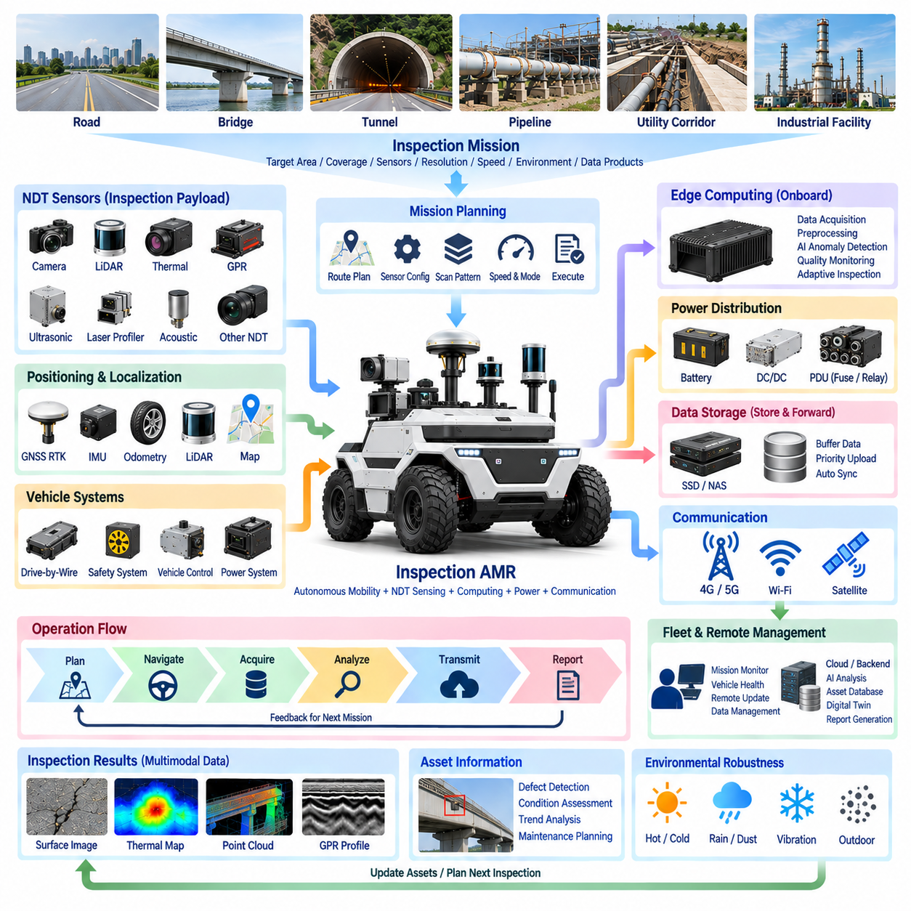
An Inspection AMR represents the system-level integration of autonomous mobility, non-destructive testing sensors, localization, edge computing, power distribution, communication, and infrastructure data management into a single field-operational platform. Rather than treating inspection as an auxiliary payload function, the complete vehicle is engineered around repeatable measurement missions in which mobility and sensing operate as coordinated subsystems.
A representative mission begins with an infrastructure asset and an inspection objective. Roads, bridges, tunnels, utility corridors, pipelines, industrial facilities, and large outdoor sites may require different combinations of surface, geometric, thermal, acoustic, or subsurface measurements. The mission definition therefore specifies the target area, inspection coverage, sensor configuration, required spatial resolution, operating speed, environmental constraints, and expected data products.
Before deployment, the vehicle converts these requirements into an executable mission plan. Route generation considers not only navigational accessibility but also sensor orientation, measurement distance, lane spacing, scanning overlap, turning geometry, and areas requiring repeated passes. GNSS RTK coordinates and infrastructure maps can define global inspection zones, while local perception and obstacle information continuously modify vehicle motion within safe operating boundaries.
The autonomous mobility layer provides the repeatability required for meaningful infrastructure monitoring. GNSS RTK establishes absolute outdoor position, while IMU, wheel odometry, LiDAR, and other localization sources maintain vehicle pose and continuity. Drive-by-wire systems execute steering, propulsion, and braking commands, while independent safety functions supervise speed, obstacles, operational boundaries, emergency conditions, and minimal-risk behavior.
The inspection payload combines sensors according to the physical characteristics being evaluated. High-resolution cameras can document visible defects, LiDAR and laser profilers can measure geometry, thermal cameras can identify temperature anomalies, and GPR or other NDT instruments can investigate hidden structures and subsurface conditions. Acoustic, ultrasonic, electromagnetic, or specialized sensors may be added when particular materials or infrastructure components require additional measurement modalities.
Mechanical integration ensures that these sensors remain useful while the AMR is moving. Mounting structures must preserve sensor alignment, field of view, sensing distance, and calibration while tolerating vibration, shock, chassis movement, and outdoor exposure. Where necessary, isolation mechanisms, protective housings, adjustable brackets, cleaning devices, or controlled sensor positioning can maintain measurement quality across changing road and environmental conditions.
The electrical architecture separates inspection payload power from propulsion and safety-critical domains. The main vehicle battery supplies energy through protected distribution and appropriate DC/DC conversion to the required payload voltage rails. Dedicated fuses, circuit breakers, relays, converters, connectors, and monitored branches isolate inspection faults while allowing the vehicle's navigation, drive-by-wire, and safety functions to remain operational.
Power management is coordinated with the inspection mission because sensing, computing, communication, heating, cooling, and propulsion all consume the same finite energy resource. The system estimates mission energy demand and reserves sufficient capacity for safe completion and return. Payloads can be selectively activated, placed into standby, or isolated according to inspection requirements, remaining battery capacity, environmental conditions, and detected electrical faults.
The onboard network connects heterogeneous sensors and vehicle systems through interfaces such as Ethernet, CAN, CAN FD, serial communication, USB, and hardware triggers. High-bandwidth inspection traffic can be separated logically or physically from deterministic vehicle-control communication. This prevents large image, point-cloud, thermal, or radar streams from interfering with essential mobility messages and simplifies fault containment between functional domains.
Time synchronization provides the common reference required to transform individual measurements into spatial inspection information. Sensor timestamps are associated with GNSS RTK position, IMU orientation, vehicle motion, and localization results. Consequently, a crack image, thermal hotspot, point-cloud feature, or GPR reflection can be assigned to the physical location where it was acquired rather than merely to the location of the vehicle when processing was completed.
Edge computing performs the first level of inspection intelligence. The onboard computer acquires sensor streams, checks data quality, performs filtering and preprocessing, monitors synchronization, and can execute AI-based anomaly detection. Candidate defects may trigger slower driving, additional measurements, repeated scanning, or higher-resolution acquisition, allowing the AMR to improve inspection completeness before leaving the target area.
Data quality is treated as an operational state rather than a post-processing concern. Excessive vibration, sensor contamination, missing frames, poor illumination, localization degradation, thermal limits, communication errors, or invalid NDT signals can reduce measurement confidence. The vehicle records these conditions together with the inspection data and can identify sections requiring reinspection instead of presenting uncertain measurements as valid asset-condition evidence.
Local storage supports continuous operation when external communication is unavailable. High-volume images, point clouds, thermal sequences, GPR profiles, and raw NDT measurements can be buffered onboard using a store-and-forward strategy. Critical telemetry, alarms, and compact anomaly reports receive higher transmission priority, while large datasets can remain locally stored until Wi-Fi, cellular, private network, or other high-bandwidth connectivity becomes available.
The remote architecture connects the Inspection AMR to fleet management, engineering systems, asset databases, and backend AI platforms. Operators can monitor mission progress, vehicle health, communication status, inspection coverage, and detected events without directly controlling low-level vehicle actuators. Mission updates and inspection parameters can be exchanged through supervisory communication while deterministic motion and safety control remain local to the vehicle.
After acquisition, multimodal data is transformed into engineering information. Images can support visible defect classification, thermal measurements can identify abnormal temperature regions, point clouds can quantify deformation, and subsurface measurements can reveal hidden features. These results are spatially registered and associated with infrastructure components so that engineers can review condition according to road segment, bridge element, tunnel section, pipeline location, or inspection zone.
Traceability connects every reported anomaly to its original measurement context. A defect record can retain sensor identity, acquisition time, geographic coordinates, vehicle pose, calibration state, processing version, confidence, quality indicators, and references to supporting raw data. This enables later verification of automated analysis and prevents inspection conclusions from becoming detached from the evidence and operating conditions that produced them.
Repeated missions extend the Inspection AMR from defect detection into infrastructure condition monitoring. By reproducing comparable routes, sensor configurations, calibration states, and spatial references, measurements from different dates can be registered and compared. Changes in crack dimensions, deformation, thermal patterns, surface profiles, or subsurface signatures can then reveal deterioration trends and support maintenance prioritization.
Fault management determines whether a problem requires mission continuation, degraded operation, reinspection, or termination. Failure of an individual NDT sensor may reduce inspection capability while leaving the vehicle safe to operate, whereas loss of essential localization or safety functions may require a minimal-risk condition. Explicit health states prevent inspection productivity from overriding autonomous-vehicle safety requirements.
Environmental robustness is essential because the Inspection AMR operates outside controlled laboratory conditions. Rain, dust, mud, temperature variation, sunlight, darkness, vibration, electromagnetic interference, and uneven terrain affect both vehicle operation and measurement quality. Enclosures, sealing, thermal management, EMC design, protected harness routing, environmental derating, and mission restrictions collectively maintain dependable field performance.
The completed Inspection AMR therefore forms a closed operational loop: plan the inspection, configure the payload, navigate autonomously, acquire synchronized measurements, evaluate data quality, detect anomalies, store and transmit results, perform backend analysis, and update infrastructure condition records. Maintenance decisions and previous inspection results can then influence subsequent missions, creating a repeatable cycle of measurement, assessment, and intervention.
As the concluding case within the Inspection Vehicle chapter, this architecture integrates the preceding NDT Sensor Integration, Infrastructure Inspection, Data Transmission Architecture, and Power for Inspection Payload functions into one deployable autonomous system. It demonstrates how the broader robotics electrical architecture can connect sensing, power, communication, computing, localization, safety, and fleet operation to support practical outdoor infrastructure inspection.

