Volume 17 Outdoor Autonomous Vehicle

Chapter 06. Patrol Vehicle

06.01. Security Patrol Architecture
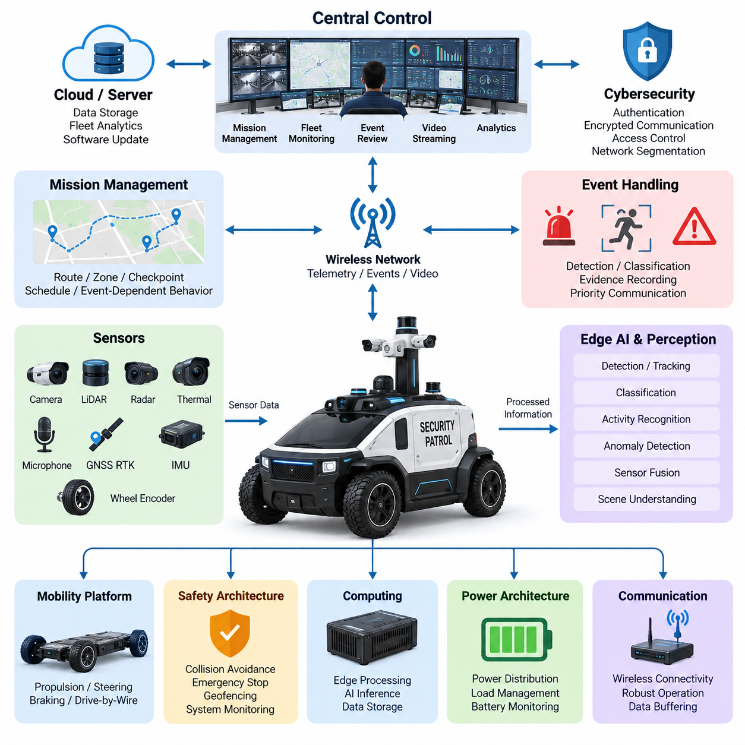
Security patrol architecture transforms an outdoor autonomous vehicle into a persistent mobile security node capable of observing environments, detecting abnormal situations, responding according to predefined policies, and communicating with remote operators. The architecture must combine autonomous mobility with surveillance functions without allowing security workloads to compromise the vehicle’s fundamental navigation, control, or safety capabilities.
The vehicle platform forms the physical foundation of the patrol system and integrates propulsion, steering, braking, power distribution, computing, sensing, and communication subsystems. Drive-by-wire interfaces allow autonomous controllers to command vehicle motion, while independent safety mechanisms supervise those commands. The patrol architecture therefore operates above a mobility platform whose basic motion and emergency functions remain available even when mission-level software experiences faults.
Localization is essential because every security observation becomes more useful when it is associated with an accurate geographic position. GNSS RTK can provide outdoor absolute positioning, while an IMU, wheel feedback, LiDAR, cameras, and other sensors can support localization when satellite reception becomes degraded. The architecture should maintain localization confidence so that patrol decisions can reflect not only estimated position but also the reliability of that estimate.
The perception layer continuously observes the area surrounding the vehicle. Visible cameras provide rich information for recognizing people, vehicles, objects, boundaries, and activities, while LiDAR supports geometric perception and obstacle detection. Radar, depth cameras, thermal sensors, microphones, or other mission sensors may complement these channels depending on the patrol environment. Their outputs are synchronized and processed by onboard computing resources.
Security perception differs from ordinary navigation perception because it must interpret events beyond immediate driving hazards. A pedestrian may simply represent an obstacle to the navigation system, while the security system may need to determine whether that person has entered a restricted area, fallen to the ground, remained in an unusual location, or exhibited behavior requiring operator attention. The same sensor information can therefore support both mobility and security interpretation.
Onboard edge AI provides the computational layer for converting continuous sensor streams into operational information. Detection, tracking, classification, activity recognition, anomaly detection, and scene understanding can be executed close to the sensors so that important decisions do not depend on permanent cloud connectivity. Edge processing also reduces communication load because the vehicle can transmit selected events and metadata instead of continuously uploading every raw sensor stream.
Mission management defines where the patrol vehicle should travel, what it should observe, and how it should respond to detected conditions. A patrol mission may contain routes, zones, checkpoints, observation positions, time schedules, speed restrictions, restricted areas, and event-dependent behaviors. Mission execution must remain connected to vehicle state so that battery condition, localization confidence, sensor availability, weather, communication quality, or safety restrictions can modify the planned operation.
Route-based patrol repeatedly moves the vehicle through predefined paths, while zone-based patrol allows the mission planner to select routes dynamically within an assigned region. Checkpoints can require additional actions such as stopping, rotating cameras, performing a sensor scan, recording evidence, or waiting for a specified observation period. These mechanisms convert autonomous navigation into a repeatable security process rather than allowing the robot to move without operational context.
A central control system provides fleet-level supervision while the vehicle retains local autonomy. The control center can distribute missions, monitor robot locations, inspect system health, receive alarms, request video, review event information, and modify operational priorities. Multiple patrol vehicles can be coordinated so that different zones are covered without unnecessary duplication, while a nearby robot may be redirected when another vehicle becomes unavailable or an incident requires additional observation.
The communication architecture connects onboard autonomy with remote supervision through available wireless networks. Routine telemetry may include vehicle position, mission status, battery state, sensor health, communication quality, and diagnostic information. Security events can receive higher transmission priority and include timestamps, coordinates, event classifications, confidence values, snapshots, video segments, and other supporting evidence required for remote assessment.
Communication loss must not automatically eliminate the vehicle’s ability to operate safely. Real-time obstacle avoidance, motion control, emergency stopping, and essential perception remain onboard functions. When connectivity deteriorates, predefined policies can determine whether the vehicle continues a limited mission, pauses at a safe location, moves toward a known communication area, returns to base, or enters a minimal risk condition. Buffered data can be transmitted after connectivity is restored.
Safety architecture remains logically distinct from security intelligence. An AI model may recommend approaching an event for closer observation, but the motion system must still obey collision avoidance, speed limits, geofencing, actuator constraints, and emergency-stop requirements. Safety supervision should monitor propulsion, steering, braking, localization, perception availability, computing health, communication status, and critical power conditions independently of the mission objective.
Power architecture must support both mobility and continuous surveillance. Propulsion generally represents a major energy load, but cameras, LiDAR, thermal sensors, lighting, communication equipment, edge GPUs, storage devices, and auxiliary payloads can significantly affect mission endurance. Power distribution should separate critical vehicle functions from mission payloads and provide suitable protection, monitoring, conversion, and controlled shutdown behavior for each electrical domain.
The architecture should also preserve evidence generated during patrol operations. Important events require consistent timestamps, vehicle position, sensor identity, event metadata, associated images or video, and system status. Local storage provides resilience during network interruption, while central storage can support longer-term review and fleet analytics. Maintaining traceability between an alarm and its original sensor observations is important for understanding why the autonomous system generated the event.
Cybersecurity protects both vehicle control and surveillance information. Remote interfaces require authenticated access, encrypted communication, controlled privileges, secure credential management, protected software updates, and appropriate network segmentation. Vehicle control traffic, safety-related communication, diagnostic interfaces, video streams, and fleet services should not be treated as a single unrestricted network domain because compromise of one service could otherwise propagate across the platform.
A mature security patrol architecture therefore consists of tightly coordinated but functionally separated mobility, perception, security AI, mission management, safety, communication, power, and fleet layers. Local autonomy enables immediate physical operation, while central supervision provides broader situational awareness and multi-vehicle coordination. This distributed arrangement allows the patrol vehicle to continue meaningful operation even when individual sensors, communication links, or external services become temporarily unavailable.
The resulting patrol vehicle is more than a mobile camera platform. It becomes a cyber-physical security system that can navigate outdoor environments, continuously observe assigned areas, interpret events, preserve evidence, communicate important information, and adapt its mission while maintaining safety constraints. This architecture establishes the foundation for night operation, event-trigger communication, live video streaming, and integrated patrol AMR applications developed in the subsequent system design stages.

06.02. Night Operation Design
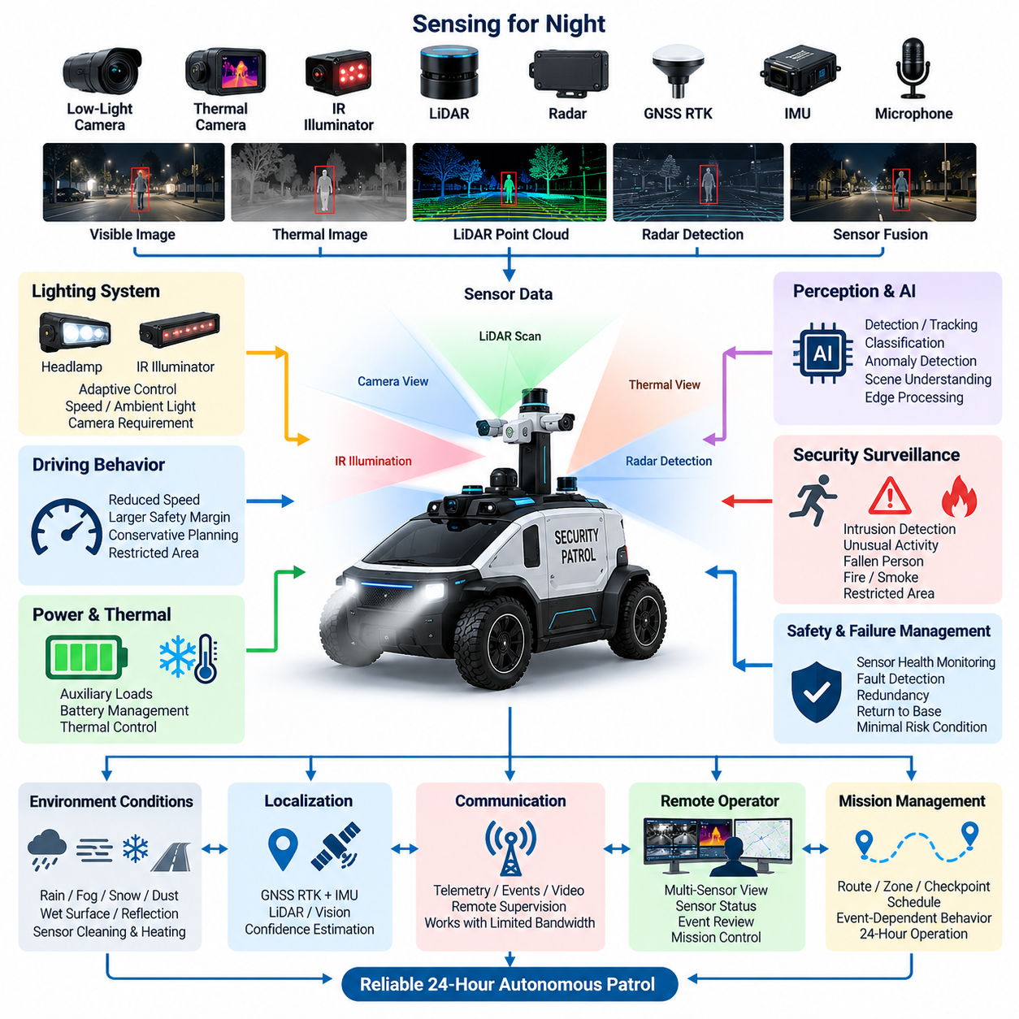
Night operation design enables an outdoor autonomous patrol vehicle to maintain safe mobility, reliable perception, and effective surveillance when natural illumination becomes insufficient or highly variable. Darkness changes more than camera visibility: it affects object contrast, localization confidence, human detection, environmental interpretation, and operator awareness. The vehicle must therefore treat night operation as a coordinated system mode rather than a simple lighting condition.
The perception architecture should combine sensing modalities with different dependencies on visible light. Low-light cameras can preserve color and semantic information under moderate illumination, while thermal or infrared sensors can detect people, animals, vehicles, and heat sources when visible imagery becomes unreliable. LiDAR and radar provide geometric or ranging information largely independent of ambient illumination, creating complementary perception channels for nighttime autonomous navigation.
Visible cameras require careful control because illumination can change rapidly along a patrol route. The vehicle may move from a brightly illuminated entrance into a dark road, pass directly beneath streetlights, encounter approaching headlights, or observe reflective surfaces. Automatic exposure, gain control, high-dynamic-range imaging, glare suppression, and image-quality monitoring should prevent temporary lighting transitions from silently degrading perception performance.
Infrared illumination can improve imaging in areas where additional visible lighting would disturb people or reveal the patrol vehicle unnecessarily. Near-infrared illuminators may support compatible cameras, but their effective range, beam pattern, power consumption, reflections, and eye-safety constraints must be considered. Illumination should be coordinated with camera field of view so that excessive foreground reflection does not reduce the visibility of more distant objects.
Thermal imaging provides another important nighttime sensing channel because it observes emitted thermal radiation rather than depending on reflected visible light. Thermal cameras can assist with detecting people in darkness, locating unusual heat sources, and maintaining surveillance in visually difficult scenes. However, thermal sensing should complement rather than replace other modalities because temperature similarity, weather, surface materials, and environmental conditions can reduce discrimination capability.
LiDAR supports night operation by providing three-dimensional or planar geometric measurements independent of scene brightness. It can detect obstacles, estimate free space, and support localization even when visible cameras have poor contrast. Radar further improves robustness in conditions where optical sensing becomes degraded. Sensor fusion should combine these complementary characteristics instead of assuming that any single nighttime sensor can provide complete environmental understanding.
Localization must remain stable during transitions between daytime and nighttime conditions. GNSS RTK and IMU measurements are not directly dependent on illumination, while LiDAR-based localization can provide additional geometric consistency. Vision-based localization may experience reduced feature quality at night, particularly in poorly illuminated or repetitive environments. The localization system should therefore estimate confidence and dynamically adjust the contribution of individual sensing modalities.
Nighttime obstacle detection requires special attention to vulnerable road users and objects with weak visual signatures. Pedestrians wearing dark clothing, animals, low-profile obstacles, unlit bicycles, temporary barriers, and objects outside streetlight coverage may be difficult to recognize with visible cameras alone. Combining geometric detection, thermal signatures, motion information, and semantic perception can provide more reliable evidence before the motion planner determines an appropriate response.
The patrol vehicle should adapt its driving behavior when nighttime perception confidence decreases. Reduced speed, increased stopping distance, conservative path planning, larger safety margins, and restricted operation in poorly observed zones can reduce risk. Operational design should connect perception confidence directly with mobility policy so that the vehicle does not continue daytime driving behavior when its ability to understand the environment has significantly deteriorated.
Security surveillance at night extends beyond navigation safety. The system may need to detect unauthorized entry, unusual movement, a fallen person, suspicious stationary objects, smoke, fire, or activity in restricted areas. Edge AI can analyze visible, infrared, thermal, acoustic, and geometric information locally, allowing event detection to continue even when communication bandwidth is limited or remote operators are not continuously watching live video.
Lighting becomes an active vehicle subsystem rather than merely an accessory. Headlamps support navigation, while auxiliary illumination can support cameras or provide scene visibility during an event. Lighting control may respond to vehicle speed, route geometry, ambient brightness, camera requirements, detected objects, and mission conditions. The architecture should prevent lighting changes from producing repeated exposure instability or interference among optical sensors.
Night operation also changes the electrical power profile of the patrol vehicle. Headlamps, infrared illuminators, thermal cameras, heaters, communication equipment, edge computers, and continuous video processing can operate simultaneously for long periods. Battery endurance calculations should therefore include nighttime auxiliary loads. Power management can prioritize propulsion, safety controllers, localization, essential perception, and communication before lower-priority surveillance or convenience loads.
Thermal management must be considered together with electrical power. Continuous AI inference, video encoding, sensor operation, and communication generate heat even when outdoor ambient temperature is low. Conversely, cameras, batteries, displays, or optical windows may require heating in cold or humid conditions. The system should monitor temperature and power consumption so that thermal protection does not unexpectedly disable critical nighttime perception functions.
Environmental conditions can make nighttime operation more difficult than darkness alone. Rain, fog, snow, dust, condensation, wet pavement, and reflective surfaces can alter camera images, LiDAR returns, radar observations, and illumination behavior. Water droplets on optical windows may create glare or distorted images. Sensor housings, cleaning mechanisms, heating, hydrophobic protection, and diagnostic monitoring should therefore be considered part of the nighttime operational architecture.
Remote operators require information that accurately represents the vehicle’s nighttime perception capability. Live video alone may be misleading when a visible camera appears dark while thermal or LiDAR sensing remains effective. The control interface can present sensor status, localization confidence, communication quality, detected events, and selected alternative imagery. This allows operators to distinguish actual environmental hazards from degradation of a particular sensor channel.
Failure management should define responses to loss of important nighttime functions. Failure of one camera may permit continued operation using redundant sensors, while simultaneous degradation of several perception channels may require reduced speed, mission restriction, return to base, or transition to a minimal risk condition. Sensor-health monitoring should detect blocked lenses, abnormal image brightness, missing frames, thermal faults, communication errors, and other conditions before they become hidden operational risks.
Night operation design therefore integrates perception, localization, illumination, autonomous driving, security AI, power, thermal management, communication, and safety supervision into a unified operating mode. A successful patrol vehicle does not simply continue driving after sunset; it recognizes how darkness changes sensing capability and dynamically adapts its behavior. This system-level approach provides the foundation for reliable twenty-four-hour autonomous patrol and subsequent event-triggered security operations.

06.03. Event Trigger Communication
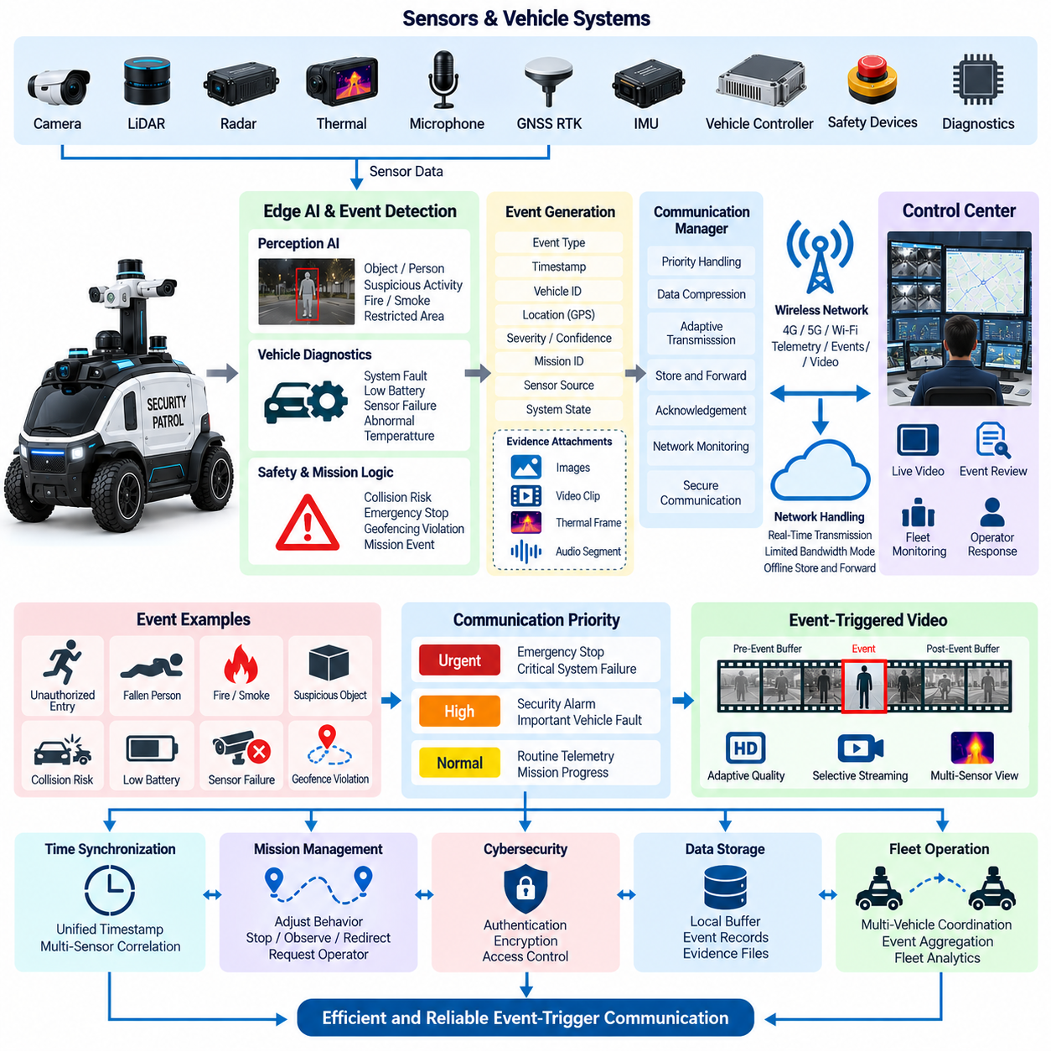
Event-trigger communication allows an autonomous patrol vehicle to transmit information according to operational significance rather than continuously treating all data with equal priority. The vehicle normally produces large volumes of sensor, video, diagnostic, localization, and mission data, but only a small portion requires immediate remote attention. Event-driven communication converts significant onboard observations into prioritized messages for the control center.
The communication architecture begins with continuous onboard sensing and state monitoring. Cameras, LiDAR, radar, thermal sensors, microphones, GNSS RTK, IMU, vehicle controllers, safety devices, and diagnostic modules generate data at different rates. Edge computing processes these streams locally and extracts operational information, allowing the communication system to transmit meaningful events instead of forwarding every raw measurement across the wireless network.
An event can originate from perception AI, vehicle diagnostics, safety controllers, mission logic, geofencing, communication monitoring, or direct operator commands. Typical security events include unauthorized entry, suspicious movement, a fallen person, smoke, fire, abandoned objects, or activity inside restricted zones. Vehicle-related triggers can include collision risk, emergency-stop activation, actuator faults, localization degradation, low battery, sensor failure, or abnormal system temperature.
Event detection should be separated from event communication because identifying an abnormal condition and deciding how urgently it must be transmitted are different functions. The detection layer determines what has occurred, while the communication policy evaluates severity, confidence, mission context, network availability, and required response. This separation allows communication behavior to change without modifying the underlying perception or safety algorithms.
Each event should be represented by structured metadata that allows the remote system to understand its context. The message may contain an event identifier, event type, timestamp, vehicle identity, geographic position, localization confidence, severity level, detection confidence, mission identifier, sensor source, and system state. Images, short video clips, thermal frames, audio segments, or other evidence can then be associated with the same event record.
Accurate time synchronization is essential because evidence may originate from several sensors and computing nodes. Camera frames, LiDAR measurements, thermal images, vehicle states, and diagnostic records should be correlated to a common time reference whenever possible. Consistent timestamps allow the control center to reconstruct what occurred before, during, and after an event and prevent evidence from different moments from being incorrectly interpreted as simultaneous.
Communication priority should reflect the operational importance of the information. Routine telemetry such as battery status, position, mission progress, and normal diagnostics can use periodic low-priority transmission. Security alarms and important vehicle faults require higher priority, while emergency-stop events, immediate collision hazards, or critical system failures may require urgent notification. Priority handling prevents routine traffic from delaying safety-relevant information.
Event-trigger communication can substantially reduce wireless bandwidth consumption. Instead of continuously transmitting every high-resolution camera stream, the vehicle can perform local inference and maintain a rolling data buffer. When an event occurs, the system preserves relevant information from a period before the trigger and continues recording afterward. The resulting event package provides contextual evidence without requiring permanent high-bandwidth transmission during normal patrol operation.
The rolling buffer is particularly useful because the most important evidence may occur before the event is formally recognized. For example, an AI model may identify a person as fallen only after several frames have been analyzed. If only post-trigger data were stored, the sequence leading to the incident could be lost. Pre-trigger and post-trigger buffering therefore improves event reconstruction, operator understanding, and later system analysis.
Network conditions should influence how event data is delivered without changing the meaning of the event itself. Under strong connectivity, metadata, images, and video may be transmitted immediately. With limited bandwidth, the system can send a compact alarm and essential metadata first, followed by compressed imagery or video. Large evidence files can remain locally stored until network capacity improves while critical notification remains available.
Communication loss requires store-and-forward behavior. Events generated while the vehicle is offline should be retained in protected local storage with their timestamps, priorities, and evidence references. When connectivity returns, the communication manager can transmit queued records according to importance and age. Duplicate detection and acknowledgement mechanisms help prevent events from being silently lost or repeatedly processed by the control center.
Acknowledgement is important for high-priority alarms because successful packet transmission does not necessarily mean that the remote application received and processed the event. The system can distinguish between message transmission, server reception, event registration, and operator acknowledgement. Escalation policies may retransmit an alarm, use an alternative communication channel, or notify another supervisory service when required acknowledgement is not received.
Event-trigger communication must also interact with mission management. Detection of an abnormal situation may cause the patrol vehicle to slow down, stop, remain at an observation point, redirect sensors, approach within a permitted distance, or request operator intervention. The communication message should therefore represent not only what the vehicle detected but also what autonomous response has been initiated and whether additional remote authorization is required.
Live video can be activated as an event-dependent service rather than operating continuously at maximum quality. A security alarm may request a relevant camera stream, increase frame rate or resolution, activate thermal imagery, or provide multiple sensor views to the operator. When the event is resolved, streaming can return to its normal low-bandwidth state. This adaptive approach balances situational awareness against limited wireless resources.
Cybersecurity is essential because event messages may contain sensitive surveillance information and may also initiate remote vehicle actions. Authentication, encryption, message integrity protection, access control, secure session management, and protected credentials should be applied according to system requirements. Commands sent from the control center must be distinguishable from telemetry so that unauthorized messages cannot be interpreted as legitimate mission or vehicle instructions.
Event communication should preserve traceability for later analysis. The system should maintain relationships among the original sensor observation, AI inference result, event decision, transmitted message, operator response, and subsequent vehicle action. Such records support incident investigation, system validation, AI performance evaluation, maintenance diagnostics, and improvement of event policies across a fleet of patrol vehicles.
Fleet operation introduces additional requirements because many vehicles may generate events simultaneously. The central system should identify the originating vehicle, combine related events when appropriate, suppress unnecessary duplicates, and prioritize incidents across the fleet. Nearby vehicles may be reassigned to provide additional observation, while fleet analytics can reveal recurring event locations, communication weak points, or abnormal patterns that are not visible from one vehicle alone.
A robust event-trigger communication architecture therefore connects perception, edge AI, mission logic, safety monitoring, local storage, wireless networking, live video, and central fleet supervision through a common event model. It enables the patrol vehicle to communicate selectively while preserving urgent information and contextual evidence. This approach provides scalable communication for autonomous security fleets and establishes the foundation for efficient live video streaming and integrated patrol AMR operation.

06.04. Live Video Streaming
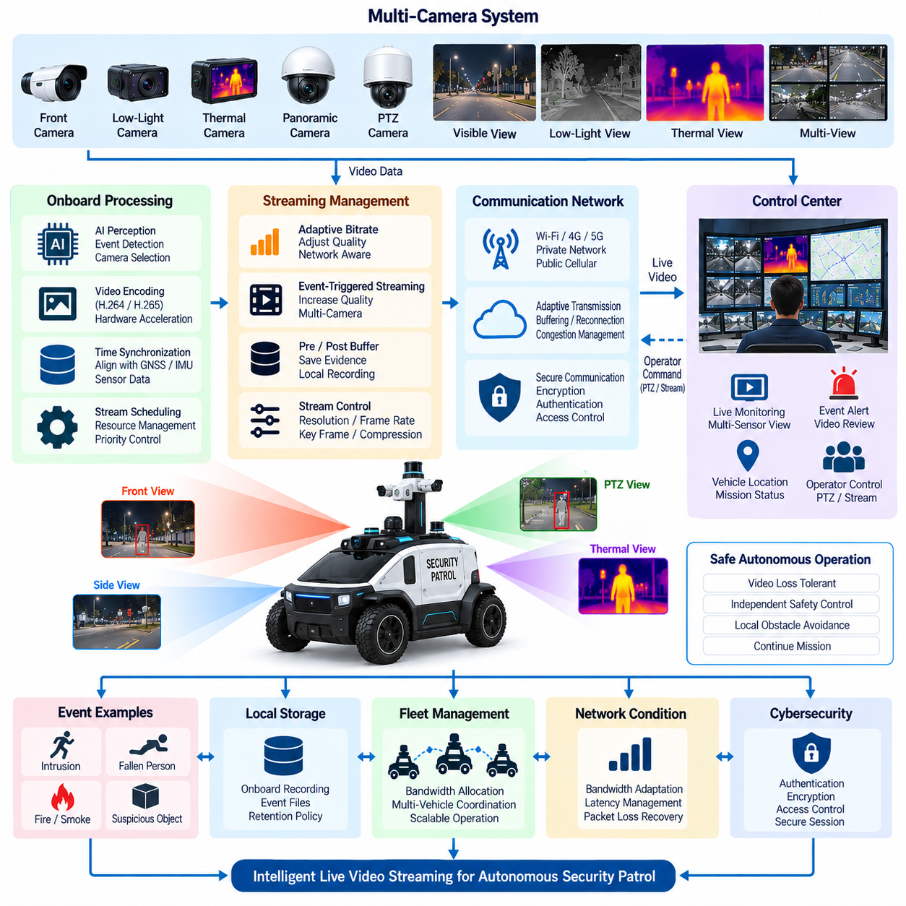
Live video streaming provides remote operators with continuous or on-demand visual access to an autonomous patrol vehicle and its surrounding environment. Unlike ordinary telemetry, video generates sustained high-volume data and must coexist with navigation, safety, mission, and event communication. The streaming architecture must therefore deliver useful situational awareness without consuming resources required for safe autonomous operation.
A patrol vehicle may carry multiple visible, low-light, thermal, panoramic, or PTZ cameras, each producing independent video streams with different resolutions and frame rates. Transmitting every camera continuously at maximum quality is usually inefficient. The onboard system should select streams according to mission context, operator requests, detected events, vehicle direction, and available network capacity while retaining other channels locally when appropriate.
Video acquisition begins with camera interfaces connected to onboard computing through suitable high-bandwidth links. Frames should be timestamped as close to acquisition as practical so that video can be correlated with GNSS RTK position, IMU data, LiDAR observations, vehicle state, and detected events. Consistent synchronization allows operators and later analysis systems to reconstruct what the vehicle observed at a specific location and moment.
Raw camera data is generally too large for practical wireless transmission, making onboard video encoding essential. Hardware-accelerated codecs can reduce bandwidth while minimizing the computing load imposed on autonomy processors. Resolution, frame rate, bitrate, key-frame interval, and compression level should be selected according to the operational purpose rather than using one fixed configuration for every camera and network condition.
Edge computing plays a central role by deciding which visual information should leave the vehicle. AI perception can identify people, vehicles, fire, smoke, restricted-area activity, or other mission-relevant conditions and associate them with the corresponding video. Instead of streaming all imagery continuously, the vehicle can provide low-bandwidth monitoring during normal patrol and automatically increase video quality when an important event occurs.
Adaptive bitrate control allows the streaming system to respond to changing wireless conditions. When available bandwidth decreases, the vehicle can reduce bitrate, resolution, or frame rate while preserving a usable operator view. When connectivity improves, quality can be restored. Adaptation should occur gradually enough to avoid unstable oscillation while ensuring that essential telemetry and safety-related communication retain priority over high-quality video.
The communication path may use Wi-Fi, private LTE or 5G, public cellular networks, or other wireless infrastructure depending on the operating site. Outdoor mobility causes signal strength, latency, packet loss, and available bandwidth to change continuously. Streaming architecture should therefore assume imperfect connectivity and provide buffering, reconnection, congestion management, and session recovery instead of treating the wireless link as a fixed wired connection.
Latency is a critical parameter when video supports active operator supervision. Excessive delay can cause the displayed scene to differ significantly from the vehicle’s current physical situation. Capture, encoding, buffering, network transport, decoding, and display each contribute to end-to-end latency. The architecture should control these stages according to whether the stream is intended for passive monitoring, event review, or time-sensitive remote interaction.
Live video should remain separated from safety-critical vehicle control. Loss, freezing, or delay of a video stream must not disable local obstacle avoidance, emergency stopping, or autonomous motion safety. The vehicle should continue to use onboard perception and safety controllers even when remote video becomes unavailable. This separation prevents communication quality from becoming an unintended dependency of fundamental autonomous driving functions.
Event-triggered streaming can provide higher efficiency than permanent high-quality transmission. When security AI detects unauthorized entry, a fallen person, suspicious activity, smoke, fire, or another predefined event, the communication manager can activate the most relevant camera, increase its quality, and notify the control center. Additional thermal or alternate-angle streams can be enabled when they improve remote understanding of the incident.
Pre-event and post-event video buffering provides context around detected incidents. A rolling onboard buffer continuously retains a limited period of recent footage without necessarily transmitting it. When an event is triggered, the system protects the preceding video and continues recording afterward. Operators can then examine not only the detected condition but also the sequence that led to it, improving incident interpretation and evidence quality.
Multi-camera streaming requires resource arbitration because encoding channels, GPU capacity, storage bandwidth, and wireless bandwidth are finite. A front camera needed for vehicle supervision may have higher priority than a secondary view, while an event-facing PTZ or thermal camera may temporarily receive the highest priority. Stream scheduling should therefore consider mission state, event severity, operator selection, and system resource utilization together.
A pan-tilt-zoom camera can extend patrol surveillance by allowing the operator or onboard AI to direct attention toward a particular object or location. PTZ commands should be coordinated with video feedback and mission policy so that camera movement does not interfere with other observation requirements. Autonomous tracking can maintain a target within the field of view while the vehicle preserves safe distance and continues its approved patrol behavior.
The control center should present video together with contextual information rather than as an isolated image. Vehicle position, heading, mission state, camera identity, timestamp, event classification, sensor health, communication quality, and localization confidence can help an operator correctly interpret what is displayed. When multiple sensor views are available, visible and thermal imagery may be selected or displayed according to the incident and environmental conditions.
Local recording remains important even when live streaming is available. Network interruptions, temporary congestion, or server failures may prevent continuous remote reception, while onboard storage can preserve operational evidence. Recorded files should be associated with timestamps, mission identifiers, event records, and vehicle information. Storage management can apply retention policies so that important event footage is protected while routine data is overwritten when capacity becomes limited.
Cybersecurity must protect both the confidentiality of surveillance video and the integrity of streaming control. Authentication, encryption, access control, secure session establishment, credential protection, and logging should prevent unauthorized viewing or manipulation. Camera selection, PTZ control, stream activation, recording requests, and configuration changes require appropriate authorization because these functions can affect security operations and privacy.
Fleet-scale deployment makes bandwidth management more complex because many patrol vehicles may share the same wireless and backend infrastructure. The central system should avoid requesting maximum-quality streams from every vehicle simultaneously unless network capacity supports it. Fleet-level policies can allocate bandwidth according to active incidents, mission priority, operator demand, and communication conditions while routine vehicles remain in reduced-bandwidth monitoring modes.
A robust live video streaming architecture therefore combines camera acquisition, time synchronization, edge processing, hardware encoding, adaptive transmission, event triggering, local buffering, cybersecurity, and remote visualization. Video becomes an intelligent mission service rather than an uncontrolled continuous data source. This architecture provides scalable situational awareness while preserving communication resources and the independent safety of autonomous patrol operations.

06.05. Patrol AMR Case
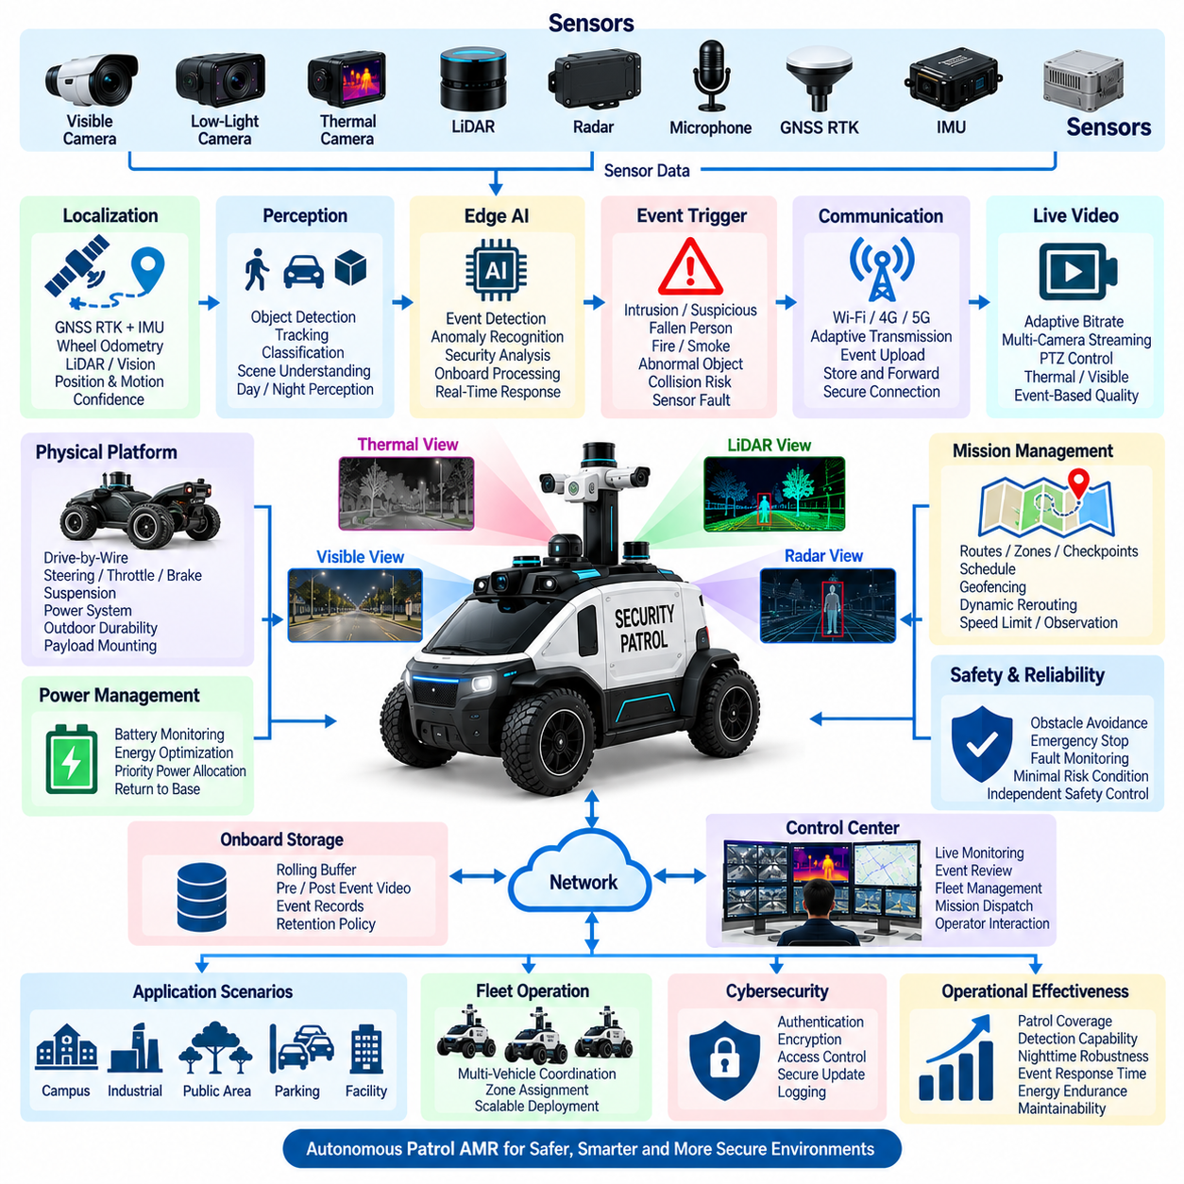
A patrol autonomous mobile robot represents the integration of autonomous driving, security surveillance, edge intelligence, communication, and fleet supervision into a single outdoor operational platform. The case demonstrates how a vehicle designed for persistent patrol can combine mobility and security missions while maintaining separation between mission intelligence and safety-critical vehicle control.
The physical platform provides propulsion, steering, braking, suspension, electrical power, environmental protection, and payload mounting for outdoor operation. Drive-by-wire interfaces connect autonomous motion commands to steering, throttle, and braking controllers, while independent safety mechanisms supervise vehicle behavior. The platform must support repeated long-duration operation over roads, pedestrian areas, campuses, industrial facilities, and other designated patrol zones.
Localization combines GNSS RTK with IMU, wheel feedback, and complementary perception sensors to maintain an accurate estimate of vehicle position and motion. LiDAR or vision-based localization can provide additional information where satellite reception becomes degraded by buildings or infrastructure. Localization confidence is continuously evaluated because route execution, geofencing, event coordinates, evidence records, and safe autonomous behavior all depend on reliable spatial information.
The perception system integrates visible cameras, low-light cameras, LiDAR, radar, thermal imaging, and other mission sensors according to the operating environment. These sensors serve both autonomous driving and security observation. Geometric sensors identify obstacles and free space, while visual and thermal sensors provide semantic information about people, vehicles, objects, environmental conditions, and activities occurring around the patrol vehicle.
Edge AI converts continuous sensor streams into operational intelligence close to the vehicle. Detection, tracking, classification, anomaly recognition, scene understanding, and security-event analysis can run onboard without requiring continuous cloud processing. This local intelligence allows the AMR to react immediately to environmental changes while transmitting compact event information rather than sending every raw sensor stream to the control center.
A typical patrol mission is organized around routes, zones, checkpoints, schedules, and observation tasks. The vehicle can repeatedly follow a predefined patrol route, stop at selected checkpoints, scan designated areas, or dynamically modify its path according to mission conditions. Geofencing prevents operation outside approved areas, while mission rules define speed limits, observation periods, restricted zones, and responses to abnormal events.
Night operation demonstrates the importance of multimodal perception. Low-light cameras preserve visual information where illumination remains available, thermal sensors support human and heat-source detection, and LiDAR or radar maintains geometric awareness independent of visible light. Adaptive lighting, infrared illumination, exposure control, and conservative nighttime driving policies help the AMR maintain useful perception when environmental visibility becomes difficult.
The vehicle adapts mobility according to perception and localization confidence. Under favorable conditions, normal autonomous patrol can continue at the approved operating speed. When visibility, sensor availability, localization quality, or environmental conditions deteriorate, the system can reduce speed, increase safety margins, restrict its operating area, pause the mission, return to base, or enter a predefined minimal risk condition.
Security events are generated when onboard intelligence or vehicle monitoring identifies conditions requiring attention. Examples include unauthorized entry, suspicious activity, a fallen person, smoke, fire, unusual stationary objects, blocked routes, collision risks, sensor failures, or emergency-stop activation. Each event is associated with a timestamp, vehicle position, classification, confidence level, sensor source, mission context, and supporting evidence.
Event-trigger communication prevents the patrol system from consuming unnecessary network bandwidth during normal operation. Routine telemetry such as position, battery state, mission progress, and system health can be transmitted periodically. When an important event occurs, communication priority increases and the vehicle sends an alarm with relevant metadata, images, video segments, thermal information, or other evidence required for remote assessment.
A rolling onboard buffer preserves sensor and video information immediately before and after important events. This capability allows operators to reconstruct how an incident developed rather than viewing only the moment when an AI model generated an alarm. Event records can remain in protected local storage during network interruption and be forwarded to the central system when communication becomes available again.
Live video streaming provides remote operators with direct visual access to the patrol environment. Instead of continuously transmitting every camera at maximum quality, the system can use adaptive bitrate, selective camera activation, hardware video encoding, and event-triggered quality changes. Visible, thermal, panoramic, or PTZ views can be selected according to the incident, mission requirement, network capacity, and operator request.
Wireless communication connects the patrol AMR with the central control system through available Wi-Fi, cellular, private network, or other site infrastructure. Because outdoor wireless quality changes as the vehicle moves, the communication architecture supports buffering, reconnection, adaptive transmission, and store-and-forward operation. Autonomous driving and essential safety functions remain onboard so that temporary network loss does not directly remove vehicle safety capability.
The central control system provides mission dispatch, fleet monitoring, event review, live video access, vehicle-health supervision, and operator interaction. Multiple patrol AMRs can divide coverage among different zones while the fleet manager coordinates routes and mission priorities. When one robot becomes unavailable or an incident requires additional observation, another nearby vehicle can be redirected according to fleet-level operational policy.
Power management integrates propulsion demand with the continuous electrical loads generated by perception sensors, edge GPUs, communication equipment, lighting, thermal cameras, storage, and auxiliary devices. Battery state influences mission planning and return-to-base decisions. Critical mobility, safety, localization, perception, and communication functions receive higher priority than nonessential payloads when available electrical energy becomes limited.
Safety architecture remains independent of the security mission objective. Even when AI identifies an event that should be investigated, vehicle movement must continue to satisfy obstacle avoidance, speed limits, geofencing, braking constraints, emergency-stop requirements, and actuator supervision. Fault monitoring evaluates critical sensors, computing resources, communication interfaces, power conditions, steering, propulsion, and braking before determining whether autonomous operation can continue.
Cybersecurity protects both vehicle operation and surveillance information. Authentication, encryption, access control, network segmentation, secure credentials, protected software updates, and logging prevent unauthorized access to vehicle commands, cameras, recorded evidence, or fleet services. Remote PTZ control, mission modification, video access, and vehicle commands require controlled authorization because these interfaces can directly influence physical or security operations.
The integrated patrol AMR case therefore demonstrates a distributed cyber-physical architecture in which onboard autonomy performs immediate perception and motion decisions while central infrastructure provides broader supervision and fleet coordination. Security AI, event-trigger communication, live video, local evidence storage, night operation, safety monitoring, and mission management cooperate without making safe vehicle operation dependent on continuous remote connectivity.
A successful patrol AMR is consequently evaluated by more than navigation accuracy alone. Patrol coverage, detection capability, nighttime robustness, event response time, communication resilience, evidence integrity, energy endurance, safety behavior, cybersecurity, maintainability, and fleet scalability collectively determine operational effectiveness. Their integration transforms an outdoor autonomous vehicle into a persistent, intelligent, and remotely supervised security patrol system.

