Volume 17 Outdoor Autonomous Vehicle

Chapter 09. Port AMR

09.01. AGV Container Handling
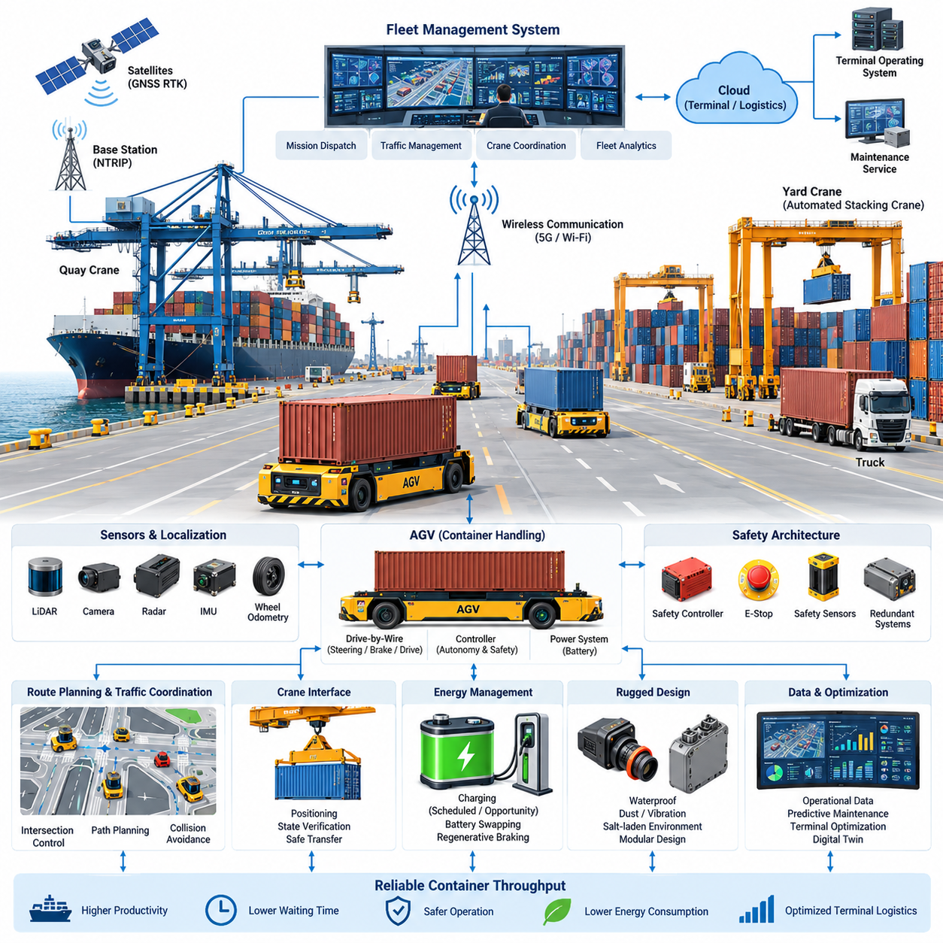
Port container handling with automated guided vehicles requires a system architecture that combines heavy-load mobility, precise positioning, reliable communication, and deterministic safety control. Unlike conventional indoor AGVs, container-handling vehicles operate across large outdoor terminals where road geometry, container stacks, cranes, trucks, workers, and other autonomous machines continuously interact. The AGV must therefore be engineered as part of a coordinated terminal transportation system rather than as an isolated mobile robot.
A container AGV typically transports standardized containers between quay cranes, transfer zones, container yards, and automated stacking cranes. The mechanical platform must support high payloads while maintaining predictable steering and braking characteristics under changing load conditions. Vehicle dynamics vary significantly between unloaded and fully loaded operation, so propulsion, steering, suspension, braking, and tire characteristics must be modeled across the complete operating envelope rather than optimized for only one nominal condition.
Container pickup and transfer require much greater positioning precision than ordinary point-to-point transportation. The vehicle must align its load interface with crane or transfer equipment while maintaining safe clearance from surrounding infrastructure. GNSS RTK can provide accurate global positioning in open terminal areas, while LiDAR, cameras, radar, wheel odometry, and IMU measurements provide complementary relative localization. Sensor fusion becomes particularly important near cranes and container stacks where satellite visibility may deteriorate because of multipath and obstruction.
The localization architecture should distinguish between global navigation accuracy and final docking accuracy. Global GNSS-based localization guides the AGV through terminal roads, but the final approach to a crane or transfer station can use infrastructure landmarks, LiDAR geometry, visual markers, or local reference targets. This hierarchical localization strategy prevents temporary GNSS degradation from directly affecting container alignment and allows the vehicle to transition smoothly from meter-scale route planning to centimeter-class terminal positioning.
Route planning in a container terminal is fundamentally a traffic coordination problem. Multiple AGVs may share intersections, crane approaches, transfer lanes, charging stations, and waiting zones, creating dependencies that cannot be resolved by independent shortest-path planning. A central fleet management system can allocate missions, reserve road segments, sequence intersection access, and coordinate vehicle arrival with crane schedules. Local autonomy remains responsible for immediate obstacle avoidance and emergency response when unexpected conditions invalidate the centrally planned trajectory.
Mission dispatch should consider more than transportation distance. Quay crane productivity, yard crane availability, container priority, vehicle battery state, congestion, maintenance status, and predicted travel time can all influence AGV assignment. A sophisticated scheduler therefore treats the fleet as a distributed logistics resource. The objective is not simply to maximize individual vehicle utilization but to minimize crane waiting, container transfer delay, empty travel, traffic conflicts, and energy consumption across the complete terminal operation.
Container terminals create demanding perception conditions because large metallic structures generate occlusion, reflection, and rapidly changing visibility. Containers can form temporary corridors that differ from previously mapped environments, while trucks and handling equipment introduce dynamic obstacles with large blind areas. LiDAR provides accurate geometric measurements, cameras contribute semantic information, and radar can improve robustness in rain, fog, dust, or difficult illumination. Redundant perception should be designed so that degradation of one sensing modality does not immediately eliminate safe mobility.
Safety architecture must separate normal autonomous control from independent protective functions. The primary autonomy system performs perception, localization, prediction, planning, and motion control, while safety controllers supervise critical conditions such as excessive speed, obstacle proximity, steering faults, brake faults, communication loss, or localization uncertainty. Emergency-stop circuits and safety-rated sensing can command controlled deceleration or direct stopping independently of high-level AI. The resulting architecture limits the consequences of software, sensor, network, or compute failures.
Drive-by-wire functionality is essential because propulsion, steering, and braking must accept electronically generated commands while reporting their actual state to supervisory controllers. Command and feedback channels should support plausibility checks so that requested steering angle, wheel speed, braking force, and measured vehicle response can be continuously compared. Fault detection must distinguish transient disturbances from conditions requiring degraded operation, mission cancellation, or a minimal-risk stop, especially when the AGV is carrying a heavy container.
Communication connects the AGV to fleet control, terminal operating systems, crane controllers, charging infrastructure, and maintenance services. Wireless connectivity must tolerate handovers and temporary packet loss as vehicles move through large yards surrounded by steel structures. Safety-critical local motion should therefore never depend entirely on uninterrupted cloud or central communication. The AGV must retain sufficient onboard intelligence to stop safely, preserve localization state, and recover or request assistance when external communication becomes unavailable.
Crane coordination represents one of the defining interfaces of port AGV operation. The vehicle must approach the designated transfer position, confirm identity and mission state, achieve acceptable alignment, establish a safe stationary condition, and exchange readiness information before container transfer begins. Crane and AGV states should be mutually verified so that lifting or lowering cannot proceed under ambiguous conditions. This interface transforms two independently controlled machines into a temporarily synchronized material-handling system.
Energy architecture must account for high vehicle mass, frequent acceleration and braking, auxiliary compute loads, environmental conditioning, and long operating hours. Battery sizing should be based on realistic terminal duty cycles rather than simple constant-speed range calculations. Opportunity charging, scheduled charging, battery swapping, or combinations of these approaches can be coordinated by fleet software. Regenerative braking can recover part of the kinetic energy during repeated deceleration, although braking safety must remain independent of regenerative capability.
Outdoor port operation also places significant demands on electrical and environmental robustness. Connectors, enclosures, harnesses, antennas, sensors, and exposed metallic components must withstand vibration, moisture, temperature variation, dust, and corrosive salt-laden air. Electrical architecture should isolate noisy propulsion equipment from perception and computing systems through appropriate grounding, shielding, filtering, and power distribution. Serviceable modular design is valuable because terminal equipment must often return to operation quickly after maintenance.
Operational data collected from AGVs can support continuous optimization of the terminal. Vehicle trajectories, localization confidence, obstacle events, energy consumption, component temperatures, braking behavior, mission delays, communication quality, and fault codes can be aggregated into fleet analytics. Historical data enables congestion analysis and predictive maintenance, while real-time telemetry supports dispatch decisions. Digital representations of terminal traffic can also be used to evaluate scheduling strategies before applying them to operating vehicles.
A mature container-handling architecture therefore forms a layered cyber-physical system extending from vehicle actuators to terminal-level logistics. The onboard layer provides sensing, localization, motion control, and immediate safety; the fleet layer coordinates missions and traffic; the infrastructure layer connects cranes, transfer stations, charging facilities, and communication networks; and the terminal management layer optimizes container flow. These layers must exchange clearly defined states while preserving local safety authority.
The ultimate performance metric is not autonomous driving alone but reliable container throughput. A technically advanced AGV that frequently waits for cranes, creates traffic conflicts, requires manual recovery, or consumes excessive charging time can reduce overall terminal productivity. Successful engineering consequently requires simultaneous optimization of vehicle autonomy, electrical architecture, safety, fleet scheduling, crane interfaces, communications, energy management, and maintainability. Container AGVs become most valuable when their autonomy is designed as an integrated component of the entire automated port ecosystem.

09.02. Crane LiDAR Integration
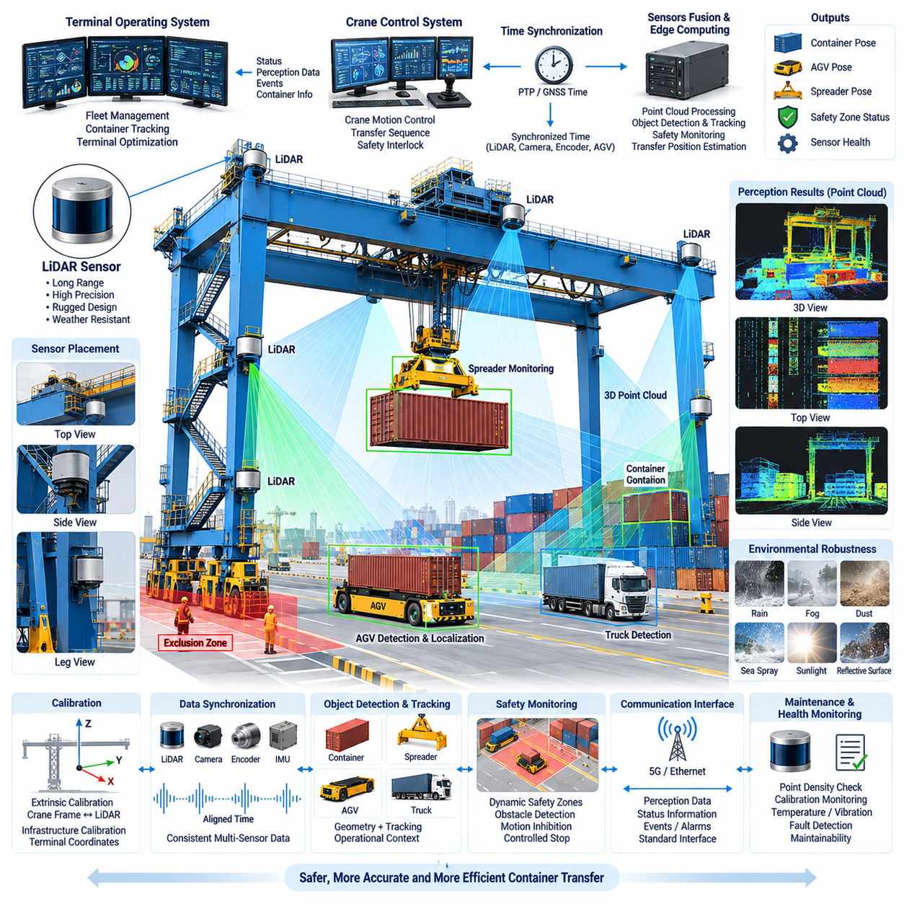
Crane LiDAR integration provides precise three-dimensional perception around quay cranes, automated stacking cranes, rail-mounted gantry cranes, and container transfer zones. Unlike LiDAR mounted on a mobile vehicle, crane-mounted sensors observe operations from elevated or structurally fixed positions and can continuously measure containers, spreaders, AGVs, trucks, crane structures, and surrounding obstacles. The integration therefore functions as both an infrastructure perception system and an important interface between crane automation and autonomous port vehicles.
The primary objective of crane-mounted LiDAR is to create reliable geometric awareness within areas where container transfer requires high positioning accuracy. A LiDAR sensor emits laser pulses and measures their return time to construct point clouds representing nearby surfaces. When installed at suitable locations on the crane structure, these point clouds can describe container edges, vehicle roofs, lane boundaries, spreader positions, obstacles, and structural elements, providing spatial information that complements cameras and other sensing technologies.
Sensor placement strongly affects the quality of crane perception. A sensor mounted too high may provide broad coverage but lose useful detail near the ground, while a low-mounted sensor can suffer severe occlusion from containers and vehicles. Multiple LiDAR units can therefore be distributed across crane legs, trolley structures, crossbeams, or transfer areas to obtain overlapping fields of view. The installation geometry should minimize blind zones while avoiding direct interference from moving crane mechanisms and container handling equipment.
Accurate calibration is essential because raw LiDAR measurements are expressed in each sensor's local coordinate frame. Extrinsic calibration determines the translation and rotation between the LiDAR and the crane reference frame, while infrastructure calibration relates that reference frame to terminal coordinates. Once these transformations are established, observations from multiple sensors can be combined into a consistent spatial representation and compared directly with AGV positions, crane trajectories, container locations, and predefined transfer points.
Time synchronization becomes particularly important when crane components, spreaders, containers, and vehicles are moving simultaneously. Measurements captured at different times can create apparent geometric displacement even when the individual sensors are correctly calibrated. Hardware timestamps, synchronized clocks, or network-based synchronization can align LiDAR data with crane encoder values, AGV telemetry, cameras, and control messages. Accurate temporal alignment allows the system to reconstruct the operational scene at a common reference time.
Container detection can exploit the strong geometric structure of standardized cargo units. Planar surfaces, rectangular boundaries, corners, and known dimensional relationships can be extracted from LiDAR point clouds to estimate container position and orientation. Rather than depending only on object classification, the system can combine geometric fitting with tracking and operational context. This approach is useful during loading and unloading because partial container visibility may occur while the spreader, crane structure, or neighboring stacks block portions of the LiDAR field of view.
Spreader monitoring is another important application of crane LiDAR. During container pickup or placement, the spreader must approach the target with controlled horizontal and vertical alignment. LiDAR observations can estimate relative displacement between the spreader, container, vehicle, and surrounding structures. These measurements can supplement crane encoders and other positioning sensors, enabling independent verification of approach geometry and supporting detection of abnormal swing, misalignment, unexpected obstacles, or incorrect container positioning before transfer continues.
AGV integration requires the crane perception system to understand both vehicle location and the designated container transfer position. As an AGV approaches the crane, infrastructure LiDAR can detect its body geometry and estimate its position relative to the transfer zone. This independent measurement can be compared with the AGV's own GNSS RTK, LiDAR, IMU, or odometry estimate. Agreement between vehicle and infrastructure localization increases confidence that the AGV has reached the correct position before container loading or unloading begins.
The final docking stage can use crane LiDAR as a local high-precision reference independent of satellite navigation. Large cranes, stacked containers, and metallic structures may degrade GNSS reception through obstruction and multipath effects. Infrastructure LiDAR observes the AGV directly within the crane coordinate frame and can therefore provide relative position and heading measurements during the final approach. This enables hierarchical localization in which GNSS supports terminal navigation while crane perception supports centimeter-class alignment near the transfer point.
Crane LiDAR can also establish dynamic safety zones around active handling operations. Point-cloud processing can identify vehicles, workers, equipment, or unexpected objects entering restricted regions beneath or around the crane. Safety logic can compare detected objects with configured exclusion zones and current crane operating states. When an unsafe condition is detected, the system can issue warnings, inhibit specific crane motions, delay container transfer, or request a controlled stop according to the safety architecture and operational authority assigned to the perception system.
Occlusion management is critical because port environments contain large objects that frequently block one another. A single LiDAR may lose sight of an AGV when a container passes through its field of view or when adjacent equipment occupies the same line of sight. Overlapping sensors positioned at different heights and viewing angles can reduce this vulnerability. Multi-LiDAR fusion should preserve sensor identity and confidence so that temporary loss of one viewpoint does not incorrectly appear as disappearance of the tracked object.
Environmental conditions also influence LiDAR performance. Rain, fog, airborne dust, sea spray, reflective surfaces, and direct sunlight can introduce noise or reduce effective detection range. Sensor housings require suitable environmental protection, while optical windows may need contamination monitoring or cleaning mechanisms. Software should reject isolated returns, detect degraded point-cloud quality, and adjust confidence when environmental conditions reduce perception reliability rather than treating all measurements as equally trustworthy.
Data processing can be divided between edge computing near the crane and higher-level terminal infrastructure. Time-critical functions such as point-cloud filtering, object detection, tracking, safety-zone monitoring, and transfer-position estimation are well suited to local edge processors. Processed object states and health information can then be transmitted to crane controllers, fleet management systems, or terminal operating systems. This reduces network bandwidth while ensuring that immediate crane decisions do not depend entirely on remote cloud connectivity.
Communication interfaces must provide clear ownership of commands and state information. The LiDAR subsystem may publish detected objects, AGV pose, container pose, spreader alignment, safety-zone status, confidence values, and sensor health, while the crane controller provides motion state and transfer sequence information. The fleet system can provide AGV identity and mission context. Explicit interface definitions prevent perception information from being interpreted differently by the crane, AGV, and terminal control layers.
Sensor health monitoring should operate continuously because contamination, vibration, cable faults, network interruption, calibration drift, or hardware failure can gradually degrade perception. Diagnostic functions can monitor point density, expected static landmarks, temperature, communication latency, timestamp consistency, and calibration residuals. When confidence falls below an acceptable threshold, the system should identify the degraded sensor and transition to an appropriate operating mode rather than continuing automated container transfer with unverified perception.
Mechanical integration must account for the severe environment experienced by crane-mounted electronics. LiDAR brackets require sufficient stiffness to preserve calibration despite vibration, shock, wind, and repeated crane motion. Connectors and harnesses need protection against moisture, salt-laden air, abrasion, and electromagnetic interference. Installation locations should also permit inspection, cleaning, calibration, and replacement without excessive crane downtime, making maintainability an important part of the perception architecture rather than an afterthought.
A mature crane LiDAR architecture ultimately creates a shared perception layer between infrastructure and autonomous vehicles. The crane observes the transfer zone from a stable external viewpoint, while the AGV observes the same environment from its onboard sensors. Combining these perspectives provides redundancy and reduces dependence on any single localization source. Through calibrated coordinates, synchronized measurements, reliable communication, health monitoring, and safety supervision, crane LiDAR integration enables more accurate container alignment, safer transfers, reduced waiting time, and higher overall terminal automation performance.

09.03. Port Communication Network
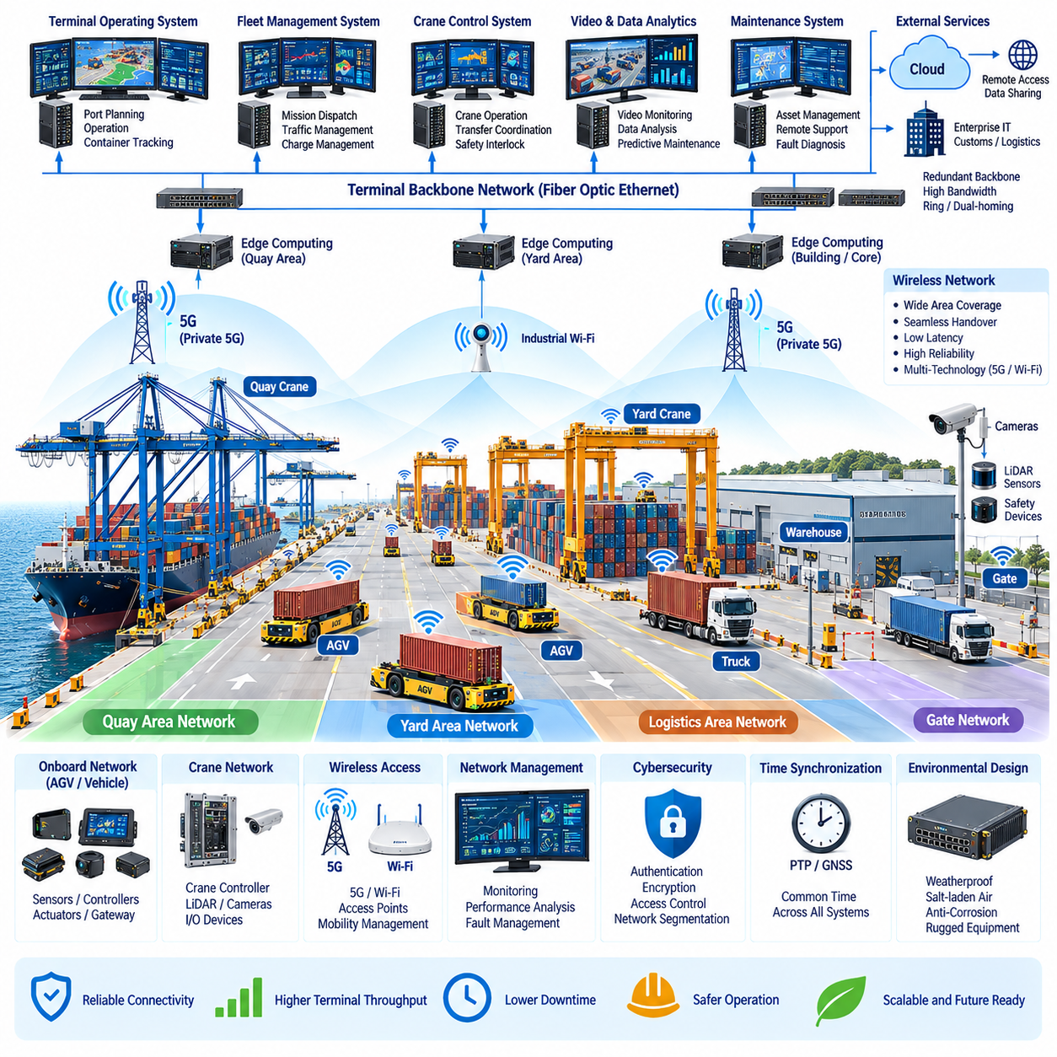
Port communication networks provide the digital infrastructure that connects autonomous guided vehicles, cranes, terminal operating systems, fleet controllers, safety systems, maintenance platforms, and field equipment across a large container terminal. Unlike conventional factory networks, port networks must support mobile machines operating over kilometers of outdoor infrastructure while maintaining reliable connectivity around ships, cranes, container stacks, warehouses, gates, and rapidly changing metallic obstacles.
A modern port communication architecture is typically organized into several interconnected layers. Vehicle and machine networks connect onboard sensors, controllers, actuators, and gateways; wireless access networks provide mobility across operational areas; the terminal backbone transports high-volume data between zones; and edge or data-center networks connect fleet management, terminal operating systems, analytics, storage, and external services. Clear separation between these layers simplifies scalability, security, maintenance, and fault isolation.
Autonomous vehicles impose particularly demanding communication requirements because they continuously exchange mission commands, position information, vehicle status, traffic coordination messages, diagnostics, and operational events. Some applications additionally transmit camera images, LiDAR-derived information, or live video. Network design must therefore distinguish low-bandwidth but latency-sensitive control information from high-bandwidth perception and monitoring traffic, preventing large data transfers from degrading time-critical operational communication.
Wireless communication is essential because AGVs, autonomous trucks, inspection robots, and other mobile equipment cannot depend on fixed connections. Industrial Wi-Fi, private 5G, or combinations of multiple wireless technologies can provide terminal coverage depending on performance and deployment requirements. Access points or radio units should be positioned according to actual propagation conditions, considering crane structures, container stacks, buildings, ships, terrain, and vehicle routes rather than assuming unobstructed theoretical coverage.
Container stacks create one of the most difficult radio environments within a port. Large steel surfaces can block line-of-sight paths, generate multipath propagation, and create temporary radio shadows as containers are continuously moved. A network that performs well when a yard is empty may behave differently when stacks reach operational height. Radio planning should therefore evaluate representative container configurations and provide overlapping coverage so that mobile equipment can maintain connectivity when one communication path becomes degraded.
Mobility management must support seamless handover as vehicles move between wireless cells. An AGV may travel continuously from a quay crane through transfer roads to a distant container yard while maintaining an active fleet connection. Excessive handover delay, packet loss, or temporary disconnection can interrupt telemetry and coordination. The network should therefore optimize cell boundaries, roaming behavior, authentication, and redundant coverage according to actual vehicle speed and mission routes.
Private 5G can provide useful capabilities for large automated terminals through managed spectrum, mobility support, quality-of-service mechanisms, and scalable connectivity for many mobile devices. Different traffic classes can be assigned according to operational importance, allowing critical vehicle messages to receive different treatment from maintenance downloads or video streams. However, autonomous vehicle safety should not rely exclusively on continuous 5G availability; local controllers must retain authority to respond safely when communication is unavailable.
Industrial Wi-Fi remains valuable for many port applications because of its mature ecosystem, high data rates, and relatively flexible deployment. It can support maintenance areas, workshops, charging stations, warehouses, crane structures, and selected outdoor zones. When Wi-Fi is used for moving AGVs, access-point density and roaming configuration become critical. Hybrid architectures can combine Wi-Fi and cellular connectivity so that each technology is applied where its technical and economic characteristics provide the greatest advantage.
The wired backbone forms the stable foundation beneath the wireless network. Fiber-optic Ethernet is particularly suitable for long-distance connections between quay areas, yard zones, control buildings, edge computing facilities, and data centers because it provides high bandwidth and resistance to electromagnetic interference. Redundant fiber paths can prevent a single cable or network-device failure from isolating major terminal areas. Ring, dual-homing, or redundant switching architectures can be selected according to availability requirements.
Edge computing reduces dependence on distant central servers by placing computation close to cranes, vehicle zones, or operational clusters. Local edge systems can process perception data, aggregate telemetry, support traffic management, cache maps, and maintain selected services during temporary backbone disturbances. This architecture also reduces unnecessary transmission of raw sensor data. Instead of continuously forwarding complete LiDAR or camera streams, edge processors can transmit processed objects, events, health information, and operational summaries.
Communication between cranes and AGVs requires clearly defined machine states and transfer protocols. Before container loading or unloading, the AGV and crane systems may exchange vehicle identity, assigned transfer position, arrival state, alignment status, readiness, safety state, and completion confirmation. These messages should be deterministic at the application level so that both machines share an unambiguous understanding of the transfer sequence. Loss of communication must lead to a predefined safe operational response rather than an undefined intermediate state.
Fleet management communication coordinates many vehicles as a single logistics system. The fleet controller distributes missions, traffic reservations, route updates, charging assignments, and operational priorities while receiving position, battery state, fault information, and mission progress from each vehicle. Communication capacity should be designed for fleet growth because message volume increases as more autonomous machines are deployed. Network architecture must support expansion without requiring fundamental redesign of the entire terminal communication system.
Quality of service is important when multiple applications share the same infrastructure. Emergency events, safety-related status, vehicle control coordination, and crane transfer messages should receive higher communication priority than software downloads, historical data synchronization, or noncritical video. Traffic classification, prioritization, bandwidth management, and congestion control can preserve predictable behavior during peak network load. Performance should be evaluated using latency, jitter, packet loss, throughput, availability, and recovery time rather than bandwidth alone.
Time synchronization provides a common temporal reference across distributed machines and sensors. GNSS time, Precision Time Protocol, or other synchronized clock mechanisms can align LiDAR measurements, camera frames, crane encoders, AGV telemetry, event logs, and control messages. Accurate timestamps are essential when reconstructing incidents or combining data from multiple systems. Time synchronization therefore becomes part of both real-time operation and engineering traceability across the automated terminal.
Network segmentation protects critical operational systems from unnecessary traffic and cyber exposure. Vehicle control, crane automation, safety systems, terminal management, maintenance, video surveillance, guest access, and enterprise IT should not automatically share unrestricted connectivity. VLANs, routing policies, firewalls, access control, and industrial security gateways can establish controlled communication boundaries. Segmentation also limits the propagation of configuration errors, broadcast storms, compromised devices, and other network disturbances.
Cybersecurity must be incorporated into port communication architecture from the beginning because connected vehicles and cranes interact directly with physical equipment. Device authentication, encrypted communication, certificate management, secure remote access, network monitoring, software integrity, and controlled update mechanisms reduce the attack surface. Security policies must nevertheless support practical maintenance, since excessive complexity can encourage unsafe workarounds. Identity and access privileges should therefore correspond to clearly defined operational roles.
Network health monitoring should continuously measure communication quality throughout the terminal. Access-point status, signal strength, handover events, packet loss, latency, switch utilization, fiber-link condition, device temperature, and abnormal traffic can be collected into a network management platform. Correlating communication metrics with AGV routes helps identify recurring radio shadows or congestion zones. Predictive analysis can then support maintenance before network degradation begins to affect container operations.
Environmental durability is another major requirement because port communication equipment operates under rain, humidity, temperature variation, vibration, dust, strong sunlight, and salt-laden air. Outdoor antennas, enclosures, connectors, switches, and cable systems require appropriate environmental protection and corrosion resistance. Equipment placement should also consider maintainability, lightning protection, grounding, electromagnetic compatibility, and physical access so that network infrastructure remains reliable throughout long-term terminal operation.
A resilient port network should assume that individual communication links and devices will eventually fail. Redundant wireless coverage, alternative backbone routes, duplicated critical switches, local autonomy, buffered data, and graceful degradation allow operations to continue safely during partial failures. AGVs should retain sufficient onboard maps, mission context, perception, and safety logic to reach a safe condition without central connectivity. Communication redundancy therefore complements, rather than replaces, autonomous local decision-making.
The complete port communication network ultimately functions as the nervous system of an automated terminal. It connects vehicle autonomy, crane control, fleet management, safety supervision, edge computing, terminal operations, maintenance, and data analytics into a coordinated cyber-physical environment. When wireless mobility, fiber backbone, traffic prioritization, time synchronization, cybersecurity, redundancy, environmental protection, and continuous monitoring are engineered together, the network enables safer vehicle coordination, faster container transfer, higher equipment availability, and more predictable terminal throughput.

09.04. Salt Air Protection Design
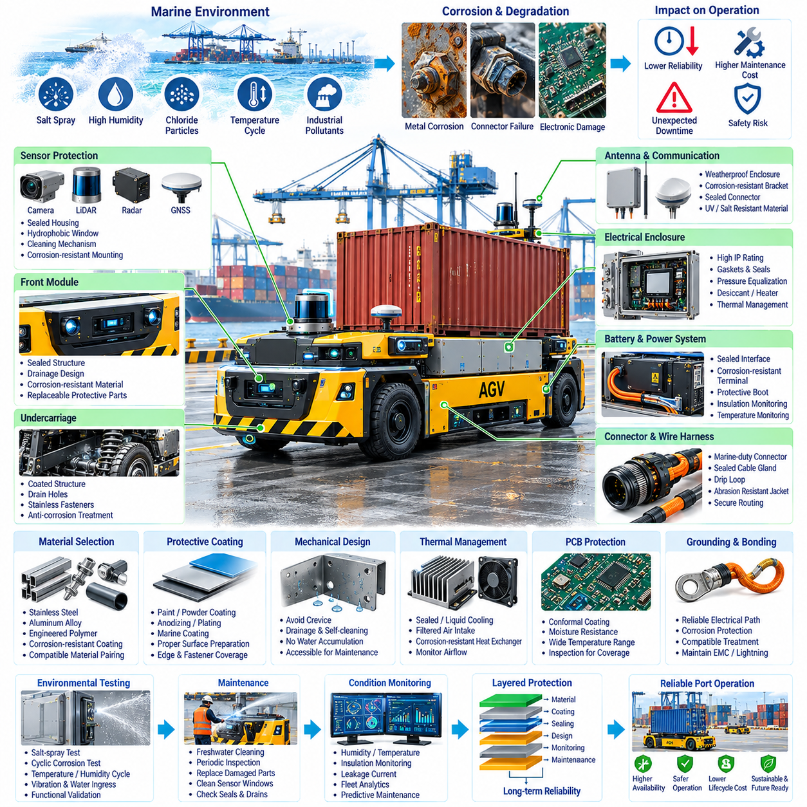
Salt-air protection design is a critical engineering requirement for autonomous vehicles and robotic systems operating in seaports, coastal logistics terminals, offshore facilities, and other marine environments. Airborne chloride particles, sea spray, high humidity, condensation, temperature cycling, and industrial pollutants can accelerate corrosion of metals and degradation of electrical components. Protection must therefore be treated as a system-level reliability function rather than as a simple enclosure requirement.
Salt contamination becomes particularly damaging when moisture is present because deposited chloride ions create conductive electrolytes on exposed surfaces. These films accelerate electrochemical corrosion and can increase leakage currents between electrical conductors. Repeated wetting and drying cycles may concentrate salts over time, meaning equipment that appears dry can still retain contamination capable of causing progressive damage. Long-term exposure must therefore be considered even when direct seawater contact is unlikely.
Material selection provides the first layer of protection against the marine environment. Structural components, brackets, fasteners, electrical enclosures, connector shells, and mounting hardware should be selected according to corrosion resistance and expected exposure severity. Stainless steels, appropriately treated aluminum alloys, engineered polymers, and corrosion-resistant coatings can reduce degradation. Material compatibility is equally important because dissimilar metals in electrical contact can create galvanic corrosion when moisture and salt provide an electrolyte.
Galvanic corrosion should be controlled through careful material pairing, electrical isolation, surface treatment, and drainage design. When two metals with significantly different electrochemical potentials are connected in a wet saline environment, the less noble material may corrode rapidly. Insulating washers, bushings, coatings, sealants, or compatible intermediate materials can interrupt the galvanic path. Mechanical designers should evaluate complete assemblies rather than considering the corrosion resistance of individual parts independently.
Protective coatings provide an additional barrier between metallic surfaces and the environment. Paint systems, powder coatings, conversion coatings, anodizing, plating, and specialized marine coatings can be selected according to substrate material and operating conditions. Coating performance depends strongly on surface preparation, thickness, adhesion, edge coverage, and resistance to mechanical damage. Scratches around fasteners, sharp edges, welds, and service openings require particular attention because localized coating failure can initiate concentrated corrosion.
Electrical and electronic enclosures must prevent salt spray and moisture from reaching sensitive circuitry while allowing practical thermal management and servicing. Appropriate ingress protection should be selected according to mounting location and exposure. Gaskets, cable glands, sealed connectors, access covers, and enclosure joints must form a coordinated sealing system. A high enclosure rating alone does not guarantee reliability if installation holes, improperly compressed seals, damaged cables, or maintenance procedures create uncontrolled leakage paths.
Condensation requires separate consideration because a sealed enclosure can still contain moisture. Daily temperature changes may cause internal air to reach its dew point, allowing water to condense on circuit boards, connectors, and metallic surfaces. Pressure-equalization membranes, controlled ventilation, desiccants, heaters, drainage, or environmental conditioning can be used according to the application. Thermal design and moisture protection should therefore be developed together rather than treating sealing and cooling as independent engineering tasks.
Connectors are especially vulnerable because they combine conductive contacts, mechanical interfaces, sealing surfaces, and repeated service operations. Marine-duty connectors should provide suitable environmental sealing, corrosion-resistant shells and contacts, secure locking mechanisms, and compatible cable seals. Unused connector positions require proper protective caps or cavity seals. Connector orientation should prevent standing water, and harness routing should avoid configurations that allow water to travel along cables directly toward electrical interfaces.
Wire harness protection must address salt exposure, abrasion, vibration, flexing, and water migration. Cable jackets, conduits, braided sleeves, heat-shrink materials, clamps, and protective channels should be selected for outdoor durability. Harness branches should include appropriate drip loops where necessary so that water does not naturally flow toward connectors or electronic modules. Clamps and routing points must prevent movement from damaging protective layers, particularly on vehicles exposed to continuous vibration and repeated shock loads.
Printed circuit boards and electronic modules may require conformal coating when environmental sealing alone cannot provide sufficient protection. Conformal coatings can reduce moisture-related leakage, corrosion, and contamination effects by covering conductors and component surfaces with a protective dielectric layer. Coating selection must consider adhesion, temperature range, repairability, chemical compatibility, and coverage around component leads. Manufacturing inspection is essential because voids or incomplete coverage can significantly reduce protection effectiveness.
Sensors require special treatment because optical, acoustic, radar, GNSS, and LiDAR devices cannot simply be enclosed behind arbitrary protective barriers. Sensor housings and connectors can be sealed, but sensing surfaces must remain functional. LiDAR windows and camera lenses may require hydrophobic surfaces, contamination monitoring, cleaning mechanisms, or replaceable protective windows. Radar covers must maintain suitable electromagnetic properties, while GNSS antennas require corrosion-resistant mounting and sealing without degrading radio-frequency performance.
Cooling systems introduce additional salt-air exposure paths. Air-cooled electronics that draw external air through heat sinks or filters can accumulate chloride contamination internally, while exposed heat exchangers may suffer corrosion and reduced thermal performance. Where practical, sealed conduction cooling or isolated liquid-cooling architectures can reduce direct environmental exposure. If forced-air cooling is unavoidable, filtration, replaceable filters, corrosion-resistant heat exchangers, inspection intervals, and airflow monitoring should be incorporated into the maintenance strategy.
Battery systems, power distribution units, inverters, motor controllers, and high-current connectors require particularly robust protection because corrosion can increase contact resistance and generate localized heating. Sealed interfaces, corrosion-resistant terminals, controlled torque, protective boots, and appropriate surface treatments help preserve electrical integrity. Diagnostic systems can monitor voltage drop, temperature, insulation condition, and abnormal current behavior to identify degradation before corrosion develops into a functional or safety-critical failure.
Grounding and bonding design must remain electrically effective throughout the equipment lifetime. Corrosion at bonding interfaces can increase impedance and degrade electromagnetic compatibility, fault-current paths, or lightning protection. Bonding surfaces may therefore require controlled preparation, compatible conductive treatments, sealing after assembly, and periodic inspection. Protective coatings should not unintentionally isolate interfaces that require electrical continuity, making corrosion protection and grounding design closely interconnected engineering disciplines.
Mechanical geometry can significantly influence corrosion resistance. Horizontal cavities, overlapping plates, unsealed seams, blind holes, and poorly drained channels can trap salty water and contamination. Components should therefore be shaped and oriented to promote drainage, drying, and cleaning. Crevices should be minimized where practical, and drain paths should remain functional throughout the vehicle operating attitude. Good geometric design can prevent persistent moisture accumulation before additional coatings or sealing technologies are required.
Environmental validation should reproduce representative marine exposure rather than relying only on visual inspection. Salt-spray or cyclic corrosion testing can evaluate coatings, materials, connectors, assemblies, and manufacturing processes under accelerated conditions. Temperature and humidity cycling, vibration, water ingress, electrical operation, and corrosion exposure may also need to be combined because real equipment experiences multiple stresses simultaneously. Testing should focus on functional degradation as well as visible corrosion.
Maintenance strategy is an integral part of salt-air protection. Periodic freshwater cleaning can remove deposited chlorides before they accumulate to damaging levels, while inspections can identify coating damage, corrosion around fasteners, degraded seals, blocked drains, contaminated sensor windows, and connector deterioration. Maintenance intervals should reflect actual exposure severity and operating history. Easily accessible inspection points and replaceable protective components can substantially reduce lifecycle cost and vehicle downtime.
Condition monitoring can make corrosion management more predictive. Humidity sensors, enclosure temperature measurements, insulation monitoring, connector temperature trends, leakage-current detection, and maintenance records can provide evidence of environmental degradation. Fleet analytics can compare failures with vehicle routes and exposure zones, helping engineers identify locations where sea spray or contamination is unusually severe. These observations can guide both maintenance scheduling and future design improvements.
A mature salt-air protection architecture combines material selection, compatible metal pairing, coatings, enclosure sealing, connector engineering, harness protection, moisture control, thermal management, sensor protection, grounding, drainage, testing, diagnostics, and maintenance into one coordinated design process. No single coating or ingress rating can guarantee long-term reliability. Layered protection ensures that failure of one barrier does not immediately expose critical electrical and electronic systems to the marine environment.
For port autonomous vehicles, effective salt-air protection directly supports availability, safety, localization reliability, communication stability, and predictable maintenance. Vehicles that operate continuously between quay cranes, container yards, charging stations, and logistics areas may accumulate environmental exposure for thousands of operating hours. Designing corrosion resistance as part of the electrical and mechanical architecture enables autonomous port equipment to maintain performance over its intended service life while reducing unexpected failures and operational downtime.

09.05. Port AMR Case
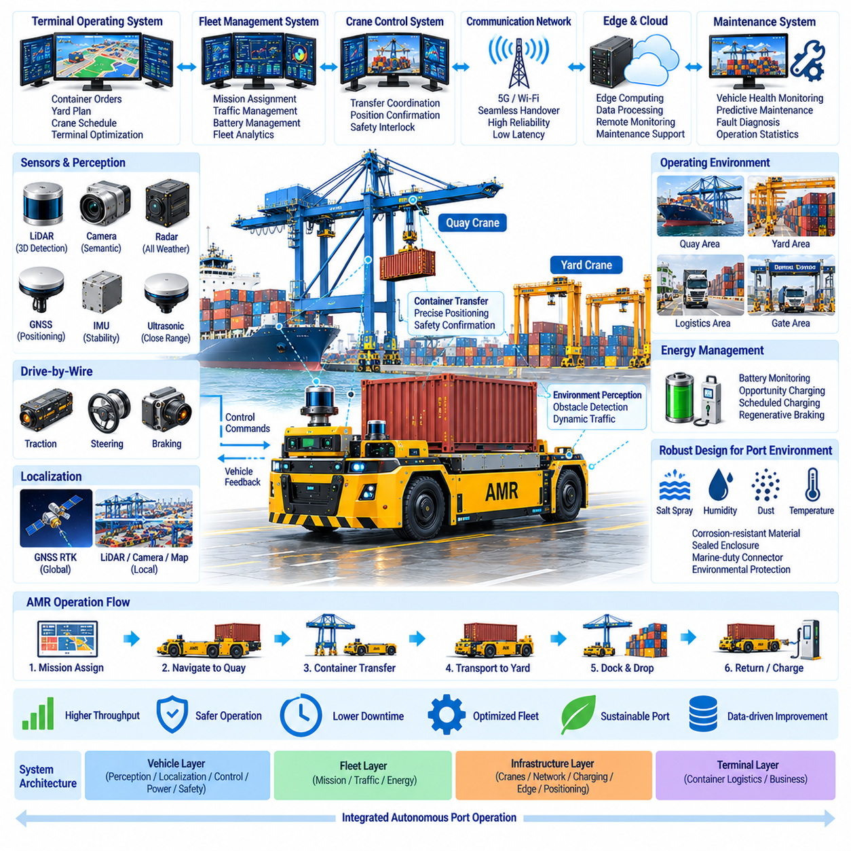
Port autonomous mobile robots represent the integration of heavy-duty mobility, outdoor autonomy, terminal communication, safety engineering, and logistics coordination into a single operational platform. Unlike indoor AMRs, a port AMR operates across quay areas, container yards, transfer lanes, warehouses, charging zones, and gates while interacting with cranes, trucks, workers, and other autonomous machines. Its design must therefore optimize terminal-level container flow rather than autonomous driving performance alone.
A representative port AMR mission begins when the terminal operating system assigns a container movement between a quay crane and a designated yard location. The fleet management system evaluates available vehicles, traffic conditions, battery state, crane schedules, and mission priority before dispatching an appropriate AMR. The vehicle then receives the destination, route constraints, transfer information, and operational context required to execute the mission while remaining coordinated with the broader terminal logistics process.
Outdoor localization combines global and local positioning technologies. GNSS RTK can provide centimeter-class positioning in open terminal areas, while IMU, wheel odometry, LiDAR, cameras, and radar maintain localization continuity and environmental awareness. Near cranes or dense container stacks, satellite signals may become degraded by obstruction and multipath effects. The AMR can therefore transition toward infrastructure-relative localization using LiDAR geometry, landmarks, crane sensors, or predefined docking references during precision transfer operations.
Perception must remain reliable in a highly dynamic environment containing container stacks, trucks, cranes, workers, temporary equipment, and continuously changing traffic patterns. LiDAR provides accurate geometric information, cameras contribute semantic interpretation, radar improves robustness under difficult weather or visibility, and ultrasonic or short-range sensors can support close-proximity detection. Multi-sensor fusion allows the vehicle to maintain a consistent environmental model even when one sensing modality temporarily becomes unreliable.
Route planning is coordinated at both fleet and vehicle levels. The fleet management system can reserve road segments, manage intersections, distribute traffic across alternative routes, and sequence vehicles approaching crane transfer zones. The onboard planner follows the assigned route while reacting to local obstacles and unexpected changes. This hierarchical approach prevents hundreds of vehicles from independently competing for the same infrastructure while preserving sufficient local autonomy for immediate collision avoidance and safe maneuvering.
Container transfer requires precise synchronization between the AMR and crane. As the vehicle approaches the assigned transfer position, its onboard localization estimate can be compared with crane-mounted LiDAR or other infrastructure measurements. The vehicle confirms identity, mission, position, heading, stationary state, and safety status before declaring readiness. The crane subsequently verifies its own transfer conditions, creating a mutual state-confirmation process before the spreader begins lifting or lowering the container.
Drive-by-wire systems provide electronic control of propulsion, steering, and braking. Commanded values are continuously compared with actuator feedback, vehicle velocity, steering position, and braking response to detect inconsistencies. Because vehicle dynamics change significantly between unloaded and container-loaded conditions, motion control must adapt acceleration, turning, stopping distance, and trajectory behavior to the current payload. Heavy-load operation therefore requires conservative safety margins and predictable control performance throughout the complete operating envelope.
The safety architecture remains independent from normal autonomous decision-making wherever practical. Safety controllers supervise emergency stops, obstacle proximity, excessive speed, steering or brake faults, localization uncertainty, communication loss, and critical compute failures. When normal operation cannot continue safely, the vehicle transitions toward a predefined degraded state or minimal-risk condition. Local safety authority ensures that loss of a fleet server, wireless connection, or high-level AI process does not prevent the AMR from executing a controlled stop.
Communication connects the AMR with fleet management, crane controllers, terminal operating systems, edge computing nodes, charging infrastructure, and maintenance platforms. Private 5G, industrial Wi-Fi, or hybrid wireless architectures can provide mobility across the terminal, while fiber-optic Ethernet forms the infrastructure backbone. Communication design should prioritize mission and safety-related information over large diagnostic or video transfers and support seamless handover as vehicles move between quay, yard, logistics, and gate communication zones.
The AMR should remain operationally safe during temporary network degradation. Onboard maps, current mission context, perception, localization, trajectory control, and safety functions allow the vehicle to respond locally without continuous central commands. If communication cannot be restored within acceptable limits, the AMR can stop at a safe location or enter a predefined recovery state. Buffered operational data can later be synchronized when connectivity returns, preventing short communication interruptions from causing uncontrolled vehicle behavior.
Energy management is integrated with fleet scheduling rather than treated as an isolated vehicle function. Battery state, predicted mission consumption, charging availability, queue length, and future workload can influence mission assignment. Opportunity charging can be performed during naturally occurring idle periods, while scheduled charging or battery swapping may support continuous terminal operation. Regenerative braking can recover energy during repeated deceleration, although safe braking capability must remain available independently of regenerative performance.
Port exposure creates severe environmental requirements for the vehicle electrical and mechanical architecture. Salt spray, chloride particles, humidity, condensation, rain, dust, temperature cycling, vibration, and sunlight can degrade structures, connectors, sensors, electronics, and power systems. Corrosion-resistant materials, protective coatings, sealed enclosures, marine-duty connectors, protected wire harnesses, controlled drainage, and moisture management form multiple defensive layers that preserve reliability during long-term coastal operation.
Sensors require protection without degrading perception performance. Camera lenses and LiDAR windows must remain optically clear, radar covers must preserve radio-frequency characteristics, and GNSS antennas require environmentally sealed mounting. Hydrophobic surfaces, cleaning mechanisms, contamination detection, replaceable windows, and corrosion-resistant brackets can maintain sensor availability. Sensor health monitoring should detect contamination or abnormal data quality so that environmental degradation is not incorrectly interpreted as valid perception information.
The electrical architecture must also preserve grounding, bonding, electromagnetic compatibility, and power integrity throughout the vehicle lifetime. Corrosion at high-current terminals or bonding interfaces can increase resistance, generate heat, and degrade fault-current paths. Power distribution units, battery connections, motor controllers, compute systems, and sensor supplies therefore require protected interfaces and diagnostic monitoring. Voltage, current, temperature, insulation, and communication health information can support early identification of developing electrical faults.
Maintenance becomes increasingly data-driven as the fleet accumulates operating hours. Each AMR can report component temperatures, battery performance, actuator behavior, network quality, localization confidence, sensor health, corrosion-related observations, fault codes, and mission statistics. Fleet analytics can identify recurring degradation patterns associated with particular routes or environmental zones. Predictive maintenance then allows components to be serviced before deterioration causes mission interruption or unexpected terminal downtime.
Edge and terminal-level analytics extend this information beyond individual vehicle maintenance. Mission duration, crane waiting time, traffic congestion, empty travel distance, charging utilization, transfer accuracy, and recovery events can be analyzed together to identify system-level inefficiencies. A digital representation of terminal operations can evaluate alternative dispatch rules or traffic strategies before deployment. The AMR fleet therefore becomes both a transportation system and a distributed source of operational intelligence.
A mature port AMR system is consequently organized as several cooperating layers. The vehicle layer contains perception, localization, drive-by-wire, power, onboard computing, and local safety; the fleet layer manages missions and traffic; the infrastructure layer provides cranes, wireless networks, charging, edge computing, and positioning references; and the terminal layer manages container logistics and business priorities. Defined interfaces allow these layers to cooperate without transferring critical local safety authority to remote systems.
Operational validation must evaluate the complete system rather than testing autonomous driving functions independently. Representative scenarios should include loaded and unloaded driving, crane docking, intersections, communication handovers, GNSS degradation, sensor obstruction, emergency stops, wet surfaces, salt exposure, charging operations, and component faults. Performance can then be measured using transfer accuracy, mission completion rate, intervention frequency, stopping behavior, communication availability, energy consumption, and recovery capability.
The success of a port AMR deployment is ultimately determined by reliable container throughput and equipment availability. Faster autonomous driving provides little value if vehicles create crane waiting, traffic congestion, charging bottlenecks, or frequent maintenance interruptions. Effective port automation therefore emerges from coordinated optimization of autonomy, fleet scheduling, crane integration, communication, electrical reliability, environmental protection, safety, energy, and maintenance. The port AMR becomes a coordinated element of the entire automated terminal rather than merely a driverless transport vehicle.

