Volume 17 Outdoor Autonomous Vehicle

Chapter 08. Agriculture AMR

08.01. Spraying Drone Integration
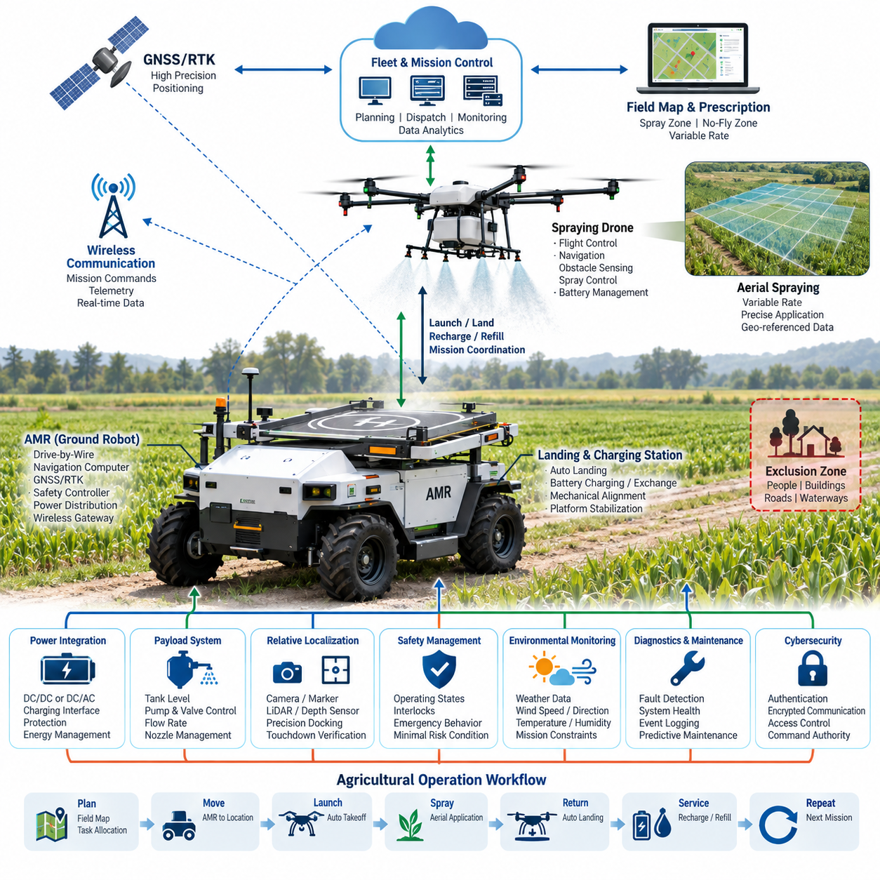
Spraying drone integration extends an agricultural autonomous mobile robot from a ground vehicle into a coordinated ground–air robotic system. The AMR can serve as a mobile logistics, sensing, charging, and communication platform, while the drone performs aerial spraying over crops that are difficult or inefficient to reach from the ground. This architecture fits within the Agriculture AMR domain of the outdoor autonomous vehicle platform.
The fundamental integration problem is not simply mounting or transporting a drone. The ground robot and aerial vehicle must operate as two autonomous subsystems connected through a common mission architecture. Mission planning determines which field sections are assigned to ground operations and which require aerial spraying, while a supervisory controller coordinates launch, flight, spraying, return, landing, replenishment, and subsequent missions.
A typical system separates the architecture into vehicle, drone, payload, communication, positioning, and supervisory layers. The AMR contains its own drive-by-wire controller, navigation computer, GNSS/RTK receiver, safety controller, power distribution system, and wireless gateway. The drone contains flight control, propulsion, navigation, obstacle sensing, spray control, and battery management functions, allowing independent stabilization even if communication with the AMR is temporarily interrupted.
Precise spatial coordination is essential because both platforms operate in the same agricultural coordinate system. GNSS/RTK can provide a common global reference for the AMR, drone, field map, crop rows, exclusion zones, and spray polygons. The mission server transforms agronomic task definitions into geographic trajectories so that spraying is performed only within authorized regions while maintaining appropriate margins from workers, roads, buildings, waterways, and neighboring fields.
The communication architecture should distinguish mission-level communication from flight-critical control. High-level commands such as mission upload, launch authorization, target polygon assignment, return request, telemetry reporting, and payload status can pass through the AMR communication gateway. Flight stabilization and immediate aircraft control should remain local to the drone so that loss of the ground communication link does not directly destabilize the aircraft.
The AMR can function as a mobile drone base station rather than merely a carrier. A dedicated landing deck may provide mechanical alignment, landing detection, electrical charging, battery exchange interfaces, and protection during transportation. The ground platform can reposition itself between missions, reducing the distance the drone must fly without spraying and allowing the aerial vehicle to operate from temporary launch points close to successive treatment areas.
Electrical integration requires careful separation between propulsion power and auxiliary payload power. The AMR battery may supply the drone charger through an appropriately isolated DC/DC or DC/AC conversion stage, depending on the charger architecture. Current limits, fuse coordination, connector ratings, thermal protection, ground strategy, emergency isolation, and battery state-of-charge thresholds must be engineered so repeated drone charging does not compromise the AMR's ability to return safely.
Spraying introduces an additional payload-control domain. The drone must coordinate flight velocity, altitude, nozzle characteristics, pump pressure, flow rate, and commanded application rate. The mission system can associate these parameters with geographic treatment zones, enabling variable-rate spraying where different crop regions receive different application quantities. Spray execution data should be time-stamped and geographically referenced for subsequent traceability and analysis.
Payload monitoring should include tank level or estimated remaining volume, pump state, flow information, valve status, and relevant fault conditions. The supervisory system can compare commanded application with measured delivery and detect abnormal conditions such as an empty tank, blocked nozzle, pump malfunction, unexpected pressure change, or excessive consumption. A mission can then be suspended or modified rather than continuing with uncertain treatment quality.
The landing interface is one of the most demanding physical integration points. Agricultural terrain can cause the AMR chassis to pitch or roll, while wind and vehicle vibration can make precision landing difficult. The system therefore benefits from a defined docking sequence in which the AMR stops, confirms acceptable platform attitude, establishes a landing-safe state, and provides the drone with increasingly precise relative-position information during final approach.
Relative localization can complement GNSS/RTK near the landing platform. Cameras, fiducial markers, depth sensing, LiDAR, or other local positioning techniques can support terminal guidance when centimeter-level relative alignment is required. The architecture should treat successful touchdown as a verified state rather than assuming that reaching a coordinate means landing has completed, particularly when automated charging or mechanical retention follows touchdown.
Safety coordination requires explicit operating states for both machines. The AMR should not begin driving while the drone is taking off, landing, insufficiently secured, or connected to a charging interface. Likewise, drone launch should be inhibited if the ground vehicle is moving, the landing platform is improperly positioned, personnel are detected within a protected area, or required communication, positioning, weather, or payload conditions are unavailable.
Emergency behavior should be distributed rather than dependent on a single controller. The drone requires autonomous responses for low battery, navigation degradation, propulsion faults, communication loss, or unsafe flight conditions, while the AMR requires its own minimal-risk behavior for mobility faults. The supervisory layer coordinates these responses but should not become a single point whose failure simultaneously removes the basic safety functions of both platforms.
Environmental information becomes particularly important for spraying because successful navigation does not necessarily mean successful chemical application. Wind speed and direction can influence drift, while rain, temperature, humidity, and rapidly changing local conditions can affect mission suitability. Weather information can therefore act as a mission constraint, allowing the system to postpone, modify, or terminate spraying when environmental limits defined for the operation are exceeded.
Mission planning can combine field maps, crop information, treatment prescriptions, AMR traversability, drone endurance, payload capacity, charging requirements, and operational restrictions. Instead of planning each robot independently, the system can optimize the combined workflow: the AMR travels to a support location, the drone treats a defined region, returns for service, and launches again while the AMR advances toward the next strategically useful position.
Fleet integration expands this concept beyond a single AMR–drone pair. A central control system can manage multiple agricultural robots, drones, charging resources, treatment areas, and mission priorities. Each completed sortie generates telemetry and application records that can be linked with the broader fleet data architecture, supporting operational monitoring, maintenance planning, resource utilization analysis, and comparison between planned and executed agricultural work.
Cybersecurity and command authority are also important because wireless interfaces connect two independently mobile machines. Mission commands should be authenticated, communication channels protected, software identities managed, and unauthorized launch or spray commands rejected. The system should define which controller owns each operating state and prevent conflicting commands from local operators, remote fleet systems, the AMR controller, and the drone control subsystem.
Diagnostics should cover both individual platforms and their interfaces. Important integration faults include unavailable drone communication, charger failure, docking sensor disagreement, GNSS/RTK degradation, incompatible mission data, insufficient AMR energy reserve, insufficient drone battery, payload depletion, and failure to confirm mechanical retention. Recording synchronized diagnostic events makes it possible to reconstruct failures that cross the ground–air system boundary.
From a robotics electrical architecture perspective, spraying drone integration demonstrates how an outdoor autonomous vehicle can become a mobile infrastructure node for another autonomous machine. The broader robotics engineering tree places this work alongside communication, calibration, battery and powertrain, safety, perception, compute, and testing disciplines, emphasizing that reliable integration depends on coordinated electrical and system-level engineering rather than a single interface technology.

08.02. GPS Tracing Design
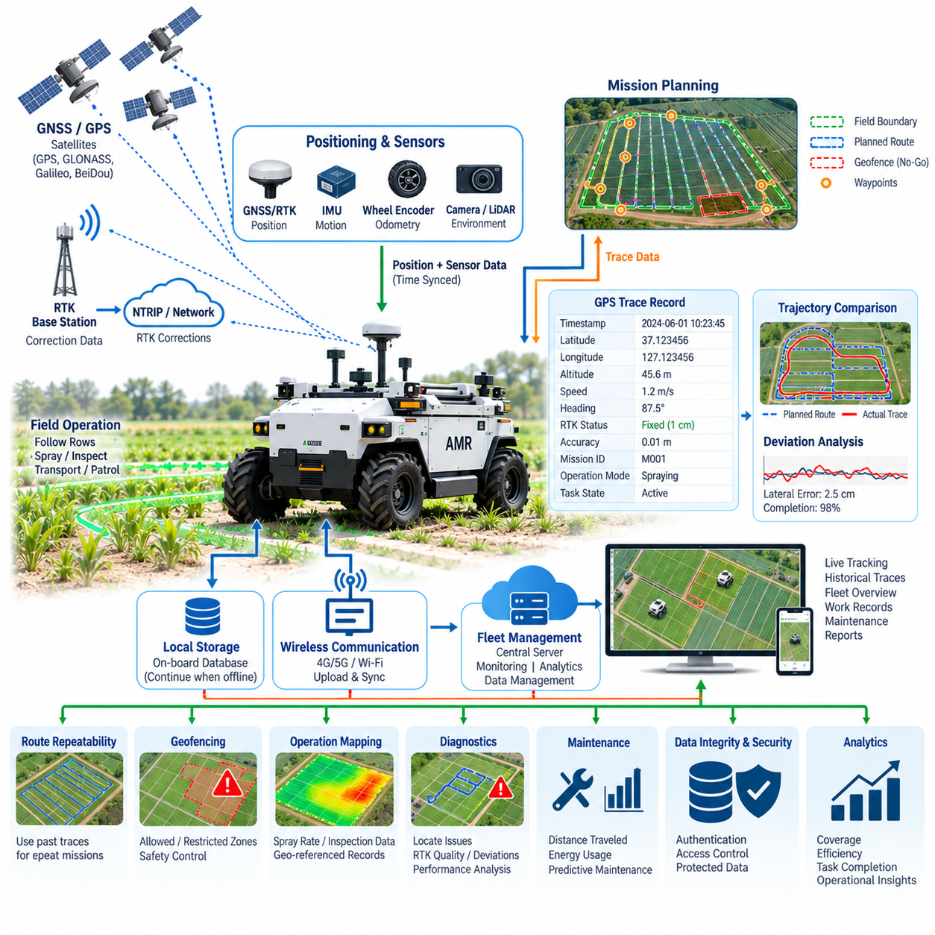
GPS tracing design for an agricultural autonomous mobile robot establishes a continuous spatial record of where the vehicle has traveled, where agricultural operations have been performed, and how accurately the robot has followed planned routes. Within an Agriculture AMR architecture, this capability connects positioning, navigation, mission execution, field mapping, and operational records into a common geographic framework.
The tracing system begins with a global positioning source that continuously estimates latitude, longitude, altitude, velocity, heading-related information, and positioning quality. Standard GPS may provide sufficient information for coarse tracking, but agricultural autonomous operation often requires GNSS with RTK corrections when the vehicle must repeatedly follow crop rows, treatment boundaries, inspection paths, or precisely defined working corridors.
GPS tracing should be distinguished from autonomous localization itself. Localization determines the robot's current pose for immediate navigation and control, whereas tracing records the historical sequence of positions associated with time and operational context. The resulting trajectory becomes a persistent digital representation of vehicle movement that can later be visualized, analyzed, compared with planned paths, or associated with completed agricultural tasks.
Each trace record should therefore contain more than geographic coordinates. A practical record can combine timestamp, latitude, longitude, altitude, positioning status, estimated accuracy, vehicle speed, heading, mission identifier, operating mode, and relevant task state. Additional fields may indicate whether the vehicle was navigating, spraying, inspecting, transporting material, waiting, docking, or responding to an abnormal operating condition.
Time synchronization is essential when GPS traces are combined with other robot information. GNSS observations, IMU measurements, wheel odometry, camera frames, LiDAR data, CAN messages, actuator states, and agricultural payload information should reference a sufficiently consistent time base. Without synchronization, the reported geographic location of an event can differ from the actual location where the corresponding sensor observation or actuator operation occurred.
A tracing architecture can separate raw positioning data from processed operational trajectories. Raw GNSS measurements and receiver status preserve information useful for diagnosis and later analysis, while the navigation system produces filtered position estimates using GNSS, RTK, IMU, and vehicle-motion information. The operational trace can then store the position estimate selected as authoritative by the localization system together with its confidence or quality state.
RTK status should be retained because centimeter-level positioning cannot be assumed continuously. The receiver may transition among fixed RTK, float RTK, differential, standalone, or degraded states depending on satellite visibility, correction availability, multipath, atmospheric conditions, communication quality, and surrounding structures. A trace without positioning-quality metadata can misleadingly represent an uncertain trajectory as if every recorded point had identical accuracy.
Agricultural environments create distinctive tracing requirements because vehicle motion frequently follows repetitive geometric patterns. Crop rows, orchard lanes, greenhouse approaches, field boundaries, headlands, access roads, and treatment polygons can be represented as geographic objects. The recorded trajectory can then be evaluated relative to these references to determine whether the AMR remained within the intended operational corridor.
Route tracing also supports repeatability. Once a validated path has been recorded, the trajectory can become a reference for later missions, provided that environmental and safety conditions remain appropriate. Repeated traversal is useful for activities such as crop monitoring, spraying support, inspection, logistics, and seasonal data collection because measurements acquired at different times can be compared using approximately consistent geographic locations.
The planned route and actual trajectory should remain separate data objects. The planned route represents where the mission system intended the AMR to travel, while the trace represents where the vehicle actually traveled. Comparing them allows calculation of lateral deviation, longitudinal progress, missed segments, unexpected detours, stopping locations, route completion, and regions where localization or mobility performance deteriorated.
Sampling strategy affects both trace quality and storage requirements. Position points may be recorded according to time interval, traveled distance, vehicle-state transition, or a combination of these conditions. Excessively sparse sampling can hide short deviations and maneuvers, while unnecessarily dense logging increases communication and storage load. The required resolution should therefore reflect vehicle speed, navigation accuracy, field geometry, and the intended analytical use.
Trace filtering must be designed carefully because GPS or GNSS coordinates can contain sudden jumps, duplicated samples, temporary outages, or physically unrealistic movement. Validation can compare consecutive positions with elapsed time, vehicle speed, IMU behavior, wheel motion, and receiver quality indicators. Suspicious observations should normally be marked with quality information rather than silently treated as reliable vehicle motion.
When GNSS becomes temporarily unavailable, the trajectory can continue using integrated localization based on IMU, wheel odometry, LiDAR, cameras, or other available sensors. However, the tracing system should preserve the distinction between directly GNSS-supported positions and estimated positions generated during degraded operation. Once reliable GNSS/RTK information returns, the localization architecture can reconcile the trajectory while retaining diagnostic evidence of the outage.
Geofencing can operate directly on the same geographic framework. The system can define permitted operating areas, restricted zones, field boundaries, roads, waterways, buildings, human work areas, or other exclusion regions. The current position is continuously compared with these geographic constraints, allowing the mission or safety architecture to warn, reduce speed, stop operation, or initiate another defined response when boundaries are approached or violated.
Tracing becomes especially valuable when combined with agricultural payload information. A vehicle supporting spraying operations can associate geographic positions with spray enable status, application rate, tank condition, or drone launch locations. Inspection systems can associate positions with detected crop conditions, images, thermal observations, or environmental measurements, producing geographically referenced agricultural records rather than isolated sensor files.
The AMR may maintain a local trace database while simultaneously transmitting selected information to a central control system. Local storage provides continuity during wireless communication loss, while fleet communication enables remote visualization and mission supervision. After connectivity is restored, buffered trajectory records can be synchronized with the central database without requiring continuous high-bandwidth transmission of every raw sensor measurement.
A fleet management system can visualize current robot positions together with historical traces, mission routes, field boundaries, and operational states. For multiple agricultural AMRs, this geographic representation helps supervisors understand coverage, vehicle distribution, progress, congestion, and remaining work. Trace data also provides evidence that specific areas were visited or treated during a particular mission period.
Data integrity is important because trajectory records may become operational evidence. Every trace should maintain consistent timestamps, coordinate reference definitions, vehicle identity, mission identity, and positioning-quality information. Database or file formats should prevent ambiguity between coordinate systems and clearly distinguish geographic latitude and longitude from projected map coordinates or robot-local coordinate frames.
Diagnostics can use tracing information to identify recurring localization or navigation problems. If RTK quality repeatedly deteriorates near particular structures, vegetation, terrain features, or communication shadow regions, historical traces can reveal the spatial pattern. Similar analysis can identify repeated route deviations, wheel slip areas, difficult turns, excessive stopping, or locations where autonomous behavior frequently requires intervention.
Trace data also supports maintenance and performance analysis. Distance traveled can be calculated from validated trajectories and combined with operating time, battery consumption, motor data, suspension loading, or payload activity. Maintenance intervals can therefore reflect actual vehicle utilization rather than only calendar time, while energy analysis can identify field sections that consistently require unusually high propulsion effort.
Cybersecurity and access control should protect both live location information and historical trajectory records. Unauthorized modification of planned routes, geofences, or recorded traces can compromise autonomous operation or invalidate operational records. Authentication, controlled command authority, protected communication, event logging, and appropriate data permissions should therefore extend from the vehicle positioning subsystem to the fleet-level geographic database.
A robust GPS tracing design ultimately converts vehicle movement into structured operational data. Rather than treating GPS as only a navigation sensor, the Agriculture AMR architecture uses geographically referenced history to connect autonomous driving, task execution, payload activity, safety constraints, fleet supervision, diagnostics, and analytics. This makes the trajectory an important digital record of both where the robot moved and what the robotic system accomplished along that path.

08.03. Agricultural CAN Integration
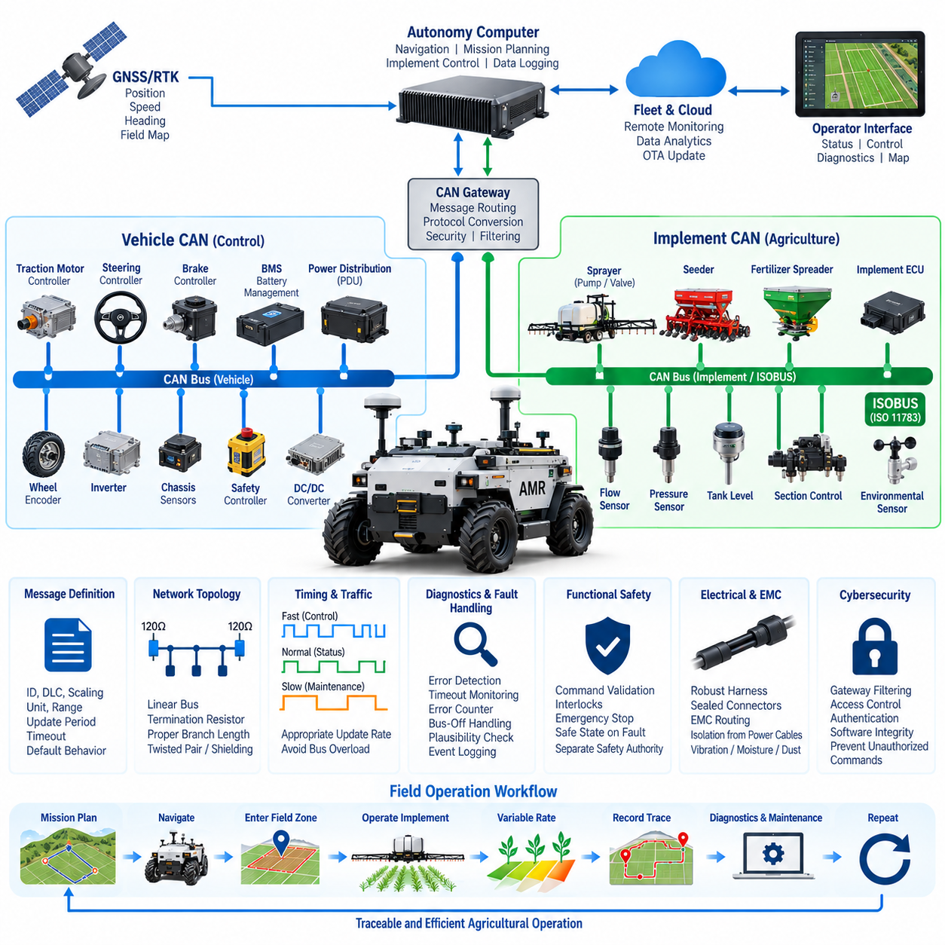
Agricultural CAN integration provides the communication backbone that connects an autonomous agricultural mobile robot with propulsion controllers, steering systems, sensors, power electronics, implements, and agricultural payloads. Within the Agriculture AMR architecture, the CAN network converts independently developed electrical subsystems into a coordinated machine whose operating states, commands, diagnostics, and safety information can be exchanged reliably during field operation.
The fundamental architecture normally separates vehicle-control communication from implement and application communication. The vehicle network carries information associated with drive-by-wire, steering, braking, motor control, battery management, and chassis status, while an agricultural interface network connects devices such as sprayers, pumps, valves, seeders, fertilizer equipment, environmental sensors, and other field implements. Gateways can exchange selected information between these domains.
CAN is particularly appropriate for agricultural machinery because it provides deterministic message arbitration, differential signaling, error detection, retransmission mechanisms, and robust operation in electrically noisy environments. Agricultural robots combine motors, inverters, pumps, relays, DC/DC converters, GNSS receivers, computers, and numerous sensors, creating conditions in which communication interfaces must tolerate electromagnetic interference, vibration, temperature variation, moisture, and long operating periods.
The physical CAN layer requires controlled bus topology rather than arbitrary wiring. A conventional CAN network uses a linear backbone with termination resistance at both physical ends, while branch lengths should remain appropriate for the selected bit rate and harness configuration. Cable impedance, twisted-pair construction, shielding strategy, connector quality, grounding, and routing relative to high-current motor cables directly influence communication reliability.
Network segmentation becomes important as the number of devices increases. Propulsion and steering controllers may operate on a dedicated control CAN, battery and power-distribution devices on another network, and agricultural implements on an implement CAN. This approach limits traffic loading and fault propagation while allowing different update rates and interface policies. A central vehicle controller or gateway provides controlled communication between these networks.
For compatibility with agricultural machinery, CAN integration may incorporate the principles of ISO 11783, commonly known as ISOBUS. ISOBUS builds agricultural communication functions on CAN-based networking and provides standardized mechanisms for communication among tractors, implements, controllers, and operator interfaces. An autonomous AMR can use compatible concepts when integrating agricultural implements that were originally designed for conventional agricultural vehicles.
The integration architecture must clearly define every CAN message. Each signal requires an identifier, data length, byte position, scaling factor, offset, unit, valid range, update period, timeout, default behavior, and ownership. Commands and status signals should not be defined informally because ambiguous signal interpretation can cause incompatible implementations between the AMR controller, implement controller, gateway, and external agricultural equipment.
Message timing should reflect the dynamics of each subsystem. Steering angle, wheel speed, drive torque, brake status, and safety-related state information generally require faster cyclic communication than tank level, temperature, accumulated operating hours, or maintenance information. Designing appropriate transmission periods reduces unnecessary bus utilization while ensuring that time-critical control information reaches receiving controllers with sufficient frequency.
Agricultural payload control can be closely coupled with vehicle motion through CAN. A spraying system, for example, may receive vehicle speed, operating state, mission enable, and requested application rate while returning pump status, pressure, flow, valve state, tank level, and diagnostic information. The controller can adjust spray delivery according to vehicle velocity so that application quantity remains consistent as the AMR accelerates or decelerates.
Geographic task execution can also be connected to the CAN architecture. GNSS/RTK and mission-planning functions determine when the AMR enters a treatment zone, while the supervisory computer converts geographic mission decisions into implement commands. CAN then provides the local machine-level interface that activates pumps, valves, actuators, or other agricultural equipment, linking digital field prescriptions with physical action.
Safety requires separation between ordinary communication and safety authority. Receiving a valid CAN frame does not automatically mean that an actuator should execute the requested operation. Controllers should evaluate operating mode, enable conditions, interlocks, communication health, emergency-stop state, vehicle motion, and other relevant safety conditions before accepting commands. Critical outputs should transition to predefined safe states when required conditions disappear.
Communication timeout monitoring is fundamental to this behavior. Every important cyclic message should have an expected reception interval, and receiving controllers should detect missing or excessively delayed messages. Loss of steering commands, propulsion status, implement enable information, or safety state should generate responses appropriate to the affected function, ranging from diagnostic reporting to controlled shutdown or transition toward a minimal-risk condition.
CAN error handling should also be incorporated into system diagnostics. Error counters, error-passive states, bus-off conditions, repeated frame errors, communication resets, and gateway failures can indicate harness damage, connector degradation, electromagnetic interference, incorrect termination, incompatible bit rates, or malfunctioning electronic control units. Recording these events allows field failures to be analyzed rather than treated as unexplained intermittent behavior.
Diagnostics should identify both communication faults and application-level faults. A healthy CAN link can still carry invalid sensor values, contradictory operating states, stale information, or commands outside permitted ranges. Plausibility checking therefore compares received information with physical expectations and related signals. Wheel speed can be compared with vehicle motion, pump command with measured flow, and valve command with application behavior.
A gateway plays an important role when agricultural equipment and the autonomous vehicle use different protocols or message conventions. It can translate identifiers, scale signals, filter traffic, enforce command permissions, timestamp events, and expose selected information to higher-level software. The gateway may also connect CAN or CAN FD networks with Ethernet, ROS 2, fleet communication, diagnostics, or cloud-facing interfaces without exposing every internal message directly.
CAN FD can be considered where larger payloads or higher data rates are useful, but compatibility with existing agricultural devices must be evaluated carefully. Conventional CAN remains widespread in embedded machinery, and an agricultural AMR may therefore operate multiple network technologies simultaneously. High-bandwidth perception data belongs on Ethernet-class networks, while CAN remains well suited to compact control, state, diagnostic, and actuator messages.
The autonomous compute platform should not directly replace embedded control functions that require predictable local behavior. A high-performance computer can calculate navigation, mission, perception, and agricultural decisions, but dedicated ECUs should continue handling motor control, steering loops, battery protection, pump regulation, and similar real-time functions. CAN forms the boundary through which high-level autonomy coordinates these deterministic embedded controllers.
Electrical power states must be coordinated with network states. During startup, controllers may become available at different times, requiring initialization sequences that prevent premature commands. During shutdown, the system should preserve diagnostic records, place implements in safe conditions, disable propulsion appropriately, and avoid communication errors caused by uncontrolled power removal. Wake-up and sleep behavior should also be defined for energy-efficient standby operation.
Harness engineering is especially important for outdoor agricultural CAN networks. Connectors and cables may be exposed to water, mud, dust, fertilizers, chemicals, vibration, repeated flexing, ultraviolet exposure, and mechanical impact. Sealed connectors, suitable cable jackets, strain relief, protected routing, service loops, proper splice methods, and accessible diagnostic points contribute directly to long-term communication reliability.
Electromagnetic compatibility must be considered together with physical routing. Motor phase cables, inverter switching, pumps, solenoids, contactors, charging equipment, and DC/DC converters can generate electrical noise. CAN wiring should be routed and grounded according to a defined EMC strategy, with separation from high-current switching conductors where practical. Shielding should be engineered as a system rather than added without considering grounding paths.
Serviceability benefits from a documented network database and diagnostic interface. Maintenance personnel should be able to identify nodes, observe relevant messages, read diagnostic trouble information, determine bus loading, inspect error states, and verify actuator or sensor communication. Version-controlled signal definitions are particularly important when agricultural implements, vehicle controllers, and autonomy software evolve independently across product generations.
Cybersecurity becomes increasingly important when CAN is connected through gateways to wireless, fleet, or remote-maintenance networks. The traditional CAN bus provides limited native security mechanisms, so external interfaces should restrict which remote commands can reach vehicle networks. Authentication, gateway filtering, access control, software integrity, diagnostic authorization, and event logging help prevent unauthorized commands from propagating toward physical actuators.
Agricultural CAN integration ultimately establishes the machine-level nervous system of the Agriculture AMR. It links autonomous computation with propulsion, steering, energy management, safety controllers, and field implements while preserving deterministic embedded control near the physical hardware. Combined with positioning, fleet communication, diagnostics, electrical protection, and robust harness engineering, the CAN architecture enables agricultural autonomy to produce controlled and traceable physical actions in real field environments.

08.04. Weather Resistant Design
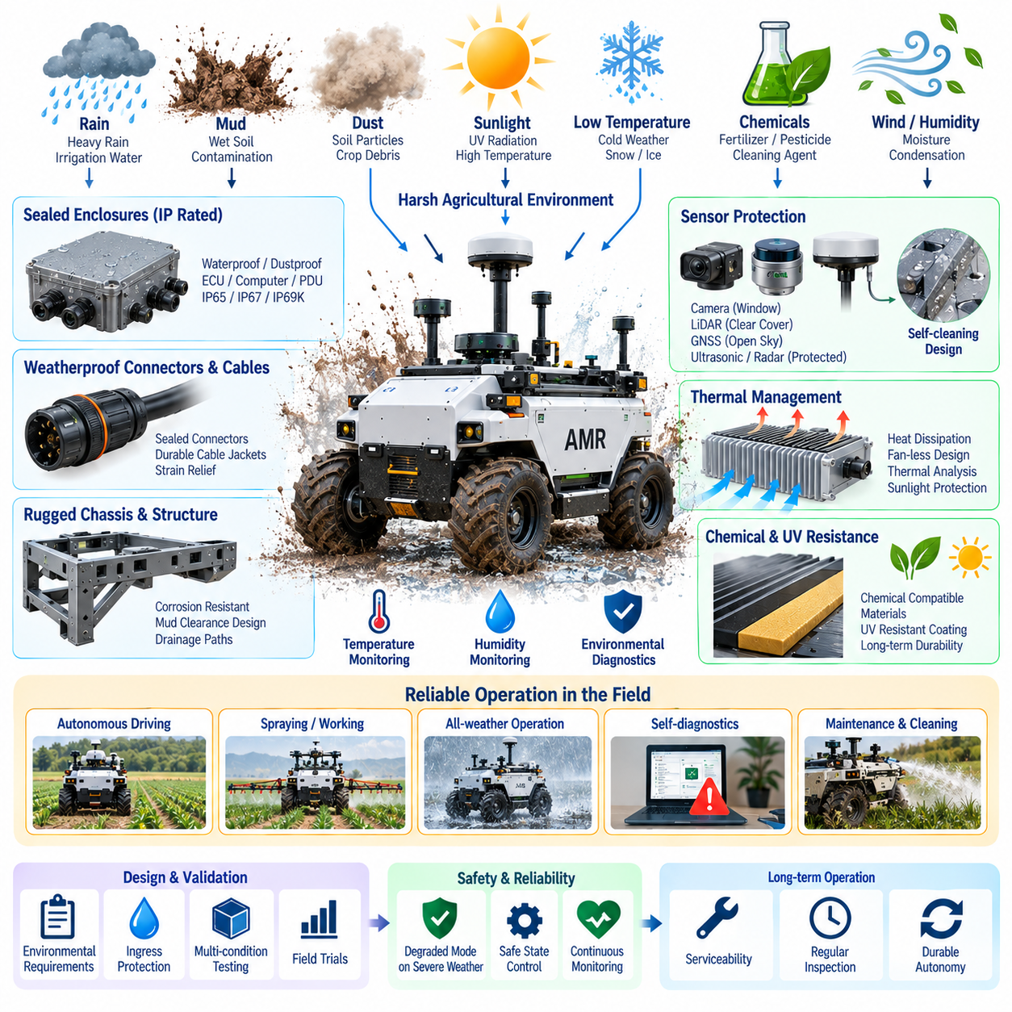
Weather-resistant design for an agricultural autonomous mobile robot ensures reliable operation when the vehicle is continuously exposed to rain, irrigation water, mud, dust, humidity, temperature variation, sunlight, agricultural chemicals, and contaminated field surfaces. Within the Agriculture AMR architecture, environmental protection must cover the complete electrical, mechanical, sensing, computing, communication, and power system rather than individual components alone.
The design process begins by defining the environmental operating envelope. Expected rainfall intensity, standing water, dust concentration, mud exposure, temperature range, humidity, solar radiation, wind, condensation, cleaning procedures, and chemical contact should be identified for the intended agricultural environment. These conditions become engineering requirements for enclosures, connectors, cables, sensors, cooling systems, batteries, actuators, and structural interfaces.
Ingress protection is a fundamental requirement because water and particulate contamination can rapidly degrade outdoor electronics. Electronic control units, power distribution devices, communication gateways, and computing modules should be installed inside appropriately sealed enclosures. The required IP rating should be selected from the actual exposure scenario rather than applying one protection level indiscriminately to every component.
Water management requires more than sealing every opening. Vehicle geometry should prevent rainwater and irrigation water from accumulating around electronic equipment, connectors, sensors, charging interfaces, and cable penetrations. Sloped surfaces, drainage channels, drip paths, protected connector orientation, and strategically located drain points can guide water away from sensitive components before enclosure seals become the final protective barrier.
Sealing interfaces require careful mechanical design because environmental protection can deteriorate after repeated service operations. Gaskets, O-rings, cable glands, access covers, connector seals, and enclosure joints should maintain compression throughout vibration, temperature cycling, and aging. Service procedures must also ensure that seals are correctly replaced or reseated after maintenance rather than assuming that an originally sealed enclosure remains protected indefinitely.
Condensation creates a different problem from direct water ingress. A sealed enclosure can contain humid air that condenses when temperature changes cause internal surfaces to fall below the dew point. Pressure-equalization membranes, controlled ventilation, moisture-resistant materials, conformal coating, thermal management, and enclosure placement can reduce condensation risk while preserving the required resistance to external water and contamination.
Dust protection is especially important during dry agricultural operation. Soil particles, crop debris, fertilizer dust, and fine organic material can accumulate around cooling systems, optical sensors, mechanical joints, and electrical interfaces. Enclosure design should minimize direct dust entry, while exposed components should tolerate contamination without creating excessive thermal resistance, optical degradation, mechanical binding, or electrical leakage paths.
Mud presents combined mechanical and electrical challenges. It can cover sensors, block drainage paths, accumulate around wheels and suspension components, retain moisture against connectors, and increase vehicle mass. Components positioned near the lower chassis require additional shielding or protective placement. Mud-clearance geometry should allow accumulated material to leave the vehicle rather than forming persistent pockets around vulnerable hardware.
Thermal design becomes more difficult when electronics are sealed against the environment. High-performance computers, motor controllers, DC/DC converters, chargers, communication equipment, and batteries generate heat, while direct sunlight can increase enclosure temperature even when the robot is stationary. Thermal analysis must therefore consider internal heat generation, solar loading, ambient temperature, airflow, enclosure conductivity, and operating duty cycle simultaneously.
Passive thermal management is desirable where practical because fans and external air paths introduce additional contamination risks. Heat spreaders, conductive enclosure walls, chassis-mounted heat sinks, thermal interface materials, and separated hot components can transfer heat without drawing dirty ambient air through electronics. Where forced cooling is necessary, filtered or isolated cooling architectures should be designed for maintainability and predictable performance as contamination accumulates.
Low-temperature operation introduces different constraints. Battery power capability, charging acceptance, lubricant characteristics, display performance, sensor behavior, cable flexibility, and condensation during warm-up can all change at low temperatures. Startup logic may therefore need temperature-dependent restrictions, preheating, reduced power operation, or delayed charging until batteries and electronics enter acceptable operating ranges.
Solar exposure affects both thermal behavior and long-term material durability. Ultraviolet radiation can degrade plastics, cable jackets, seals, labels, optical covers, and exposed polymer components. Outdoor materials should therefore be selected for UV resistance, while protective coatings, covers, and component placement can reduce direct exposure. Surface color and solar absorptivity can also influence enclosure temperature under prolonged sunlight.
Agricultural chemicals introduce environmental conditions not normally encountered by indoor AMRs. Fertilizers, pesticides, herbicides, cleaning agents, oils, and other substances may contact the chassis, harnesses, connectors, seals, sensors, and coatings. Material compatibility should be evaluated because a component that is waterproof may still deteriorate through swelling, cracking, corrosion, discoloration, or loss of mechanical strength after chemical exposure.
Corrosion protection should address metallic structures and electrical interfaces together. Moisture, fertilizers, chemicals, and contaminated soil can accelerate corrosion of fasteners, brackets, chassis members, connector contacts, and grounding points. Suitable materials, plating, coatings, sealed electrical contacts, drainage, galvanic compatibility, and controlled grounding interfaces help preserve both structural integrity and stable electrical resistance over the vehicle lifetime.
Harness design is a major part of weather resistance. Outdoor cables require suitable jackets, sealed connectors, strain relief, abrasion protection, controlled bend radius, and routing away from water traps or direct mechanical damage. Harness branches should avoid unnecessary upward-facing connector interfaces, while service loops and attachment points must prevent vibration and vehicle motion from repeatedly loading seals or terminals.
Sensor protection requires balancing environmental sealing with measurement performance. Cameras need clear optical windows, LiDAR requires unobstructed transmission surfaces, GNSS antennas require appropriate sky visibility, and ultrasonic or radar sensors have their own installation constraints. Protective covers must therefore resist water, dust, impact, and chemicals without introducing unacceptable attenuation, reflections, distortion, or blind regions.
Sensor contamination should be treated as an operational state rather than only a maintenance issue. Mud, water droplets, dust, insects, crop material, or chemical residue can reduce perception performance even when the sensor remains electrically healthy. The system can monitor signal quality and sensor confidence to identify degraded perception and request cleaning, reduce operating capability, or enter an appropriate safe state.
Cleaning strategy should be considered during initial vehicle design. Agricultural equipment may require frequent washing, but high-pressure water can challenge seals and force contamination into interfaces that tolerate ordinary rainfall. Components, labels, vents, charging ports, connectors, and sensor windows should therefore be designed around defined cleaning procedures, including restrictions on pressure, direction, temperature, and cleaning chemicals where necessary.
Weather conditions also affect traction and autonomous mobility. Wet soil, mud, snow, ice, loose material, and standing water change tire friction, wheel slip, braking distance, steering response, and traversability. Environmental sensing and vehicle dynamics information can be combined so that the autonomous system reduces speed, modifies path planning, avoids unsuitable terrain, or terminates a mission when mobility margins become insufficient.
The electrical architecture should detect environmental effects before they become severe failures. Temperature sensors, humidity monitoring, insulation diagnostics, current monitoring, enclosure status, battery temperature, cooling-system status, and communication diagnostics can provide early indications of abnormal conditions. Environmental data should be time-stamped and correlated with vehicle faults so recurring weather-dependent problems can be identified during fleet analysis.
Power interfaces require particular attention because charging and high-current connections are vulnerable when exposed outdoors. Charging should be inhibited when connector conditions are unsafe, and exposed contacts should be protected from water, mud, chemicals, and conductive debris. Mechanical covers, interlocks, contact detection, isolation strategies, and controlled connection sequences can prevent energized interfaces from becoming environmental failure points.
Functional safety must account for environmental degradation. A robot should not continue operating at full autonomous capability merely because its computers remain powered. Loss of sensor visibility, excessive temperature, water intrusion indications, severe wheel slip, communication degradation, or unsafe weather can reduce the validity of autonomous decisions. The safety architecture should define degraded modes and minimal-risk responses for these environmental conditions.
Validation should reproduce realistic combinations of environmental stresses rather than testing each condition only in isolation. Water exposure followed by vibration, temperature cycling with humidity, mud contamination followed by cleaning, chemical exposure followed by mechanical stress, and thermal loading under sealed operation can reveal failure mechanisms that simple component tests miss. Field trials remain important because agricultural contamination patterns are difficult to reproduce completely in laboratories.
Maintenance procedures should preserve weather resistance throughout the product lifecycle. Inspection of seals, connectors, harness damage, corrosion, drainage paths, sensor windows, vents, protective coatings, and enclosure fasteners should be incorporated into scheduled service. Environmental protection should therefore be treated as a maintainable system whose condition can degrade with age, repair activity, impact, and repeated field operation.
Weather-resistant design ultimately enables the Agriculture AMR to preserve autonomous capability despite changing outdoor conditions. Successful protection combines enclosure engineering, drainage, sealing, thermal management, corrosion control, chemical compatibility, robust harnessing, sensor protection, diagnostics, safety logic, validation, and maintenance. The objective is not merely to keep components dry, but to maintain reliable perception, computation, communication, power, control, and physical operation throughout real agricultural service.

08.05. Agriculture AMR Case
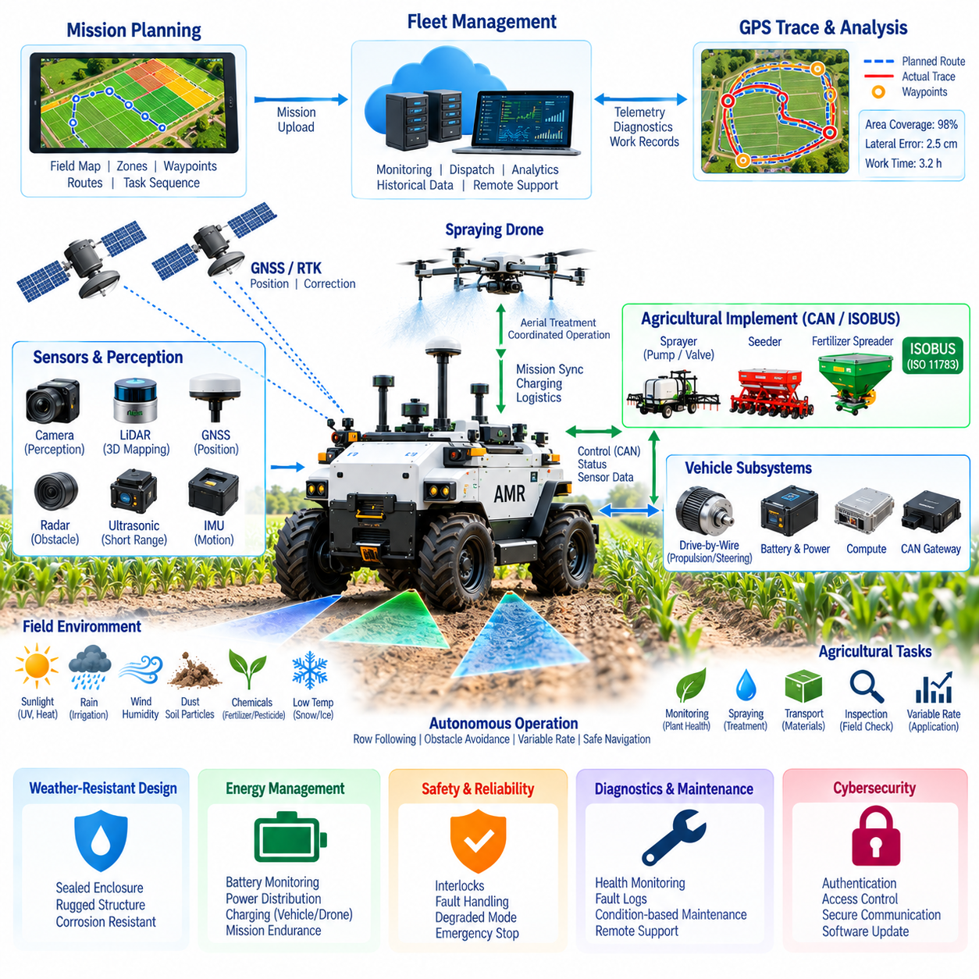
An Agriculture AMR case represents the integration of autonomous mobility, precision positioning, agricultural implements, environmental protection, communication, and fleet-level intelligence into a single outdoor robotic platform. Within the Outdoor Autonomous Vehicle architecture, the Agriculture AMR is positioned alongside specialized inspection, patrol, mining, port, and smart-city vehicles, but its mission is specifically adapted to repetitive field operations and agricultural environments.
The operational concept begins with an autonomous ground vehicle capable of moving between crop rows, field boundaries, orchards, agricultural roads, and designated work zones. The vehicle combines GNSS/RTK positioning with onboard navigation and perception to execute geographically defined missions. Agricultural tasks can include spraying support, inspection, crop monitoring, material transportation, implement operation, and coordination with aerial robotic systems.
A typical Agriculture AMR contains a rugged mobile chassis, drive-by-wire propulsion and steering, battery and power distribution systems, an autonomous computing platform, GNSS/RTK, IMU, LiDAR, cameras, communication gateways, and agricultural payload interfaces. These subsystems form a common vehicle platform on which mission-specific equipment can be installed without redesigning the complete autonomy architecture for every agricultural application.
Precision positioning provides the geographic foundation for field operation. GNSS/RTK allows the robot to associate its position with crop rows, treatment zones, field boundaries, waypoints, exclusion areas, and previously recorded trajectories. The navigation system can combine this global positioning information with IMU, wheel odometry, LiDAR, and camera observations to maintain vehicle localization when GNSS quality changes during actual operation.
Mission planning converts agricultural requirements into executable robot tasks. A field map can contain crop geometry, traversable corridors, headlands, restricted areas, treatment polygons, docking locations, and service points. The mission system uses these geographic objects to generate routes and task sequences, while the AMR continuously reports its position, operating state, remaining energy, payload condition, and mission progress.
GPS tracing provides a persistent record of actual vehicle movement. Planned routes and executed trajectories remain separate so that lateral deviation, missed areas, stopping locations, detours, and mission completion can be evaluated after operation. Time-stamped traces can also be associated with spraying, inspection, payload activity, energy consumption, or detected agricultural conditions, converting movement history into geographically referenced work records.
One important use case is integration with a spraying drone. The Agriculture AMR can operate as a mobile ground station that transports the drone, provides charging or battery service, supports replenishment, exchanges mission information, and establishes temporary launch and landing locations. The drone performs aerial treatment while the AMR repositions between missions, creating a coordinated ground–air agricultural robotic system.
In this configuration, mission control assigns appropriate work to each platform. The ground robot handles mobility, logistics, local infrastructure, and potentially ground-based agricultural operations, while the drone addresses areas where aerial access provides greater efficiency. Shared GNSS/RTK references and geographic mission definitions allow both machines to operate relative to the same field map, treatment zones, exclusion regions, and operational records.
Agricultural CAN integration connects autonomous decisions with physical equipment. Separate CAN networks can support propulsion, steering, braking, battery management, safety controllers, and agricultural implements. Sprayers, pumps, valves, seeders, fertilizer equipment, flow sensors, pressure sensors, and other devices can exchange commands and status information through a structured vehicle communication architecture, with gateways connecting the embedded networks to higher-level autonomy software.
Compatibility with CAN-based agricultural communication concepts such as ISO 11783 or ISOBUS can simplify integration with appropriate agricultural implements. The autonomous computer determines what operation should occur according to navigation and mission information, while dedicated embedded controllers execute deterministic local control. This separation preserves predictable actuator behavior while allowing high-level autonomy to coordinate complex agricultural tasks.
Variable-rate operation demonstrates the connection between digital planning and physical control. A geographic prescription can specify different treatment requirements for different field regions. As the AMR enters each region, the mission controller selects the required operating parameters, while CAN-connected equipment controls pumps, valves, flow, or other implement functions. Vehicle speed and measured application data can be used to maintain the intended treatment rate.
The platform must also operate reliably under agricultural environmental conditions. Rain, irrigation water, mud, dust, humidity, sunlight, temperature variation, fertilizer, pesticides, and cleaning processes influence electrical and mechanical design. Weather-resistant enclosures, sealed connectors, protected harnesses, corrosion-resistant materials, drainage, thermal management, and chemically compatible components are therefore fundamental elements of the vehicle architecture.
Sensors require special protection because environmental contamination can degrade perception before causing an electrical failure. Cameras, LiDAR, GNSS antennas, radar, and other sensors must retain their required field of view and signal characteristics while resisting water, mud, dust, crop debris, and chemicals. Sensor contamination can be monitored as an operational condition so that the AMR can request cleaning or reduce autonomous capability when perception confidence becomes insufficient.
Weather conditions also influence vehicle dynamics and mission feasibility. Wet soil and mud can increase wheel slip, while standing water, snow, ice, or loose ground can change braking and steering behavior. Environmental information and vehicle-motion measurements can therefore influence speed limits, route selection, traversability assessment, and mission continuation decisions rather than treating environmental protection only as an enclosure-design problem.
Energy management becomes important when the AMR simultaneously supports propulsion, autonomy computing, sensors, agricultural implements, communication, and potentially drone charging. The power architecture should maintain sufficient reserve for safe vehicle return while allocating energy to mission payloads. Battery state, power demand, thermal conditions, charging opportunities, and expected remaining mission distance can be considered together by the supervisory system.
Safety architecture coordinates autonomous mobility with agricultural equipment. Propulsion, steering, spraying, drone operation, charging, and other physical actions should require valid operating states and interlocks. Communication loss, localization degradation, unsafe weather, sensor contamination, excessive wheel slip, low energy, implement faults, or emergency-stop activation can trigger degraded operation, controlled shutdown, or transition toward a defined minimal-risk condition.
Communication between the AMR and fleet system supports remote mission supervision. Selected telemetry can include position, trajectory, operating mode, task status, battery state, payload condition, diagnostics, environmental measurements, and mission progress. Local storage preserves records during wireless outages, while synchronization after reconnection allows the central system to maintain a continuous operational history without depending on permanent network availability.
Fleet management expands the case from one autonomous machine to coordinated agricultural operations. Multiple AMRs, spraying drones, implements, charging stations, service locations, and field missions can be represented in a common management environment. Mission dispatch can allocate resources according to location, capability, energy state, payload availability, operational priority, and remaining work, improving utilization across large agricultural sites.
Diagnostics provide another layer of integration. Vehicle controllers can report propulsion, steering, battery, CAN, sensor, communication, thermal, environmental, and implement faults. When these events are synchronized with GPS traces and mission states, operators can determine not only what failed but also where the failure occurred, what the robot was doing, and which environmental conditions were present at the time.
Historical data can support performance and maintenance analysis. Repeated trajectories reveal localization problems, difficult terrain, wheel-slip regions, communication shadows, or inefficient routing. Distance traveled, operating hours, battery consumption, payload usage, thermal loading, and fault history can support condition-based maintenance and provide quantitative evidence for improving subsequent missions and vehicle configurations.
Cybersecurity protects the connection between digital mission planning and physical agricultural actions. Wireless commands, fleet interfaces, diagnostic access, CAN gateways, software updates, and stored geographic records require appropriate authentication and access control. Particularly important commands such as vehicle motion, implement activation, spraying, drone launch, or charging should not be accepted solely because they arrive through a connected network.
The Agriculture AMR case therefore illustrates a complete Physical AI system rather than an isolated autonomous vehicle. Perception establishes environmental awareness, GNSS/RTK provides geographic context, autonomous computing determines actions, CAN-connected controllers execute physical commands, payload systems perform agricultural work, and fleet software coordinates resources and records outcomes. Environmental protection and safety preserve these capabilities under real field conditions.
At the system level, successful Agriculture AMR engineering depends on the interaction of positioning, drive-by-wire, communication, power, sensing, compute, safety, weather resistance, payload integration, diagnostics, and fleet management. This reflects the broader robotics electrical architecture in which agricultural autonomy is produced by coordinated subsystem engineering rather than by a single navigation algorithm or sensor.
The resulting platform can function as a reusable autonomous agricultural infrastructure rather than a machine dedicated to only one task. By changing mission software and compatible payloads, the same AMR foundation can support monitoring, spraying, inspection, logistics, treatment, and coordinated drone operations while retaining a common electrical, communication, positioning, safety, and fleet architecture across agricultural applications.

