Volume 17 Outdoor Autonomous Vehicle

Chapter 10. Smart City Integration

10.01. V2I Communication
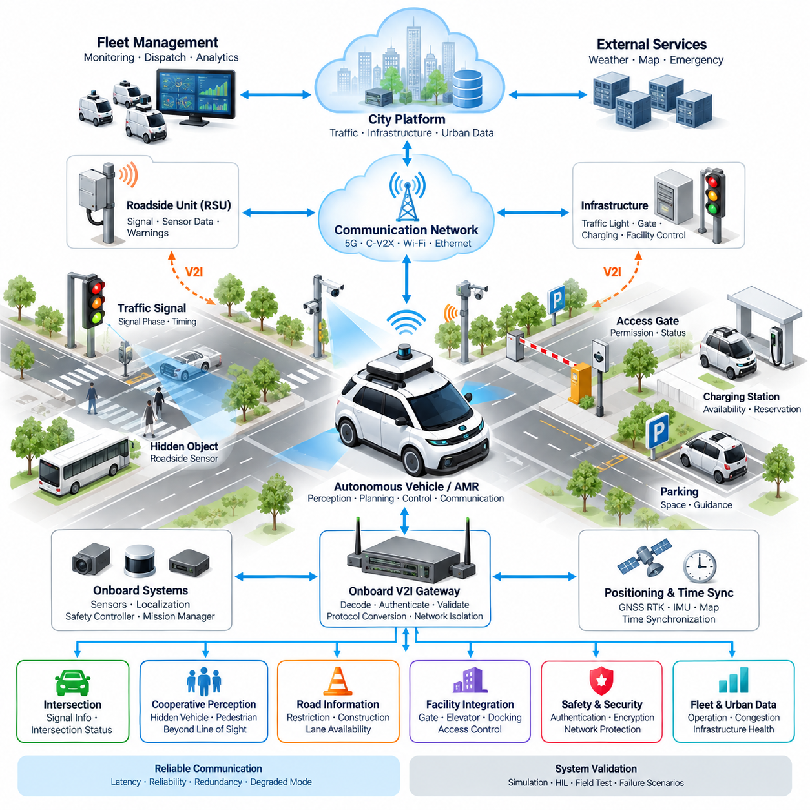
Vehicle-to-Infrastructure communication enables an outdoor autonomous vehicle to exchange operational information with roadside and smart-city infrastructure rather than relying exclusively on onboard perception. Within the Smart City Integration architecture, V2I connects autonomous vehicles and AMRs with traffic signals, roadside units, intersections, access gates, parking systems, monitoring stations, and urban control platforms. It therefore extends vehicle awareness beyond the physical range and visibility limits of cameras, LiDAR, radar, and other onboard sensors.
A typical V2I architecture consists of an onboard communication unit, roadside communication equipment, a city communication network, and infrastructure applications. The onboard unit interfaces with the autonomous driving computer, localization system, safety controller, and mission manager. Roadside units collect information from traffic controllers and infrastructure sensors and transmit selected data to approaching vehicles. This architecture creates a digital communication layer between physical transportation infrastructure and autonomous machines operating within the city.
The primary purpose of V2I is not to replace autonomous perception but to provide complementary information that cannot always be obtained reliably from onboard sensors. A vehicle approaching an intersection may visually recognize a traffic light, while the infrastructure can simultaneously communicate the signal phase and timing information directly. Similar communication can provide road restrictions, temporary construction information, lane availability, intersection status, access permissions, environmental conditions, or warnings generated by infrastructure sensors.
Communication technology should be selected according to latency, coverage, reliability, deployment cost, and interoperability requirements. Cellular V2X can provide wide-area connectivity through mobile communication infrastructure, while direct communication technologies can support low-latency exchanges near intersections or roadside equipment. Wi-Fi, private 5G, Ethernet-connected roadside gateways, and other wireless networks may also participate in a smart-city deployment. In practice, heterogeneous communication technologies are often combined rather than forcing every infrastructure interface onto a single network.
The onboard V2I gateway should isolate external infrastructure communication from safety-critical vehicle control networks. Messages received from roadside systems must be decoded, authenticated, validated, timestamped, and converted into internal representations before they are supplied to planning or decision modules. A gateway can also translate between external V2X protocols and internal CAN, CAN FD, Automotive Ethernet, DDS, or ROS 2 communication. This separation reduces unnecessary coupling between public infrastructure networks and the vehicle's real-time control architecture.
Localization is essential because infrastructure messages have meaning only when associated with the correct road segment, intersection, lane, or geographic region. GNSS RTK can provide centimeter-class outdoor positioning where correction services and satellite visibility are sufficient, while IMU and onboard perception maintain localization continuity when GNSS quality deteriorates. V2I information should therefore be fused with vehicle position, heading, map data, and route context before it influences autonomous behavior, rather than being interpreted as an isolated communication event.
At signalized intersections, V2I can provide information such as the current signal state, remaining phase duration, upcoming phase transitions, and intersection configuration. The autonomous vehicle can combine this information with detected traffic lights, stop lines, pedestrians, surrounding vehicles, and predicted trajectories. The planner may then determine whether to continue, decelerate, stop, or prepare for a phase change. Infrastructure information increases anticipation distance, but final motion decisions should remain consistent with locally verified safety conditions.
Roadside infrastructure can also provide information that is difficult to observe from the vehicle because of occlusion. A roadside camera, radar, or LiDAR may detect a pedestrian hidden behind a parked vehicle, another vehicle approaching from a blind intersection, or an obstacle beyond the autonomous vehicle's direct field of view. After infrastructure processing, the relevant event can be communicated to approaching autonomous systems. This concept effectively extends perception from vehicle-centered sensing toward cooperative perception distributed across the urban environment.
For outdoor AMRs, V2I extends beyond conventional road traffic applications. Robots operating on campuses, industrial complexes, hospitals, residential developments, ports, and smart-city districts may communicate with automatic gates, elevators, pedestrian crossings, charging stations, security systems, docking facilities, and restricted-area controllers. Infrastructure can provide permission or status information, while the robot can report identity, destination, estimated arrival time, mission state, or service requirements. V2I consequently becomes an operational interface between autonomous mobility and intelligent facilities.
Reliable V2I operation requires explicit handling of communication degradation. Wireless coverage can disappear, packets can be delayed, infrastructure devices can fail, and received information can become stale. Every important message should therefore include suitable identifiers, timestamps, validity periods, sequence information, and confidence or status indicators where applicable. The vehicle should continuously evaluate message freshness and communication health. Loss of V2I must lead to a defined degraded mode rather than creating an uncontrolled dependency on infrastructure availability.
Time synchronization is particularly important when infrastructure information is fused with onboard perception. A signal-state message or detected-object report generated several hundred milliseconds earlier may describe a condition that has already changed by the time it reaches the vehicle. GNSS-based time, Precision Time Protocol, or other synchronized time sources can establish a common temporal reference. The receiving system can then compensate for communication delay, reject excessively old messages, and align infrastructure observations with camera, LiDAR, radar, GNSS, and IMU measurements.
Cybersecurity is another fundamental design requirement because V2I creates an external path into the autonomous vehicle. Authentication should establish whether a message originates from an authorized infrastructure node, while integrity protection should detect unauthorized modification. Encryption may protect sensitive operational data where required. Network segmentation, secure gateways, certificate management, access control, logging, software updates, and intrusion monitoring should be considered as system-level functions rather than optional communication features.
The V2I interface should also distinguish advisory information from safety-relevant information. A congestion notification may influence route optimization without directly affecting immediate vehicle control, whereas an infrastructure-generated collision warning may require rapid consideration by the planner. Message classes can therefore be associated with different latency, reliability, validation, and fallback requirements. This classification prevents low-priority smart-city data from competing unnecessarily with information needed for real-time autonomous operation.
From an electrical and hardware perspective, the V2I subsystem includes antennas, communication modems, roadside radios, gateways, network switches, power supplies, protective devices, connectors, and computing interfaces. Outdoor installations must tolerate temperature variation, rain, dust, vibration, electromagnetic interference, surge conditions, and unstable power. Antenna placement must consider vehicle structure and radio visibility, while communication equipment should be electrically isolated and protected so that faults in external communication hardware do not propagate into essential control systems.
V2I data can additionally be forwarded to fleet management and urban data platforms. A fleet control system may use infrastructure information to coordinate multiple robots, estimate congestion, allocate missions, or modify routes. Conversely, aggregated vehicle information can help a city platform understand mobility demand, blocked paths, infrastructure faults, and operating conditions. The resulting architecture links individual autonomous vehicles with fleet-level intelligence and city-level coordination while preserving clear interfaces between local autonomy and centralized services.
System validation should include normal operation as well as delayed packets, duplicated messages, corrupted data, incorrect timestamps, communication loss, infrastructure failures, GNSS degradation, network congestion, and contradictory information between infrastructure and onboard sensors. Hardware-in-the-loop, simulation, controlled test sites, and progressively expanded field trials can be used to verify these conditions. Particular attention should be given to transition behavior when the vehicle enters or leaves V2I coverage or when infrastructure information suddenly becomes unavailable.
A mature smart-city autonomous vehicle should therefore treat V2I as one component of a layered autonomy architecture. Onboard sensing and localization provide independent local awareness, V2I contributes cooperative and infrastructure-derived knowledge, fleet communication adds multi-vehicle coordination, and the urban platform supplies broader operational context. By combining these layers without making safe motion dependent on a single communication channel, outdoor autonomous vehicles can operate more efficiently and predictably while remaining resilient to infrastructure and network failures.

10.02. Traffic Signal Integration
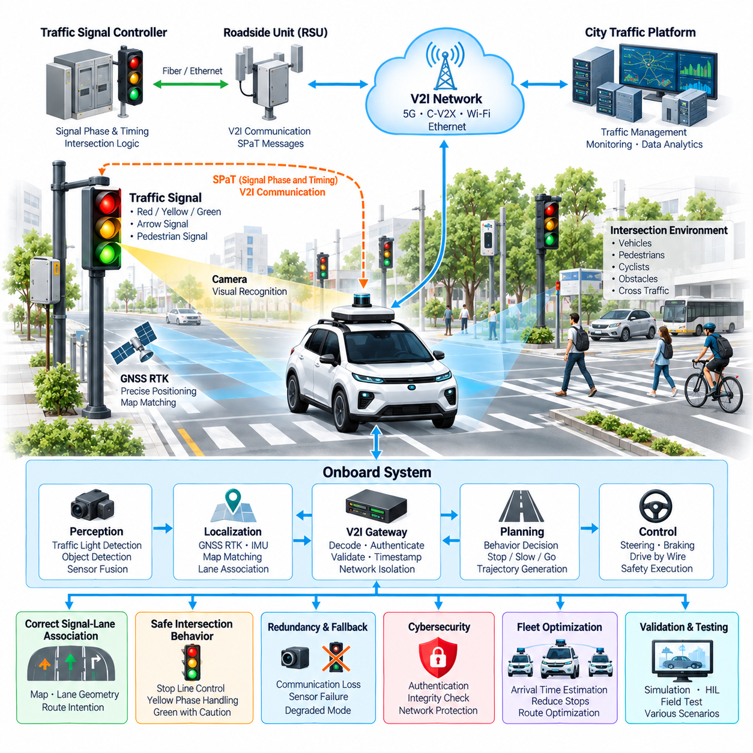
Traffic signal integration enables an outdoor autonomous vehicle to interpret, receive, validate, and respond to intersection signal states as part of its autonomous driving architecture. Within Smart City Integration, the traffic signal is treated not only as a visual object detected by cameras but also as a connected infrastructure element capable of providing digital information. This combination improves situational awareness and supports more predictable operation at controlled intersections.
The integration architecture normally connects the autonomous vehicle, traffic signal controller, roadside communication unit, V2I network, localization subsystem, perception stack, and motion-planning system. Signal information can travel from the intersection controller through a roadside unit and communication network to the vehicle gateway. The onboard system associates the received data with the relevant intersection and combines it with locally observed traffic conditions before determining an appropriate driving response.
Visual traffic-light recognition remains an important independent source of information. Forward-facing cameras can detect the signal head and classify states such as red, yellow, green, directional arrows, or other locally defined indications. Computer vision then associates the recognized signal with the vehicle's intended lane and route. This process is essential because an intersection may contain multiple signal heads controlling different lanes, directions, pedestrian movements, or protected turning phases.
Digital signal information can complement visual recognition by providing the current signal phase and information about expected phase transitions. Signal Phase and Timing data allows the vehicle to anticipate whether a green phase is likely to remain available or whether deceleration should begin before reaching the intersection. This information can improve smoothness and energy efficiency, but predicted timing should not be interpreted as an unconditional authorization to proceed because signal operation and surrounding traffic conditions can change.
Correct signal-to-lane association is one of the most important integration problems. The autonomous system must determine which signal controls the vehicle's current or planned movement rather than simply selecting the nearest visible signal. High-definition map information, lane geometry, stop-line position, vehicle heading, route intention, and infrastructure identifiers can be combined to establish this relationship. Incorrect association may cause a technically correct signal observation to produce an unsafe behavioral decision.
Localization therefore provides a fundamental reference for traffic signal integration. GNSS RTK, IMU, map matching, and onboard perception can determine the vehicle's position relative to the intersection, approach lane, and stop line. The system should recognize whether the vehicle is approaching, entering, traversing, or leaving the controlled intersection. Accurate spatial context also prevents information transmitted from nearby intersections from being incorrectly applied to the vehicle's current driving situation.
The onboard V2I gateway provides a controlled interface between traffic infrastructure and the autonomous driving computer. Incoming signal messages should be authenticated, decoded, timestamped, checked for validity, and converted into an internal representation suitable for perception and planning modules. Network isolation is important because infrastructure communication originates outside the vehicle. External messages should therefore never obtain unrestricted access to steering, braking, propulsion, or other safety-critical control networks.
Signal fusion compares infrastructure information with visual observations and other contextual evidence. When both sources indicate the same state, confidence in the interpreted traffic condition can increase. When they disagree, the system should identify the inconsistency instead of arbitrarily selecting one source. Possible causes include camera misclassification, incorrect infrastructure mapping, communication delay, stale packets, clock misalignment, signal-controller faults, or temporary occlusion of the physical traffic light.
Time synchronization is especially important because traffic signals change state within precisely controlled sequences. Every infrastructure message should contain timing information that allows the vehicle to determine when the reported state was generated and whether it remains valid. GNSS-derived time or synchronized network timing can establish a common reference. The vehicle can then estimate communication latency, reject stale information, and align digital signal messages with camera frames and vehicle trajectory data.
Traffic signal integration must also support stopping behavior. When a red signal is confirmed, the planner calculates a safe trajectory toward the associated stop line while considering vehicle velocity, acceleration limits, road friction, following traffic, and obstacle conditions. The controller then executes the required deceleration through the drive-by-wire system. The objective is not merely to stop before the line but to achieve a stable, comfortable, and predictable maneuver without violating safety constraints.
Yellow-phase handling requires more contextual reasoning because the correct response depends on distance to the stop line, current velocity, achievable deceleration, road conditions, and applicable traffic rules. The planning system should evaluate whether a safe stop remains feasible rather than applying a simplistic fixed-distance rule. Infrastructure timing information can provide additional context, while onboard perception and vehicle dynamics determine whether the planned maneuver can actually be executed safely.
A green signal does not automatically mean that the vehicle should enter the intersection. The autonomous system must still evaluate pedestrians, cyclists, crossing vehicles, stationary obstacles, emergency vehicles, intersection blockage, and other relevant hazards. Cooperative perception from roadside cameras, radar, or LiDAR may provide additional information about objects hidden from the vehicle's sensors. Traffic signal integration therefore participates in a broader intersection safety decision rather than acting as a direct motion command.
For outdoor AMRs operating in smart-city environments, signal integration may involve more than conventional road intersections. Robots may encounter pedestrian crossings, internal campus signals, industrial traffic lights, automated gates, warning beacons, railway-style crossings, and dedicated robotic mobility corridors. A common infrastructure interface allows the mission planner to interpret these devices according to operational context while maintaining appropriate separation between infrastructure information and local autonomous safety functions.
Communication failures must be considered a normal operational condition rather than an exceptional event. V2I packets may be delayed or lost, roadside equipment may become unavailable, and network coverage may temporarily disappear. The vehicle should detect communication degradation through message timeout, sequence monitoring, connectivity status, and data freshness checks. If infrastructure information becomes unavailable, operation should transition to a predefined degraded mode based on onboard sensing and applicable safety requirements.
The opposite condition must also be addressed: infrastructure communication may remain available while the physical signal cannot be visually recognized because of weather, glare, obstruction, camera contamination, or sensor failure. Digital information may improve awareness in such situations, but its use should depend on system safety requirements and confidence in infrastructure integrity. Redundant information sources are most valuable when their independence and failure characteristics have been explicitly considered during architecture design.
Cybersecurity is essential because falsified traffic signal information could influence autonomous vehicle behavior. Traffic infrastructure and vehicle gateways should therefore support authentication, message integrity verification, authorization, secure credential management, logging, and controlled software updates. Network segmentation can prevent a compromised communication interface from propagating directly into safety-critical domains. Security monitoring should also identify abnormal message frequency, invalid identifiers, repeated packets, and unexpected signal-state transitions.
Traffic signal integration can contribute to fleet-level optimization as well as individual vehicle control. A fleet management system may use intersection states and expected signal timing to estimate arrival times, reduce unnecessary stops, coordinate multiple robots, or select alternative routes around congested areas. Urban traffic platforms can similarly use aggregated autonomous-vehicle information to evaluate intersection performance, queue formation, mobility demand, and infrastructure health without transferring immediate safety responsibility away from the vehicle.
Electrical and hardware implementation includes communication modems, antennas, roadside units, signal-controller interfaces, onboard gateways, network switches, power conversion, protective circuits, and computing interfaces. Equipment installed outdoors must tolerate temperature variation, water, dust, vibration, surge events, electromagnetic interference, and unstable supply conditions. Vehicle-side components should also be packaged so that failures in communication equipment do not interrupt essential perception, localization, braking, steering, or propulsion functions.
Validation should reproduce both normal and abnormal intersection conditions. Testing should include all supported signal phases, turning movements, multiple signal heads, occlusion, glare, night operation, rain, communication loss, delayed messages, incorrect timestamps, contradictory camera and infrastructure information, localization errors, and signal-controller faults. Simulation, software-in-the-loop, hardware-in-the-loop, closed-course testing, and controlled field trials can progressively verify behavior before deployment in unrestricted operating environments.
A robust traffic signal integration architecture ultimately combines infrastructure connectivity with independent onboard autonomy. Cameras provide direct observation, V2I supplies digital signal context, localization establishes the correct intersection and lane relationship, cooperative perception expands environmental awareness, and planning determines the final vehicle response. By treating traffic signals as both physical and digital infrastructure while maintaining safe fallback behavior, outdoor autonomous vehicles can interact with smart-city intersections more reliably, smoothly, and predictably.

10.03. Urban Data Platform
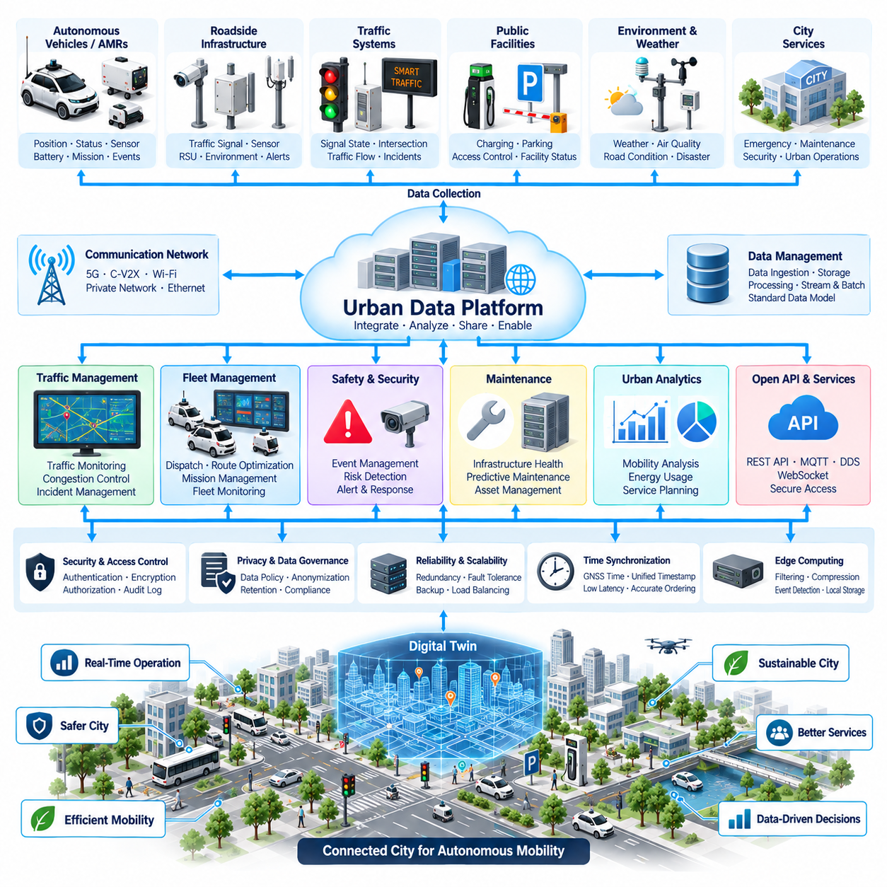
An Urban Data Platform provides the shared digital environment through which autonomous vehicles, AMRs, roadside infrastructure, traffic systems, public facilities, and city services exchange operational information. Within Smart City Integration, the platform sits above individual V2I connections and aggregates data from many distributed sources. Its purpose is to transform fragmented vehicle and infrastructure information into a consistent city-level operational context that supports mobility, safety, maintenance, and coordinated autonomous services.
Outdoor autonomous vehicles continuously generate information about position, velocity, route progress, mission status, sensor health, battery condition, detected obstacles, road conditions, and communication quality. Infrastructure simultaneously produces traffic signal states, intersection events, environmental measurements, access-control status, parking availability, and equipment diagnostics. The Urban Data Platform receives selected information from these sources and organizes it so that different applications can consume the same operational data without requiring direct point-to-point connections.
A practical platform architecture can be divided into edge, communication, ingestion, data-management, analytics, and application layers. Vehicle and roadside gateways form the edge layer, while 5G, C-V2X, Wi-Fi, private networks, and wired Ethernet provide communication paths. Ingestion services receive streaming and event-based messages, after which storage and processing systems create structured datasets. Application services then expose the processed information to traffic management, fleet control, monitoring dashboards, maintenance systems, and smart-city applications.
Data ingestion must accommodate information arriving at very different rates and with different priorities. Vehicle position may be updated several times per second, while battery health or infrastructure maintenance information may change much more slowly. Emergency events require immediate delivery, whereas historical analytics can tolerate greater delay. The platform should therefore distinguish real-time streams, operational events, periodic telemetry, configuration information, and bulk historical data instead of processing every message through an identical communication path.
A common data model is important because vehicles and infrastructure may be supplied by different manufacturers and use different internal representations. The platform can normalize identifiers, timestamps, geographic coordinates, vehicle states, infrastructure states, event classifications, and health information into standardized logical objects. This abstraction allows applications to work with concepts such as vehicle, intersection, lane, charging station, mission, or incident without requiring detailed knowledge of each device's proprietary interface.
Geospatial information forms one of the most important foundations of an urban platform. Vehicle trajectories, intersections, road segments, pedestrian areas, restricted zones, charging stations, parking areas, and detected events must be associated with geographic locations. GNSS RTK, map information, and infrastructure coordinates can provide this spatial reference. The platform can then correlate events from multiple vehicles and infrastructure devices according to location rather than treating every message as an unrelated data record.
Time synchronization provides the corresponding temporal reference. Data collected from autonomous vehicles, traffic signals, roadside cameras, LiDAR, environmental sensors, and fleet systems must be interpreted according to when the event actually occurred. Timestamps should therefore be preserved throughout ingestion and processing. Synchronized time enables the platform to reconstruct incidents, correlate observations from multiple sources, measure communication latency, and distinguish current operational information from delayed or stale data.
The platform should support both streaming and historical data processing. Streaming analytics can identify congestion, blocked routes, abnormal vehicle behavior, infrastructure failures, or rapidly developing safety events. Historical processing can reveal recurring traffic patterns, mission performance, energy consumption, communication coverage, component degradation, and infrastructure utilization. Combining both forms of analysis allows the city to respond to immediate conditions while continuously improving long-term autonomous mobility operations.
Fleet management becomes more powerful when connected to city-level data. Instead of dispatching robots according only to vehicle availability and mission priority, the fleet system can consider traffic conditions, intersection states, road restrictions, charging-station availability, weather information, and infrastructure events. Routes and missions can therefore be adjusted according to the broader urban environment. The Urban Data Platform acts as the information bridge between local fleet optimization and conditions observed across the smart-city infrastructure.
The relationship between the platform and individual vehicles should remain carefully controlled. City-level information can improve route selection and operational planning, but the platform should not become the only source required for immediate safe motion. Cameras, LiDAR, radar, GNSS, IMU, onboard maps, and local planning continue to provide autonomous capability at the vehicle level. If cloud or city connectivity is lost, the vehicle should retain a defined level of safe local operation or transition to an appropriate minimal-risk condition.
Event management provides another important platform function. Vehicles and infrastructure can publish events such as road blockage, collision risk, equipment failure, unauthorized access, fire detection, abnormal environmental conditions, or communication loss. The platform can classify these events according to severity, location, affected assets, and required response. Relevant information can then be distributed to fleet operators, nearby autonomous vehicles, traffic systems, maintenance teams, security personnel, or emergency services according to predefined operational policies.
Urban data can also support cooperative perception. Several autonomous vehicles or roadside sensors may observe the same road environment from different viewpoints. Rather than transmitting all raw sensor data continuously, edge systems can extract objects, tracks, occupancy information, or significant events and forward compact representations to the platform. The platform can correlate these observations and distribute useful information to authorized consumers, extending awareness beyond the direct sensing range of an individual autonomous vehicle.
Data volume management becomes increasingly important as the number of autonomous vehicles grows. Continuous transmission of raw camera, LiDAR, or radar streams from every robot would impose substantial communication and storage requirements. Edge computing should therefore perform filtering, compression, feature extraction, event detection, and local retention. High-bandwidth raw data can be uploaded selectively when required for incident investigation, model improvement, maintenance analysis, or validation rather than being treated as the default city-wide communication format.
Application programming interfaces and message interfaces provide controlled access to platform information. REST APIs can support configuration and historical queries, while MQTT, DDS, WebSocket, or similar messaging technologies can distribute operational updates and real-time events according to system requirements. Interface definitions should specify data schemas, units, coordinate systems, timestamps, error handling, version compatibility, and quality indicators so that applications can evolve without creating uncontrolled dependencies between city subsystems.
Cybersecurity and access control are fundamental because an Urban Data Platform connects many operational domains. Vehicles, roadside units, fleet servers, traffic systems, maintenance applications, and external services should authenticate before exchanging information. Authorization determines which data and commands each participant may access. Encryption, network segmentation, certificate management, audit logging, intrusion detection, secure software updates, and credential lifecycle management help prevent a compromised endpoint from becoming a pathway into the wider smart-city environment.
Privacy and data governance must also be incorporated into platform architecture. Autonomous mobility systems may observe pedestrians, vehicles, facilities, routes, and operational behavior that should not be retained indefinitely or exposed without justification. Data collection should therefore be linked to defined operational purposes, retention periods, access policies, and anonymization or aggregation rules where appropriate. Governance becomes especially important when information is shared among city agencies, private operators, infrastructure owners, and autonomous-service providers.
Reliability requires distributed failure handling rather than dependence on a single central server. Platform services can use redundant communication paths, replicated databases, clustered processing nodes, health monitoring, message buffering, and recovery mechanisms. Edge gateways should temporarily retain important information when central connectivity disappears and forward it after communication is restored. Critical operational functions should have defined degraded modes so that a platform outage does not automatically cause widespread loss of autonomous vehicle capability.
The Urban Data Platform can additionally provide a foundation for digital-twin applications. Live vehicle positions, infrastructure states, traffic conditions, missions, and equipment health can be mapped into a virtual representation of the operating environment. Historical and real-time information can then support simulation, route evaluation, capacity analysis, maintenance planning, and operational forecasting. The digital twin becomes particularly useful when changes to traffic policies or autonomous fleet operations need to be evaluated before deployment in the physical city.
System monitoring should provide visibility into both mobility operations and the platform itself. Operators need information about active vehicles, mission progress, communication status, infrastructure availability, data latency, processing load, storage capacity, and abnormal events. Health metrics and logs allow faults to be traced across vehicle, network, edge, and cloud layers. A well-designed monitoring architecture reduces the time required to distinguish a vehicle problem from a communication failure, infrastructure fault, or platform service malfunction.
Validation should examine data correctness, timing, scalability, interoperability, cybersecurity, and failure recovery under realistic operating conditions. Testing can introduce delayed messages, duplicate events, incorrect coordinates, communication interruptions, server failures, overloaded message streams, inconsistent device identifiers, and corrupted data. Simulation and staged field trials can also evaluate how hundreds or thousands of virtual or physical mobility devices affect ingestion, storage, analytics, and application performance before large-scale city deployment.
A mature Urban Data Platform therefore functions as the information backbone connecting autonomous vehicles with the wider smart-city ecosystem. V2I communication supplies infrastructure connectivity, traffic signal integration provides intersection context, fleet systems coordinate autonomous assets, and the urban platform combines these sources into shared operational intelligence. By preserving local vehicle autonomy while enabling secure city-level data exchange, the architecture supports scalable, resilient, and increasingly coordinated outdoor autonomous mobility.

10.04. Smart City Network Design
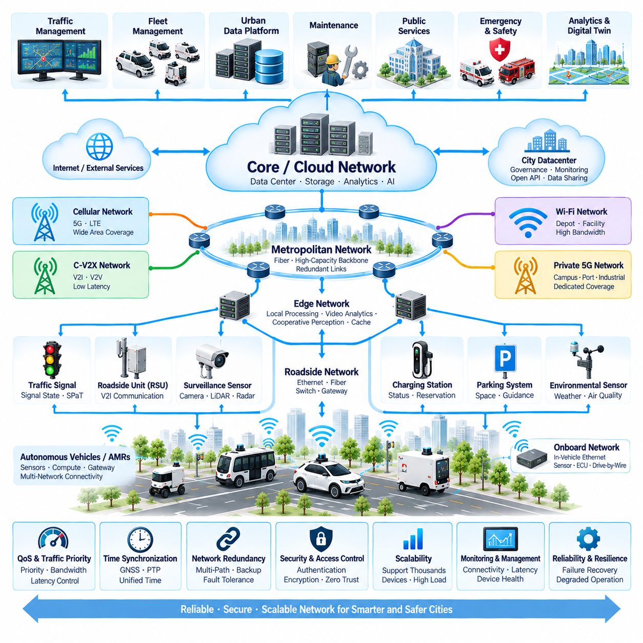
A smart city network for outdoor autonomous vehicles must connect mobile robots, roadside infrastructure, traffic systems, fleet servers, urban data platforms, and public services while maintaining predictable performance across a geographically distributed environment. Within Smart City Integration, the network is not merely an Internet connection. It becomes an operational infrastructure that transports mobility, safety, telemetry, control, maintenance, and situational data between autonomous systems and the city.
The overall architecture is best organized as multiple interconnected network domains rather than one flat network. Vehicle networks support onboard sensors, compute platforms, gateways, and controllers. Access networks connect vehicles to nearby infrastructure, while roadside and metropolitan networks aggregate distributed devices. Edge computing provides local processing, and core or cloud networks connect fleet management, urban data platforms, analytics services, and long-term storage.
Outdoor autonomous vehicles normally require several communication technologies because no single network satisfies every operational requirement. Cellular 5G can provide broad mobility coverage, C-V2X can support vehicle and infrastructure communication, Wi-Fi can serve depots and controlled facilities, and private 5G can provide managed coverage in campuses, ports, industrial complexes, or dedicated smart-city zones. Wired Ethernet and fiber are suitable for fixed roadside infrastructure, edge servers, traffic controllers, and backbone connections.
Network design should begin by classifying communication according to latency, bandwidth, reliability, mobility, and safety requirements. Emergency alerts and safety-relevant events require rapid and dependable delivery, while vehicle telemetry can tolerate moderate latency. Live video requires substantial bandwidth but may permit limited delay, whereas historical logs can be transferred asynchronously. Separating these traffic classes prevents high-volume applications from unnecessarily degrading time-sensitive operational communication.
Edge computing is important because transmitting all vehicle and sensor data to a distant cloud introduces unnecessary latency and bandwidth consumption. Roadside or district-level edge servers can process traffic information, cooperative perception, video analytics, local fleet coordination, and infrastructure events close to their sources. Only selected results, summarized information, or data requiring centralized processing need to be forwarded to the urban platform, improving scalability as the number of autonomous systems increases.
A hierarchical topology can connect vehicle, roadside, district, city, and cloud levels. Vehicles communicate with access points or roadside units, which connect to local aggregation switches and edge servers. District networks can then connect multiple intersections and facilities to a metropolitan backbone. The backbone provides access to fleet management and urban data services. This structure limits unnecessary traffic propagation and makes faults easier to isolate than in an unrestricted city-wide network.
Network redundancy should be designed according to operational criticality. A vehicle may use cellular communication as its primary wide-area connection while retaining an alternative network where available. Fixed infrastructure can use redundant Ethernet or fiber paths, dual switches, backup power, and multiple uplinks. Critical servers may be deployed in clusters. Redundancy is valuable only when common failure points such as shared power supplies, physical cable routes, antennas, and upstream providers are also considered.
Mobility management becomes essential because autonomous vehicles continuously move between radio coverage areas. The communication architecture should support transitions between cells, access points, or network domains without unnecessarily interrupting important sessions. Applications must nevertheless tolerate temporary disconnection because seamless handover cannot always be guaranteed. Message buffering, session recovery, retry policies, and local autonomous operation help maintain service continuity during communication transitions.
Quality of Service provides a mechanism for protecting important network traffic. Safety events, infrastructure warnings, mission commands, vehicle status, video streams, software downloads, and historical data should not necessarily receive equal priority. Traffic classification, prioritization, bandwidth allocation, and congestion control can preserve critical communication when network capacity becomes limited. The design should also prevent a malfunctioning device or excessive data stream from consuming resources required by other autonomous systems.
Time synchronization must extend across the network because smart-city applications combine information from many distributed sources. GNSS time, Precision Time Protocol, or other synchronized timing mechanisms can provide a common temporal reference for vehicles, roadside units, traffic signals, cameras, LiDAR, edge servers, and platform services. Accurate timestamps allow observations to be correlated correctly, communication latency to be measured, and stale information to be rejected before it affects operational decisions.
Addressing and device identity require systematic management when thousands of mobile and fixed devices are deployed. Vehicles, roadside units, gateways, cameras, traffic controllers, charging stations, edge computers, and servers should have unique logical identities. Network addressing, naming, certificates, and asset databases should be coordinated so that operators can determine what a device is, where it belongs, which services it may access, and whether its communication behavior is legitimate.
Network segmentation limits the consequences of faults and cybersecurity incidents. Safety-related vehicle systems, infrastructure control, fleet communication, maintenance access, public services, guest networks, and administrative systems should not exist within an unrestricted shared domain. VLANs, routing policies, firewalls, secure gateways, and access-control mechanisms can establish boundaries between functions. Communication across those boundaries should be explicitly authorized according to operational requirements.
A zero-trust-oriented security model is appropriate for a distributed smart-city environment because physical access to every endpoint cannot be guaranteed. Devices should authenticate before accessing services, and authorization should be based on identity and required function rather than physical network location alone. Encryption, certificate management, secure key storage, intrusion detection, audit logging, credential rotation, and controlled software updates should be incorporated throughout the network lifecycle.
The network must also support V2I communication and traffic signal integration as coordinated services. Roadside units can exchange information with autonomous vehicles while traffic controllers provide signal states and timing data. Edge systems may combine these messages with roadside sensor observations before distributing relevant information. The network therefore links the communication functions of V2I with intersection intelligence, rather than treating each roadside device as an independent communication endpoint.
Fleet management places additional demands on network architecture because many vehicles continuously exchange position, mission, health, and operational information with central services. The network should support scalable publish-subscribe or messaging patterns instead of relying exclusively on individual point-to-point connections. Fleet servers can distribute mission updates and operational policies while vehicles report status and events, allowing hundreds or potentially thousands of autonomous assets to share the communication infrastructure efficiently.
The Urban Data Platform forms another major network endpoint. Vehicle telemetry, traffic information, infrastructure health, environmental data, and operational events can flow through gateways and edge services into the platform. APIs and messaging systems then distribute authorized information to traffic management, maintenance, analytics, digital-twin, and city applications. Network design must therefore consider both real-time operational flows and larger historical transfers without allowing one workload to destabilize the other.
High-bandwidth perception data requires special treatment. Raw camera, LiDAR, radar, and audio streams can quickly exceed practical wireless capacity when many vehicles operate simultaneously. Most perception processing should remain onboard or at nearby edge nodes. Metadata, detected objects, tracks, alerts, or compressed event clips can be transmitted routinely, while raw datasets are uploaded selectively through high-capacity connections when required for diagnostics, incident analysis, model development, or validation.
Network monitoring should provide continuous visibility into connectivity, latency, packet loss, bandwidth utilization, device health, link availability, and abnormal communication patterns. Monitoring should cover wireless access, roadside infrastructure, switches, routers, edge servers, backbone links, and application endpoints. Correlating network health with vehicle and mission status helps operators determine whether an operational problem originates from the robot, communication path, infrastructure, or central platform.
Failure management should assume that individual links and devices will eventually become unavailable. When communication is lost, vehicles should continue safe local autonomy where permitted rather than immediately becoming dependent on remote recovery. Edge systems can buffer data, roadside infrastructure can retain local functions, and redundant paths can restore connectivity. When communication returns, systems should reconcile buffered messages carefully to prevent outdated commands or duplicated events from being applied incorrectly.
Electrical and physical network design is particularly important for roadside installations. Switches, radios, gateways, power supplies, fiber interfaces, antennas, and connectors must tolerate temperature changes, water, dust, vibration, electromagnetic interference, surge events, and lightning-related disturbances. Outdoor enclosures require suitable environmental protection, while power and communication cabling should be designed so that infrastructure faults do not propagate across multiple network devices or roadside systems.
Scalability testing should evaluate network behavior as the number of autonomous vehicles and infrastructure endpoints increases. Simulation and controlled load generation can reproduce thousands of telemetry streams, event bursts, video sessions, handovers, and simultaneous service requests. Tests should measure latency, packet loss, server load, queue growth, recovery time, and application performance. Network capacity should be evaluated under abnormal peaks rather than only under average traffic conditions.
Validation must also include network failures and cybersecurity scenarios. Tests can introduce radio coverage loss, congested links, failed switches, broken fiber paths, duplicated packets, delayed messages, incorrect routing, time synchronization errors, unauthorized devices, and denial-of-service-like traffic conditions. Hardware-in-the-loop, network emulation, closed-site trials, and staged smart-city deployments can verify that autonomous operations remain predictable as communication conditions deteriorate.
A mature Smart City Network Design therefore combines heterogeneous wireless access, resilient wired infrastructure, edge computing, traffic prioritization, synchronized time, cybersecurity, and centralized data services into a layered communication architecture. Vehicles preserve independent local autonomy while V2I, traffic systems, fleet management, and the Urban Data Platform provide increasingly broad operational context. This layered approach creates a scalable and resilient communication foundation for coordinated outdoor autonomous mobility.

10.05. Smart City AMR Case
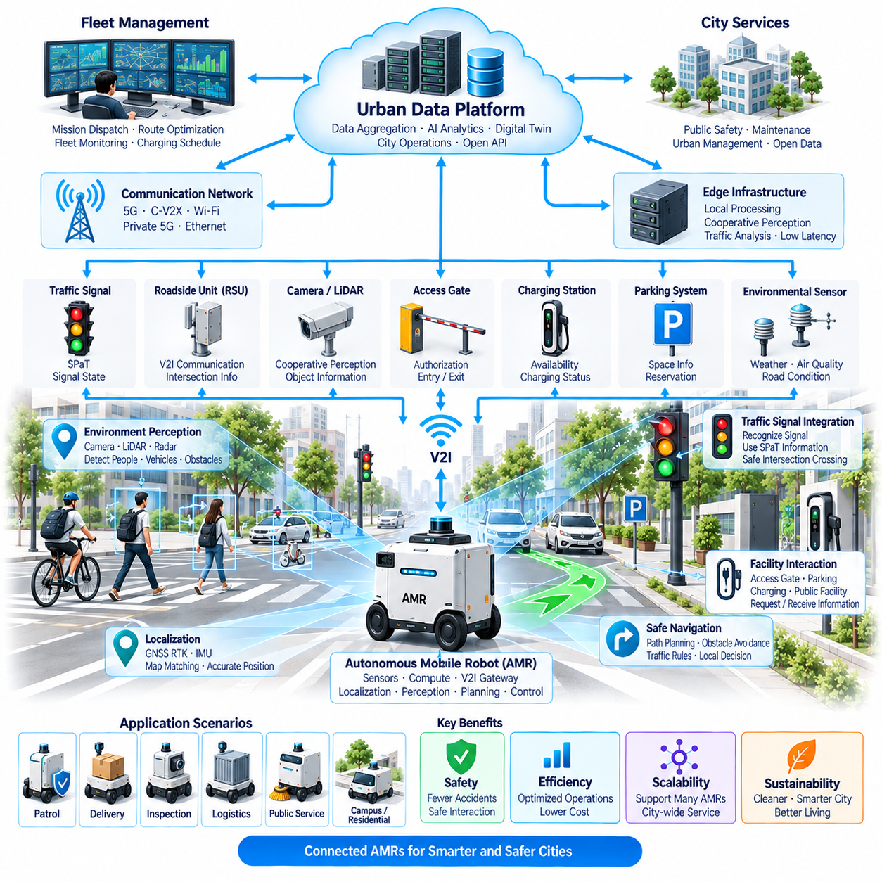
A Smart City AMR represents an outdoor autonomous mobile robot integrated not only with its local navigation environment but also with city infrastructure, communication networks, fleet services, and urban data systems. In a representative deployment, the AMR performs patrol, logistics, inspection, delivery, or public-service missions while exchanging information with traffic signals, roadside units, access facilities, and centralized operational platforms.
The vehicle platform combines autonomous driving hardware with smart-city communication interfaces. Cameras, LiDAR, radar, GNSS RTK, IMU, ultrasonic sensors, and other perception devices provide local environmental awareness, while onboard computing performs localization, perception, planning, and control. A V2I gateway connects these vehicle functions with external infrastructure without allowing the city network to directly control safety-critical steering, braking, or propulsion functions.
A typical mission begins when the fleet management system assigns a destination, route, service objective, and operational priority to the AMR. The vehicle evaluates its battery state, sensor health, localization quality, communication status, and mission constraints before departure. City-level information such as road restrictions, congestion, infrastructure availability, or temporary events can be incorporated into route selection while the vehicle retains responsibility for immediate local motion.
GNSS RTK provides the principal absolute positioning reference in open outdoor areas, while IMU and onboard perception maintain localization continuity when satellite visibility deteriorates. Map matching associates the vehicle with roads, lanes, pedestrian zones, intersections, and mission areas. Accurate localization is especially important in a smart-city environment because infrastructure messages must be matched to the correct intersection, signal, gate, charging station, or geographic service zone.
As the AMR approaches an intersection, V2I communication can provide information from roadside infrastructure before all relevant conditions become visible to onboard sensors. A roadside unit may transmit signal state, timing information, intersection status, warnings, or other operational data. The vehicle gateway authenticates and validates these messages and associates them with map and localization information before making them available to the autonomous planning system.
Traffic signal integration combines digital infrastructure information with direct camera observation. The AMR identifies the signal controlling its intended movement and verifies the relationship using lane geometry, stop-line position, route intention, and infrastructure identifiers. Signal Phase and Timing information can improve anticipation of upcoming changes, but the planner continues to evaluate pedestrians, vehicles, cyclists, obstacles, and local safety conditions before entering the intersection.
Cooperative perception can extend awareness beyond the AMR's direct field of view. Roadside cameras, LiDAR, or radar may observe pedestrians hidden behind vehicles, cross traffic at visually restricted intersections, or temporary obstacles farther along the route. Edge infrastructure can process these observations and distribute relevant object or event information. The AMR treats this information as an additional perception source rather than a replacement for onboard sensing.
After leaving the intersection, the AMR may enter pedestrian areas, campuses, residential complexes, public facilities, or industrial zones. Smart-city integration allows it to interact with access gates, parking systems, charging stations, warning devices, and other connected facilities. The robot can transmit identity, mission information, estimated arrival time, or service requests, while infrastructure returns authorization, availability, status, or operational constraints.
The communication architecture can combine cellular 5G, C-V2X, Wi-Fi, private 5G, and fixed roadside networks according to operating conditions. Wide-area cellular connectivity supports fleet and platform communication, while local networks can provide high-bandwidth or low-latency services near facilities and infrastructure. The AMR should tolerate transitions between communication domains because continuous connectivity cannot be assumed throughout a real urban operating area.
Edge computing reduces dependence on distant cloud services. District or roadside edge servers can process intersection events, cooperative perception, local traffic conditions, video analytics, or communication aggregation near the operating environment. Only selected information needs to be transferred to central services. This architecture reduces latency and backbone traffic while allowing local smart-city functions to continue operating when connectivity to central platforms becomes degraded.
The Urban Data Platform receives selected telemetry and events from vehicles and infrastructure. Vehicle position, mission state, battery condition, sensor health, road observations, communication quality, and detected events can be combined with traffic information, environmental data, infrastructure status, and facility availability. A common spatial and temporal reference allows information from multiple systems to be correlated into a city-level operational view rather than remaining isolated device records.
Fleet management uses this wider operational context to coordinate multiple AMRs. A route may be modified because of congestion, construction, an unavailable road segment, a blocked pedestrian path, or a charging requirement. Missions can be reassigned when one vehicle experiences a fault or low battery condition. The fleet system therefore optimizes distributed robot operations while each AMR continues to perform local obstacle avoidance and immediate safety decisions independently.
Consider a patrol AMR assigned to inspect a public district. During its mission, the vehicle follows a predefined patrol route while cameras and other sensors monitor the environment. If it detects an obstacle, abnormal infrastructure condition, or safety-related event, the onboard system can classify the event and transmit a compact report containing location, timestamp, event type, confidence, and selected supporting data to fleet and city services.
The platform can correlate the AMR report with information from roadside sensors or other autonomous vehicles. If several sources indicate the same blocked road or abnormal condition, the event can be elevated and distributed to relevant operators. Nearby AMRs may receive route restrictions, while maintenance or public-safety personnel receive the information required for response. This illustrates how individual robot observations can contribute to broader city-level situational awareness.
Charging provides another example of infrastructure integration. Before the battery reaches an operational limit, the fleet system or vehicle can identify an appropriate charging station according to location, mission priority, station availability, and remaining energy. The AMR requests access, navigates to the facility, verifies docking conditions, and begins charging. Charging status can then be reflected in fleet scheduling and the Urban Data Platform for subsequent mission planning.
Smart City AMR operation must remain safe when external communication becomes unavailable. Loss of V2I, cellular connectivity, an edge server, or the Urban Data Platform should not immediately remove the vehicle's local autonomous capability. The AMR detects communication degradation and applies a predefined fallback strategy. Depending on mission and environment, it may continue at reduced capability, avoid infrastructure-dependent areas, stop at a safe location, or enter a minimal-risk condition.
Cybersecurity is essential because the AMR communicates with infrastructure outside its physical control. Vehicle and infrastructure endpoints authenticate each other, and message integrity is checked before information influences operational decisions. Network segmentation separates external communication from safety-critical vehicle networks. Encryption, certificates, access control, secure updates, logging, and monitoring help protect the vehicle, roadside infrastructure, fleet services, and urban platform as one connected system.
Time synchronization supports reconstruction and fusion across the entire deployment. GNSS time or other synchronized timing mechanisms provide a common reference for vehicle sensors, roadside devices, traffic signals, edge servers, and city platforms. Accurate timestamps allow the system to determine whether infrastructure information is still valid, correlate observations from several devices, evaluate communication latency, and reconstruct the sequence of events during incident investigation.
The deployment can also support a city-scale digital twin. Live AMR locations, mission states, traffic conditions, infrastructure availability, and detected events can be represented in a virtual operational environment. Historical information can then support route optimization, capacity planning, maintenance analysis, and simulation of future deployments. Proposed changes can be evaluated virtually before new routes, infrastructure configurations, or larger autonomous fleets are introduced into the physical city.
Validation should reproduce complete missions rather than testing individual communication functions only. Scenarios should include intersection crossing, pedestrian interaction, gate access, charging, route modification, cooperative perception, communication handover, network loss, incorrect infrastructure data, localization degradation, and emergency events. Simulation, HIL testing, controlled sites, and staged field deployment can progressively verify the integrated behavior before expansion to larger urban environments.
The Smart City AMR case therefore demonstrates how local autonomy and city-level intelligence can operate as complementary layers. The robot independently perceives, localizes, plans, and controls its motion, while V2I communication, traffic signal integration, smart-city networking, fleet management, and the Urban Data Platform provide increasingly broader operational information. Their integration creates a resilient architecture for scalable outdoor autonomous mobility and coordinated robotic services across smart-city environments.

