Volume 17 Outdoor Autonomous Vehicle

Chapter 01. GNSS RTK

01.01. RTK Base Station Design
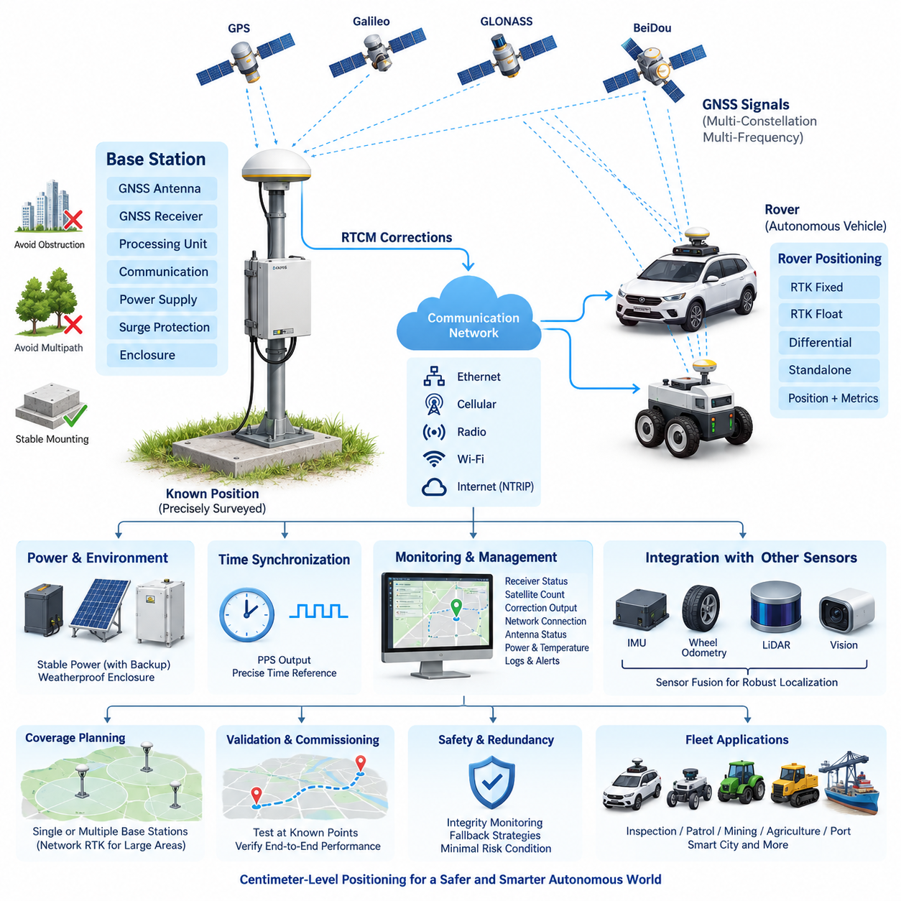
Real-Time Kinematic positioning extends conventional Global Navigation Satellite System positioning by using carrier-phase measurements and correction information from a precisely surveyed reference receiver. In an outdoor autonomous vehicle architecture, the RTK base station becomes part of the localization infrastructure rather than merely an accessory to the onboard GNSS receiver. The reference station continuously observes satellite signals from a known coordinate and generates corrections that allow mobile receivers to suppress common positioning errors.
The fundamental design begins with selection of the base-station location. The GNSS antenna should have the widest practical view of the sky and should be separated from buildings, metallic structures, trees, antennas, power equipment, and other objects capable of blocking signals or producing multipath reflections. A mechanically stable installation point is equally important because physical movement of the reference antenna directly appears as a systematic displacement in every rover position derived from that station.
A base station normally consists of a multi-band GNSS antenna, precision GNSS receiver, processing and communication interface, power subsystem, environmental enclosure, surge protection, and network connection. The receiver should support the satellite constellations and frequency bands required by the vehicle fleet. Multi-constellation reception using GPS, Galileo, GLONASS, BeiDou, or compatible regional systems increases satellite availability and improves geometry, especially where vehicles operate near buildings, vegetation, industrial equipment, or other partial obstructions.
Accurate knowledge of the reference antenna coordinate is one of the most important requirements. A base station can determine an approximate position by averaging GNSS observations, but centimeter-class infrastructure should preferably use a coordinate obtained through a reliable survey or sufficiently rigorous static positioning procedure. The coordinate must refer to a clearly defined antenna reference point and coordinate frame. An incorrect base coordinate can still produce apparently stable RTK fixes while shifting the entire vehicle trajectory by the same systematic offset.
The antenna installation must therefore be treated as precision measurement infrastructure. The mounting pole, mast, roof fixture, or ground monument should resist vibration, wind loading, thermal movement, and accidental displacement. Antenna height must be measured and documented consistently. Ground-plane characteristics, antenna phase-center behavior, cable length, connector quality, lightning protection, and water ingress protection should also be considered because localization performance depends on the complete RF path rather than the receiver specification alone.
The base receiver continuously compares measured satellite observations with observations expected at its known position. From these measurements it produces correction information that can be transmitted to autonomous vehicles using standardized formats such as RTCM. The rover combines its own GNSS measurements with the received reference observations or corrections and resolves carrier-phase ambiguities. Once integer ambiguities are reliably fixed, RTK can provide centimeter-level relative positioning under favorable satellite, communication, and environmental conditions.
Correction delivery should be separated conceptually from correction generation. The base station generates GNSS correction data, while Ethernet, cellular communication, radio, Wi-Fi, or an Internet-based service transports that information to the vehicle. This separation allows one reference station to support multiple robots and makes the positioning infrastructure scalable. The neighboring NTRIP correction-service topic can then address Internet distribution, caster architecture, mountpoints, authentication, and fleet access without overloading the physical base-station design itself.
Communication latency and continuity directly influence practical RTK availability. Correction messages must reach the rover frequently enough that the onboard estimator can use observations representing nearly the same satellite conditions. Network architecture should therefore monitor correction age, packet loss, connection state, throughput, and reconnection behavior. The autonomous vehicle should never interpret the presence of a GNSS coordinate as proof of centimeter accuracy; RTK mode, ambiguity status, correction age, satellite geometry, and receiver integrity information must also be evaluated.
Power architecture is another important design consideration for permanent infrastructure. The base station should remain operational during short disturbances because loss of corrections can simultaneously degrade localization across an entire autonomous fleet. A regulated power supply, appropriate DC conversion, surge protection, grounding, and backup power can therefore be justified even when receiver consumption is relatively small. Remote sites may additionally use battery or solar power, but energy storage must be sized for communication equipment as well as the GNSS receiver.
Environmental engineering becomes critical when the reference station is deployed outdoors for continuous operation. Receiver electronics and communication equipment should be installed in an enclosure appropriate for rain, dust, condensation, temperature variation, insects, and ultraviolet exposure. Thermal design must avoid both overheating and internal condensation. Cable entries require suitable glands and strain relief, while external antenna and communication lines should incorporate appropriate surge and lightning protection according to the installation environment.
Time synchronization should also be considered because GNSS infrastructure can provide more than position corrections. GNSS receivers inherently operate with precise satellite-derived timing, and selected base-station designs can expose pulse-per-second or related timing interfaces. This timing reference can support synchronization of localization servers, communication gateways, sensor systems, logging infrastructure, or distributed monitoring equipment. Position and time should nevertheless be managed as distinct system services with explicit interfaces and health monitoring.
The rover must distinguish between RTK Fixed, RTK Float, differential operation, and ordinary standalone GNSS states. A Fixed solution generally represents successful carrier-phase ambiguity resolution, whereas Float indicates that the ambiguities have not yet been reliably resolved. Autonomous control software should receive not only latitude, longitude, and altitude but also solution state, covariance or accuracy estimates, correction age, satellite count, dilution indicators, and receiver diagnostic information. Localization confidence can then influence planning and vehicle speed.
A robust outdoor vehicle should not depend on RTK alone. GNSS/RTK measurements are normally integrated with an inertial measurement unit, wheel odometry, steering information, LiDAR localization, visual localization, or other motion estimates. During short GNSS interruptions, these sources can maintain continuity while uncertainty grows. When high-quality RTK returns, the fusion estimator can constrain accumulated drift. This makes the base station one component of a broader localization architecture rather than a single point of autonomous-navigation truth.
Coverage planning must account for both radio or network connectivity and the spatial behavior of differential GNSS errors. A reference station should be positioned so that the operational area receives dependable correction delivery and remains within the distance assumptions established for the required accuracy. Large campuses, ports, industrial areas, agricultural regions, or smart-city deployments may eventually require multiple reference stations, commercial correction infrastructure, or network RTK rather than one isolated base.
Base-station monitoring should expose operational health to the fleet-management or infrastructure-management layer. Useful parameters include receiver status, tracked satellite count, constellation availability, correction-message output, communication connection, antenna status, power state, enclosure temperature, storage utilization, and last valid correction timestamp. Alarm thresholds can detect failures before vehicles lose high-accuracy localization, while historical logs make it possible to correlate navigation anomalies with GNSS or infrastructure events.
Commissioning should verify the complete positioning chain rather than testing the receiver in isolation. The surveyed base coordinate, antenna installation, correction generation, communication path, rover reception, RTK convergence, fixed-solution stability, and vehicle localization output should be tested together. Measurements at known checkpoints are particularly valuable because they reveal constant coordinate offsets, height errors, multipath effects, or configuration mistakes that may remain invisible when engineers inspect only the receiver-reported accuracy value.
Operational validation should include difficult conditions such as partial sky blockage, nearby buildings, trees, moving vehicles, network interruptions, base-station restart, rover restart, temporary correction loss, and transitions between Fixed and Float states. The system should demonstrate predictable degradation rather than abrupt or unexplained localization jumps. Recovery time after correction restoration should also be measured because autonomous operation depends not only on peak accuracy but on availability, integrity, continuity, and controlled recovery.
Configuration management is essential once the base station becomes shared fleet infrastructure. Antenna coordinates, antenna model, receiver firmware, RTCM message configuration, constellation selection, elevation masks, communication parameters, coordinate reference system, geoid settings, and installation measurements should be version controlled. Unauthorized modification of the surveyed coordinate is particularly dangerous because every connected rover may remain operational while producing consistently displaced positions.
For safety-related outdoor autonomy, the RTK architecture should therefore expose positioning integrity to higher-level decision logic. When correction age increases, the solution changes from Fixed to Float, estimated uncertainty exceeds an operational threshold, or GNSS observations become inconsistent with inertial and environmental localization, the vehicle can reduce speed, restrict its operating envelope, stop at a safe location, or transition to another localization mode according to system requirements.
The resulting RTK base-station architecture forms the infrastructure foundation for the broader GNSS/RTK chapter identified in the outdoor autonomous vehicle structure. It provides the physical reference from which correction services, multi-band receiver design, centimeter-class localization, and GNSS/RTK redundancy can subsequently be developed as separate engineering layers. This modular organization allows positioning accuracy, communication availability, receiver capability, and redundancy to be engineered independently while remaining part of one integrated outdoor autonomy system.

01.02. NTRIP Correction Service
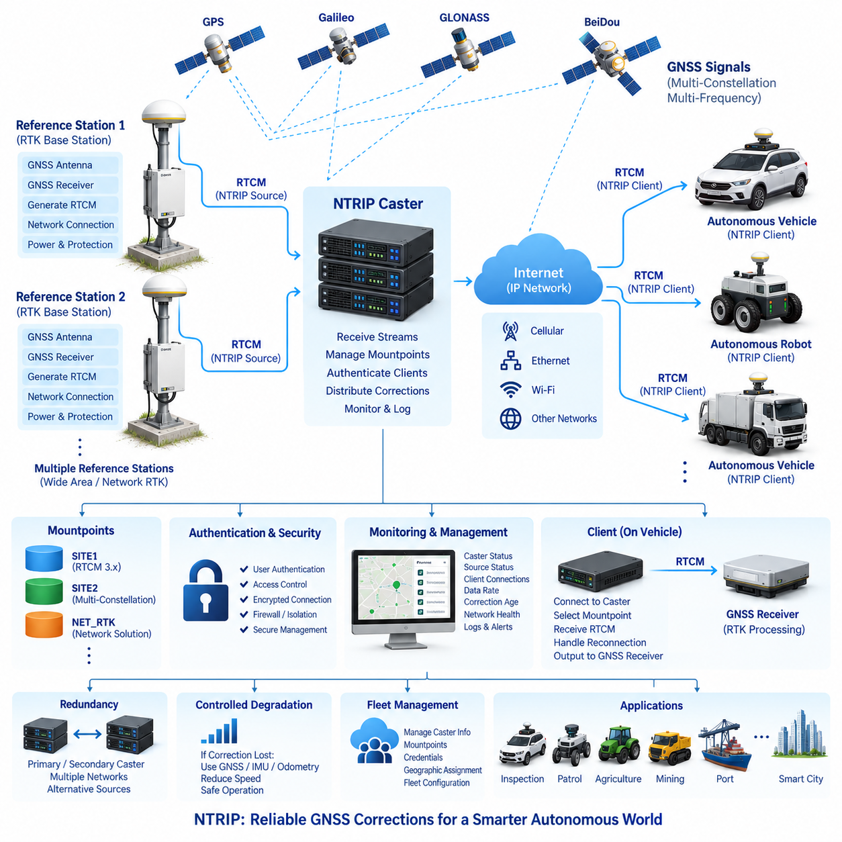
Networked Transport of RTCM via Internet Protocol, commonly known as NTRIP, provides a standardized mechanism for distributing GNSS correction data from reference infrastructure to mobile receivers through IP networks. Within an outdoor autonomous vehicle system, NTRIP separates correction generation from correction delivery, allowing RTK base stations to serve vehicles through cellular, Ethernet, Wi-Fi, or other Internet-connected networks instead of requiring a dedicated point-to-point radio link.
The basic NTRIP architecture consists of an NTRIP Source or Server, an NTRIP Caster, and one or more NTRIP Clients. The reference station generates GNSS observations or correction messages, normally using RTCM-compatible formats, and forwards them toward the caster. The caster acts as a distribution hub, while the client running on the autonomous vehicle establishes a network session, selects the required correction stream, and delivers the received data to the onboard GNSS RTK receiver.
The NTRIP Caster is therefore a central logical component of the correction service. It accepts correction streams from one or multiple reference stations and exposes them through individually identifiable mountpoints. A mountpoint represents a particular correction stream and may correspond to a specific base station, geographic area, RTCM configuration, or correction service. This organization enables a single caster infrastructure to support multiple sites, receiver configurations, and autonomous vehicle fleets.
Correction messages transported through NTRIP commonly contain information required by RTK processing, including reference-station information and satellite observations. The precise RTCM message configuration should match the capabilities of the base receiver and rover receivers, including supported GNSS constellations and signal bands. GPS, Galileo, GLONASS, and BeiDou observations may be incorporated where supported, enabling multi-constellation and multi-frequency RTK operation for improved satellite availability and positioning robustness.
An NTRIP Client must manage more than simple data reception. It establishes a connection with the caster, requests the appropriate mountpoint, performs any required authentication, receives the correction stream, and forwards correction data to the GNSS receiver with minimal unnecessary delay. In autonomous vehicles, the client may run directly inside the GNSS receiver, on a Jetson platform, edge computer, communication gateway, or dedicated positioning controller depending on the system architecture.
Network latency is a critical design parameter because RTK corrections represent time-dependent GNSS observations. Excessive transport delay reduces the usefulness of the correction stream and can degrade ambiguity resolution or positioning quality. The system should therefore measure correction age rather than assuming that an active network connection guarantees valid corrections. End-to-end timing includes base-station processing, caster transport, communication-network delay, client processing, and delivery into the rover GNSS receiver.
Communication reliability must be engineered for realistic outdoor operating environments. Cellular networks may experience handovers, temporary coverage loss, congestion, variable latency, or IP-session interruption as the vehicle moves. Wi-Fi may provide excellent local performance but limited geographic coverage, while wired Ethernet is normally restricted to stationary infrastructure. NTRIP client software should consequently support timeout detection, automatic reconnection, session recovery, and restoration of the selected mountpoint after communication interruptions.
Correction availability and positioning state must be monitored independently. A vehicle may remain connected to the caster while receiving stale, incomplete, or unsuitable RTCM data, and it may receive valid corrections without immediately achieving RTK Fixed status. The localization system should therefore observe network state, RTCM reception, correction age, GNSS solution type, ambiguity status, satellite count, estimated accuracy, and relevant receiver diagnostics as separate indicators of positioning health.
Authentication provides controlled access to correction infrastructure when the service is shared across multiple robots, customers, or operational sites. NTRIP deployments may use credentials or other access-control mechanisms to restrict mountpoint usage. Fleet-scale systems should manage these credentials systematically rather than embedding unmanaged account information in individual robots. Credential provisioning, replacement, expiration, and revocation should become part of the overall vehicle and infrastructure configuration-management process.
Security design should recognize that NTRIP data directly influences localization performance. The correction service should therefore be deployed using appropriate network protection, authenticated access, infrastructure isolation, firewall policies, and secure operational management. Where supported by the selected implementation, protected communication channels can reduce exposure of credentials and correction sessions. Security mechanisms must nevertheless be evaluated together with latency, compatibility, computational load, and field maintainability.
A fleet architecture benefits from treating NTRIP as a shared positioning service rather than configuring every autonomous vehicle independently. Fleet management can maintain approved caster addresses, mountpoints, authentication parameters, geographic assignments, and service priorities. Vehicles can then receive configuration according to their operating area or mission. This approach simplifies deployment when inspection, patrol, logistics, agricultural, mining, port, or smart-city vehicles share common GNSS infrastructure.
Large operational regions may require more than one RTK reference station. Multiple stations can be exposed through different NTRIP mountpoints, allowing vehicles to use correction data appropriate to their current area. More advanced deployments may employ network RTK services that combine observations from multiple reference stations. In either case, the vehicle architecture should define how the appropriate correction source is selected and how transitions between correction services are handled without creating unsafe localization discontinuities.
Geographic information from the rover can also participate in correction-service selection when supported by the NTRIP infrastructure. The vehicle may provide an approximate GNSS position to help the service identify an appropriate reference or network solution. Such mechanisms are especially useful for vehicles traveling across large areas where a single fixed mountpoint is insufficient. The approximate position used for service selection must remain conceptually separate from the high-accuracy RTK solution ultimately produced by the rover.
The communication gateway between the NTRIP Client and GNSS receiver should be explicitly engineered. Depending on the receiver, RTCM corrections may be transferred through Ethernet, serial interfaces, USB, CAN-related gateways, or vendor-specific interfaces. Buffering should be minimized and monitored because excessive queues can increase correction age even when the external Internet connection appears healthy. Interface bandwidth must also accommodate the selected constellation, frequency, and RTCM message configuration.
Service monitoring should extend from the base station to the rover. Infrastructure monitoring can record whether each source is connected, whether RTCM messages are being generated, caster session status, connected client count, network throughput, correction-stream age, and service availability. Vehicle-side monitoring can record connection attempts, authentication results, selected mountpoint, received data rate, correction age, RTK state, and reconnection events. Combining both perspectives greatly simplifies diagnosis of positioning failures.
Logging is particularly important because intermittent RTK problems are often difficult to reproduce. Timestamped records of caster connections, RTCM reception, GNSS solution transitions, network state, vehicle position, and localization confidence allow engineers to determine whether a navigation anomaly originated from satellite visibility, the reference station, the caster, the communication network, the client, or the rover receiver. Consistent time synchronization makes correlation between these distributed logs significantly more reliable.
Redundancy can be introduced at several layers of the NTRIP correction architecture. A vehicle may be configured with primary and secondary caster endpoints, alternative communication networks, multiple mountpoints, or an independent correction provider. Infrastructure may similarly use redundant network connections or replicated caster services. Redundancy should not simply duplicate components; the system must define failure detection, switchover conditions, source validation, recovery behavior, and prevention of rapid oscillation between correction sources.
Loss of NTRIP corrections should cause controlled localization degradation rather than immediate uncontrolled behavior. The rover may temporarily continue using GNSS, IMU, wheel odometry, LiDAR, vision, or other localization sources while RTK quality decreases. Higher-level autonomy software should receive the resulting localization confidence and apply operational rules such as reduced speed, restricted maneuvering, mission suspension, or transition to a minimal risk condition when positioning uncertainty exceeds defined limits.
Commissioning should verify the entire NTRIP path under realistic operating conditions. Testing should include caster connection, authentication, mountpoint selection, RTCM reception, RTK convergence, correction-age behavior, network interruption, automatic reconnection, base-station restart, caster restart, communication handover, and restoration of RTK Fixed operation. Known survey checkpoints can then confirm that successful data transport actually produces the expected centimeter-class positioning performance at the vehicle level.
The resulting NTRIP correction service forms the communication layer between the RTK base-station infrastructure and the multi-band GNSS receivers installed on outdoor autonomous vehicles. Within the GNSS/RTK architecture, it complements the physical base-station design while providing scalable correction distribution for centimeter-class positioning. This separation establishes a foundation for subsequent receiver selection, 1 cm accuracy engineering, and GNSS/RTK redundancy while allowing correction infrastructure to evolve independently of individual vehicle platforms.

01.03. Multi Band Receiver Selection
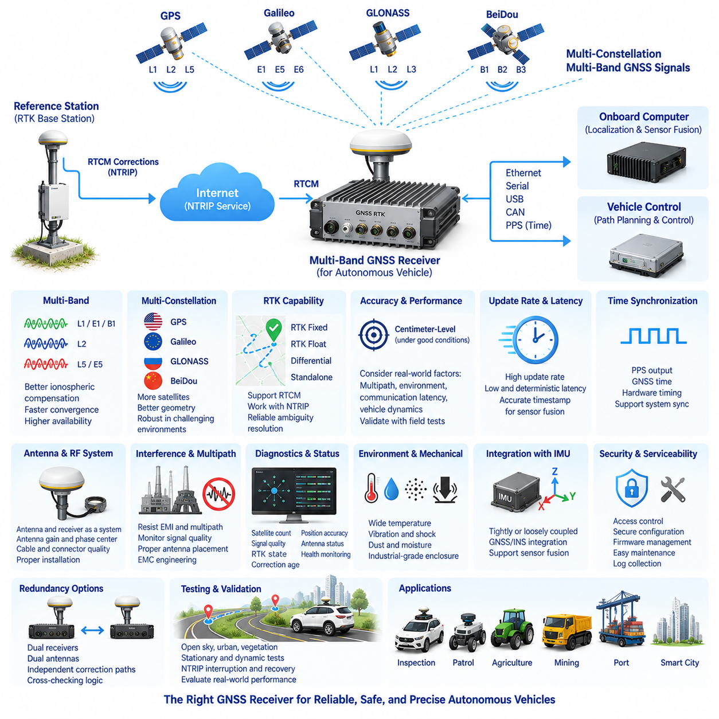
Multi-band GNSS receiver selection for an outdoor autonomous vehicle must begin with the positioning performance required by the complete localization architecture rather than with receiver specifications alone. The receiver operates between the GNSS antenna, RTK correction service, onboard localization computer, and sensor-fusion system, so its constellation support, frequency coverage, RTK capability, update rate, interfaces, timing, diagnostics, environmental tolerance, and integration characteristics must be evaluated together.
A multi-band receiver simultaneously processes signals transmitted on multiple GNSS frequency bands. Compared with a single-frequency design, this provides additional measurements that can improve ionospheric error compensation, ambiguity resolution, convergence behavior, and positioning availability. For outdoor autonomous vehicles expected to achieve reliable centimeter-class RTK positioning, dual-band or multi-band reception should therefore be considered a fundamental system capability rather than an optional performance enhancement.
Multi-constellation support is equally important. A receiver capable of tracking GPS, Galileo, GLONASS, and BeiDou can observe substantially more satellites than a receiver restricted to a single constellation. The resulting improvement in satellite geometry becomes especially valuable in ports, industrial complexes, campuses, agricultural areas, and urban environments where buildings, machinery, vegetation, or infrastructure may partially obstruct the sky and temporarily remove individual satellites from usable visibility.
Frequency-band selection should be evaluated together with constellation support because different GNSS systems transmit navigation signals across different frequency structures. Modern receivers may support combinations of L1/E1/B1, L2, L5/E5, and related signals depending on their architecture. The objective is not simply to maximize the number of listed bands, but to obtain a combination that improves measurement diversity, carrier-phase processing, interference resilience, and RTK performance within the intended operating environment.
RTK capability is a primary selection criterion because a receiver intended for centimeter-level autonomous localization must process carrier-phase measurements and correction information reliably. The receiver should support the RTCM messages generated by the selected base station or correction provider and should interoperate correctly with the NTRIP correction architecture. Compatibility must be verified at the actual message, constellation, signal, and firmware level rather than inferred only from a general statement that both devices support RTK.
The receiver must provide clearly distinguishable positioning states such as RTK Fixed, RTK Float, differential positioning, and standalone GNSS. Autonomous software should never treat every valid latitude and longitude output as equivalent. A Fixed solution indicates successful ambiguity resolution under the receiver's processing logic, while Float represents greater uncertainty. The receiver should expose sufficient status information for the localization system to determine whether a reported position is appropriate for autonomous control.
Accuracy specifications require careful interpretation. A manufacturer may provide horizontal and vertical accuracy values under favorable conditions, but these values do not guarantee equivalent performance in every deployment. Satellite visibility, multipath, antenna quality, correction distance, atmospheric conditions, communication latency, vehicle dynamics, and installation geometry all influence actual performance. Receiver selection should therefore combine datasheet evaluation with vehicle-level testing at surveyed reference points and representative operating sites.
Update rate influences how effectively GNSS information can support a moving autonomous platform. A low-rate position stream may be sufficient for slow monitoring applications but may be inadequate for higher-speed navigation or tightly coupled sensor fusion. The required rate should be derived from vehicle dynamics, control frequency, localization architecture, and expected speed. Higher output frequency is useful only when measurements remain accurately timestamped and can be consumed reliably by the onboard processing system.
Latency should be evaluated independently from update rate. A receiver can produce frequent outputs while still introducing processing delay between signal observation and delivery of the navigation solution. For sensor fusion, the measurement timestamp must represent when the observation occurred rather than merely when the message arrived at the computer. Deterministic timing and documented latency characteristics become increasingly important when GNSS is fused with high-rate IMU, wheel odometry, LiDAR, camera, and steering information.
Precise time interfaces can provide additional value beyond positioning. Receivers supporting pulse-per-second output, GNSS-derived time, or hardware timing signals can contribute to synchronization of distributed vehicle systems. This capability is particularly useful when perception sensors and localization processors must operate within a common time framework. PPS availability, electrical interface characteristics, timestamp behavior, and synchronization accuracy should therefore be considered when the GNSS receiver participates in the vehicle time architecture.
Communication interfaces must match the electrical and computing architecture of the autonomous vehicle. Depending on the receiver, available interfaces may include Ethernet, serial communication, USB, CAN-related integration, or dedicated timing and correction ports. The selected design should provide reliable paths for navigation output, RTCM correction input, configuration, diagnostics, and firmware management. Interface redundancy may also be useful where localization is considered operationally critical.
The GNSS antenna and receiver must be selected as a coordinated RF system. A high-performance multi-band receiver cannot compensate for an antenna that lacks the required frequency coverage or is poorly installed. Antenna gain, polarization, phase-center stability, ground-plane requirements, cable loss, connector quality, filtering, and low-noise amplification can influence receiver performance. Long RF cables and unsuitable connectors may degrade signal quality before satellite measurements reach the receiver processing stage.
Interference and multipath behavior deserve particular attention in autonomous vehicle deployments. Electric motors, inverters, DC/DC converters, high-speed digital computers, communication radios, and other onboard electronics can generate electromagnetic noise, while surrounding structures can reflect GNSS signals. Receiver selection should therefore consider interference detection, signal-quality indicators, filtering capability, and diagnostic visibility in addition to nominal sensitivity. Proper antenna placement and EMC engineering remain necessary regardless of receiver capability.
The receiver should provide comprehensive diagnostic outputs that can be consumed by vehicle software. Useful information includes satellite count, constellation usage, signal quality, RTK state, correction age, estimated horizontal and vertical uncertainty, dilution-of-precision indicators, antenna status, and communication health. These parameters allow the localization architecture to calculate confidence and identify gradual degradation before the position error becomes large enough to affect autonomous navigation.
Integration with an inertial measurement unit is particularly important because GNSS availability can change rapidly in outdoor environments. Some receivers provide integrated GNSS/INS processing, while other architectures perform GNSS and IMU fusion in an external localization computer. The appropriate choice depends on system partitioning, required transparency, computational architecture, sensor quality, and development strategy. In either case, raw or sufficiently detailed measurements can improve future algorithm development and fault analysis.
Mechanical and environmental requirements must reflect the intended vehicle class. Outdoor receivers may experience vibration, shock, dust, moisture, temperature cycling, electrical transients, and continuous operation. Industrial, agricultural, mining, inspection, patrol, and port vehicles may impose substantially harsher conditions than laboratory prototypes. Receiver enclosure rating, connector retention, operating temperature, input-power tolerance, vibration resistance, and mounting strategy should therefore be evaluated as part of the selection process.
Startup and RTK convergence behavior also affect operational availability. Autonomous vehicles may be power-cycled, temporarily lose satellite visibility, or move between open and partially obstructed environments. The receiver should recover predictably after these events and regain a high-quality solution within an acceptable period. Time to first fix, time to RTK Fixed, reacquisition behavior, and recovery following correction interruption should be measured experimentally rather than assessed only from ideal datasheet values.
Configuration management becomes increasingly important when many vehicles share the same GNSS infrastructure. Receiver firmware, enabled constellations, frequency bands, RTCM configuration, update rates, elevation masks, coordinate systems, output messages, communication settings, and antenna parameters should be controlled as versioned vehicle configuration. Two receivers of the same model can produce different operational behavior if their firmware or configuration differs, making configuration traceability essential for fleet maintenance.
Redundancy requirements can influence receiver selection from the beginning. A safety-oriented outdoor vehicle may use dual GNSS receivers, dual antennas, independent correction paths, or GNSS combined with independent LiDAR and inertial localization. If dual receivers are planned, electrical independence, antenna separation, common-mode failure, correction-source independence, timestamp consistency, and cross-checking logic must be considered. Simply installing two identical receivers does not automatically create effective positioning redundancy.
Cybersecurity and serviceability should also be included in the evaluation. Network-connected receivers may expose configuration interfaces, firmware-update mechanisms, remote management functions, or correction-service credentials. Access control and secure configuration practices should be compatible with the broader vehicle cybersecurity architecture. At the same time, field engineers need practical methods to inspect receiver state, collect logs, update approved firmware, restore configuration, and replace hardware without introducing undocumented calibration changes.
Receiver evaluation should ultimately be performed using a structured test program on the target vehicle. Tests should cover open sky, partial obstruction, urban multipath, vegetation, stationary operation, low-speed motion, higher-speed motion, NTRIP interruption, correction recovery, power cycling, electromagnetic interference, and known survey checkpoints. Position error, RTK Fixed availability, convergence time, correction age, output latency, satellite usage, and recovery behavior can then be compared objectively across candidate receivers.
The final multi-band receiver should therefore be selected as part of an integrated GNSS/RTK localization system rather than as an isolated component. Its role connects the RTK base-station design and NTRIP correction service with the subsequent centimeter-level accuracy and redundancy architecture defined in the GNSS/RTK chapter. A properly selected receiver provides the measurement quality, timing, diagnostics, interoperability, and operational robustness required to transform GNSS corrections into dependable positioning for outdoor autonomous vehicles.

01.04. 1cm Accuracy Design
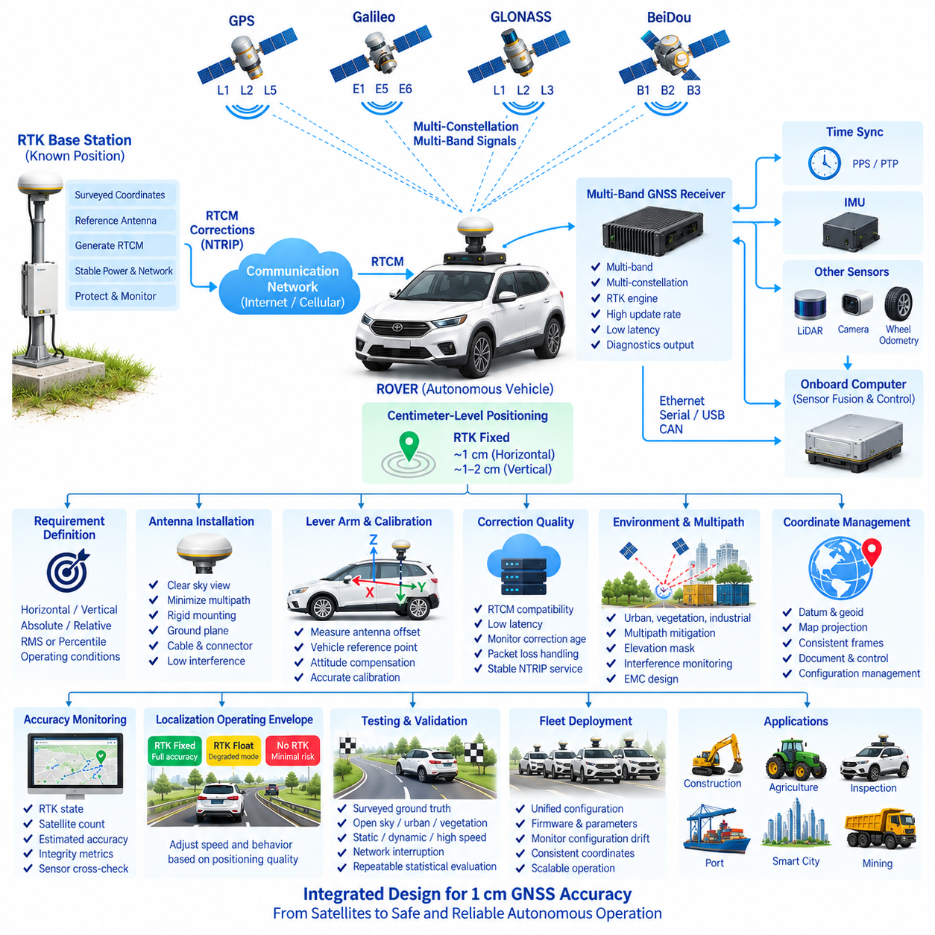
Centimeter-level GNSS positioning for an outdoor autonomous vehicle is not achieved by selecting a receiver whose datasheet simply states “1 cm accuracy.” It requires coordinated design of the complete positioning chain, including satellite visibility, multi-band GNSS reception, RTK reference infrastructure, correction delivery, antenna installation, coordinate management, timing, sensor fusion, integrity monitoring, and vehicle-level validation. The 1 cm target must therefore be defined as a system performance requirement rather than an isolated receiver specification.
The accuracy requirement should first distinguish horizontal, vertical, absolute, and relative positioning performance. RTK commonly provides stronger horizontal performance than vertical performance, while relative accuracy to a nearby surveyed reference may differ from absolute accuracy in a global coordinate frame. Engineering requirements should specify whether 1 cm represents RMS, standard deviation, percentile error, or another statistical criterion, and should define the environmental and operational conditions under which that value is expected.
A precisely surveyed RTK base station establishes the fundamental spatial reference. Any error in the base coordinate propagates directly into rover positions, meaning that a vehicle can maintain an apparently stable RTK Fixed solution while its entire trajectory remains systematically displaced. The reference antenna coordinate, antenna height, phase-center definition, coordinate reference system, datum, and geoid treatment must therefore be documented consistently and protected through configuration management.
Multi-band and multi-constellation reception improves the measurement foundation required for high-accuracy positioning. Simultaneous observation of multiple frequencies enables better compensation of frequency-dependent propagation errors and supports reliable carrier-phase ambiguity resolution. Tracking GPS, Galileo, GLONASS, and BeiDou increases satellite availability and improves geometry, particularly when buildings, trees, industrial structures, vehicles, or other obstacles temporarily restrict portions of the sky.
Carrier-phase processing is the principal mechanism that enables RTK to reach centimeter-class precision. Unlike code-based GNSS positioning, carrier-phase measurements provide extremely precise ranging information but contain unknown integer cycle ambiguities. The RTK engine must resolve these ambiguities reliably before the solution can be considered Fixed. A 1 cm architecture should consequently evaluate ambiguity-fix confidence, convergence time, continuity, reacquisition behavior, and false-fix risk rather than relying only on the reported solution label.
Correction quality is equally important. RTCM information generated by the reference station must correspond to the constellations and frequencies used by the rover and must arrive with sufficiently low latency through the NTRIP correction service. Correction age, packet loss, network interruptions, caster availability, and reconnection behavior should be continuously monitored. An active NTRIP connection alone does not prove that the corrections reaching the GNSS receiver remain timely or suitable for centimeter-level positioning.
Distance between the rover and reference infrastructure influences achievable RTK performance because atmospheric errors become less correlated as separation increases. A single base station may be appropriate for a localized campus or industrial site, while larger operating regions may require multiple stations or network RTK. Coverage engineering should therefore consider both communication availability and GNSS correction quality, ensuring that the vehicle remains within the validated operating envelope of the selected correction architecture.
Antenna installation can determine whether a high-performance receiver actually achieves its expected accuracy. The antenna should be mounted where satellite visibility is maximized and multipath from the vehicle body, roof equipment, payload structures, or nearby objects is minimized. Mechanical rigidity is essential because antenna movement relative to the vehicle coordinate frame becomes localization error. Antenna phase-center characteristics, ground plane, cable loss, connector quality, and RF interference must be included in the design.
The transformation between the GNSS antenna position and the vehicle reference point must be calibrated accurately. Autonomous navigation usually requires the position of a defined vehicle origin, axle center, control point, or body-frame reference rather than the physical antenna phase center. The three-dimensional lever arm between these points must therefore be measured and represented in the localization model. Orientation errors can convert even a correctly measured lever arm into position errors during turning, pitching, or rolling.
Vehicle attitude becomes increasingly important as the accuracy target approaches the centimeter scale. If the GNSS antenna is located significantly above or away from the vehicle reference point, roll, pitch, and yaw affect the transformed position. High-quality IMU measurements and accurate extrinsic calibration are therefore required to compensate for vehicle attitude. Dual-antenna GNSS can additionally provide heading information under suitable conditions and may improve low-speed or stationary orientation observability.
Time synchronization must be engineered with the same care as spatial calibration. GNSS, IMU, wheel odometry, LiDAR, cameras, and vehicle-control data are measured at different rates and may experience different communication delays. At vehicle speed, even a small timestamp error can translate directly into spatial error. GNSS-derived PPS, hardware timestamps, PTP, or another controlled synchronization mechanism can establish a common time reference and reduce temporal misalignment in the localization estimator.
Update rate and latency must be treated separately. A receiver may output positions at a high frequency while delivering them with significant processing delay. The localization system must know when each measurement was physically observed and account for known latency when combining it with other sensors. Deterministic data paths, controlled buffering, accurate timestamps, and measured end-to-end latency are particularly important when centimeter-level GNSS is integrated into a high-rate autonomous vehicle state estimator.
Sensor fusion provides continuity when GNSS conditions temporarily deteriorate. RTK measurements can be combined with IMU, wheel odometry, LiDAR localization, visual localization, steering information, or other motion constraints. The objective is not to force the fused solution to remain artificially at 1 cm under all conditions, but to maintain a statistically meaningful estimate of position and uncertainty. When RTK quality decreases, the estimator should explicitly represent growing uncertainty instead of hiding degradation behind a continuously available coordinate.
Multipath is one of the most significant threats to centimeter-level operation in practical environments. Reflected satellite signals can bias measurements even when many satellites remain visible and the receiver reports a valid solution. Urban buildings, containers, cranes, metallic walls, parked vehicles, industrial equipment, and the autonomous vehicle itself can create reflection paths. Site surveys, antenna placement, signal-quality monitoring, elevation masking, receiver algorithms, and sensor cross-checking should therefore form part of multipath mitigation.
Electromagnetic compatibility also affects GNSS measurement quality. Motors, inverters, DC/DC converters, high-performance GPU computers, Ethernet electronics, radios, and switching power supplies can generate interference near GNSS frequency bands or along antenna cabling. EMC design should address physical separation, grounding, shielding, filtering, cable routing, connector integrity, and noise-source characterization. Receiver interference indicators should be logged so that positioning anomalies can be correlated with vehicle electrical operating states.
Coordinate management must remain consistent from the base station through the autonomous navigation stack. GNSS coordinates may be represented in geographic latitude, longitude, and ellipsoidal height, while vehicle navigation may operate in projected maps, local Cartesian frames, or site-specific coordinates. Datum transformations, map origins, geoid models, altitude definitions, and frame conventions must be explicitly controlled. A centimeter-level receiver cannot compensate for centimeter- or meter-level errors introduced by an incorrect coordinate transformation.
The localization system should expose accuracy and integrity metrics rather than only the final position. RTK state, correction age, satellite count, signal quality, dilution indicators, estimated covariance, ambiguity status, receiver diagnostics, IMU consistency, and differences from independent localization sources can collectively describe positioning confidence. Operational logic can then define when centimeter-level localization is available, when degraded operation is permitted, and when autonomous motion must be restricted.
A practical design should define a localization operating envelope. Open-sky operation with RTK Fixed and fresh corrections may support the highest accuracy mode, while partial obstruction, RTK Float, excessive correction age, poor satellite geometry, or sensor disagreement may require a degraded mode. The vehicle can reduce speed, increase safety margins, restrict precision maneuvers, suspend a mission, or enter a minimal risk condition when localization uncertainty exceeds application-specific thresholds.
Validation requires surveyed ground truth that is more accurate than the performance being evaluated. Known checkpoints, calibrated trajectories, high-grade reference equipment, or appropriately surveyed test areas should be used to compare reported vehicle position with independent truth. Testing should measure horizontal and vertical error distributions, repeatability, bias, RTK Fixed availability, convergence time, latency, recovery time, and localization continuity rather than recording only a small number of favorable centimeter-level samples.
Testing should cover the complete operational domain, including open sky, vegetation, buildings, industrial structures, stationary operation, low-speed maneuvering, higher-speed travel, turns, slopes, network handovers, correction interruptions, receiver restarts, and transitions between RTK Fixed and Float. Repeated testing is necessary because satellite geometry changes with time. A credible 1 cm design must demonstrate statistical performance and predictable degradation across representative conditions rather than a single successful demonstration.
Fleet deployment adds another layer of control because all vehicles must use compatible positioning configurations. Base coordinates, antenna parameters, receiver firmware, enabled signals, RTCM messages, NTRIP mountpoints, coordinate transformations, lever-arm calibration, timing configuration, and localization thresholds should be version controlled. Monitoring should identify vehicles whose configuration differs from the approved baseline, since small configuration inconsistencies can create systematic localization differences across an otherwise identical fleet.
The 1 cm accuracy objective should ultimately be interpreted as an engineered capability with explicitly defined conditions, confidence, availability, and failure behavior. RTK base-station design establishes the spatial reference, NTRIP provides correction delivery, and the multi-band receiver converts satellite and correction observations into precision measurements. Calibration, timing, fusion, integrity monitoring, and validation then determine whether that theoretical capability becomes dependable vehicle-level localization for outdoor autonomous operation.

01.05. GNSS RTK Redundancy
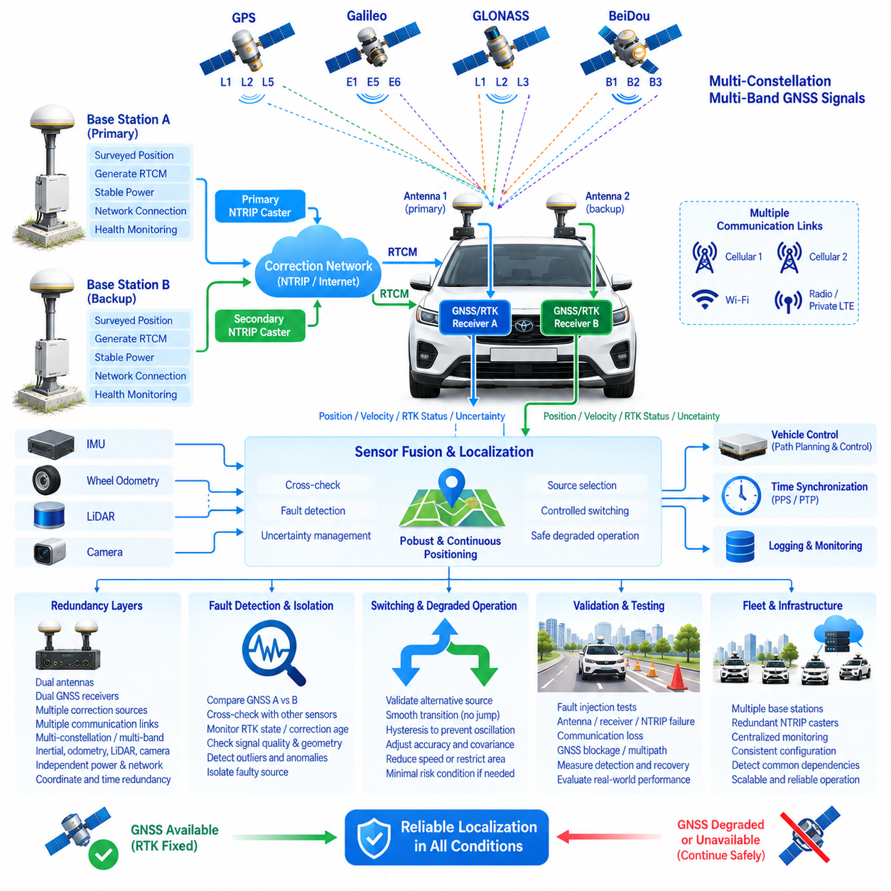
GNSS/RTK redundancy for an outdoor autonomous vehicle should be designed as a layered localization architecture rather than as the simple duplication of a GNSS receiver. The objective is to preserve trustworthy position, velocity, heading, and time information when individual receivers, antennas, correction links, satellite signals, communication networks, or supporting infrastructure become degraded or unavailable. Redundancy must therefore include fault detection, independence, cross-checking, controlled switching, and safe degraded operation.
A basic redundant architecture can employ two independent GNSS/RTK receivers connected to separate antennas. Each receiver should independently calculate navigation solutions and expose RTK state, position, velocity, satellite count, correction age, estimated uncertainty, and diagnostic information. A supervisory localization function can compare these outputs continuously. Agreement increases confidence, while persistent differences beyond defined thresholds indicate that one channel, both channels, or the surrounding GNSS environment may be abnormal.
Physical antenna redundancy requires more than installing two antennas close together. Their locations should provide suitable sky visibility while maintaining precisely measured positions relative to the vehicle reference frame. Antenna separation can also support heading estimation when dual-antenna processing is available. However, both antennas may still experience common multipath, blockage, interference, or jamming, so antenna duplication alone cannot provide complete independence from environmental GNSS failures.
Receiver independence should be evaluated at hardware, software, power, communication, and configuration levels. Two receivers powered by the same unprotected supply or connected through the same failing communication gateway can be lost simultaneously. Similarly, identical firmware or configuration defects may affect both channels. Where safety requirements justify it, separate power protection, independent communication paths, controlled configuration, and potentially diverse receiver implementations can reduce common-mode failure exposure.
RTK correction redundancy is another essential layer. Both GNSS receivers should not automatically depend on a single base station, NTRIP caster, mountpoint, modem, or Internet connection. The architecture may provide primary and secondary correction services, multiple caster endpoints, alternative mountpoints, network RTK, or an independent commercial correction provider. Correction-source diversity allows centimeter-class localization to continue when a particular base station or correction-distribution service becomes unavailable.
Communication redundancy should be considered separately from correction-source redundancy. A vehicle could have multiple correction providers but still lose all corrections if they use the same cellular modem or network path. Depending on the mission, the design may combine cellular links from different operators, Wi-Fi at controlled sites, private LTE or 5G, radio links, or other available communication technologies. The system should monitor each path independently and select an appropriate connection without unnecessary switching.
Satellite diversity already provides a useful form of measurement redundancy. Multi-constellation receivers capable of tracking GPS, Galileo, GLONASS, and BeiDou can continue operating when individual satellites or portions of a constellation become unavailable. Multi-band reception adds additional signal diversity across frequencies. However, these measurements are not completely independent because local obstruction, broadband interference, atmospheric effects, antenna faults, or severe multipath can degrade multiple constellations and frequencies simultaneously.
Redundancy should therefore extend beyond GNSS. An inertial measurement unit can propagate position, velocity, and attitude through short GNSS outages, while wheel odometry provides vehicle-motion constraints. LiDAR localization can compare observed environmental geometry with a known map, and visual localization can provide additional motion or landmark information. These independent sensing principles allow the vehicle to recognize GNSS anomalies and maintain localization continuity when satellite-based positioning becomes unreliable.
The localization estimator should combine redundancy with explicit uncertainty management. When RTK Fixed is available and consistent with other sensors, GNSS can strongly constrain the global position. If one receiver changes to RTK Float or its correction age increases, its measurement uncertainty should increase accordingly. If GNSS becomes unavailable, the estimator may rely more heavily on IMU, odometry, LiDAR, or vision while allowing covariance to grow. Redundancy must not hide the actual loss of positioning confidence.
Cross-checking logic is central to fault detection. The system can compare the positions reported by GNSS channel A and channel B, but this comparison alone is insufficient when both channels are affected by the same error. GNSS results should also be compared with predicted motion from IMU and wheel odometry and, where available, independent LiDAR or visual localization. Position, velocity, heading, acceleration, timestamp consistency, and innovation residuals can collectively provide stronger evidence of abnormal behavior.
Fault detection thresholds should account for normal measurement uncertainty and vehicle dynamics. Thresholds that are too tight can produce frequent false alarms, while excessively wide thresholds may allow hazardous positioning errors to remain undetected. Fixed numerical differences should therefore be complemented by covariance, solution state, correction age, satellite geometry, vehicle speed, and sensor consistency. Thresholds should be established through statistical testing under representative operating conditions rather than chosen only from nominal receiver accuracy.
Fault isolation determines which source should be trusted after disagreement is detected. If one GNSS receiver loses corrections while the other remains RTK Fixed and agrees with inertial and LiDAR localization, the degraded receiver can be excluded. If both GNSS receivers disagree with an independent environmental localization source, the system should consider a common GNSS fault. Reliable isolation requires multiple independent observations because two disagreeing sensors alone cannot determine which one is correct.
Switching between redundant sources should be controlled to prevent abrupt position discontinuities. Immediately replacing one GNSS solution with another can create a jump in the vehicle state estimate, especially if the receivers use slightly different coordinate solutions or biases. The localization architecture should validate the replacement source, align relevant states where appropriate, update estimator uncertainty, and perform a controlled transition. Hysteresis can prevent rapid oscillation between primary and secondary sources.
A redundant RTK architecture must also address reference-station failures. Base-station power loss, antenna damage, coordinate corruption, receiver failure, network outage, or incorrect RTCM configuration can affect every rover using that reference. A secondary surveyed base station or network RTK service can reduce this dependency. Infrastructure monitoring should detect missing corrections, abnormal coordinates, unexpected message changes, excessive correction age, and reference-station health degradation before fleet-level localization is significantly affected.
Coordinate integrity is particularly important because redundant hardware cannot compensate for a shared coordinate configuration error. If both receivers use corrections referenced to an incorrect base coordinate, both may agree while producing the same displaced position. Datum, coordinate reference system, geoid model, map origin, antenna lever arms, and transformation parameters should therefore be independently verified and configuration controlled. Agreement between redundant receivers is evidence of consistency, not absolute proof of correctness.
Time redundancy and synchronization should also be considered. GNSS receivers commonly provide precise time and PPS outputs, but the vehicle should define how localization timing behaves when one timing source disappears or becomes inconsistent. PTP, synchronized onboard clocks, independent oscillators, or another disciplined timing architecture can maintain temporal continuity. Monitoring should distinguish a spatial positioning fault from a timestamp fault because timing errors can appear as position errors when the vehicle is moving.
Power distribution can create hidden common-mode failures in otherwise redundant localization channels. Dual receivers should be connected through appropriately protected power paths, and critical communication gateways may require independent or backed-up supplies. Voltage monitoring, brownout detection, fuse coordination, grounding, and electromagnetic compatibility should be included in the architecture. Backup energy may be useful where a short power interruption would otherwise disable both GNSS channels and the correction communication system simultaneously.
Cybersecurity becomes part of redundancy when correction services and receivers are network connected. Compromised credentials, unauthorized configuration changes, false correction streams, or malicious network interference can affect localization without producing a conventional hardware failure. Authentication, access control, protected configuration, secure update processes, network segmentation, and correction-source validation help prevent redundant channels from accepting the same untrusted information and producing consistently incorrect positions.
Health monitoring should provide a unified localization status to the autonomous driving system. Relevant information includes receiver availability, RTK Fixed or Float state, correction age, satellite count, signal quality, estimated covariance, antenna status, network condition, IMU consistency, cross-channel differences, environmental localization residuals, and active correction source. The higher-level autonomy system should receive a clear localization integrity state rather than attempting to interpret dozens of raw receiver parameters independently.
Degraded operating modes should be defined before failures occur. Loss of one redundant receiver may permit normal or slightly restricted operation if the remaining channel and independent sensors remain healthy. Loss of RTK corrections may require reduced speed or larger safety margins, while loss of trustworthy global localization may restrict the vehicle to a locally mapped area. If localization uncertainty exceeds the validated operational limit, the vehicle should transition to a minimal risk condition rather than continue nominal autonomous operation.
Recovery logic is as important as failure detection. A receiver that reconnects to NTRIP or returns to RTK Fixed should not immediately regain full authority. Its corrections, solution stability, coordinate consistency, and agreement with other sensors should be observed for a defined validation period. Only after the recovered channel satisfies the required confidence criteria should it be reintroduced into the estimator or designated as an available redundant source. This prevents repeated failure-recovery oscillations from destabilizing localization.
Validation of redundancy requires deliberate fault injection rather than normal driving tests alone. Testing should include receiver power loss, antenna disconnection, NTRIP interruption, caster failure, cellular loss, stale corrections, base-station outage, RTK Fixed-to-Float transitions, GNSS blockage, multipath, timing faults, communication failures, and disagreement between localization sources. The test should verify detection time, isolation accuracy, switchover behavior, state continuity, uncertainty growth, recovery, and the resulting vehicle response.
Fleet deployment extends redundancy from the vehicle to the infrastructure level. Multiple autonomous vehicles may share RTK base stations, NTRIP casters, communication networks, maps, and monitoring servers, creating common dependencies that are not visible when analyzing a single robot. Fleet architecture should identify these shared resources, monitor their health centrally, provide alternative correction and communication paths where justified, and prevent one infrastructure failure from simultaneously disabling high-accuracy localization across the fleet.
GNSS/RTK redundancy therefore completes the GNSS/RTK architecture by integrating the previously defined RTK base station, NTRIP correction service, multi-band receiver, and centimeter-level accuracy design into a fault-tolerant localization system. Effective redundancy combines diverse measurements, independent infrastructure, integrity monitoring, controlled degradation, safe switching, and rigorous validation so that outdoor autonomous vehicles can continue operating safely when positioning components or environmental conditions no longer support nominal RTK performance.

