Volume 17 Outdoor Autonomous Vehicle

Chapter 07. Mining AMR

07.01. Explosion Proof Design (ATEX)
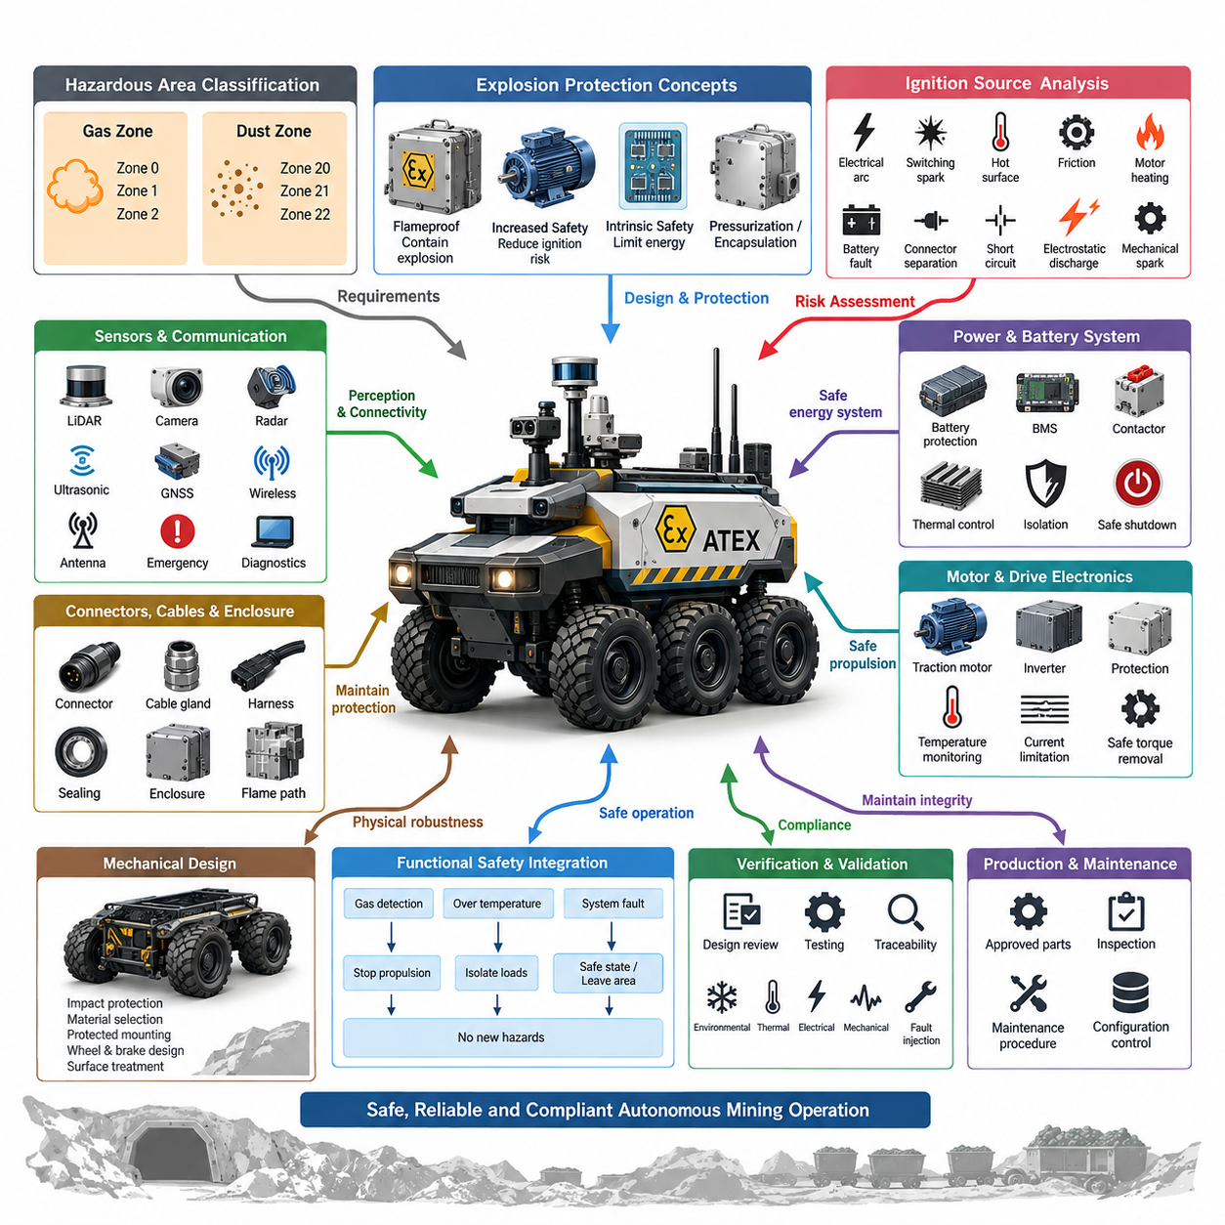
Explosion-proof design is a fundamental requirement for autonomous mobile robots operating in mines where methane, combustible dust, fuel vapor, or other hazardous substances may create an explosive atmosphere. The engineering objective is not simply to strengthen the enclosure, but to prevent electrical, thermal, mechanical, and electrostatic ignition sources from initiating combustion during normal operation or foreseeable fault conditions.
ATEX engineering begins with hazardous-area classification because the required protection concept depends on where and how frequently an explosive atmosphere may occur. Gas environments are generally classified as Zones 0, 1, and 2, while combustible-dust environments use Zones 20, 21, and 22. A mining AMR must therefore be designed from a documented operational-zone assumption rather than attempting to add explosion protection after the vehicle architecture has already been completed.
Equipment intended for underground mining requires particular attention because firedamp and combustible dust can coexist with severe mechanical and environmental conditions. The protection strategy must consider the complete robot as an integrated system, including traction drives, batteries, power distribution, computing units, sensors, communication equipment, connectors, lighting, braking devices, and auxiliary payloads. Certification of individual components alone does not automatically establish compliance of the assembled AMR.
Ignition-source analysis should systematically identify electrical arcs, switching sparks, hot surfaces, motor heating, battery faults, connector separation, short circuits, electrostatic discharge, friction, and mechanically generated sparks. Each source must be evaluated under normal operation, expected disturbances, and relevant failure conditions. The resulting analysis becomes a central engineering artifact linking the hazardous-area assumptions to component selection, protection methods, verification activities, and operational restrictions.
Several explosion-protection concepts may be combined within one mining robot. Flameproof enclosures can contain an internal explosion and prevent flame propagation, while increased-safety techniques reduce the probability of arcs, excessive temperatures, and insulation failures. Intrinsic-safety techniques restrict available electrical and thermal energy in suitable low-power circuits. Encapsulation, pressurization, or other protection methods may also be applied where justified by equipment function and certification strategy.
Temperature control is particularly important because an ignition hazard can exist even when no electrical spark occurs. Motors, brakes, power converters, batteries, processors, GPUs, lighting modules, and resistive components may generate substantial heat during sustained mining operation. Thermal design must therefore establish worst-case surface temperatures using load profiles, ambient conditions, cooling degradation, component tolerances, and fault scenarios while maintaining the applicable temperature limitation.
Battery architecture requires special treatment because an autonomous robot contains a mobile, high-energy electrical source that cannot simply be isolated from the hazardous environment. Cell faults, overcurrent, internal short circuits, contactor switching, charging interfaces, and thermal propagation must be addressed through coordinated mechanical and electrical protection. Battery monitoring, current protection, temperature supervision, isolation strategy, controlled shutdown, and enclosure design should operate as complementary protection layers.
Motors and drive electronics introduce another concentration of ignition risks. Traction motors can produce elevated winding and housing temperatures, while inverters contain high-frequency switching devices and substantial stored electrical energy. The design should therefore coordinate certified motor construction, protected power electronics, cable entry systems, overtemperature monitoring, current limitation, fault detection, and safe torque removal so that propulsion failures do not create an uncontrolled ignition source.
Connectors, cable glands, harnesses, and enclosure interfaces must preserve the explosion-protection concept throughout the vehicle. An enclosure with an appropriate protection method can lose its effectiveness if an unsuitable gland, connector, seal, or maintenance modification creates an unintended flame path or environmental entry point. Harness routing must additionally withstand abrasion, crushing, vibration, bending, contamination, and mechanical impact encountered during continuous underground operation.
Sensors and communication equipment create a difficult integration problem because autonomous operation requires extensive external perception and connectivity. LiDAR, cameras, radar, ultrasonic sensors, GNSS-related equipment where applicable, wireless radios, antennas, emergency devices, and diagnostic interfaces must be evaluated as possible ignition sources. Where certified versions are unavailable, the architecture may require protected housings, energy limitation, isolation barriers, or relocation of electronics into appropriate protected compartments.
Functional safety and explosion protection must be engineered together rather than treated as independent compliance activities. A detected gas condition, excessive temperature, enclosure fault, battery abnormality, or protection-system failure may require the AMR to stop propulsion, isolate selected loads, enter a predefined safe state, or leave a hazardous region when movement remains permissible. The transition must avoid creating new hazards through abrupt braking, contactor operation, or uncontrolled loss of essential safety functions.
Mechanical design also contributes directly to ignition prevention. Collisions with rock, steel infrastructure, rails, machinery, or debris may produce sparks, enclosure deformation, cable damage, or loss of sealing integrity. Material selection, impact protection, guarded connectors, protected sensor mounting, wheel and brake design, structural clearances, and suitable surface treatments should therefore be included in the explosion-risk assessment instead of limiting ATEX engineering to electrical components.
Verification requires more than a final certification test. Design reviews should maintain traceability from hazardous-area classification and ignition-risk assessment through protection concepts, component certificates, thermal calculations, drawings, installation requirements, and inspection procedures. Environmental, thermal, electrical, mechanical, and fault-injection tests should demonstrate that the integrated AMR continues to satisfy its protection assumptions under representative mining loads and foreseeable degradation.
Production and maintenance controls are equally important because explosion protection depends on configuration integrity throughout the robot lifecycle. Replacement connectors, enclosure fasteners, cable glands, seals, batteries, motors, and electronic modules must conform to approved specifications. Maintenance documentation should identify inspection intervals, prohibited modifications, torque requirements, damaged-component criteria, and procedures for restoring protective features after servicing or field repair.
A robust ATEX-oriented mining AMR architecture therefore treats explosion protection as a system-level design constraint extending from requirements definition to retirement. Hazardous-zone assumptions drive equipment selection; ignition analysis drives protection measures; thermal and electrical monitoring support safe operation; and controlled configuration preserves certification. This integrated approach allows autonomy, high electrical power, perception, and connectivity to coexist with the stringent safety demands of hazardous mining environments.

07.02. Mining Communication (Leaky Feeder)
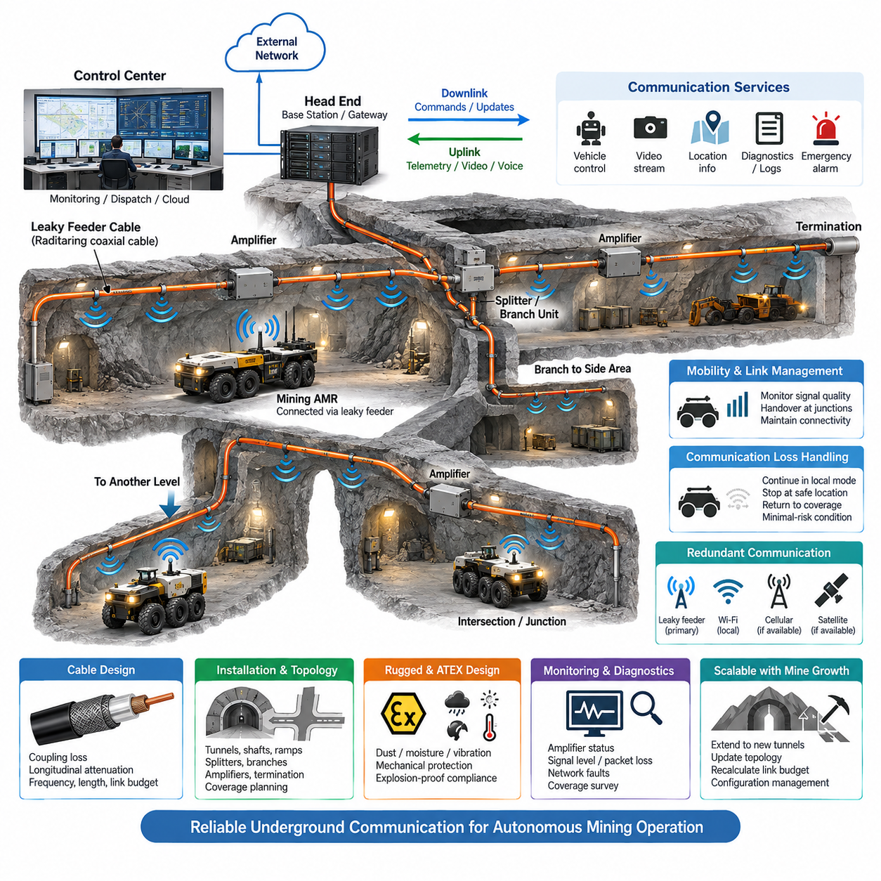
Underground mining communication presents conditions fundamentally different from surface wireless networks. Rock formations, tunnels, metallic infrastructure, machinery, and irregular excavation geometry severely attenuate conventional radio signals and create extensive non-line-of-sight regions. A mining autonomous mobile robot therefore requires a communication architecture specifically engineered for long tunnels, changing mine layouts, hazardous areas, and continuous vehicle movement.
A leaky feeder system provides radio coverage by intentionally allowing controlled radio-frequency energy to radiate from and couple back into a specially constructed coaxial cable installed along underground tunnels. Unlike conventional coaxial cable designed to confine electromagnetic energy, the leaky feeder acts as a distributed antenna extending throughout the mine. Mobile radios and robotic communication devices can consequently maintain connectivity while traveling through areas where ordinary access points would provide insufficient coverage.
The fundamental architecture consists of a head-end communication unit, leaky coaxial cable, line amplifiers, power supplies, branching components, termination devices, and mobile radio interfaces. The head end connects underground communication infrastructure with dispatch, control, or external networks, while the cable distributes radio signals along the tunnel. Bidirectional operation enables both downlink commands toward the mining AMR and uplink telemetry, alarms, voice, or operational information from underground equipment.
Cable characteristics directly influence system performance. Coupling loss determines how efficiently radio energy transfers between the cable and nearby wireless devices, while longitudinal attenuation describes signal loss as energy propagates along the cable. These parameters must be balanced because strong radiation can improve local coverage but increase transmission loss over distance. Cable selection therefore depends on operating frequency, tunnel length, required communication range, installation geometry, and expected link margin.
Long underground routes require amplifiers at calculated intervals to compensate for accumulated cable and coupling losses. Amplifier spacing cannot be determined solely from nominal cable attenuation because connectors, splitters, branches, installation bends, aging, and environmental effects also contribute to the link budget. Engineering analysis should calculate worst-case signal levels in both communication directions and maintain sufficient margin for equipment tolerances, mine expansion, and changing propagation conditions.
Tunnel topology introduces additional complexity because real mines contain intersections, shafts, ramps, production levels, refuge areas, loading zones, and equipment chambers. Splitters and branch units can extend the leaky feeder network into these sections, but every division introduces additional attenuation. Network planning should therefore represent the physical mine topology and determine where branches, amplifiers, termination points, redundant routes, and communication gateways are required to maintain operational coverage.
For an autonomous mining AMR, the leaky feeder should be considered part of a broader communication architecture rather than merely a replacement for Wi-Fi. Low-bandwidth but highly reliable channels can carry vehicle status, emergency messages, dispatch commands, location information, and minimal-risk instructions. Higher-bandwidth services may be provided through complementary technologies when required for camera streams, map transfer, software updates, or large diagnostic datasets.
Communication interfaces on the robot should separate safety-relevant operational data from bandwidth-intensive application traffic. Vehicle state, emergency-stop coordination, mission control, health monitoring, and critical alarms require predictable delivery behavior, whereas video, perception data, and bulk logs can tolerate different latency and availability characteristics. This separation prevents a high-volume data transfer from consuming communication resources needed for essential control and supervisory functions.
Mobility management is especially important because the AMR continuously changes position relative to the radiating cable, amplifiers, branches, and other communication infrastructure. Link quality may vary at intersections, cable discontinuities, equipment rooms, or locations where large machinery temporarily changes the propagation environment. The robot should monitor communication quality and use defined thresholds to detect degradation before connectivity falls below the level required for safe autonomous operation.
Loss of communication must be treated as a normal system condition that can occur during underground operation rather than as an unexpected software exception. The autonomous vehicle should define what functions remain locally available when the external link is degraded or unavailable. Depending on mission and safety requirements, it may continue within a limited autonomous envelope, stop at a safe location, return toward known coverage, or enter a predefined minimal-risk condition until communication is restored.
Redundancy can significantly improve communication availability in critical mining applications. A leaky feeder may provide the primary underground radio path while additional wireless, wired, or localized network technologies supply complementary connectivity. The communication manager aboard the AMR can evaluate link state and select an appropriate path according to availability, latency, bandwidth, and mission criticality, while avoiding unnecessary dependence on any single communication medium.
Mining communication hardware must also withstand vibration, shock, moisture, dust, mud, temperature variation, corrosion, and mechanical damage. Cable routing should protect the leaky feeder from vehicles, falling material, blasting activities, and maintenance operations while preserving its intended radio characteristics. Connectors, amplifiers, power interfaces, and branching devices require appropriate environmental and mechanical protection because one damaged segment can degrade communication over a substantial underground area.
In hazardous underground environments, communication equipment must additionally remain compatible with the applicable explosion-protection architecture. Amplifiers, power supplies, radios, connectors, and associated electrical interfaces can become ignition sources if inappropriate equipment is introduced into classified areas. Communication design must therefore coordinate hazardous-area requirements with equipment selection, installation methods, energy distribution, enclosure concepts, maintenance procedures, and the overall ATEX strategy of the mining AMR system.
Monitoring and diagnostics are essential because gradual degradation can be difficult to detect from individual robot communication failures. The infrastructure should support observation of amplifier status, power conditions, signal levels, network faults, and segment availability where technically practical. Robot-side logging of received signal strength, packet loss, latency, disconnection events, and location allows communication performance to be correlated with specific tunnel sections and recurring operational conditions.
Commissioning should include coverage surveys throughout the actual mine rather than relying exclusively on theoretical link-budget calculations. Measurements should be performed along travel routes, intersections, ramps, loading areas, turning points, and other operationally important locations. Testing with representative machinery operating nearby is valuable because vehicles, metallic structures, and changing mine geometry can alter radio propagation after the initial communication infrastructure has been installed.
The leaky feeder network must evolve with the mine itself. Excavation continuously creates new tunnels, production areas are relocated, and some routes may become inactive or physically modified. Communication engineering therefore requires controlled extension procedures, updated topology documentation, recalculation of amplifier and branch losses, configuration management, and periodic coverage verification so that autonomous vehicle deployment does not depend on an outdated representation of underground connectivity.
A well-designed leaky feeder architecture ultimately provides a communication backbone that follows the physical structure of the underground mine. By combining distributed radio coverage, engineered link budgets, amplification, branching, diagnostics, mobility management, communication-loss handling, and complementary networks, the system can support reliable AMR supervision and data exchange. This infrastructure becomes an enabling layer for scalable autonomous mining rather than simply a tunnel radio installation.

07.03. Shock and Vibration Durability
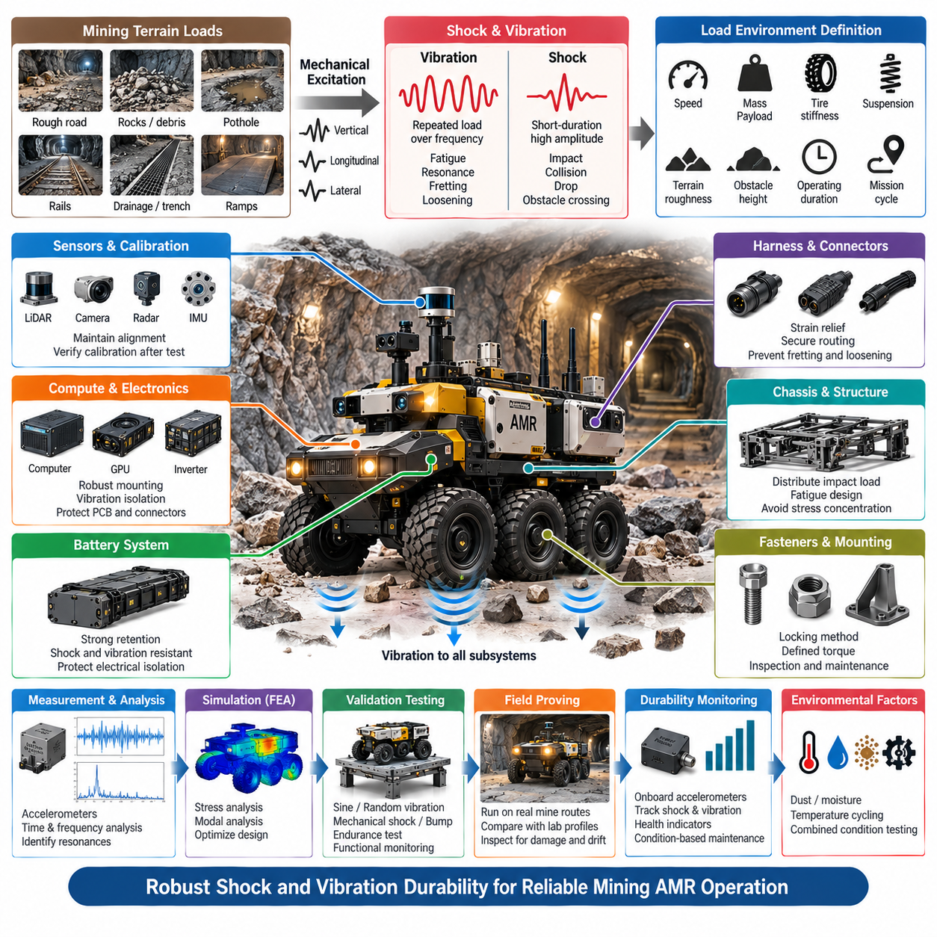
Shock and vibration durability is a fundamental design requirement for mining autonomous mobile robots because underground roads expose the vehicle to continuous mechanical excitation far beyond typical indoor AMR conditions. Broken rock, potholes, rails, drainage channels, ramps, debris, and uneven tunnel floors generate repeated vertical, longitudinal, and lateral loads. These inputs propagate through the chassis into batteries, computers, sensors, connectors, harnesses, and precision electronic assemblies.
Shock and vibration must be treated as different but interacting load mechanisms. Vibration consists of repeated dynamic excitation over a range of frequencies and can produce fatigue, resonance, connector fretting, fastener loosening, and accumulated structural damage. Shock is a short-duration, high-amplitude event caused by impacts such as wheel strikes, drops, collisions, or abrupt obstacle crossing. A mining AMR durability strategy must therefore address both cumulative fatigue and individual extreme events.
The engineering process begins by defining a representative mechanical load environment. Vehicle mass, payload, speed, wheel diameter, tire stiffness, suspension characteristics, terrain roughness, obstacle height, operating duration, and expected mission cycles influence the loads experienced by the robot. Measurements from representative mine routes are especially valuable because laboratory assumptions alone may not reproduce the irregular and highly localized impacts generated by actual underground terrain.
Accelerometers installed at the wheel assemblies, chassis, battery enclosure, compute compartment, sensor mast, and other critical locations can characterize how mechanical energy propagates through the vehicle. Time-domain acceleration records reveal individual impacts, while frequency-domain analysis identifies dominant excitation frequencies and structural resonances. These measurements provide the foundation for deriving realistic component requirements and laboratory vibration profiles rather than applying one generic test severity to every subsystem.
Resonance control is essential because relatively moderate excitation can produce severe local motion when an input frequency approaches a structural natural frequency. Sensor masts, equipment trays, enclosure panels, PCB assemblies, antennas, cooling modules, and battery supports can each exhibit different dynamic behavior. Modal analysis and physical testing should identify critical modes so that stiffness, mass distribution, damping, mounting positions, or isolation characteristics can be adjusted before fatigue failures emerge in field operation.
The chassis provides the primary mechanical load path and must distribute impact forces without excessive deformation or local stress concentration. Frame joints, welds, brackets, cross-members, suspension interfaces, payload mounts, and protective structures require fatigue-oriented design rather than evaluation only against static strength. Repeated loads substantially below the ultimate structural capacity can still initiate cracks after enough operating cycles, making lifecycle durability an important part of mining vehicle structural engineering.
Battery systems require particularly robust mechanical integration because they combine significant mass with high stored energy. Repeated vibration can damage cell interconnections, busbars, contactors, sensing wires, cooling interfaces, and enclosure mounts, while severe shock can deform the pack or compromise electrical isolation. Battery retention structures should prevent excessive movement under multidirectional loads, and the mechanical design should ensure that foreseeable impacts do not create secondary electrical or thermal hazards.
Compute hardware and power electronics also require controlled mechanical environments. Edge computers, GPU modules, inverters, DC/DC converters, power distribution units, and control ECUs contain printed circuit boards, solder joints, connectors, cooling hardware, and relatively heavy internal components. Mounting strategies may combine rigid structural support with carefully selected vibration isolation, while excessive isolation should be avoided when it permits large displacement or introduces damaging low-frequency resonance.
Perception sensors demand additional attention because mechanical durability and measurement accuracy are closely connected. LiDAR, cameras, radar, IMUs, and other sensors may remain electrically functional after vibration while their mounting geometry has shifted enough to degrade calibration. Sensor brackets should therefore maintain position and orientation under repeated loading, and durability verification should include post-test calibration checks rather than evaluating only whether the sensor continues to produce data.
Harnesses and connectors are frequent durability weak points because relative motion can concentrate stress at terminals, backshells, clamps, and cable transitions. Vibration may cause fretting corrosion, intermittent contacts, conductor fatigue, seal damage, or connector disengagement. Harness routing should provide controlled strain relief, appropriate bend radius, abrasion protection, secure clamping, and sufficient service loops while avoiding unsupported cable lengths that can oscillate strongly near structural resonances.
Fastener strategy is equally important in a high-vibration mining platform. Bolted joints used for sensors, electronics, battery packs, covers, structural modules, and protective guards can gradually lose preload when joint design or installation control is inadequate. Appropriate locking methods, defined tightening torque, joint-surface design, inspection requirements, and torque traceability should be established according to criticality. Maintenance procedures should identify joints requiring periodic inspection after demanding field operation.
Environmental conditions can accelerate vibration-related degradation. Dust and mud may enter damaged seals, moisture can promote corrosion at fretting interfaces, and temperature cycling can change material stiffness, joint preload, and isolator properties. Shock and vibration durability should therefore not be considered independently from environmental protection. Combined-condition testing can reveal failure mechanisms that are absent when vibration, temperature, moisture, and contamination are evaluated separately.
Simulation provides an efficient method for identifying structural weaknesses before prototype testing. Finite element analysis can estimate stress distribution, modal frequencies, deformation, and load transfer through the chassis and mounting structures. Simulation models should progressively be correlated with measured prototype data because tire behavior, joint stiffness, damping, payload distribution, and real terrain excitation are difficult to predict accurately from idealized models alone.
Laboratory validation can include sinusoidal vibration, random vibration, mechanical shock, bump, and endurance testing according to the component and vehicle-level requirement. Testing should represent the actual mounting orientation and operating state whenever practical because boundary conditions strongly influence results. Functional monitoring during tests can expose intermittent electrical faults that may disappear once excitation stops, making continuous communication and diagnostic logging important during durability validation.
Vehicle-level proving should complement laboratory testing by repeatedly operating the AMR over representative rough surfaces, obstacles, ramps, joints, and impact features. Instrumented durability routes allow engineers to compare measured loads with laboratory profiles and determine whether the accelerated test reproduces field severity without introducing unrealistic failure modes. Inspections should track structural cracks, loose fasteners, connector degradation, calibration drift, enclosure damage, and changes in vibration behavior over accumulated distance.
Durability monitoring can continue after deployment through onboard accelerometers and diagnostic software. Repeated shock events, vibration exposure, operating hours, terrain severity, and component temperatures can be accumulated into equipment-health indicators. When combined with maintenance records, these data can support condition-based maintenance and help identify vehicles or components experiencing unusually severe mechanical loading before visible damage develops into an operational failure.
A robust mining AMR therefore requires shock and vibration durability to be engineered across the complete mechanical, electrical, sensing, and computing architecture. Terrain loads must be characterized, load paths understood, resonances controlled, critical components protected, and laboratory results correlated with field measurements. This system-level approach preserves structural integrity, electrical continuity, sensor calibration, and autonomous functionality throughout prolonged operation in demanding underground environments.

07.04. Dust and Mud Protection
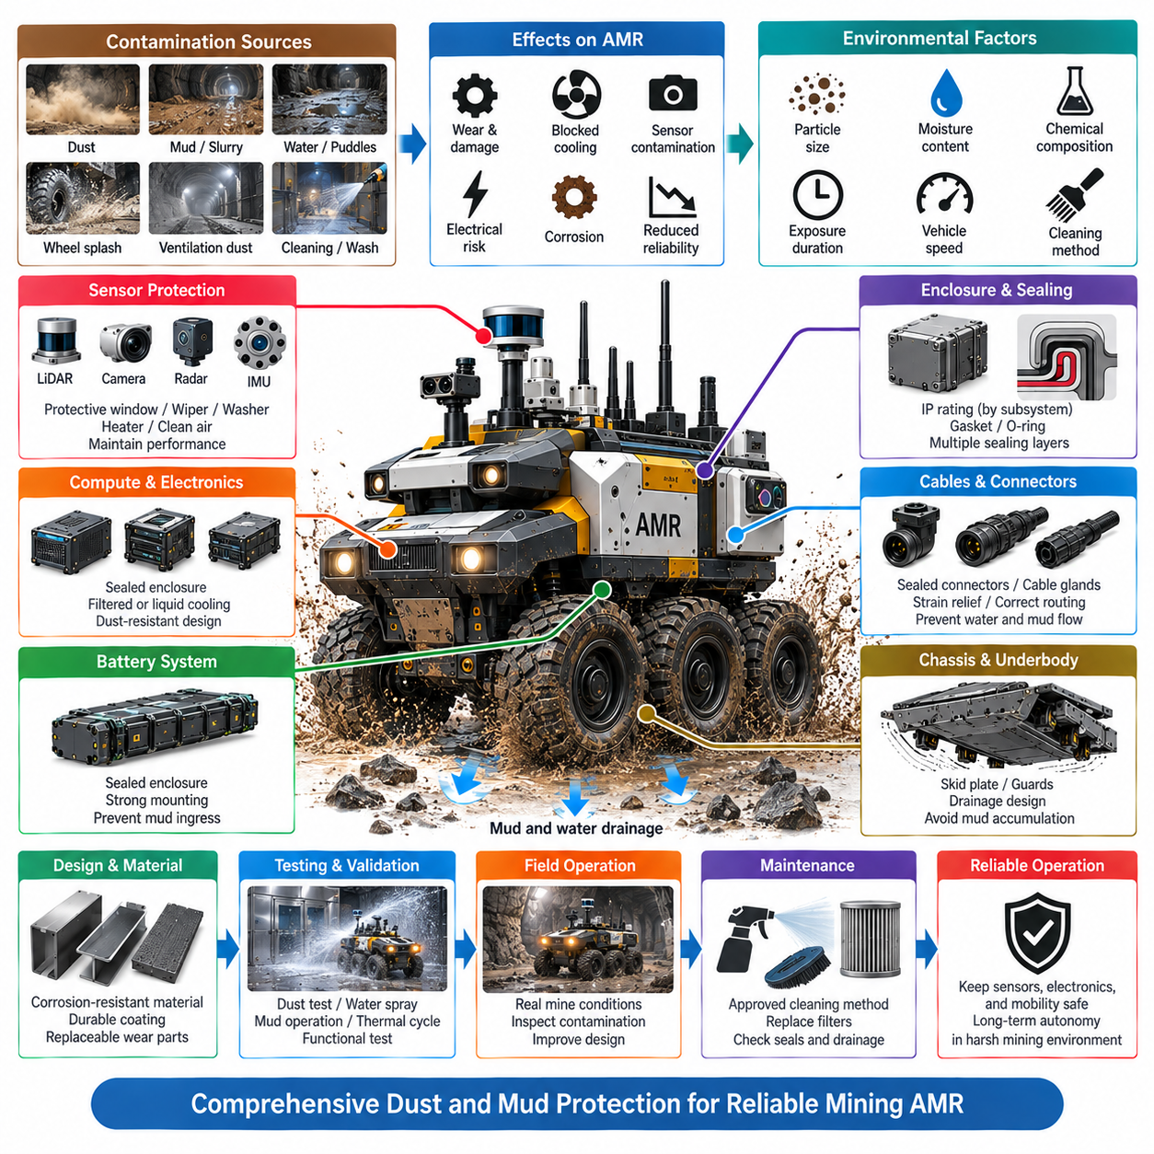
Dust and mud protection is a critical durability requirement for mining autonomous mobile robots because underground environments continuously expose vehicles to fine mineral particles, wet soil, slurry, standing water, and material thrown from rotating wheels. These contaminants can penetrate mechanical and electrical systems, obstruct cooling paths, degrade optical sensors, accelerate wear, and create conductive or corrosive deposits that progressively reduce vehicle reliability.
Protection engineering begins by identifying realistic contamination sources and exposure mechanisms throughout the mining mission. Airborne dust may enter through ventilation openings and pressure differences, while mud and water can reach the vehicle through wheel splash, puddles, drainage channels, cleaning operations, and direct contact with wet tunnel surfaces. Particle size, moisture content, chemical composition, exposure duration, vehicle speed, and cleaning practices should therefore be included in environmental requirements.
Ingress protection should be defined at subsystem level rather than assigning a single enclosure rating to the complete AMR. Battery compartments, power distribution units, compute modules, motor controllers, sensors, connectors, junction boxes, and communication equipment may require different protection levels according to location and consequence of contamination. IP ratings provide a useful design reference, but successful mining operation also depends on installation details, interfaces, aging, and maintenance conditions.
Enclosure architecture is the primary barrier against dust, mud, and water entering sensitive electronics. Covers, doors, service panels, cable penetrations, ventilation interfaces, and mechanical joints should be designed so contamination is not driven directly toward sealing surfaces. Overlapping structures, drainage paths, protected openings, appropriate gasket compression, and controlled fastening can create multiple defensive layers instead of relying on one seal to protect critical equipment.
Sealing materials must remain effective despite vibration, temperature variation, compression cycling, mineral contamination, oils, and repeated maintenance. Gaskets and O-rings can lose elasticity or become damaged when abrasive particles accumulate on sealing surfaces. Seal geometry should provide predictable compression without excessive deformation, while service procedures should require inspection and cleaning before an enclosure is closed so trapped debris does not create an unintended leakage path.
Cable entries and connectors are common contamination paths because they combine enclosure penetrations with mechanically flexible interfaces. Cable glands, connector seals, backshells, boots, and unused ports should maintain the required environmental protection under vibration and cable movement. Connector orientation should discourage water accumulation, and harness routing should prevent mud from being transported along cables toward electrical interfaces through gravity, capillary action, or repeated vehicle motion.
Mud presents additional challenges beyond simple water ingress because it can accumulate as a heavy mechanical deposit. Packed material around wheels, suspension components, steering mechanisms, brakes, actuators, and cooling surfaces can restrict movement or increase loads. Mechanical geometry should minimize pockets where slurry can collect, provide clearance for contaminated operation, and allow accumulated material to leave the vehicle naturally rather than becoming progressively compacted during repeated missions.
Dust management is especially important for cooling systems. High-performance edge computers, GPUs, motor drives, DC/DC converters, and battery systems generate heat that must be removed while environmental openings can provide direct contamination paths. Where possible, sensitive electronics should use sealed conduction-cooled or liquid-cooled architectures. If filtered airflow is necessary, filter loading, pressure drop, replacement intervals, fan degradation, and blocked-filter detection must be included in thermal design.
Perception sensors require protection without significantly degrading measurement performance. Dust films, mud splashes, water droplets, and condensation on LiDAR windows, camera lenses, radar covers, or lighting surfaces can reduce detection range and introduce false or missing observations. Sensor placement should reduce direct wheel spray and impact exposure, while protective windows, air cleaning, wipers, washers, hydrophobic surfaces, heaters, or other cleaning mechanisms may be applied according to mission severity.
Sensor contamination should also be treated as an autonomy problem rather than only a mechanical cleanliness issue. The perception system should detect abnormal signal degradation when practical and distinguish contamination from actual environmental changes. Reduced camera contrast, LiDAR return degradation, persistent occlusion, or inconsistent sensor fusion can trigger diagnostics, cleaning actions, speed reduction, sensor redundancy, mission restrictions, or transition toward an appropriate safe operating condition.
The underbody requires particularly strong protection because it experiences direct exposure to stones, slurry, standing water, and material displaced by the tires. Battery housings, traction cables, brake lines, communication harnesses, connectors, and sensors installed near the lower structure should be shielded from direct impact and splash. Skid plates, guards, protected routing corridors, recessed interfaces, and drainage features can prevent environmental exposure from becoming physical damage.
Drainage is as important as sealing because completely preventing water from reaching every external cavity is often impractical. Structural channels, equipment trays, sensor housings, and body panels should avoid geometries that retain water or mud. Drain paths should remain functional when the vehicle is parked on expected slopes, and drainage openings should be positioned so discharged contaminants do not flow onto connectors, brakes, sensors, cooling interfaces, or other vulnerable components.
Material selection and surface treatment influence long-term resistance to contamination. Abrasive mineral dust can remove coatings, while water and chemically active mine deposits may accelerate corrosion after protective surfaces are damaged. Corrosion-resistant materials, suitable coatings, protected fasteners, galvanic compatibility, and replaceable wear surfaces should therefore be considered together with sealing. Exposed interfaces should remain serviceable after prolonged contamination rather than only surviving initial qualification.
Cleaning and maintenance must be considered during product design because mining robots may require frequent removal of accumulated dust and mud. Pressure washing or aggressive cleaning can impose water loads substantially different from normal vehicle operation and may force contamination into poorly protected interfaces. Approved cleaning directions, pressure and distance limits, protected service connectors, accessible drainage, replaceable filters, and inspection points should be defined to prevent maintenance itself from damaging the AMR.
Validation should reproduce realistic combinations of dust, water, mud, vibration, temperature, and vehicle operation rather than evaluating every environmental stress independently. Dust-chamber testing, water spray, splash exposure, mud operation, thermal cycling, and contaminated durability driving can reveal leakage paths that appear only after seals and joints have aged mechanically. Functional monitoring during testing should confirm continued operation of power, communication, sensing, computing, and safety functions.
Field inspection provides essential feedback because contamination patterns are strongly influenced by actual vehicle geometry and mine conditions. Engineers should examine where mud accumulates, which seals retain abrasive particles, where water remains after operation, and which sensors require frequent cleaning. These observations can guide modifications to shields, drainage paths, sealing interfaces, sensor placement, harness routing, and maintenance intervals more effectively than theoretical enclosure analysis alone.
A robust mining AMR therefore requires dust and mud protection to be engineered as an integrated environmental architecture rather than as a collection of waterproof enclosures. Sealing, drainage, cooling, material selection, sensor cleaning, underbody protection, diagnostics, maintenance, and validation must operate together. This approach preserves electrical integrity, thermal performance, perception quality, mechanical mobility, and autonomous functionality throughout prolonged operation in contaminated underground environments.

07.05. Mining AMR Case
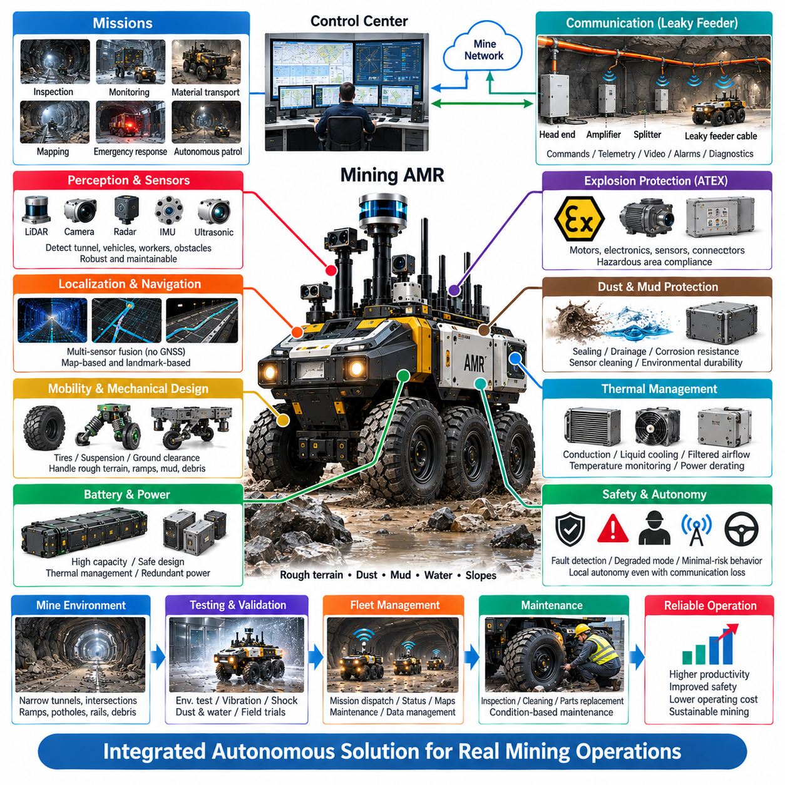
Mining autonomous mobile robots represent a specialized class of outdoor autonomous vehicle adapted for environments where conventional mobility, communication, sensing, and maintenance assumptions no longer apply. A practical mining AMR must combine rugged locomotion, autonomous navigation, hazardous-area protection, resilient communications, environmental durability, and remote supervision into one integrated platform capable of operating reliably within underground production infrastructure.
A representative mining AMR mission may include tunnel inspection, environmental monitoring, equipment surveillance, material transport, emergency reconnaissance, infrastructure mapping, and autonomous patrol. These missions frequently require the robot to travel beyond direct human visibility through narrow passages, intersections, ramps, and production areas. The vehicle must therefore maintain local autonomous capability while remaining integrated with the mine control center for mission dispatch, status reporting, alarms, and operational coordination.
The mobility platform should be designed around the terrain rather than adapted from an indoor AMR after development. Uneven rock surfaces, potholes, drainage channels, rails, debris, slopes, mud, and standing water demand appropriate ground clearance, traction, tire selection, steering geometry, suspension behavior, and structural strength. Vehicle dimensions must also remain compatible with tunnel width, turning space, equipment clearance, refuge areas, and interactions with larger mining machinery.
Localization and navigation require multiple complementary information sources because underground operation restricts or eliminates conventional GNSS availability. LiDAR, cameras, radar, IMU, wheel odometry, mapped landmarks, and infrastructure references can contribute to localization according to the mine configuration. Sensor fusion should tolerate temporary degradation of individual sensing channels and continuously estimate localization confidence so that the autonomy system can modify speed or behavior when navigation certainty decreases.
Perception architecture must recognize both static mine geometry and dynamic operational hazards. The AMR may encounter workers, vehicles, machinery, fallen rocks, temporary barriers, cables, water, dust clouds, and unexpected changes to previously mapped tunnels. LiDAR, cameras, radar, ultrasonic sensing, and appropriate environmental sensors can provide complementary observations. Sensor placement must simultaneously support coverage, calibration stability, impact protection, contamination resistance, and maintainability.
Hazardous-area operation introduces requirements extending across the complete electrical architecture. Motors, batteries, power electronics, computing equipment, sensors, connectors, communication devices, and auxiliary payloads must be evaluated as potential ignition sources. Where ATEX or equivalent explosion-protection requirements apply, hazardous-zone assumptions, equipment categories, protection concepts, temperature limitations, installation details, and maintenance controls must be incorporated from the beginning rather than added after prototype completion.
Communication can be supported by a leaky feeder network following the underground tunnel structure. The radiating cable acts as a distributed antenna, while head-end equipment, amplifiers, splitters, branches, and termination devices extend connectivity through production levels and intersections. The AMR can use this infrastructure for commands, telemetry, alarms, location information, diagnostics, and selected data services while complementary networks provide additional bandwidth or redundancy where required.
Communication loss must not automatically imply loss of vehicle safety. The onboard autonomy and safety architecture should define behavior for degraded bandwidth, high latency, intermittent links, and complete disconnection. Depending on mission conditions, the AMR may continue within a restricted autonomous envelope, reduce speed, stop at a designated safe location, return toward known communication coverage, or enter a minimal-risk condition. Essential decisions should therefore remain executable locally without continuous cloud connectivity.
Mechanical durability is central to the mining AMR case because repeated terrain excitation propagates through every subsystem. Shock and vibration can fatigue the chassis, loosen fasteners, damage battery connections, cause connector fretting, stress circuit boards, and shift sensor calibration. Accelerometer measurements, modal analysis, finite element simulation, laboratory vibration testing, mechanical shock testing, and representative mine-route endurance testing should be combined to establish and verify realistic durability requirements.
The battery and power architecture must simultaneously support mission endurance, traction peaks, computing loads, sensor operation, communication equipment, and safety functions. Mechanical retention, electrical protection, temperature monitoring, contactor control, isolation supervision, and controlled shutdown should protect the energy system during normal and abnormal operation. Power distribution should prioritize safety-critical loads so that a failure in a high-power payload or auxiliary subsystem does not unnecessarily disable essential vehicle functions.
Dust, mud, slurry, and water create another system-level engineering challenge. Environmental protection cannot be achieved solely by specifying sealed electronic boxes because contamination also affects cooling, sensors, connectors, moving mechanisms, brakes, harnesses, and structural cavities. Enclosure sealing, drainage, guarded cable routing, protected underbody interfaces, corrosion-resistant materials, sensor cleaning, and contamination-aware maintenance should therefore form a coordinated environmental architecture.
Thermal management becomes difficult when high-performance computing must coexist with sealed or explosion-protected structures. Edge computers, GPUs, motor drives, converters, and batteries can generate substantial heat while open airflow may introduce mineral dust into sensitive equipment. Conduction cooling, liquid cooling, heat exchangers, protected airflow, temperature monitoring, and power derating can be combined according to platform requirements. Thermal performance must be validated under contaminated and degraded cooling conditions.
The safety architecture should supervise autonomy, propulsion, braking, communication, power, sensing, thermal conditions, and hazardous-environment indicators. Faults should be classified according to their effect on continued operation, and the vehicle should transition through controlled degraded states rather than relying only on emergency shutdown. A minimal-risk strategy must consider the surrounding tunnel because stopping immediately at an intersection, ramp, evacuation path, or active equipment route may itself create an operational hazard.
Fleet integration transforms individual mining robots into part of the mine operating system. A central platform can manage mission dispatch, robot status, route coordination, maintenance information, alarms, maps, and historical operational data. Multiple AMRs should share relevant infrastructure information while preserving local collision avoidance and safety authority. Changes to tunnel availability, communication coverage, restricted zones, or operational priorities should be distributed through controlled and traceable configuration updates.
Maintenance engineering is particularly important because contamination, vibration, and harsh operating cycles gradually change vehicle condition. Inspection should cover seals, cable glands, connectors, fasteners, sensor windows, cooling interfaces, battery mounts, tires, brakes, structural joints, and protective guards. Onboard diagnostics can accumulate shock exposure, temperature history, communication quality, contamination indicators, operating hours, and fault events to support condition-based maintenance instead of relying only on fixed service intervals.
Validation should progress from subsystem tests to integrated vehicle operation under representative mine conditions. Environmental, electrical, thermal, communication, shock, vibration, contamination, braking, perception, navigation, and fault-response testing must ultimately converge at vehicle level. Field trials should include realistic routes, communication shadows, dust and mud exposure, obstacles, slopes, intersections, changing maps, and degraded sensors so that interactions between independently designed protection mechanisms can be evaluated.
A successful mining AMR case therefore depends on integration rather than any single autonomous-driving technology. Explosion protection, leaky-feeder communication, shock and vibration durability, dust and mud protection, perception, localization, power, thermal management, functional safety, fleet supervision, and maintenance must reinforce one another. When these elements are engineered as a unified system, the AMR can become a dependable autonomous asset for sustained operation in demanding underground mining environments.

