Volume 18. Cargo UAV Architecture

Chapter 01. UAV Fundamentals

01.01. Fixed Wing/Rotary/Tiltrotor
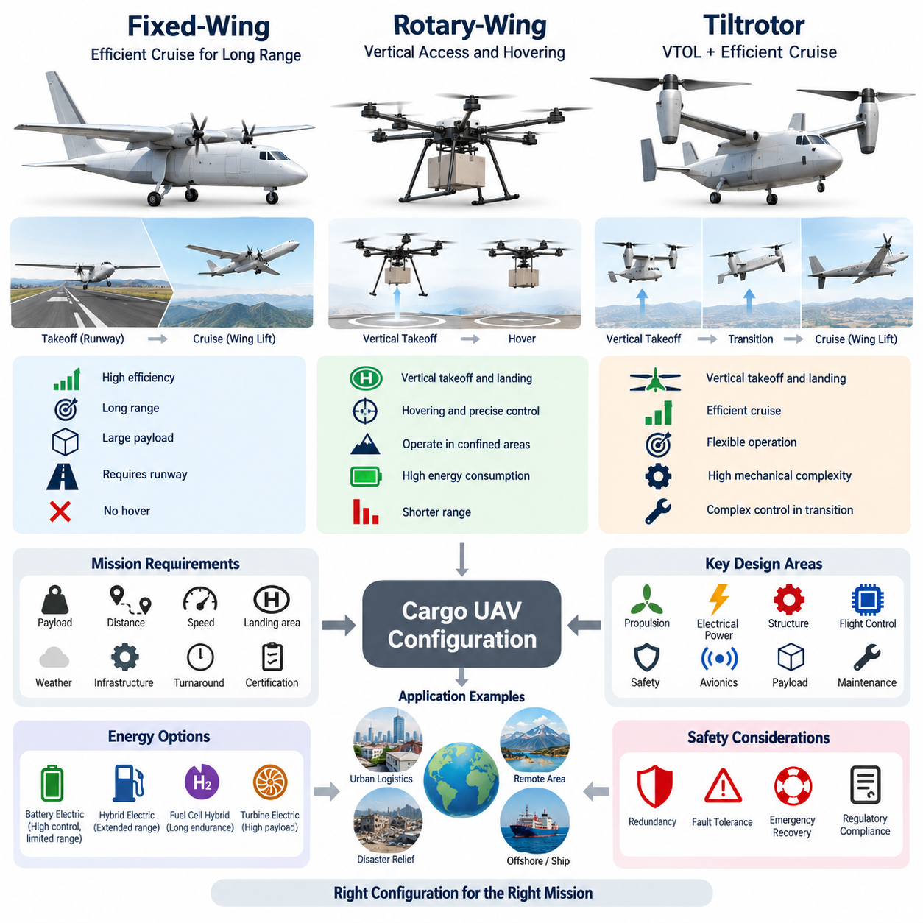
Fixed-wing, rotary-wing, and tiltrotor aircraft represent three fundamental aerodynamic architectures for unmanned aerial vehicles. Their differences are not merely geometric; they determine how lift is generated, how propulsion energy is consumed, how the aircraft takes off and lands, and how efficiently it transports cargo. For cargo UAV architecture, selecting among these configurations is therefore one of the earliest system-level decisions because it influences propulsion, electrical power, flight control, structural design, payload capacity, range, and operational infrastructure.
A fixed-wing UAV generates most of its lift aerodynamically as air flows over the wings during forward flight. Propellers or turbine engines primarily provide forward thrust rather than continuously supporting the aircraft's full weight. Once sufficient airspeed is established, the wing produces lift efficiently, allowing the aircraft to transport relatively large payloads over long distances with lower energy consumption per kilometer than hovering aircraft. This characteristic makes fixed-wing architecture particularly attractive for regional and long-range cargo transportation.
The major limitation of a conventional fixed-wing configuration is its dependence on forward velocity for lift. Takeoff normally requires a runway, launcher, or another mechanism that accelerates the aircraft to flying speed, while landing requires sufficient space for controlled deceleration. These infrastructure requirements can restrict operation in urban logistics centers, remote sites, islands, disaster zones, and locations without prepared runways. Short takeoff and landing technologies can reduce this limitation, but they do not provide the unrestricted vertical access available from rotorcraft.
A rotary-wing UAV produces lift directly through rotating blades. Multirotors, helicopters, and related configurations can therefore take off vertically, hover over a fixed position, maneuver at very low speeds, and land within compact areas. These characteristics provide exceptional operational flexibility. A cargo UAV can approach a warehouse, ship, construction site, mountain area, or emergency location without requiring a runway, making rotary-wing architecture particularly valuable when point-to-point accessibility is more important than maximum transportation efficiency.
Hovering, however, imposes a significant energy requirement because the propulsion system must continuously generate thrust approximately equal to aircraft weight. As gross weight and payload increase, rotor diameter, installed propulsion power, structural strength, thermal management, and energy-storage requirements become increasingly important. A heavy cargo multirotor may therefore achieve excellent vertical mobility but substantially shorter range or endurance than a comparable fixed-wing aircraft. This tradeoff becomes critical when scaling cargo UAVs from small delivery platforms toward multi-ton payload classes.
Rotor architecture also influences control-system design. Multirotors commonly control attitude and trajectory by changing thrust among distributed propulsion units, whereas conventional helicopters use collective and cyclic blade-pitch mechanisms together with anti-torque control. Distributed electric propulsion can provide mechanical simplification and propulsion redundancy, but it introduces electrical distribution, inverter, motor synchronization, battery management, fault isolation, and thermal challenges. Consequently, rotorcraft architecture must be evaluated as an integrated propulsion, electrical, structural, and flight-control system.
Tiltrotor architecture attempts to combine vertical takeoff and landing with efficient wing-borne cruise. During takeoff and landing, the rotors are oriented primarily to generate vertical thrust, allowing the aircraft to operate similarly to a rotorcraft. After gaining altitude and accelerating, the propulsion units tilt toward the horizontal direction. Increasing airspeed transfers the primary lift-generation function from the rotors to the wings, enabling the aircraft to enter an airplane-like cruise condition with substantially improved range and aerodynamic efficiency.
The transition between vertical flight and wing-borne cruise is the defining technical challenge of a tiltrotor. During this phase, lift, thrust, aerodynamic control surfaces, rotor forces, aircraft attitude, and airspeed interact continuously. The flight-control computer must coordinate propulsion-vector angle, rotor thrust, pitch and roll control, and aerodynamic surfaces while maintaining adequate control authority throughout the conversion corridor. Sensor accuracy, actuator response, control-law robustness, and fault management therefore become especially important for autonomous cargo operations.
Tiltrotor systems also introduce mechanical and structural complexity. Tilting nacelles, actuators, bearings, locking mechanisms, power cables, communication interfaces, and sometimes rotating shafts must operate reliably under vibration, aerodynamic loading, repeated conversion cycles, and environmental exposure. Electric tiltrotor configurations can eliminate some traditional transmission components, but high-power electrical routing through moving propulsion assemblies remains challenging. Mechanical complexity must therefore be balanced against the operational value gained from combining VTOL capability with efficient cruise.
A closely related architecture is lift-plus-cruise, in which separate propulsion systems perform vertical lift and forward cruise. Dedicated vertical rotors provide takeoff and landing, while one or more cruise propellers generate forward thrust after the wing becomes aerodynamically effective. This configuration avoids physically tilting major propulsion units and can simplify transition mechanisms and control allocation. Its disadvantage is that the vertical-lift propulsion system may become largely inactive during cruise, creating mass and aerodynamic drag that do not directly contribute to long-range flight.
For cargo transportation, architecture selection should therefore begin with the mission rather than with a preferred aircraft shape. Required payload, route distance, cruise speed, landing-zone dimensions, available infrastructure, weather conditions, turnaround time, energy source, maintenance capability, and certification requirements must be considered together. A fixed-wing aircraft may dominate when long range and transportation efficiency are primary requirements, while rotary-wing systems are attractive for short-range operations demanding precise vertical access.
Tiltrotor and other VTOL-wing configurations become particularly valuable when both requirements exist simultaneously. A logistics network may require an aircraft to depart from a compact distribution center, climb vertically, travel tens or hundreds of kilometers efficiently, and land at another site without conventional runway infrastructure. In this scenario, the additional propulsion and flight-control complexity may be justified because the architecture removes a major ground-infrastructure constraint while retaining much of the aerodynamic advantage of fixed-wing cruise.
Payload scaling changes these tradeoffs substantially. At small UAV scale, multiple electric rotors can provide a practical and relatively simple VTOL solution. At multi-ton cargo scale, however, disk loading, propulsion power, structural mass, stored energy, thermal rejection, rotor dimensions, and emergency landing capability become dominant design drivers. Pure hover-oriented architecture becomes progressively demanding, increasing the value of transferring lift generation to aerodynamic wings during the majority of the mission.
The propulsion architecture must consequently be evaluated together with the energy architecture. Pure battery-electric propulsion offers high controllability, distributed installation, rapid motor response, and relatively simple mechanical power delivery, but stored energy per unit mass limits long-range heavy-cargo applications. Hybrid-electric, fuel-cell hybrid, and turbine-electric architectures can extend endurance and range while retaining electrically controlled distributed propulsion. This relationship becomes increasingly important as cargo UAV development progresses from 2.5-ton toward 5-ton and 10-ton classes.
Safety architecture also differs among the three configurations. A fixed-wing aircraft can potentially retain aerodynamic glide capability following certain propulsion failures, although safe recovery depends on altitude, configuration, terrain, and control availability. Rotary-wing aircraft depend more directly on continued rotor lift, requiring carefully designed propulsion redundancy or other emergency strategies. Tiltrotors must address failures in hover, transition, and cruise, meaning that fault-tolerant control must consider several fundamentally different aerodynamic operating regimes.
From an avionics perspective, increasingly complex aircraft architectures require stronger integration among flight control, navigation, propulsion control, power management, health monitoring, and communication systems. The flight-control computer must understand not only aircraft attitude and trajectory but also propulsion availability and configuration state. In a tiltrotor or distributed-propulsion cargo UAV, actuator position, rotor speed, motor temperature, inverter status, electrical-bus condition, battery or generator state, and aerodynamic state can all become safety-critical inputs.
Cargo itself further affects configuration selection because payload mass and center-of-gravity variation directly influence aircraft stability and control authority. Heavy freight can shift the center of gravity as different containers are loaded, while structural load paths must transfer cargo forces safely into the airframe during takeoff, maneuvering, turbulence, transition, and landing. The aircraft architecture must therefore be developed together with cargo restraint, weight sensing, center-of-gravity monitoring, and payload-interface systems rather than treating the cargo bay as an independent subsystem.
No single configuration is universally superior. Fixed-wing architecture provides strong cruise efficiency and range, rotary-wing architecture provides superior vertical accessibility and hovering capability, and tiltrotor architecture combines characteristics of both at the cost of greater system complexity. For cargo UAV engineering, the correct choice emerges from quantitative mission analysis followed by integrated aerodynamic, propulsion, electrical, structural, avionics, safety, and operational trade studies.
These three architectures can therefore be viewed as different solutions to the fundamental problem of allocating lift and thrust throughout a mission. Fixed-wing aircraft separate wing-generated lift from propulsion-generated forward thrust, rotary-wing aircraft use rotor thrust to support and maneuver the vehicle, and tiltrotors dynamically redistribute these functions between rotor-borne and wing-borne flight. Understanding this distinction establishes the foundation for subsequent analysis of thrust-to-weight ratio, battery-versus-fuel tradeoffs, structural load paths, and eVTOL architecture within the cargo UAV design process.

01.02. Thrust-Weight Calculation
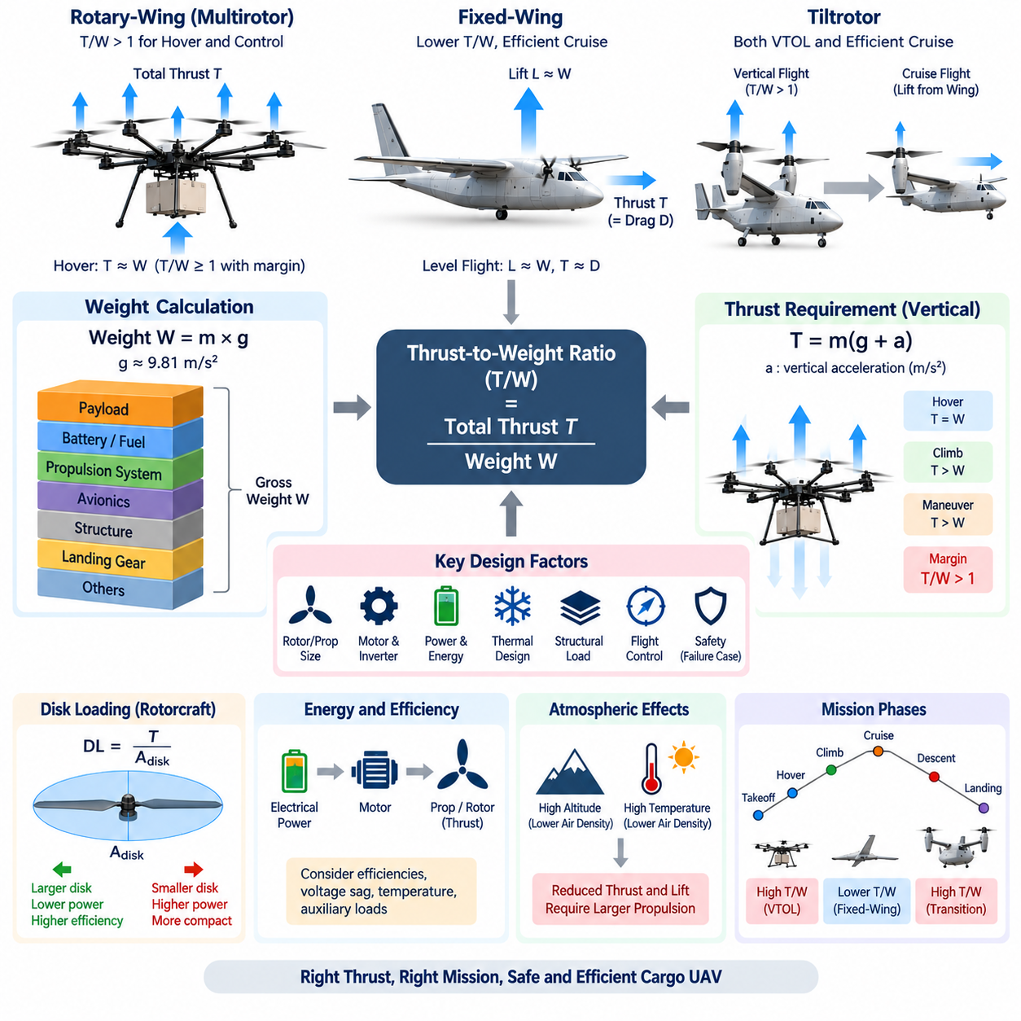
Thrust-to-weight calculation is one of the most fundamental sizing activities in cargo UAV design because it determines whether the propulsion system can generate sufficient force to support, accelerate, climb, and maneuver the aircraft. The relationship connects aircraft gross weight directly to required propulsion capability and therefore influences motor or engine selection, propeller and rotor sizing, electrical power, energy storage, thermal design, structural loads, and flight-control authority.
Aircraft weight is the gravitational force acting on the total vehicle mass. If the maximum takeoff mass is \(m\), the corresponding weight is expressed as \(W = mg\), where \(g\) is gravitational acceleration, approximately 9.81 m/s² near sea level. A 1,000 kg aircraft therefore has a weight of approximately 9,810 N. For cargo UAV engineering, maximum takeoff weight must include the airframe, propulsion system, batteries or fuel, avionics, landing system, cargo, wiring, cooling equipment, and all operational equipment.
Thrust is the force generated by the propulsion system to move or support the aircraft. In a multirotor or vertical takeoff aircraft, total rotor thrust acts primarily against gravity during hover. Under ideal stationary hover conditions, total thrust must equal aircraft weight, giving \(T = W\) and a thrust-to-weight ratio of \(T/W = 1.0\). This represents only the theoretical equilibrium condition and does not provide sufficient margin for climbing, maneuvering, disturbances, component degradation, or safe operation.
Practical VTOL aircraft therefore require a thrust-to-weight ratio greater than one. If an aircraft weighs 9,810 N and its propulsion system can generate 14,715 N of maximum thrust, its maximum thrust-to-weight ratio is 1.5. This means that maximum available thrust is 50 percent greater than the static weight. The additional capability provides control authority and climb performance, although actual usable margin depends on aerodynamic losses, operating conditions, propulsion limits, and flight-control constraints.
For a distributed electric propulsion UAV with multiple rotors, total thrust is the sum of the thrust generated by individual propulsion units. If eight identical rotors each produce 2,000 N, the theoretical total thrust is 16,000 N. For an aircraft weighing 10,000 N, the resulting thrust-to-weight ratio is 1.6. This simple calculation provides an initial sizing reference, but engineering analysis must also consider unequal loading, installation effects, rotor interference, voltage variation, motor temperature, and propulsion-unit failure.
Hover thrust per rotor can initially be estimated by dividing aircraft weight by the number of lift rotors. An eight-rotor aircraft weighing 16,000 N requires approximately 2,000 N per rotor in ideal hover. However, selecting a propulsion unit whose maximum thrust is only 2,000 N would leave essentially no reserve. Each motor, inverter, rotor, and electrical branch must therefore be sized with adequate operational margin while avoiding excessive mass caused by unnecessary oversizing.
The required margin is closely related to flight-control authority. A multirotor changes roll, pitch, yaw, and vertical acceleration by increasing thrust from some rotors while reducing it from others. If all propulsion units are already operating near maximum thrust merely to hover, the controller has little remaining capability to reject wind disturbances or command rapid maneuvers. Hover operation should therefore occur sufficiently below maximum propulsion output to preserve differential thrust capability.
Vertical climb introduces an additional thrust requirement because the aircraft must both oppose gravity and produce upward acceleration. From Newton's second law, the simplified vertical relationship can be written as \(T-W=ma\), giving \(T=m(g+a)\). If a 1,000 kg aircraft must accelerate upward at 2 m/s², the ideal instantaneous thrust requirement becomes approximately 11,810 N before aerodynamic and propulsion losses are considered. Desired climb performance therefore directly affects propulsion sizing.
Descending flight must also be analyzed carefully. Although average required thrust may decrease during descent, rotorcraft can encounter complex aerodynamic conditions involving induced flow, rotor wake interaction, or reduced control effectiveness. Heavy cargo UAVs should not be sized solely from steady hover and maximum climb calculations. The propulsion envelope must cover takeoff, hover, climb, cruise transition, descent, landing, maneuvering, wind rejection, and abnormal operating conditions.
Fixed-wing aircraft use thrust differently because aerodynamic wings support most of the aircraft weight during normal cruise. Consequently, cruise thrust does not need to equal weight. Instead, thrust primarily balances aerodynamic drag. During steady level flight, lift approximately equals weight and thrust approximately equals drag. The thrust-to-weight ratio of a fixed-wing cargo UAV can therefore be significantly lower than that of a VTOL aircraft while still supporting efficient long-range operation.
For fixed-wing design, required thrust increases during takeoff, climb, acceleration, and high-drag operating conditions. The designer must evaluate whether available propulsion can provide the required runway performance, climb gradient, cruise speed, and operational ceiling. Wing loading, lift-to-drag ratio, propeller efficiency, aircraft drag, atmospheric density, and engine or motor characteristics therefore become closely coupled with thrust-to-weight sizing rather than relying on hover requirements.
Tiltrotor aircraft require both rotorcraft and fixed-wing thrust analyses because propulsion performs different functions across the mission. During vertical takeoff, the rotors must directly support aircraft weight, making the requirement similar to a rotary-wing UAV. During transition, thrust is progressively redirected while aerodynamic wing lift increases. In cruise, propulsion mainly overcomes drag. The propulsion system must consequently satisfy the most demanding condition across hover, transition, climb, cruise, and landing.
Transition can become a critical sizing case because the aircraft may temporarily receive only partial lift from the wings while rotor thrust is no longer entirely vertical. If total rotor thrust is \(T\) and the propulsion vector is tilted by an angle, only the vertical component contributes directly to supporting weight. The flight-control and aerodynamic design must ensure that the combination of rotor vertical thrust and wing-generated lift remains sufficient throughout the complete conversion corridor.
Propeller and rotor diameter strongly affect the power required to generate thrust. Producing a given lift force with a larger total rotor disk area generally reduces induced power because a larger mass of air can be accelerated by a smaller velocity change. This is one reason large rotors can improve hover efficiency. However, increasing rotor diameter introduces packaging, structural, ground-clearance, blade-tip-speed, vibration, transportation, and rotor-interference constraints that become increasingly important for heavy cargo aircraft.
Disk loading provides another useful measure for rotorcraft sizing and is defined as aircraft weight or rotor thrust divided by total rotor disk area. Higher disk loading allows more compact rotors but generally requires greater induced power during hover. Lower disk loading can improve hover efficiency but requires larger rotor area. Cargo UAV design therefore involves a tradeoff among vehicle dimensions, propulsion efficiency, rotor count, rotor diameter, structural mass, noise, and available landing-zone dimensions.
Electrical propulsion sizing must translate required thrust into shaft power and ultimately electrical power. Motor output depends on rotor aerodynamic characteristics, rotational speed, torque, propeller efficiency, and operating point. Electrical input must additionally account for motor and inverter efficiency, cable losses, battery voltage variation, and auxiliary loads. Consequently, thrust calculations should eventually be connected to a complete power-flow model rather than treating maximum motor power as an independent specification.
Battery state of charge and voltage sag can reduce available propulsion power during demanding flight phases. A propulsion system that satisfies the required thrust-to-weight ratio with a fully charged battery may fail to provide the same margin near the end of a mission. Temperature can further affect batteries, motors, and inverters. Propulsion capability should therefore be evaluated at representative worst-case voltage, temperature, altitude, payload, and component-aging conditions rather than only at nominal laboratory conditions.
Atmospheric density is especially important because propellers, rotors, and wings interact directly with surrounding air. Higher altitude and higher temperature reduce air density, potentially decreasing rotor thrust and aerodynamic lift for a given operating condition. Heavy cargo UAVs intended for mountainous regions or hot environments must therefore include density-altitude effects in propulsion sizing. A vehicle capable of safe hover at sea level may have significantly less thrust margin under high-and-hot conditions.
Failure conditions can impose even more demanding requirements on distributed propulsion systems. If a multi-rotor aircraft is expected to tolerate one propulsion-unit failure, the remaining units must generate sufficient thrust while preserving controllability. For an eight-rotor system, losing one motor does not simply reduce thrust by one eighth; redistribution of thrust may also be constrained by vehicle geometry and yaw, roll, or pitch moments. Fault-tolerant sizing must therefore be performed together with control-allocation analysis.
Cargo mass variation creates another important design case. A vehicle may operate with no cargo during repositioning and at maximum payload during revenue missions. The resulting change in gross weight modifies hover throttle, acceleration, climb capability, energy consumption, and control response. Cargo loading may also shift the center of gravity, causing individual rotors or propulsion units to carry unequal loads. Thrust analysis should therefore consider both total weight and propulsion-force distribution around the aircraft center of gravity.
The initial thrust-to-weight calculation is consequently simple, but reliable cargo UAV design requires progressively deeper analysis. Starting from \(W=mg\) and \(T/W\), engineers can establish basic propulsion capacity, then incorporate climb acceleration, rotor distribution, aerodynamic efficiency, transition conditions, atmospheric effects, electrical losses, thermal limits, payload variation, and failure cases. Each refinement converts a basic force ratio into a realistic propulsion-system requirement.
For multi-ton cargo UAVs, this calculation becomes a system architecture driver rather than merely a motor-selection exercise. Increasing payload requires additional thrust, but larger motors, rotors, batteries, generators, cooling systems, and structures themselves increase aircraft weight, which again increases required thrust. This recursive relationship creates a mass-growth loop that must be resolved through iterative aircraft sizing and multidisciplinary optimization.
A robust design therefore seeks sufficient thrust margin without excessive propulsion oversizing. Too little margin compromises climb performance, maneuverability, fault tolerance, and safety, while excessive margin increases propulsion mass, structural loads, electrical capacity, cooling requirements, and cost. Thrust-to-weight calculation provides the quantitative foundation for balancing these competing requirements and connects directly to subsequent battery-versus-fuel tradeoffs, structural load-path design, and overall eVTOL architecture selection within the cargo UAV development process.

01.03. Battery vs Fuel Tradeoff
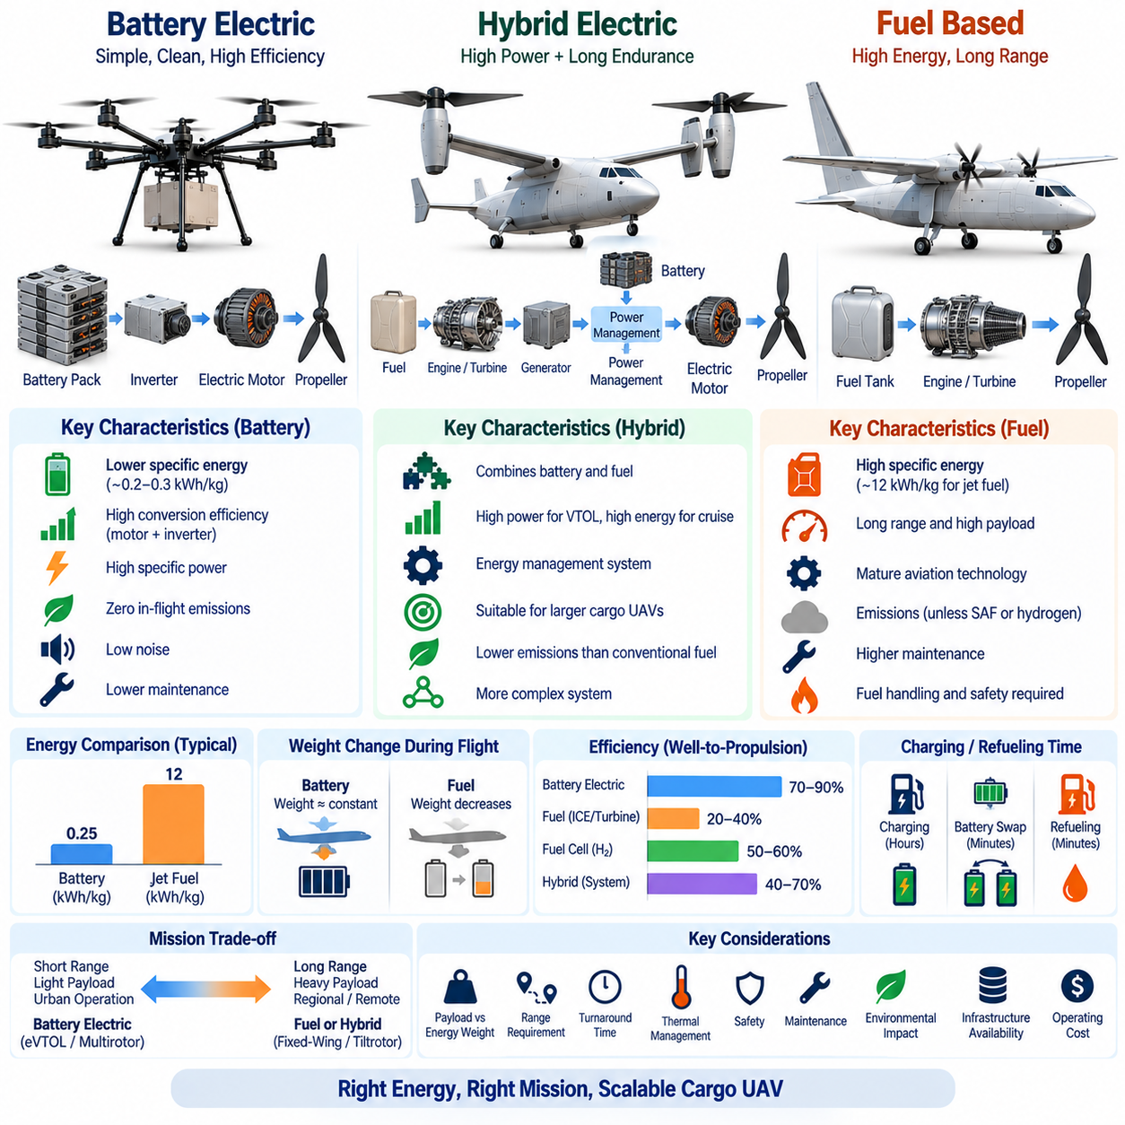
Battery and fuel represent fundamentally different approaches to storing energy for cargo UAV propulsion. Battery-electric systems store electrical energy directly and deliver it to motors through power electronics, while fuel-based systems store chemical energy that must be converted through an engine, turbine, fuel cell, or generator. The choice affects aircraft mass, range, payload capacity, propulsion architecture, thermal management, refueling or charging time, maintenance, safety, and operating infrastructure.
The central engineering difference is specific energy, meaning the amount of stored energy available per unit mass. Modern rechargeable batteries provide far less stored energy per kilogram than hydrocarbon fuels at the storage-medium level. Fuel therefore offers a major advantage when an aircraft must carry large payloads over long distances. However, comparing storage media alone is insufficient because the complete propulsion chain determines how much of that stored energy is converted into useful propulsive work.
Battery-electric propulsion can achieve high conversion efficiency because electrical energy passes through an inverter and electric motor with relatively low losses. Electric motors also provide rapid torque response, precise speed control, distributed installation, and comparatively simple mechanical integration. These properties are particularly valuable for multirotor and eVTOL aircraft, where several propulsion units must continuously coordinate thrust for attitude control, hovering, transition, and fault management.
Fuel-based propulsion contains more conversion stages and may have lower overall efficiency, but the much higher specific energy of the fuel can compensate for these losses in long-range missions. Internal-combustion engines and turbines convert chemical energy into shaft power, while turbine-electric or engine-generator architectures convert mechanical power again into electrical power. The additional equipment adds mass and complexity, yet the resulting aircraft can carry substantially more usable mission energy than a battery-only design of similar takeoff mass.
Battery mass remains nearly constant throughout a flight because a discharged battery weighs essentially the same as a charged battery. This characteristic simplifies some mass-property calculations but creates an important aircraft-level disadvantage: energy consumed during flight does not significantly reduce vehicle weight. A fuel-powered aircraft, in contrast, becomes lighter as fuel is consumed, reducing the weight that must be supported during later portions of the mission and potentially improving cruise and landing performance.
For cargo UAVs, the energy-storage system competes directly with payload for allowable takeoff mass. Increasing battery capacity extends endurance but simultaneously adds battery mass, which increases required lift and propulsion energy. Beyond a certain point, adding batteries can produce diminishing improvements in range because part of the additional stored energy is consumed merely to transport the added batteries. This mass-energy feedback is particularly severe for aircraft that spend significant time in hover.
Hovering magnifies the battery-versus-fuel tradeoff because the propulsion system must continuously generate lift approximately equal to aircraft weight. A heavy battery pack therefore increases both stored energy and the power required to keep that additional mass airborne. Battery-electric VTOL aircraft can be highly effective for relatively short missions, but long-duration hovering or long-range heavy-cargo transportation can drive battery mass to levels that significantly reduce economically useful payload.
Fixed-wing aircraft experience a different balance because aerodynamic wings support the vehicle efficiently during cruise. Battery-electric fixed-wing UAVs can therefore achieve considerably longer endurance than comparable battery multirotors for the same stored energy. Nevertheless, as route distance, aircraft mass, and payload increase, battery specific energy remains a major limitation. Fuel or hybrid propulsion becomes increasingly attractive when mission requirements move toward regional and long-range cargo transportation.
Tiltrotor and other winged VTOL configurations combine both energy-intensive and energy-efficient flight regimes. Vertical takeoff and landing require high propulsion power, while wing-borne cruise can substantially reduce continuous power demand. Battery systems can provide the high transient power needed for VTOL, whereas fuel-based energy sources can provide sustained mission energy. This complementary behavior creates a strong technical motivation for hybrid-electric architectures in larger cargo UAVs.
Specific power must be considered separately from specific energy. An energy source may store substantial total energy but still be unable to deliver the instantaneous power required for vertical takeoff, rapid climb, or emergency maneuvering. Batteries generally provide excellent transient electrical power, while some fuel cells are better suited to sustained power generation. Hybrid systems can therefore use batteries as power buffers while another energy source supplies average cruise energy and recharges or supports the electrical bus.
Charging and refueling time also influence operational productivity. Battery charging can require significant ground time unless high-power charging, battery swapping, or modular packs are used. Fuel can usually be replenished more rapidly, allowing high-utilization cargo aircraft to return to service quickly. However, fuel requires storage, transportation, handling, fire protection, and appropriate ground infrastructure. The preferred solution therefore depends not only on aircraft efficiency but also on the logistics network supporting the fleet.
Battery swapping can reduce turnaround time by replacing depleted packs with charged units, but it introduces additional requirements for mechanical interfaces, high-current connectors, automated locking, battery identification, state-of-health tracking, and inventory management. Large cargo UAV batteries can also become extremely heavy, making manual replacement impractical. Automated handling equipment may therefore become part of the ground infrastructure when battery swapping is applied to high-capacity aircraft.
Thermal management differs significantly between energy architectures. Batteries generate heat through internal resistance, especially during high-power takeoff, climb, fast charging, and repeated mission cycles. Motors and inverters also require cooling. Fuel engines and turbines operate at much higher temperatures and require exhaust management, lubrication, cooling, fire protection, and separation from sensitive electronics or cargo. Hybrid aircraft may require both thermal domains to coexist within a tightly integrated vehicle.
Safety must be evaluated at the complete system level rather than by assuming that one energy source is inherently safe. Battery systems must address cell failure, overcharge, short circuits, thermal propagation, crash damage, and high-voltage isolation. Fuel systems must manage leakage, ignition, fire, pressure, ventilation, and crashworthiness. Hybrid systems introduce interactions between electrical and fuel hazards, requiring coordinated detection, isolation, containment, emergency shutdown, and health-monitoring strategies.
Maintenance requirements also differ. Electric propulsion contains fewer moving mechanical components and can reduce routine servicing compared with combustion-based propulsion. Motors and power electronics are well suited to condition monitoring through current, voltage, temperature, vibration, and insulation measurements. Engines and turbines introduce additional rotating components, lubrication systems, fuel systems, filters, and scheduled maintenance, but their established aviation heritage can provide advantages for long-duration and high-energy missions.
Environmental performance depends on the complete energy lifecycle. Battery-electric aircraft produce no local combustion emissions during flight and can reduce noise and local air pollution, which is valuable for urban logistics. Their total environmental impact depends on electricity generation, battery manufacturing, lifetime, and recycling. Fuel-based aircraft produce operational emissions unless low-carbon fuels are used, while hydrogen and fuel-cell systems introduce separate production, storage, transport, and infrastructure considerations.
Fuel cells provide an intermediate architecture between conventional fuel combustion and battery-electric propulsion. Hydrogen stores energy chemically, while a fuel cell converts that energy directly into electricity for electric motors. This allows the aircraft to retain many advantages of electric propulsion while potentially increasing endurance beyond battery-only systems. However, hydrogen storage volume, tank mass, pressure or cryogenic requirements, infrastructure, and system integration can offset part of the theoretical energy advantage.
Hybrid-electric propulsion combines two or more energy sources to exploit complementary characteristics. A battery can handle takeoff peaks and rapid load changes, while an engine-generator, turbine-generator, or fuel-cell system supplies sustained cruise power. An energy management system determines how power is shared according to flight phase, state of charge, component temperature, efficiency, reserve requirements, and failure conditions. The quality of this control strategy directly affects range, component life, and safety.
Series-hybrid architectures generate electricity centrally and distribute it to electric propulsion motors. This arrangement enables distributed electric propulsion without requiring mechanical shafts to connect the prime mover to every propulsor. It can simplify propulsion placement and control while allowing the generator to operate near efficient conditions. The disadvantages include generator, converter, cabling, and cooling mass, together with energy losses introduced by each conversion stage.
Energy reserves are particularly important in cargo aviation. The aircraft cannot be designed to consume all available battery energy or fuel during the nominal route. Reserve energy is required for wind, route deviation, holding, aborted landing, repeated approach, diversion, battery degradation, and unexpected operational conditions. Therefore, usable mission energy is smaller than nominal stored energy, and reserve policy can materially change the apparent range advantage of a particular architecture.
As payload increases toward multi-ton classes, the battery-versus-fuel decision becomes increasingly connected to overall aircraft architecture. A 2.5-ton-class cargo UAV may use substantial electrification for short or regional missions, while larger 5-ton and 10-ton systems place greater emphasis on extended range, high mission energy, and rapid turnaround. This progression explains why the broader cargo UAV structure considers pure-electric, hybrid-electric, and turbine-electric propulsion across different aircraft scales.
The correct comparison must therefore be performed at mission level rather than by comparing battery watt-hours per kilogram directly with fuel energy density. Engineers must include storage tanks or battery enclosures, motors, engines, generators, inverters, cooling systems, wiring, fuel delivery, structural reinforcement, reserve energy, conversion efficiency, and changing aircraft mass. Only the complete installed system reveals the actual payload-range capability of the aircraft.
Battery and fuel should ultimately be viewed as architectural variables within a larger energy-management problem. Battery-electric propulsion offers simplicity, controllability, high conversion efficiency, and strong compatibility with distributed propulsion, while fuel provides superior stored energy for long-range and heavy-payload missions. Hybrid architectures occupy the space between them by combining high electrical power capability with higher mission energy, making energy-source selection a central driver of scalable cargo UAV design.

01.04. UAV Load Path Structure
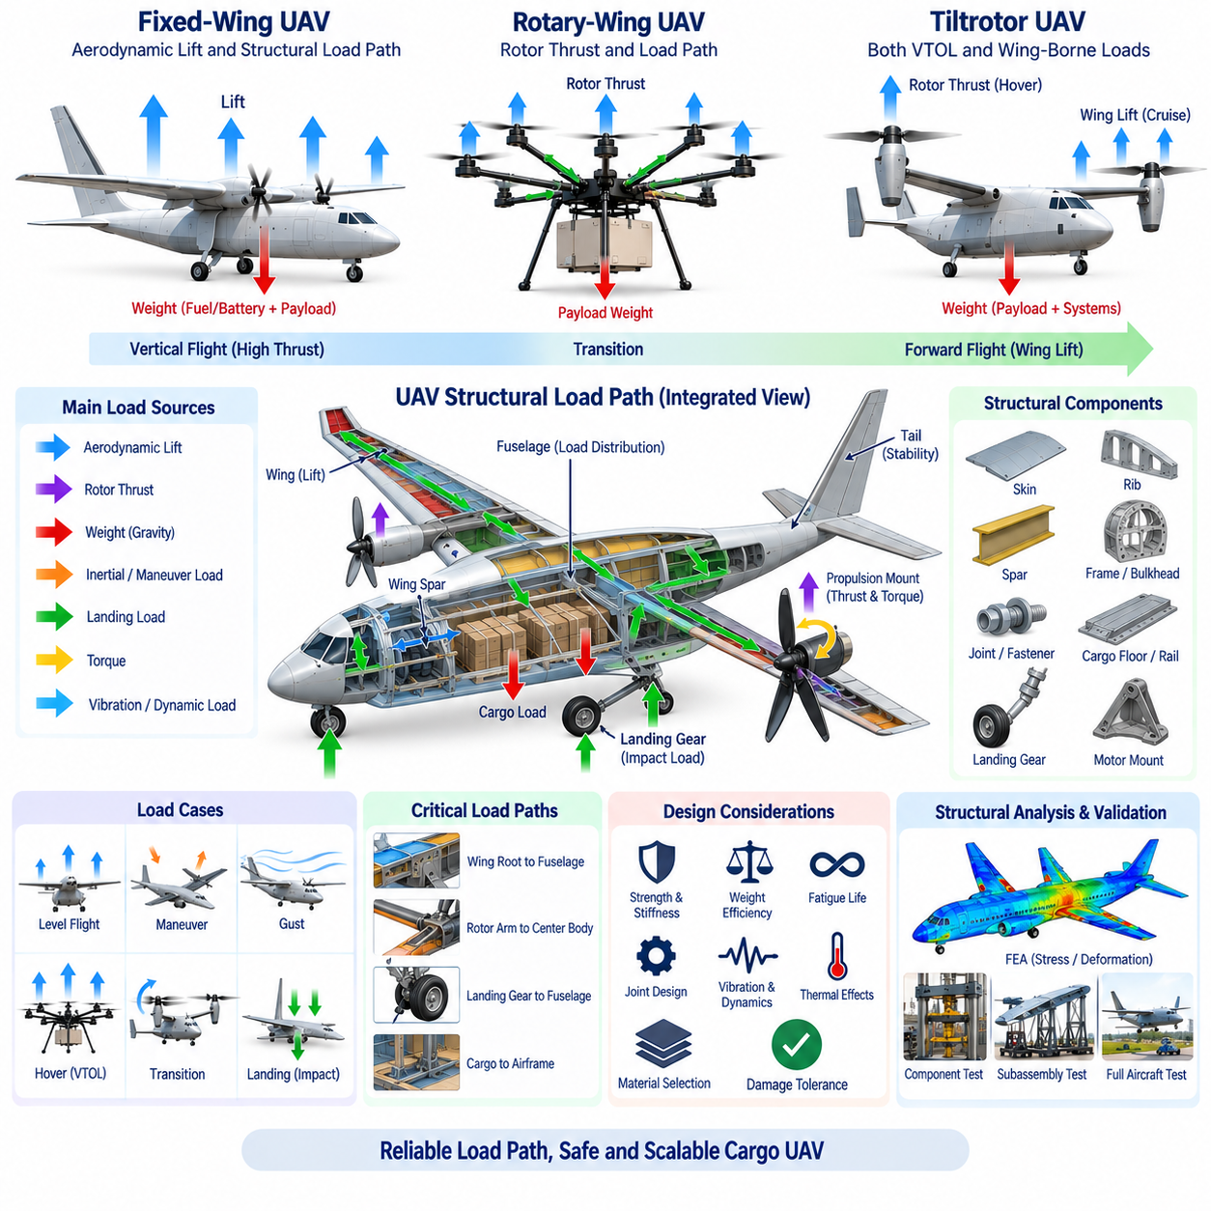
A UAV load path describes how aerodynamic, propulsion, payload, landing, and inertial forces travel through the aircraft structure before being balanced by other forces. Understanding this force-transfer network is fundamental to cargo UAV structural architecture because every major component must transmit loads without excessive deformation or failure. Wings, fuselage frames, spars, rotor mounts, landing gear, cargo supports, joints, and fasteners therefore form an integrated structural system rather than independent mechanical parts.
The basic principle of load-path design is that every applied force must have a continuous and sufficiently strong route through the structure. When a wing generates lift, the aerodynamic load is distributed over the wing surface and transferred through ribs and skin into the primary spars. The spars then carry bending and shear loads toward the wing root, where concentrated forces enter the fuselage. The fuselage structure must redistribute these forces while simultaneously supporting payload, propulsion, landing, and equipment loads.
In a conventional fixed-wing cargo UAV, the wing is one of the most heavily loaded structural elements. Distributed aerodynamic lift creates an upward bending load, while the fuselage, cargo, batteries, fuel, and equipment contribute downward gravitational forces. This combination produces large bending moments near the wing root. Wing spars therefore act as principal load-carrying members, while ribs maintain aerodynamic shape, distribute local loads, and stabilize the wing skin against deformation.
The wing skin can also become an important structural member rather than serving only as an aerodynamic surface. In stressed-skin or semi-monocoque construction, the skin carries significant shear and torsional loads together with spars, ribs, and internal stiffeners. Closed structural sections are particularly effective in resisting torsion. This becomes important when propulsion units, control surfaces, gust loads, or asymmetric flight conditions create twisting moments along the wing.
The fuselage provides the structural backbone connecting major aircraft subsystems. Longitudinal members, frames, bulkheads, skin, floor beams, and reinforced attachment regions distribute forces between the wing, tail, landing gear, propulsion system, and cargo compartment. For a heavy cargo UAV, the fuselage must carry not only flight loads but also concentrated payload forces. Structural architecture must therefore prevent local cargo loads from creating excessive stress in thin skin or lightly reinforced regions.
Cargo introduces a distinctive load-path problem because its mass can be concentrated in a relatively small area. A multi-ton payload should normally transfer forces through dedicated cargo floors, rails, frames, hardpoints, or structural beams into the primary airframe. Cargo restraints must withstand forces generated during acceleration, turbulence, maneuvering, emergency landing, and abnormal conditions. The load path should remain predictable even when cargo dimensions, mass distribution, or center of gravity vary between missions.
The center of gravity is closely connected to structural loading. Moving cargo forward or aft changes the forces and moments that must be balanced by the wing, tail, propulsion system, and flight-control surfaces. In distributed-propulsion aircraft, lateral or longitudinal cargo offset can also change individual rotor or motor loads. Cargo weight sensing and center-of-gravity monitoring can therefore support not only flight control but also structural load management by identifying potentially unfavorable loading conditions before takeoff.
Rotary-wing UAVs create a different structural load environment because rotor thrust is introduced into the aircraft through discrete propulsion mounts. Each rotor produces thrust, torque, vibration, and transient forces that must travel through motor mounts, arms, beams, joints, and the central airframe. In a multirotor cargo UAV, the structural arms effectively connect distributed lift sources to the concentrated vehicle and payload mass, making their bending stiffness, torsional rigidity, fatigue resistance, and attachment design critical.
Rotor arms experience combined loading rather than simple vertical bending. Motor torque can twist the arm, maneuvering can generate lateral forces, vibration produces repeated cyclic stresses, and asymmetric thrust can create additional bending and torsion. The junction between an arm and the central fuselage often becomes a high-stress region because loads from relatively slender members converge there. Smooth load transfer, adequate joint stiffness, reinforcement, and avoidance of abrupt geometric discontinuities are therefore essential.
Tiltrotor aircraft combine structural characteristics of both fixed-wing and rotary-wing configurations. During hover, concentrated rotor thrust enters the wing or nacelle structure and must support nearly the complete aircraft weight. During cruise, distributed aerodynamic wing lift becomes dominant. During transition, both mechanisms operate simultaneously while propulsion-vector angles change. The structural system must therefore tolerate significantly different combinations of bending, torsion, shear, vibration, and dynamic loading across the flight envelope.
Propulsion installation creates additional local load paths. Motors, engines, turbines, gearboxes, and propellers generate thrust and torque that must be transferred into reinforced structural members. Heavy propulsion units also create inertial loads during maneuvering and landing. Mounting structures must provide sufficient stiffness to maintain alignment while limiting vibration transmission to sensors, avionics, and cargo. In electric aircraft, structural integration must additionally accommodate high-voltage cables, cooling lines, and maintenance access.
Landing loads can be substantially higher than normal static weight because vertical velocity is rapidly reduced when the aircraft contacts the ground. Landing gear transfers these impact forces through attachment points into frames, bulkheads, beams, or other primary structural members. A poor load path can produce severe local stress even when the overall airframe appears strong. Landing gear attachment regions therefore require careful analysis of compression, bending, shear, energy absorption, and repeated operational cycles.
Vertical-takeoff cargo UAVs may experience repeated landing cycles at distributed logistics sites, making fatigue particularly important. Structural components can survive a single maximum load yet fail after many lower-amplitude cycles. Rotor vibration, gust response, repeated takeoffs, landings, payload loading, and propulsion transients all contribute to cumulative fatigue damage. Structural design must consequently consider both ultimate strength and long-term durability throughout the expected operational life of the aircraft.
Maneuver loads are commonly expressed through load factor, which represents the relationship between aerodynamic or inertial loading and aircraft weight. When an aircraft experiences a load factor greater than one, structural forces can increase substantially above normal level-flight values. Cargo restraints, wing roots, rotor mounts, fuselage frames, and landing structures must therefore be sized for defined limit-load conditions rather than simply supporting the aircraft's stationary weight.
Structural design distinguishes between limit load and ultimate load. Limit load represents the maximum load expected during specified operation without unacceptable permanent deformation, while ultimate load incorporates an additional safety factor to provide structural failure margin. The exact values depend on aircraft category, certification basis, operational assumptions, and applicable requirements. For cargo UAV development, these loads should be established from a clearly defined flight and ground operating envelope rather than selected independently for individual components.
Load-path efficiency strongly influences aircraft empty mass. A direct structural path transfers forces through a small number of appropriately sized primary members, whereas an indirect path may require additional reinforcement because loads must travel through secondary structures or around discontinuities. Efficient cargo UAV architecture therefore seeks to align major force-producing and force-reacting components whenever practical. Wing attachments, cargo supports, landing gear, and propulsion mounts can benefit substantially from coordinated structural placement.
Material selection affects how these loads are carried. Aluminum alloys provide predictable behavior, established manufacturing methods, and relatively straightforward inspection and repair. Composite materials can provide high specific strength and stiffness while enabling aerodynamic structural integration, but load introduction around joints, fasteners, inserts, and concentrated attachments requires careful design. Hybrid structures may combine metals and composites to exploit the advantages of each material in different load-path regions.
Composite structures require particular attention because their strength depends strongly on fiber orientation. Loads should ideally follow fiber directions capable of carrying tension, compression, and shear efficiently. Poorly designed holes, inserts, bonded joints, or abrupt laminate transitions can create stress concentrations and delamination risks. For heavy cargo UAVs, composite optimization must therefore consider not only minimum mass but also damage tolerance, inspection, repairability, environmental exposure, and manufacturing repeatability.
Joints are often more critical than the primary beams they connect. Bolts, rivets, bonded joints, welded structures, fittings, and composite inserts must transfer forces without excessive local bearing stress, shear, peel, or fatigue damage. When several load paths converge at one attachment, the joint can become a structural bottleneck. Detailed joint design is therefore essential for wing roots, rotor arms, nacelles, landing gear, cargo rails, battery enclosures, and removable maintenance modules.
Structural stiffness is as important as structural strength. A component may remain below its material failure stress but deform enough to degrade aerodynamic performance, rotor alignment, sensor calibration, or control-system stability. Wing deflection changes aerodynamic geometry, motor-mount deformation alters thrust direction, and flexible sensor structures can reduce perception accuracy. Structural requirements should therefore include allowable displacement, rotation, vibration, and natural-frequency targets in addition to stress limits.
Dynamic loads introduce another level of complexity. Propellers, rotors, motors, engines, aerodynamic turbulence, landing impacts, and control actions generate time-varying forces. If excitation frequencies approach structural natural frequencies, resonance can greatly amplify vibration and stress. Modal analysis and vibration testing are therefore important for identifying structural modes and ensuring adequate separation from dominant propulsion and operational frequencies, particularly in distributed electric propulsion systems containing many synchronized or near-synchronized rotors.
The battery or fuel system must also participate safely in the structural architecture. Large battery packs can represent a significant portion of total aircraft mass and therefore create major inertial loads. Battery enclosures and attachment structures must transfer these loads while providing crash protection, thermal isolation, electrical safety, and service access. Fuel tanks similarly require structural support while accommodating fuel movement, pressure, plumbing, thermal effects, and changing mass during flight.
Structural analysis should ultimately evaluate the aircraft as an integrated system across multiple operating cases. Hover, forward flight, maximum climb, gusts, turns, transition, propulsion failure, hard landing, ground handling, cargo loading, and emergency conditions can produce different critical load paths. Finite element analysis, analytical calculations, component testing, structural coupons, subassembly tests, and full-airframe validation can progressively demonstrate that the predicted force paths correspond to actual structural behavior.
As cargo UAVs scale from smaller aircraft toward 2.5-ton, 5-ton, and eventually 10-ton classes, load-path architecture becomes increasingly important because structural mass does not scale independently of payload and propulsion. Larger payloads require stronger structures, which increase empty mass and consequently increase lift, thrust, energy, and landing-load requirements. Efficient load paths help control this mass-growth loop and are therefore directly connected to propulsion sizing, energy architecture, payload capacity, safety, and aircraft economics.
A successful UAV structure is therefore not simply the strongest possible airframe. It is a carefully organized network that transfers aerodynamic lift, rotor thrust, propulsion torque, cargo inertia, landing impacts, and maneuver loads through predictable structural paths while maintaining acceptable strength, stiffness, fatigue life, mass, and damage tolerance. Understanding these paths establishes the structural foundation required for subsequent eVTOL architecture development and for scalable heavy-cargo UAV design.

01.05. eVTOL Architecture Overview
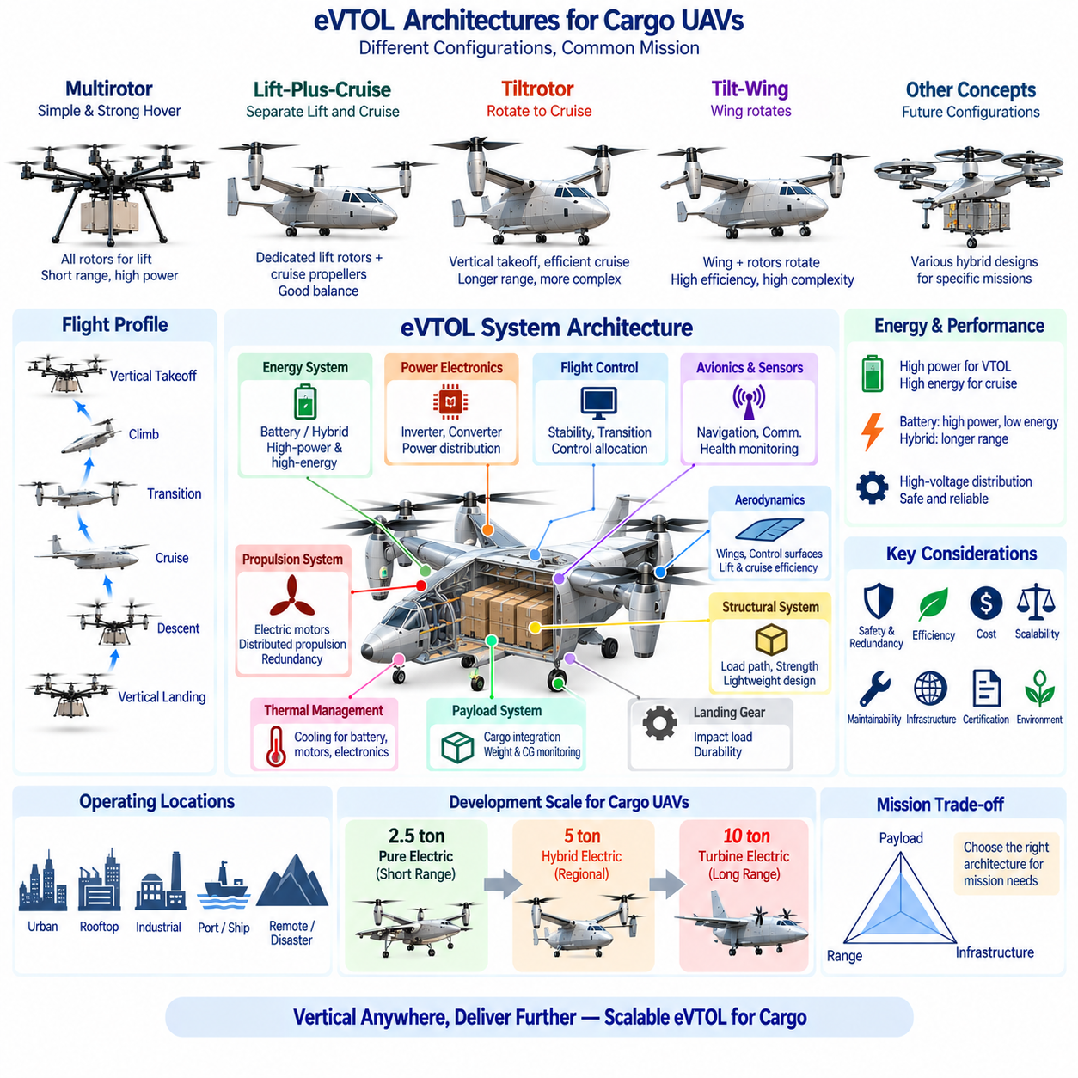
Electric Vertical Takeoff and Landing aircraft, commonly called eVTOL, combine electrically driven propulsion with the ability to take off and land vertically. The concept is not limited to one aircraft shape; it includes multirotors, lift-plus-cruise vehicles, tiltrotors, tilt-wings, and other distributed-propulsion configurations. For cargo UAVs, eVTOL architecture provides a framework for connecting aerodynamic configuration, propulsion, electrical power, flight control, structural design, payload integration, and operational infrastructure.
The defining capability of eVTOL is runway-independent vertical operation. During takeoff, electric propulsion units generate sufficient vertical thrust to overcome aircraft weight and establish a controlled climb. During landing, the same propulsion architecture provides low-speed positioning and vertical descent. This capability allows cargo aircraft to operate from compact logistics hubs, rooftops, industrial sites, ports, ships, remote locations, and disaster areas where conventional runway infrastructure may be unavailable.
A basic multirotor eVTOL uses several fixed lift rotors distributed around the airframe. Vehicle attitude and trajectory are controlled primarily through differential rotor thrust rather than conventional aerodynamic control surfaces. This architecture offers mechanical simplicity, rapid electric-motor response, and strong hovering capability. Its principal limitation is cruise efficiency because the rotors must continuously generate nearly all required lift, making long-range transportation increasingly energy intensive as aircraft mass and payload increase.
Lift-plus-cruise architecture separates vertical and horizontal propulsion functions. Dedicated lift rotors support vertical takeoff, hover, and landing, while separate cruise propellers provide forward thrust after the wing begins producing aerodynamic lift. The architecture avoids mechanically tilting large propulsion assemblies and can simplify transition mechanisms. However, lift rotors become largely inactive during cruise, so their motors, propellers, supporting structures, and wiring remain as non-propulsive mass and aerodynamic drag during forward flight.
Tiltrotor architecture uses propulsion units that rotate between vertical and horizontal orientations. During hover, rotor thrust supports aircraft weight; during transition, propulsion vectors progressively tilt forward while wing lift increases; during cruise, the aircraft operates more like a fixed-wing vehicle. This configuration can combine VTOL accessibility with efficient long-range cruise, but it requires reliable tilting mechanisms, sophisticated flight-control laws, structural reinforcement, and coordinated management of rapidly changing aerodynamic forces.
Tilt-wing architecture extends the conversion concept by rotating a substantial portion of the wing together with the propulsion units. This can maintain favorable airflow relationships between propellers and wings during some transition conditions, but moving a large aerodynamic surface introduces additional structural, actuator, control, and failure-management challenges. For heavy cargo UAVs, the mass and reliability of the conversion mechanism must be evaluated against the aerodynamic and operational advantages gained from the configuration.
Distributed Electric Propulsion, or DEP, is a major enabling technology for many eVTOL architectures. Instead of relying on one or two large propulsion units, multiple electric motors and propellers can be distributed across the wing or airframe. Individual thrust can be controlled electronically, enabling propulsion redundancy, control allocation, aerodynamic integration, and flexible packaging. The architecture also creates additional requirements for high-power distribution, synchronization, cooling, wiring, protection, and fault isolation.
The electrical power architecture must support both average mission energy and short-duration peak power. Vertical takeoff and climb can demand very high power, while wing-borne cruise may require substantially less. Batteries are well suited to rapid power delivery, but their specific energy limits endurance in heavy aircraft. Hybrid-electric systems can combine batteries with engines, turbines, generators, or fuel cells, allowing batteries to support transient VTOL loads while another source provides sustained cruise energy.
High-voltage electrical distribution becomes increasingly important as propulsion power increases. Raising bus voltage can reduce current for a given power level, helping reduce conductor mass and resistive losses. However, higher voltage introduces stronger requirements for insulation, creepage and clearance, connectors, contactors, precharge circuits, isolation monitoring, arc protection, electromagnetic compatibility, and maintenance procedures. Heavy-cargo eVTOL electrical architecture must therefore be developed as an aircraft-level safety system rather than simply a collection of motors and batteries.
Power electronics form the interface between the energy source and electric propulsion motors. Inverters regulate motor torque and speed according to flight-control commands, while DC/DC converters provide appropriate voltages for avionics, sensors, actuators, communication systems, and auxiliary equipment. Power Distribution Units coordinate switching and protection. Because propulsion depends directly on electrical availability, failures in buses, converters, contactors, cables, or cooling systems can become flight-critical events.
Flight-control architecture is closely coupled with propulsion configuration. A conventional fixed-wing aircraft primarily controls attitude using aerodynamic surfaces, while a multirotor relies heavily on differential thrust. Tiltrotor and lift-plus-cruise vehicles may use different combinations of rotor thrust and aerodynamic surfaces according to flight mode. The flight-control computer must therefore perform control allocation dynamically while accounting for airspeed, rotor state, propulsion availability, vehicle configuration, center of gravity, and actuator limits.
Transition flight is one of the defining challenges of winged eVTOL systems. At low speed, rotors provide most of the lift and control authority. As forward velocity increases, wings and aerodynamic control surfaces become increasingly effective. The controller must smoothly transfer responsibility between these mechanisms without creating unstable attitude changes or insufficient lift. Accurate estimation of airspeed, attitude, propulsion state, aerodynamic condition, and actuator position is essential throughout this transition corridor.
Redundancy is particularly important because electric propulsion allows multiple independent or semi-independent propulsion channels. A distributed system can potentially tolerate individual motor or inverter failures, but redundancy exists only when the remaining system can still produce adequate forces and moments. Electrical buses, batteries, communication networks, flight-control computers, sensors, and cooling systems must also avoid common-cause failures. Propulsion count alone therefore does not establish true fault tolerance.
Structural architecture must carry concentrated rotor thrust, motor torque, aerodynamic wing loads, battery or fuel-system mass, cargo inertia, and landing impacts through continuous load paths. In winged eVTOL aircraft, the critical structural condition may change between hover and cruise. Tilt mechanisms introduce additional concentrated forces and joint requirements. For heavy cargo vehicles, propulsion mounts, wing roots, cargo floors, landing gear attachments, and energy-storage supports must therefore be integrated into the primary load-bearing structure.
Thermal management becomes a system-level requirement because batteries, motors, inverters, converters, generators, and avionics all generate heat. Peak VTOL power may create short but intense thermal loads, while cruise produces lower but sustained heat generation. Cooling architecture must maintain component temperatures across repeated missions, high ambient temperatures, charging, and abnormal conditions. Hybrid-electric aircraft additionally require management of engine or turbine heat and exhaust alongside electrical thermal systems.
Payload integration strongly affects eVTOL architecture because cargo mass changes gross weight, center of gravity, propulsion demand, structural loading, and energy consumption. Heavy cargo should be transferred into reinforced structural hardpoints or cargo floors, while weight and center-of-gravity monitoring can verify safe loading before flight. A cargo management system can provide loading status to flight control and mission planning so that performance calculations reflect the actual aircraft configuration.
Landing infrastructure can be smaller than a conventional runway, but eVTOL operation still requires carefully designed ground interfaces. Vertiports or logistics pads may require charging or refueling equipment, communications, navigation support, cargo handling, fire protection, weather monitoring, and maintenance access. Large cargo vehicles also generate significant rotor downwash and noise, meaning landing-zone dimensions and surrounding safety areas must reflect propulsion configuration and maximum takeoff weight.
Mission architecture ultimately determines which eVTOL configuration is appropriate. Short-range urban cargo delivery may favor relatively simple battery-electric multirotors where vertical accessibility and rapid control are dominant requirements. Longer routes favor winged configurations that transfer lift generation from rotors to aerodynamic surfaces during cruise. Heavy regional cargo missions increasingly motivate tiltrotor, lift-plus-cruise, or hybrid-electric solutions that combine VTOL operation with improved payload-range capability.
As cargo capacity increases, propulsion and energy scaling become central design constraints. Larger payloads increase gross weight, requiring greater rotor thrust, motor power, structural capacity, and stored energy. These additions themselves increase aircraft mass, creating the mass-growth loop encountered throughout aircraft design. Efficient wings, optimized load paths, higher-energy propulsion architectures, and careful system integration therefore become increasingly important when moving from smaller eVTOL platforms toward multi-ton cargo aircraft.
The development path identified for cargo UAV architecture reflects this scaling challenge through dedicated 2.5-ton, 5-ton, and 10-ton aircraft classes. The broader structure associates these classes with pure-electric, hybrid-electric, and turbine-electric architectural considerations respectively, together with increasingly demanding avionics, power, logistics, and certification requirements. This provides a logical progression from highly electrified regional platforms toward long-range heavy-cargo systems.
Certification and safety considerations must be incorporated from the beginning rather than added after prototype development. Aircraft configuration determines critical failure conditions, emergency landing capability, propulsion redundancy, electrical isolation requirements, structural loads, and flight-control complexity. Verification must therefore cover propulsion failures, electrical faults, sensor failures, transition anomalies, thermal events, communication loss, degraded navigation, cargo abnormalities, and combinations of failures appropriate to the intended operational environment.
An eVTOL should consequently be understood as an integrated aircraft architecture rather than simply an electrically powered rotorcraft. Aerodynamics determines how lift is generated, propulsion determines how forces are produced, energy systems determine endurance, structures transfer loads, avionics coordinate vehicle state, and flight control manages these elements across different operating modes. Cargo handling, ground infrastructure, maintenance, safety, and certification complete the operational system surrounding the aircraft.
The most effective architecture is therefore the configuration that satisfies the required mission with acceptable payload, range, energy consumption, safety, reliability, infrastructure demand, and lifecycle cost. Multirotor, lift-plus-cruise, tiltrotor, tilt-wing, battery-electric, and hybrid-electric concepts represent different combinations of these tradeoffs rather than universally superior solutions. Understanding their interactions establishes the system-level foundation for designing scalable cargo eVTOL aircraft from short-range logistics vehicles to future multi-ton autonomous cargo platforms.

