Volume 18. Cargo UAV Architecture

Chapter 06. Ground Control Station

06.01. GCS Architecture
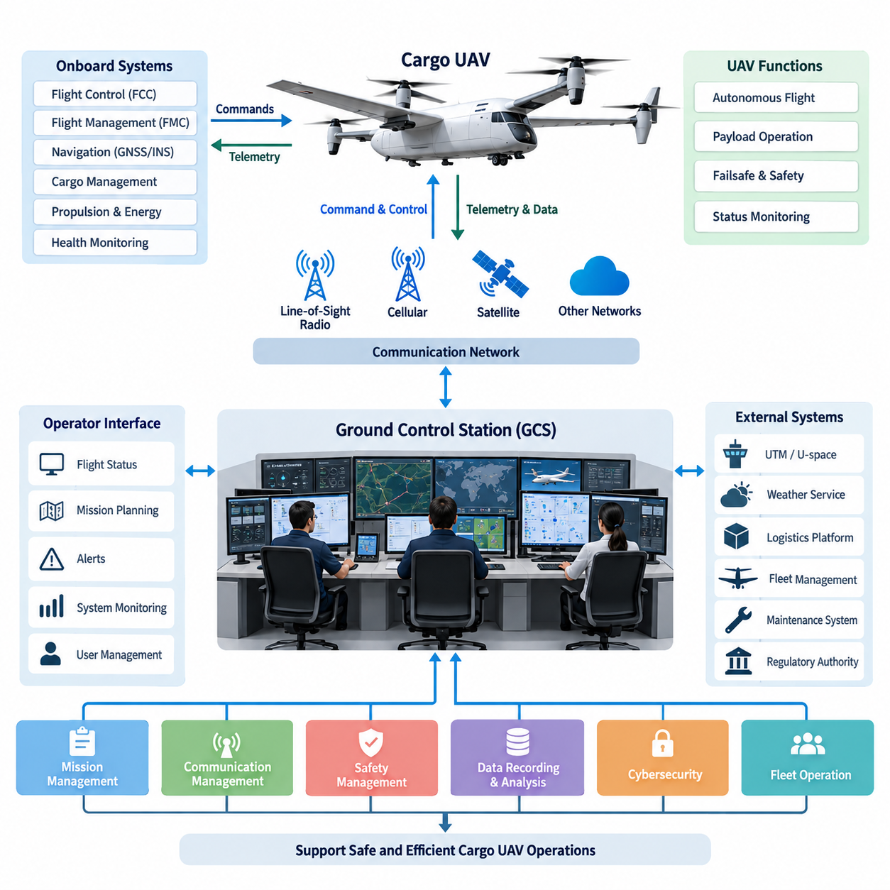
A Ground Control Station (GCS) is the terrestrial command, supervision, and mission-management environment that connects human operators with an unmanned aircraft. In a cargo UAV system, the GCS must support more than basic vehicle piloting because the aircraft may conduct long-range autonomous logistics missions while carrying valuable or safety-critical payloads. Its architecture therefore integrates mission control, flight monitoring, communications, payload supervision, safety management, and operational data services into one coordinated ground system.
The GCS should be considered part of the overall UAV system rather than an independent user terminal. It exchanges information with the Flight Control Computer (FCC), Flight Management Computer (FMC), navigation systems, cargo management system, propulsion and energy systems, and onboard health-monitoring functions. These interfaces allow ground operators to observe aircraft state, mission progress, payload condition, system faults, and remaining operational capability without directly participating in every low-level control loop.
A practical GCS architecture can be organized around operator interfaces, mission-management computing, communication gateways, operational databases, and external-service interfaces. Operator workstations provide the human-machine interface, while backend computers process telemetry, mission data, maps, alerts, and aircraft configuration information. Communication gateways isolate radio and network-specific functions from higher-level applications, allowing the same mission software to operate through different datalink technologies or communication providers.
The operator interface should present information according to operational priority rather than simply displaying every available aircraft parameter. Position, altitude, velocity, heading, flight mode, route status, navigation quality, propulsion condition, energy reserve, communication quality, and critical warnings form the primary operational picture. Detailed engineering parameters remain accessible through secondary pages so that abnormal conditions can be investigated without overwhelming the operator during normal autonomous flight.
Mission-management functions convert logistics objectives into executable aircraft operations. A cargo mission may include departure preparation, taxi or launch, climb, cruise, waypoint navigation, approach, landing, cargo transfer, and return or repositioning. The GCS maintains the mission definition and verifies that route constraints, aircraft performance, payload characteristics, weather assumptions, destination information, and operational restrictions remain consistent before and during execution.
Communication architecture is a central element because the GCS cannot assume uninterrupted connectivity with the aircraft. Command and control traffic, telemetry, payload information, maintenance data, and optional high-bandwidth sensor streams have different latency, bandwidth, integrity, and availability requirements. The architecture should therefore classify data by operational criticality and allocate communication resources accordingly instead of treating all network traffic as having equal importance.
The command-and-control path carries high-priority information such as authorized flight commands, mission changes, emergency instructions, and aircraft status required for safe supervision. Less critical traffic, including detailed diagnostic logs or large maintenance datasets, can tolerate delay or temporary interruption. This separation prevents nonessential data transfers from consuming communication capacity needed for flight safety and allows degraded communication modes to preserve essential operational functions.
Because cargo UAVs may operate beyond visual line of sight, the GCS should support multiple communication paths where mission requirements justify them. Line-of-sight radio may provide local operation around departure and destination sites, while cellular, private wireless, satellite, or other beyond-line-of-sight networks can extend mission coverage. A communication-management layer can monitor link quality and select or transition between available paths without forcing mission applications to manage each physical link independently.
Aircraft autonomy and GCS authority must be clearly separated. The aircraft should retain sufficient onboard capability to maintain safe flight when the ground link becomes unavailable, because stability control, navigation, propulsion control, and immediate failsafe responses cannot depend on terrestrial communication latency. The GCS provides supervisory command and mission-level authority, while onboard systems execute deterministic flight-control functions and predefined contingency behaviors independently when necessary.
This separation creates a hierarchical control architecture. Fast inner-loop control remains inside the aircraft, autonomous guidance and navigation operate at the vehicle level, and mission supervision occurs at the GCS level. Human operators can modify authorized mission objectives or initiate contingency procedures, but routine stabilization and actuator control remain onboard. Such partitioning reduces dependence on communication performance and makes the system more scalable for long-range and increasingly autonomous cargo operations.
Safety management within the GCS includes alert prioritization, contingency selection, operational boundary monitoring, and emergency coordination. The station should distinguish advisory information from caution and warning conditions so that operators immediately understand the required response. Events such as navigation degradation, datalink loss, abnormal energy consumption, propulsion faults, cargo anomalies, route deviation, or geofence conflicts can trigger predefined procedures linked to the aircraft's onboard failsafe logic.
Cargo supervision introduces functions that are less prominent in conventional small-UAV ground stations. The GCS may display payload weight, center-of-gravity information, cargo-lock status, compartment environmental conditions, and payload-interface health when these measurements are available from the Cargo Management System. This enables the operator to confirm that the payload remains mechanically secured and operationally acceptable throughout loading, departure, transportation, arrival, and unloading phases.
The GCS architecture should also preserve a consistent operational record. Telemetry, operator commands, mission revisions, alarms, communication events, aircraft configuration, cargo status, and maintenance-relevant information can be time-stamped and stored for later analysis. Accurate event correlation is particularly important when reconstructing abnormal missions because information may originate from multiple aircraft computers, ground applications, communication networks, and external services operating at different update rates.
Cybersecurity must be integrated into the architecture because unauthorized access to the command path could directly affect aircraft operation. Authentication, authorization, encrypted communications, secure credential management, network segmentation, software integrity checking, and controlled configuration changes should protect both aircraft-facing and external interfaces. Security boundaries are especially important when the GCS communicates simultaneously with public networks, cloud services, logistics platforms, maintenance systems, and operational authorities.
External interfaces allow the GCS to participate in a larger airspace and logistics ecosystem. Mission applications may exchange information with UTM or U-space services, weather providers, geospatial databases, fleet-management systems, cargo terminals, maintenance systems, and enterprise logistics platforms. These external connections should remain separated from safety-critical command functions through defined gateways so that failures or cybersecurity incidents in business systems cannot directly propagate into aircraft control paths.
For fleet operation, the architecture must distinguish aircraft-specific control from fleet-level supervision. Individual UAV sessions maintain detailed vehicle state and command authority, while a higher-level fleet service can allocate missions, coordinate departure times, monitor aircraft availability, and optimize logistics resources. This layered approach allows one operational center to supervise multiple cargo aircraft without assuming that a single operator manually pilots every vehicle throughout the mission.
Scalability becomes increasingly important as cargo UAV capacity grows from smaller logistics aircraft toward 2.5-ton, 5-ton, and eventually 10-ton-class platforms. Larger aircraft increase the consequences of communication failures, incorrect commands, payload abnormalities, and ground-system outages. The GCS should therefore evolve from a workstation-oriented installation toward a resilient operational infrastructure with redundant computing, networking, communication gateways, storage, operator positions, and disaster-recovery capabilities.
Availability can be improved by eliminating unnecessary single points of failure. Critical GCS services may operate on redundant servers, independent network paths, duplicated communication equipment, and protected power supplies. State synchronization allows a standby component or alternate control position to assume required functions following a failure. The architecture should ensure that redundancy itself does not introduce ambiguous authority, particularly when multiple operator stations or geographically separated facilities can access the same aircraft.
Operational authority must consequently be explicit and traceable. At any moment, the system should know which station, operator role, or automated service possesses permission to issue specific classes of commands. Role-based access control can separate mission planning, active flight supervision, maintenance, payload operation, and administrative functions. Command arbitration prevents conflicting instructions and provides an auditable record of who initiated significant mission or aircraft-state changes.
Human factors remain fundamental even as aircraft autonomy increases. A highly autonomous cargo UAV may require fewer continuous manual actions, but operators must understand system intent, automation state, degraded modes, and the consequences of intervention. The GCS should therefore make autonomy transparent by displaying current flight mode, active mission segment, expected next action, contingency state, and significant reasons for route or mode changes whenever that information is available.
The resulting architecture forms a supervisory bridge between the autonomous aircraft and the wider operational environment. Aircraft-side systems preserve real-time control and immediate safety functions, the GCS provides mission-level command and situational awareness, and external systems contribute airspace, logistics, weather, maintenance, and fleet information. Clear interface boundaries between these domains reduce coupling while allowing information to flow where it is operationally required.
For a mature cargo UAV program, the GCS ultimately becomes an operational control infrastructure rather than merely a remote-piloting console. Its effectiveness depends on coordinated design of human interfaces, mission computing, datalinks, safety logic, cybersecurity, redundancy, data management, cargo supervision, and external integration. This system-level approach provides the foundation required to supervise increasingly autonomous cargo aircraft safely while supporting future fleet-scale and long-range logistics operations.

06.02. Datalink Design
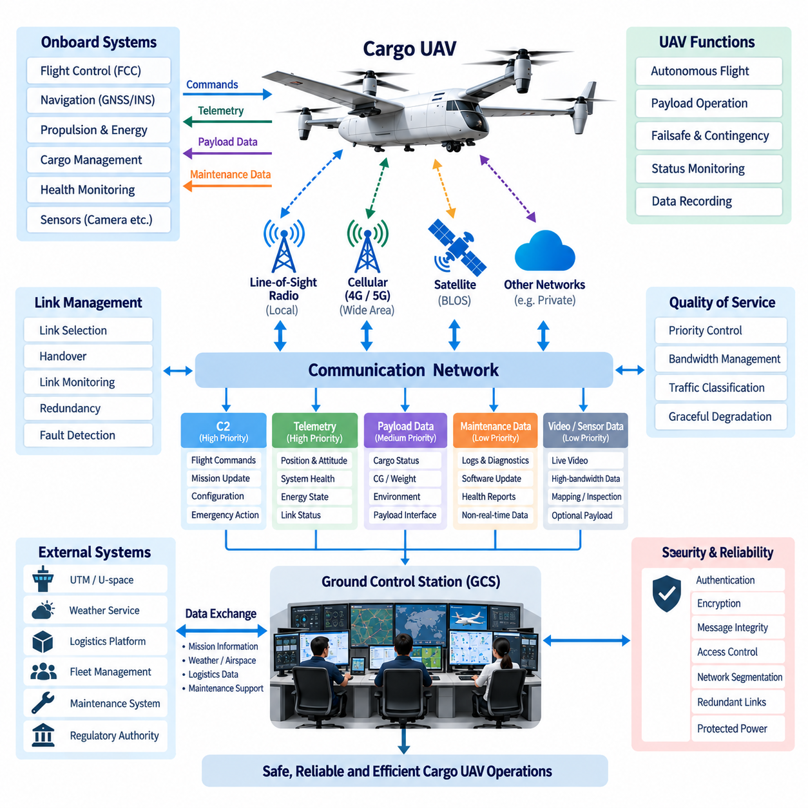
A datalink is the communication infrastructure that connects the cargo UAV with the Ground Control Station (GCS) and enables continuous exchange of command, telemetry, mission, and operational information. Unlike a conventional network connection, an aviation datalink must remain useful under changing range, altitude, terrain, interference, mobility, and network availability. Its design therefore focuses on maintaining dependable command-and-control capability while supporting the additional information required for autonomous cargo operations.
The datalink architecture should separate communication functions according to their operational importance. Command and Control (C2) messages require predictable delivery because they may modify flight modes, mission parameters, contingency actions, or operational authority. Telemetry provides aircraft position, velocity, navigation status, propulsion condition, energy state, system health, and communication quality. Payload and maintenance information can normally use lower-priority channels when communication resources become constrained.
A cargo UAV may employ several physical communication technologies rather than relying on one radio system. Line-of-Sight (LOS) radio can provide direct connectivity near departure sites, landing zones, and local operating areas. Cellular networks such as 4G or 5G can extend coverage where terrestrial infrastructure exists, while satellite communication can provide Beyond-Line-of-Sight (BLOS) connectivity over remote regions. The architecture should present these different links through a common communication-management layer.
Link selection should consider more than received signal strength. Available bandwidth, latency, packet loss, coverage prediction, network congestion, interference, communication cost, security state, and expected mission trajectory may influence which path is preferred. A communication manager can continuously evaluate these parameters and maintain a primary link while preparing secondary links for transition. This allows the aircraft and GCS applications to exchange operational information without being tightly coupled to one communication technology.
Seamless handover is especially important for long-range cargo missions. An aircraft may depart using a local LOS radio, transition to a terrestrial broadband network during cruise, and later require satellite connectivity when leaving populated coverage areas. The datalink system should preserve communication sessions and command authority during these transitions whenever possible. Temporary degradation should not automatically cause unnecessary mission interruption if another qualified communication path remains available.
The uplink and downlink have different operational roles. The uplink primarily carries authorized commands, mission updates, configuration parameters, and selected control information from the GCS to the aircraft. The downlink carries telemetry, navigation state, health information, payload condition, alarms, and mission progress. High-bandwidth sensor streams such as video may also use the downlink, but they should not interfere with the delivery of safety-relevant aircraft status or essential command acknowledgements.
Quality of Service (QoS) mechanisms can protect critical communication when available bandwidth decreases. C2 traffic should normally receive the highest operational priority, followed by essential telemetry and safety information. Mission-support data, payload information, maintenance logs, imagery, and other high-volume data can be assigned progressively lower priorities. Such traffic classification allows the datalink to degrade gracefully rather than becoming unusable when network performance falls below nominal conditions.
Communication latency must be considered together with the aircraft control architecture. Fast stabilization loops, actuator control, navigation filtering, and immediate failsafe responses remain onboard because terrestrial communication cannot guarantee sufficiently low and deterministic latency. The datalink therefore supports supervisory control rather than continuous low-level flight control. This architecture allows the GCS to change mission objectives or initiate authorized actions while the Flight Control Computer (FCC) maintains real-time aircraft stability.
Loss of communication must be treated as an expected operational condition rather than an undefined failure. The aircraft should monitor link availability and determine whether communication degradation has exceeded configured thresholds. Depending on mission state and operational rules, predefined responses may include maintaining the current route, proceeding to a designated waypoint, holding, returning to base, diverting to an alternate landing site, or executing another approved contingency procedure without waiting indefinitely for ground commands.
Redundant datalinks improve availability only when their failure dependencies are understood. Two communication channels using different frequencies but sharing the same modem, antenna system, power supply, network provider, or ground gateway may still contain common failure points. Effective redundancy therefore considers radio hardware, antennas, communication processors, power domains, terrestrial infrastructure, service providers, and routing paths. Diversity should be introduced where justified by the safety and availability objectives of the cargo UAV.
Antenna architecture is closely connected to datalink performance because aircraft attitude and structural geometry continuously change propagation conditions. Airframe structures, propulsion equipment, cargo compartments, batteries, and other conductive components can create shadowing or attenuation. Antenna placement should therefore consider flight attitude, expected ground-station geometry, operating frequencies, structural integration, electromagnetic compatibility, and the possibility that different communication systems may interfere with one another.
The communication subsystem should provide measurable link-health information rather than a simple connected or disconnected indication. Signal quality, latency, packet loss, throughput, retransmission activity, link availability, and communication errors can be monitored by both the aircraft and GCS. These measurements allow the communication manager to detect gradual degradation before complete link loss and provide the operator with meaningful information about remaining communication capability and possible transitions.
Data integrity is essential because corrupted information can be as hazardous as lost information. Communication protocols should provide mechanisms for detecting transmission errors, validating message structure, identifying sequence discontinuities, and confirming critical transactions when appropriate. Command messages may require acknowledgement so that the GCS can determine whether an instruction was received and accepted. Time stamps and sequence identifiers also help distinguish current operational information from delayed, duplicated, or out-of-order messages.
Cybersecurity must be incorporated directly into datalink design. Authentication establishes that the aircraft and GCS are communicating with authorized systems, while encryption protects information transmitted across potentially exposed networks. Message integrity mechanisms help detect unauthorized modification, and access-control policies restrict which users or systems may issue commands. Credential management, key protection, secure initialization, and controlled software configuration become increasingly important when public cellular or satellite infrastructure is involved.
Network segmentation prevents noncritical services from directly affecting the command path. Video transmission, maintenance uploads, payload applications, cloud connectivity, and enterprise logistics services may share portions of the communication infrastructure, but they should not possess unrestricted access to flight-critical communication functions. Gateways, routing policies, firewalls, and application-level authorization can establish boundaries between operational domains while still allowing required information exchange through controlled interfaces.
The datalink should also support the Cargo Management System because cargo condition may influence mission decisions. Payload weight, center-of-gravity status, locking state, compartment environment, and payload-interface health can be transmitted to the GCS when available. Abnormal cargo conditions can receive elevated transmission priority so that operators become aware of conditions that may require mission modification, diversion, landing, or other predefined responses during transportation.
For fleet operations, the communication architecture must scale beyond a single aircraft-to-station connection. Each UAV requires an identifiable and authenticated communication session while fleet services coordinate mission allocation and overall operational status. Network addressing, session management, bandwidth allocation, command authority, and data routing must therefore remain manageable as the number of simultaneously connected aircraft increases. Fleet growth should not create ambiguity regarding which GCS authority controls a particular UAV.
Long-range 2.5-ton, 5-ton, and 10-ton-class cargo UAVs place progressively greater demands on communication availability and operational assurance. As aircraft size, payload value, mission distance, and operational consequence increase, datalink design must evolve from a convenient telemetry connection into a resilient communications subsystem. Multiple links, independent communication paths, protected power, fault monitoring, cybersecurity, and carefully defined degraded modes become increasingly significant parts of the overall aircraft architecture.
Datalink information should be recorded together with other mission data. Link transitions, signal degradation, communication interruptions, command transmission, acknowledgements, latency changes, routing events, and communication faults provide valuable evidence during post-flight analysis. Correlating these records with aircraft telemetry and GCS operator actions can reveal whether an abnormal event originated in the vehicle, communication infrastructure, ground system, or interaction between multiple subsystems.
The datalink must also interface cleanly with external operational systems without allowing those systems to bypass GCS authority. UTM or U-space services, weather systems, logistics platforms, maintenance infrastructure, and fleet-management services may provide information that eventually influences the mission. However, external data should pass through defined processing and authorization boundaries before becoming an aircraft command. This preserves clear separation between information services and safety-relevant command authority.
A mature cargo UAV datalink is therefore a multi-path, priority-aware, secure, and fault-tolerant communication architecture rather than a single wireless connection. Its purpose is not to move the maximum possible amount of data at all times, but to preserve the right information with the required reliability and priority throughout the mission. By coordinating C2 traffic, telemetry, payload data, redundant links, cybersecurity, and autonomous contingency behavior, the datalink becomes a fundamental enabler of safe long-range cargo UAV operations.

06.03. Remote Control System
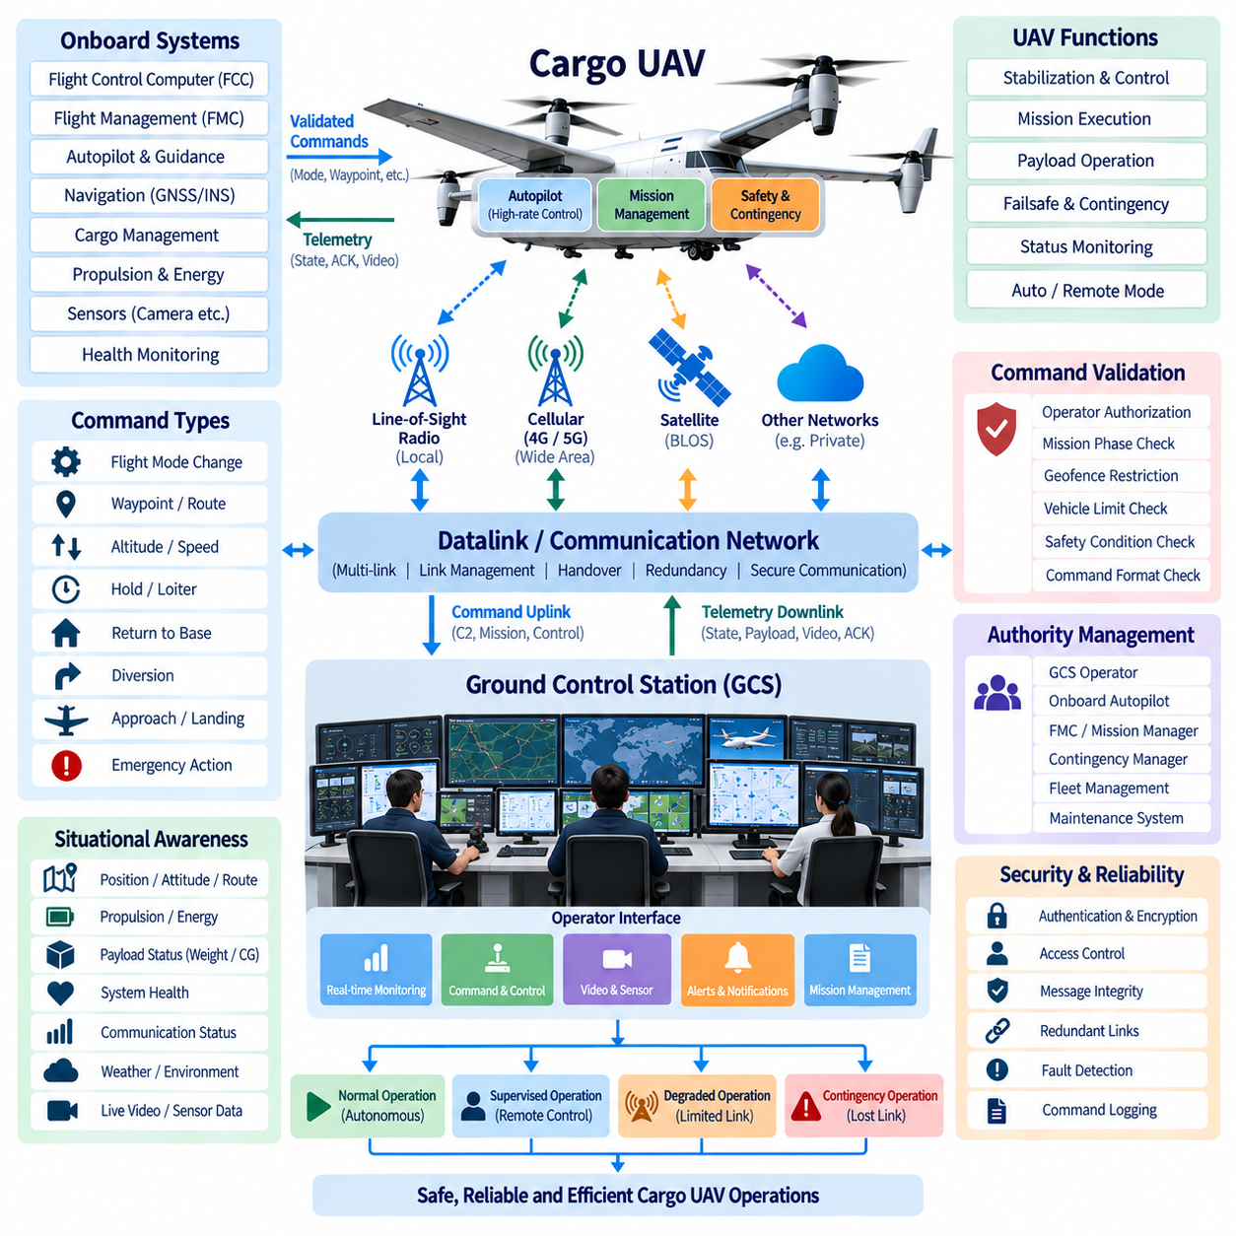
The Remote Control System provides the operational interface through which a ground operator can supervise, command, and when authorized intervene in the behavior of a cargo UAV. Within the Ground Control Station (GCS), remote control is not simply equivalent to conventional radio piloting. It forms a supervisory control layer that connects human decisions with onboard flight-management and flight-control functions while preserving the aircraft’s autonomous and safety-critical capabilities.
For large cargo UAVs, the aircraft should normally remain responsible for high-rate stabilization and actuator control. The Flight Control Computer (FCC) executes attitude stabilization, control allocation, actuator commands, and immediate safety responses at rates that cannot depend on a remote communication link. The remote operator instead issues higher-level commands such as flight-mode changes, waypoint modifications, mission continuation, holding, diversion, return-to-base, approach authorization, or other predefined operational actions.
This separation creates a hierarchical control structure between the operator, GCS, datalink, onboard autonomy, FCC, and physical actuators. Human commands are interpreted and validated at the supervisory level before they influence aircraft behavior. The remote control architecture therefore avoids sending continuous low-level actuator commands whenever autonomous flight functions can safely perform the required task. Such partitioning reduces sensitivity to communication latency, jitter, packet loss, and temporary datalink interruption.
Remote control authority must be explicitly defined because several systems may simultaneously participate in aircraft operation. The GCS operator, onboard autopilot, Flight Management Computer (FMC), contingency manager, fleet-management system, and maintenance functions may each generate requests affecting vehicle behavior. An authority-management mechanism determines which source is permitted to command a particular function and prevents conflicting commands from being executed at the same time.
The operator interface should convert human intent into structured and verifiable commands. Rather than relying only on manual stick inputs, the interface may provide commands such as proceed to waypoint, modify altitude, hold position, resume mission, return home, divert, initiate approach, abort landing, or activate an approved contingency mode. Each command should clearly indicate the expected aircraft response so that the operator can understand the consequences before execution.
Command validation is required before a remote instruction is accepted by the aircraft. The system can verify command format, operator authorization, aircraft operating mode, mission phase, navigation state, geofence restrictions, vehicle limitations, and safety conditions. Commands that violate defined operational constraints should be rejected or require additional authorization. This prevents accidental or inappropriate operator actions from directly propagating into flight-critical functions without system-level checks.
The remote control system depends on the datalink architecture described for the GCS communication environment. Commands travel through an uplink while aircraft state, acknowledgements, and operational feedback return through the downlink. Because communication quality changes with distance and network conditions, the control system must account for latency, packet loss, retransmission, handover, and temporary outages instead of assuming a continuously reliable connection.
Command acknowledgement is especially important in remote operation. The GCS should distinguish between a command that was created by the operator, transmitted through the network, received by the aircraft, accepted by the onboard system, and finally executed. These are different states. A visible acknowledgement chain prevents the operator from assuming that an aircraft has changed behavior merely because a command was entered at the ground station.
Latency should be monitored and presented as an operational parameter. A command that arrives several seconds late may no longer be appropriate if the aircraft has entered another mission phase or changed position significantly. Time stamps, sequence numbers, command validity periods, and state verification can prevent delayed messages from producing unintended actions. Commands that have exceeded their defined validity interval should normally be discarded rather than executed blindly.
Manual remote piloting may still be useful for specific operational situations, but its role should be carefully bounded. Local departure, maintenance testing, ground maneuvering, special landing operations, or recovery procedures may justify direct pilot inputs when communication performance is sufficiently predictable. For long-range Beyond Visual Line of Sight (BVLOS) operations, however, continuous manual control through variable-latency networks is less robust than onboard autonomous guidance combined with supervisory remote commands.
The transition between autonomous and remotely supervised modes must be deterministic and understandable. When an operator requests control, the aircraft should verify that the requested mode is available and that transfer conditions are satisfied. The GCS should clearly indicate whether control authority remains with onboard autonomy, has transferred to the remote operator, or has entered a protected contingency mode. Ambiguous control ownership can become a significant system-level hazard.
Loss of datalink must not leave the aircraft waiting indefinitely for operator input. The onboard system should detect communication degradation and execute predefined contingency behavior appropriate to the current mission phase. Depending on the approved operational concept, this may involve maintaining the route, holding at a safe location, returning to base, diverting to an alternate site, or landing at a designated location while attempting to restore communication.
The remote control system should support multiple levels of degraded operation. If high-bandwidth video is unavailable but command and telemetry channels remain healthy, supervisory operation may continue normally. If communication bandwidth decreases further, nonessential information can be suppressed while preserving C2 messages and essential aircraft state. Only when communication capability falls below defined safety thresholds should the system transition to an autonomous lost-link or contingency procedure.
Situational awareness is necessary for effective remote intervention. The GCS should provide position, altitude, velocity, attitude, route, navigation quality, propulsion status, energy reserve, flight mode, communication condition, system warnings, and mission progress. Cargo-specific information such as payload weight, center-of-gravity condition, cargo-lock status, and compartment environment can also be presented when available, allowing operational decisions to consider both aircraft and payload conditions.
Video and sensor information can improve remote situational awareness but should not become the sole basis for safe aircraft control. Camera streams can be affected by bandwidth limitations, latency, weather, lighting, or communication interruption. Navigation and vehicle-state telemetry therefore remain fundamental sources of operational information. Sensor data should complement rather than replace the aircraft’s onboard perception, navigation, and autonomous safety functions.
Emergency controls require special treatment because their consequences can be significant. Functions such as abort, hold, return-to-base, emergency diversion, or controlled landing should be clearly separated from routine mission commands. Appropriate confirmation mechanisms can reduce accidental activation while still allowing rapid execution during genuine emergencies. The interface should avoid complicated interaction sequences that delay operator response when time-critical action is required.
Cybersecurity is essential because the remote control path represents a direct route through which external commands may influence aircraft behavior. Operator authentication, role-based authorization, encrypted communication, message integrity protection, secure session management, and command logging should protect this path. The aircraft should reject commands from unauthorized or unverified sources even when those messages arrive through otherwise valid communication infrastructure.
Remote operation also requires protection against conflicting control sessions. In fleet environments, several GCS workstations or geographically separated control centers may have access to aircraft information, but only the properly authorized control entity should issue operational commands. Control handover between stations should therefore follow a defined process that transfers authority explicitly while maintaining traceability and preventing simultaneous contradictory instructions.
Every significant remote-control event should be recorded. Operator identity, command type, creation time, transmission time, aircraft acknowledgement, execution result, communication condition, aircraft state, and control-authority transitions provide an operational history. These records support post-flight analysis, safety investigation, maintenance diagnostics, operator training, and verification that the aircraft responded correctly to human intervention during abnormal situations.
Fleet-scale cargo operations further change the role of remote control. One operator may eventually supervise several highly autonomous aircraft rather than manually pilot one vehicle continuously. The GCS must therefore emphasize exception management, alert prioritization, mission-level intervention, and controlled transfer of attention between aircraft. Automation should handle routine flight while human operators concentrate on situations requiring judgment, authorization, or coordination.
As the architecture progresses from 2.5-ton to 5-ton and 10-ton-class cargo UAVs, remote control becomes increasingly dependent on formal authority management, communication redundancy, safety monitoring, and deterministic contingency behavior. Larger aircraft increase the consequences of inappropriate commands and communication failures. The remote control function must therefore be engineered as part of the overall avionics and safety architecture rather than added as an independent ground-station feature.
A mature Remote Control System ultimately combines human supervision with onboard autonomy instead of placing them in competition. The aircraft performs time-critical control and immediate safety functions, while the GCS provides mission-level authority, operational awareness, and controlled intervention. By integrating command validation, authority management, datalink monitoring, cybersecurity, failsafe behavior, and traceable operator interaction, the system provides a scalable foundation for safe long-range cargo UAV supervision.

06.04. Mission Planning Interface
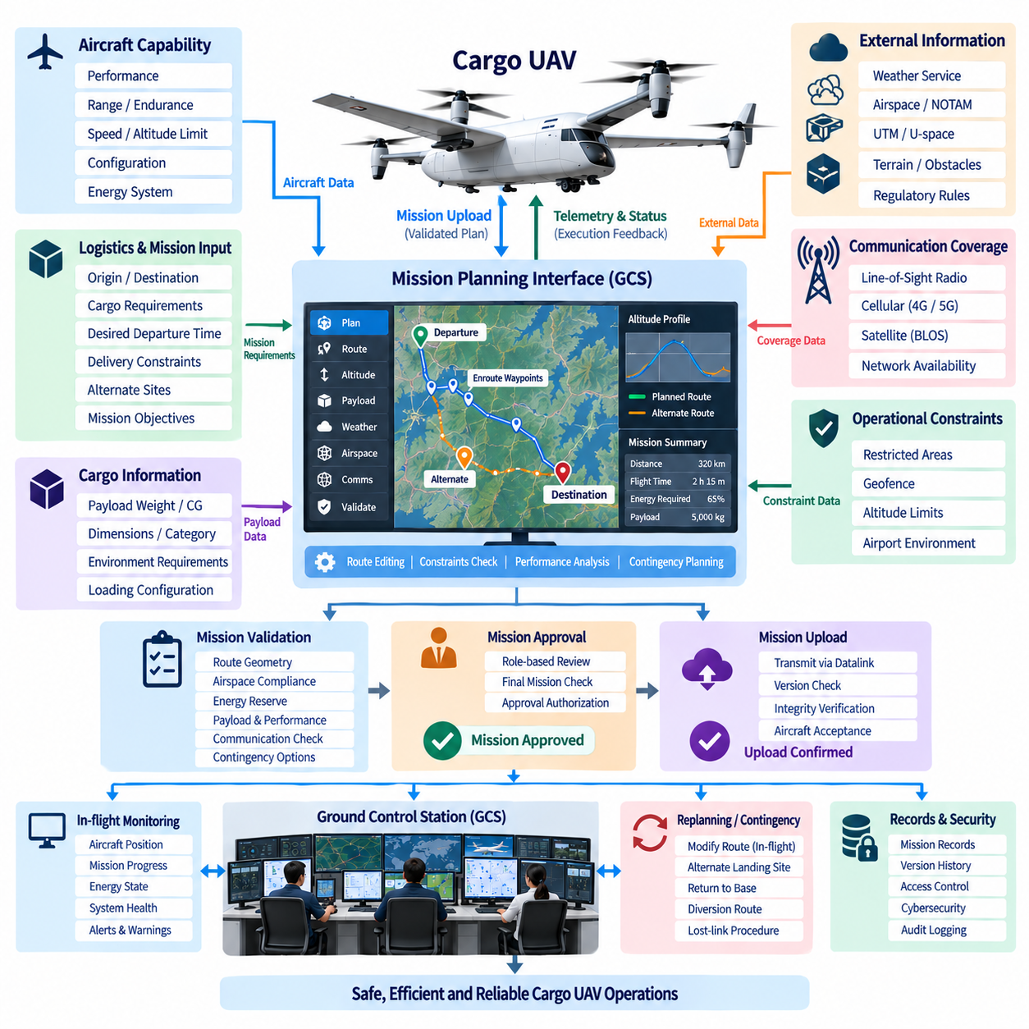
The Mission Planning Interface is the primary environment through which operators transform a transportation objective into an executable cargo UAV mission. Within the Ground Control Station (GCS), it connects logistics requirements with aircraft capability, navigation constraints, airspace information, payload conditions, and operational rules. Its purpose is not merely to draw a route, but to create a validated mission definition that can be safely interpreted by the Flight Management Computer (FMC) and onboard autonomous systems.
Mission planning begins with operational intent. The operator defines departure and destination locations, cargo requirements, desired departure time, delivery constraints, alternate sites, and other mission objectives. The interface converts these requirements into structured mission parameters while retrieving relevant aircraft configuration and performance information. This allows logistics objectives to be evaluated against the actual capability and current operational state of the assigned UAV.
Route construction typically uses geographically referenced waypoints connected into an ordered flight path. Each waypoint can contain position, altitude, speed, navigation behavior, and mission-specific actions. The interface should allow operators to create, move, insert, delete, and inspect waypoints while maintaining a clear representation of the complete route. Route editing should remain intuitive while preventing modifications that create invalid or operationally hazardous flight segments.
Altitude planning requires more than assigning a single cruise altitude. Terrain, obstacles, controlled airspace, weather, communication coverage, aircraft performance, departure and arrival procedures, and regulatory restrictions may affect the allowable vertical profile. The interface should therefore present the route in both horizontal and vertical contexts so that operators can evaluate climb, cruise, descent, and approach segments as one continuous mission rather than independent waypoint values.
Cargo information is an integral part of mission planning because payload characteristics directly affect aircraft performance. Payload weight, center of gravity, dimensions, cargo category, environmental requirements, and loading configuration may influence available range, energy consumption, climb capability, landing performance, and route selection. Information provided by the Cargo Management System can therefore be incorporated into mission validation before departure and monitored for significant changes during operation.
Energy planning should estimate whether sufficient reserves exist to complete the intended mission under defined assumptions. The calculation may consider payload mass, route distance, altitude profile, expected wind, propulsion configuration, aircraft performance, battery or fuel condition, and required reserve margins. For hybrid cargo UAVs, mission planning may additionally interact with the Energy Management System to evaluate expected use of batteries, generators, fuel cells, turbines, or other onboard energy sources.
Weather information should be associated with the planned route rather than treated only as a general departure-site condition. Wind direction and velocity, precipitation, visibility, temperature, icing risk, turbulence, and significant weather can affect route feasibility and energy consumption. The planning interface can present relevant weather information geographically and temporally so that operators can understand how environmental conditions may change as the aircraft progresses through different mission segments.
Airspace constraints must be integrated into the mission representation. Restricted areas, prohibited zones, controlled airspace, temporary restrictions, geofences, airport environments, altitude limits, and other operational boundaries can affect route selection. The interface should identify conflicts before mission approval and clearly indicate which route segment violates a constraint. Where authorized alternatives exist, the operator can modify the route while preserving the original logistics objective.
Integration with UTM or U-space services extends mission planning beyond the local GCS environment. Planned trajectories, operational volumes, identification information, airspace restrictions, and authorization status may be exchanged with external traffic-management services according to the applicable operating environment. The GCS should maintain a clear boundary between external airspace information and aircraft command authority so that externally received data is validated before it influences an executable mission.
Communication coverage is also relevant to route design, particularly for Beyond Visual Line of Sight (BVLOS) cargo operations. The mission planner can associate expected Line-of-Sight radio, cellular, satellite, or other network availability with different route segments. Areas of weak or unavailable communication can be identified before departure, allowing operators to determine whether redundant links, autonomous lost-link procedures, alternate routing, or additional operational restrictions are required.
Mission planning should explicitly include contingency routes rather than treating emergencies as improvised operator decisions. Alternate landing sites, holding locations, diversion routes, return-to-base paths, communication-loss procedures, and other predefined responses can be associated with mission phases. This provides the onboard autonomy and GCS with a common understanding of expected behavior when normal mission execution can no longer continue.
Before a mission is uploaded, the interface should perform systematic validation. Route geometry, waypoint sequencing, altitude limits, vehicle performance, payload condition, energy reserve, geofence compliance, communication assumptions, destination suitability, and required contingency options can be checked. Validation results should distinguish blocking errors from warnings or advisory information so that operators understand whether a mission is invalid or simply requires additional attention.
Mission approval should remain separate from mission editing. An operator may construct or modify a route without automatically authorizing it for flight. Once validation is complete, an authorized role can review the final mission configuration and approve it for upload. This separation supports operational discipline and reduces the possibility that incomplete route changes or experimental planning values are unintentionally transmitted to an active aircraft.
Mission upload transfers the approved mission definition through the datalink to the aircraft. The onboard system should verify message integrity, mission version, compatibility, and required parameters before accepting the new plan. The GCS should receive confirmation that the mission has been received and accepted rather than assuming successful transfer. Version identification is particularly important when route revisions occur shortly before departure or during an active mission.
During flight, the interface changes from a planning environment into a mission-monitoring environment. Aircraft position can be displayed relative to the approved trajectory together with current mission phase, next waypoint, estimated arrival time, remaining distance, energy state, and relevant alerts. The operator can therefore compare planned behavior with actual progress and identify deviations before they become significant operational problems.
In-flight replanning may be required because weather, airspace restrictions, destination availability, aircraft health, payload condition, or logistics priorities can change after departure. Proposed route changes should undergo appropriate validation before becoming active commands. The system should clearly distinguish the current approved mission from a proposed modification so that operators do not confuse an edited planning route with the trajectory currently being executed by the aircraft.
Collaborative fleet operation introduces additional planning requirements. Multiple cargo UAVs may share departure facilities, destination sites, communication infrastructure, charging resources, or portions of the same airspace. Fleet-management services can coordinate mission assignments and schedules, while the mission planning interface maintains aircraft-specific route and safety constraints. This enables logistics optimization without removing the detailed validation required for each individual aircraft mission.
Human factors strongly influence mission-planning effectiveness. Maps, altitude profiles, aircraft state, weather, airspace restrictions, communication coverage, cargo information, and alerts can create excessive information if displayed without hierarchy. The interface should emphasize operationally significant conflicts and provide detailed information when requested. Consistent symbols, clear status indications, and predictable editing behavior reduce the likelihood of planning errors during time-constrained operations.
Cybersecurity and access control are necessary because modification of mission data can directly influence aircraft behavior. Authentication and role-based authorization should determine who may create, modify, approve, upload, or cancel a mission. Mission files and transmitted plans should be protected against unauthorized alteration, while significant planning actions should be logged. External logistics or traffic-management systems should not obtain unrestricted authority to modify executable flight plans.
Mission records provide traceability across the complete logistics operation. The system can preserve mission versions, operator changes, approval events, uploaded routes, contingency definitions, actual flown trajectories, and significant in-flight modifications. Comparing planned and executed missions supports operational analysis, safety investigation, performance optimization, regulatory evidence, and improvement of future route and energy-planning models.
As cargo UAVs progress from 2.5-ton to 5-ton and 10-ton-class platforms, mission planning becomes increasingly similar to integrated aviation operations management rather than simple waypoint programming. Payload value, aircraft performance, route length, energy complexity, airspace interaction, and consequences of diversion all increase. The planning interface must therefore coordinate logistics, avionics, communication, safety, and external operational information within a controlled workflow.
A mature Mission Planning Interface ultimately provides the bridge between logistics intent and autonomous flight execution. It combines route design, payload constraints, energy planning, weather, airspace, communication coverage, contingency preparation, mission validation, approval, upload, and real-time monitoring into a coherent operational process. By ensuring that each executable mission is understandable, validated, traceable, and compatible with aircraft capability, the interface becomes a fundamental component of safe and scalable cargo UAV operations.

06.05. GCS Redundancy Design
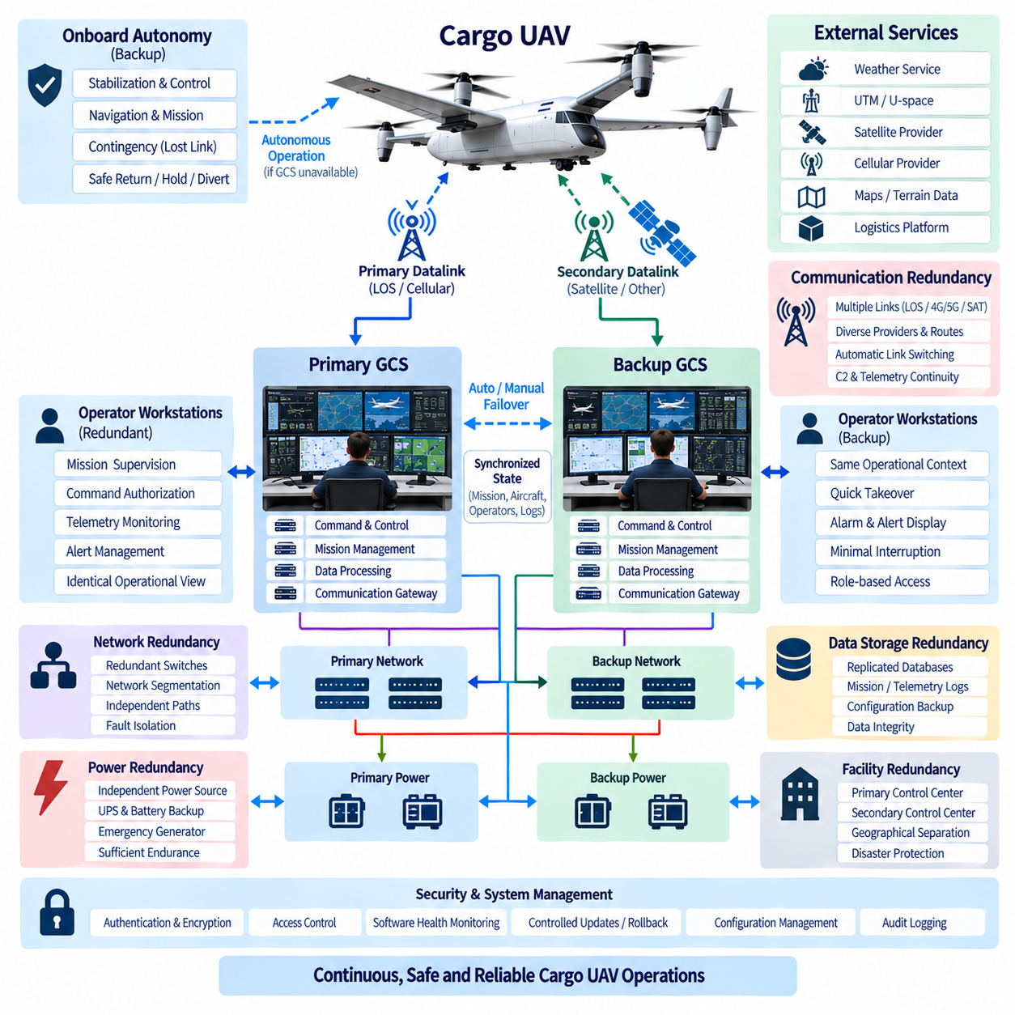
Ground Control Station redundancy is designed to preserve safe supervisory control when individual ground-system components fail. For cargo UAV operations, especially Beyond Visual Line of Sight missions, the GCS may remain responsible for mission supervision, command authorization, telemetry monitoring, contingency coordination, and operational communication. Redundancy must therefore address the complete control chain rather than simply installing a second operator workstation.
The redundancy architecture begins by identifying functions whose loss could prevent continued safe operation. These typically include command-and-control processing, aircraft telemetry reception, operator displays, mission management, datalink gateways, authentication services, operational databases, time synchronization, networking, and electrical power. Each function should be evaluated according to its failure consequence, required recovery time, and whether onboard autonomy can temporarily compensate for its loss.
A fundamental distinction exists between component redundancy and functional redundancy. Two identical computers may provide hardware redundancy, but they do not guarantee continued operation if both depend on the same network switch, power supply, software service, database, or communication gateway. Effective GCS redundancy therefore considers shared dependencies and common-cause failures across computing, communication, power, software, facilities, and external infrastructure.
Critical computing services can be implemented using primary and standby processing nodes. The primary node performs active mission and communication functions while the standby node maintains synchronized operational state and remains ready to assume responsibility. Depending on availability requirements, architectures may use active-standby or active-active configurations. The selected method must ensure that a failure does not create two independent systems simultaneously claiming command authority.
State synchronization is essential for successful failover. Aircraft position, flight mode, active mission version, waypoint progress, alerts, operator actions, command history, payload condition, communication status, and authorization state may need to remain consistent across redundant systems. A standby GCS that starts with outdated mission information can introduce new operational hazards even if its computing hardware itself is functioning correctly.
Redundant operator workstations provide continuity when a display computer, control device, or local application fails. However, workstation redundancy should preserve the same operational context rather than forcing an operator to reconstruct the mission manually. The alternate station should be able to recover aircraft state, active alerts, mission information, communication condition, and command authority so that operational supervision can continue with minimal interruption.
Command authority requires particularly careful treatment during redundancy transitions. Only one authorized control entity should normally possess active command authority for a specific aircraft at a given operational level. When control transfers between GCS computers, operator stations, or control centers, the system should explicitly revoke or suspend the previous authority before enabling the new authority. This prevents split-control conditions in which conflicting commands can reach the aircraft.
The datalink subsystem requires redundancy independent of GCS computing redundancy. A fully operational backup server provides little benefit if both primary and backup systems depend on a failed communication path. Line-of-Sight radio, cellular networks, satellite communication, and other qualified links can provide communication diversity. Link-management functions should detect degradation, select an alternate path, and preserve essential C2 and telemetry services whenever possible.
Communication redundancy should minimize common failure dependencies. Two modems connected to the same antenna, network provider, gateway, router, or power source may not constitute meaningful independence. Where safety objectives require greater availability, diversity can extend across antennas, radios, frequencies, network technologies, service providers, routing paths, and ground communication facilities. The appropriate level of independence depends on mission consequence and operational environment.
Network infrastructure inside the GCS also requires fault-tolerant design. Critical servers, operator stations, communication gateways, and storage systems may use redundant network interfaces and independent switches. Network segmentation should separate safety-relevant operational traffic from video, maintenance, administrative, and enterprise traffic. A failure or congestion event in a noncritical network domain should not remove the command-and-control path needed for aircraft supervision.
Electrical power is another major source of common-mode failure. Redundant computers connected to one unprotected electrical circuit can fail simultaneously when facility power is lost. Critical GCS equipment can therefore use independent power distribution, Uninterruptible Power Supplies, battery backup, and where required emergency generation. Power architecture should provide sufficient endurance for orderly transfer, continued mission supervision, or controlled termination of operations.
Data storage redundancy supports both operational continuity and post-mission traceability. Mission plans, aircraft configuration, command logs, telemetry, operator actions, alerts, authorization records, and system events should not depend on a single storage device. Replicated databases or redundant storage systems can preserve essential records after hardware failure while maintaining consistency between active and standby GCS services.
Software redundancy requires different considerations from hardware duplication. Identical software running on duplicated computers can still fail simultaneously because of the same software defect, corrupted configuration, incompatible update, or erroneous input. Redundancy design should therefore include software health monitoring, controlled deployment, rollback capability, configuration management, and isolation of failed services. Critical updates should not unintentionally disable both primary and standby systems at the same time.
Health monitoring provides the information needed to initiate failover before complete service loss. The GCS can monitor processor health, application status, memory utilization, network connectivity, datalink performance, storage condition, synchronization state, power availability, and external-service connectivity. Fault detection should distinguish transient degradation from persistent failure so that unnecessary switching does not itself destabilize the operational system.
Failover behavior should be deterministic and tested. When the primary service fails, the architecture must define which component detects the failure, how the standby system confirms that takeover is permitted, how command authority transfers, and how operators are notified. Recovery time should be consistent with the operational safety requirements. Automatic failover may be appropriate for infrastructure services, while transfer of flight command authority may require additional controlled logic.
The aircraft’s onboard autonomy forms an important layer of overall redundancy even though it is not physically part of the GCS. If both primary and backup ground-control functions temporarily become unavailable, the UAV should not lose stabilization, navigation, or immediate safety capability. Predefined lost-link behavior can maintain flight, hold, divert, return to base, or execute another approved contingency while the ground infrastructure attempts to recover.
Geographical redundancy extends protection beyond individual equipment failures. A secondary control center can protect against building power loss, fire, network outage, environmental damage, or other site-level failures affecting the primary GCS. The secondary facility requires synchronized mission information, compatible communication access, operator capability, security credentials, and a defined authority-transfer procedure before it can serve as a genuine operational backup.
Geographically separated control centers introduce additional synchronization and authority challenges. Both locations may receive aircraft telemetry, but simultaneous command capability should be tightly controlled. The system should identify which center is primary, which is standby, and under what conditions authority can transfer. Transfer events must be logged and visible to operators so that the operational organization maintains a single, unambiguous chain of control.
External services should not become hidden single points of failure. Weather providers, UTM or U-space services, cellular operators, satellite services, authentication infrastructure, mapping systems, and logistics platforms may support GCS operations. The architecture should determine which external dependencies are essential for continued flight and define degraded modes when those services become unavailable rather than assuming continuous external connectivity.
Cybersecurity must remain effective during redundant and degraded operation. Backup systems should not bypass authentication, encryption, access control, or command validation merely because the primary system has failed. Security credentials and cryptographic material must remain available through protected mechanisms, while redundant systems should be isolated sufficiently to prevent a compromised component from automatically compromising every backup resource.
Maintenance procedures must preserve redundancy availability. Taking one server, communication link, power channel, or workstation offline for maintenance reduces the remaining fault tolerance and may change the permitted operational state. The GCS should therefore identify when redundancy has been degraded and communicate that condition to operators. Certain cargo missions may require full redundancy before departure, while others may permit operation under defined restrictions.
Redundancy verification requires deliberate fault-injection and recovery testing rather than confirmation that duplicate equipment exists. Tests should include server failure, workstation loss, switch failure, datalink interruption, database failure, power loss, synchronization error, communication handover, and control-center transfer. The objective is to verify that the entire operational function survives the failure with correct state, authority, alerts, and data integrity.
As cargo UAVs scale from 2.5-ton to 5-ton and 10-ton-class platforms, the required GCS resilience becomes increasingly significant. Larger payloads, longer routes, BVLOS operation, and higher operational consequences can justify stronger independence between computing, communication, power, and control facilities. Redundancy should therefore evolve according to aircraft risk and operational assurance requirements rather than being applied as identical duplication to every subsystem.
A mature GCS redundancy architecture combines redundant computing, operator interfaces, datalinks, networks, storage, power, security services, and potentially geographically separated control centers with onboard autonomous contingency capability. Its central objective is controlled continuity: failures must be detected, authority must remain unambiguous, operational state must remain synchronized, and essential supervision must either continue or transition safely to a predefined degraded mode.

