Volume 18. Cargo UAV Architecture

Chapter 03. Aerospace Protocols

03.01. ARINC 429 in UAV
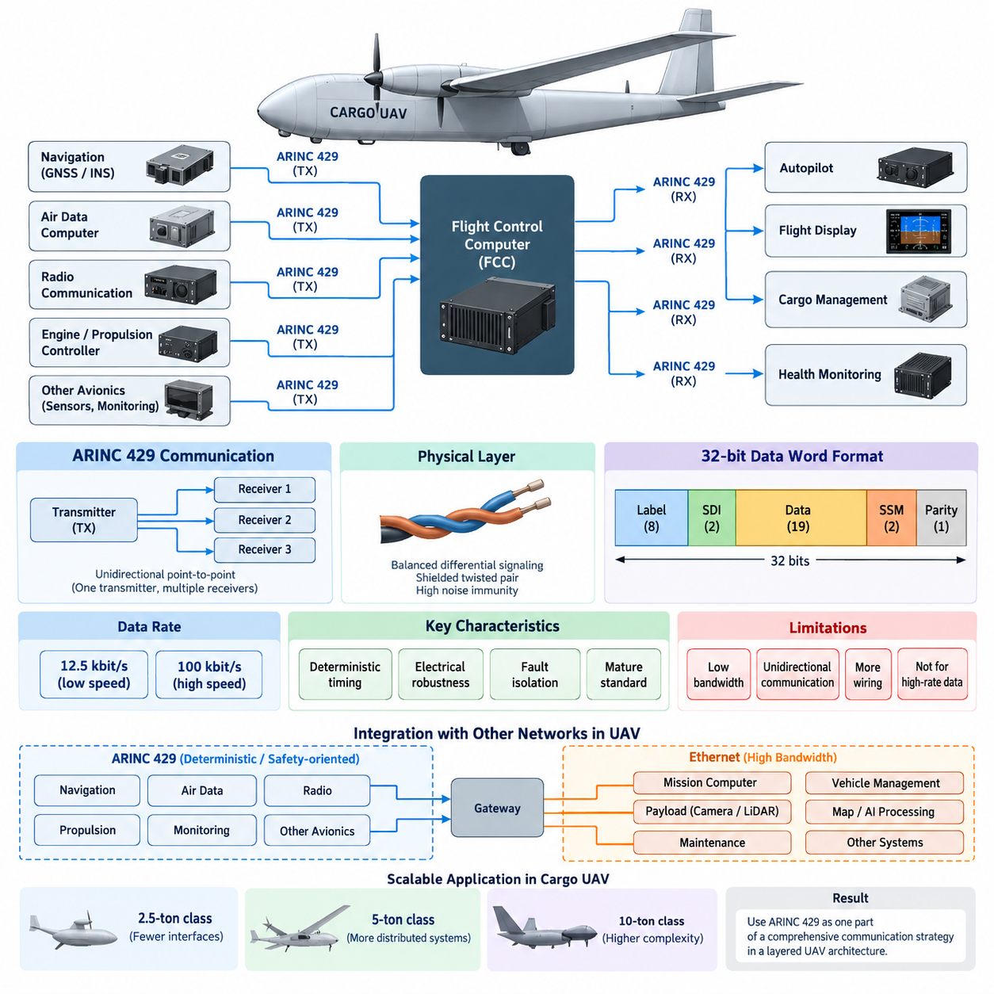
ARINC 429 is a mature digital data bus standard widely used in civil avionics for transferring deterministic, low-rate information between aircraft subsystems. In a cargo UAV, it can provide a simple and predictable interface among flight-control computers, navigation units, air-data systems, engine or propulsion controllers, monitoring equipment, and selected mission avionics. Its value lies less in bandwidth than in stable timing, electrical robustness, and well-established avionics integration practices.
The basic ARINC 429 architecture uses a unidirectional point-to-point communication model. One transmitter can distribute information to multiple receivers, but information does not travel back through the same connection. Bidirectional communication therefore requires separate transmit and receive channels. This arrangement increases wiring compared with shared-bus networks, yet it provides strong communication isolation and makes the direction and ownership of each data flow straightforward to analyze.
At the physical layer, ARINC 429 normally uses a balanced differential signaling pair that improves resistance to electromagnetic interference in electrically noisy aircraft environments. Shielded twisted-pair wiring is commonly associated with the interface, while differential signaling helps suppress common-mode disturbances. These characteristics are important in cargo UAVs containing high-power propulsion inverters, electric motors, DC/DC converters, switching power electronics, radios, and other potential electromagnetic noise sources.
ARINC 429 communication is based on 32-bit words rather than variable-length network packets. A word contains fields that identify the transmitted parameter and provide associated data, source or destination information where applicable, status information, and parity protection. The Label field identifies the meaning of the data, while the Sign/Status Matrix can communicate validity or operating state. This fixed word organization simplifies receiver implementation and supports predictable processing behavior.
Two standard data rates are commonly associated with ARINC 429: approximately 12.5 kbit/s for low-speed operation and 100 kbit/s for high-speed operation. These rates are extremely modest compared with modern Ethernet-based avionics networks, but many flight-critical parameters do not require high bandwidth. Airspeed, altitude, heading, navigation status, temperatures, pressures, actuator states, and system-health values can often be represented efficiently as periodically transmitted compact data words.
Determinism is one of the important reasons ARINC 429 remains useful in avionics. A transmitter sends predefined parameters at controlled repetition intervals, allowing the receiving system to anticipate when important information should appear. There is no complex shared-medium arbitration among many nodes. For UAV flight-control architecture, this predictable behavior can simplify timing analysis for navigation inputs, air-data measurements, equipment status, and other signals whose update periods must remain bounded and understandable.
ARINC 429 also provides useful fault containment because communication channels are physically separated. A malfunctioning receiver normally cannot seize a shared network and prevent unrelated equipment from communicating. Likewise, carefully partitioned transmitter channels can limit the propagation of interface failures. In redundant UAV avionics, independent ARINC 429 channels may therefore support separation between redundant flight-control, navigation, monitoring, or propulsion-related paths when the system architecture requires such isolation.
A cargo UAV can employ ARINC 429 selectively rather than using it as the only onboard network. Navigation equipment, GNSS/INS units, air-data computers, radio equipment, or certified avionics modules may expose ARINC 429 interfaces, while higher-bandwidth sensors and computing systems use Ethernet-based communication. The resulting aircraft becomes a heterogeneous network in which ARINC 429 serves deterministic legacy or safety-oriented interfaces and faster networks carry data-intensive information.
Interface design must consider more than simply connecting a transmitter to a receiver. Engineers must define the required labels, data representation, transmission rate, repetition interval, source/destination conventions, status interpretation, parity handling, timeout behavior, and response to invalid or missing information. The receiving software must distinguish between a physically valid word and operationally trustworthy data, because successful electrical reception does not necessarily mean that the associated sensor or subsystem is healthy.
Data representation can use formats such as Binary Coded Decimal or binary numerical encoding depending on the parameter and equipment interface definition. Scaling, resolution, range, sign conventions, units, and validity states must be specified consistently between transmitting and receiving equipment. A mismatch in interpretation can produce plausible but incorrect engineering values, making interface-control documentation and verification especially important when integrating avionics supplied by multiple vendors.
For redundant flight-control systems, identical information may be obtained through independent channels from redundant sensors or avionics units. The Flight Control Computer can monitor these sources, detect missing or invalid words, compare redundant measurements, and apply system-level voting or selection logic. ARINC 429 itself does not create redundancy or perform fault voting; it provides communication channels upon which the aircraft designer can construct a redundant avionics architecture.
The protocol has important limitations for advanced autonomous UAVs. Its 100 kbit/s maximum conventional operating rate is unsuitable for cameras, LiDAR point clouds, high-rate radar information, large maps, AI perception tensors, software updates, or other data-intensive workloads. Extensive point-to-point wiring can also increase harness mass, connector count, installation complexity, and maintenance effort as the number of communicating subsystems grows, which becomes increasingly significant in large distributed aircraft architectures.
For this reason, ARINC 429 and modern Ethernet technologies can occupy complementary roles. ARINC 429 can remain appropriate for relatively small, periodic, deterministic avionics parameters, while ARINC 664/AFDX or other deterministic Ethernet approaches can support greater network aggregation and bandwidth. Conventional Ethernet may additionally serve mission computers, payload systems, maintenance interfaces, and non-flight-critical data domains when the safety architecture permits their use and provides suitable separation.
Gateway devices become important when ARINC 429 equipment must exchange information with Ethernet-based flight computers or vehicle-management networks. A gateway receives ARINC words, validates and interprets them, maps the parameters into the destination network representation, and performs the reverse transformation when required. Such gateways must preserve data semantics, update timing, validity information, and failure behavior rather than merely converting electrical signals between two physical interfaces.
In electrically powered cargo UAVs, network design must be coordinated with electromagnetic compatibility engineering. ARINC 429 harnesses should be routed with appropriate separation from high-current propulsion cables and switching-power conductors, while shielding, grounding, connector termination, and bonding practices must be considered at aircraft level. Communication reliability therefore depends not only on protocol logic but also on physical installation, harness engineering, power architecture, and EMC verification.
Health monitoring should supervise both the communicated parameter and the communication path itself. Flight software can detect stale information through reception timeouts, identify invalid status indications, record parity or interface errors, and compare redundant sources. These mechanisms allow communication faults to become explicit system states that can trigger degraded operating modes, sensor substitution, mission restrictions, return-to-base behavior, or other responses defined by the UAV safety architecture.
The relevance of ARINC 429 changes as cargo UAV size and complexity increase. A smaller 2.5-ton-class aircraft may use relatively few conventional avionics interfaces, whereas 5-ton and 10-ton platforms can contain more distributed flight-control, propulsion, energy-management, navigation, cargo, and communication equipment. As network complexity grows, using ARINC 429 everywhere becomes inefficient, encouraging a layered architecture that combines specialized deterministic interfaces with higher-capacity backbone networks.
Within the broader cargo UAV architecture, ARINC 429 should therefore be understood as one component of an aerospace communication strategy rather than as a universal network. Its strengths are simplicity, predictable data transfer, electrical robustness, mature avionics practice, and effective point-to-point isolation. Its weaknesses are limited bandwidth, one-way communication, and increasing wiring burden, making careful protocol allocation essential as autonomous cargo aircraft evolve toward larger and more integrated avionics systems.

03.02. ARINC 664 (AFDX) in UAV
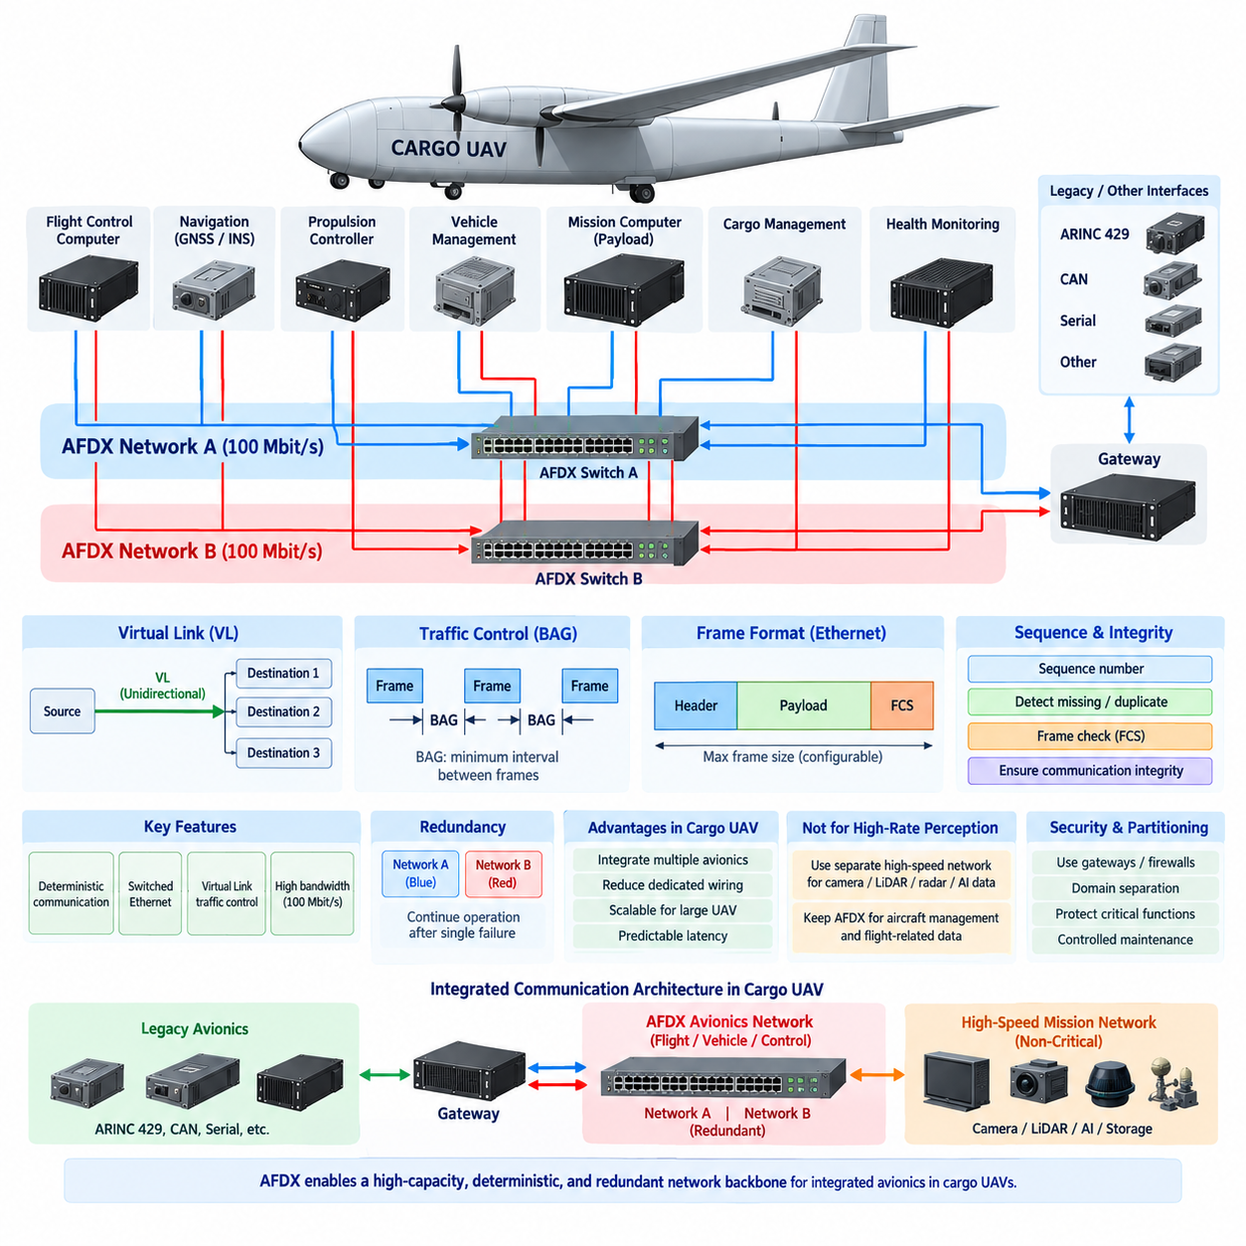
ARINC 664 Part 7, commonly associated with Avionics Full-Duplex Switched Ethernet (AFDX), provides a deterministic Ethernet-based communication architecture for integrated avionics systems. In a cargo UAV, AFDX can form a high-capacity backbone connecting flight-control computers, navigation systems, propulsion controllers, vehicle-management computers, mission systems, and gateways while maintaining predictable communication behavior required by critical airborne applications.
Unlike ARINC 429, which primarily relies on dedicated unidirectional point-to-point links, AFDX uses a switched Ethernet architecture. End systems connect to network switches through full-duplex links, allowing simultaneous transmission and reception without Ethernet collisions. This topology reduces the need for numerous dedicated signal paths and enables many avionics functions to share a structured network infrastructure while remaining logically separated through controlled communication channels.
The fundamental communication abstraction in AFDX is the Virtual Link (VL). A Virtual Link defines a logical unidirectional connection from one transmitting end system to one or more receiving end systems. Each VL is configured with known traffic characteristics and destinations. This allows multiple avionics applications to share physical Ethernet links while maintaining controlled information flows, making network behavior easier to analyze than conventional best-effort Ethernet communication.
Traffic control is achieved partly through the Bandwidth Allocation Gap (BAG), which defines the minimum interval between successive frames transmitted on a Virtual Link. Combined with limits on frame size, BAG constrains the bandwidth that each VL can consume. This traffic-shaping mechanism prevents one application from transmitting unlimited traffic and interfering with other network users, supporting predictable latency and bounded network utilization across the avionics communication infrastructure.
AFDX commonly operates using 100 Mbit/s full-duplex Ethernet links, providing substantially greater capacity than the 100 kbit/s high-speed mode of ARINC 429. The increased bandwidth makes AFDX suitable for integrated avionics containing larger quantities of navigation, control, health-monitoring, mission, and aircraft-management data. Nevertheless, AFDX is designed primarily for controlled avionics networking rather than unrestricted transfer of extremely high-rate perception data such as raw camera streams.
Network redundancy is a major architectural feature of AFDX. Critical end systems can communicate through two physically separate networks, conventionally identified as Network A and Network B. Identical frames may be transmitted across both paths, and the receiving end system can accept the first valid copy while rejecting the duplicate. This approach allows communication to continue when a cable, connector, switch, or network path experiences a single failure.
Sequence numbers and integrity mechanisms help receiving systems detect abnormal communication behavior. The receiver can identify duplicate, missing, or incorrectly ordered frames and apply acceptance rules defined by the communication architecture. Ethernet frame checking also provides error detection at the data-link level. These mechanisms do not replace system-level safety monitoring, but they provide important evidence about communication integrity and support fault detection within distributed avionics systems.
Deterministic behavior distinguishes AFDX from ordinary enterprise Ethernet. Conventional Ethernet networks are often designed primarily for throughput and interoperability, whereas critical avionics require bounded latency, controlled bandwidth, known communication paths, and analyzable failure behavior. By predefining Virtual Links, traffic parameters, switch configurations, and receiving destinations, engineers can evaluate whether critical messages reach their destinations within the timing requirements established by the aircraft system design.
An AFDX end system provides the interface between an avionics application and the switched network. Flight-control computers, navigation computers, propulsion-management systems, or other equipment generate application data that the end system prepares for network transmission. At the receiving side, the end system validates incoming traffic and delivers appropriate information to applications. This separation helps maintain controlled network behavior while allowing distributed avionics functions to communicate through standardized Ethernet technology.
AFDX switches forward frames according to predefined network configuration rather than treating all traffic as unrestricted general-purpose Ethernet communication. Network engineering therefore includes Virtual Link allocation, routing configuration, bandwidth analysis, switch-port assignment, redundancy planning, and latency verification. The communication database becomes an important engineering artifact because incorrect configuration can affect multiple interconnected functions even when the physical network hardware itself is operating normally.
For a cargo UAV, AFDX can provide the central avionics backbone while specialized interfaces remain at subsystem boundaries. A GNSS/INS unit or air-data computer may communicate through ARINC 429, while a gateway converts selected parameters for distribution over AFDX. Flight-control, propulsion, energy-management, cargo-management, and health-monitoring computers can then exchange information through the backbone without requiring dedicated wiring between every pair of communicating devices.
This gateway-based architecture is especially useful during migration from conventional avionics toward more integrated UAV systems. Existing certified equipment does not necessarily need to be redesigned simply because the aircraft adopts an Ethernet backbone. ARINC 429, CAN, serial interfaces, or other subsystem protocols can remain where appropriate, while gateways translate selected information into the AFDX domain. The aircraft can therefore evolve incrementally while preserving suitable legacy interfaces.
AFDX should also be distinguished from ordinary high-bandwidth mission Ethernet. Autonomous cargo UAVs may contain cameras, LiDAR, radar, AI accelerators, mission computers, and storage systems generating data volumes far beyond traditional avionics requirements. Such workloads may be assigned to separate high-speed Ethernet networks, while AFDX carries controlled aircraft-management and flight-related information. Network separation prevents data-intensive perception workloads from consuming communication resources reserved for critical avionics functions.
Cybersecurity and partitioning become increasingly important as UAV avionics integrate flight-critical, mission, maintenance, and external communication domains. AFDX Virtual Links provide structured communication paths, but they should not be interpreted as a complete cybersecurity solution. Gateways, firewalls, secure boot mechanisms, authenticated software, controlled maintenance interfaces, and domain separation may still be required to prevent unauthorized traffic or compromised mission systems from affecting critical aircraft functions.
Physical network design remains important despite the transition from dedicated avionics buses to Ethernet. Cable selection, connector design, shielding, grounding, routing, switch placement, power redundancy, and electromagnetic compatibility must be engineered for the aircraft environment. In electric and hybrid cargo UAVs, network cables may operate near propulsion inverters, motors, generators, battery systems, and high-power converters, requiring careful EMC design to preserve reliable communication under demanding operating conditions.
Network timing analysis must consider more than nominal link speed. Engineers evaluate frame sizes, BAG values, switch delays, traffic aggregation, Virtual Link routing, end-system processing, redundancy behavior, and worst-case network loading. The objective is not simply to demonstrate that average communication is fast, but to establish that required information remains within defined latency and jitter limits under the network conditions considered by the aircraft safety and verification process.
Health monitoring can supervise end systems, switches, redundant network paths, Virtual Links, frame sequence behavior, and communication timeouts. Detected faults can be reported to vehicle-management or maintenance systems and associated with predefined degraded modes. A cargo UAV may continue operation using one redundant network after a single network failure, while additional failures can trigger mission restrictions, diversion, return-to-base, controlled landing, or other responses defined by the safety architecture.
As cargo UAVs progress from 2.5-ton to 5-ton and eventually 10-ton classes, the number of distributed avionics functions can increase substantially. More propulsion channels, energy-management units, cargo systems, redundant flight computers, navigation equipment, and health-monitoring functions create growing communication requirements. A switched backbone such as AFDX becomes increasingly attractive because it can consolidate many controlled data flows without requiring a separate physical point-to-point interface for every communicating subsystem.
ARINC 664/AFDX should therefore be viewed as an integrated avionics backbone technology rather than merely a faster replacement for ARINC 429. ARINC 429 remains effective for simple deterministic equipment interfaces, while AFDX provides higher bandwidth, network aggregation, Virtual Link traffic control, switched communication, and redundant network paths. In a large autonomous cargo UAV, combining these technologies with separate high-bandwidth mission networks can create a layered communication architecture balancing determinism, scalability, fault tolerance, and data capacity.

03.03. MIL-STD-1553 Legacy
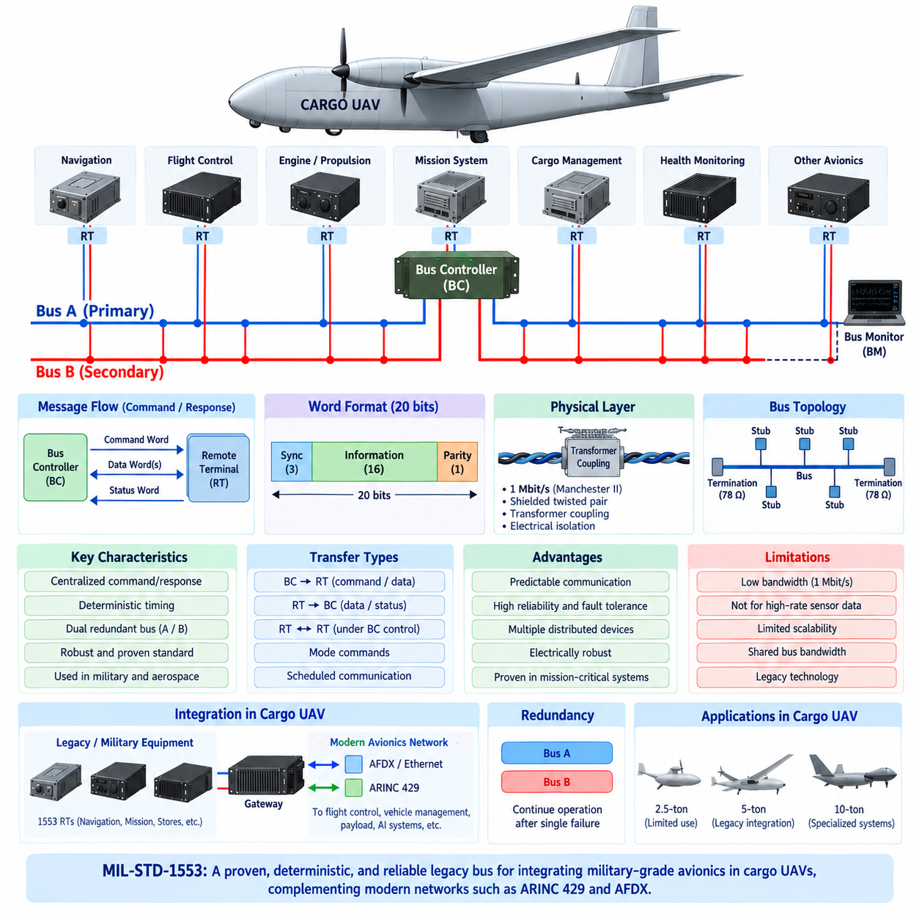
MIL-STD-1553 is a command/response digital data bus originally developed for military avionics and remains important as a legacy communication technology in aircraft, spacecraft, missiles, and specialized unmanned systems. In a cargo UAV architecture, it is most relevant when integrating proven military-grade avionics, mission equipment, navigation units, stores-related systems, or existing subsystems that already implement the standard rather than as the default network for a new high-bandwidth design.
The architecture is fundamentally different from modern switched Ethernet. MIL-STD-1553 uses a shared bus controlled by a centralized Bus Controller (BC). Multiple Remote Terminals (RTs) connect to the bus and exchange information only according to commands issued by the Bus Controller. A Bus Monitor (BM) may observe communication without controlling normal traffic. This centralized organization provides highly predictable communication sequencing and prevents terminals from transmitting arbitrarily onto the shared medium.
The Bus Controller is responsible for managing communication schedules and initiating data transfers. It sends command words specifying the intended Remote Terminal, transfer direction, subaddress, and amount of data involved. The addressed terminal responds according to the requested transaction. Because communication is initiated under centralized control, system designers can construct a known message schedule and analyze the timing of important avionics exchanges with relatively high confidence.
Remote Terminals provide interfaces between the shared MIL-STD-1553 bus and individual avionics subsystems. An RT may represent a navigation computer, flight-control subsystem, actuator controller, mission device, sensor interface, or other equipment. Each terminal interprets commands addressed to it, transfers requested data, and reports status information. This arrangement allows multiple distributed devices to participate in one controlled avionics network without independently competing for access to the communication medium.
MIL-STD-1553 communication uses three principal word types: Command Words, Data Words, and Status Words. Each word is 20 bits on the physical transmission medium, consisting of a synchronization field, 16 information bits, and a parity bit. Command Words define transactions, Data Words carry application information, and Status Words allow Remote Terminals to report their operating or communication condition back to the Bus Controller.
The standard operates at a nominal data rate of 1 Mbit/s using Manchester II bi-phase encoding. Although this bandwidth is very low compared with modern Ethernet networks, it was sufficient for many traditional avionics functions involving control commands, discrete states, navigation parameters, equipment status, and moderate-rate sensor information. Its signaling method also supports reliable clock recovery and robust operation in electrically demanding aerospace environments.
A major feature of MIL-STD-1553 is dual-redundant bus architecture. Systems commonly provide two physical buses, typically identified as Bus A and Bus B. Normal communication may occur on one bus while the second provides an alternate path if the active bus experiences a failure. This redundancy improves fault tolerance against wiring, connector, coupler, or other communication-path failures and became one reason for the standard's widespread use in mission-critical platforms.
Terminals normally connect to the main bus through coupling arrangements rather than simply attaching arbitrary wiring branches. Transformer coupling is widely used because it provides electrical isolation and helps reduce the effect of terminal or stub faults on the primary bus. Bus topology, stub length, termination, impedance, shielding, and coupling design therefore become important physical-layer engineering considerations when integrating MIL-STD-1553 equipment into an aircraft.
Determinism is one of the strongest characteristics of MIL-STD-1553. Since the Bus Controller decides when transactions occur, Remote Terminals cannot independently generate uncontrolled traffic. Critical messages can be scheduled according to predefined timing requirements, and lower-priority transfers can be placed around them. This behavior is particularly useful for systems where predictable control communication and analyzable worst-case timing are more important than high throughput.
The protocol supports several transfer patterns, including communication from the Bus Controller to a Remote Terminal, from a Remote Terminal to the Bus Controller, and transfers involving two Remote Terminals under Bus Controller supervision. Mode commands provide additional control and management functions. Regardless of transaction type, the centralized command/response philosophy remains fundamental, giving the Bus Controller authority over communication activity across the shared network.
Error detection and status reporting are integral to communication operation. Parity checking, expected response behavior, word validation, timing supervision, and terminal status information allow the system to recognize many abnormal conditions. The Bus Controller can detect missing responses or communication errors and may retry transactions, use the redundant bus, isolate problematic equipment, or report faults to higher-level vehicle-management and maintenance functions according to the system design.
For a modern cargo UAV, the principal limitation of MIL-STD-1553 is bandwidth. A 1 Mbit/s shared bus is unsuitable for camera imagery, LiDAR point clouds, high-resolution radar data, large mission databases, AI perception streams, or other data-intensive autonomous functions. Even where the protocol remains valuable for command and control, these high-rate workloads require Ethernet or another higher-capacity network specifically designed for modern sensor and computing traffic.
Scalability is another consideration. Adding many devices and increasing their update rates consumes the finite communication schedule of the shared bus. As aircraft functionality expands, designers must carefully allocate bus time among critical and noncritical messages. This differs significantly from switched network architectures in which multiple physical links can operate simultaneously. Consequently, MIL-STD-1553 is better suited to controlled legacy integration than unrestricted expansion of data-intensive UAV architectures.
A cargo UAV may therefore employ MIL-STD-1553 through a gateway connected to a newer avionics backbone. Existing military or aerospace equipment can remain on a local 1553 bus, while the gateway translates selected commands, status information, and application data into ARINC 664/AFDX or another aircraft network. This preserves compatibility with proven equipment while preventing a legacy 1 Mbit/s bus from becoming the bandwidth constraint for the entire vehicle architecture.
Gateway engineering must preserve more than the numerical value of transferred data. Command/response semantics, message timing, equipment status, timeout behavior, bus selection, validity information, and fault conditions must be mapped correctly into the destination network. A poorly designed gateway can hide failures or introduce timing behavior that did not exist in the original interface, so protocol conversion must be treated as a system-level avionics integration function.
MIL-STD-1553, ARINC 429, and AFDX illustrate three different approaches to deterministic aerospace communication. ARINC 429 emphasizes simple unidirectional point-to-point transmission, MIL-STD-1553 uses centralized command/response communication over a shared redundant bus, and AFDX applies controlled Virtual Links over switched Ethernet. Understanding these architectural differences is more important than comparing their nominal data rates alone when selecting interfaces for a cargo UAV.
Physical integration also requires careful electromagnetic compatibility engineering. Shielded cabling, controlled impedance, correct termination, transformer coupling, grounding, connector selection, and separation from high-power conductors affect communication reliability. This becomes especially significant in electric or hybrid cargo UAVs containing propulsion motors, inverters, generators, battery systems, DC/DC converters, and other switching devices capable of producing substantial electromagnetic interference.
Health monitoring can supervise Bus Controller operation, Remote Terminal responses, bus errors, redundant-bus availability, timeouts, and equipment status. Repeated failures can be associated with maintenance records or system-level degraded modes. Depending on the safety architecture, loss of one bus may permit continued operation on the redundant path, while loss of critical terminals or both communication paths may trigger mission restriction, return-to-base, diversion, or controlled landing.
As cargo UAV architectures evolve from 2.5-ton to 5-ton and 10-ton platforms, MIL-STD-1553 is unlikely to serve efficiently as the primary network for all newly developed avionics and autonomous systems. Its strongest role is instead likely to remain at legacy or specialized subsystem boundaries where compatibility, deterministic control, proven equipment, and robust fault containment are more important than bandwidth, network flexibility, or support for large data streams.
MIL-STD-1553 should therefore be regarded as a durable legacy aerospace protocol with continuing integration value rather than an obsolete technology that must always be removed. In a layered cargo UAV communication architecture, 1553 can support existing deterministic command-and-control equipment, ARINC 429 can serve selected point-to-point avionics interfaces, AFDX can provide the integrated avionics backbone, and separate high-speed networks can carry perception, AI, payload, and storage traffic.

03.04. TT-Ethernet in UAV
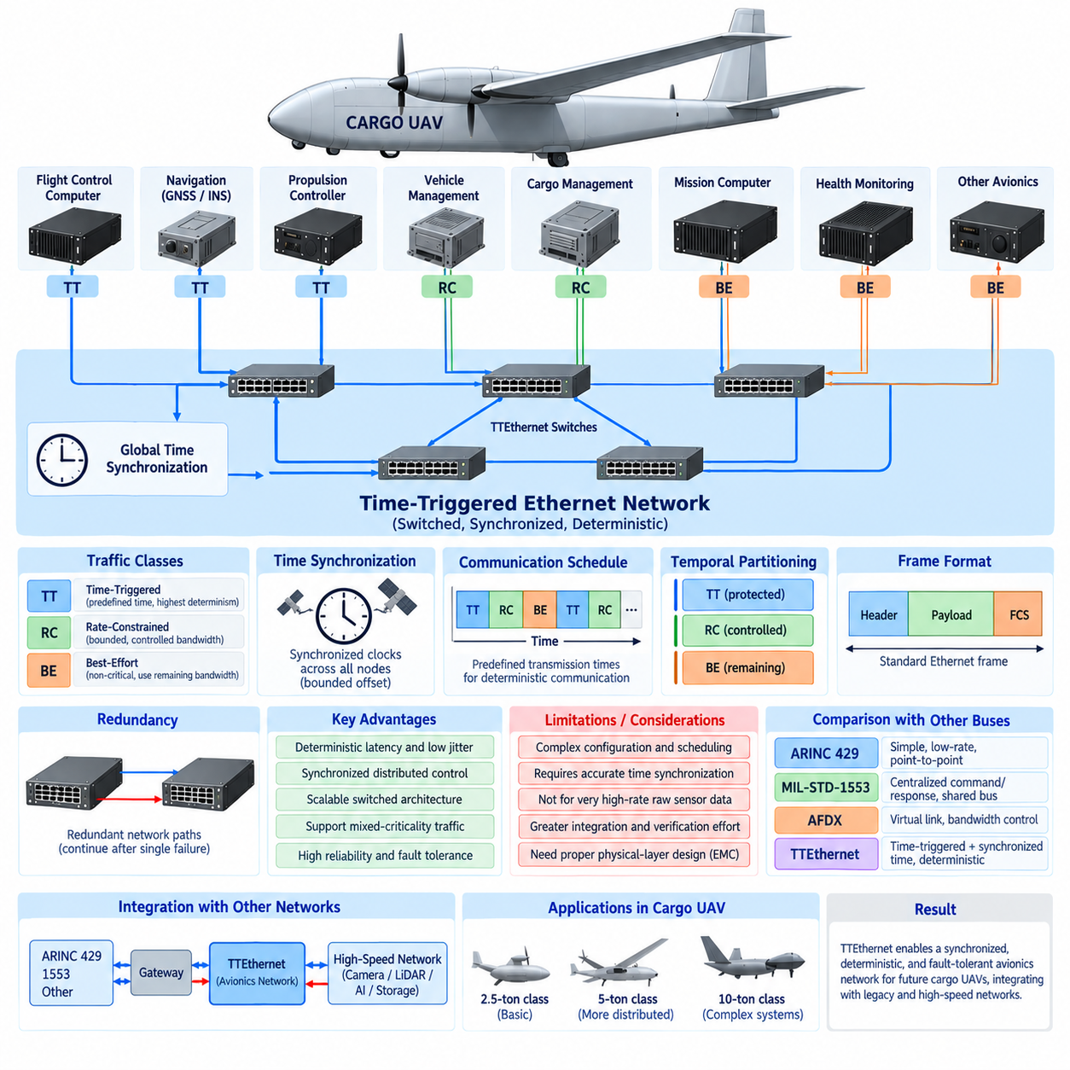
Time-Triggered Ethernet (TTEthernet) extends standard Ethernet with deterministic communication mechanisms designed for distributed systems that require tightly controlled timing and fault tolerance. In a cargo UAV, it can provide a synchronized communication backbone for flight-control computers, navigation systems, propulsion controllers, vehicle-management computers, and other safety-critical avionics while also supporting less time-critical traffic on the same physical network infrastructure.
The central concept of TTEthernet is that communication can be coordinated according to a predefined global time schedule. Instead of allowing every device to transmit whenever network access becomes available, critical messages are assigned specific transmission opportunities. This time-triggered behavior makes message latency and jitter highly predictable, which is valuable for flight-control loops, synchronized sensor processing, actuator commands, and distributed control functions requiring precise temporal coordination.
TTEthernet commonly distinguishes among Time-Triggered (TT), Rate-Constrained (RC), and Best-Effort (BE) traffic classes. TT traffic receives predefined transmission times and is intended for the most deterministic communication. RC traffic provides bounded communication behavior without requiring an exact global transmission instant. BE traffic resembles conventional Ethernet and can carry noncritical information using network capacity that remains available after higher-priority deterministic communication requirements are satisfied.
Time synchronization is fundamental to TT communication. Network participants maintain a coordinated notion of time so that scheduled transmissions and receptions occur within defined temporal windows. Synchronization protocols compensate for differences among local clocks and maintain bounded clock offsets across distributed equipment. For a UAV containing multiple flight-control and vehicle-management computers, this shared time base can support coordinated execution and consistent interpretation of time-sensitive information across the aircraft.
A TTEthernet network typically consists of end systems connected through Ethernet switches. End systems interface avionics applications with the network, while switches forward traffic according to configured timing and routing rules. Because switched links allow multiple communications to occur simultaneously, the architecture scales more effectively than traditional shared buses and can support distributed avionics without requiring an individual physical connection between every pair of communicating subsystems.
The predefined communication schedule is an important engineering artifact. Designers determine when critical frames are transmitted, which path they follow, when switches forward them, and when receiving systems should expect them. Schedule generation must consider message periods, frame sizes, link capacities, switch delays, processing times, and interactions among traffic classes. Correct scheduling can provide bounded end-to-end latency even when many distributed avionics functions share the network.
TTEthernet also emphasizes temporal partitioning. Critical TT traffic can be protected from interference caused by less critical network communication because transmission opportunities are allocated according to the configured schedule. A mission computer generating large amounts of ordinary Ethernet traffic should therefore not be allowed to delay a scheduled flight-control message. This separation is especially valuable when avionics of different criticality levels share portions of the same communication infrastructure.
Fault tolerance can be strengthened through redundant network paths. Critical messages may be transmitted through physically independent switches, links, or network channels so that a single communication-path failure does not immediately eliminate required information exchange. Redundant flight-control computers can receive equivalent data through independent routes, while system-level logic supervises path availability and determines how communication should continue after detected failures.
Fault-tolerant clock synchronization is another important aspect of time-triggered architectures. A distributed system cannot depend safely on a global schedule if one faulty clock can arbitrarily disturb the timing of all participants. Synchronization mechanisms therefore need to tolerate specified faults and maintain a sufficiently consistent global time base. This capability becomes particularly important in redundant flight-control architectures where multiple computing channels must remain temporally coordinated.
Deterministic Ethernet can benefit distributed flight-control functions. Sensor measurements can be sampled, transferred, processed, and converted into actuator commands according to coordinated timing relationships. Instead of treating network delay as an unpredictable variable, designers can include known communication timing within control-system analysis. This supports architectures in which flight-control, propulsion-control, energy-management, and actuator functions are distributed among several computing nodes.
For autonomous cargo UAVs, synchronized networking can also support sensor fusion. IMU, GNSS, air-data, radar, and other measurements are most useful when their acquisition times are accurately known. A common time framework can improve temporal alignment among distributed sensors and processing computers. However, network synchronization does not eliminate the need for sensor timestamping, calibration, latency characterization, and application-level handling of measurement uncertainty.
TTEthernet should not automatically be used to transport every high-volume data source. Raw camera streams, dense LiDAR point clouds, AI tensors, mapping data, and large storage transfers can require substantial bandwidth and may have different determinism requirements from flight-control traffic. A cargo UAV can therefore separate safety-critical deterministic networking from dedicated high-speed perception and mission networks while exchanging selected processed information through controlled gateways.
Compared with ARINC 429, TTEthernet provides far greater opportunities for network aggregation and bidirectional communication through switched Ethernet. ARINC 429 remains attractive for simple, low-rate, point-to-point avionics interfaces, whereas TTEthernet can connect many distributed computing systems through a common backbone. The tradeoff is increased configuration, synchronization, scheduling, verification, and integration complexity compared with the comparatively simple behavior of an ARINC 429 channel.
The architectural difference from MIL-STD-1553 is equally significant. MIL-STD-1553 achieves deterministic behavior through centralized command/response control over a shared bus, while TTEthernet obtains strong temporal determinism through synchronized time-triggered communication across switched links. The Ethernet architecture offers substantially greater scalability for distributed computing, although legacy 1553 equipment may remain valuable at subsystem boundaries and can be integrated through gateways.
TTEthernet and ARINC 664/AFDX are both deterministic Ethernet approaches, but their fundamental traffic-control philosophies differ. AFDX primarily controls communication through configured Virtual Links and bandwidth constraints such as the Bandwidth Allocation Gap. TTEthernet can add explicit time-triggered transmission schedules and synchronized global time. This makes it particularly attractive where extremely low jitter and tightly coordinated distributed execution are architectural priorities.
Network design must still account for physical-layer reliability. Cable routing, shielding, grounding, connector selection, switch placement, redundant power, and electromagnetic compatibility remain critical in electric or hybrid cargo UAVs. Propulsion inverters, motors, generators, high-voltage batteries, and power converters can create electrically harsh environments, so deterministic protocol behavior alone cannot compensate for poor physical installation or inadequate EMC engineering.
Verification of a time-triggered network requires more than measuring average throughput. Engineers must confirm synchronization accuracy, scheduled transmission windows, end-to-end latency, jitter, redundant-path behavior, switch configuration, traffic-class isolation, and response to network faults. Timing analysis should include worst-case conditions because the value of deterministic networking lies in demonstrating bounded behavior rather than simply achieving high average communication performance.
Health monitoring can supervise synchronization status, switch operation, communication links, missed frames, timing violations, redundant paths, and end-system availability. Detected abnormalities can be reported to vehicle-management and maintenance functions. Depending on system criticality, the aircraft may isolate a faulty network component, transition to a redundant communication path, enter a degraded operating mode, return to base, or perform a controlled landing.
As cargo UAV platforms grow from 2.5-ton to 5-ton and 10-ton classes, distributed control complexity can increase considerably. Larger aircraft may contain multiple propulsion channels, redundant flight computers, distributed power and energy controllers, cargo-management systems, navigation computers, and health-monitoring nodes. A synchronized switched network can coordinate these functions while avoiding the rapidly increasing wiring burden associated with extensive point-to-point communication.
TTEthernet should therefore be considered a candidate architecture for future cargo UAVs requiring tightly synchronized, deterministic, fault-tolerant communication among distributed avionics systems. It does not eliminate ARINC 429, MIL-STD-1553, AFDX, or conventional Ethernet; instead, these technologies can occupy different layers and subsystem boundaries. A carefully partitioned architecture can combine legacy interfaces, deterministic avionics networking, and high-speed mission networks according to bandwidth, timing, safety, and integration requirements.

03.05. Protocol Selection Matrix
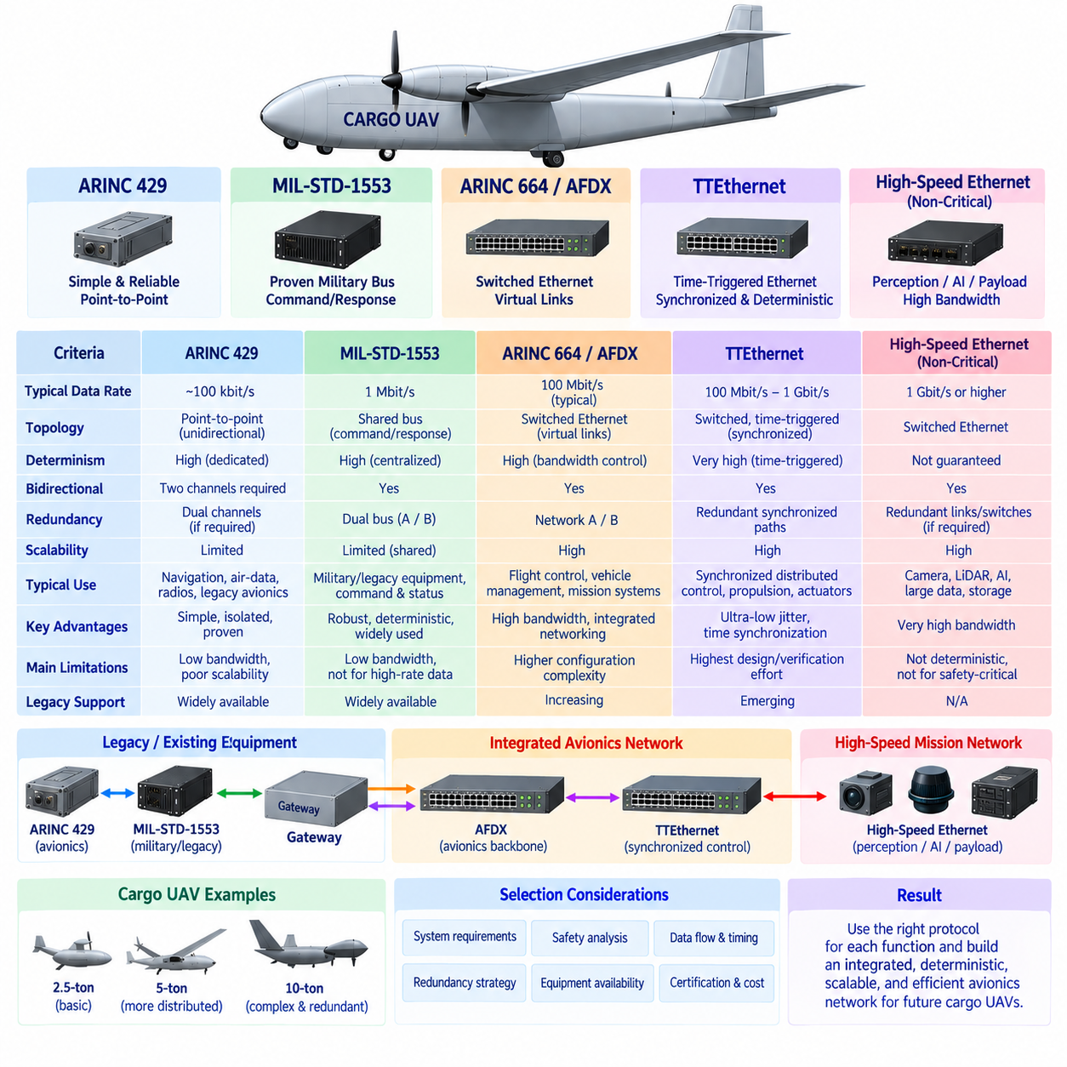
A protocol selection matrix for cargo UAV avionics should evaluate communication technologies according to system function rather than assuming that one network can efficiently satisfy every requirement. ARINC 429, ARINC 664/AFDX, MIL-STD-1553, and Time-Triggered Ethernet represent different architectural philosophies, ranging from simple point-to-point links to synchronized switched networks. The appropriate choice depends on bandwidth, determinism, redundancy, scalability, legacy compatibility, wiring, and safety requirements.
ARINC 429 is most suitable when communication requirements are simple, deterministic, and relatively low in bandwidth. Its unidirectional point-to-point architecture provides clear data ownership, strong channel isolation, and straightforward failure analysis. Navigation units, air-data equipment, radios, and established avionics modules can therefore remain practical ARINC 429 candidates, particularly when these devices already provide certified or proven interfaces using the standard.
The principal disadvantage of ARINC 429 is limited scalability. High-speed operation provides only about 100 kbit/s, and bidirectional communication requires separate channels. As the number of connected devices increases, wiring, connector count, interface electronics, and harness mass can grow rapidly. Consequently, ARINC 429 should normally be selected for bounded subsystem interfaces rather than as the primary communication backbone of a large distributed autonomous cargo UAV.
MIL-STD-1553 occupies a different position because it provides centralized command/response communication over a shared bus. A Bus Controller manages transactions with multiple Remote Terminals, producing highly controlled and analyzable communication behavior. Its dual-redundant bus architecture and long history in military aerospace systems make it particularly appropriate when a cargo UAV must integrate existing military-grade navigation, mission, control, or specialized avionics equipment.
The main limitation of MIL-STD-1553 is its 1 Mbit/s shared bandwidth. Although adequate for traditional command, status, and moderate-rate avionics data, it cannot efficiently support modern perception or high-volume computing workloads. For newly designed cargo UAVs, 1553 is therefore usually more attractive as a legacy integration technology than as a primary future network. Gateways can preserve compatible equipment while connecting its selected data to a modern avionics backbone.
ARINC 664/AFDX becomes attractive when many distributed avionics systems require substantially greater bandwidth and network aggregation. Its switched full-duplex Ethernet architecture, Virtual Links, controlled bandwidth allocation, and redundant Network A and Network B paths support integrated avionics communication. Compared with extensive ARINC 429 wiring, AFDX can consolidate many logical data flows onto a structured backbone while maintaining predictable communication characteristics suitable for aircraft-management functions.
AFDX is particularly appropriate for communication among flight-control computers, navigation computers, propulsion-management systems, energy-management controllers, cargo-management computers, and health-monitoring systems. Virtual Links allow designers to define controlled communication paths, while mechanisms such as the Bandwidth Allocation Gap constrain network usage. The result is greater scalability than traditional point-to-point or shared-bus architectures without abandoning deterministic avionics networking principles.
Time-Triggered Ethernet should receive stronger consideration when precise temporal coordination is itself a primary system requirement. TTEthernet can combine Time-Triggered, Rate-Constrained, and Best-Effort traffic while maintaining synchronized global time. Critical messages can be assigned predefined transmission opportunities, enabling very low jitter and bounded communication latency. This makes the technology attractive for tightly coupled distributed flight-control, propulsion-control, actuator, and synchronized sensing architectures.
The additional determinism of TTEthernet comes with greater engineering complexity. Global clock synchronization, communication schedule generation, traffic-class partitioning, redundant-path configuration, timing verification, and fault-tolerant synchronization must all be designed and validated. Therefore, TTEthernet should not be selected merely because it is technologically advanced. Its benefits are strongest when distributed control functions genuinely require tightly synchronized execution that simpler deterministic networks cannot efficiently provide.
Bandwidth alone is not sufficient for protocol selection. ARINC 429 offers low bandwidth but excellent simplicity and isolation. MIL-STD-1553 offers moderate legacy bandwidth with centralized deterministic control. AFDX provides substantially greater capacity with controlled switched networking, while TTEthernet combines Ethernet scalability with explicit time-triggered communication. The engineering decision must therefore evaluate the relationship among data volume, update rate, latency, jitter, criticality, and failure behavior.
Determinism should similarly be evaluated according to application needs rather than as a single yes-or-no property. ARINC 429 obtains predictability through dedicated channels and periodic transmission. MIL-STD-1553 uses centralized Bus Controller scheduling. AFDX constrains traffic through configured Virtual Links and bandwidth allocation. TTEthernet can provide explicit synchronized transmission schedules. Each technology therefore creates deterministic behavior using a fundamentally different architectural mechanism.
Redundancy requirements provide another selection dimension. ARINC 429 can implement redundant channels, but redundancy must be designed through additional interfaces and wiring. MIL-STD-1553 commonly uses dual Bus A and Bus B paths. AFDX supports physically redundant networks with duplicate frame transmission, while TTEthernet can employ redundant synchronized network paths. Protocol redundancy must still be coordinated with redundant computers, sensors, power supplies, and system-level fault-management logic.
Legacy compatibility can strongly influence practical aircraft architecture. A theoretically optimal new network may be economically or technically undesirable if existing navigation, propulsion, mission, or certified avionics already use ARINC 429 or MIL-STD-1553. Replacing proven equipment can introduce new development and verification burdens. Gateway-based integration allows these interfaces to remain at subsystem boundaries while newer AFDX or TTEthernet networks provide the central communication backbone.
High-rate autonomous perception requires a separate consideration. None of these protocols should automatically become the universal transport for raw camera streams, dense LiDAR point clouds, large radar datasets, AI tensors, mapping databases, or bulk storage traffic. Such workloads can use dedicated high-speed Ethernet or specialized sensor networks. Selected perception results can then cross controlled gateways into the safety-related avionics domain when required for flight or vehicle-management functions.
Physical implementation must be included in the selection matrix because protocol choice affects aircraft wiring and installation. Point-to-point ARINC 429 can increase harness quantity, while shared 1553 buses reduce some connections but impose bus-topology constraints. Switched Ethernet requires switches, Ethernet-compatible cabling, connectors, and redundant power. In every case, shielding, grounding, routing, termination, electromagnetic compatibility, maintainability, and aircraft mass must be considered.
Verification effort is another important discriminator. Simple ARINC 429 links can be comparatively straightforward to inspect and test. MIL-STD-1553 requires verification of bus scheduling, terminal behavior, redundancy, and physical topology. AFDX adds Virtual Link configuration, bandwidth, routing, latency, and redundant-network analysis. TTEthernet further introduces global synchronization and schedule verification. Increasing network capability therefore generally increases configuration and verification responsibility.
Cargo UAV size changes the weighting of these criteria. A 2.5-ton-class aircraft with a limited number of avionics nodes may use ARINC 429 together with a modest Ethernet backbone. A 5-ton platform with more distributed propulsion and vehicle-management equipment may benefit substantially from AFDX or another deterministic switched network. A 10-ton platform with highly distributed redundant control could justify TTEthernet where synchronized execution provides measurable system-level benefits.
A practical architecture can therefore use protocols hierarchically rather than selecting a single winner. ARINC 429 can connect conventional low-rate avionics, MIL-STD-1553 can preserve specialized legacy or military equipment, AFDX can serve as an integrated deterministic avionics backbone, and TTEthernet can support tightly synchronized distributed control where required. Separate high-speed Ethernet can carry perception, AI, payload, maintenance, and storage traffic according to safety partitioning rules.
The final protocol decision should emerge from system requirements, safety analysis, data-flow modeling, timing analysis, redundancy strategy, equipment availability, certification objectives, and lifecycle cost. A protocol selection matrix is therefore not merely a comparison of bit rates. It is an architectural decision framework linking each communication technology to the functions it serves best, allowing future cargo UAVs to balance deterministic control, fault tolerance, scalability, integration complexity, and autonomous computing demands.

