Volume 18. Cargo UAV Architecture

Chapter 09. 2.5t Cargo UAV

09.01. eVTOL Electrical Architecture
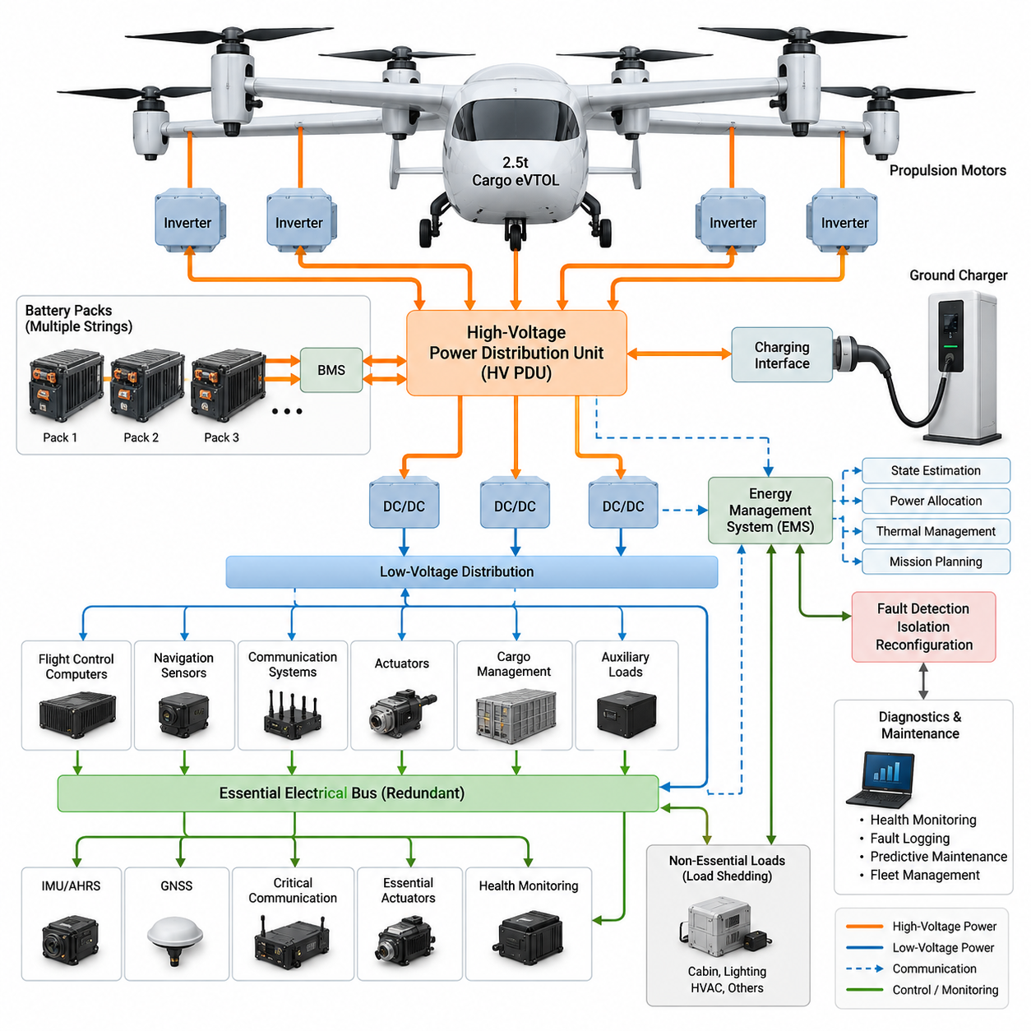
A 2.5-ton cargo eVTOL requires an electrical architecture that treats propulsion power, flight-critical avionics, energy storage, and auxiliary loads as coordinated but independently protected domains. Unlike a small UAV, the aircraft carries enough electrical energy that failures can propagate rapidly through high-current paths. The architecture must therefore combine high power density with electrical isolation, fault containment, redundancy, and continuous health monitoring.
The primary electrical domain supplies the propulsion system and normally operates at a substantially higher DC voltage than conventional avionics buses. Raising distribution voltage reduces current for a given propulsion power, which decreases conductor mass, resistive loss, connector size, and thermal loading. However, higher voltage increases insulation, creepage, clearance, switching, arc-management, and personnel-protection requirements throughout the aircraft.
Energy storage should be divided into multiple independently controllable battery strings or packs rather than implemented as one monolithic source. Each energy source requires battery management, current sensing, temperature monitoring, isolation monitoring, contactors, pre-charge circuitry, and appropriately coordinated protection. Pack segmentation allows a damaged electrical section to be disconnected while healthy sections continue supplying sufficient power for controlled flight or landing.
The high-voltage distribution system forms the electrical backbone between energy storage and propulsion inverters. A central or distributed high-voltage power distribution unit manages contactors, protection devices, pre-charge paths, bus measurements, and isolation functions. Distribution should be partitioned so that a short circuit, inverter fault, cable damage, or motor-side electrical failure does not automatically collapse every propulsion channel simultaneously.
Propulsion channels should be electrically separated according to the aircraft's lift and control philosophy. Independent feeders can supply groups of motor inverters, with physical routing arranged to reduce common-cause vulnerability. Separation is especially important for eVTOL configurations because propulsion units may simultaneously provide lift, attitude control, and maneuvering authority. Electrical redundancy must therefore correspond directly to aerodynamic and flight-control redundancy.
Each propulsion inverter converts high-voltage DC power into controlled multiphase power for its motor. The inverter also becomes an important diagnostic node because phase current, DC-link voltage, semiconductor temperature, motor speed, winding temperature, and fault status can be monitored locally. Fast protection must operate close to the power electronics, while supervisory controllers coordinate system-level responses to degraded propulsion capability.
Flight-critical electronics should not depend directly on the propulsion bus. Isolated DC/DC conversion stages derive stable lower-voltage buses for flight-control computers, navigation sensors, communication equipment, actuators, cargo management, and other avionics. Multiple converters and separated low-voltage buses prevent a single converter failure or high-voltage disturbance from disabling all flight-control electronics at the same time.
A dedicated essential electrical bus should maintain the minimum functions required to keep the aircraft controllable after major power-system failures. Typical essential loads include flight-control computing, inertial sensing, navigation, critical communications, selected actuators, power-system monitoring, and emergency control functions. Nonessential loads can be shed progressively when available energy or generation capacity falls below predefined margins.
The electrical architecture must coordinate closely with the flight-control system because electrical failures can immediately alter available thrust. Battery pack loss, bus isolation, inverter shutdown, motor degradation, or converter failure should be communicated through deterministic interfaces. The flight-control computer can then redistribute thrust commands, modify the flight envelope, initiate contingency logic, or command an emergency landing before remaining margins become unacceptable.
Energy management operates above individual battery and converter controllers to estimate total available energy, instantaneous power capability, thermal limits, and reserve margins. For an electric cargo aircraft, state of charge alone is insufficient. The system must also consider state of health, cell temperature, voltage sag, pack imbalance, mission phase, propulsion demand, and the energy required to reach an alternate or safe landing location.
Vertical takeoff and landing create particularly severe electrical design conditions because peak propulsion demand occurs during hover, climb, and transition. Cables, busbars, contactors, connectors, battery packs, and inverters must tolerate these transient loads without excessive voltage drop or temperature rise. Thermal design and electrical design are therefore inseparable, especially where repeated high-power missions can accumulate heat faster than passive cooling can remove it.
Grounding and electromagnetic compatibility require aircraft-level engineering rather than component-level treatment. High-frequency switching from propulsion inverters and DC/DC converters can interfere with GNSS, IMU, communication links, flight-control electronics, and sensor interfaces. Controlled return paths, shielding, bonding, filtering, cable separation, connector termination, and physical zoning help prevent propulsion-generated electromagnetic noise from corrupting safety-critical information.
The wiring architecture must balance electrical efficiency against aircraft mass and maintainability. High-voltage propulsion cables should follow short, protected routes while remaining separated from sensitive signal wiring. Harness design must account for vibration, bending, temperature, abrasion, fluids, connector retention, and structural movement. Maintenance access is equally important because propulsion feeders and battery interfaces will require inspection throughout the operational life of the cargo aircraft.
Charging architecture should support safe connection between ground infrastructure and the aircraft energy-storage system. Charging control must verify connector state, insulation condition, battery temperature, pack voltage, allowable current, and communication status before significant energy transfer begins. Interlocks should prevent propulsion activation during charging and prevent connector disengagement under unsafe electrical conditions, while diagnostic records support fleet-level battery maintenance.
Fault detection, isolation, and reconfiguration transform redundancy from duplicated hardware into an operational capability. The system should continuously identify abnormal current, undervoltage, overvoltage, insulation degradation, contactor faults, converter failures, thermal excursions, and communication loss. Once a fault is confirmed, the architecture isolates the affected zone and reconfigures healthy power paths while preserving the highest-priority propulsion and avionics functions.
Electrical health information should be integrated into onboard diagnostics and ground maintenance systems. Recording battery trends, contactor operations, inverter temperatures, insulation resistance, bus transients, converter loading, and fault histories enables predictive maintenance rather than purely scheduled replacement. For a cargo fleet, this information can also support dispatch decisions by determining whether sufficient electrical and battery margins remain for the planned mission.
The final architecture should therefore be understood as a layered energy and safety network rather than a collection of batteries, motors, and cables. Segmented energy storage feeds protected high-voltage distribution, which supplies redundant propulsion channels and isolated low-voltage avionics domains. Supervisory energy management, flight control, diagnostics, thermal management, and fault isolation coordinate these layers so that individual failures remain contained.
For the 2.5-ton platform, this architecture also establishes the engineering foundation for later cargo-UAV scaling. The attached structure places pure-electric propulsion, battery redundancy, urban logistics interfaces, and certification immediately after the eVTOL electrical architecture, indicating that this section serves as the system-level bridge between the general hybrid-power chapters and the detailed 2.5-ton aircraft design.

09.02. Pure Electric Propulsion
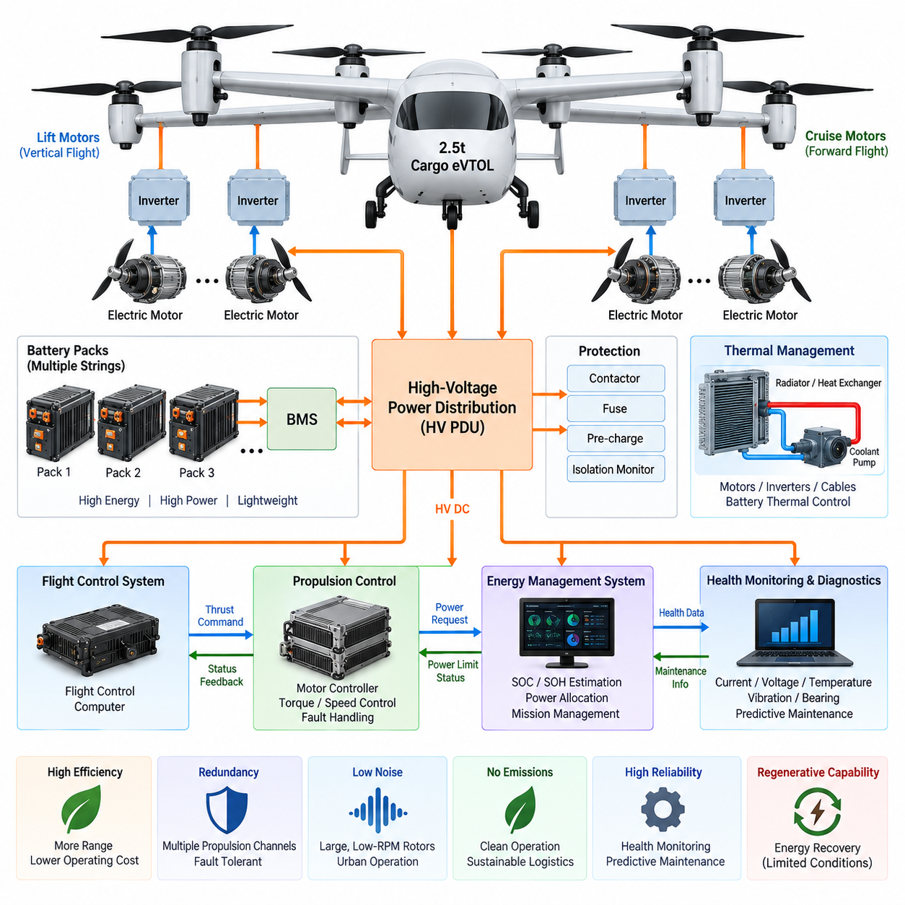
Pure electric propulsion for a 2.5-ton cargo eVTOL converts stored electrical energy directly into aerodynamic thrust without relying on combustion engines, turbines, or onboard fuel conversion. The propulsion chain consists primarily of battery packs, high-voltage distribution, motor inverters, electric motors, and lift or cruise propulsors. This direct energy path simplifies mechanical architecture while making electrical efficiency, thermal performance, and fault tolerance central to aircraft capability.
For a cargo aircraft of this scale, propulsion power must satisfy several distinctly different operating conditions. Vertical takeoff and hover impose very high continuous power demand, transition introduces rapidly changing thrust requirements, and cruise emphasizes energy efficiency over peak output. The electrical propulsion system must therefore support both high transient power and sustained operation without exceeding battery, inverter, motor, cable, or thermal limits.
The battery system is the primary energy source and strongly determines range, payload, endurance, and reserve capability. High specific energy reduces battery mass, while high specific power allows the cells to support demanding takeoff and climb conditions. These requirements can conflict because cells optimized for energy are not always optimized for maximum power. Battery selection must therefore consider the complete mission profile rather than nominal capacity alone.
Battery packs should be divided into multiple electrically independent sections connected to protected high-voltage distribution channels. Each pack requires a battery management system that monitors cell voltage, current, temperature, state of charge, state of health, and abnormal conditions. Independent contactors and protection devices allow a faulty pack to be isolated while remaining packs continue supporting propulsion according to the aircraft's degraded-flight strategy.
High-voltage DC distribution transfers battery energy to propulsion inverters with minimum mass and electrical loss. Increasing bus voltage reduces current at a given power level, allowing smaller conductors and reducing resistive heating, but it also increases insulation and protection requirements. Cable routing, connectors, busbars, contactors, fuses, isolation monitoring, and pre-charge circuits consequently become integral elements of propulsion-system engineering rather than secondary electrical components.
The propulsion inverter is the controllable interface between the DC energy system and each electric motor. It converts high-voltage DC into precisely regulated multiphase AC while controlling motor torque and rotational speed. Semiconductor switching devices must operate efficiently across hover, climb, transition, and cruise conditions because even small conversion losses become significant when hundreds of kilowatts or potentially megawatt-class aggregate propulsion power passes through the system.
Electric motors for cargo eVTOL applications require high torque density, high power density, efficiency, and reliability within a lightweight package. Permanent-magnet synchronous machines are attractive because of their efficiency and compactness, although final motor technology depends on aircraft-level requirements. Motor electromagnetic design, winding configuration, insulation, bearings, rotor containment, temperature limits, cooling, vibration resistance, and inverter compatibility must be engineered as one integrated propulsion unit.
Motor and propulsor selection cannot be optimized independently. Rotor diameter, rotational speed, blade geometry, motor torque, and operating voltage jointly determine thrust efficiency, acoustic characteristics, and propulsion mass. Larger, slower-turning rotors can improve propulsive efficiency and reduce certain noise components, but they affect structural dimensions and integration. The optimal solution therefore emerges from simultaneous aerodynamic, electrical, structural, acoustic, and thermal optimization.
Distributed electric propulsion is particularly valuable for eVTOL aircraft because several independently controlled motors can generate both lift and control forces. Differential thrust between propulsion units can contribute to roll, pitch, and yaw control while reducing dependence on conventional mechanical control mechanisms. However, the number and location of propulsion units must be selected so that loss of one channel does not create an uncontrollable thrust asymmetry or eliminate required flight-control authority.
Redundancy must extend beyond simply installing additional motors. If several propulsion units share one battery bus, contactor, cable route, cooling circuit, controller, or communication interface, a single upstream failure may disable multiple motors simultaneously. True fault tolerance therefore requires consideration of electrical independence, physical separation, control independence, thermal segregation, and communication redundancy so that apparently separate propulsion channels do not contain hidden common failure points.
Thermal management becomes one of the principal constraints during vertical flight because batteries, inverters, motors, connectors, and conductors all generate heat under high electrical loading. Liquid cooling may be required for high-power components, while airflow and structural heat rejection can supplement the cooling system. Thermal architecture must handle peak takeoff power as well as accumulated heat from repeated missions, particularly when turnaround time between cargo flights is short.
Propulsion efficiency should be evaluated from battery terminals to generated thrust rather than by considering motor efficiency alone. Losses occur through battery internal resistance, contactors, cables, busbars, inverter switching, motor copper and magnetic losses, bearings, and propeller aerodynamics. Improving each stage increases usable range, but aircraft-level optimization is essential because reducing electrical loss may require additional cooling, conductor mass, or component size that offsets the original benefit.
Regenerative operation may be technically possible during selected flight conditions when aerodynamic energy drives the propulsor and motor as a generator. Its practical value depends strongly on aircraft configuration, flight profile, rotor aerodynamics, battery charging limits, and safety constraints. Unlike ground vehicles, an eVTOL cannot assume that large amounts of mission energy can routinely be recovered, so mission sizing should not depend on regeneration unless demonstrated by aircraft-level analysis.
Propulsion control must interact continuously with the flight-control computer and energy management system. The flight controller determines required thrust, while local motor controllers execute torque or speed commands within electrical and thermal limits. When a propulsion channel becomes degraded, the system must rapidly communicate its remaining capability so that thrust can be redistributed among healthy motors without destabilizing the aircraft or exceeding their permissible operating envelopes.
Health monitoring supports early identification of degradation before it becomes a propulsion failure. Useful parameters include phase current, DC-link voltage, inverter temperature, motor winding temperature, rotor speed, vibration, bearing condition, insulation status, and cooling-system performance. Combining these signals with operating history enables condition-based and predictive maintenance, which is especially important for commercial cargo fleets expected to perform repeated high-power missions with limited turnaround time.
The pure-electric architecture also changes operational planning because available propulsion capability depends on battery condition and environmental conditions. Low or high battery temperature, aging, cell imbalance, repeated high-power operation, and reserve requirements can reduce usable mission energy even when indicated state of charge appears sufficient. Dispatch logic should therefore evaluate predicted power capability and landing reserve throughout the complete route rather than relying on a single battery percentage.
For the 2.5-ton cargo UAV, pure electric propulsion represents the direct propulsion implementation following the system-level eVTOL electrical architecture. In the attached volume structure, it is followed by battery redundancy design, urban logistics interfaces, and certification planning. The propulsion design must therefore provide not only sufficient thrust and range, but also the electrical partitioning, monitoring, controllability, and fault-management foundation required by the subsequent aircraft-level design activities.

09.03. Battery Redundancy Design
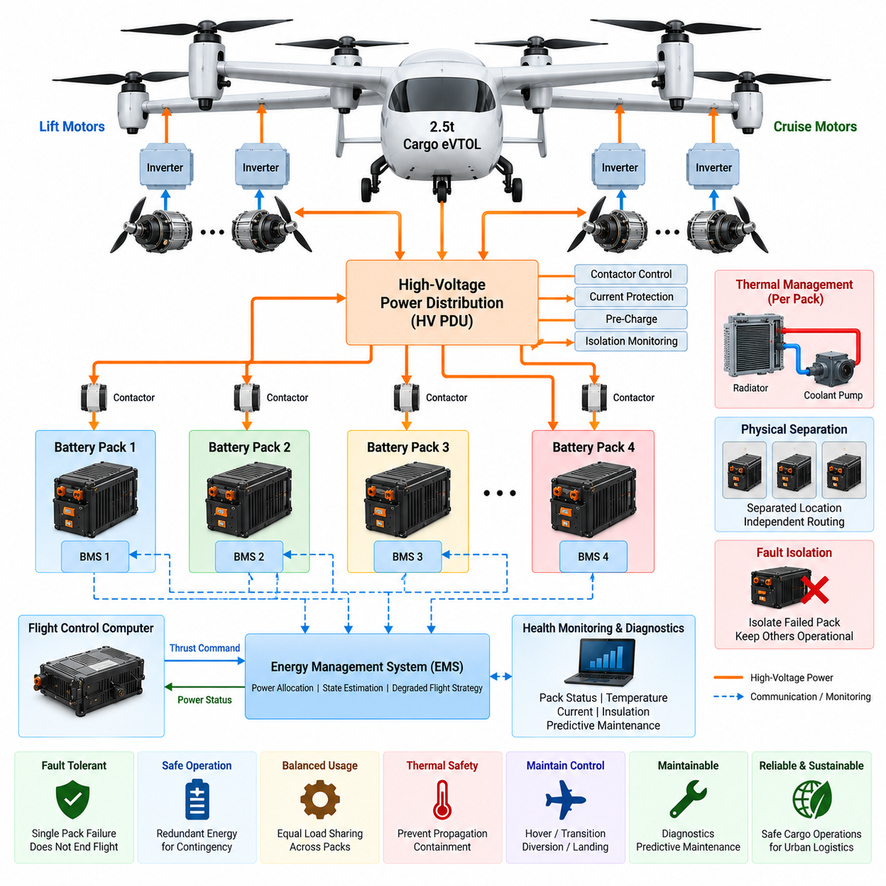
Battery redundancy in a 2.5-ton cargo eVTOL must ensure that loss of a single battery pack, electrical connection, protection device, or distribution path does not immediately remove the energy required for controlled flight. Because pure-electric propulsion depends entirely on stored electrical energy, redundancy is not merely an endurance feature. It becomes part of the aircraft’s flight-safety architecture and must be coordinated with propulsion, flight control, and energy management.
The fundamental design approach is to divide the total battery capacity into multiple independently controlled battery packs or strings. Each section should have dedicated monitoring, switching, protection, and electrical isolation capability. A segmented architecture prevents one internal battery failure from automatically propagating across the complete energy-storage system and allows healthy packs to remain connected when another section must be disconnected.
Redundancy should be designed according to the minimum electrical power required after a failure rather than simply by duplicating nominal battery capacity. The remaining battery channels must provide enough instantaneous power for essential propulsion and sufficient usable energy for the defined contingency mission. Depending on flight phase, this may require continued hover capability, transition to forward flight, diversion, or execution of a controlled emergency landing.
Each battery pack requires an independent battery management system that supervises cell voltage, pack current, temperature, state of charge, state of health, balancing, and fault conditions. The BMS should determine whether the pack can safely remain connected and communicate its available power capability to the aircraft energy management system. Redundant sensing is particularly important where a single incorrect measurement could unnecessarily disconnect a healthy battery or leave a dangerous pack energized.
Independent contactors provide the principal means of connecting and isolating battery sections from the high-voltage bus. Positive and negative switching paths, pre-charge circuits, current protection, and contactor-state verification should be coordinated so that a failed pack can be electrically separated. Welded contactors, failed-open contactors, unexpected bus energization, and unsuccessful pre-charge sequences must be treated as detectable system faults rather than assumed to be improbable events.
Pre-charge management is essential because propulsion inverters and other high-voltage equipment contain substantial DC-link capacitance. Connecting a battery directly to a discharged bus can create severe inrush current, damaging contactors, connectors, or capacitors. Each redundant power path should therefore establish bus voltage through a controlled pre-charge sequence before closing its main contactor, with voltage monitoring confirming successful synchronization.
Electrical protection must selectively isolate the smallest practical failed section. A propulsion-channel short circuit should not unnecessarily disconnect every battery, while an internal battery fault must not be sustained by energy flowing backward from parallel packs. Fuses, contactors, current sensors, reverse-current protection, and distribution topology therefore need coordinated operating characteristics so that fault clearing preserves the maximum amount of healthy propulsion capability.
Parallel battery operation requires careful management because differences in pack voltage, impedance, temperature, aging, and state of charge can cause unequal current sharing. One pack may become overloaded while another contributes less than expected. The energy management system should therefore monitor individual pack currents and dynamically determine allowable discharge power, ensuring that redundant packs operate as controlled energy sources rather than as an unmanaged parallel battery bank.
Physical separation is as important as electrical separation. Two nominally independent battery packs provide limited redundancy if they occupy the same vulnerable compartment or share wiring routes susceptible to the same impact, fire, fluid leakage, or structural damage. Battery locations, high-voltage feeders, connectors, cooling circuits, and control wiring should be arranged to reduce common-cause failures while remaining compatible with aircraft center-of-gravity and structural requirements.
Thermal propagation represents one of the most critical battery redundancy concerns. Segmentation should prevent a thermal event within one module or pack from rapidly affecting adjacent energy-storage sections. Temperature monitoring, thermal barriers, ventilation or containment strategies, cooling isolation, and emergency disconnection must work together. The objective is not only to detect abnormal heating but also to preserve independent energy sources long enough to support the required safe-flight response.
Cooling architecture must also respect redundancy boundaries. If multiple battery packs depend on a single pump, heat exchanger, coolant manifold, or controller, the apparent electrical redundancy can be defeated by one thermal-system failure. Independent cooling loops or appropriately partitioned thermal circuits may therefore be necessary for safety-critical battery groups, particularly during hover and climb when high discharge currents generate substantial heat.
Isolation monitoring is required to detect deterioration between the high-voltage system and aircraft structure or other electrical domains. Cable damage, moisture, contamination, connector degradation, or insulation breakdown can create hazardous leakage paths without immediately producing a conventional short circuit. Continuous insulation monitoring allows the system to identify developing faults and determine whether a particular battery or distribution section should be isolated before the condition becomes critical.
Battery redundancy must be mapped directly to propulsion redundancy. Supplying all lift motors from one battery group and all remaining propulsion units from another may create unacceptable failure combinations even though two energy sources exist. Battery channels should instead be assigned so that loss of any permitted energy-storage section leaves a geometrically and aerodynamically useful distribution of operational propulsion units capable of maintaining required control authority.
The flight-control computer must understand the consequences of battery isolation because reduced electrical power changes available thrust. When one pack becomes unavailable, the energy management system should communicate revised power limits to propulsion and flight-control functions. The controller can then limit peak thrust, redistribute motor commands, alter transition strategy, reduce nonessential loads, or select a landing trajectory consistent with the remaining electrical capability.
State-of-charge redundancy must also be managed throughout normal operation. If one battery pack is discharged significantly faster than the others, the aircraft may technically retain multiple packs but lose meaningful fault tolerance near the end of the mission. Energy allocation should therefore maintain balanced reserve capability across independent channels so that the loss of one pack at a late mission stage still leaves sufficient energy for the required contingency action.
State of health becomes increasingly important as the fleet accumulates operating cycles. Packs age at different rates due to temperature exposure, manufacturing variation, power loading, and maintenance history. Capacity fade and increasing internal resistance can reduce both available energy and peak power. Redundancy calculations should consequently use measured or estimated current capability rather than assuming that every installed battery continues to provide its original rated performance.
Fault detection, isolation, and reconfiguration should occur automatically within tightly defined safety logic. Abnormal current, cell voltage, temperature, insulation resistance, contactor behavior, communication loss, or pack imbalance can trigger progressive responses ranging from power limitation to complete isolation. After isolation, the system must confirm the resulting bus configuration and verify that sufficient healthy energy and propulsion capability remain before continuing the selected flight strategy.
Ground charging must preserve the same redundancy philosophy used in flight. Individual packs may require independent monitoring and controlled charging so that imbalance, excessive temperature, or a defective section can be identified before dispatch. Charging infrastructure and onboard controls should prevent unsafe cross-currents between packs and verify that contactors, insulation monitoring, cooling, BMS communication, and protection functions are operational before the aircraft is released.
Maintenance diagnostics should record battery faults, current histories, temperature exposure, charge and discharge cycles, isolation events, contactor operations, and abnormal voltage behavior. Trend analysis can reveal degradation before it compromises redundancy. Fleet-level data can also identify repeated patterns associated with specific packs, cooling zones, connectors, or mission profiles, allowing predictive maintenance and more reliable battery replacement decisions.
The resulting battery redundancy architecture should be viewed as a coordinated combination of energy segmentation, independent protection, physical separation, thermal containment, monitoring, and automatic reconfiguration. Multiple battery packs alone do not create fault tolerance. True redundancy exists only when a single credible failure can be isolated without simultaneously removing the electrical, thermal, control, or propulsion resources required to maintain safe aircraft operation.
Within the attached 2.5-ton cargo UAV structure, battery redundancy follows the eVTOL electrical architecture and pure-electric propulsion sections and precedes the urban logistics interface and certification plan. It therefore converts the earlier power-system concepts into a safety-oriented energy-storage architecture, establishing how the pure-electric aircraft can retain controlled propulsion after battery-related failures while supporting subsequent operational and certification considerations.

09.04. Urban Logistics Interface
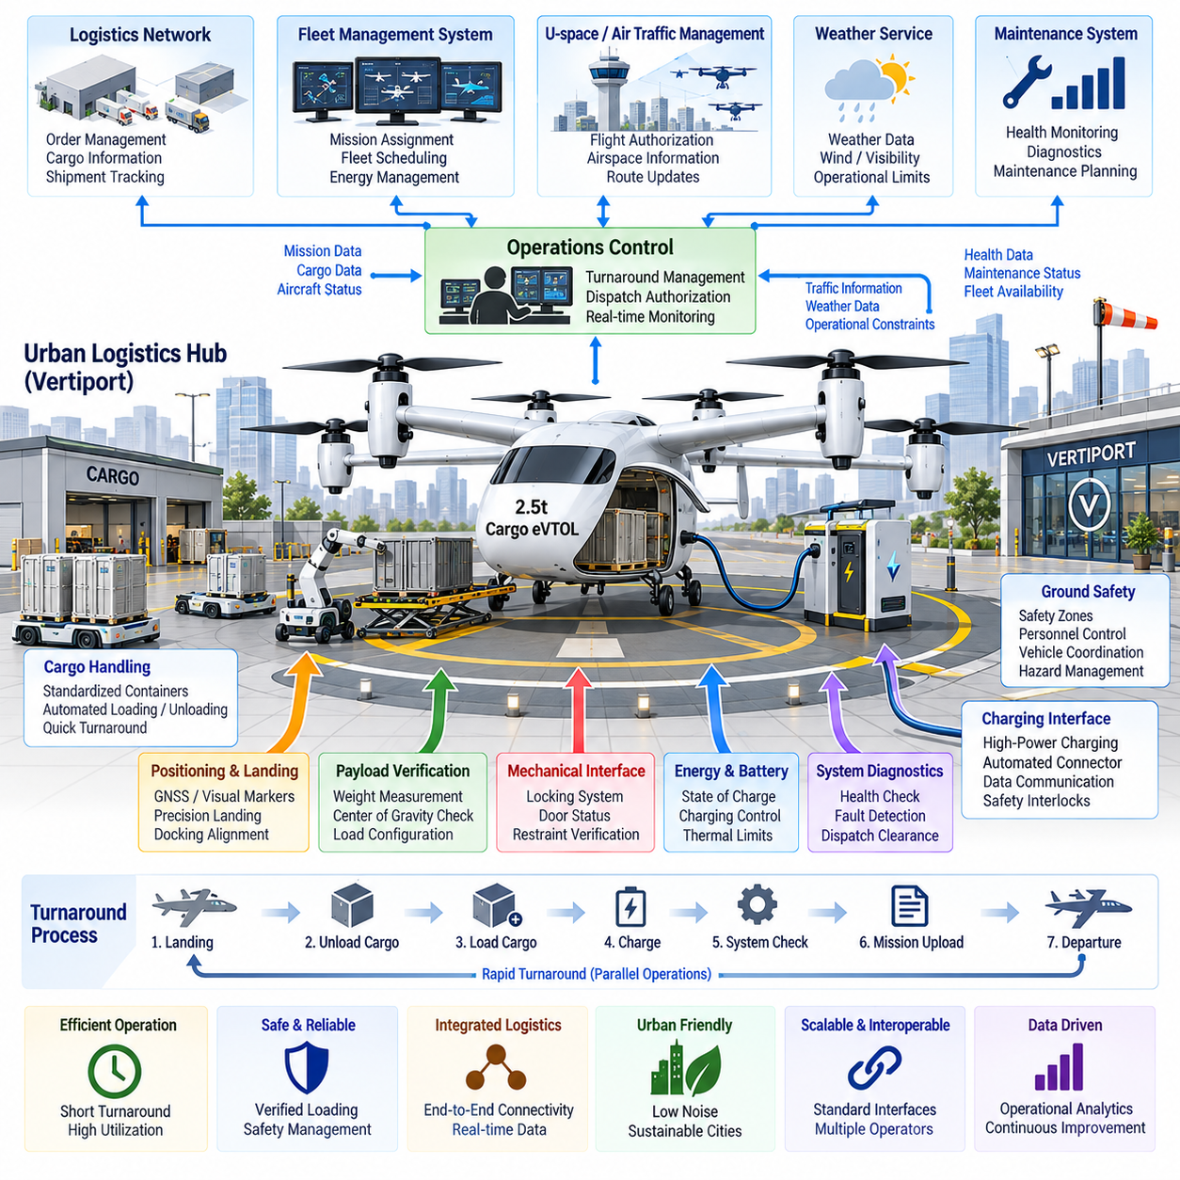
The urban logistics interface for a 2.5-ton cargo eVTOL connects the aircraft with the ground infrastructure, digital services, cargo-handling equipment, and operational systems required for routine city logistics. It extends beyond the physical loading interface because every arrival and departure must coordinate landing authorization, cargo transfer, charging, aircraft health, mission data, and fleet scheduling within a tightly managed turnaround process.
Urban cargo operations require dedicated vertiports or logistics nodes capable of supporting repeated eVTOL movements while occupying limited ground space. The aircraft interface must therefore accommodate landing-zone geometry, positioning references, safety boundaries, loading access, charging connections, and maintenance access. Standardized ground interfaces reduce dependence on site-specific procedures and allow the same aircraft to operate across multiple logistics hubs.
Precision landing provides the first connection between airborne operation and ground logistics. GNSS, visual markers, local positioning systems, or other landing references can guide the aircraft toward a defined touchdown area. Accurate final positioning is important not only for flight safety but also for aligning cargo doors, automated loaders, charging equipment, and service interfaces with fixed ground infrastructure after landing.
The cargo-transfer interface should minimize aircraft turnaround time while preventing loading errors. Standardized cargo containers, pallets, locking points, dimensional envelopes, and mechanical guides allow cargo to be exchanged using automated or semi-automated equipment. The interface must verify that cargo is correctly positioned and mechanically secured before flight, while allowing rapid release after landing without unnecessary manual intervention.
Cargo identification should be digitally linked to the aircraft mission. Container or shipment identifiers can associate each payload with destination, weight, handling requirements, and operational status. Before departure, the logistics system should confirm that the loaded cargo corresponds to the assigned mission. This prevents routing errors and provides traceability from the originating logistics facility through airborne transportation to the receiving hub.
Payload weight and center-of-gravity information are particularly important for a 2.5-ton eVTOL because loading configuration directly affects flight performance and control margins. Ground logistics equipment can provide measured cargo information, while onboard sensors independently verify actual loading conditions. The aircraft should reject dispatch when payload mass, distribution, or center of gravity exceeds the allowable envelope defined for the planned mission.
The mechanical cargo interface should also communicate its state to the flight-control and cargo-management systems. Lock position, door status, restraint condition, and payload presence must be verified before propulsion is enabled for departure. Where multiple locking mechanisms are used, individual status monitoring helps detect incomplete engagement. A disagreement between commanded and measured lock states should prevent normal dispatch until the condition is resolved.
Charging must be integrated into the logistics cycle rather than treated as a separate maintenance activity. After landing, the aircraft may connect to high-power charging infrastructure while cargo is unloaded and the next shipment is prepared. Automated charging connectors can reduce turnaround time, but electrical interlocks, insulation checks, communication handshakes, battery temperature limits, and connector-state verification must be completed before high-power energy transfer begins.
The charging interface should exchange more than electrical power. Aircraft and ground systems can communicate battery state of charge, allowable charging current, pack temperature, state of health, expected departure time, and required mission energy. This enables charging power to be adjusted according to operational priority while avoiding unnecessary battery stress and ensuring that sufficient energy and reserve are available before the next dispatch.
Rapid turnaround requires simultaneous coordination of several activities that would traditionally be performed sequentially. Cargo unloading, incoming cargo verification, battery charging, system diagnostics, mission upload, weather assessment, and departure preparation can proceed in parallel when their safety dependencies are clearly defined. A digital turnaround manager can supervise these activities and authorize departure only after all mandatory conditions have been satisfied.
The aircraft must interface with the fleet-management system that assigns missions across multiple vehicles. Fleet software can consider aircraft location, payload capability, battery condition, maintenance status, route availability, and expected demand when selecting an aircraft. For pure-electric eVTOL operations, energy availability becomes a scheduling resource, so fleet assignment and charging strategy should be optimized together rather than managed as independent functions.
Mission information should move electronically from the logistics network to the aircraft and ground control environment. The mission package can contain origin, destination, route constraints, payload information, reserve requirements, landing-site identifiers, and operational restrictions. Configuration control is essential so that the aircraft, ground control station, logistics system, and destination facility operate from consistent mission information rather than independently entered data.
The urban logistics interface must also coordinate with unmanned traffic management or U-space services where applicable. Flight authorization, airspace restrictions, geofencing information, traffic conditions, and route updates can affect whether a planned cargo mission remains executable. The logistics system therefore cannot regard an aircraft departure slot as purely a warehouse decision; it must incorporate current aviation constraints into dispatch and scheduling.
Communication architecture should maintain clear boundaries between safety-critical aircraft control and commercial logistics data. Shipment databases, warehouse systems, customer information, and scheduling platforms do not require direct access to flight-control networks. Secure gateways and defined application interfaces can exchange only the necessary information, reducing cybersecurity exposure while allowing logistics automation to interact with aircraft operations.
Cybersecurity becomes increasingly important as automated logistics nodes connect aircraft, chargers, fleet servers, cargo databases, maintenance systems, and external networks. Authentication, authorization, encrypted communication, software integrity, logging, and network segmentation should prevent unauthorized commands or manipulated logistics information from influencing aircraft dispatch. Operational convenience must not create uncontrolled paths into flight-critical systems.
Ground safety management must account for the unique hazards of a large eVTOL. Rotor clearance zones, high-voltage equipment, battery hazards, cargo-handling machinery, and automated ground vehicles can coexist within a compact logistics facility. The interface should coordinate aircraft safe state, propulsion inhibition, charging state, cargo access, and personnel or equipment movement so that incompatible activities cannot occur simultaneously.
Noise is also an interface consideration because urban logistics facilities may operate close to residential or commercial areas. Flight trajectories, rotor operating conditions, arrival and departure schedules, and ground procedures can influence community noise exposure. Logistics planning can distribute operations across time and locations while aircraft-level propulsion control minimizes unnecessary high-power operation on the ground or near sensitive areas.
Weather and environmental information should be integrated into dispatch decisions. Wind, precipitation, visibility, temperature, and local hazards affect both aircraft performance and vertiport usability. Temperature is particularly relevant to pure-electric operation because it influences battery power capability and charging behavior. Mission scheduling should therefore combine environmental conditions with aircraft energy status rather than treating weather and charging as unrelated constraints.
Maintenance interfaces should support rapid automated assessment during every ground cycle. Aircraft health records can be transferred to maintenance systems after landing, allowing battery, propulsion, avionics, thermal, and cargo-interface faults to be evaluated before the next mission. Minor anomalies may be monitored, while conditions exceeding defined limits can automatically remove the aircraft from dispatch and generate maintenance actions.
Operational data collected across repeated logistics missions can support continuous improvement of fleet utilization. Turnaround duration, charging time, energy consumption, payload distribution, route performance, component temperatures, delays, and maintenance events reveal where infrastructure or aircraft operation can be optimized. The logistics interface therefore becomes a source of fleet intelligence as well as a mechanism for transferring cargo.
Interoperability is important if the aircraft is expected to serve multiple logistics operators or cities. Common cargo dimensions, electrical charging interfaces, communication protocols, landing references, identification methods, and operational data models reduce infrastructure fragmentation. Even when complete standardization is not possible, clearly defined interface control documents allow aircraft and ground-system suppliers to integrate their equipment without redesigning the complete logistics chain.
A mature urban logistics interface ultimately creates a coordinated flow from warehouse to aircraft, through flight, and into the destination logistics network. Cargo identification, weight verification, loading, locking, charging, health checks, mission authorization, traffic coordination, landing, and unloading become connected stages of one operational process. Automation is valuable when it shortens turnaround while preserving independent verification of flight-critical conditions.
Within the attached volume structure, the urban logistics interface follows eVTOL electrical architecture, pure-electric propulsion, and battery redundancy design, and is immediately followed by the 2.5-ton certification plan. Its role is therefore to translate the aircraft’s electrical and propulsion capabilities into a practical urban cargo operation, defining how the vehicle interacts with logistics infrastructure before the complete aircraft and operating concept are addressed from a certification perspective.

09.05. 2.5t Certification Plan
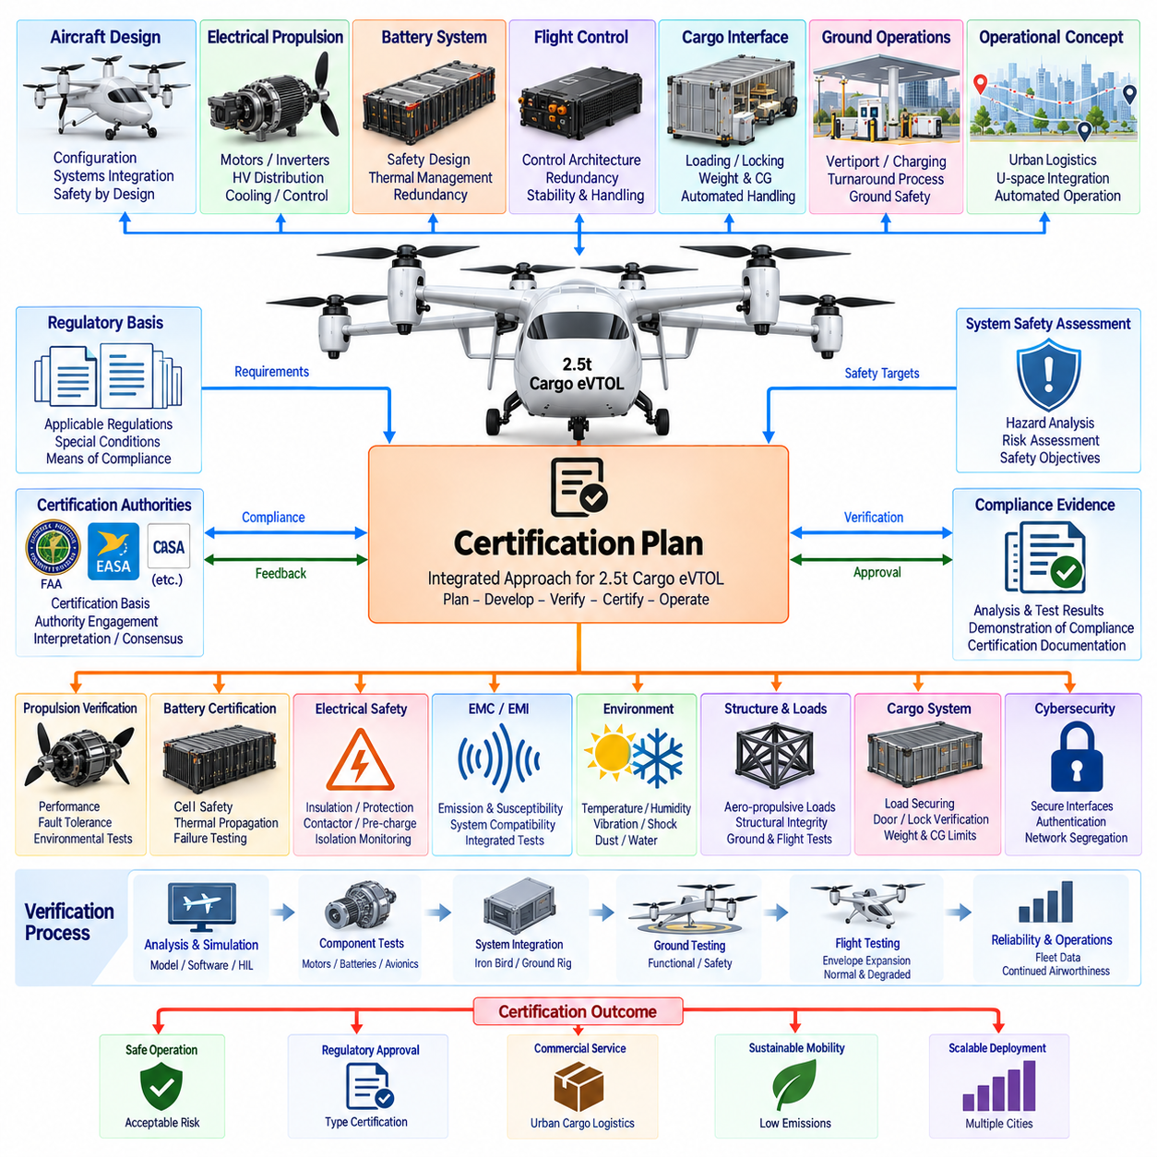
Certification planning for a 2.5-ton cargo eVTOL must begin at the aircraft architecture stage rather than after prototype completion. The certification program must connect vehicle configuration, electrical propulsion, battery safety, flight controls, cargo interfaces, ground operations, and operational limitations to a structured body of compliance evidence. Early planning reduces the risk that a technically successful prototype later requires major redesign to demonstrate airworthiness.
The first step is to establish the certification basis applicable to the intended aircraft category and operating concept. A cargo eVTOL combines characteristics of rotorcraft, powered-lift aircraft, electric propulsion systems, and potentially unmanned aircraft operations. The certification strategy must therefore identify applicable regulatory requirements, special conditions, means of compliance, and authority-specific interpretations before detailed verification activities are committed.
The intended concept of operations strongly influences certification scope. Urban cargo missions may include vertical takeoff, transition, automated cruise, operation near populated areas, vertiport use, remote supervision, and highly automated landing. Each operational assumption should be translated into aircraft-level requirements so that certification demonstrates not merely component performance but safe operation throughout the complete mission and foreseeable abnormal conditions.
A system safety assessment should establish the relationship between aircraft hazards and required system integrity. Loss of thrust, uncontrolled thrust, battery fire, flight-control failure, erroneous navigation, cargo release, loss of communication, and electrical distribution failure are representative hazards requiring analysis. Their consequences determine the redundancy, monitoring, independence, fault-detection, and verification rigor expected from the associated aircraft systems.
The electrical propulsion system requires a particularly strong certification argument because propulsion depends on batteries, high-voltage distribution, inverters, motors, cooling, and control electronics operating as one integrated chain. Compliance evidence should demonstrate normal performance, transient capability, environmental tolerance, electrical protection, fault containment, and continued safe behavior following defined failures rather than evaluating motor output or inverter efficiency in isolation.
Battery certification must address hazards beyond normal energy-storage performance. Cell failures, internal short circuits, overcharge, over-discharge, overheating, thermal propagation, insulation degradation, contactor faults, and abnormal charging conditions require controlled evaluation. The battery design should demonstrate that credible failures are detected and contained and that resulting aircraft-level consequences remain compatible with the safety objectives established for the mission.
Battery redundancy should be verified through failure-oriented testing as well as analysis. Disconnecting a battery channel, degrading available power, introducing sensor faults, or simulating contactor and communication failures can demonstrate whether healthy channels remain usable. Certification evidence must show that energy management, propulsion control, and flight control respond coherently and preserve the required capability for continued flight, diversion, or controlled landing.
Flight-control certification must consider the distinctive dynamics of distributed electric propulsion. Multiple propulsion units may simultaneously provide lift, attitude control, and transition authority, making motor availability part of the control architecture. Verification should therefore include propulsion-unit failures, asymmetric thrust, sensor faults, actuator limitations, computational failures, and degraded electrical power while demonstrating that the aircraft remains within defined controllability and stability criteria.
Hardware and software assurance should be planned according to the safety significance of the functions they implement. Flight-control computers, propulsion controllers, battery-management functions, communication gateways, and monitoring systems may require different assurance levels depending on failure consequences. Requirements traceability, configuration management, verification independence, change control, and reproducible test evidence become essential elements of the certification program as system complexity increases.
High-voltage electrical safety requires dedicated verification covering insulation, creepage and clearance, grounding, bonding, protection coordination, connector behavior, pre-charge operation, contactor sequencing, and isolation monitoring. Tests should include normal and abnormal conditions across expected voltage, temperature, humidity, vibration, contamination, and aging ranges. The objective is to demonstrate that electrical faults remain contained and do not create uncontrolled hazards elsewhere in the aircraft.
Electromagnetic compatibility must be demonstrated at equipment and integrated-aircraft levels. High-power inverters, motors, switching converters, communication equipment, and charging systems can generate or receive electromagnetic disturbances. Verification should demonstrate that propulsion switching does not corrupt flight-control, navigation, sensing, or communication functions and that external electromagnetic environments do not cause unsafe behavior in safety-critical electrical systems.
Environmental qualification should reproduce the conditions encountered throughout the aircraft life cycle. Temperature extremes, altitude, humidity, vibration, mechanical shock, water exposure, dust, fluids, and other relevant environments can affect batteries, connectors, electronics, sensors, and propulsion components. Qualification must establish that equipment continues satisfying its allocated functions or transitions safely when conditions exceed its permitted operating envelope.
Structural and propulsion certification must remain connected because rotor thrust, motor torque, battery mass, and emergency load cases generate forces that propagate through the airframe. Ground and flight testing should verify structural response under representative propulsion conditions, including asymmetric or degraded operation where relevant. Electrical-system failures that change thrust distribution must therefore be included when defining structural and dynamic verification cases.
Cargo-system certification must demonstrate that the payload remains within approved mass and center-of-gravity limits and remains securely restrained throughout the mission. Weight sensing, cargo identification, locking mechanisms, door monitoring, and restraint verification contribute to this safety case. Incorrect loading, incomplete locking, unexpected cargo movement, and sensor disagreement should be addressed through detection, dispatch inhibition, or appropriate operational procedures.
Ground and charging interfaces form part of the overall safety argument because hazardous conditions can occur before flight begins. Certification planning should verify charging interlocks, connector sequencing, battery temperature limits, insulation checks, propulsion inhibition, cargo-access conditions, and ground personnel protection. Automated turnaround functions should not permit incompatible operations such as propulsion activation while charging equipment or cargo-handling systems remain connected.
Cybersecurity should be considered wherever external systems exchange information with aircraft functions. Fleet management, mission planning, maintenance, charging infrastructure, logistics networks, and traffic-management services create potential digital entry points. Certification evidence should support controlled interfaces, authentication, software integrity, network segregation, secure update processes, and detection of unauthorized or corrupted information affecting safety-relevant functions.
Verification should progress from analysis and simulation toward increasingly representative hardware. Model-in-the-loop, software-in-the-loop, hardware-in-the-loop, subsystem rigs, propulsion benches, battery tests, iron-bird or integrated-system rigs, ground vehicles, and finally flight-test aircraft can provide successive levels of evidence. This staged approach allows hazardous failure cases to be explored extensively before they are introduced into an actual aircraft.
Ground testing should demonstrate integrated behavior before expansion of the flight envelope. Power-up and shutdown sequencing, charging, propulsion operation, cooling, communication, fault isolation, emergency procedures, cargo locking, and degraded power configurations can be exercised under controlled conditions. Instrumentation should capture electrical, thermal, mechanical, and software responses so that test results can be traced directly to certification requirements and safety assumptions.
Flight testing should expand gradually from basic controllability to the complete operational envelope. Hover, climb, transition, cruise, descent, landing, payload variations, center-of-gravity limits, environmental effects, and selected degraded modes require verification. Failure cases introduced in flight must be carefully selected from prior analysis and ground testing so that certification evidence is obtained without exposing the test aircraft to unjustified risk.
Reliability evidence becomes increasingly important as the aircraft approaches operational approval. Component qualification alone cannot fully demonstrate fleet-level behavior, so accumulated operating hours, repeated mission cycles, charging cycles, propulsion events, and maintenance findings should be evaluated. Reliability growth testing can reveal failure mechanisms that are difficult to predict analytically and provide evidence for inspection intervals and continued-airworthiness procedures.
Certification documentation must maintain traceability from regulations and safety objectives through requirements, design implementation, verification methods, test results, and final compliance findings. Changes to batteries, motors, inverters, software, structures, or operational assumptions should be evaluated for certification impact. A disciplined configuration baseline prevents test evidence generated for one aircraft configuration from being incorrectly applied to a substantially changed design.
The certification plan should ultimately integrate aircraft approval with the intended operating environment. The 2.5-ton cargo UAV chapter places certification after electrical architecture, pure-electric propulsion, battery redundancy, and urban logistics integration, so certification becomes the consolidation point for these preceding design decisions. The final evidence must demonstrate that the complete aircraft can perform its intended cargo mission with acceptable safety under normal, degraded, and foreseeable failure conditions.

