Volume 18. Cargo UAV Architecture

Chapter 05. Cargo Management System

05.01. Cargo Weight Sensor
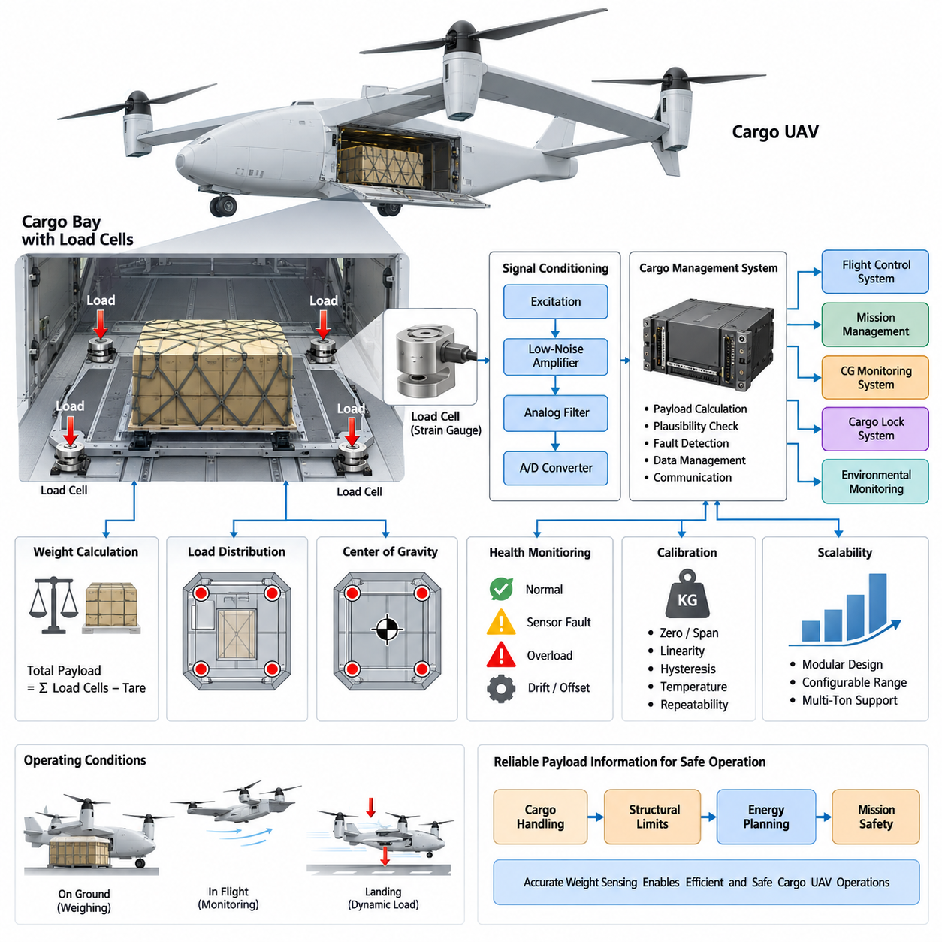
A cargo weight sensor is a fundamental element of the Cargo Management System because the aircraft must know the actual payload before takeoff and, where practical, continue monitoring it during operation. In a cargo UAV, measured weight influences allowable gross mass, required thrust, energy consumption, flight range, structural loading, and the validity of the mission plan.
The sensing architecture normally converts mechanical loading at the cargo interface into electrical measurements. Strain-gauge load cells are a common solution because they provide direct force measurement with relatively mature signal-conditioning techniques. Depending on the cargo bay design, sensors may be installed beneath the cargo floor, integrated into pallet supports, or incorporated into dedicated attachment points.
A single load cell can measure concentrated loading, but a distributed arrangement is generally more useful for large cargo UAVs. Three, four, or more measurement points can determine total payload while also revealing how the load is distributed across the cargo platform. This distributed measurement becomes especially important as the aircraft progresses from smaller cargo configurations toward multi-ton payload classes.
Each load-cell channel requires stable excitation, low-noise amplification, analog filtering, and analog-to-digital conversion. Because strain-gauge signals are small, wiring resistance, electromagnetic interference, temperature variation, connector quality, and grounding can materially affect measurement accuracy. The electronics should therefore be located and routed to minimize noise while preserving maintainability and environmental protection.
The basic payload estimate is obtained by combining the forces measured at all supporting points. Before cargo is loaded, the system establishes a zero or tare reference representing the empty cargo interface and any permanently installed fixtures. After loading, the measured increase is converted into payload mass using calibrated scale factors, while plausibility logic verifies that individual sensor values remain physically consistent.
Weight measurement should not be treated as an isolated display function. The Cargo Management System can transmit validated payload information to the avionics and mission-management domains so that takeoff mass, performance margins, energy requirements, and route feasibility can be recalculated. If measured cargo weight exceeds an approved limit, the system should generate a clear warning and prevent unsafe mission assumptions from propagating.
Sensor placement is strongly related to structural load paths. A load cell should measure forces transferred through a defined mechanical interface rather than forces distorted by floor bending, friction, uncontrolled preload, or structural deformation. Mechanical stops may also be required so that landing impact, cargo handling, or abnormal loads do not permanently overload the sensing element while the primary structure remains capable of carrying the cargo.
Temperature compensation is particularly important because cargo UAVs may operate across substantial environmental ranges. Both the sensor element and its supporting structure can change dimensions with temperature, producing apparent load variation even when the payload is unchanged. Compensation coefficients, temperature measurements, calibration tables, and software correction can be combined to maintain useful accuracy throughout the intended operating envelope.
Dynamic flight introduces another challenge because a load sensor responds to force rather than mass directly. During acceleration, maneuvering, turbulence, landing, or vibration, the apparent cargo force can differ significantly from static weight. The system should distinguish a stable ground-based weighing condition from dynamic monitoring and should avoid interpreting short-duration inertial loads as changes in actual payload mass.
Filtering must therefore balance measurement stability against fault-detection speed. Low-pass filtering can suppress structural vibration and propulsion-induced oscillation, while time-window averaging can improve the preflight weight estimate. However, excessive filtering may hide rapid changes associated with cargo movement, partial release, structural failure, or abnormal load transfer, so separate static and dynamic processing paths can be advantageous.
Redundancy and diagnostics become increasingly important as payload mass and aircraft criticality increase. Individual channels can be checked for open circuits, short circuits, saturation, implausible offsets, excessive drift, and disagreement with neighboring sensors. A distributed system can also compare the sum of healthy channels against expected loading patterns, allowing certain sensor failures to be detected before they corrupt the total weight estimate.
The cargo weight system can provide valuable information to the adjacent CG Monitoring System defined within the same Cargo Management System architecture. When multiple load points have known geometric coordinates, their measured forces can contribute to estimating the effective center of loading. Weight and center-of-gravity information can therefore be generated from a coordinated sensing architecture rather than independent subsystems.
Calibration should cover the complete measurement chain, including load cells, mechanical interfaces, amplifiers, converters, wiring, and software coefficients. Calibration loads should span the intended operating range and include multiple loading positions where distributed sensing is used. Zero, span, linearity, hysteresis, repeatability, cross-axis sensitivity, and temperature effects should be characterized rather than relying on a single nominal scale factor.
The sensor range must include adequate margin above the maximum operational payload. Selecting a range that is too narrow risks mechanical or electrical saturation during transient loading, while an unnecessarily large range reduces useful measurement resolution. The design should consider static cargo mass, expected maneuver loads, landing loads, handling shocks, structural amplification, and the overload capability of both the sensor and its mounting hardware.
Electrical architecture should preserve measurement integrity during power disturbances and avionics faults. Sensor excitation and acquisition electronics may use regulated power derived from an avionics supply, with local filtering and protection against transients. For higher-integrity designs, independent measurement channels or segregated power paths can reduce the probability that a single electrical fault eliminates all knowledge of cargo loading.
Communication between the weight measurement electronics and the Cargo Management System should include more than a numerical mass value. Useful data can include individual load-point forces, total payload, measurement validity, temperature, calibration status, fault flags, overload history, and timestamps. Time-correlated data allows other avionics functions to distinguish a current verified measurement from stale or degraded information.
Preflight operation should establish a controlled weighing state after loading and cargo locking are complete. The aircraft can verify that the measured payload agrees with the declared manifest, remains within structural and performance limits, and exhibits an acceptable distribution. A mismatch may indicate incorrect cargo documentation, incomplete loading, an unsecured item, calibration error, or an abnormal mechanical interface requiring inspection.
In-flight monitoring can provide an additional layer of assurance even when precise weighing is not possible under dynamic conditions. Trends in distributed forces can reveal cargo shifting, asymmetric load transfer, lock degradation, or unexpected unloading. When combined with acceleration data from the flight-control system, measured forces can be interpreted in the context of aircraft motion rather than evaluated as raw static weight.
Cargo locking and weight sensing can also support cross-checking logic. A locked cargo interface accompanied by an unexpected reduction in measured load may indicate a sensor fault or structural problem, while a commanded cargo release should produce a predictable change in measured forces. Such relationships allow the Cargo Management System to perform functional plausibility checks across weight sensing, locking, and payload-interface functions.
For heavy cargo UAVs, the measurement architecture should be scalable rather than redesigned for every payload class. A modular sensing unit with configurable load-cell capacity, channel count, mechanical interface, and calibration data can support progressively larger aircraft. The fundamental functions remain consistent: measure forces accurately, validate the measurements, calculate payload, diagnose faults, and distribute trustworthy cargo data.
Ultimately, the cargo weight sensor is part of the aircraft’s operational assurance architecture rather than merely an electronic scale. Reliable payload knowledge connects cargo handling with structural limits, propulsion capability, energy planning, flight-control assumptions, and mission safety. Designing the sensing system together with the CG monitor, cargo locks, environmental monitoring, and payload interface creates a coherent Cargo Management System.

05.02. CG Monitoring System
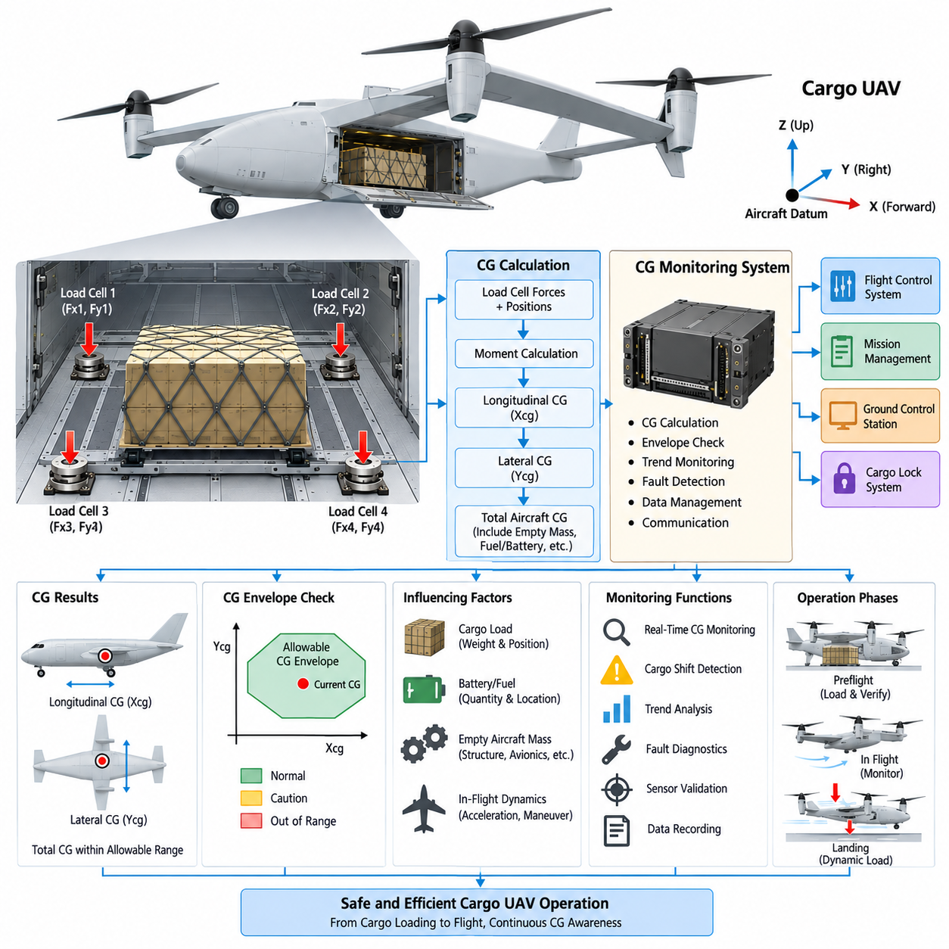
A Center of Gravity monitoring system continuously determines whether the aircraft’s mass distribution remains within the allowable flight envelope. For a cargo UAV, total payload weight alone is insufficient because identical masses positioned at different locations create different pitching, rolling, and structural moments. CG information therefore becomes a fundamental input to safe loading and flight preparation.
The basic principle of CG estimation is the relationship between force and moment. When the cargo platform is supported by multiple load cells at known geometric positions, each sensor measures a portion of the total vertical load. The Cargo Management System combines these forces with their coordinates to calculate the resultant load position and estimate the longitudinal and lateral center of gravity.
For a simplified longitudinal calculation, each measured force is multiplied by its distance from a defined aircraft reference datum. The sum of these moments is divided by the total measured force to determine the effective longitudinal CG position. The same principle can be applied across the aircraft width to estimate lateral CG and identify asymmetric cargo loading.
The CG reference coordinate system must be clearly defined across structural, cargo, avionics, and flight-control engineering. A common aircraft datum prevents ambiguity when cargo positions, pallet locations, structural stations, and allowable CG limits are exchanged between subsystems. Coordinate definitions should remain consistent from mechanical design and calibration through mission planning and operational loading procedures.
A distributed load-cell architecture provides a practical foundation for CG monitoring because it measures both total load and load distribution. Four sensors positioned near the corners of a cargo platform, for example, can indicate whether the payload is concentrated forward, aft, left, or right. Additional measurement points can improve observability for large cargo decks or complex multi-pallet configurations.
The CG Monitoring System should distinguish between cargo CG and total aircraft CG. Cargo sensors directly characterize the payload contribution, while the complete aircraft calculation must also account for empty-aircraft mass, batteries, fuel or hybrid-energy components, avionics, propulsion equipment, and other variable masses. These contributions can be combined through a mass-property model maintained by the aircraft management system.
Fuel consumption can progressively change aircraft CG when fuel tanks are located at different longitudinal or lateral positions. Hybrid cargo UAVs may therefore require the CG estimator to incorporate fuel quantity and tank location in addition to cargo measurements. Battery-dominant aircraft generally experience smaller consumable-mass changes, although modular battery installation can still alter the initial mass distribution.
The allowable CG envelope is normally defined as a region rather than a single ideal point. The system compares the estimated longitudinal and lateral CG against boundaries established through aerodynamic, structural, stability, control-authority, and certification analysis. A payload may satisfy the maximum-weight requirement while still being unacceptable because its position places the aircraft outside this approved envelope.
A forward CG generally increases the control effort required to maintain pitch equilibrium, whereas an excessively aft CG can reduce longitudinal stability and decrease recovery margin. Lateral displacement can require persistent roll compensation and produce unequal loading across propulsion or lifting systems. These effects become increasingly significant as cargo mass represents a larger fraction of total aircraft mass.
Preflight CG verification should occur after cargo placement and locking are completed. The measured loading condition can be compared with the planned cargo manifest and expected pallet positions. If the calculated CG exceeds a warning threshold, operators can reposition cargo before flight rather than relying on the flight-control system to compensate for an inherently unfavorable loading configuration.
Multiple operational thresholds can provide more useful information than a simple valid-or-invalid decision. A normal region indicates sufficient margin, while caution boundaries can identify configurations approaching operational limits. Exceeding the certified or approved envelope should generate a clear fault condition and may inhibit mission authorization until the cargo configuration is corrected and successfully revalidated.
CG estimation accuracy depends strongly on load-sensor accuracy, mounting geometry, structural stiffness, and calibration quality. Sensor offsets or incorrect coordinate definitions can create systematic CG errors even when total weight appears reasonable. Calibration should therefore verify not only total payload measurement but also calculated position using known test masses placed at controlled locations throughout the cargo platform.
Structural deformation must also be considered because a large cargo deck is not perfectly rigid. Heavy concentrated loads may bend floor structures and redistribute reaction forces among sensors in ways that differ from ideal analytical assumptions. Mechanical design, finite-element analysis, calibration testing, and compensation models can be combined to characterize these effects across representative payload distributions.
During flight, raw CG estimates can be disturbed by acceleration and rotational motion because load cells measure reaction forces rather than static gravitational mass. Maneuvers, turbulence, vibration, and landing events may temporarily produce highly asymmetric sensor readings. The monitoring algorithm should therefore use flight-state information to distinguish actual cargo redistribution from inertial effects generated by normal aircraft dynamics.
IMU and flight-control information can significantly improve dynamic CG monitoring. Accelerometer and angular-rate measurements provide context describing aircraft motion, while load sensors describe forces transmitted through the cargo interface. Combining these sources allows the system to determine whether an observed load change is consistent with commanded maneuvering or potentially indicates cargo movement.
In-flight CG monitoring is especially valuable for detecting cargo shift. If a pallet or container moves because of inadequate restraint, the total measured cargo weight may remain almost unchanged while its distribution across load cells changes substantially. A CG system can therefore identify hazardous conditions that would be invisible to a total-weight measurement function operating by itself.
The Cargo Lock System provides another source of cross-validation. CG movement detected while all locks report a secure condition can indicate sensor error, structural deformation, or an abnormal cargo-interface condition. Conversely, a lock-status change accompanied by a corresponding shift in measured load distribution strengthens the evidence that actual cargo movement has occurred and requires appropriate system response.
Fault diagnostics should monitor individual sensor validity, communication integrity, calibration status, and consistency between independent information sources. A failed load cell should not silently produce a plausible but incorrect CG value. The system should determine whether sufficient healthy measurements remain for degraded estimation and clearly communicate the resulting accuracy or availability level to dependent avionics functions.
Redundant sensing becomes increasingly valuable for multi-ton cargo aircraft because incorrect CG information can directly affect flight safety. Additional load channels, independent measurement electronics, redundant communication paths, or analytical cross-checks against expected aircraft response can improve fault detection. The appropriate redundancy level should reflect aircraft size, payload criticality, and the safety classification assigned to the function.
CG data should be distributed to the Flight Control System, mission-management functions, and Ground Control Station using defined validity and timing information. The flight controller can use the estimated loading condition when selecting control parameters, while mission software can evaluate performance margins. Ground personnel can simultaneously confirm that the physical loading configuration agrees with the approved mission configuration.
Historical CG data also provides useful maintenance and operational information. Repeated flights can reveal recurring asymmetric loading practices, gradual sensor drift, structural changes, or abnormal cargo-interface behavior. Recorded weight, CG, lock status, flight state, and fault information can support post-flight analysis and help distinguish operational loading problems from sensor or structural degradation.
For scalable cargo UAV families, CG monitoring should use a modular architecture capable of supporting different cargo deck dimensions, sensor counts, and payload classes. Configuration data can define sensor coordinates, maximum loads, aircraft reference datums, and allowable envelopes. This allows the same fundamental monitoring concept to evolve from smaller cargo aircraft toward 2.5-ton, 5-ton, and eventually 10-ton-class systems.
The CG Monitoring System ultimately connects physical cargo placement with aircraft dynamics and flight safety. By integrating distributed weight sensing, geometric modeling, calibration, flight-state information, cargo-lock status, diagnostics, and avionics communication, the aircraft gains continuous knowledge of how its payload affects balance. This transforms cargo loading from a static ground procedure into a monitored aircraft-level function.

05.03. Cargo Lock/Unlock Mechanism
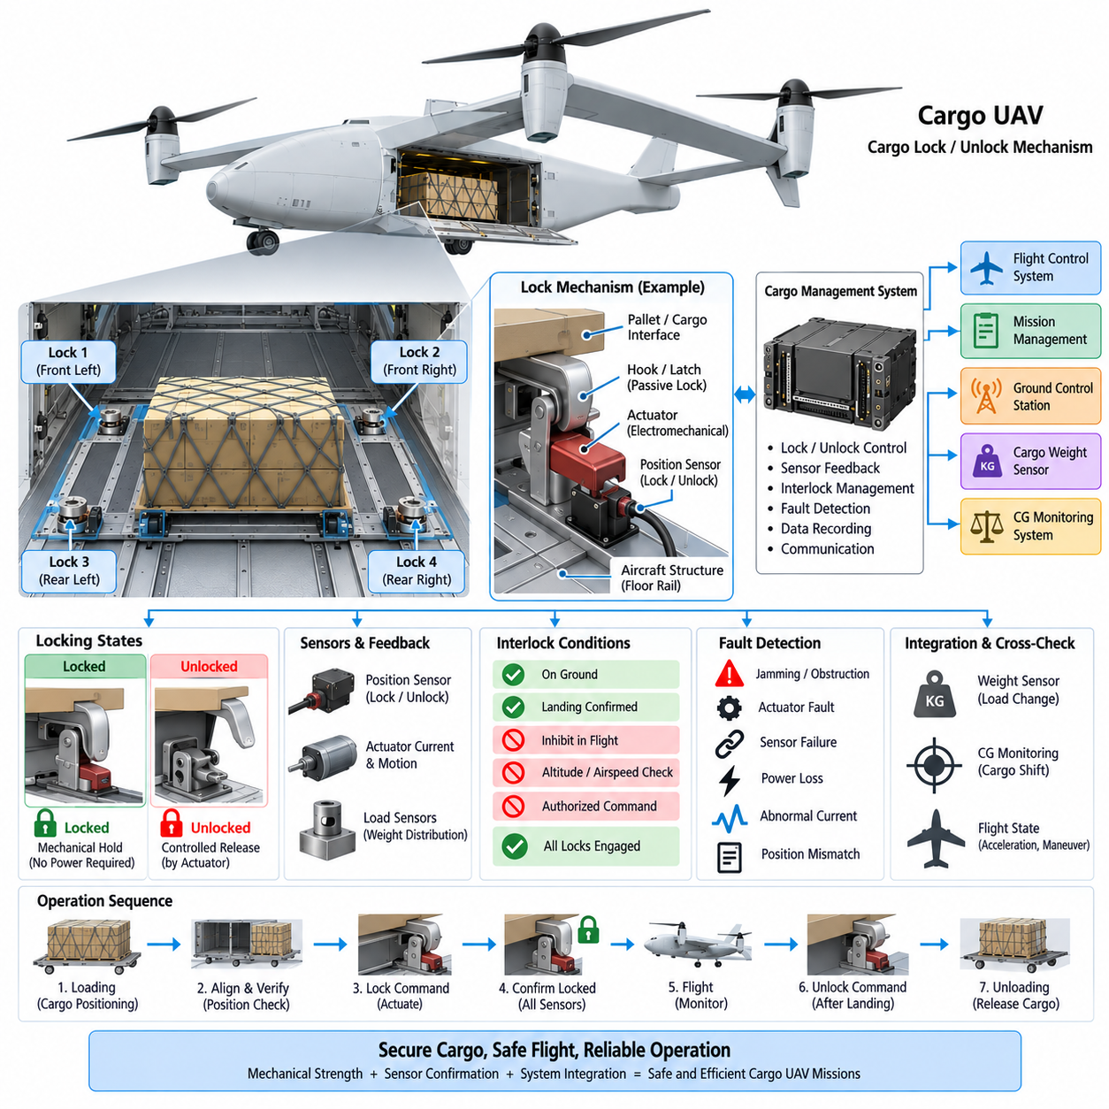
The cargo lock and unlock mechanism is the physical interface that secures payloads to the aircraft structure throughout loading, takeoff, cruise, maneuvering, landing, and unloading. In a cargo UAV, this function must restrain the payload against longitudinal, lateral, and vertical forces while allowing controlled release when commanded. Its reliability directly affects structural integrity, aircraft balance, and mission safety.
A typical locking architecture combines mechanical restraint with electrically controlled actuation and independent position sensing. The mechanical components carry the cargo loads, while an actuator changes the mechanism between locked and unlocked states. Sensors confirm the actual position of the lock rather than assuming that an electrical command has been successfully translated into mechanical engagement.
The mechanical load path should transfer forces directly from the pallet, container, or payload interface into reinforced aircraft structure. Locking components should not depend on actuator torque to continuously resist operational loads. Once engaged, hooks, pins, wedges, latches, or equivalent positive-locking elements should mechanically retain the cargo so that electrical power is not required simply to maintain a secure state.
Positive locking is particularly important for heavy cargo UAVs because vibration, maneuver loads, turbulence, and landing impact can create repeated forces at the cargo interface. A properly designed mechanism should resist unintended release even if electrical power is lost. Mechanical geometry can therefore be arranged so that operational loads tend to maintain engagement rather than drive the lock toward the released position.
The actuator may be electromechanical, hydraulic, or another technology appropriate to aircraft size and payload class. Electromechanical actuators are attractive where electrical integration, controllability, and maintenance simplicity are priorities. Larger multi-ton systems may require higher-force mechanisms, but the actuator should remain functionally separated from the primary structural load path whenever practical.
Lock-state sensing should normally provide explicit confirmation of both locked and unlocked conditions. Limit switches, proximity sensors, Hall-effect sensors, or position encoders can monitor latch movement and final engagement. Using independent sensing prevents the Cargo Management System from declaring the cargo secure merely because an actuator reached an expected current, time, or commanded position.
For distributed cargo interfaces, multiple locks may be installed around a pallet or cargo platform. Each locking point should report its individual status so that partial engagement can be detected. A system in which three locks are fully engaged while a fourth remains incomplete should not be interpreted as equivalent to a completely secured payload, particularly for large or asymmetric cargo.
The Cargo Management System coordinates lock commands, sensor feedback, fault detection, and operational interlocks. During loading, the system can maintain the interface in an unlocked state until the cargo reaches the correct position. After alignment is confirmed, a lock command initiates actuation, followed by verification that every required locking point has reached and maintained its secure condition.
Preflight verification should cross-check locking status with cargo weight and CG information. A payload may have the correct mass and center of gravity but still be unsafe if one or more mechanical restraints are not properly engaged. Combining weight sensing, CG monitoring, and lock confirmation allows the aircraft to evaluate cargo readiness as an integrated condition rather than as several unrelated measurements.
Interlocks should prevent unintended unlocking during normal flight. Release commands can be inhibited according to flight phase, altitude, airspeed, landing status, mission mode, or other aircraft conditions. For conventional logistics missions, unlocking would normally be permitted only after a verified landing and safe ground state unless the aircraft is specifically designed for controlled aerial cargo delivery.
Command authorization is another important design consideration for autonomous cargo aircraft. An unlock request may originate from the Ground Control Station, mission computer, local maintenance interface, or automated unloading system. The Cargo Management System should verify command source, system state, and applicable safety conditions before energizing the release mechanism.
The mechanism should distinguish a requested unlock from a confirmed physical release. After an unlock command, the system should monitor actuator movement and sensor transitions until the expected mechanical state is reached. Failure to complete the sequence within an allowable time can indicate jamming, excessive cargo force, actuator failure, structural deformation, contamination, or a damaged locking component.
Actuator current and motion information can provide useful diagnostic evidence. An abnormal current increase may indicate mechanical obstruction, while unexpectedly low current can suggest a disconnected actuator or failed load transmission. When combined with position sensing and timing information, these measurements support condition monitoring without replacing the independent sensors required to confirm the actual mechanical state.
Cargo weight sensors can also help validate lock and unlock behavior. When cargo is secured, distributed load measurements should remain consistent with the expected loading configuration. If an unlock or release operation occurs, predictable changes in interface forces may follow. Disagreement between lock status and measured load distribution can therefore identify abnormal cargo movement or sensor and mechanism faults.
The CG Monitoring System provides another complementary check. A lock that becomes partially disengaged may allow the payload to shift even though total cargo weight remains nearly constant. A resulting movement of the calculated center of gravity can provide evidence of changing cargo position and can trigger warnings before the displacement becomes large enough to threaten controllability or structural margins.
Fail-safe behavior should be defined explicitly for power loss, communication failure, controller reset, and actuator faults. For most cargo-retention applications, loss of electrical power should leave the mechanism mechanically locked rather than automatically releasing the payload. Emergency or specialized cargo-drop missions may require different behavior, but such functions should be deliberately separated from normal cargo-retention logic.
Manual release capability may be necessary for maintenance, recovery, or emergency unloading. The manual mechanism should permit authorized personnel to release cargo when electrical actuation is unavailable while minimizing the possibility of accidental operation. Its state should preferably be detectable so that the aircraft cannot unknowingly begin a mission with a manually overridden or improperly restored lock.
Mechanical design must account for tolerance, wear, contamination, temperature, corrosion, and structural deflection. Cargo interfaces repeatedly experience loading cycles and may be exposed to dust, moisture, ice, or handling damage. Adequate engagement margin and robust guidance features are therefore necessary to ensure that moderate misalignment does not produce false locking or excessive actuator loads.
The locking mechanism should also tolerate dynamic loads significantly different from the static cargo weight. Takeoff acceleration, maneuvering, turbulence, emergency landing, and ground handling can generate forces in multiple directions. Structural sizing should therefore use defined limit and ultimate load cases rather than selecting lock capacity solely from the nominal payload mass.
Redundancy can be introduced through multiple independent locking points, duplicated sensors, segregated electrical channels, or mechanical secondary retention. The required architecture depends on payload mass and safety assessment. For multi-ton cargo UAVs, a single undetected lock failure may have serious consequences, making fault containment and continued mechanical restraint important design objectives.
Communication with avionics should include individual lock states, overall cargo-secure status, actuator condition, fault information, command state, and data validity. The Flight Control System and mission-management functions generally do not need to control each actuator directly; instead, they can consume a validated cargo-secure status produced by the Cargo Management System and apply appropriate mission interlocks.
Maintenance data should record operating cycles, abnormal actuator currents, incomplete engagements, manual overrides, detected impacts, and recurring sensor disagreement. Such history enables preventive inspection of mechanisms experiencing increasing friction or wear. For autonomous fleets, condition data can also support centralized maintenance planning before a degraded lock develops into an operational failure.
A modular cargo interface can allow the same fundamental lock architecture to support different payload classes and aircraft sizes. Lock modules can be scaled in structural capacity and actuator force while preserving common electrical interfaces, diagnostics, state definitions, and control logic. This approach supports evolution from smaller cargo UAVs toward 2.5-ton, 5-ton, and 10-ton-class platforms.
Ultimately, the cargo lock and unlock mechanism integrates mechanical restraint, actuation, sensing, diagnostics, and safety logic into a single cargo-retention function. Coordinating it with cargo weight sensing, CG monitoring, flight-state information, and mission control ensures that payload security is continuously verified rather than assumed. The result is a controlled physical interface between the aircraft and the cargo it is responsible for transporting.

05.04. Cargo Environment Monitoring
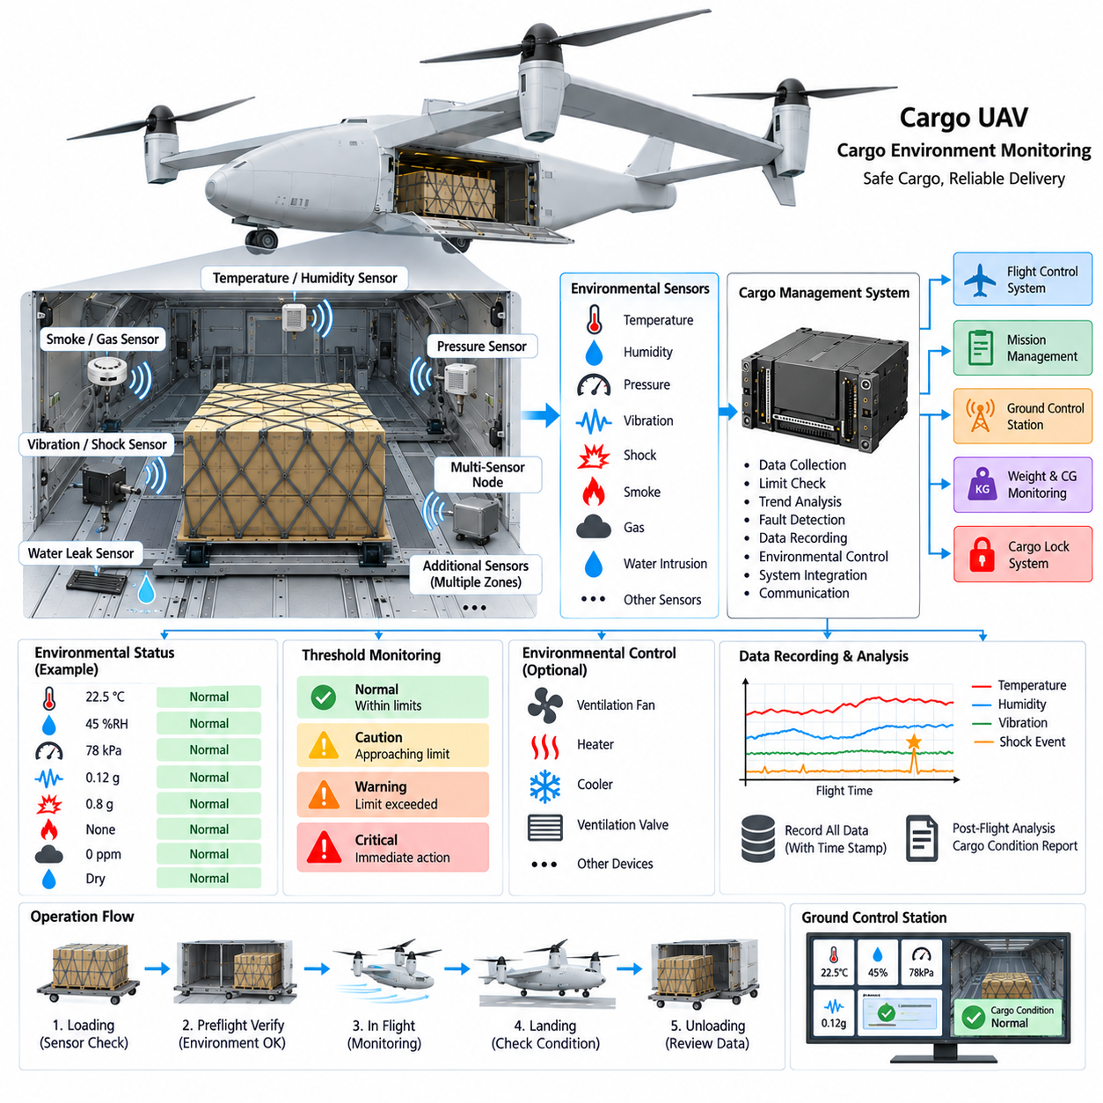
Cargo environment monitoring provides continuous awareness of the physical conditions surrounding payloads during loading, ground handling, takeoff, cruise, maneuvering, landing, and unloading. In a cargo UAV, environmental conditions can affect sensitive electronics, medical supplies, batteries, biological materials, industrial equipment, and other mission-critical cargo even when the aircraft itself remains fully operational.
The monitoring architecture should be designed according to the cargo types that the aircraft is expected to transport. Typical measurements include temperature, relative humidity, pressure, vibration, shock, smoke, gas, and moisture or water intrusion. Not every mission requires every sensor, so a modular architecture allows the Cargo Management System to activate appropriate monitoring functions according to payload requirements.
Temperature monitoring is one of the most fundamental functions because many payloads have defined storage and transportation limits. Multiple temperature sensors can be distributed throughout a large cargo compartment to identify local hot or cold regions rather than relying on a single measurement point. Sensor placement should consider airflow, external surfaces, propulsion heat sources, batteries, avionics, and cargo packaging.
Relative humidity monitoring provides complementary information for cargo susceptible to condensation, corrosion, packaging degradation, or moisture absorption. Temperature and humidity should often be evaluated together because condensation risk depends on their relationship. The Cargo Management System can calculate environmental trends and detect conditions approaching limits before visible moisture or cargo damage occurs.
Pressure sensing becomes important when the cargo compartment experiences altitude-related pressure changes or when specific payloads require pressure-controlled transportation. Even in an unpressurized compartment, pressure data provides useful context for interpreting other sensors and verifying the expected flight environment. A rapid unexpected pressure change may also indicate compartment damage or abnormal ventilation behavior.
Vibration monitoring characterizes the continuous mechanical excitation transmitted from propulsion systems, aerodynamic loads, structural modes, and aircraft maneuvering into the cargo interface. Accelerometers mounted on the cargo deck or selected payload attachment points can measure vibration severity and frequency content. These data help determine whether transported equipment has been exposed beyond its specified transportation environment.
Shock monitoring addresses short-duration events that may not be adequately represented by average vibration measurements. Hard landings, cargo handling impacts, severe turbulence, restraint events, or structural contact can produce high transient accelerations. Recording peak acceleration, duration, direction, and event time allows the system to identify cargo that may require inspection even when no external damage is immediately visible.
For sensitive payloads, distributed accelerometers can distinguish aircraft-wide dynamic events from localized cargo impacts. If multiple sensors detect similar acceleration simultaneously, the event may originate from aircraft motion. A strong response at only one cargo location can instead indicate local movement, impact, or restraint problems. This information complements cargo-lock and CG monitoring functions.
Smoke and fire detection are important when cargo can create or be damaged by thermal hazards. Optical smoke sensors, temperature-rate monitoring, gas sensors, or other detection technologies can provide early warning of abnormal conditions. The monitoring architecture should distinguish ordinary temperature variation from rapid thermal escalation that may indicate an emerging fire or battery-related event.
Gas monitoring may be required for specific cargo classes or battery-intensive logistics operations. Sensors can be selected for gases associated with leakage, combustion, thermal runaway, or hazardous materials according to the intended mission. Because gas sensors may have cross-sensitivity, aging, and calibration requirements, their measurements should include validity and health information rather than being interpreted as unconditional truth.
Water or moisture intrusion sensing can protect cargo compartments exposed to rain, condensation, cleaning processes, or seal degradation. Sensors placed near doors, floor drains, low points, or vulnerable interfaces can detect water before it spreads across the cargo deck. Combining moisture detection with humidity and temperature data helps distinguish environmental condensation from direct liquid intrusion.
Sensor distribution should reflect the physical size and internal airflow of the cargo compartment. A single environmental sensor may be adequate for a small homogeneous enclosure but can be misleading in a multi-ton cargo aircraft containing several pallets or containers. Distributed sensor zones allow the system to associate environmental conditions with specific cargo positions and identify localized anomalies.
The Cargo Management System collects environmental measurements, evaluates their validity, compares them with mission-specific limits, and records relevant events. Rather than simply forwarding raw sensor values, it can generate interpreted states such as normal, caution, warning, or critical. Thresholds should be configurable because acceptable environmental conditions can vary substantially between general freight and sensitive payloads.
Time duration is as important as instantaneous threshold crossing for many environmental conditions. A short temperature excursion may be acceptable while prolonged exposure may damage the cargo. Monitoring logic can therefore evaluate both magnitude and duration, allowing cumulative exposure to be tracked. Similar approaches can be applied to vibration dose, humidity exposure, or repeated shock events.
Preflight operation should verify that required environmental sensors are available and that the cargo compartment is within acceptable initial conditions. The system can compare the selected cargo profile with sensor configuration and confirm that required monitoring channels are functioning. This prevents a mission requiring temperature supervision from beginning with a failed or unavailable temperature sensor.
During flight, environmental data can be correlated with flight phase and aircraft state. Temperature changes may correspond to altitude, propulsion operation, or ventilation mode, while vibration may increase during transition, maneuvering, or landing. Time synchronization with avionics data enables post-flight analysis to determine when and under what aircraft conditions an environmental excursion occurred.
Environmental monitoring should also interact with the cargo weight, CG, and locking functions defined within the Cargo Management System architecture. An abnormal shock accompanied by a change in load distribution or CG may indicate cargo movement. Similarly, unusual vibration combined with a lock-status anomaly provides stronger evidence of a mechanical restraint problem than either measurement alone.
Active environmental control may be added when monitoring alone is insufficient. Fans, heaters, cooling units, ventilation valves, or conditioned cargo containers can be commanded according to sensor feedback. In such systems, monitoring becomes part of a closed-loop environmental management function, while independent limits and fault detection ensure that a failed controller does not create unsafe cargo conditions.
Power architecture should consider which monitoring functions must remain available during aircraft power transitions or partial electrical failures. Critical sensors may require protected or redundant power supplies, while less important channels can operate from standard cargo-system power. Sensor electronics should also tolerate electromagnetic interference generated by propulsion, power conversion, communication, and actuator systems.
Communication between distributed sensors and the Cargo Management System should preserve sensor identity, measurement value, timestamp, validity, and diagnostic status. Depending on the architecture, sensors may connect through local analog interfaces, CAN-based networks, serial communication, or Ethernet gateways. The selected network should provide adequate reliability without adding unnecessary complexity to simple sensing functions.
Fault diagnostics should identify open circuits, short circuits, frozen values, implausible rates of change, communication loss, calibration expiration, and disagreement between nearby sensors. Environmental alarms should not be generated from measurements already known to be invalid. At the same time, loss of a sensor required for a specific cargo profile may itself constitute an operational warning or mission restriction.
Data recording provides traceability after delivery. A complete environmental history can demonstrate whether cargo remained within specified transportation conditions and can support investigation when damage is discovered. For high-value or sensitive cargo, the recorded dataset can include temperature, humidity, pressure, vibration, shock events, alarms, flight phase, cargo identity, and sensor health information.
Ground Control Station integration allows remote operators to monitor cargo condition without directly controlling individual sensors. The interface should emphasize meaningful status, trends, and exceptions rather than overwhelming operators with raw data. Critical environmental events can trigger prioritized alerts, while detailed sensor histories remain available for diagnostics and post-flight evaluation.
Scalable cargo UAV families benefit from a modular environmental monitoring architecture. Small aircraft may use a limited temperature, humidity, and shock sensor set, while 2.5-ton, 5-ton, and 10-ton platforms can support multiple cargo zones and specialized sensor modules. Common interfaces and data definitions allow monitoring capability to expand without redesigning the entire Cargo Management System.
Ultimately, cargo environment monitoring extends aircraft awareness beyond whether the payload is present, correctly balanced, and mechanically secured. By continuously observing temperature, humidity, pressure, vibration, shock, and mission-specific hazards, the Cargo Management System can determine whether the payload remains within its required transportation environment. This provides an essential link between successful aircraft operation and successful cargo delivery.

05.05. Payload Interface Standard
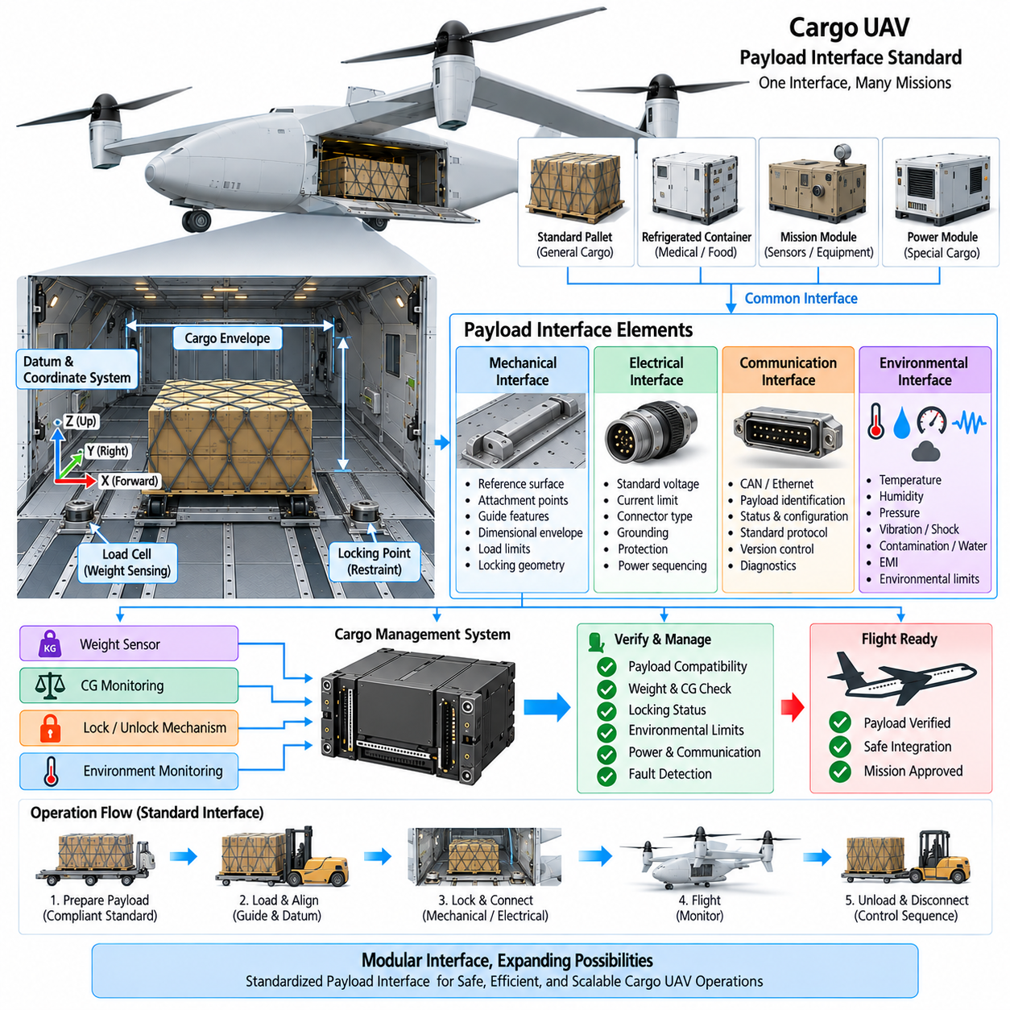
The payload interface standard defines the common physical, electrical, communication, and operational boundaries between a cargo UAV and the payload it transports. A standardized interface allows different pallets, containers, mission modules, and specialized cargo systems to be integrated without redesigning the aircraft for every mission. It therefore forms the foundation for modular cargo operations and scalable UAV logistics.
The mechanical interface establishes how the payload is positioned, supported, restrained, and transferred into the aircraft structure. Standardized reference surfaces, attachment points, guide features, and dimensional envelopes allow compatible cargo modules to be installed repeatedly with predictable alignment. Mechanical standardization also ensures that payload loads enter the airframe through structural paths designed to withstand them.
A defined cargo envelope specifies the maximum dimensions and allowable installation volume for a payload or container. This envelope should consider not only the physical cargo bay but also loading clearances, door movement, locking mechanisms, sensor visibility, ventilation paths, and maintenance access. Payloads that satisfy the dimensional standard can therefore be evaluated without repeating a complete packaging analysis for every installation.
The interface should define allowable payload mass and load distribution rather than specifying only a maximum total weight. Concentrated loads can produce local structural stresses even when total cargo mass remains within the aircraft limit. Requirements for floor loading, attachment-point loads, longitudinal distribution, lateral distribution, and permissible center-of-gravity locations provide a more complete definition of mechanical compatibility.
Standardized datum points and coordinate systems are essential for integrating payload information with the Cargo Management System. Payload position, load-cell coordinates, locking points, and center-of-gravity data should reference a common aircraft coordinate system. This enables the aircraft to determine where a payload is installed and how its mass properties affect the total aircraft CG without ambiguous geometric conversions.
The cargo locking interface should define the geometry and engagement requirements between the payload and the aircraft restraint system. Standardized pins, slots, rails, hooks, receptacles, or equivalent features can allow automated locking mechanisms to work with multiple payload modules. The interface should also define tolerances and alignment margins so that normal manufacturing variation does not prevent reliable engagement.
Lock compatibility includes more than mechanical dimensions. The aircraft must be able to determine whether the payload is correctly positioned and whether all required locking points are fully engaged. Position targets, presence sensors, lock-state indicators, or encoded interface features can support automatic verification. A payload should not be declared flight-ready solely because it physically fits inside the cargo compartment.
The electrical interface provides power to payloads requiring refrigeration, monitoring, computing, communication, lighting, or other active functions. Standardization should define available voltage levels, maximum current, connector characteristics, grounding, circuit protection, and power sequencing. The aircraft should protect itself from payload-side short circuits, overloads, reverse polarity, and abnormal power consumption.
Different payload classes may require different electrical power levels. A passive pallet may require no aircraft power, while a temperature-controlled medical container or intelligent logistics module may require continuous electrical supply. The interface can therefore define several standardized power profiles while maintaining a common protection and connector philosophy across the cargo UAV family.
The communication interface allows intelligent payloads to exchange identification, status, configuration, and monitoring information with the Cargo Management System. Depending on system complexity, communication may use CAN-based networks, serial interfaces, Ethernet, or other defined protocols. The important requirement is that the aircraft understands the data contract without requiring mission-specific modifications to core avionics software.
Payload identification enables automatic configuration after installation. A compatible module can provide payload type, serial number, mass properties, required environmental limits, power requirements, communication capabilities, and maintenance information. The Cargo Management System can compare these data with the mission manifest and aircraft capability before allowing the payload to become operational.
Interface data should include validity and version information so that incompatible configurations can be detected. Mechanical compatibility does not guarantee electrical or software compatibility. A payload using an unsupported interface revision, communication profile, or power requirement should be identified before flight. Version-controlled interface definitions are therefore important for long-lived cargo UAV platforms.
Environmental interface requirements define the conditions that the payload and aircraft-side connector system must tolerate. Temperature, humidity, vibration, shock, contamination, water exposure, electromagnetic interference, and pressure variation may all affect interface reliability. Connectors, sensors, locking mechanisms, and exposed contact surfaces should be selected according to the intended cargo operating environment.
The payload interface should also cooperate with Cargo Environment Monitoring. A specialized payload can declare required temperature, humidity, shock, or other transportation limits when connected. The Cargo Management System can then configure appropriate monitoring thresholds and verify that the necessary sensors are available before mission authorization.
Weight sensing can be integrated directly into the standardized mechanical interface. Load cells positioned beneath standardized support points allow the aircraft to measure payload mass without relying only on declared cargo information. Because the support geometry is known, distributed measurements can also provide information about load distribution and support the calculation of cargo center of gravity.
CG monitoring benefits substantially from standardized payload mass-property information. An intelligent payload module can provide its nominal mass, internal CG, and installation orientation, while aircraft sensors independently estimate actual loading. Comparing declared and measured information creates a useful plausibility check and reduces the risk of incorrect cargo configuration entering the flight-control calculations.
The standardized interface should integrate naturally with the Cargo Lock and Unlock Mechanism. Cargo alignment, presence detection, lock engagement, weight measurement, and CG verification can form a coordinated loading sequence. Once all required conditions are satisfied, the Cargo Management System can generate a validated cargo-secure state for mission-management and flight-control functions.
Loading and unloading automation becomes easier when interface geometry is predictable. Ground robots, automated guided vehicles, forklifts, conveyors, or robotic cargo handlers can align pallets using standardized dimensions and reference features. This reduces dependence on manual positioning and creates a foundation for autonomous logistics in which cargo moves between warehouses, ground vehicles, and UAVs with limited human intervention.
A standardized payload interface should define safe states during connection and disconnection. Electrical power should not be applied before appropriate mechanical engagement, and communication initialization should not create unintended actuator commands. Similarly, unlocking should follow defined sequencing so that powered payloads, data connections, and mechanical restraints are released in a controlled order.
Fault containment is essential because the aircraft should remain protected from a malfunctioning payload. Electrical isolation, current limiting, network segmentation, communication validation, and mechanical load limits prevent a payload-side failure from propagating into critical avionics. The interface should therefore be treated as a controlled system boundary rather than simply a collection of connectors and mounting holes.
Diagnostics should determine whether mechanical, electrical, and communication interfaces are healthy before flight. The system can verify payload presence, lock engagement, power consumption, communication status, sensor availability, weight consistency, and CG compliance. A failure in one interface domain should be reported explicitly rather than being hidden behind a generic payload fault indication.
Maintenance and configuration management are important because interface components experience repeated loading cycles. Connectors wear, locking surfaces deform, guide structures accumulate damage, and sensors can drift. Recording connection cycles, abnormal loads, electrical faults, communication errors, and locking problems allows maintenance personnel to identify degrading interface modules before operational reliability is affected.
Modularity is particularly valuable for a cargo UAV family that evolves across different payload capacities. Smaller aircraft and 2.5-ton, 5-ton, or 10-ton-class platforms may use mechanically different load-bearing hardware while retaining common interface concepts, data definitions, electrical protection, diagnostics, and operational states. Standardization therefore does not require every aircraft to use physically identical components.
The interface architecture can also support specialized mission modules beyond conventional freight. Medical logistics containers, refrigerated cargo modules, sensor packages, emergency-response equipment, communications modules, and other mission payloads can share a common aircraft-side integration philosophy. This enables the cargo UAV to evolve from a dedicated transporter into a configurable aerial logistics platform.
Ultimately, the payload interface standard connects the Cargo Weight Sensor, CG Monitoring System, Cargo Lock and Unlock Mechanism, and Cargo Environment Monitoring functions defined within the Cargo Management System architecture. By standardizing mechanical attachment, electrical power, communication, sensing, safety, and operational sequencing, the aircraft can accept diverse payloads through a predictable and verifiable integration process.

