Volume 19. Testing and Validation

Chapter 04. Communication Test

04.01. CAN Bus Analyzer Test
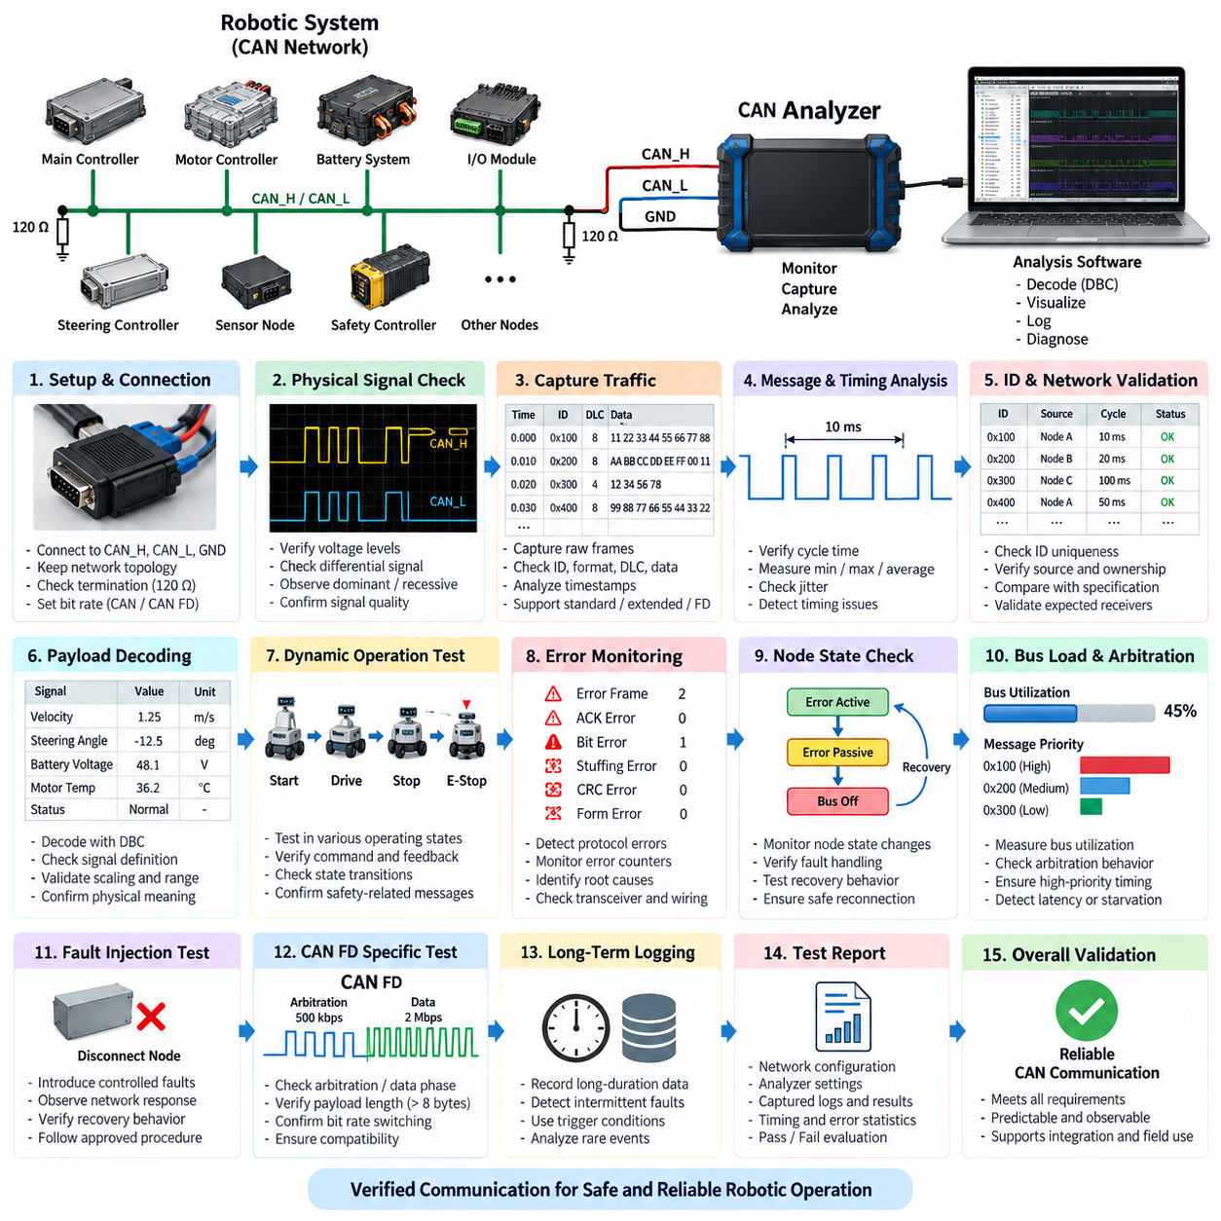
A CAN bus analyzer test verifies whether Controller Area Network communication operates correctly under the electrical, timing, protocol, and traffic conditions expected in the target robotic system. The analyzer observes communication without changing the intended behavior of the network and provides visibility into transmitted identifiers, data payloads, frame timing, bus utilization, error states, and node interactions.
The test begins by connecting a CAN analyzer to CAN_H, CAN_L, and the appropriate reference ground while maintaining the intended network topology. The analyzer interface must support the required CAN version, nominal bit rate, and, when applicable, CAN FD data-phase settings. Proper termination should be confirmed before detailed communication analysis because incorrect termination can create reflections and intermittent errors that resemble software or protocol faults.
Before active operation is evaluated, the physical bus should be observed for basic electrical integrity. CAN_H and CAN_L voltage behavior, differential signaling, dominant and recessive states, termination resistance, and waveform stability provide important evidence about network health. An oscilloscope may complement the analyzer when detailed signal quality must be examined, while the CAN analyzer concentrates on frame-level communication and protocol behavior.
After establishing a stable connection, the analyzer captures raw CAN traffic during representative robot operating states. Each captured frame is examined according to its identifier, frame format, data length, payload, transmission period, and timestamp. Standard and extended identifiers must be interpreted correctly, and remote, error, or CAN FD frames should be distinguished when they are supported by the architecture. This creates a communication-level record of actual system behavior.
Periodic messages are evaluated by measuring their transmission intervals and comparing them with the expected communication design. A message intended to be transmitted every 10 ms, for example, should maintain a sufficiently stable cycle time during normal operation and under increased processing load. Minimum, maximum, average, and jitter values help reveal scheduling problems, overloaded controllers, software timing variation, or arbitration delays that may not be visible from payload inspection alone.
Message identifiers should also be checked for uniqueness and correct ownership. Unexpected duplicate identifiers can cause multiple nodes to transmit frames with indistinguishable arbitration identifiers, potentially producing inconsistent data or difficult-to-diagnose behavior. The analyzer trace should therefore be compared with the communication database or interface specification so that each observed identifier, transmission source, cycle time, and expected receiver relationship can be validated systematically.
Payload validation determines whether the data contained in each frame represents the intended physical or logical information. Signal start bit, bit length, byte order, signedness, scaling factor, offset, range, and invalid-value definitions must correspond to the network specification. When a DBC or equivalent communication database is available, analyzer software can decode raw hexadecimal payloads into engineering values such as velocity, steering angle, battery voltage, motor temperature, or diagnostic status.
Dynamic testing is particularly important for robotic systems because CAN traffic changes with operating state. The analyzer should record communication while the robot is initialized, enabled, driven, stopped, placed into an emergency condition, charged, and transitioned between relevant operating modes. Correlating physical actions with CAN messages helps confirm that commands, acknowledgements, sensor values, state transitions, and safety-related status information propagate through the network as intended.
Error monitoring provides another major function of the CAN bus analyzer test. The test should identify error frames, acknowledgement errors, bit errors, stuffing errors, CRC errors, and other abnormal protocol events supported by the analyzer. Error counters and node state transitions should be monitored when accessible. Repeated errors can indicate defective termination, wiring problems, connector degradation, electromagnetic interference, incorrect bit timing, or malfunctioning CAN transceivers.
The CAN protocol includes mechanisms that prevent a defective node from continuously disrupting the network. A node may progress through error-active, error-passive, and bus-off behavior as its error counters increase. Testing should verify that communication faults are detected and that affected controllers respond according to the intended recovery strategy. Automatic recovery must be evaluated carefully because uncontrolled reconnection can repeatedly disturb a safety-relevant robotic network.
Bus utilization is measured to determine how much of the available communication capacity is consumed by normal traffic. Utilization should be observed not only during idle or nominal operation but also during demanding conditions in which diagnostic traffic, control commands, sensor updates, and status messages occur simultaneously. High utilization increases arbitration delay and can reduce timing margin, so the worst representative operating condition is more meaningful than an isolated average value.
Arbitration behavior should be examined because CAN assigns bus access according to message identifier priority. High-priority frames must obtain access without causing unacceptable starvation or latency for lower-priority traffic. Timestamp analysis can reveal whether control and safety messages meet their required timing while background, diagnostic, or monitoring traffic is present. This is especially important when motor controllers, battery systems, safety controllers, and supervisory computers share the same bus.
The analyzer can also support controlled fault investigation by comparing communication immediately before, during, and after an abnormal event. Disconnecting a permitted test node, interrupting a non-safety-critical message, changing traffic load in a controlled environment, or reproducing a known communication fault can expose recovery behavior. Such testing should follow an approved test procedure so that deliberate disturbances do not create uncontrolled actuator movement or damage connected equipment.
For AMRs and other Physical AI platforms, CAN often forms the deterministic lower-level communication path between edge computing and embedded devices such as motor controllers, steering controllers, battery management systems, power distribution units, and I/O controllers. Higher-level perception or planning may operate over Ethernet, while CAN transports compact commands and feedback close to actuators. Analyzer testing therefore helps verify the boundary between computational intelligence and physical execution.
CAN FD requires additional attention because arbitration and data phases may operate at different bit rates and payloads can exceed classical CAN limits. The analyzer must be configured with compatible nominal and data bit timing, and captured frames should be checked for correct format, payload length, bitrate switching, and error behavior. Mixed-network configurations require particular care because compatibility assumptions between classical CAN and CAN FD nodes can otherwise produce misleading results.
Long-duration logging is useful for detecting intermittent faults that may not appear during short laboratory tests. Timestamped traces can be collected during repeated missions, charging cycles, thermal changes, vibration exposure, or extended robot operation. Analysis can then identify rare missing messages, unusual latency, transient error bursts, unexpected resets, or gradual communication degradation. Trigger conditions reduce data volume by preserving traffic surrounding a selected event or error.
A complete CAN bus analyzer test should produce reproducible evidence rather than relying only on visual observation of live traffic. The test record should identify the network configuration, analyzer settings, bit rates, termination condition, software or firmware versions, operating scenarios, captured traces, detected errors, timing statistics, and acceptance criteria. Raw log files should be retained when practical so that communication behavior can be reanalyzed after software or hardware changes.
Pass or fail evaluation should be based on defined requirements for message presence, identifier correctness, payload validity, timing, jitter, error occurrence, bus utilization, fault handling, and recovery behavior. A network can appear operational while still containing timing or robustness defects, so successful transmission alone is insufficient. The analyzer test should demonstrate that communication remains predictable and diagnostically observable across the representative operating envelope.
CAN analyzer testing ultimately connects electrical validation, protocol verification, functional testing, and system-level debugging. Within the testing structure, it provides the first detailed communication test before broader Ethernet, protocol-conformance, bus-load, and EtherCAT evaluations. A disciplined CAN test process establishes trustworthy communication evidence that can support later integration, regression, reliability, and field validation of robotic electrical architectures.

04.02. Ethernet Network Test
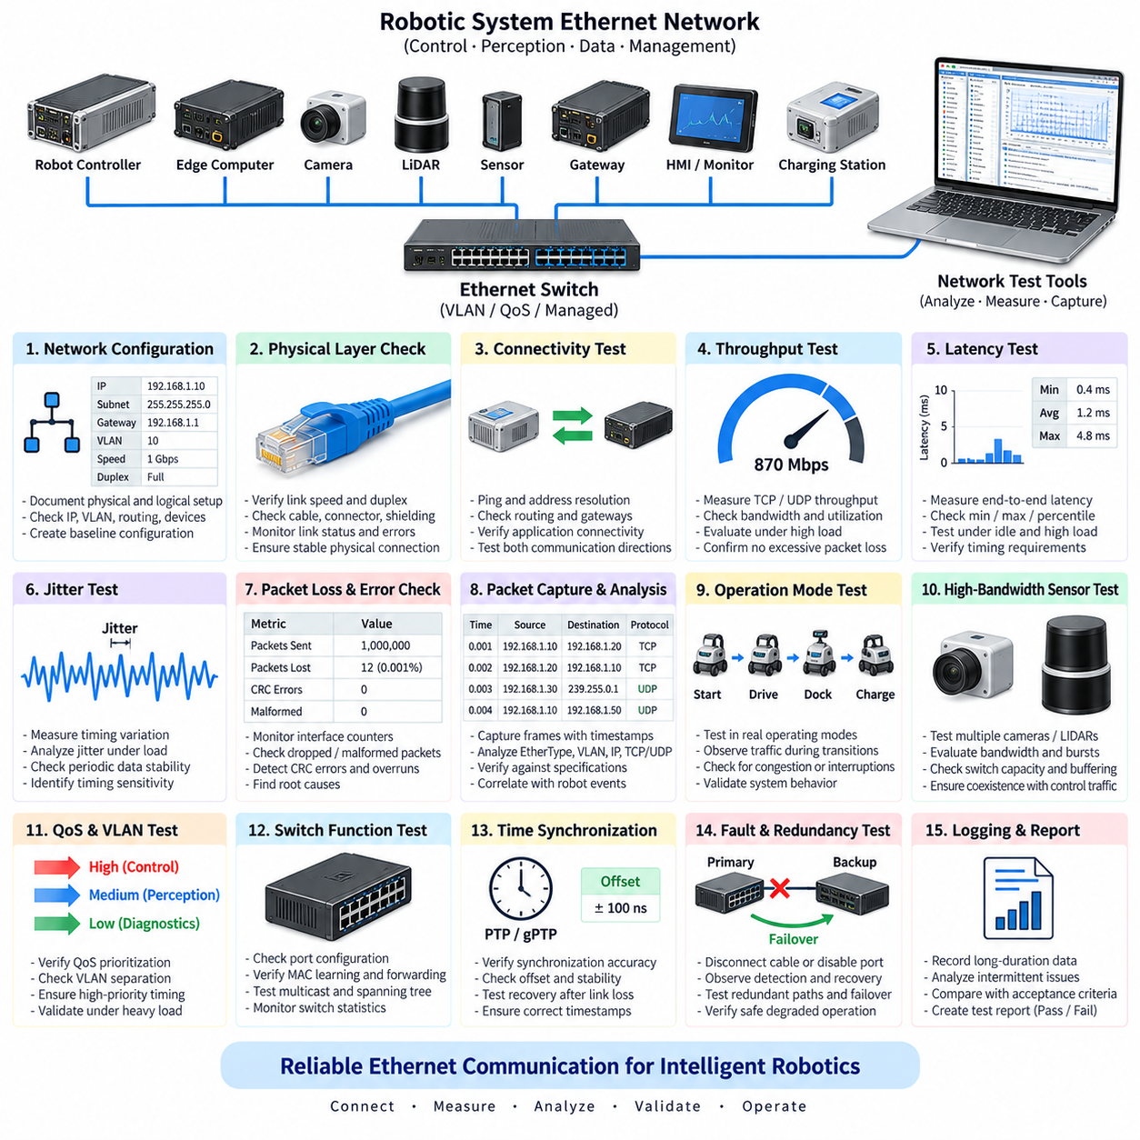
Ethernet network testing verifies that wired communication between robotic controllers, edge computers, sensors, gateways, switches, and other networked devices operates with the required connectivity, bandwidth, latency, reliability, and fault tolerance. Unlike basic link confirmation, the test evaluates whether the Ethernet infrastructure can consistently support real-time control, perception data, diagnostics, and supervisory communication under representative operating conditions.
Testing begins by documenting the physical and logical network configuration. Device interfaces, switch ports, cable categories, connector types, negotiated link speeds, duplex modes, VLAN assignments, IP addresses, subnet masks, gateways, and routing rules should be identified. This baseline configuration allows unexpected behavior to be distinguished from intentional architecture and provides a reproducible reference for later regression and system-level validation.
Physical-layer verification confirms that every Ethernet connection establishes a stable link at the intended speed. Link indicators and interface statistics are checked for negotiation failures, link resets, packet errors, dropped frames, and abnormal retransmission behavior. Cable integrity, shielding, connector engagement, and grounding should also be considered because intermittent physical faults can appear as software, protocol, or application-level communication problems.
Basic connectivity is then verified between expected communication endpoints. ICMP echo testing, address resolution, routing checks, and direct application connections can confirm that devices are reachable through the intended network path. Connectivity should be tested in both directions where required, particularly when robots contain multiple subnets, managed switches, gateways, firewalls, or separated control and perception networks.
Throughput testing determines whether the network can transport the expected amount of data without excessive congestion or packet loss. TCP and UDP traffic should be evaluated because their behavior differs significantly under network stress. Measurements of sustained throughput, instantaneous bandwidth, packet rate, and utilization help determine whether high-volume sources such as cameras, LiDARs, logging systems, and edge computers can coexist with control communication.
Latency testing measures the time required for data to travel between network endpoints. Average latency alone is insufficient for robotic systems because occasional long delays may disrupt control or sensor processing even when the mean value appears acceptable. Minimum, maximum, percentile, and worst-case latency should therefore be examined under idle, nominal, and high-load conditions to determine whether communication remains within system timing requirements.
Jitter represents variation in packet delivery timing and is particularly important for periodic sensor streams and time-sensitive control traffic. Stable average latency with large jitter can still create inconsistent data arrival, buffer accumulation, synchronization errors, or control instability. Ethernet testing should therefore correlate jitter with traffic load, packet size, switch behavior, operating state, and competing network flows to identify timing sensitivity within the architecture.
Packet loss and error behavior should be monitored throughout testing. Interface counters, switch statistics, packet captures, and operating-system network diagnostics can reveal discarded packets, malformed frames, CRC errors, receive overruns, buffer exhaustion, or unexpected retransmissions. Persistent errors may indicate defective cables, connectors, transceivers, switch ports, electromagnetic interference, configuration mismatches, or excessive traffic concentration.
Packet capture provides detailed visibility into actual network communication. Tools such as protocol analyzers can record Ethernet frames and higher-layer traffic with timestamps for subsequent examination. Source and destination addresses, EtherType, VLAN tags, IP headers, TCP or UDP ports, packet lengths, sequence behavior, and application protocols can then be correlated with expected communication specifications and physical robot events.
Network traffic should be evaluated during representative robotic operating modes rather than only while the system is idle. Startup, sensor initialization, autonomous driving, mapping, perception processing, docking, charging, emergency stopping, diagnostics, data logging, and shutdown can produce significantly different traffic patterns. Capturing these transitions helps identify temporary congestion, communication interruptions, burst traffic, or dependencies that are hidden during steady operation.
For perception-intensive robots, camera and LiDAR traffic requires particular attention because these devices can consume a substantial portion of available Ethernet bandwidth. Multiple high-resolution sensors operating simultaneously may create bursts that compete with control or diagnostic communication. Testing should determine whether switch capacity, uplink bandwidth, buffering, and traffic prioritization remain sufficient when all intended sensors operate at their maximum representative data rates.
Quality of Service, traffic prioritization, and VLAN behavior should be verified when these mechanisms are included in the architecture. Safety-related, control, synchronization, perception, diagnostic, and background traffic may require different priorities or logical separation. Tests should confirm that VLAN boundaries are correctly maintained and that high-priority communication continues to satisfy latency requirements when lower-priority traffic generates substantial network load.
Managed switches should be examined as active components rather than treated as transparent wiring devices. Port configuration, forwarding behavior, MAC address learning, multicast handling, spanning-tree settings, VLAN configuration, traffic statistics, and diagnostic functions can directly affect robotic communication. Incorrect switch configuration may create intermittent failures that are difficult to reproduce unless switch state and packet traces are analyzed together.
Multicast and broadcast traffic require special evaluation in robotic networks using discovery mechanisms, middleware, or distributed sensor communication. Excessive multicast or broadcast traffic can unnecessarily consume bandwidth across multiple ports. Where protocols such as DDS or ROS 2 rely on discovery and distributed communication, testing should confirm that discovery occurs reliably and that switch configuration does not unintentionally block or amplify required traffic.
Time synchronization should be validated when distributed controllers and sensors depend on a common time reference. Precision Time Protocol, generalized PTP, hardware timestamping, or other synchronization mechanisms may be used depending on system requirements. Testing should measure synchronization accuracy, offset stability, delay variation, and recovery after link interruptions because inaccurate timestamps can degrade sensor fusion, localization, mapping, and coordinated control.
Fault testing evaluates how the network behaves when physical or logical communication is intentionally disturbed under controlled conditions. A cable may be disconnected, a switch port disabled, a device restarted, or selected traffic interrupted according to an approved test procedure. The resulting detection, timeout, degraded operation, reconnection, and recovery behavior should be observed to verify that communication failures do not produce uncontrolled robotic behavior.
Redundant Ethernet architectures require additional validation of failover behavior. When dual links, redundant switches, multiple interfaces, or alternative communication paths are provided, the primary path can be interrupted to determine whether traffic transfers correctly to the backup path. Failover time, packet loss during transition, application recovery, and restoration to normal operation should be measured rather than assuming redundancy guarantees uninterrupted communication.
Long-duration network logging is useful for detecting intermittent problems that short laboratory tests may miss. Interface statistics, switch counters, packet traces, latency measurements, and application communication status can be collected during extended missions or repeated operating cycles. Analysis can reveal rare link resets, progressive packet loss, traffic bursts, timing anomalies, or failures associated with temperature, vibration, processing load, or specific robot states.
For AMRs and Physical AI platforms, Ethernet often connects high-performance computing with perception sensors, gateways, fleet interfaces, and other bandwidth-intensive subsystems, while lower-level actuator control may use CAN, CANopen, EtherCAT, or dedicated interfaces. Ethernet network testing therefore verifies the communication backbone connecting perception, computation, coordination, diagnostics, and higher-level intelligence across the robotic architecture.
A complete test record should document the network topology, hardware configuration, cable and switch information, IP configuration, link speeds, software versions, test tools, traffic conditions, captured data, and measured performance. Throughput, latency, jitter, packet loss, synchronization accuracy, interface errors, and recovery times should be compared with defined acceptance criteria so that pass or fail decisions are based on measurable evidence.
Ethernet network testing provides the communication foundation for subsequent protocol conformance, bus-load stress, functional, reliability, and field validation. Within the communication-test structure, it complements CAN bus analyzer testing by addressing higher-bandwidth packet-based networking and prepares the system for more specialized protocol and deterministic-network evaluations. Reliable Ethernet operation is therefore essential for scalable, observable, and robust robotic system integration.

04.03. Protocol Conformance Test
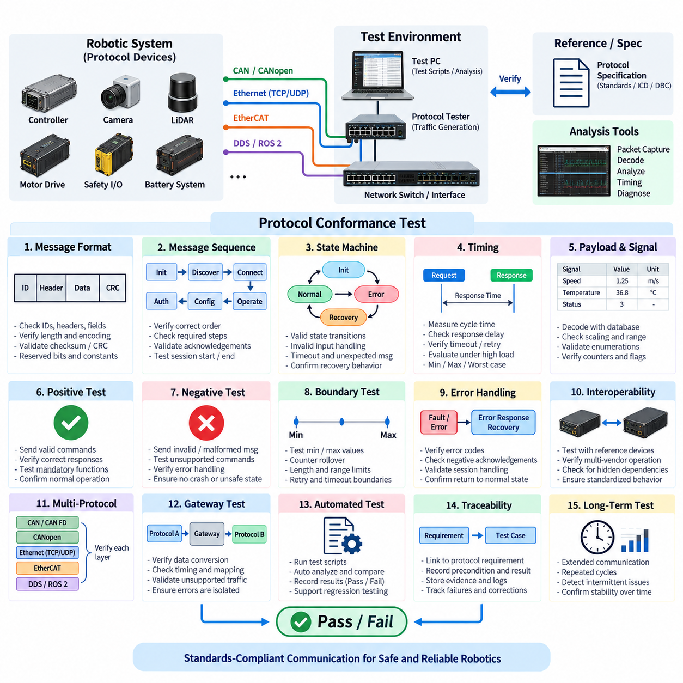
Protocol conformance testing verifies that communication devices, controllers, gateways, sensors, and software components implement a defined protocol according to its specification and system interface requirements. The objective is not merely to confirm that two devices can exchange data, but to determine whether message formats, sequences, timing, states, error responses, and optional functions behave consistently with the expected protocol definition.
The test begins by defining the protocol implementation under test and establishing a reference specification. This may include an international standard, industry specification, vendor interface document, communication database, interface control document, or project-specific protocol definition. The supported protocol version, physical interface, transport mechanism, message set, device role, mandatory functions, and optional capabilities should be clearly identified before execution begins.
A conformance test environment typically includes the device under test, reference communication equipment, monitoring or analysis software, traffic generation tools, and controlled network infrastructure. The environment should allow valid messages, boundary conditions, malformed inputs, timing variations, and abnormal sequences to be introduced reproducibly. Accurate timestamps and complete communication traces are important because many protocol violations are associated with sequence or timing rather than individual data values.
Message-format validation confirms that transmitted frames or packets follow the required structural definition. Identifiers, headers, addresses, control fields, payload lengths, data encoding, counters, checksums, CRC fields, and reserved bits should be examined where applicable. Fields defined as constant or reserved must contain permitted values, while variable fields should remain within their specified ranges and follow the required byte order and encoding conventions.
Message sequence testing evaluates whether communication occurs in the correct procedural order. Many protocols require initialization, discovery, connection establishment, authentication, configuration, command exchange, acknowledgement, state transition, and termination to follow defined sequences. A device that generates individually valid messages can still violate the protocol if those messages are transmitted in an incorrect state or at an inappropriate point in the communication procedure.
State-machine behavior is therefore an important part of protocol conformance. The device should enter, remain in, and leave protocol states only when permitted conditions occur. Normal transitions are tested first, followed by invalid commands, unexpected messages, repeated requests, missing responses, timeouts, and interrupted communication. The resulting state should correspond to the defined protocol behavior rather than producing an undefined or uncontrolled operating condition.
Timing conformance verifies requirements such as message cycle time, response time, acknowledgement delay, timeout duration, retry interval, heartbeat period, and session timing. Measurements should include minimum, maximum, average, percentile, and worst representative values where appropriate. Timing should also be evaluated under increased processor and network load because a device may satisfy requirements during an idle laboratory test but violate them during realistic robotic operation.
Payload and signal validation confirms that transmitted data has the intended interpretation. Signal position, bit length, byte order, signedness, scaling, offset, physical range, enumerated states, invalid values, counters, and status flags should match the applicable communication definition. When databases or machine-readable interface descriptions are available, automated decoding can compare captured traffic directly with expected signal definitions and reduce manual interpretation errors.
Positive conformance testing applies valid protocol inputs and confirms that the device produces the required responses. Supported commands, requests, state changes, configuration operations, diagnostic functions, and normal data exchanges should execute successfully. This establishes that mandatory protocol capabilities are implemented and provides a baseline before more demanding negative, boundary, stress, and fault-oriented test cases are introduced.
Negative testing intentionally provides unsupported, malformed, incomplete, duplicated, out-of-order, or otherwise invalid communication. The purpose is to verify that the implementation rejects or handles abnormal inputs according to the protocol definition without crashing, entering an undefined state, or generating unsafe outputs. Invalid identifiers, lengths, values, sequences, checksums, commands, and timing conditions can be introduced when they are meaningful for the protocol being evaluated.
Boundary-value testing examines behavior near permitted limits. Minimum and maximum payload sizes, numeric ranges, counter rollover, timeout boundaries, maximum retry counts, address limits, sequence numbers, and resource-related limits should be exercised where defined. Boundary testing is particularly valuable because implementations that behave correctly during nominal communication may contain defects that appear only when counters wrap or parameters reach extreme values.
Error-handling conformance verifies the response to communication failures and protocol violations. Depending on the protocol, expected behavior may include an error response, negative acknowledgement, diagnostic code, retry, timeout, state transition, session termination, or controlled recovery. The test should verify both the externally visible response and the subsequent ability of the device to return to valid communication without requiring an unintended reset or manual intervention.
Interoperability should be distinguished from strict conformance even though the two are closely related. Two nonconforming implementations can sometimes communicate because they share the same undocumented assumption, while two conforming devices should communicate through standardized behavior. Testing with reference implementations, multiple vendors, or independent analysis tools can therefore reveal hidden dependencies that are not visible when only one pair of devices is tested together.
Protocol conformance in robotic systems often spans multiple communication layers. CAN or CAN FD may transport control and diagnostic messages, CANopen may define device profiles, Ethernet may carry TCP or UDP traffic, EtherCAT may support deterministic motion communication, and DDS or ROS 2 may provide distributed middleware communication. Each layer should be evaluated against the requirements that actually apply to its role rather than treating the complete network as a single protocol.
Gateway testing requires particular attention because gateways translate or route information between communication domains. A gateway may convert identifiers, signals, addressing, timing, diagnostic information, or protocol semantics while preserving the intended system meaning. Conformance testing should verify that required data is transferred correctly, unsupported traffic is handled as designed, timing remains acceptable, and errors on one network are not propagated incorrectly into another domain.
For AMRs and Physical AI platforms, protocol conformance directly affects the boundary between high-level intelligence and physical execution. Commands generated by planning or supervisory software eventually reach embedded controllers, motor drives, safety devices, sensors, battery systems, and other physical components through defined interfaces. A semantic or sequencing error at this boundary can produce incorrect behavior even when the electrical network and individual communication links remain healthy.
Automated conformance testing improves repeatability when the protocol contains many messages, states, and parameter combinations. Test scripts can generate predefined inputs, capture responses, evaluate timing, compare payloads, check state transitions, and automatically record pass or fail results. Automation is especially valuable for regression testing because firmware, middleware, gateway, or application changes can be evaluated against the same protocol requirements throughout system development.
Traceability should connect each conformance test case to a specific protocol requirement or interface requirement. The test record should identify the requirement, preconditions, input stimulus, expected response, measured result, captured evidence, and final verdict. This prevents a large collection of packet traces from being mistaken for systematic verification and allows failed requirements to be traced directly to implementation defects and corrective actions.
Long-duration and repeated testing can expose protocol defects that occur only after extensive communication. Counter rollover, resource leakage, session accumulation, repeated reconnection, intermittent timeout behavior, and gradual synchronization problems may remain hidden during short tests. Repeating protocol sequences while varying traffic load, operating state, and connection conditions provides stronger evidence that conformance is maintained throughout realistic robot operation.
Pass or fail evaluation should consider message structure, sequence, state behavior, timing, payload interpretation, error handling, mandatory functions, and recovery behavior. A device should not be considered conformant merely because normal communication appears functional. Any deviation from a mandatory requirement should be documented with the corresponding trace, operating condition, expected behavior, actual behavior, severity, and disposition for correction or approved exception.
Protocol conformance testing complements CAN bus analyzer and Ethernet network testing within the communication validation structure. CAN and Ethernet tests establish whether the underlying communication paths operate correctly, while conformance testing determines whether information exchanged across those paths follows the required communication rules. Together, these tests provide the foundation for subsequent bus-load stress, functional, reliability, regression, and field validation of robotic systems.

04.04. Bus Load Stress Test
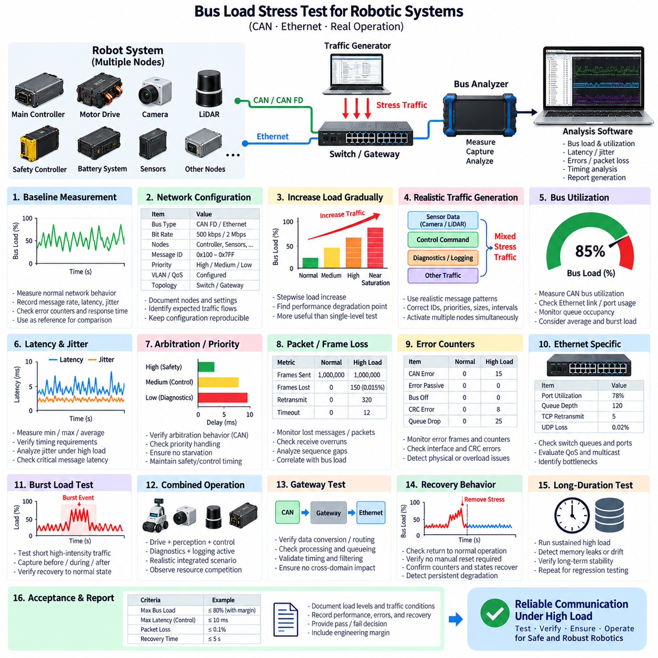
Bus load stress testing verifies whether a communication network can maintain required timing, data integrity, availability, and fault behavior when traffic approaches or exceeds demanding operating conditions. The objective is to expose weaknesses that remain hidden during nominal communication by deliberately increasing message frequency, payload volume, competing traffic, or simultaneous node activity while observing whether critical communication remains predictable.
The test begins by establishing a baseline of normal network behavior. Message rates, frame sizes, bus utilization, latency, jitter, error counters, retransmissions, and application response times are recorded during representative nominal operation. This baseline provides the reference against which stressed conditions can be compared and prevents naturally occurring traffic variations from being incorrectly interpreted as failures caused by the stress test.
The network configuration should be documented before stress traffic is introduced. Participating nodes, communication interfaces, nominal bit rates, CAN or CAN FD settings, Ethernet link speeds, message priorities, VLANs, QoS policies, switches, gateways, and expected traffic flows should be identified. The test configuration must remain reproducible because relatively small changes in topology or traffic distribution can significantly affect observed load and latency.
Bus utilization is a primary measurement during the test. For CAN-based networks, utilization represents the proportion of available bus time occupied by transmitted frames, including protocol overhead. Ethernet testing may evaluate link utilization, packet rate, throughput, switch-port loading, and queue occupancy. Measurements should distinguish average utilization from short traffic bursts because transient saturation can produce timing failures even when long-term average load appears acceptable.
Stress conditions should be increased progressively rather than applied only at a single maximum level. Testing may begin near normal utilization and then move through moderate, high, and near-saturation conditions. This approach reveals the point at which latency, jitter, packet loss, arbitration delay, queue depth, or application performance begins to degrade and provides more useful engineering information than a simple pass or fail result at one arbitrary traffic level.
Traffic generation must represent realistic communication behavior whenever possible. Artificial frames or packets can be introduced to increase load, but their identifiers, priorities, packet sizes, transmission intervals, and destinations should reflect plausible system traffic. Additional stress can also be produced by simultaneously activating cameras, LiDARs, diagnostic sessions, logging functions, motor controllers, gateways, or other devices that generate traffic during demanding robotic operating modes.
Message latency is monitored as network load increases. Critical messages should continue to reach their destinations within their specified timing limits even when lower-priority traffic occupies a substantial portion of available bandwidth. Minimum, maximum, average, percentile, and worst-case latency provide different views of performance. A small average delay does not guarantee acceptable behavior if occasional messages experience excessive arbitration or queueing delays.
Jitter should be evaluated together with latency because increasing network load often affects the consistency of message delivery before communication fails completely. Periodic control commands, sensor updates, synchronization traffic, and heartbeat messages can become irregular when arbitration, buffering, or scheduling delays increase. Excessive jitter may degrade motion control, sensor fusion, localization, or distributed state estimation even when every message eventually reaches its destination.
For CAN and CAN FD networks, arbitration behavior becomes increasingly important as utilization rises. Frames with numerically lower arbitration identifiers generally obtain access before lower-priority traffic, causing delays to accumulate for less urgent messages. Stress testing should verify that safety and control messages maintain required timing while also confirming that lower-priority diagnostic or status traffic does not experience unacceptable starvation during sustained high-load operation.
Ethernet stress testing focuses additionally on switch queues, port utilization, packet buffering, TCP behavior, UDP loss, multicast traffic, and QoS prioritization. High-bandwidth perception streams may generate large bursts while control and synchronization traffic require low latency. The test should determine whether the network infrastructure can isolate or prioritize critical flows and whether congestion at a single uplink or switch port creates a bottleneck for otherwise adequate network capacity.
Packet and frame loss must be measured throughout the stress sequence. CAN networks may exhibit delayed transmission rather than conventional packet loss until errors or application timeouts occur, whereas Ethernet devices may discard packets when queues or buffers are exhausted. Lost messages, receive overruns, dropped frames, retransmissions, sequence gaps, and application-level timeouts should therefore be correlated with measured network utilization and traffic conditions.
Error counters and communication health indicators provide evidence of how the network behaves near its operating limits. CAN error frames, error-active or error-passive transitions, bus-off events, Ethernet CRC errors, interface drops, queue discards, and protocol retries should be monitored where applicable. Increasing logical traffic should not normally create physical-layer errors, so such errors may indicate an underlying hardware or signal-integrity weakness exposed by sustained activity.
Priority inversion and starvation are important failure modes to investigate. A network may preserve high-priority traffic successfully while delaying low-priority messages indefinitely, or poorly configured scheduling may allow background traffic to interfere with critical communication. The test should therefore evaluate different message classes separately and determine whether each class receives the latency, bandwidth, and delivery characteristics defined by the communication architecture.
Burst-load testing complements sustained-load testing. Robotic networks frequently experience short periods of intense traffic during startup, sensor initialization, mapping transitions, diagnostic requests, emergency events, log uploads, or mode changes. These bursts can temporarily saturate links or buffers even when continuous traffic is moderate. Capturing traffic before, during, and after a burst reveals whether the network absorbs the event and returns cleanly to normal operation.
Combined operating scenarios provide a more realistic stress condition than synthetic traffic alone. An AMR can be commanded to drive while cameras and LiDARs stream data, motor controllers exchange feedback, the battery system reports status, diagnostics are active, and logs are transferred to an edge computer. Such scenarios test the communication architecture as an integrated system and expose resource competition between perception, control, diagnostics, and supervisory functions.
Gateways should be monitored carefully during high-load testing because traffic concentration or protocol conversion can create localized bottlenecks. A gateway may receive messages from several CAN networks and forward selected information over Ethernet, or perform the reverse operation. Processing capacity, queue behavior, conversion latency, message filtering, and overload recovery should be evaluated to ensure that gateway saturation does not propagate communication degradation across network domains.
Recovery behavior should be evaluated after the stress condition is removed. Message latency, utilization, queue depth, error counters, node states, and application communication should return to their expected normal condition without requiring an unintended reset. Persistent degradation after overload may indicate exhausted resources, blocked queues, lost sessions, memory leakage, synchronization problems, or software state machines that do not recover correctly from temporary congestion.
Long-duration stress testing can reveal failures that short peak-load experiments cannot detect. Sustained high utilization may expose memory leakage, buffer accumulation, counter rollover, thermal effects, timing drift, or progressive application degradation. Repeating the same traffic profile for extended periods also helps determine whether network performance remains statistically stable rather than merely surviving a brief period of elevated communication activity.
Safety-related communication requires special attention during bus load stress testing. Emergency-stop status, drive-enable information, watchdog or heartbeat messages, safety controller communication, and other critical signals should maintain their defined behavior under the highest permitted network load. Stress generation must itself be controlled so that the test does not create unintended actuator motion or compromise personnel and equipment safety while evaluating communication robustness.
Test limits and acceptance criteria should be defined before execution. These may specify maximum permitted bus utilization, message latency, jitter, packet loss, error counts, timeout frequency, recovery time, or minimum bandwidth for selected traffic classes. The practical operating limit should include sufficient engineering margin below the point where communication becomes unstable, rather than defining normal operation directly at the measured saturation boundary.
Automated tools can generate controlled traffic profiles while simultaneously capturing utilization, timestamps, errors, latency, and application responses. Automation allows identical load patterns to be repeated after firmware, network, gateway, or application changes and therefore supports regression testing. Results should preserve the exact traffic profile and configuration so that a later test can reproduce both the stress condition and the measured system response.
The final test record should correlate network load with communication performance rather than reporting utilization alone. Traffic conditions, message classes, load levels, latency distributions, jitter, losses, errors, node states, bottlenecks, recovery behavior, and acceptance results should be documented together. This provides evidence not only that the network survived the test, but also that its performance degradation characteristics and usable engineering margin are understood.
Bus load stress testing extends CAN bus analyzer, Ethernet network, and protocol conformance testing by evaluating communication behavior under demanding traffic conditions. Those preceding tests establish correct connectivity and protocol behavior, while stress testing determines whether these properties remain valid as network demand increases. The resulting evidence supports functional, reliability, regression, and field validation of robust communication architectures for AMRs and Physical AI systems.

04.05. EtherCAT Conformance Test
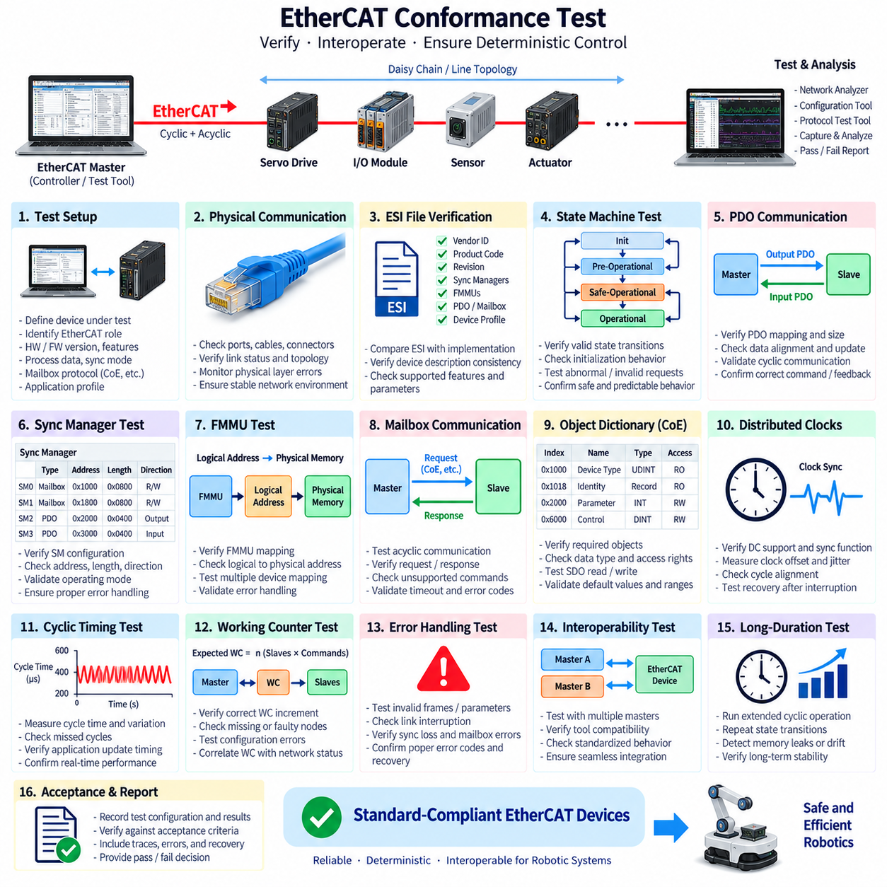
EtherCAT conformance testing verifies that an EtherCAT device implements the communication behavior, state transitions, object access, synchronization functions, and device-specific capabilities required by its applicable specification and implementation profile. The purpose is not simply to demonstrate successful cyclic communication, but to establish that the device behaves predictably and interoperably when integrated into a deterministic industrial or robotic EtherCAT network.
The test begins by defining the device under test and its intended EtherCAT role. Device identity, hardware revision, firmware version, supported features, process-data requirements, synchronization mode, mailbox protocols, and application profile should be documented. The corresponding EtherCAT Slave Information, or ESI, file becomes an important reference because it describes device characteristics that engineering and configuration tools use during network integration.
Physical communication should first be verified before protocol-level conclusions are made. Ethernet ports, cabling, connectors, link status, topology, and physical-layer error counters are inspected to establish a stable test environment. EtherCAT uses standard Ethernet physical technology but processes frames according to its own communication mechanism, so ordinary Ethernet connectivity alone does not demonstrate correct EtherCAT operation or deterministic performance.
The ESI description should be compared with the actual device implementation. Vendor identification, product code, revision information, supported Sync Managers, Fieldbus Memory Management Units, process-data objects, mailbox capabilities, and synchronization parameters should correspond to the implemented hardware and firmware. Incorrect device-description information can prevent configuration or create integration failures even when the underlying EtherCAT communication electronics operate normally.
EtherCAT state-machine behavior is a fundamental conformance area. The device normally progresses through Initialization, Pre-Operational, Safe-Operational, and Operational states according to defined conditions. Testing should verify permitted transitions, required initialization behavior, application readiness, process-data activation, and responses to invalid or interrupted transitions. The device should never enter an unintended operational condition merely because a master issues an inappropriate sequence.
Process Data Object communication should be validated after successful configuration. Input and output PDO mappings, data sizes, offsets, access directions, and update behavior must correspond to the device description and application requirements. For motor drives or robotic actuators, command and feedback values should remain correctly aligned during continuous cyclic operation because even a small mapping error can cause incorrect interpretation between the EtherCAT master and physical device.
Sync Manager configuration controls the exchange of process and mailbox data between the EtherCAT communication system and local application. Conformance testing should verify that supported Sync Managers are configured with valid addresses, lengths, directions, and operating modes. Invalid configurations should be rejected or handled according to the defined behavior rather than allowing memory overlap, inconsistent data exchange, or unpredictable application operation.
Fieldbus Memory Management Unit behavior should also be verified where applicable. FMMUs map logical EtherCAT address space to physical memory locations inside slave devices and enable efficient processing of distributed process data. Tests should confirm that supported mappings operate correctly, invalid mappings are handled appropriately, and logical addressing does not produce unexpected data corruption when several devices participate in the same cyclic EtherCAT frame.
Mailbox communication is evaluated when the device supports acyclic configuration or diagnostic services. Depending on the device, this may include protocols such as CAN application protocol over EtherCAT, commonly called CoE, or other supported mailbox mechanisms. Requests, responses, object access, unsupported commands, timeout handling, and error codes should follow the declared device capabilities so that commissioning and diagnostic tools can interact reliably with the slave.
For devices supporting CoE, object-dictionary access is an important part of testing. Required objects, data types, access permissions, default values, ranges, and read or write behavior should match the implementation definition. Service Data Object transfers should operate correctly for normal, boundary, and invalid requests. Incorrect object behavior can cause configuration failures that appear only when a master attempts parameterization rather than during basic cyclic communication.
Distributed Clocks are particularly important in robotic systems requiring tightly synchronized motion or sensor acquisition. Conformance testing should verify whether the device supports the declared synchronization functions and whether clock synchronization reaches the required stable condition. Clock offset, synchronization error, cycle alignment, and recovery after communication interruption should be examined because deterministic frame delivery alone does not guarantee synchronized physical execution.
Cyclic timing should be evaluated under representative application conditions. The EtherCAT master transmits frames through the network while slave devices process relevant data as frames pass through them, enabling efficient deterministic communication. Cycle time, response behavior, timing variation, missed cycles, and application update timing should be measured to determine whether the complete device implementation maintains the required real-time characteristics rather than merely maintaining an active link.
Working Counter behavior provides important evidence about successful EtherCAT datagram processing. The expected Working Counter value depends on the commands and participating slave operations, allowing the master to detect missing or incorrectly processed communication. Testing should confirm that the device contributes correctly to the Working Counter and that communication faults, configuration errors, or unavailable nodes produce observable behavior consistent with the expected network response.
Error handling should include malformed or unsupported accesses, invalid configuration parameters, interrupted links, incorrect state requests, synchronization loss, mailbox failures, and process-data communication disturbances where applicable. The device should generate appropriate status or error information and transition to a controlled condition when required. Recovery should restore valid communication without leaving stale outputs, inconsistent process data, or an undefined application state.
Safe-Operational behavior deserves particular attention because it forms an important boundary between communication readiness and active output operation. Inputs may be available while outputs remain constrained according to the device implementation and EtherCAT state model. Testing should verify that output behavior during Safe-Operational and transitions to or from Operational state cannot unintentionally command actuators before the system is fully configured and ready.
Network topology changes and link interruptions can be used to evaluate robustness in a controlled environment. Disconnecting an approved link, restarting a slave, or temporarily interrupting master communication allows detection and recovery behavior to be observed. The test should record state transitions, Working Counter changes, synchronization recovery, process-data validity, and application response before, during, and after the disturbance.
Interoperability testing complements formal conformance by integrating the device with representative EtherCAT masters, configuration software, and neighboring slave devices. A device may appear functional in a vendor-specific environment while depending on undocumented assumptions. Using independent tools or alternative master implementations helps determine whether the device description, configuration behavior, state machine, mailbox access, and cyclic communication are sufficiently standardized for practical integration.
Robotic EtherCAT networks frequently connect servo drives, distributed I/O, force-torque sensors, actuators, and other time-sensitive devices to a real-time controller. Conformance therefore affects physical execution directly. A communication defect that changes PDO interpretation, synchronization, state transition, or output validity can propagate into motion behavior even when the higher-level planner, Ethernet backbone, and mechanical system are otherwise functioning correctly.
Automated test execution improves repeatability because EtherCAT conformance involves many configuration states, object accesses, timing conditions, and abnormal cases. Scripts and specialized test tools can apply predefined sequences, capture frames, evaluate state transitions, inspect errors, and compare observed behavior with expected results. The same cases can then be repeated after firmware or hardware changes as part of systematic regression testing.
Long-duration cyclic testing should verify that conformance is maintained over extended operation. Repeated state transitions, continuous PDO exchange, mailbox access, synchronization, and controlled communication interruptions can reveal intermittent failures, resource leakage, counter-related defects, timing drift, or recovery problems. Stable operation over time is especially important for AMRs and industrial robots expected to operate continuously for long production or mission periods.
Test evidence should connect configuration and communication results to defined acceptance criteria. The record should include device identification, ESI version, network topology, master configuration, cycle time, state transitions, PDO mappings, synchronization results, Working Counter behavior, mailbox tests, captured traces, errors, recovery results, and final verdicts. Failed cases should preserve sufficient evidence to reproduce the condition and identify the responsible implementation area.
EtherCAT conformance testing completes the communication-test sequence following CAN bus analysis, Ethernet network testing, general protocol conformance, and bus-load stress testing in the provided validation structure. Together, these activities move from basic communication observation toward deterministic protocol verification and system robustness, providing a foundation for later functional, reliability, regression, and field validation of robotic electrical architectures.

