Volume 19. Testing and Validation

Chapter 05. Calibration Test

05.01. Calibration Accuracy Validation
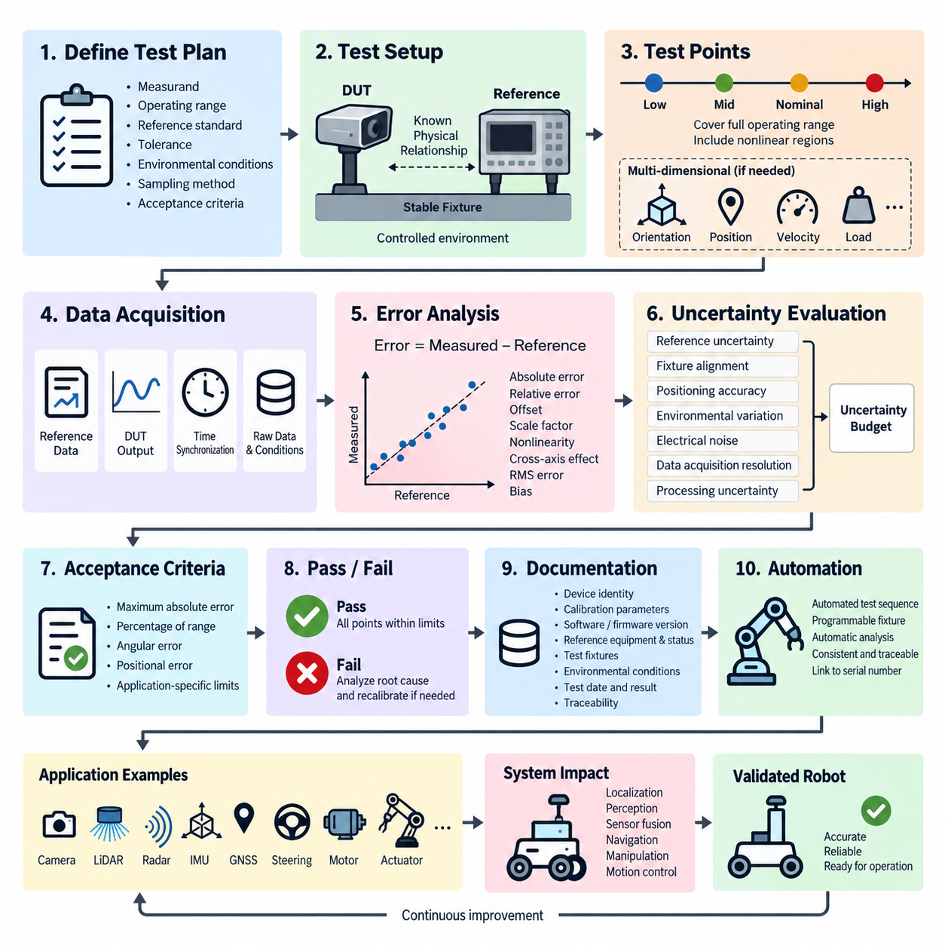
Calibration accuracy validation establishes whether a calibrated sensor, actuator, measurement channel, or robotic subsystem produces values sufficiently close to a recognized reference under defined operating conditions. Within the calibration test structure, it serves as the primary verification of absolute measurement correctness before repeatability, temperature drift, long-term stability, and statistical process analysis are evaluated separately.
The validation process begins by defining the measurand, operating range, reference standard, required tolerance, environmental conditions, sampling method, and acceptance criteria. Accuracy cannot be evaluated meaningfully without a traceable reference whose uncertainty is substantially smaller than the tolerance assigned to the device under test. The reference configuration and calibration status therefore become part of the formal test evidence.
A representative set of validation points should cover the usable measurement range rather than concentrating only around the nominal operating point. Tests normally include low, intermediate, nominal, and high values, with additional points near regions where nonlinear behavior or operational limits are expected. For multidimensional sensors, several orientations, positions, distances, velocities, or loads may be required to characterize accuracy across the relevant operating envelope.
At each validation point, the reference value and device-under-test output are acquired under controlled and synchronized conditions. The measurement error can be expressed as the difference between measured and reference values, while relative or percentage error may be used when comparison across a wide dynamic range is necessary. The sign of the error should normally be retained because systematic positive or negative bias provides important diagnostic information.
Accuracy assessment should distinguish offset, scale-factor error, nonlinearity, cross-axis effects, quantization, alignment error, and other mechanisms that can produce apparently similar deviations. A sensor may show a small error near one calibration point while accumulating substantial error toward the ends of its range. Evaluating the complete error profile therefore provides considerably stronger evidence than reporting only a single average accuracy value.
Measurement uncertainty must be considered when interpreting validation results. Reference uncertainty, fixture alignment, positioning accuracy, synchronization, environmental variation, electrical noise, data acquisition resolution, and numerical processing can all contribute to the observed deviation. An uncertainty budget helps determine whether an apparent failure originates from the device itself or from limitations of the validation setup and measurement chain.
For camera, LiDAR, radar, IMU, GNSS, steering, motor, and servo systems, accuracy has different physical meanings and therefore requires application-specific reference quantities. Camera calibration may evaluate reprojection or geometric errors, LiDAR validation may examine range and angular accuracy, and an IMU may require controlled angular-rate or acceleration references. Actuator calibration instead relates commanded states to measured physical motion.
Calibration accuracy validation is particularly important for robotic systems because individual calibration errors propagate into higher-level functions. Angular bias in an IMU can influence localization, extrinsic calibration error can degrade sensor fusion, steering offset can create trajectory deviation, and incorrect actuator scaling can reduce motion-control precision. Validation limits should therefore be related not only to component specifications but also to system-level performance requirements.
The test fixture must preserve a known geometric and mechanical relationship between the device under test and the reference equipment. Fixture deformation, backlash, vibration, mounting tolerance, cable forces, thermal expansion, or movement during acquisition can introduce errors that are incorrectly attributed to calibration. Mechanical configuration should consequently be documented together with reference positions, coordinate frames, mounting orientation, and relevant setup dimensions.
Data acquisition should preserve sufficient raw information to permit independent reconstruction of the validation result. Reference measurements, raw device outputs, calibrated outputs, timestamps, calibration parameters, environmental conditions, configuration versions, and test identifiers should be recorded whenever applicable. Automated processing can then calculate point-wise error, maximum absolute error, mean error, RMS error, bias, and other metrics required by the engineering specification.
Time synchronization becomes critical when calibration accuracy is evaluated using moving targets or dynamically changing references. Even an accurately calibrated sensor can appear incorrect when its data are compared with a reference captured at a different instant. Hardware timestamps, synchronized clocks, trigger signals, known communication latency, or time-alignment correction should therefore be incorporated whenever temporal misalignment could materially affect the measured error.
Acceptance criteria should be established before examining test results and should correspond to the intended engineering use of the calibrated device. A typical criterion may specify a maximum permissible absolute error, percentage-of-range error, angular error, positional error, or application-specific performance boundary. Multiple limits may be necessary when different portions of the operating range have different accuracy requirements or safety consequences.
A successful result demonstrates that all required validation points remain within the defined acceptance limits while the reference and measurement uncertainties remain adequately controlled. A failure should not immediately lead to arbitrary recalibration. The error pattern should first be examined to determine whether the cause is offset, gain, nonlinear response, incorrect coordinate transformation, mechanical installation, synchronization, reference uncertainty, software configuration, or an actual device defect.
When recalibration is required, the corrected calibration parameters should be treated as controlled configuration data. The complete accuracy validation should then be repeated using the same defined procedure so that improvement can be demonstrated quantitatively. Comparing pre-calibration and post-calibration error distributions provides evidence that the calibration operation corrected the intended error rather than merely optimizing a limited subset of test points.
Calibration accuracy validation must also remain distinct from repeatability testing. Accuracy determines closeness to a reference value, whereas repeatability determines how consistently the same result can be reproduced under equivalent conditions. A device can be highly repeatable but systematically inaccurate, or individually accurate at selected points while exhibiting poor repeatability. Both properties are therefore evaluated as complementary but separate calibration characteristics.
For production robotics, automated validation can substantially improve consistency and traceability. Programmable fixtures, precision motion stages, calibration targets, reference sensors, robotic positioning systems, and automated analysis software can execute predefined validation sequences and immediately compare results against stored limits. Such automation also reduces operator-dependent variation and enables calibration evidence to be linked directly to device serial numbers and manufacturing records.
Accuracy validation results should be retained with the identity of the device, calibration parameter version, software and firmware configuration, reference equipment, reference calibration status, test fixture, environmental conditions, operator or automated station identifier, date, and acceptance decision. This information creates traceability between the physical product and the calibration state that was verified before integration, shipment, maintenance, or field deployment.
At system level, calibration accuracy should ultimately be connected to functional validation rather than treated as an isolated laboratory metric. The validated calibration parameters become inputs to localization, perception, sensor fusion, navigation, manipulation, steering, and motion-control functions. This relationship explains why calibration testing occupies a dedicated stage within the broader robotics testing and validation architecture rather than being treated only as sensor setup.
A mature calibration accuracy validation process therefore combines traceable references, controlled fixtures, representative operating points, synchronized acquisition, uncertainty awareness, predefined acceptance limits, configuration control, and reproducible data analysis. Its purpose is not simply to confirm that calibration software completed successfully, but to provide objective evidence that the resulting physical measurements and commanded behaviors are accurate enough for their intended robotic functions.

05.02. Repeatability Test
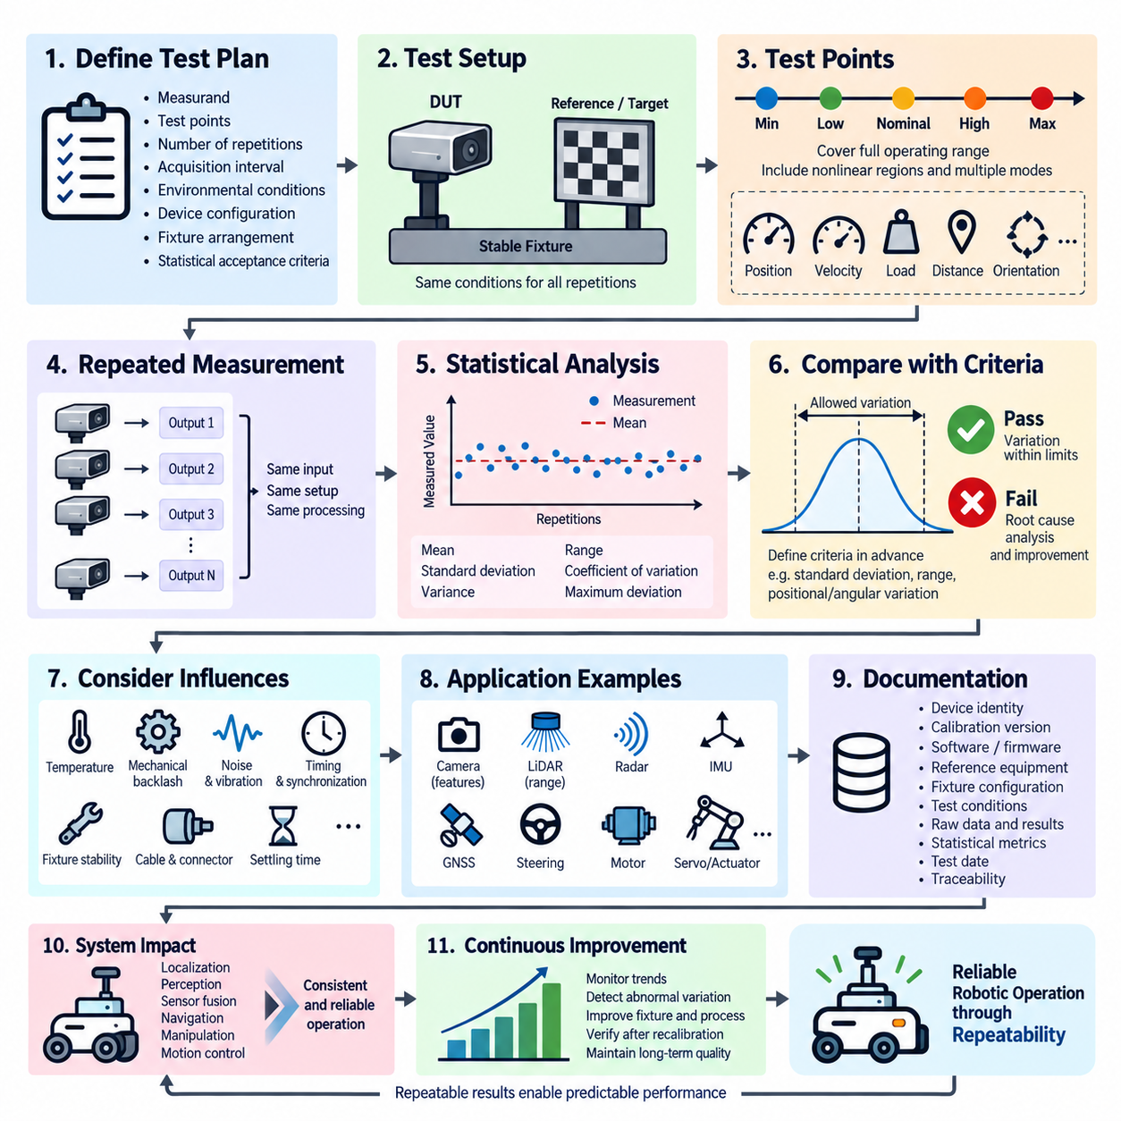
Repeatability testing determines whether a calibrated sensor, actuator, measurement channel, or robotic subsystem can reproduce consistent results when the same input or physical condition is applied repeatedly under nominally identical conditions. Unlike calibration accuracy validation, which compares measurements with a reference value, repeatability focuses on the dispersion of repeated observations and therefore evaluates the stability and consistency of the measurement or actuation process.
A repeatability test begins by defining the measurand, test point, number of repetitions, acquisition interval, environmental conditions, device configuration, fixture arrangement, and statistical acceptance criteria. These conditions should remain as constant as reasonably possible throughout the test. Any intentional variation in temperature, operator, equipment, installation, or elapsed time changes the nature of the evaluation and may introduce reproducibility or stability effects rather than pure repeatability.
Representative test points should be selected across the operating range because repeatability may vary with measurement magnitude, actuator position, velocity, load, distance, orientation, or signal level. Testing only at a nominal point can conceal instability near minimum or maximum operating limits. For nonlinear devices or systems with multiple operating modes, additional points should be selected where changes in sensitivity, control behavior, or measurement characteristics are expected.
At each selected condition, the same stimulus or reference state is applied repeatedly without intentionally changing the setup. The device output is recorded for every repetition using identical acquisition settings and processing parameters. Where practical, sufficient samples should be collected to characterize the distribution rather than relying on only a few observations. The resulting dataset provides the basis for evaluating short-term variation around the repeated operating condition.
Repeatability is commonly quantified using statistical measures such as the mean, standard deviation, variance, range, coefficient of variation, and maximum deviation from the repeated mean. Standard deviation is particularly useful because it describes the dispersion of observations around their average value. For applications with substantially different measurement magnitudes, normalized or percentage-based repeatability metrics can make performance easier to compare across the operating range.
The repeatability result must be distinguished from systematic bias. A sensor may repeatedly report nearly identical values and therefore exhibit excellent repeatability while all measurements remain offset from the true reference. Conversely, a device may have a mean value close to the reference while individual observations fluctuate excessively. Accuracy and repeatability must therefore be evaluated separately before they are combined into an overall assessment of calibration quality.
The test setup itself can strongly influence observed repeatability. Fixture movement, mechanical backlash, connector instability, cable forces, electrical noise, vibration, target movement, inconsistent triggering, communication latency, or insufficient settling time may increase measured dispersion even when the device is inherently stable. A controlled fixture and clearly defined stabilization period are therefore essential for separating device variation from variation introduced by the test environment.
For mechanical and electromechanical systems, the direction from which a test point is approached can also affect the result. Steering systems, servo mechanisms, joints, linear stages, and other moving assemblies may exhibit backlash, friction, hysteresis, or load-dependent behavior. Repeatability procedures should specify whether each point is approached from the same direction, from alternating directions, or after a defined reset sequence so that the measurement condition remains reproducible.
Time synchronization is important when repeated measurements involve dynamic motion or multiple sensors. Variations in timestamp alignment can appear as measurement variation even when the underlying sensor response is stable. Hardware triggering, synchronized clocks, deterministic acquisition sequences, and consistent processing latency help ensure that repeated observations represent equivalent physical states rather than different moments within a changing process.
Camera, LiDAR, radar, IMU, GNSS, motor, steering, and servo systems require repeatability metrics appropriate to their physical outputs. Camera calibration may evaluate repeated feature or reprojection behavior, while LiDAR can be assessed through repeated range measurements. IMU testing can examine variation in stationary or controlled-motion outputs, whereas steering and servo systems can evaluate repeated achievement of commanded angular or positional targets.
Multi-sensor calibration introduces additional repeatability considerations because relative geometry between sensors must remain stable across repeated calibration or measurement cycles. Camera-to-LiDAR, LiDAR-to-IMU, or other extrinsic transformations can be recalculated several times and compared statistically. Variation in translation and rotation parameters can reveal sensitivity to target placement, feature extraction, optimization initialization, mounting rigidity, or synchronization quality.
Acceptance criteria should be defined before the repeated measurements are analyzed. Depending on the application, limits may be specified for standard deviation, total range, maximum deviation, angular variation, positional variation, or another application-specific metric. The required threshold should reflect the downstream system requirement because apparently small variation can become significant when propagated through localization, perception, sensor fusion, manipulation, or motion-control functions.
When repeatability exceeds the allowed variation, root-cause analysis should examine both the device and the measurement process before calibration parameters are changed. Random electrical noise, unstable mounting, insufficient warm-up, mechanical play, inconsistent target detection, software filtering, timing variation, actuator hysteresis, or uncontrolled environmental changes can all produce poor repeatability. Recalibration alone cannot correct variation caused by an unstable physical or measurement process.
Repeated trials should preserve raw observations together with processed results so that statistical calculations can be independently reconstructed. Test records should include device identity, calibration version, software and firmware configuration, reference equipment, fixture configuration, timestamps, environmental conditions, sample count, acquisition settings, and calculated repeatability metrics. This traceability is especially important when comparing production units or investigating changes after maintenance.
Automated repeatability testing can improve statistical quality by executing identical test sequences with controlled timing and a larger number of repetitions. Programmable motion stages, robotic fixtures, automated targets, reference instruments, and test software can repeatedly establish the same condition while collecting synchronized data. Automation reduces operator-dependent variation and enables consistent comparison among devices, production batches, software releases, and calibration versions.
Repeatability can also be evaluated before and after calibration to determine whether the calibration procedure affects measurement stability. Calibration may reduce systematic error without improving random dispersion, and an overly sensitive calibration algorithm may even produce unstable parameters across repeated runs. Comparing repeated calibration results therefore helps distinguish improvements in absolute accuracy from improvements in the robustness and consistency of the calibration process.
In production environments, repeatability data can provide an early indication of abnormal variation even when individual measurements remain inside absolute accuracy limits. Increasing dispersion may indicate fixture wear, connector degradation, mechanical looseness, sensor contamination, unstable electronics, or changes in manufacturing processes. Repeatability testing can consequently support both calibration validation and broader quality monitoring before failures become large enough to violate functional limits.
At system level, repeatability determines whether higher-level robotic functions receive consistent physical information and produce consistent physical responses. Variability in sensor measurements can propagate into localization and perception, while actuator variation can influence trajectory tracking and manipulation precision. Stable repeatability is therefore essential for predictable autonomous behavior even when the average calibration accuracy satisfies its specified tolerance.
A mature repeatability test combines controlled operating conditions, representative test points, sufficient repeated observations, appropriate statistical metrics, stable fixtures, synchronized acquisition, predefined acceptance criteria, root-cause analysis, and complete traceability. Its purpose is to demonstrate that a calibrated robotic component or subsystem does not merely achieve the desired result once, but can reproduce that result consistently enough to support reliable operation throughout its intended function.

05.03. Temperature Drift Test
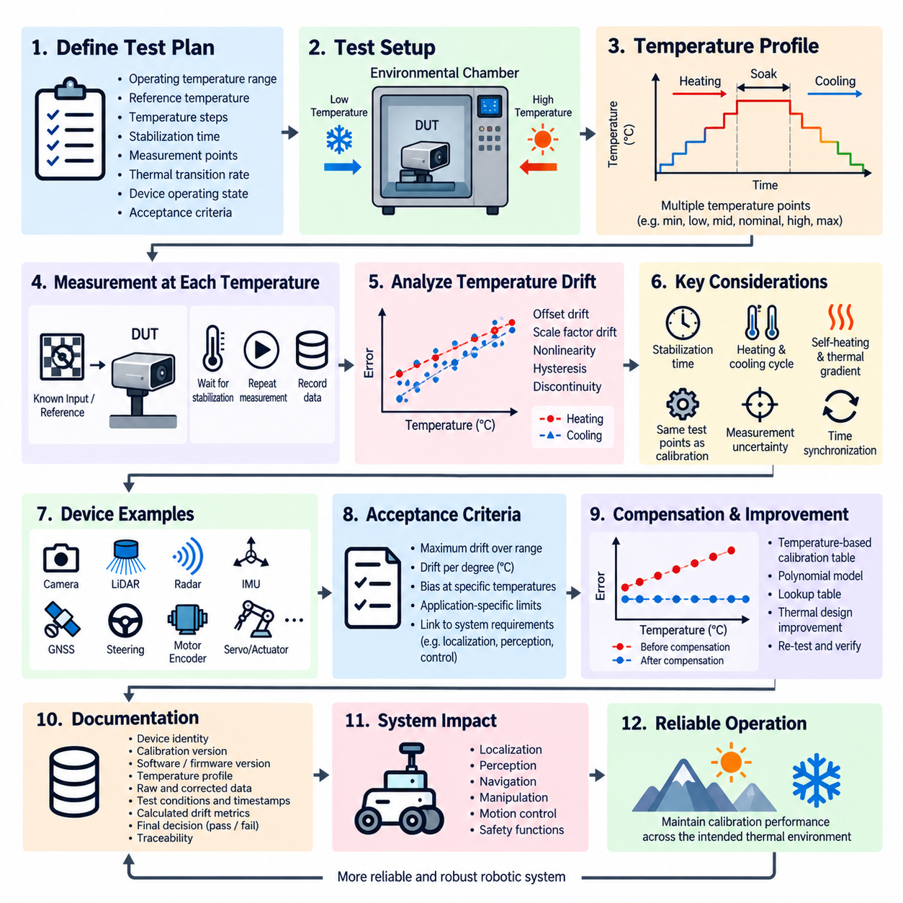
Temperature drift testing determines how the output of a calibrated sensor, measurement channel, actuator, or robotic subsystem changes as temperature varies while the intended physical input remains controlled. Within the calibration test sequence, it complements accuracy and repeatability testing by identifying temperature-dependent bias, scale changes, nonlinear effects, and other deviations that may remain hidden when calibration is evaluated only at normal laboratory temperature.
The test begins by defining the operating temperature range, reference temperature, temperature steps, stabilization time, measurement points, thermal transition rate, device operating state, and acceptance criteria. These conditions should reflect the expected environment of the final robotic system. Indoor equipment may experience moderate variation, while outdoor robots, vehicles, UAVs, and exposed sensors can encounter substantially wider thermal conditions during actual operation.
A controlled thermal chamber is normally used when accurate and reproducible temperature exposure is required. The device under test should be installed in a configuration representative of its intended use while reference equipment remains appropriately controlled or compensated. Temperature sensors placed near critical components can record the actual thermal state because chamber air temperature alone may not accurately represent the temperature of electronics, optical assemblies, inertial sensors, actuators, or mechanical structures.
Measurements should be collected at multiple temperatures spanning the specified operating range rather than only at minimum, nominal, and maximum conditions. Additional points can reveal nonlinear behavior, transition regions, or changes in compensation performance. When practical, the same measurement or command points used during calibration accuracy validation should be repeated at each temperature so that temperature-dependent deviations can be directly compared with the baseline calibration result.
Thermal stabilization is essential before a measurement is treated as representative of steady-state behavior. Although the surrounding air may quickly reach the commanded chamber temperature, internal electronics, housings, lenses, mechanical structures, and sensor elements may require substantially longer to reach thermal equilibrium. Measurements taken too early can characterize transient thermal response rather than true temperature drift and can therefore produce misleading conclusions.
At each stabilized temperature, a known physical input or reference condition is applied and the device output is recorded. The deviation from the reference-temperature result can then be calculated as a function of temperature. Temperature drift may be expressed in engineering units per degree Celsius, percentage of full scale per degree Celsius, angular change per degree, positional change per degree, or another metric appropriate to the physical quantity being evaluated.
The resulting temperature-versus-error relationship should be examined for offset drift, sensitivity or scale-factor drift, nonlinear behavior, discontinuities, and regions of unusually rapid change. A simple device may exhibit approximately linear drift that can be represented by a temperature coefficient. More complex sensors and systems can require polynomial, lookup-table, piecewise, or model-based compensation when their response cannot be adequately described by a single linear coefficient.
Heating and cooling cycles should be compared because identical temperatures do not necessarily produce identical outputs depending on the previous thermal state. Thermal hysteresis can result from mechanical expansion, material properties, sensor packaging, adhesive interfaces, optical alignment, electronic characteristics, or internal compensation behavior. Testing both increasing and decreasing temperature sequences helps distinguish reversible temperature coefficients from hysteresis and other history-dependent effects.
Temperature gradients within the device can also influence calibration. A sensor mounted close to a processor, GPU, motor driver, power converter, battery, or actuator may experience local heating substantially different from ambient temperature. For robotic systems, self-heating under computational or mechanical load should therefore be considered in addition to chamber temperature. Operational power states may need to be reproduced to obtain representative drift characteristics.
Camera systems can exhibit temperature-dependent changes in intrinsic parameters, focus, lens geometry, and mechanical alignment. LiDAR and radar systems may experience range, timing, or angular changes, while IMUs are particularly sensitive to temperature-dependent bias and scale-factor variation. GNSS-related electronics, steering sensors, force sensors, motor encoders, and servo systems can likewise exhibit thermal effects that influence the accuracy of higher-level robotic functions.
Multi-sensor systems require attention to thermally induced changes in relative sensor geometry. Expansion or deformation of brackets, frames, housings, and mounting structures can alter camera-to-LiDAR, LiDAR-to-IMU, or other extrinsic relationships even when each individual sensor remains internally stable. Temperature drift testing should therefore consider both intrinsic sensor behavior and mechanical transformation changes when system performance depends on precise sensor alignment.
Time synchronization and acquisition consistency remain important during thermal testing. Long stabilization periods and temperature transitions can produce datasets collected over many hours, increasing the possibility of configuration changes, clock drift, reference movement, or inconsistent processing. Automated acquisition with synchronized timestamps and controlled configuration helps ensure that observed changes are associated with temperature rather than unintended variation in the measurement procedure.
Measurement uncertainty must be evaluated alongside thermal drift. Chamber temperature accuracy, temperature uniformity, reference instrument stability, fixture expansion, target movement, electrical noise, reference sensor temperature coefficients, and acquisition resolution can all contribute to the measured result. The uncertainty of the test setup should be sufficiently smaller than the allowed temperature-dependent error so that meaningful pass or fail decisions can be made.
Acceptance criteria may define maximum drift over the complete operating range, maximum drift per degree, permissible bias at specified temperatures, or application-specific functional limits. The criteria should be connected to downstream requirements because a small sensor-level thermal shift may propagate into localization, perception, navigation, manipulation, or motion-control errors. Safety-relevant functions may require tighter limits or additional temperature-specific validation.
When measured drift exceeds the permitted limits, root-cause analysis should distinguish intrinsic sensor behavior from mounting, electronics, software compensation, thermal gradients, and test-system effects. Corrective actions may include improved temperature compensation, mechanical redesign, thermal isolation, heat spreading, modified mounting, calibration-table updates, or changes to operating constraints. The complete thermal test should be repeated after corrective action to verify improvement.
Temperature compensation can use measured temperature as an additional calibration input. Depending on device behavior, compensation may apply temperature-dependent offset and scale corrections, interpolation tables, polynomial functions, or more sophisticated models. The compensation algorithm itself must then be validated across the full temperature range to ensure that correction at one region does not introduce excessive error or discontinuity in another operating region.
Raw data should be retained together with temperature histories so that thermal behavior can be reconstructed independently. Records should include device identity, calibration version, software and firmware versions, chamber profile, reference equipment, fixture configuration, measurement timestamps, local temperature measurements, operating state, stabilization periods, raw outputs, corrected outputs, calculated drift metrics, and the final acceptance decision.
Automated temperature drift testing can coordinate thermal chamber commands, stabilization detection, reference equipment, device communication, synchronized acquisition, analysis, and reporting. Automation is particularly valuable because a complete heating and cooling sequence may require many hours or days. Consistent automated procedures reduce operator-dependent variation and allow direct comparison among devices, production batches, hardware revisions, and calibration algorithms.
At system level, temperature drift testing verifies that calibration remains valid beyond the laboratory condition in which it was originally established. A robot that is accurate and repeatable at room temperature may still become unreliable when deployed outdoors, near heat-generating equipment, or under sustained computational and actuator loads. Thermal robustness is therefore an essential condition for maintaining dependable perception, localization, navigation, and control.
A mature temperature drift test combines controlled thermal exposure, sufficient stabilization, representative measurement points, heating and cooling cycles, local temperature monitoring, uncertainty analysis, predefined limits, compensation validation, and complete traceability. Its purpose is to demonstrate that calibrated robotic hardware maintains acceptable measurement and actuation performance across its intended thermal environment rather than only at a single calibration temperature.

05.04. Long Term Stability Test
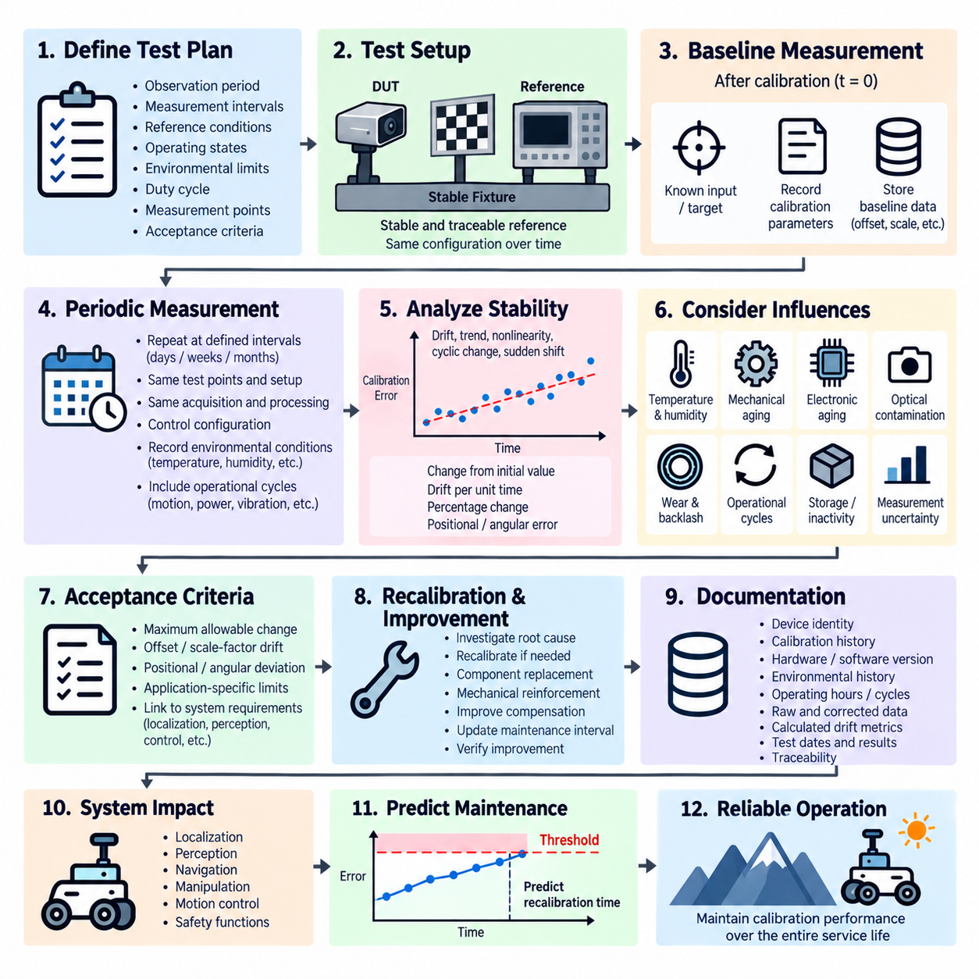
Long-term stability testing determines whether a calibrated sensor, actuator, measurement channel, or robotic subsystem maintains its calibration characteristics over an extended period of operation or storage. Unlike repeatability testing, which evaluates short-term dispersion, long-term stability focuses on gradual changes that develop over days, weeks, months, or operational cycles and may eventually cause performance to move outside the original calibration limits.
The test begins by defining the observation period, measurement intervals, reference conditions, operating states, environmental limits, duty cycle, measurement points, and acceptance criteria. The selected duration should reflect the intended service interval and expected degradation mechanisms of the device. When a full operational lifetime cannot be reproduced practically, representative periods or accelerated conditions may be combined with periodic measurements to identify measurable trends.
A stable and traceable reference is essential because the objective is to detect relatively small changes occurring over a long period. Reference instruments, fixtures, targets, and measurement systems must therefore remain more stable than the device variation being evaluated. Periodic verification of the reference equipment helps prevent reference drift from being incorrectly interpreted as degradation of the device under test.
Baseline measurements should be established immediately after calibration under clearly defined reference conditions. These initial measurements provide the zero-time reference against which subsequent observations are compared. The baseline should include sufficient information to characterize offset, scale factor, sensitivity, positional or angular accuracy, and other relevant calibration parameters so that different forms of long-term change can be distinguished.
Measurements are then repeated at predefined intervals using the same test points, fixture configuration, acquisition settings, processing methods, and reference conditions whenever practical. Consistency of the measurement procedure is critical because changes in equipment, software, mounting, operators, or analysis methods can appear as long-term drift. Configuration control therefore becomes an important part of stability testing.
Long-term stability can be expressed as change from the initial calibrated value, drift per unit time, percentage change over the observation period, accumulated positional or angular error, or another application-specific metric. Plotting calibration error against elapsed time provides a direct way to identify gradual trends. Statistical analysis can additionally distinguish persistent drift from normal short-term measurement variation.
Observed behavior may include approximately linear drift, nonlinear aging, sudden parameter shifts, cyclic variation, or periods of relative stability followed by accelerated degradation. A simple linear trend can sometimes be represented by a drift rate, while more complicated behavior may require piecewise models or trend analysis. Sudden changes should be investigated separately because they may indicate mechanical movement, component damage, firmware changes, or intermittent faults.
Long-term stability must be distinguished from temperature drift. Temperature drift describes changes correlated with thermal conditions, whereas long-term drift represents changes associated primarily with elapsed time, accumulated use, aging, wear, or permanent physical change. Environmental conditions should therefore be monitored during stability testing so that temperature- or humidity-related variation is not incorrectly classified as irreversible aging.
Mechanical aging is an important source of calibration change in robotic systems. Fasteners can loosen, brackets can deform, bearings and joints can wear, adhesives can creep, and repeated vibration can alter sensor mounting geometry. These changes may modify camera-to-LiDAR, LiDAR-to-IMU, actuator-to-joint, or other physical transformations even when the electronic sensor elements themselves remain stable.
Electronic components can also exhibit gradual changes caused by aging, repeated thermal cycling, power cycling, electrical stress, contamination, or component parameter variation. Analog measurement circuits, oscillators, voltage references, inertial sensors, encoders, and power electronics may slowly change their characteristics. Monitoring both raw and calibrated outputs helps determine whether the drift originates in hardware or in the calibration and compensation chain.
Optical and perception sensors introduce additional stability concerns. Camera lenses and mounts can shift, protective windows can become contaminated, LiDAR optical paths can change, and radar mounting structures can gradually move. Some effects represent true calibration drift while others represent maintenance or environmental degradation. Long-term testing should preserve enough diagnostic information to distinguish these mechanisms before recalibration is selected as the corrective action.
Actuators, steering mechanisms, servo joints, and mobile robot drive systems may experience long-term changes due to wear, backlash growth, friction changes, encoder movement, or mechanical compliance. A command that originally produced a particular physical position or angle may gradually produce a different result. Stability testing should therefore include both sensing and actuation paths when calibration directly influences closed-loop robotic motion.
Operational cycling can be incorporated when elapsed calendar time alone does not adequately represent aging. Repeated steering movements, joint cycles, motor operation, power cycles, docking operations, vibration exposure, or sensor activation cycles may be accumulated between measurement intervals. Recording both elapsed time and accumulated operational cycles helps identify whether calibration degradation is primarily time-dependent or usage-dependent.
The test should also consider periods of storage or inactivity when relevant. Long storage can introduce effects from humidity, material relaxation, battery condition, connector oxidation, mechanical settling, or environmental exposure. Measurements performed before storage, immediately after storage, and after a defined stabilization or warm-up period can reveal whether calibration changes are temporary, recoverable, or persistent.
Measurement uncertainty remains important because the expected long-term drift may be small compared with the normal variation of the test system. Reference stability, fixture repeatability, environmental changes, measurement noise, software processing, and equipment replacement can all contribute apparent trends. An uncertainty-aware analysis prevents normal test-system variation from being mistaken for statistically or functionally significant degradation.
Acceptance criteria should define the maximum permissible change over the specified period or operational exposure. Limits may be expressed as maximum offset drift, scale-factor change, positional or angular deviation, percentage change, or application-specific functional degradation. These limits should be linked to system requirements so that allowable component drift remains compatible with localization, perception, navigation, manipulation, and motion-control performance.
Trend analysis can provide more value than a simple final pass-or-fail comparison. A device may still remain within specification while exhibiting a consistent drift toward the acceptance boundary. Estimating the rate and direction of change can support prediction of when recalibration or maintenance may become necessary. Such information is useful for defining preventive maintenance intervals and calibration schedules before functional performance is affected.
When excessive drift is detected, root-cause analysis should examine mechanical mounting, sensor aging, electronic changes, environmental history, software or firmware updates, compensation parameters, connector condition, accumulated operating cycles, and maintenance events. Corrective action may involve recalibration, component replacement, mechanical reinforcement, improved environmental protection, revised compensation, or changes to inspection and maintenance intervals.
Recalibration should not erase evidence of the preceding drift. Pre-recalibration measurements and calibration parameters should be retained so that the magnitude and direction of long-term change remain available for engineering analysis. Comparing successive calibration histories across multiple devices can reveal common aging mechanisms, manufacturing variation, design weaknesses, or characteristic maintenance intervals.
Automated long-term stability monitoring can periodically acquire reference measurements, calculate drift metrics, update trend histories, and generate warnings when predefined thresholds are approached. For connected robotic systems, calibration-health information can become part of maintenance diagnostics. Automated monitoring is particularly valuable for fleets because trends can be compared across many units to identify abnormal devices before their calibration error causes functional failure.
Complete traceability should include device identity, calibration version, hardware revision, software and firmware versions, reference equipment, environmental history, operating hours, cycle counts, maintenance events, measurement dates, raw data, corrected data, calculated drift, and acceptance decisions. Maintaining this history transforms long-term stability testing from a one-time qualification activity into evidence supporting lifecycle calibration management.
At system level, long-term calibration stability is necessary for predictable robotic performance throughout the service life. Gradual sensor or actuator drift can propagate into localization errors, degraded sensor fusion, inaccurate navigation, reduced manipulation precision, or inconsistent motion control. A system that satisfies calibration requirements at initial deployment must therefore also demonstrate that its calibration remains sufficiently stable between planned inspection and maintenance intervals.
A mature long-term stability test combines a well-defined baseline, stable references, periodic measurements, configuration control, environmental monitoring, operational-cycle tracking, uncertainty analysis, trend evaluation, predefined limits, and complete calibration history. Its purpose is to demonstrate that calibrated robotic hardware maintains acceptable performance over time and to provide the evidence needed to determine when recalibration, maintenance, or design improvement becomes necessary.

05.05. Calibration SPC Analysis
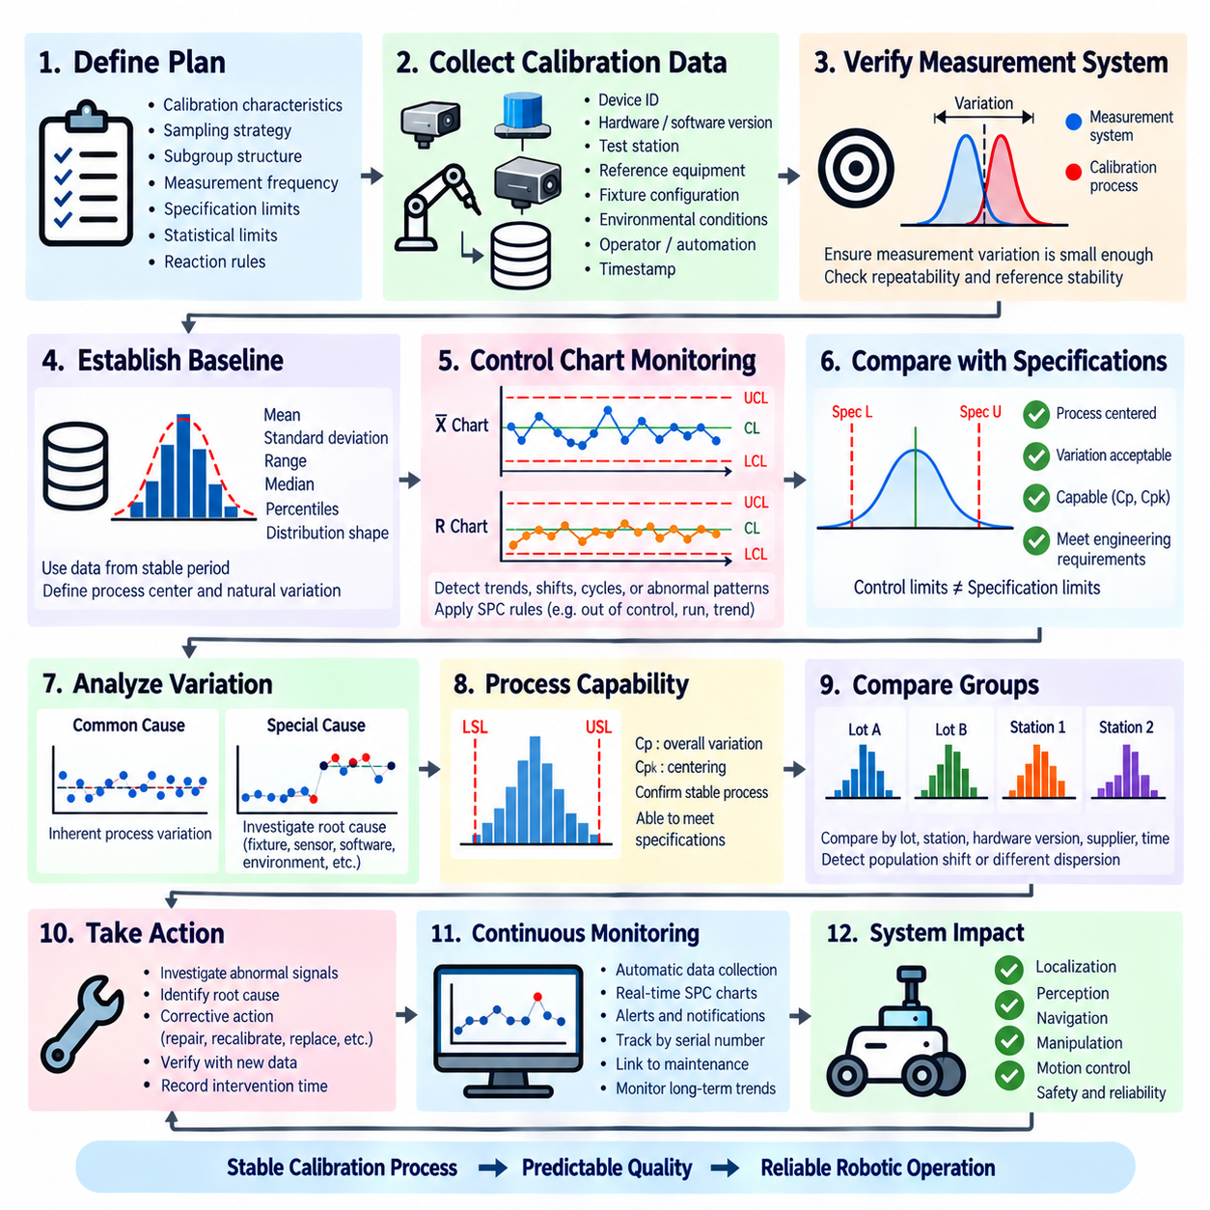
Calibration Statistical Process Control analysis evaluates whether calibration results remain statistically stable across repeated tests, production units, batches, stations, or operating periods. Rather than judging each calibration only as an isolated pass or fail event, SPC examines the distribution and evolution of calibration parameters and errors. This makes it possible to detect emerging process variation before individual devices exceed engineering acceptance limits.
The analysis begins by defining the calibration characteristics to be monitored, sampling strategy, subgroup structure, measurement frequency, specification limits, statistical limits, and required reaction rules. Suitable characteristics may include offset, scale factor, positional error, angular error, sensor bias, reprojection error, range error, actuator correction value, or another parameter that quantitatively represents calibration performance.
Calibration data must be collected under sufficiently controlled and comparable conditions. Device identity, hardware revision, calibration algorithm, software and firmware versions, test station, reference equipment, fixture configuration, environmental conditions, operator or automated process, and timestamp should accompany each result. Without this contextual information, statistical shifts caused by configuration changes may be incorrectly interpreted as physical process variation.
Before applying SPC methods, the measurement process itself should be sufficiently stable. Reference uncertainty, fixture repeatability, acquisition noise, environmental variation, and calibration-test repeatability can contribute to the observed distribution. If the measurement system introduces excessive variation, control charts may primarily describe the test equipment rather than the calibration process. Measurement capability must therefore be considered when interpreting SPC results.
A baseline dataset is established from calibration results collected while the process is believed to be operating normally. The baseline characterizes the process center and natural variation and provides the statistical foundation for subsequent monitoring. Mean, standard deviation, range, median, percentiles, and distribution shape can be examined to understand whether calibration results are centered, dispersed, skewed, multimodal, or affected by unusual observations.
Control charts provide a practical method for monitoring calibration behavior over time. Depending on the sampling structure, charts for individual measurements, moving ranges, subgroup means, or subgroup ranges can be used. The center line represents the expected process level, while upper and lower control limits represent statistically expected process variation. These control limits should not automatically be treated as engineering specification limits.
The distinction between control limits and specification limits is fundamental. Specification limits describe the maximum calibration error or parameter range permitted by engineering requirements, while control limits describe the behavior of the observed process. A calibration process can be statistically stable but centered too close to a specification boundary, or it can satisfy specifications temporarily while exhibiting statistically abnormal variation that indicates an emerging process problem.
SPC analysis should therefore search for more than individual points outside the control limits. Persistent movement in one direction, repeated observations on one side of the center line, sudden level shifts, increasing dispersion, cyclic patterns, or clusters can indicate non-random behavior. Such patterns may provide earlier warning of calibration degradation than waiting for a device to exceed its final acceptance criterion.
Common-cause variation and special-cause variation should be distinguished during interpretation. Common-cause variation represents the inherent variability of a stable calibration process, whereas special-cause variation originates from identifiable events such as fixture movement, sensor damage, reference-equipment problems, software changes, incorrect assembly, environmental disturbance, connector instability, or changes in the calibration procedure.
Process capability analysis can complement control-chart monitoring when the calibration process is statistically stable. Capability indices compare process variation and process centering with engineering specification limits and help determine whether the normal calibration process can consistently satisfy requirements. Capability results should be interpreted carefully because a mathematically favorable index is not meaningful when the underlying process is unstable or the measurement system is inadequate.
Calibration SPC becomes particularly useful in production environments where many nominally identical sensors, robots, actuators, or electronic modules are calibrated. Distributions can be compared across production lots, hardware revisions, suppliers, assembly lines, calibration stations, or time periods. A gradual population shift can reveal manufacturing or process changes even when every individual unit still passes its specified calibration limits.
Station-to-station comparison is important when multiple automated calibration systems are deployed. Two stations may independently produce passing devices while generating systematically different offsets or correction parameters. SPC can expose these differences through changes in process center or dispersion. Investigation may then identify differences in fixtures, reference devices, alignment, software configuration, environmental conditions, or maintenance state.
Environmental variables can also be incorporated into calibration SPC interpretation. Temperature, humidity, vibration, warm-up state, supply voltage, or computational load may correlate with changes in calibration results. Separating data by relevant operating conditions can help determine whether an observed shift represents actual production variation or a predictable environmental influence that should instead be addressed through compensation or tighter test control.
Calibration parameters themselves can provide valuable diagnostic information even when final calibrated accuracy remains acceptable. Increasing correction magnitude may indicate that uncalibrated hardware is gradually moving away from its nominal condition. Monitoring both pre-calibration error and post-calibration residual error therefore provides greater visibility than tracking only the final pass result and can expose developing mechanical, sensor, or manufacturing problems.
Long-term stability data can be incorporated into SPC to connect individual-device aging with population-level behavior. Recalibration histories from multiple devices can reveal whether offset, scale factor, alignment, or other parameters systematically change with operating hours or accumulated cycles. This information can support calibration interval selection, maintenance planning, component improvement, and identification of abnormal units within a robotic fleet.
When an SPC rule indicates an abnormal condition, the reaction should follow a predefined investigation process rather than immediately adjusting the calibration algorithm. Relevant evidence may include recent hardware changes, fixture maintenance, reference calibration records, software releases, environmental logs, production lots, raw measurements, and calibration histories. Unnecessary process adjustment can increase variability when the apparent change is only normal statistical fluctuation.
Corrective actions should address the identified source of variation and be followed by verification using new calibration data. Actions may include fixture repair, reference-equipment recalibration, software correction, assembly improvement, sensor replacement, environmental control, revised compensation, or process parameter adjustment. The SPC history should preserve the timing of these interventions so that their effects can be evaluated quantitatively.
Automated SPC systems can collect calibration results directly from test stations, calculate statistical metrics, update control charts, detect predefined rules, and generate warnings without requiring manual analysis of every device. Linking records to serial numbers, hardware versions, calibration stations, software releases, and production batches enables engineers to move from an abnormal statistical signal to the relevant population and configuration efficiently.
Data integrity and traceability are essential because SPC depends on historical comparison. Raw measurements, calibration parameters, corrected outputs, acceptance results, statistical calculations, configuration metadata, control-limit revisions, detected events, and corrective actions should be retained. Changes to analysis rules or control limits should also be version controlled so that historical decisions can be reconstructed and audited.
At system level, calibration SPC provides an early-warning mechanism for degradation that may eventually affect localization, perception, sensor fusion, navigation, manipulation, steering, or motion control. It shifts calibration management from reactive correction of failed devices toward continuous observation of process health. This is especially valuable for production robotics and fleets where small systematic changes can affect many units simultaneously.
Calibration SPC should be viewed together with accuracy validation, repeatability testing, temperature drift testing, and long-term stability testing. Accuracy establishes closeness to the reference, repeatability characterizes short-term variation, temperature testing identifies thermal dependence, and long-term testing evaluates aging-related change. SPC integrates repeated calibration results statistically so that these characteristics can be monitored as an evolving engineering process.
A mature Calibration SPC Analysis process combines controlled measurement, trustworthy baseline data, statistical control charts, capability evaluation, trend and pattern detection, configuration-aware comparison, predefined reaction rules, corrective-action verification, and complete traceability. Its purpose is not merely to generate statistical charts, but to detect meaningful calibration-process changes early and maintain predictable calibration quality across production, deployment, maintenance, and the robotic system lifecycle.

