Volume 19. Testing and Validation

Chapter 09. Field Test

09.01. Alpha Test Procedure
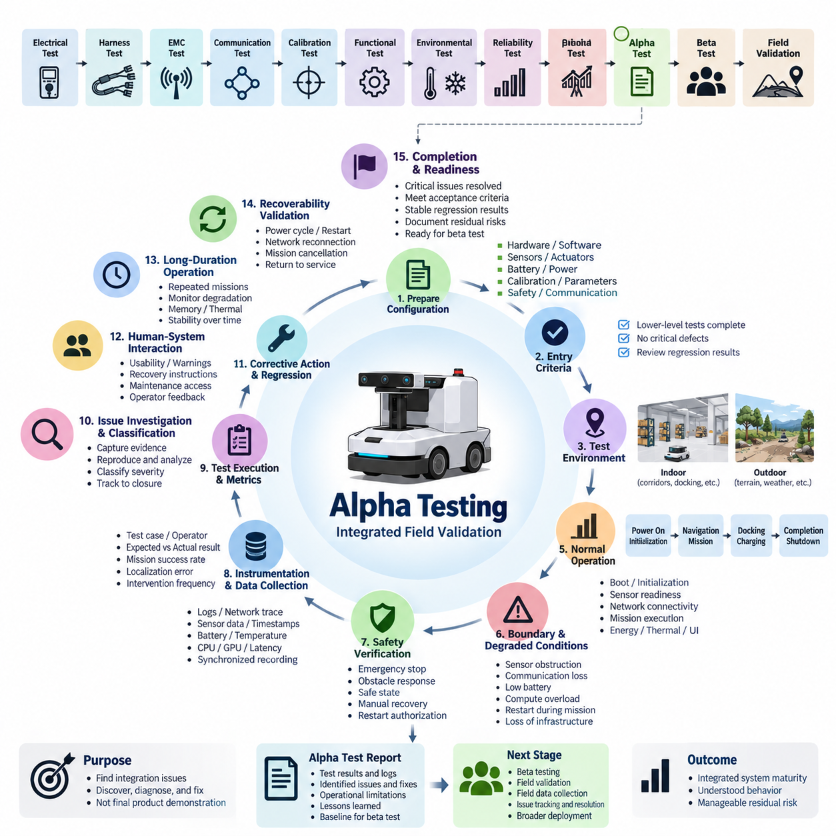
Alpha testing is the first structured field-oriented validation stage in which a robot or autonomous system is exercised as an integrated product rather than as a collection of individually verified subsystems. Within the testing and validation sequence, it follows electrical, harness, EMC, communication, calibration, functional, environmental, and reliability activities and precedes beta testing and broader field validation.
The primary purpose of an alpha test is to expose integration problems that may remain hidden during laboratory verification. The system is operated in controlled or semi-controlled environments that resemble its intended field conditions while engineering personnel retain direct access to hardware, software, diagnostic interfaces, logs, and emergency controls. The emphasis is therefore discovery, diagnosis, correction, and repeated verification rather than demonstration of final product maturity.
Before alpha testing begins, the test configuration should be formally identified. Hardware revision, wiring and harness configuration, sensor installation, actuator versions, battery and power architecture, firmware, operating system, middleware, application software, AI models, calibration data, parameter sets, safety configuration, and communication settings should be recorded. This configuration baseline ensures that every observed behavior can be traced to a reproducible system state.
Entry criteria should confirm that lower-level verification has reached sufficient maturity for integrated operation. Critical electrical faults, communication instability, unresolved safety defects, calibration errors, and known failures that could invalidate field results should be closed or explicitly accepted. Functional regression results should also be reviewed so that alpha testing does not become a substitute for incomplete component, subsystem, HIL, SIL, environmental, or reliability verification.
The alpha environment should reproduce representative operational conditions while remaining sufficiently controlled for engineering investigation. For an AMR, this may include corridors, intersections, docking stations, charging locations, ramps, floor transitions, obstacles, pedestrians, restricted areas, and communication coverage changes. Outdoor autonomous platforms may additionally require uneven terrain, GNSS variation, changing illumination, weather exposure, slopes, vegetation, dust, and realistic mission distances.
Test scenarios should be derived from actual system missions rather than isolated functions. A complete scenario may begin with power-up and initialization, continue through localization, mission reception, autonomous navigation, obstacle avoidance, payload handling or inspection, docking, charging, and mission completion, and finish with shutdown or restart. Exercising these functions as a continuous operational chain reveals interface failures that are difficult to reproduce through independent subsystem testing.
Normal operation should first establish a stable baseline before abnormal conditions are introduced. Engineers should verify boot behavior, initialization time, sensor readiness, network connectivity, localization convergence, actuator response, mission execution, energy consumption, thermal behavior, and user-interface operation. Repeated execution is important because intermittent faults, resource leaks, timing problems, and gradual performance degradation may not appear during a single successful mission.
Alpha testing should deliberately examine boundary and degraded conditions without creating uncontrolled hazards. Representative cases include temporary sensor obstruction, communication loss, delayed messages, reduced battery state, localization uncertainty, actuator degradation, charging interruption, compute overload, restart during mission execution, and temporary loss of external infrastructure. The expected response should be defined beforehand so that safe degradation can be distinguished from unexpected failure.
Safety behavior requires continuous attention throughout the procedure. Emergency stop functions, protective fields, speed limitation, obstacle response, braking behavior, fault transitions, manual recovery, restart authorization, and safe-state entry should remain effective under realistic integrated operation. Any condition that creates an unacceptable risk should immediately terminate the affected test scenario, preserve available evidence, and trigger engineering review before testing resumes.
Instrumentation should capture synchronized evidence from all important domains. Useful records include system logs, CAN or industrial network traces, Ethernet statistics, ROS 2 or middleware messages, localization states, sensor timestamps, actuator commands, safety events, battery voltage and current, temperatures, CPU and GPU utilization, memory usage, network latency, mission states, and operator actions. Accurate time synchronization is essential when reconstructing causal sequences across distributed controllers.
Each test run should have an identifiable test case, configuration, operator, environment, start and end time, expected result, actual result, and disposition. Quantitative metrics should be collected whenever possible rather than relying only on subjective observations. Mission completion rate, intervention frequency, localization error, docking accuracy, obstacle response, communication availability, recovery time, energy consumption, thermal margin, fault frequency, and software stability provide measurable evidence of alpha maturity.
Unexpected events should be preserved as engineering evidence rather than immediately erased by restarting the system. Logs, traces, sensor recordings, screenshots, fault codes, environmental conditions, operator actions, and recent configuration changes should be captured before recovery whenever practical. Reproduction attempts should then use the same baseline and scenario. A reproducible failure provides much stronger information for root-cause analysis than an isolated verbal description.
Issue classification should reflect both technical severity and operational impact. A defect that can cause unsafe motion, loss of control, critical mission failure, hardware damage, or unrecoverable system shutdown normally requires immediate containment. Less severe defects may involve degraded performance, intermittent communication, excessive recovery time, confusing operator behavior, or diagnostic deficiencies. Every issue should remain traceable from discovery through analysis, correction, regression testing, and closure.
Corrective changes introduced during alpha testing must be controlled carefully. Software patches, calibration changes, mechanical adjustments, wiring modifications, sensor relocation, parameter tuning, or replacement hardware can alter previously established behavior. After a correction, the failed scenario should be repeated first, followed by relevant regression scenarios to confirm that the modification solved the original problem without introducing failures elsewhere in the integrated system.
Human interaction is also an important part of alpha validation. Engineers and selected internal operators should evaluate startup procedures, mission assignment, status indication, warning messages, recovery instructions, charging interaction, maintenance access, diagnostic interfaces, and emergency procedures. Confusing behavior that does not constitute a hardware or software failure may still become a serious field problem when users must operate or recover the system under time pressure.
Longer-duration operation should supplement individual mission tests. Continuous or repeated missions can reveal memory growth, thermal accumulation, battery estimation drift, communication degradation, localization deterioration, storage exhaustion, timing instability, and mechanical loosening. These tests bridge the gap between conventional functional verification and subsequent reliability or field validation by showing whether integrated performance remains stable over operationally meaningful periods.
Alpha testing should also evaluate recoverability because real field systems inevitably encounter interruptions. Power cycling, controller restart, network reconnection, mission cancellation, interrupted charging, localization recovery, safe manual relocation, and return to autonomous operation should be tested under defined conditions. A robust system should not merely detect failures; it should provide predictable transitions, preserve necessary state, and support safe restoration of service.
Completion of alpha testing should be based on evidence rather than elapsed test time. Critical safety and mission-blocking defects should be resolved, required scenarios should meet their acceptance criteria, regression results should remain stable, major failures should have understood causes, and residual issues should have documented risk and disposition. Configuration records, test results, logs, defect status, and known limitations should collectively demonstrate readiness for the next field-validation stage.
The final alpha test record becomes an engineering baseline for the subsequent beta test procedure, field validation protocol, field data collection, and issue tracking activities defined within the Field Test chapter structure. It should therefore preserve not only pass or fail results but also configuration identity, operational limitations, unresolved observations, corrective actions, regression evidence, and lessons learned for later deployment.
A successful alpha program does not prove that the product is ready for unrestricted customer operation. Instead, it demonstrates that the integrated system has progressed from laboratory verification to controlled operational maturity with sufficiently understood behavior and manageable residual risk. This distinction is essential because beta testing can then focus on broader users, environments, workloads, and operational variability rather than repeatedly discovering fundamental integration defects.

09.02. Beta Test Procedure
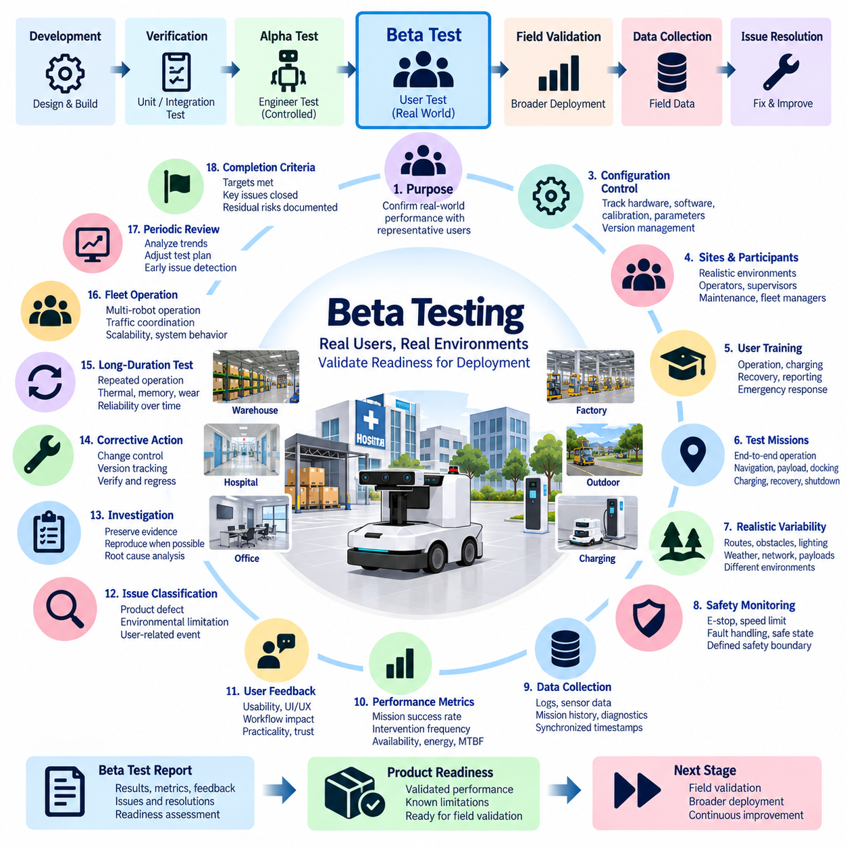
Beta testing is a controlled field-validation stage in which a robot or autonomous system is operated by representative users under realistic conditions after major integration problems have been addressed during alpha testing. Within the Field Test sequence, beta testing follows the Alpha Test Procedure and provides the transition toward formal field validation, systematic field data collection, and structured issue tracking and resolution.
The primary objective of beta testing is to determine whether the integrated product performs reliably when exposed to the diversity and uncertainty of actual operation. Unlike alpha testing, where engineers maintain close control over the environment and system, beta testing intentionally expands variation in users, missions, locations, operating durations, environmental conditions, network quality, payloads, and interaction patterns while maintaining defined safety boundaries.
Entry into beta testing should require evidence that alpha testing has reached an acceptable level of maturity. Critical safety defects and mission-blocking integration failures should be resolved, essential regression tests should pass, major failure mechanisms should be understood, and residual limitations should be documented. The released beta configuration must also be sufficiently stable to prevent uncontrolled software, hardware, or calibration changes from invalidating field observations.
Every beta unit should have a traceable configuration baseline. Hardware revision, sensor and actuator configuration, battery and power architecture, firmware, operating system, middleware, application software, AI models, calibration files, communication parameters, safety settings, and relevant mechanical configuration should be recorded. Configuration changes introduced during the beta program must be version controlled and associated with corresponding field results.
Beta sites and participants should represent intended operational use as closely as practical. For an AMR, representative environments may include warehouses, hospitals, commercial buildings, factories, logistics facilities, or outdoor operating areas. Participants may include operators, supervisors, maintenance personnel, fleet managers, and other users who interact with the product differently from the development engineers who performed earlier verification activities.
Before field operation begins, participants should receive appropriate training covering normal operation, mission assignment, status interpretation, charging, routine recovery, reporting procedures, and emergency response. Training should be sufficient for safe operation but should not compensate for poor product usability. If users repeatedly require engineering assistance to understand ordinary functions, the behavior should be recorded as a beta finding rather than hidden through excessive instruction.
The beta test plan should define representative missions instead of focusing only on isolated functions. Missions can include startup, localization, task assignment, autonomous navigation, obstacle interaction, payload transportation, inspection, docking, charging, mission interruption, recovery, and shutdown. Repeated end-to-end operation exposes problems involving subsystem interaction, operational sequencing, state management, and user behavior that laboratory testing may not reveal.
Realistic variability is a major source of beta-test value. The system should encounter different routes, obstacle arrangements, pedestrian densities, lighting conditions, floor surfaces, temperatures, communication coverage, battery states, payload conditions, and operating schedules within approved safety limits. Outdoor systems may additionally encounter terrain variation, GNSS quality changes, weather, dust, slopes, vegetation, and longer mission distances.
Safety controls established during earlier validation must remain active throughout beta testing. Emergency stop functions, protective sensing, speed restrictions, braking behavior, fault handling, manual recovery, restart authorization, restricted operating zones, and escalation procedures should be clearly defined. Any event presenting unacceptable risk should result in immediate containment and engineering review before the affected configuration or scenario is returned to service.
Field instrumentation should collect sufficient information without preventing realistic operation. System logs, mission histories, localization states, sensor health, communication quality, battery information, thermal data, processor utilization, fault codes, safety events, recovery actions, and operator interventions are valuable sources. Where practical, synchronized timestamps should allow events across distributed controllers, sensors, networks, and applications to be reconstructed accurately.
Quantitative performance indicators should complement qualitative user observations. Useful measures include mission completion rate, autonomous operating time, intervention frequency, localization failures, docking success, communication availability, recovery time, charging success, energy consumption, software restart frequency, safety events, and mean operating time between relevant failures. Metrics should be interpreted in the context of the actual mission and environmental conditions.
User feedback is a distinguishing element of beta testing. Operators should report confusing interfaces, unclear warnings, unexpected robot behavior, difficult recovery procedures, excessive maintenance effort, inconvenient charging interaction, poor status visibility, and workflow disruption. These observations may not appear as conventional engineering failures, yet they can strongly influence whether the system is practical, trustworthy, and supportable in everyday operation.
Beta testing should distinguish product defects from environmental limitations and user-related events. A failed mission may originate from software, hardware, calibration, communication infrastructure, unsuitable operating conditions, incorrect user action, or an interaction among several factors. Classification should therefore be evidence-based, avoiding the assumption that every field anomaly is automatically a product failure or that user involvement automatically eliminates product responsibility.
When an anomaly occurs, available evidence should be preserved before the system is reset or modified whenever practical. Logs, timestamps, mission state, sensor status, environmental conditions, operator actions, screenshots, network information, and configuration identifiers should be captured. High-severity or recurring events should be reproduced under controlled conditions when possible so that root cause can be separated from incidental field circumstances.
Issues discovered during beta testing should enter a structured tracking process with severity, frequency, operational impact, reproducibility, ownership, status, and resolution evidence. Safety-critical events and failures that prevent essential missions require immediate escalation. Lower-severity issues can be prioritized according to their effect on availability, usability, maintainability, customer workflow, and the probability of recurrence during broader deployment.
Corrective actions during beta testing require strict change control. Software patches, parameter changes, AI model updates, calibration modifications, sensor adjustments, wiring changes, or mechanical improvements can affect previously validated behavior. Each modification should therefore have a defined reason, version identifier, affected units, regression scope, deployment record, and verification result so that improvements and unintended side effects remain traceable.
A corrected issue should be verified first against the scenario that exposed it and then against related regression scenarios. Field verification may also be necessary because laboratory reproduction does not always capture the combination of environment, workload, network behavior, and human interaction that triggered the original problem. Closure should require objective evidence that the corrective action is effective rather than simply the absence of another immediate failure.
Long-duration and repeated operation are particularly important during beta testing because field reliability depends on accumulated behavior. Extended missions can reveal memory growth, thermal accumulation, storage exhaustion, battery estimation drift, localization degradation, communication instability, mechanical wear, calibration changes, and recovery problems. These observations provide a bridge between controlled reliability testing and actual operational dependability.
Fleet-level behavior should be evaluated when multiple robots are intended to operate together. Mission allocation, traffic coordination, shared charging resources, communication congestion, map consistency, software version compatibility, recovery coordination, and operator workload may create problems that are absent during single-robot testing. Beta operation therefore provides valuable evidence about scalability and system-level interaction under realistic workloads.
The beta program should periodically review accumulated results rather than waiting until all planned operation is complete. Trends in mission failures, interventions, fault categories, environmental sensitivity, user complaints, and corrective-action effectiveness can reveal emerging systemic problems. Early trend analysis allows the organization to modify testing priorities and collect additional evidence before the beta period ends.
Completion criteria should be defined before the beta program begins. Required operating exposure should be achieved, critical defects should be closed, significant recurring failures should have understood causes, performance indicators should satisfy agreed targets, and residual risks should have documented dispositions. Known limitations that remain acceptable must be communicated clearly so that later field validation does not interpret them as unexpected behavior.
The final beta test record should consolidate the released configuration, test sites, participant profiles, operational exposure, mission results, performance metrics, field anomalies, user feedback, corrective actions, regression evidence, unresolved limitations, and final readiness assessment. This record provides a traceable engineering baseline for the subsequent Field Validation Protocol, Field Data Collection, and Issue Tracking and Resolution activities defined within the Field Test chapter.
Successful beta testing does not mean that every possible field condition has been demonstrated. It provides evidence that the system can operate with representative users and realistic environmental variability while maintaining acceptable safety, reliability, usability, and recoverability. The resulting knowledge reduces uncertainty before broader deployment and transforms field experience into measurable evidence for final product validation and continuous improvement.

09.03. Field Validation Protocol
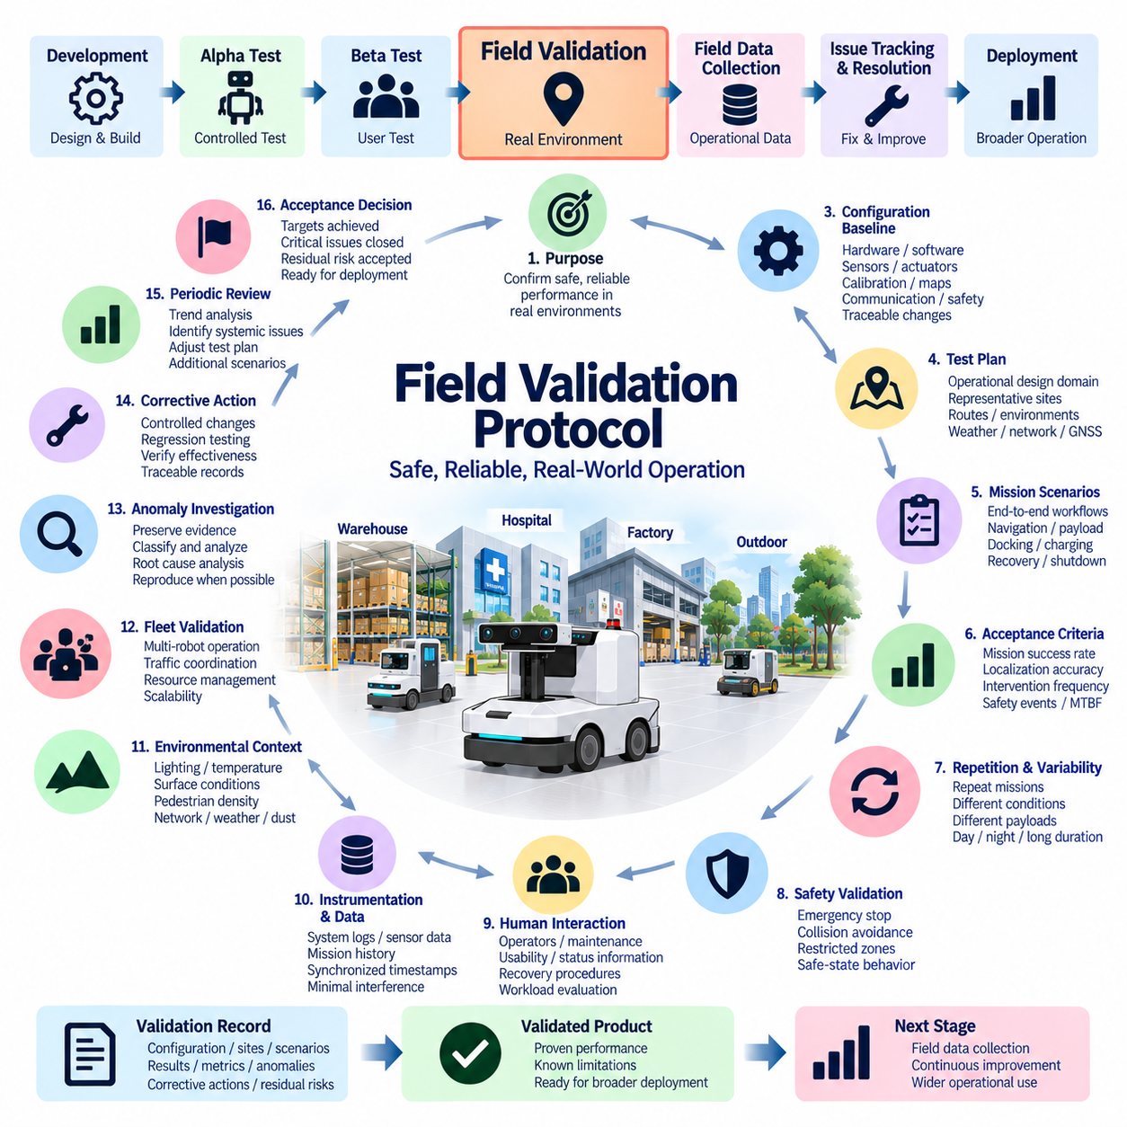
Field validation is the structured process of demonstrating that a robot or autonomous system can perform its intended missions safely, reliably, and consistently in representative operational environments. Within the Field Test sequence, it follows alpha and beta testing and establishes a formal bridge between controlled product verification and broader operational deployment. The protocol converts field operation into repeatable engineering evidence rather than informal demonstration.
The primary objective is to confirm that system-level performance remains acceptable when hardware, software, sensing, communication, power, autonomy, human interaction, and environmental conditions operate together. Field validation therefore evaluates complete mission behavior rather than isolated subsystem functions. Results should demonstrate not only successful operation but also predictable behavior when conditions vary or system capability becomes degraded.
Validation should begin from a formally released configuration baseline. Hardware revision, sensors, actuators, electrical architecture, battery system, firmware, operating system, middleware, application software, AI models, maps, calibration files, communication parameters, safety settings, and mission configuration should be identified. Any change introduced during validation must remain traceable so that results can be associated with the exact configuration that produced them.
Entry criteria should confirm that preceding alpha and beta activities have achieved sufficient maturity. Critical safety defects should be closed, major integration failures should be resolved, regression testing should be stable, known limitations should be documented, and representative user operation should have demonstrated acceptable behavior. Unresolved issues may remain only when their operational impact, mitigation, and acceptance rationale are explicitly understood.
The validation plan should define the intended operational design domain and representative field conditions. For mobile robots, this may include warehouses, factories, hospitals, commercial facilities, outdoor roads, yards, inspection areas, or mixed indoor-outdoor environments. Routes, surfaces, slopes, obstacles, pedestrian activity, lighting, temperature, weather, dust, communication coverage, GNSS availability, and infrastructure conditions should reflect realistic operation.
Mission scenarios should represent actual workflows from initialization to completion. A typical sequence may include power-up, self-diagnostics, localization, mission reception, autonomous navigation, obstacle interaction, payload transport or inspection, docking, charging, recovery, and shutdown. Validation of complete mission chains is essential because system-level failures often emerge from interactions between individually verified functions rather than from a single component.
Each scenario should define expected behavior and measurable acceptance criteria before execution. Appropriate measures may include mission success rate, localization accuracy, docking success, obstacle response, intervention frequency, communication availability, recovery time, charging performance, energy consumption, thermal margin, safety events, and operating time between relevant failures. Criteria should be connected to operational requirements rather than selected after observing results.
Field validation should include sufficient repetition to characterize consistency rather than demonstrating a single successful run. Missions should be repeated across representative routes, operating periods, environmental conditions, payload states, and system states. Repetition helps distinguish robust performance from occasional success and reveals intermittent problems, accumulated degradation, timing sensitivities, and combinations of conditions that may produce unstable behavior.
Normal operation should be supplemented by controlled evaluation of boundary and degraded conditions where safe and appropriate. Examples include reduced battery state, partial communication loss, localization uncertainty, temporary sensor degradation, increased traffic, changed illumination, delayed infrastructure response, or interrupted charging. The purpose is to determine whether the system transitions predictably toward degraded operation, recovery, or a defined safe state.
Safety validation remains active throughout all field activities. Emergency stop, protective sensing, speed limitation, braking, collision avoidance, restricted zones, fault handling, manual intervention, recovery authorization, and safe-state behavior should be monitored under realistic missions. A field validation protocol must specify stop criteria and escalation rules so that evidence collection never takes priority over personnel, equipment, or environmental safety.
Instrumentation should provide synchronized evidence while minimizing interference with normal operation. Relevant data can include system logs, sensor health, localization state, actuator commands, safety events, network performance, battery voltage and current, temperature, processor and GPU utilization, mission states, diagnostic codes, operator interventions, and recovery actions. Accurate timestamps are especially important for distributed robotic architectures where failures propagate across multiple controllers.
Environmental context should be recorded together with system data because field performance cannot be interpreted independently of operating conditions. Lighting, temperature, surface condition, precipitation, dust, pedestrian density, obstacle configuration, wireless coverage, GNSS quality, payload, route, and mission duration may influence results. Recording these variables enables engineers to identify correlations between performance degradation and specific environmental factors.
Human interaction should form part of the validation evidence. Operators, supervisors, maintenance personnel, and fleet managers may interact with the system through mission assignment, status monitoring, charging, recovery, maintenance, and emergency procedures. The protocol should evaluate whether required actions are understandable and repeatable and whether the system provides sufficient status, warnings, diagnostics, and recovery guidance during realistic operations.
For systems intended for fleet operation, validation should extend beyond individual robot performance. Multiple robots may introduce mission allocation conflicts, traffic congestion, shared-resource contention, charging queues, network loading, map inconsistencies, software-version interactions, and increased operator workload. Fleet validation should therefore evaluate coordination, scalability, recovery, communication, and resource management under representative multi-robot workloads.
Long-duration operation is required to evaluate behavior that cannot be observed through short missions. Repeated or continuous field operation may reveal memory growth, thermal accumulation, battery estimation drift, storage exhaustion, communication degradation, localization deterioration, calibration changes, mechanical wear, or increasing intervention frequency. These effects are important indicators of operational reliability and maintainability.
When an anomaly occurs, the validation process should preserve evidence before unnecessary resets or configuration changes are made. Logs, timestamps, sensor state, mission context, environmental conditions, network information, operator actions, fault codes, and configuration identifiers should be captured whenever practical. The event should then be classified according to severity, operational impact, reproducibility, safety relevance, and potential effect on deployment readiness.
Failure investigation should distinguish among product defects, infrastructure problems, environmental limitations, user interaction, configuration errors, and combinations of these factors. Root-cause analysis should rely on synchronized evidence and controlled reproduction where possible. A field event should not be dismissed simply because it cannot immediately be reproduced, particularly when it affects safety, mission availability, or essential autonomous behavior.
Corrective actions introduced during validation must follow controlled engineering change procedures. Software patches, AI model updates, calibration changes, sensor adjustments, electrical modifications, parameter tuning, or mechanical improvements should receive configuration identifiers and defined regression scopes. The original failure scenario should be repeated after correction, followed by related tests to confirm that the modification has not degraded previously validated behavior.
Field validation results should be reviewed periodically rather than only at program completion. Trends in mission success, interventions, safety events, localization failures, communication problems, charging faults, environmental sensitivity, and recurring defect categories may reveal systemic weaknesses. Trend analysis also helps determine whether additional operating exposure or targeted scenarios are required before sufficient validation confidence has been achieved.
Acceptance decisions should combine quantitative results with engineering assessment of residual risk. Completion normally requires planned operational exposure, achievement of defined performance targets, closure of critical defects, acceptable regression results, understood causes for significant recurring failures, and documented disposition of remaining limitations. A successful validation decision should therefore be supported by traceable evidence rather than by subjective confidence.
The final field validation record should consolidate configuration baselines, sites, environments, scenarios, operating exposure, acceptance criteria, mission results, performance metrics, safety observations, anomalies, corrective actions, regression evidence, residual risks, and final readiness assessment. This record becomes an important source for the subsequent Field Data Collection and Issue Tracking and Resolution activities within the Field Test structure.
Field validation does not prove that every possible real-world condition has been tested. Its purpose is to establish sufficient evidence that the integrated system behaves safely and predictably across a representative range of intended operation. By connecting realistic missions, environmental variability, quantitative metrics, synchronized evidence, failure investigation, and controlled corrective action, the protocol transforms field experience into defensible engineering validation for deployment.

09.04. Field Data Collection
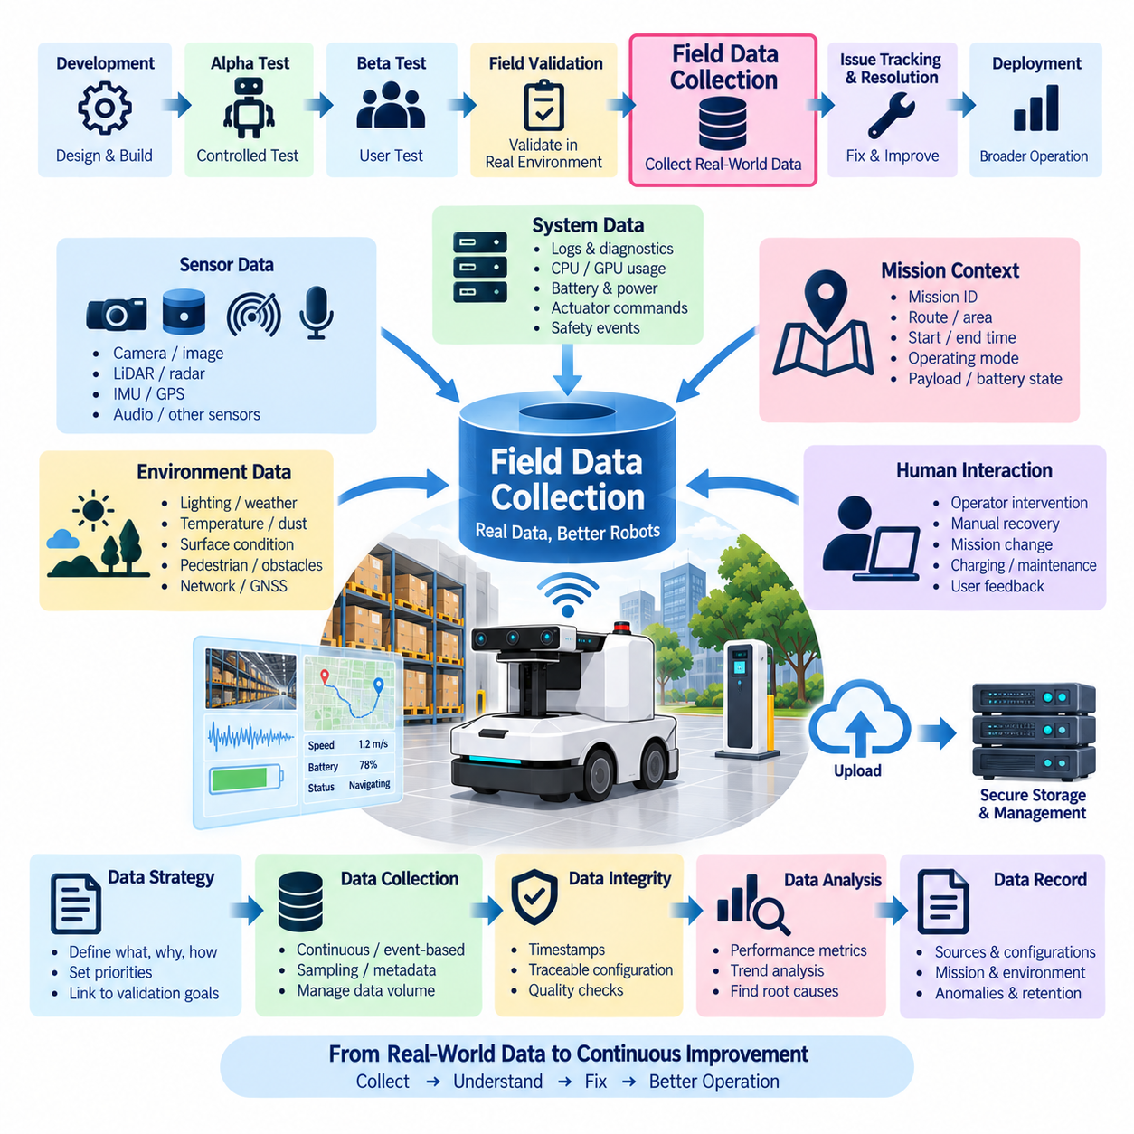
Field data collection is the systematic process of acquiring, organizing, and preserving operational evidence from robots and autonomous systems during representative field operation. Within the Field Test structure, it follows field validation and provides the empirical foundation for understanding real-world performance, reliability, environmental sensitivity, user interaction, and recurring failures. The objective is not simply to accumulate large volumes of data, but to obtain traceable and interpretable evidence that can support engineering decisions and subsequent issue resolution.
The collection process should begin with a clearly defined data strategy that identifies what information is required, why it is required, how it will be collected, and how it will be associated with specific missions and system configurations. Data should cover operational behavior, system health, perception, localization, communication, power, computing resources, safety events, user interventions, and environmental conditions where applicable. Collection priorities should reflect the validation objectives and the operational risks that need to be understood.
Every data record should remain associated with a controlled system configuration. Hardware revision, sensor and actuator configuration, firmware, operating system, middleware, application software, AI model version, calibration files, maps, communication parameters, and relevant mission settings should be recorded together with the collected data. This configuration traceability is essential because the same field behavior can have different causes when the system configuration changes between test periods or deployed units.
Mission context should be captured together with technical measurements. Each recording should identify the mission, route or operating area, start and end time, operating mode, payload condition, battery state, environmental situation, and relevant operator actions. Without this context, large collections of sensor or system logs may become difficult to interpret. Context transforms raw measurements into operational evidence that can be compared across missions, locations, configurations, and time periods.
Time synchronization is particularly important for distributed robotic systems. Sensors, controllers, computers, communication networks, safety systems, and applications may generate independent records at different rates. Accurate and consistent timestamps allow engineers to reconstruct the sequence of events and determine relationships between perception, localization, planning, control, communication, and physical behavior. Timestamp quality should therefore be treated as part of data quality rather than as a secondary logging detail.
Operational data should include both system-level and subsystem-level information. Useful sources may include mission states, sensor health, localization status, actuator commands, network traffic, diagnostic codes, battery voltage and current, temperatures, CPU and GPU utilization, memory usage, storage status, safety events, and operator interventions. The appropriate data set depends on the validation objective, but collection should be sufficient to explain important successes, failures, and unexpected behaviors after the mission has ended.
Environmental information should be collected whenever it can influence system performance. Temperature, lighting, precipitation, dust, surface conditions, terrain, pedestrian density, obstacle configuration, wireless coverage, GNSS quality, and other relevant environmental factors should be recorded or associated with the mission. Environmental context allows engineers to distinguish intrinsic product behavior from conditions that may have influenced perception, localization, communication, thermal performance, or mechanical operation.
Field data should include information about human interaction because actual users can significantly influence system behavior. Operator interventions, manual recovery, mission changes, emergency actions, charging procedures, maintenance activities, warnings, and user feedback can provide important evidence about usability and operational workload. Such information should be recorded consistently so that repeated interventions can be analyzed as potential indicators of product limitations rather than treated as isolated operator events.
Data collection should preserve both normal and abnormal operation. Successful missions provide a baseline for expected behavior, while anomalies reveal weaknesses that may require further investigation. Fault events, communication interruptions, localization loss, unexpected stops, recovery actions, safety events, degraded performance, and mission cancellations should be captured with sufficient surrounding context. Recording only failure moments is insufficient because the preceding and following system states may be necessary to determine the actual cause.
The volume of field data should be managed according to engineering value. High-bandwidth sensor streams such as camera, LiDAR, radar, and video data can rapidly consume storage and network resources. Therefore, the collection strategy should distinguish between continuous data, event-triggered recording, sampled data, metadata, and summarized metrics. Critical evidence should receive higher preservation priority, while redundant information can be reduced through controlled sampling or retention policies.
Data integrity and provenance should be maintained throughout collection, transfer, storage, and analysis. Files should have identifiable sources, timestamps, configuration references, and appropriate integrity checks. Missing segments, corrupted recordings, incomplete transfers, duplicated files, or uncertain timestamps should be identified rather than silently incorporated into engineering analysis. A trustworthy field dataset must allow engineers to understand not only what information exists but also the limitations of that information.
Privacy, security, and access control should be considered when field data contains people, facilities, network information, or other operationally sensitive content. Collection procedures should follow applicable organizational requirements and defined data-handling rules. Where necessary, personal or sensitive information should be appropriately protected or processed before broader analysis. Data usefulness should not be achieved by weakening necessary operational security or privacy controls.
Collected data should be converted into structured datasets that support analysis and comparison. Mission identifiers, system identifiers, configuration versions, timestamps, environmental conditions, performance metrics, anomaly labels, and issue references should use consistent naming and metadata conventions. Standardized organization makes it easier to compare multiple robots, locations, software versions, environmental conditions, and operating periods and supports automated analysis at larger scale.
Field data analysis should connect quantitative measurements with observed operational events. Mission success rate, intervention frequency, localization error, communication availability, energy consumption, thermal behavior, recovery time, fault frequency, and other metrics can reveal trends that are not obvious from individual logs. When these metrics are associated with environmental and configuration information, engineers can identify correlations, recurring conditions, and potential root causes requiring additional investigation.
The final field data collection record should preserve the collection strategy, data sources, system configurations, mission context, environmental information, timestamps, quality status, storage locations, integrity checks, anomaly records, and retention decisions. The resulting dataset should provide a reliable engineering foundation for issue tracking and resolution, reliability improvement, software and AI updates, calibration refinement, operational optimization, and future validation activities. Effective field data collection therefore transforms real-world robot operation into structured evidence that can continuously improve system performance and deployment confidence.

09.05. Issue Tracking and Resolution
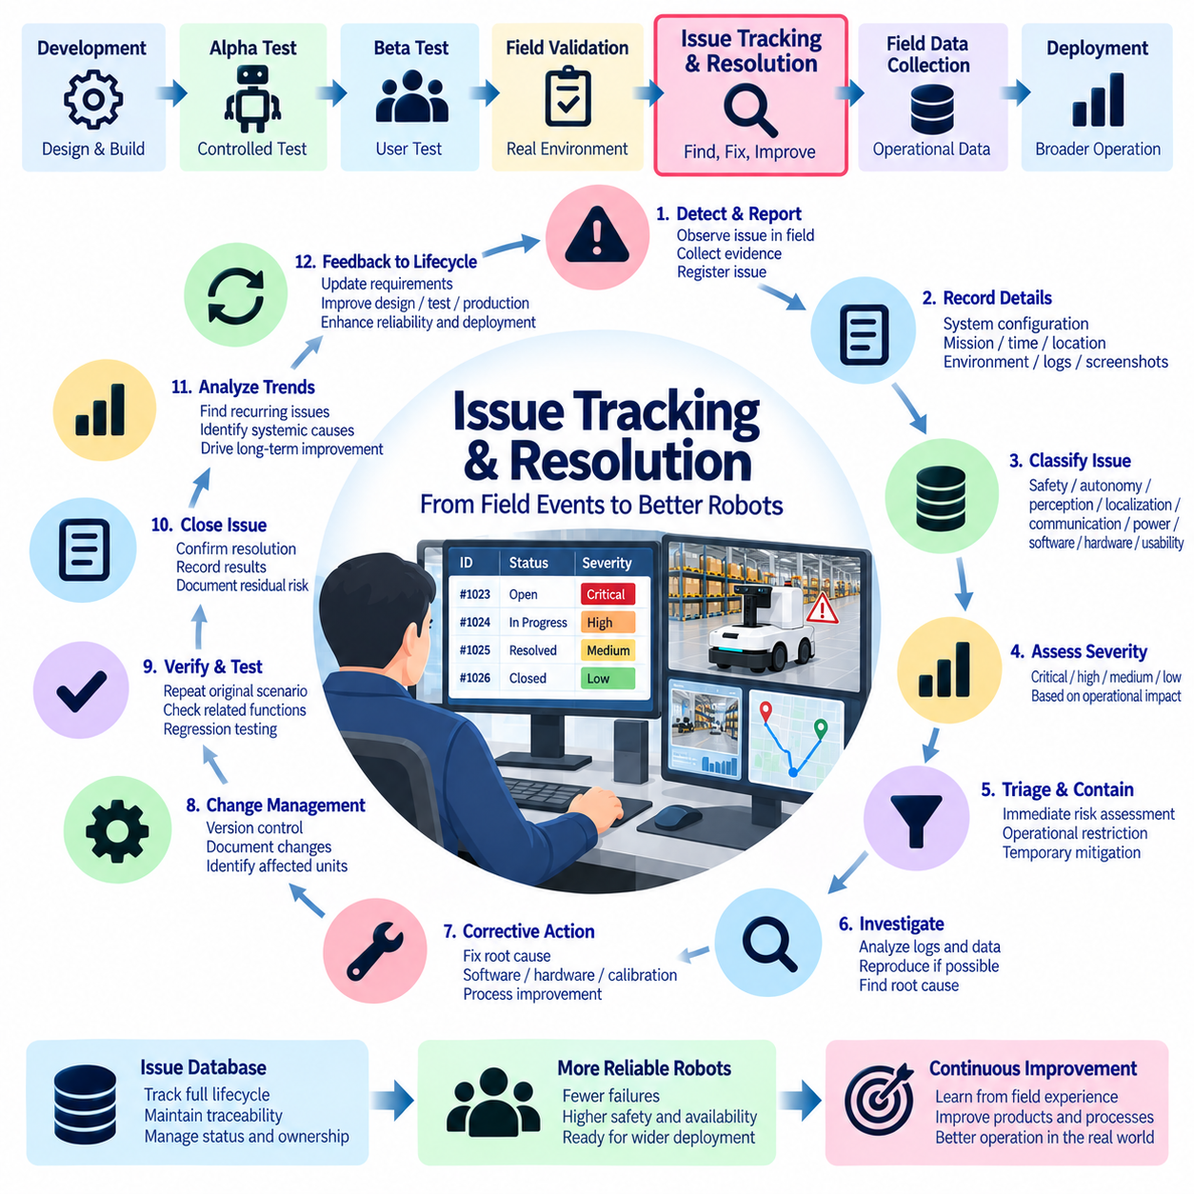
Issue tracking and resolution is the structured process of recording, analyzing, prioritizing, correcting, verifying, and closing problems discovered during field operation. Within the Field Test structure, it follows field data collection and converts operational observations into controlled engineering actions. The objective is not simply to maintain a list of failures, but to preserve traceability from the original field event through root-cause analysis, corrective action, regression verification, and final disposition.
Every field issue should be registered with sufficient information to reconstruct what happened. The record should identify the system, hardware and software configuration, mission, location, date and time, operating conditions, observed behavior, expected behavior, and available evidence. Logs, sensor recordings, screenshots, diagnostic codes, network traces, environmental information, and operator observations should be associated with the issue whenever practical so that subsequent analysis is based on evidence rather than memory.
Configuration traceability is essential because the same symptom can have different causes in different system versions. Hardware revision, sensor and actuator configuration, firmware, operating system, middleware, application software, AI model version, calibration data, maps, parameters, and communication settings should be linked to each issue. When a corrected configuration is released, the issue record should retain both the original failing configuration and the corrected configuration so that the relationship between failure and corrective action remains clear.
Issue classification should distinguish the technical nature and operational impact of each event. A problem may involve safety, mission availability, autonomy, perception, localization, communication, power, thermal behavior, mechanical integrity, software stability, usability, maintainability, or manufacturing quality. Classification should remain evidence-based and should allow related events to be grouped so that repeated symptoms can be recognized as a possible common failure mechanism rather than treated as unrelated incidents.
Severity should reflect the consequences of the problem rather than the difficulty of fixing it. A safety-critical event, loss of control, collision risk, uncontrolled motion, critical mission failure, or hardware-damaging condition requires a substantially different response from a minor user-interface inconvenience. Severity criteria should therefore be defined consistently before large-scale field operation so that different teams and test sites do not assign significantly different priorities to similar events.
Frequency and reproducibility should be considered together with severity. An apparently minor problem that occurs on a large proportion of missions may have greater operational importance than a severe but extremely rare event, while a rare safety event may still require immediate escalation. Reproduction under controlled conditions is valuable because it helps separate systematic defects from environmental, configuration, or incidental conditions, but inability to reproduce an event should not automatically justify closing it.
Initial triage should determine whether an issue requires immediate containment. If continued operation could create unacceptable safety risk, damage equipment, corrupt data, or compromise critical missions, the affected system or scenario should be removed from operation until an appropriate decision is made. Temporary restrictions, reduced operating areas, software rollback, component replacement, or additional supervision may be used as controlled containment measures while the underlying cause is investigated.
Evidence preservation should occur before unnecessary resets, software updates, configuration changes, or hardware replacement. The objective is to retain the system state surrounding the event, including recent logs, timestamps, sensor status, mission state, network conditions, battery state, thermal conditions, operator actions, and fault codes. Preserving evidence at the time of occurrence substantially increases the probability of identifying the actual sequence of events and prevents important information from being lost during recovery.
Root-cause analysis should proceed from observable evidence toward the underlying failure mechanism. Engineers should consider whether the problem originated in hardware, software, calibration, configuration, manufacturing, environmental conditions, communication infrastructure, user interaction, or an interaction among several factors. The analysis should avoid stopping at the first visible symptom. For example, an intermittent communication failure may be caused by a connector, power instability, electromagnetic interference, software timing, network congestion, or an interaction between these conditions.
Where practical, controlled reproduction should be used to confirm the suspected cause. The original configuration, environmental conditions, workload, mission sequence, and relevant stress factors should be recreated as closely as possible. Reproduction should be performed carefully because changing several variables simultaneously can make the result difficult to interpret. A successful reproduction provides strong evidence that the proposed failure mechanism is relevant, while a failed reproduction should lead to further evidence gathering rather than premature closure.
Corrective action should address the root cause and not merely suppress the visible symptom. Depending on the failure mechanism, the solution may involve software modification, AI model changes, calibration updates, parameter adjustment, sensor replacement, harness improvement, connector redesign, mechanical reinforcement, thermal improvement, communication changes, manufacturing process control, or operator-interface improvement. The selected action should be proportional to the risk and supported by documented engineering reasoning.
Every corrective action should be controlled through configuration and change management. The affected hardware, software, model, calibration, parameter set, or manufacturing process should receive a clear revision identifier. The change record should explain why the modification was introduced, what issues it addresses, which units are affected, what regression scope is required, and how effectiveness will be verified. This prevents uncontrolled fixes from creating additional field problems or making historical results impossible to interpret.
Verification after corrective action should begin with the original failure scenario. The purpose is to determine whether the specific issue has actually been resolved under the conditions that exposed it. Related scenarios should then be tested to determine whether the correction introduced side effects in connected functions. For autonomous robots, this may require repeating the affected mission as well as checking perception, localization, planning, control, communication, safety, power, and user interaction behaviors that could have been influenced by the change.
Regression testing is particularly important when corrections affect shared software, communication interfaces, common hardware, or AI models. A fix for one mission may alter another mission, and a change to a common component may affect multiple robot configurations. Regression scope should therefore be selected according to the affected interfaces and failure mechanisms rather than limited to the exact test case that originally failed.
Issue closure should require objective evidence and an explicit disposition. A problem should not be closed merely because the system operated successfully once after a modification. The record should contain the corrective action, updated configuration, verification results, relevant regression evidence, and an engineering decision that the remaining risk is acceptable. If the problem cannot yet be completely eliminated, it may instead require documented mitigation, monitoring, operational restriction, or continued investigation.
Recurring issues should be analyzed collectively to identify systemic weaknesses. Multiple reports involving similar communication failures, sensor dropouts, charging interruptions, connector faults, thermal events, or software resets may share a common cause even when they occur on different robots or at different sites. Trend analysis across issue records can therefore reveal weaknesses in design, suppliers, manufacturing processes, software architecture, maintenance procedures, or field operating practices.
Issue management should also distinguish between product defects and conditions outside the product's intended operating domain. Environmental conditions, infrastructure limitations, incorrect configuration, unauthorized modifications, user procedures, or external network problems may contribute to a field event. Such factors should be recorded rather than automatically classified as product defects. At the same time, repeated interaction with realistic external conditions may reveal that the operational design domain or system robustness needs to be reconsidered.
The issue database should support status management throughout the complete lifecycle. An issue may move from newly reported to triaged, contained, under investigation, root cause identified, corrective action planned, corrective action implemented, regression verified, accepted, and closed. The exact status terminology may vary by organization, but transitions should be controlled and supported by evidence. Ownership and responsibility should also be explicit so that issues do not remain unresolved because responsibility is unclear.
Periodic issue reviews should examine both individual high-severity events and aggregate trends. Engineering teams should review open issues, aging, recurrence, severity distribution, affected configurations, failure categories, corrective-action effectiveness, and unresolved residual risks. These reviews can identify areas where additional field exposure, laboratory reproduction, design changes, supplier investigation, or reliability testing should be performed before broader deployment.
Field issue information should feed back into the wider engineering lifecycle. Repeated failures may require updates to requirements, design rules, test procedures, calibration methods, manufacturing controls, diagnostic functions, safety analysis, reliability models, or maintenance instructions. This feedback loop prevents issue tracking from becoming a purely administrative activity and turns real-world failures into improvements that reduce future occurrence.
The final issue-tracking record should preserve the original observation, configuration, evidence, severity, containment actions, investigation, root cause, corrective action, changed configuration, regression results, residual risk, ownership, and final disposition. The complete history provides traceability from field discovery to engineering resolution and supports audits, reliability analysis, future product development, and lessons learned. A mature issue-management process therefore transforms field failures into controlled knowledge and continuously improves the safety, reliability, maintainability, and deployment readiness of the robotic system.

