Volume 19. Testing and Validation

Chapter 06. Functional Test

06.01. HIL (Hardware in the Loop)
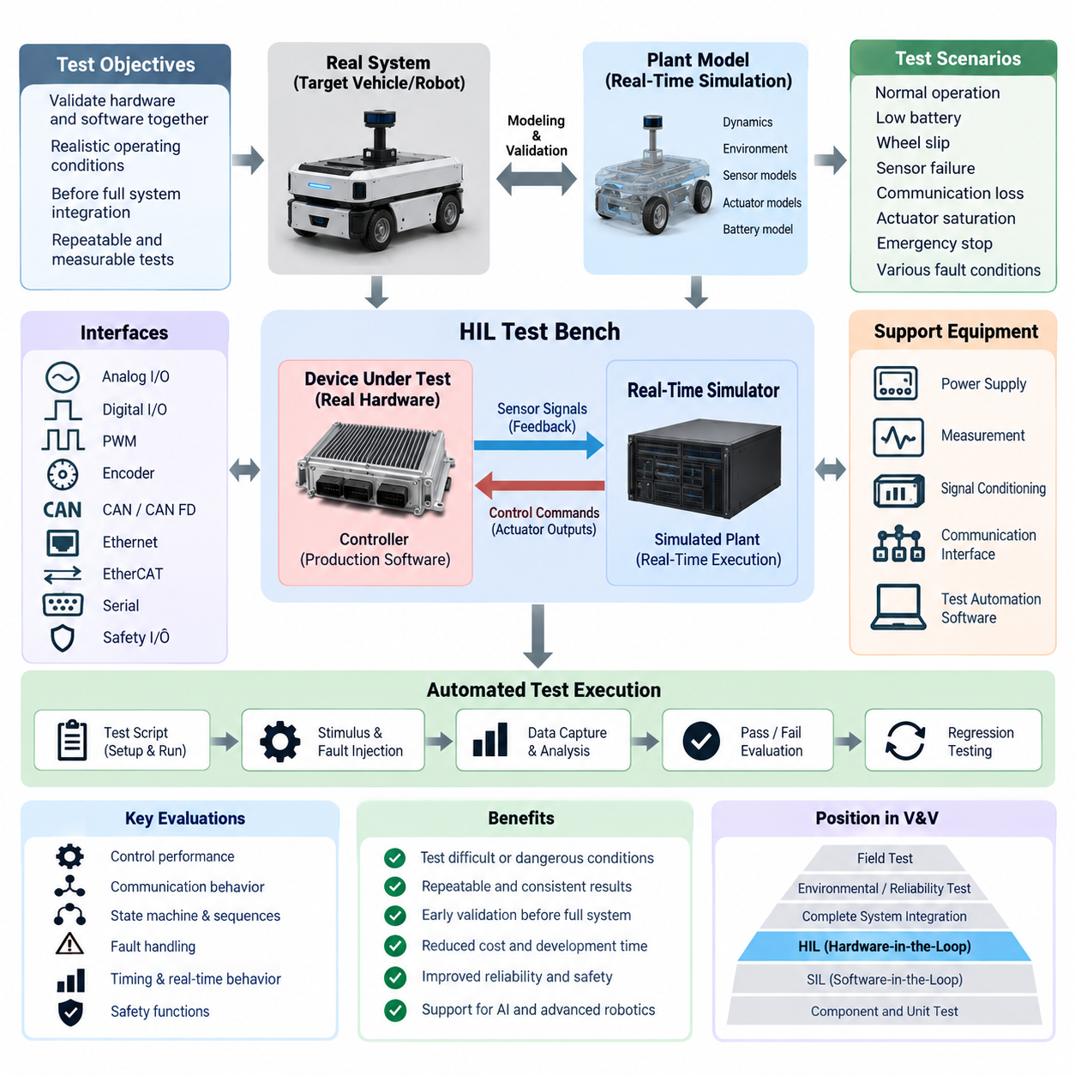
Hardware-in-the-Loop (HIL) testing is a functional validation method in which a real electronic controller, embedded computer, motor controller, safety controller, or other hardware device is connected to a real-time simulation of the physical system that it is intended to control. Instead of operating the complete robot or vehicle, the test bench reproduces sensors, actuators, communication networks, environmental conditions, and plant dynamics while the actual hardware executes its production control software.
The fundamental purpose of HIL is to validate hardware and embedded software together under realistic operating conditions before full system integration. A real-time simulator calculates the behavior of the virtual plant at deterministic intervals and converts simulated states into electrical or network signals that the device under test can interpret. Commands generated by the controller are captured by the simulator and applied back to the plant model, creating a closed-loop interaction comparable to operation on the physical machine.
A typical HIL environment consists of the device under test, a real-time simulation computer, signal-conditioning interfaces, communication interfaces, power supplies, measurement equipment, and test automation software. Depending on the target system, interfaces may include analog voltage and current signals, digital I/O, PWM, encoder signals, CAN or CAN FD, Ethernet, EtherCAT, serial communication, and safety-related discrete signals. Accurate electrical behavior is important because HIL evaluates the controller through its actual interfaces rather than abstract software variables.
Real-time execution distinguishes HIL from ordinary offline simulation. The simulated plant must calculate its next state within a fixed execution period so that sensor feedback reaches the controller with realistic timing. Motor dynamics, wheel motion, steering response, battery behavior, inertial measurements, actuator loads, and vehicle motion may therefore be represented using models with different update rates. Timing jitter, communication latency, synchronization error, and missed deadlines must be controlled because they can alter closed-loop behavior.
For an autonomous mobile robot, the simulated plant can represent drivetrain dynamics, wheel encoders, steering mechanisms, battery states, proximity devices, IMU signals, and selected perception or localization inputs. The physical controller receives these simulated measurements as though they originated from the real robot and produces torque, velocity, steering, braking, or mode commands. Engineers can consequently examine navigation-related control behavior without exposing an unfinished platform to unnecessary mechanical risk.
HIL is particularly valuable for testing operating conditions that are difficult, expensive, or dangerous to reproduce repeatedly with physical equipment. Low battery voltage, wheel slip, encoder failure, communication interruption, sensor dropout, actuator saturation, excessive temperature indications, emergency-stop transitions, or inconsistent feedback can be introduced in a controlled manner. Each condition can be repeated with identical timing, allowing engineers to compare software versions and determine whether the controller responds according to defined requirements.
Communication behavior forms an important part of robotic HIL testing because modern systems distribute functions across multiple controllers and computing nodes. A test bench can reproduce CAN traffic, Ethernet communication, EtherCAT devices, gateway behavior, message delays, packet loss, corrupted data, or bus loading while monitoring the response of the hardware under test. This allows functional behavior to be evaluated together with communication timing and complements the dedicated communication tests defined elsewhere in the validation structure.
HIL also provides an effective environment for validating state machines and operating sequences. Startup, initialization, homing, standby, autonomous operation, manual control, charging, docking, shutdown, recovery, and emergency states can be executed automatically while the simulator supplies the required environmental responses. Engineers can verify transition conditions, timeout handling, interlocks, command priorities, and recovery logic across thousands of combinations that would be inefficient to reproduce manually on a complete robot.
Fault handling can be evaluated systematically by injecting abnormal signals at precise points during execution. An encoder may freeze while the drive command remains active, a communication message may disappear for a specified interval, or an analog sensor may exceed its valid range. The objective is not merely to determine whether the controller detects a fault, but also whether it enters the intended degraded or safe state, records appropriate diagnostic information, suppresses unsafe commands, and recovers correctly when recovery is permitted.
The fidelity of the plant model determines how closely HIL results represent real system behavior. A model that is too simple may verify basic logic but fail to reproduce transient responses, nonlinearities, delays, friction, saturation, or coupled dynamics. Model fidelity should therefore be selected according to the validation objective. Control-loop testing may require detailed dynamic models, whereas communication sequencing or diagnostic testing may need simpler plant behavior combined with highly accurate timing and interface reproduction.
Model validation is consequently an essential part of establishing a trustworthy HIL bench. Parameters should be derived from design information, component specifications, measurements, or physical-system identification where available. Representative responses from the simulated system should be compared with bench or vehicle measurements to determine whether relevant dynamics are reproduced adequately. HIL results should always be interpreted within the validated operating range of the models rather than assuming that every simulated condition represents physical reality equally well.
Test automation transforms HIL from an engineering experiment into a repeatable validation platform. Test scripts can configure initial conditions, execute operating sequences, stimulate interfaces, inject faults, capture signals, calculate performance metrics, and automatically determine pass or fail results. The same test suite can then be executed whenever controller hardware, firmware, calibration parameters, communication configuration, or application software changes, providing a strong foundation for regression testing later in the validation process.
A well-designed automated HIL test records both stimulus and response with synchronized timestamps. Important measurements may include command latency, tracking error, state-transition time, communication cycle time, fault-detection delay, recovery time, actuator limits, watchdog behavior, and safety-related outputs. Raw traces should be retained together with software version, hardware revision, calibration set, model version, test configuration, and execution results so that failures can be reproduced and compared across development iterations.
HIL should be considered part of a layered verification strategy rather than a replacement for Software-in-the-Loop (SIL), component testing, environmental testing, or field validation. SIL can evaluate algorithms and software logic rapidly without physical hardware, while HIL introduces real processors, interfaces, timing behavior, electrical characteristics, and communication hardware. Successful HIL testing increases confidence before tests progress toward complete robotic platforms, environmental qualification, reliability testing, and operational field evaluation.
For Physical AI and increasingly intelligent robotic systems, HIL can also provide a controlled boundary between nondeterministic high-level intelligence and deterministic embedded control. Perception, planning, or AI-generated commands may be supplied to the actual control hardware while the real-time plant verifies whether resulting actions remain within defined operational constraints. This makes it possible to evaluate how conventional control, safety mechanisms, communication networks, and AI-driven decisions interact before deployment on physical machines.
The final value of HIL lies in converting functional validation into a controlled, measurable, repeatable engineering process. A mature HIL platform allows developers to reproduce failures, test boundary conditions, evaluate software changes, verify interfaces, and accumulate regression evidence without continuously requiring the complete robot. When models, timing, interfaces, automation, and configuration management are carefully maintained, HIL becomes a central bridge between simulation-based development and validation of the real robotic system.

06.02. SIL (Software in the Loop)
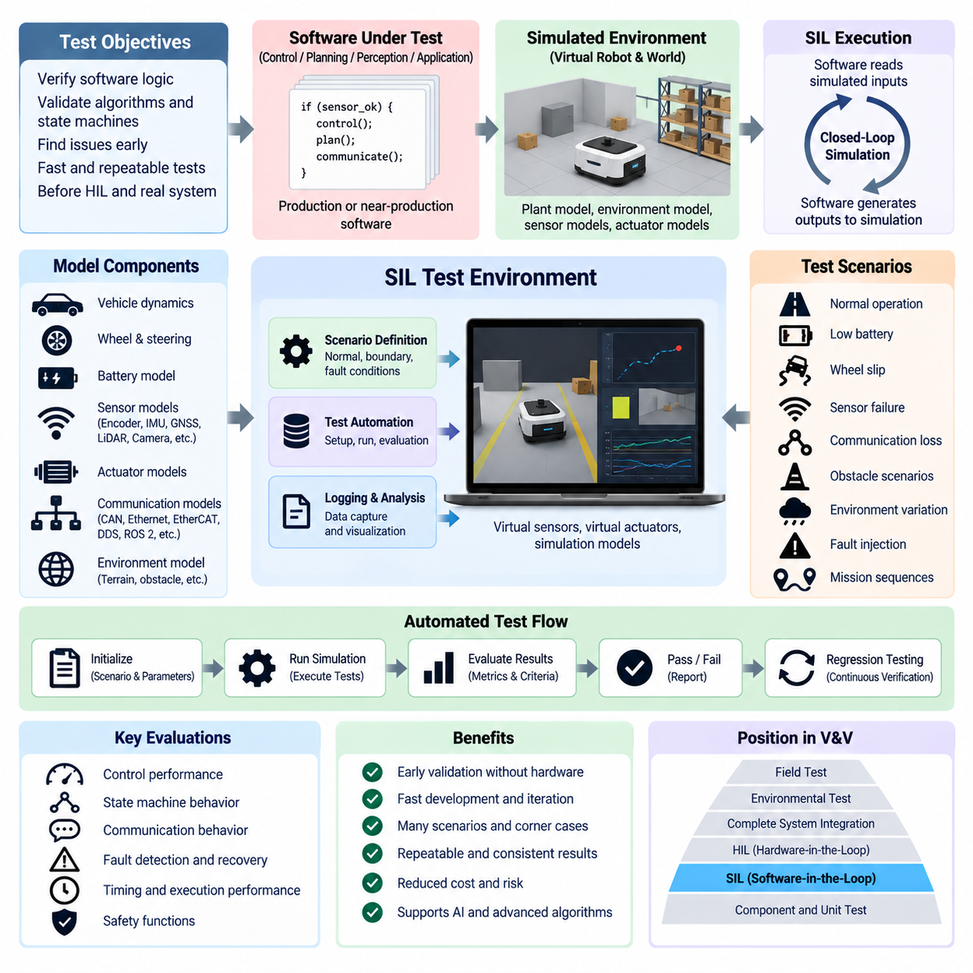
Software-in-the-Loop (SIL) testing is a functional validation method in which production or near-production software is executed against simulated models of the system, environment, sensors, actuators, and external interfaces without requiring the target electronic hardware. Within the functional-test structure, SIL provides an early verification layer before Hardware-in-the-Loop (HIL), complete system integration, environmental testing, and field validation.
The primary purpose of SIL is to determine whether control algorithms, application logic, state machines, diagnostics, communication behavior, and decision functions operate correctly before software is deployed to physical controllers. The software receives simulated inputs representing the operating system and generates outputs that are returned to the simulation. This closed-loop execution allows developers to evaluate functional behavior rapidly while avoiding hardware availability, damage, and configuration constraints.
A typical SIL environment contains the software under test, plant and environment models, virtual sensor and actuator interfaces, communication models, scenario definitions, test automation tools, logging functions, and result-analysis software. Depending on the implementation, individual algorithms, complete controller applications, middleware components, or multiple interacting software nodes can be executed together. Interfaces are represented through software abstractions rather than physical electrical connections.
The simulated plant represents the physical dynamics with which the software is expected to interact. For mobile robotics, this may include vehicle motion, wheel dynamics, steering response, drivetrain behavior, actuator limits, battery state, and environmental interaction. Virtual sensors can generate encoder, IMU, GNSS, LiDAR, camera, proximity, or other measurements according to the required test scope, while actuator commands modify the simulated system state for the next calculation cycle.
Unlike HIL, SIL does not fundamentally depend on the timing characteristics, electrical interfaces, processors, or communication transceivers of the final hardware. Execution may therefore run slower than real time for detailed analysis or substantially faster than real time for large regression campaigns. This flexibility enables thousands of scenarios to be evaluated efficiently, although hardware-dependent timing behavior must later be verified using HIL or physical-system testing.
SIL is especially useful during algorithm and control-software development because parameters and models can be modified rapidly without changing physical equipment. Engineers can evaluate velocity control, steering logic, trajectory tracking, docking sequences, energy-management logic, operating modes, and supervisory control under many simulated conditions. Failed cases can be reproduced from identical initial states, making debugging more systematic than testing directly on a moving robotic platform.
State-machine verification is another major application of SIL. Startup, initialization, standby, autonomous operation, manual operation, charging, docking, shutdown, degraded operation, recovery, and emergency transitions can be exercised automatically. Test scenarios can verify whether transition conditions, timers, interlocks, command priorities, initialization dependencies, and recovery rules produce the expected software states for both normal and abnormal operating sequences.
SIL also enables controlled fault simulation before hardware-based fault injection is attempted. Sensor values can become unavailable, frozen, noisy, delayed, biased, or outside their valid ranges. Communication messages can be delayed or removed, actuator responses can be limited, and simulated subsystem failures can occur at precisely defined times. The resulting software behavior can then be evaluated for fault detection, diagnostic reporting, fallback logic, safe-state transitions, and recovery.
Communication functions can be represented virtually so that distributed software behavior is tested before all physical network devices are available. Simulated CAN, Ethernet, EtherCAT, DDS, ROS 2 middleware, or other communication mechanisms can reproduce message exchange between software components according to the intended architecture. Engineers can examine sequencing, timeout logic, data validity, message dependencies, and application-level reactions before later validating physical network behavior with dedicated communication and HIL tests.
For autonomous and Physical AI systems, SIL can extend beyond conventional control logic to perception, localization, planning, prediction, and decision-making software. Simulated environments can provide structured sensor observations or synthetic sensor data while the software generates trajectories, commands, or behavioral decisions. This enables developers to investigate interactions among intelligent functions and deterministic control logic before allowing generated actions to influence a real robot.
Simulation fidelity must be selected according to the purpose of each SIL test. High-fidelity vehicle dynamics may be necessary for control-performance analysis, while simplified models may be sufficient for state-machine, communication, diagnostic, or supervisory-function verification. Excessive model complexity can reduce execution speed without improving the targeted validation, whereas insufficient fidelity may hide important software defects. Model assumptions and valid operating ranges should therefore be explicitly managed.
Scenario design is equally important because SIL effectiveness depends on the operating conditions presented to the software. Nominal cases should establish expected functionality, while boundary conditions, parameter variations, disturbances, and fault conditions expose weaknesses that normal operation may not reveal. Scenario libraries can progressively represent different payloads, friction conditions, battery states, sensor uncertainties, communication disturbances, obstacle configurations, and mission sequences relevant to the robotic system.
Test automation allows SIL to scale from interactive development into continuous verification. Automated scripts can initialize simulation conditions, configure software parameters, execute scenarios, inject events, capture signals, calculate metrics, and determine pass or fail results. Because physical hardware is not required, multiple SIL instances may be executed in parallel on workstation or server resources, allowing broad regression suites to be completed much faster than equivalent physical testing.
Useful SIL evaluation metrics depend on the tested function and may include tracking error, trajectory deviation, state-transition time, command response, fault-detection latency, recovery behavior, computational execution time, mission completion, collision occurrence, safety-rule violations, and communication timeout behavior. Results should be stored together with software version, model version, configuration parameters, scenario definition, random seed where applicable, and acceptance criteria to ensure reproducibility.
Regression testing is one of the strongest benefits of SIL. Every software modification can automatically trigger a defined collection of previously validated scenarios so that developers can determine whether new functionality has unintentionally affected existing behavior. A growing regression library converts discovered defects into permanent test cases, allowing the verification system to preserve engineering knowledge and detect recurrence of previously resolved failures throughout the development lifecycle.
SIL and HIL therefore perform complementary roles within the validation process. SIL emphasizes software logic, algorithms, scenarios, scalability, and rapid iteration without requiring target hardware, while HIL introduces the real controller, physical interfaces, processor behavior, communication hardware, and real-time execution constraints. Tests that pass in SIL can progressively migrate toward HIL, reducing the number of basic software defects encountered during more expensive hardware-based validation.
A mature SIL environment ultimately creates a reproducible bridge between software development and physical-system verification. By combining executable software, plant models, scenario libraries, fault simulation, automated evaluation, and regression testing, engineers can expose functional problems early and repeatedly. For increasingly software-defined robots and Physical AI systems, SIL becomes a fundamental validation layer that improves development speed while preparing software for subsequent HIL, integrated-system, and field testing.

06.03. Functional Safety Validation
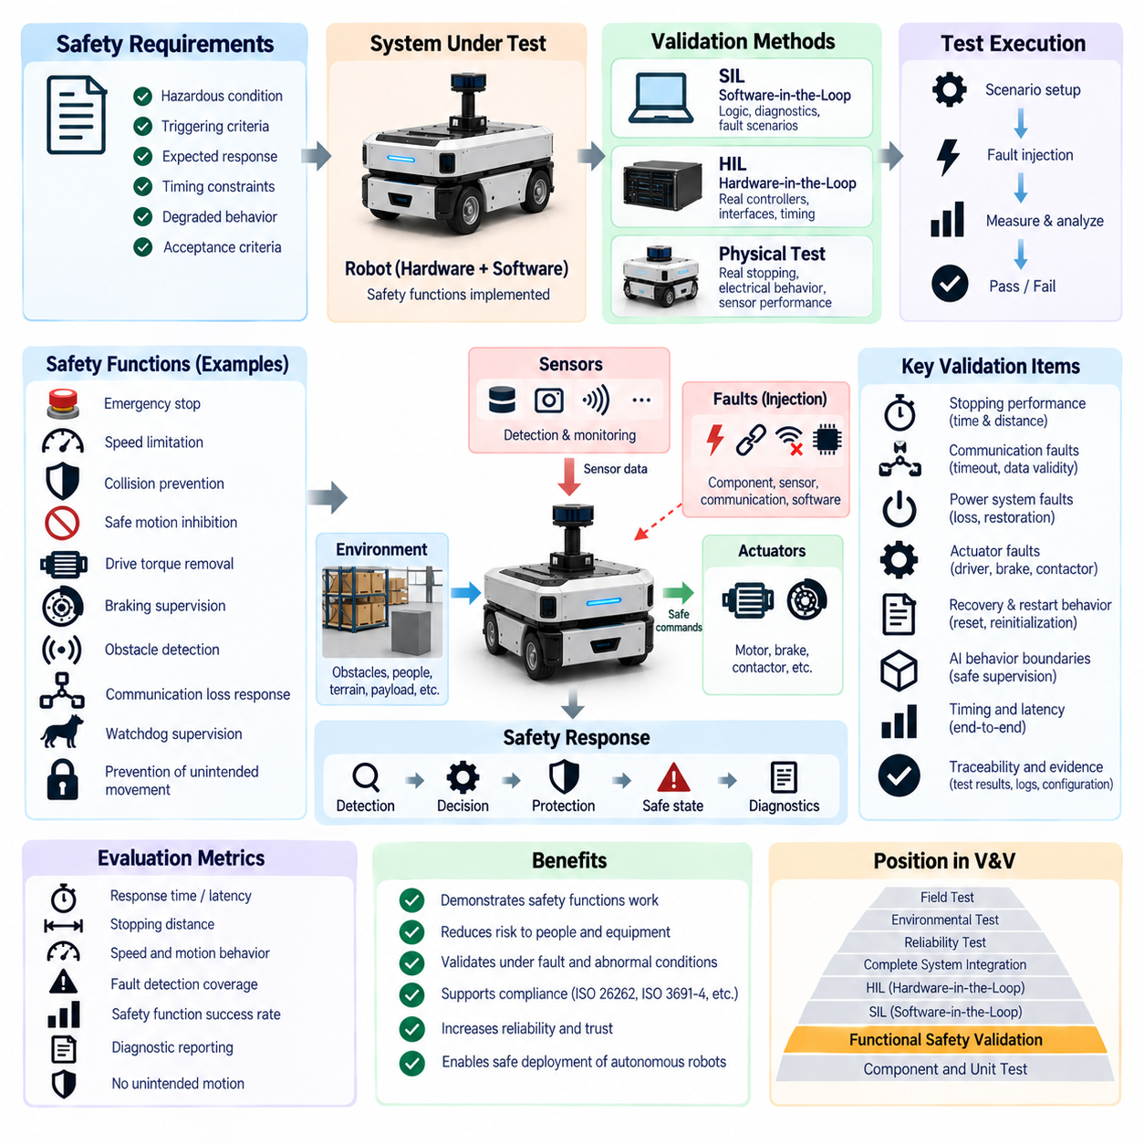
Functional safety validation is the systematic process of demonstrating that safety-related functions perform correctly when faults, abnormal operating conditions, or foreseeable misuse could create hazardous robot behavior. Within the testing and validation structure, it follows SIL and HIL-based functional verification and focuses specifically on whether implemented safety mechanisms can detect hazardous conditions, control risk, and transition the system toward a defined safe or degraded state.
The purpose of functional safety validation is not simply to confirm that the robot operates correctly during normal conditions. It must provide evidence that safety functions remain effective when components fail, information becomes invalid, communication is interrupted, or control behavior deviates from its intended operation. Validation therefore examines the complete safety response from fault occurrence and detection through decision logic, protective action, diagnostic reporting, and final system state.
Safety requirements provide the foundation for validation. Each safety-related requirement should define the hazardous condition being controlled, triggering criteria, expected system response, timing constraints, permitted degraded behavior, and acceptance criteria. Validation tests then trace these requirements to observable system behavior. This requirement-to-test relationship provides evidence that safety concepts implemented during system, electrical, software, and control design have actually been realized in the integrated system.
For mobile robots, relevant safety functions can include emergency stopping, protective stopping, speed limitation, collision prevention, safe motion inhibition, drive torque removal, braking supervision, obstacle detection, communication-loss response, watchdog supervision, and prevention of unintended movement. The exact functions depend on the robot architecture and operational environment. Validation must therefore be based on the defined safety concept rather than applying an identical test set to every robotic platform.
Emergency-stop validation verifies the complete response chain from activation of the emergency device to removal or control of hazardous motion. Testing should examine detection of the input, safety logic execution, actuator response, braking or torque interruption, stopping behavior, system indication, and restart prevention. Release of the emergency-stop device should not automatically create hazardous motion; the required reset and controlled restart sequence must also be evaluated under representative operating states.
Protective sensing requires validation of both detection and system reaction. Safety LiDAR, bumpers, proximity sensors, interlocks, or other protective devices may define warning, protective, or stopping conditions. Tests should confirm that relevant objects or events are detected within the intended operating region and that the resulting speed reduction, controlled stop, or motion inhibition occurs correctly. Sensor availability and invalid-data handling should also be evaluated because a failed protective sensor can itself become a safety-relevant condition.
Stopping performance is particularly important for moving robotic systems because safety depends on the distance and time required to eliminate hazardous motion. Validation should consider representative speeds, payloads, directions of travel, surface conditions, actuator states, and braking characteristics. Measured stopping time and stopping distance can then be compared with defined safety limits and protective-field assumptions so that sensing distance, system latency, and physical stopping capability remain consistent.
Functional safety validation must also examine faults within power and actuator systems. Loss of control power, unexpected power restoration, motor-driver faults, brake faults, contactor failures, invalid feedback, or actuator command inconsistencies can produce unsafe behavior if they are not handled correctly. Tests should verify whether the safety architecture detects these conditions and whether independent protective mechanisms prevent uncontrolled torque, unintended movement, or unsafe restart when normal control functions become unreliable.
Communication faults are significant because safety-related information may cross multiple controllers, networks, and gateways. Missing messages, stale data, excessive latency, corrupted information, synchronization loss, or communication interruption should result in behavior consistent with the safety concept. Validation should determine whether timeout supervision, data validity checking, heartbeat mechanisms, redundant information, or other diagnostics detect the problem within the required time and initiate the appropriate safe response.
Fault injection provides a controlled method for evaluating safety mechanisms that may rarely activate during normal operation. Sensor signals can be frozen, communication channels interrupted, feedback values made inconsistent, software states corrupted within the permitted test environment, or simulated component failures introduced. The objective is to demonstrate not only fault detection but also fault containment, diagnostic coverage, transition to the intended state, prevention of hazardous commands, and appropriate recovery behavior.
HIL and SIL environments are valuable supporting tools for functional safety validation because hazardous scenarios can be exercised before they are attempted on complete physical machines. SIL allows safety logic, state transitions, diagnostics, and fault responses to be explored efficiently across many scenarios, while HIL adds real controllers, physical interfaces, communication hardware, and real-time timing behavior. Physical-system testing remains necessary where actual mechanical stopping, electrical behavior, or sensor performance determines safety.
Timing is a critical validation parameter because correct safety logic may still be ineffective if its response is too slow. The complete reaction path can include sensor detection, communication delay, controller processing, safety decision, command transmission, actuator response, and mechanical stopping. Validation should measure relevant latency across this chain and evaluate worst-case or appropriately bounded behavior rather than relying only on average response values that may conceal hazardous timing conditions.
Recovery and restart behavior must be validated as carefully as fault detection. After a safety event, the robot should remain in the required safe state until defined recovery conditions have been satisfied. Tests should evaluate reset logic, operator acknowledgement where required, sensor restoration, communication recovery, reinitialization, brake release, and transition back to operational states. Automatic recovery must not cause unexpected motion or bypass safety conditions that originally triggered the protective response.
Autonomous and Physical AI systems introduce additional validation challenges because perception, planning, or AI-generated decisions may vary with environmental observations. Functional safety should therefore maintain enforceable boundaries around intelligent behavior. Safety mechanisms can supervise velocity, operating zones, actuator commands, collision constraints, system health, or permissible modes independently of high-level decision generation, ensuring that an unexpected AI output does not directly become an uncontrolled physical action.
Validation evidence should be traceable and reproducible. Each test should identify the safety requirement, test configuration, hardware and software versions, initial conditions, injected faults, expected response, measured results, acceptance criteria, and final verdict. Signal traces and synchronized timestamps are especially important when proving detection and reaction times. Configuration management ensures that evidence generated for one system version is not incorrectly attributed to another hardware, software, or calibration configuration.
Functional safety validation is closely related to the broader safety architecture represented elsewhere in the robotics electrical-engineering structure, including ISO 26262, IEC 61508, ISO 3691-4, ISO 13849, SIL and ASIL assessment, emergency-stop design, safety PLCs, safety LiDAR, and safety networks. These subjects provide the architectural and standards context, while functional testing determines whether the implemented robot actually exhibits the intended safety behavior.
Successful functional safety validation does not mean that every possible failure has been eliminated. Instead, it provides structured evidence that identified hazardous conditions are controlled by defined safety mechanisms and that these mechanisms behave correctly within their validated assumptions and operating limits. Combined with fault injection, regression testing, environmental validation, reliability testing, and field evaluation, it builds confidence that the robot can respond predictably when normal operation is disturbed.
A mature functional safety validation process therefore connects hazard-driven requirements with measurable physical and software behavior. It verifies sensing, communication, decision logic, actuation, stopping, diagnostics, degradation, recovery, and restart as an integrated safety chain. For autonomous robots and Physical AI platforms, this disciplined approach is essential for ensuring that increasingly capable intelligence remains bounded by independently verifiable mechanisms that protect people, equipment, and the surrounding environment.

06.04. Fault Injection Test
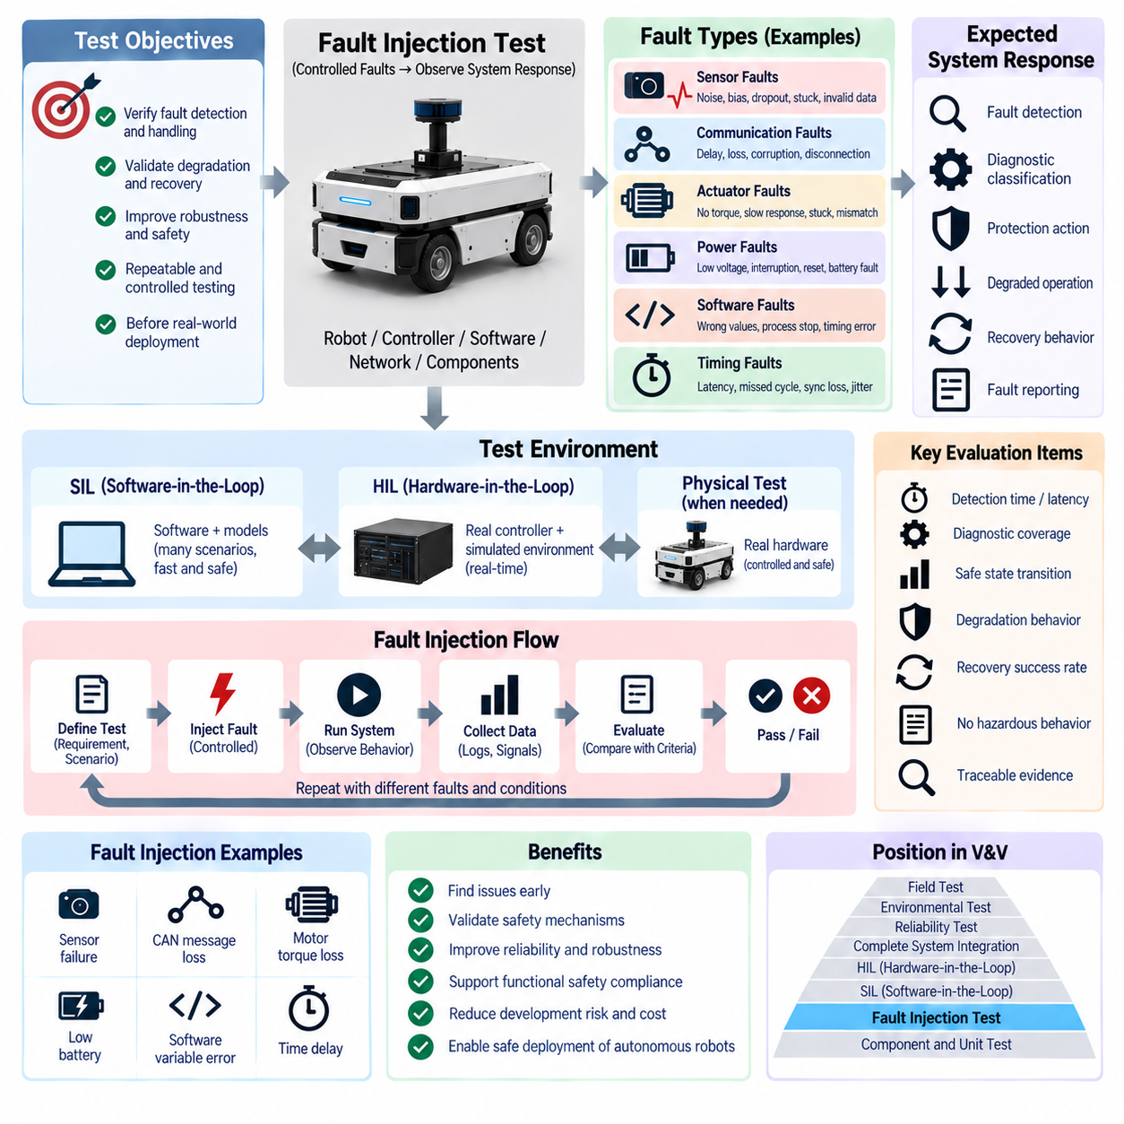
Fault injection testing is a systematic validation method in which controlled faults are deliberately introduced into a robot, controller, software component, communication network, sensor, actuator, or simulated environment to evaluate how the system detects and manages abnormal conditions. Within functional testing, it complements HIL, SIL, and functional safety validation by directly challenging diagnostic, degradation, recovery, and protection mechanisms under repeatable conditions.
The primary objective of fault injection is to determine whether the system behaves predictably when assumptions made during normal operation are violated. A fault may represent missing information, corrupted data, delayed communication, sensor failure, actuator malfunction, power disturbance, software abnormality, or inconsistent subsystem behavior. The test evaluates not only whether the fault is detected but also whether the resulting response prevents the fault from developing into an unsafe or mission-critical failure.
Fault injection should be derived from defined system requirements, hazard analysis, failure analysis, diagnostic concepts, and operational scenarios. Each test requires a clear relationship between the injected fault and the expected system response. The injection point, activation condition, fault duration, expected detection mechanism, permitted degraded behavior, recovery condition, timing requirement, and acceptance criteria should be defined before execution so that results can be evaluated objectively.
Sensor fault injection is particularly important in autonomous robots because control and intelligent functions depend heavily on sensor information. Encoder values may be frozen, IMU measurements biased, GNSS data removed, LiDAR messages delayed, camera streams interrupted, or proximity signals forced into invalid states. Noise, drift, offset, saturation, dropout, and implausible values can also be introduced to determine whether data validation, plausibility checking, redundancy, and fallback mechanisms operate correctly.
Communication fault injection evaluates the behavior of distributed systems when information exchange becomes unreliable. CAN or CAN FD frames may be delayed, dropped, repeated, or corrupted, while Ethernet, EtherCAT, DDS, ROS 2, or other network traffic may experience packet loss, excessive latency, disconnection, stale data, or synchronization problems. Tests should determine whether timeout monitoring, heartbeat supervision, sequence checking, data-validity mechanisms, and communication recovery respond according to the intended architecture.
Actuator-related faults examine whether the system can recognize differences between commanded and actual physical behavior. A motor may fail to generate expected torque, a steering actuator may respond slowly, a brake may fail to engage or release, or feedback may disagree with the issued command. Simulated saturation, stuck outputs, reduced performance, unexpected motion, and unavailable actuators can reveal whether supervisory logic detects abnormal behavior and transitions the robot to an appropriate degraded or safe operating state.
Power-system faults can also be introduced where the test environment permits controlled and safe execution. Examples include low supply voltage, transient power interruption, unexpected controller reset, loss of a subsystem supply, contactor-state inconsistency, or simulated battery faults. The purpose is to verify initialization, brownout handling, power-state supervision, shutdown logic, diagnostic retention, and restart behavior without creating uncontrolled electrical or mechanical hazards during the validation process.
Software fault injection focuses on abnormal internal states and interfaces rather than physical component failures. Variables may be forced outside expected ranges, software messages may be suppressed, processes may be stopped, timing may be disturbed, or selected interfaces may return invalid information. Such testing can expose assumptions that are not protected by input validation, watchdogs, exception handling, state supervision, or recovery logic and can reveal failure propagation between software components.
Timing faults are especially relevant to real-time robotic systems. Delayed sensor updates, missed control cycles, excessive processing latency, timestamp errors, synchronization loss, and communication jitter can degrade system behavior even when individual data values remain correct. Fault injection should therefore evaluate whether timing supervision detects stale or late information and whether the system prevents outdated data or delayed commands from producing unstable, unsafe, or unpredictable physical actions.
SIL provides an efficient environment for early fault injection because software and models can be manipulated without risking physical hardware. Large numbers of fault combinations can be executed automatically, including cases that would be difficult to reproduce manually. Simulation also allows precise control of injection timing, duration, magnitude, and repetition, making SIL suitable for exploring diagnostic logic, state transitions, fallback strategies, and broad regression coverage before hardware-based testing begins.
HIL extends fault injection by introducing real controllers, processors, communication interfaces, and real-time behavior. The simulator can modify sensor signals, communication traffic, actuator feedback, or plant responses while the actual controller executes production software. This allows engineers to verify whether diagnostics and protection mechanisms continue to function when hardware timing, electrical interfaces, processor behavior, and real communication devices become part of the closed-loop validation environment.
Physical fault injection may be necessary when simulation cannot adequately reproduce the relevant failure mechanism. Controlled sensor obstruction, connector disconnection, communication interruption, actuator disabling, or power-related disturbances may be performed using appropriate test equipment and safety controls. Physical injection should be carefully bounded because deliberately creating faults can damage equipment or generate hazardous motion. Simulation and HIL should therefore be used whenever they can provide equivalent validation evidence with lower risk.
A central concern in fault injection is failure propagation. A local defect should not automatically become a system-level hazardous event. Tests should observe how abnormal information moves through sensors, communication networks, middleware, control functions, decision logic, actuators, and supervisory systems. Effective fault containment may involve rejecting invalid data, isolating a failed component, switching to redundant information, reducing performance, limiting motion, stopping operation, or transferring control to a defined fallback mode.
Fault detection alone is insufficient if the system cannot respond appropriately. Validation should therefore examine detection latency, diagnostic classification, fault reporting, state transition, actuator response, degradation strategy, safe-state entry, and recovery behavior as one continuous chain. A fault detected correctly but reported too late, classified incorrectly, or followed by an unsuitable control action may still represent an unacceptable system response.
Recovery testing determines what happens after the injected fault disappears or the failed function becomes available again. Some faults may permit automatic recovery, while others may require operator acknowledgement, reinitialization, recalibration, or a complete restart. The system should not resume hazardous motion merely because an input returns to normal. Recovery conditions and transition logic must ensure that the robot returns to operation only when required safety and functional assumptions have been restored.
Fault injection becomes especially important for autonomous and Physical AI systems because perception, planning, prediction, and decision functions can depend on complex data chains. Faults at the sensor or communication level may propagate into incorrect world representations or action decisions. Independent supervision, operational constraints, plausibility checks, and safety mechanisms should therefore prevent erroneous high-level outputs from becoming uncontrolled physical actions when upstream information becomes unreliable.
Automation allows fault injection to scale beyond manually selected failure cases. Test frameworks can execute fault matrices that vary injection point, timing, duration, magnitude, operating state, payload, environment, and software configuration. Results can be compared automatically against expected responses and acceptance criteria. Repeating these tests after software or hardware changes transforms fault injection into a powerful regression mechanism for detecting degradation in diagnostic and fault-management behavior.
Test evidence should record the exact injected fault, injection mechanism, activation time, duration, system configuration, software and hardware versions, initial operating state, observed response, diagnostic output, timing measurements, recovery behavior, and final verdict. Synchronized signal traces are particularly valuable because they allow engineers to reconstruct the sequence from fault occurrence through detection and protective response and determine whether required timing constraints were satisfied.
Fault injection testing is closely connected with functional safety validation and the wider robotics safety architecture, including emergency-stop design, safety controllers, safety sensing, communication supervision, and system-level protection. It does not replace hazard analysis or safety design; instead, it provides experimental evidence that implemented diagnostic and mitigation mechanisms actually respond to representative failures as intended within the defined validation scope.
A mature fault injection process therefore converts anticipated failures into reproducible engineering experiments. By systematically introducing sensor, communication, actuator, power, software, and timing faults across SIL, HIL, and controlled physical tests, engineers can evaluate detection, containment, degradation, protection, and recovery before failures occur in operational environments. This strengthens functional robustness and provides essential evidence for reliable deployment of autonomous robots and Physical AI systems.

06.05. Regression Test Automation
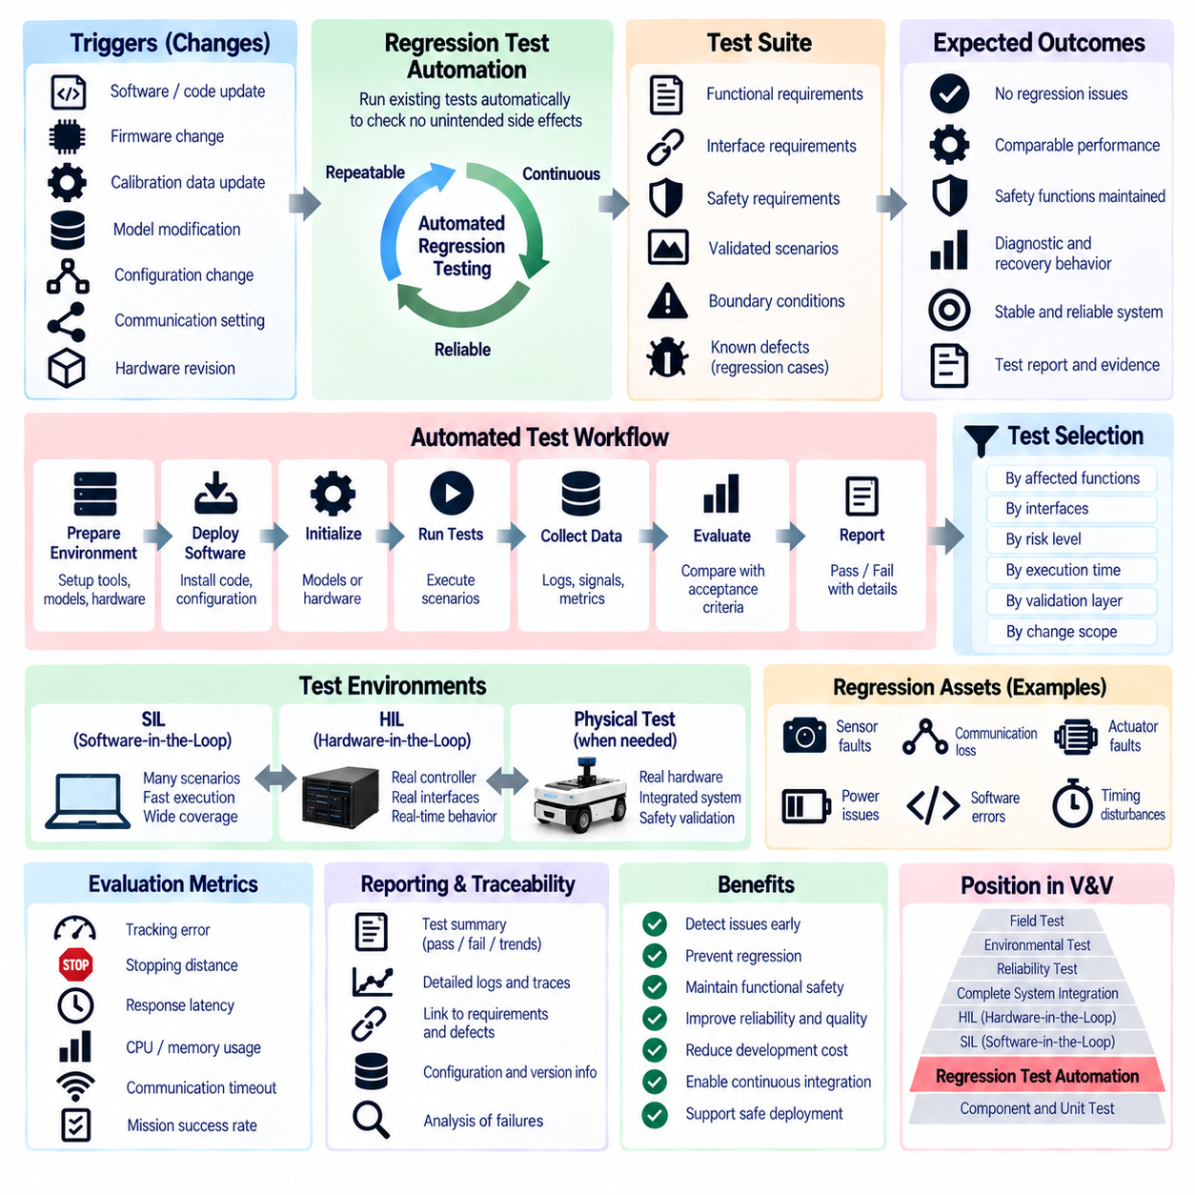
Regression test automation is the systematic execution of previously defined tests whenever software, firmware, calibration data, hardware configuration, communication settings, or system models are changed. Within functional testing, it follows HIL, SIL, functional safety validation, and fault injection by converting validated behaviors and discovered defects into repeatable test assets that can be executed continuously throughout development.
The primary objective of regression testing is to verify that a new modification has not unintentionally damaged functionality that previously operated correctly. Robotic systems contain many interacting components, so a change in motion control, communication, diagnostics, perception interfaces, or configuration may affect functions far from the modified component. Automated regression testing provides systematic evidence that established behavior remains valid after each relevant engineering change.
A regression suite is built from functional requirements, interface requirements, safety requirements, previously validated scenarios, boundary conditions, and defects discovered during development. Tests that once revealed failures should normally become permanent regression cases after the underlying problem is corrected. Over time, the suite therefore accumulates engineering knowledge and provides protection against recurrence of known problems while continuously checking essential system behavior.
Automation begins with a controlled and reproducible test configuration. Software version, firmware version, calibration set, model version, communication configuration, hardware revision, test parameters, and scenario definition should be identifiable for every execution. Without configuration control, a pass or fail result may be difficult to reproduce or compare. Regression automation must therefore connect test execution with version information and configuration management.
The automated workflow typically prepares the environment, deploys the required software, initializes models or hardware, configures parameters, executes test scenarios, records signals and logs, calculates evaluation metrics, compares results with acceptance criteria, and generates a final verdict. These activities should require minimal manual intervention so that the same procedure can be repeated consistently across software versions, development branches, controllers, simulation environments, and test benches.
SIL is particularly suitable for large regression campaigns because it does not require physical target hardware. Many simulations can run sequentially or in parallel, enabling broad scenario coverage within relatively short execution periods. Control algorithms, state machines, diagnostics, planning logic, communication behavior, and fault responses can be tested repeatedly. Faster-than-real-time execution can further increase throughput when the simulation architecture and tested functions permit it.
HIL regression introduces the actual controller and physical interfaces into the automated test process. A HIL bench can repeatedly stimulate sensor interfaces, communication channels, digital and analog signals, actuator feedback, and simulated plant behavior while production software runs on the target hardware. Although HIL generally offers lower test throughput than SIL, it provides important evidence concerning processor behavior, real-time timing, electrical interfaces, and communication hardware.
Regression automation should therefore distribute tests according to the most appropriate validation layer rather than attempting to execute every case on the most expensive platform. Fast software-oriented tests can run frequently in SIL, while hardware-dependent functions can be assigned to HIL and selected integrated-system tests. This layered strategy improves coverage and feedback speed while reserving limited physical test resources for conditions that genuinely require real hardware.
Fault injection scenarios are valuable regression assets because diagnostic and recovery behavior can be unintentionally affected by later changes. Sensor dropout, communication loss, delayed messages, invalid data, actuator faults, power-state abnormalities, and timing disturbances can be automatically reproduced after software updates. Expected detection, degradation, safe-state transition, diagnostic reporting, and recovery behavior can then be compared with previously accepted results.
Functional safety tests also benefit from regression automation. Safety-related software, communication supervision, watchdog behavior, motion inhibition, speed limits, emergency responses, and restart logic should be re-evaluated when relevant components change. Automation does not replace formal safety validation, but it can identify regressions early and prevent obviously incorrect versions from progressing toward more expensive integrated or physical safety testing.
Test selection becomes increasingly important as the regression library grows. Executing every test after every small modification may eventually become inefficient. Tests can therefore be organized according to affected functions, interfaces, risk, execution time, validation layer, and change scope. A rapid subset may provide immediate feedback for frequent development changes, while a broader suite can be executed before integration milestones, releases, or major configuration updates.
Traceability connects automated tests to engineering requirements and known issues. Each test should identify the requirement, function, interface, fault condition, or defect that it verifies. When a test fails, engineers should be able to determine which expected behavior is affected and which system configuration produced the failure. Traceability also helps identify requirements that lack regression coverage and tests that no longer correspond to active system behavior.
Reliable pass or fail evaluation requires measurable acceptance criteria. Depending on the function, criteria may include tracking error, stopping distance, state-transition time, response latency, communication timeout, diagnostic code, mission completion, safe-state entry, recovery time, resource consumption, or absence of unintended motion. Automated evaluation should distinguish genuine functional regressions from acceptable numerical variation, simulation tolerance, measurement uncertainty, or nondeterministic behavior.
Timing and performance regression are especially relevant to real-time robotic systems. A software change may preserve functional output while increasing execution latency, CPU or GPU utilization, communication load, memory consumption, or control-cycle jitter. These changes may later cause missed deadlines or unstable operation. Regression frameworks should therefore retain relevant performance metrics and compare them across versions rather than evaluating only logical correctness.
For autonomous and Physical AI systems, regression testing must also address functions whose outputs may not be perfectly deterministic. Perception, prediction, planning, or learned models can change behavior when models, datasets, parameters, or runtime environments are updated. Evaluation may therefore use bounded performance criteria, scenario-level success metrics, safety constraints, statistical comparisons, or fixed random seeds where appropriate instead of requiring identical output values for every execution.
Parallel execution can significantly improve regression throughput. Multiple SIL instances can run across workstation or server resources, while several HIL benches may divide hardware-dependent scenarios when infrastructure permits. Test scheduling should consider execution time, required hardware, licenses, model resources, and dependencies. Efficient resource allocation allows large test libraries to provide timely engineering feedback without creating excessive delays in the development process.
Automated reporting converts raw test execution into actionable engineering information. Reports should summarize the tested configuration, total tests, passed and failed cases, newly failing tests, recovered tests, skipped cases, performance changes, and relevant diagnostic evidence. Detailed logs and synchronized traces should remain accessible for investigation. Trend information across builds can reveal gradual degradation that might not be obvious from a single pass or fail result.
A failed regression test should initiate structured investigation rather than simply being rerun until it passes. Engineers should determine whether the failure represents a genuine software defect, an intentional requirement change, a model problem, an unstable test, an infrastructure issue, or an incorrect acceptance threshold. Maintaining trustworthy tests is essential because a regression system that produces frequent unexplained false failures will eventually lose engineering value.
Regression automation is most effective when connected to the software integration and release workflow. Relevant tests can be triggered when code, configuration, models, or calibration data change, while broader suites can support release candidates and system milestones. Test results then become part of the evidence used to determine whether a build is suitable for progression toward HIL, complete-system integration, environmental testing, reliability testing, or field validation.
The testing structure places regression automation within a broader validation framework that also includes electrical, harness, EMC, communication, calibration, environmental, reliability, field, and certification-related testing. Regression automation should preserve successful functional behavior while changes occur across this wider engineering lifecycle, providing continuity between repeated development iterations and later validation stages.
A mature regression test automation system ultimately becomes a continuously growing verification asset for the robotic platform. By combining reusable scenarios, SIL and HIL execution, fault injection, safety checks, configuration control, measurable acceptance criteria, parallel execution, traceability, and automated reporting, it enables engineers to detect unintended changes early and repeatedly. This continuous verification capability is essential for maintaining reliable autonomous robots and Physical AI systems as their software and system complexity increase.

