Volume 19. Testing and Validation

Chapter 01. Electrical Test

01.01. Insulation Resistance Test
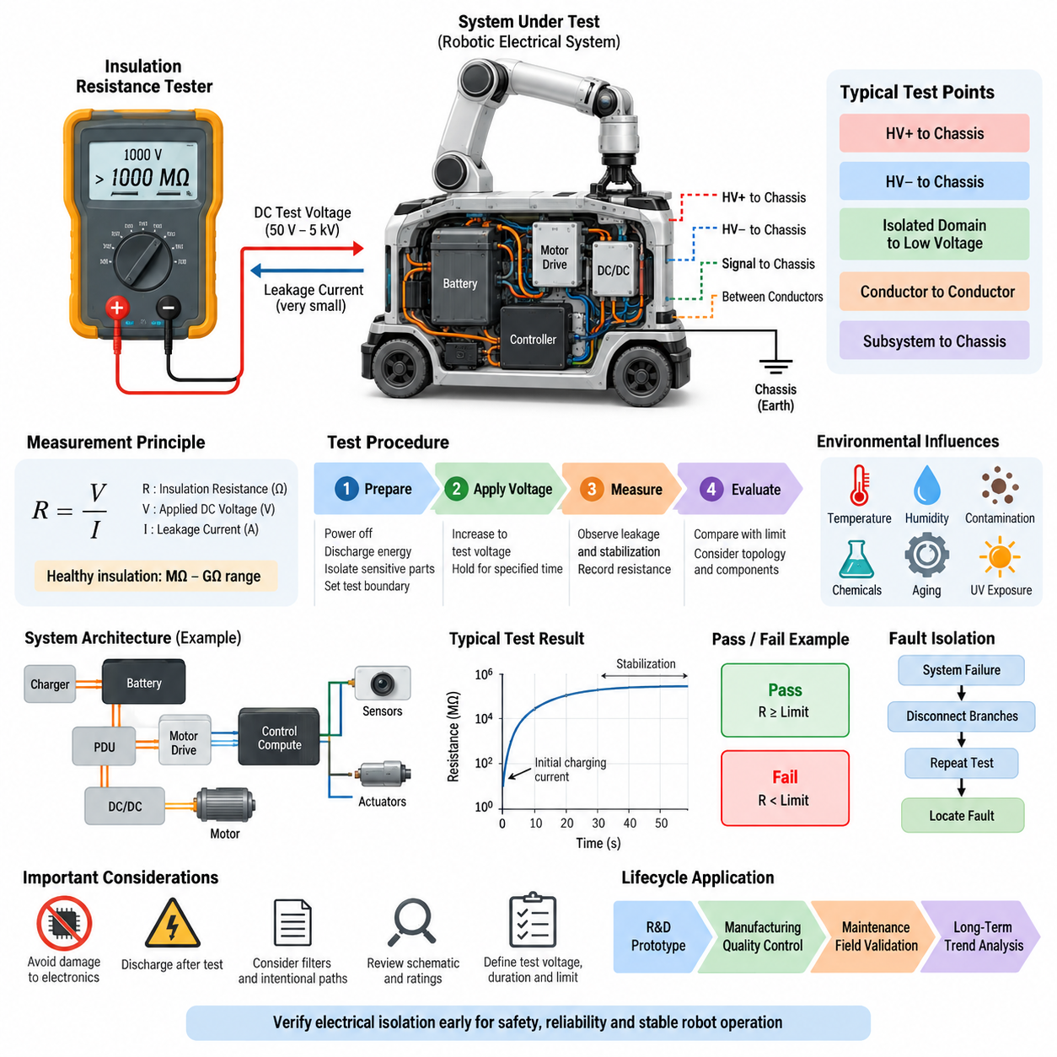
Insulation resistance testing is a fundamental electrical validation method used to determine whether conductors, power circuits, enclosures, and electrically isolated subsystems maintain adequate separation from one another. Within the electrical test structure of Volume 19, it forms the first verification activity before dielectric withstand, continuity, polarity, and high-voltage electrical testing.
The basic principle is to apply a controlled DC test voltage between two electrically isolated points and measure the extremely small leakage current that flows through or across the insulation. From the applied voltage and measured leakage current, the insulation resistance is determined according to Ohm’s law. Healthy insulation normally produces resistance values in the megaohm or gigaohm range.
Unlike a normal continuity measurement, insulation resistance testing intentionally examines paths that should not conduct electricity. Typical measurement points include positive and negative power conductors to chassis, high-voltage circuits to protective earth, isolated power domains to low-voltage electronics, and individual conductors to adjacent conductors. The objective is to identify unintended electrical leakage before it becomes hazardous.
A typical insulation resistance tester, often called a megohmmeter, contains a regulated high-voltage DC source and a sensitive current-measurement circuit. Test voltages may range from tens of volts to several kilovolts depending on the equipment, insulation system, and applicable requirements. The selected voltage must stress the insulation sufficiently without exceeding the limits of connected electronic components.
Before testing, the equipment should be placed in a defined electrical state. Power sources are disconnected, stored energy is discharged, and sensitive electronic modules that cannot tolerate the test voltage are isolated when required. Contactors, switches, and connectors must be configured according to the intended test boundary so that the measurement represents the insulation path defined by the validation procedure.
The test voltage is normally increased in a controlled manner and maintained for a specified period while resistance or leakage current is observed. Initial readings can vary because cable capacitance and dielectric polarization produce transient charging currents. The measurement should therefore distinguish these temporary effects from steady leakage. Recording both resistance and stabilization behavior provides more information than a single instantaneous reading.
Insulation resistance is strongly influenced by temperature, humidity, contamination, and the physical condition of insulating materials. Moisture, conductive dust, coolant residue, damaged cable jackets, carbonized surfaces, and connector contamination can significantly reduce measured resistance. Test reports should therefore record environmental conditions so that measurements from different prototypes, production lots, or service periods can be compared meaningfully.
For robotic electrical systems, the test boundary should reflect the actual architecture rather than treating the robot as one undivided circuit. Battery systems, power distribution units, motor drives, DC/DC converters, charging interfaces, compute electronics, sensors, and actuator branches may require separate measurements. Segmenting the architecture helps locate insulation degradation and prevents one parallel leakage path from masking another defect.
High-voltage robotic platforms require particular attention because loss of insulation can create hazardous touch voltage or unintended current through the chassis. Measurements can be performed between the high-voltage positive bus and chassis, high-voltage negative bus and chassis, and other isolated domains defined by the system architecture. Both individual branch results and the assembled-system condition should be considered during validation.
Low-voltage systems also benefit from insulation resistance testing even when electric-shock risk is limited. Harness damage, pin contamination, trapped moisture, and manufacturing debris can create high-resistance leakage paths that later develop into intermittent faults. Such defects may disturb analog sensors, communication interfaces, safety inputs, or power-control circuits long before they become obvious short circuits.
Pass and fail criteria should be defined before the measurement begins. A test specification should identify the test voltage, application duration, measurement points, minimum acceptable resistance, environmental condition, equipment configuration, and required discharge procedure. Acceptance limits should be derived from the product requirements and applicable standards rather than using one universal resistance value for every robotic electrical subsystem.
The measured value should not be interpreted independently of the system topology. Filters, surge suppressors, electromagnetic compatibility components, monitoring circuits, and intentionally connected resistive paths can produce measurable leakage even when insulation is healthy. Engineers should review the schematic and component ratings before testing so that intentional circuit behavior is not incorrectly classified as insulation failure.
When an unexpectedly low resistance is detected, fault isolation should proceed by progressively separating branches and repeating the measurement. Harnesses, connectors, motor phases, power converters, batteries, charging circuits, and external interfaces can be disconnected in controlled stages. This divide-and-isolate approach converts a system-level failure into a smaller electrical region where contamination, damage, or assembly defects can be inspected directly.
Special care is necessary when testing equipment containing semiconductor devices. Applying an insulation-test voltage across an unintended electronic path can damage MOSFETs, gate drivers, communication transceivers, sensors, or protection components. The validation procedure must therefore define exactly which terminals may be connected together, which modules must be removed, and which chassis or reference points are used during each measurement.
After the test voltage is removed, capacitive energy can remain stored in cables, filters, motors, and power electronics. The circuit must be discharged through an appropriate path before connectors are touched or equipment is returned to normal operation. Verification of residual voltage is especially important for high-voltage battery systems and long harnesses, where stored charge can remain even after the tester indicates completion.
Insulation resistance testing can also be incorporated into manufacturing quality control. Automated fixtures can connect selected harness pins, power terminals, chassis points, and connector shells to a programmable insulation tester. Results can then be associated with product serial numbers and compared against manufacturing limits. Trending the measurements may reveal process degradation before individual units cross the formal rejection threshold.
For maintenance and field validation, historical measurements provide additional diagnostic value. A robot may still satisfy the minimum requirement while its insulation resistance gradually decreases over months of operation. Comparing measurements taken after production, environmental qualification, field deployment, repair, and scheduled maintenance can reveal aging caused by vibration, thermal cycling, moisture ingress, chemicals, or repeated connector servicing.
Insulation resistance testing is related to, but distinct from, dielectric withstanding testing. Insulation resistance testing primarily quantifies leakage behavior under a defined DC voltage, whereas dielectric withstand testing evaluates whether insulation can survive a higher electrical stress without breakdown. The Volume 19 structure appropriately treats these as separate electrical validation activities followed by continuity, polarity, and high-voltage system testing.
For autonomous mobile robots and Physical AI platforms, insulation integrity ultimately supports more than electrical reliability. Stable isolation protects compute systems, sensors, communication networks, motor controllers, and safety circuits from unintended electrical coupling. It also reduces the probability that mechanical damage or environmental exposure will propagate into system-level faults affecting perception, control, or safe motion.
A complete test record should preserve the equipment identification, test instrument, calibration status, test voltage, measurement duration, connection configuration, environmental conditions, measured resistance, acceptance criterion, and final disposition. Abnormal observations should be linked to corrective actions and retest results. This traceability allows insulation verification to become part of the engineering validation evidence rather than an isolated laboratory measurement.
When applied systematically from component and harness testing through subsystem integration and complete-robot validation, insulation resistance testing provides an early indicator of electrical integrity. Its greatest value comes from combining controlled measurement, architecture-aware test boundaries, environmental context, and historical trending, creating a repeatable foundation for subsequent electrical, functional, environmental, reliability, and field validation activities.

01.02. Dielectric Withstanding Test
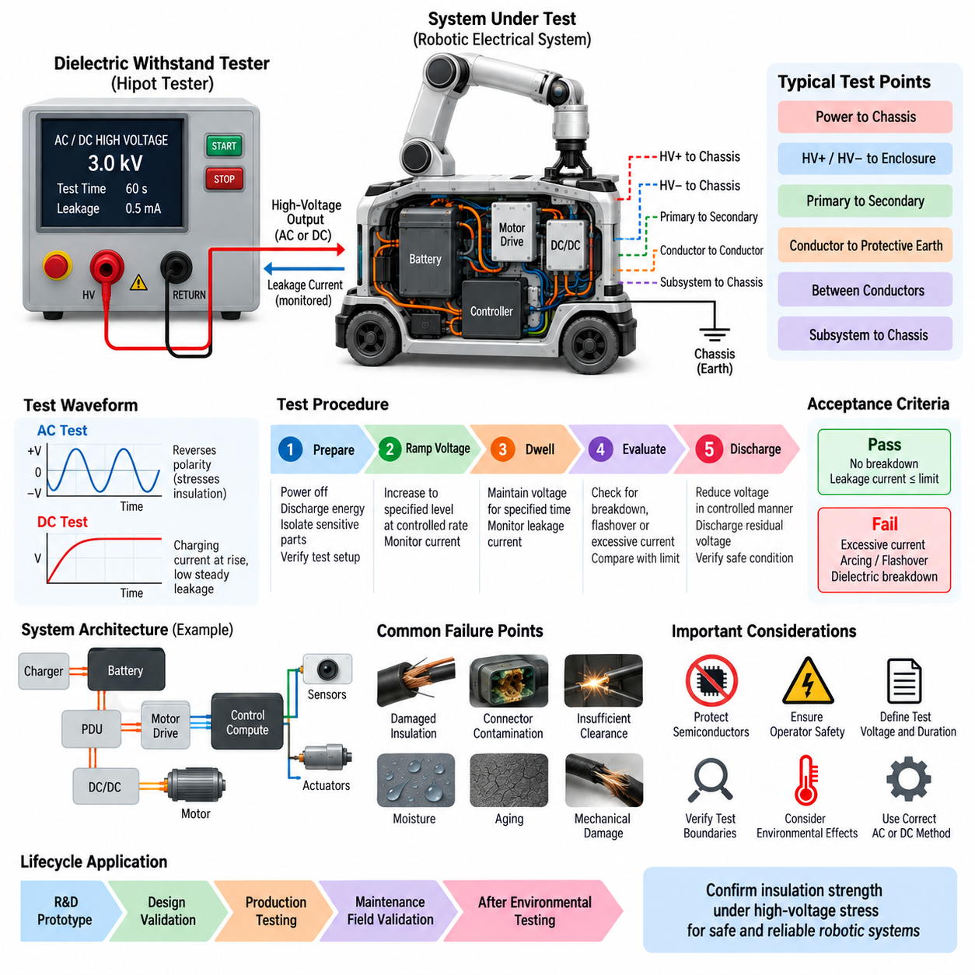
Dielectric withstanding testing is an electrical safety and insulation validation method used to verify that an electrical system can tolerate a specified high-voltage stress without insulation breakdown, flashover, or excessive leakage current. Within the electrical test structure of Volume 19, it follows insulation resistance testing and precedes continuity, polarity, and high-voltage electrical testing.
The fundamental objective is not simply to measure the normal resistance of insulation, but to demonstrate that the insulation barrier possesses sufficient dielectric strength under an intentionally elevated electrical potential. A controlled test voltage is applied between normally isolated conductive regions while the test equipment monitors current flow and detects conditions indicating electrical breakdown.
Typical test boundaries include power conductors to chassis, high-voltage positive and negative circuits to conductive enclosures, isolated primary and secondary circuits, conductor groups to protective earth, and electrically separated subsystems. The selected boundaries should correspond to the actual insulation architecture so that each safety-critical barrier is subjected to the intended electrical stress.
A dielectric withstand tester, frequently referred to as a hipot tester, generates a controlled AC or DC high voltage and monitors the resulting current. Depending on the equipment and validation requirement, the test voltage can be substantially higher than the normal operating voltage. The instrument must provide controlled voltage ramping, current limiting, trip detection, timing, and safe discharge functions.
The required test voltage should be established from the rated operating voltage, insulation category, system architecture, component ratings, and applicable product requirements. Arbitrarily selecting an excessively high voltage can damage otherwise acceptable insulation, while an insufficient voltage may fail to expose weaknesses. The voltage, waveform, duration, and allowable leakage current must therefore be defined before testing.
Before voltage application, the system under test must be placed in a known and electrically safe configuration. Normal power sources should be disconnected, stored energy discharged, and test boundaries verified against electrical schematics. Sensitive electronics, surge-protection components, filters, communication interfaces, or semiconductor devices may require isolation when their ratings are incompatible with the specified test voltage.
The test commonly begins with the output at a low or zero voltage and then increases it toward the specified withstand level at a controlled rate. This voltage ramp reduces abrupt electrical stress and provides an opportunity to identify abnormal current behavior before full voltage is reached. After reaching the target voltage, the tester maintains it for the specified dwell time while continuously monitoring current.
During the dwell period, successful insulation prevents destructive conduction between the test points. A small current may still exist because of insulation leakage, cable capacitance, filters, suppression devices, and other intentional circuit elements. The acceptance criterion must distinguish these expected currents from abnormal leakage, arcing, flashover, or dielectric breakdown that represents failure of the insulation system.
AC and DC dielectric withstand tests produce different electrical stresses and measurement behavior. AC testing repeatedly reverses the electric field and continuously charges the capacitance of the system, whereas DC testing primarily produces charging current during voltage rise followed by lower steady leakage. The selected method should therefore match the validation requirement rather than treating AC and DC testing as interchangeable.
Robotic platforms require architecture-aware test planning because batteries, power distribution units, motor drives, DC/DC converters, chargers, compute systems, sensors, and communication electronics can contain different insulation technologies. Testing the complete robot without understanding these internal paths can produce misleading results or expose components to voltages for which they were never designed.
For high-voltage robotic systems, dielectric withstand testing is particularly important for verifying separation between energized circuits and accessible conductive structures. High-voltage battery buses, traction or actuator inverters, charging circuits, power distribution assemblies, and high-voltage harnesses should maintain the required isolation from chassis and low-voltage domains even when subjected to the specified validation stress.
Harnesses and connectors are also important test targets because insulation failures frequently originate at physical interfaces. Damaged wire jackets, insufficient creepage or clearance, displaced seals, conductive contamination, improperly terminated shielding, pin deformation, and assembly damage can reduce dielectric strength. Testing at component, harness, subsystem, and assembled-system levels improves localization of such defects.
Environmental conditions can significantly influence dielectric performance. Moisture and condensation can create surface leakage paths, while contamination can reduce effective creepage distance. Temperature, chemical exposure, vibration damage, aging, and mechanical abrasion can also weaken insulation. Dielectric withstand testing performed after environmental or durability exposure can therefore reveal degradation that was absent in the initial production condition.
A test failure may appear as excessive current, an instrument trip, visible or audible arcing, flashover across an insulating surface, or permanent dielectric breakdown through the insulation material. These failure modes should not be treated identically. Determining whether the event occurred through solid insulation, across a contaminated surface, inside a connector, or through an intentional electronic path is essential for corrective action.
When a complete system fails, fault isolation can be performed by dividing the electrical architecture into progressively smaller test regions. Disconnecting harness branches, power converters, motor drives, charging interfaces, batteries, and external equipment allows the test to be repeated on individual sections. This systematic isolation process helps distinguish a genuine insulation defect from a component or circuit configuration that was inappropriate for the test.
Semiconductor-based equipment requires particular caution during dielectric testing. MOSFETs, IGBTs, gate drivers, isolation amplifiers, communication transceivers, capacitors, transient suppressors, and electromagnetic compatibility components may create paths that alter the test result or suffer damage. Test procedures must specify which terminals are shorted together, disconnected, grounded, or excluded before high voltage is applied.
Operator safety is a fundamental part of dielectric withstand testing because the tester intentionally generates hazardous voltage. Test fixtures should prevent accidental access to energized conductors, and appropriate interlocks, warning indicators, emergency interruption, and discharge mechanisms should be used. The equipment must remain inaccessible until the high-voltage source is removed and residual voltage has been verified as safe.
After completion of the dwell period, the applied voltage should be reduced in a controlled manner and the system discharged. Capacitive elements, long harnesses, filters, motors, and power electronics can retain significant electrical charge after the source is removed. Residual voltage verification is therefore necessary before test leads are disconnected or the equipment is returned to normal operation.
Dielectric withstand testing and insulation resistance testing provide complementary information. Insulation resistance testing evaluates leakage behavior and resistance under a defined DC voltage, whereas dielectric withstand testing demonstrates survival under a higher electrical stress without breakdown. Passing one test does not automatically guarantee passing the other, so both are valuable elements of a comprehensive electrical validation strategy.
For production testing, automated hipot equipment can apply predefined voltage profiles, monitor leakage current, detect trips, and store results against individual product serial numbers. Consistent fixtures and controlled connection sequences improve repeatability. Statistical monitoring of leakage or trip behavior can also reveal manufacturing trends involving insulation materials, connector assembly, harness routing, or contamination control.
A complete dielectric withstand test record should identify the test object, electrical configuration, test boundaries, equipment and calibration status, AC or DC method, target voltage, ramp rate, dwell time, measured current, trip threshold, environmental condition, result, and post-test inspection. Any failure should be linked to fault analysis, corrective action, and documented retesting.
Applied systematically, dielectric withstand testing provides evidence that the electrical isolation architecture retains adequate strength beyond normal operating conditions. In autonomous mobile robots and Physical AI systems, this supports protection of users, service personnel, sensors, compute electronics, communication networks, and motion-control hardware while establishing a reliable foundation for subsequent electrical, functional, environmental, and field validation activities.

01.03. Continuity Test
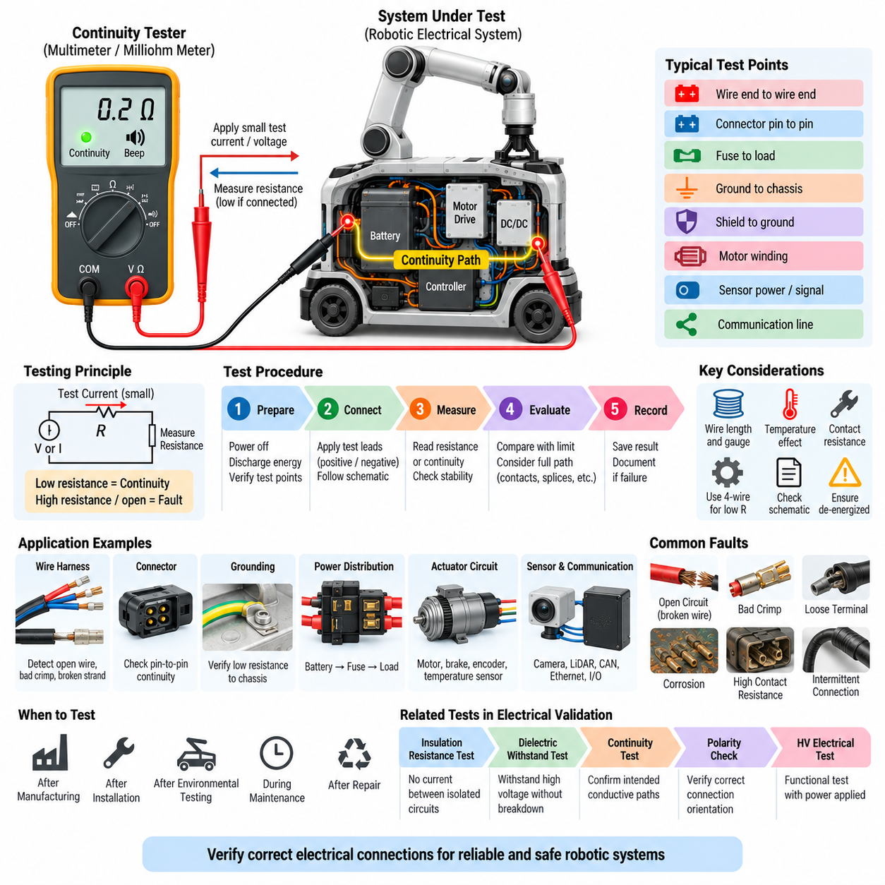
Continuity testing is a fundamental electrical verification method used to confirm that an intended conductive path exists between specified points in a circuit, harness, connector, grounding network, or electrical assembly. Within the electrical test sequence of Volume 19, it follows insulation resistance and dielectric withstand testing and precedes polarity checking and high-voltage electrical testing.
The basic principle is to apply a small test current or voltage across two points that should be electrically connected and measure the resulting resistance or voltage response. A correctly assembled conductive path normally exhibits very low resistance, whereas an open circuit, incomplete connection, damaged conductor, or improperly seated terminal produces a significantly higher resistance or no measurable conduction.
Continuity testing differs fundamentally from insulation resistance testing because the two methods examine opposite electrical conditions. Insulation testing verifies that current does not flow between circuits that should remain isolated, while continuity testing verifies that current can flow through paths that should be connected. Together, these tests establish both electrical separation and intentional electrical connectivity.
A digital multimeter, dedicated continuity tester, milliohm meter, or automated harness tester can be used depending on the required accuracy and complexity. Simple instruments may provide an audible indication when resistance falls below a threshold, while precision systems measure resistance directly. Low-resistance measurements may require four-wire Kelvin techniques to minimize errors caused by test leads and contact resistance.
Typical continuity test points include wire end to wire end, connector pin to connector pin, battery terminal to power distribution input, fuse output to downstream load, protective earth to chassis, shield termination to designated grounding point, and control output to actuator interface. Each measurement should correspond to a connection explicitly defined by the electrical schematic or harness documentation.
Before testing, the circuit should normally be de-energized and stored electrical energy safely discharged. Applying a continuity tester to an energized circuit can produce incorrect readings or damage the measuring instrument. Batteries, capacitors, DC/DC converters, motor drives, and other energy-storage or power-conversion devices should therefore be considered when establishing the safe electrical state of the system.
A continuity test procedure should define the source point, destination point, expected electrical path, maximum acceptable resistance, and test configuration. For complex robotic systems, identifying only connector numbers may be insufficient. Pin numbers, wire identifiers, circuit names, splice locations, grounding points, and intermediate components should be documented so that the measurement can be repeated consistently.
Measured resistance includes more than the resistance of the wire itself. Connector contacts, crimp joints, splices, terminals, switches, relays, fuses, and grounding interfaces can contribute to the total value. Engineers should therefore interpret the result according to the complete conductive path rather than assuming that every valid connection must produce an ideal resistance of zero ohms.
Wire length and conductor cross-sectional area also influence the expected resistance. A long, small-gauge wire naturally exhibits greater resistance than a short, large-gauge power conductor. Temperature further changes conductor resistance. Acceptance limits should consequently be based on the designed circuit characteristics, measurement accuracy, and intended function rather than on one universal continuity threshold.
For robotic wire harnesses, continuity testing is particularly effective for detecting open wires, incorrect crimps, partially inserted terminals, broken strands, defective splices, and connector assembly errors. Testing can be performed immediately after harness manufacturing and repeated after installation in the robot, because routing, bending, clamping, and mechanical integration can introduce defects that were absent during initial production.
Connector continuity requires attention to contact condition as well as simple electrical connection. A terminal may technically conduct while having excessive contact resistance caused by insufficient insertion, contamination, corrosion, weak contact force, or crimp degradation. Precision resistance measurements can therefore provide additional diagnostic information when a simple audible continuity indication is insufficient for power or safety-critical circuits.
Ground continuity is especially important because protective grounding, chassis bonding, shielding, and electrical reference networks depend on reliable low-resistance connections. Paint, anodized surfaces, loose fasteners, corrosion, contamination, or improper bonding hardware can increase resistance at mechanical interfaces. Testing should verify that intended grounding paths remain electrically effective after final mechanical assembly.
Continuity testing of power distribution circuits should include relevant fuses, contactors, relays, connectors, busbars, and harness sections according to the required test state. A circuit that appears open may simply contain a normally open switching device. The test procedure must therefore define contactor and relay states so that expected switching behavior is not incorrectly diagnosed as a wiring failure.
Robotic actuator circuits introduce additional considerations because motor windings, brakes, encoders, and temperature sensors may share the same connector while representing different electrical paths. Continuity measurements should distinguish motor phases from low-current signal circuits and verify each path independently. Unexpected cross-connections should be investigated through complementary insulation or short-circuit testing.
Sensor and communication circuits also require careful verification. Camera power, LiDAR interfaces, CAN networks, Ethernet connections, safety sensors, encoders, and discrete I/O may use multi-pin connectors containing power, ground, signal, and shield contacts. Pin-to-pin continuity testing helps confirm correct harness construction before electronic modules are energized and communication-level diagnostics are performed.
Intermittent continuity faults are more difficult to detect than permanent open circuits. A conductor with partially fractured strands or a poorly retained terminal may pass a stationary test but fail when the harness moves. Flexing, gently manipulating, or mechanically stressing selected harness regions while monitoring resistance can reveal unstable connections associated with vibration, articulation, steering, or repeated robot motion.
When a continuity failure is detected, fault isolation should divide the conductive path into smaller sections. Measurements can be repeated across individual connectors, splices, harness branches, protection devices, and terminal interfaces until the defective region is identified. This sectional approach is particularly useful in large robots where a single circuit may pass through several harness assemblies and distribution modules.
Automated harness testers significantly improve efficiency when hundreds of conductors must be verified. A test fixture can connect simultaneously to multiple harness connectors and automatically compare measured connectivity against a predefined netlist. The same equipment can often detect opens, shorts, miswires, and unexpected cross-connections, making continuity testing suitable for repeatable manufacturing quality control.
For safety-related circuits such as emergency-stop loops, safety relays, brake-control circuits, protective grounding, and power isolation paths, continuity verification should be traceable to the corresponding electrical requirement. A simple pass indication may not provide sufficient evidence. Measured values, test conditions, equipment identification, and acceptance limits should be retained when the connection contributes to a safety function.
Continuity testing should also be performed after environmental and durability exposure when mechanical degradation is possible. Vibration, shock, thermal cycling, moisture, corrosion, repeated connector mating, and cable flexing can gradually damage conductive interfaces. Comparing resistance before and after these tests helps identify degradation that may later develop into intermittent field failures.
A complete continuity test record should identify the system or harness, source and destination terminals, circuit identifier, test equipment, calibration status, measured resistance, acceptance limit, test condition, and final result. Failures should be linked to the physical defect, repair action, and subsequent retest so that manufacturing and engineering teams can identify recurring connection-quality problems.
When continuity testing is combined with insulation resistance, dielectric withstand, polarity, and high-voltage electrical testing, the electrical assembly can be evaluated from complementary perspectives. Continuity confirms intended conductive paths, insulation tests confirm separation between unintended paths, and subsequent polarity and energized tests verify that the completed electrical architecture behaves correctly when power is applied.
Applied systematically from individual wires and harnesses through power distribution, grounding, sensors, actuators, and complete robot integration, continuity testing provides a simple but powerful foundation for electrical validation. It prevents basic connection defects from propagating into communication failures, unstable control, power loss, safety faults, or difficult field problems in autonomous mobile robots and Physical AI systems.

01.04. Polarity Check
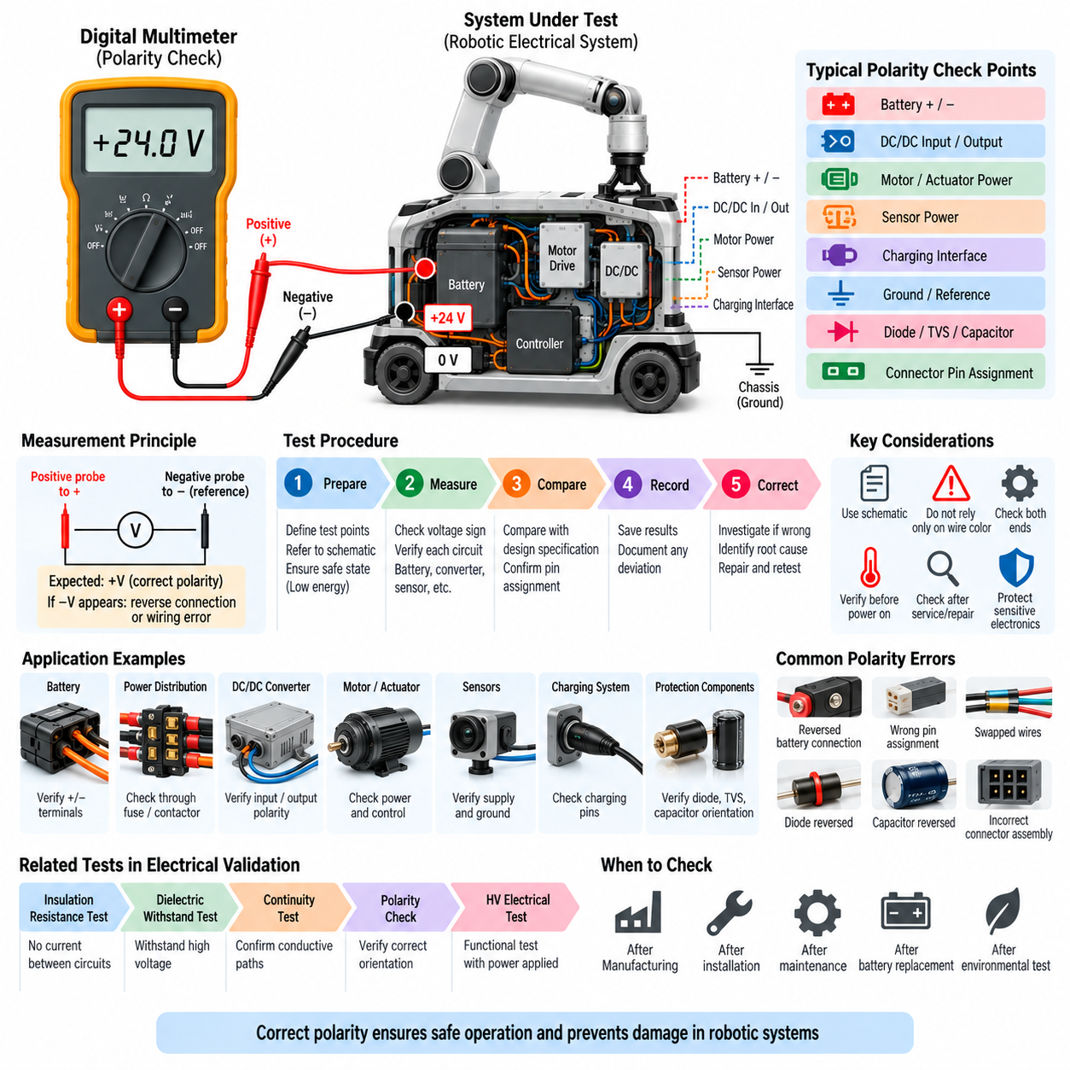
Polarity checking is a fundamental electrical verification method used to confirm that positive, negative, supply, return, signal, and reference connections are oriented according to the intended electrical design. Within the electrical test sequence of Volume 19, it follows insulation resistance, dielectric withstand, and continuity testing and precedes high-voltage electrical testing.
The primary objective of a polarity check is to prevent electrical components from being energized with reversed or incorrectly assigned connections. A circuit may pass continuity testing because conductive paths exist, yet still be wired with opposite polarity. Polarity verification therefore confirms not only that connections are present, but also that each connection reaches the correct electrical terminal.
In a simple DC circuit, polarity identifies the relationship between positive and negative conductors. In complex robotic systems, however, the concept extends to battery terminals, DC power rails, converter inputs and outputs, actuator supplies, sensor power, grounding references, charging interfaces, and polarized protection devices. Each interface must preserve the orientation defined by the electrical architecture.
A digital multimeter is commonly used for polarity verification because it can directly indicate voltage magnitude and sign between two test points. When the positive probe is connected to the intended positive node and the reference probe to the intended return, the displayed voltage should have the expected sign. A negative indication can reveal reversed leads, incorrect wiring, or an unexpected reference relationship.
Polarity can also be verified before power is applied by tracing conductors through continuity measurements, connector pin assignments, harness drawings, and electrical schematics. This approach is particularly valuable during manufacturing because incorrect wiring can be detected before sensitive electronics are connected. Automated harness testers can perform polarity-related pin mapping across large multi-connector assemblies.
The test procedure should begin by defining the expected source, return, reference, connector pin, and voltage relationship for every circuit being examined. Wire colors alone should never be treated as sufficient evidence because manufacturing errors, repairs, substitutions, or documentation inconsistencies can occur. Connector identifiers, pin numbers, circuit names, and schematic references provide more reliable verification.
Battery connections are among the most critical polarity-check locations in mobile robotic systems. Reversing battery positive and negative terminals can damage power distribution units, DC/DC converters, motor drives, chargers, and electronic controllers. Before connecting or energizing a battery, the actual terminal polarity should therefore be confirmed against the intended system connection and connector assignment.
Power distribution circuits require polarity verification at multiple stages rather than only at the battery interface. The orientation should remain correct through disconnect devices, fuses, contactors, busbars, distribution modules, converters, and downstream loads. Testing at intermediate points can identify a reversed harness branch or incorrectly assembled connector before the fault propagates across the complete electrical system.
DC/DC converters deserve particular attention because their input and output sides may operate at different voltage levels while maintaining specific polarity requirements. Reversed input polarity can damage the converter, while incorrect output polarity can expose downstream controllers and sensors to destructive voltage orientation. Input and output terminals should therefore be verified independently before load connection.
Motor and actuator systems may contain power polarity as well as direction-related phase or control assignments. For brushed DC motors, reversing supply polarity can reverse rotation direction. In electronically controlled motors, incorrect phase, encoder, brake, or control connections can produce abnormal behavior even when basic continuity is correct. Polarity checking should therefore be coordinated with later functional direction verification.
Sensors and low-voltage electronics are particularly vulnerable to polarity errors because their internal circuits may tolerate only limited reverse voltage. Cameras, LiDAR units, encoders, IMUs, proximity sensors, communication modules, and embedded controllers often share connectors containing supply, ground, and signal contacts. Pin-level verification before energization reduces the risk of damaging expensive perception hardware.
Ground and reference connections also require careful interpretation. A conductor labeled ground does not always represent protective earth or chassis ground; it may be a signal return, isolated reference, power return, or shield connection. Polarity verification must therefore use the actual circuit architecture rather than assuming that all conductors identified as ground are electrically interchangeable.
Charging systems introduce additional polarity-sensitive interfaces between the robot, battery, charger, and charging station. Positive and negative charging conductors, protective earth, communication contacts, and detection signals must be correctly assigned. Incorrect polarity at a charging interface can create severe current faults, damage charging electronics, or prevent contactors and battery-management systems from operating safely.
Protection components may also depend on correct polarity. Diodes, transient-voltage suppressors, electrolytic capacitors, reverse-polarity protection circuits, and some semiconductor switching devices have defined electrical orientation. Incorrect assembly can cause immediate failure or latent reliability problems. Polarity checking should therefore include component orientation where manufacturing or service processes can affect installation.
For high-current circuits, polarity should preferably be verified before the main power path is closed. Pre-power checks can use low-energy measurement methods to establish correct orientation without exposing the system to full battery current. This is particularly important in robotic platforms where large batteries and low-resistance conductors can produce extremely high fault currents if positive and negative paths are accidentally reversed.
High-voltage robotic systems require additional controls because a polarity mistake can affect not only equipment functionality but also electrical safety. High-voltage positive and negative buses, contactors, pre-charge circuits, insulation monitoring devices, inverters, and charging connections must correspond exactly to the approved schematic. Verification should be completed before high-voltage activation and documented as part of the test record.
A polarity failure should trigger systematic fault isolation rather than immediate rewiring without diagnosis. Engineers should compare measured terminal relationships with schematics and trace the circuit through connectors, splices, harness branches, distribution devices, and intermediate modules. This approach identifies whether the root cause is a manufacturing error, incorrect pin assignment, documentation problem, or service modification.
Automated production testing can combine continuity and polarity verification using predefined connector maps or netlists. Test fixtures identify whether each source pin reaches the intended destination pin and whether power and return circuits occupy the correct positions. This approach reduces human error and is particularly effective for complex robotic harnesses containing hundreds of conductors and multiple connector families.
Polarity verification should be repeated after harness repair, connector replacement, power-system modification, battery replacement, or major service activity. A system that was correctly assembled during production can acquire reversed connections during maintenance. Rechecking critical interfaces before power restoration provides a low-cost safeguard against damage introduced during field servicing.
Test acceptance criteria should define the expected terminal relationship rather than merely stating that polarity must be correct. Documentation should specify expected positive and negative nodes, reference point, nominal voltage range, connector configuration, measurement method, and allowable deviations. Clear criteria make the test repeatable across prototypes, production units, and maintenance operations.
A complete polarity-check record should identify the system or harness, test points, expected polarity, measured voltage or connection relationship, test equipment, electrical state, acceptance criterion, result, and any corrective action. For safety-critical power circuits, traceable records demonstrate that polarity was independently verified before energized testing or final system commissioning.
Polarity checking complements the preceding electrical validation activities. Insulation resistance testing confirms separation between circuits, dielectric withstand testing confirms insulation strength, and continuity testing confirms that intended conductive paths exist. Polarity checking then verifies that those conductive paths are connected in the correct orientation before the system proceeds to energized high-voltage and functional testing.
Applied systematically across batteries, power distribution, converters, charging systems, actuators, sensors, grounding references, and communication interfaces, polarity checking prevents simple wiring errors from becoming destructive system failures. In autonomous mobile robots and Physical AI systems, this verification provides an essential transition from passive electrical inspection to safe power application and integrated system validation.

01.05. HV Electrical Test
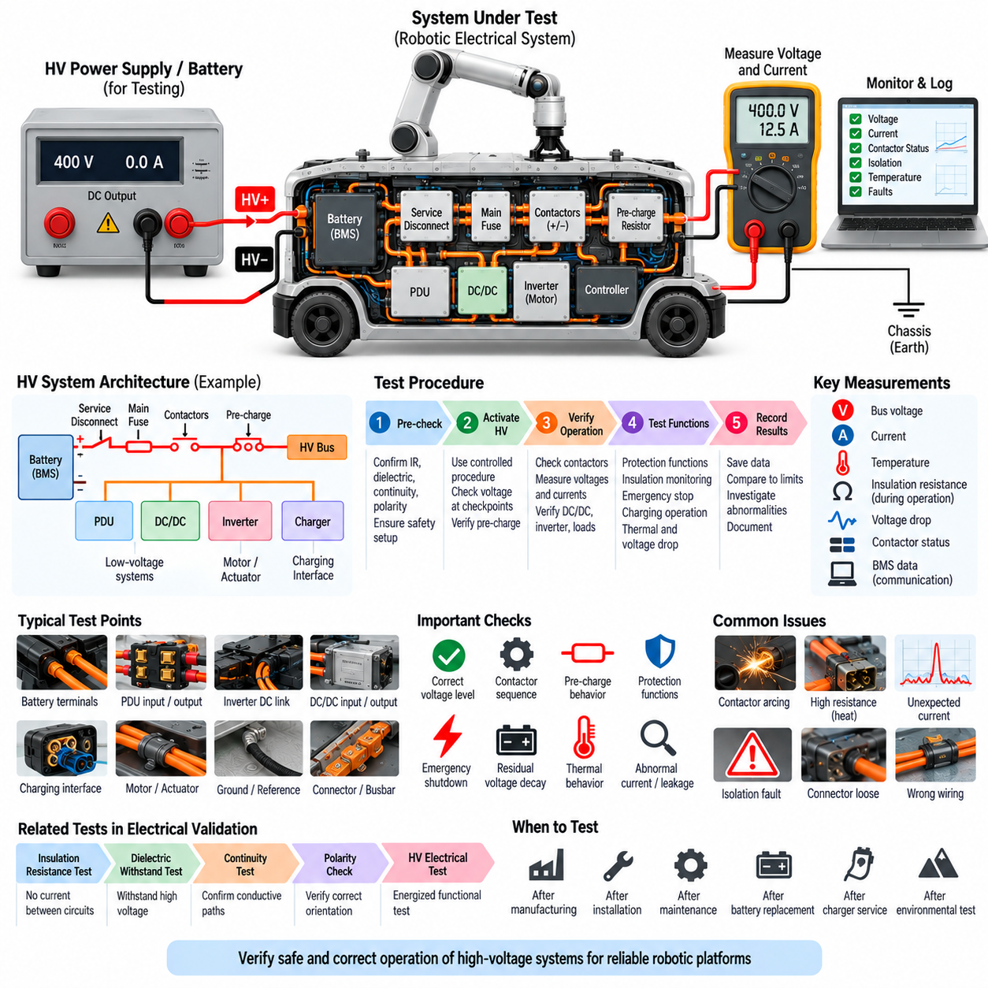
High-voltage electrical testing is the energized verification stage used to confirm that a high-voltage power system operates correctly, safely, and predictably under controlled electrical conditions. Within the Volume 19 electrical test sequence, it follows insulation resistance, dielectric withstand, continuity, and polarity verification, completing Chapter 01 before the validation process advances to harness testing.
Unlike dielectric withstand testing, which intentionally applies elevated voltage to challenge insulation strength, HV electrical testing evaluates the actual high-voltage architecture under conditions representative of normal system operation. The objective is to verify voltage distribution, current flow, switching behavior, protection functions, isolation status, and interactions among high-voltage components after passive electrical checks have been completed.
A typical robotic HV architecture may include a traction or main battery, battery management system, service disconnect, main fuse, positive and negative contactors, pre-charge circuit, power distribution unit, DC/DC converters, motor inverters, actuator drives, charging interface, and insulation monitoring functions. Testing should examine these components as an integrated energy system rather than as unrelated individual devices.
Before energization, the preceding electrical verification results should be reviewed to confirm that the system is ready for HV activation. Insulation resistance should be acceptable, dielectric withstand testing should show no breakdown, required conductive paths should pass continuity checks, and polarity should be correct. Energizing a system before these conditions are established can convert a simple assembly defect into severe equipment damage.
The initial HV activation should normally be performed using a controlled procedure that limits available energy wherever practical. Current-limited supplies, staged battery connection, service disconnects, protected test fixtures, or other engineering controls can reduce risk during first power-up. Voltage should be measured at defined checkpoints before progressively enabling additional branches and high-power loads.
Pre-charge operation is a critical part of many HV systems containing large DC-link capacitors. Connecting the battery directly to an uncharged inverter or converter can produce excessive inrush current, contactor arcing, fuse stress, and component damage. The pre-charge circuit should raise the downstream bus voltage in a controlled manner before the main contactor closes and establishes the low-resistance power path.
During pre-charge testing, engineers should observe battery voltage, DC-link voltage, voltage rise time, pre-charge current, and contactor state. The downstream voltage should approach the expected fraction of battery voltage within the specified time window. Failure to reach the target may indicate excessive load, leakage, an open resistor path, incorrect contactor sequencing, or a fault within a connected power-electronic module.
Main contactor operation should be verified as both an electrical and control function. The positive and negative contactors must close and open according to the intended sequence, and auxiliary feedback signals should agree with the commanded state. Welded contacts, delayed operation, incorrect feedback, excessive contact resistance, or unintended closure can compromise both power control and system safety.
Once the HV bus is established, voltage should be measured at important distribution points such as battery output, PDU input and output, inverter DC links, DC/DC converter inputs, charging interfaces, and other high-voltage loads. Measurements should be compared with expected values while considering cable voltage drop, contact resistance, switching states, and the operating condition of connected equipment.
Current measurement provides another essential view of HV system behavior. Unexpected current during an idle state can indicate leakage, an incorrectly enabled load, converter malfunction, or wiring error. Under commanded operation, measured current should remain consistent with the expected load and operating mode. Excessive or unstable current should trigger investigation before higher-power testing continues.
DC/DC converters should be evaluated for correct HV input behavior and regulated low-voltage output. Engineers should confirm input voltage, output voltage, startup sequence, enable control, current demand, and shutdown response. Because these converters often supply controllers, sensors, communication equipment, and safety electronics, unstable conversion can propagate disturbances throughout the complete robotic electrical architecture.
Motor inverters and actuator drives should initially be evaluated without immediately demanding maximum mechanical output. The test can confirm DC-link voltage, inverter readiness, enable logic, fault status, low-power switching, and controlled actuator response. Gradually increasing operating demand helps identify abnormal current, overheating, incorrect control states, or power-distribution limitations before full-load validation.
The battery management system plays a central role in HV electrical testing because it supervises cell voltage, pack current, temperature, contactor control, state estimation, and fault conditions. Communication between the BMS and supervisory controller should be verified together with electrical behavior. A valid HV system requires agreement between physical measurements and the status information reported through the control network.
Insulation monitoring should remain active during energized operation where the architecture provides an insulation monitoring device. Isolation can change after contactors close and additional converters, inverters, chargers, or loads become connected to the HV bus. Monitoring insulation status during different switching configurations helps identify faults that may not be visible when the system is completely de-energized.
Protection functions should be verified using controlled and non-destructive methods appropriate to the system design. Engineers should confirm that overvoltage, undervoltage, overcurrent, abnormal isolation, overtemperature, communication faults, or other defined conditions lead to the expected protective response. Testing should focus on verifying detection and safe reaction without unnecessarily damaging components.
The emergency shutdown path is particularly important in mobile robots because HV energy must be removed when a safety-critical condition occurs. Activation of an emergency stop or equivalent safety command should produce the specified torque response, disable relevant power stages, open required contactors, and transition the system toward a safe electrical state according to the designed safety architecture.
Residual voltage after HV shutdown must be measured because DC-link capacitors and other energy-storage components can remain charged after contactors open. The voltage should decay through the designed discharge path to the required safe level within the specified time. A failed discharge resistor, disconnected circuit, or abnormal power-electronic condition can leave hazardous voltage present even when the battery is isolated.
Charging operation should be included when the robot contains an onboard or external HV charging interface. Verification should cover connector state, polarity, contactor sequencing, charger communication, voltage and current limits, BMS authorization, and termination behavior. Charging tests should also confirm that abnormal connection or system conditions prevent uncontrolled energy transfer.
Thermal behavior becomes increasingly important as electrical load rises. Battery terminals, contactors, busbars, fuses, connectors, cables, inverters, and converters can develop localized heating from excessive resistance or insufficient current capacity. Temperature measurements during controlled load testing can reveal connections that pass continuity testing but become problematic when significant operating current flows.
Voltage-drop measurements can similarly expose high-resistance interfaces that are difficult to identify during low-current checks. Measuring the voltage across contactors, connectors, fuses, busbars, and harness sections while current flows provides direct evidence of power-path quality. Unexpected voltage drop can indicate loose terminals, degraded contacts, inadequate conductor sizing, or defective assemblies.
HV electrical testing should progress from low-energy activation toward increasingly representative operating conditions. Functional loads can be introduced sequentially so that abnormal behavior remains easy to localize. Battery supply, control electronics, converters, individual actuators, charging functions, and complete motion operation can be validated progressively rather than applying maximum system demand during the first energized test.
All high-voltage measurements require appropriately rated instruments, probes, connectors, personal protective measures, and test procedures. Measurement equipment must be suitable for the maximum expected voltage and transient environment. Test points should be designed to minimize accidental contact, and personnel should avoid creating uncontrolled conductive paths while working around an energized robotic platform.
A complete HV electrical test record should capture system configuration, battery state, HV bus voltage, relevant currents, pre-charge behavior, contactor states, converter outputs, insulation status, protection responses, residual-voltage decay, environmental conditions, test equipment, acceptance criteria, observed anomalies, corrective actions, and final disposition. Traceable records are essential when HV functions contribute to safety.
HV electrical testing also provides an important transition from component-level electrical verification to functional system validation. Once power distribution, switching, protection, conversion, monitoring, and shutdown behavior have been demonstrated, later tests can evaluate the robot under increasingly realistic functional, environmental, reliability, and field conditions while relying on a verified electrical foundation.
Applied systematically, HV electrical testing demonstrates that the high-voltage architecture behaves as an integrated and controllable energy system rather than merely a collection of correctly wired components. For autonomous mobile robots and Physical AI platforms, this verification is essential for delivering power safely to computation, sensing, actuation, mobility, and charging functions while maintaining controlled fault response and electrical protection.

