Volume 19. Testing and Validation

Chapter 10. UAV Certification Test

10.01. DO-160G Environmental Test
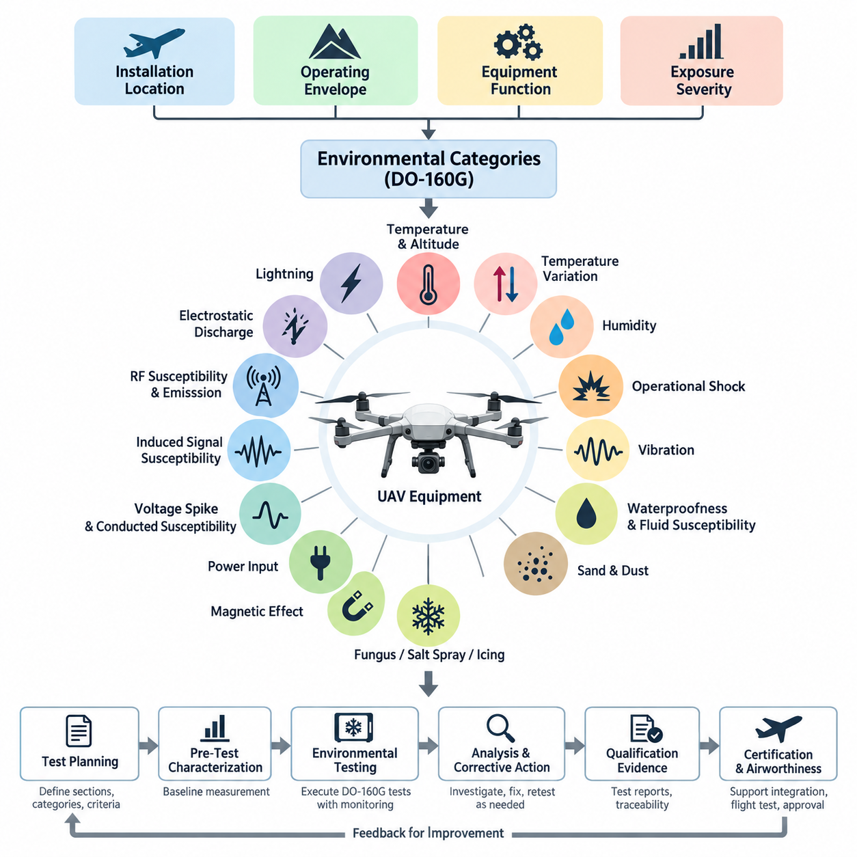
DO-160G environmental testing provides a structured method for demonstrating that airborne electronic and electrical equipment can operate safely and reliably under the environmental conditions expected during aircraft and UAV service. The test program translates installation location, aircraft operating envelope, equipment function, and exposure severity into defined environmental categories and qualification evidence.
For UAV certification, DO-160G should not be treated as a single fixed test sequence applied identically to every component. The applicable sections and categories are selected according to the equipment installation environment and intended operation. Avionics installed inside a protected fuselage, external sensors, propulsion electronics, batteries, antennas, and flight-control equipment may therefore require different qualification profiles.
Temperature and altitude testing evaluates equipment behavior across the thermal and pressure conditions associated with storage, ground operation, climb, cruise, descent, and high-altitude exposure. Testing should verify normal operation at specified temperature limits, survival under extreme storage conditions, and performance during temperature transitions while monitoring electrical parameters, communication integrity, sensor outputs, processor status, and fault responses.
Temperature variation testing addresses rapid thermal transitions that can create mechanical stress, condensation-related effects, dimensional changes, and electrical instability. Repeated transitions between low and high temperatures can expose weaknesses in solder joints, connectors, printed circuit boards, seals, optical assemblies, and sensor interfaces. Functional monitoring during and after exposure helps distinguish temporary drift from permanent degradation.
Humidity testing determines whether prolonged exposure to moisture can degrade insulation, connectors, circuit boards, coatings, sensors, or mechanical interfaces. UAV equipment may experience significant humidity changes during outdoor storage and repeated transitions between conditioned facilities and the external environment. Post-exposure inspection should therefore include corrosion, leakage current, insulation degradation, communication faults, and abnormal sensor behavior.
Operational shock and crash-safety-related evaluations address mechanical loads that can occur during handling, landing, turbulence, emergency events, or abrupt vehicle motion. Test severity should be derived from the equipment category and installation characteristics. Mechanical integrity alone is insufficient; critical avionics should also be evaluated for intermittent power loss, connector disturbance, memory corruption, sensor discontinuity, and unintended reset behavior.
Vibration testing is particularly important for UAV systems because propulsion units, rotors, motors, gear mechanisms, aerodynamic excitation, and structural modes can generate continuous broadband and discrete-frequency vibration. The qualification profile should represent the installation location as closely as practical. Functional monitoring can reveal intermittent contacts, resonance-sensitive failures, optical misalignment, IMU disturbances, and fatigue-related degradation.
Waterproofness and fluid susceptibility become important when equipment is installed where rain, condensation, cleaning fluids, hydraulic substances, fuel-related fluids, lubricants, or other operational chemicals may be encountered. Qualification should consider not only immediate functional failure but also delayed deterioration of seals, housings, cable jackets, labels, adhesives, coatings, connector interfaces, and exposed sensing surfaces after environmental exposure.
Sand and dust testing may be required for UAVs operating from unprepared fields, construction areas, deserts, ports, industrial facilities, or military environments. Fine particles can enter enclosures, obstruct cooling paths, contaminate optical surfaces, increase connector wear, and interfere with mechanical mechanisms. Test planning should connect the selected exposure category with realistic deployment scenarios rather than applying maximum severity without justification.
Fungus, salt spray, and icing-related considerations depend strongly on the UAV mission and installation environment. Maritime operations can expose equipment to corrosive salt atmospheres, while long-term operation in warm and humid regions can increase biological contamination risks. Equipment exposed to cold clouds, precipitation, or freezing conditions may require additional assessment of ice formation and its effects on sensors, antennas, ventilation, and moving components.
Magnetic effect testing evaluates whether equipment generates magnetic fields capable of disturbing nearby magnetic compasses or other magnetically sensitive devices. This consideration remains relevant when UAV navigation architectures include magnetometers as part of an integrated GNSS, IMU, and heading solution. High-current power distribution, motors, converters, contactors, and magnetic components should therefore be considered when defining installation separation and qualification conditions.
Power input testing verifies equipment behavior under voltage and frequency conditions representative of the aircraft electrical supply. UAV power networks may experience startup transients, battery voltage variation, converter switching, regenerative effects, propulsion load changes, and source transitions. Qualification should confirm that avionics remain within defined operational states or transition predictably to safe states without corrupted data or uncontrolled outputs.
Voltage spike and audio-frequency conducted susceptibility testing examines disturbances coupled through electrical power interfaces. Switching converters, motor drives, actuators, pumps, relays, and high-current propulsion systems can create challenging electrical environments in compact UAV platforms. Testing should verify that disturbances do not cause processor resets, false sensor information, communication errors, actuator commands, or degradation of safety-critical functions.
Induced signal susceptibility evaluates the ability of equipment and interconnected wiring to tolerate electromagnetic signals coupled from neighboring circuits. Harness routing, shielding, grounding, cable separation, and interface design directly influence susceptibility. UAV qualification should therefore test representative cable assemblies and grounding configurations whenever possible, because laboratory results obtained with unrealistic harness arrangements may not represent aircraft-level behavior.
Radio-frequency susceptibility and emission testing addresses interactions between avionics and the dense electromagnetic environment created by radios, telemetry links, GNSS receivers, payload transmitters, processors, high-speed networks, and power electronics. Qualification must demonstrate both immunity to expected RF fields and control of emissions that could interfere with navigation, communication, command-and-control, or other aircraft systems.
Electrostatic discharge testing evaluates equipment response to charge accumulation and discharge events associated with personnel handling, maintenance, airflow, materials, and exposed interfaces. Testing should identify temporary disturbances as well as permanent damage. For flight-critical electronics, acceptance criteria should explicitly address unintended reboot, corrupted configuration, lost communication, false command generation, and recovery behavior following the discharge event.
Lightning-related tests require careful applicability analysis for UAV platforms because exposure depends on aircraft size, materials, operating altitude, mission profile, installation location, and certification basis. Where applicable, indirect lightning effects testing evaluates transient voltages and currents induced into equipment wiring. Protection architecture may combine shielding, bonding, transient suppression, grounding, isolation, and controlled cable routing.
Icing and other specialized DO-160G sections should be selected through a documented environmental qualification analysis rather than assumed to apply universally. The analysis should map each equipment item to its installation zone, environmental exposure, safety significance, and required category. This creates a traceable relationship between UAV operational requirements, aircraft architecture, equipment qualification levels, and the final certification evidence.
A practical qualification program begins with an Environmental Qualification Form or equivalent compliance matrix defining the applicable DO-160G sections, categories, equipment configuration, test sequence, acceptance criteria, and required records. The tested hardware and software configuration should be controlled because changes to enclosure design, PCB layout, connectors, power architecture, firmware, cooling, or harness interfaces can affect previously demonstrated compliance.
Pre-test characterization establishes a reference baseline for subsequent comparison. Electrical consumption, communication performance, sensor accuracy, processing status, thermal behavior, insulation characteristics, diagnostic information, and safety-related functions should be recorded before environmental exposure. During testing, synchronized acquisition of environmental conditions and equipment telemetry makes it possible to correlate anomalies with specific stress levels and transitions.
Failures discovered during qualification should be investigated through structured root-cause analysis rather than simply repeating the failed test. Corrective actions may involve mechanical reinforcement, sealing improvement, component substitution, PCB modification, filtering, shielding, grounding, software recovery logic, thermal management, or harness redesign. The impact of each modification determines whether focused regression testing or broader requalification is necessary.
For autonomous UAVs, environmental qualification should also consider interactions between conventional avionics and Physical AI functions. Environmental stress can alter camera images, LiDAR measurements, IMU bias, GNSS reception, compute performance, network timing, and AI accelerator temperature. A component may remain electrically operational while degraded perception or timing produces unacceptable system-level behavior, making functional monitoring essential.
The final qualification evidence should combine approved procedures, calibrated instrumentation records, configuration identification, environmental profiles, measured responses, anomaly reports, corrective actions, photographs where required, and formal test results. Traceability should connect each qualification result to the applicable equipment requirement and certification objective so that reviewers can determine exactly what configuration was tested and under which conditions.
DO-160G qualification ultimately provides environmental evidence within a broader UAV verification and certification framework rather than proving complete aircraft airworthiness by itself. Its strongest value comes from disciplined category selection, representative installation conditions, controlled configurations, measurable acceptance criteria, and traceable evidence. These principles allow environmental testing to support subsequent aircraft integration, flight testing, certification, and continued airworthiness activities.

10.02. Type Certificate Process
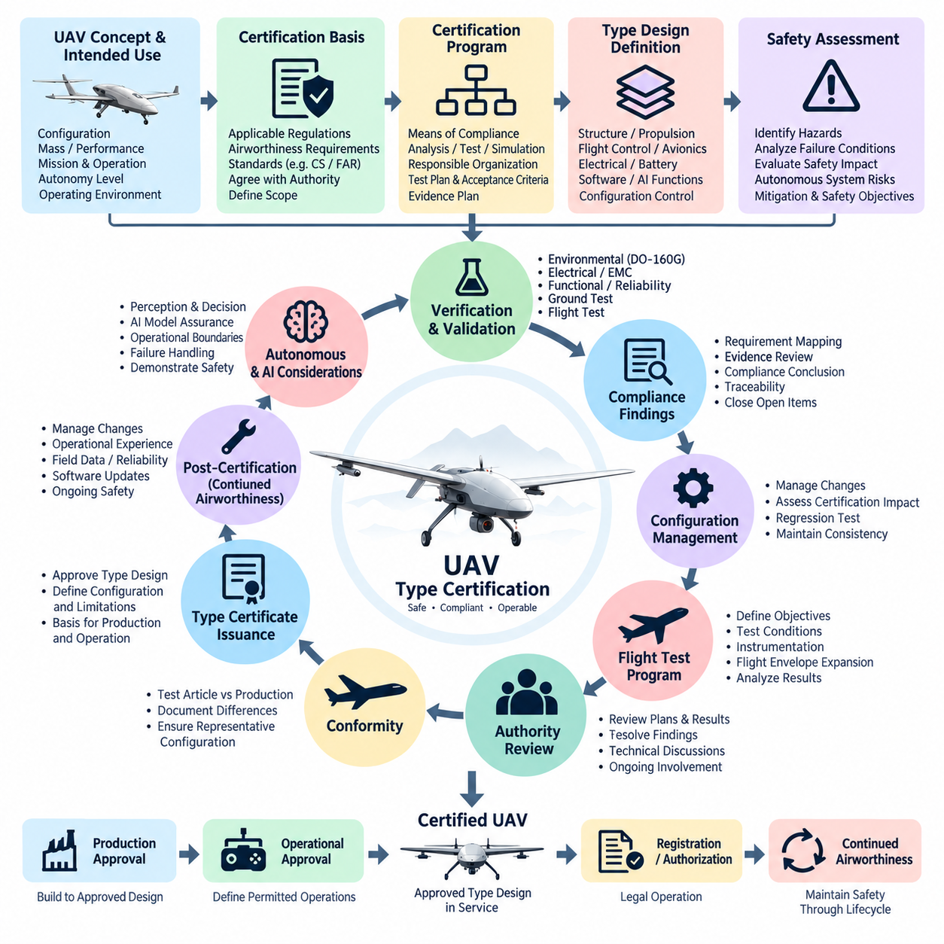
A Type Certificate (TC) process establishes that a complete aircraft design complies with the applicable airworthiness requirements and can be produced and operated within an approved design definition. For a UAV, the process connects the aircraft concept, intended mission, operational envelope, system architecture, safety objectives, verification activities, and certification evidence into one controlled framework. The objective is not simply to pass individual tests, but to demonstrate that the overall type design consistently satisfies the applicable certification basis.
The process begins by defining the aircraft and its intended use. The applicant establishes the UAV configuration, maximum mass, propulsion system, flight envelope, operating altitude, speed, environmental conditions, mission functions, autonomy level, control architecture, and intended operating limitations. These characteristics determine which regulatory requirements and certification standards are applicable. The certification scope should be established early because late changes to the aircraft concept can significantly affect the required analysis, testing, documentation, and certification schedule.
A certification basis defines the technical requirements against which the aircraft will be evaluated. It provides the reference framework for demonstrating compliance and should be agreed with the applicable certification authority or responsible regulatory organization. The basis may include structural requirements, flight characteristics, propulsion, electrical systems, avionics, software, environmental qualification, electromagnetic compatibility, equipment safety, communication, navigation, and operational considerations. The final certification basis should remain traceable to the aircraft configuration and intended operating conditions.
The applicant then develops a certification program that maps each requirement to an appropriate means of compliance. Depending on the requirement, compliance may be demonstrated through analysis, inspection, laboratory testing, ground testing, simulation, flight testing, similarity, or a combination of these methods. The certification program should identify the responsible organization, test configuration, required instrumentation, acceptance criteria, evidence format, and approval status. This creates a controlled path from each regulatory requirement to objective certification evidence.
The type design must be sufficiently defined before final compliance demonstration. Major structural elements, propulsion systems, flight-control systems, electrical power distribution, batteries, avionics, communication systems, navigation equipment, sensors, computing platforms, software, and safety-related functions should have controlled specifications and configuration identification. For autonomous UAVs, this configuration control must also include relevant software, AI models, parameters, firmware, datasets where applicable, and operational logic when these elements influence certified aircraft behavior.
Safety assessment provides an important foundation for the certification process. Aircraft-level hazards are identified and evaluated according to their potential effects on flight and operational safety. Failure conditions are analyzed across propulsion, flight control, power, communication, navigation, sensing, computing, and human interaction functions. Particular attention is required for autonomous systems because failures may result not only from hardware faults but also from degraded perception, incorrect decision logic, communication loss, timing errors, sensor disagreement, or unexpected interactions between software functions.
Verification and validation activities then provide objective evidence that the type design satisfies its requirements. Environmental qualification may include DO-160G testing, while electrical, communication, functional, reliability, and safety tests provide additional evidence. Ground tests verify system behavior before flight, and flight testing evaluates the integrated aircraft under representative operational conditions. Test articles, instrumentation, software versions, procedures, results, anomalies, and corrective actions must remain configuration-controlled throughout the certification program.
Compliance findings are developed from the collected evidence. Each finding should identify the requirement being addressed, the selected means of compliance, the tested or analyzed configuration, the resulting evidence, and the conclusion regarding compliance. Traceability is essential because certification authorities must be able to determine how each applicable requirement has been addressed. A requirement without adequate evidence remains an open certification item even when the aircraft appears to operate successfully.
Configuration management becomes increasingly important as certification progresses. Hardware, software, firmware, wiring, sensors, propulsion components, structural parts, and AI-related functions may change during development. Each change should be evaluated for its potential certification impact. Minor engineering changes may require limited regression testing, while changes affecting safety, performance, structural integrity, flight controls, or certified software may require additional analysis or formal requalification. The objective is to ensure that the certified configuration remains consistent with the configuration actually produced and operated.
Flight-test preparation follows successful completion of the required ground verification and safety activities. The flight-test program defines objectives, aircraft configuration, instrumentation, test conditions, test cards, operational restrictions, emergency procedures, and data collection requirements. Initial flights should normally be conducted within controlled and conservative conditions before progressively expanding the operational envelope. Flight-test results provide evidence for characteristics and functions that cannot be fully demonstrated through laboratory or ground testing.
Certification authority involvement is maintained throughout the process rather than being limited to the final submission. Reviews may address the certification basis, certification program, test plans, safety assessments, engineering analyses, conformity, test results, and unresolved findings. The applicant must therefore maintain a clear evidence structure that allows the authority to review the status of each requirement and understand the technical justification supporting each compliance conclusion.
Conformity is another critical element of the Type Certificate process. The hardware used for certification testing must represent the approved type design, and the relationship between the test article and the production configuration must be controlled. Differences between prototype, engineering test article, certification article, and production aircraft should be documented and evaluated. Without adequate conformity, otherwise successful test results may not provide sufficient evidence for the final certified configuration.
When all applicable compliance activities have been completed, open findings are resolved and the certification authority accepts the submitted evidence, the applicant can proceed toward Type Certificate issuance. The resulting approval establishes the approved type design and defines the configuration and limitations under which the aircraft is considered compliant. For a UAV, this provides the technical foundation for subsequent production approval, operational approval, aircraft registration or authorization processes, and continued airworthiness activities as applicable.
Type certification does not end when the certificate is issued. Changes to the aircraft type design may require approved design changes, supplemental approvals, amended certification evidence, or additional testing depending on their significance. Operational experience, field failures, reliability data, software updates, cybersecurity considerations, and safety events can also generate new requirements for investigation or corrective action. Continued configuration control therefore remains an essential part of the certified product lifecycle.
For autonomous and Physical AI UAVs, the Type Certificate process must increasingly connect conventional aerospace certification with software-intensive system assurance. Perception models, AI-assisted decision functions, adaptive algorithms, high-performance computing platforms, sensor fusion, and autonomous mission management can influence aircraft behavior without fitting neatly into traditional hardware-only verification methods. These functions therefore require clearly defined operational boundaries, controlled configurations, measurable performance criteria, robust failure handling, and evidence that supports the safety claims made for the integrated aircraft.
The overall Type Certificate process can therefore be viewed as a continuous chain from aircraft definition to certification basis, compliance planning, controlled type design, safety assessment, verification, conformity, ground testing, flight testing, compliance findings, authority review, and final approval. The strength of the certification case depends on the consistency of this chain. A successful UAV certification program is consequently not simply a collection of passed tests, but a traceable engineering argument demonstrating that the defined aircraft type satisfies its applicable requirements throughout its intended operational envelope.

10.03. Airworthiness Certification
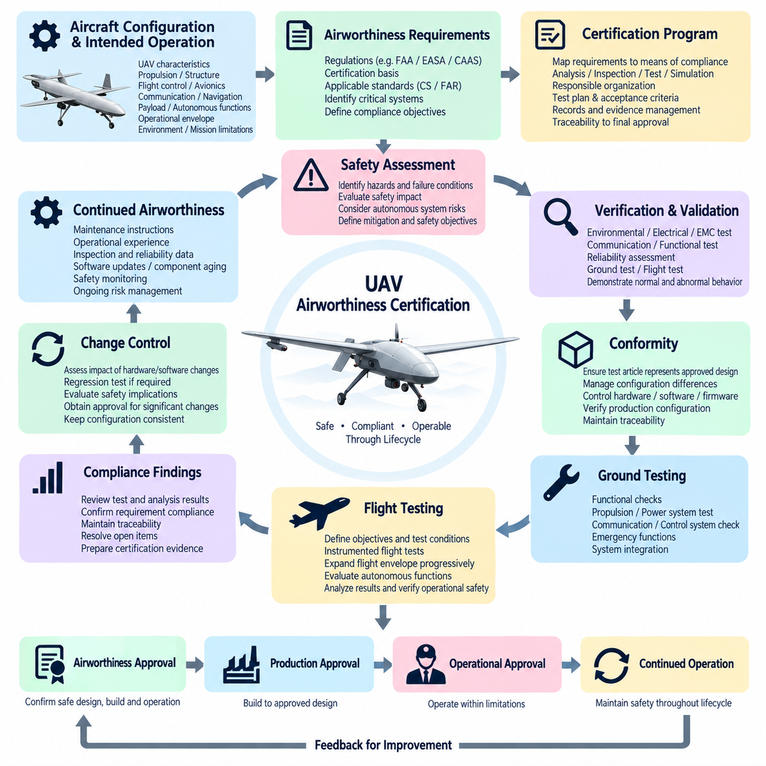
Airworthiness certification establishes that an aircraft is designed, built, tested, and maintained so that it can be operated safely within its approved limitations. For a UAV, this process connects the approved type design with actual aircraft configuration, operational conditions, safety requirements, verification evidence, and regulatory oversight. Airworthiness is therefore broader than passing individual tests; it requires consistent evidence that the complete aircraft remains capable of performing its intended functions without creating unacceptable safety risks.
The process begins with defining the aircraft configuration and intended operational envelope. The UAV characteristics, propulsion system, structure, flight-control architecture, electrical power system, avionics, communication and navigation functions, payloads, autonomous functions, operating altitude, speed, environmental conditions, and mission limitations must be clearly established. These definitions provide the basis for determining applicable airworthiness requirements and identifying which systems and functions are critical to safe flight.
An airworthiness certification program then establishes how compliance will be demonstrated and maintained. Requirements are mapped to appropriate methods such as analysis, inspection, laboratory testing, ground testing, simulation, and flight testing. The program should identify responsible organizations, test configurations, acceptance criteria, required records, and evidence status. This structure provides traceability from regulatory requirements through engineering activities to objective evidence supporting the final airworthiness determination.
Aircraft safety assessment is a central part of airworthiness certification. Potential hazards and failure conditions are identified across propulsion, flight control, power distribution, batteries, communication, navigation, sensors, computing, and operational interfaces. The consequences of individual and combined failures are evaluated according to their potential effect on safe flight. For autonomous UAVs, the assessment should also consider degraded perception, sensor disagreement, navigation loss, software faults, timing errors, communication interruption, and unexpected autonomous behavior.
Verification and validation demonstrate that the aircraft satisfies its defined requirements under representative conditions. Environmental testing, electrical testing, EMC evaluation, communication testing, functional testing, reliability assessment, ground testing, and flight testing provide complementary evidence. Test procedures and configurations must be controlled, while measured results, anomalies, corrective actions, and final conclusions should remain traceable to the corresponding requirements. Testing should demonstrate both normal operation and appropriate behavior under defined abnormal conditions.
Conformity ensures that the aircraft or equipment used to generate certification evidence represents the configuration being approved for operation. Differences between development hardware, test articles, certification articles, and production aircraft must be identified and evaluated. Configuration control should cover mechanical components, electrical systems, wiring, sensors, avionics, software, firmware, and relevant autonomous functions. Without adequate conformity, successful test results may not provide valid evidence for the final aircraft configuration.
Ground testing provides an important bridge between engineering development and flight demonstration. Functional checks, propulsion tests, power-system verification, communication tests, control-system checks, emergency functions, and system integration activities should be completed before expanding the flight envelope. Ground testing can identify integration problems that could otherwise appear during flight, reducing risk and providing objective evidence that the aircraft is ready for controlled flight-test activities.
Flight testing evaluates aircraft behavior under actual or representative operating conditions. The flight-test program should define objectives, aircraft configuration, instrumentation, test conditions, operational restrictions, emergency procedures, data collection, and criteria for expanding the flight envelope. Early flights should be conducted conservatively, followed by progressive evaluation of speed, altitude, maneuvering, payload, environmental exposure, autonomous functions, and abnormal conditions. Flight-test evidence supports the final assessment of aircraft characteristics and operational safety.
For UAVs incorporating autonomous and Physical AI functions, airworthiness assessment must extend beyond traditional mechanical and avionics considerations. Perception systems, sensor fusion, AI-assisted decisions, mission planning, autonomous navigation, high-performance computing, and adaptive software can directly influence aircraft behavior. Their operational boundaries, performance limitations, failure responses, update controls, and interaction with safety-critical systems should therefore be explicitly defined and verified as part of the overall airworthiness case.
Airworthiness also requires effective control of continuing changes. Hardware replacement, software updates, firmware revisions, sensor substitutions, battery changes, structural modifications, and algorithm updates can affect previously demonstrated compliance. Each change should be evaluated for its potential effect on safety and certification status. Depending on the significance of the change, additional analysis, regression testing, conformity inspection, or formal approval may be required before the modified configuration is returned to service.
The final airworthiness evidence combines approved design information, compliance records, safety assessments, conformity results, test reports, flight-test data, limitations, maintenance requirements, and unresolved-item status. The evidence should allow the responsible authority or organization to determine whether the aircraft satisfies its applicable requirements and can safely operate within its approved envelope. Clear traceability is essential because airworthiness is ultimately based on a defensible engineering and safety case rather than on isolated test results.
After approval, continued airworthiness maintains the safety condition demonstrated during certification throughout the aircraft lifecycle. Operational experience, inspection findings, reliability data, incidents, software changes, component aging, environmental exposure, and newly identified hazards may require corrective action or additional evaluation. Maintenance instructions, configuration records, service information, software-control procedures, and safety monitoring therefore become part of the continuing airworthiness framework.
For a UAV, airworthiness certification can be understood as a continuous lifecycle process connecting aircraft definition, requirements, safety assessment, controlled design, conformity, verification, ground testing, flight testing, certification evidence, operational limitations, and continued monitoring. The final objective is not simply to obtain an approval document, but to establish and maintain justified confidence that the UAV can perform its intended mission safely within clearly defined operational boundaries. This lifecycle approach becomes increasingly important as UAVs evolve toward highly autonomous and Physical AI-based aircraft.

10.04. Flight Test Program
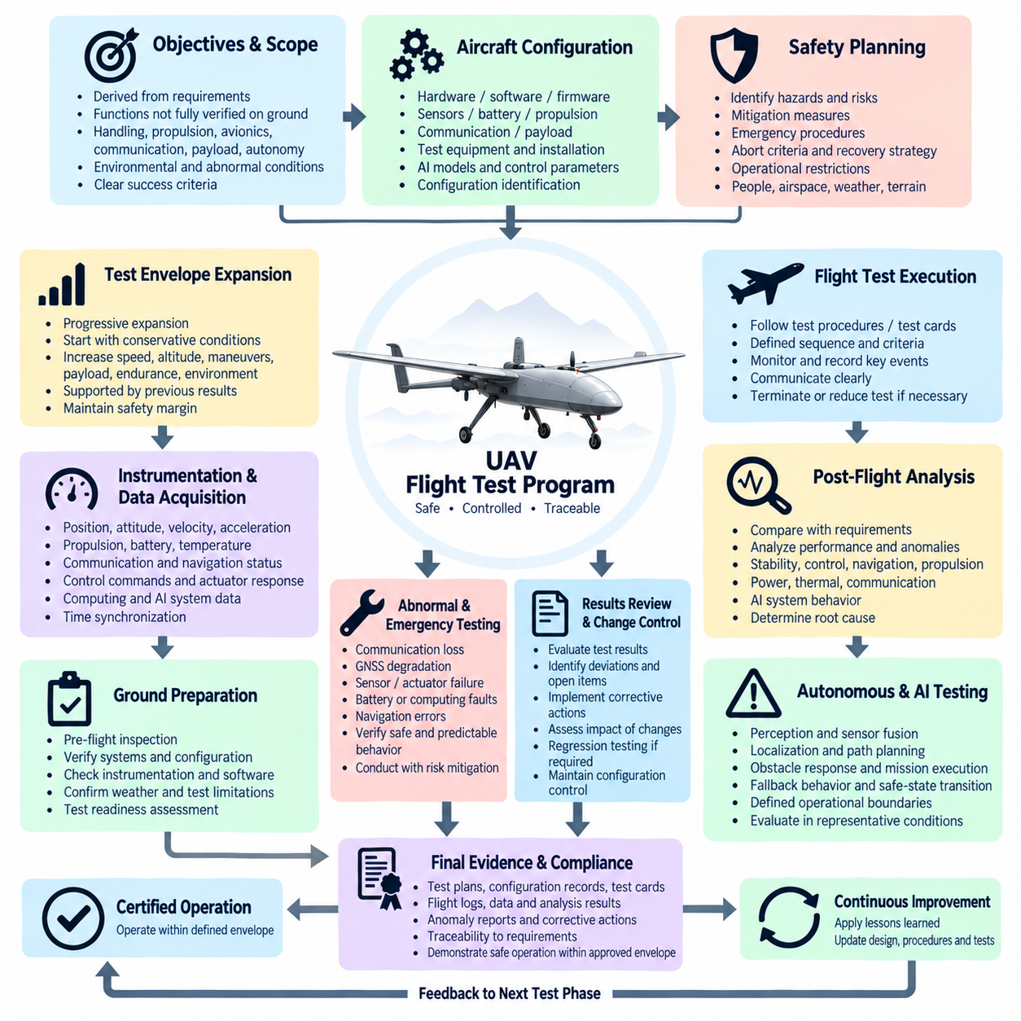
A UAV Flight Test Program provides the controlled process for demonstrating that an aircraft can safely perform its intended functions throughout the approved flight envelope. It connects the aircraft configuration, certification requirements, safety assessment, test objectives, instrumentation, operational limitations, flight procedures, data collection, and final compliance evidence. The program should be treated as an engineering and certification activity rather than simply a series of demonstration flights, with every flight designed to answer defined technical questions and generate traceable evidence.
The program begins by establishing the objectives and scope of flight testing. The objectives should be derived from aircraft requirements, certification criteria, safety assessments, system specifications, and functions that cannot be completely verified through laboratory or ground testing. The scope may include basic aircraft handling, propulsion performance, electrical behavior, navigation, communication, control response, payload operation, autonomous functions, environmental performance, and abnormal or emergency conditions. Each objective should have clearly defined success criteria.
Aircraft configuration control is essential before flight testing begins. The test aircraft should have a clearly identified hardware, software, firmware, sensor, battery, propulsion, communication, and payload configuration. Any temporary instrumentation or test equipment should also be documented. For autonomous UAVs, software versions, AI models, parameters, mission logic, perception modules, and control algorithms may influence flight behavior and therefore require configuration identification. Flight-test results are meaningful only when the tested configuration is clearly known and controlled.
Safety planning establishes the conditions under which flight testing can be conducted. Hazards associated with propulsion, flight control, battery systems, communication loss, navigation failure, sensor degradation, software faults, autonomous decision errors, weather, terrain, people, and surrounding airspace should be evaluated before each test phase. Appropriate mitigation measures, emergency procedures, abort criteria, recovery strategies, and operational restrictions should be established. The objective is to prevent an engineering test from creating an uncontrolled flight or ground safety event.
The flight-test envelope should normally be expanded progressively rather than explored at maximum conditions during the initial flights. Early tests can establish basic controllability, propulsion response, stability, communication integrity, and navigation performance under conservative conditions. Subsequent tests can gradually increase speed, altitude, maneuvering range, payload, endurance, environmental exposure, and autonomous functionality. Each expansion should be supported by previous test evidence so that the aircraft enters more demanding conditions with an established safety margin.
Instrumentation and data acquisition provide the quantitative foundation for flight-test analysis. Sensors and measurement systems should capture parameters appropriate to each objective, including position, attitude, velocity, acceleration, propulsion variables, battery voltage and current, temperatures, communication status, navigation quality, control commands, actuator responses, and computing performance. Time synchronization is particularly important for autonomous UAVs because sensor, control, communication, and AI events must be correlated accurately when analyzing transient behavior or abnormal events.
Ground preparation is completed before each flight sequence. Pre-flight inspection should verify structural condition, propulsion components, batteries, wiring, connectors, avionics, sensors, communication links, software configuration, mission parameters, and safety functions. Instrumentation should be checked and synchronized, while weather and operational conditions should be confirmed against the approved test limitations. A formal test readiness assessment helps ensure that unresolved issues from previous flights do not unintentionally enter the next test phase.
Flight-test execution should follow approved test procedures or test cards that define the intended sequence, expected behavior, measurement requirements, and decision criteria. Test personnel should maintain clear communication and record significant events, configuration changes, environmental conditions, anomalies, and deviations from the planned procedure. If the aircraft behavior differs materially from expectations, the flight should be terminated or the test objective reduced when required by the safety plan rather than continuing solely to complete the planned sequence.
Post-flight analysis converts recorded flight data into engineering evidence. The analysis should compare measured performance with requirements, predicted behavior, simulation results, and previously established baselines. Particular attention should be given to stability, control response, navigation accuracy, propulsion performance, power consumption, thermal behavior, communication integrity, sensor consistency, and autonomous-system behavior. Anomalies should be correlated with time-synchronized data to determine whether they resulted from hardware, software, environmental conditions, operator actions, or interactions among multiple systems.
Autonomous and Physical AI functions require additional flight-test considerations because their behavior may depend on sensor inputs, environmental conditions, computational resources, and decision logic. Testing should evaluate perception reliability, sensor fusion, localization, path planning, obstacle response, mission execution, fallback behavior, communication loss, degraded sensing, and safe-state transitions. AI-related functions should be evaluated within explicitly defined operational boundaries, and performance outside those boundaries should not be assumed to be equivalent to validated behavior.
Abnormal and emergency flight testing verifies that the aircraft can respond appropriately when important functions are degraded or lost. Depending on the approved test scope, scenarios may include communication interruption, GNSS degradation, sensor failure, actuator abnormalities, battery limitations, computing faults, navigation errors, propulsion degradation, or autonomous-system recovery. Such tests should be conducted only under controlled conditions with appropriate risk mitigation. The objective is to demonstrate predictable and safe behavior rather than to expose the aircraft to unnecessary hazards.
Flight-test results should be reviewed through a structured process that identifies completed objectives, successful demonstrations, deviations, anomalies, unresolved issues, and required corrective actions. When a modification is introduced to address a flight-test problem, the impact of that modification should be evaluated before further testing. Hardware, software, firmware, calibration, control parameters, or AI-model changes may require focused regression testing or repetition of previously completed test points to confirm that the correction has not introduced a new problem.
The final Flight Test Program evidence should include approved test plans, aircraft configuration records, test cards, instrumentation information, flight logs, environmental conditions, measured data, analysis results, anomaly reports, corrective actions, and final compliance conclusions. The evidence should remain traceable to the applicable requirements and certification objectives. A complete flight-test program therefore provides more than operational experience; it establishes a controlled engineering record demonstrating that the UAV has been progressively evaluated, that identified risks have been addressed, and that the aircraft can safely operate within its defined and approved flight envelope.

10.05. Continued Airworthiness
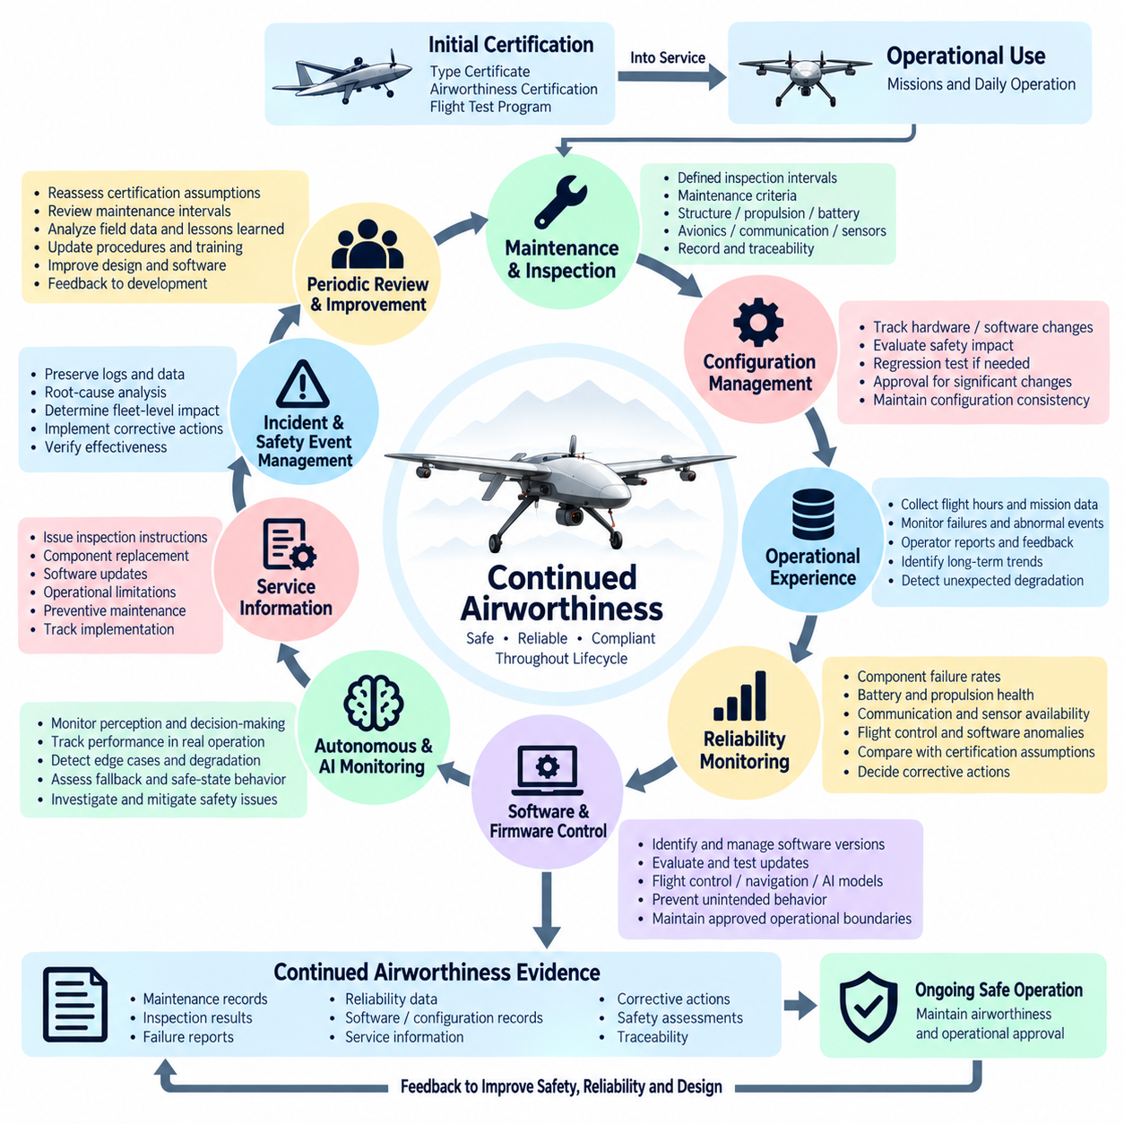
Continued Airworthiness establishes the processes required to maintain an aircraft in a safe and compliant condition throughout its operational life after initial certification. For a UAV, airworthiness does not end when the Type Certificate or operational approval is obtained. The aircraft must continue to conform to its approved configuration while accumulating flight hours, experiencing environmental exposure, undergoing maintenance, receiving component replacements, and incorporating approved hardware or software changes.
The continued airworthiness system begins with controlled maintenance and inspection requirements. Structural components, propulsion systems, batteries, flight-control equipment, avionics, communication systems, sensors, wiring, connectors, and safety-related equipment should have defined inspection intervals and maintenance criteria. These requirements should reflect the demonstrated reliability and environmental exposure of the aircraft. Maintenance activities must be documented so that the condition and configuration of each aircraft remain traceable throughout its service life.
Configuration management remains essential after certification because aircraft can change during normal operation. Replacement components, modified wiring, new sensors, firmware revisions, software updates, battery substitutions, and approved design changes may affect previously demonstrated compliance. Each change should therefore be evaluated for its technical and safety impact. Significant changes may require additional analysis, regression testing, conformity inspection, or formal approval before the modified configuration is released for operational use.
Operational experience provides an important source of continuing airworthiness information. Flight hours, mission cycles, environmental exposure, component failures, abnormal events, maintenance findings, and pilot or operator reports should be collected and analyzed systematically. Trends that are not visible during initial certification testing can emerge after extended operation. These data can reveal unexpected degradation, recurring failures, maintenance problems, or differences between predicted reliability and actual field performance.
Reliability monitoring connects operational data with maintenance and safety decisions. Important parameters may include component failure rates, battery degradation, propulsion performance, communication reliability, sensor availability, flight-control anomalies, software faults, and mission interruption frequency. Reliability trends should be compared with established assumptions and certification evidence. When a significant deviation is identified, the organization should determine whether additional inspection, preventive maintenance, component replacement, design improvement, or further investigation is required.
Software and firmware control becomes particularly important for autonomous UAVs. Updates to flight-control software, navigation functions, perception systems, sensor-fusion algorithms, mission management, AI models, and communication modules can change aircraft behavior even when the physical hardware remains unchanged. Software changes should therefore be uniquely identified, evaluated, tested, and released through controlled processes. Updates should not invalidate previously demonstrated safety functions or introduce behavior outside the approved operational boundaries.
For UAVs using autonomous and Physical AI functions, continued airworthiness should also monitor the behavior of perception, decision-making, planning, and fallback functions during real operation. Changes in sensors, lighting, weather, terrain, computational resources, or software versions can influence system performance. Operational data should be used to identify degradation, unexpected behavior, repeated edge cases, and situations in which autonomous functions approach their defined performance limits. Safety-related findings should trigger controlled investigation and corrective action.
Maintenance and inspection results should be linked to the aircraft configuration and operational history. A traceable record should identify installed components, software versions, major repairs, replacements, inspections, accumulated flight hours, mission cycles, and relevant environmental exposure. This information allows engineers to understand the history of an aircraft when investigating failures or evaluating continued serviceability. It also prevents maintenance actions from creating undocumented configuration differences between aircraft of the same approved type.
Service information provides a controlled mechanism for communicating technical findings and required actions to operators and maintenance organizations. Depending on the nature of an issue, the response may include inspection instructions, component replacement, software updates, operational limitations, preventive maintenance, or design changes. Safety-critical findings should be prioritized according to their potential consequences and should be tracked until the required corrective action has been completed and verified.
Continued airworthiness also requires structured management of incidents, failures, and safety events. When an abnormal event occurs, the organization should preserve relevant flight logs, diagnostic information, configuration data, environmental conditions, and maintenance history before modifying the aircraft whenever practical. Root-cause analysis can then determine whether the event was isolated or represents a broader fleet-level risk. Corrective actions should be evaluated for effectiveness and incorporated into the appropriate maintenance, design, software, or operational process.
Periodic review provides a mechanism for reassessing the aircraft as operational knowledge increases. Certification assumptions, reliability models, maintenance intervals, component availability, software dependencies, and environmental exposure may need to be reviewed using accumulated service data. Lessons learned from the field can lead to improved inspection procedures, revised maintenance intervals, updated training, hardware improvements, software corrections, or additional verification testing. This creates a feedback loop between operation and engineering development.
The continued airworthiness evidence should remain traceable throughout the aircraft lifecycle. Maintenance records, inspection results, failure reports, reliability data, software and configuration records, service information, corrective actions, and safety assessments should be retained according to the applicable control process. The objective is to demonstrate that the aircraft remains consistent with its approved design and that emerging safety risks are identified and managed in a timely manner.
For a UAV, Continued Airworthiness can therefore be understood as a continuous lifecycle process connecting certified design, production configuration, maintenance, inspection, operational data, reliability monitoring, software and hardware change control, incident investigation, corrective action, and ongoing safety assessment. The final objective is not simply to preserve the original certification status, but to maintain justified confidence that every aircraft continues to operate safely within its approved limitations throughout its service life. This becomes increasingly important as autonomous and Physical AI systems evolve through controlled software, model, sensor, and computing updates.

