Volume 19. Testing and Validation

Chapter 08. Reliability Test

08.01. HALT (Highly Accelerated Life Test)
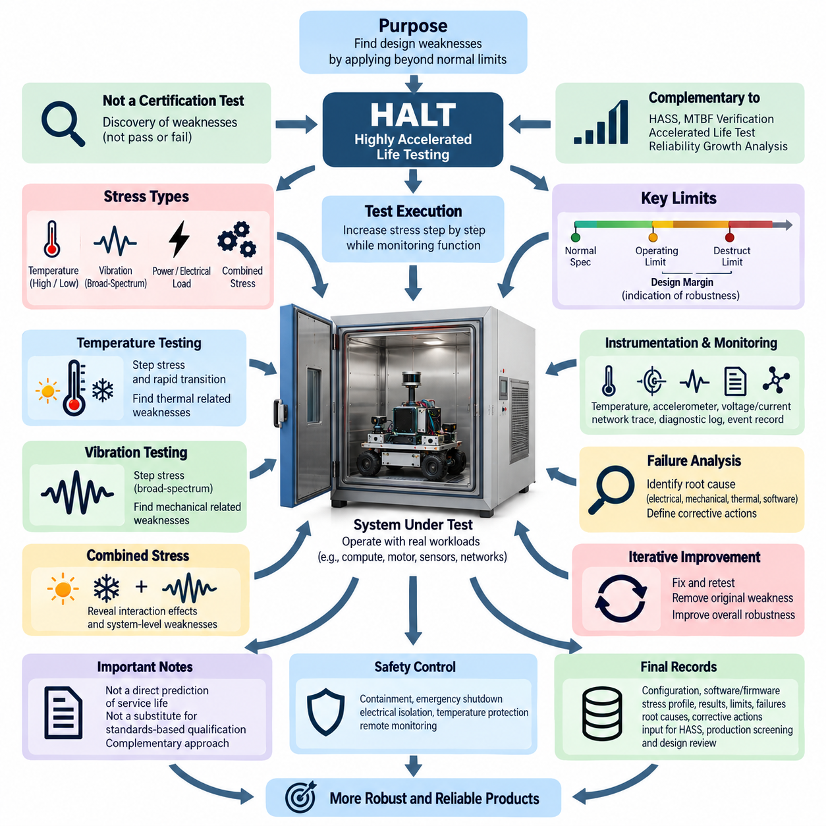
Highly Accelerated Life Testing (HALT) is an engineering reliability method used to expose latent design weaknesses by operating a product beyond its normal qualification and expected service limits. Unlike conventional environmental qualification, HALT is primarily a discovery process rather than a pass-or-fail certification test. Within the reliability test structure, it complements HASS, MTBF verification, accelerated life testing, and reliability growth analysis by identifying weaknesses early enough for corrective design action.
The fundamental objective of HALT is to determine how a system behaves as environmental and operational stresses progressively increase. Testing typically begins near benign conditions and moves toward increasingly severe temperature, vibration, power, electrical load, or combined stresses. Functional performance is continuously monitored while the stress level changes. The resulting limits provide valuable information about design margin, failure mechanisms, recovery behavior, and the robustness of the complete product architecture.
A HALT program should distinguish between the normal operating specification, operating limit, destruct limit, and practical design margin. The operating limit is the stress boundary beyond which the unit no longer performs its required function but may recover when the stress is reduced. The destruct limit represents a higher stress level at which permanent physical damage occurs. The difference between specified operating conditions and discovered limits provides an engineering indication of available robustness rather than a formal reliability prediction.
Temperature step stressing is commonly used to reveal weaknesses associated with semiconductor behavior, solder joints, connectors, batteries, sensors, power conversion, oscillators, and mechanical interfaces. The test article is exposed progressively to higher and lower temperatures while critical functions remain active. Engineers observe boot behavior, communication stability, sensor accuracy, power consumption, protection responses, processor operation, actuator control, and diagnostic information to identify temperature-dependent degradation before catastrophic failure occurs.
Rapid thermal transitions can reveal failure mechanisms that steady-temperature testing may not expose efficiently. Repeated expansion and contraction create differential strain among printed circuit boards, packages, connectors, fasteners, adhesives, enclosures, and harness interfaces. Thermal transition testing is therefore valuable for detecting intermittent contacts, marginal solder connections, mechanical movement, seal degradation, and calibration instability. Temperature measurements should be taken at representative internal locations because chamber air temperature alone may not represent component stress.
Vibration step stressing applies progressively increasing mechanical excitation while the system remains powered and operational whenever practical. HALT equipment often uses broad-spectrum excitation intended to stimulate many structural resonances simultaneously rather than reproduce one specific field vibration profile. Functional monitoring can reveal intermittent connectors, loose fasteners, PCB resonance, cable movement, cracked solder joints, sensor disturbances, and mechanically induced communication faults that may remain invisible during static inspection or conventional functional testing.
Combined thermal and vibration stressing is particularly powerful because real products contain interacting failure mechanisms. A connector that operates correctly at room temperature may become intermittent when thermal contraction changes contact force while vibration simultaneously excites the harness. Similarly, a marginal solder joint may remain functional under either temperature or vibration alone but fail under their combination. Combined stressing therefore helps identify nonlinear interactions and system-level weaknesses that isolated environmental tests can miss.
For robotic systems, HALT should be performed with representative operating modes rather than treating the controller as an inactive electronic assembly. Compute modules, motor drivers, communication networks, sensors, safety circuits, power distribution units, DC-DC converters, and embedded controllers should execute realistic workloads whenever possible. Representative traffic on CAN, Ethernet, EtherCAT, or other internal networks can expose timing, power, thermal, and mechanical interactions that would not appear when subsystems are evaluated independently.
Instrumentation is essential because HALT is valuable only when engineers can identify what failed, when it failed, and under which stress conditions. Temperature sensors, accelerometers, voltage and current measurements, network traces, diagnostic logs, processor telemetry, error counters, reset histories, and synchronized event records should be collected throughout the test. Automated monitoring is especially useful for detecting short-duration intermittent faults that may disappear before an operator can observe or reproduce them manually.
When a functional failure occurs, the immediate objective is not simply to terminate testing. Engineers should document the stress level, symptoms, affected functions, diagnostic information, and recovery behavior, then determine whether the event represents a reversible operating limit or permanent damage. Controlled reduction of stress can establish whether functionality returns. Repeated exposure near the discovered boundary may then help reproduce the mechanism and provide evidence for root-cause analysis before corrective action is selected.
Failure analysis connects HALT observations to engineering improvement. The investigation may include electrical measurement, connector inspection, PCB examination, mechanical disassembly, log analysis, thermal review, vibration response analysis, and component-level testing. The important result is not merely the identification of a failed component but an understanding of why the architecture allowed the weakness. Corrective actions may involve component derating, mechanical reinforcement, improved cooling, connector changes, PCB redesign, filtering, mounting changes, or software protection.
After a weakness has been corrected, the modified design should be retested to verify that the original failure mechanism has been removed and that the corrective action has not introduced another vulnerability. This iterative process of stress, discovery, analysis, correction, and retest converts HALT into a reliability growth activity. Multiple cycles may be required because eliminating the weakest mechanism can expose the next limiting mechanism, gradually increasing the overall robustness of the system.
HALT results should not be interpreted as direct evidence of service life or as a substitute for standards-based environmental qualification. The intentionally extreme stresses may not reproduce actual field distributions, and the relationship between HALT exposure and calendar life is generally not suitable for simple conversion into operating hours. Qualification testing verifies compliance against defined requirements, while HALT explores design margin and failure behavior. Both approaches are therefore complementary rather than interchangeable.
HALT planning should also consider whether particular stresses could create unrealistic failure mechanisms. Excessive vibration may damage a structure in a manner impossible during service, while extreme temperatures may exceed the physical range of batteries, displays, lubricants, adhesives, or sensors for reasons unrelated to useful design margin. Engineering judgment is required to distinguish meaningful weaknesses from artifacts produced by inappropriate stress application, especially when heterogeneous robotic subsystems have very different physical limits.
Safety controls become increasingly important as stress levels exceed normal design conditions. High-energy batteries, high-voltage circuits, rotating actuators, capacitors, thermal surfaces, and mechanically excited assemblies can create hazards during destructive exploration. Test fixtures should provide containment, emergency shutdown, electrical isolation, temperature protection, remote monitoring, and controlled access where appropriate. Safety limits must remain independent from the experimental limits being explored so that reliability discovery never depends on unsafe laboratory operation.
The final HALT record should preserve the configuration of the test article, software and firmware versions, instrumentation, stress sequence, measured response, operating and destruct limits, observed failures, root causes, corrective actions, and retest results. This information becomes part of the engineering reliability knowledge base and can guide subsequent HASS development, accelerated life testing, production screening, design reviews, supplier requirements, and reliability growth activities within the broader testing and validation process.

08.02. HASS Screening
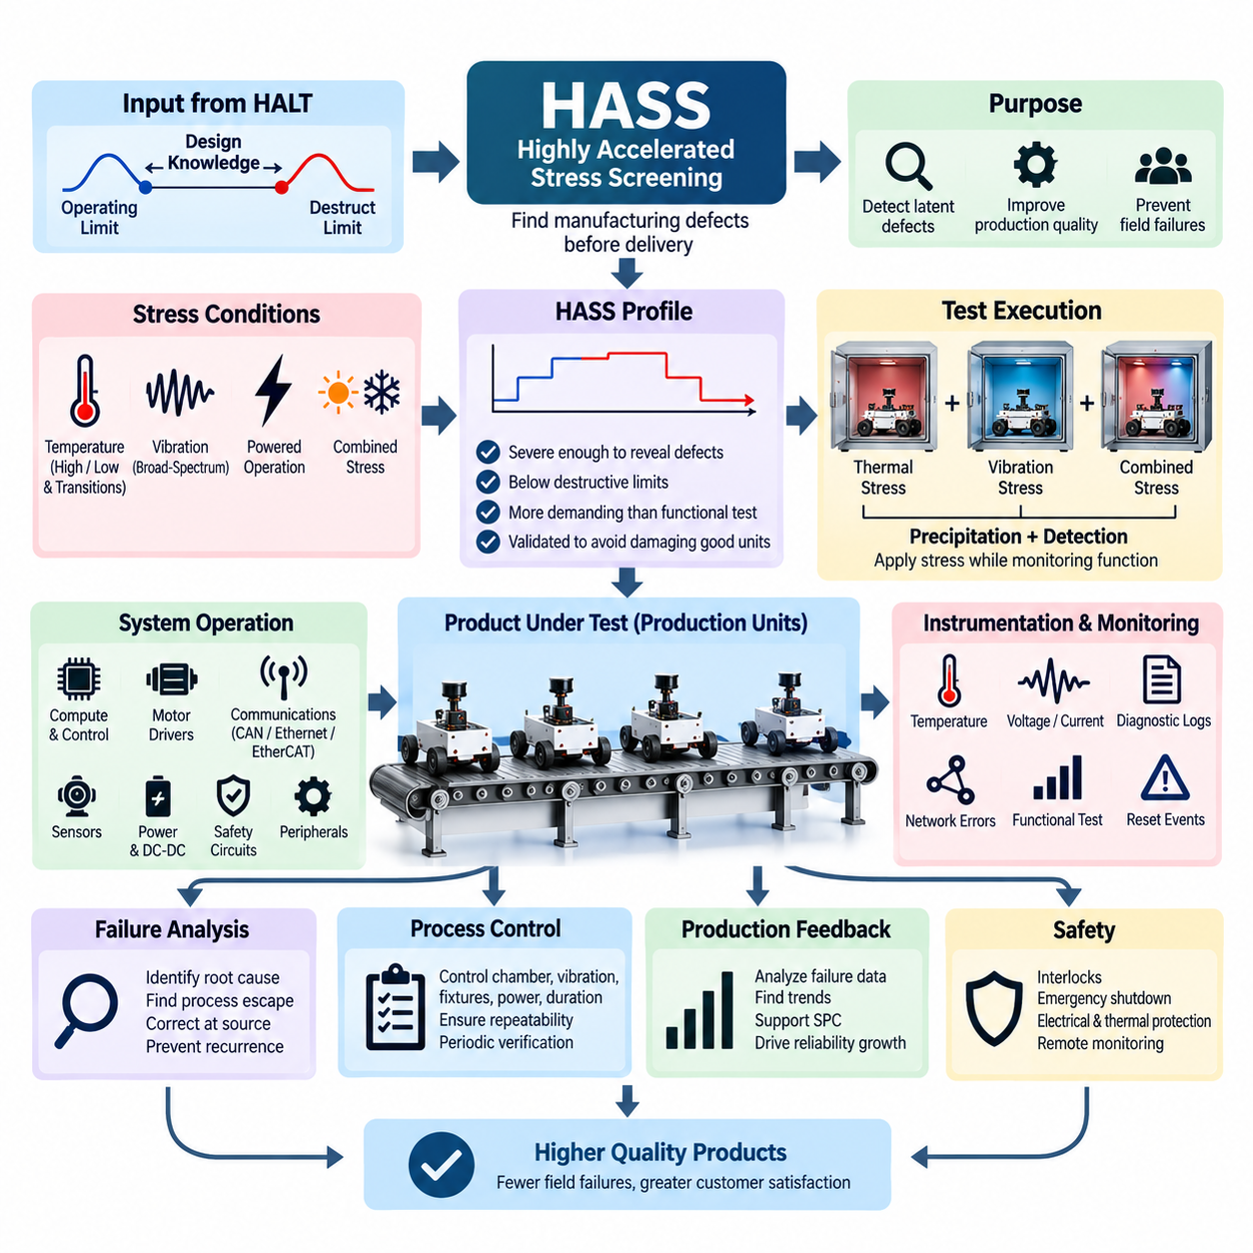
Highly Accelerated Stress Screening (HASS) is a production reliability screening method used to detect manufacturing defects, workmanship problems, and process variations before products reach customers. It is typically developed after Highly Accelerated Life Testing (HALT) has identified the product’s operating and destruct limits. Within the reliability test structure, HASS complements HALT, MTBF verification, accelerated life testing, and reliability growth analysis by transferring design knowledge into production quality control.
The fundamental purpose of HASS is different from that of HALT. HALT intentionally explores design limits and discovers weaknesses during development, whereas HASS applies controlled stresses to production units to reveal latent defects without consuming an unacceptable portion of product life. The screening profile is therefore designed to be severe enough to precipitate manufacturing-related weaknesses but sufficiently controlled to avoid damaging correctly manufactured products or reducing their intended field reliability.
Development of a HASS profile begins with knowledge obtained from HALT and subsequent design verification. Engineers consider the normal operating specification, discovered operating limits, destruct limits, component capabilities, and known failure mechanisms. Screening stresses are selected inside a safe region relative to destructive boundaries while remaining significantly more demanding than ordinary production functional testing. This relationship between HALT characterization and HASS screening is essential for establishing an effective and defensible production process.
Temperature stress is commonly incorporated into HASS because manufacturing defects can become visible when materials expand, contract, or change electrical characteristics. Rapid transitions between elevated and reduced temperatures may reveal marginal solder joints, connector problems, PCB defects, component mounting weaknesses, intermittent contacts, and assembly variation. Temperature limits and transition rates must be selected carefully so that the screening process stimulates defects without creating unrealistic damage in otherwise conforming products.
Vibration stress can be combined with thermal stress to expose mechanical and electrical workmanship problems. Broad-spectrum vibration may stimulate loose fasteners, poorly seated connectors, inadequate cable retention, cracked solder joints, marginal mechanical assemblies, and intermittent electrical connections. The purpose is not to reproduce a specific transportation or operating vibration environment. Instead, vibration acts as an efficient stimulus for revealing defects that might otherwise remain dormant until the product experiences extended field operation.
Combined thermal and vibration screening can be more effective than either stress applied independently because manufacturing defects frequently respond to interacting conditions. Thermal expansion may reduce connector contact margin while vibration introduces relative motion, or temperature variation may change solder-joint strain while mechanical excitation stimulates an intermittent connection. Carefully controlled combined stresses therefore increase screening sensitivity while reducing the time required to reveal defects that could escape conventional end-of-line testing.
A typical HASS process includes a precipitation phase and a detection phase. During precipitation, environmental stresses encourage latent manufacturing defects to develop into observable conditions. During detection, the product is operated and monitored so that the resulting functional abnormality can be identified. Effective screening requires both mechanisms: stressing without adequate functional monitoring may create an observable defect that remains undetected, while extensive monitoring without sufficient stress may fail to activate the latent weakness.
For robotic products, functional operation during HASS should represent the critical behavior of the integrated system. Compute modules, embedded controllers, power distribution, DC-DC converters, communication interfaces, sensors, motor controllers, safety circuits, and relevant peripheral devices should remain active whenever practical. Representative CAN, Ethernet, EtherCAT, or other network traffic can help reveal intermittent communication problems, timing instability, power disturbances, resets, and integration defects associated with production variation.
Instrumentation and automated monitoring are particularly important because many HASS failures are intermittent and may exist only during a specific combination of temperature, vibration, electrical load, and system activity. Voltage, current, internal temperature, communication errors, processor status, diagnostic messages, reset events, sensor outputs, and functional test results can be recorded automatically. Time-correlated data allows engineers to connect observed abnormalities with the exact screening condition under which they occurred.
The screening profile must be validated before routine production deployment. Representative conforming units should undergo repeated HASS cycles to demonstrate that the selected stresses do not produce unacceptable degradation or consume excessive useful life. Engineers may inspect units before and after repeated screening, compare functional parameters, and perform additional reliability evaluation where necessary. A profile that damages good products is not an effective screen, even if it successfully detects defective units.
HASS effectiveness depends strongly on process control and repeatability. Chamber temperature, transition rate, vibration level, fixture configuration, product loading, power conditions, test duration, software configuration, and functional monitoring criteria should be controlled consistently. Changes in fixtures, chamber characteristics, product mass, mounting method, or production configuration can alter the stresses actually transferred to the unit. Periodic verification is therefore required to maintain screening sensitivity and prevent unintended overstress.
When a production unit fails HASS, the failure should not be treated merely as an isolated unit requiring repair. The defect may indicate a broader manufacturing process issue involving soldering, crimping, connector assembly, component handling, fastening, adhesive application, PCB fabrication, harness routing, calibration, or supplier quality. Failure analysis should identify both the physical failure mechanism and the process escape that allowed the defect to occur, enabling corrective action at its manufacturing source.
HASS data can provide valuable feedback for statistical process control and reliability growth. Failure rates, defect categories, stress conditions, production lots, suppliers, repair histories, and recurring mechanisms can be analyzed to identify trends. A sudden increase in a specific failure mode may indicate process drift or material variation, while a sustained reduction following corrective action provides evidence of manufacturing improvement. Screening therefore becomes both a defect-detection mechanism and a source of production intelligence.
HASS should not be confused with qualification testing or conventional environmental acceptance testing. Qualification demonstrates that a design satisfies specified environmental requirements, while HASS deliberately uses accelerated stresses derived from knowledge of the product’s margins to identify production defects efficiently. The screening profile is product-specific and process-specific, so a profile developed for one design should not automatically be transferred to another product without engineering evaluation and appropriate validation.
Safety considerations remain essential because HASS may involve rapid thermal transitions, substantial vibration, powered electronics, batteries, high-current circuits, actuators, and automated equipment. Test systems should incorporate appropriate interlocks, emergency shutdown, electrical protection, thermal protection, fixture integrity checks, and remote monitoring. Screening stresses must remain within validated boundaries, and abnormal conditions should trigger controlled responses that protect personnel, equipment, and the product under test.
The final HASS process should be maintained as a controlled production procedure containing the approved stress profile, equipment configuration, fixture requirements, functional monitoring criteria, acceptance limits, failure handling rules, traceability information, and periodic verification requirements. Screening results should remain linked to product serial numbers and manufacturing history where practical. This disciplined feedback loop allows HASS to support production screening, process improvement, supplier control, and continuing reliability growth throughout the product lifecycle.

08.03. MTBF Verification
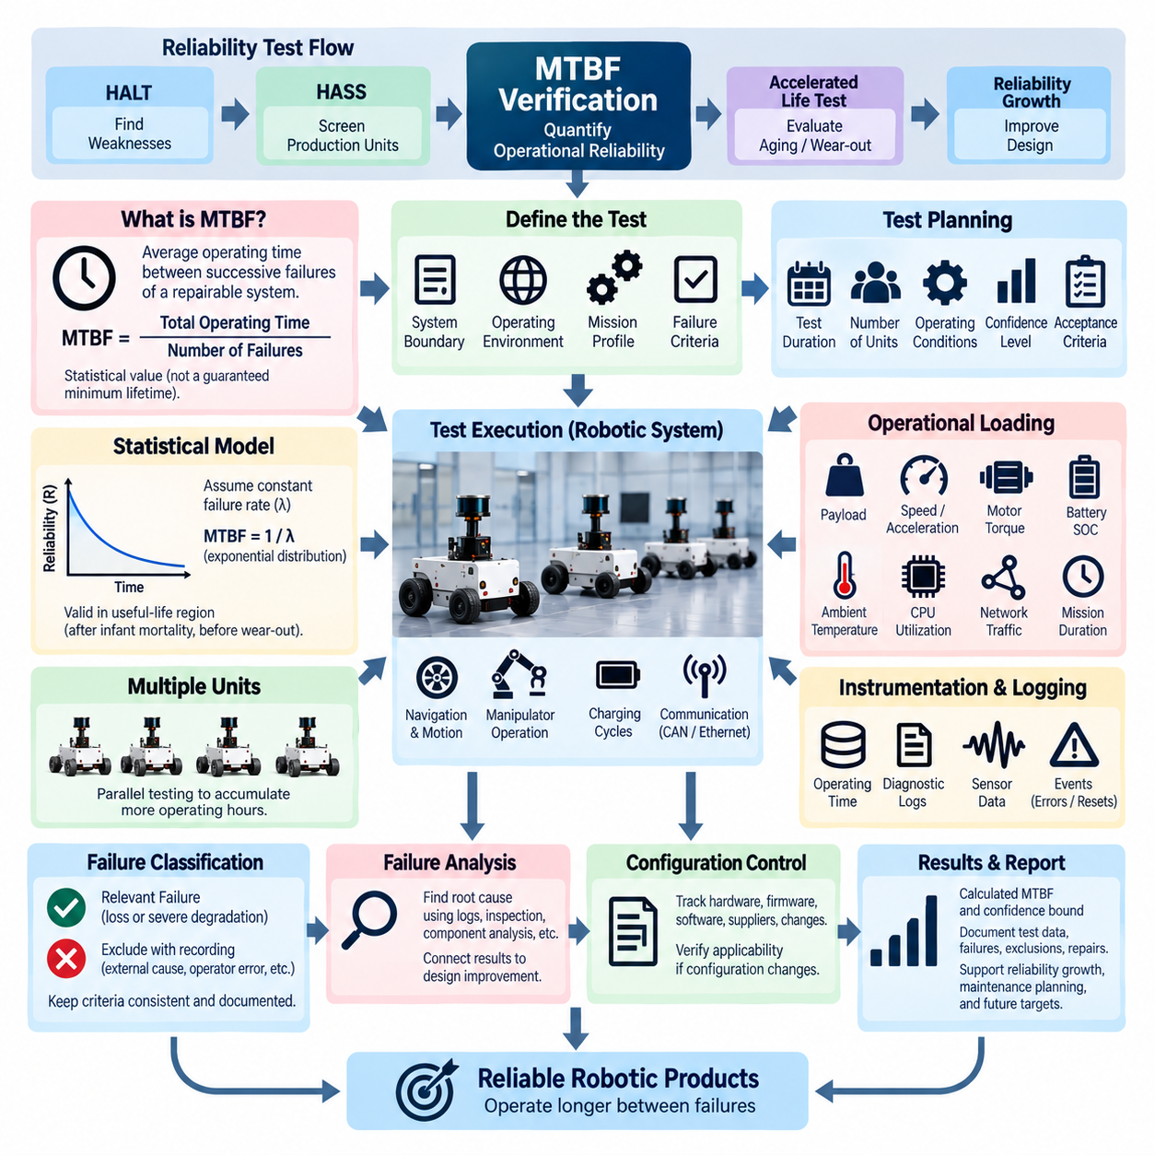
Mean Time Between Failures (MTBF) verification is a reliability evaluation process used to determine whether a repairable system can achieve a specified level of operational reliability. Within the reliability testing structure, MTBF verification follows the discovery-oriented HALT and production-oriented HASS activities and complements accelerated life testing and reliability growth analysis. Its purpose is to provide quantitative evidence that the system can operate for an acceptable duration between inherent failures.
MTBF represents the average operating time expected between successive failures of a repairable item under defined conditions. Conceptually, it is calculated by dividing accumulated operating time by the number of relevant failures observed during a test or operational period. This value must be interpreted carefully because MTBF is a statistical reliability parameter rather than a guaranteed minimum lifetime, warranty period, or prediction that every individual product will operate for exactly the stated number of hours.
A meaningful MTBF requirement begins with a precise definition of the system boundary, operating environment, mission profile, and failure criteria. Engineers must establish which hardware and software elements belong to the system under test and what constitutes a reliability failure. A temporary communication interruption, automatic recovery event, degraded sensor, controller reset, or complete loss of operation may require different classifications depending on the intended function and reliability specification.
Verification planning defines the required test duration, number of test units, operating conditions, confidence objective, and statistical acceptance criteria before testing begins. Simply operating one product for a convenient period and dividing the hours by observed failures does not provide strong verification evidence. The test plan should provide enough accumulated exposure to distinguish a system that satisfies the reliability objective from one whose true failure rate is unacceptably high.
MTBF analysis commonly assumes that failures can be represented by a statistical model over the evaluation interval. Under a constant failure-rate assumption, reliability behavior is often modeled using an exponential distribution, with failure rate λ related approximately to MTBF by MTBF = 1/λ. This assumption is most appropriate during the useful-life region where early manufacturing defects have been controlled and wear-out mechanisms have not yet become dominant.
Confidence level is critical because a measured MTBF is based on finite test evidence. Even when no failures occur during a test, the true MTBF cannot be considered infinite. Statistical confidence bounds are therefore used to express what reliability level is supported by the accumulated operating time and observed failures. Higher confidence requirements generally demand more test exposure, making the relationship among target MTBF, test duration, allowable failures, and confidence level an important planning consideration.
Multiple units can be operated simultaneously to accumulate test time more efficiently. For example, ten representative systems operating for hundreds of hours each can contribute thousands of unit-hours of exposure, provided their conditions and operating records are properly controlled. Parallel testing reduces calendar time but does not eliminate the need for representative workloads, configuration control, accurate time accounting, and consistent failure classification across all units participating in the verification.
For robotic systems, accumulated operating hours should represent meaningful operational activity rather than powered idle time alone. Mobile robots may execute repeated navigation, acceleration, braking, turning, docking, charging, sensing, computation, and communication cycles. Manipulators may perform repeated joint motions and payload operations. Representative duty cycles help ensure that motors, bearings, power electronics, connectors, networks, sensors, compute modules, and thermal systems receive realistic functional exposure.
Operational loading should include conditions that materially influence reliability. Payload, speed, acceleration, motor torque, battery state of charge, charging cycles, processor utilization, network traffic, ambient temperature, and mission duration can affect failure occurrence. A verification test performed under unrealistically light conditions may accumulate many operating hours while providing little evidence about actual service reliability. Test severity should therefore remain traceable to the intended field mission profile.
Instrumentation and automated logging provide the evidence required for credible MTBF verification. Each unit should record operating time, mission cycles, power events, resets, communication errors, diagnostic trouble information, temperatures, voltage and current behavior, sensor status, software exceptions, and relevant functional events. Synchronized logs make it possible to reconstruct failures and determine whether an event is an inherent product failure, an external disturbance, an operator error, or a test-equipment problem.
Failure classification must remain consistent throughout the verification program. Relevant failures generally include events attributable to the system that prevent or significantly degrade its required function and require corrective intervention. Events caused by external power loss, inappropriate test operation, unrelated laboratory equipment, or explicitly excluded maintenance activities may be treated differently. Every exclusion should nevertheless be documented so that reliability results cannot be improved artificially by removing unfavorable observations after testing.
When a failure occurs, engineers should preserve the failed condition whenever practical and perform structured failure analysis. Diagnostic logs, electrical measurements, mechanical inspection, component examination, software traces, environmental conditions, and operating history can help identify the root cause. Repairing the unit without understanding the mechanism may restore testing quickly but loses important reliability information. Failure analysis connects quantitative MTBF results with specific opportunities for engineering improvement.
Configuration control is essential because reliability evidence is meaningful only for the configuration that was actually tested. Hardware revisions, firmware versions, software releases, suppliers, component substitutions, calibration data, manufacturing processes, and corrective modifications should be traceable. If a significant design change is introduced during testing, engineers must determine whether previous accumulated hours remain statistically applicable or whether additional verification is necessary for the modified configuration.
MTBF verification should also distinguish random useful-life failures from infant mortality and wear-out behavior. Early failures may indicate manufacturing or workmanship problems better addressed through process improvement and HASS, while failures occurring after extensive usage may indicate aging or wear mechanisms requiring accelerated life testing. Separating these mechanisms prevents a single MTBF number from hiding fundamentally different reliability problems that require different engineering responses.
The final verification report should document the reliability requirement, system configuration, mission profile, test population, accumulated operating hours, failure definitions, observed failures, exclusions, repairs, statistical method, confidence level, calculated MTBF or confidence bound, and acceptance conclusion. Supporting logs and failure-analysis records should remain traceable to individual test units. These results provide quantitative input for reliability growth, maintenance planning, design improvement, field validation, and future product reliability targets.

08.04. Accelerated Life Test
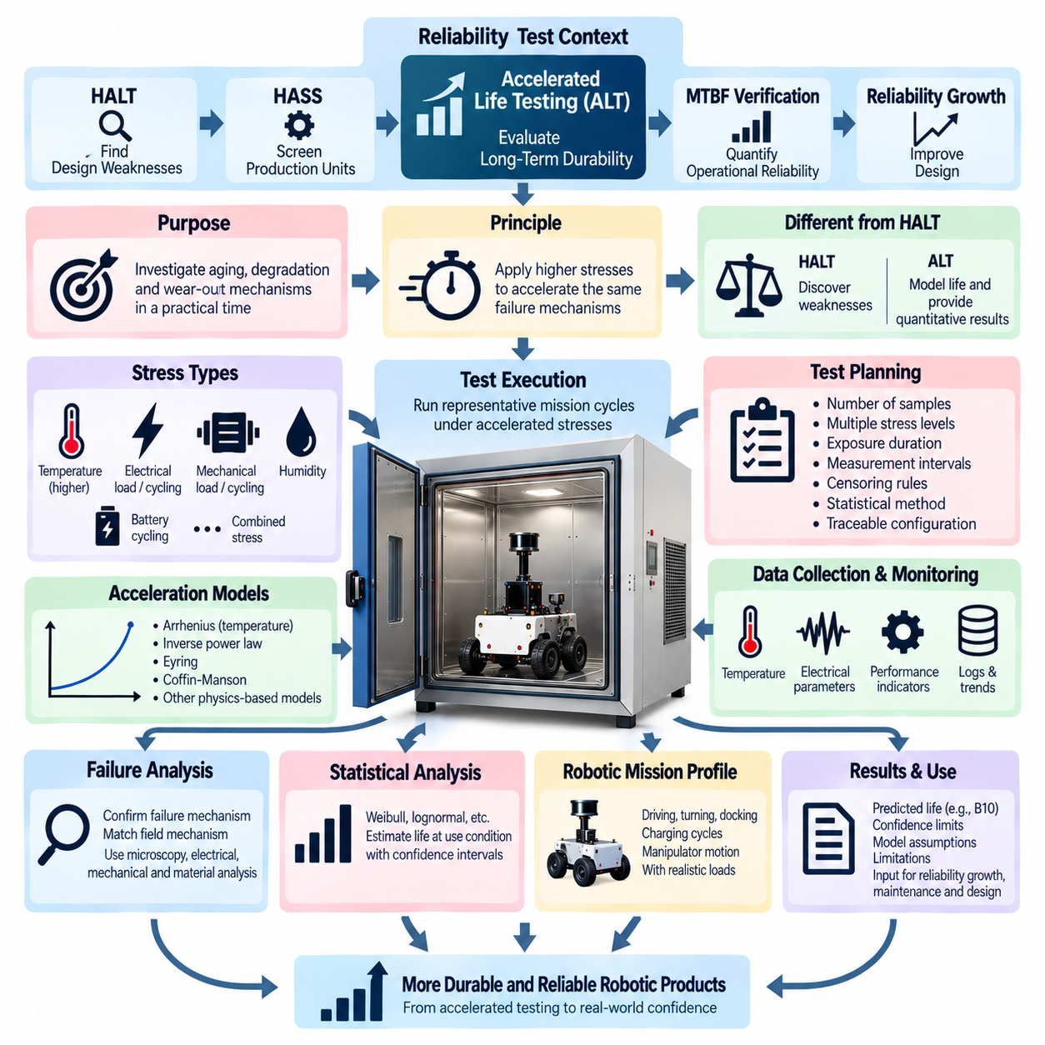
Accelerated Life Testing (ALT) is a reliability evaluation method used to investigate aging, degradation, and wear-out mechanisms within a practical laboratory period. Instead of waiting for products to accumulate years of normal service, ALT applies controlled stresses above typical operating conditions to accelerate relevant physical processes. Within the reliability test structure, it complements HALT, HASS, MTBF verification, and reliability growth analysis by providing evidence about long-term durability and life-limiting mechanisms.
The fundamental principle of ALT is that many failure mechanisms progress faster when temperature, electrical load, mechanical load, humidity, cycling frequency, or other influential stresses are increased. The applied stress must accelerate the same mechanism expected during normal service rather than create an unrelated failure mode. A successful ALT therefore depends not simply on making the test severe, but on understanding the physics connecting stress, degradation rate, and eventual failure.
ALT differs fundamentally from HALT even though both use stresses beyond ordinary operating conditions. HALT is primarily a discovery process that explores design margins and exposes weaknesses, while ALT attempts to establish a quantitative relationship between accelerated stress and expected life under normal conditions. The stress levels used for ALT should therefore remain within a region where the target failure mechanism is physically meaningful and can be modeled using an appropriate acceleration relationship.
Life testing begins by defining the product, mission profile, expected service conditions, reliability target, and failure criteria. Engineers should identify which components and functions are expected to limit useful life and determine measurable indicators of degradation. For robotic systems, these may include motor performance, bearing wear, battery capacity, connector resistance, actuator backlash, sensor drift, cooling performance, insulation degradation, power-electronic characteristics, or repeated mechanical-cycle performance.
A test plan normally defines the number of samples, stress levels, exposure duration, measurement intervals, censoring rules, and statistical analysis method. Multiple stress levels are particularly valuable because they allow engineers to observe how lifetime changes as stress changes. Test specimens should represent the intended production configuration, and their hardware, firmware, software, component sources, manufacturing history, and calibration state should remain traceable throughout the evaluation.
Temperature acceleration is widely used when the dominant degradation mechanism is thermally activated. Reaction rates associated with chemical aging, insulation degradation, semiconductor mechanisms, adhesives, polymers, and some electronic components can increase significantly with temperature. Arrhenius-type relationships are commonly used when physically appropriate, relating the acceleration factor to absolute temperature and an activation-energy parameter representing the temperature sensitivity of the mechanism.
Mechanical accelerated testing is important for products containing moving structures. Motors, gears, bearings, joints, wheels, suspension components, cable chains, connectors, and robotic manipulators can accumulate wear through repeated motion and load cycles. Increasing cycle frequency, torque, payload, force, speed, or motion count may reduce the calendar time required to accumulate representative damage, provided the increased stress does not introduce dynamics, heating, lubrication behavior, or structural loads that are absent during actual operation.
Electrical and power cycling can accelerate degradation in power electronics, converters, motor drives, relays, contactors, connectors, and electronic assemblies. Repeated changes in voltage, current, power dissipation, and junction temperature can produce thermal-mechanical fatigue and contact deterioration. For high-power robotic systems, realistic interactions among electrical loading, cooling, switching operation, motor demand, and battery behavior should be considered because component temperature may depend strongly on the complete operating cycle.
Battery life evaluation requires particular attention because degradation depends on multiple interacting variables such as temperature, state of charge, depth of discharge, charge and discharge current, storage duration, and cycle count. Accelerated cycling can provide useful information about capacity fade and internal resistance growth, but excessive stress may activate failure mechanisms that are not representative of normal service. Battery ALT should therefore preserve traceability between accelerated conditions and the intended charging and operating strategy.
Combined-stress ALT may be required when field degradation is governed by interactions among temperature, humidity, vibration, electrical load, and mechanical cycling. Applying several stresses simultaneously can better represent the physics of the actual failure mechanism, but it also makes modeling more difficult. Engineers should understand which variables are causal, how they interact, and whether the resulting acceleration model remains valid before extrapolating laboratory results to expected field life.
Acceleration factor is the relationship between the degradation rate or lifetime under accelerated conditions and that under the intended use condition. Depending on the mechanism, engineers may use Arrhenius, inverse power law, Eyring, Coffin-Manson, or other physics-based and empirical relationships. Selection of the model should be justified by the dominant failure mechanism and supporting data rather than chosen merely because a mathematical equation provides a convenient fit to limited observations.
Data collection should capture both complete failures and progressive degradation. Measurements may include operating hours, cycle counts, temperatures, electrical parameters, vibration, motor current, battery capacity, internal resistance, sensor accuracy, mechanical clearance, communication errors, resets, and performance indicators. Periodic measurements allow degradation trends to be modeled before catastrophic failure occurs and can provide more information than a simple record of whether each specimen survived or failed.
Statistical analysis converts accelerated observations into reliability information for the intended use condition. Depending on the available data, lifetime distributions such as Weibull or lognormal models may be evaluated together with the selected acceleration relationship. Confidence intervals are important because limited sample populations and extrapolation introduce uncertainty. A predicted characteristic life or percentile life should therefore be reported together with assumptions, confidence information, and the range over which the model has supporting evidence.
Failure analysis remains essential whenever a specimen reaches a defined failure criterion. Engineers should determine whether the observed mechanism matches the mechanism expected in service and whether it remains consistent across different acceleration levels. If higher stress produces a different physical failure mode, combining those observations into one life model can generate misleading predictions. Microscopy, electrical analysis, mechanical inspection, material examination, diagnostic logs, and teardown evidence can support this mechanism verification.
For robotic systems, ALT should represent actual mission usage as closely as practical. Mobile robots may repeat driving, turning, braking, docking, charging, and payload cycles, while manipulators may execute repeated trajectories, gripping operations, and joint reversals. Combining mission cycles with thermal, electrical, and mechanical measurements helps relate laboratory exposure to field usage and supports maintenance intervals, component replacement policies, warranty planning, and durability requirements.
The final ALT report should document the test configuration, mission assumptions, samples, stress levels, exposure times, measured degradation, failures, failure mechanisms, acceleration model, statistical method, confidence limits, predicted life, and limitations of extrapolation. Results should feed reliability growth and future design decisions rather than remain only as a lifetime number. Properly executed ALT provides a quantitative bridge between controlled laboratory testing and the long-term durability expected from robotic products in real service.

08.05. Reliability Growth Analysis
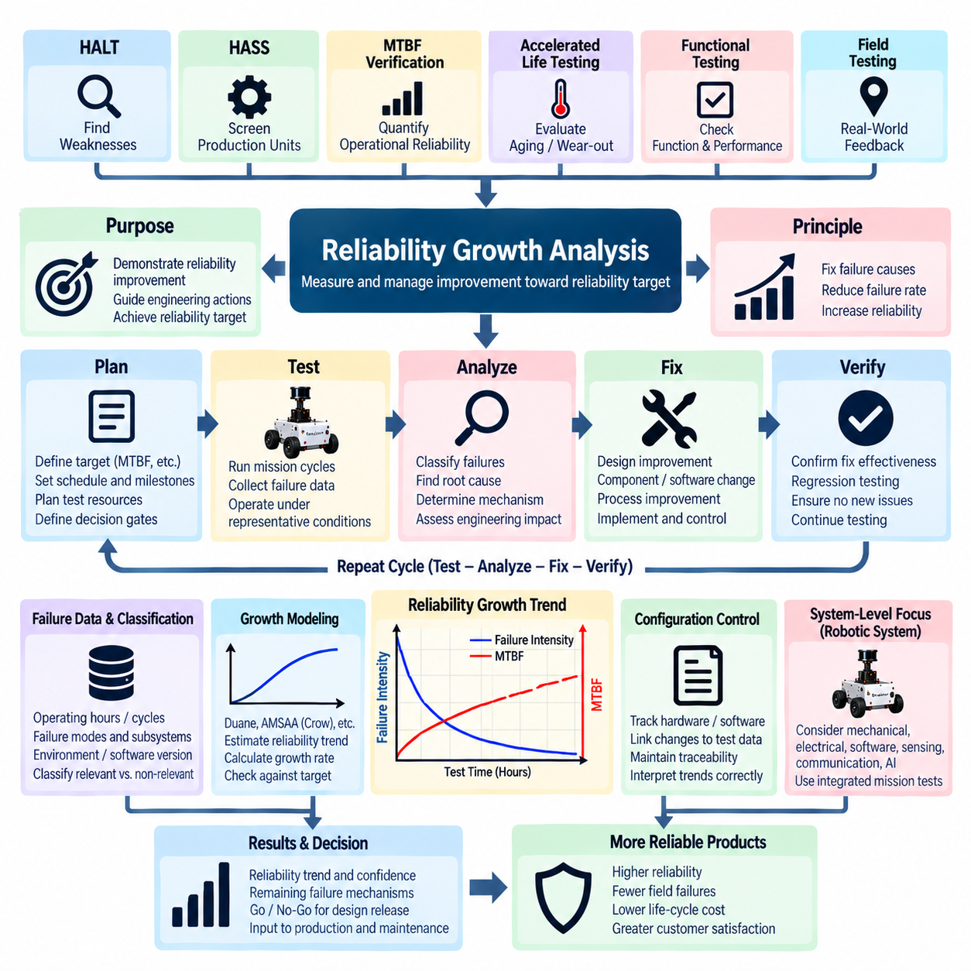
Reliability Growth Analysis is an engineering process used to measure and manage how system reliability improves as failures are discovered, analyzed, corrected, and verified through repeated development cycles. Within the reliability testing structure, it integrates evidence from HALT, HASS, MTBF verification, accelerated life testing, functional testing, and field testing. Its objective is not merely to report failures, but to demonstrate quantitatively that corrective engineering actions are moving the product toward its required reliability target.
The fundamental concept of reliability growth is that the reliability of a developing product is not necessarily constant. Early prototypes may contain design weaknesses, integration problems, manufacturing sensitivities, software defects, or insufficient protection against environmental stresses. When these problems are systematically removed, the underlying failure rate should decrease and reliability should increase. Reliability growth analysis provides a structured method for observing this improvement rather than treating each test failure as an isolated event.
A typical reliability growth process follows a test-analyze-fix-test cycle. The system is operated under representative conditions until failures or significant degradation events occur. Each event is investigated to determine its root cause and engineering significance. Corrective actions are then implemented and verified before testing continues. Repetition of this cycle progressively removes important failure mechanisms and creates measurable evidence that the system is becoming more robust throughout development.
Reliability growth planning begins with a clearly defined reliability objective and development schedule. Engineers establish the target MTBF, failure rate, mission reliability, or other relevant reliability metric and determine intermediate goals for major development stages. The plan should also define available test time, number of units, expected corrective-action periods, configuration changes, and decision gates. Without a planned growth path, reliability improvement may occur too late to influence architecture or production readiness.
Failure data forms the foundation of reliability growth analysis. Operating hours, mission cycles, failure times, failure modes, affected subsystems, environmental conditions, software versions, repair actions, and configuration changes should be recorded consistently. For robotic systems, additional information may include navigation cycles, docking operations, actuator movements, charging cycles, payload conditions, processor utilization, network errors, sensor status, motor loads, and thermal conditions associated with each reliability event.
Failure classification is important because not every observed event contributes equally to reliability growth. Engineers should distinguish inherent product failures from test-equipment problems, operator errors, external disturbances, maintenance events, and other non-product causes. Relevant failures may also be grouped by subsystem, severity, recurrence, or failure mechanism. Consistent classification prevents the apparent reliability trend from being distorted by arbitrary inclusion or exclusion of events during different development phases.
Root-cause analysis converts failure observations into actionable engineering knowledge. Hardware failures may originate from thermal design, electrical overstress, vibration, connector interfaces, mechanical fatigue, component selection, or power distribution. Software and system failures may involve timing, resource exhaustion, communication loss, state transitions, recovery logic, or subsystem interactions. The analysis should identify the mechanism that created the failure rather than stopping at the component or module where the symptom first appeared.
Corrective action is the mechanism that actually produces reliability growth. Depending on the root cause, improvement may require component derating, PCB modification, improved cooling, mechanical reinforcement, connector changes, harness redesign, software correction, diagnostic enhancement, protection logic, supplier process improvement, or manufacturing control. Each corrective action should be traceable to the failure it addresses, and its implementation status should be controlled across the tested product population.
Verification of corrective action is essential because a proposed fix does not automatically represent reliability improvement. The modified system should be exposed again to conditions capable of reproducing the original failure mechanism. Regression testing should confirm that the correction eliminates the targeted weakness without creating new functional or reliability problems. Only verified corrective actions should be credited when interpreting reliability growth, particularly when important architecture or software changes are introduced.
Reliability growth can be visualized by plotting accumulated test exposure against cumulative failures, failure intensity, or estimated MTBF. A successful development program should generally show decreasing failure intensity or increasing MTBF as effective corrective actions are incorporated. However, temporary deterioration may occur when new functions, hardware revisions, or more demanding operating conditions are introduced. Reliability trends must therefore be interpreted together with configuration and test-condition history.
Statistical reliability growth models can provide a quantitative description of the observed improvement process. Models such as Duane-type growth relationships or AMSAA/Crow approaches may relate cumulative test time to cumulative failures and estimate the rate at which reliability is changing. These models can help evaluate whether growth is occurring rapidly enough to meet a target, but their results depend on assumptions, data quality, test strategy, and the effectiveness of corrective actions.
Growth rate is an important management indicator because it reflects how effectively testing and corrective engineering convert discovered failures into improved reliability. A program may accumulate many test hours without meaningful growth if failures recur or corrective actions are delayed. Conversely, focused root-cause analysis and effective fixes can produce substantial improvement with less exposure. Reliability growth therefore measures engineering learning and correction effectiveness, not simply the quantity of testing performed.
For robotic systems, reliability growth should be evaluated at the integrated system level because failures often emerge from interactions among mechanical, electrical, software, sensing, communication, and AI-related functions. A mobile robot may fail because of an interaction between battery voltage, compute load, network timing, sensor availability, and motion control rather than a single defective component. Integrated mission testing is therefore essential for discovering system-level mechanisms that subsystem tests may not reveal.
Configuration control becomes particularly important during reliability growth because the product is intentionally changing throughout development. Hardware revisions, firmware versions, software releases, calibration updates, suppliers, manufacturing processes, and corrective modifications should be linked to the corresponding test exposure and failure records. Mixing data from substantially different configurations without traceability can create misleading reliability trends and make it difficult to determine which design changes actually produced improvement.
Reliability growth analysis should connect development testing with production and field information. HALT may identify design weaknesses, HASS may expose manufacturing defects, MTBF verification may quantify operational reliability, and accelerated life testing may reveal aging or wear-out mechanisms. Field testing can then identify conditions that laboratory programs did not fully represent. Combining these sources creates a closed reliability feedback loop from design discovery through production and real-world operation.
The final reliability growth assessment should document the original reliability objective, accumulated test exposure, failure history, classification rules, root causes, corrective actions, configuration changes, statistical model, estimated reliability trend, remaining failure mechanisms, and confidence in achieving the target. The result should support engineering and management decisions about additional testing, design release, production readiness, maintenance strategy, and future improvements, transforming reliability testing into a continuous evidence-based process of product maturation.

