Volume 20. Quadruped Electrical Architecture

Chapter 01. Introduction to Quadruped Electrical Systems

01.01. Evolution From AMR to Quadruped
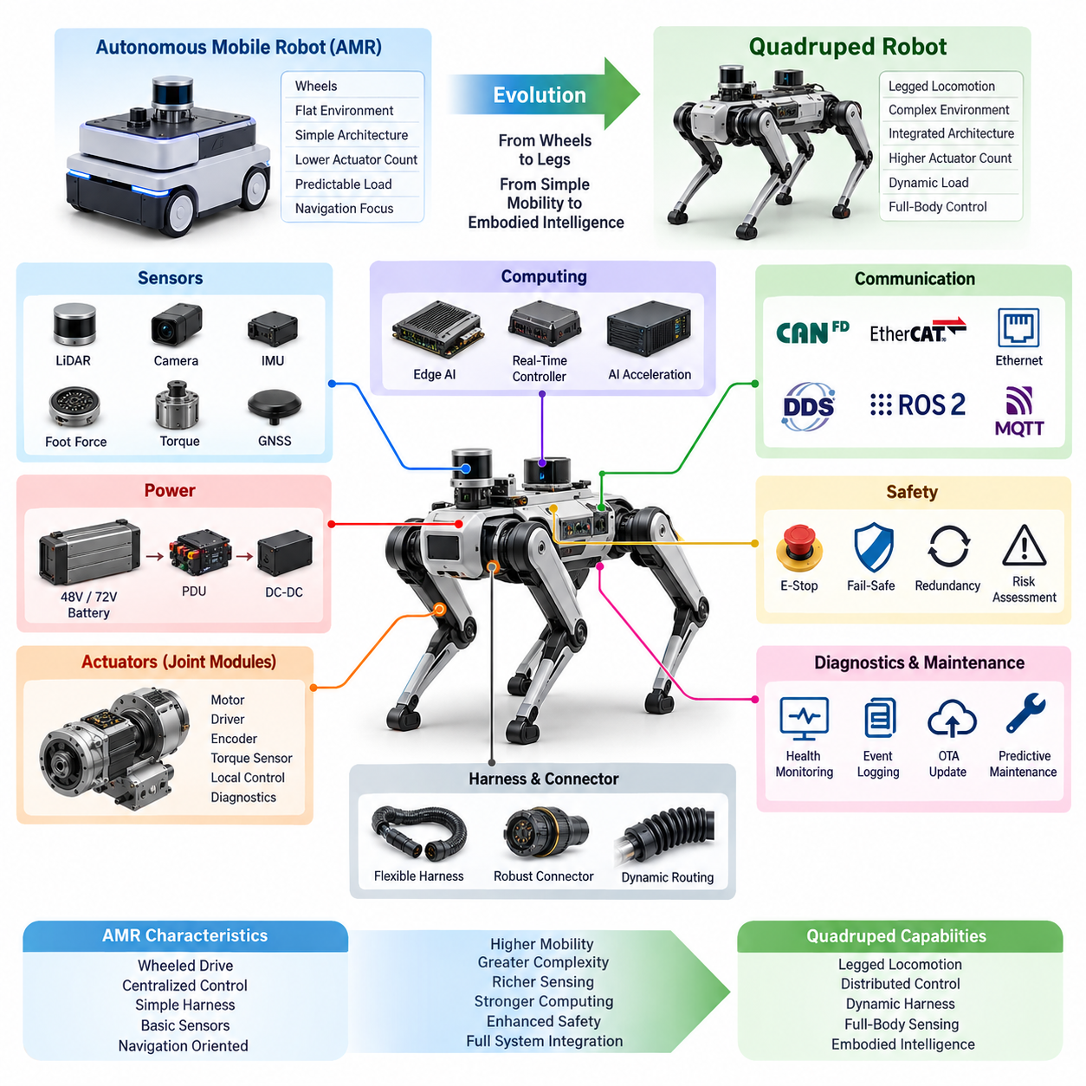
The evolution from an Autonomous Mobile Robot (AMR) to a quadruped robot represents a fundamental transition in both mechanical mobility and electrical system architecture. Conventional AMRs are primarily designed for relatively flat and structured environments, where wheels provide efficient and predictable motion. Their electrical architecture can therefore focus on traction motors, battery power, navigation sensors, and a centralized control system. Quadruped robots must instead coordinate multiple articulated legs, distributed actuators, high-speed feedback, and dynamic body motion, requiring a substantially more integrated electrical architecture.
An AMR generally separates mobility from the body structure through a small number of drive wheels and steering mechanisms. This simplifies power distribution, motor control, wiring, and sensing because the major electrical components remain relatively fixed within the chassis. In a quadruped, however, each leg becomes an active electromechanical subsystem. Hip, upper-leg, knee, lower-leg, and foot mechanisms require multiple actuators and feedback devices, while their cables must tolerate continuous movement. The transition therefore changes electrical design from a mostly static vehicle architecture into a highly dynamic distributed system.
The most important architectural change is the increase in actuator count and control bandwidth. A wheeled AMR can often control its motion using a limited number of traction motors, while a quadruped must continuously regulate multiple joints to maintain posture, balance, and locomotion. Each actuator may require motor power, position feedback, torque information, local control, diagnostics, and communication. This creates a distributed control architecture in which joint modules and leg-level subsystems interact with higher-level controllers rather than relying entirely on one centralized actuator-control structure.
Power architecture also becomes more demanding as the platform evolves toward quadruped mobility. AMRs can often use a relatively straightforward battery and power distribution system because their peak mechanical loads are comparatively predictable. Quadrupeds experience rapidly changing loads during standing, walking, climbing, jumping, and recovery from disturbances. Their power architecture therefore needs to support high transient currents, efficient voltage conversion, protected distribution, and appropriate battery integration. Architectures based on 48 V or 72 V can provide a practical foundation for distributing power while reducing current for a given power level.
The harness architecture changes together with the mechanical architecture. In an AMR, most harnesses can be routed through protected and relatively stationary chassis regions. Quadruped harnesses must pass through joints and moving leg structures, where repeated bending, twisting, vibration, and mechanical contact can create long-term reliability risks. The electrical design therefore requires trunk harnesses, flexible leg harnesses, dynamic cable routing, suitable connectors, environmental protection, and serviceability. IP67 or IP68-level protection may also become important when the robot operates outdoors or in demanding industrial environments.
Sensor architecture also expands from basic navigation toward full-body state estimation. An AMR can primarily depend on LiDAR, cameras, wheel odometry, IMU, and GNSS when appropriate. A quadruped requires these environmental sensors while also monitoring the internal physical state of the robot. Joint encoders, torque sensors, foot force sensing, and IMU measurements become essential for understanding body motion and ground interaction. These measurements must be synchronized and processed with sufficient temporal consistency to support stable locomotion, making sensor architecture closely connected with computing and communication architecture.
Computing architecture consequently evolves from navigation-oriented processing toward real-time embodied control. An AMR may use an embedded computer for perception, localization, planning, and fleet communication while dedicated motor controllers handle traction. A quadruped requires a real-time control layer capable of coordinating many actuators while a higher-level compute platform performs perception, locomotion planning, and AI inference. Jetson-class edge computing, real-time controllers, AI acceleration, PTP-based time synchronization, and appropriate compute redundancy can therefore become important elements of the overall architecture.
Communication requirements increase in parallel with system complexity. A relatively simple AMR may rely heavily on CAN or CAN FD for vehicle-level control and Ethernet for high-bandwidth perception and external connectivity. A quadruped can require CAN FD or EtherCAT for distributed actuator communication, Gigabit Ethernet for sensors and computing, and DDS/ROS 2 for higher-level robotic software integration. Time synchronization becomes particularly important because actuator commands, encoder feedback, IMU measurements, foot forces, and perception data must be interpreted within a consistent temporal framework.
Safety architecture must also evolve because the consequences of control failure become more significant when the robot dynamically balances itself. An AMR can generally stop by removing traction power, although safety requirements depend on its operating environment and application. A quadruped may need controlled transitions between motion, stable standing, emergency stopping, and fault recovery. Emergency-stop mechanisms, fail-safe and fail-operational strategies, redundancy, risk assessment, and field safety validation therefore become integral parts of the electrical architecture rather than isolated safety functions.
The evolution toward quadrupeds also changes the role of diagnostics and maintenance. With a small number of relatively simple drive components, AMR diagnostics can focus on battery status, motor faults, communication errors, sensor failures, and system-level health. A quadruped has many more potential failure points distributed across actuators, encoders, torque sensors, communication links, power supplies, and flexible harnesses. Continuous health monitoring, event logging, remote diagnostics, CAN-based diagnostics, OTA updates, and predictive maintenance can therefore become necessary to manage system complexity and maintain operational availability.
At the highest level, the transition from AMR to quadruped is not simply a change from wheels to legs. It is an architectural transition from a comparatively static mobile platform to a distributed electromechanical system in which power, actuation, sensing, computation, communication, safety, and AI must operate as one coordinated system. The later architecture therefore naturally progresses from system-level design through power and actuator modules, leg electrical design, harnesses and sensors, computing and communication, safety, diagnostics, and finally AI and Physical AI integration. This progression provides the foundation for developing quadruped platforms capable of reliable operation in increasingly complex environments.

01.02. Quadruped System Architecture
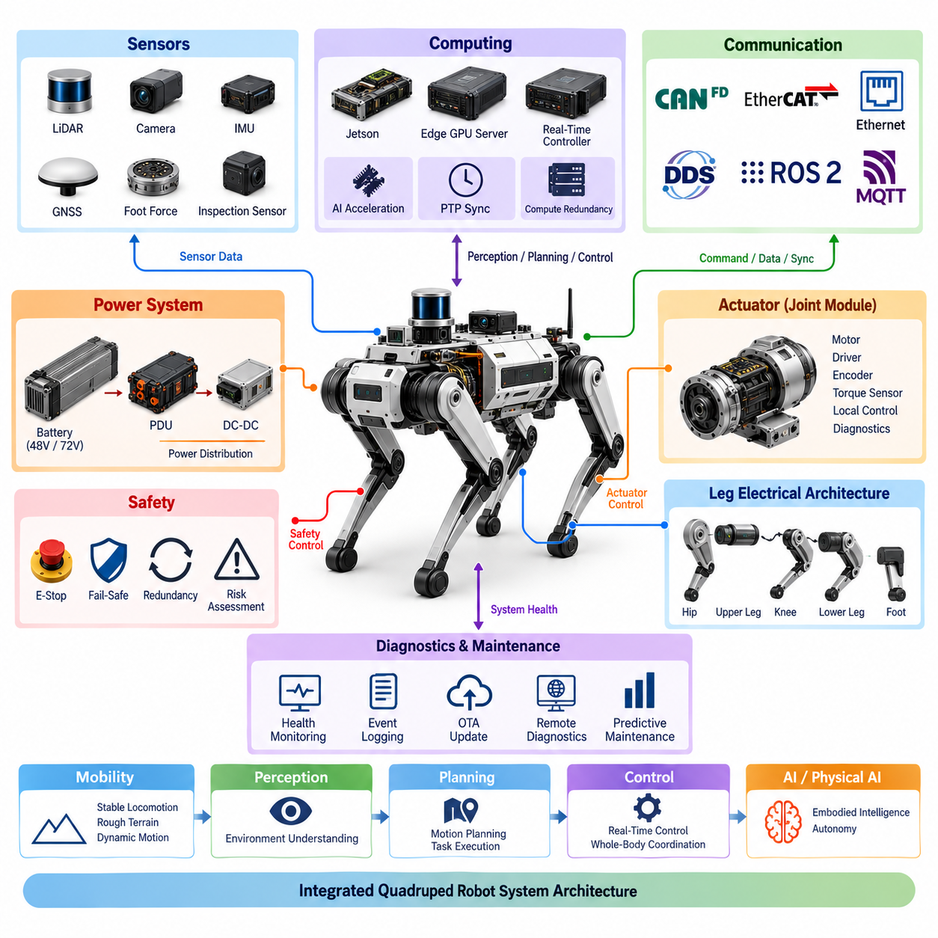
A quadruped robot system architecture is fundamentally organized as an integrated electromechanical system in which mobility, power, actuation, sensing, computing, communication, safety, diagnostics, and artificial intelligence operate as coordinated layers. Unlike a simple mobile platform, the quadruped must continuously connect body-level functions with four independently articulated legs. The system architecture therefore establishes clear relationships between the central body, distributed leg and joint modules, sensors, computing resources, communication networks, power distribution, and safety mechanisms.
At the system level, the central body functions as the primary integration domain for energy storage, power distribution, computing, communication, and major perception components. The four legs extend this architecture into distributed electromechanical domains, where each leg contains multiple functional modules associated with hip, upper-leg, knee, lower-leg, and foot structures. This arrangement allows the robot to distribute control and electrical functions closer to the physical mechanisms while maintaining coordinated operation through higher-level system controllers.
The architecture can therefore be understood as a hierarchy connecting system-level control with distributed actuation. High-level computing determines navigation, perception, motion planning, and AI-related functions, while real-time control functions translate these decisions into coordinated actuator commands. Joint modules provide local motor control and feedback, allowing the system to manage position, velocity, torque, and other actuator states. This separation between high-level intelligence and real-time control is essential for maintaining stable locomotion while supporting increasingly sophisticated Physical AI functions.
Power architecture forms another fundamental layer of the quadruped system. The battery supplies the primary energy source, while power distribution and conversion stages deliver appropriate electrical power to computing, sensors, communication devices, and distributed actuators. The system structure supports both 48 V and 72 V architectures, reflecting different requirements for power density, current levels, and actuator performance. Battery integration, hot-swappable battery concepts, power distribution units, and emergency power cutoff functions must be considered together because power availability directly affects mobility, safety, serviceability, and operational endurance.
The actuator layer converts electrical energy into controlled mechanical motion. A quadruped requires multiple joint modules distributed across its four legs, with each module potentially integrating a BLDC or PMSM motor, motor driver, encoder interface, torque sensing, local control, and diagnostic functions. This modular approach reduces the need to route every low-level control function back to a single central controller. Instead, electrical and control intelligence can be distributed near the actuators while the system-level architecture coordinates the behavior of all joints to produce stable and synchronized leg motion.
The leg electrical architecture connects these joint modules into complete functional legs. The hip, upper-leg, knee, lower-leg, and foot regions have different mechanical movements and electrical constraints, requiring appropriate power and signal routing throughout the leg. The architecture must accommodate continuous movement while maintaining reliable electrical connections and feedback. Consequently, leg integration cannot be treated simply as an extension of the central harness; it must be designed as a dynamic electrical subsystem that connects actuation, sensing, communication, and mechanical motion.
Sensing provides the robot with both internal state information and environmental information. The architecture includes IMU integration, foot force sensing, LiDAR, cameras, GNSS, and application-specific inspection sensors. Internal sensors provide information about body motion, contact, and actuator states, while external sensors support perception and localization. Combining these sources requires an architecture that can preserve meaningful timing relationships between measurements. This makes sensing closely connected to computing and communication, particularly when the robot performs dynamic locomotion or Physical AI tasks.
Computing is organized into complementary functional domains rather than being treated as a single processor. The architecture includes Jetson-based computing, an Edge GPU Server, a Real-Time Controller, AI acceleration, PTP time synchronization, and compute redundancy. High-level computing can support perception, planning, and AI inference, while real-time control handles time-sensitive actuator functions. This separation allows computationally intensive AI workloads to coexist with deterministic control requirements, creating a foundation for integrating increasingly capable embodied intelligence into the quadruped platform.
Communication architecture provides the infrastructure connecting these distributed functions. CAN FD and EtherCAT can support actuator and real-time device communication, while Gigabit Ethernet provides higher-bandwidth connections for sensors and computing resources. DDS and ROS 2 provide a software-oriented communication framework for robotic applications, while MQTT can support appropriate external or fleet-level communication functions. Time synchronization is treated as an explicit architectural concern because distributed sensing, control, and computing must share a consistent temporal reference for coordinated system behavior.
Safety is integrated across the architecture rather than being isolated in a single component. Risk assessment establishes system-level safety requirements, while emergency-stop mechanisms provide controlled responses to hazardous conditions. Fail-operational and fail-safe concepts define how the system should behave under different failure conditions, and redundancy can be introduced where continued operation or controlled recovery is required. Field safety validation then confirms that the implemented architecture behaves appropriately under realistic operating conditions. This creates a direct relationship between electrical architecture, control architecture, and physical robot safety.
The complete architecture also requires continuous diagnostics and lifecycle management. System health monitoring, CAN diagnostics, event logging, OTA updates, remote diagnostics, and predictive maintenance provide mechanisms for detecting failures, recording system behavior, maintaining software, and supporting long-term operation. These functions connect the physical electrical system with its software lifecycle and operational management. As the number of actuators, sensors, communication links, and computing resources increases, diagnostics become an essential architectural layer rather than an optional maintenance feature.
Ultimately, the quadruped system architecture is a coordinated hierarchy extending from energy and physical actuation to sensing, real-time control, communication, computing, safety, diagnostics, and Physical AI. The architecture defined at this level provides the foundation for the subsequent electrical design of power systems, joint modules, legs, harnesses, sensors, computing platforms, communication networks, and safety mechanisms. It also creates the interface through which higher-level AI, embodied intelligence, testing, validation, and future quadruped applications can be integrated without fundamentally redesigning the underlying electrical system.

01.03. Use Cases and Missions
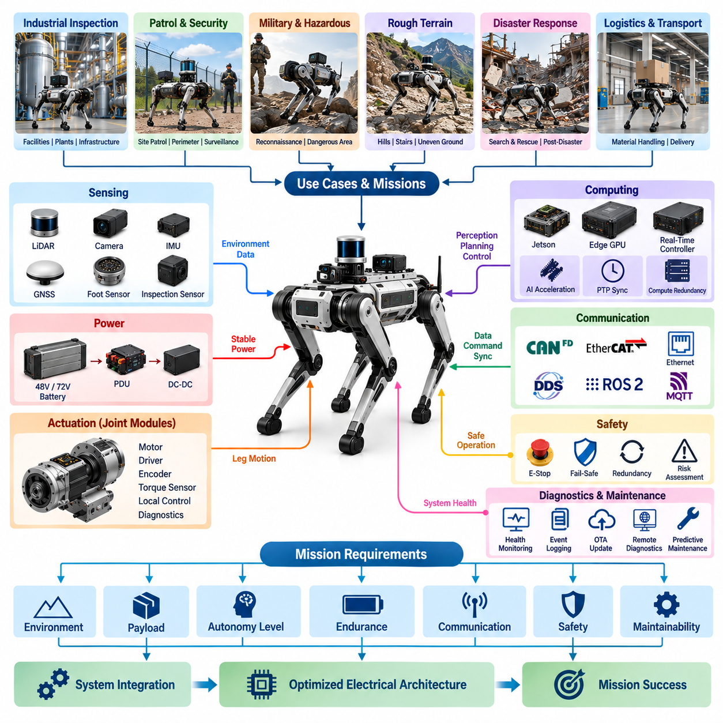
A quadruped robot can support missions that are difficult for wheeled Autonomous Mobile Robots (AMRs) because its legged structure provides greater mobility over uneven terrain and allows the body to maintain a controlled posture while moving. The appropriate use case, however, is not determined by mobility alone. Each mission creates different requirements for sensing, computing, power, communication, safety, endurance, and diagnostics. The electrical architecture must therefore be designed around the intended mission rather than treating the quadruped platform as a generic mobile robot.
Industrial inspection is one of the most important application areas for quadruped robots. A robot can be deployed in facilities where stairs, uneven floors, narrow passages, or other obstacles make wheeled mobility difficult. Inspection missions may require cameras, LiDAR, IMU, GNSS where available, and specialized inspection sensors to collect information while the robot moves through the environment. The electrical architecture must consequently provide stable sensor power, reliable data communication, accurate timing, and sufficient computing capability for perception and inspection-related processing.
Patrol and security-oriented missions place greater emphasis on autonomous mobility, environmental perception, continuous operation, and reliable communication. A quadruped may need to move through outdoor or semi-structured environments while maintaining awareness of obstacles and mission conditions. The electrical system must support sensing, computing, communication, and actuator control continuously rather than treating each function as an independent subsystem. This makes power management, system health monitoring, communication reliability, and fail-safe behavior important elements of the mission-oriented architecture.
Military and hazardous-environment missions impose additional requirements because the robot may need to operate where direct human access is undesirable or unsafe. The system architecture must therefore support remote operation, robust perception, reliable locomotion, and controlled responses to faults. The structure of this volume explicitly includes military quadrupeds as a case-study area, together with functional safety, redundancy, diagnostics, and field validation. These elements indicate that mission success must be considered together with the robot's ability to remain controllable and recover safely when individual components or subsystems experience failures.
The physical environment strongly influences quadruped mission requirements. Indoor inspection, outdoor patrol, industrial sites, and difficult terrain can produce very different demands on the robot's electrical and mechanical systems. Rough terrain increases dynamic loads and requires accurate feedback from joint sensors, IMU systems, and foot-contact sensing. Outdoor operation can also increase requirements for environmental protection, GNSS integration, and communication range. Consequently, mission definition should precede detailed electrical design because environmental conditions directly affect actuator loads, sensing requirements, power consumption, harness protection, and system reliability.
Inspection missions also demonstrate why payload and sensor integration must be considered at the system level. A quadruped may carry cameras, LiDAR, or dedicated inspection equipment while simultaneously performing locomotion and real-time control. Additional payload can increase power consumption and alter the mechanical load on the legs. The electrical architecture must therefore provide sufficient power distribution and computing capacity while preserving the control performance required for stable movement. Sensor integration cannot be separated from the actuator, power, and computing architecture because all of these functions compete for available system resources.
Different missions also require different levels of autonomy. A simple remote-controlled mission may primarily require reliable command communication and low-level real-time control, while a more autonomous mission requires perception, localization, planning, and AI-based decision functions. The architecture defined for the quadruped platform includes Jetson computing, Edge GPU capability, real-time control, AI acceleration, and Physical AI integration. These capabilities allow the same basic platform architecture to evolve from remote operation toward increasingly autonomous and intelligent mission execution.
Mission duration introduces another important architectural consideration. Short inspection tasks may tolerate a relatively simple battery strategy, while long-duration patrol or field missions require careful management of energy consumption, battery capacity, charging, and potentially battery replacement. The electrical architecture therefore needs to connect mission duration with battery and power-distribution design. The broader structure includes 48 V and 72 V power architectures, battery integration, hot-swap battery concepts, and emergency power cutoff, providing the foundation for adapting the platform to different operational endurance requirements.
Communication requirements also depend strongly on the mission. A local industrial inspection task may primarily require communication between sensors, controllers, and onboard computing, while a remote mission may additionally require reliable external communication with an operator or mission-management system. The quadruped architecture includes CAN FD, EtherCAT, Gigabit Ethernet, DDS/ROS 2, MQTT, and time synchronization. These communication layers allow low-level actuator control, high-bandwidth sensor data, robotic software communication, and external connectivity to be organized according to their different timing and bandwidth requirements.
Safety requirements become particularly important when quadrupeds operate near people, expensive equipment, or hazardous environments. A mission-oriented design must consider what happens when an actuator, sensor, communication link, power component, or computing resource fails. Emergency stop, fail-safe operation, fail-operational strategies, redundancy, risk assessment, and field safety validation are therefore not independent features but part of the mission definition itself. A robot that can complete a task under normal conditions but cannot respond safely to faults should not be considered mission-ready.
Mission capability also depends on maintainability because quadrupeds contain many distributed electrical and electromechanical components. Long-duration industrial or field missions require the system to detect abnormal conditions before they become complete failures. Health monitoring, CAN diagnostics, event logging, OTA updates, remote diagnostics, and predictive maintenance therefore become operational capabilities rather than merely engineering support functions. These functions allow mission operators and engineers to understand system condition, investigate failures, update software, and maintain availability over the robot's operational lifecycle.
The relationship between use case and electrical architecture ultimately becomes a process of matching mission objectives to system capabilities. Industrial inspection emphasizes sensing and inspection payloads; patrol emphasizes mobility, perception, communication, and endurance; hazardous or military applications place stronger emphasis on robustness, remote operation, safety, and redundancy. The specific case studies identified in the architecture include Boston Dynamics Spot, Unitree B2, Go2, military quadrupeds, industrial inspection, and future quadruped electrical architectures. These examples provide a progression from existing commercial platforms toward more demanding mission-oriented electrical architectures.
A quadruped platform should therefore be understood as a mission-adaptable physical system rather than a single-purpose robot. The fundamental electrical architecture provides common capabilities for power, actuation, sensing, computing, communication, safety, and diagnostics, while mission-specific requirements determine how these capabilities are configured and prioritized. This approach allows one electrical platform to support different operational roles without redesigning the entire system for every application. The subsequent performance requirements and detailed electrical architecture can then be derived directly from the environmental, functional, safety, endurance, and autonomy requirements established by the intended mission.

01.04. Performance Requirements
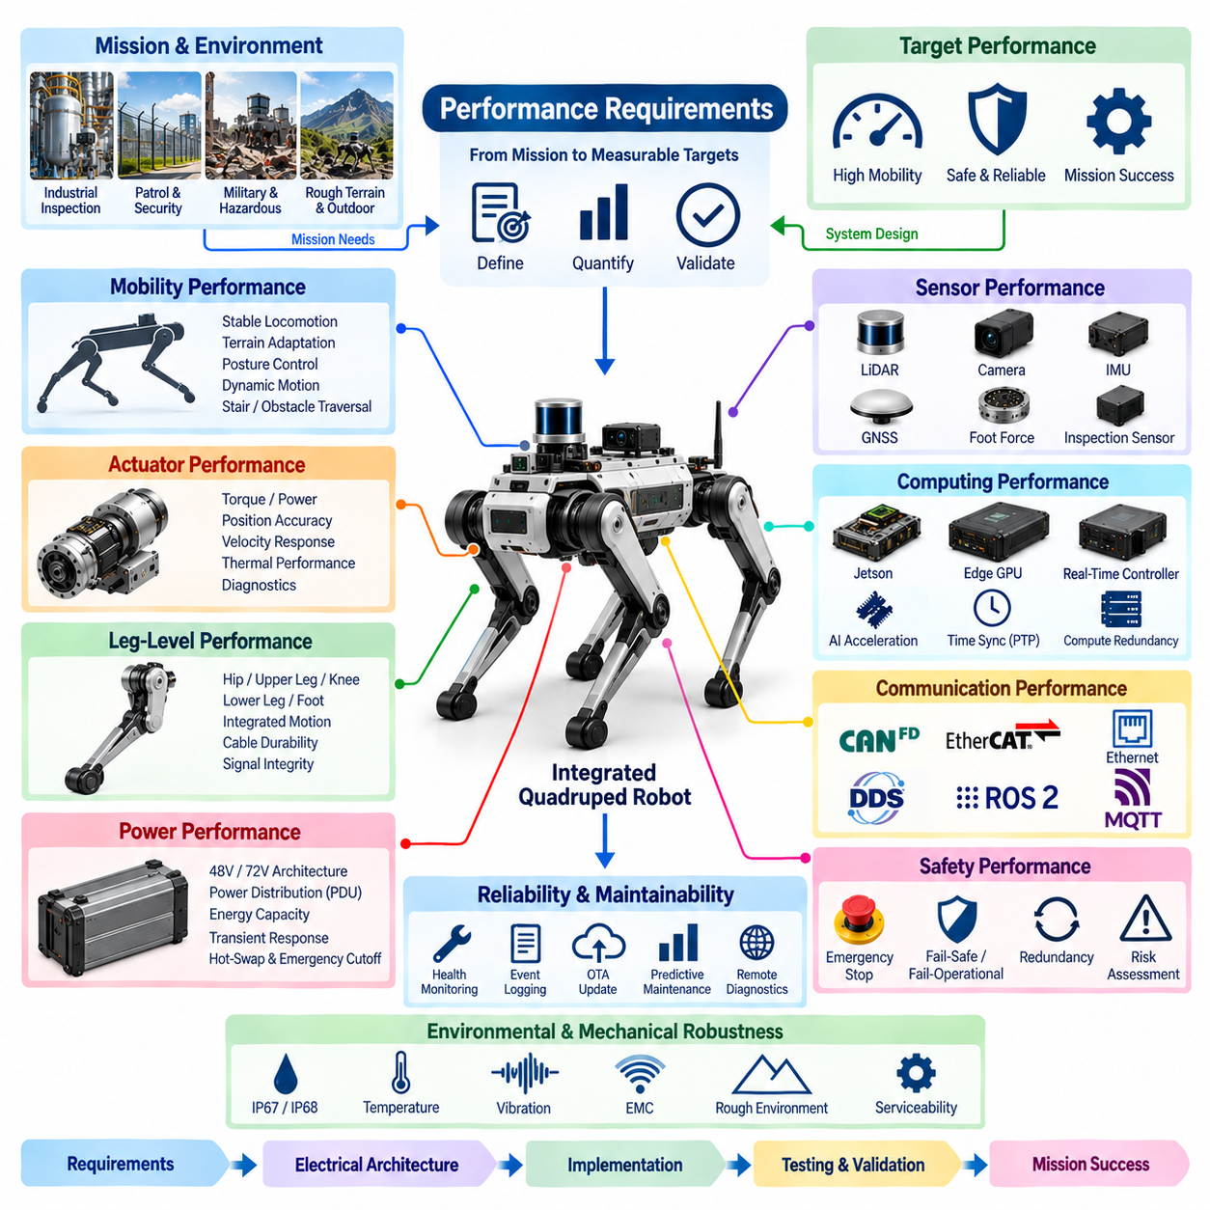
Performance requirements for a quadruped robot must be defined as system-level requirements that connect mobility, actuation, sensing, computing, communication, power, safety, diagnostics, and environmental durability. The requirements cannot be established independently for each subsystem because quadruped operation depends on the coordinated behavior of all four legs and the central body. A useful performance definition therefore begins with the intended mission and environment, then translates those conditions into measurable requirements for electrical, mechanical, computational, and control functions. The architecture structure places performance requirements before detailed electrical architecture, emphasizing this system-level relationship.
Mobility performance is one of the primary requirements because the fundamental advantage of a quadruped is its ability to move through environments that may be difficult for wheeled robots. The required performance includes stable locomotion, coordinated movement of multiple legs, posture control, and the ability to maintain operation under changing terrain conditions. These requirements directly influence actuator capability, encoder feedback, torque sensing, IMU performance, foot-force sensing, and real-time control. The electrical architecture must therefore provide sufficient power, feedback bandwidth, communication capability, and control responsiveness to support the required locomotion behavior.
Actuator performance must be defined in relation to the physical demands placed on each joint. The architecture identifies BLDC/PMSM selection, integrated motor drivers, encoder interfaces, torque sensor interfaces, and joint-module diagnostics as dedicated design areas. This indicates that performance cannot be represented only by motor power or peak torque. Position accuracy, velocity response, torque control, feedback quality, thermal behavior, diagnostic capability, and communication responsiveness must also be considered. The joint module must provide predictable behavior across its operating range so that higher-level controllers can coordinate all joints without being dominated by individual actuator uncertainty.
Leg-level performance extends the actuator requirements into complete functional structures. The architecture separates the hip, upper leg, knee, lower leg, foot, and leg integration functions, reflecting the different mechanical and electrical roles within a quadruped leg. Performance requirements therefore need to consider how individual joint modules interact during coordinated motion. Electrical power delivery, signal integrity, dynamic cable behavior, sensor feedback, and communication must remain reliable while the leg repeatedly moves through its operating range. A leg that performs well in an isolated actuator test may still fail to meet system requirements if integration introduces excessive latency, interference, cable stress, or feedback instability.
Power performance must support both continuous operation and dynamic load conditions. The architecture defines dedicated 48 V and 72 V power architectures, PDU design, battery integration, hot-swap battery capability, and emergency power cutoff. These elements indicate that the performance definition must include power availability, distribution stability, conversion efficiency, transient response, protection, and energy capacity. Battery performance must also be considered together with mission duration and actuator demand because locomotion can produce rapidly changing power requirements. The power system must provide sufficient energy and instantaneous capability without compromising safety or the operation of computing, sensing, communication, and control functions.
Sensor performance must support both environmental understanding and internal robot-state estimation. The architecture identifies IMU integration, foot-force sensing, LiDAR, cameras, GNSS, and inspection sensors as distinct areas. Their requirements therefore extend beyond simple sensor accuracy. Timing consistency, data availability, synchronization, robustness, mounting stability, environmental protection, and communication performance can all affect the quality of the information available to the controller. For a dynamic quadruped, delayed or poorly synchronized sensor information can directly influence balance and locomotion, making sensor performance inseparable from computing and time-synchronization performance.
Computing performance must accommodate both deterministic control and increasingly demanding AI workloads. The architecture separates Jetson architecture, Edge GPU Server, Real-Time Controller, AI acceleration, PTP time synchronization, and compute redundancy. This structure suggests that computing requirements should be defined according to function rather than simply by processor specifications. Real-time control requires predictable timing and response, while perception, planning, and AI inference may require substantial computational throughput. The performance target must therefore balance latency, throughput, determinism, thermal constraints, power consumption, and system availability across the different computing domains.
Communication performance provides the foundation for coordinating distributed electrical and software functions. CAN FD and EtherCAT are identified alongside Gigabit Ethernet, DDS/ROS 2, MQTT, and time synchronization. These technologies serve different communication roles, so their performance requirements should reflect bandwidth, latency, determinism, reliability, synchronization accuracy, and fault behavior. Actuator communication may prioritize deterministic and time-sensitive behavior, while cameras and other high-bandwidth sensors require substantially greater data capacity. Higher-level robotic software may prioritize flexible data distribution and integration. The architecture must therefore avoid treating all communication as one homogeneous network.
Safety performance must be defined according to the consequences of failures and hazardous operating conditions. The architecture explicitly includes risk assessment, emergency stop, fail-operational design, fail-safe architecture, redundancy, and field safety validation. Performance requirements should therefore specify not only normal operating behavior but also the expected response when sensors, actuators, communication links, computing resources, or power components fail. A safety function must respond within an appropriate time, place the robot into an acceptable state, and prevent a localized failure from creating an uncontrolled system condition. Safety performance is consequently a system property rather than an isolated component specification.
Environmental and mechanical robustness are also essential performance dimensions for a quadruped. The harness and connector architecture includes dynamic cable routing, IP67/IP68 design, connector selection, and serviceability, while the testing structure includes EMC, IP, vibration, field, and reliability testing. These elements indicate that the robot must maintain electrical and functional performance under environmental and mechanical stress. Water and dust protection, vibration resistance, electromagnetic compatibility, connector integrity, and repeated harness movement can all influence long-term operation. Performance requirements should therefore describe not only what the robot can do under laboratory conditions but also how consistently it can perform in its intended field environment.
Reliability and maintainability requirements extend performance evaluation across the robot's operational lifecycle. System health monitoring, CAN diagnostics, OTA updates, event logging, remote diagnostics, and predictive maintenance are explicitly included in the architecture. These functions allow performance degradation and abnormal behavior to be detected before they become severe failures. Reliability should therefore be considered in terms of continued system availability, fault detection, fault isolation, recovery, serviceability, and software maintenance. A quadruped intended for repeated industrial or field missions must maintain predictable performance over time rather than achieving its performance target only during initial testing.
Ultimately, quadruped performance requirements should form a traceable chain from mission objectives to system behavior and then to individual subsystem specifications. Mobility requirements influence actuators and sensing; actuator requirements influence power and thermal design; sensor requirements influence computing, communication, and synchronization; safety requirements influence redundancy and control architecture; and endurance requirements influence battery and power distribution. The subsequent electrical architecture can then be evaluated against these requirements through electrical, EMC, IP, vibration, field, and reliability testing. This creates a closed engineering loop in which requirements define the architecture, architecture enables implementation, and validation demonstrates whether the complete quadruped system achieves the intended mission performance.

01.05. Electrical Architecture Overview
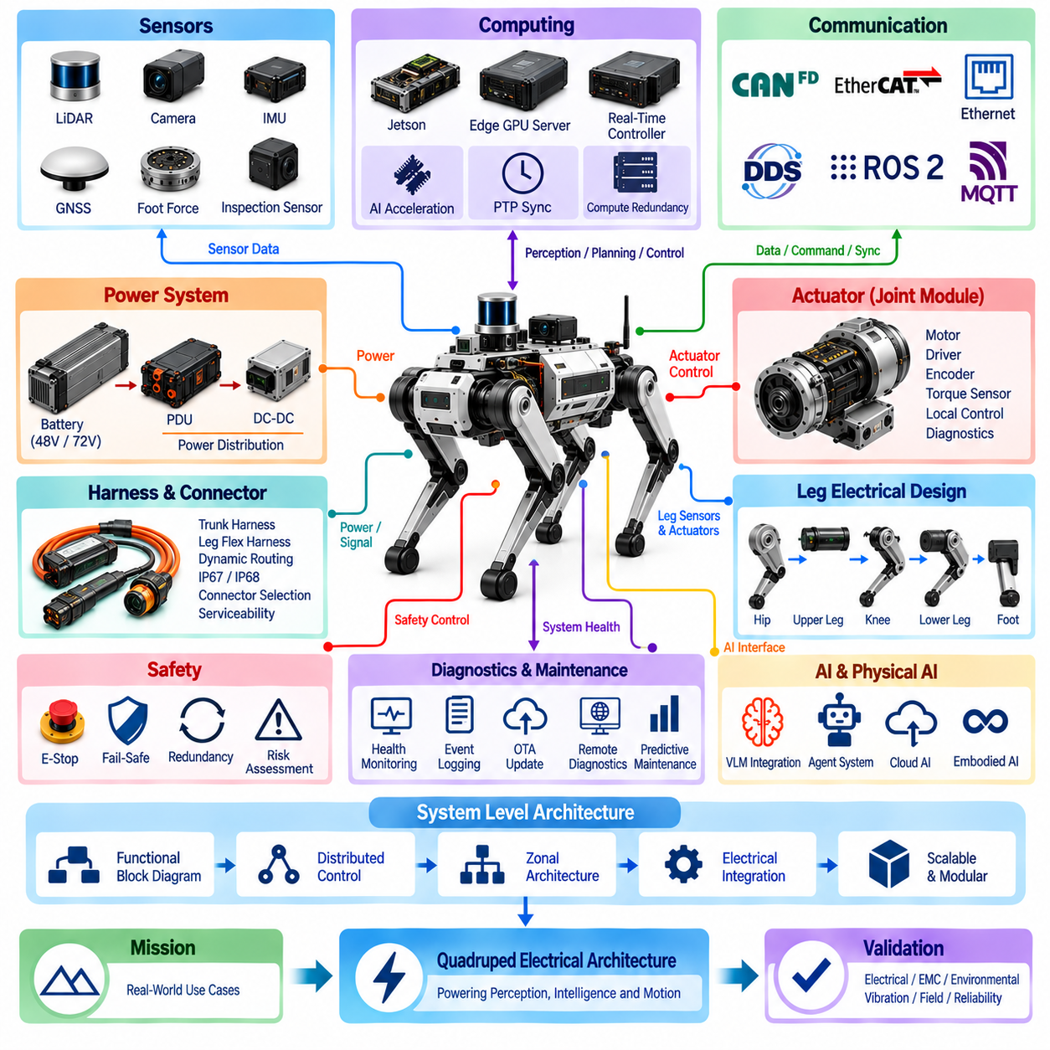
The electrical architecture of a quadruped robot provides the structural framework that connects energy storage, power distribution, actuators, sensors, computing resources, communication networks, safety functions, and diagnostic services into one coordinated physical system. Because four articulated legs must operate simultaneously with perception and higher-level intelligence, the architecture must support both distributed real-time functions and centralized system integration. It therefore establishes electrical boundaries and interfaces that allow individual subsystems to operate independently while remaining synchronized with the complete robot.
At the system level, the architecture progresses from functional organization toward distributed and zonal electrical structures. The volume separates functional block diagrams, distributed control architecture, zonal electrical architecture, computing architecture, and safety architecture into dedicated design topics. This organization reflects the need to determine where electrical functions are physically located, how controllers are distributed, and how power and data move between the central body and four legs. A clear system-level architecture reduces unnecessary wiring and provides a foundation for modularity, fault isolation, maintenance, and future expansion.
Power architecture forms the energy backbone of the robot. The defined structure includes 48 V and 72 V architectures, Power Distribution Unit design, battery integration, hot-swap battery capability, and emergency power cutoff. The battery supplies the primary electrical energy, while the PDU distributes protected power to actuator, computing, sensing, and auxiliary domains. DC-DC conversion can then provide the voltage levels required by lower-voltage electronics. This hierarchical power structure allows high-power joint actuation and sensitive electronic loads to coexist while maintaining appropriate protection and distribution boundaries.
Actuator electrical architecture represents the primary interface between electrical energy and physical motion. Each joint module can integrate a BLDC or PMSM motor, motor driver, encoder interface, torque sensor interface, and diagnostic functions. Distributing these functions close to the joint reduces the need to route low-level motor signals across the entire robot and creates a modular actuator architecture. Higher-level controllers can therefore exchange commands and state information with intelligent joint modules while local electronics handle motor commutation, feedback acquisition, and actuator-level control.
The four legs extend this distributed architecture into mechanically dynamic regions. Separate design areas are defined for the hip, upper leg, knee, lower leg, foot, and complete leg integration. Electrical interfaces must remain reliable while joints repeatedly rotate and the leg experiences vibration, impact, and changing mechanical loads. Power conductors, communication lines, sensor signals, and local electronics must therefore be integrated with the mechanical structure rather than added afterward. The leg becomes a distributed electrical subsystem whose performance depends on both electrical design and physical packaging.
Harness and connector engineering provides the physical connectivity between these electrical domains. The architecture distinguishes the trunk harness from flexible leg harnesses and explicitly includes dynamic cable routing, IP67/IP68 design, connector selection, and serviceability. The central body can use relatively protected routing, while leg harnesses must tolerate repeated bending and motion. Connector and cable choices must therefore consider current capacity, signal integrity, environmental sealing, mechanical retention, repeated movement, accessibility, and replacement. Harness architecture becomes a major reliability element because every distributed electrical function ultimately depends on physical interconnection.
Sensor architecture supplies information about both the robot itself and its surroundings. The defined system includes IMU integration, foot-force sensing, LiDAR, cameras, GNSS, and inspection sensors. Internal sensing supports body-state estimation, contact detection, and locomotion control, while environmental sensors provide information for perception, localization, navigation, and mission execution. These sensors have different power, bandwidth, timing, and physical-interface requirements. Their electrical integration therefore requires coordinated power supply, communication interfaces, mounting, synchronization, and data delivery to the appropriate computing domain.
Computing architecture provides the processing hierarchy required to transform sensor information into coordinated physical action. The structure includes Jetson architecture, Edge GPU Server, Real-Time Controller, AI acceleration, PTP time synchronization, and compute redundancy. Real-time controllers can handle deterministic control functions, while higher-performance processors execute perception, planning, and AI workloads. This division prevents computationally intensive intelligence functions from directly compromising time-critical actuator control. Time synchronization then establishes a common temporal reference across distributed sensing, computing, and control functions.
Communication architecture connects the distributed controllers, sensors, computing resources, and external systems. CAN FD, EtherCAT, Gigabit Ethernet, DDS/ROS 2, MQTT, and time synchronization are treated as separate architectural topics because they address different communication requirements. Actuator networks require predictable control communication, high-bandwidth sensors require greater data capacity, and robotic software requires flexible information exchange between processes and computers. The complete electrical architecture can therefore use multiple communication domains rather than forcing all devices onto a single network technology.
Safety architecture overlays the power, control, communication, and actuation domains. The defined structure includes risk assessment, emergency stop, fail-operational design, fail-safe architecture, redundancy, and field safety validation. An emergency condition may require coordinated responses from power distribution, controllers, communication networks, and actuators rather than simply disconnecting one electrical circuit. Safety architecture must therefore define how faults are detected, how hazardous energy or motion is controlled, and which functions must remain available during degraded operation. Redundancy can then be applied selectively where continued operation or controlled recovery is required.
Diagnostics and OTA functions provide visibility into the increasingly distributed electrical system. System health monitoring, CAN diagnostics, OTA updates, event logging, remote diagnostics, and predictive maintenance allow the robot to detect abnormal conditions, preserve failure information, maintain software, and support field service. Because faults may originate in joint electronics, sensors, harnesses, communication links, power devices, or computing systems, diagnostic information must be collected across multiple architectural domains. This creates a system-wide health layer that supports fault isolation and lifecycle management.
The electrical architecture also provides the physical foundation for AI and Physical AI integration. The volume connects VLM integration, agent systems, Edge AI architecture, Cloud AI architecture, embodied AI interfaces, and foundation-model integration with the underlying robot platform. Higher-level intelligence ultimately depends on reliable sensor data, synchronized computing, deterministic control, communication, and available electrical power. Physical AI should therefore be viewed as an upper architectural capability built upon the electrical and control infrastructure rather than as an independent software function detached from the physical robot.
Taken as a whole, the quadruped electrical architecture forms a layered but tightly integrated structure connecting battery energy to physical action and environmental information to intelligent decision-making. Power enables actuation and computing; sensors describe robot and environment states; communication transports commands and data; computing transforms information into decisions; safety constrains system behavior; and diagnostics preserve operational health. The subsequent chapters develop each of these domains in greater detail, while testing and validation ultimately verify their combined electrical, EMC, environmental, vibration, field, and reliability performance.

