Volume 20. Quadruped Electrical Architecture

Chapter 11. Diagnostics and OTA

11.01. System Health Monitoring
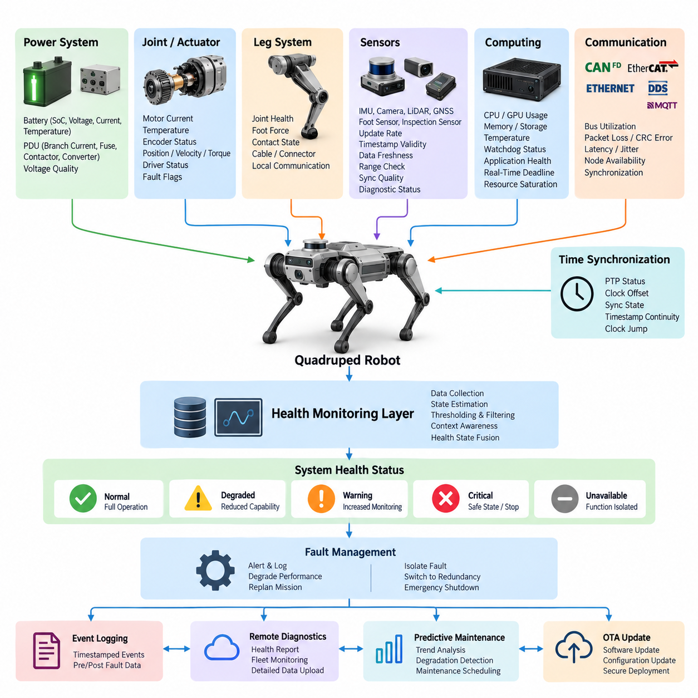
System health monitoring in a quadruped robot is the continuous observation of electrical, computational, communication, sensing, and actuator conditions that determine whether the machine can safely perform its mission. Unlike a stationary industrial system, a quadruped experiences rapidly changing loads, repeated impacts, vibration, joint motion, and environmental exposure, so health information must be evaluated continuously during operation.
A practical monitoring architecture combines information from the battery management system, power distribution unit, joint controllers, real-time controller, AI computer, sensors, communication interfaces, and safety controller. These components generate measurements and diagnostic states at different rates. The monitoring layer converts this distributed information into a coherent representation of overall robot condition rather than treating each subsystem as an isolated diagnostic domain.
Power health begins with continuous observation of battery voltage, current, state of charge, temperature, cell imbalance, insulation condition where applicable, and abnormal charge or discharge behavior. The power distribution system should additionally report branch currents, fuse or electronic protection states, contactor conditions, converter outputs, and voltage quality. Sudden voltage sag during high-torque locomotion can therefore be distinguished from persistent battery or distribution faults.
Joint health monitoring is especially important because locomotion depends on coordinated operation of multiple high-power actuators. Each joint controller can expose motor current, phase current, winding temperature, driver temperature, encoder status, commanded and measured position, velocity, estimated torque, and internal fault flags. Comparing these signals allows the system to recognize abnormal friction, overload, sensor disagreement, thermal stress, or deteriorating actuator performance before complete failure.
The leg-level monitor aggregates joint information with foot force, contact state, and local communication status. A joint that remains electrically functional may still behave abnormally when mechanical resistance, cable degradation, encoder instability, or impact damage develops. Cross-checking commanded motion against measured motion and expected contact forces therefore provides stronger diagnostic evidence than a single threshold. Repeated deviations can be classified as persistent degradation rather than transient terrain disturbances.
Sensor health requires more than checking whether data packets continue to arrive. IMUs, cameras, LiDAR, GNSS, foot sensors, and inspection sensors should be evaluated for update frequency, timestamp validity, data freshness, range plausibility, synchronization quality, and internal diagnostic status. A sensor producing stale or temporally misaligned data may be more dangerous than a completely unavailable sensor because apparently valid measurements can silently corrupt localization, perception, and control.
Computing health monitoring covers the real-time controller, Jetson or other AI processor, GPU resources, storage, memory, operating temperature, processor utilization, watchdog state, and application execution. The architecture should distinguish resource saturation from actual hardware failure. Persistent GPU overload, memory exhaustion, thermal throttling, or missed real-time deadlines can progressively reduce perception and planning capability even when the computing platform continues to respond to ordinary network requests.
Communication health must reflect the heterogeneous network architecture of the robot, including CAN FD, EtherCAT, Gigabit Ethernet, DDS/ROS 2, and other supervisory channels identified in the quadruped architecture. Monitoring can include bus utilization, packet loss, CRC errors, retransmissions, node availability, communication latency, jitter, and timeout frequency. These measurements help separate a defective endpoint from congestion, wiring degradation, synchronization failure, or network-wide disturbance.
Time synchronization is itself a health variable because distributed sensing and control depend on consistent temporal references. PTP status, clock offset, synchronization state, timestamp continuity, and detected clock jumps should therefore be monitored alongside ordinary network metrics. If synchronization accuracy moves outside an allowed operating envelope, sensor fusion and distributed control functions can be degraded or isolated even though the associated sensors and controllers remain electrically healthy.
Raw diagnostic signals become useful only when converted into interpretable health states. A hierarchical model can summarize component conditions into joint, leg, perception, compute, power, communication, and robot-level health. Typical states may represent normal operation, degraded operation, warning, critical fault, and unavailable functionality. The important principle is that state transitions should combine persistence, severity, operational context, and confidence instead of responding blindly to every instantaneous threshold crossing.
Threshold design must account for the highly dynamic behavior of quadruped locomotion. Motor current that indicates overload while standing may be completely normal during jumping, climbing, recovery, or acceleration. Battery voltage sag and processor load can also vary strongly with mission state. Health logic should therefore use operating envelopes, filtering, hysteresis, duration conditions, rate-of-change detection, and mission context to reduce false alarms while preserving rapid detection of genuinely dangerous conditions.
Watchdogs provide an independent mechanism for detecting functions that stop progressing even when ordinary diagnostic values appear valid. Hardware and software watchdogs can supervise controller execution, communication heartbeat, actuator command freshness, safety processes, and critical application loops. A missed heartbeat should not automatically imply identical responses for every subsystem; the required reaction depends on whether redundancy exists and whether the affected function is necessary for stabilization, perception, locomotion, or mission execution.
Health monitoring becomes operationally valuable when it is connected to fault management. A warning may only require logging and increased observation, while a persistent degraded condition can trigger reduced speed, restricted gait, reduced payload, sensor substitution, or mission replanning. Critical failures may require controlled stopping, stabilization, isolation of faulty power branches, transition to redundant computation, or emergency shutdown according to the functional safety architecture established for the robot.
Diagnostic information should preserve the sequence of events surrounding a failure. Health-state transitions, sensor abnormalities, power disturbances, communication errors, watchdog events, actuator faults, and software conditions should be timestamped using a common time reference. This provides the foundation for the event logging, remote diagnostics, and predictive maintenance functions that follow system health monitoring within the Diagnostics and OTA chapter structure.
Remote health reporting should transmit summarized information rather than indiscriminately streaming every internal signal. Robot identity, mission state, battery condition, subsystem health, active diagnostic codes, thermal margins, communication quality, and critical events can form a compact health report for fleet supervision. Detailed high-frequency traces can remain locally buffered and be uploaded when a significant event occurs, enabling deeper investigation without continuously consuming network bandwidth.
The monitoring architecture should also separate detection from diagnosis. Detection answers whether observed behavior has departed from its acceptable operating envelope, while diagnosis attempts to identify the likely source and propagation path. For example, several simultaneous joint undervoltage events may originate from a battery or PDU disturbance rather than independent actuator failures. Correlating events across power, communication, computing, sensing, and actuation domains reduces misleading fault conclusions.
Health history creates the transition from reactive diagnostics toward predictive maintenance, which is explicitly positioned later in the chapter structure. Trends in motor current, temperature, encoder errors, battery resistance indicators, communication error rates, connector-related intermittency, and computation margins can reveal gradual degradation. Maintenance can then be scheduled according to measured condition and accumulated stress rather than relying only on fixed service intervals.
Ultimately, system health monitoring forms the observability layer connecting the quadruped's electrical architecture with functional safety, diagnostics, OTA management, remote operation, and maintenance. Its purpose is not merely to report faults after they occur, but to maintain an evolving estimate of whether the robot can continue its current mission safely, whether capability should be degraded, and what evidence must be preserved for engineering analysis and future reliability improvement.

11.02. CAN Diagnostics [w/Code]
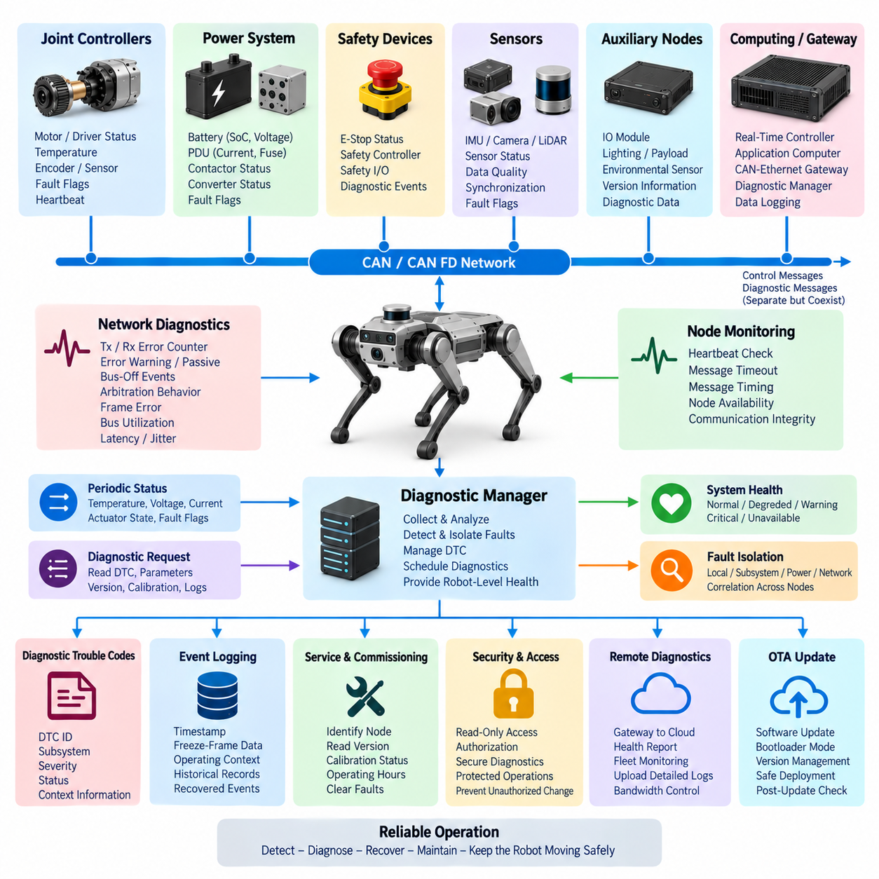
CAN diagnostics in a quadruped robot provides a structured mechanism for observing, identifying, and isolating faults across distributed electronic controllers connected through CAN or CAN FD networks. Joint controllers, power modules, battery systems, safety devices, and auxiliary nodes continuously exchange operational data, while diagnostic information allows supervisory software to determine whether each node is communicating correctly and operating within its expected electrical and functional limits.
The diagnostic architecture should distinguish normal control traffic from diagnostic information without allowing diagnostic activity to interfere with deterministic motion control. Periodic status messages can report temperatures, voltages, currents, actuator states, and fault flags, while dedicated diagnostic requests retrieve detailed information when required. CAN FD is particularly useful because its larger payload capacity enables richer diagnostic records to be transferred while preserving compatibility with distributed embedded control architectures.
Network-level diagnostics begins with monitoring communication integrity. CAN controllers provide information such as transmit and receive error counters, error-warning conditions, error-passive states, bus-off events, arbitration behavior, and frame errors. These indicators reveal whether communication degradation originates from an individual node, physical wiring problem, termination fault, electromagnetic interference, excessive bus utilization, or a controller that repeatedly generates invalid traffic.
A healthy CAN node should transmit expected heartbeat or status messages within defined timing limits. The supervisory controller can maintain a node table containing expected message identifiers, update periods, timeout thresholds, and current communication states. If a joint controller stops transmitting, the system can classify it as unavailable after a defined timeout rather than waiting for higher-level locomotion software to discover the failure indirectly through missing actuator response.
CAN diagnostics should also evaluate message timing rather than checking only message presence. Increased latency, irregular transmission periods, excessive jitter, or repeated deadline violations may indicate bus saturation or deteriorating controller performance before complete communication loss occurs. Comparing observed message intervals with their configured periods allows the monitoring system to identify gradual communication degradation and provides useful evidence when diagnosing intermittent failures.
Physical-layer problems often appear as communication symptoms before they become complete network failures. Loose connectors, damaged twisted-pair wiring, incorrect termination resistance, grounding problems, water ingress, or electromagnetic interference can increase error counters and produce intermittent frame loss. Correlating CAN error statistics with robot motion, vibration, temperature, and leg position can help identify faults that occur only when a harness bends or a connector experiences mechanical stress.
Node-level diagnostics should expose internal conditions through compact status words or diagnostic messages. A joint controller may report motor overcurrent, driver overtemperature, encoder failure, torque sensor disagreement, undervoltage, overvoltage, communication timeout, or internal software faults. The battery management system and power distribution unit can similarly report battery protection events, contactor state, branch faults, converter abnormalities, and other conditions relevant to robot-level health assessment.
Diagnostic trouble codes can provide a consistent abstraction above vendor-specific fault registers. Each code should identify the affected subsystem, fault category, severity, status, and sufficient contextual information for troubleshooting. The diagnostic layer can map low-level controller faults into robot-level meanings such as actuator degraded, leg unavailable, power supply unstable, or communication unreliable. This prevents higher-level software from depending directly on hardware-specific register definitions.
Fault information should distinguish active, intermittent, historical, and recovered conditions. An active fault represents a condition currently affecting operation, while an intermittent fault records behavior that appears and disappears. Historical records preserve evidence after recovery or reboot. This distinction is important for quadruped robots because vibration, repeated impacts, dynamic harness movement, and rapidly changing actuator loads can create temporary electrical faults that cannot be reproduced easily during stationary maintenance.
Diagnostic messages should preserve contextual data around significant events. When an overcurrent or communication fault occurs, associated information such as timestamp, joint position, velocity, motor current, temperature, supply voltage, robot gait, and network state can be captured as freeze-frame data. This transforms a simple fault code into an engineering record that helps determine what the robot was doing immediately before and during the abnormal condition.
The supervisory diagnostic manager can periodically request detailed information from selected controllers while receiving lightweight status information continuously. Polling frequency should reflect fault criticality and network capacity. Safety-critical communication status may require rapid supervision, whereas detailed historical records can be retrieved at much lower rates. Diagnostic scheduling therefore needs to consider CAN bandwidth so that troubleshooting traffic never compromises actuator control or safety-related communication.
CAN FD provides additional flexibility for transferring richer diagnostic payloads, but bandwidth must still be managed carefully. High-frequency actuator control messages normally receive predictable communication opportunities, while health reports, detailed fault records, calibration information, and service data can operate at lower priorities or frequencies. Bus-load monitoring should be integrated into diagnostics so that diagnostic traffic itself cannot unintentionally create congestion during demanding locomotion conditions.
Fault isolation requires correlation across multiple CAN nodes. If one joint reports undervoltage while neighboring controllers remain normal, the problem may be local to that joint or its wiring. If several controllers simultaneously report undervoltage, the likely source moves toward the power distribution or battery domain. Similarly, simultaneous communication errors across multiple nodes may indicate a shared harness, termination, gateway, grounding, or electromagnetic compatibility problem rather than independent controller failures.
Recovery behavior must be controlled rather than allowing nodes to restart indefinitely. A controller entering bus-off may attempt recovery according to defined network rules, but repeated bus-off events should increase diagnostic severity. Automatic recovery can be appropriate for transient disturbances, whereas persistent failures may require node isolation, reduced robot capability, controlled stopping, or maintenance intervention. Recovery counters and timestamps should therefore become part of the diagnostic history.
CAN diagnostics also supports service and commissioning activities. Engineering tools can request controller identification, hardware and software versions, serial information, calibration status, operating hours, accumulated fault counts, and current diagnostic states. These capabilities allow technicians to verify that the correct controller configuration is installed and help identify mismatches between robot hardware, embedded firmware, calibration data, and higher-level software following maintenance or module replacement.
Security and access control become increasingly important when diagnostic interfaces can modify controller states or parameters. Read-only health information may be broadly accessible inside the robot, while operations such as clearing faults, changing calibration values, entering bootloader mode, or initiating software updates should require controlled authorization. Diagnostic functionality should therefore be designed as an engineering and service interface rather than an unrestricted path into safety-critical controllers.
CAN diagnostic events should be integrated with the system-wide event logging architecture. Local controller timestamps, network events, power disturbances, actuator faults, and supervisory decisions should be aligned to a consistent temporal reference whenever possible. This allows engineers to reconstruct fault propagation across the distributed system and determine whether a communication failure caused another subsystem fault or merely appeared as a consequence of an earlier electrical or mechanical problem.
Remote diagnostics can expose selected CAN information through the robot's higher-level communication architecture without directly extending the CAN bus outside the machine. A gateway or diagnostic manager can translate internal diagnostic states into structured reports for fleet management and service systems. Detailed CAN traces may be buffered locally and uploaded only after significant events, reducing external bandwidth while preserving valuable evidence for difficult intermittent failures.
The relationship between CAN diagnostics and system health monitoring is hierarchical. CAN diagnostics provides detailed visibility into network nodes and embedded controllers, while system health monitoring combines this information with Ethernet, computing, sensing, power, safety, and mission-level observations. Within the chapter structure, CAN diagnostics therefore forms a foundation for subsequent OTA update, event logging, remote diagnostics, and predictive maintenance capabilities.
A well-designed CAN diagnostic system ultimately converts distributed low-level electrical and communication observations into actionable information about robot capability. Instead of merely reporting that an error frame or controller fault occurred, it helps determine which component is affected, how severe the condition is, whether recovery is possible, and whether locomotion can continue safely. This makes CAN diagnostics an essential bridge between embedded joint electronics and dependable quadruped-level operation.

11.03. OTA Update [w/Code]
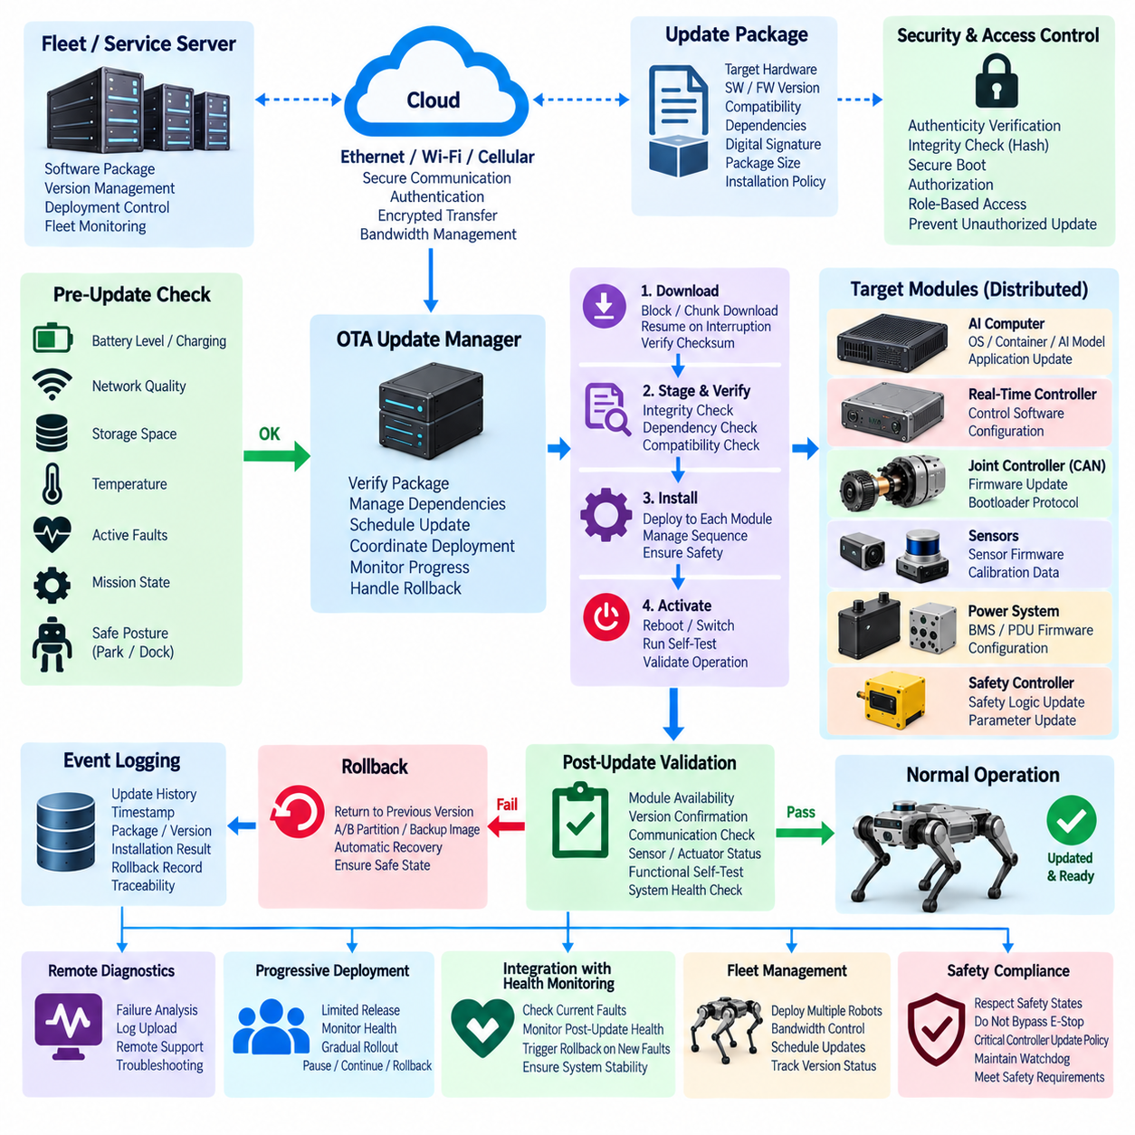
OTA update in a quadruped robot provides a controlled mechanism for distributing new software, firmware, configuration, and selected calibration data without physically connecting service equipment to every electronic module. Because the robot contains distributed joint controllers, real-time controllers, AI computers, gateways, sensors, and power-management devices, OTA must be treated as a system-level engineering function rather than a simple file-transfer process.
The OTA architecture normally separates external update distribution from the robot's internal deployment network. A fleet or service server can deliver an approved software package to the robot through Ethernet, Wi-Fi, cellular, or another secure communication channel. The onboard update manager then verifies the package and coordinates installation across internal computing platforms and embedded controllers without exposing low-level CAN or EtherCAT devices directly to external networks.
Every update package should carry sufficient metadata to determine exactly what is being installed. Typical information includes target hardware, software version, firmware version, compatibility requirements, package size, cryptographic integrity information, dependencies, and installation policy. The robot should reject a package intended for an incompatible controller or hardware revision before any modification begins, preventing configuration mismatches from propagating into safety-critical subsystems.
Package authenticity and integrity are fundamental requirements because an update mechanism can modify executable software controlling physical motion. Digital signatures allow the robot to verify that an update originates from an authorized source, while cryptographic hashes detect accidental or malicious modification during storage and transmission. Secure boot and trusted software verification can extend this chain of trust from package delivery through startup of the newly installed software.
The update manager should evaluate robot operating conditions before beginning deployment. Battery state of charge, charging status, network quality, available storage, thermal condition, active faults, mission state, and robot posture may all influence whether an update is safe to execute. Updating critical controllers during walking, climbing, inspection, or payload transport should normally be prohibited, while a stable parked or docked condition provides a more appropriate maintenance state.
Download and installation should be treated as separate phases. Large packages can be downloaded while the robot remains operational if bandwidth and storage permit, but activation can be delayed until an approved maintenance window. Staging the package locally allows integrity verification, dependency checking, and compatibility validation to occur before existing software is modified, reducing the time during which the robot must remain unavailable for service.
A robust OTA design should tolerate interrupted communication. Update packages can be divided into blocks or chunks so that transmission resumes from the last successfully received portion rather than restarting the entire download. Checksums or hashes can verify individual blocks and the complete package. This capability is especially important for mobile robots operating through wireless networks where temporary signal loss, roaming, interference, or limited coverage can interrupt connectivity.
Different computing domains require different deployment mechanisms. An AI computer may update operating-system components, containers, perception models, planning software, or application services, while an embedded joint controller may require a compact firmware image transferred through a bootloader. The OTA manager therefore coordinates heterogeneous update procedures while presenting a consistent robot-level view of package state, progress, success, failure, and recovery.
CAN-connected controllers require particular care because firmware transfer shares network resources with control and diagnostic communication. The gateway or diagnostic manager can place selected nodes into an authorized programming state and transfer firmware through a defined bootloader protocol. Update scheduling must prevent programming traffic from disrupting critical communication, and controllers required for stabilization or locomotion should only be reprogrammed when the robot is in a safe non-operational state.
Version management should preserve relationships between distributed components rather than considering each controller independently. A new locomotion controller may require specific joint firmware, sensor interfaces, calibration formats, or communication definitions. The OTA system should therefore maintain a compatibility matrix or dependency policy that prevents partial combinations known to be invalid and ensures that the deployed robot configuration represents a tested software and firmware baseline.
Atomic update concepts are valuable when several components must change together. The system can first stage all required packages, verify their compatibility, and only then initiate coordinated activation. If one required component cannot be prepared successfully, activation of the remaining components can be cancelled. This prevents a robot from entering an unintended mixed-version state in which individual modules operate correctly but their interfaces are mutually incompatible.
Rollback capability is essential for recovering from an update that installs successfully but fails during operation. Computing platforms can use dual partitions, A/B system images, container versioning, or retained previous packages to preserve a known-good software state. Embedded controllers can similarly maintain a recovery bootloader or alternate image where resources permit. If startup validation fails, the system can automatically return to the previously approved configuration.
Post-update validation determines whether installation success actually corresponds to operational readiness. The robot should verify controller availability, expected software versions, communication interfaces, sensor status, actuator diagnostics, configuration consistency, and essential application processes after restart. Critical functions can perform self-tests before motion is enabled. Only after these checks pass should the update state transition from installed to operationally accepted.
Health monitoring and OTA should therefore be tightly connected. Existing active faults may block an update, while new faults appearing immediately after installation can trigger rollback or quarantine of the new version. System health information provides evidence that the updated configuration remains stable across power, communication, sensing, computing, and actuator domains. This relationship prevents OTA success from being defined merely as successful transfer and reboot.
Event logging should record the complete OTA lifecycle. Relevant records include update request time, package identity, previous and target versions, authorization result, download status, integrity verification, installation progress, reboot events, validation results, rollback activity, and final system state. Timestamped records allow engineers to correlate newly observed faults with software changes and provide traceability when investigating field incidents or fleet-wide reliability issues.
Remote diagnostics becomes especially valuable when an OTA operation fails. Service personnel should be able to determine whether failure occurred during download, signature verification, storage preparation, bootloader communication, installation, restart, or post-update validation. Detailed logs can remain on the robot and be uploaded on demand, allowing engineers to investigate the problem without requiring immediate physical access to a robot operating at a remote industrial or inspection site.
Fleet deployment should avoid updating every robot simultaneously. A new release can first be deployed to a limited group of robots and observed through system health monitoring and event logging before broader distribution. Progressive deployment reduces fleet-level risk because unexpected software behavior can be detected while most robots remain on the previous validated version. Deployment can then continue, pause, or roll back according to observed health indicators.
OTA bandwidth management is important when many robots share the same wireless or facility network. Packages can be downloaded during low-traffic periods, cached locally, rate-limited, or distributed according to fleet priority. The update manager should prevent large software transfers from degrading teleoperation, safety supervision, mission communication, or other operational traffic. Download priority and activation priority should therefore be independently controlled.
Access control must distinguish ordinary monitoring from privileged software modification. Reading robot health or version information may require relatively limited authority, while installing firmware, entering bootloader mode, changing protected configuration, or approving rollback should require stronger authentication and authorization. Credentials, update permissions, and package-signing authority should be managed so that unauthorized software cannot be introduced through maintenance interfaces.
Safety architecture places additional constraints on OTA because some controllers directly influence actuator torque, emergency behavior, power isolation, or stabilization. Updates affecting these functions require stricter compatibility verification and post-installation testing than ordinary application software. The OTA manager should respect subsystem criticality and prevent software deployment from bypassing safety states, emergency-stop behavior, watchdog supervision, or other independent protective mechanisms.
The relationship between OTA, CAN diagnostics, and subsequent diagnostic functions is therefore continuous. CAN diagnostics identifies controller versions and fault conditions before deployment, OTA modifies approved software, event logging preserves the update history, and remote diagnostics provides field visibility afterward. Predictive maintenance can further use this history to distinguish hardware degradation from behavior introduced by software or configuration changes within the distributed robot architecture.
A dependable OTA system ultimately manages the complete transition from one validated robot configuration to another. It must answer not only whether a package was downloaded, but whether it was authentic, compatible, safely installed, successfully activated, verified across dependent subsystems, and recoverable if problems appear. By combining secure delivery, controlled deployment, validation, rollback, diagnostics, and traceability, OTA becomes a core lifecycle capability for maintaining reliable quadruped robots in the field.

11.04. Event Logging [w/Code]
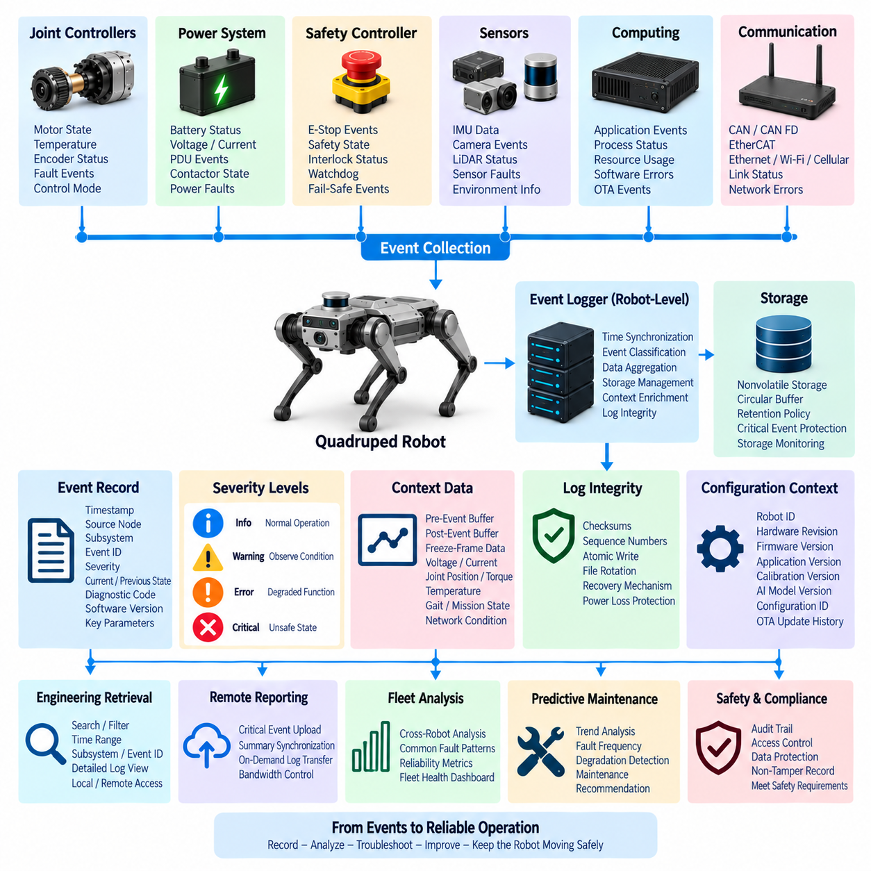
Event logging in a quadruped robot provides a persistent record of significant electrical, computational, communication, sensing, actuator, safety, and software events occurring throughout operation. It complements real-time system health monitoring by preserving evidence after transient conditions disappear. Because quadrupeds operate under vibration, impacts, dynamic loads, and changing network conditions, many failures can only be understood by reconstructing what happened before and after an abnormal event.
An effective logging architecture collects information from distributed joint controllers, the battery management system, power distribution unit, safety controller, real-time controller, AI computer, sensors, communication gateways, and supervisory applications. Rather than allowing every subsystem to maintain unrelated records, a robot-level logging service provides common timestamping, event classification, storage policies, and retrieval mechanisms so that observations from different domains can be analyzed together.
Each event record should contain enough context to identify what occurred without requiring continuous recording of every internal variable. Typical fields include timestamp, source node, subsystem, event identifier, severity, current state, previous state, diagnostic code, software version, and selected operating parameters. Additional contextual values such as battery voltage, motor current, joint position, temperature, robot gait, mission state, or network condition can be attached when they are relevant to the event.
Accurate timestamps are essential because distributed failures often propagate across several controllers within milliseconds. Events from CAN FD, EtherCAT, Ethernet, sensors, real-time applications, and AI processes should therefore be aligned to a consistent temporal reference whenever possible. PTP synchronization or another coordinated clock architecture allows engineers to determine whether a voltage disturbance preceded communication loss, whether actuator errors preceded a fall, or whether software failure occurred after sensor degradation.
Event severity should communicate operational significance rather than simply identify the source of a message. Informational events may document startup, shutdown, mode transitions, docking, or successful updates, while warnings indicate conditions requiring observation. Error and critical events represent degraded or unsafe functionality. Severity can also influence storage duration, remote transmission priority, operator notification, and whether additional high-frequency data should be captured automatically.
Event logging should distinguish state transitions from repetitive measurements. Recording the same overtemperature warning thousands of times provides little diagnostic value and can rapidly consume storage. Instead, the system can record when the condition begins, changes severity, persists beyond defined thresholds, and finally clears. Counters and duration fields can summarize repeated occurrences, preserving meaningful information while controlling the volume of generated records.
Pre-event and post-event data are particularly valuable for diagnosing dynamic failures. A circular memory buffer can continuously retain a short history of selected high-rate signals such as joint current, position, velocity, torque, IMU data, supply voltage, communication errors, and controller state. When a critical trigger occurs, the logger freezes the preceding interval and continues recording for a defined period afterward, creating an engineering snapshot of the complete fault sequence.
Freeze-frame data provides a smaller contextual snapshot when full high-frequency recording is unnecessary. A CAN diagnostic trouble code, for example, can be stored together with motor current, driver temperature, encoder state, supply voltage, gait mode, and communication status at the instant the fault becomes active. This approach connects the CAN diagnostic architecture with robot-level event logging and makes intermittent field failures substantially easier to reproduce and analyze.
Storage architecture must account for both limited onboard capacity and the possibility that network connectivity is unavailable during operation. Critical records should therefore be stored locally in nonvolatile memory before remote transmission is assumed to have succeeded. The logging system can use separate storage classes for persistent fault history, temporary diagnostic traces, operational summaries, and large sensor captures, each with different retention and deletion policies.
Circular storage is useful for bounded diagnostic data because it prevents logging from exhausting the filesystem. Older low-priority records can be overwritten when allocated capacity is reached, while critical safety events, major failures, update history, and maintenance records can receive protected retention. Storage monitoring should itself generate health events when free space falls below defined limits or when persistent-memory errors threaten the reliability of future records.
Log integrity is important because records may be used for engineering analysis, maintenance decisions, safety investigations, and software validation. Unexpected power loss should not corrupt the complete event database, so records should be written using resilient transaction or append-oriented methods. Checksums, sequence numbers, file rotation, and recovery mechanisms can help identify incomplete writes and preserve usable information after abrupt battery isolation or emergency shutdown.
Event sources should use consistent identifiers and schemas across the robot. A standardized event definition can specify source, category, severity, state, parameters, and recommended interpretation. This avoids ambiguous free-form text generated independently by different controller teams. Structured records also allow fleet software to search, filter, correlate, and statistically analyze events across many robots without first translating manufacturer-specific diagnostic messages.
The event logger should preserve configuration context because identical faults can have different meanings under different software baselines. Robot identifier, hardware revision, controller firmware, application version, calibration version, AI model version, and relevant configuration identifiers can be associated with event sessions. This allows engineers to determine whether a fault appeared only after a particular OTA release, calibration change, controller replacement, or hardware revision.
OTA update history is therefore an important event category. Package download, authentication, staging, installation, activation, reboot, post-update validation, failure, and rollback events should be recorded together with previous and target versions. If a new fault begins after an update, engineers can reconstruct the software transition and determine whether the behavior correlates with the deployment rather than assuming that the underlying hardware has degraded.
Safety events require particularly reliable recording. Emergency-stop activation, safety-controller intervention, actuator shutdown, power isolation, watchdog timeout, loss of critical communication, excessive tilt, or transition into a fail-safe state should be recorded with high priority. Logging must not delay or interfere with the safety response itself; the safety mechanism acts first, while the logging architecture preserves available evidence independently or immediately afterward.
Event correlation converts individual records into a system-level fault narrative. A battery voltage drop may be followed by multiple joint undervoltage reports, CAN communication errors, locomotion degradation, and finally a controlled stop. Examined independently, these events may appear to represent several unrelated failures. Ordered by synchronized timestamps and subsystem relationships, they reveal a likely propagation chain beginning in the power domain.
Remote event reporting should prioritize summaries rather than continuously uploading all local data. Critical events can be transmitted immediately when connectivity is available, while warning summaries and routine operational logs can be synchronized later. Large traces, sensor captures, or pre/post-event buffers can remain onboard until specifically requested by remote diagnostics. This approach preserves diagnostic depth while controlling wireless bandwidth and cloud-storage consumption.
The logging system should support efficient engineering retrieval. Engineers may search by time interval, robot, subsystem, event code, severity, software version, mission, or fault state and then retrieve detailed records surrounding a selected event. A diagnostic manager can expose these functions locally through service tools and remotely through the robot gateway, while maintaining separation between internal real-time networks and external fleet or cloud interfaces.
Security and access control apply to logs because diagnostic records can reveal internal architecture, software versions, operational history, and potentially mission-related information. Read permissions, remote upload authority, deletion privileges, and retention policies should therefore be controlled. Critical maintenance or safety records should not be silently modified or deleted by ordinary applications, and protected operations can generate their own audit events to preserve traceability.
Fleet-level aggregation extends event logging beyond individual robot troubleshooting. Repeated motor-temperature warnings, encoder errors, CAN bus-off events, battery abnormalities, or update failures can be compared across many robots to identify population-level patterns. A fault that appears insignificant on one robot may become an important reliability indicator when the same event occurs repeatedly across similar joints, production batches, operating environments, or software versions.
Event history also provides essential input for predictive maintenance. Trends in fault frequency, warning duration, thermal excursions, communication errors, actuator overloads, battery events, and recovery attempts can reveal gradual degradation before a permanent failure occurs. Predictive algorithms can combine event sequences with operating hours, mission conditions, and health measurements to estimate which components require inspection or replacement before availability is affected.
Within the Diagnostics and OTA architecture, event logging connects the preceding system health monitoring, CAN diagnostics, and OTA update functions with the following remote diagnostics and predictive maintenance functions. It transforms transient observations into durable engineering evidence, enabling local troubleshooting, remote support, fleet analysis, software traceability, safety investigation, and long-term reliability improvement through a common diagnostic history.
A well-designed event logging system ultimately functions as the operational memory of the quadruped robot. It should record not everything, but the right information at the right time and with sufficient context to reconstruct significant behavior. By combining synchronized timestamps, structured events, severity classification, pre/post-event capture, resilient storage, remote retrieval, security, and fleet-level correlation, event logging turns field experience into actionable knowledge for safer and more dependable robot operation.

11.05. Remote Diagnostics
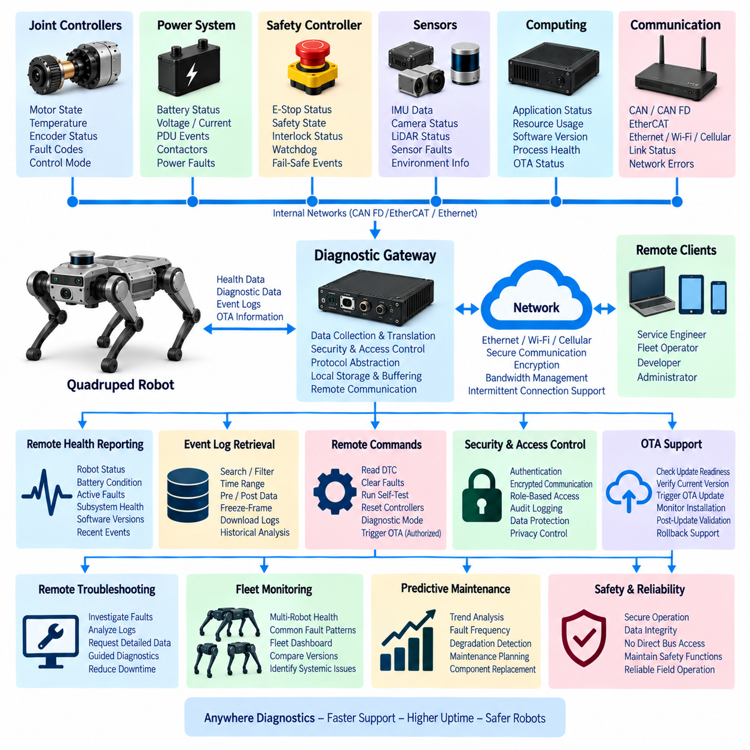
Remote diagnostics extends the quadruped robot’s onboard diagnostic architecture beyond the physical machine, allowing engineers, service personnel, and fleet operators to observe system health and investigate faults without direct access to the robot. It connects system health monitoring, CAN diagnostics, event logging, and OTA information through a controlled external interface while preserving separation between internal real-time networks and remote service infrastructure.
The remote diagnostic architecture should use an onboard gateway or diagnostic manager as the boundary between internal robot networks and external communication. CAN FD, EtherCAT, sensor networks, safety controllers, and real-time control systems remain protected inside the robot, while selected diagnostic information is translated into structured reports. This prevents external clients from directly interacting with time-critical buses or safety-critical embedded controllers.
External connectivity may use Ethernet, Wi-Fi, cellular communication, or other available network technologies depending on the deployment environment. Because industrial inspection robots may move through areas with intermittent coverage, remote diagnostics should not assume continuous connectivity. The robot must continue local health monitoring and logging independently, buffering important diagnostic information until a reliable connection becomes available for synchronization or detailed investigation.
Remote health reporting provides a compact representation of current robot condition. Typical information includes robot identity, mission state, battery condition, active faults, subsystem health, actuator availability, sensor status, computing resources, communication quality, software versions, and recent critical events. Rather than continuously transmitting every internal signal, the robot can summarize these states into periodic health reports suitable for fleet supervision and service dashboards.
Diagnostic information should be organized hierarchically so that an operator can begin with robot-level health and progressively inspect deeper subsystem details. A degraded robot state may lead to examination of a specific leg, followed by an individual joint controller and its diagnostic trouble codes. This drill-down approach reduces information overload while preserving access to detailed electrical, communication, thermal, actuator, and software evidence when troubleshooting requires it.
Remote diagnostics should support both periodic reporting and event-driven communication. Routine health summaries can be transmitted at moderate intervals, while critical faults such as emergency stops, actuator shutdowns, battery protection events, repeated CAN bus-off conditions, or major computing failures can generate immediate notifications when connectivity exists. Event severity therefore becomes an important input to communication priority and remote alert behavior.
Event logging provides the historical foundation for remote troubleshooting. Engineers should be able to request records by time interval, subsystem, event identifier, severity, or diagnostic state and then retrieve contextual information surrounding a selected fault. Pre-event buffers, post-event data, freeze-frame records, and synchronized timestamps can reveal how a failure developed even when the engineer was not connected to the robot when the original event occurred.
Large diagnostic datasets should be transferred selectively. High-frequency joint traces, sensor recordings, network captures, or detailed application logs can consume substantial bandwidth and may not be required for routine monitoring. The remote system can first inspect summaries and metadata, then request a specific time range or data category. This staged retrieval model preserves engineering depth while preventing diagnostic traffic from overwhelming operational wireless networks.
Bandwidth management becomes particularly important when multiple robots share the same infrastructure. Remote diagnostic traffic should not degrade teleoperation, mission commands, safety supervision, fleet coordination, or other operational communication. Transfer rates can be limited according to network condition and mission priority, while large logs can be deferred until the robot is docked, connected through higher-bandwidth Wi-Fi or Ethernet, or otherwise operating under favorable communication conditions.
The remote interface should expose diagnostic states rather than uncontrolled access to internal buses. For example, a remote service application can request joint temperature, fault status, firmware version, or CAN error statistics through the diagnostic manager instead of transmitting arbitrary CAN frames directly. This abstraction protects deterministic communication and allows internal network architecture to evolve without requiring every remote diagnostic application to understand hardware-specific bus implementation.
Command capability requires stronger controls than passive monitoring. Reading system health may be permitted during normal operation, while clearing diagnostic trouble codes, resetting controllers, initiating self-tests, changing diagnostic modes, entering a bootloader, or starting an OTA update should require explicit authorization. Commands that could influence motion or safety must additionally respect robot operating state, local safety logic, and subsystem-specific restrictions.
Authentication and encrypted communication are therefore essential components of remote diagnostics. The robot should verify the identity and authority of remote clients before releasing protected information or accepting privileged operations. Secure sessions can protect diagnostic data against interception and modification, while role-based access control can distinguish fleet operators, service technicians, developers, and administrators according to the functions each role is permitted to perform.
Remote commands should be auditable. The event logging system can record the requester, command type, target subsystem, authorization result, execution time, response, and resulting robot state. This provides traceability when investigating configuration changes, controller resets, fault clearing, or update operations. Audit records are especially important when several engineering teams or external service organizations can access the same fleet.
Connection loss must never leave the robot dependent on a remote diagnostic session for safe operation. Local controllers, watchdogs, safety functions, and health monitoring continue independently if the external network disappears. A partially executed remote operation should either complete safely or return to a defined state. Critical protection mechanisms therefore remain local, while remote diagnostics provides observation, analysis, and controlled service functions rather than replacing onboard autonomy or safety.
Remote diagnostics can also coordinate active tests when the robot is placed in an appropriate maintenance state. Engineers may request sensor self-tests, communication checks, actuator diagnostics, storage verification, or controller status queries. Tests involving actuator movement or power switching require additional safeguards, including confirmation of robot posture, operating mode, local interlocks, and potentially physical service conditions before execution is permitted.
Software and configuration information should accompany diagnostic reports because field behavior often depends on the deployed baseline. Hardware revision, controller firmware, operating-system image, application version, calibration version, AI model version, and OTA history help engineers determine whether an observed failure is specific to a particular configuration. Comparing this information across robots can reveal problems associated with a release or hardware production batch.
Remote diagnostics and OTA update therefore form a closely coupled lifecycle process. Diagnostics establishes whether the robot is healthy enough to accept an update, identifies its current software baseline, and provides evidence when deployment fails. After installation, the same remote interface can inspect post-update health, retrieve validation results, observe new faults, and support rollback decisions when the updated configuration does not meet expected operational behavior.
Fleet-level remote diagnostics expands this capability from individual troubleshooting to population monitoring. A fleet service can aggregate health states, diagnostic codes, software versions, battery events, actuator warnings, network faults, and update results across many robots. Common patterns can then be identified by robot model, subsystem, component revision, operating site, mission type, or software baseline, allowing engineering teams to prioritize recurring reliability problems.
Diagnostic correlation across robots is especially valuable for distinguishing isolated incidents from systematic defects. A repeated encoder fault on one machine may indicate local damage, while the same event appearing on the same joint across many robots may suggest component, harness, firmware, or calibration problems. Remote fleet data therefore transforms individual service records into evidence for design improvement, supplier investigation, and preventive maintenance planning.
Privacy, operational security, and data retention policies should determine what information may leave the robot. Diagnostic records can contain detailed operational history, location-related mission information, internal software identifiers, or sensor-derived context. Remote systems should transmit only information required for the intended service purpose, apply appropriate retention rules, and restrict access to detailed traces according to organizational and operational requirements.
Remote diagnostic services should remain usable even when cloud infrastructure is unavailable. Local service access through a maintenance Ethernet or protected wireless connection can provide similar diagnostic functions using the same structured interface. Designing cloud and local service paths around a common diagnostic model reduces duplicated engineering effort and allows field technicians to troubleshoot robots at sites where external connectivity is restricted or prohibited.
The diagnostic manager can expose stable interfaces above heterogeneous internal technologies. CAN diagnostics, EtherCAT status, Ethernet statistics, system health, application logs, sensor states, event history, and OTA records can all be represented through a unified service model. This abstraction allows remote tools to focus on robot condition and troubleshooting workflows rather than the protocol details used by each embedded subsystem.
Remote diagnostics also provides an important bridge toward predictive maintenance, the next function in the chapter structure. Historical health reports, fault frequency, temperature excursions, actuator warnings, communication degradation, battery events, recovery attempts, and maintenance actions can be aggregated over time. These records create the longitudinal dataset needed to recognize degradation patterns before they develop into permanent failures.
A dependable remote diagnostic system ultimately creates controlled engineering visibility into a robot operating anywhere in the field. Its purpose is not unrestricted remote access, but secure observation, structured fault investigation, selective data retrieval, authorized service actions, and fleet-level analysis. By combining onboard autonomy with remote engineering intelligence, it reduces troubleshooting time while preserving network determinism, cybersecurity, functional safety, and reliable quadruped operation.

11.06. Predictive Maintenance
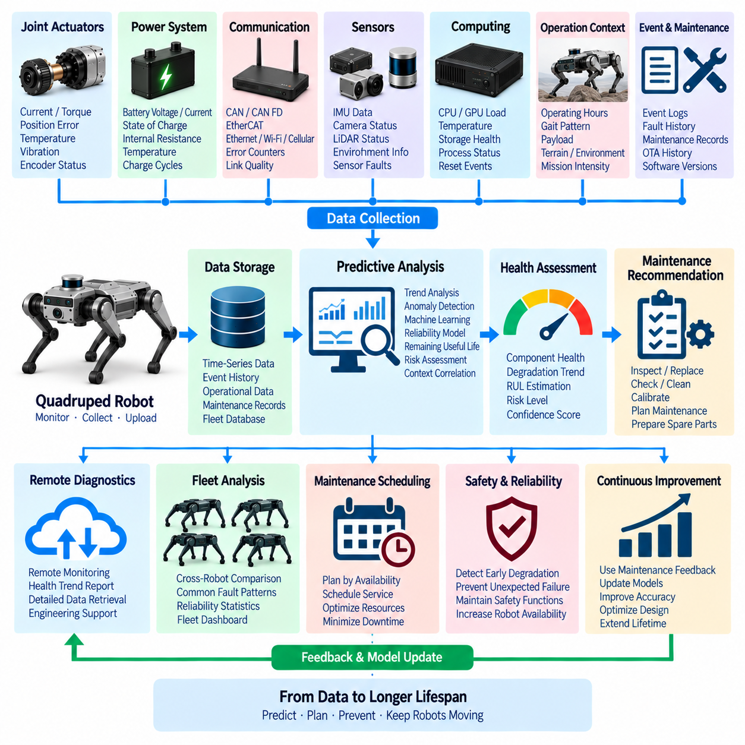
Predictive maintenance in a quadruped robot uses accumulated health, diagnostic, operational, and maintenance data to identify degradation before it develops into a functional failure. Unlike reactive maintenance, which begins after a component fails, predictive maintenance evaluates changes in actuator behavior, electrical conditions, thermal characteristics, communication quality, battery performance, and computing health to estimate when inspection or replacement should be performed.
The predictive maintenance architecture builds on the diagnostic functions already operating throughout the robot. System health monitoring provides continuous measurements, CAN diagnostics exposes embedded controller conditions, event logging preserves abnormal behavior, and remote diagnostics makes historical information available for fleet analysis. Together, these sources create a longitudinal record that describes how each robot and subsystem changes throughout its operational lifetime.
Data collection should focus on indicators that have meaningful relationships with component degradation. Joint current, torque, position error, motor temperature, vibration, encoder faults, communication errors, battery voltage, current, state of charge, thermal cycles, processor temperature, storage errors, and repeated controller resets can all provide useful evidence. Operating hours, gait patterns, payload, terrain, environmental conditions, and mission intensity provide additional context for interpreting these measurements.
Individual measurements rarely provide sufficient evidence of impending failure. A high motor temperature during demanding locomotion may be completely normal, while a gradual temperature increase under the same load and ambient conditions may indicate increasing friction or deteriorating actuator efficiency. Predictive maintenance therefore emphasizes trends, rates of change, repeated anomalies, and relationships between operating conditions and component responses rather than relying only on fixed thresholds.
A baseline should be established for normal behavior of each important subsystem. This baseline can describe expected current consumption, temperature range, vibration characteristics, communication error rate, joint tracking accuracy, battery behavior, and computing resource usage under representative operating conditions. Future observations can then be compared with the baseline to identify deviations that may indicate wear, contamination, electrical deterioration, mechanical looseness, or calibration drift.
Joint actuators are particularly important predictive maintenance targets because they experience repeated mechanical loading and directly affect locomotion capability. Changes in current required to produce similar torque, increasing tracking error, unusual temperature rise, encoder inconsistencies, vibration changes, or repeated overcurrent events can indicate developing problems in motors, gearboxes, bearings, sensors, connectors, or drive electronics before complete actuator failure occurs.
Electrical and communication degradation can also develop gradually. Increasing CAN error counters, intermittent node timeouts, repeated bus-off recovery, voltage fluctuations, connector-related interruptions, or communication errors correlated with specific leg positions may indicate harness or connector deterioration. Tracking these events over time can reveal problems caused by repeated bending, vibration, contamination, or mechanical stress before communication becomes permanently unavailable.
Battery predictive maintenance should examine more than instantaneous state of charge. Changes in usable capacity, internal resistance, voltage sag under comparable load, charging behavior, temperature response, cell imbalance, protection events, and cycle history can reveal progressive battery aging. Combining these indicators with mission energy consumption allows maintenance planning to consider whether the battery can continue supporting required locomotion and payload performance.
Thermal history provides another valuable degradation indicator. Repeated operation near thermal limits can accelerate aging of motors, power electronics, processors, batteries, and connectors. Predictive analysis can track thermal excursions, duration above defined temperature ranges, heating and cooling rates, and differences between similar components. A joint consistently operating hotter than equivalent joints under comparable loads may warrant inspection even when no overtemperature fault has occurred.
Event history converts intermittent abnormalities into measurable reliability indicators. Repeated encoder warnings, actuator overloads, CAN communication errors, watchdog resets, undervoltage events, sensor interruptions, or recovery attempts can be counted and analyzed over operating time. Increasing event frequency or decreasing intervals between similar events may indicate that a component is moving from occasional disturbance toward persistent degradation.
Pre-event and post-event records provide additional information for understanding degradation mechanisms. If repeated joint faults occur, engineers can compare motor current, torque, temperature, vibration, supply voltage, and robot motion immediately before each event. Similar patterns across multiple occurrences may reveal a consistent precursor that can later be used as an early-warning indicator rather than waiting for the diagnostic fault itself to appear.
Predictive algorithms can range from simple statistical methods to machine-learning models. Trend analysis, moving averages, rate-of-change detection, threshold adaptation, anomaly detection, and survival or reliability models can provide useful results with relatively modest data requirements. More advanced models can learn multidimensional relationships among actuator loads, temperature, vibration, electrical behavior, environmental conditions, and fault history when sufficient representative fleet data is available.
Anomaly detection is useful when explicit failure examples are limited. A model can learn the normal operating distribution of a joint, battery, computing platform, or communication network and identify observations that increasingly deviate from that distribution. The anomaly score should not automatically be interpreted as a confirmed failure; instead, it provides evidence that can be combined with diagnostic codes, trends, event history, and engineering rules.
Remaining useful life estimation attempts to predict how much operational time or usage remains before maintenance becomes necessary. Such estimates may be expressed in operating hours, mission cycles, walking distance, actuator cycles, battery cycles, or another relevant usage metric. Because uncertainty can be substantial, the system should communicate confidence or prediction ranges rather than presenting a precise failure time that cannot be justified by available data.
Maintenance recommendations should translate analytical results into practical engineering actions. Instead of reporting only that an anomaly score has increased, the system can indicate that a particular actuator should be inspected within a defined maintenance window, a battery should undergo capacity testing, a harness should be checked for intermittent communication, or a cooling path should be examined for contamination or airflow restriction.
Predictive maintenance should distinguish between immediate safety concerns and longer-term degradation. Conditions that exceed safety limits remain the responsibility of real-time protection, health monitoring, and fail-safe mechanisms. Predictive analysis operates at a different timescale, identifying components that remain functional today but show evidence of increasing risk. It must therefore complement rather than replace deterministic safety diagnostics and protective controls.
Fleet-level data substantially improves predictive capability. A single robot may provide only a small number of degradation examples, while many robots operating similar hardware can reveal recurring patterns. Event frequency, actuator temperatures, battery aging, communication faults, component replacements, and maintenance outcomes can be compared by hardware revision, production batch, operating environment, software version, and accumulated usage.
Maintenance records are essential feedback for validating predictions. When a component is inspected or replaced, the observed physical condition should be linked with the diagnostic history that triggered the maintenance action. Confirmed bearing wear, connector damage, battery degradation, sensor contamination, or a false alarm provides labeled evidence that can improve future thresholds, engineering rules, and predictive models.
Software and OTA history should also be considered because behavioral changes are not always caused by hardware degradation. A new controller algorithm may change motor current, temperature, network utilization, or computing load without indicating physical wear. Predictive analysis should therefore associate measurements with firmware, application, calibration, and AI model versions so that software-induced changes can be separated from genuine component deterioration.
Predictive maintenance models themselves require monitoring and lifecycle management. Changes in robot hardware, missions, payloads, environments, or software can alter the statistical relationships learned from earlier data. Model performance should therefore be evaluated against confirmed maintenance outcomes, and thresholds or models should be updated when prediction accuracy deteriorates. Versioning provides traceability between maintenance decisions and the analytical model that produced them.
Remote diagnostics provides the operational pathway for delivering predictive information to engineering and service teams. Health trends, risk indicators, maintenance recommendations, and supporting event history can be summarized remotely, while detailed traces remain available for investigation when required. Fleet dashboards can prioritize robots according to predicted maintenance urgency instead of requiring engineers to manually inspect every diagnostic record.
Maintenance scheduling can then be coordinated with robot availability and operational priorities. Components showing gradual degradation can be serviced during planned downtime, docking periods, or scheduled facility maintenance rather than after an unexpected field failure. Spare parts and technical resources can also be prepared in advance, reducing repair time and minimizing the operational impact of maintenance activities.
The value of predictive maintenance should be measured through operational outcomes rather than model accuracy alone. Useful indicators include fewer unexpected failures, reduced emergency maintenance, increased robot availability, improved component utilization, shorter troubleshooting time, and better spare-parts planning. Excessive false alarms can create unnecessary maintenance and reduce trust, while missed degradation can lead to costly downtime or safety-related incidents.
Within the Diagnostics and OTA architecture, predictive maintenance represents the long-term analytical use of information produced by the preceding functions. System health monitoring observes current conditions, CAN diagnostics identifies controller-level abnormalities, OTA records configuration changes, event logging preserves historical evidence, and remote diagnostics aggregates field information. Predictive maintenance converts this accumulated history into forward-looking maintenance decisions.
A well-designed predictive maintenance system ultimately transforms robot operating history into an estimate of future reliability. By combining condition monitoring, synchronized event records, degradation trends, fleet statistics, maintenance feedback, software context, and appropriately validated analytical models, the robot organization can move from repairing failures after they occur toward identifying and servicing components before their degradation compromises availability, performance, or safe quadruped operation.

