Volume 20. Quadruped Electrical Architecture

Chapter 12. AI and Physical AI Integration

12.01. VLM Integration
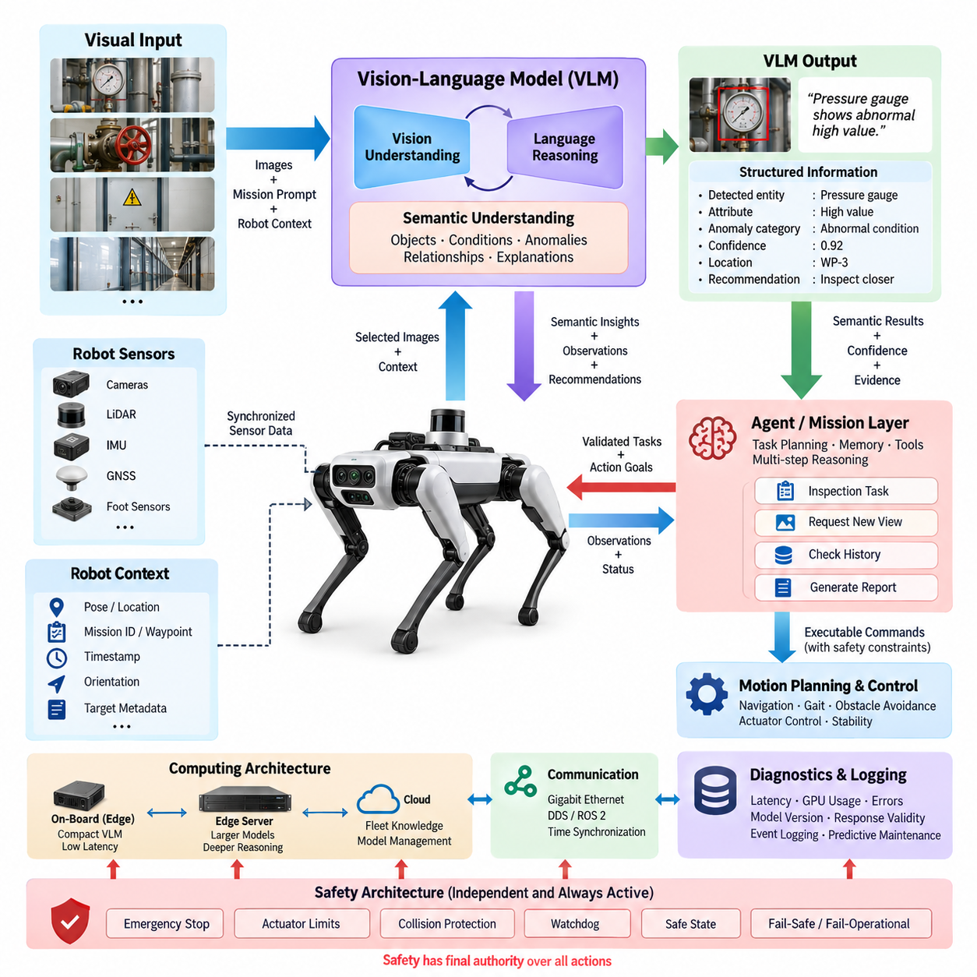
Vision-Language Model (VLM) integration gives a quadruped robot the ability to connect visual perception with semantic understanding expressed through natural language. Instead of treating camera images only as inputs to conventional detection or segmentation pipelines, the robot can interpret objects, spatial relationships, environmental conditions, signs, equipment, and human activities within a broader mission context.
A quadruped platform is particularly suitable for VLM-based intelligence because it can physically enter spaces that are difficult, dangerous, or inefficient for humans and wheeled robots. Cameras mounted on the body, head, or inspection payload continuously provide visual observations, while the VLM transforms selected observations into semantic descriptions such as blocked passageways, abnormal equipment states, damaged infrastructure, or potential hazards.
VLM integration should complement rather than replace the robot's deterministic perception and control functions. High-frequency locomotion, joint control, obstacle avoidance, emergency stopping, and other safety-critical operations must remain within dedicated real-time control paths. The VLM operates at a higher semantic layer, interpreting observations and providing contextual information to mission planning, inspection logic, or an agent system.
The basic processing path begins with synchronized camera acquisition followed by image selection, preprocessing, and optional region-of-interest extraction. Frames or short visual sequences are delivered to the VLM together with prompts describing the current mission and relevant robot state. The resulting semantic representation can then be converted into structured observations, events, task parameters, or recommendations that downstream software can evaluate.
Prompt construction is an important part of the interface between the robot and the VLM. A generic question such as “What do you see?” may generate a broad description, while mission-specific prompts can focus attention on relevant evidence. An inspection robot may ask whether gauges, valves, cables, doors, warning indicators, corrosion, leakage, or foreign objects exhibit conditions inconsistent with the expected operating state.
Visual information becomes more useful when combined with robot context. Pose estimates, timestamps, camera identity, mission ID, waypoint information, orientation, and inspection target metadata can accompany each VLM request. This allows a semantic observation to be associated with a physical location and operational event rather than remaining an isolated text description. Such grounding is essential for repeatable inspection and fleet-level data analysis.
The VLM interface should preferably return machine-readable information in addition to natural-language explanations. Structured fields may represent detected entities, attributes, spatial relationships, confidence indicators, anomaly categories, recommended follow-up observations, and supporting image references. A downstream agent can validate these outputs against conventional perception, sensor measurements, mission rules, or previously recorded observations before initiating further actions.
Quadruped inspection can exploit active perception because the robot is able to reposition its entire body to obtain better observations. When a target is partially occluded or visually ambiguous, the AI layer may request another viewpoint, shorter viewing distance, different body orientation, or additional sensor measurement. The motion planner then determines whether the requested observation can be obtained safely without allowing the VLM to command joint actuators directly.
This separation establishes an important control boundary. The VLM can propose semantic goals such as “inspect the left side of the cabinet more closely,” but a validated task or agent layer translates that intention into allowable robot behaviors. Navigation, foothold selection, gait generation, collision avoidance, actuator commands, and stability control remain under specialized control systems with explicit constraints, watchdogs, and safety supervision.
VLM processing also creates significant computing requirements. High-resolution multi-camera streams can easily exceed the practical inference capacity of an embedded AI computer if every frame is processed by a large model. The architecture therefore requires frame sampling, event-triggered inference, image resizing, region selection, model quantization, caching, and task-dependent scheduling. Conventional vision models can continuously filter observations before invoking the more computationally expensive VLM.
An effective architecture can distribute inference between edge and external computing resources. Compact models running on the quadruped provide low-latency semantic functions when connectivity is limited, while larger models on an edge GPU server or on-premise infrastructure can perform deeper reasoning over selected observations. Cloud processing may support non-real-time analysis, fleet knowledge, model management, and large-scale historical comparison where network availability and data policy permit.
Communication architecture must account for the difference between raw sensor traffic and semantic AI traffic. Gigabit Ethernet can transport high-bandwidth camera data internally, while DDS/ROS 2 can distribute robot state and AI messages among software components. VLM requests should include consistent timestamps and source identifiers so that visual reasoning can be correlated with synchronized LiDAR, IMU, GNSS, force sensing, diagnostics, and mission events.
Reliability requires explicit handling of uncertainty because VLM outputs are probabilistic and may contain incorrect descriptions or unsupported conclusions. Critical decisions should therefore use confidence thresholds, cross-checking, repeated observation, deterministic perception, geometric verification, or human confirmation according to risk. A semantic statement generated by the VLM must never automatically be interpreted as a verified physical fact merely because the response is linguistically convincing.
Safety architecture should prevent semantic AI failures from propagating directly into hazardous motion. The VLM must not bypass emergency-stop logic, real-time controllers, actuator limits, collision protection, communication watchdogs, or predefined safe states. When semantic reasoning conflicts with safety constraints, the deterministic safety layer has authority. Loss of the VLM or external AI service should degrade mission intelligence without destabilizing basic locomotion.
Diagnostics should monitor the complete VLM processing chain rather than only model execution. Useful health information includes camera availability, inference latency, GPU utilization, memory consumption, dropped requests, timeout frequency, model version, prompt version, response validity, and communication status. These records make it possible to distinguish failures caused by sensors, computing resources, networking, model behavior, or mission-level software.
Event logging is especially valuable for Physical AI because semantic decisions need traceability. Important VLM outputs can be stored together with timestamps, selected input frames, robot pose, prompt identifiers, structured responses, validation results, and subsequent actions. Such records support field debugging, model evaluation, incident reconstruction, predictive maintenance, and comparison between software or foundation-model versions deployed through the robot lifecycle.
VLM integration becomes more powerful when connected to the agent system that follows this architectural layer. The VLM provides semantic interpretation, while the agent manages goals, memory, tools, mission state, and multi-step reasoning. For example, an observed abnormal indicator can become an inspection event, trigger closer visual acquisition, request diagnostic data, compare previous records, and generate a structured report without embedding all reasoning inside the perception model.
The broader Physical AI architecture therefore treats the VLM as a semantic bridge between perception and intelligent action. Cameras provide visual evidence, the VLM converts that evidence into contextual meaning, an agent or mission layer evaluates what should happen next, and deterministic robot subsystems execute validated actions. This layered organization preserves the advantages of foundation-model reasoning while respecting the electrical, computing, communication, diagnostic, and safety architecture of the quadruped platform.
A mature implementation ultimately enables the quadruped to move beyond simple remote sensing toward context-aware physical operation. The robot can recognize mission-relevant situations, associate observations with places and tasks, request additional evidence, communicate findings in human-readable language, and contribute structured knowledge to fleet or higher-level AI systems. VLM integration thus forms one of the key interfaces connecting embodied sensing with higher-level Physical AI intelligence.

12.02. Agent System
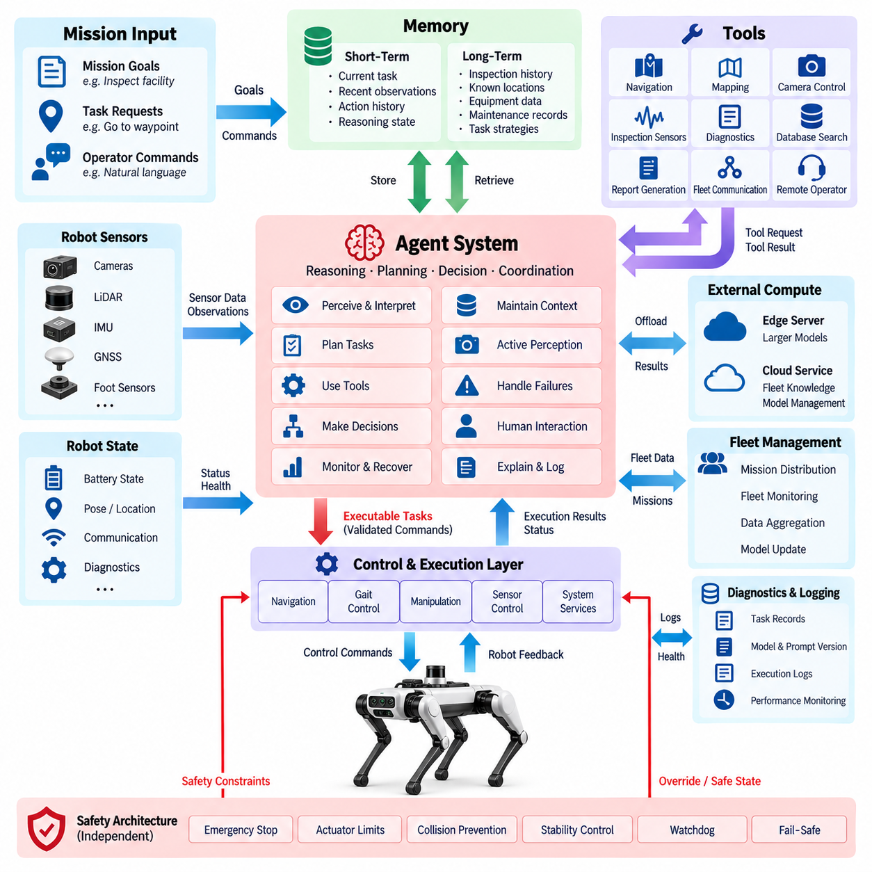
An agent system transforms a quadruped robot from a collection of perception, locomotion, and communication functions into a goal-oriented Physical AI platform. The agent receives mission objectives, interprets environmental information, maintains operational context, selects appropriate tools, and coordinates multiple robot capabilities. It operates above deterministic control layers and provides the reasoning required to connect semantic understanding with executable tasks.
Within the quadruped architecture, the agent should be treated as a supervisory intelligence layer rather than a direct actuator controller. Joint torque control, gait generation, balance stabilization, collision avoidance, emergency stopping, and other time-critical functions remain under dedicated real-time controllers. The agent determines what should be accomplished, while validated motion and control subsystems determine how the requested physical behavior can be executed safely.
The agent receives information from multiple sources including VLM outputs, conventional perception models, LiDAR processing, IMU and GNSS estimates, foot-force sensors, diagnostics, mission databases, and operator commands. These heterogeneous observations are converted into a common operational context. The agent can therefore reason about both semantic information, such as an abnormal valve condition, and physical information, such as robot position, battery state, communication quality, or available mobility.
A typical agent processing cycle begins with observation and state interpretation. The system evaluates the current mission, robot condition, environmental events, and previously completed actions before determining the next objective. Reasoning may decompose a high-level instruction such as “inspect the equipment room” into navigation, target identification, viewpoint adjustment, image acquisition, anomaly assessment, diagnostic queries, and reporting activities executed through specialized robot services.
Memory is an important architectural component because useful physical operation extends beyond a single inference request. Short-term memory can retain the current task, recent observations, attempted actions, and intermediate reasoning state. Longer-term mission memory can contain inspection history, previously detected anomalies, known locations, equipment metadata, maintenance records, and successful task strategies, allowing new observations to be evaluated against prior operational experience.
Tool use provides the interface between agent reasoning and actual robot capabilities. Tools may expose navigation, mapping, camera control, inspection sensors, diagnostic services, database retrieval, report generation, fleet communication, or remote operator interaction. Each tool should have clearly defined inputs, outputs, execution constraints, timeout behavior, and failure states so that the agent interacts with deterministic software through controlled interfaces instead of directly manipulating low-level hardware.
Task planning converts mission intent into an ordered or conditional sequence of actions. Unlike a fixed state machine, an AI agent can adapt the sequence when observations change, while still operating inside predefined boundaries. If a planned route becomes blocked, for example, the agent may request an alternative path, select another inspection target, gather additional visual evidence, or ask for operator assistance rather than repeatedly attempting an invalid action.
The agent should distinguish between reasoning, decision authorization, and physical execution. A foundation model may propose an action, but the proposal must pass through policy checks and capability validation before becoming an executable command. The system verifies whether the requested behavior is permitted, whether required resources are available, whether environmental conditions satisfy execution constraints, and whether the robot remains inside its operational and safety envelope.
This architecture enables active perception to become part of autonomous reasoning. When a VLM reports an uncertain object or ambiguous equipment state, the agent can determine that additional evidence is required. It may request a new camera viewpoint, adjust inspection distance, activate lighting, acquire thermal or other inspection data, or compare the observation with historical records. The resulting information is then returned to the reasoning loop for reassessment.
Agent execution must explicitly handle failures because physical actions frequently produce outcomes different from predicted results. Navigation may fail, communication may disappear, a sensor may become unavailable, or a requested inspection position may be unreachable. Instead of assuming success, each action should return execution status and evidence. The agent can retry within defined limits, select an alternative strategy, degrade the mission, request human intervention, or transition toward a safe condition.
Human-agent interaction remains important even in highly autonomous quadrupeds. Operators can define goals, approve sensitive actions, modify mission priorities, inspect reasoning summaries, and intervene when uncertainty exceeds acceptable limits. Natural-language interaction can simplify mission specification, but operator commands should be converted into structured task representations and checked against system capabilities and safety policies before physical execution begins.
The agent can also coordinate multiple levels of computing. A local edge agent provides mission continuity and low-latency decisions when external connectivity is unavailable. More computationally demanding reasoning can be delegated to an edge server or on-premise AI infrastructure, while cloud services can support fleet knowledge, large-scale historical analysis, model services, and mission management. Loss of external connectivity should not eliminate essential local safety and recovery functions.
Communication between the agent and robot subsystems should use structured interfaces rather than unrestricted natural-language messages. DDS/ROS 2 services, actions, and topics can expose robot capabilities, while Ethernet provides the underlying high-bandwidth network. Every command should carry sufficient context such as task identity, timestamps, parameters, execution limits, and response status, enabling deterministic components to reject malformed, stale, unauthorized, or unsafe requests.
Time synchronization is necessary when agent decisions depend on observations from several sensors and software components. Camera frames, LiDAR data, robot pose, diagnostic events, VLM responses, and action results must be associated with a consistent temporal reference. Without reliable timestamps, the agent may incorrectly connect an old semantic observation with a new robot state, producing decisions that appear logically valid but are physically inconsistent with the current environment.
Safety authority must remain independent of the agent. Emergency-stop circuits, actuator limits, stability protection, collision prevention, watchdogs, power protection, and fail-safe mechanisms must be able to override or reject agent commands. The agent may request movement or manipulation, but it cannot disable these protections. If agent reasoning becomes unavailable, inconsistent, or excessively delayed, the robot should preserve deterministic control and transition according to predefined degradation policies.
Agent health monitoring should cover reasoning latency, task completion rate, tool failures, invalid command frequency, memory usage, communication timeouts, model availability, and repeated planning loops. A system that continuously generates plans without achieving measurable progress requires detection just as much as a failed sensor does. Watchdogs and mission-level progress monitors can identify stalled reasoning and initiate recovery before it causes excessive energy consumption or operational risk.
Traceability is essential because autonomous decisions must be explainable after field operation. Important records include mission objectives, observations used for decisions, model and prompt versions, selected tools, command parameters, validation results, execution responses, operator interventions, and final outcomes. These records support debugging, performance evaluation, incident analysis, software validation, predictive maintenance, and comparison between different agent configurations deployed across a robot fleet.
The agent system also provides a natural interface to fleet-level intelligence. Individual quadrupeds can report mission status, discovered obstacles, inspection anomalies, and task results to a fleet service. Higher-level coordination can distribute missions according to robot location, battery condition, payload capability, sensor configuration, or availability. However, fleet commands should enter each robot through the same validated agent and safety interfaces rather than bypassing local control authority.
A mature architecture may combine several specialized agents instead of relying on one unrestricted general-purpose agent. Mission planning, inspection reasoning, diagnostics, navigation supervision, and reporting can be separated into bounded functional roles with explicit information exchange. A supervisory mechanism can coordinate these functions while limiting permissions, reducing uncontrolled interactions, and making the overall system easier to validate, monitor, and maintain.
The agent system therefore forms the orchestration layer between semantic AI and physical execution. VLMs and perception systems explain what is happening, memory preserves relevant context, planning determines what should happen next, tools expose available robot capabilities, and deterministic controllers perform validated actions. Safety mechanisms independently constrain the complete process, establishing a clear boundary between probabilistic AI reasoning and safety-critical robotic control.
Through this layered architecture, a quadruped can progress from executing predefined sequences toward adaptive mission autonomy. It can interpret goals, observe its environment, plan multi-step activities, acquire additional evidence, recover from failures, use historical knowledge, collaborate with operators, and generate mission results. The agent does not replace the electrical and control architecture; it coordinates those capabilities into a context-aware Physical AI system capable of purposeful operation.

12.03. Edge AI Architecture
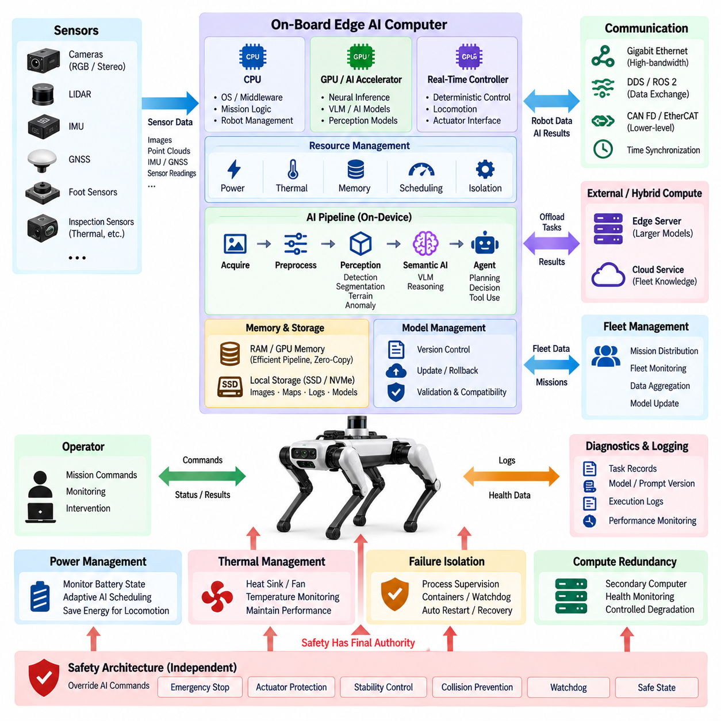
Edge AI architecture places the computing resources required for perception, reasoning, and mission intelligence directly on the quadruped or within a nearby edge computing environment. This arrangement reduces dependence on remote cloud services and enables the robot to maintain intelligent operation when network bandwidth is limited, communication latency increases, or external connectivity is completely unavailable during field missions.
The on-board computing platform typically combines heterogeneous processors optimized for different workloads. CPUs execute operating systems, middleware, mission logic, and general software, while GPUs or dedicated AI accelerators execute neural-network inference. Real-time controllers independently handle deterministic locomotion and actuator functions. This separation allows computationally intensive AI workloads to coexist with predictable robotic control without assigning safety-critical timing requirements to probabilistic AI processes.
Sensor processing represents one of the largest edge computing workloads. Multiple cameras, LiDAR, IMU, GNSS, foot sensors, and specialized inspection sensors continuously generate data with different bandwidth and timing characteristics. The edge architecture performs acquisition, synchronization, preprocessing, filtering, compression, feature extraction, and inference close to the sensors, reducing the amount of raw information that must travel through external networks.
A layered AI pipeline can improve computational efficiency. Lightweight perception models may continuously perform object detection, segmentation, terrain classification, or anomaly screening, while larger VLMs and foundation models are invoked only when semantic interpretation is required. Event-triggered inference, region-of-interest processing, frame sampling, and adaptive model scheduling prevent expensive models from consuming GPU resources when simpler processing is sufficient.
Resource management becomes particularly important because a mobile quadruped has strict limits on electrical power, thermal dissipation, physical volume, and battery capacity. AI performance cannot be evaluated only by model accuracy or inference throughput. GPU utilization, memory consumption, power draw, processor temperature, cooling capability, and remaining mission energy must be considered together so that intensive AI processing does not compromise locomotion endurance or system reliability.
The edge platform should support multiple execution priorities. Safety-related perception and essential navigation require predictable access to computing resources, while semantic reasoning, reporting, mapping updates, or background analytics can tolerate greater latency. CPU affinity, GPU scheduling, process priorities, memory allocation, and workload isolation can prevent a large AI model from unexpectedly degrading control-supporting perception or other mission-critical software.
Memory architecture is another critical consideration because high-resolution sensor streams and AI models can consume substantial system memory and GPU memory. Efficient designs minimize unnecessary copies between camera buffers, CPU memory, and accelerator memory. Shared-memory transport, zero-copy mechanisms, hardware-accelerated decoding, tensor pipelines, and controlled buffer pools reduce latency and memory bandwidth while preventing resource exhaustion during prolonged operation.
Local storage complements volatile memory by preserving mission data that cannot be transmitted immediately. Selected images, sensor events, maps, diagnostic records, VLM results, agent decisions, and inspection evidence can be stored on industrial SSD or NVMe devices. Data retention policies should prioritize important events and manage storage capacity automatically, allowing lower-value raw data to be discarded or compressed while preserving information required for traceability.
Edge AI must remain integrated with the communication architecture rather than operating as an isolated computer. Gigabit Ethernet can connect cameras, LiDAR, computing modules, and internal network switches, while DDS/ROS 2 provides structured data exchange among software components. CAN FD or EtherCAT may connect lower-level controllers where appropriate. Time synchronization ensures that AI outputs remain correctly associated with the physical sensor observations and robot states that produced them.
The edge architecture also provides the local execution environment for VLM and agent functions. A compact VLM can interpret selected images without sending sensitive or bandwidth-intensive visual data outside the robot. The local agent can maintain mission context, use robot tools, evaluate execution results, and perform recovery actions. Larger reasoning workloads can be delegated externally without making basic autonomous mission continuity dependent on remote inference.
Hybrid edge computing extends this architecture beyond the robot itself. A nearby edge GPU server can execute larger models, aggregate information from several robots, perform computationally expensive mapping, or provide shared AI services. The quadruped retains essential local intelligence, while the external edge server increases available computing capacity. This division is useful in factories, construction sites, inspection facilities, campuses, and other managed operational environments.
Workload offloading requires dynamic decisions because network quality and available compute capacity can change during a mission. The system may execute a model locally when latency is critical, transfer selected data to an edge server when additional performance is available, or defer nonessential analysis until connectivity improves. Offloading policies should consider latency, bandwidth, model size, data sensitivity, energy consumption, server availability, and the operational importance of each request.
Failure isolation is essential when many AI applications share the same computing platform. A VLM process that consumes excessive memory, a perception node that crashes, or an agent that enters a repeated reasoning loop should not destabilize the complete robot. Process supervision, containers, resource quotas, watchdogs, health checks, and controlled restart mechanisms can isolate software failures and recover individual services without unnecessarily rebooting the entire computing system.
Compute redundancy may be introduced when mission availability requirements justify additional hardware. A secondary computing module can monitor the primary platform, maintain essential perception or mission functions, and support controlled degradation after a failure. Redundancy does not necessarily require duplicating every AI workload. Critical functions can be assigned to a reduced backup configuration that preserves navigation, communication, diagnostics, and safe mission termination.
Thermal management directly affects sustained AI performance. Peak benchmark throughput is insufficient if the processor rapidly reaches thermal limits and reduces clock frequency during continuous field operation. Heat sinks, fans, conductive chassis paths, environmental sealing, airflow design, temperature sensors, and power management must therefore be considered as part of the AI architecture. Thermal telemetry should be available to system health monitoring and mission management software.
Power management can dynamically adapt AI workloads to the robot's operating condition. During demanding locomotion, the system may reduce nonessential inference frequency to preserve energy and thermal margin. During stationary inspection, more computing capacity can be allocated to high-resolution vision or deeper semantic reasoning. Such adaptive scheduling connects AI resource consumption with battery state, mission priority, actuator demand, and expected remaining operating time.
Model deployment on the edge requires controlled lifecycle management. Model files, inference engines, calibration parameters, preprocessing definitions, and compatibility information should be versioned together. Updates must be validated before activation and should support rollback when performance or compatibility problems occur. Diagnostic records should identify the exact model and software versions responsible for each inference result, particularly when AI outputs influence mission decisions.
Cybersecurity is also part of edge AI architecture because model packages, mission data, sensor streams, and software services exist directly on the mobile platform. Secure boot, signed software and model packages, authenticated communication, access control, encrypted storage where required, and protected update mechanisms reduce the possibility that compromised software can alter AI behavior or gain access to robot functions.
Observability allows engineers to understand whether edge intelligence is operating within its intended envelope. Important metrics include inference latency, frame processing rate, GPU and CPU utilization, accelerator memory usage, temperature, power consumption, queue depth, dropped frames, model failures, communication delay, and storage capacity. Correlating these metrics with mission events helps distinguish algorithmic limitations from hardware, thermal, network, or resource-management problems.
The safety architecture must remain logically independent from high-performance AI computing. Emergency stopping, actuator protection, stability control, collision protection, watchdog functions, and defined safe states cannot depend solely on a large neural model or general-purpose GPU process. If the edge AI computer becomes overloaded or unavailable, deterministic controllers must retain sufficient authority to stabilize the robot, stop hazardous motion, and execute the defined degradation strategy.
A well-designed edge AI architecture therefore balances intelligence with deterministic engineering constraints. It combines heterogeneous computing, efficient sensor pipelines, local inference, resource management, storage, communication, diagnostics, security, thermal control, and workload offloading while maintaining a strict boundary around safety-critical control. This architecture provides the computational foundation required for VLMs, agents, embodied AI, and future foundation models to operate reliably on a mobile quadruped.
As quadruped intelligence evolves, edge computing becomes the bridge between electrical hardware and higher-level Physical AI capabilities. The robot can perceive and reason locally, continue operating during network disruption, selectively use external computing when beneficial, and continuously adapt computational effort to mission conditions. Edge AI therefore enables advanced autonomy without requiring the physical robot to surrender operational continuity, timing control, or safety authority to remote infrastructure.

12.04. Cloud AI Architecture
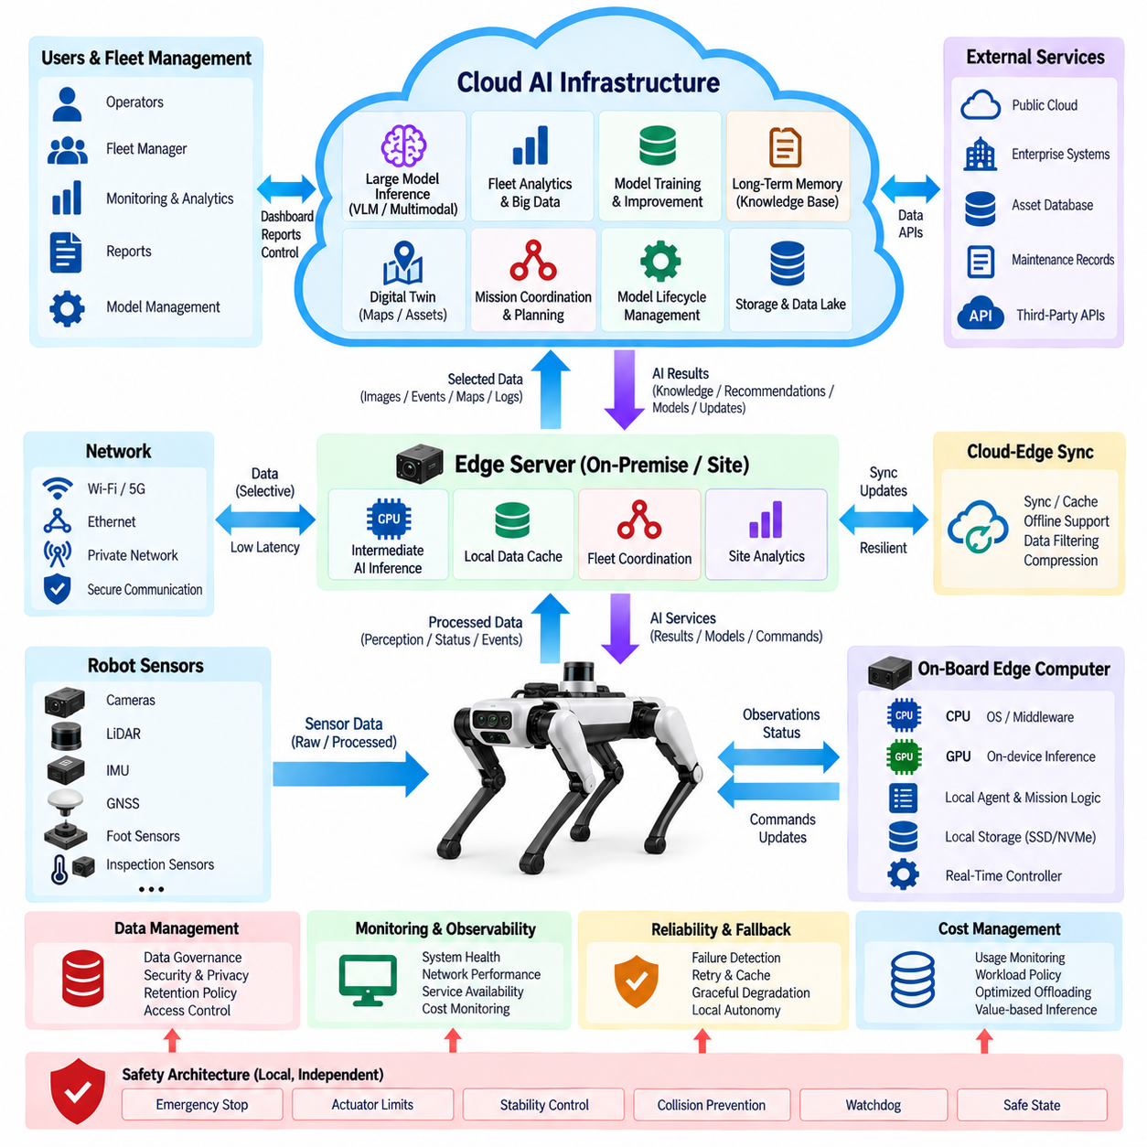
Cloud AI architecture extends the intelligence of a quadruped robot beyond the computational and storage limits of its on-board platform. It provides scalable resources for foundation models, fleet analytics, historical reasoning, model training, data management, and mission coordination. The cloud complements local edge intelligence rather than replacing it, allowing the robot to preserve essential autonomy while selectively accessing larger computational capabilities.
The fundamental design principle is separation between local operational control and remote intelligence services. Locomotion, stability control, obstacle avoidance, emergency stopping, and other time-critical functions remain on the robot. Cloud services operate on tasks that tolerate network latency, including large-model inference, fleet-wide analysis, report generation, long-term knowledge retrieval, model optimization, and computationally intensive interpretation of selected mission data.
A hierarchical architecture typically includes the on-board edge computer, a nearby edge server when available, and remote cloud infrastructure. The robot executes low-latency perception and mission functions locally, while the edge server can provide intermediate computing capacity for site-level operations. Cloud resources provide elastic computing and storage for workloads that exceed the capacity of individual robots or require information aggregated across many missions and platforms.
Communication between the robot and cloud should exchange selected information rather than continuously uploading every raw sensor stream. Images, video segments, point clouds, semantic events, diagnostic records, maps, and mission summaries can be prioritized according to operational value. Local preprocessing, compression, filtering, and event selection reduce bandwidth consumption while preserving evidence required for deeper cloud analysis or long-term storage.
Cloud inference enables access to models that are impractical to deploy directly on a mobile quadruped because of memory, power, or thermal limitations. Large VLMs, multimodal foundation models, reasoning models, and specialized inspection models can analyze selected observations transferred from the robot. Their results return as semantic information, recommendations, structured data, or mission knowledge rather than direct low-level actuator commands.
The cloud can provide long-term memory for agent-based operation. Individual robots normally retain only the information required for immediate mission continuity, whereas cloud storage can preserve inspection histories, equipment records, maps, anomaly trends, maintenance information, previous mission outcomes, and validated operational knowledge. An agent can retrieve relevant historical context when evaluating a new observation without storing the complete organizational knowledge base on every robot.
Fleet intelligence is one of the strongest advantages of cloud AI architecture. Information collected by multiple quadrupeds can be aggregated to create a broader operational representation of facilities, assets, routes, hazards, and recurring anomalies. Fleet services can compare robot status, battery condition, sensor configuration, location, mission progress, and availability to support task allocation and operational planning across multiple platforms.
Cloud analytics can transform individual observations into long-term operational knowledge. Repeated inspection results can reveal degradation patterns that are difficult to identify during a single mission. Statistical analysis, anomaly clustering, temporal comparison, and predictive models can evaluate equipment conditions across weeks or months. The resulting knowledge can support predictive maintenance, inspection prioritization, and improved mission planning for subsequent robot deployments.
Training and model improvement are naturally separated from real-time robot execution. Mission data collected in the field can be transferred to managed datasets where engineers perform labeling, validation, training, fine-tuning, evaluation, and regression testing using scalable GPU infrastructure. Approved models can then enter a controlled deployment pipeline and eventually be distributed to edge computers after compatibility and safety validation.
Model lifecycle management should maintain clear relationships among datasets, model versions, inference engines, calibration parameters, prompts, evaluation results, and deployed software. A cloud model registry can identify which model is approved for each robot configuration or mission type. Deployment records should show when a model was installed, which version it replaced, and whether rollback is required when unexpected behavior appears in field operation.
Cloud architecture also supports digital representations of robot and mission state. Maps, asset information, robot configuration, inspection targets, and historical observations can be combined into a persistent operational model. New field observations update this representation, while mission planning services use it to prepare routes and inspection objectives. The cloud therefore becomes a shared knowledge environment rather than merely a remote inference computer.
The agent architecture can use cloud services as external tools. A local agent may request historical inspection data, ask a larger model to analyze an ambiguous observation, retrieve equipment documentation, compare anomalies across the fleet, or generate a detailed mission report. Cloud responses return to the local agent as information to be evaluated within the current robot context rather than automatically becoming physical commands.
Network variability must be treated as a normal operating condition. Wireless coverage may degrade, latency may fluctuate, or communication may disappear completely as the quadruped moves through industrial facilities, tunnels, remote sites, or complex structures. The robot should therefore cache necessary mission information locally and continue essential operation without cloud access. Deferred requests and stored data can be synchronized when communication becomes available again.
Service interfaces should define timeouts, retries, request identifiers, timestamps, version information, and validity periods. A cloud response arriving after the physical situation has changed may no longer be appropriate even if its reasoning is correct. The local system must verify that remote information still corresponds to the current mission state before using it, preventing stale cloud results from influencing actions in a changed environment.
Data governance becomes increasingly important as visual, operational, and inspection information leaves the robot. Organizations must determine which data can be transmitted, where it may be stored, how long it should be retained, and which users or services may access it. Sensitive imagery or facility information may require local processing, anonymization, encryption, or restrictions that prevent selected datasets from being transferred to public cloud infrastructure.
Cybersecurity must protect the complete path between robot, edge infrastructure, and cloud services. Mutual authentication, encrypted communication, access control, signed software artifacts, secure credential management, audit logging, and protected APIs reduce the risk of unauthorized access. Cloud connectivity must never create a pathway through which an external service can bypass the robot's local command validation or safety mechanisms.
Availability engineering should assume that individual cloud services can fail. Model endpoints may become unavailable, storage services may experience disruption, or authentication infrastructure may temporarily reject requests. Local software should distinguish between optional cloud intelligence and functions required for mission continuity. Redundant services, retry policies, caching, graceful degradation, and local fallback models can prevent remote failures from unnecessarily terminating robot operation.
Observability should cover both the robot-to-cloud communication path and the cloud AI services themselves. Useful metrics include upload and download bandwidth, round-trip latency, request success rate, inference time, queue delay, service availability, storage usage, synchronization backlog, model version, and cost per workload. These metrics help engineers determine whether a function should remain in the cloud, migrate toward the edge, or be redesigned.
Cloud computing introduces an economic dimension that does not exist in the same form for fixed on-board hardware. GPU inference, storage, network transfer, database queries, and large-scale model services can generate recurring operating costs. Workload policies should therefore consider not only technical performance but also mission value. Routine perception can remain local while expensive cloud reasoning is reserved for ambiguous, high-value, or computationally demanding situations.
Safety authority must remain local regardless of cloud capability. A cloud model may recommend a new inspection viewpoint, alternative route, or mission action, but the request must pass through the robot's local agent, policy validation, motion planning, and safety layers. Emergency stop, actuator limits, stability protection, collision prevention, watchdogs, and safe-state transitions must remain functional even when every external AI service is unavailable.
Cloud AI architecture therefore creates a distributed intelligence system in which different computing layers perform tasks appropriate to their latency, resource, and reliability characteristics. The quadruped preserves immediate perception and control, nearby edge systems provide additional low-latency capacity, and cloud infrastructure supplies scalable models, knowledge, analytics, training, and fleet coordination. Clear interfaces maintain separation among these responsibilities.
When combined with edge AI, VLM integration, and agent systems, the cloud becomes the long-term intelligence and learning layer of the Physical AI architecture. Knowledge acquired by one mission can improve future missions, models can evolve from accumulated field data, and multiple robots can contribute to shared operational understanding. The result is a scalable architecture in which individual quadrupeds remain autonomous physical systems while participating in a continuously improving distributed AI ecosystem.

12.05. Embodied AI Interface
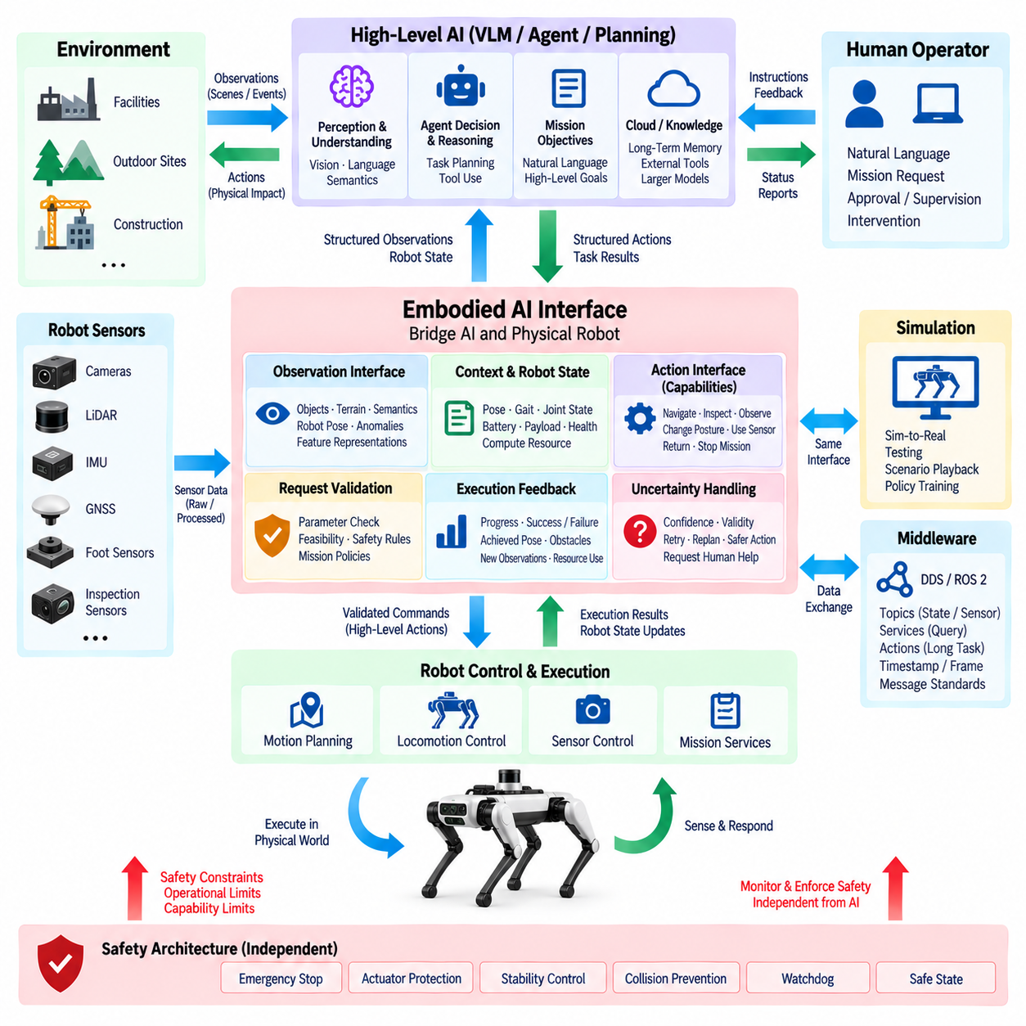
The Embodied AI interface connects high-level artificial intelligence with the physical capabilities of a quadruped robot. It defines how perception, semantic reasoning, agent decisions, and learned policies are translated into structured interactions with navigation, locomotion, sensing, and mission services. Rather than allowing AI models to manipulate hardware directly, the interface establishes a controlled boundary between probabilistic intelligence and deterministic robotic execution.
Embodied intelligence differs from conventional software AI because decisions continuously interact with the physical world. A quadruped observes its environment, selects an action, changes its physical state, and receives new sensory evidence resulting from that action. The interface must therefore support a closed perception-action loop in which observations, robot state, actions, execution results, and environmental changes remain consistently connected throughout the mission.
The observation interface combines information from cameras, LiDAR, IMU, GNSS, foot-force sensors, joint states, diagnostics, and specialized inspection sensors. Raw measurements do not always need to reach the higher AI layer. Perception modules can transform them into objects, terrain properties, traversability information, robot pose, anomalies, semantic descriptions, or compact feature representations that provide the intelligence layer with mission-relevant information.
Robot state forms another essential part of the interface because an intelligent action is meaningful only when interpreted relative to the body's current condition. The AI layer may require position, orientation, gait state, joint condition, battery level, payload configuration, communication status, thermal state, and available computing resources. This context prevents reasoning from treating the robot as an abstract software agent disconnected from its physical limitations.
The action interface should expose capabilities rather than unrestricted actuator commands. High-level actions may include navigating to a waypoint, approaching an inspection target, changing observation posture, acquiring an image, activating a sensor, returning to a safe location, or stopping a mission. Each capability is implemented by deterministic robot services that translate the requested objective into validated trajectories, gait commands, and low-level actuator operations.
A capability-based interface improves both safety and portability. An AI model can request “move to inspection pose” without needing to understand individual motor currents, encoder protocols, or joint-control frequencies. The robot platform determines whether the request is feasible and how it should be executed. This separation allows higher-level AI components to evolve without tightly coupling foundation models or agents to a specific actuator implementation.
Action requests should include explicit parameters and constraints. A navigation request may contain a destination, speed limit, arrival tolerance, timeout, preferred route, or prohibited region. An inspection request may specify target identity, viewing distance, sensor type, and required evidence. Structured parameters make AI intentions machine-verifiable and allow deterministic software to reject incomplete, unsupported, stale, or unsafe requests before physical execution.
Execution feedback closes the embodied interaction loop. Every action should return more than a simple success indicator when possible. Progress, completion status, failure reason, achieved pose, obstacle information, resource consumption, and newly acquired observations provide evidence about what actually happened in the physical world. The AI system can then update its internal context and determine whether to continue, retry, replan, or request assistance.
Active perception illustrates the importance of this interface. A VLM may determine that an equipment label is unreadable or that an anomaly cannot be confirmed from the current viewpoint. The agent can request another observation pose through the Embodied AI interface. Motion planning and locomotion systems evaluate terrain and stability constraints, reposition the robot, and return new visual evidence for another reasoning cycle.
The interface should also represent affordances, describing actions that are physically possible in the current environment. A location may be visually identifiable but unreachable because of terrain, clearance, slope, payload, or stability limitations. Combining semantic understanding with traversability and robot capability prevents the AI layer from assuming that every recognized target can be physically approached or inspected from an arbitrary position.
Spatial grounding is required to connect language and perception with robot motion. Terms such as “left valve,” “door ahead,” or “inspect behind the cabinet” must eventually correspond to coordinate frames, mapped objects, poses, or regions. Transform information and timestamps allow semantic references to be associated with the robot frame, sensor frames, local map, and global mission frame so that language-based intentions can be converted into physically meaningful objectives.
Temporal grounding is equally important because both the robot and environment can change while reasoning is performed. Observations, semantic outputs, agent decisions, and action requests should carry timestamps and validity information. Before execution, the system can verify whether the referenced object, robot state, or environmental condition is still current. This prevents delayed AI results from controlling the robot based on an outdated physical situation.
The Embodied AI interface must accommodate learned policies as well as symbolic or language-based agents. A learned locomotion or manipulation policy may produce actions at a different abstraction level from a VLM-based mission agent. Interface boundaries should clearly define which learned components may operate at high frequency, what state they receive, what command range they can generate, and which deterministic monitors constrain their outputs.
Simulation provides an important environment for developing this interface before deployment on physical hardware. The same observation and action abstractions can connect AI components to simulated sensors, robot dynamics, terrain, and mission scenarios. Maintaining compatible interfaces between simulation and the real robot reduces software changes during transfer and enables large-scale testing of agent behavior, failure recovery, and learned policies before field operation.
The interface should expose uncertainty rather than hiding it. Perception confidence, localization quality, terrain uncertainty, VLM confidence indicators, sensor validity, and execution reliability can influence agent decisions. When uncertainty becomes excessive, the AI system may acquire additional observations, reduce speed, select a safer action, request operator confirmation, or abandon a task rather than treating uncertain information as verified physical truth.
Human interaction can enter the same structured interface. An operator may issue a natural-language mission request, approve an AI-proposed action, identify an inspection target, or assume supervisory control. Natural-language instructions should be converted into validated task representations before execution. Operator authority, AI autonomy, and deterministic safety control should remain clearly separated so that command ownership is always identifiable.
Communication middleware provides the technical mechanism for exchanging embodied observations and actions. DDS/ROS 2 topics can distribute state and perception data, services can perform bounded queries, and actions can represent long-running physical tasks with feedback and cancellation. Interface definitions should specify message types, coordinate frames, timestamps, quality indicators, command identifiers, timeouts, and response semantics consistently across software modules.
Diagnostics and logging should record the complete observation-decision-action relationship. Important records include sensor evidence, semantic interpretation, agent objective, requested capability, validation result, execution command, physical outcome, and subsequent observation. This chain allows engineers to reconstruct why the robot performed an action and determine whether unexpected behavior originated from perception, reasoning, interface translation, planning, control, or hardware.
Safety validation must occur before probabilistic AI intentions reach safety-critical execution. Requested actions pass through capability checks, operational limits, collision constraints, stability requirements, and mission policies. Emergency-stop logic, actuator protection, watchdogs, and safe-state mechanisms remain independent and retain final authority. The Embodied AI interface therefore functions as a controlled gateway rather than a direct path from AI inference to motors.
Graceful degradation should be part of the interface contract. If a VLM, agent, external server, or high-level perception service becomes unavailable, lower-level robot functions should continue according to predefined behavior. The interface can report unavailable capabilities and reduced confidence so that mission logic selects alternatives. Essential stabilization, safe stopping, local navigation, and recovery should not depend on continuous availability of higher-level AI.
Standardized capability interfaces also support reuse across different quadruped platforms. Although robots may use different joint arrangements, sensors, computing modules, communication buses, and locomotion controllers, higher AI layers can interact through common concepts such as navigate, observe, inspect, stop, report, and return. Platform-specific adapters translate these abstractions into the electrical and software architecture of each robot.
The Embodied AI interface ultimately creates the contract between intelligence and embodiment. Perception describes the physical world, robot state describes the body, semantic AI interprets context, agents select objectives, and capability interfaces translate those objectives into validated physical tasks. Execution feedback then returns the consequences to the intelligence layer, completing a continuous loop between sensing, reasoning, action, and learning.
Through this architecture, a quadruped becomes more than a mobile carrier for AI models. Its physical body, sensors, actuators, computing resources, environment, and intelligence participate in a unified closed-loop system. A carefully designed Embodied AI interface allows advanced models to exploit physical interaction while preserving deterministic control boundaries, traceability, portability, and independent safety authority required for reliable Physical AI operation.

12.06. Foundation Model Integration
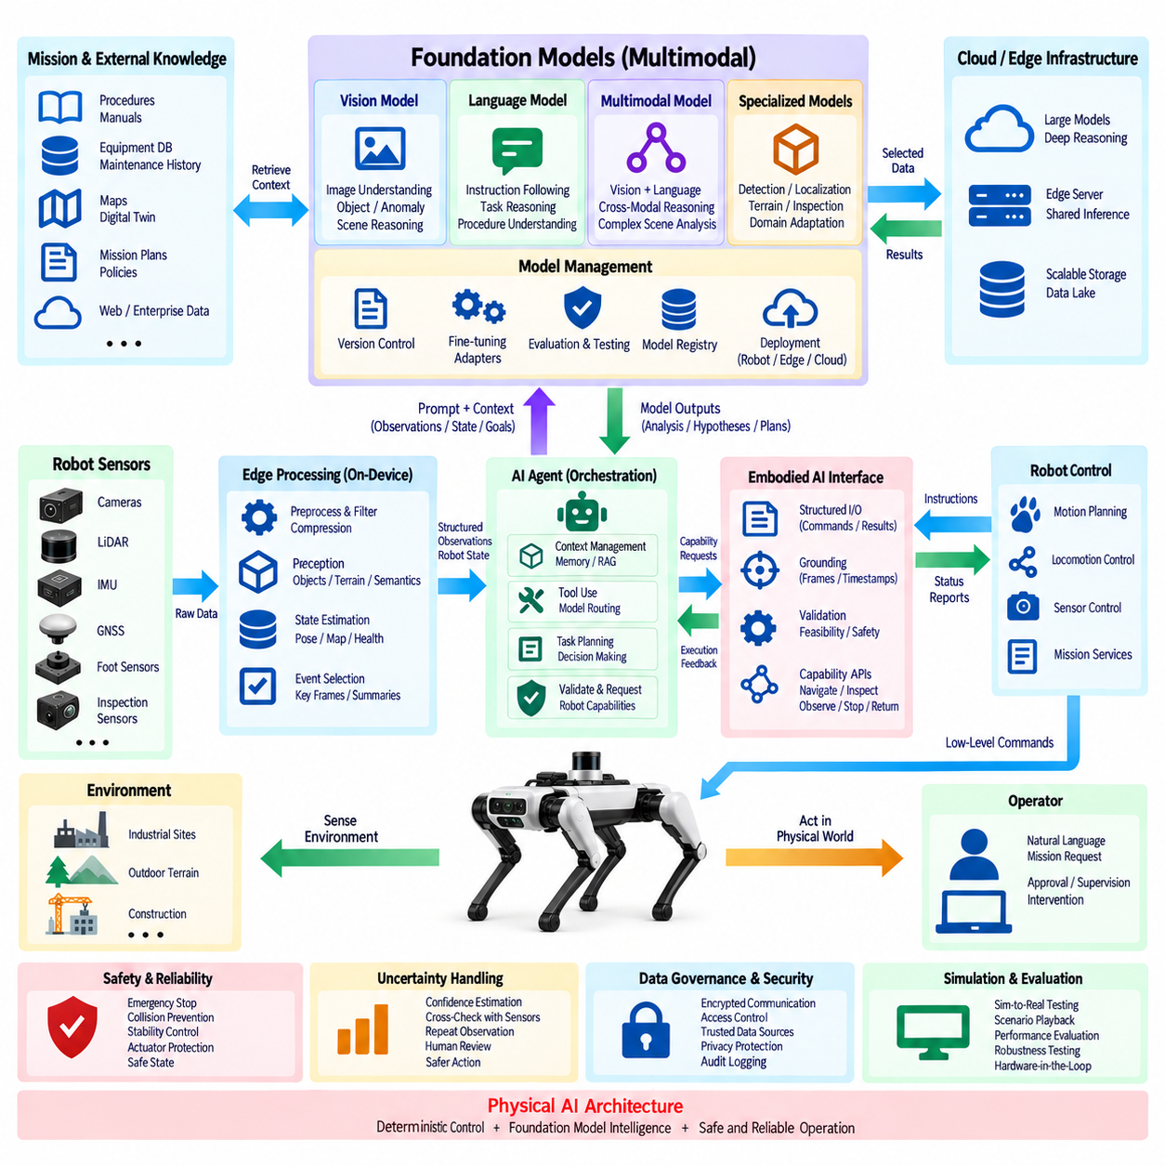
Foundation model integration extends a quadruped robot from task-specific AI toward reusable intelligence that can interpret diverse observations, instructions, and mission contexts. Instead of deploying an independent model for every semantic task, foundation models provide shared representations and reasoning capabilities across vision, language, multimodal perception, and planning. They complement specialized perception and control algorithms within the broader Physical AI architecture.
A foundation model should occupy a higher intelligence layer rather than the deterministic control path. Joint control, gait stabilization, emergency stopping, collision avoidance, and other time-critical functions remain under dedicated controllers. Foundation models interpret observations, understand instructions, generate semantic hypotheses, support planning, or propose actions, while validated robotic services determine whether and how those proposals can be executed physically.
Multimodal foundation models are particularly relevant to quadruped operation because field missions combine several information types. Camera images, text instructions, maps, robot state, inspection records, sensor summaries, and previous mission information can be represented within a common reasoning context. This allows the system to interpret an observation not only by visual appearance but also by location, mission objective, equipment identity, and historical condition.
The integration pipeline begins by transforming robot data into model-compatible representations. High-bandwidth sensor streams are filtered and processed locally before selected images, semantic objects, state summaries, or events reach the foundation model. Prompt templates and structured context describe the mission, robot state, available capabilities, constraints, and expected output format. This reduces unnecessary inference and provides the model with operationally relevant grounding.
Foundation models can support several roles without being directly responsible for all robot intelligence. A multimodal model may interpret inspection imagery, a language model may reason about mission procedures, and a learned representation model may encode environmental observations. Specialized models can still provide object detection, localization, terrain estimation, or anomaly measurement when deterministic performance, low latency, or validated accuracy is required.
The model interface should favor structured outputs over unrestricted natural-language responses. Results can include detected entities, semantic relationships, anomaly hypotheses, task recommendations, required evidence, confidence indicators, or proposed capability calls. Structured schemas allow software components to validate model outputs, compare them with sensor evidence, and translate acceptable recommendations into agent goals without interpreting arbitrary text as an executable robot command.
Grounding is essential because a foundation model operates on representations rather than directly experiencing the physical environment. Semantic references must be connected to robot pose, coordinate frames, timestamps, mapped objects, mission identifiers, and sensor sources. A statement such as “inspect the damaged pipe on the left” becomes useful only when the referenced object can be associated with a physical target and a valid observation in the robot's current environment.
The agent system provides an important orchestration layer around foundation models. Rather than allowing a model to continuously control the mission, an agent can decide when model reasoning is required, construct appropriate context, call external tools, preserve memory, evaluate responses, and request physical capabilities. This architecture separates model inference from mission state management and prevents a single generative model from becoming an unrestricted system controller.
Foundation models can also participate in active perception. If an observation is insufficient to determine equipment condition, the model may indicate that another viewpoint, higher-resolution image, thermal measurement, or contextual record is required. The agent translates this requirement into a capability request, and the Embodied AI interface validates the requested physical action. New evidence then returns to the model for another reasoning cycle.
Edge deployment provides low-latency access to compact foundation models. Quantization, pruning, optimized inference engines, reduced context windows, and accelerator-specific implementations can make selected models practical on embedded GPUs. Local execution improves privacy and availability while reducing network dependency, although model size, GPU memory, power consumption, thermal limits, and competition with perception workloads constrain what can operate continuously on the robot.
Larger foundation models can be hosted on nearby edge servers or cloud infrastructure when deeper reasoning or greater model capacity is required. The robot can transmit selected observations and structured context rather than complete raw sensor streams. Hybrid execution allows local models to handle routine situations while larger remote models analyze ambiguous or computationally demanding events, provided that communication latency and service availability are acceptable.
Model routing can dynamically select the appropriate inference resource. A simple classification may use a small local model, while a complex inspection anomaly may be sent to a larger multimodal model. Routing decisions can consider task complexity, confidence, latency requirement, network quality, data sensitivity, available GPU resources, energy consumption, and inference cost. This avoids using the most expensive model for every observation.
Memory and retrieval mechanisms can supplement the limited context of foundation models. Retrieval-augmented generation can provide equipment manuals, inspection procedures, previous anomalies, maintenance history, maps, or mission policies when relevant. Instead of expecting model parameters to contain current facility knowledge, the system retrieves controlled information from validated repositories and associates the response with the robot's present mission context.
Uncertainty must be explicitly managed because foundation models can generate plausible but incorrect conclusions. Model confidence alone may not reliably indicate correctness, so important outputs should be verified using deterministic perception, geometric constraints, sensor measurements, repeated observations, external databases, or human review. The required level of verification should increase with the physical consequence of the proposed action.
Safety-critical decisions must never rely solely on generative inference. A foundation model may suggest approaching an object, changing a route, or performing another inspection, but the request must pass through capability validation, motion planning, operational limits, and independent safety mechanisms. Emergency stop, stability control, actuator protection, collision prevention, and safe-state logic retain authority regardless of model output.
Model lifecycle management is necessary because foundation models, prompts, adapters, inference engines, and supporting knowledge sources evolve independently. Each deployed configuration should identify the model version, quantization method, prompt template, retrieval source, runtime, and compatibility requirements. Controlled updates, regression testing, staged deployment, rollback, and traceable configuration records prevent uncontrolled model changes from altering robot behavior.
Evaluation must extend beyond conventional AI benchmark scores. A model integrated into a quadruped should be assessed for semantic accuracy, grounding quality, reasoning latency, resource consumption, robustness to environmental variation, tool-use correctness, uncertainty handling, and mission-level task completion. Testing should include ambiguous observations, sensor degradation, communication loss, incorrect contextual information, and adversarial or unexpected instructions.
Simulation can provide large-scale evaluation before models are exposed to physical hardware. Foundation models can interact with simulated cameras, environments, mission events, and robot capabilities through the same interfaces used by the real platform. Scenario variation enables testing of reasoning behavior and failure recovery, while hardware-in-the-loop and field validation progressively confirm whether model recommendations remain appropriate under real timing and physical constraints.
Diagnostics and logging should preserve the complete model interaction chain. Records can include input observations, retrieved context, prompt version, model identifier, inference latency, structured output, validation result, selected action, execution feedback, and subsequent observations. These records allow engineers to determine whether failures originate from perception, retrieval, model reasoning, agent orchestration, interface translation, planning, control, or physical hardware.
Cybersecurity and data governance become important when foundation models access robot observations, external knowledge, or remote inference services. Model packages and adapters should be authenticated, communication encrypted, access permissions controlled, and sensitive mission information protected. External model services must not obtain unrestricted control authority, and retrieved knowledge should come from trusted sources appropriate to the operational environment.
A modular architecture prevents dependence on a single model family or provider. Standardized observation schemas, structured model outputs, capability interfaces, and agent tool definitions allow models to be replaced as technology evolves. Different foundation models can be assigned to vision-language understanding, reasoning, planning support, or specialized inspection while the underlying electrical, communication, control, and safety architecture remains stable.
Foundation model integration therefore creates a scalable intelligence layer above the quadruped's deterministic robotic foundation. Perception provides grounded observations, models interpret and reason about them, agents manage context and goals, the Embodied AI interface converts accepted intentions into capabilities, and deterministic controllers execute validated actions. Feedback from the physical world continuously returns to the intelligence layer for reassessment.
Through this layered approach, foundation models become reusable reasoning resources rather than autonomous motor controllers. They allow quadrupeds to understand broader mission contexts, adapt to unfamiliar situations, combine multimodal evidence, use external knowledge, and communicate naturally with humans while remaining constrained by engineering interfaces. This integration establishes a practical path from specialized robotic AI toward general-purpose Physical AI without sacrificing deterministic control, traceability, or independent safety authority.

