Volume 20. Quadruped Electrical Architecture

Chapter 13. Testing and Validation

13.01. Electrical Test
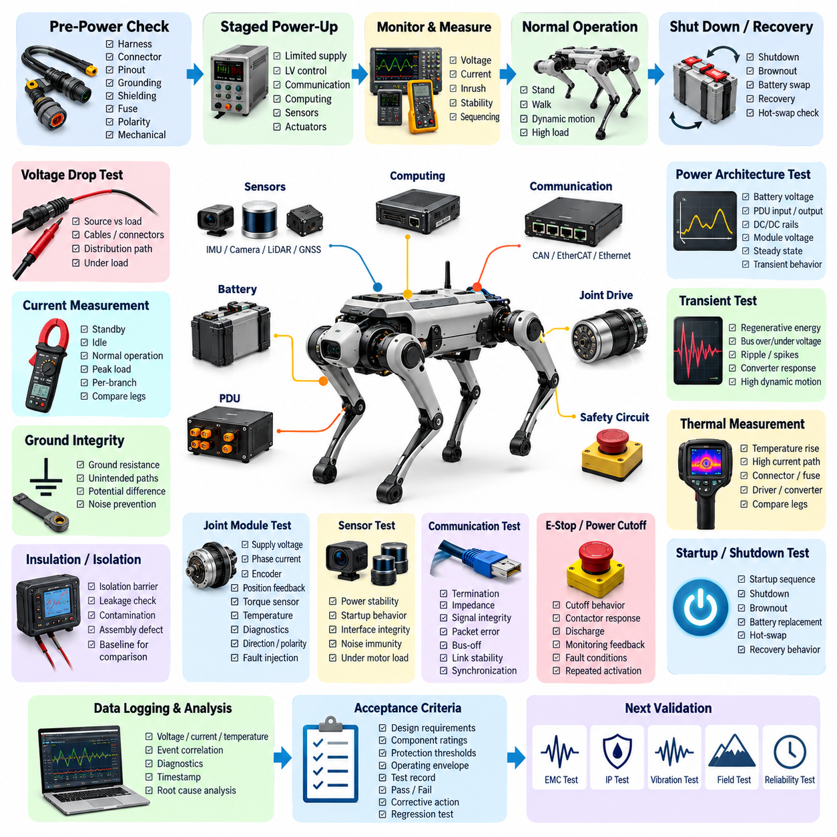
Electrical testing of a quadruped robot verifies that the complete power, control, sensing, and communication infrastructure operates within its intended electrical limits before higher-level functional validation begins. The test scope should extend from the battery and power distribution unit to joint drives, computing modules, sensors, communication interfaces, safety circuits, and auxiliary loads. Testing must therefore evaluate both individual electrical characteristics and interactions among subsystems.
A practical electrical test strategy begins with controlled inspection before power is applied. Harness routing, connector engagement, pin assignments, grounding points, shielding termination, fuse ratings, polarity, and mechanical protection should be checked against the released electrical design. Continuity and isolation measurements can then identify open circuits, unintended shorts, incorrect cross-connections, or resistance anomalies that might otherwise damage expensive motor drives, sensors, or computing hardware during initial energization.
Power-up testing should use a staged sequence rather than connecting the complete robot directly to its maximum-energy battery source. Current-limited laboratory supplies or protected battery interfaces can first energize low-voltage control domains, followed by communication devices, computing hardware, sensors, and finally actuator power stages. Voltage and current should be recorded during each transition so abnormal inrush current, unexpected standby consumption, converter instability, or incorrect sequencing can be detected before full-power operation.
The quadruped power architecture requires particular attention because multiple high-dynamic actuators can create rapid changes in electrical demand. Battery voltage, PDU input and output voltage, DC/DC converter rails, joint-driver supply voltage, and local module voltages should be measured under representative operating conditions. Tests should capture steady-state values as well as transient behavior during standing, leg lifting, walking, acceleration, recovery motions, and simultaneous joint activation, where short-duration power demand may be substantially higher.
Voltage-drop testing determines whether cables, connectors, fuses, contactors, PCB traces, and distribution paths maintain sufficient voltage at each load. Measurements should preferably be performed at both the source and the actual load terminals while significant current is flowing. This is especially important for distant leg modules because dynamic harness sections and multiple connector interfaces can introduce resistance. Excessive voltage drop can reduce actuator torque capability, disturb electronics, increase conductor heating, and produce intermittent faults that appear only during demanding motions.
Current measurements should characterize the robot at several operational states, including power-off leakage, standby, computing-only operation, actuator-enabled idle, normal locomotion, and peak dynamic loading. Individual branch currents provide additional diagnostic value because abnormal consumption can reveal a damaged motor, excessive mechanical friction, driver malfunction, wiring problem, or sensor fault. Comparing measured current signatures among nominally identical legs can also expose manufacturing variation or early degradation before a conventional fault threshold is exceeded.
Ground integrity testing verifies that power return paths and reference grounds behave as intended throughout the distributed electrical architecture. Resistance between designated grounding points should be measured, while unintended current paths through shields, structural members, communication grounds, or sensor references should be investigated. Under operating conditions, ground-potential differences should remain sufficiently controlled to prevent corrupted analog measurements, communication instability, encoder errors, or resets of sensitive computing and sensing equipment.
Insulation and isolation testing becomes important wherever the architecture contains separated power domains, exposed conductive structures, high-current battery circuits, or isolated communication interfaces. The test must confirm that isolation barriers remain effective without applying stress beyond component ratings. Leakage paths caused by damaged insulation, contamination, assembly defects, or incorrect connector pinning should be detected before environmental exposure. Baseline isolation measurements are also useful for comparison after vibration, moisture, and long-duration reliability testing.
Joint-module electrical testing should verify each actuator interface independently before coordinated locomotion is attempted. Supply voltage, driver enable behavior, phase current response, encoder communication, position feedback, torque-sensor signals, temperature sensing, and diagnostic outputs should be observed together. Direction and polarity checks are essential because an electrically functional but reversed motor or encoder relationship can create immediate instability when closed-loop control is enabled. Fault injection can additionally confirm that diagnostic mechanisms recognize disconnected or abnormal interfaces.
Sensor electrical validation should verify not only whether a device produces data, but whether its power and interface characteristics remain stable across realistic robot operating conditions. IMUs, cameras, LiDAR, GNSS modules, foot-force sensors, and inspection payloads may have different voltage, current, grounding, timing, and communication requirements. Supply ripple, startup behavior, interface integrity, and susceptibility to actuator-generated disturbances should therefore be evaluated while motors and high-current loads are actively switching.
Communication interfaces should be electrically checked together with their protocol-level operation. CAN FD, EtherCAT, Gigabit Ethernet, and other buses depend on correct termination, impedance, grounding, shielding, connector quality, and physical-layer signal integrity. Tests should examine communication during actuator switching and high-load motion rather than only in a quiet laboratory state. Packet errors, bus-off events, link renegotiation, synchronization loss, or intermittent connector behavior may indicate electrical problems even when software configuration appears correct.
Emergency-stop and power-cutoff circuits require dedicated electrical verification because their behavior must remain predictable independently of normal application software. Tests should confirm the commanded removal or inhibition of actuator energy, contactor response, discharge behavior, monitoring feedback, and restoration sequence. Open-circuit, short-circuit, stuck-signal, or loss-of-control-power conditions should be considered where the architecture supports diagnostic coverage. Repeated activation also helps reveal contact degradation or sequencing problems that a single functional demonstration may miss.
Transient testing is particularly relevant to quadrupeds because regenerative motor operation and rapid actuator deceleration can return energy to the DC bus. Engineers should observe bus overvoltage, undervoltage, ripple, switching spikes, and converter response during aggressive acceleration, braking, landing, disturbance recovery, and abrupt emergency stopping. Measurement equipment must have adequate bandwidth and sampling performance; otherwise short electrical events capable of resetting electronics or damaging components may disappear from averaged voltage readings.
Thermal measurements complement electrical measurements because many electrical defects manifest as localized heating. Battery terminals, PDU devices, fuses, contactors, DC/DC converters, motor-driver power stages, connectors, splices, and high-current harness sections should be monitored during sustained operation. Temperature rise should be correlated with measured current and ambient conditions. Unexpected differences between equivalent joints or legs can indicate excessive contact resistance, insufficient conductor capacity, poor assembly, or abnormal actuator loading before visible damage occurs.
Testing should also evaluate startup, shutdown, brownout, battery replacement, and recovery behavior. A quadruped may contain controllers and sensors that reach operational state at different times, so unstable sequencing can generate communication faults or unsafe actuator states. Controlled reduction and restoration of supply voltage can reveal inadequate undervoltage handling, repeated processor resets, corrupted communication states, or unexpected motor-driver enabling. Hot-swap architectures require additional confirmation that insertion and removal do not create destructive current or voltage transients.
Electrical validation becomes substantially more useful when measurements are synchronized with system diagnostics and event logging. Voltage, current, temperature, actuator status, communication faults, controller resets, and timestamps can be correlated to reconstruct the sequence preceding an abnormal event. This approach connects electrical testing with the system health monitoring, event logging, remote diagnostics, and predictive-maintenance functions defined elsewhere in the quadruped architecture, turning test results into reusable engineering evidence rather than isolated laboratory observations.
Acceptance criteria should be established before formal testing and linked to design requirements, component ratings, protection thresholds, and operating envelopes. Each test record should identify hardware revision, firmware and software configuration, battery condition, instrumentation, environmental state, procedure, measured results, and pass/fail determination. Deviations should be traceable to corrective actions and subsequent regression tests. This discipline is essential because electrical behavior can change after harness revisions, connector substitutions, actuator updates, or modifications to power-distribution hardware.
Electrical testing ultimately provides the baseline for the broader validation sequence of the quadruped platform. A robot that passes bench-level electrical checks can proceed with greater confidence into EMC, ingress-protection, vibration, field, and reliability testing, which are explicitly separated as subsequent validation areas in the architecture. Electrical measurements should also be repeated after those tests because environmental and mechanical stresses can reveal latent connector, harness, grounding, insulation, or power-distribution weaknesses that were not observable in the initial laboratory condition.

13.02. EMC Test
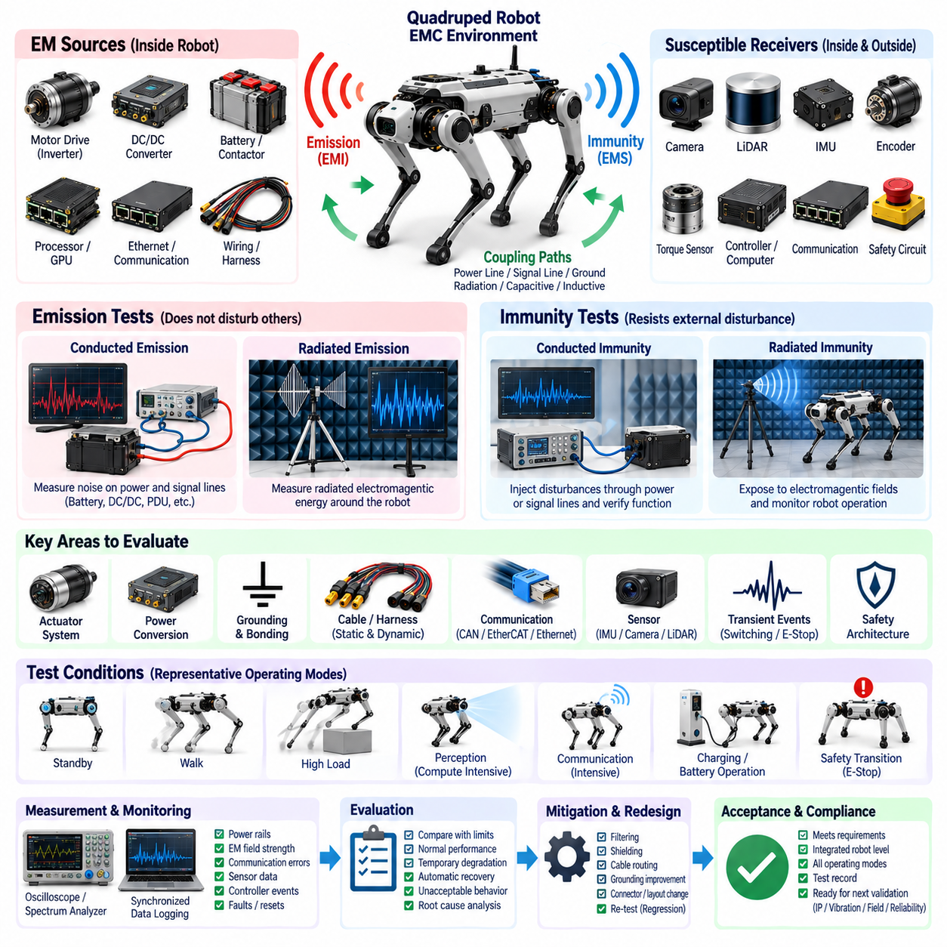
Electromagnetic compatibility testing verifies that a quadruped robot can operate correctly in its intended electromagnetic environment without generating disturbances that interfere with its own subsystems or nearby equipment. Because the platform combines high-current actuators, switching power electronics, distributed controllers, high-speed communication, cameras, LiDAR, IMUs, and sensitive sensor interfaces, EMC validation must address both electromagnetic emissions and immunity across the complete integrated robot.
The EMC test strategy should begin by identifying the major electromagnetic sources, coupling paths, and susceptible receivers within the architecture. Motor inverters, BLDC or PMSM drives, DC/DC converters, contactors, high-current battery cables, processors, GPU modules, and Ethernet interfaces can generate broadband or narrowband disturbances. These disturbances may couple through shared power lines, ground structures, harnesses, connector shields, free-space radiation, or parasitic capacitance and inductance into sensitive circuits.
Conducted emission testing evaluates unwanted electrical noise that propagates through power and signal conductors. Measurements should examine battery lines, DC/DC converter inputs and outputs, PDU branches, actuator supplies, and relevant low-voltage rails under representative operating conditions. Testing only with stationary joints is insufficient because inverter switching patterns and current demand change significantly during locomotion. Standing, walking, acceleration, joint reversal, high-torque motion, and recovery maneuvers should therefore be included when characterizing conducted disturbances.
Radiated emission testing determines whether electromagnetic energy generated by the robot exceeds acceptable levels or creates interference with surrounding systems. The robot should be evaluated with major computing, perception, communication, and actuator subsystems operating simultaneously. Motor-drive switching, processor clocks, GPU activity, Ethernet traffic, and poorly terminated cables can all contribute to radiation. Measurements should consider different robot orientations because the chassis, leg positions, and moving harness geometry can change effective antenna characteristics.
Conducted immunity testing examines whether disturbances entering through power or signal interfaces cause functional degradation. Injected disturbances can expose weaknesses in filtering, grounding, isolation, connector design, or power regulation that may not appear during ordinary operation. During testing, engineers should monitor controller resets, actuator faults, encoder errors, sensor corruption, communication interruptions, diagnostic events, and unexpected safety-state transitions rather than relying solely on whether the robot remains powered.
Radiated immunity testing exposes the integrated robot to controlled electromagnetic fields while its essential functions remain active. The purpose is to determine whether external transmitters or electromagnetic sources can influence locomotion, perception, computing, or safety behavior. Joint control stability, IMU outputs, camera and LiDAR operation, communication links, real-time controllers, and emergency functions should be continuously monitored. Temporary degradation can be significant even when the robot automatically recovers after the electromagnetic field is removed.
The actuator system deserves particular attention because multiple high-power joint modules operate close to sensors, communication cables, and computing electronics. Rapid PWM switching and high phase currents can generate common-mode and differential-mode noise that propagates through the robot structure and harness. EMC measurements should therefore compare individual joint operation with simultaneous multi-joint activation. Aggressive gait transitions and high-torque maneuvers can reveal interference mechanisms that remain hidden when each actuator is tested independently.
Power-conversion devices form another major EMC source. Battery interfaces, PDU switching devices, DC/DC converters, auxiliary converters, and motor drivers generate transient and repetitive switching components over a wide frequency range. Input filters, output filters, local decoupling, cable routing, grounding, and shielding should be evaluated as a coordinated system. A filter that performs adequately on a bench can behave differently after integration because actual cable impedance, chassis coupling, and distributed loads modify its electrical environment.
Grounding and bonding validation should accompany EMC testing because electromagnetic performance depends strongly on return-current paths. Chassis connections, electronics grounds, power returns, sensor references, shield terminations, and structural bonding points should follow the intended architecture. High-frequency currents do not necessarily follow the same paths as DC current, so a connection with acceptable resistance at low frequency may still have excessive high-frequency impedance. Unexpected ground loops can also convert common-mode disturbances into differential noise at sensitive interfaces.
Harness configuration must represent the production design as closely as possible during formal EMC evaluation. Cable length, routing, separation, twisting, shielding, connector backshells, clamp positions, and proximity to motors or power electronics can strongly affect coupling. The dynamic leg harness is particularly important because its geometry changes as the robot moves. EMC testing should therefore consider representative leg postures and cable configurations rather than assuming that one static harness arrangement represents every operational condition.
Communication networks require simultaneous physical-layer and protocol-level observation during EMC testing. CAN FD, EtherCAT, Gigabit Ethernet, and other links may continue operating while experiencing increased error rates, retries, synchronization disturbances, or intermittent packet loss. Bus errors, link status, packet statistics, latency, clock synchronization, and diagnostic counters should be logged together with electromagnetic test conditions. This approach helps distinguish communication susceptibility from application software faults and identifies margins before complete link failure occurs.
Sensor susceptibility is critical because small disturbances can corrupt measurements without producing an obvious electrical failure. IMUs, encoders, torque sensors, foot-force sensors, cameras, LiDAR, GNSS receivers, and inspection sensors should be observed for bias shifts, spikes, dropped frames, invalid measurements, synchronization loss, or temporary communication interruptions. Particular attention should be given to sensor signals used directly by balance and locomotion control because short disturbances can propagate rapidly into actuator commands and whole-body behavior.
Transient electromagnetic events should also be evaluated because switching inductive loads, opening contactors, emergency power cutoff, battery connection, and regenerative actuator operation can generate short-duration disturbances. These events may produce voltage spikes, ringing, ground shifts, or temporary supply interruptions that interact with sensitive electronics. Oscilloscopes and appropriate probes should capture events at relevant power rails and interfaces while system logs record resets, faults, communication errors, and safety responses at synchronized timestamps.
EMC testing of the safety architecture should determine whether electromagnetic disturbances can compromise emergency-stop paths, actuator disable functions, safety controllers, monitoring signals, or power cutoff mechanisms. Safety-related interfaces should move to their defined safe or degraded states when disturbances exceed tolerated limits rather than producing uncontrolled behavior. Testing should also examine whether false emergency triggers occur, since excessive susceptibility can reduce operational availability even when the system ultimately remains safe.
Pre-compliance testing is valuable during development because EMC problems are substantially easier to correct before the mechanical and electrical architecture becomes fixed. Near-field probes, current probes, oscilloscopes, spectrum analyzers, and temporary shielding or filtering can help identify dominant sources and coupling paths. Engineers can compare alternative cable routes, shield termination methods, ferrites, filters, grounding arrangements, and converter configurations before committing to formal laboratory testing and production-intent hardware.
Formal EMC validation should use clearly defined operating modes because electromagnetic behavior varies with robot activity. Representative modes can include standby, computing-intensive perception, communication-intensive operation, actuator-enabled idle, normal walking, maximum practical joint activity, charging or battery-related operation where applicable, and safety transitions. The worst emission condition and the most susceptible operating condition may be different, so test planning should not assume that a single maximum-power state represents every EMC risk.
Test instrumentation and robot diagnostics should share a consistent time reference whenever practical. Correlating field strength, injected disturbance level, frequency, power-rail behavior, communication errors, actuator faults, sensor anomalies, and controller events makes root-cause analysis considerably more effective. The quadruped architecture already incorporates time synchronization, health monitoring, diagnostics, and event logging, allowing EMC results to become part of the broader validation evidence rather than remaining isolated laboratory measurements.
Acceptance criteria should distinguish between normal performance, temporary degradation, automatic recovery, and unacceptable or unsafe behavior. A test record should identify robot hardware configuration, harness revision, firmware and software versions, battery condition, operating mode, test setup, disturbance parameters, observed behavior, diagnostic records, and corrective actions. Any design change introduced to solve an EMC problem should be followed by regression testing because modifications to filters, grounding, shielding, connectors, or cable routing can influence other subsystems.
EMC validation should ultimately demonstrate compatibility at the integrated robot level rather than merely showing that individual components passed isolated tests. A compliant motor driver, computer, sensor, or converter can still create system-level interference after installation because the final chassis, harness, grounding, and power distribution architecture establishes new coupling paths. EMC results should therefore be considered together with electrical, ingress-protection, vibration, field, and reliability testing within the overall quadruped testing and validation framework.

13.03. IP Test
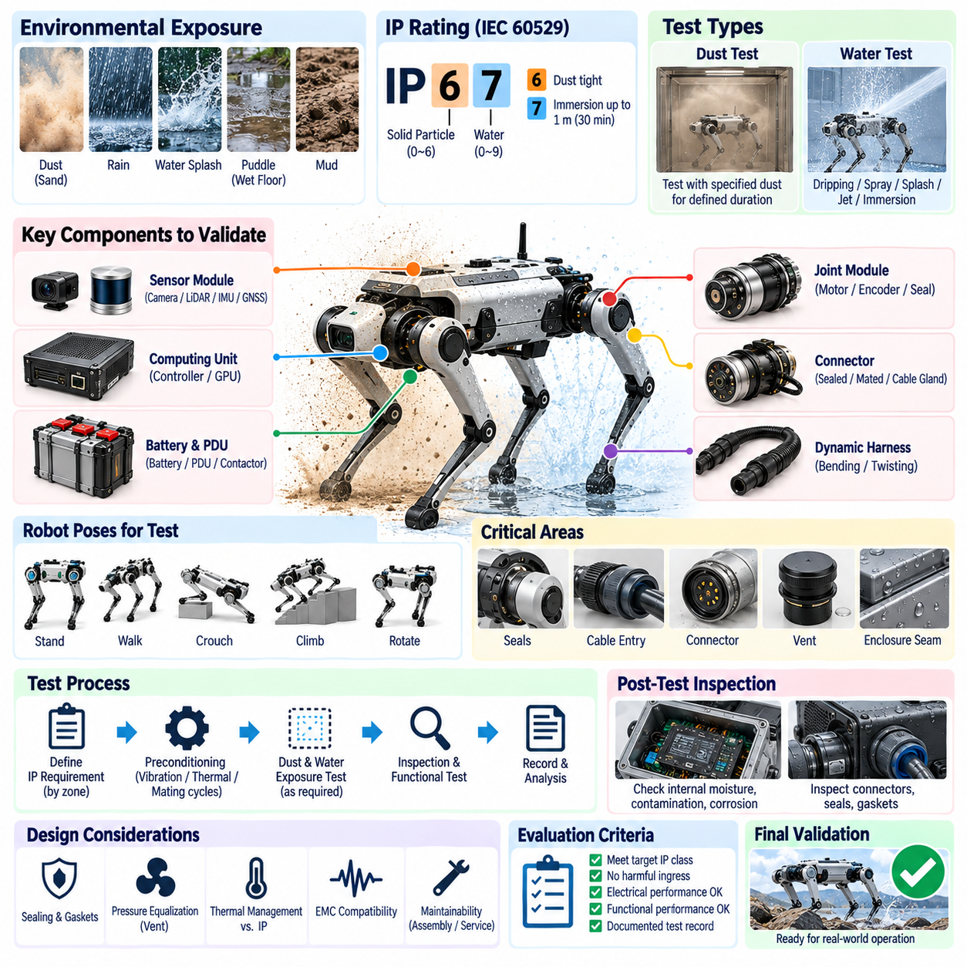
Ingress Protection testing verifies whether a quadruped robot can prevent harmful intrusion of solid particles and water into electrical and electronic assemblies under the environmental conditions defined for its mission. Because the robot contains moving legs, articulated joints, dynamic harnesses, sensors, computers, batteries, power electronics, and external connectors, protection must be validated at component, enclosure, interface, and integrated-system levels rather than assumed from individual IP-rated parts.
The IP test strategy should begin by defining the required protection level for each electrical zone. A central computing enclosure may experience different exposure from a foot module, joint actuator, battery compartment, or externally mounted sensor. The target IP rating should therefore reflect installation position, expected dust, rain, splash, cleaning procedures, temporary immersion risk, and mission environment. The final robot rating must consider the weakest relevant enclosure or interface exposed during normal operation.
Solid-particle protection testing evaluates whether dust or other particles can enter an enclosure in quantities that impair operation or create unsafe electrical conditions. Fine particles can contaminate connectors, optical surfaces, cooling systems, bearings, printed circuit boards, and high-voltage or high-current interfaces. For quadrupeds used in industrial, construction, mining, agricultural, or outdoor inspection environments, dust exposure may occur continuously while the robot walks and can be intensified by airflow generated around moving legs.
Dust testing should represent the actual mechanical configuration of the robot or the enclosure being qualified. Cable glands, pressure vents, removable covers, service panels, connector interfaces, shaft seals, and fastening points are common ingress paths and should be installed using production-intent parts and assembly processes. Testing an idealized prototype with additional sealant or temporary closures can produce results that do not represent production performance, so configuration control is essential throughout validation.
Water protection testing evaluates resistance to dripping water, spray, splashing, jets, or immersion according to the required protection class. A quadruped robot can encounter rain, wet floors, puddles, cleaning water, mud, or direct splash generated by its own motion. Water may approach an enclosure from many directions because the robot continuously changes body height and leg orientation. Test planning should therefore consider realistic exposure angles rather than treating the robot as a stationary cabinet.
Joint modules are particularly challenging because they combine electrical interfaces with continuous mechanical motion. Rotary seals, motor housings, encoder covers, torque-sensor interfaces, bearings, cable exits, and connector boundaries must maintain protection throughout the intended joint range. A seal that prevents ingress in a static position may deform or open during repeated articulation. IP validation should therefore include representative joint positions and, where practical, motion before or during environmental exposure.
Dynamic leg harnesses require dedicated attention because repeated bending, twisting, abrasion, and tension can gradually reduce ingress protection at cable jackets, boots, glands, and connectors. Harness routing should be tested in representative standing, crouching, walking, and extreme articulation configurations. Water or dust intrusion at a damaged cable entry can migrate along conductors or braided shields into an enclosure, meaning the visible entry point and the eventual electrical failure location may be physically separated.
Connector sealing should be validated in the fully mated production condition. Interface seals, radial seals, wire seals, backshells, locking mechanisms, unused cavities, and protective caps can all influence performance. Incorrect wire diameter, damaged seal surfaces, incomplete connector engagement, or poor crimp positioning may compromise protection even when the connector family itself carries an IP rating. Service-disconnect connectors should also be evaluated after realistic mating and unmating cycles because sealing performance can deteriorate with handling.
Battery and power-distribution areas require careful ingress validation because moisture or conductive contamination can create leakage currents, corrosion, short circuits, insulation degradation, or unintended current paths. Battery enclosures, PDU housings, fuse and contactor compartments, charging interfaces, emergency disconnects, and high-current connectors should be inspected before and after exposure. Drainage and pressure-equalization features must prevent water accumulation without creating uncontrolled paths for contaminants to reach sensitive electrical components.
Pressure equalization is important in sealed robot enclosures because internal temperature changes can create pressure differences that draw moisture through small gaps. Batteries, motor drivers, processors, and DC/DC converters generate heat during operation, while outdoor environments can expose the robot to rapid temperature changes. Membrane vents or other pressure-management devices should therefore be evaluated as part of the enclosure system. Their location, orientation, contamination resistance, and long-term sealing behavior can directly affect ingress performance.
Sensor modules present additional challenges because their optical or sensing surfaces cannot simply be enclosed behind arbitrary protective structures. Cameras, LiDAR, GNSS modules, IMUs, and inspection sensors may require transparent windows, exposed apertures, radomes, or specialized seals. Water droplets, condensation, dust deposits, and contamination can degrade perception even without entering the electronics. IP validation should therefore distinguish between enclosure integrity and mission-level sensor performance following environmental exposure.
Preconditioning should be considered before formal IP testing because a new enclosure may perform differently from hardware that has experienced realistic mechanical stress. Vibration, thermal cycling, connector mating cycles, joint movement, harness flexing, maintenance access, or controlled aging can expose weaknesses in gaskets and sealing interfaces. Performing ingress tests only on pristine hardware can overestimate field durability. The sequence of environmental tests should therefore be defined according to the failure mechanisms that the validation program intends to reveal.
Post-exposure inspection should combine visual examination with electrical and functional testing. Engineers should inspect internal surfaces, connector cavities, seals, vents, cable entries, corrosion-prone areas, and moisture indicators where provided. Continuity, insulation resistance, leakage current, communication stability, sensor operation, actuator behavior, and diagnostic status should be checked after exposure. A robot that powers on successfully may still contain trapped moisture or contamination capable of causing delayed corrosion and reliability failures.
Water detection should not rely only on obvious pools or droplets. Small quantities of moisture can migrate beneath connectors, along harness braids, around fasteners, or between enclosure interfaces. Condensation may also appear after the robot returns to a different temperature. Controlled disassembly procedures should preserve evidence of ingress rather than allowing water to escape before inspection. Photographs, moisture-sensitive indicators, mass measurements, or localized inspection methods can support root-cause analysis when leakage is difficult to trace.
The interaction between IP protection and thermal management must be considered during design validation. Increasing enclosure sealing can restrict airflow and improve resistance to water and dust while simultaneously increasing internal temperature. Conversely, adding vents, fans, or cooling openings can create new ingress paths. Quadruped electrical architecture therefore requires coordinated evaluation of sealing, pressure equalization, cooling, component temperature, and power dissipation so that environmental protection does not unintentionally reduce electrical or computing reliability.
Ingress protection can also interact with electromagnetic compatibility. Conductive gaskets, metal enclosure joints, connector backshells, shield terminations, and cable glands may contribute simultaneously to environmental sealing and EMC performance. A sealing modification that changes metal-to-metal contact or shield termination can alter electromagnetic behavior, while an EMC modification can compromise a water barrier. Design changes following IP failures should therefore trigger appropriate electrical and EMC regression testing rather than being treated as isolated mechanical corrections.
Integrated robot testing should reproduce representative operating configurations because enclosure orientation changes continuously during quadruped locomotion. Standing, crouching, climbing, turning, and recovery postures can expose seams or connectors that are normally protected by geometry. The underside, foot and lower-leg regions may receive substantially greater contamination than upper-body electronics. Mission-specific tests can supplement standardized IP procedures when standardized exposure alone does not represent the actual environmental risk of the intended application.
Acceptance criteria should specify not only the target ingress-protection classification but also allowable internal evidence, electrical performance, functional behavior, and post-test condition. Test records should document hardware revision, sealing materials, fastener torque, connector configuration, harness routing, preconditioning, exposure parameters, orientation, operating state, inspection results, and corrective actions. This traceability is essential because seemingly minor changes to gaskets, cable glands, covers, vents, or assembly processes can materially change protection performance.
A failed IP test should lead to identification of the physical ingress path and failure mechanism rather than simply adding sealant around the suspected region. Root-cause analysis should determine whether leakage resulted from tolerance stack-up, gasket compression, surface finish, connector assembly, cable movement, pressure differential, mechanical deformation, or an unsuitable sealing concept. Corrective designs should then be retested under equivalent conditions and, where relevant, after mechanical preconditioning to demonstrate that the improvement is robust.
IP validation ultimately establishes whether the quadruped electrical architecture can preserve its required electrical and functional integrity when exposed to dust and water throughout realistic operation. Its results should be evaluated together with electrical, EMC, vibration, field, and reliability testing because ingress protection can degrade through mechanical stress and aging. The testing structure therefore treats IP testing as one part of an integrated validation process rather than an isolated enclosure qualification activity.

13.04. Vibration Test
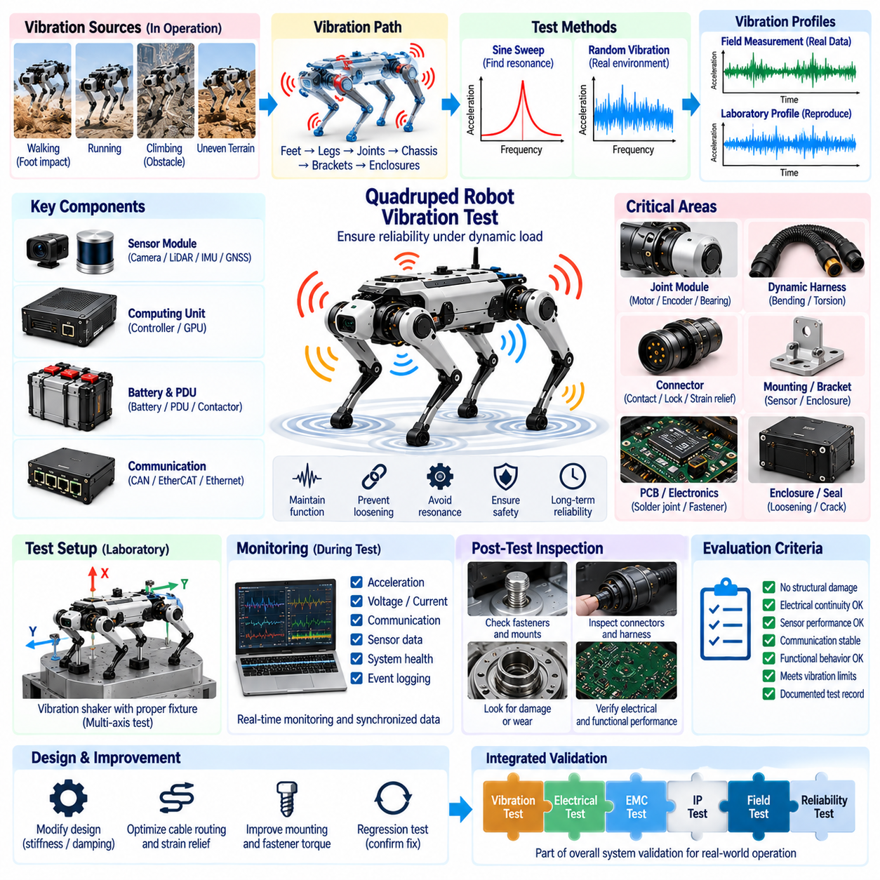
Vibration testing verifies that a quadruped robot can maintain mechanical, electrical, sensing, computing, and communication integrity when exposed to dynamic loads generated by locomotion and the external environment. Unlike stationary industrial equipment, a quadruped continuously produces shocks and vibration through foot impacts, joint acceleration, structural flexing, and terrain interaction. Validation must therefore address components, assemblies, articulated legs, harnesses, connectors, sensors, and the integrated robot.
The vibration test strategy should begin by identifying the mechanical excitation sources and the electrical assemblies most susceptible to them. Repeated foot contact, rapid joint reversal, running, climbing, recovery motions, payload movement, transportation, and uneven terrain can introduce vibration over different frequency ranges. These inputs propagate through the feet, legs, joints, chassis, equipment brackets, and enclosures, where structural resonances can amplify local acceleration beyond the vibration measured at the original excitation point.
Representative vibration profiles should be derived from the robot's intended operating environment whenever practical. Accelerometers installed at the body, joint modules, sensor mounts, battery enclosure, computing unit, and other critical locations can capture field vibration during standing transitions, walking, turning, climbing, obstacle traversal, and recovery. Measured data can then support laboratory profiles that reproduce relevant frequency content, acceleration levels, shock events, and exposure durations rather than relying only on generic vibration assumptions.
Laboratory vibration testing commonly uses controlled sinusoidal or random excitation to investigate different failure mechanisms. A sine sweep is useful for identifying resonant frequencies and structural responses, while random vibration can represent broadband excitation associated with complex terrain and repeated locomotion. The test fixture must transfer the commanded vibration to the device under test without introducing unrealistic resonances or excessive damping that would distort the actual mechanical environment experienced by the robot.
Resonance identification is especially important for sensors and computing equipment because relatively small external excitation can become severe at a structural natural frequency. Camera brackets, LiDAR mounts, antenna supports, PCB assemblies, battery structures, and electronic enclosures may each have different resonant characteristics. Comparing response measurements before, during, and after exposure helps determine whether mounting stiffness, fastener preload, damping, or structural reinforcement should be modified to prevent amplification and fatigue.
Joint modules require dedicated vibration evaluation because they contain motors, bearings, encoders, torque sensors, power electronics, connectors, and mechanical transmission components within a compact moving assembly. Testing should examine whether vibration causes intermittent electrical contact, encoder instability, sensor drift, fastener loosening, bearing degradation, or changes in motor-control behavior. Representative joint orientation and mechanical preload should be considered because the response of an unloaded actuator may differ significantly from that of a joint installed in a load-bearing leg.
Dynamic leg harnesses are among the most vibration-sensitive electrical elements because they simultaneously experience flexing, torsion, acceleration, and local impact. Conductors, shield braids, crimps, splices, cable jackets, connector strain reliefs, and retention clips should be inspected for fatigue or movement. Electrical continuity monitoring during vibration can reveal momentary open circuits that disappear after the test stops. Such intermittent faults are particularly important because they can produce actuator or sensor failures only during locomotion.
Connector validation should consider both electrical continuity and mechanical retention. Vibration can produce fretting at contact interfaces, reduce contact force, loosen locking mechanisms, or transfer cable loads into terminals. High-current battery and actuator connectors deserve particular attention because increasing contact resistance can create localized heating, while low-level sensor and communication connectors may exhibit intermittent signal corruption. Production-intent mating, backshell, strain-relief, and mounting configurations should therefore be maintained during testing.
Battery and power-distribution assemblies experience vibration while carrying substantial stored energy and current. Battery cells, busbars, terminals, fuses, contactors, PDU components, mounting brackets, and high-current cables should remain mechanically secure and electrically stable throughout exposure. Testing should identify loosening, insulation abrasion, connector displacement, busbar fatigue, or unexpected voltage interruption. Post-test resistance and thermal measurements can reveal degradation that is not visible during an external inspection.
Sensor vibration testing must distinguish between temporary measurement disturbance and permanent mechanical or calibration change. IMUs naturally respond to acceleration and therefore require careful interpretation, while cameras and LiDAR can suffer image blur, point-cloud distortion, mounting displacement, or calibration shift. GNSS antennas and inspection sensors may also be affected by mounting movement. Sensor outputs should be synchronized with reference accelerometers so that vibration-induced artifacts can be separated from genuine changes in the surrounding environment.
Computing hardware should be monitored during vibration rather than evaluated only after exposure. Real-time controllers, Jetson or edge computing modules, storage devices, memory, cooling assemblies, and internal connectors may experience resets, communication loss, thermal-interface movement, or intermittent contact. Continuous health monitoring, event logging, and communication supervision can identify short disturbances that would otherwise disappear when the test is completed. Computing mounts and heavy heat sinks should also be checked for fatigue and fastener loosening.
Communication networks can reveal vibration-induced electrical faults before complete connector failure occurs. CAN FD, EtherCAT, Gigabit Ethernet, and sensor interfaces should be monitored for packet errors, retransmissions, link interruptions, synchronization loss, or bus faults while vibration is applied. Correlating these events with acceleration measurements helps locate mechanically sensitive interfaces. A network that operates correctly before and after testing may still be unacceptable if communication becomes unstable only while the structure is vibrating.
Shock events should complement continuous vibration testing because quadruped robots can experience short, high-amplitude loads during foot impact, stumbling, jumping, obstacle contact, emergency stopping, or recovery from a fall. Mechanical shock can stress solder joints, connectors, sensor mounts, batteries, and structural interfaces differently from broadband vibration. Test severity should represent credible operational events without introducing unrealistic loads that exceed the intended mechanical design envelope.
Multi-axis behavior must be considered because vibration enters the quadruped structure in different directions as the robot changes posture and direction of travel. Testing along orthogonal axes can reveal weaknesses hidden in a single-axis test, particularly for cantilevered sensors, connectors, PCB assemblies, and battery mounts. Component orientation relative to gravity and mechanical preload can also affect response. The test configuration should therefore reproduce representative installation orientation whenever the laboratory equipment allows it.
Preconditioning and test sequencing are important because vibration can alter sealing, electrical connections, calibration, and EMC behavior. An assembly that initially passes an IP test may develop small seal gaps after prolonged mechanical excitation, while shield terminations or grounding interfaces can change after fastener movement. For this reason, vibration testing should be coordinated with electrical, EMC, IP, and environmental validation. Selected tests may need to be repeated after vibration exposure to identify mechanically induced degradation.
Functional monitoring during vibration provides stronger evidence than post-test inspection alone. The robot or subsystem should operate in a safe representative mode while voltage, current, communication status, sensor output, controller health, actuator diagnostics, and safety signals are recorded. Where full locomotion cannot be reproduced on a shaker, electrical loads and communication traffic can emulate relevant operating states. Synchronized timestamps allow transient functional anomalies to be correlated directly with mechanical excitation.
Post-test inspection should search for both obvious damage and subtle changes. Engineers should examine fasteners, brackets, welds, housings, PCB supports, connectors, cable clamps, harness jackets, seals, battery mounts, and sensor alignment. Electrical continuity, insulation resistance, contact resistance, communication stability, actuator performance, and sensor calibration should be compared with pre-test baselines. Small changes may indicate progressive fatigue even when the hardware remains fully functional immediately after the test.
Fatigue assessment becomes important because many quadruped missions involve millions of repeated gait cycles rather than a small number of severe events. Low-amplitude vibration can gradually damage conductors, solder joints, mounting structures, and connector interfaces. Accelerated laboratory testing should reproduce the dominant failure mechanisms without creating unrealistic ones. Exposure duration and severity therefore need engineering justification so that accelerated testing represents long-term operation rather than simply applying the highest possible vibration level.
Acceptance criteria should combine structural condition, electrical continuity, functional behavior, sensor stability, communication performance, and post-test inspection. Test documentation should record hardware revision, fixture configuration, mounting torque, orientation, vibration spectrum, acceleration level, duration, operating state, instrumentation, observed anomalies, and corrective actions. Configuration traceability is essential because changes to brackets, fasteners, cable routing, connectors, enclosure mass, or payload location can significantly modify the vibration response.
A vibration failure should be analyzed by tracing the excitation path from the mechanical input to the affected component. Root-cause analysis may identify resonance, insufficient stiffness, excessive mass, poor damping, inadequate strain relief, connector movement, fastener preload loss, or unsuitable cable routing. Corrective actions should address the actual mechanism rather than merely strengthening the visibly damaged location. The modified design should then undergo equivalent regression testing to confirm that the failure mode has been removed without transferring excessive stress elsewhere.
Vibration validation ultimately demonstrates that the quadruped electrical architecture can preserve its required functions while repeatedly experiencing the mechanical dynamics inherent to legged locomotion. The testing structure places vibration alongside electrical, EMC, IP, field, and reliability validation, emphasizing that mechanical excitation can influence nearly every electrical subsystem. Results should therefore become part of integrated system evidence used to establish readiness for prolonged field operation and subsequent reliability qualification.

13.05. Field Test
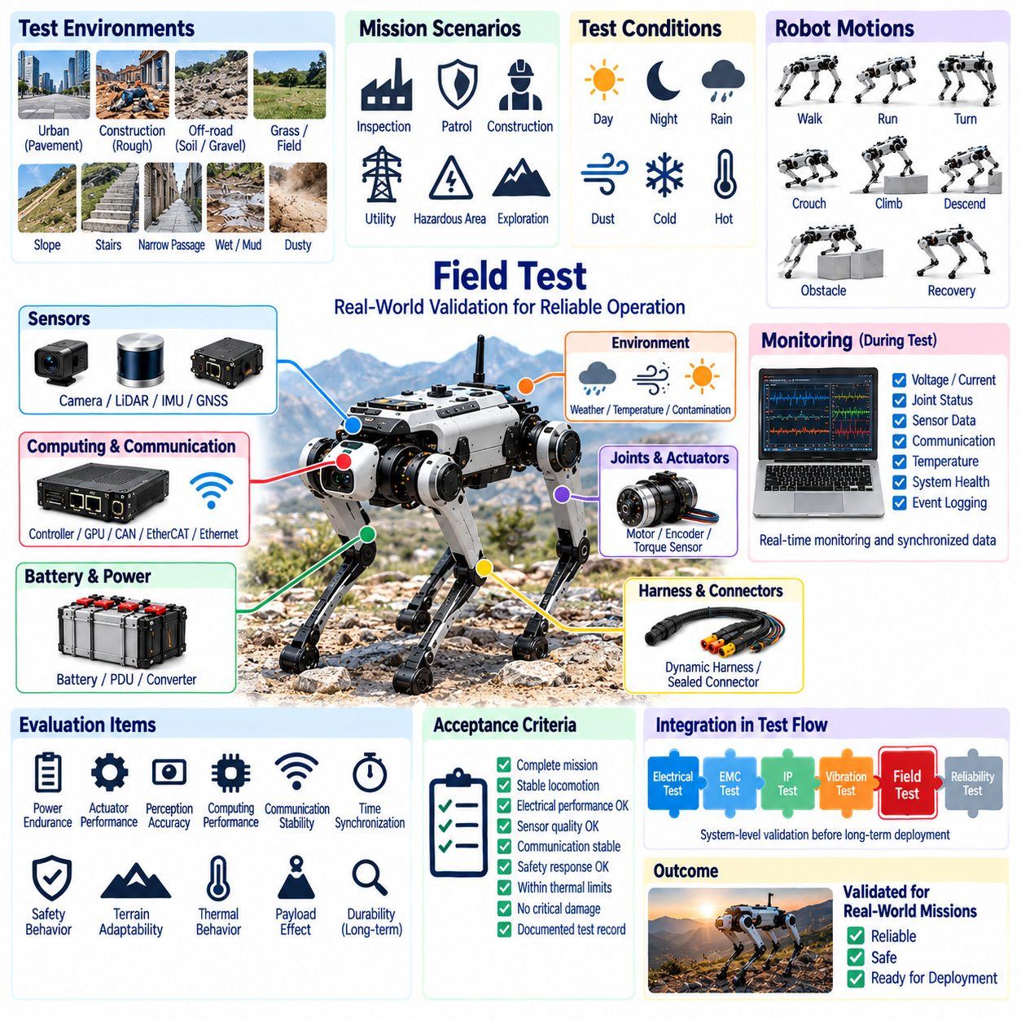
Field testing validates whether a quadruped robot can perform its intended missions reliably and safely in environments that cannot be fully reproduced by laboratory testing. It combines locomotion, electrical, sensing, computing, communication, safety, and environmental behavior into a single system-level evaluation. Within the testing structure, field validation follows electrical, EMC, IP, and vibration testing and provides operational evidence before long-term reliability qualification.
A field test program should begin with clearly defined mission scenarios and measurable acceptance criteria. The test environment should represent the terrain, obstacles, weather, communication conditions, payloads, operating duration, and human interaction expected in actual deployment. Industrial inspection, outdoor patrol, construction, utility, or hazardous-area missions can impose very different requirements, so successful walking on a controlled demonstration course alone is not sufficient evidence of operational readiness.
Test sites should include representative terrain characteristics such as flat pavement, rough concrete, gravel, soil, grass, slopes, steps, curbs, narrow passages, and irregular surfaces where appropriate to the mission. Terrain transitions are particularly important because they produce rapid changes in foot contact, joint torque, body attitude, and power demand. Engineers should evaluate whether the robot maintains stability and electrical integrity while moving between surfaces rather than validating each terrain type only in isolation.
Locomotion testing should cover more than steady forward walking. Starting, stopping, turning, reversing, crouching, climbing, descending, obstacle traversal, constrained-space movement, and recovery maneuvers should be exercised repeatedly. These behaviors generate different combinations of joint current, mechanical shock, harness movement, and sensor dynamics. Field testing should identify conditions where a motion remains mechanically possible but approaches electrical, thermal, computational, or control-system limits.
Power-system behavior should be monitored throughout representative missions. Battery voltage, current, state of charge, PDU status, converter rails, actuator power, regenerative events, and temperature provide evidence of whether laboratory assumptions remain valid in real operation. Terrain and gait can significantly change energy consumption, while simultaneous high-torque joint activity can create short power peaks. Mission endurance should therefore be determined from measured field profiles rather than nominal battery capacity alone.
Actuator and joint performance should be evaluated under realistic mechanical loading. Motor current, torque command, position error, velocity, temperature, driver status, and diagnostic events can reveal joints that operate closer to their limits than expected. Comparing corresponding joints across four legs is useful for identifying asymmetric loading, mechanical friction, calibration differences, or early degradation. Repeated high-load terrain should also be used to evaluate thermal accumulation rather than considering only short peak events.
Dynamic harnesses and connectors should be inspected throughout extended field operation because locomotion continuously changes cable geometry. Leg flexion, torsion, impact, contamination, and contact with surrounding structures can expose weaknesses not apparent during bench testing. Intermittent continuity faults, connector movement, damaged strain relief, abrasion, or seal displacement should be correlated with robot posture and terrain. Field inspection intervals can help identify progressive damage before it develops into a mission-ending electrical failure.
Perception validation should evaluate sensor performance in realistic environmental variation. Cameras and LiDAR may encounter direct sunlight, shadows, darkness, reflective surfaces, rain, dust, fog, or contamination, while IMUs experience continuous vibration and impact. GNSS performance can change near buildings, vegetation, or partially obstructed sky. Field testing should determine whether these effects remain manageable at the system level and whether degraded sensor quality is correctly detected by diagnostics or sensor-fusion functions.
Sensor mounting and calibration stability should also be checked during prolonged operation. Mechanical impacts, vibration, temperature variation, and repeated handling can gradually change camera, LiDAR, IMU, or inspection-sensor alignment. A sensor may continue producing apparently valid data while its extrinsic calibration has shifted enough to degrade localization or perception. Periodic reference measurements can distinguish algorithmic errors from physical mounting changes and establish appropriate calibration inspection intervals.
Computing performance should be evaluated under actual mission workloads rather than synthetic processing loads alone. Real-time controllers, Jetson or edge GPU systems, perception pipelines, planning functions, logging, diagnostics, and AI workloads may operate simultaneously during field missions. Processor utilization, GPU utilization, memory consumption, storage activity, temperature, latency, and throttling should be monitored. Sustained outdoor operation can expose thermal or resource limitations that short laboratory tests do not reveal.
Communication testing should include both internal and external networks. CAN FD, EtherCAT, and Ethernet must remain stable while the robot experiences vibration and actuator noise, while wireless links may encounter distance, interference, obstacles, handover, or temporary disconnection. DDS/ROS 2, remote diagnostics, telemetry, and mission-control interfaces should be observed for latency, packet loss, reconnection behavior, and synchronization. Loss of external connectivity should not cause uncontrolled local robot behavior.
Time synchronization should be validated during field operation because meaningful reconstruction of system behavior depends on consistent timestamps across sensors, controllers, communication networks, and diagnostic logs. IMU, camera, LiDAR, actuator, and computing events should remain sufficiently aligned during long missions and after communication interruptions or subsystem restarts. Synchronization errors can appear as perception or control faults even when individual devices remain electrically healthy.
Safety validation must include realistic abnormal conditions rather than only nominal mission execution. Emergency stop, communication loss, sensor degradation, actuator fault, low battery, excessive temperature, localization failure, and computing restart should lead to defined safe or degraded behavior. Tests should verify whether the robot stops, maintains balance, limits motion, returns to a safe location, or requests operator intervention according to the intended safety architecture without introducing secondary hazards.
Recovery behavior is particularly important for a legged platform because field operation inevitably includes unexpected contact and loss of ideal posture. The robot should be evaluated after slips, incomplete steps, obstacle contact, temporary perception loss, or other credible disturbances. Recovery actions should remain within electrical and mechanical limits, and repeated recovery should not create excessive joint temperature or battery demand. Failed recovery attempts should transition predictably toward a safe condition.
Environmental exposure during field testing should extend the evidence obtained from IP and vibration qualification. Dust, wet surfaces, rain where permitted, temperature variation, and repeated mechanical contamination can interact in ways that standardized tests do not reproduce. Engineers should inspect seals, vents, connectors, sensor windows, cable entries, and cooling paths during and after missions. Environmental contamination should also be evaluated for its effect on perception and thermal management, not merely enclosure ingress.
Thermal behavior should be observed over complete mission cycles because heat accumulates differently in actuators, batteries, power converters, and computing modules. Ambient temperature, solar loading, terrain difficulty, payload, speed, and cooling conditions all influence thermal margin. Temperature trends are often more informative than isolated peak measurements. A system that remains below protection thresholds may still have insufficient margin for hotter weather, longer missions, component aging, or increased payload.
Field tests should include representative payload configurations because payload mass and placement affect joint torque, power consumption, structural vibration, stability, and thermal loading. Inspection sensors or mission equipment can additionally alter communication traffic and computing demand. Testing only an unloaded base platform may therefore underestimate system stress. Payload configuration, center-of-mass condition, electrical consumption, and mounting arrangement should be recorded as part of each field-test configuration.
Long-duration missions are necessary to expose faults that short demonstrations rarely reveal. Repeated operation can produce thermal drift, connector fretting, harness fatigue, memory accumulation, storage limitations, communication degradation, battery imbalance, or calibration change. Tests should progressively increase mission duration and cycle count while maintaining diagnostic monitoring. Intermittent faults should be treated as significant evidence even when the robot automatically recovers and continues the mission.
Data logging is central to effective field validation. Electrical measurements, actuator states, sensor outputs, localization quality, network statistics, computing utilization, temperatures, safety events, and operator commands should share synchronized timestamps whenever possible. Event markers for terrain transitions, obstacles, disturbances, and environmental changes make later analysis more effective. Logs should preserve enough context to reconstruct the sequence preceding faults rather than recording only final diagnostic codes.
Field anomalies should be reproduced whenever safely practical. A single unexplained reset, communication interruption, sensor dropout, or actuator fault may indicate a systematic weakness that becomes important after deployment. Root-cause analysis should correlate environmental conditions, robot posture, electrical measurements, mechanical loading, and software events. Corrective changes should be followed by regression testing under the same or more representative field conditions rather than being accepted solely from bench verification.
Acceptance criteria should combine mission completion with quantitative subsystem limits. A robot should not be considered validated merely because it reaches its destination. Stability, power margin, actuator temperature, sensor quality, communication performance, computing latency, safety response, environmental integrity, and diagnostic behavior must remain within defined limits. Test records should identify hardware, software, calibration, payload, battery, environmental conditions, route, duration, anomalies, corrective actions, and final disposition.
Field validation ultimately connects controlled engineering tests with real operational performance. Electrical, EMC, IP, and vibration testing isolate important failure mechanisms, while field testing exposes their interactions during complete missions. The resulting evidence should establish whether the integrated quadruped architecture is ready to progress toward reliability testing and sustained deployment. Repeated field results also provide realistic load profiles and failure data that can refine subsequent laboratory qualification and future design revisions.

13.06. Reliability Test
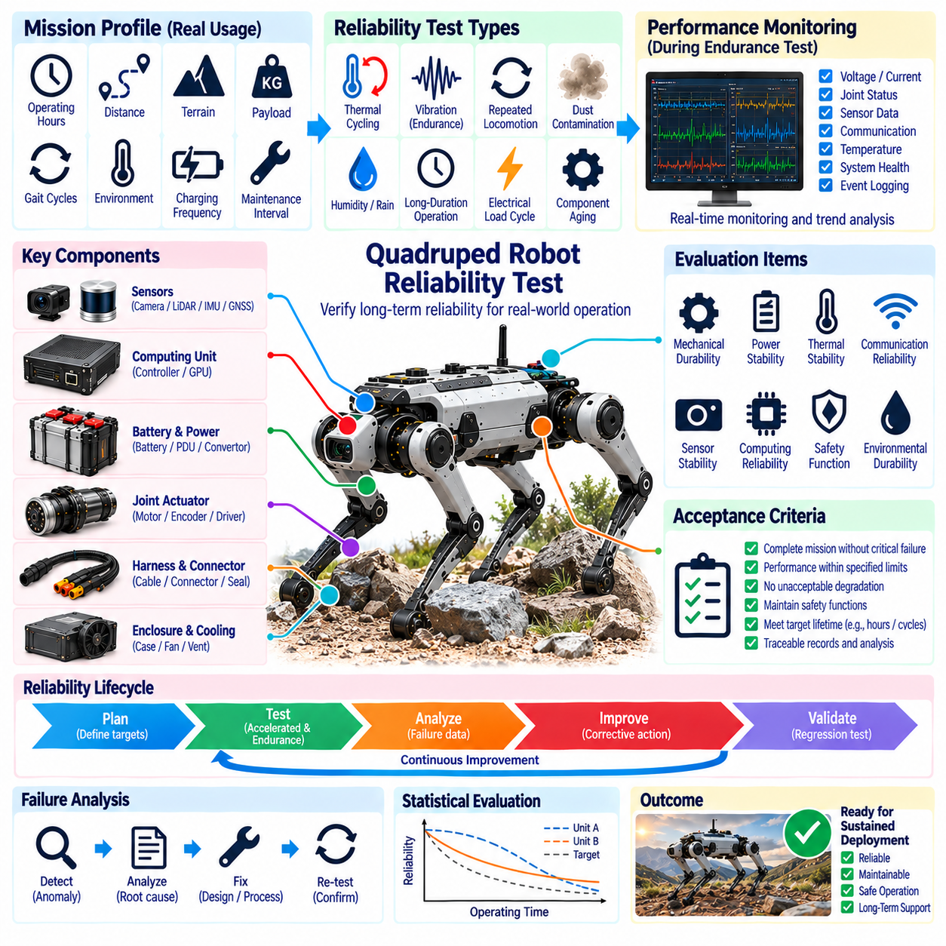
Reliability testing verifies that a quadruped robot can preserve required electrical, mechanical, sensing, computing, communication, and safety functions throughout its intended operational life. Unlike qualification tests focused on a single environmental stress, reliability validation evaluates cumulative degradation caused by repeated locomotion, thermal cycling, electrical loading, vibration, contamination, connector wear, and component aging. The objective is to identify failure mechanisms before sustained deployment.
The reliability program should begin by defining mission profiles that represent how the robot will actually be used. Operating hours, gait cycles, traveled distance, terrain distribution, payload, environmental exposure, charging frequency, standby periods, and maintenance intervals determine the stresses accumulated by the system. Reliability targets should therefore be connected to measurable mission quantities rather than expressed only as generic operating time, because different missions can produce substantially different degradation rates.
A system-level reliability model should connect critical components with their functional consequences. Batteries, power distribution units, DC/DC converters, joint actuators, motor drivers, sensors, computing modules, communication interfaces, harnesses, connectors, cooling devices, and safety circuits should be considered together. Failure mode and effects analysis can identify single-point failures, degraded operating states, detectable faults, maintenance requirements, and areas where redundancy or improved diagnostics are necessary.
Accelerated life testing can reduce the time required to expose long-term failure mechanisms, but acceleration factors must be selected carefully. Increased temperature, vibration, electrical load, duty cycle, or mechanical cycling can accelerate degradation when the physical mechanism remains representative of field operation. Excessive stress may instead create artificial failures that would never occur during normal use. Test severity should therefore be justified by the relationship between accelerated conditions and the expected mission environment.
Repeated locomotion is a fundamental reliability stress for quadruped robots. Millions of joint rotations, foot contacts, body oscillations, and gait transitions can progressively affect bearings, gears, seals, fasteners, cables, connectors, sensors, and structural interfaces. Endurance testing should include representative walking, turning, crouching, climbing, obstacle traversal, and recovery sequences. Cycle counts should be recorded together with electrical and thermal measurements so degradation can be related to accumulated mechanical usage.
Joint actuator reliability deserves particular attention because locomotion depends on multiple actuators operating continuously under dynamic loads. Motor current, torque, position error, temperature, bearing condition, gearbox behavior, encoder stability, and driver diagnostics should be trended over endurance testing. Gradual changes can indicate increasing friction, lubrication degradation, mechanical wear, sensor drift, or electrical deterioration before a functional failure occurs. Corresponding joints across different legs can provide useful comparative baselines.
Dynamic harness reliability should be evaluated through repeated flexing, twisting, vibration, and joint motion. Conductors may experience strand fatigue while shield braids, cable jackets, crimps, strain reliefs, and connector interfaces gradually deteriorate. Continuity monitoring during cycling is important because early failures may appear only as short intermittent interruptions. Harness inspection should also identify abrasion, localized bending, seal displacement, or routing changes that could later affect EMC, IP protection, or communication integrity.
Connector durability should account for both continuous vibration and maintenance-related mating cycles. Contact surfaces can experience fretting, oxidation, contamination, reduced contact force, or increasing resistance, while locking mechanisms and seals can wear mechanically. High-current connectors should be monitored for voltage drop and temperature rise, while communication and sensor connectors should be observed for intermittent errors. Reliability evaluation should include production-intent connectors, terminals, seals, backshells, and strain-relief arrangements.
Battery reliability should consider capacity retention, internal resistance, cell balance, temperature distribution, charging behavior, and power-delivery capability over repeated mission and charging cycles. Quadruped locomotion can create highly dynamic current profiles with short high-power demands and regenerative events. Battery aging can therefore influence not only endurance but also voltage stability during demanding maneuvers. Reliability testing should determine whether aged batteries continue supporting required peak power without triggering resets or actuator undervoltage conditions.
Power-distribution and conversion hardware should be evaluated for cumulative electrical and thermal stress. Contactors, fuses, busbars, PDU assemblies, DC/DC converters, filters, and high-current connections repeatedly experience current transitions and temperature changes. Increasing contact resistance, solder fatigue, insulation degradation, or thermal-interface deterioration can develop gradually. Trending rail voltage, ripple, temperature, efficiency, and contact resistance provides evidence of degradation before complete power-system failure occurs.
Thermal cycling is important because repeated heating and cooling produces expansion and contraction across materials with different coefficients of thermal expansion. Printed circuit boards, solder joints, connectors, power modules, sensor packages, enclosures, seals, and thermal interfaces can accumulate fatigue. Reliability testing should reproduce realistic powered and unpowered temperature cycles where appropriate. Temperature gradients inside computing, battery, and actuator assemblies should also be considered because local stresses may exceed those suggested by ambient temperature alone.
Computing reliability should be evaluated under sustained representative workloads. Real-time controllers, Jetson or edge GPU modules, memory, storage, cooling systems, and network interfaces may operate continuously while perception, planning, AI inference, logging, and diagnostics compete for resources. Long-duration testing can reveal memory leaks, storage exhaustion, thermal throttling, unexpected resets, software deadlocks, or cooling degradation. Hardware reliability and software operational stability should therefore be monitored together during endurance runs.
Sensor reliability requires monitoring both functional availability and measurement stability. Cameras, LiDAR, IMUs, GNSS receivers, encoders, torque sensors, and inspection sensors may continue operating while calibration, bias, noise, alignment, or sensitivity gradually changes. Periodic reference measurements should be compared with initial baselines to detect drift. Sensor mounting structures should also be inspected because mechanical movement can create apparent sensor degradation even when the sensing element itself remains electrically healthy.
Communication reliability should be evaluated over long-duration operation because intermittent errors may accumulate slowly. CAN FD, EtherCAT, Ethernet, wireless links, and time-synchronization mechanisms should be monitored for error counters, packet loss, retries, link resets, latency changes, and synchronization anomalies. Increasing communication errors can indicate connector wear, harness degradation, electromagnetic changes, or device aging before complete network failure. Diagnostic trends are therefore valuable reliability indicators rather than merely troubleshooting information.
Environmental durability should combine aging with realistic contamination and exposure. Dust, moisture, temperature changes, vibration, and repeated cleaning can gradually degrade seals, vents, connectors, optical windows, cable entries, and cooling paths. An enclosure that initially satisfies an IP requirement may not maintain equivalent protection after prolonged mechanical cycling. Reliability validation should therefore include periodic inspection or selected regression tests to determine whether environmental protection remains effective throughout representative life accumulation.
Safety-related functions require reliability evidence because their availability must be preserved even as other components age. Emergency-stop circuits, actuator disable paths, safety controllers, monitoring channels, power cutoff devices, and fault-detection mechanisms should be exercised periodically during endurance testing. The system should continue reaching defined safe or degraded states after accumulated operating cycles. Reliability testing should also identify nuisance trips because increasing false safety activation can make an otherwise safe robot operationally unavailable.
Preventive maintenance intervals can be derived from reliability observations rather than selected only from conservative assumptions. Trends in actuator condition, connector resistance, harness wear, battery capacity, filter contamination, calibration stability, and cooling performance can indicate when inspection or replacement becomes appropriate. Components with predictable degradation can be managed through scheduled maintenance, while unpredictable or safety-critical failures may require redundancy, enhanced diagnostics, design improvement, or condition-based monitoring.
Failure data should be recorded with sufficient context for meaningful root-cause analysis. Hardware revision, software version, accumulated operating hours, gait cycles, distance, payload, temperature history, charging cycles, environmental exposure, maintenance actions, and previous anomalies should accompany each failure record. A simple count of failed components is insufficient because reliability improvement depends on understanding the conditions and accumulated stresses that produced each failure mechanism.
Statistical reliability assessment becomes increasingly valuable as multiple robots and test units accumulate operating time. Failure rates, survival distributions, mean time between failures, confidence intervals, and mission success statistics can provide quantitative evidence when the sample size is sufficient. Early development programs may have limited populations, so engineering analysis and failure physics remain important. Reliability claims should clearly distinguish demonstrated test evidence from predictions derived from models or limited samples.
Corrective actions should be validated through regression and continued endurance testing. Replacing a failed component with a stronger part does not automatically demonstrate that the system-level failure mechanism has been eliminated. Changes to mounting, sealing, cable routing, cooling, filtering, software supervision, or component selection can introduce new interactions elsewhere. The modified configuration should therefore accumulate sufficient representative operation to demonstrate that the original failure is resolved without creating another reliability weakness.
Reliability validation ultimately determines whether the quadruped architecture can progress from successful prototypes and field demonstrations to sustained operational deployment. Electrical, EMC, IP, vibration, and field tests establish resistance to specific stresses and realistic missions, while reliability testing evaluates how those stresses accumulate over time. The resulting evidence supports design maturity, maintenance planning, life-cycle management, fleet deployment, and future hardware revisions within the complete testing and validation framework.

