Volume 20. Quadruped Electrical Architecture

Chapter 06. Harness and Connector Engineering

06.01. Trunk Harness
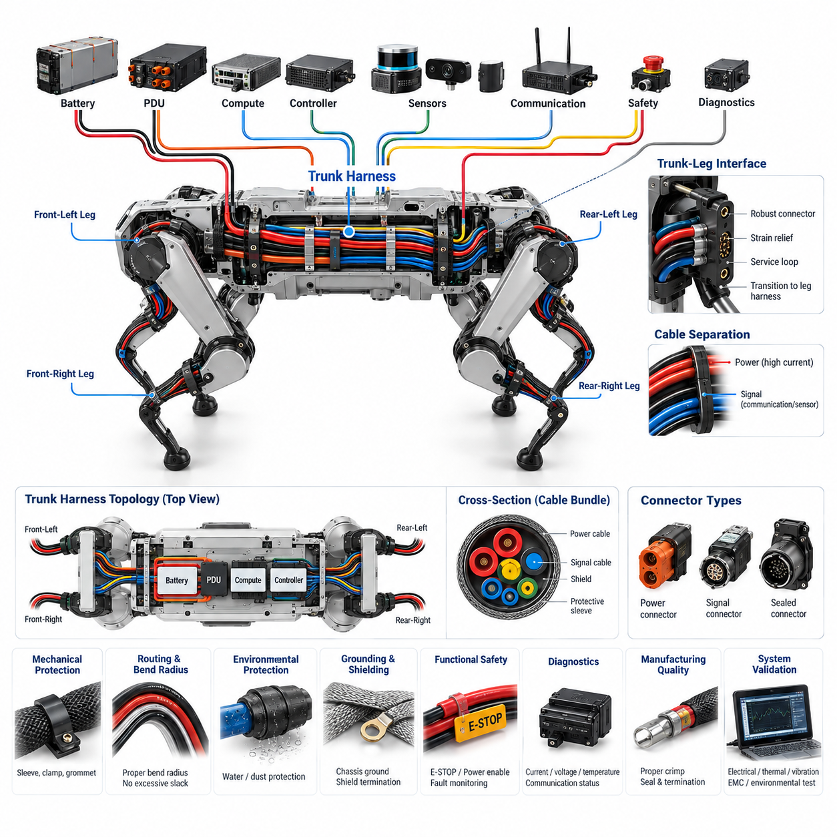
The trunk harness forms the primary electrical distribution backbone of a quadruped robot, connecting the battery and power distribution system with computing units, communication gateways, sensors, and the four leg assemblies. Unlike a conventional stationary harness, it must support high actuator power while maintaining reliable low-voltage control and high-speed communication paths within a compact, vibration-intensive body structure.
A practical trunk harness begins near the battery and power distribution unit, where protected power branches are separated according to their electrical loads and safety functions. High-current conductors supplying joint actuators should be distinguished from lower-power circuits serving computers, sensors, communication devices, and auxiliary electronics. This separation simplifies protection coordination, voltage-drop management, diagnostics, and controlled power isolation during faults.
Conductor sizing must consider continuous current, transient motor current, ambient temperature, bundle density, insulation temperature rating, allowable voltage drop, and installation conditions. Quadruped actuators can generate rapidly changing loads during acceleration, jumping, climbing, or disturbance recovery. The trunk harness therefore requires sufficient electrical and thermal margin so that short-duration peak currents do not cause excessive voltage sag or conductor heating.
The physical topology should follow the mechanical structure of the robot rather than simply connecting devices by the shortest electrical path. A central trunk can run through the body and divide into front-left, front-right, rear-left, and rear-right leg interfaces. Additional branches connect the central compute platform, real-time controller, perception sensors, communication hardware, safety circuits, and diagnostic interfaces while maintaining clear functional segmentation.
Power and communication circuits require careful routing because motor drives and switching power converters generate substantial electromagnetic noise. High-current motor conductors should be physically separated from sensitive encoder, IMU, Ethernet, synchronization, and sensor lines wherever packaging permits. Differential communication pairs must preserve their intended geometry, while shields and grounding paths should be terminated according to the selected EMC architecture rather than connected arbitrarily.
The interface between the trunk harness and each leg is particularly important because it establishes the boundary between relatively static body wiring and highly dynamic leg wiring. The trunk side should provide mechanically stable connector mounting, strain relief, defined service loops, and controlled transition into the leg flex harness. Connector orientation should prevent cable loads from being transferred directly into contacts when the robot experiences shock, vibration, or repeated leg motion.
Mechanical protection is required throughout the body because quadruped robots experience continuous vibration, impact loads, chassis deformation, and potentially severe field environments. Harness branches should be restrained at suitable intervals and protected from sharp edges, fasteners, heat sources, gears, and moving mechanisms. Sleeving, conduit, abrasion-resistant coverings, clamps, grommets, and local reinforcement can be selected according to the mechanical exposure of each routing region.
Routing design must also account for bend radius and three-dimensional packaging. Excessively tight bends can damage conductors, shields, twisted pairs, or optical elements and can concentrate stress near connector backshells. Excessive slack is equally undesirable because unsupported cable can strike surrounding structures during locomotion. Harness geometry should therefore control both minimum bend radius and free cable motion across the complete operating envelope of the robot.
Connector selection for the trunk harness must reflect current capacity, voltage rating, contact resistance, environmental sealing, vibration resistance, mating durability, size, weight, and service requirements. Power connectors and signal connectors may be physically separated to reduce coupling and assembly errors. Keying, polarization, coding, and connector location should prevent incorrect mating between similar leg, sensor, power, or communication interfaces during manufacturing and field maintenance.
Environmental protection becomes critical when the quadruped operates outdoors or in industrial facilities. Water, dust, mud, conductive contamination, cleaning fluids, and condensation can penetrate poorly designed harness interfaces. Sealed connectors, appropriate cable jackets, backshell sealing, cavity plugs, controlled drainage, and properly designed harness entry points help preserve the intended environmental rating without relying solely on the connector's nominal IP classification.
Grounding and shielding should be treated as part of the trunk harness architecture rather than as secondary installation details. Power return paths, chassis bonding, shield connections, and electronic reference grounds influence both electromagnetic compatibility and sensor accuracy. Poorly controlled return currents can create ground offsets that disturb encoders, communication transceivers, analog sensors, and computing equipment, particularly when actuator currents change rapidly.
The trunk harness also participates in functional safety by carrying emergency-stop, power-enable, contactor-control, watchdog, and fault-monitoring signals between safety-related components. Safety-critical circuits should be routed and protected so that a single abrasion event, connector failure, or short circuit does not silently defeat the intended protective function. Where required, independent conductors, redundant channels, diagnostic feedback, or physical separation can reduce common-cause vulnerabilities.
Serviceability should influence the architecture from the beginning. A quadruped may require replacement of a leg, compute module, battery assembly, sensor package, or power distribution unit without removing the entire harness. Modular connectors and clearly defined electrical boundaries allow technicians to isolate defective assemblies efficiently. Identification labels, connector codes, branch markings, and documented pin assignments further reduce maintenance errors and troubleshooting time.
Harness diagnostics can extend beyond simple continuity checking. Voltage sensing, current monitoring, communication error counters, insulation or short-circuit detection, connector temperature monitoring, and intelligent power distribution can help identify developing electrical problems. Correlating these signals with individual trunk branches or leg interfaces enables the robot to distinguish actuator faults from wiring faults and supports more effective predictive maintenance.
Manufacturing quality strongly affects long-term reliability because many harness failures originate at crimps, splices, seals, connector terminations, or poorly controlled branch transitions. Wire preparation, crimp force, terminal insertion, seal installation, splice construction, shield termination, and dimensional routing should therefore follow controlled processes. End-of-line testing can verify continuity, isolation, pin mapping, resistance, communication integrity, and selected power-path characteristics.
The completed trunk harness should be validated as part of the assembled robot rather than only as an independent wiring component. Electrical load testing, voltage-drop measurement, thermal evaluation, vibration testing, EMC testing, environmental exposure, and repeated locomotion trials reveal interactions that bench inspection may miss. Particular attention should be given to branch points, connector interfaces, clamp locations, and transitions between rigid trunk routing and dynamic leg harnesses.
A well-designed trunk harness ultimately acts as an engineered physical interface between the quadruped's power, computation, communication, sensing, safety, and actuation architectures. Its quality directly influences mobility performance, electromagnetic robustness, environmental durability, maintainability, and system availability. Designing it as a system-level backbone rather than a collection of wires provides a scalable foundation for increasingly capable quadruped platforms.

06.02. Leg Flex Harness
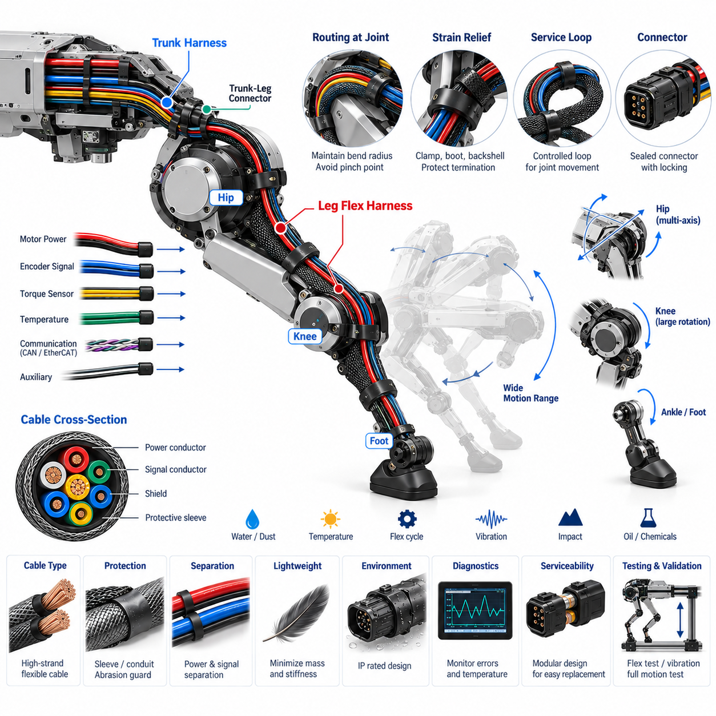
A leg flex harness is the dynamic electrical link between the relatively stable trunk harness and the moving electrical components distributed through each quadruped leg. It carries actuator power, motor-control communication, encoder signals, torque or force sensing, temperature monitoring, and auxiliary circuits across joints that continuously rotate during locomotion. Its design must therefore combine electrical capacity with exceptional mechanical flexibility and fatigue resistance.
Unlike the trunk harness, which experiences mainly chassis vibration and limited structural movement, the leg flex harness undergoes repeated bending, twisting, acceleration, and direction reversal. Walking alone can generate millions of flex cycles over the robot's operating life, while running, climbing, jumping, or recovering from disturbances increases both motion amplitude and mechanical loading. Cable construction must consequently be selected for continuous dynamic operation rather than static installation.
The electrical architecture normally follows the mechanical hierarchy of the leg from the hip region toward the knee, lower leg, and foot. Power and communication paths may pass through several joint zones before reaching their associated devices. Branch locations should correspond to module boundaries so that individual actuators, sensors, or complete leg sections can be replaced without disturbing unrelated wiring or requiring extensive disassembly of the robot.
Conductor selection must consider both current capacity and flex life. High-strand-count conductors are generally better suited to repeated movement than conductors optimized only for static wiring because mechanical strain can be distributed across many fine strands. Conductor cross-section must still satisfy continuous and peak actuator currents, allowable voltage drop, temperature rise, insulation rating, bundle derating, and fault-current requirements throughout the expected operating environment.
Joint motion defines the most critical routing constraints. Each cable segment should be positioned so that movement produces controlled bending rather than sharp folding, uncontrolled twisting, or tensile loading. The minimum dynamic bend radius must be maintained through the entire joint range. Routing should also prevent the harness from entering pinch points, rubbing against rotating components, contacting sharp structures, or becoming trapped between moving mechanical elements.
The hip region presents a particularly complex challenge because multiple rotational axes may create combined bending and torsional motion. A routing strategy that performs well around one axis may impose excessive twist when another axis moves simultaneously. The harness path should therefore be evaluated using the complete three-dimensional joint workspace, including extreme postures and combined joint movements rather than only testing each axis independently.
Knee and lower-leg routing typically experiences large repetitive angular motion within a more constrained mechanical envelope. Controlled service loops can provide the additional cable length required for articulation, but excessive slack can create whipping, abrasion, or entanglement. The loop geometry should have a predictable deformation pattern so that mechanical strain is distributed over a designed flex zone instead of concentrating immediately behind a connector or clamp.
Strain relief is essential at every transition between flexible cable and mechanically fixed components. Connectors, splice regions, sensor interfaces, and actuator entries should not carry repeated cable bending directly at their electrical terminations. Proper clamps, boots, backshells, molded transitions, or flexible support structures transfer mechanical loads away from contacts and conductor terminations while preserving sufficient freedom for the intended joint movement.
Power conductors for BLDC or PMSM actuators can generate electromagnetic interference that affects nearby encoder, torque-sensor, communication, and low-level measurement circuits. Where packaging permits, motor power and sensitive signals should maintain physical separation. Twisted differential pairs, suitable shielding, controlled return paths, and appropriate shield termination help preserve signal integrity while avoiding excessive cable stiffness that would reduce dynamic flex life.
Communication networks such as CAN FD or EtherCAT require additional attention because repeated cable deformation must not significantly alter pair geometry or impedance. Differential pairs should maintain controlled twisting through dynamic sections and connector transitions. Mechanical damage, shield degradation, or conductor fatigue can first appear as intermittent communication errors rather than complete electrical failure, making network error monitoring useful for detecting early harness degradation.
Environmental protection must remain effective while the harness moves. Quadruped legs may encounter water, dust, mud, oil, cleaning fluids, vegetation, sand, and other contaminants much more directly than electronics located inside the trunk. Cable jackets, seals, connector interfaces, protective sleeves, and boots should therefore withstand both environmental exposure and repeated mechanical deformation without cracking, loosening, or creating paths for moisture ingress.
Protective coverings must balance durability with flexibility. Heavy conduit or excessive reinforcement can improve abrasion resistance but increase mass, stiffness, and joint resistance. Conversely, a lightweight unprotected cable may achieve excellent flexibility while suffering rapid wear in field operation. Sleeving, braided protection, local abrasion guards, flexible conduits, and strategically positioned mechanical covers should therefore be applied according to the exposure of each leg region.
Harness mass and stiffness can influence leg dynamics because wiring becomes part of the moving mechanical system. Additional mass near distal sections such as the lower leg or foot increases inertia and can reduce actuator efficiency. Excessive cable stiffness can also create parasitic joint torque or alter control behavior. Dynamic harness design should therefore minimize unnecessary material while maintaining the required electrical, environmental, and mechanical reliability.
Connector placement should avoid the highest-motion zones whenever practical. Interfaces are preferably located on mechanically stable regions where connectors can be rigidly mounted and protected from direct impact. Keying and polarization prevent incorrect assembly, while suitable locking mechanisms resist vibration-induced disengagement. Sealed connectors may be required near exposed leg regions, but their size and stiffness must be considered as part of the overall moving harness design.
The leg flex harness should support modular service and replacement because legs are among the components most exposed to impact and mechanical damage. A defined trunk-to-leg connector allows a complete leg assembly to be disconnected without opening the central electrical architecture. Additional internal interfaces can support replacement of joint modules or sensors, although excessive connector count should be avoided because every interface adds resistance, weight, packaging demand, and potential failure points.
Diagnostics can help distinguish cable degradation from actuator or sensor faults. Intermittent communication errors, abnormal voltage drop, increasing contact resistance, unexpected sensor discontinuities, or temperature changes may indicate developing harness problems. Correlating these symptoms with joint position and motion is particularly valuable because a damaged conductor may fail only when the leg reaches a specific angle, making conventional stationary continuity testing insufficient.
Validation must reproduce realistic dynamic loading rather than relying only on static electrical tests. Flex-cycle testing, torsion testing, full-range joint motion, vibration, impact, temperature cycling, environmental exposure, and powered locomotion trials should be used to identify weak routing regions. Testing should include representative combinations of joint movement because the most severe harness strain can occur during complex whole-leg motion rather than at a single joint limit.
A reliable leg flex harness is ultimately a co-designed electrical and mechanical subsystem rather than simply flexible wiring attached after the leg mechanism has been completed. Joint geometry, actuator placement, connector locations, cable construction, routing volume, protection, sensing, and service strategy must be developed together. This integrated approach allows electrical connectivity to survive continuous locomotion while preserving mobility, signal integrity, safety, maintainability, and long-term quadruped reliability.

06.03. Dynamic Cable Routing
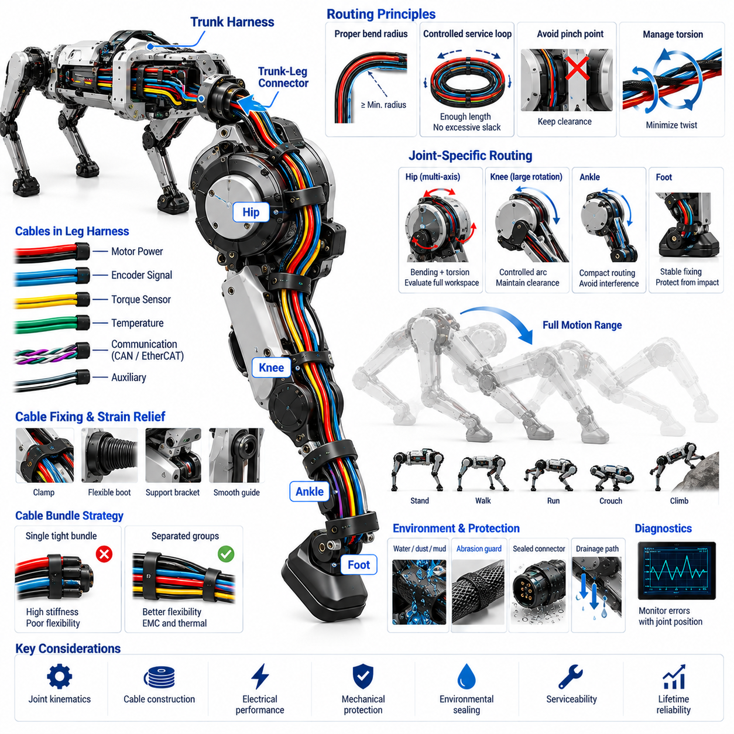
Dynamic cable routing defines how electrical conductors and communication lines are guided through moving regions of a quadruped robot while preserving electrical performance and mechanical durability. Unlike static body wiring, cables around the hip, knee, ankle, and other articulated interfaces continuously change shape during locomotion. Routing must therefore be designed as part of the joint mechanism rather than treated as a final packaging activity.
The fundamental objective is to transform complex joint motion into predictable cable deformation. A properly routed cable should bend gradually within a defined flex zone instead of folding sharply, stretching axially, or twisting unpredictably. The cable path, fixing points, free length, and orientation determine where mechanical strain develops. These parameters should be established from the complete joint workspace before physical harness dimensions are finalized.
Minimum dynamic bend radius is one of the primary routing constraints. Repeated bending below the cable's allowable radius can accelerate conductor fatigue, insulation cracking, shield degradation, and impedance variation. The required radius depends on cable diameter, conductor construction, insulation material, shielding, and flex-cycle requirements. Dynamic applications normally require more conservative bend-radius control than equivalent cables installed in stationary equipment.
Cable length must provide sufficient freedom for the complete mechanical range without creating uncontrolled slack. A cable that is too short experiences tensile loading near extreme joint positions, while excessive length can produce whipping, rubbing, entanglement, or interference with adjacent mechanisms. Controlled service loops can accommodate movement, but their shape and deformation direction should remain predictable throughout walking, running, crouching, climbing, and recovery motions.
Routing around a multi-axis hip joint is especially demanding because the harness can experience simultaneous bending and torsion. A path optimized for a single rotational axis may become severely twisted when abduction, adduction, flexion, and extension occur together. The routing volume should therefore be evaluated through representative combined motions, with attention to accumulated cable twist and the possibility that repeated cycles gradually rotate or migrate the harness.
Knee routing often involves a larger but more predictable angular sweep. The cable can be arranged so that the dominant deformation occurs through a broad controlled arc centered near the joint. Fixing points should prevent the flex zone from migrating into connectors or sharp mechanical boundaries. At maximum flexion and extension, sufficient clearance must remain between the harness and links, actuator housings, covers, fasteners, and surrounding structural elements.
The transition between fixed and moving cable sections requires carefully designed strain relief. A rigid clamp located directly beside an aggressive bending region can concentrate mechanical stress at the clamp edge, while insufficient restraint allows the entire harness to move unpredictably. Gradual transitions using flexible boots, controlled clamp spacing, compliant supports, or suitable protective sleeving can distribute deformation over a longer cable section.
Pinch-point avoidance must be verified across the complete motion envelope. A cable that appears clear in the nominal standing posture may become trapped between links or actuator housings during deep crouching, turning, climbing, or impact recovery. Clearance analysis should include manufacturing tolerances, cable diameter variation, harness movement, structural deflection, and connector geometry rather than relying solely on nominal CAD surfaces.
Abrasion is another major dynamic-routing failure mechanism. Even small repeated contact forces can eventually damage protective sleeving, cable jackets, shields, and insulation. Harnesses should therefore avoid continuous sliding contact wherever practical. Where contact cannot be eliminated, local abrasion guards, smooth guide surfaces, replaceable protective sleeves, or mechanically defined cable guides can control wear and prevent damage to electrically critical layers.
Cable torsion must be managed separately from bending because many cable constructions tolerate these loads differently. Repeated axial twisting can loosen shields, change pair geometry, damage conductor strands, and transfer torque into connector terminations. Routing should minimize accumulated twist and allow torsional deformation to occur over sufficient free cable length. Multi-axis joints may require specially selected torsion-rated cable or dedicated mechanical guidance.
Electrical separation requirements remain important even within restricted dynamic-routing spaces. High-current motor conductors can generate electromagnetic interference near encoder, torque-sensor, communication, and other low-level signal lines. Where physical separation is limited, twisted pairs, shielding, controlled return paths, and suitable cable grouping become increasingly important. Routing should preserve these electrical relationships while allowing the bundle to move without excessive stiffness.
High-speed communication cables introduce additional mechanical constraints because their electrical properties depend on conductor geometry. Repeated deformation of Ethernet, EtherCAT, or similar differential links should not significantly disturb pair twist, characteristic impedance, or shielding continuity. Connectors and transition regions require particular attention because abrupt mechanical stiffness changes can concentrate strain and eventually produce intermittent communication faults before complete conductor failure occurs.
Cable bundles should not automatically be treated as a single flexible element. Combining large power conductors, communication pairs, sensor wires, and safety circuits into one tightly constrained bundle may produce excessive stiffness and force every circuit to follow the same bending path. In some joint regions, separating the harness into smaller functional groups can improve flexibility, electromagnetic compatibility, thermal behavior, and fault isolation.
Harness supports should constrain motion without preventing the movement required by the joint. Clamps, guides, clips, and brackets establish the effective flex length and determine how cable loads are transferred into the robot structure. Their positions must therefore be engineered rather than selected only for convenient assembly. Support geometry should also avoid sharp edges and concentrated pressure that could damage the cable during repeated movement.
Environmental protection and dynamic routing must be considered together. Water, dust, mud, sand, oil, and cleaning fluids can enter moving interfaces or become trapped between cables and protective structures. Protective sleeves and boots should remain effective while repeatedly bending, and drainage paths should prevent contamination from accumulating around low points. Materials should maintain flexibility across the expected operating temperature range and environmental exposure.
Routing design also influences leg dynamics. Cable mass, stiffness, and friction create forces that the joint actuators must overcome during motion. These effects are especially significant toward the distal leg, where additional moving mass increases inertia. A well-designed routing system minimizes unnecessary cable length and heavy protection while ensuring that cable forces remain small and repeatable enough not to interfere with precision joint control.
Serviceability requires dynamic routes to remain understandable and reproducible after maintenance. Technicians should be able to replace a harness or joint module and restore the original cable path, clamp locations, service-loop geometry, and connector orientation. Clearly defined routing references and assembly features reduce variation between robots, preventing maintenance-induced changes that could shorten flex life or introduce interference with moving structures.
Dynamic harness diagnostics can exploit the relationship between electrical faults and joint position. Intermittent resistance changes, communication errors, sensor dropouts, or power disturbances occurring repeatedly at a specific joint angle can indicate conductor fatigue or connector stress. Recording these events together with joint position, velocity, and load provides valuable evidence for distinguishing routing-related degradation from actuator, sensor, or controller failures.
Validation should combine mechanical simulation, packaging inspection, and physical endurance testing. Full-range articulation can identify obvious interference, while repeated flex and torsion cycling reveal fatigue mechanisms that cannot be predicted from static geometry alone. Powered locomotion tests should include representative walking, running, turning, crouching, climbing, and disturbance-recovery motions so that realistic combinations of joint movement and vibration are reproduced.
The final dynamic cable routing architecture is therefore a coordinated relationship among joint kinematics, cable construction, electrical function, mechanical protection, environmental sealing, serviceability, and expected lifetime. Successful routing creates predictable deformation with controlled bend radius, minimal torsion, adequate clearance, and protected transition regions. This allows the quadruped's electrical connections to remain reliable throughout continuous and highly dynamic locomotion.

06.04. IP67/IP68 Design
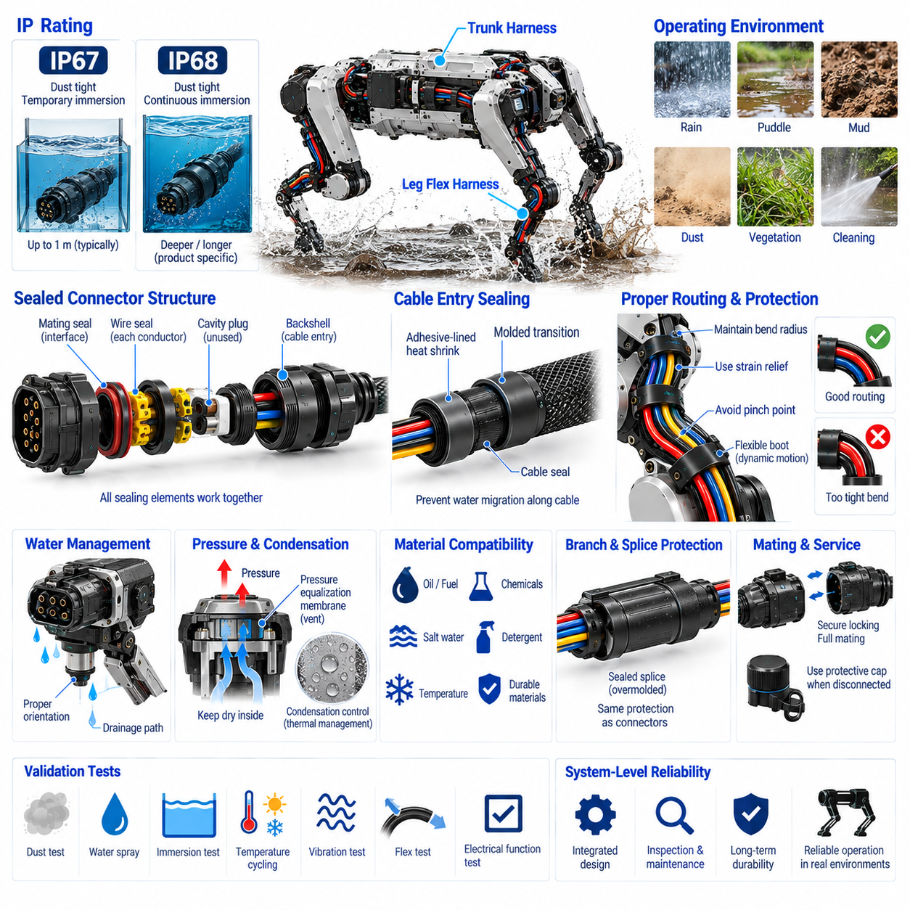
Ingress protection for a quadruped harness must be designed as a complete sealing system rather than assigned only from the rating printed on individual connectors. IP67 and IP68 protection depends on the interaction among connectors, cable jackets, seals, backshells, enclosure interfaces, branch points, and assembly quality. A single weak transition can allow water or contamination to bypass otherwise well-sealed electrical components.
IP67 generally represents protection against dust ingress and temporary immersion under defined test conditions, while IP68 addresses continuous or more demanding immersion according to conditions agreed for the specific product. These ratings should not be interpreted as universal guarantees for every depth, duration, temperature, or operating environment. The robot manufacturer must define realistic exposure requirements before selecting components and validation procedures.
Quadruped robots create demanding sealing conditions because their electrical systems operate close to the ground and are repeatedly exposed to dust, rain, puddles, mud, splash, wet vegetation, cleaning processes, and condensation. Leg motion can additionally pump contaminants toward interfaces through repeated pressure and volume changes. Environmental design must therefore address both direct external exposure and contamination transported by moving cables and mechanical structures.
The trunk harness and leg flex harness experience different environmental risks. Body-mounted connections can often be protected by covers and internal packaging, whereas leg connectors may experience direct splash, mud impact, and temporary immersion. Connector location should consequently be treated as part of the sealing strategy. Moving or highly exposed interfaces require greater mechanical protection and sealing robustness than protected connections inside the central body.
Connector sealing normally combines interface seals, individual wire seals, cavity plugs, and sealed backshell or cable-entry structures. The mating interface prevents contamination from passing between connector halves, while rear wire seals restrict ingress along individual conductors. Unused cavities must also be closed correctly because an empty terminal position can become a direct leakage path even when the connector housing itself has a suitable environmental rating.
Cable entry regions require particular attention because water can migrate along the conductor or between cable layers after penetrating a damaged jacket or poorly sealed termination. Sealing only the connector face does not prevent this longitudinal migration. Proper cable seals, adhesive-lined heat shrink, molded transitions, sealed splices, or equivalent techniques may be required where the architecture must prevent moisture from traveling from an exposed harness section toward protected electronics.
Seal performance depends strongly on cable diameter and surface condition. A wire seal designed for a specific diameter range may provide inadequate compression when used with an undersized conductor or excessive stress when used with an oversized jacket. Scratches, contamination, damaged insulation, incorrect terminal insertion, or lubricant incompatibility can also compromise sealing. Harness specifications should therefore define compatible wire, seal, terminal, and connector combinations.
Dynamic cable routing introduces additional challenges because repeated bending can progressively degrade environmental protection. Boots, sleeves, overmolds, and cable jackets must remain flexible without cracking after large numbers of motion cycles. A sealed interface positioned directly inside a severe flex zone can experience repeated mechanical loads that distort seals or loosen backshells. Environmental sealing and dynamic routing should therefore be developed as one coordinated mechanical design.
Water management should not rely exclusively on preventing every droplet from entering the surrounding mechanical structure. The robot should also provide drainage paths so that water cannot accumulate around connectors, cable loops, cavities, or low points. Connector orientation can reduce standing water around sealing interfaces, while drainage holes or channels can direct contamination away from sensitive regions without compromising the protected electrical enclosure.
Pressure variation can challenge sealed electrical assemblies. Temperature changes, altitude variation, internal heating, and rapid cooling after exposure to water can create pressure differences between sealed volumes and the external environment. These differences may pull moisture through weak seals. Where appropriate, pressure-equalization membranes or vents can reduce differential pressure while maintaining resistance to liquid water and particulate contamination.
Condensation must be considered separately from direct water ingress. Even an enclosure that successfully prevents external liquid penetration may contain humid air that condenses when temperature falls. Electronics, terminals, and exposed conductive surfaces can then experience corrosion or leakage currents. Material selection, enclosure ventilation strategy, conformal protection where appropriate, and thermal management should address the internal moisture environment as well as external sealing.
Mud and fine particles can be more challenging than clean-water testing suggests. Contamination may collect around connector locks, seals, cable entries, and moving interfaces, then dry and create abrasive deposits. Repeated motion can drive these particles against sealing surfaces. Protective covers, smooth external geometries, accessible cleaning paths, and abrasion-resistant materials can reduce contamination accumulation while preserving service access.
Connector mating integrity is essential for maintaining the intended IP performance. Locking mechanisms must remain fully engaged despite vibration, impact, and cable loading. Partial mating can reduce seal compression even when electrical contact initially remains functional. Connector position assurance, secondary locks, visible mating indicators, or mechanical retention features can therefore improve both electrical reliability and environmental sealing in high-vibration quadruped applications.
Service operations create another major sealing risk. Disconnecting a field connector exposes sealing surfaces to dust, moisture, grease, and accidental damage. Maintenance procedures should require inspection and cleaning of seals before reconnection, and damaged seals should be replaceable where practical. Protective caps can be used when connectors remain disconnected. Service documentation should also specify correct mating force, lock engagement, and replacement criteria.
Material compatibility becomes important when the robot encounters oils, fuels, hydraulic fluids, detergents, disinfectants, salt, or industrial chemicals. A material that performs well in water may swell, harden, soften, or crack after chemical exposure. Cable jackets, connector housings, elastomer seals, adhesives, protective sleeves, and overmolds should therefore be selected according to the actual mission environment rather than the IP rating alone.
Corrosion protection complements ingress protection because small amounts of moisture may eventually reach electrical interfaces during long-term field operation. Terminal plating, compatible contact materials, controlled grounding, sealed splices, and appropriate material pairing can reduce corrosion risk. Galvanic interactions should also be considered where connectors, chassis components, fasteners, and shielding hardware use different metals in wet or conductive environments.
Harness branch points and splices require the same environmental engineering as connectors. An exposed splice hidden beneath ordinary tape or sleeving can become a moisture collection point and later produce resistance changes or corrosion. Sealed splice systems, appropriate overmolding, adhesive-lined protection, or protected junction modules should be selected according to exposure level, current capacity, mechanical loading, and service requirements.
IP67 or IP68 qualification of an individual component does not automatically establish the rating of the assembled robot. Installation can change seal compression, cable loading, connector orientation, enclosure interfaces, and drainage behavior. Validation should therefore be performed on representative harness assemblies and ultimately on the integrated robot, including production-equivalent cables, connectors, seals, clamps, covers, and manufacturing processes.
Environmental validation should combine dust exposure, water spray, immersion where required, temperature cycling, vibration, flex cycling, and functional electrical testing. Sequential testing is particularly valuable because seals may pass a water test when new but fail after vibration or repeated cable movement. Testing after mechanical aging provides a more realistic assessment of whether the sealing architecture can maintain protection throughout the intended service life.
A robust IP67/IP68 design ultimately depends on coordinated connector selection, cable sealing, routing, drainage, pressure management, materials, manufacturing control, service procedures, and system-level validation. Environmental protection should remain effective after locomotion, vibration, thermal cycling, contamination, and maintenance rather than only during an initial laboratory test. This system-level approach provides the durability required for quadruped robots operating in demanding outdoor and industrial environments.

06.05. Connector Selection
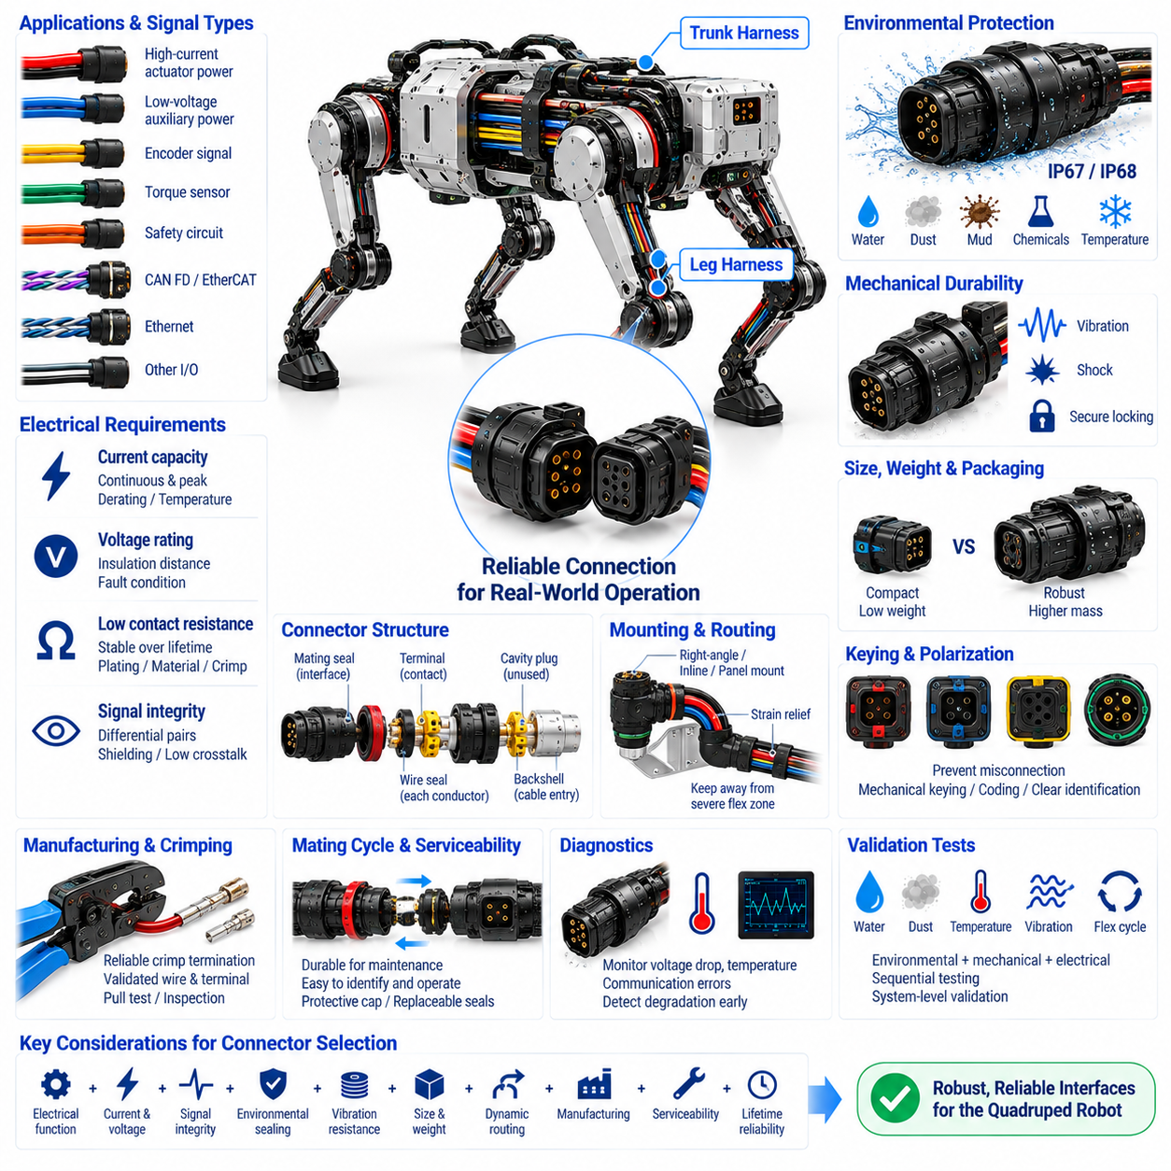
Connector selection in a quadruped robot is a system-level engineering decision that directly affects power integrity, communication reliability, environmental protection, mechanical durability, manufacturing, and serviceability. Connectors used in the trunk and leg harnesses must operate under vibration, impact, repeated motion, contamination, and restricted packaging while maintaining stable electrical contact throughout the robot’s intended service life.
The selection process begins by defining the electrical function of each interface. High-current actuator power, low-voltage auxiliary power, encoder signals, torque sensors, safety circuits, CAN FD, EtherCAT, Ethernet, and other communication links impose different requirements. Using one connector family for every function may simplify purchasing, but it can create compromises in current capacity, signal integrity, size, weight, and environmental performance.
Power connectors must be sized for both continuous and transient current rather than nominal operating current alone. Quadruped joints can demand large peak currents during acceleration, climbing, jumping, or disturbance recovery. Contact resistance, terminal temperature rise, conductor size, connector derating, ambient temperature, and the number of simultaneously loaded contacts should therefore be evaluated together when determining the required current capability.
Voltage rating is equally important because adequate insulation distance must be maintained under normal and fault conditions. Systems based on 48 V or 72 V architectures may not require conventional high-voltage automotive connectors, but connector insulation, contamination conditions, transient voltage, and fault energy must still be considered. Power and low-level signal circuits should be separated when necessary to prevent electrical coupling and simplify protection.
Contact resistance should remain low and stable over the connector lifetime. Even a small increase in resistance can produce significant heating when high actuator current passes through the interface. Terminal material, plating, contact geometry, normal force, crimp quality, contamination, vibration, and mating cycles all influence resistance. Thermal evaluation should therefore include aged and representative assembled connectors rather than relying only on catalog values.
Signal connectors require different priorities. Encoder, torque-sensor, IMU, and other measurement interfaces may carry low-level signals that are sensitive to contact instability and electromagnetic interference. Differential communication networks additionally require controlled pair geometry and suitable termination through the connector. Pin assignment should preserve signal pairs, return paths, and shielding relationships while avoiding unnecessary proximity to noisy power contacts.
CAN FD and EtherCAT interfaces require reliable differential connectivity under vibration and repeated mechanical loading. Connector transitions should minimize disturbance of twisted-pair geometry and should provide appropriate shield continuity where shielding is used. For higher-speed Ethernet links, impedance discontinuity, crosstalk, insertion loss, and return loss become increasingly important, making connector electrical performance part of the communication-channel design rather than only a mechanical interface.
Environmental rating is critical for connectors located on exposed leg assemblies. Water, dust, mud, sand, cleaning fluids, and condensation can attack contacts or sealing interfaces. IP67 or IP68 capability may be required depending on the defined mission environment, but the connector rating must be considered together with wire seals, unused cavity plugs, backshells, cable-entry sealing, mating condition, and installation orientation.
Mechanical retention must withstand continuous vibration and occasional high shock loads. A connector that gradually backs out can first produce intermittent communication or power faults before complete disconnection occurs. Positive locking mechanisms, secondary locks, connector position assurance, or other retention features can improve mating security. The locking system should also provide a clear indication that the connector has reached its fully seated condition.
Connector size and mass are particularly important in leg assemblies because every component attached to the moving structure contributes to inertia. Large industrial connectors may offer excellent robustness but impose excessive mass and packaging volume near joints. Compact connectors can reduce these penalties but may provide less current capacity, smaller sealing structures, or more difficult service handling. Selection therefore requires a balance between robustness and dynamic performance.
Connector placement and selection should be considered together. Interfaces located near severe flex zones can transfer cable bending forces directly into terminals and seals. Where possible, connectors should be mounted on mechanically stable regions, with strain relief separating the connector from the dynamic cable section. Right-angle, inline, panel-mount, or bulkhead configurations can be selected according to routing direction, available space, and mechanical protection requirements.
Keying and polarization are essential where multiple similar interfaces exist. Four legs may contain nearly identical actuator and sensor connections, making incorrect mating possible during assembly or service. Mechanical keying, different connector coding, unique shell arrangements, or clearly controlled pin configurations can reduce this risk. Color identification and labels can support the design, but they should not replace physical prevention of hazardous misconnection.
Pin assignment should be developed as part of the electrical architecture. High-current contacts should have adequate thermal spacing, differential pairs should remain adjacent where required, grounds and returns should be positioned deliberately, and unused pins should be controlled rather than left undefined. Safety-related signals may require separation or redundant contacts depending on the system concept. Future expansion pins can be reserved when justified by expected platform evolution.
Crimp termination is often preferable for robotic harnesses because a correctly engineered crimp creates a mechanically strong and electrically stable connection without introducing a rigid solder transition into a flexing wire. Terminal and wire combinations must be validated for conductor cross-section, strand construction, insulation diameter, and crimp tooling. Pull-force, crimp-height, visual, and electrical inspections can be incorporated into manufacturing quality control.
Mating-cycle durability should reflect the expected maintenance strategy. A trunk-to-leg connector may be disconnected whenever a leg module is replaced, while internal connectors may remain mated for most of the robot’s life. Repeated mating can wear plating, damage seals, or reduce contact performance. Connector specifications should therefore distinguish frequently serviced interfaces from permanent or low-cycle internal connections.
Serviceability requires connectors that technicians can identify, reach, unlock, and reconnect without damaging surrounding components. Extremely small connectors may save space but become difficult to manipulate in field conditions, particularly when gloves or protective equipment are used. Adequate finger access, tool clearance, visible locking features, replaceable seals, protective caps, and clear orientation can significantly reduce maintenance time and assembly errors.
Modularity should be balanced against connector count. Adding connectors at every subsystem boundary simplifies replacement but introduces additional contact resistance, mass, cost, sealing interfaces, and possible failure points. A practical architecture places connectors at meaningful service and manufacturing boundaries, such as trunk-to-leg, joint-module, sensor-module, and removable compute interfaces, while avoiding unnecessary intermediate connections within stable harness sections.
Diagnostics can improve connector fault detection. Voltage drop across power interfaces, contact temperature, communication error counters, intermittent sensor signals, or resistance changes can reveal degrading contacts before complete failure. Correlating faults with vibration, joint movement, temperature, or operating current is especially useful because connector problems may appear only under specific mechanical or electrical conditions.
Connector qualification should reproduce the combined stresses expected in service. Electrical load, temperature rise, vibration, mechanical shock, mating durability, dust, water exposure, temperature cycling, corrosion, and cable movement should be evaluated as applicable. Sequential testing is valuable because a connector may pass individual tests independently yet develop leakage or contact instability after environmental and mechanical aging are combined.
Manufacturing validation must confirm that the selected connector can be assembled consistently. Terminal insertion, secondary-lock engagement, seal positioning, cavity plugging, crimp dimensions, wire preparation, and connector mating should be controllable and inspectable. End-of-line continuity and pin-mapping tests can detect assembly errors, while representative load and communication tests provide additional assurance for critical interfaces.
The final connector architecture should therefore be based on electrical function, current and voltage capability, signal integrity, environmental sealing, vibration resistance, packaging, weight, dynamic routing, manufacturing, serviceability, and lifetime reliability. Selecting connectors as part of the complete quadruped electrical architecture creates robust interfaces between trunk harnesses, flexible leg wiring, actuators, sensors, computing systems, communication networks, and safety functions.

06.06. Serviceability Design
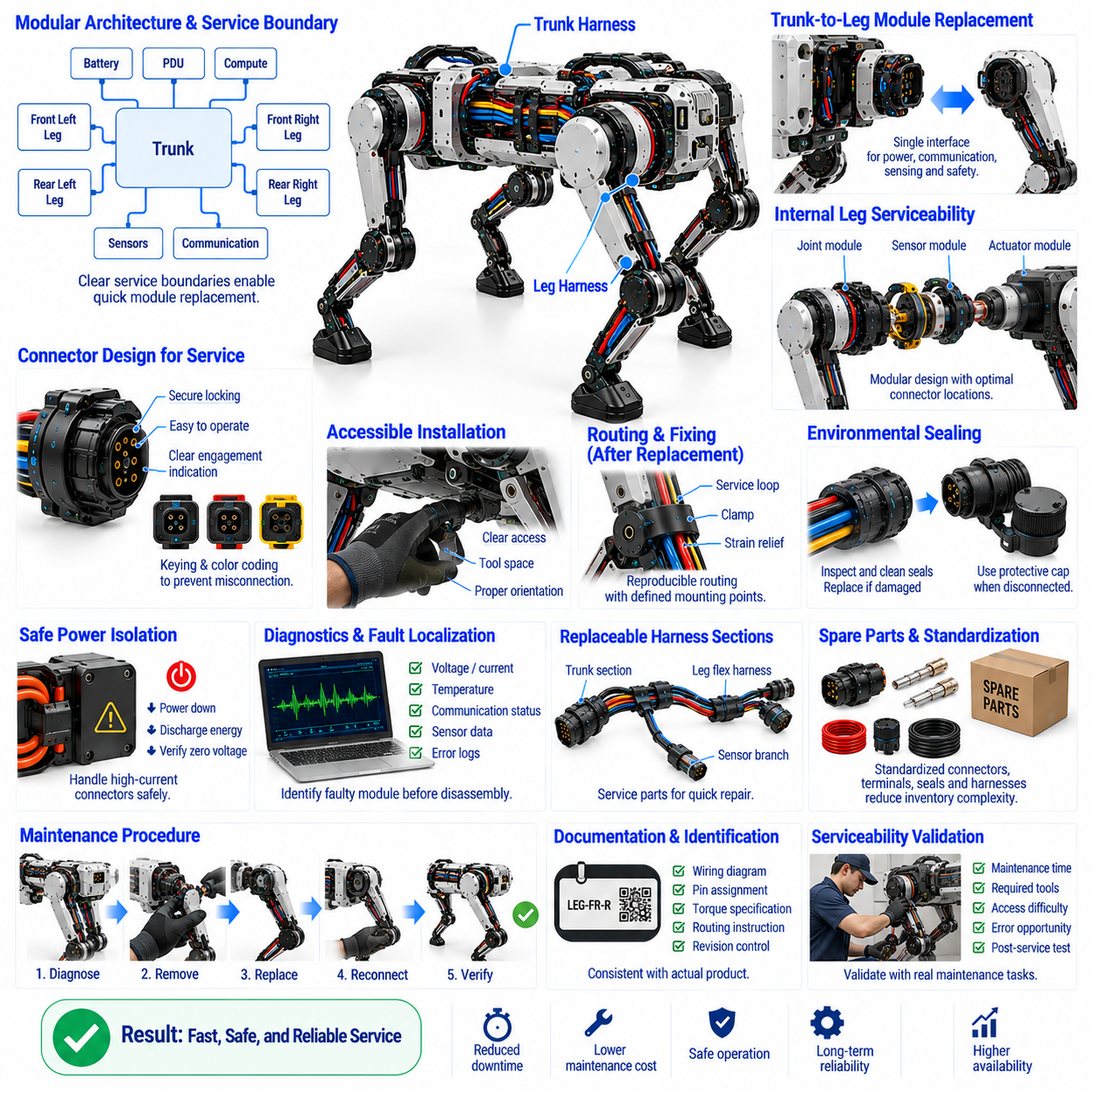
Serviceability design ensures that the quadruped robot’s harness and connector architecture can be inspected, diagnosed, repaired, and replaced efficiently throughout its operational life. Because legs, actuators, sensors, batteries, and computing modules may require field replacement, electrical interfaces should support modular maintenance without forcing technicians to dismantle large portions of the robot or disturb unrelated wiring.
Service boundaries should follow the physical and functional modularity of the robot. The trunk harness can provide defined interfaces to each leg, battery, power distribution unit, compute module, sensor group, and communication subsystem. When these boundaries correspond to replaceable assemblies, a failed module can be disconnected and exchanged while the remaining electrical architecture stays intact, reducing maintenance time and the risk of secondary damage.
The trunk-to-leg interface is one of the most important service points because leg assemblies experience high mechanical loads and environmental exposure. A complete leg should ideally be removable through a clearly defined electrical disconnect combined with mechanical attachment points. Power, communication, sensing, and safety circuits can be integrated into an appropriate connector arrangement that supports rapid replacement without opening the central harness.
Internal leg serviceability requires a balance between modularity and connector count. Providing connectors at every actuator or sensor can simplify individual replacement, but each interface adds mass, electrical resistance, sealing requirements, cost, and potential failure points. Connectors should therefore be located at meaningful maintenance boundaries such as joint modules, sensor modules, or major leg sections rather than introduced simply for assembly convenience.
Physical accessibility is essential for effective maintenance. A connector may be electrically ideal but difficult to service if it is hidden behind structural components or cannot be reached with normal tools. Connector orientation, hand clearance, tool access, release direction, cable movement, and nearby mechanical components should be evaluated using realistic maintenance procedures rather than only considering the assembled CAD geometry.
Connector locking mechanisms should be secure during operation but understandable and manageable during service. Secondary locks, connector position assurance, threaded couplings, or positive latches may be required for vibration resistance. However, a locking system that requires excessive force or specialized tools can increase maintenance difficulty. The design should provide clear confirmation of both complete engagement and intentional release.
Identification reduces the possibility of incorrect reconnection. Connectors, harness branches, and modules can use durable labels, identification codes, color references, or machine-readable markings. Physical keying and polarization should prevent hazardous cross-connection where similar interfaces are located close together. Documentation should use the same identifiers as the physical hardware so technicians can move directly between wiring information and the robot.
Harness routing should be reproducible after replacement. Service loops, clamp positions, bend radii, branch orientations, and strain-relief locations must not depend entirely on technician judgment. Defined mounting features and routing references allow a replacement harness to follow the validated geometry. This is particularly important for dynamic leg wiring, where small routing changes can significantly alter flex life or create interference during joint movement.
Clamps and cable supports should be serviceable without damaging the harness. Reusable clamps can simplify maintenance where repeated access is expected, while permanent fastening may be appropriate in regions that rarely require disassembly. Support hardware should provide sufficient retention without crushing cable jackets or shields. Fastener selection should also consider accessibility, torque control, vibration resistance, and the risk of loose hardware.
Environmental sealing must be recoverable after service. Disconnecting an IP67 or IP68 interface exposes seals and connector cavities to contamination and possible damage. Maintenance procedures should include inspection of sealing surfaces, cleaning when necessary, replacement of damaged seals, correct installation of cavity plugs, and verification of complete connector mating. Protective caps can protect disconnected interfaces during extended maintenance activities.
The architecture should minimize the need to disturb high-current power connections during unrelated repairs. Battery and actuator power interfaces can carry significant stored or available energy, so maintenance boundaries should allow safe isolation before connectors are handled. Service procedures should define power-down states, energy discharge, connector sequencing, and verification of de-energized conditions before technicians access electrically sensitive areas.
Diagnostic access can substantially reduce repair time. Service connectors, communication interfaces, software diagnostic ports, or remotely accessible health data can help technicians identify a failed subsystem before mechanical disassembly begins. Voltage, current, temperature, communication status, sensor validity, and fault histories can be associated with specific harness branches or modules so that troubleshooting becomes targeted rather than based on repeated component substitution.
Fault localization should distinguish between a failed device and its electrical connection. An actuator communication fault, for example, may originate from the actuator electronics, connector contacts, cable conductors, network topology, or power supply. Harness architecture and diagnostics should provide enough observability to narrow these possibilities. Connector voltage measurements, network error counters, continuity checks, and substitution tests can support systematic fault isolation.
Event logging can improve serviceability when failures are intermittent. A conductor or connector may operate normally while stationary but fail during vibration or at a particular joint angle. Recording communication errors, voltage disturbances, temperatures, joint positions, and operating loads allows maintenance personnel to correlate electrical symptoms with robot motion. This can reveal dynamic harness faults that are difficult to reproduce during workshop inspection.
Replaceable harness sections can reduce repair cost compared with replacing the complete robot wiring system. A damaged leg flex harness, sensor branch, or local trunk section can be designed as an independent service part when appropriate. Modular replacement is especially valuable in exposed regions, but additional interfaces should only be introduced when the maintenance benefit outweighs increased connector count, weight, packaging complexity, and reliability risk.
Spare-part strategy should be considered during electrical design. Standardized connector families, terminals, seals, cables, clamps, and harness modules can reduce inventory complexity and improve field support. Excessive variation between left and right or front and rear assemblies increases the number of service parts. Where mechanical geometry permits, common components and symmetric interfaces can improve maintainability without compromising electrical performance.
Repair policy should define which faults are repaired at component level and which require module replacement. Field technicians may replace a complete sealed harness or joint module, while specialized facilities perform terminal replacement, crimp repair, or connector rebuilding. This distinction influences connector placement, accessibility, documentation, tooling, test equipment, and spare-part packaging and should therefore be established during architecture development.
Manufacturing and service documentation should remain consistent with the physical product. Harness drawings, connector views, pin assignments, wire identifiers, routing instructions, torque requirements, seal information, and test procedures should correspond to the actual configuration. Revision control is essential because using outdated pin maps or routing information during maintenance can introduce faults into an otherwise functional robot.
Post-service verification should confirm both electrical function and mechanical restoration. Continuity, insulation, power delivery, communication, sensor operation, and diagnostic status may be checked after replacement. Dynamic sections should also be inspected through representative joint motion to verify bend radius, clearance, service-loop geometry, strain relief, and connector retention before the robot returns to normal operation.
Serviceability should also be validated experimentally rather than assumed from design drawings. Representative technicians can perform common tasks such as leg replacement, harness exchange, connector inspection, and sensor-module service using production-equivalent hardware. Maintenance time, required tools, access difficulties, error opportunities, and post-service verification results provide measurable feedback that can be incorporated into subsequent design revisions.
A successful serviceability architecture integrates modular electrical boundaries, accessible connectors, reproducible routing, recoverable environmental sealing, diagnostics, documentation, spare parts, and verification procedures. Designing these features together with the trunk harness, leg flex harness, dynamic routing, and connector architecture allows the quadruped to return to operation quickly after faults while preserving electrical safety, environmental protection, and long-term reliability.

