Volume 20. Quadruped Electrical Architecture

Chapter 10. Functional Safety

10.01. Risk Assessment
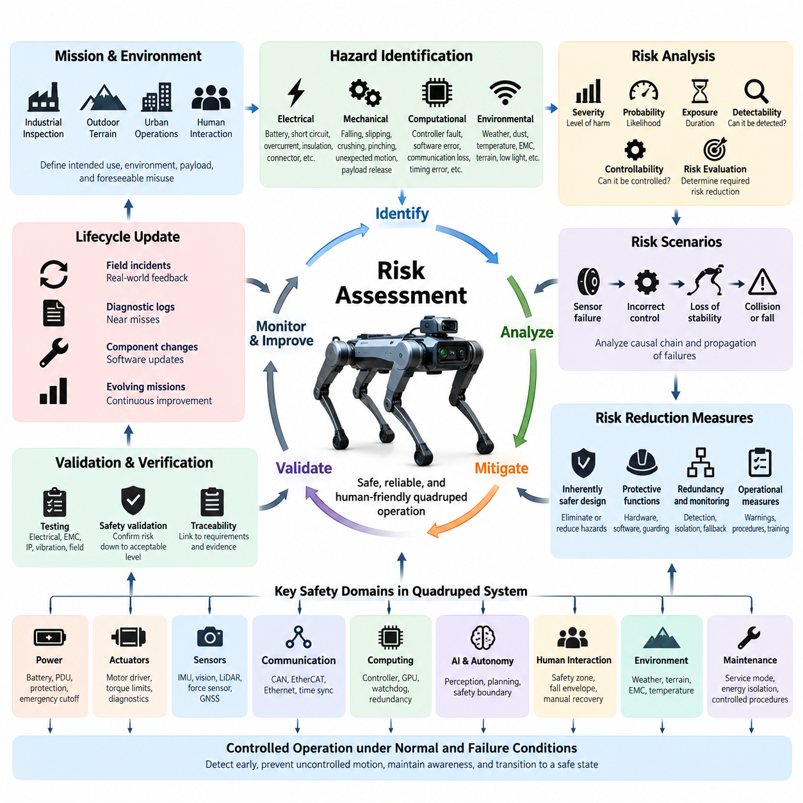
Risk assessment for a quadruped robot is the systematic process of identifying hazardous conditions, estimating their potential consequences, and defining engineering measures that reduce risk to an acceptable level. Unlike a stationary industrial machine, a quadruped continuously changes posture, contact points, velocity, and interaction geometry. Safety analysis must therefore consider electrical, mechanical, computational, environmental, and behavioral hazards together throughout the complete operating mission.
A useful starting point is to define the intended use, operating environment, mission boundaries, payload configuration, expected human interaction, and reasonably foreseeable misuse. A quadruped intended for industrial inspection may encounter stairs, narrow passages, wet floors, machinery, cables, elevated platforms, or personnel. Each operating context changes the probability and severity of hazardous events, so risk assessment should be performed against representative missions rather than only against nominal laboratory operation.
Hazard identification begins at the system level and is progressively decomposed into subsystems. Electrical hazards include battery short circuits, insulation failure, connector overheating, uncontrolled current paths, and loss of protective power switching. Mechanical hazards include falling, slipping, crushing, pinching, unexpected joint motion, and payload release. Computational hazards include controller faults, corrupted sensor information, communication loss, timing errors, software deadlock, and unintended commands generated by higher-level autonomy.
The dynamic nature of quadruped locomotion introduces hazards that do not exist in conventional wheeled robots. Every walking cycle transfers load among multiple legs while the robot continuously modifies joint torque to preserve balance. Failure of a single actuator, encoder, torque sensor, communication link, or real-time controller can rapidly alter the support polygon. Risk analysis must therefore evaluate not only component failure itself but also how quickly that failure can propagate into instability, collapse, uncontrolled motion, or collision.
Risk is commonly evaluated by combining the severity of possible harm with the probability or frequency of occurrence. Additional factors may include exposure duration, possibility of avoidance, detectability, and the controllability of the hazardous situation. The objective is not merely to assign a numerical score. The assessment must establish whether an identified risk requires elimination through architecture, reduction through protective functions, operational restriction, warning, maintenance control, or a combination of these measures.
Hazardous scenarios should be expressed as causal sequences rather than isolated component faults. For example, loss of an encoder signal may produce an incorrect joint position estimate, which may cause inappropriate motor torque, leg trajectory deviation, loss of foothold, body instability, and eventual robot collapse. Constructing such chains helps engineers identify where detection, isolation, redundancy, torque limitation, controlled shutdown, or mechanical protection can interrupt the progression before unacceptable harm occurs.
Electrical power deserves particular attention because the battery and actuator network can contain substantial stored energy. Risk assessment should examine overcurrent, short circuits, reverse polarity, ground faults, contactor welding, DC/DC converter failures, damaged leg harnesses, connector contamination, and thermal overload. Protective measures should be coordinated across the battery management system, power distribution unit, fuses, contactors, emergency cutoff paths, motor drivers, and diagnostic controllers so that electrical faults are contained without creating secondary motion hazards.
Actuator hazards require analysis at both joint and whole-body levels. A motor driver may generate excessive torque because of sensor corruption, software failure, communication errors, or power-stage malfunction. Torque, velocity, position, temperature, and current monitoring provide complementary evidence of abnormal behavior. Limits should be defined according to the mechanical capability and mission state, while independent protection paths should prevent a failure in the primary motion-control software from defeating critical safety constraints.
Sensor faults can create dangerous behavior even when every actuator remains electrically healthy. IMU drift may corrupt attitude estimation, foot-force errors may produce incorrect contact detection, cameras or LiDAR may fail to identify nearby people, and GNSS errors may affect outdoor navigation. Risk assessment must determine which sensing functions are safety relevant and whether plausibility checking, sensor diversity, redundant measurement, confidence monitoring, environmental constraints, or transition to a degraded operating mode is required.
Communication architecture is another important source of common and cascading failures. CAN FD, EtherCAT, Gigabit Ethernet, DDS/ROS 2, and time-synchronization mechanisms may serve different control and information domains within the quadruped architecture. Packet loss, excessive latency, bus saturation, clock divergence, duplicated messages, or network partitioning can transform valid local data into unsafe system behavior. Safety analysis should therefore specify timeout behavior, freshness checks, sequence validation, communication supervision, and deterministic responses to loss of connectivity.
Timing faults must be treated as functional faults rather than simply performance degradation. A sensor measurement can be numerically correct yet unsafe when associated with the wrong time. Joint states, IMU data, foot contact measurements, perception results, and control commands should therefore carry sufficient temporal information to determine validity and freshness. Where synchronized computing nodes are used, clock quality and synchronization status should be monitored so that degraded timing cannot silently propagate through estimation and control functions.
The computing architecture must distinguish failures that can be detected from failures that can be tolerated. Processor crashes, GPU faults, memory corruption, thermal throttling, operating-system stalls, watchdog expiration, and power loss can affect different functions with different consequences. Safety-critical control should not depend unnecessarily on complex AI computing resources. A practical architecture separates fast deterministic protection and motion supervision from computationally intensive perception, planning, foundation-model, or agent functions.
Autonomous and AI-enabled functions introduce additional uncertainty because behavior may depend on learned representations rather than explicitly programmed rules. A perception model can misclassify an obstacle, a planner can select an inappropriate route, or an AI agent can generate a command that is semantically reasonable but physically unsafe. Risk reduction therefore requires an architectural boundary in which AI-generated intentions are checked against deterministic constraints governing velocity, workspace, stability, actuator capability, collision avoidance, and permitted mission states.
Human interaction must be evaluated under realistic conditions. Personnel may approach the robot unexpectedly, touch it during operation, walk behind it, enter blind regions, attempt to recover it manually, or remain close during maintenance. A quadruped may also fall in a direction that differs from its commanded trajectory. Safety zones should consequently account for body dimensions, leg sweep, stopping behavior, possible sliding, payload geometry, and credible fall envelopes rather than relying solely on navigation obstacle-clearance distances.
Environmental conditions can convert otherwise acceptable faults into serious hazards. Rain, dust, mud, temperature extremes, vibration, electromagnetic interference, steep slopes, loose gravel, stairs, reflective surfaces, and low illumination can degrade electrical components and perception simultaneously. Environmental risk assessment should connect expected exposure conditions with enclosure protection, connector design, harness routing, thermal margins, sensor limitations, traction capability, and operating restrictions so that environmental assumptions become explicit engineering requirements.
Maintenance and service activities require a separate assessment because normal protective assumptions may no longer apply. Covers may be removed, connectors disconnected, batteries replaced, legs lifted from the ground, or diagnostic commands issued directly to actuators. Hazardous stored electrical and mechanical energy should be identified before service procedures are defined. Maintenance states should prevent unintended motion, clearly indicate power status, restrict actuator enablement, and provide controlled procedures for isolation, verification, recovery, and return to operation.
Risk reduction should follow an architectural hierarchy. Hazards should first be eliminated or reduced through inherently safer design wherever practical. Remaining risks should then be addressed through protective hardware, safety functions, diagnostics, redundancy, monitoring, controlled degradation, emergency stopping, and physical guarding where appropriate. Information, warnings, and operating procedures are important but should not substitute for engineering controls when the hazardous condition can reasonably be prevented or automatically mitigated by the system.
The risk assessment should remain traceable to engineering requirements and validation evidence. Each significant hazard should be associated with its initiating conditions, affected functions, estimated risk, required mitigation, responsible subsystem, detection mechanism, system response, and verification method. This traceability connects functional safety with later activities such as emergency-stop design, fail-operational behavior, fail-safe architecture, redundancy, and field safety validation, which form the subsequent safety topics of the quadruped architecture.
Risk assessment is therefore not a document produced once near the end of development. It is a lifecycle activity that evolves as the electrical architecture, software, sensors, actuators, payloads, missions, and operating environments change. Field incidents, diagnostic logs, near misses, component revisions, software updates, and new autonomous capabilities should feed back into the hazard analysis. This closed-loop process allows safety assumptions to remain aligned with the actual robot rather than with an obsolete design baseline.
For a mature quadruped platform, the final objective is controlled behavior under both normal operation and credible failure conditions. The architecture should detect abnormal states early, prevent uncontrolled energy release, maintain sufficient awareness of its own health, and transition predictably toward a safe or degraded state. Risk assessment provides the engineering foundation for these decisions by translating physical hazards into explicit safety requirements that can be implemented, tested, validated, and maintained throughout the robot lifecycle.

10.02. Emergency Stop
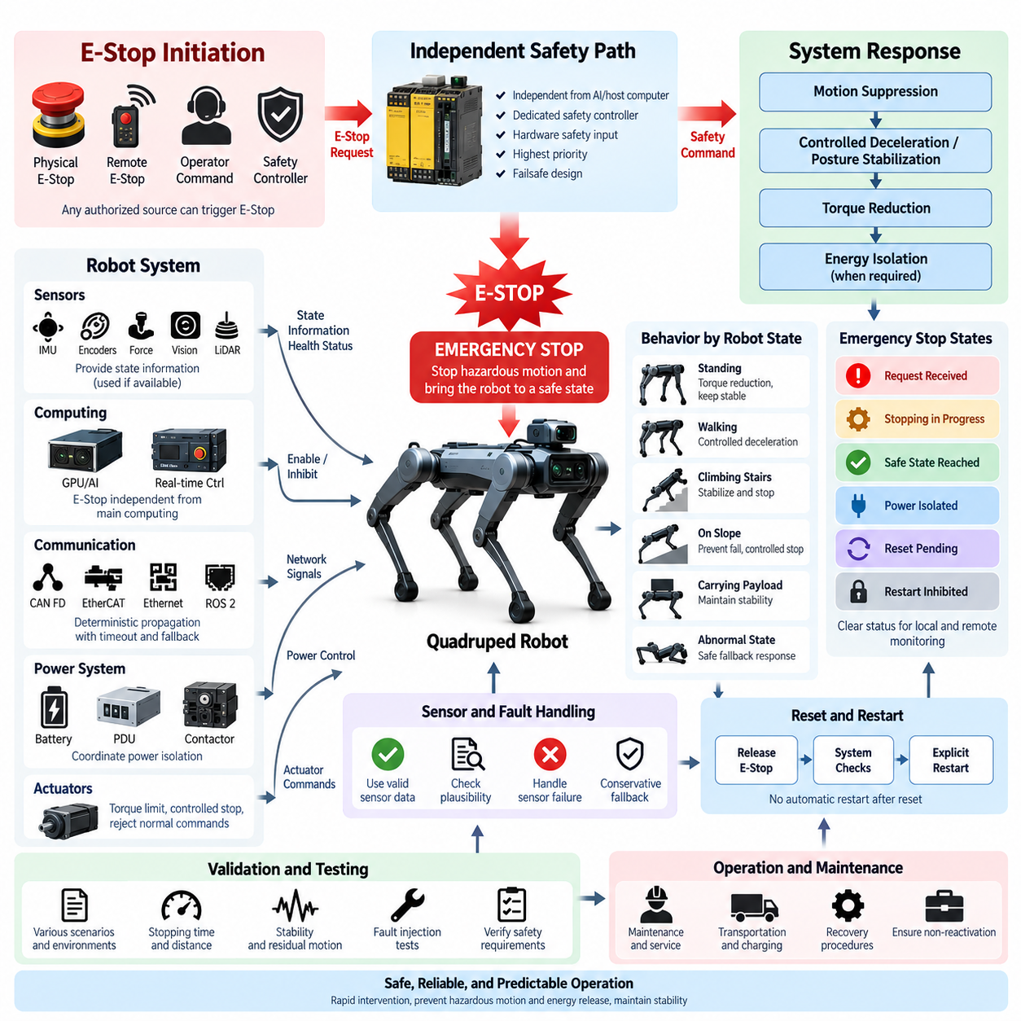
An emergency stop function provides a deliberate and independent means of bringing a quadruped robot into a controlled safety condition when continued operation presents an immediate hazard. Because a quadruped combines high-torque joints, stored battery energy, autonomous motion, and dynamically changing body support, emergency stopping cannot be treated as a simple software command. It must be designed as a system-level safety function spanning human interfaces, control electronics, power distribution, actuators, communication, and diagnostics.
The primary purpose of an emergency stop is to override normal mission execution when hazardous motion or another dangerous condition requires immediate intervention. Activation may originate from a physical emergency-stop device, remote operator interface, safety controller, or another authorized safety mechanism. The resulting action must have higher priority than navigation, locomotion, AI planning, inspection tasks, and ordinary supervisory commands so that autonomous behavior cannot prevent or delay the required safety response.
Emergency-stop behavior must consider the dynamic characteristics of legged locomotion. Simply removing electrical power from every actuator can cause a standing or walking quadruped to collapse because joint torque may be required to support the body. Conversely, maintaining unrestricted actuator power after an emergency request can permit hazardous movement to continue. The architecture must therefore define a controlled transition that balances rapid motion suppression with preservation of mechanical stability wherever the operating condition permits.
The required stopping response depends strongly on the robot state when the emergency stop is activated. A stationary robot standing on level ground presents a different problem from a robot climbing stairs, traversing a slope, carrying a payload, or walking at high speed. Safety logic should evaluate available state information and execute a predefined response, such as controlled deceleration, stabilization, posture lowering, actuator torque restriction, or final power isolation, while preventing normal autonomous commands from reactivating motion.
A physical emergency-stop interface should be positioned so that personnel can identify and operate it rapidly without entering an additional hazardous region. The device should provide an unambiguous command and remain in the activated state until intentionally reset. Where personnel may supervise the robot from a distance, an appropriately engineered remote emergency-stop mechanism can complement the local interface, but communication loss must not create uncertainty about whether the safety command has been received and executed.
The emergency-stop signal path should be sufficiently independent from the main autonomy and AI computing stack. A failure of the GPU computer, operating system, ROS 2 process, perception pipeline, planner, or high-level network should not eliminate the ability to stop hazardous motion. A dedicated safety controller, real-time controller, hardware safety input, or equivalent independent mechanism can supervise the stop path and directly influence actuator enable signals or protected power-control devices without depending on normal mission software.
Electrical architecture plays a central role in implementing the emergency-stop response. The battery, power distribution unit, contactors, DC/DC converters, motor drivers, and actuator power domains should be coordinated so that hazardous energy can be isolated when required. However, power removal should follow the defined safety sequence rather than assuming that immediate total disconnection is always safest. Logic power, safety controllers, brakes, or selected actuators may temporarily require energy to complete controlled stabilization or shutdown.
Actuator-level emergency behavior should define what happens to torque, velocity, position control, and motor enable states during the transition. Depending on the mechanical design, joints may first receive bounded commands that reduce velocity and stabilize the body before drive torque is disabled. Motor drivers should reject ordinary motion commands once the emergency state is active, and independent enable or inhibit mechanisms should provide additional protection against software continuing to generate commands after the safety function has been triggered.
Communication networks must propagate emergency-related state deterministically while avoiding excessive dependence on a single communication channel. CAN FD, EtherCAT, Ethernet, and higher-level DDS/ROS 2 communication may participate in normal control, but critical emergency actions should account for network interruption, delayed messages, corrupted data, and node failure. Local controllers should therefore define timeout and fallback behavior so that loss of communication during an emergency transition does not result in uncontrolled actuator operation.
The stopping sequence should also consider perception and sensor availability. IMU data, joint encoders, torque measurements, foot-force sensors, and other state information may be useful for determining whether controlled stabilization remains possible. Nevertheless, the emergency-stop architecture must anticipate that the initiating hazard may itself involve sensor failure. Safety behavior should therefore use validated information where available while retaining a conservative fallback response when required measurements become unavailable, implausible, stale, or internally inconsistent.
A practical emergency-stop architecture separates the emergency request, safety decision, motion suppression, energy isolation, and status confirmation into traceable functions. This prevents a single ambiguous command from representing the entire safety mechanism. Each stage can be monitored to determine whether the request was detected, whether actuators entered the commanded safe condition, whether hazardous power was removed when necessary, and whether any discrepancy requires escalation to a more restrictive fallback state.
Resetting the emergency stop must not automatically restart locomotion. Release of the physical emergency-stop device indicates that the emergency command has been reset, but it does not prove that the environment or robot is safe for operation. The system should remain in a controlled inhibited state until required checks are completed and an explicit restart or enable command is issued. This separation prevents unexpected movement immediately after personnel release an emergency-stop device.
Restart authorization should verify relevant system conditions before actuator motion is restored. Depending on the architecture, these conditions can include acceptable battery and power status, valid communication, healthy controllers, available sensors, actuator readiness, stable posture, and absence of unresolved critical diagnostic faults. If the robot collapsed or entered an abnormal configuration during the emergency event, a dedicated recovery procedure may be required rather than returning directly to the interrupted autonomous mission.
Emergency-stop status should be clearly observable both locally and remotely. Operators, maintenance personnel, fleet systems, and diagnostic software should be able to distinguish normal operation, emergency-stop requested, stopping in progress, safe state reached, power isolated, reset pending, and restart inhibited where these states are implemented. Clear state representation reduces uncertainty during recovery and enables diagnostic logs to reconstruct the sequence of events that occurred before, during, and after activation.
Remote and fleet-operated quadrupeds require particular attention because the operator may not have direct visual contact with the robot. A remote emergency-stop command must account for wireless latency, connection loss, network partitioning, and remote-system failure. The robot should not depend exclusively on cloud connectivity or fleet software for immediate safety action. Local safety supervision remains necessary so that hazardous motion can be terminated even when communication with remote infrastructure becomes unavailable.
AI and autonomous functions must remain subordinate to the emergency-stop architecture. A vision-language model, agent, navigation planner, learned locomotion policy, or foundation-model interface must not reinterpret, suppress, postpone, or autonomously cancel an active emergency-stop condition. Once the safety function is triggered, AI-generated actions should be blocked at an architectural boundary until the safety state is intentionally cleared and normal control authority is restored through the defined restart process.
Diagnostics are essential for demonstrating that the emergency-stop function remains available throughout the robot lifecycle. The system should detect failures such as broken signal wiring, stuck inputs, welded contactors, failed actuator inhibits, safety-controller faults, communication inconsistencies, and unexpected power states where the architecture permits such monitoring. Relevant events should be recorded with sufficient timing and state information to support maintenance, fault investigation, safety validation, and improvement of future system revisions.
Emergency-stop validation must extend beyond verifying that a button can stop the robot under ideal laboratory conditions. Tests should cover representative postures, locomotion states, speeds, payloads, slopes, communication failures, sensor faults, computing faults, power abnormalities, and realistic environmental conditions. Measurements such as stopping time, stopping distance, residual motion, body stability, actuator response, power isolation time, and final robot state provide objective evidence that the implemented behavior satisfies its safety requirements.
The emergency-stop function must also be considered during maintenance, transportation, charging, recovery, and field servicing. Different operating modes can expose personnel to different combinations of electrical and mechanical energy, and a single stopping strategy may not be appropriate for every condition. Service procedures should define when emergency stopping is available, how hazardous energy is isolated, how actuator motion is prevented, and how technicians verify that the robot cannot unexpectedly return to an enabled state.
A robust emergency-stop design therefore combines rapid intervention with predictable system behavior. Its objective is not merely to disconnect power as quickly as possible, but to prevent hazardous motion and energy release while bringing the quadruped toward a defined safe condition. By coordinating independent safety logic, actuator control, power isolation, communication supervision, diagnostics, reset management, and validation, the emergency-stop architecture becomes a fundamental protective layer within the quadruped functional safety system.

10.03. Fail Operational Design
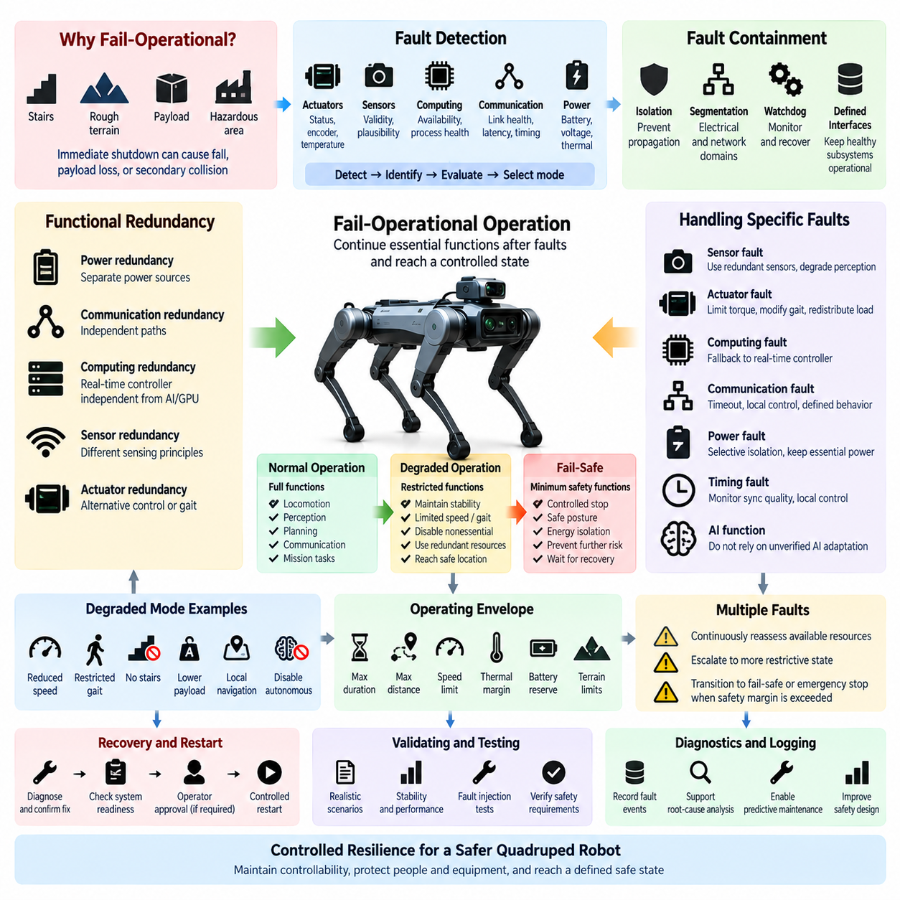
Fail-operational design enables a quadruped robot to continue performing essential functions after one or more faults have occurred, rather than immediately terminating all operation. The objective is not unrestricted continuation of the original mission, but preservation of sufficient control authority to maintain stability, protect people and equipment, and reach a controlled condition. This capability is particularly important for dynamically balanced robots that may become more hazardous if power or control is removed abruptly.
The need for fail-operational behavior originates from the physical characteristics of quadruped locomotion. A robot may be walking on stairs, traversing uneven terrain, carrying a payload, or operating near hazardous equipment when a fault occurs. Immediate shutdown could cause collapse, sliding, payload loss, or secondary collision. The safety architecture must therefore determine which functions must remain available temporarily and which functions can be disabled without compromising the robot’s ability to manage the fault safely.
Fail-operational design begins by identifying essential functions and their required duration after failure. Body stabilization, joint control, attitude estimation, contact detection, communication supervision, and controlled power management may need to remain active long enough to stop locomotion or reach a safer posture. Mission-level perception, inspection processing, cloud communication, or advanced AI reasoning may be unnecessary during this transition and can often be suspended to preserve computational and electrical resources.
The architecture should distinguish full functionality, degraded functionality, and minimum safety functionality. During normal operation, all locomotion, perception, planning, communication, and mission functions may be available. Following a fault, selected capabilities can be restricted while essential control remains operational. If additional failures occur or the remaining resources become insufficient, the robot should transition from degraded operation toward a defined fail-safe state rather than attempting to continue beyond its available safety margin.
Fault detection is the entry point to any fail-operational transition. Controllers should supervise actuator status, encoder validity, sensor plausibility, communication health, computing availability, battery condition, power distribution, timing integrity, and thermal state. Detection alone is insufficient; the system must determine the affected function, evaluate whether redundant or alternative resources remain available, and select an operating mode that matches the robot’s remaining physical and computational capability.
Fault containment prevents a localized failure from propagating across the robot. A failed joint controller should not corrupt communication for healthy legs, and a malfunctioning AI computer should not prevent the real-time controller from maintaining balance. Electrical protection, communication segmentation, process isolation, watchdogs, independent controllers, and well-defined interfaces help establish fault-containment regions. These boundaries allow healthy subsystems to remain usable while the failed element is isolated or disabled.
Redundancy is a major enabler of fail-operational behavior, but redundancy must be designed at the functional level rather than by simply duplicating components. Two sensors connected to the same failed power rail or two controllers dependent on the same communication switch may provide little effective independence. Useful redundancy considers power sources, communication paths, computing resources, sensing principles, timing sources, and software dependencies so that a common-cause failure does not simultaneously eliminate both primary and backup capability.
Computing redundancy should preserve deterministic safety and motion functions when higher-performance computing becomes unavailable. A GPU or AI computer may execute perception, mapping, planning, and learned models, while a separate real-time controller maintains joint supervision and stability functions. If the main computing node crashes, overheats, or becomes unresponsive, the remaining controller should retain enough validated state information and predefined behavior to inhibit new autonomous actions and execute a controlled stabilization or stopping sequence.
Sensor degradation requires similar architectural treatment. Loss of a camera may reduce perception capability without immediately preventing locomotion, whereas loss of reliable attitude information can directly threaten stability. The system should classify sensors according to functional criticality and identify allowable substitutes. Redundant IMUs, joint encoders, foot-force information, LiDAR, proprioceptive estimation, or other independent observations can provide limited continuation when one sensing source becomes unavailable or unreliable.
Actuator faults are especially challenging because each leg contributes directly to body support and locomotion. A joint may experience encoder failure, motor-driver fault, overtemperature, communication loss, or reduced torque capability. Depending on robot geometry and current posture, limited operation may remain possible by restricting speed, modifying gait, redistributing loads, locking or constraining the affected joint, or transitioning toward a stable posture. Such strategies require explicit validation and must not be assumed safe merely because motion remains physically possible.
Power architecture must support controlled degradation as well as fault isolation. Failure of a nonessential power domain should not necessarily remove energy from safety controllers or stabilization functions. Segmented power distribution, protected logic supplies, monitored contactors, DC/DC converters, battery supervision, and selective actuator isolation can preserve essential functions during a fault. At the same time, electrical protection must prevent continued operation from worsening short circuits, overheating, insulation faults, or other hazardous energy conditions.
Communication failures can divide a distributed quadruped architecture into partially isolated subsystems. CAN FD, EtherCAT, Gigabit Ethernet, DDS/ROS 2, and synchronization services may support different control layers, so fail-operational behavior should define what each node does when messages become delayed, stale, corrupted, or unavailable. Local controllers should have bounded fallback behavior and should not indefinitely maintain the last received command when communication authority or state validity can no longer be guaranteed.
Time synchronization is also part of operational availability. Distributed sensor and controller data may remain numerically valid while becoming unsafe because timestamps or clock relationships are incorrect. The system should monitor synchronization quality and distinguish loss of precise global timing from loss of local real-time control. Where possible, local deterministic control should continue independently for the limited period required to stabilize or stop the robot while functions dependent on synchronized multi-sensor information are restricted.
Degraded modes must be explicitly defined rather than improvised after a fault. Examples can include reduced speed, restricted gait, prohibited stairs, reduced payload capability, local-only navigation, disabled autonomous planning, limited sensor coverage, or controlled return to a recovery location. Each degraded mode should specify its entry conditions, available functions, operating limits, monitoring requirements, exit conditions, and the faults that require escalation to a more restrictive state.
A fail-operational system also requires a clear hierarchy of control authority. Safety controllers and deterministic motion supervision should override mission software, fleet commands, AI agents, and autonomous planners when degraded operation is active. Higher-level software may request a destination or recovery action, but it should not bypass safety restrictions imposed because of a detected fault. This architectural separation ensures that intelligent behavior remains bounded by the robot’s verified remaining capability.
AI-enabled functions require particular caution because their output may be difficult to validate under abnormal conditions. A perception model or learned locomotion policy trained primarily on nominal data may behave unpredictably when sensors, timing, computing resources, or actuators are degraded. Fail-operational design should therefore avoid relying on unverified AI adaptation as the primary safety mechanism. Deterministic constraints, validated fallback controllers, predefined motion limits, and explicit authority boundaries should govern behavior after safety-relevant faults.
Fail-operational capability must have a finite operating envelope. Continuing operation indefinitely after a fault can transform resilience into additional risk. The architecture should define maximum duration, distance, speed, thermal margin, battery reserve, terrain constraints, or other limits applicable to each degraded state. When these boundaries are approached, the robot should transition toward a controlled stop, safe posture, recovery location, or other predefined safe condition before the remaining capability is exhausted.
Multiple faults require escalation logic because a system designed to tolerate one failure may no longer remain safe after a second independent failure. The safety supervisor should continuously reassess available resources after entering degraded operation. Loss of a backup sensor, additional actuator degradation, falling battery voltage, communication failure, or thermal overload may invalidate the assumptions supporting continued operation and trigger transition from fail-operational behavior to fail-safe response or emergency stopping.
Recovery from fail-operational operation must be controlled. A temporary communication restoration or component reset should not automatically return the robot to full autonomous operation. Diagnostic checks should confirm that the original fault has cleared, redundant resources are available, sensor information is valid, actuator capability is acceptable, and the robot remains physically stable. Depending on fault severity, maintenance authorization or operator confirmation may be required before full functionality is restored.
Diagnostics and event logging provide evidence for both runtime decisions and later safety analysis. The system should record the initiating fault, detection time, affected subsystem, selected degraded mode, unavailable resources, control restrictions, subsequent faults, recovery actions, and final state. These records support root-cause analysis, predictive maintenance, field validation, and refinement of the safety architecture as operational experience accumulates.
Validation of fail-operational behavior must reproduce realistic combinations of robot state and fault conditions. Testing should include walking, standing, slopes, stairs, payload operation, communication interruption, sensor loss, actuator degradation, computing failure, power-domain faults, and timing abnormalities. Evaluation should determine whether the robot detects the fault correctly, contains it, selects the intended degraded mode, preserves stability, respects operating limits, and reaches the required final condition without introducing secondary hazards.
Fail-operational design therefore represents controlled resilience rather than simple fault tolerance. Its purpose is to preserve only the capabilities required to manage a failure safely, while progressively restricting functions as system confidence decreases. By combining fault detection, containment, functional redundancy, degraded modes, independent safety control, bounded operating envelopes, diagnostics, and validated transitions, a quadruped can remain controllable long enough to protect people, payloads, equipment, and the robot itself before reaching a safe state.

10.04. Fail Safe Architecture
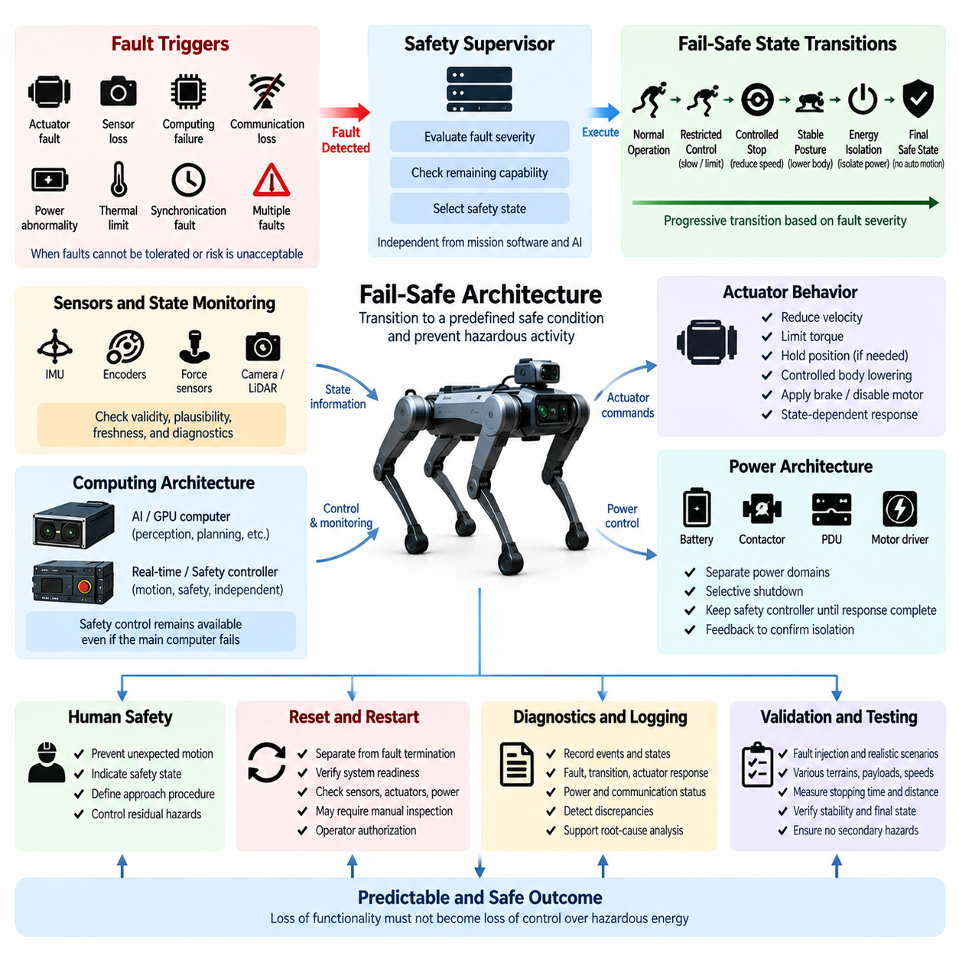
Fail-safe architecture defines how a quadruped robot transitions toward a predetermined safe condition when faults can no longer be tolerated or when continued operation would create unacceptable risk. Unlike fail-operational design, which preserves selected functions after a fault, fail-safe behavior prioritizes termination or restriction of hazardous activity. The transition must remain controlled because abrupt loss of torque, power, sensing, or computation can itself destabilize a dynamically balanced legged robot.
A safe state is not necessarily equivalent to complete electrical shutdown. For a quadruped standing, walking, climbing, or carrying a payload, immediate removal of actuator power may cause collapse, uncontrolled sliding, or payload release. The safe state must therefore be defined according to physical configuration and operating context. It may involve stopping locomotion, lowering the body, restricting joint motion, maintaining temporary support torque, isolating hazardous power, and preventing subsequent autonomous movement.
The transition to fail-safe operation begins when the safety architecture determines that normal or degraded operation can no longer be maintained with sufficient confidence. Triggers may include unrecoverable actuator faults, loss of critical sensing, computing failure, communication loss, power abnormalities, thermal limits, synchronization faults, or multiple simultaneous failures. The safety supervisor must evaluate these conditions against predefined criteria rather than allowing mission software or AI functions to decide whether continued operation remains acceptable.
Fail-safe architecture should use a hierarchy of safety states rather than treating every failure identically. A minor fault may first cause motion restriction or controlled deceleration, while a severe electrical or control fault may require immediate actuator inhibition or power isolation. The system can progressively move from normal operation through restricted control, controlled stop, stable posture, energy isolation, and final safe state according to fault severity and the remaining capability of the robot.
Controlled stopping is particularly important because kinetic and gravitational energy remain present even after a stop request is issued. The robot may require active joint control to reduce velocity, establish reliable foot contact, redistribute load, and lower its center of mass. Once mechanical stability has been achieved, actuator torque can be reduced or removed according to the design. This sequence minimizes the possibility that the safety response itself produces a fall or other secondary hazard.
When stabilization is no longer possible, the architecture should provide a conservative fallback response. Loss of critical attitude sensing, extensive actuator failure, severe power faults, or structural instability may prevent execution of the preferred controlled-stop sequence. In such conditions, the robot should inhibit further commanded locomotion, minimize available hazardous energy where practical, and enter the most predictable physical condition achievable with the remaining hardware rather than attempting uncertain autonomous recovery.
Power-domain control is fundamental to fail-safe behavior. Battery power, actuator buses, computing supplies, sensor rails, and auxiliary loads should be separated sufficiently to support selective shutdown. A fault in a motor or high-current branch should not unnecessarily remove power from the safety controller before it completes the required response. Conversely, a hazardous electrical condition should not remain energized merely to preserve mission availability. Power sequencing must therefore follow safety priorities rather than normal operational priorities.
Contactors, fuses, protection devices, power distribution units, and motor-driver enable circuits form important hardware layers within the fail-safe path. Software commands alone are insufficient when the initiating fault may involve the main computer or communication system. Independent hardware or safety-controller outputs should be capable of inhibiting hazardous actuator operation and disconnecting relevant energy domains. Feedback should confirm whether commanded isolation actually occurred and identify failures such as welded contactors or persistent drive enablement.
Actuator behavior must be explicitly defined for each fail-safe transition. Depending on the joint design, the response may include velocity reduction, torque limitation, position holding, controlled body lowering, brake application, motor disablement, or combinations of these actions. The safest sequence can differ between standing and moving conditions. The design should therefore avoid a universal assumption that either maintaining torque or removing torque is always the correct response for every joint and robot state.
Sensor validity determines whether sophisticated stabilization remains trustworthy. IMUs, encoders, foot-force sensors, torque sensors, LiDAR, cameras, and other measurements may contribute to the decision process, but a safety-relevant fault may make some of these inputs unreliable. Plausibility checks, freshness monitoring, cross-comparison, and diagnostic status should determine which information remains usable. When confidence becomes insufficient, the controller should select simpler and more conservative behavior rather than extrapolating uncertain state estimates.
Communication failure must lead to predetermined local behavior. Distributed joint controllers should not continue executing stale commands indefinitely after losing communication with the supervisory controller. Timeouts, command counters, heartbeat supervision, message freshness checks, and local safety states can establish deterministic responses. The communication architecture should ensure that a network partition or failed central computer results in bounded local behavior rather than uncontrolled continuation of the last valid locomotion command.
Computing failures require independence between complex autonomous computation and essential safety control. A GPU computer executing perception, navigation, foundation models, or learned locomotion functions may crash or become unavailable without warning. A separate real-time or safety controller should retain authority to inhibit motion, monitor critical hardware, execute predefined stabilization behavior where possible, and command power isolation. This separation prevents failure of computational intelligence from becoming simultaneous failure of the robot’s final protective mechanism.
AI functions must never override a fail-safe transition. Once a safety condition requires restricted operation, an AI agent, learned policy, navigation planner, vision-language model, or remote mission system should lose authority to initiate unrestricted motion. AI-generated commands should pass through deterministic safety constraints during normal operation and be rejected when the robot enters a protected state. Returning control to AI should require completion of the defined recovery and restart process rather than autonomous reinterpretation of the fault.
The relationship between fail-operational and fail-safe behavior should be explicitly designed. Fail-operational mechanisms may initially preserve stability and limited mobility after a tolerable fault, but their operating envelope is finite. If redundant resources are lost, another fault occurs, battery reserve falls below a threshold, thermal margins disappear, or confidence in state estimation becomes inadequate, the safety architecture should escalate from degraded operation to fail-safe behavior before controllability is lost.
Human interaction affects the definition of the final safe state. A robot that has stopped may still present crushing, pinching, electrical, thermal, or stored-energy hazards. Indicators should communicate that the system is in a safety-related state, while restart inhibition prevents unexpected movement during inspection or recovery. Where personnel must approach the robot, procedures should define how actuator energy is isolated, how mechanical stability is verified, and how residual hazards are controlled before physical intervention begins.
Reset and restart must remain separate from fault termination. Clearing a fault flag or restoring communication does not prove that the robot is ready to move. Before normal control is restored, the system should verify power integrity, controller health, communication status, sensor validity, actuator readiness, posture, and unresolved diagnostics as appropriate. Severe events may require manual inspection, maintenance authorization, or physical repositioning before autonomous operation can safely resume.
Diagnostics provide the evidence required to understand whether fail-safe mechanisms actually performed as intended. Event records should capture the initiating fault, safety-state transition, controller decisions, actuator responses, power changes, communication status, sensor validity, and final state. Diagnostic feedback from contactors, drives, controllers, and power domains can reveal discrepancies between commanded and achieved safety conditions and support root-cause analysis after field events.
Fail-safe validation must include fault injection and realistic physical operating conditions. Tests should evaluate standing, walking, stairs, slopes, different speeds, payload configurations, low battery conditions, sensor loss, communication interruption, controller failure, actuator faults, thermal events, and power abnormalities. The objective is to confirm not only that hazardous functions stop, but that the transition itself remains bounded and does not introduce unacceptable secondary motion or energy hazards.
Verification should measure observable safety performance such as fault-detection time, reaction time, stopping time, stopping distance, residual velocity, body stability, joint response, power-isolation time, and final energy state. Requirements should be traceable from identified hazards through safety mechanisms to test evidence. This allows the fail-safe architecture to be evaluated as an integrated system rather than as a collection of individually functioning protection components.
Field operation should continuously provide feedback into fail-safe design. Near misses, unexpected falls, diagnostic events, connector failures, actuator degradation, software updates, environmental exposure, and new payload configurations can reveal assumptions that were not captured during development. Safety requirements and transition logic should therefore be reassessed as the platform evolves, particularly when new autonomous capabilities or operating environments expand the robot’s original functional boundaries.
A mature fail-safe architecture ultimately ensures that loss of functionality does not become loss of control over hazardous energy. It combines fault recognition, deterministic authority, controlled stopping, stabilization, selective power isolation, actuator inhibition, communication fallback, diagnostics, restart management, and validation. The goal is a predictable progression from abnormal operation toward the safest achievable physical condition, while preventing the robot from resuming hazardous activity until safe operation has been deliberately re-established.

10.05. Redundancy
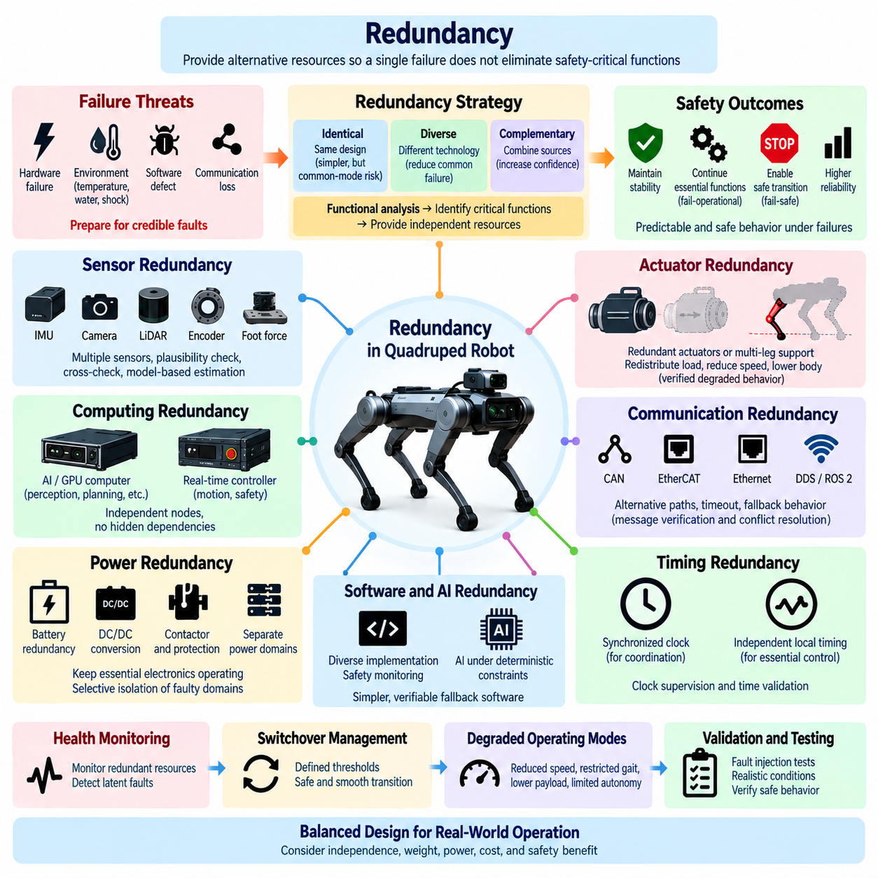
Redundancy in a quadruped robot is the deliberate provision of alternative resources, information paths, or control capabilities so that a single failure does not immediately eliminate a safety-critical function. Within the functional safety architecture, redundancy supports both fail-operational and fail-safe behavior by preserving sufficient sensing, computation, communication, power, or control authority to detect faults, maintain stability, and transition toward a controlled condition.
Effective redundancy begins with functional analysis rather than simple duplication of hardware. Installing two identical components does not necessarily provide meaningful fault tolerance if both depend on the same power rail, connector, communication network, clock source, software process, or environmental condition. The architecture must identify the function that must survive, determine credible failure causes, and provide sufficiently independent resources capable of maintaining that function when the primary path becomes unavailable.
Redundancy can be implemented through identical, diverse, or complementary technologies. Identical redundancy simplifies interfaces and replacement but can remain vulnerable to common design defects. Diverse redundancy uses different hardware, algorithms, sensing principles, or communication paths to reduce common-mode vulnerability. Complementary redundancy combines information from different sources, such as inertial, joint, force, and environmental sensing, to maintain confidence when one measurement becomes degraded or unavailable.
Sensor redundancy is particularly important because quadruped stability depends continuously on knowledge of body orientation, joint configuration, ground contact, and surrounding obstacles. Multiple IMUs, joint encoders, foot-force sensors, cameras, LiDAR, GNSS, or proprioceptive estimates can provide overlapping information. The safety architecture should determine which sensors require direct duplication and which functions can be reconstructed from independent observations when a primary sensing source fails.
Redundant sensors require more than parallel data acquisition. Their outputs must be compared, checked for plausibility, monitored for freshness, and evaluated against physical constraints. When two measurements disagree, the system must determine whether one source can be identified as faulty or whether overall confidence has become insufficient. Voting, cross-checking, analytical redundancy, model-based estimation, and consistency monitoring can support this decision without assuming that every redundant measurement is equally trustworthy.
Actuator redundancy is more difficult because duplicating every motor, gearbox, drive, and joint may be impractical in a compact quadruped. Functional redundancy can instead exploit the robot’s multi-legged structure. Remaining joints and legs may temporarily redistribute support forces, reduce gait speed, alter footholds, or lower the body after a localized actuator fault. Such strategies constitute redundancy only when the resulting degraded behavior has been explicitly analyzed and validated within defined mechanical and stability limits.
Joint-level redundancy should also consider sensing and control electronics. A motor may remain mechanically healthy while its encoder, torque sensor, driver, or communication interface fails. Independent measurements or secondary estimates may preserve limited control long enough to stabilize the robot. However, alternative estimation should not be treated as equivalent to the primary feedback path unless its accuracy, latency, observability, and failure behavior are sufficient for the intended degraded operating mode.
Computing redundancy separates essential safety and motion functions from complex autonomous processing. A high-performance GPU computer may execute perception, mapping, planning, AI models, and mission applications, while an independent real-time controller maintains actuator supervision, health monitoring, stabilization, and safety-state management. If the main computer crashes or becomes unavailable, the redundant control path should retain enough authority to suppress new autonomous actions and execute validated fallback behavior.
Redundant computing nodes must avoid hidden dependencies that can defeat their intended independence. Two processors connected to the same power converter, Ethernet switch, storage device, operating-system service, or synchronization source may fail together. Independence analysis should therefore examine electrical supply, reset circuits, clocks, communication interfaces, thermal conditions, software dependencies, and physical packaging. Separation should reflect the failure mechanisms that the architecture is intended to tolerate.
Communication redundancy provides alternative paths for safety-relevant state and commands when a network segment becomes unavailable. The quadruped architecture may use CAN FD, EtherCAT, Gigabit Ethernet, DDS/ROS 2, and time-synchronization mechanisms for different functions. Critical communication should be analyzed for cable damage, connector failure, switch failure, bus faults, excessive latency, packet loss, and node isolation, with local controllers providing deterministic fallback when communication cannot be restored.
Communication diversity can reduce dependence on a single network technology, but multiple networks should not be added without a defined safety purpose. A redundant path must specify which messages it carries, when control transfers to it, how message freshness and sequence are verified, and how conflicting information is resolved. For fast safety functions, local hardware or deterministic controller behavior may provide more reliable redundancy than attempting to reroute every command through a complex higher-level network.
Power redundancy must ensure that failure of one electrical domain does not unnecessarily disable all safety-critical functions. Separate protected supplies may be provided for safety controllers, real-time control, essential sensing, communication, and actuator stabilization. Segmented power distribution, independent DC/DC conversion, monitored contactors, protected logic rails, and selective isolation can allow essential electronics to remain operational while a faulty high-power branch is disconnected.
Battery redundancy or multiple energy paths can increase availability, but energy sources require careful coordination. Parallel batteries, hot-swap arrangements, backup supplies, or hold-up energy may introduce additional contactors, protection devices, balancing requirements, and failure modes. The safety objective should determine whether redundant energy is needed for continued mission operation, controlled stopping, maintaining safety electronics, or preserving sufficient actuator torque to reach a stable posture before final isolation.
Timing redundancy is relevant in distributed control because correct data with incorrect temporal relationships can become unsafe. Controllers may use synchronized clocks for sensor fusion and coordination while retaining independent local timing for essential control loops. Loss of global synchronization should therefore not necessarily eliminate local stabilization capability. Clock supervision, timestamp validation, local oscillators, and defined behavior during synchronization degradation can provide temporal resilience without concealing timing faults.
Software redundancy must be approached carefully because two instances of the same defective algorithm can reproduce the same unsafe result. Diverse implementations, independent monitoring logic, safety kernels, watchdog processes, range checking, and simplified fallback controllers can provide stronger protection than straightforward software duplication. Safety-critical fallback software should preferably be smaller, deterministic, and easier to verify than the complex autonomy or AI software whose failure it is intended to supervise.
AI redundancy introduces additional challenges because multiple learned models can share training data, architectures, biases, and failure characteristics. Running two neural networks does not automatically provide independent safety evidence. AI outputs should therefore remain supervised by deterministic constraints and conventional safety mechanisms. Where multiple perception models or modalities are used, their diversity should improve confidence, while disagreement should trigger restriction or degradation rather than uncontrolled selection of a convenient result.
Redundancy management requires continuous health monitoring. Backup resources that are never checked may remain silently failed until they are needed. Controllers should supervise redundant sensors, communication paths, power supplies, processors, actuators, and safety mechanisms during operation whenever practical. Latent faults should be detected early, recorded, and communicated so that the system does not continue operating under the false assumption that its required fault-tolerance capability remains available.
Switchover between primary and redundant resources must itself be treated as a safety-relevant function. The transition can introduce discontinuities in sensor values, control commands, timing, network authority, or power. Switching logic should therefore define detection thresholds, confirmation criteria, transfer timing, initialization requirements, state synchronization, and fallback behavior if the redundant resource cannot assume control successfully. A poorly controlled switchover can create a larger disturbance than the original failure.
Redundancy should support clearly defined degraded operating modes rather than attempting to preserve full performance after every fault. Loss of one sensor, compute node, communication path, or actuator may require reduced speed, restricted gait, lower payload, prohibited stairs, limited autonomy, or return to a recovery location. The remaining redundant resources determine what capability is still trustworthy, and safety limits should be tightened as redundancy is consumed.
Multiple failures require continuous reassessment because redundancy is a finite resource. After the primary component fails and the backup assumes its function, the architecture may no longer tolerate another failure in the same safety path. The safety supervisor should recognize this reduction in fault tolerance and modify the operating envelope accordingly. Further degradation can require escalation from fail-operational behavior to controlled stopping, fail-safe transition, or emergency stopping.
Common-cause and common-mode failures are among the most important limitations of redundant architecture. Water ingress, excessive temperature, electromagnetic interference, mechanical impact, software defects, shared grounding faults, connector damage, or loss of a common power source can disable multiple supposedly redundant channels simultaneously. Physical separation, design diversity, independent protection, environmental qualification, and dependency analysis are therefore essential complements to component duplication.
Diagnostics and logging should record the health and use of redundant resources throughout the robot lifecycle. Relevant information includes detected faults, disagreement between channels, backup activation, switchover timing, degraded-mode entry, unavailable redundancy, and recovery results. These records provide evidence for field reliability analysis and reveal whether redundancy mechanisms are actually improving safety or merely increasing architectural complexity without providing effective independence.
Validation must demonstrate redundancy under realistic fault conditions rather than only verifying that duplicate hardware exists. Fault-injection tests should disable sensors, processors, communication links, power domains, and selected actuator functions while the robot is standing, walking, climbing, or carrying payloads. Testing should confirm fault detection, isolation, successful transfer to redundant resources, stability during transition, correct degraded behavior, and escalation when redundancy is exhausted.
A mature redundancy architecture therefore balances availability, independence, complexity, weight, power consumption, cost, and safety benefit. The objective is not maximum duplication but sufficient functional resilience against credible faults. By combining diverse sensing, independent computing, segmented power, deterministic communication fallback, health monitoring, controlled switchover, degraded modes, and common-cause analysis, redundancy becomes an engineered foundation for predictable quadruped behavior under failure conditions.

10.06. Field Safety Validation
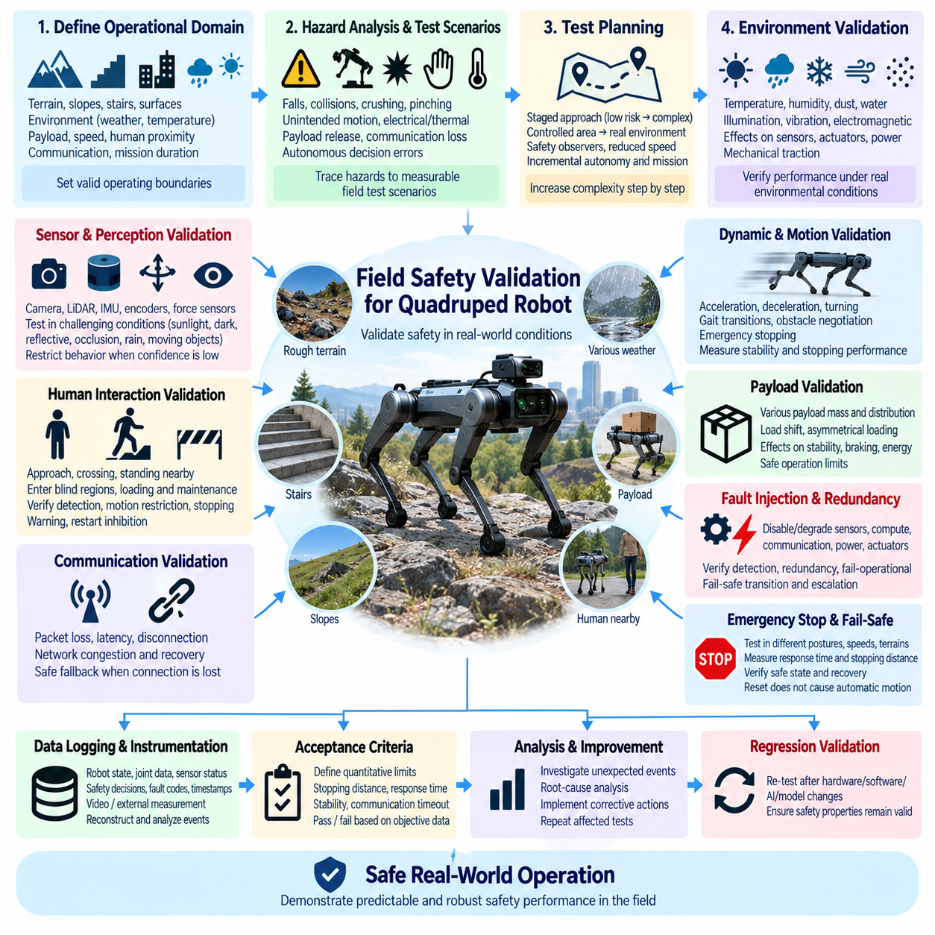
Field safety validation determines whether a quadruped robot’s safety architecture remains effective when the system leaves controlled laboratory conditions and operates in representative real-world environments. Laboratory verification can demonstrate individual requirements, but field operation introduces terrain variation, weather, communication disturbances, human interaction, payload uncertainty, and unexpected combinations of faults. Validation must therefore demonstrate that the integrated robot behaves predictably within its intended operational boundaries.
Field validation begins with a clearly defined operational design domain and intended use. The test program should identify expected terrain, slopes, stairs, floor conditions, outdoor surfaces, environmental exposure, payload ranges, operating speeds, human proximity, communication coverage, and mission duration. These boundaries establish the conditions under which safety claims are valid and prevent successful testing in favorable environments from being generalized to operating conditions that were never evaluated.
Safety requirements should be traceable from identified hazards to field validation scenarios. Risks associated with falls, collisions, crushing, pinching, unintended motion, electrical faults, thermal events, payload release, communication loss, and autonomous decision errors should be represented by measurable test conditions. Each scenario should identify the initiating condition, expected safety response, acceptance criteria, required instrumentation, and evidence needed to demonstrate that residual risk remains within the defined safety objective.
Field testing should progress gradually from low-risk environments toward increasingly representative and challenging conditions. Initial tests can use controlled areas with barriers, safety observers, reduced speed, and limited autonomy before expanding toward realistic terrain and mission execution. This staged approach allows unexpected behavior to be identified while exposure remains limited. Test complexity should increase only after prerequisite safety functions and recovery procedures have demonstrated sufficient reliability.
Terrain validation is especially important for quadruped robots because stability depends directly on ground geometry and contact conditions. Tests should include flat surfaces, slopes, steps, stairs, uneven ground, loose material, wet or low-friction surfaces, gaps, and representative obstacles where these conditions belong to the intended operation. Evaluation should consider foot placement, body stability, slip behavior, joint loading, ground clearance, stopping capability, and the ability to enter a controlled state after locomotion becomes unreliable.
Dynamic testing should cover the operating speed and gait envelope rather than only stationary or slow movement. Acceleration, deceleration, turning, gait transitions, obstacle negotiation, and emergency stopping can produce different mechanical and control loads. Safety validation should measure whether stability margins remain adequate and whether stopping distance, residual motion, actuator response, and body movement remain within defined limits when safety functions are triggered during representative dynamic states.
Payload conditions can significantly alter the robot’s center of mass, actuator loading, braking behavior, energy consumption, and stability. Field validation should therefore include representative payload masses and distributions rather than relying only on an unloaded platform. Tests should evaluate secure retention, load shift, asymmetrical loading, degraded actuator capability, slopes, turning, stopping, and recovery behavior so that safety limits reflect the actual mechanical configuration expected during operation.
Environmental testing should reproduce realistic temperature, humidity, dust, water exposure, illumination, vibration, and electromagnetic conditions where relevant to the intended application. Environmental factors can affect sensors, connectors, batteries, motor drives, cooling systems, communication links, and mechanical traction simultaneously. Field validation should examine not only whether components continue operating, but whether environmental degradation causes incorrect state estimation or delayed safety responses.
Perception safety must be evaluated under conditions that challenge sensor performance. Bright sunlight, darkness, shadows, reflective surfaces, dust, rain, partial occlusion, repetitive textures, and moving objects can reduce perception reliability. Cameras, LiDAR, IMUs, encoders, force sensors, and other sensing systems should be assessed individually and as an integrated perception system. When confidence decreases, the robot should restrict behavior or transition toward a safer operating state rather than continuing with unsupported assumptions.
Human interaction scenarios should represent realistic proximity and behavior rather than assuming that people remain outside the robot’s path. Validation should consider personnel approaching unexpectedly, crossing the trajectory, standing near the robot, entering blind regions, or interacting during loading and maintenance. The objective is to verify detection, motion restriction, stopping, warning, restart inhibition, and safe recovery while ensuring that foreseeable human behavior does not create uncontrolled robot responses.
Communication validation should reproduce packet loss, latency, temporary interruption, complete disconnection, network congestion, and restoration of connectivity. Remote or fleet-operated robots must remain safe when cloud services, wireless networks, supervisory systems, or operator interfaces become unavailable. Local controllers should enter predefined fallback behavior without indefinitely executing stale commands. Restoration of communication should not automatically restore unrestricted motion until required safety conditions are confirmed.
Fault injection provides direct evidence that fail-operational, fail-safe, emergency-stop, and redundancy mechanisms work under realistic operating conditions. Selected sensors, communication paths, computing nodes, power domains, and actuator functions can be intentionally disabled or degraded using controlled procedures. Tests should verify fault detection, containment, redundant-resource activation, degraded-mode entry, controlled stopping, power isolation, and escalation when the remaining safety capability becomes insufficient.
Multiple-fault testing is important where the architecture claims tolerance to a fault while continuing limited operation. Once a redundant resource has been consumed, an additional failure can require immediate escalation. Field scenarios should therefore examine representative sequences such as sensor failure followed by communication loss, computing degradation followed by low battery, or actuator degradation followed by thermal limitation. The expected transition must remain predictable as available safety margins decrease.
Emergency-stop validation should include different postures, speeds, terrains, slopes, payloads, and operator locations. Testing should determine whether the emergency request is detected, prioritized over autonomous commands, and converted into the intended stopping or stabilization sequence. Measurements can include response time, stopping time, stopping distance, residual velocity, body motion, final posture, actuator state, and power state. Reset must also be tested to confirm that release does not cause automatic locomotion restart.
Fail-safe validation should verify the complete transition from abnormal operation to the defined safe state. It should confirm that the robot suppresses hazardous commands, preserves stabilization when appropriate, isolates faulty energy domains, inhibits unsafe actuators, and reaches a predictable physical condition. Cases where normal stabilization is impossible should also be tested so that conservative fallback behavior is understood rather than discovered for the first time during an actual field incident.
Fail-operational validation should demonstrate that degraded operation remains within a bounded and verified envelope. If the robot is permitted to continue after a fault, tests should confirm reduced speed, restricted gait, limited terrain access, reduced autonomy, or other imposed constraints. Validation must also demonstrate the exit condition from degraded operation, including the point at which remaining capability is no longer sufficient and the system must transition toward fail-safe stopping.
Redundancy validation should demonstrate effective independence rather than merely confirming that backup hardware is installed. Tests should verify sensor disagreement handling, processor switchover, communication fallback, power-domain isolation, and backup resource health monitoring. Common-cause conditions should also be considered because shared power, environmental exposure, connectors, software, or communication infrastructure can defeat multiple nominally redundant channels at the same time.
Instrumentation and data logging are essential for objective field validation. Robot state, joint position, velocity, torque, IMU data, sensor validity, communication status, safety-controller decisions, power states, fault codes, timestamps, and operator commands should be recorded with sufficient synchronization. Video or external measurement systems can provide independent evidence of physical behavior. Accurate records allow unexpected events to be reconstructed and compared with the safety architecture’s intended response.
Acceptance criteria should be established before testing whenever practical. Pass or fail decisions should not depend only on subjective observation after an event. Criteria can define allowable stopping distance, response time, residual motion, posture stability, communication timeout, temperature, voltage, fault-detection latency, or successful transition to a required safety state. Quantitative limits make repeated tests comparable and allow safety performance to be tracked as hardware and software revisions evolve.
Unexpected events, near misses, and failed tests are valuable safety evidence and should not be treated merely as test interruptions. Each event should be classified, reconstructed, and linked to its initiating conditions and system response. Root-cause analysis can reveal incorrect assumptions, insufficient diagnostics, weak redundancy, unsuitable operating limits, or interactions between subsystems. Corrective actions should be implemented and the affected scenarios repeated before the corresponding safety claim is accepted.
Regression validation is necessary whenever safety-relevant hardware, firmware, software, AI models, calibration, payload configuration, or operating procedures change. A modification that improves one function can unintentionally alter timing, resource consumption, actuator response, or communication behavior elsewhere. A maintained regression suite should therefore repeat critical field scenarios and verify that previously demonstrated safety properties remain valid across system revisions.
AI-enabled behavior requires additional field evidence because learned functions may encounter conditions not represented adequately during training. Perception and planning outputs should be monitored against deterministic safety constraints, and unusual confidence patterns or disagreements should be recorded. Field validation should focus on whether the safety architecture bounds AI behavior when uncertainty increases, rather than assuming that successful nominal AI performance alone demonstrates system-level safety.
Recovery and maintenance procedures should also be validated in the field. Personnel may need to approach a stopped or fallen robot, isolate power, remove a payload, replace components, or manually reposition the platform. Tests should confirm that indicators, restart inhibition, energy isolation, mechanical stability, and diagnostic information support safe intervention. The robot should not unexpectedly return to an enabled state while personnel remain within a hazardous area.
Field safety validation is therefore an iterative lifecycle activity rather than a final demonstration performed immediately before deployment. Test results, operational logs, near misses, maintenance findings, environmental exposure, and new mission requirements should continuously refine the safety case. By combining representative scenarios, fault injection, quantitative acceptance criteria, traceable evidence, regression testing, and operational feedback, field validation demonstrates that the quadruped’s safety mechanisms remain effective where they ultimately matter: during real physical operation.

