Volume 20. Quadruped Electrical Architecture

Chapter 14. Case Studies

14.01. Boston Dynamics Spot
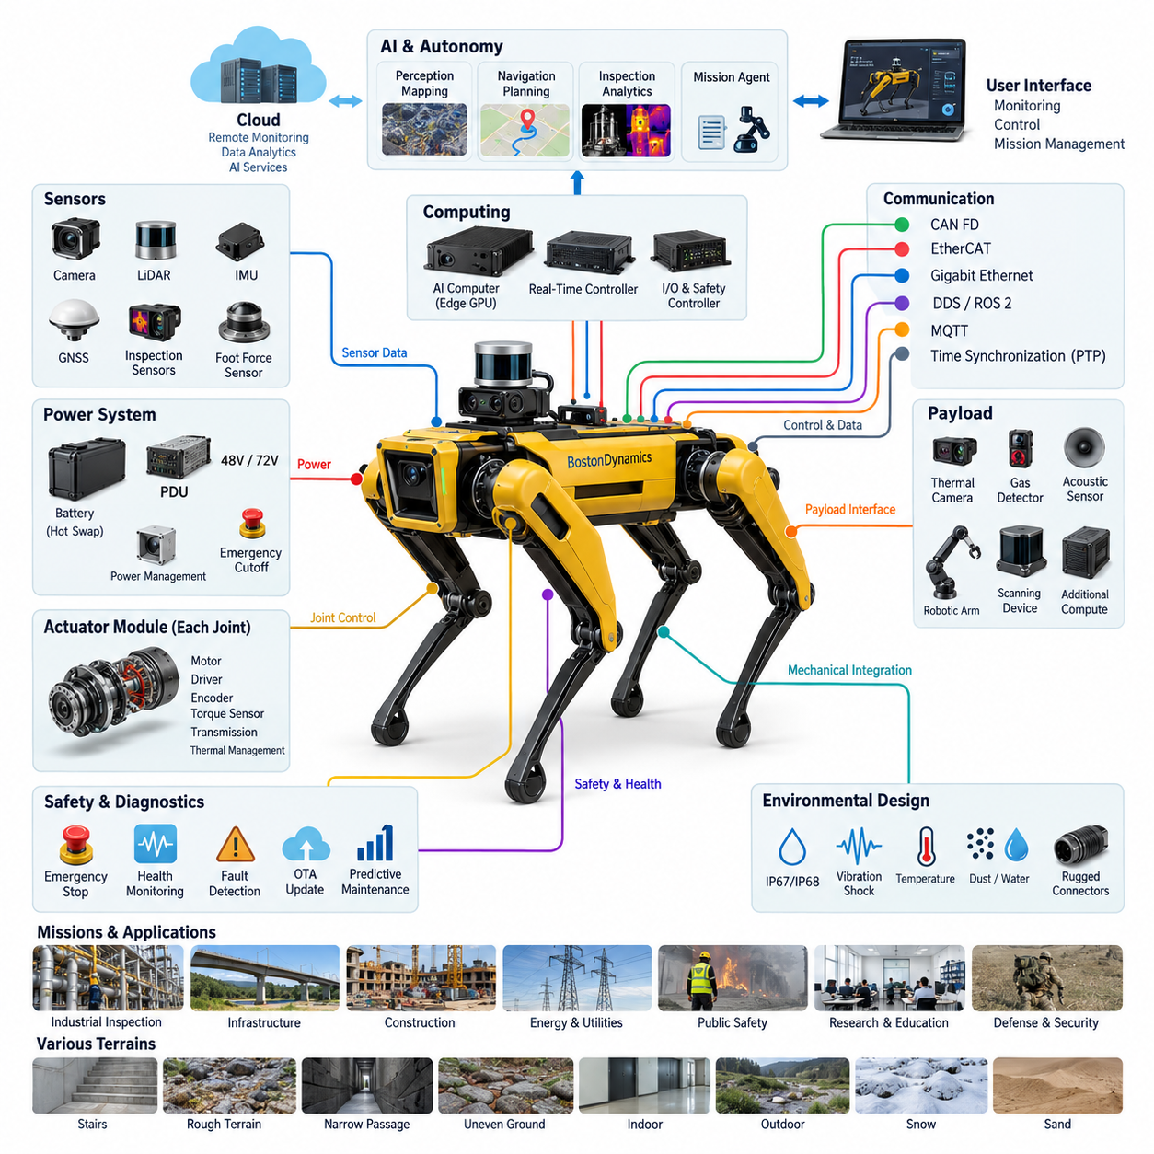
Boston Dynamics Spot represents one of the most mature examples of a commercially deployed quadruped robot in which electrical architecture, locomotion control, perception, computing, communication, and payload integration must operate as a tightly coordinated system. Within a quadruped architecture study, Spot is particularly valuable because it demonstrates how high mobility can be transformed from a laboratory capability into a field-deployable robotic platform.
Unlike conventional wheeled AMRs, a quadruped continuously coordinates multiple powered joints while maintaining dynamic balance. Electrical energy therefore supports not only forward motion but also posture stabilization, foot placement, body orientation, recovery from disturbances, and adaptation to irregular terrain. This creates rapidly changing actuator loads and requires power distribution, motor control, sensing, and real-time computation to remain synchronized during every locomotion cycle.
The electrical architecture can be understood as a hierarchy connecting the battery and power distribution system to distributed joint actuation, embedded control, perception sensors, higher-level computing, and external interfaces. Such partitioning prevents the entire machine from depending on a single centralized control loop. Fast joint-level functions remain close to the actuators, while body-level locomotion, perception, autonomy, mission execution, and payload processing operate at progressively higher computational layers.
Each leg requires several controlled degrees of freedom, making the joint actuator one of the fundamental electrical building blocks of the robot. A practical joint module combines an electric motor, power electronics, position sensing, control electronics, mechanical transmission, and thermal management into a compact assembly. The resulting architecture reduces long analog signal paths and enables high-bandwidth local control while the central locomotion system coordinates the behavior of all four legs.
Reliable sensing is equally important because quadruped locomotion depends on continuous estimation of body motion and environmental geometry. Joint encoders provide actuator state, while inertial sensing contributes body orientation and motion information. External perception sensors support terrain interpretation, obstacle awareness, navigation, and inspection. The electrical architecture must therefore transport heterogeneous sensor streams without allowing high-current actuator switching noise to degrade sensitive measurements.
Spot also illustrates why quadruped robots require separation between deterministic motion control and computationally intensive autonomy. Joint and stabilization loops demand predictable timing, whereas mapping, perception, inspection analytics, and autonomous planning can consume substantially greater processing resources with different latency characteristics. Separating these domains allows the robot to preserve stable locomotion even when higher-level perception or mission software experiences temporary computational variation.
Communication architecture connects these distributed functions into a coordinated cyber-physical system. Low-level actuator communication emphasizes bounded latency, synchronization, and fault detection, while higher-bandwidth networks support cameras, perception data, payloads, diagnostics, and application interfaces. This layered approach reflects the broader quadruped architecture structure in which CAN FD, EtherCAT, Gigabit Ethernet, DDS/ROS 2, and time synchronization represent different communication requirements rather than interchangeable technologies.
Payload integration is an especially important aspect of Spot as an industrial platform. A useful quadruped must carry more than its native locomotion sensors; inspection missions may require thermal cameras, acoustic sensors, gas detectors, specialized vision systems, scanning devices, or additional computation. Electrical payload interfaces therefore need controlled power, communication connectivity, mechanical compatibility, and software interfaces while respecting limits on mass, power consumption, thermal load, and center of gravity.
Inspection missions demonstrate the advantage of combining mobility with payload modularity. A quadruped can traverse stairs, thresholds, narrow passages, uneven surfaces, and industrial environments that may be difficult for conventional wheeled robots. Once positioned, the same platform can collect visual, thermal, acoustic, or other inspection data. Electrical architecture consequently becomes an enabling infrastructure that connects mobility, sensing, computation, communications, and mission-specific instrumentation.
Power management is particularly challenging because locomotion produces highly dynamic demand. Standing, walking, climbing, accelerating, recovering balance, and carrying payloads impose different electrical loads, while onboard computing and sensors create more continuous consumption. The battery and power distribution system must tolerate transient actuator demand without destabilizing computing or perception electronics. Protection, voltage regulation, current monitoring, thermal supervision, and controlled shutdown therefore become system-level design functions.
Field deployment also places strong requirements on harness and connector engineering. Leg motion repeatedly bends cables and exposes routing paths to vibration, impact, contamination, and environmental stress. Harnesses must avoid excessive bending radius, abrasion, tensile loading, and interference with moving mechanisms. Connector placement must simultaneously support sealing, mechanical retention, electrical integrity, manufacturability, and service access, illustrating why dynamic cable routing differs fundamentally from wiring a stationary industrial machine.
Environmental robustness cannot be treated as a separate enclosure problem. Water, dust, vibration, temperature variation, shock, and repeated mechanical loading influence connectors, sensors, electronics, batteries, and actuator assemblies simultaneously. A field-ready quadruped therefore requires environmental protection to be designed across subsystem boundaries. This explains the close relationship between IP protection, vibration testing, EMC validation, electrical testing, field testing, and reliability testing in a complete quadruped development process.
Functional safety in a quadruped also differs from that of a stationary robot because loss of control may result in falling, uncontrolled motion, or interaction with nearby people and equipment. Emergency stopping cannot simply remove energy without considering the mechanical consequences of losing joint torque. Safety architecture must coordinate fault detection, actuator behavior, computing state, communication integrity, and power isolation so that detected failures lead toward a controlled and predictable system response.
Diagnostics become critical because the robot contains many interacting electrical and electromechanical components. Useful health monitoring extends beyond reporting whether a device is online. Joint temperature, current behavior, battery condition, communication errors, sensor validity, controller status, and repeated fault events can collectively indicate developing degradation. Event logging and remote diagnostics allow field failures to be reconstructed and support the transition from reactive maintenance toward condition-based and predictive maintenance.
Software update capability must similarly respect the distributed nature of the machine. Updating perception or mission software is different from modifying components involved in locomotion, safety, or low-level actuator control. A robust update architecture therefore needs compatibility management, integrity verification, version control, rollback capability, and controlled activation. The important lesson is that OTA functionality is not merely a communication feature; it is part of configuration management and lifecycle safety.
Spot further demonstrates the transition from a robot as an isolated machine toward a robot as an extensible Physical AI platform. Perception models, autonomous navigation, inspection applications, mission agents, and remote services can operate above the locomotion foundation without replacing the deterministic control responsible for physical stability. This separation provides a practical architectural boundary between embodied intelligence and the electrical and control infrastructure that executes actions in the physical world.
From an engineering perspective, the most important lesson is not to reproduce a specific commercial robot component by component. The stronger lesson is architectural: high-performance quadrupeds require power, actuation, sensing, real-time control, high-level computing, communication, safety, diagnostics, environmental protection, and payload interfaces to be designed as one integrated system. Optimizing any single subsystem without considering these dependencies can reduce reliability or constrain overall capability.
As a case study within the broader robotics electrical architecture framework, Spot therefore provides a useful reference for understanding how quadruped design extends concepts already found in AMRs, autonomous vehicles, industrial robotics, and edge AI systems. The key difference is the intensity of physical coupling: electrical power, computation, communication, sensing, and mechanical motion interact continuously to maintain the robot itself before mission-level intelligence can perform useful work.

14.02. Unitree B2
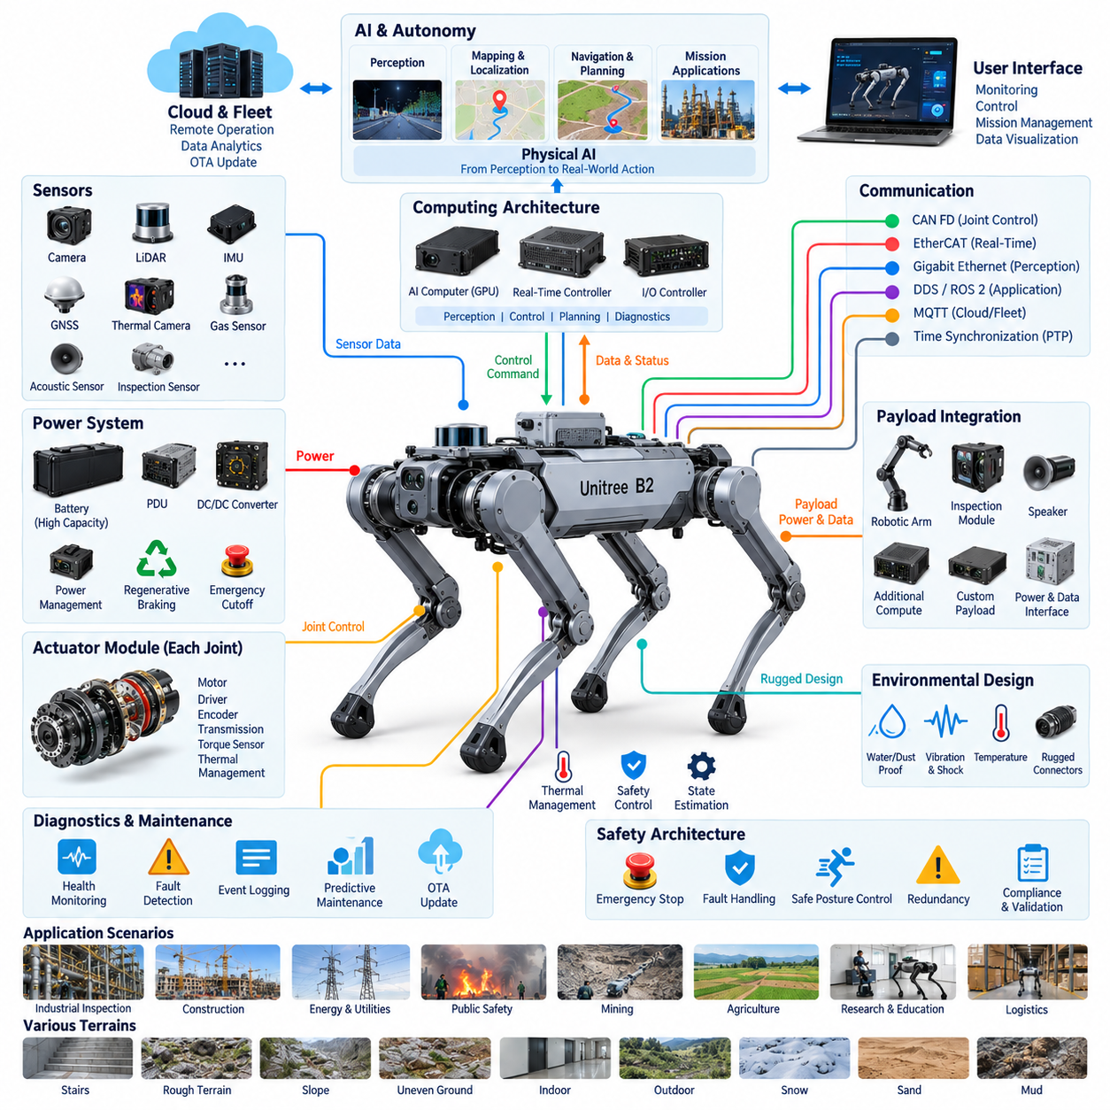
Unitree B2 represents a heavy-duty industrial quadruped platform designed around higher mobility, payload capacity, endurance, and environmental adaptability than smaller research-oriented quadrupeds. Within quadruped electrical architecture, it provides a useful case study of how actuator power, distributed control, rugged sensing, onboard computing, communication, and energy storage must scale together when a legged robot is expected to perform practical industrial missions rather than controlled laboratory demonstrations.
The B2 architecture highlights a fundamental characteristic of high-performance quadrupeds: locomotion is an electrically intensive, continuously coordinated process. Multiple powered joints must generate and regulate torque while supporting the robot body, payload, acceleration, terrain transitions, and external disturbances. Consequently, electrical design cannot treat motors as independent loads. Battery capability, distribution impedance, motor drives, thermal limits, and control timing collectively determine achievable locomotion performance.
At the joint level, compact electromechanical actuator modules form the foundation of the locomotion system. Each module combines a motor, transmission, position feedback, motor drive electronics, and local control functions to provide accurately regulated motion and torque. High joint performance requires rapid current regulation and precise state feedback because small errors across several joints can propagate into body attitude errors, foot placement deviations, or reduced stability during dynamic movement.
Distributed control is therefore more appropriate than routing every actuator signal directly to one central processor. Local controllers can execute high-frequency motor and joint functions, while a real-time body controller coordinates the legs and maintains locomotion stability. Higher computing layers can then perform perception, navigation, mapping, mission planning, and application processing. This hierarchy separates hard real-time physical control from computationally variable autonomy and reduces unnecessary dependence between the two domains.
Power architecture becomes especially significant as robot mass, payload, joint torque, and operating speed increase. Dynamic maneuvers can create short-duration current peaks substantially different from average consumption. The battery and power distribution system must therefore support transient actuator demand while maintaining stable supply rails for computing, sensing, and communication electronics. Protection coordination, current monitoring, voltage conversion, thermal supervision, and controlled power sequencing are essential system functions.
Regenerative energy is another consideration in electrically actuated legs. During deceleration, downhill motion, joint braking, or certain phases of the gait cycle, mechanical energy can flow back through the actuator drive toward the electrical system. The architecture must manage these bidirectional power conditions without producing excessive bus voltage or stressing the battery. Effective energy management can improve efficiency, but it must remain subordinate to predictable actuator behavior and electrical protection.
The B2 also demonstrates why thermal engineering and electrical architecture cannot be separated in powerful quadrupeds. Motors, inverters, processors, voltage converters, and batteries all generate heat, while enclosure sealing can restrict natural cooling. Continuous walking, climbing, high payload operation, and elevated ambient temperature can create thermal conditions very different from short demonstrations. Temperature sensing and derating strategies are therefore necessary to preserve component life and prevent abrupt performance loss.
Sensor architecture provides the state information required to control both the robot and its relationship with the environment. Joint feedback and inertial sensing support body-state estimation, while external perception can provide obstacle detection, terrain understanding, localization, and mapping. Industrial configurations may additionally integrate cameras, LiDAR, thermal imaging, gas detection, acoustic sensing, or other inspection instruments, turning the locomotion platform into a mobile sensing system.
Reliable sensor operation requires careful electrical integration because actuator electronics are substantial sources of electromagnetic noise. Fast switching currents, long harness paths, grounding errors, and poorly separated power domains can interfere with low-level sensor signals or high-speed communication. Grounding, shielding, filtering, connector design, cable routing, and power-domain separation therefore contribute directly to perception reliability rather than serving merely as conventional electrical packaging considerations.
Communication must support several fundamentally different traffic classes. Joint and locomotion networks require deterministic or tightly bounded timing, while cameras and LiDAR generate high-bandwidth streams. Diagnostics require reliable access to distributed controllers, and mission applications may exchange information with remote computers or fleet infrastructure. A scalable quadruped therefore benefits from a layered network architecture rather than attempting to carry every control and application function over one communication channel.
Time synchronization becomes increasingly important when perception and motion interact closely. Camera frames, inertial measurements, joint states, LiDAR observations, and control events may originate from different electronic devices but must describe the same physical instant accurately enough for estimation and fusion. A shared timing architecture reduces temporal alignment errors and improves the consistency of localization, mapping, motion analysis, event reconstruction, and multi-sensor inspection data.
Industrial deployment places strong demands on harnesses and connectors because every leg repeatedly changes geometry during locomotion. Electrical paths must survive bending, vibration, shock, contamination, and thousands or millions of motion cycles without becoming a dominant reliability limitation. Dynamic harness sections require controlled bend radii, strain relief, abrasion protection, secure retention, and sufficient service access, while connectors must maintain electrical integrity under repeated mechanical and environmental stress.
Environmental protection is particularly important for a quadruped intended to operate beyond clean indoor spaces. Dust, water, mud, temperature variation, vibration, impact, and uneven terrain affect mechanical and electrical components simultaneously. Sealing alone is insufficient; connectors, pressure equalization, thermal paths, cable entries, sensor windows, actuator interfaces, and enclosure joints must be engineered as a coordinated environmental protection system while preserving maintainability and cooling performance.
Payload capability introduces another system-level electrical challenge. Increasing payload changes joint torque demand, battery consumption, thermal loading, body dynamics, and center of gravity while additional equipment may consume electrical power and network bandwidth. A practical payload interface should therefore provide more than a mounting surface. It should define power availability, communication access, mechanical constraints, software interfaces, and operating limits that protect both locomotion stability and platform reliability.
Safety architecture must account for the fact that a quadruped cannot always respond to faults by instantly removing actuator power. Sudden loss of joint torque can itself create a hazardous fall or uncontrolled body movement. Fault responses should therefore distinguish between conditions requiring immediate energy isolation and conditions where controlled posture transition, reduced performance, or managed stopping provides a safer outcome. Safety decisions must coordinate actuator, power, computing, and communication states.
Diagnostics are essential for managing the large number of distributed electromechanical components. Joint current, motor temperature, encoder validity, communication errors, battery condition, processor status, sensor health, and power-rail behavior can provide early evidence of degradation. Centralized health monitoring can correlate these observations and generate fault histories that support troubleshooting, preventive maintenance, fleet comparison, and eventually predictive maintenance for robots operating repeatedly in demanding environments.
Remote operation and software lifecycle management further extend the electrical architecture into a connected robotic system. Mission software, perception algorithms, configuration parameters, and selected firmware may require controlled updates over the product lifetime. Update mechanisms should incorporate integrity checking, version compatibility, recovery procedures, and rollback capability so that a failed or incompatible update does not disable essential locomotion, safety, or diagnostic functions.
From a Physical AI perspective, B2 illustrates the importance of maintaining a stable execution foundation beneath increasingly intelligent applications. AI perception, semantic understanding, autonomous navigation, inspection reasoning, and mission agents can expand robot capability, but they ultimately depend on deterministic joint execution, synchronized sensing, reliable power, and predictable communication. Intelligence cannot compensate for an unstable electrical foundation when the system must continuously interact with the physical world.
The B2 case also demonstrates how quadruped architecture changes as the platform moves toward heavier industrial operation. Higher payload and stronger locomotion do not simply require larger motors and batteries; they increase stress throughout the architecture, including connectors, harnesses, power electronics, cooling, structural interfaces, communication, diagnostics, and safety mechanisms. Scaling therefore requires coordinated subsystem engineering rather than independent enlargement of individual components.
As a case study, Unitree B2 complements other quadruped platforms by emphasizing the relationship between high mobility and industrial-scale electrical integration. Its most important architectural lesson is that power, actuation, sensing, computing, communication, thermal management, environmental protection, diagnostics, safety, and payload interfaces must be treated as a coupled system. This integrated approach is fundamental to transforming a dynamically capable quadruped into a durable Physical AI platform suitable for sustained field operation.

14.03. Go2
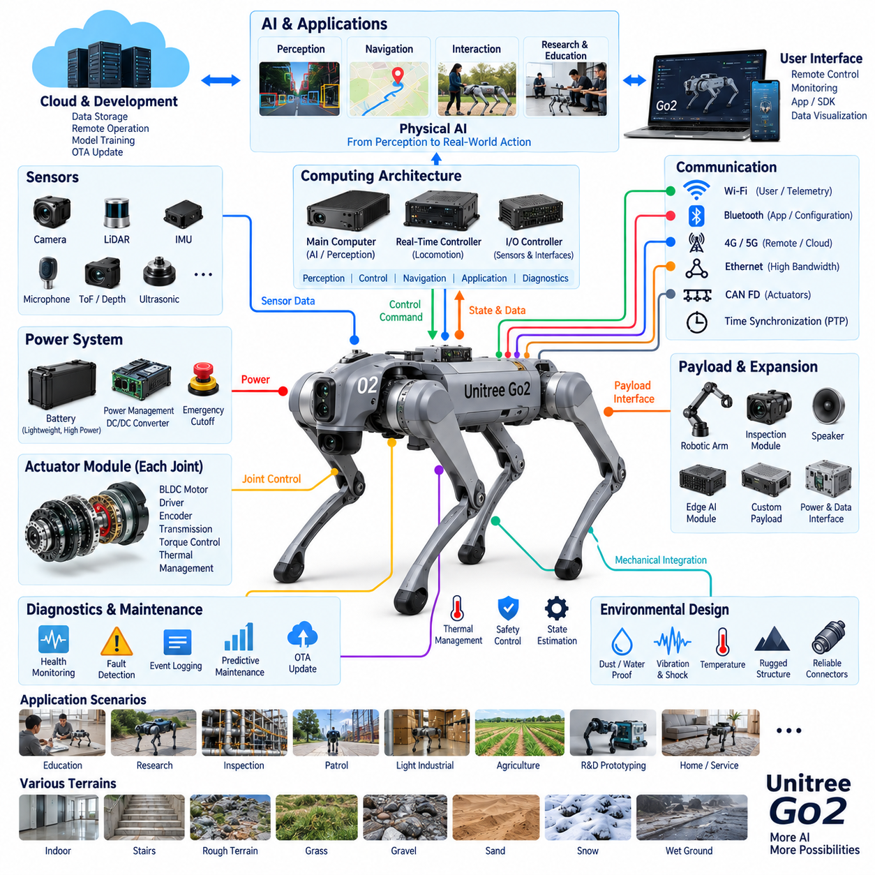
Unitree Go2 represents a compact quadruped platform in which mobility, embedded computing, sensing, wireless communication, and intelligent software are integrated within a comparatively small electrical and mechanical envelope. Within the quadruped electrical architecture structure, Go2 provides a useful contrast to heavier industrial platforms such as B2, showing how similar architectural principles can be optimized for lower mass, lower power consumption, accessibility, research, education, and lightweight Physical AI applications.
The compact size of Go2 does not eliminate the fundamental electrical challenges of quadruped locomotion. Multiple powered joints must continuously coordinate torque, position, and velocity while maintaining body stability. Walking, turning, climbing, recovering from disturbances, and adapting foot placement all generate rapidly changing actuator demands. The electrical system must therefore support transient motor loads while preserving stable power for computing, sensing, communication, and supervisory control.
Joint actuator modules form the physical execution layer of the robot. Each actuator requires a motor, power electronics, position feedback, transmission, and local control functions operating with sufficiently low latency for dynamic locomotion. Compact integration is particularly important because excessive actuator mass increases leg inertia and consequently raises the energy required for acceleration and deceleration. Electrical and mechanical optimization therefore directly influence locomotion efficiency and responsiveness.
A distributed control architecture allows fast joint-level functions to remain close to the actuators while higher-level controllers coordinate whole-body behavior. Local motor control can execute current, torque, position, and protection functions, whereas a real-time locomotion controller processes body state and coordinates gait generation. Higher computing layers can then execute navigation, perception, interaction, application logic, and AI workloads without directly controlling every switching event inside the motor drives.
Power architecture in a compact quadruped requires careful balancing between energy capacity, battery mass, peak discharge capability, and operating time. Increasing battery capacity can extend endurance but also increases weight that the actuators must continuously carry. Conversely, reducing battery mass improves agility but constrains mission duration. Efficient power conversion, low-loss distribution, actuator efficiency, and intelligent power management therefore become as important as nominal battery capacity.
Dynamic locomotion also produces electrical conditions that differ significantly from steady-state operation. Joint acceleration can create short current peaks, while deceleration and mechanically back-driven joints can return energy toward the electrical bus. Motor drives and battery interfaces must tolerate these bidirectional energy flows and maintain bus voltage within acceptable limits. Coordinated regenerative behavior can improve energy efficiency while preventing excessive voltage excursions during aggressive motion.
Go2 demonstrates the importance of tightly integrated sensing in compact mobile robots. Inertial sensing and joint feedback provide the fundamental information needed for body-state estimation and balance control, while external perception supports obstacle awareness, environmental understanding, navigation, and interaction. Depending on configuration, additional perception capabilities can extend the robot from a locomotion platform into a mobile intelligent system capable of responding to its surroundings.
Sensor integration must be designed together with electromagnetic compatibility. High-frequency motor switching and rapidly changing actuator currents can introduce conducted and radiated interference into nearby electronics. Compact packaging reduces physical separation between noisy power electronics and sensitive sensors, increasing the importance of grounding, shielding, filtering, cable routing, connector selection, and power-domain management. EMC performance therefore becomes a system architecture issue rather than a late-stage compliance activity.
Computing architecture must separate workloads according to their timing requirements. Locomotion stabilization requires predictable execution and should not be compromised by variable AI processing loads. Perception, semantic interpretation, visual processing, autonomous navigation, or learned behaviors may require significantly different computing resources. A layered architecture enables real-time control to remain deterministic while higher-level processors execute increasingly complex Physical AI functions when sufficient computational capacity is available.
Communication architecture similarly contains several logical domains. Internal communication connects actuators, sensors, controllers, and computing devices, while external wireless communication provides user interaction, telemetry, remote control, software services, or development access. Different data classes have different requirements for bandwidth, latency, reliability, and determinism. Separating critical motion traffic from noncritical application traffic reduces the possibility that high-bandwidth data transfer will disturb locomotion control.
Wireless connectivity is particularly significant for a compact robot intended for interactive, research, and mobile applications. Remote commands, telemetry, video, diagnostic information, and application data may need to move between the robot and external devices. However, locomotion safety cannot depend entirely on continuous wireless availability. Essential stabilization and protective behavior must remain onboard so that temporary network degradation or communication loss does not immediately compromise physical stability.
Time synchronization remains important even in a smaller platform. Joint states, inertial measurements, perception frames, control commands, and diagnostic events are generated by different components but represent a common physical process. Accurate timestamps allow these observations to be correlated during state estimation, sensor fusion, debugging, and data analysis. Synchronization becomes even more valuable when recorded robot data is later used for AI training, behavior learning, or simulation comparison.
Compact quadrupeds also present distinctive harness engineering challenges. Each leg repeatedly flexes while the body contains limited space for cable routing, connectors, control electronics, and power distribution. Harnesses must accommodate repeated motion without excessive bending, abrasion, or tensile loading. Shorter cable paths can reduce mass and electrical losses, but dense packaging increases routing complexity and makes mechanical retention, strain relief, and service accessibility important design considerations.
Thermal management becomes difficult because compact packaging provides limited surface area and internal volume for cooling. Motors and drives generate heat during locomotion, while processors and communication electronics add continuous thermal loads. Aggressive movement, high ambient temperature, or sustained AI computation can increase thermal stress. Temperature monitoring, efficient heat conduction, workload management, and controlled derating help prevent local overheating while maintaining useful robot performance.
Environmental robustness determines how far a compact quadruped can move beyond controlled indoor environments. Dust, moisture, vibration, impacts, and repeated contact with terrain affect sensors, connectors, actuator seals, harnesses, and electronics. Protection must therefore be considered at interfaces throughout the robot rather than only at the main enclosure. Improved environmental design expands the range of educational, research, inspection, patrol, and experimental outdoor missions that the platform can support.
Diagnostics provide visibility into the health of the distributed electrical system. Motor temperature, current consumption, encoder status, battery condition, communication errors, controller state, sensor validity, and system events can reveal faults before they become complete failures. Centralized logging allows developers to reconstruct abnormal behavior and correlate software events with physical responses, which is especially valuable when experimenting with new locomotion algorithms or AI-based behaviors.
Software lifecycle management is particularly relevant for a platform used for development and experimentation. Application software, AI models, configuration parameters, perception functions, and selected firmware may evolve repeatedly throughout the robot's operational life. Reliable update procedures should maintain version compatibility and provide recovery mechanisms when deployment fails. Separating experimental software from essential motion-control functions helps prevent application development from unnecessarily compromising basic robot operation.
From a Physical AI perspective, Go2 is valuable because it places an embodied computing platform within reach of research, education, prototyping, and application development. The robot can connect perception and intelligent decision-making directly to physical action, allowing algorithms to experience consequences through movement and sensor feedback. This makes the electrical architecture an execution substrate through which AI models interact with real environments rather than merely process offline datasets.
Go2 also demonstrates that scaling a quadruped downward is not simply a matter of reducing dimensions. Lower mass and smaller packaging change actuator selection, battery sizing, thermal paths, harness routing, computing capacity, payload limits, and energy budgets. Every additional sensor or processor consumes a larger fraction of available mass and power. Compact robot design therefore demands disciplined hardware-software co-design to achieve useful intelligence without overwhelming the mobility platform.
As a case study, Unitree Go2 illustrates how the fundamental architecture of a quadruped can be implemented in a compact and accessible form while preserving the essential relationships among power, actuation, sensing, computing, communication, diagnostics, and intelligent control. Its broader engineering lesson is that successful Physical AI depends not only on advanced algorithms but on a balanced electrical foundation capable of converting perception and decisions into reliable, synchronized, and energy-efficient physical behavior.

14.04. Military Quadrupeds
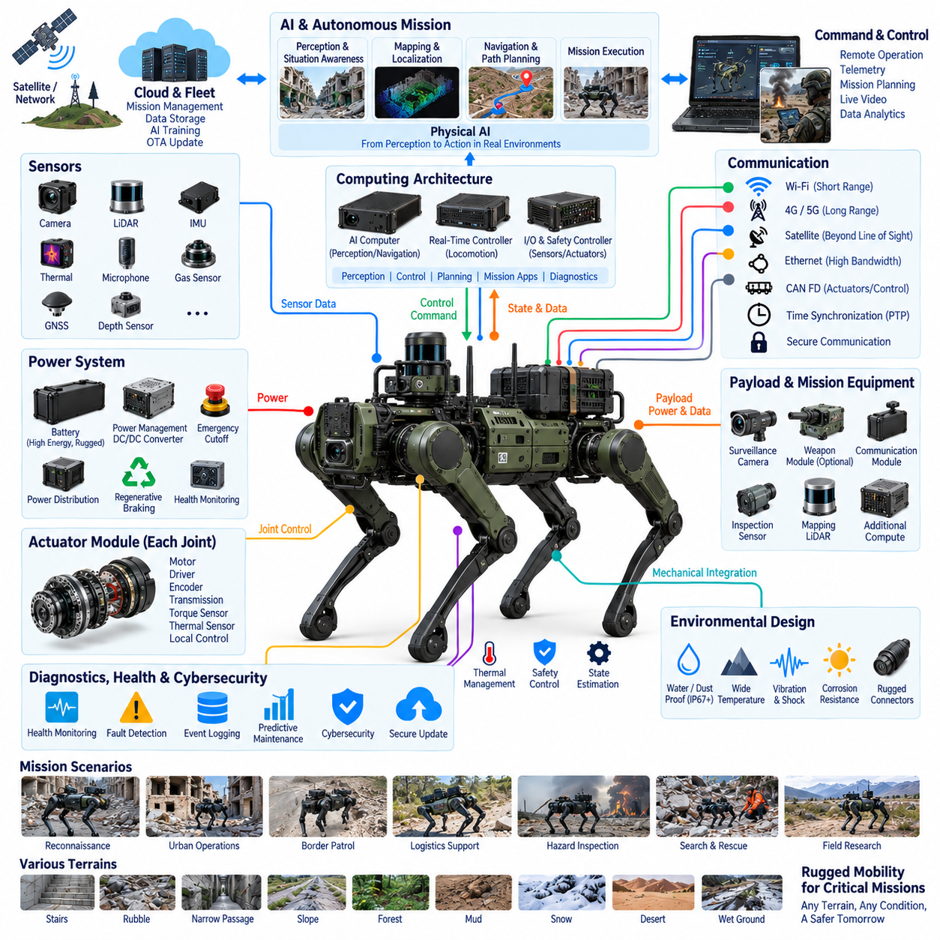
Military quadrupeds extend legged robotics into environments where mobility, resilience, sensing, communication, and mission continuity may be more important than maximum efficiency. Unlike conventional wheeled or tracked unmanned ground vehicles, a quadruped can negotiate stairs, rubble, trenches, narrow passages, steep slopes, and irregular terrain by actively selecting footholds. This mobility creates an electrical architecture in which locomotion, perception, computing, power, and safety are tightly coupled.
The fundamental electrical challenge is maintaining dynamic locomotion while carrying mission equipment under uncertain terrain conditions. Multiple high-torque joints continuously regulate position, velocity, and torque while supporting the robot body and payload. Sudden impacts, slips, jumps, or terrain transitions can produce large transient loads. Battery, power distribution, motor drives, connectors, and protection devices must therefore tolerate both continuous demand and short-duration power peaks without destabilizing critical electronics.
Joint actuator modules form the primary physical execution layer. Each joint typically integrates an electric motor, motor drive, position feedback, transmission, temperature sensing, and local control functions. Military-oriented platforms place additional emphasis on shock tolerance, thermal margin, contamination resistance, and fault monitoring. Distributed joint electronics reduce long high-frequency signal paths and allow rapid local control while a body-level controller coordinates posture, gait, balance, and recovery behavior.
Power architecture must balance endurance against mass because every additional battery increases available energy while simultaneously increasing the load carried by the legs. Mission payloads such as cameras, LiDAR, communication equipment, navigation sensors, inspection instruments, or additional computers also consume energy. Efficient conversion and distribution are therefore critical, and the architecture may use separated power domains so that actuator disturbances do not cause resets or instability in mission-critical computing and sensing systems.
Regenerative operation can improve energy utilization during downhill motion, deceleration, or phases in which joints are mechanically back-driven. Returned energy must be managed through motor drives, the DC bus, and battery interfaces while preventing excessive bus voltage. In demanding terrain, however, predictable torque response and electrical protection remain more important than maximizing recovered energy. Energy management must therefore cooperate with locomotion control rather than independently optimizing efficiency.
Military quadrupeds require a broad sensor architecture because mobility and mission awareness depend on different forms of environmental information. Joint encoders and inertial sensors support body-state estimation, while cameras, depth sensors, LiDAR, and other perception devices can support navigation and terrain interpretation. GNSS may contribute outdoors, but operation in buildings, tunnels, forests, or obstructed environments requires localization methods that can continue when satellite navigation becomes degraded or unavailable.
Perception electronics must operate near powerful motors and switching converters, creating significant electromagnetic compatibility challenges. Motor phase currents, inverter switching, DC/DC converters, radios, and high-speed digital interfaces can generate conducted and radiated interference. Grounding, shielding, filtering, harness separation, connector design, and enclosure bonding must therefore be considered from the beginning. Poor EMC design can degrade sensors or communication even when individual components function correctly in isolation.
Computing architecture normally separates deterministic locomotion from higher-level mission processing. Real-time controllers maintain joint coordination and body stability, while more capable processors execute perception, localization, mapping, autonomous navigation, mission management, and AI functions. This separation prevents computationally variable workloads from disturbing fundamental motion control. The robot should retain sufficient onboard intelligence to stabilize itself and execute essential protective behavior even when external communication becomes unavailable.
Communication architecture must similarly distinguish internal control networks from external mission links. Internal networks require predictable latency and reliable delivery for actuator, sensor, and controller traffic, whereas Ethernet-class networks can transport perception data and high-bandwidth payload information. External radios provide remote supervision, telemetry, or mission coordination. Loss or degradation of an external link should not directly interrupt the real-time communication required to keep the quadruped physically stable.
Time synchronization provides a common temporal reference across distributed sensing and computing. Joint states, IMU measurements, camera frames, LiDAR scans, navigation estimates, and control events must be correlated accurately when the robot moves dynamically. Synchronization improves sensor fusion, localization, mapping, fault reconstruction, and mission-data interpretation. Accurate timing also becomes valuable when field recordings are transferred to simulation, AI training, or post-mission engineering analysis.
Harness and connector engineering becomes particularly demanding because the robot combines continuous articulated motion with harsh environmental exposure. Leg harnesses experience repeated flexing, vibration, shock, and changes in routing geometry, while external connectors may encounter dust, moisture, mud, or mechanical impact. Dynamic cable sections require controlled bend radius, strain relief, abrasion protection, and secure retention so that electrical wiring does not become a limiting factor in mechanical endurance.
Environmental engineering must address the complete robot rather than only its central enclosure. Water and dust protection, temperature range, vibration resistance, shock tolerance, corrosion control, and mechanical sealing affect actuators, batteries, sensors, connectors, harnesses, and computing modules simultaneously. Ruggedization also creates thermal challenges because stronger sealing can reduce airflow. Electrical packaging must therefore balance environmental protection, heat rejection, mass, accessibility, and structural robustness.
Payload architecture distinguishes a general-purpose quadruped from a mission-configurable platform. Payload interfaces may provide regulated electrical power, Ethernet or other data connectivity, synchronization signals, and software access while defining mechanical and thermal constraints. Different missions can then integrate sensing, communication, mapping, inspection, logistics, or other equipment without redesigning the locomotion architecture. Payload mass and center-of-gravity changes must nevertheless remain within validated operating limits.
Functional safety and fault management require special consideration because simply removing actuator power can cause a standing quadruped to collapse. Fault responses should therefore be classified according to severity and available system capability. Some conditions may require immediate isolation, while others may permit reduced-speed movement, controlled stopping, safe posture transition, or return to a recovery location. Power, actuation, computing, sensing, and communication health must be evaluated together when selecting the response.
Redundancy can improve mission continuity, but indiscriminate duplication increases mass, power consumption, wiring complexity, and failure opportunities. A practical architecture concentrates redundancy on functions whose loss creates unacceptable consequences. Independent monitoring, protected communication paths, backup sensing, isolated power domains, or supervisory controllers may provide greater value than duplicating every subsystem. The design objective is controlled degradation rather than unlimited operation after every possible failure.
Diagnostics are essential because distributed electromechanical systems can accumulate degradation that is difficult to identify from a single symptom. Joint current, temperature, encoder consistency, battery condition, communication errors, processor status, sensor validity, and power-rail behavior can be combined into system health information. Event logging allows engineers to reconstruct failures after demanding missions, while trend analysis can support preventive or predictive maintenance across multiple deployed platforms.
Cybersecurity becomes closely connected with electrical architecture when remote communication, software updates, payload interfaces, and autonomous computing are integrated into the robot. Authentication, software integrity, protected configuration, secure update mechanisms, and separation between external services and critical motion-control domains reduce the possibility that compromised application functions can propagate into essential control. Security boundaries should therefore follow the same architectural partitioning used for safety and real-time control.
Physical AI can expand the capability of military quadrupeds through terrain understanding, semantic perception, autonomous navigation, adaptive behavior, and mission-level reasoning. However, AI operates above a physical execution foundation that must remain deterministic and observable. Intelligent software can select goals or interpret environments, but reliable motors, synchronized sensors, protected power, real-time controllers, and robust communications are responsible for converting those decisions into controlled physical behavior.
Military quadruped development therefore emphasizes graceful degradation and mission continuity rather than isolated component performance. A robot that detects a degraded sensor, limits speed, changes its navigation strategy, and reaches a safe state may provide greater operational value than one optimized only for peak locomotion performance. System engineering must consider how electrical faults propagate across locomotion, perception, autonomy, communication, and payload functions before field deployment.
As a case study, military quadrupeds demonstrate the extreme end of integrated legged-robot electrical engineering. Their central architectural lesson is that rugged mobility emerges from coordinated power, distributed actuation, synchronized sensing, deterministic control, resilient computing, communication, diagnostics, environmental protection, cybersecurity, and carefully managed payload interfaces. The resulting platform is best understood not as a walking vehicle alone, but as a distributed Physical AI system engineered to preserve controlled operation under demanding conditions.

14.05. Industrial Inspection
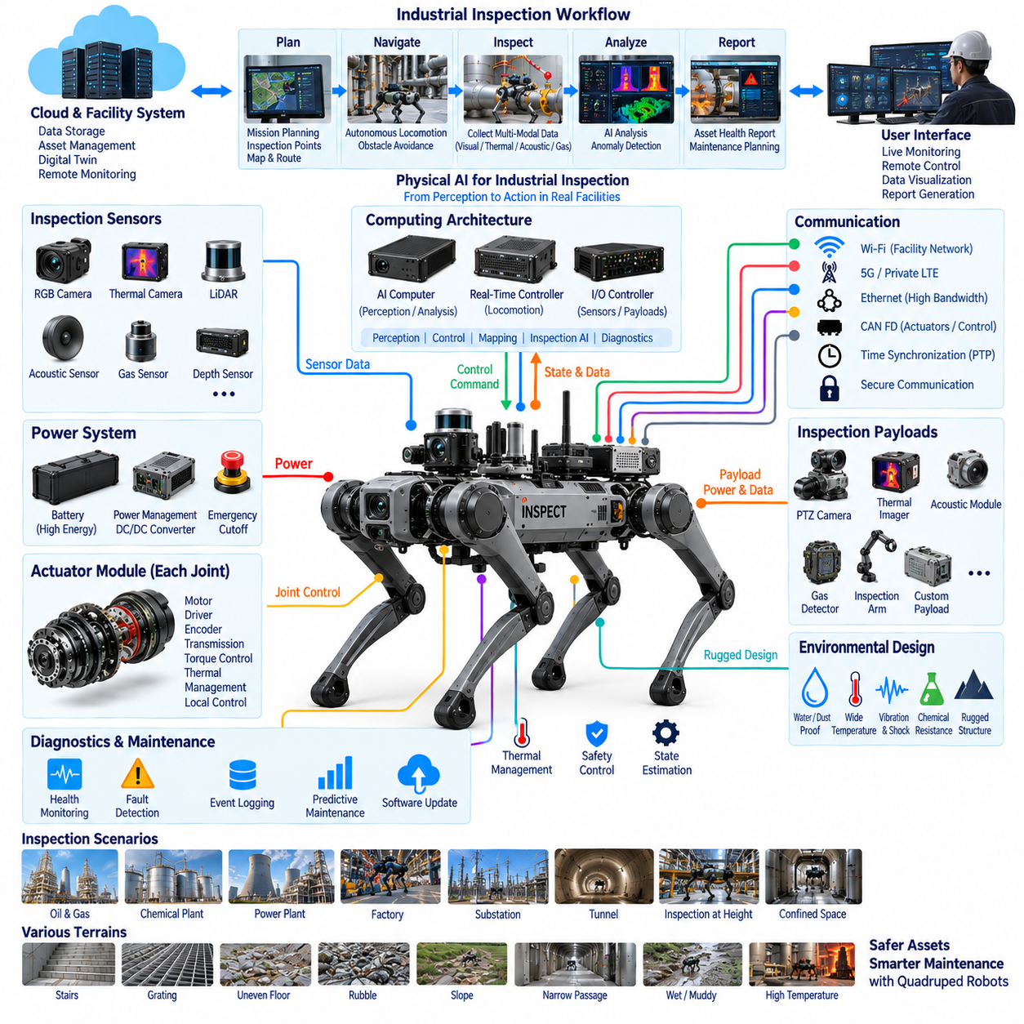
Industrial inspection is one of the strongest application domains for quadruped robots because many facilities combine narrow passages, stairs, gratings, uneven floors, pipes, machinery, and hazardous areas that challenge conventional wheeled platforms. A quadruped can carry inspection sensors through these environments while maintaining stable positioning near assets of interest. Its electrical architecture must therefore integrate locomotion, perception, inspection payloads, computing, communication, and data acquisition as one coordinated system.
The inspection mission begins with reliable mobility. Multiple electrically driven joints continuously control body posture and foot placement while the robot crosses thresholds, stairs, ramps, cables, debris, or irregular industrial surfaces. Unlike transportation-focused robots, inspection platforms may repeatedly stop, crouch, turn, or reposition to obtain measurements. Actuator control must therefore support both dynamic traversal and precise low-speed positioning without compromising balance or sensor stability.
Power architecture must support two substantially different load profiles. Locomotion generates rapidly changing motor currents and short-duration power peaks, while inspection sensors and computers create relatively continuous electrical loads. The battery and power distribution system must prevent actuator transients from disturbing sensitive measurement electronics. Separate regulated rails, DC/DC conversion, protection devices, current monitoring, and controlled startup sequences help maintain stable operation across these different electrical domains.
Inspection payloads transform the quadruped from a mobile robot into a distributed measurement platform. RGB cameras can document visible conditions, thermal cameras can identify abnormal temperature patterns, acoustic sensors can capture machine signatures, and gas sensors can detect environmental conditions. LiDAR or depth sensors may support both navigation and dimensional observation. Specialized payloads can be added when the facility requires measurements beyond the robot's standard perception suite.
Payload integration requires standardized electrical, mechanical, communication, and software interfaces. An inspection module needs suitable voltage and current capacity, reliable data connectivity, secure mounting, and known thermal limits. Payload mass and location also influence locomotion because they modify the robot's center of gravity and joint loading. The payload interface must therefore be treated as part of the overall robot architecture rather than as an independent accessory connection.
Sensor positioning is critical because measurement quality depends on geometry as well as sensor specifications. Cameras require appropriate fields of view, thermal sensors must avoid obstruction, microphones may need isolation from actuator vibration, and gas sensors require exposure to representative airflow. Mechanical mounting, electrical routing, calibration, and software configuration must be designed together so that locomotion-induced vibration or electromagnetic noise does not degrade inspection results.
Time synchronization becomes essential when multiple sensors observe the same event. A thermal anomaly, visible image, acoustic signature, robot pose, and environmental measurement may need to be correlated to a common location and time. Accurate timestamps allow data from different devices to be fused during analysis. Synchronization also improves repeatability when the robot performs periodic inspections and engineers compare measurements collected during different missions.
Localization and mapping connect inspection measurements to physical assets. Sensor readings become significantly more useful when they can be associated with a machine, pipe, electrical cabinet, structural element, or predefined inspection point. LiDAR, cameras, inertial sensing, joint states, and other localization sources can contribute to robot pose estimation. The resulting spatial reference allows inspection data to become part of a persistent digital representation of the facility.
Computing architecture must accommodate locomotion and inspection workloads simultaneously. Real-time controllers maintain gait and body stability, while higher-performance processors execute perception, localization, mapping, anomaly detection, mission planning, and data processing. Inspection algorithms may include thermal analysis, visual defect detection, gauge reading, acoustic classification, or multimodal inference. Workload isolation prevents intensive analytics from interfering with deterministic locomotion control.
Physical AI can extend inspection from simple data collection toward contextual interpretation. Perception models can identify equipment, recognize gauges or indicators, detect unusual visual conditions, and associate observations with mission objectives. Multimodal models may combine images, thermal information, acoustic signals, robot pose, and historical records. The robot can then prioritize observations or request additional measurements while still relying on deterministic lower-level control for safe physical execution.
Communication architecture must support internal control traffic, high-bandwidth sensor data, and external facility connectivity. Ethernet-class networks can connect cameras, LiDAR, computers, and payload devices, while deterministic buses may serve actuator and control functions. Wi-Fi, private cellular networks, or other external links can transfer telemetry and inspection results. Essential locomotion and local safety functions should remain operational when facility communication temporarily becomes unavailable.
Industrial environments create significant electromagnetic compatibility challenges. Motors, variable-frequency drives, welding equipment, high-current machinery, switching power supplies, and radio systems can produce electromagnetic interference. The robot itself also contains powerful motor drives and converters. Shielding, grounding, filtering, cable separation, connector selection, and enclosure bonding are therefore necessary to preserve sensor accuracy, network reliability, and controller stability in electrically noisy facilities.
Thermal management affects both the robot and its inspection instruments. Continuous walking generates heat in motors and drives, while AI processors and payload computers produce concentrated thermal loads. Thermal cameras may additionally require stable operating conditions for consistent measurements. Heat conduction, enclosure design, temperature monitoring, and controlled derating must maintain component temperatures while avoiding thermal interactions that could bias inspection sensors or reduce mission endurance.
Environmental protection is equally important because industrial facilities can contain water, dust, oil mist, chemicals, vibration, elevated temperatures, or contaminated surfaces. Connectors, cable entries, sensor windows, actuator interfaces, and payload enclosures must maintain protection without preventing maintenance. Ruggedization should be considered across the complete electrical architecture because a single exposed interface can undermine the environmental performance of otherwise protected subsystems.
Harness design requires particular attention around articulated legs and movable inspection equipment. Repeated joint motion subjects cables to bending and vibration, while payload cables may be installed and removed during configuration changes. Dynamic sections need controlled bend radius, abrasion resistance, strain relief, and mechanical retention. Serviceable connector placement is also important because industrial robots must often be repaired or reconfigured without extensive disassembly.
Safety architecture must protect both the robot and personnel working around industrial equipment. Emergency stopping, controlled posture management, collision avoidance, speed limitation, fault detection, and power isolation must interact coherently. Immediate removal of joint power may cause a quadruped to fall, so some failures require a controlled transition to a stable posture. Mission planning should also respect restricted areas and operational constraints defined by the facility.
Diagnostics support dependable operation across repeated inspection cycles. Joint currents, motor temperatures, battery condition, communication errors, sensor validity, processor utilization, storage capacity, and payload status can be monitored throughout a mission. Event logs help distinguish robot faults from inspection anomalies. Long-term trends can reveal degradation in actuators, batteries, connectors, or sensors before failures interrupt scheduled inspection activities.
Repeatable inspection is one of the major advantages of autonomous quadruped deployment. A robot can revisit predefined locations using similar viewpoints, sensor settings, and measurement procedures. This consistency improves comparison between inspection cycles and makes gradual changes easier to detect. Reliable localization, calibration, timestamping, mission configuration, and data management are therefore as important as the nominal accuracy of individual sensors.
Inspection data can also connect the robot to higher-level maintenance and digital-twin systems. Measurements associated with asset identity, position, time, and robot state can be uploaded for visualization, trend analysis, anomaly management, or maintenance planning. The quadruped then becomes a mobile edge node within a larger industrial information architecture, bridging physical equipment with AI analytics, asset databases, and remote engineering workflows.
Graceful degradation is important because inspection missions may continue safely despite some noncritical failures. Loss of an auxiliary inspection sensor may allow the robot to complete navigation and return, whereas degradation of localization, locomotion control, or critical power functions may require mission termination. Health management should classify failures according to operational impact and select responses such as payload isolation, reduced capability, controlled return, or safe shutdown.
Industrial inspection therefore demonstrates why quadruped robots should be engineered as integrated Physical AI systems rather than merely mobile sensor carriers. Locomotion provides access, synchronized sensing captures physical conditions, computing transforms measurements into information, and communication connects results to operational systems. Power, safety, diagnostics, environmental protection, and calibration provide the infrastructure that allows these functions to remain dependable during repeated real-world deployment.
As a case study, industrial inspection illustrates the practical convergence of robotics electrical architecture and intelligent asset management. The central engineering objective is not simply to make a quadruped walk through a factory, but to create a repeatable measurement system capable of reaching difficult locations, acquiring trustworthy multimodal data, associating observations with physical assets, and delivering actionable information. This integration transforms mobility into sustained operational value for industrial facilities.

14.06. Future Quadruped EE Architecture
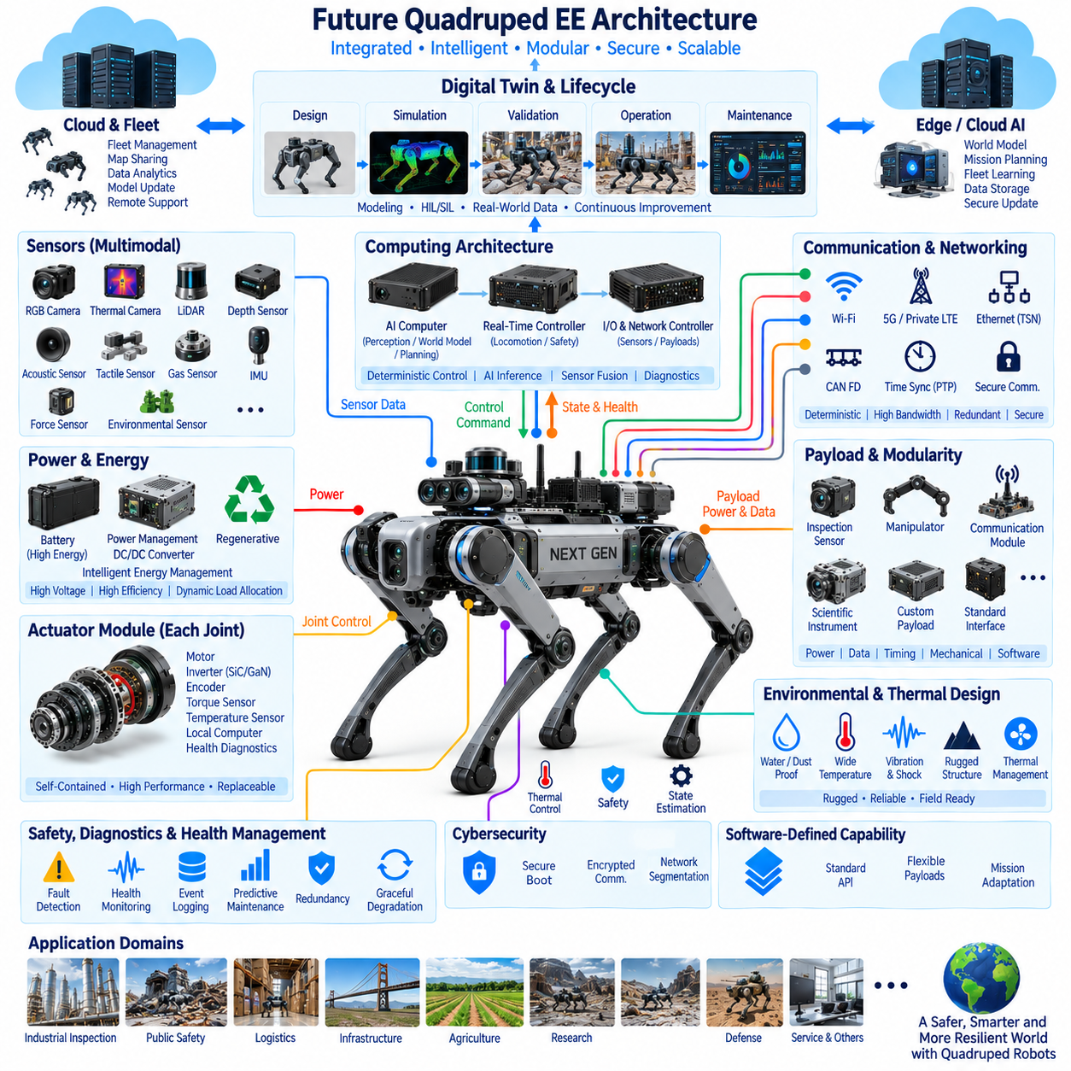
Future quadruped electrical and electronic architecture will evolve from collections of specialized controllers toward integrated, software-defined Physical AI platforms. Power electronics, distributed actuation, sensing, deterministic control, AI computing, communication, diagnostics, and safety will increasingly be designed as coordinated architectural domains. The objective will not simply be greater computing performance, but predictable interaction between intelligence and physical execution under changing real-world conditions.
A major transition will occur in computing architecture as centralized and distributed processing are combined more deliberately. Joint-level controllers will retain hard real-time motor and torque functions, while body controllers coordinate locomotion and safety-critical motion. High-performance edge computers will execute perception, world modeling, planning, and multimodal AI. This hierarchy will prevent variable AI workloads from disturbing deterministic control while allowing intelligence to expand independently.
Future joint modules will become increasingly self-contained electromechanical nodes. Motors, inverters, encoders, torque sensing, temperature monitoring, local computation, and health diagnostics can be integrated close to each joint. Local intelligence will support rapid current and torque loops while reporting standardized state and health information upward. Such modularity can simplify wiring, reduce analog signal exposure, improve maintainability, and enable joint assemblies to become replaceable intelligent components.
Power architecture will move toward more actively managed energy systems rather than passive battery distribution. Battery management, regenerative energy, high-efficiency conversion, dynamic load allocation, and predictive energy estimation will cooperate with locomotion and mission planning. The robot may adapt speed, gait, computing workload, sensor activity, or mission sequence according to available energy, allowing electrical power to become an explicit planning resource rather than merely a remaining battery percentage.
Increasing actuator capability will place greater emphasis on high-voltage and high-efficiency power electronics where platform scale justifies them. Higher bus voltage can reduce current for a given power level and consequently reduce conductor losses and cable mass, but it also increases requirements for insulation, isolation, connector design, fault protection, and service safety. Future architectures must therefore optimize voltage level as a complete system decision involving power density, efficiency, mass, reliability, and maintainability.
Wide-bandgap semiconductor technologies such as silicon carbide and gallium nitride may progressively influence motor drives and DC/DC conversion as cost, packaging, and reliability mature for robotics. Higher switching efficiency can reduce conversion losses and potentially decrease cooling requirements, while higher switching frequency can enable smaller passive components. These advantages must be balanced against electromagnetic compatibility, thermal concentration, control complexity, and the demanding mechanical environment of articulated robots.
Communication architecture will increasingly converge around deterministic high-bandwidth networking. Traditional control buses can remain useful for robust low-rate functions, while real-time Ethernet technologies provide synchronized communication among actuators, sensors, controllers, and computers. Gigabit and multi-gigabit Ethernet will support dense perception workloads. The architecture will become less dependent on isolated protocol islands and more focused on traffic classes, latency guarantees, redundancy, security, and time-aware communication.
Precise time synchronization will become a foundational service rather than an optional networking feature. Joint states, IMU measurements, camera frames, LiDAR scans, tactile observations, control commands, and AI events must share a consistent temporal reference. IEEE 1588 PTP or comparable synchronization mechanisms can support distributed sensor fusion and event reconstruction. Accurate timing will also improve digital-twin correlation, training-data quality, system validation, and post-failure analysis.
Sensor architecture will expand beyond conventional vision and inertial sensing toward richer multimodal perception. Depth, thermal, acoustic, tactile, force, vibration, environmental, and proprioceptive sensors can collectively describe both the external world and the robot's internal physical condition. Future architectures will increasingly fuse these signals rather than operate them as independent channels, allowing the robot to understand terrain, contact, equipment conditions, environmental hazards, and its own mechanical health.
The distinction between perception computing and world-model computing will become increasingly important. Instead of responding only to current sensor observations, future Physical AI systems may maintain internal representations that estimate environmental state, predict future interactions, and evaluate possible actions before execution. These workloads require substantial AI acceleration and memory bandwidth, but their outputs must still pass through deterministic motion and safety layers before becoming physical actuator commands.
Hardware-software co-design will therefore become central to quadruped development. AI model size, inference latency, sensor resolution, network bandwidth, memory capacity, thermal limits, and battery consumption cannot be optimized independently. A larger perception model may improve semantic understanding while reducing endurance or increasing cooling demand. Future platforms will allocate computational resources according to mission context, allowing hardware capacity and software intelligence to be treated as one shared system budget.
Safety architecture will evolve toward distributed supervision and graceful degradation. Independent monitoring functions can observe actuator state, communication integrity, computing health, sensor validity, and power conditions. When degradation occurs, the robot may reduce speed, change gait, disable a payload, isolate a faulty node, return to a safe location, or transition into a stable posture. Safety will increasingly depend on coordinated system state rather than a single emergency power-disconnection mechanism.
Redundancy will also become more selective and intelligent. Duplicating every component would impose unacceptable penalties in mass, energy, cost, and complexity. Instead, architectures can provide redundant sensing where observability is critical, alternate communication paths where network loss is hazardous, and isolated computing or power domains where common-cause failures must be controlled. The goal will be fault containment and continued essential operation rather than complete duplication of the robot.
Diagnostics will progress from fault reporting toward prognostics and health management. Joint current signatures, temperature histories, vibration, battery impedance, communication error rates, encoder consistency, and computing telemetry can be analyzed over time to detect degradation before functional failure. Machine learning may assist anomaly detection, but engineering thresholds and causal diagnostics will remain important. Fleet-level comparison can further identify patterns that are difficult to recognize from one robot alone.
Future harness architecture will be strongly influenced by modularity and distributed electronics. Integrating controllers near actuators and sensors can reduce centralized wiring, but articulated legs will continue to require highly reliable power and communication paths. Flexible harnesses, rugged connectors, optimized bend zones, strain relief, shielding, and serviceable modular interfaces will remain essential. Wireless technologies may complement selected functions, but critical power and deterministic control will continue to require robust physical connections.
Thermal architecture will become increasingly coupled with workload management. Motors, inverters, AI accelerators, communication devices, batteries, and payload computers compete for limited thermal capacity within sealed structures. Future robots can combine distributed temperature sensing with predictive thermal models to adjust locomotion intensity and computing demand before limits are exceeded. Thermal state may therefore become another variable considered directly by autonomous mission planning.
Cybersecurity will become a fundamental architectural layer as quadrupeds connect to fleet servers, cloud services, remote operators, software repositories, and external payloads. Secure boot, authenticated communication, signed software, protected keys, network segmentation, access control, and secure update mechanisms will be integrated with lifecycle management. Critical locomotion and safety domains should remain isolated from externally exposed application services so that connectivity does not create uncontrolled physical risk.
Software-defined capability will allow the same electrical platform to support increasingly diverse missions. Standardized payload power, communication, timing, and software interfaces can enable inspection sensors, manipulators, communication equipment, scientific instruments, or additional AI computers to be integrated without redesigning the core robot. This modularity will shift product differentiation from fixed hardware configurations toward validated combinations of software, payloads, autonomy, and mission behavior.
Digital twins will increasingly connect design, validation, operation, and maintenance. Electrical loads, actuator temperatures, battery state, sensor timing, communication behavior, and mechanical motion can be represented in simulation and compared with field telemetry. Hardware-in-the-loop and software-in-the-loop environments will allow failures and extreme conditions to be evaluated before deployment. The digital twin can consequently become a lifecycle engineering framework rather than only a visualization model.
Fleet architecture will extend the quadruped beyond the boundaries of a single machine. Multiple robots can share maps, mission information, inspection results, software versions, health statistics, and learned representations through edge or cloud infrastructure. However, essential locomotion and safety must remain locally executable. Future systems will therefore divide intelligence between robot, edge, fleet, and cloud layers according to latency, connectivity, privacy, computational cost, and operational criticality.
The long-term direction is toward an architecture in which electrical hardware provides a dependable physical substrate and software determines an increasing proportion of robot capability. Standardized interfaces, deterministic networks, synchronized sensing, modular computing, intelligent power management, distributed safety, predictive diagnostics, and secure lifecycle management will allow quadrupeds to evolve without complete hardware redesign. Architecture will become the mechanism that separates rapid AI evolution from slower physical-platform development.
Future quadruped EE architecture should therefore be understood as a converged Physical AI architecture rather than a collection of electrical subsystems. Energy, actuation, sensing, networking, computation, intelligence, safety, diagnostics, thermal management, cybersecurity, and digital-twin infrastructure will continuously exchange state and constraints. The most successful platforms will be those that preserve deterministic and reliable physical execution while allowing perception, world models, autonomy, and mission intelligence to evolve rapidly above that foundation.

