Volume 21. Humanoid Electrical Architecture

Chapter 10. Computing Architecture

10.01. Real Time Control
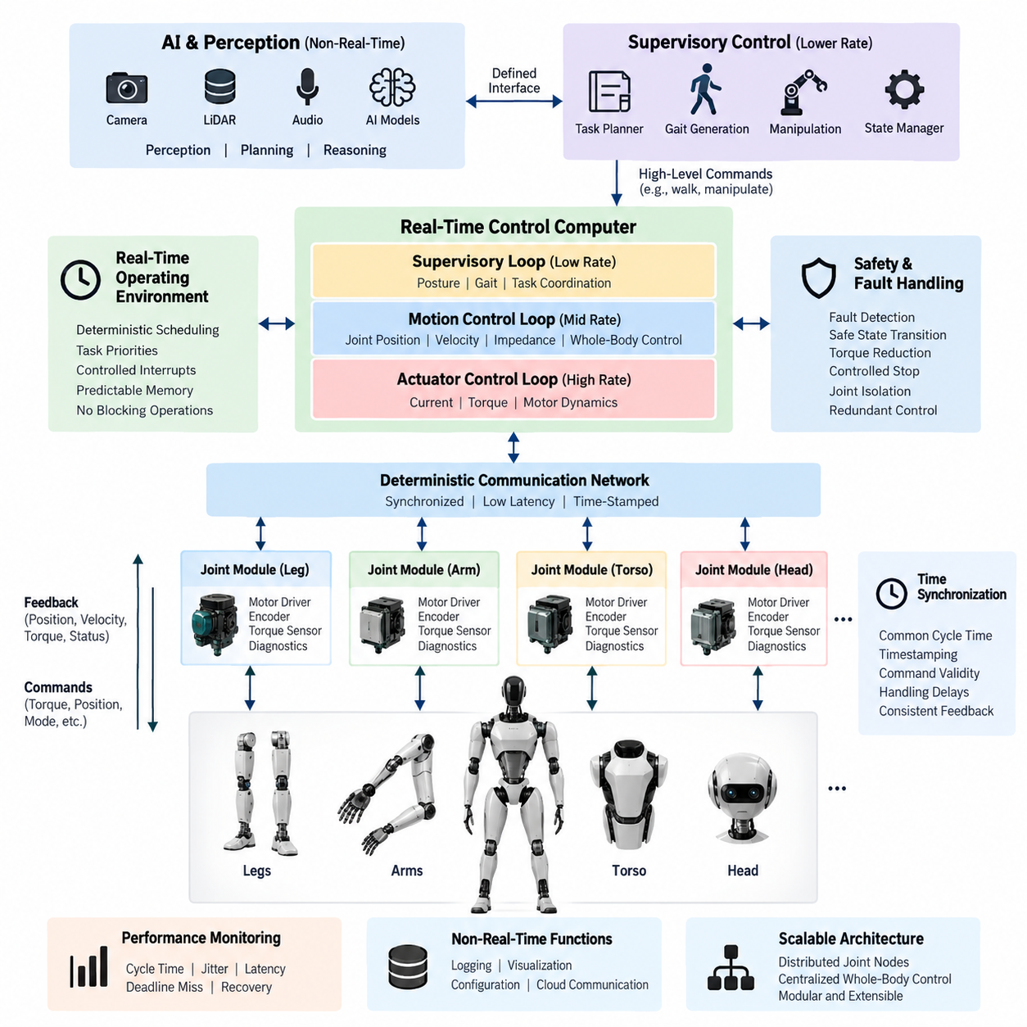
Real-time control is the computational foundation that converts a humanoid robot’s high-level motion objectives into deterministic actuator behavior. Unlike AI workloads, which can often tolerate variable execution time, real-time control must repeatedly execute within defined timing constraints. Joint position, velocity, torque, encoder, current, and safety information therefore need to be processed with predictable latency. The control architecture should separate deterministic control functions from computationally intensive perception and AI workloads so that temporary AI delays cannot directly disturb basic motion stability.
A typical humanoid real-time control loop operates through a hierarchy of control rates. High-rate inner loops manage motor current, torque, and actuator dynamics, while intermediate loops coordinate joint position, velocity, impedance, and whole-body motion. Lower-rate supervisory loops handle gait generation, posture commands, task states, and system coordination. The exact frequencies depend on actuator dynamics and hardware capability, but the architecture should preserve clear timing boundaries between these layers. This separation allows each controller to meet its own latency and jitter requirements.
The real-time controller receives feedback from distributed joint modules through deterministic communication paths. Encoder measurements provide joint position and velocity information, torque sensors provide mechanical interaction feedback, and motor-driver status supplies current, temperature, voltage, and fault information. These signals are sampled, validated, timestamped, and incorporated into the control cycle. Commands generated by the controller are then transmitted to the appropriate motor drivers. Consistent communication timing is important because simultaneous or coordinated motion of multiple joints depends on temporally coherent feedback.
A real-time operating environment or real-time capable execution framework should provide bounded scheduling latency, controlled interrupt behavior, deterministic task priorities, and predictable memory access. Control tasks should generally use fixed execution patterns and avoid operations that can introduce uncontrolled delays, such as unexpected dynamic memory allocation or blocking communication. High-priority safety and stabilization functions should preempt lower-priority supervisory activities when necessary. The objective is not simply high computational speed, but repeatable execution with bounded latency and jitter.
Humanoid motion requires coordination across many joints, so synchronization between control tasks is essential. A controller may calculate commands for the legs, arms, torso, and head within a common control cycle, while actuator-level loops operate at higher rates locally. Time synchronization mechanisms allow measurements from different modules to be interpreted consistently. The real-time architecture should therefore establish clear cycle boundaries, timestamp conventions, command validity windows, and handling rules for delayed or missing data. These mechanisms reduce instability caused by inconsistent feedback timing.
The control computer should also isolate real-time functions from AI and perception workloads. Camera processing, LiDAR processing, speech recognition, vision-language models, and other AI functions can produce highly variable computational loads. They should communicate with the real-time domain through defined interfaces rather than directly controlling actuator timing. A high-level planner may request a walking trajectory or manipulation task, while the real-time controller remains responsible for continuously enforcing joint limits, dynamic constraints, balance requirements, and actuator commands.
Real-time control must include robust fault handling because humanoid robots operate in dynamically unstable conditions. Communication loss, encoder disagreement, excessive torque, motor-driver faults, thermal overload, abnormal voltage, or invalid commands should be detected within appropriate timing limits. The controller should transition to predefined safe states rather than continuing with stale or uncertain commands. Depending on the system design, this may include torque reduction, controlled stopping, posture stabilization, joint isolation, or activation of redundant control paths.
The architecture should distinguish between hard real-time, firm real-time, and non-real-time activities. Hard real-time functions require completion within strict deadlines because missing a deadline may directly compromise stability or safety. Firm real-time functions may tolerate occasional missed cycles but lose value when the deadline is exceeded. Non-real-time functions such as logging, visualization, configuration management, and cloud communication can operate asynchronously. This classification helps allocate processor resources and prevents noncritical workloads from consuming resources required by motion control.
Control-loop performance should be evaluated using measurable timing characteristics rather than processor utilization alone. Important parameters include cycle time, execution-time variation, scheduling latency, communication latency, sensor-to-actuator delay, jitter, deadline misses, and recovery behavior after transient overload. Monitoring these values during development and validation provides evidence that the controller remains deterministic under realistic combinations of locomotion, manipulation, perception, and communication workloads. Timing budgets should be defined at system level and allocated across sensing, computation, networking, and actuation.
A scalable humanoid architecture can therefore use distributed real-time control nodes for individual joints or body regions while maintaining centralized coordination at the whole-body level. Local controllers handle fast actuator dynamics and protection functions, while a higher-level real-time controller coordinates posture, balance, locomotion, and manipulation. Above this layer, AI computers provide perception, planning, reasoning, and embodied intelligence. This layered structure keeps safety-critical motion control deterministic while allowing increasingly capable AI systems to evolve without redesigning the fundamental actuator control path.

10.02. AI Computer
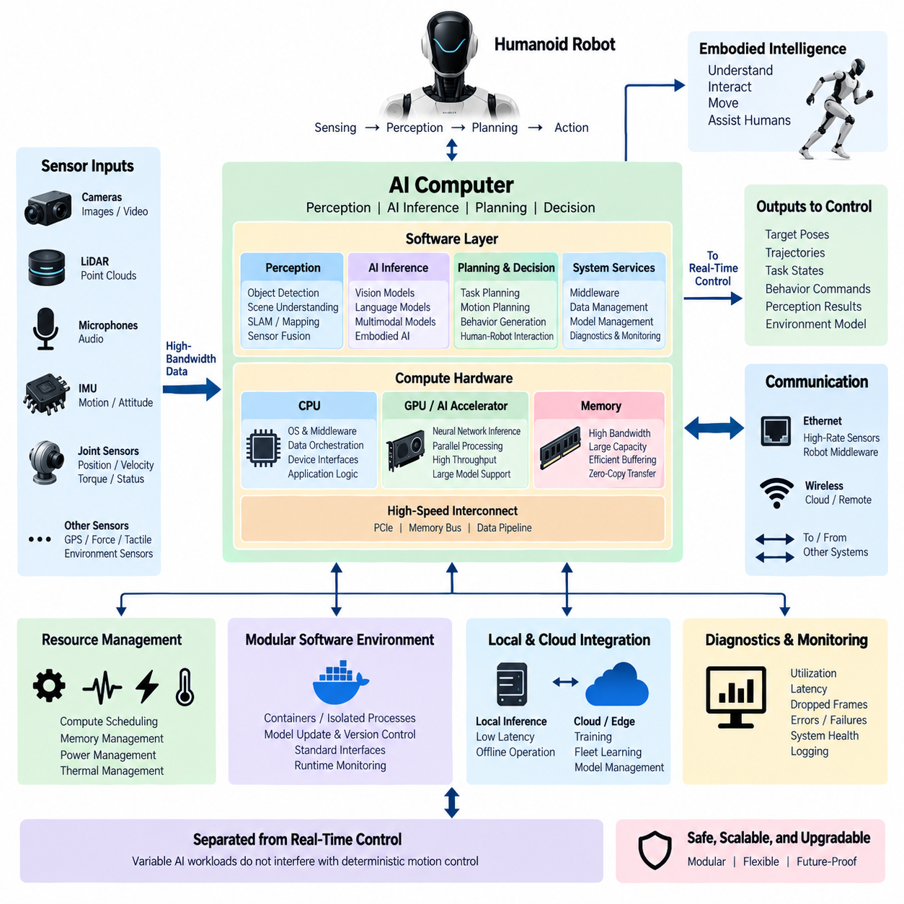
The AI computer serves as the primary computational platform for perception, artificial intelligence inference, high-level planning, and embodied intelligence in a humanoid robot. It is intentionally separated from the deterministic real-time control domain so that variable AI workloads do not interfere with actuator timing. The AI computer receives data from cameras, LiDAR, microphones, joint states, and other sensors, processes these inputs through software pipelines and AI models, and provides perception results, predictions, task decisions, and motion objectives to the appropriate control layers.
A humanoid AI computer must process multiple sensor streams with substantially different data rates and computational characteristics. Camera images may require high-bandwidth processing, LiDAR produces spatial point data, microphones generate continuous audio streams, and joint sensors provide structured state information. The compute architecture therefore requires high memory bandwidth, efficient data movement, parallel processing capability, and suitable interfaces for heterogeneous sensors. Input processing should also preserve timestamps and sensor relationships so that perception results remain consistent with the robot's physical state.
The AI computer typically contains a general-purpose CPU together with one or more accelerators such as GPUs or dedicated AI engines. The CPU manages operating-system services, middleware, data orchestration, device interfaces, and application logic, while accelerators execute computationally intensive neural-network operations. This heterogeneous architecture allows perception, object detection, segmentation, pose estimation, speech processing, and other AI workloads to execute efficiently. The allocation of workloads should consider latency, memory consumption, thermal limits, power consumption, and the required computational throughput.
Perception processing forms one of the major workloads of the AI computer. Visual data can be processed for object detection, semantic understanding, human pose estimation, depth estimation, and scene interpretation, while LiDAR data can support spatial mapping and geometric perception. Audio processing can provide speech recognition, sound localization, and interaction cues. These individual pipelines may operate independently but should ultimately produce a coherent representation of the robot's environment. Sensor fusion can combine complementary information to improve robustness when an individual sensor is degraded or temporarily unavailable.
The AI computer also supports higher-level planning and decision functions that transform perception results into actionable objectives. A planner may determine where the robot should move, which object should be manipulated, or how a task should be decomposed into sequential actions. These functions operate at a lower rate than actuator control and can tolerate greater computational variability. Their outputs should therefore be expressed through well-defined interfaces such as target poses, trajectories, task states, or behavioral commands rather than direct uncontrolled actuator signals.
AI model execution requires careful management of computational resources because humanoid robots may run several models concurrently. A perception model, language model, pose estimator, object tracker, and motion-planning component may compete for GPU memory and processing capacity. The AI computer should establish resource priorities and execution policies so that critical perception and planning functions maintain acceptable latency. Model selection should consider not only accuracy but also inference time, memory footprint, batch behavior, power consumption, and the available accelerator architecture.
The AI computer should maintain a clear boundary between AI inference and real-time control. AI outputs may be delayed, temporarily unavailable, or affected by uncertain perception. The real-time controller must therefore remain capable of maintaining safe and stable operation when an AI result is missing or invalid. Interfaces should define data validity, confidence, timestamps, timeout behavior, and fallback actions. This separation allows advanced AI functions to evolve independently while preserving predictable operation of the underlying motion-control system.
Communication between the AI computer and the rest of the humanoid system should support high-bandwidth sensor data as well as lower-bandwidth control information. Ethernet-based communication may be used for cameras, LiDAR, and other high-data-rate devices, while robotics middleware can provide structured communication between perception, planning, and control software. Joint states and actuator information may originate from deterministic control networks and be exposed to the AI domain through controlled interfaces. The architecture should avoid unnecessary data copying because sensor bandwidth and memory traffic can become major performance limitations.
Memory architecture is particularly important because modern AI workloads frequently require large model parameters, intermediate tensors, image buffers, point-cloud data, and historical sensor information. High-speed system memory and accelerator memory should be sized according to the expected workload rather than only the nominal AI model size. Efficient buffer management, memory reuse, zero-copy transfers where appropriate, and controlled data retention can reduce latency and improve system stability. The design should also reserve sufficient memory for operating-system services and safety-related supervisory functions.
Thermal and power management are fundamental constraints for a humanoid AI computer because the compute platform operates inside a mobile body with limited energy and cooling capacity. High-performance GPUs and accelerators can generate substantial heat during sustained inference. The compute architecture should therefore balance peak performance with continuous operating capability. Thermal monitoring, power-state management, workload scheduling, and controlled performance scaling can prevent thermal throttling from causing unpredictable degradation during prolonged walking, manipulation, or perception tasks.
The software environment should support modular deployment of perception and AI applications. Containers, isolated processes, or equivalent software boundaries can separate individual workloads and simplify model updates. AI models should have clearly defined input and output interfaces so that one perception model can be replaced without redesigning the complete system. Version management, configuration control, model validation, and runtime monitoring are also important because changes to AI software can influence robot behavior even when the underlying electrical and real-time control architecture remains unchanged.
The AI computer should support local inference because many humanoid functions require low latency and continuous operation without dependence on an external network. At the same time, cloud or edge resources can provide additional computational capacity for model training, large-scale analysis, model management, simulation, and fleet-level learning. The local system should therefore operate as an autonomous edge AI platform while maintaining controlled interfaces to external compute resources. This approach allows the robot to remain operational when connectivity is unavailable while still benefiting from larger computing infrastructure.
AI computer architecture should also support diagnostics and performance monitoring. Important measurements include CPU and accelerator utilization, memory consumption, inference latency, sensor-processing latency, thermal state, power consumption, dropped frames, communication errors, and model execution failures. These measurements provide information for identifying performance bottlenecks and abnormal behavior. Logging should preserve sufficient context to correlate AI events with robot states, sensor inputs, and control responses without allowing diagnostic activities to interfere with critical computation.
For humanoid robots, the AI computer becomes an important bridge between physical sensing and embodied intelligence. It converts raw sensor information into representations that higher-level software can use for perception, reasoning, planning, and interaction. As AI capabilities evolve toward vision-language models, vision-language-action models, agents, and foundation-model-based robotics, the computing platform must remain sufficiently modular to accommodate increasingly complex workloads. The architecture should therefore emphasize scalable accelerator support, flexible memory resources, standardized interfaces, deterministic separation from motion control, and controlled integration with the broader humanoid computing hierarchy.

10.03. GPU Architecture
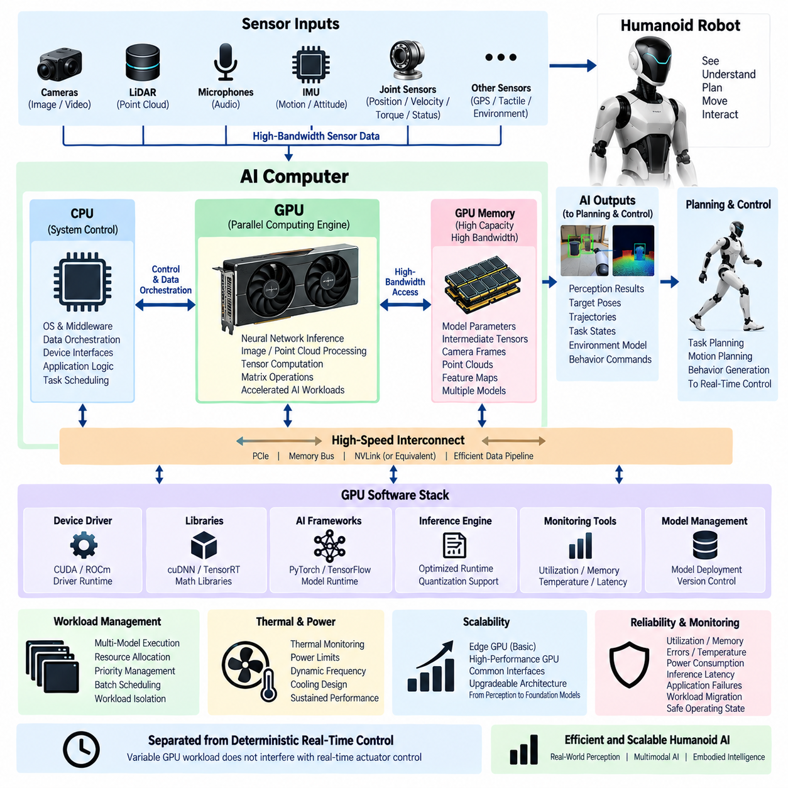
A GPU architecture provides the parallel computing foundation for demanding AI workloads in a humanoid robot. Within the computing architecture, the GPU is primarily responsible for highly parallel operations such as neural-network inference, image processing, point-cloud processing, tensor computation, and large-scale matrix operations. It operates alongside the CPU rather than replacing it, allowing the CPU to manage system control, middleware, data orchestration, and application logic while the GPU executes computationally intensive workloads. This division enables the humanoid system to process complex perception and AI models within practical latency and power constraints.
The GPU receives data from the AI computer through high-speed memory and interconnect paths. Camera images, LiDAR point clouds, depth information, and other sensor representations can be transferred into GPU-accessible memory for parallel processing. Efficient data movement is essential because the performance of an AI system is determined not only by raw GPU compute capability but also by memory bandwidth, transfer latency, and synchronization overhead. The architecture should therefore minimize unnecessary copies between CPU memory and GPU memory and use efficient buffer management to maintain a continuous data pipeline.
Modern GPUs contain many parallel processing resources that execute large numbers of similar operations simultaneously. This characteristic is particularly suitable for deep-learning workloads because convolution, matrix multiplication, attention mechanisms, tensor operations, and other neural-network calculations can be divided into many parallel tasks. Specialized AI acceleration hardware can further improve inference performance by executing reduced-precision operations efficiently. The GPU architecture should therefore be selected according to the expected AI workload, including model size, numerical precision, inference frequency, concurrent models, and required throughput.
GPU memory capacity is an important architectural parameter for humanoid AI systems. Perception and embodied-AI applications may require memory for neural-network parameters, intermediate tensors, camera frames, LiDAR data, point clouds, feature maps, and multiple simultaneously executing models. Insufficient memory can prevent larger models from running even when the GPU has sufficient computational performance. The architecture should therefore consider both compute capability and memory capacity. Memory allocation should also reserve sufficient resources for concurrent perception, planning, and AI functions rather than optimizing only for a single benchmark workload.
Memory bandwidth directly affects the ability of the GPU to keep its processing resources supplied with data. Large perception models and multimodal AI systems can repeatedly move substantial quantities of tensors between computational units and memory. If data cannot be delivered fast enough, the GPU may remain underutilized despite having high theoretical compute performance. High-bandwidth memory systems, efficient caching, memory reuse, and optimized tensor layouts can reduce this limitation. GPU selection should therefore evaluate sustained application performance rather than relying only on peak arithmetic throughput.
The GPU software stack is another major component of the architecture. Device drivers, GPU runtime libraries, numerical libraries, AI frameworks, inference engines, and optimized model runtimes provide the software path between robotic applications and GPU hardware. The software environment should support efficient execution of the required AI models and provide mechanisms for monitoring memory use, utilization, temperature, and execution latency. Compatibility between the GPU architecture, operating system, AI framework, model format, and inference runtime is essential because a theoretically capable GPU may provide poor practical performance if the software stack is not properly optimized.
Multiple AI workloads may need to share the same GPU in a humanoid robot. Camera perception, object detection, segmentation, human pose estimation, LiDAR processing, speech processing, language models, and motion-related planning may execute concurrently. The architecture should therefore define resource allocation and scheduling policies that prevent one large workload from consuming all available GPU resources. Priority management, controlled batch sizes, model partitioning, asynchronous execution, and appropriate workload isolation can help maintain predictable response times while maximizing overall accelerator utilization.
The GPU should remain logically separated from deterministic real-time control even when it contributes information used by the motion-control system. AI inference may have variable execution time because of model complexity, memory contention, thermal conditions, or concurrent workloads. A real-time controller should therefore not depend directly on the completion of an individual GPU inference cycle for basic actuator stability. Instead, the GPU should provide validated perception results, target poses, trajectories, environment representations, or planning information through defined interfaces. This separation allows AI performance to evolve without compromising deterministic control behavior.
Thermal and power characteristics become especially important when a high-performance GPU is installed inside a mobile humanoid platform. Sustained AI inference can generate significant heat and electrical power demand, while the robot has limited battery capacity and constrained cooling volume. GPU architecture must therefore consider sustained performance rather than short-duration peak performance. Thermal monitoring, power limits, dynamic frequency management, workload scheduling, and appropriate cooling design can prevent thermal throttling and maintain stable performance during prolonged perception, walking, manipulation, or interaction tasks.
A scalable humanoid architecture may use different GPU classes according to robot capability and mission requirements. A compact edge accelerator may be sufficient for basic perception and navigation, while a higher-performance GPU platform may be required for multimodal foundation models, vision-language-action systems, or advanced embodied-AI workloads. The architecture should preserve common software interfaces so that GPU capability can be increased without redesigning the complete application architecture. This enables the same humanoid platform concept to evolve from conventional perception toward increasingly capable AI systems.
GPU reliability and monitoring should also be incorporated into the computing architecture. Important parameters include GPU utilization, memory utilization, memory errors, temperature, power consumption, inference latency, application failures, and communication errors. These measurements can identify abnormal behavior and provide information for preventive maintenance. When multiple accelerators are installed, workload distribution and fault detection can also be used to prevent a single GPU failure from unnecessarily disabling unrelated functions. The appropriate response depends on system requirements and may include workload migration, reduced AI functionality, controlled degradation, or transition to a safe operating state.
The overall GPU architecture should therefore be designed as an integrated part of the humanoid computing hierarchy rather than as an isolated accelerator. Sensors provide high-bandwidth data to the AI computer, the CPU coordinates software and data flow, and the GPU performs highly parallel AI and perception computation. The resulting information is transferred to planning and control layers through defined interfaces while real-time actuator control remains independently protected. This architecture provides a practical foundation for scalable perception, multimodal AI, embodied intelligence, and future foundation-model workloads while maintaining controlled power, thermal, memory, and reliability characteristics.

10.04. Time Synchronization
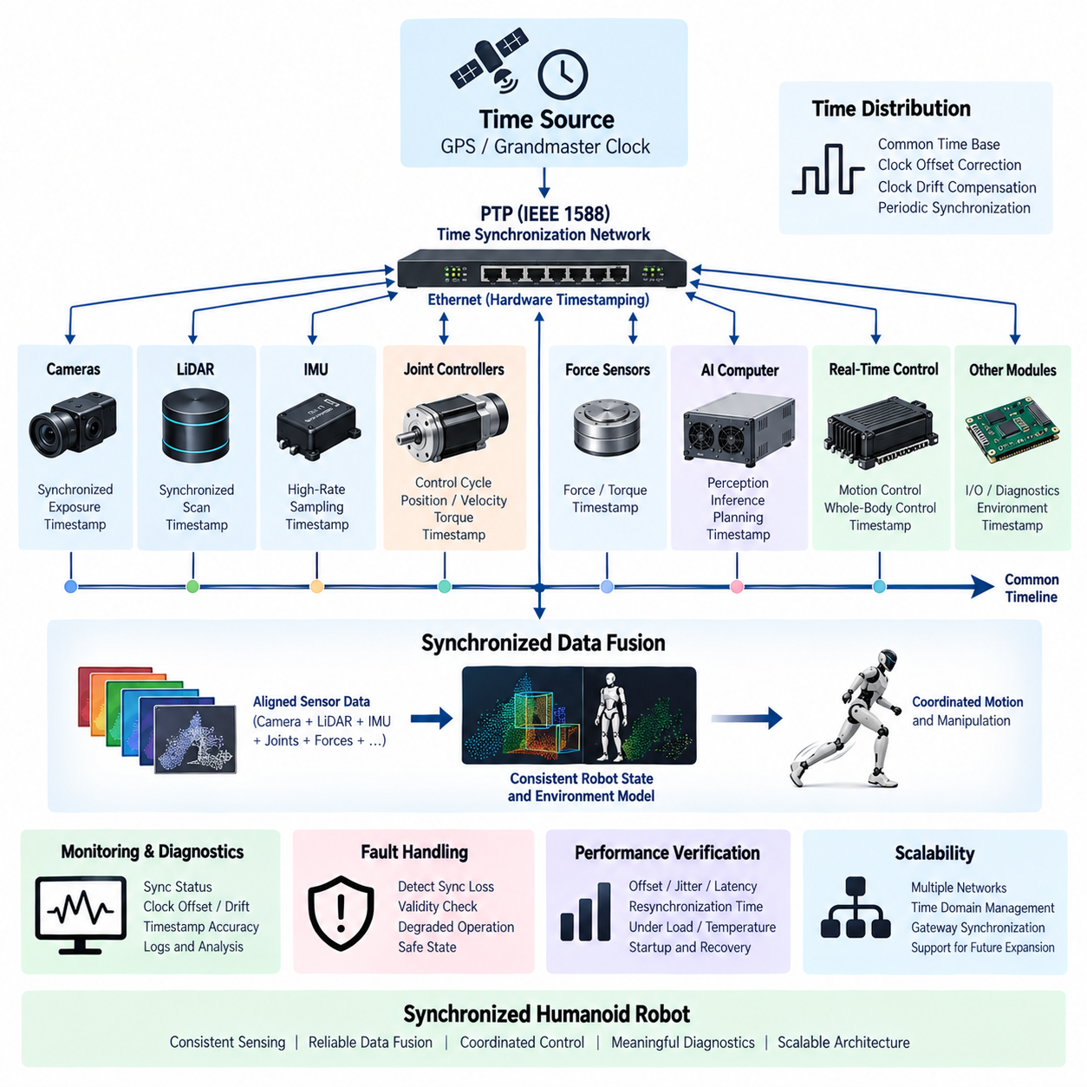
Time synchronization provides a common temporal reference across the distributed computing, sensing, communication, and actuator systems of a humanoid robot. Cameras, LiDAR, IMUs, joint controllers, force sensors, AI computers, and real-time control nodes may operate with independent clocks and different sampling rates. Without synchronization, measurements that appear to describe the same physical event can represent different moments in time. A coordinated time architecture therefore enables sensor data, control commands, and system events to be interpreted within a consistent temporal framework.
A humanoid robot presents particularly demanding synchronization requirements because its body contains many distributed electronic modules operating simultaneously. Joint controllers may execute high-frequency servo loops while cameras and LiDAR operate at lower frame rates, and AI processing may introduce variable latency. The synchronization architecture must establish a shared time base that allows these heterogeneous data streams to be related accurately. This common reference is essential for reconstructing the robot's state and understanding when a measurement or command was actually generated.
Clock differences arise because every electronic oscillator has finite accuracy and changes with temperature, aging, supply conditions, and manufacturing variation. Two processors initialized at the same nominal time will gradually diverge if their clocks run at slightly different rates. Synchronization mechanisms must therefore correct both clock offset and clock drift. Periodic synchronization exchanges allow distributed nodes to estimate their relationship to a reference clock and continuously maintain temporal alignment instead of relying on one-time clock initialization.
Network-based synchronization can distribute time information throughout the humanoid computing architecture. Precision Time Protocol, commonly represented by IEEE 1588 PTP, is suitable for Ethernet-based systems that require substantially better synchronization than conventional software clock adjustment. A selected grandmaster or reference clock distributes timing information through the network, while participating devices adjust or correlate their local clocks. Hardware timestamping can reduce uncertainty introduced by software stacks, operating-system scheduling, and variable packet-processing delays.
Hardware timestamping records transmission and reception events close to the physical network interface rather than relying only on software-generated timestamps. This becomes important when camera frames, LiDAR measurements, or control messages must be correlated precisely. Software timestamping may include unpredictable delays caused by queues, interrupts, drivers, and task scheduling. By moving timestamp generation closer to the communication hardware, the system can reduce timing uncertainty and provide more accurate measurements of when information actually entered or left a device.
Sensor synchronization requires more than simply setting clocks to approximately the same time. Cameras may require synchronized exposure, LiDAR devices may generate scans over finite intervals, and IMUs can sample at much higher frequencies than vision sensors. The architecture should define whether synchronization is achieved through a common clock, hardware trigger, timestamp correlation, or a combination of these mechanisms. The selected method should preserve the temporal relationship among sensor measurements sufficiently accurately for the perception and control algorithms that consume them.
Accurate synchronization is especially important for sensor fusion. A humanoid robot may combine camera images, depth information, LiDAR point clouds, IMU measurements, joint positions, and force information to estimate body motion and environmental geometry. If these measurements correspond to different physical times, moving objects can appear displaced and the estimated robot pose can become inconsistent. Timestamp-based alignment, interpolation, buffering, and motion compensation can be used to transform asynchronous measurements into a temporally coherent representation before fusion.
Real-time control also depends on consistent timing across distributed joint modules. Joint positions, velocities, torque measurements, and actuator commands should be associated with known control cycles or timestamps so that the whole-body controller can interpret them correctly. If one joint reports significantly older information than another, the combined robot state may not represent any real physical configuration. Synchronization therefore supports coordinated locomotion, balance control, manipulation, and other functions that require simultaneous interpretation of multiple joints.
Time synchronization should be distinguished from deterministic communication. Two devices can share highly accurate clocks while network messages still experience variable latency, and a deterministic network can deliver messages predictably even when device clocks are poorly aligned. A robust humanoid architecture therefore considers synchronization accuracy, communication latency, jitter, and control-cycle scheduling as related but separate engineering parameters. Together, these mechanisms establish predictable temporal behavior across the distributed computing system.
The computing architecture should define a hierarchy of time sources and synchronization domains. A central reference may distribute time to AI computers, perception devices, gateways, and real-time controllers, while local actuator networks can maintain tighter cycle synchronization for joint control. Gateways connecting different network technologies should preserve timestamp information and explicitly manage conversions between time domains. This prevents hidden timing discontinuities when data passes between Ethernet, deterministic field networks, sensor interfaces, and internal processor buses.
Fault handling is necessary because synchronization can degrade or disappear. A failed reference clock, disconnected network segment, excessive packet delay, oscillator instability, or device restart can cause a node to lose synchronization. Each node should monitor synchronization status, clock offset, estimated accuracy, and time-source validity. When timing uncertainty exceeds an acceptable threshold, dependent functions can reject affected data, increase uncertainty margins, enter degraded operation, or transition to a safe state according to the criticality of the function.
System diagnostics should record timing information so that temporal failures can be reconstructed during testing and field operation. Logs from different computers are difficult to correlate when each device uses an unrelated clock. A common synchronized time base allows sensor events, AI decisions, communication faults, actuator responses, and safety transitions to be placed on one timeline. This capability is valuable for debugging intermittent failures, validating control behavior, analyzing collisions or unexpected motion, and supporting digital-twin reconstruction of real robot operation.
Synchronization performance should be verified quantitatively rather than assumed from protocol configuration alone. Relevant characteristics include clock offset, drift, synchronization error, timestamp accuracy, network residence time, jitter, resynchronization time, and behavior after communication interruption. Testing should cover startup, steady operation, high network load, processor overload, temperature variation, link failure, and recovery. The required synchronization accuracy should ultimately be derived from the timing sensitivity of perception, sensor fusion, motion control, and safety functions.
A scalable humanoid time architecture therefore combines a shared reference clock, precise timestamping, network synchronization, hardware triggering where necessary, and explicit timing supervision. High-bandwidth perception devices, AI computers, real-time controllers, and distributed joint modules can operate at different rates while remaining correlated through a common temporal framework. By treating time as a system-level architectural resource rather than a local processor property, the humanoid platform can achieve coherent sensing, reliable data fusion, coordinated motion, meaningful diagnostics, and predictable integration across its complete computing architecture.

10.05. Compute Redundancy
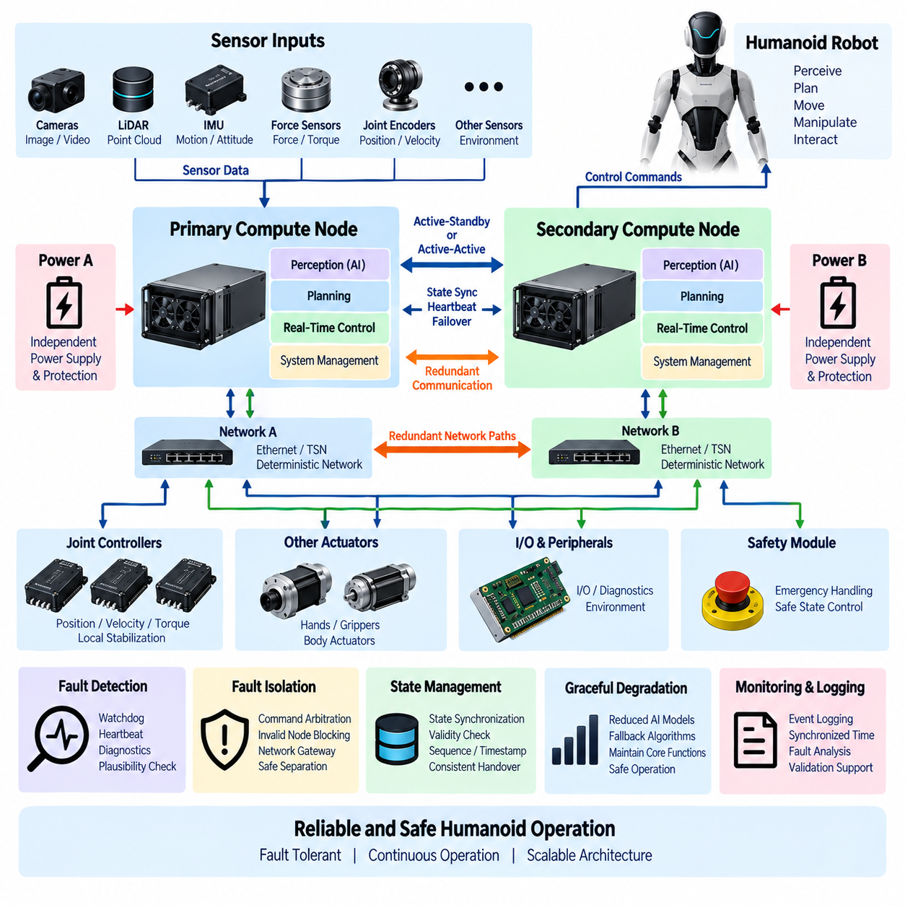
Compute redundancy is the architectural capability that allows a humanoid robot to maintain essential functions when a processor, computing node, communication path, or software execution environment fails. Because locomotion, balance, manipulation, perception, and safety functions depend on distributed computation, a single computing failure can affect multiple body functions. Redundancy therefore combines duplicated resources, fault detection, isolation, state management, and controlled recovery so that failures do not immediately propagate into unsafe robot behavior.
Not every computing function requires the same level of redundancy. Joint stabilization, balance control, emergency handling, and other safety-related functions generally require stronger fault tolerance than visualization, logging, or noncritical AI services. The architecture should classify computing functions according to their criticality and define the required behavior after a fault. This prevents unnecessary duplication of every processor while concentrating redundant resources on functions whose loss could directly affect stability, safety, or controlled robot operation.
Redundancy can be implemented at several architectural levels. Processor-level redundancy may duplicate CPUs or microcontrollers, node-level redundancy may provide primary and secondary controllers, and system-level redundancy may use independent computing domains with separate power and communication paths. Software redundancy can add independent monitoring or alternative implementations. Combining these levels provides stronger protection than simply installing two identical computers that still share the same power supply, network switch, cooling path, or software defect.
An active-standby architecture uses one computing node as the primary controller while another node remains ready to assume its responsibilities. The standby node may continuously receive system state, configuration information, and relevant sensor data so that takeover can occur with limited interruption. Failover logic must determine when the primary node is no longer trustworthy and transfer authority without creating conflicting commands. The required takeover time depends on the controlled function and can be much shorter for balance or actuator coordination than for noncritical supervisory applications.
Active-active redundancy allows multiple computing nodes to operate simultaneously and can provide higher availability or additional fault-detection capability. Two controllers may independently calculate outputs and compare their results, while more advanced architectures can use voting among multiple channels. Divergence between outputs can indicate a processor, software, sensor, or communication problem. However, active-active systems require careful synchronization, deterministic comparison criteria, and command arbitration so that disagreement does not result in multiple nodes issuing incompatible commands to the same actuator system.
Redundant computing channels should minimize common-cause failures. Two processors connected to the same power rail, communication switch, storage device, cooling system, or operating environment can fail together even though the processors themselves are duplicated. Critical channels may therefore require independent power protection, separate network paths, isolated watchdogs, independent reset mechanisms, or physically separated components. Diversity can also be introduced through different monitoring logic or independently developed safety mechanisms where the system risk justifies the additional complexity.
Fault detection is fundamental because redundant hardware provides little benefit if the system cannot determine that a computing channel has failed. Watchdog timers, heartbeat messages, execution-time monitoring, memory checks, processor diagnostics, communication supervision, thermal monitoring, and plausibility checks can identify abnormal operation. The architecture should detect not only complete processor shutdown but also more subtle failures such as frozen software, excessive latency, corrupted state, repeated deadline misses, or computational outputs that remain active but are no longer credible.
Fault isolation prevents a failed computing node from continuing to influence the robot after another channel has taken control. A malfunctioning processor may still transmit messages or actuator commands even when its internal state is corrupted. The system therefore requires explicit ownership and arbitration mechanisms that determine which node is authorized to command each controlled function. Network gateways, actuator controllers, safety processors, or dedicated arbitration logic can reject commands from a node that has been declared invalid and prevent simultaneous control authority.
State synchronization is required when a backup computer must continue a function previously executed by another node. Configuration data, operating mode, robot state, task state, trajectory information, and selected runtime variables may need to be replicated between redundant channels. Replication should be carefully designed because blindly copying corrupted state can transfer a failure to the backup. Critical state information should therefore include validity checks, sequence information, timestamps, and consistency rules so that the receiving node can determine whether synchronized data can be trusted.
Compute redundancy must interact correctly with real-time control. A backup controller that becomes active too slowly may be technically available but still fail to prevent loss of balance or uncontrolled motion. Failover timing should therefore be included in the end-to-end timing budget together with fault detection, decision time, state restoration, communication switching, and actuator response. For extremely fast stabilization loops, local joint controllers may maintain temporary autonomous control while a higher-level computer recovers or transfers control to a redundant node.
AI computing requires a different redundancy strategy from deterministic motion control. Loss of a GPU or AI computer may reduce perception, reasoning, or advanced planning capability without immediately destabilizing the robot. Instead of duplicating every accelerator, the system can support graceful degradation by disabling computationally expensive models, reducing perception functions, switching to simpler algorithms, or relying on previously validated local behaviors. Essential motion and safety functions should remain protected independently from variable AI computing resources.
Communication redundancy is closely related to compute redundancy because a healthy backup computer is ineffective if it cannot receive sensor data or communicate with actuators. Critical computing nodes may therefore use redundant Ethernet links, independent switches, dual network interfaces, or separate deterministic control networks. The system should distinguish processor failure from network failure and determine whether communication can be rerouted before transferring computational authority. Redundant communication paths should also be monitored continuously rather than tested only after a primary path fails.
Power and thermal architecture must also support redundant computing. Primary and backup processors connected to a single unprotected converter or cooling subsystem can be lost simultaneously. Redundant compute domains should therefore be evaluated together with power distribution, protection devices, voltage monitoring, thermal sensors, cooling capability, and controlled shutdown mechanisms. The objective is not necessarily complete duplication of all infrastructure, but elimination of single points of failure that would defeat the intended availability of critical computing functions.
Diagnostics and event logging should record the complete redundancy sequence, including fault detection, channel status, arbitration decisions, state synchronization, failover initiation, takeover completion, degraded operation, and recovery. Common synchronized timestamps allow events from different processors and networks to be reconstructed on one timeline. These records are important for validation because many redundancy failures occur not during normal operation but during transitions, when two channels temporarily disagree or ownership changes between controllers.
Validation of compute redundancy should include injected failures rather than only normal functional testing. Processor resets, software hangs, communication interruptions, corrupted messages, delayed execution, power disturbances, thermal overload, and loss of synchronization can be introduced under controlled conditions. Testing should verify detection coverage, isolation behavior, failover time, state continuity, command arbitration, degraded modes, and safe-state transitions. Repeated testing under locomotion and manipulation workloads demonstrates whether redundancy remains effective when the robot is dynamically active.
A scalable humanoid compute architecture therefore combines redundancy according to functional criticality rather than applying identical duplication everywhere. Distributed joint controllers can preserve local stabilization, redundant real-time computers can protect whole-body control, and AI computers can use graceful degradation or workload migration where appropriate. Independent monitoring, synchronized state, redundant communication, protected power, fault isolation, and controlled failover together create a computing system that can tolerate faults while maintaining predictable and safe humanoid operation.

10.06. Edge Cloud Integration
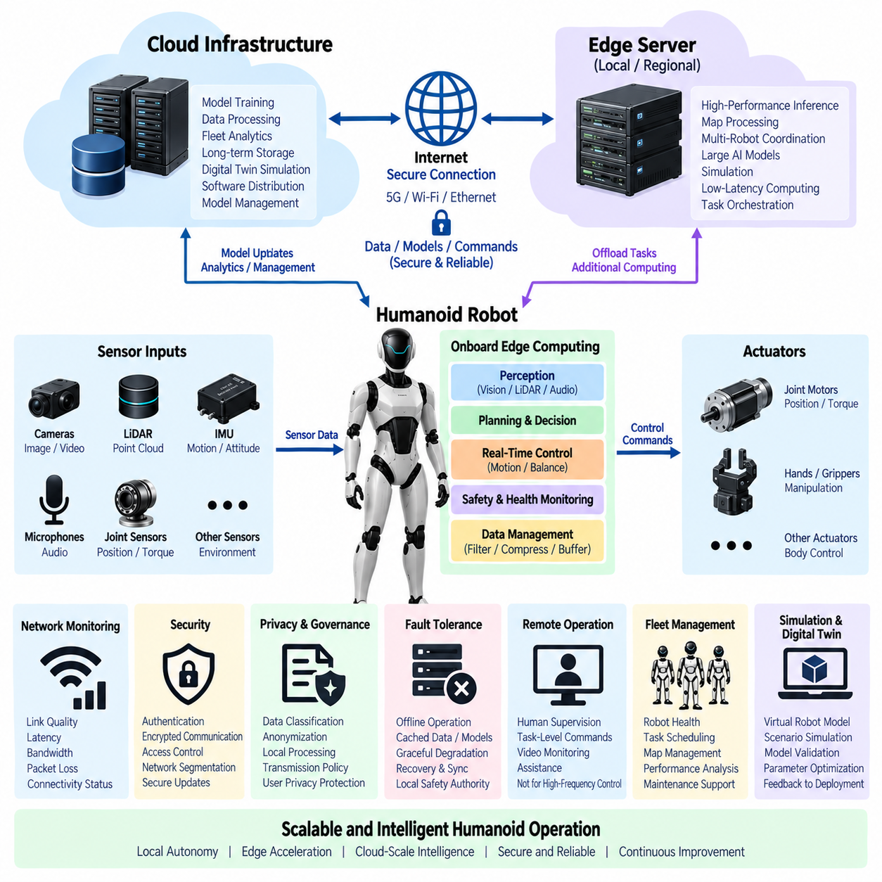
Edge-cloud integration extends the humanoid robot’s computing architecture beyond the processors physically installed in the robot while preserving autonomous local operation. The robot acts as an intelligent edge system that performs latency-sensitive perception, control, planning, and safety functions locally, while remote edge servers or cloud infrastructure provide additional computing, storage, training, analytics, and fleet services. The architecture must define which functions remain onboard and which can safely use external resources without making essential robot operation dependent on network availability.
Local edge computing is responsible for functions that require immediate response or must continue when connectivity is unavailable. Real-time motion control, balance stabilization, actuator protection, essential perception, obstacle avoidance, and basic task execution should therefore remain within the robot. AI accelerators and local CPUs can process sensor data close to its source, reducing communication latency and external bandwidth requirements. This local-first principle ensures that temporary network degradation does not directly cause loss of stability or basic operational capability.
Remote edge computing can provide an intermediate layer between the robot and centralized cloud infrastructure. A nearby server may offer substantially greater GPU capacity while maintaining lower latency than a distant data center. Computationally intensive perception, map processing, simulation, multi-robot coordination, or larger AI models can therefore be executed on a local edge server when communication quality is sufficient. The robot should nevertheless treat remote computation as an additional capability rather than as an unconditional dependency for safety-critical operation.
Cloud infrastructure provides scalable computing and storage resources that are difficult to integrate directly into a mobile humanoid platform. Large-scale model training, dataset processing, fleet analytics, long-term log storage, digital-twin simulation, software distribution, and model management can be performed centrally. Cloud resources can also aggregate experience from multiple robots and produce improved models or policies. Updated artifacts can subsequently be validated, versioned, and deployed back to individual robots through controlled lifecycle-management processes.
The boundary between onboard, edge, and cloud computation should be determined by latency, bandwidth, reliability, power, privacy, and safety requirements. A function with strict millisecond-level timing constraints belongs close to the physical system, while a workload requiring large GPU clusters but tolerating seconds or minutes of delay may be suitable for cloud execution. Intermediate functions can be dynamically assigned to nearby edge resources. Explicit placement policies prevent application developers from unintentionally moving critical functions into infrastructure that cannot guarantee the required availability.
Network connectivity becomes an architectural resource in an edge-cloud system. Ethernet, Wi-Fi, private cellular networks, 5G, or other wireless technologies may connect the robot to local infrastructure and remote services. Available bandwidth can vary significantly as the robot moves through buildings or outdoor environments. The computing architecture should monitor link quality, latency, packet loss, and connectivity state so that applications can adapt their behavior. Large data transfers should not interfere with control-related or operationally important communication.
Data management is particularly important because humanoid robots can generate large volumes of camera images, depth data, LiDAR point clouds, audio, joint states, diagnostics, and AI results. Continuously uploading all raw sensor data may be impractical and unnecessary. The edge architecture can filter, compress, summarize, or select important events before transmission. Local storage can temporarily buffer information during network outages, while upload policies determine which data is retained, transferred, or discarded according to operational, privacy, and engineering requirements.
Edge-cloud integration supports continuous improvement of AI models through a controlled data and model lifecycle. Robots can collect selected operational data and transfer it to centralized infrastructure for labeling, analysis, training, or validation. New perception, language, planning, or behavior models can then be evaluated before deployment. Model updates should include version identification, compatibility checks, integrity verification, staged rollout, and rollback capability. A newly downloaded model should not automatically become operational merely because it has arrived on the robot.
Fleet-level operation is another important benefit of cloud integration. Multiple humanoid robots can report health status, software versions, task progress, resource utilization, and selected environmental information to centralized management services. Fleet systems can distribute tasks, coordinate maintenance, manage maps, monitor failures, and compare performance across robots. However, centralized coordination should not replace local safety authority. Each robot must remain capable of rejecting or modifying remote commands when local conditions indicate that execution would violate safety or operational constraints.
Remote operation and human supervision can also use the edge-cloud architecture. Operators may inspect robot status, review camera feeds, issue task-level commands, or assist when autonomous behavior reaches an uncertain condition. Communication delays make direct remote control unsuitable for many high-frequency actuator functions, so remote interfaces should normally operate at supervisory or task level. Local controllers continue to enforce collision avoidance, joint limits, stability constraints, and emergency behavior even while commands originate from a remote operator.
Security is fundamental because edge-cloud connectivity expands the attack surface of the humanoid system. Communication channels should use authenticated and protected connections, while devices and services should verify the identity and authorization of communicating parties. Software and model updates require integrity checking and controlled installation. Network segmentation can separate safety-critical control domains from external-facing services. Compromise of a cloud account or wireless interface should not provide unrestricted access to actuator commands or disable independent safety mechanisms.
Privacy and data governance should be considered when humanoid robots operate around people. Cameras, microphones, and interaction systems may capture information that should not automatically leave the local platform. Data classification and transmission policies can determine which information remains onboard, which can be anonymized or summarized, and which is permitted to enter centralized storage. Edge processing can reduce privacy exposure by extracting required features locally instead of transmitting continuous raw sensor streams to remote infrastructure.
The architecture must support graceful operation during connectivity loss. When cloud or edge services become unavailable, remote-dependent tasks may pause or operate with reduced capability, while essential local functions continue. Cached maps, local AI models, task state, and necessary configuration information can allow the robot to operate independently for an appropriate period. Once connectivity returns, buffered data and system state can be synchronized carefully. Recovery logic should prevent stale cloud commands from being executed after local conditions have changed.
Observability across onboard, edge, and cloud resources is required to diagnose distributed failures. Monitoring should include local processor utilization, accelerator load, network latency, bandwidth, packet loss, remote service response time, storage status, model versions, and application health. Synchronized timestamps allow events generated across different computing domains to be reconstructed on a common timeline. This makes it possible to determine whether degraded behavior originated from the robot, wireless connection, edge server, cloud service, or application software.
Edge-cloud integration can also support digital twins and simulation-driven development. Operational data from the physical robot can update virtual representations of the robot and its environment, while cloud computing can execute large numbers of simulation scenarios that would be impractical onboard. Simulation results can support model development, parameter optimization, failure analysis, and software validation. The resulting software or AI artifacts should still pass controlled verification before they are introduced into the physical robot.
A scalable humanoid architecture therefore treats onboard computing, nearby edge infrastructure, and centralized cloud resources as complementary layers of one distributed computing system. Safety-critical and latency-sensitive functions remain local, expandable AI workloads can use edge acceleration, and large-scale training, analytics, storage, simulation, and fleet management can use cloud infrastructure. Clear interfaces, adaptive connectivity, secure communication, controlled model deployment, graceful degradation, and local safety authority allow the robot to gain cloud-scale intelligence without sacrificing autonomous and predictable physical operation.

