Volume 21. Humanoid Electrical Architecture

Chapter 16. Case Studies

16.01. Tesla Optimus
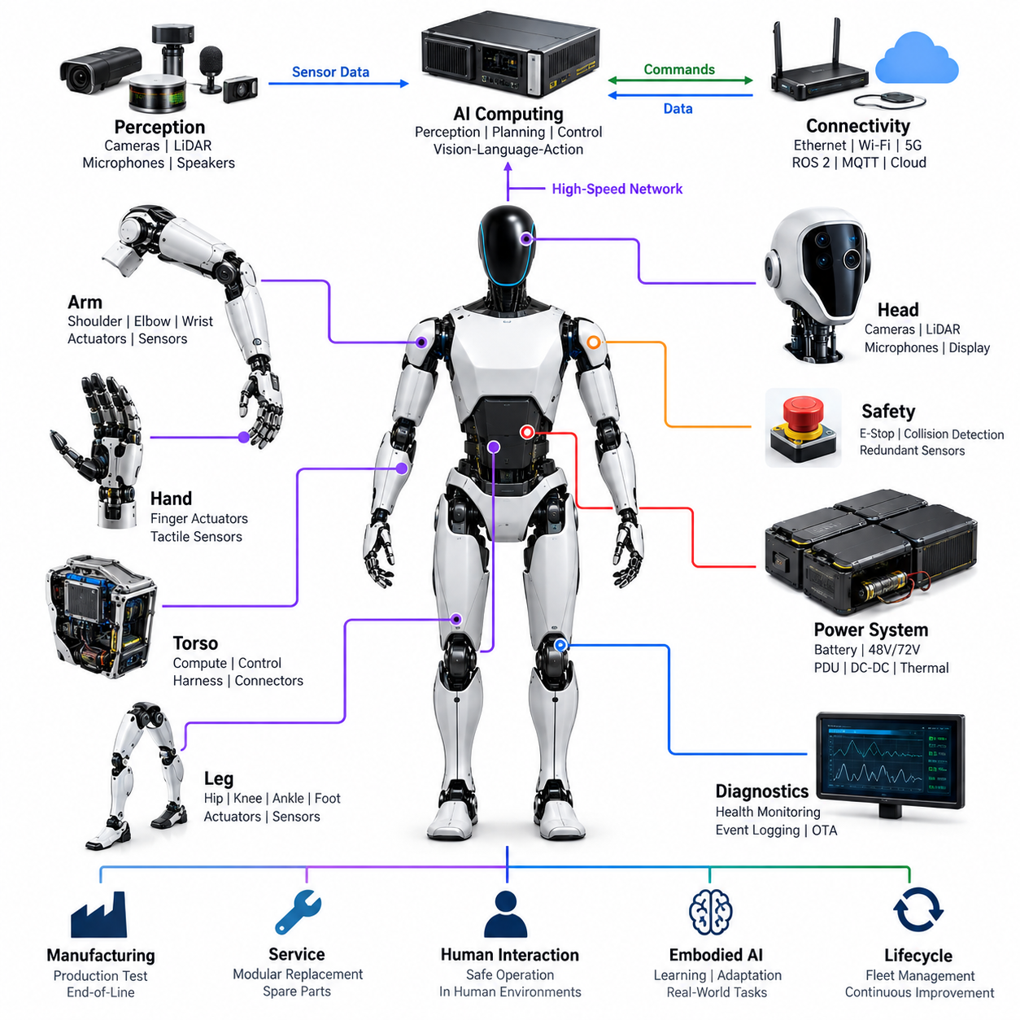
Tesla Optimus represents a humanoid robot architecture optimized for scalable manufacturing, general-purpose manipulation, and operation in environments originally designed for humans. Within the electrical architecture context, it is significant because it combines battery power, distributed joint actuation, perception, high-performance AI computing, communications, and safety functions inside a compact anthropomorphic platform.
The electrical system can be understood as a hierarchy extending from the central energy source to distributed electromechanical modules throughout the torso, arms, hands, legs, and head. Rather than treating every actuator as an independently engineered subsystem, a production-oriented humanoid benefits from reusable joint electronics, common communication interfaces, standardized power connections, and modular control functions that can be replicated across multiple axes.
Power architecture is particularly important because humanoid locomotion produces highly dynamic loads. Walking, lifting, balancing, recovering from disturbances, and manipulating objects can create rapid changes in motor current. The battery, power distribution network, converters, motor drives, protection devices, wiring, and thermal system must therefore support short-duration peak power while maintaining acceptable voltage stability for computers and sensors.
Distributed actuation reduces the need to route every motor phase connection back to a central controller. Motor drives and local sensing can instead be positioned close to joints or integrated into actuator assemblies. Such an arrangement reduces high-current cable length and allows local control loops to operate with deterministic timing. The system-level computer can then command desired position, velocity, torque, or impedance while local electronics execute fast actuator regulation.
Optimus also illustrates the importance of tightly integrating mechanical and electrical joint design. Each major degree of freedom requires a motor, transmission, position feedback, drive electronics, power connection, communication interface, and thermal path. Torque or force information may additionally be derived from dedicated sensing or actuator state estimation. These signals allow the robot to regulate contact forces and coordinate whole-body motion rather than merely commanding geometric joint positions.
The hands impose a different electrical challenge from the larger arm and leg joints. Dexterous manipulation requires multiple compact actuators, position information, force or tactile feedback, and dense routing through a small mechanical volume. Consequently, hand architecture emphasizes miniaturized electronics, flexible interconnects, efficient motor control, low-mass wiring, and high channel density while preserving sufficient sensing for grasp stability and object interaction.
Perception connects the humanoid body to its operating environment. Camera-based sensing is especially important for recognizing objects, estimating geometry, observing human activity, and supporting manipulation. Perception data must be transported to high-performance compute resources with predictable bandwidth and latency. The electrical architecture therefore has to coordinate sensor power, high-speed communication, compute interfaces, synchronization, and physical placement rather than treating cameras as isolated peripherals.
Central AI computing performs functions fundamentally different from the fast servo loops located near actuators. Large perception and learned-control workloads require substantial parallel computation, whereas balance and actuator control demand deterministic low-latency execution. A practical humanoid architecture therefore separates computational responsibilities while allowing information to flow between perception, planning, whole-body control, safety supervision, and distributed joint controllers.
Communication architecture is the nervous system connecting these computational layers. High-bandwidth links are appropriate for cameras and central processors, while deterministic field networks are suitable for coordinated actuator control and distributed I/O. The broader volume structure identifies CAN FD, EtherCAT, Gigabit Ethernet, ROS 2 DDS, MQTT, and PTP as relevant humanoid communication technologies, illustrating the different timing and bandwidth domains that a complete platform may require.
Time synchronization becomes increasingly important as perception and motion control are combined. Camera frames, inertial measurements, joint positions, motor currents, force estimates, and controller states represent a moving physical system and must be correlated accurately. Timestamp errors can appear as spatial or dynamic errors during sensor fusion. A common time base therefore improves state estimation, event reconstruction, diagnostics, learning-data quality, and coordinated control.
Harness engineering is unusually difficult in humanoids because electrical paths repeatedly cross moving joints. Shoulder, elbow, wrist, hip, knee, ankle, neck, and finger motions impose bending, twisting, abrasion, and packaging constraints. The architecture must minimize harness mass while maintaining current capacity and signal integrity. Connector placement must also permit assembly and service without creating excessive mechanical discontinuities inside articulated structures.
Safety architecture must operate independently enough to respond when high-level AI behavior becomes unreliable. Emergency stopping, power isolation, actuator-state supervision, communication watchdogs, sensor plausibility checks, thermal protection, and controlled degradation can form multiple layers of defense. Because a humanoid works close to people, safety is not limited to electrical fault protection; unexpected motion and excessive contact force are also system-level hazards.
Diagnostics are essential because a humanoid contains many interacting electromechanical channels. Useful health information includes motor current, temperature, encoder state, communication quality, battery condition, supply voltage, controller faults, sensor availability, and abnormal mechanical loading. Event logging can correlate these signals across a synchronized timeline, allowing engineers to distinguish electrical failures from mechanical degradation, software faults, environmental effects, and transient operating conditions.
A production humanoid also requires an architecture designed for manufacturing rather than laboratory assembly. Repeated actuator modules, standardized connectors, automated calibration, end-of-line testing, firmware configuration, and traceable component identities can reduce production complexity. This corresponds directly to the volume's progression from joint and body electrical architecture through diagnostics, production testing, modular replacement, spare-parts strategy, and lifecycle management.
Serviceability becomes especially important when large robot fleets are deployed. Replacing an arm, hand, joint module, sensor assembly, battery, or compute unit should ideally require limited disassembly followed by automated identification and calibration. Modular electrical boundaries make this possible. Diagnostic records can further associate component history with operating hours, temperature exposure, fault events, and maintenance actions throughout the robot lifecycle.
Optimus is also an important case study in the convergence of humanoid hardware and embodied AI. Electrical architecture supplies the synchronized sensory observations and controllable physical interfaces required by learned models. Vision, proprioception, actuator state, force interaction, and task commands become inputs to increasingly integrated perception-action systems, while deterministic controllers translate higher-level learned outputs into physically stable and electrically constrained motion.
The resulting design philosophy is therefore broader than selecting motors, batteries, computers, or communication buses independently. A scalable humanoid requires co-design across energy, actuation, sensing, computation, networking, safety, diagnostics, manufacturing, and AI. Tesla Optimus is valuable as a case study because it demonstrates how these traditionally separate engineering domains must converge into a repeatable robotic platform intended for sustained operation in human-centered environments.

16.02. Figure 02
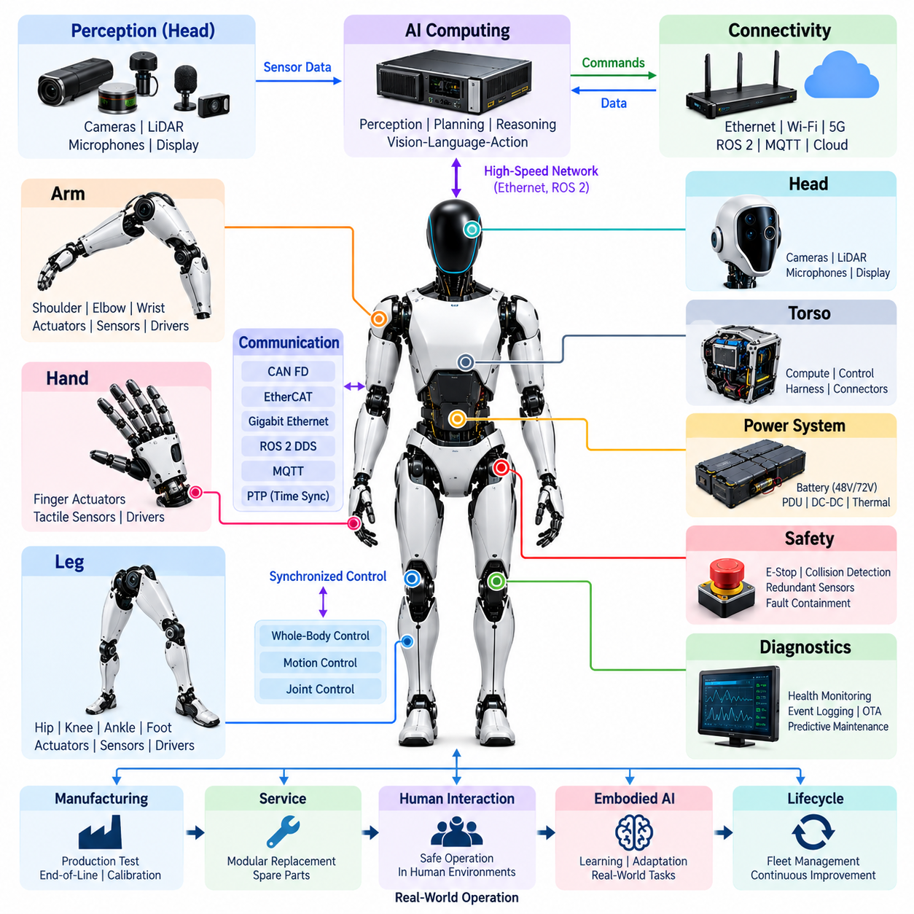
Figure 02 represents a humanoid architecture developed around the idea that general-purpose robots must combine human-scale mechanical capability with perception, reasoning, and learned behavior. Within the humanoid electrical architecture, it is a useful case study because locomotion, manipulation, sensing, computing, power distribution, communications, and safety must operate as one tightly coordinated physical system.
The robot can be viewed as a distributed electromechanical platform organized around the torso, head, arms, hands, and legs. Each region contains different combinations of actuators, sensors, embedded electronics, communication interfaces, and power connections. This modular organization allows high-level computing to coordinate the whole body while local subsystems handle functions requiring faster response and closer interaction with hardware.
Power distribution must accommodate continuously changing loads generated by walking, balancing, reaching, lifting, and grasping. Large joints may demand substantial instantaneous power, while cameras, computers, communication devices, and low-level controllers require stable supply rails. The electrical design must therefore coordinate battery energy, power conversion, protection, distribution, thermal limits, and transient behavior across the entire body.
Joint modules form the physical foundation of humanoid motion. Hip, knee, ankle, shoulder, elbow, and wrist actuators require motor drives, position feedback, current measurement, communication, and local protection. Their controllers must execute commands with sufficiently low latency to support coordinated movement. Position, velocity, torque, and estimated load information can then be exchanged with higher-level controllers responsible for posture and whole-body behavior.
The leg architecture is especially demanding because locomotion depends on rapid interaction between actuator control and body-state estimation. Hip, knee, and ankle modules must cooperate with inertial sensing and foot-related measurements to maintain balance. Electrical latency, sensor synchronization, motor-drive response, and communication determinism therefore directly affect the robot's ability to walk, stop, recover from disturbances, and adapt to changing contact conditions.
The arm architecture introduces another combination of precision and dynamic control. Shoulder and elbow joints provide the major workspace, while wrist mechanisms orient the hand for manipulation. Electrical integration must deliver power and deterministic control through articulated structures without excessive harness mass. Joint sensing also contributes to collision detection, force regulation, manipulation accuracy, and coordinated motion between the arms and torso.
Figure 02 places particular emphasis on manipulation, making hand electrical architecture a critical subsystem. A dexterous hand requires multiple compact actuators together with position, force, or tactile sensing channels. Dense wiring and limited packaging volume increase the importance of compact motor drives, flexible harnesses, lightweight connectors, distributed electronics, and efficient local processing for grasping and controlled interaction with objects.
The head and perception subsystem provides information about the external world. Camera systems supply visual observations used for object recognition, scene understanding, human interaction, navigation, and manipulation. Perception hardware must be connected to computing resources through interfaces capable of supporting high data rates while maintaining synchronization with robot motion, joint states, and other time-sensitive sensor information.
High-performance AI computing converts perception into useful representations, plans actions, and supports learned robot behavior. However, AI inference and deterministic motor control have different computational requirements. A practical architecture therefore separates high-level perception and reasoning from hard real-time control while establishing interfaces through which goals, trajectories, state estimates, safety conditions, and actuator commands can be exchanged reliably.
This separation creates a hierarchical control structure. High-level AI can determine what action should be performed, a motion layer can determine how the body should execute it, and distributed controllers can regulate individual actuators. Such partitioning prevents large AI workloads from directly determining every motor-control cycle and provides clearer boundaries between learned behavior, motion generation, real-time execution, and hardware protection.
Communication networks connect these layers into a coherent robot. High-bandwidth networking supports cameras and compute-intensive perception, while deterministic communication is needed for coordinated actuator control and distributed sensing. The surrounding volume identifies CAN FD, EtherCAT, Gigabit Ethernet, ROS 2 DDS, MQTT, and PTP as relevant communication and synchronization technologies for humanoid architecture, each addressing different system-level requirements.
Accurate time synchronization is important because the robot must interpret sensor measurements while its body is continuously moving. Camera observations, inertial data, joint positions, motor currents, contact information, and control commands need consistent timestamps. A synchronized architecture improves sensor fusion, state estimation, motion reconstruction, diagnostic analysis, learning-data generation, and the ability to associate physical events with software decisions.
Harness and connector engineering strongly influence humanoid reliability. Cables must pass through joints that repeatedly rotate, bend, and change configuration while carrying both power and communication signals. Harness design must therefore consider flex life, strain relief, electromagnetic compatibility, routing clearance, connector retention, service access, and mechanical interference while minimizing weight that would otherwise increase actuator energy consumption.
Safety requires supervision across both hardware and software domains. Unexpected motion, excessive contact force, communication loss, sensor failure, motor-drive faults, overheating, or power abnormalities can create hazardous conditions. Emergency-stop functions, watchdog mechanisms, redundant sensing, collision detection, controlled shutdown, and fault containment provide layers that can restrict or stop motion when normal control behavior can no longer be trusted.
Diagnostics extend this supervision into operation and maintenance. Temperatures, motor currents, encoder status, communication errors, battery condition, controller faults, sensor health, and software events can be recorded as synchronized operational data. Event logging and health monitoring help engineers reconstruct failures and identify whether abnormal behavior originated from an actuator, sensor, electrical connection, communication path, compute subsystem, or software component.
Manufacturing architecture is equally important when humanoids move from prototypes toward repeated production. Modular joints, standardized interfaces, production testing, end-of-line verification, calibration, firmware provisioning, and component traceability reduce variation between robots. The volume structure explicitly connects these concerns with production test, end-of-line test, field service, modular replacement, spare-parts strategy, and lifecycle management.
Figure 02 is ultimately valuable as an embodied AI case study because intelligence cannot be separated from the electrical and mechanical platform that executes it. Learned perception and action depend on reliable sensors, synchronized data, responsive actuators, deterministic low-level control, adequate energy, and safe physical interaction. The robot therefore demonstrates how AI capability must be supported by disciplined system engineering throughout the body.
From an electrical architecture perspective, the key lesson is integration. A capable humanoid is not created simply by combining powerful motors with a large AI computer. Power, actuation, sensing, networking, real-time control, AI computing, safety, diagnostics, harnessing, manufacturing, and service must be co-designed as interacting layers. Figure 02 provides a practical reference case for understanding how these domains converge in a general-purpose humanoid platform.

16.03. Agility Digit
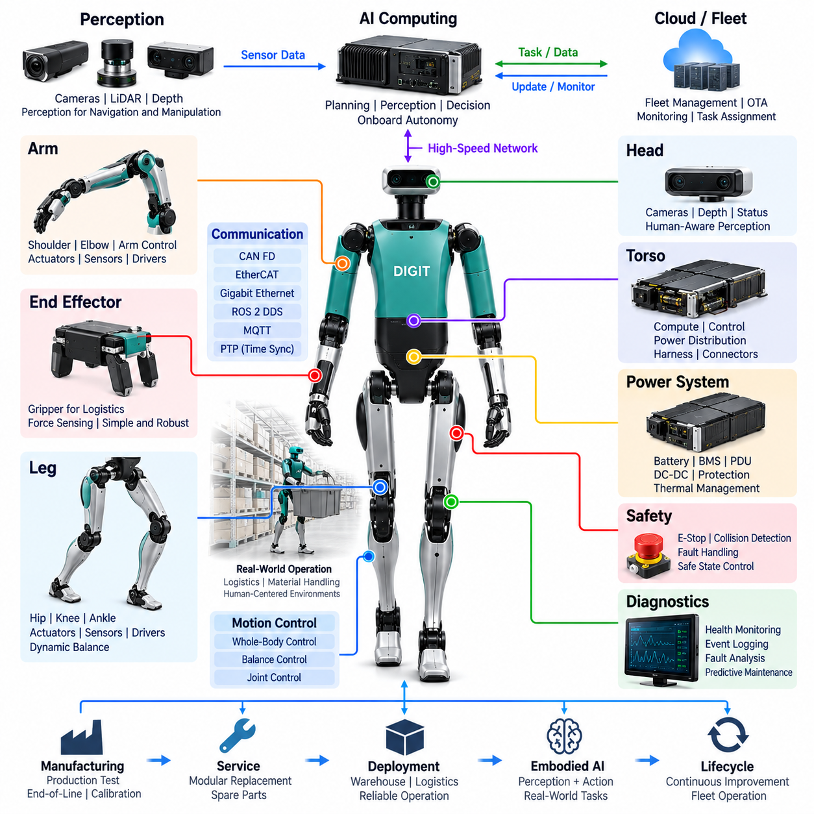
Agility Robotics Digit represents a humanoid platform developed specifically around practical mobility, material handling, and operation in human-designed logistics environments. Within humanoid electrical architecture, Digit is particularly valuable because its design emphasizes reliable locomotion and useful manipulation rather than reproducing human anatomy exactly. The resulting system integrates distributed actuation, perception, computing, power, communication, and safety around operational tasks.
Digit demonstrates how humanoid architecture can be optimized for a defined industrial mission. Its body proportions, leg configuration, arms, sensing system, and computing resources support movement through spaces designed for people while allowing interaction with containers and other objects. From an electrical perspective, this requires coordinated power and data distribution across a highly articulated machine that repeatedly changes posture while walking, turning, reaching, and handling loads.
The power architecture must support large variations in electrical demand. Locomotion creates cyclic loads as the legs accelerate, support body weight, and control ground contact, while manipulation adds simultaneous demand from the upper body. Battery output, power distribution, conversion stages, motor drives, protection circuits, and thermal management must therefore operate as one coordinated energy system rather than as independent electrical subsystems.
Digit's leg architecture is a defining element of the platform. Multiple actuated joints must cooperate to maintain dynamic balance while allowing the robot to walk through warehouses and logistics facilities. Motor drives require rapid current regulation and accurate position feedback, while joint states must be communicated to higher-level controllers with predictable timing. Electrical performance consequently becomes directly connected to mechanical stability and locomotion quality.
Balance control requires information extending beyond individual joint positions. Inertial sensing, actuator feedback, body-state estimation, and contact-related information must be combined to estimate the robot's motion relative to the environment. These measurements are meaningful only when their timing relationships are sufficiently accurate. Sensor synchronization and deterministic communication therefore contribute directly to stable locomotion, disturbance rejection, and controlled transitions between movement states.
The arm architecture supports manipulation while also influencing whole-body dynamics. Shoulder, elbow, and other arm actuators require coordinated motion when reaching toward objects, carrying loads, or placing containers. Because moving an object changes the robot's mass distribution and dynamic state, manipulation cannot be treated independently from balance. Electrical and control architectures must consequently connect upper-body commands with locomotion and posture-control functions.
Digit's end-effector strategy illustrates an important engineering tradeoff between dexterity and task specialization. Industrial material handling does not always require a highly anthropomorphic hand containing many independently controlled fingers. Reducing actuator count and mechanical complexity can decrease wiring, motor-drive channels, control complexity, weight, and maintenance requirements while still providing sufficient manipulation capability for targeted logistics tasks.
Perception provides the environmental information required to navigate and manipulate safely. Sensors must support detection of obstacles, identification of relevant workspace geometry, localization of objects, and interpretation of areas shared with people or equipment. Their electrical integration includes regulated power, communication bandwidth, mechanical mounting, timestamping, diagnostics, and interfaces to the perception computer responsible for transforming sensor measurements into usable environmental representations.
Computing architecture must serve several different timing domains simultaneously. Perception and autonomous decision-making may require substantial processing resources, while balance and joint control demand predictable low-latency execution. A hierarchical approach allows higher-level autonomy to select tasks and motion objectives while real-time controllers maintain stable body behavior. This separation prevents computationally intensive perception workloads from compromising critical actuator-control timing.
Communication architecture connects sensors, computers, controllers, and actuator electronics into a distributed cyber-physical system. High-bandwidth data paths are useful for perception, whereas deterministic networks are more appropriate for tightly coordinated motion. The broader humanoid architecture described in this volume includes CAN FD, EtherCAT, Gigabit Ethernet, ROS 2 DDS, MQTT, and PTP, illustrating the different communication and synchronization domains that can coexist within advanced humanoid systems.
Harness engineering becomes difficult because power and data cables must pass through a body designed for continuous movement. Leg and arm harnesses experience repeated bending and changing mechanical geometry during every operating cycle. Routing must account for flex life, minimum bend radius, abrasion, strain relief, electromagnetic compatibility, connector retention, and service access while minimizing cable mass and avoiding interference with moving mechanical components.
Safety architecture is particularly important for a robot intended to operate in logistics facilities near people and industrial equipment. Potential hazards include unexpected movement, loss of balance, excessive contact force, actuator faults, sensor degradation, communication failures, and electrical abnormalities. Safety supervision must therefore observe both motion and hardware conditions and provide mechanisms for stopping, restricting, or transitioning robot behavior when acceptable operating conditions are lost.
Fault handling should also recognize that stopping a legged robot differs from stopping a stationary machine. Removing actuator power without considering posture can itself create undesirable motion or loss of balance. A humanoid safety strategy therefore benefits from coordinated fault responses that consider actuator state, body configuration, available sensing, communication status, and the severity of the detected fault before transitioning toward a safe condition whenever circumstances permit.
Diagnostics provide the information required to maintain this complex distributed platform. Motor current, drive temperature, encoder state, battery condition, communication errors, sensor availability, processor status, and software events can be continuously monitored. Time-correlated event records allow engineers to reconstruct failures and distinguish between mechanical loading, electrical faults, sensor problems, communication disturbances, thermal limitations, and higher-level software behavior.
Digit is especially relevant as a manufacturing and service case study because commercial logistics deployment requires more than successful demonstrations. Robot availability depends on production testing, end-of-line verification, component traceability, field diagnostics, modular replacement, spare-parts management, and lifecycle support. These concerns correspond directly to the manufacturing and service topics preceding the case-study chapter in the volume structure.
Fleet operation adds another architectural dimension. Multiple robots working within logistics facilities require task assignment, operational monitoring, software management, diagnostic reporting, and coordination with external automation systems. Cloud or facility-level services can support these functions, while safety-critical and real-time control should remain available locally. This creates a layered architecture extending from individual joint controllers through onboard autonomy to fleet-level infrastructure.
Digit also demonstrates an important principle of embodied AI: useful intelligence emerges from the interaction between computation and a body engineered for real-world tasks. Perception algorithms cannot compensate indefinitely for unreliable sensing, and sophisticated planning cannot produce useful work without responsive actuators and stable locomotion. Mechanical design, electrical architecture, real-time control, and AI therefore become mutually dependent components of the complete robotic capability.
From an electrical architecture perspective, the major lesson from Digit is task-oriented integration. Humanoid engineering does not require every platform to duplicate the human body or maximize every technical capability. Power, actuation, sensing, computing, communication, safety, diagnostics, and serviceability should instead be co-designed around the operational mission. Digit provides a valuable reference for understanding how this principle can shape an industrial humanoid intended for sustained real-world deployment.

16.04. Apptronik Apollo
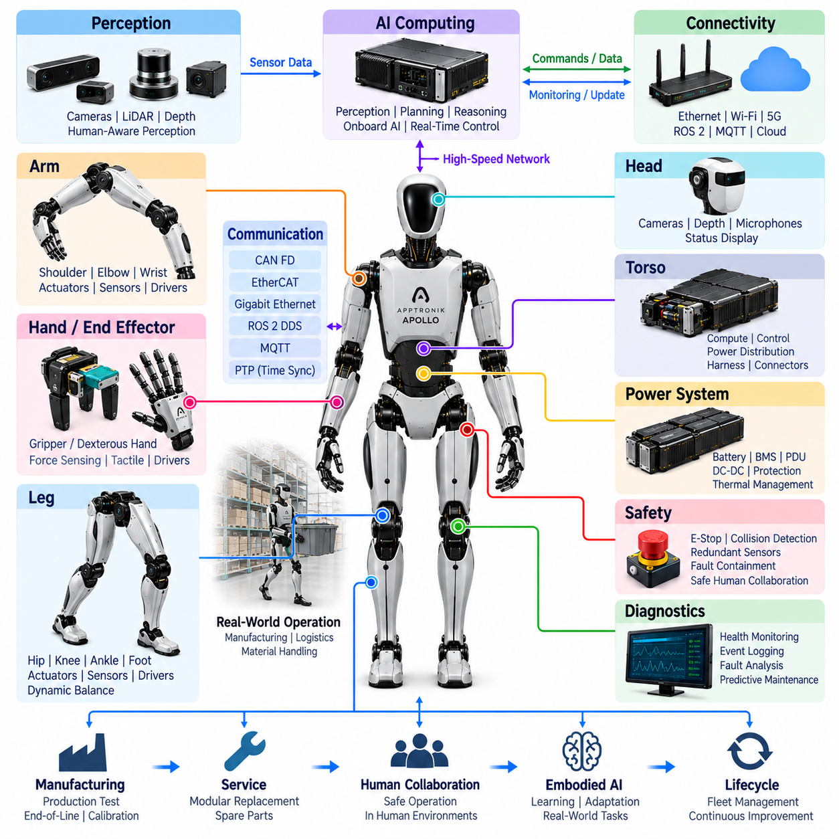
Apptronik Apollo represents an industrial humanoid architecture developed around safe human collaboration, modularity, practical manipulation, and deployment in manufacturing and logistics environments. Within humanoid electrical architecture, Apollo is valuable because it demonstrates how power, actuation, perception, computing, communication, safety, diagnostics, and serviceability can be integrated around repetitive real-world work rather than laboratory performance alone.
The platform can be understood as a distributed electromechanical system organized around the torso, head, arms, hands, and legs. Each body region combines actuators, sensing, local electronics, power interfaces, and communication links according to its functional requirements. A modular architecture allows these subsystems to be developed and serviced independently while still participating in coordinated whole-body control and centralized autonomous decision-making.
Power architecture is fundamental because humanoid motion creates rapidly varying electrical loads. Walking, maintaining posture, reaching, lifting, and carrying objects may activate many joints simultaneously. The battery and distribution system must therefore supply both sustained energy and transient power while maintaining stable voltage for computers and sensors. Protection, conversion, thermal monitoring, and fault isolation become integral parts of the energy architecture.
Apollo's actuator architecture illustrates the importance of designing joints as integrated mechatronic modules. A practical joint combines an electric motor, transmission, position feedback, motor drive, current sensing, thermal monitoring, communication, and mechanical interfaces. Standardizing these functions across multiple joints can simplify manufacturing and diagnostics while allowing local control loops to execute faster than higher-level whole-body and AI control processes.
Leg electrical architecture must support both body weight and dynamic balance. Hip, knee, and ankle actuation works together with inertial and joint-state sensing to estimate posture and regulate movement. The control system must react rapidly to changes in load and contact conditions while maintaining predictable communication timing. Consequently, motor-drive response, sensor accuracy, network latency, and synchronization directly influence locomotion stability.
The upper-body architecture is optimized around useful industrial manipulation. Shoulder, elbow, wrist, and end-effector functions must coordinate when the robot reaches toward a workstation, receives an object, carries material, or places a component. Arm motion also changes the body's center of mass, so manipulation commands must be coordinated with posture and balance rather than executed as an isolated robotic-arm process.
End-effector design introduces a balance between dexterity, robustness, payload, and complexity. Industrial applications may benefit from hands or grippers that provide sufficient object interaction without maximizing the number of independently actuated fingers. Fewer actuators can reduce wiring, power consumption, drive electronics, weight, and failure points. The electrical interface should nevertheless support sensing required for reliable grasping and controlled contact.
Perception architecture provides the information needed to work safely in human-centered environments. Cameras and other sensing devices can observe objects, workspaces, people, obstacles, and robot motion. These devices require regulated power, reliable high-bandwidth communication, mechanical alignment, timestamps, and health monitoring. Perception data must then be transformed by onboard computing into environmental representations suitable for navigation and manipulation.
Apollo also illustrates the need for hierarchical computing. AI-oriented processors can perform perception, planning, task reasoning, and learned behavior, while real-time controllers execute balance and actuator regulation. Separating these timing domains prevents computationally intensive AI workloads from directly interfering with critical servo loops. Clearly defined interfaces connect task goals, motion commands, state estimates, safety information, and low-level actuator states.
Whole-body control provides the bridge between high-level task commands and distributed joint execution. Instead of treating each limb independently, the controller considers the coordinated state of the robot when generating movement. This is particularly important during material handling because arm forces, payload mass, body posture, and foot support interact dynamically. Electrical architecture must provide synchronized sensor and actuator information to support this coordination.
Communication networks form the data backbone connecting distributed electronics. High-speed links are suitable for perception and central computing, while deterministic communication is important for coordinated actuators and time-sensitive sensing. The surrounding humanoid architecture in this volume includes CAN FD, EtherCAT, Gigabit Ethernet, ROS 2 DDS, MQTT, and PTP, illustrating how multiple communication domains may coexist according to bandwidth, latency, synchronization, and system-level requirements.
Time synchronization becomes critical when sensor observations and actuator states describe a continuously moving robot. Camera frames, inertial measurements, encoder positions, motor currents, force information, and control events should share a consistent temporal reference. Accurate timestamping improves state estimation, sensor fusion, event reconstruction, diagnostics, learning-data generation, and analysis of interactions between software decisions and physical responses.
Harness and connector architecture must accommodate continuous articulation while remaining suitable for industrial service. Cables routed through shoulders, elbows, wrists, hips, knees, ankles, and the torso experience repeated bending and movement. Harness engineering must therefore consider flex life, bend radius, strain relief, electromagnetic compatibility, connector retention, abrasion protection, assembly sequence, service access, and the effect of wiring mass on robot efficiency.
Human-robot safety is central to an industrial humanoid intended to share workspaces with people. Unexpected motion, excessive contact force, loss of balance, communication faults, sensor failures, motor-drive abnormalities, or overheating may create hazardous situations. Safety architecture can combine emergency stopping, collision detection, redundant or diverse sensing, watchdogs, power supervision, fault containment, and controlled transitions toward safe operating states.
Diagnostics transform the distributed electrical system into an observable and maintainable platform. Motor currents, temperatures, encoder conditions, communication errors, battery health, sensor availability, processor status, power faults, and software events can be monitored and logged. When these records use synchronized timestamps, engineers can reconstruct abnormal behavior and distinguish electrical failures from mechanical, thermal, communication, sensing, or software-related causes.
Apollo's modular philosophy is particularly relevant to manufacturing and field service. Commercial robots must eventually be assembled, calibrated, tested, repaired, and upgraded efficiently. Standardized electrical interfaces and replaceable modules can reduce service time and production variability. This aligns with the volume's manufacturing structure covering production test, end-of-line test, field service, modular replacement, spare-parts strategy, and lifecycle management.
Industrial deployment also requires integration beyond the individual robot. Apollo-class humanoids may exchange task information, status, diagnostic data, and software packages with facility or fleet systems. Local control should retain the functions required for safe real-time operation, while higher-level infrastructure can support scheduling, monitoring, analytics, software distribution, and fleet optimization. This creates an architecture extending from joint electronics to enterprise-level automation.
From an embodied AI perspective, Apollo demonstrates that intelligent behavior depends on the quality of the physical platform beneath the AI models. Reliable perception requires stable sensors and synchronization, while learned manipulation requires responsive actuators and accurate state feedback. AI, real-time control, electrical hardware, mechanical design, and safety therefore form an interconnected system rather than independent technology layers.
The primary electrical-architecture lesson from Apollo is modular industrial integration. A useful humanoid must combine adequate performance with reliability, maintainability, safety, manufacturability, and operational efficiency. Power, joints, sensing, computing, networking, diagnostics, harnessing, and service boundaries should therefore be co-designed around deployment requirements. Apollo provides a valuable case study of how humanoid architecture can evolve toward practical participation in human-centered industrial workflows.

16.05. Unitree H1/G1
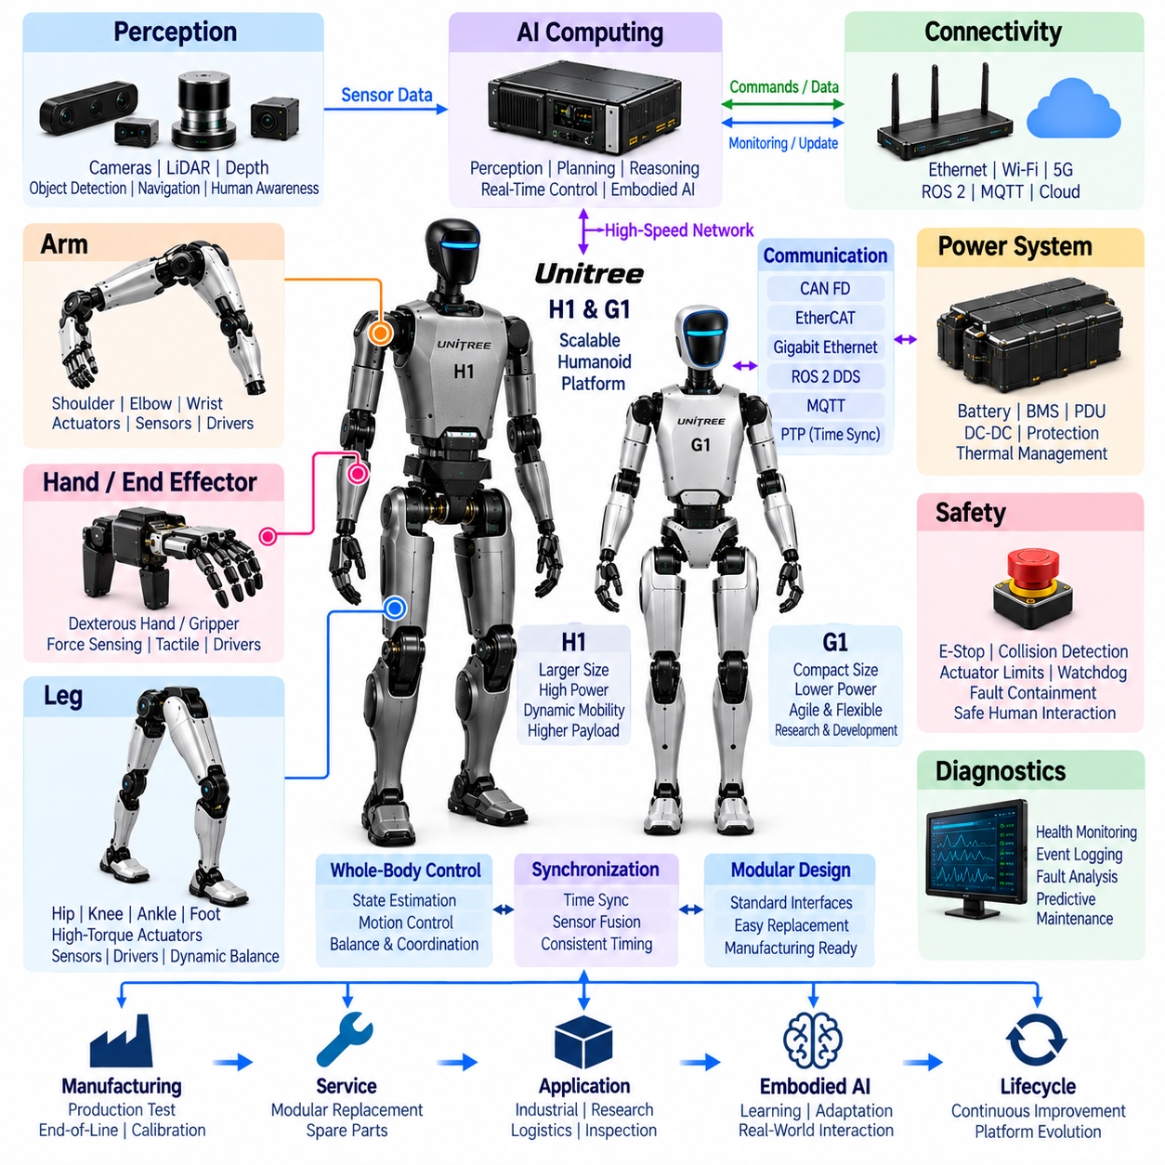
Unitree H1 and G1 represent two complementary approaches to humanoid robotics within a common emphasis on high-performance electric actuation, dynamic mobility, integrated perception, and accessible development. As case studies in humanoid electrical architecture, they illustrate how different body scales and application targets influence joint power, battery capacity, computing resources, sensor integration, communication, harness design, safety, and system modularity.
H1 is positioned around a larger humanoid form in which powerful lower-body actuation and dynamic locomotion are major architectural drivers. G1 uses a smaller and more compact platform that reduces overall mass and energy requirements while providing a practical basis for manipulation, embodied AI research, and development. Comparing the two demonstrates how electrical architecture must scale with mechanical dimensions, actuator loading, payload expectations, and intended operating scenarios.
The power architecture begins with the relationship between battery capability and actuator demand. Walking, accelerating, recovering balance, changing direction, and manipulating objects create rapidly varying electrical loads. Larger joints generally require higher peak power, while processors and sensors need stable regulated supplies. Battery management, power distribution, DC-DC conversion, protection, wiring, connectors, and thermal supervision must therefore be designed as a coordinated energy system.
H1 emphasizes the electrical demands associated with high-torque dynamic joints. Hip, knee, and ankle actuators must generate substantial forces while repeatedly accelerating and decelerating the robot's body. Motor drives require fast current regulation, accurate rotor or joint-position feedback, temperature monitoring, and protection against abnormal electrical conditions. The quality of these local control functions directly influences locomotion bandwidth, stability, efficiency, and mechanical stress.
G1 demonstrates how compact humanoid architecture can reduce some absolute power requirements while increasing packaging density. Smaller limbs and joints permit lower total mass, but motors, drives, sensors, wiring, and structural elements must fit into tighter spaces. Electrical design therefore becomes strongly dependent on component integration, thermal paths, connector size, harness flexibility, electromagnetic compatibility, and the ability to service densely packaged modules.
For both platforms, leg control requires more than independent joint regulation. Joint positions, velocities, motor currents, inertial measurements, and contact-related information contribute to whole-body state estimation. These signals must be sampled and transported with sufficiently consistent timing for balance control. Deterministic communication and synchronized measurements allow the controller to coordinate multiple actuators as one dynamic system rather than as unrelated motor axes.
Upper-body architecture expands the platform from locomotion toward interaction with the physical world. Shoulder, elbow, and wrist joints require coordinated electrical and control interfaces, while hand or end-effector systems introduce additional actuator and sensor channels. Manipulation also changes the robot's mass distribution, making arm motion relevant to balance. Whole-body control must consequently connect upper-body trajectories with leg and posture regulation.
Dexterous manipulation increases electrical complexity significantly. Multiple compact actuators may be combined with position, force, or tactile sensing, creating dense concentrations of motor-drive channels and communication interfaces near the hands. A scalable architecture benefits from modular local electronics that aggregate sensor information and execute fast control functions before exchanging higher-level state and command information with central computing resources.
Perception architecture supplies environmental information for locomotion, manipulation, and embodied intelligence. Cameras, depth sensing, LiDAR, or related sensors can provide observations of geometry, obstacles, objects, and people. Their integration requires regulated power, sufficient data bandwidth, accurate mechanical mounting, timestamps, diagnostics, and high-performance processing. Sensor architecture must therefore be considered together with networking and compute placement.
Computing is divided naturally between real-time control and AI-oriented processing. Joint regulation and balance require deterministic execution, whereas perception, learned policies, vision-language models, and higher-level planning can demand substantial parallel computation. Separating these domains protects critical motion-control timing while allowing increasingly sophisticated AI workloads to operate on the same robot. Defined interfaces connect state estimation, motion generation, autonomy, and actuator execution.
Communication architecture forms the nervous system linking these distributed resources. Motor controllers require low-latency exchanges, perception sensors require higher bandwidth, and software components may use middleware-oriented communication. The broader volume structure includes CAN FD, EtherCAT, Gigabit Ethernet, ROS 2 DDS, MQTT, and PTP, providing representative technologies for different communication, integration, and synchronization layers in a humanoid platform.
Time synchronization is particularly important for dynamic robots because measurement errors can quickly become control errors. Camera frames, inertial measurements, joint positions, motor currents, and contact events describe different aspects of the same physical motion. A common temporal reference improves sensor fusion, state estimation, learning-data collection, motion reconstruction, diagnostics, and analysis of the relationship between AI decisions and resulting physical behavior.
Harness architecture must accommodate continuous motion through the neck, shoulders, elbows, wrists, hips, knees, ankles, and potentially dexterous hands. Cables experience repeated bending, twisting, vibration, and changing clearance. Engineering considerations include flex life, conductor sizing, voltage drop, shielding, electromagnetic compatibility, strain relief, connector retention, abrasion resistance, routing, and serviceability while keeping mass low enough to avoid unnecessary actuator load.
Safety becomes increasingly important as dynamic performance rises. A humanoid capable of rapid motion can generate significant kinetic energy, so abnormal commands, communication failures, sensor faults, excessive joint loads, overheating, or loss of balance require controlled responses. Emergency stopping, collision detection, actuator limits, watchdogs, power supervision, redundant sensing, and fault containment can provide independent layers that prevent a single failure from producing uncontrolled behavior.
Diagnostics provide visibility into the condition of the distributed electrical system. Motor current, drive temperature, encoder status, battery voltage, communication errors, sensor availability, processor load, power faults, and software events can be monitored continuously. Synchronizing these records makes it possible to distinguish mechanical overload from electrical faults, thermal limitations, sensor degradation, communication disturbances, and software-related abnormalities.
H1 and G1 are also useful examples of how manufacturing objectives affect humanoid architecture. Reusable actuator concepts, standardized electrical interfaces, common communication mechanisms, calibration procedures, production testing, and firmware management can reduce complexity across a product family. Modular replacement further allows defective joints, sensors, compute modules, or other assemblies to be serviced without rebuilding the complete robot.
The comparison is especially relevant to embodied AI development because platform scale affects experimentation. A smaller robot can provide a practical environment for collecting interaction data and developing learned behaviors, while a larger platform can explore tasks requiring different reach, force, mobility, and physical capability. In both cases, AI performance remains dependent on reliable sensing, synchronized state information, responsive actuators, and predictable real-time control.
From an electrical architecture perspective, the central lesson of H1 and G1 is scalable integration. Humanoid design is not simply a matter of enlarging or shrinking the same electrical system. Changes in body scale alter peak power, thermal density, wiring, actuator loading, compute packaging, mechanical dynamics, safety risk, and service requirements. H1 and G1 therefore provide complementary reference cases for understanding how modular electrical architecture can support multiple humanoid classes within a broader Physical AI platform strategy.

16.06. Future Humanoid Architecture
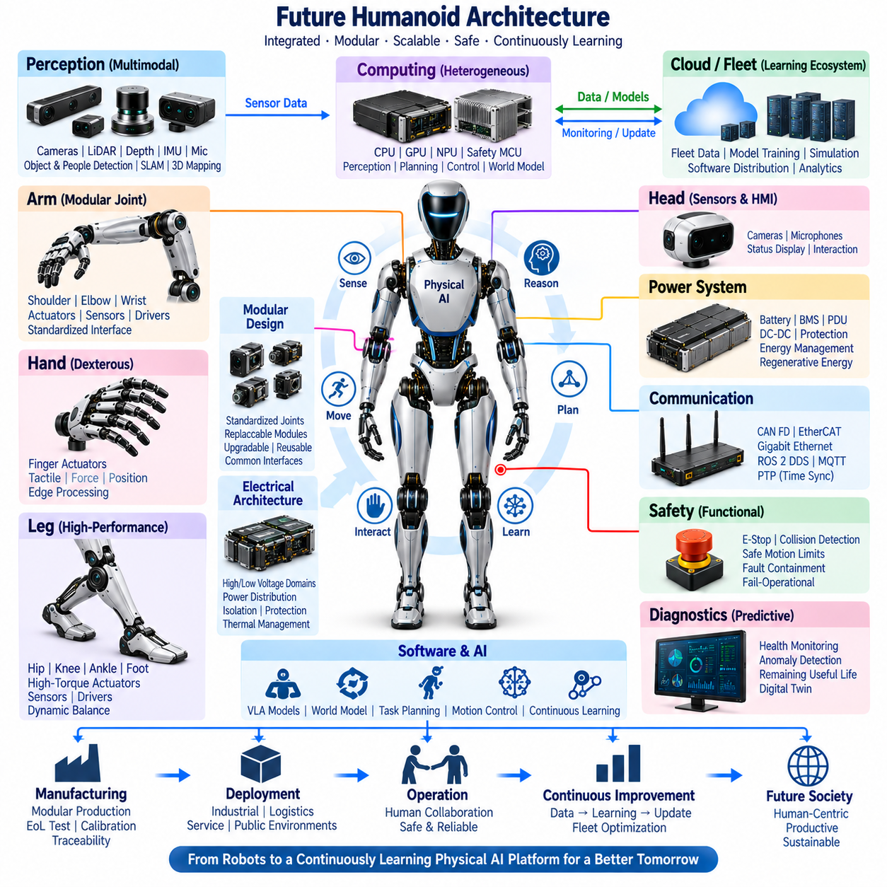
Future humanoid architecture is expected to evolve from collections of specialized subsystems into tightly integrated Physical AI platforms in which power, actuation, sensing, computing, communication, safety, diagnostics, and embodied intelligence are designed together. The architecture will increasingly treat the humanoid body as a distributed cyber-physical system whose electrical structure must support continuous perception, reasoning, motion, interaction, learning, and adaptation.
A major architectural direction will be stronger modularization at the body and joint levels. Arms, legs, hands, head assemblies, battery modules, compute units, and actuator modules can use standardized electrical and mechanical boundaries. Such modularity can reduce development complexity while enabling replacement, upgrade, calibration, and reuse across different humanoid platforms. Common interfaces may eventually support configurable product families rather than individually engineered robots.
Power architecture will move toward higher energy density, improved peak-power capability, and more intelligent distribution. Future humanoids must simultaneously supply high-current actuators and sensitive computing and perception electronics. Distributed power management, smart PDUs, bidirectional converters, electronic protection, regenerative energy handling, and detailed energy telemetry can allow the robot to dynamically allocate power according to locomotion, manipulation, thermal conditions, and remaining battery capacity.
Voltage architecture may also become increasingly segmented. High-power actuator domains can operate at higher voltages to reduce conductor current and harness mass, while lower-voltage rails support sensors, controllers, communication devices, and auxiliary electronics. Isolation, grounding, fault containment, precharge, discharge, and power-state coordination will therefore become system-level design functions rather than simple electrical implementation details.
Actuator modules are likely to become highly integrated intelligent nodes. Motors, transmissions, encoders, torque sensing, temperature sensing, motor drives, local processors, communication interfaces, and diagnostic functions can be packaged into repeatable joint units. Local controllers will execute high-bandwidth current, torque, position, and impedance loops while publishing standardized state information to whole-body controllers and receiving coordinated motion objectives.
Future hands will push this distributed architecture further because dexterous manipulation requires exceptional actuator and sensor density. Finger motors, tactile arrays, force sensing, position sensing, and local control electronics must operate within severe volume and mass constraints. Edge processing inside the hand can compress tactile information, detect contact events, estimate grasp conditions, and execute fast reflex-like responses before forwarding higher-level representations to central embodied AI systems.
Perception architecture will increasingly become multimodal and body-wide. Cameras, depth sensors, LiDAR, inertial sensors, joint encoders, tactile arrays, force sensors, microphones, and potentially additional proximity or environmental sensors will collectively represent the robot and its surroundings. Instead of processing each modality independently, future systems will require synchronized sensor fabrics that provide temporally coherent information for unified world and body models.
Computing architecture will likely develop into a heterogeneous hierarchy. Safety controllers and real-time processors will execute deterministic functions, while CPUs, GPUs, NPUs, and other AI accelerators handle perception, world modeling, language understanding, planning, and learned control. Workloads can be partitioned according to latency, criticality, computational intensity, and energy consumption, allowing powerful AI capability without sacrificing deterministic physical control.
The separation between perception, planning, and control may gradually become less rigid at higher computational layers. Vision-language-action models, world models, foundation models, and agent architectures can combine visual observations, language instructions, robot state, memory, and action generation. Nevertheless, deterministic motion and safety layers will remain essential interfaces between probabilistic AI outputs and the physical actuators that can generate significant forces in human environments.
Communication architecture must support this heterogeneous computational structure. Deterministic networks will carry time-sensitive actuator and sensor traffic, while high-speed Ethernet-class networks will transport perception and AI data. Middleware and service-oriented communication will connect software components, edge systems, and external infrastructure. The volume's CAN FD, EtherCAT, Gigabit Ethernet, ROS 2 DDS, MQTT, and PTP structure provides representative building blocks for these different communication domains.
Time synchronization will become a fundamental infrastructure service rather than an optional sensor feature. A future humanoid may produce thousands of distributed measurements and control events across its body. Accurate common time allows camera frames, tactile events, inertial measurements, joint states, motor currents, AI decisions, and safety events to be reconstructed consistently, improving sensor fusion, control, diagnostics, training-data quality, and digital-twin fidelity.
Harness architecture will evolve toward lighter, more modular, and more distributed designs. Higher distribution voltages can reduce conductor size, while local electronics can decrease the number of signals routed through moving joints. High-speed serial communication, compact connectors, flexible circuits, optimized grounding, and zonal distribution can reduce harness complexity. Digital electrical-interface definitions can further support automated design, manufacturing, validation, and service.
Functional safety will need to address increasingly autonomous and adaptive behavior. Traditional protection against electrical and actuator faults will remain necessary, but future safety architectures must also supervise AI-generated actions, unexpected environmental interactions, degraded perception, communication loss, and uncertainty in learned behavior. Independent safety controllers, redundant sensors, safe motion limits, collision detection, fault containment, and controlled degradation can establish enforceable physical boundaries around intelligent behavior.
Fail-operational concepts may become more important as humanoids enter workplaces and public environments. Not every fault should necessarily cause immediate uncontrolled power removal. Depending on the failure, a robot may need to maintain balance, place a carried object safely, move to a stable posture, isolate a faulty limb, or request assistance. Achieving this behavior requires coordinated redundancy across power, sensing, communication, computing, and actuator control.
Diagnostics will evolve from fault reporting toward continuous health estimation and predictive maintenance. Joint friction, motor current signatures, thermal behavior, battery impedance, connector degradation, communication quality, sensor drift, and mechanical loading can be analyzed over time. Digital twins and fleet analytics may combine these observations to estimate remaining useful life, identify abnormal trends, and schedule maintenance before failures interrupt operation.
Manufacturing architecture will increasingly influence electrical design from the earliest development stage. Standardized modules, automated programming, calibration, end-of-line testing, configuration management, and component traceability will be necessary for large-scale production. A robot's digital identity can associate hardware revisions, firmware, calibration parameters, service history, and operational data throughout its lifecycle, directly connecting manufacturing with diagnostics and fleet management.
Edge-cloud integration will extend the individual humanoid into a larger learning ecosystem. Real-time control and safety must remain onboard, while cloud or on-premise infrastructure can perform fleet analytics, model training, simulation, software distribution, and long-term data management. Knowledge obtained from multiple robots can be validated and incorporated into updated models, creating a controlled pathway from fleet experience to improved individual robot capability.
The ultimate architectural transition is toward a humanoid as a continuously learning Physical AI system. Perception, world modeling, memory, reasoning, planning, manipulation, locomotion, and human interaction will increasingly share common representations. However, scalable deployment will depend on maintaining clear interfaces between adaptive intelligence and deterministic engineering layers so that learned capability can evolve without compromising power integrity, real-time behavior, serviceability, or safety.
Future humanoid electrical architecture will therefore be defined less by any single battery, processor, actuator, sensor, or AI model than by the quality of system integration. Modular hardware, distributed intelligent joints, synchronized multimodal sensing, heterogeneous computing, deterministic networking, independent safety, predictive diagnostics, automated manufacturing, and fleet learning will converge into a unified platform. This integration provides the architectural foundation for humanoids capable of reliable long-term operation in human-centered environments.

